****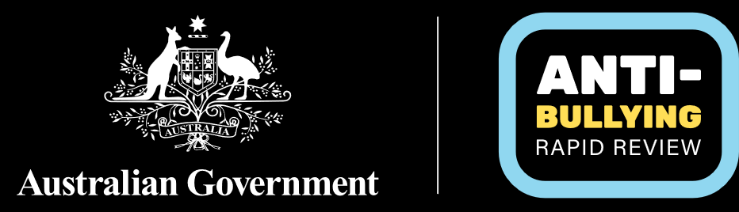

# A National Standard on Bullying in Australian Schools

A National Standard on Bullying in Australian Schools provides the framework for all school systems and schools to establish shared national expectations and actions and provide confidence that no matter where a student goes to school, bullying behaviours, including harmful antecedent behaviours (referred to as bullying and other harmful behaviours) will be appropriately addressed and the school workforce supported to take appropriate action.

The National Standard considers bullying to be within a continuum of harmful behaviours and negative interpersonal behaviours, whether physical or psychosocial, that are counter to creating a safe learning environment.

The National Standard comprises interconnected principles-based elements, set out below, which should be implemented together to effectively prevent and address bullying and other harmful behaviours.

|  |  |  |
| --- | --- | --- |
| Standard 1: Consistent anti-bullying requirements School systems implement explicit and dedicated action to build positive and respectful school community cultures, to ensure bullying and other harmful behaviours are not accepted, appropriate and timely action is taken and students’ right to education and a safe learning environment is upheld.  This involves implementing and adhering to all the interconnected elements of the National Standard in a way that is appropriate for the unique local school context. Standard 2: Whole of school and locally tailored approaches Schools implement a whole of school approach to preventing and addressing bullying and other harmful behaviours, involving the whole school community – students, parents and carers, the school workforce and wider school community – working together against bullying and other harmful behaviours, upholding shared expectations and creating a positive and safe learning environment. This includes:   * Developing and implementing school-based anti-bullying policies and processes in partnership with students, parents and carers, and the school workforce, for their local school context. * Ensuring the school community has access to information and opportunities to support and contribute to anti-bullying actions. * School leadership driving and embedding anti-bullying and behavioural expectations throughout school operations and culture. * Considering and addressing the unique needs of the local school context, including the unique and intersecting needs of diverse student groups and school staff including First Nations people, those who identify as LGBTIQA+, people with disability, and other groups experiencing additional risk factors such as women and girls. * School systems assisting the schools to deliver this through appropriate leadership and supports. | Standard 3: Create clarity and confidence in school anti-bullying action All school systems and schools have visible and transparent anti-bullying policies and processes in place and are accountable for timely and appropriate actions. This includes:   * Anti-bullying policies and processes being publicly available and accessible and clearly specifying processes on how to report an incident; how schools will manage and communicate their actions; what supports are available; and what escalation steps can be taken. * All school systems and schools make reasonable effort to initiate a response to any observed or reported harmful behaviour, including bullying, within two school days of becoming aware of the behaviour. Initial response involves early safety and support planning and action to prevent further harm and initial communication actions, recognising further time may be required to fully address the issue. * School systems and schools communicating what actions have been taken, and the reasons for those actions, to those involved or impacted, to the greatest extent possible while maintaining privacy responsibilities. * Schools keeping records outlining steps taken against the school’s anti-bullying policy and procedures. * School systems and schools reviewing their anti-bullying policies and processes in 2027 and routinely thereafter to ensure they remain fit for purpose and are having the intended impact.  Standard 4: Intervening early and appropriately All school systems and schools implement an evidence-based continuum of prevention, early proactive intervention and response action on bullying and other harmful behaviours. This includes:   * Prioritising primary prevention and proactive early intervention action to stop bullying and other harmful behaviours from occurring and escalating. * Ensuring response actions are trauma-informed, relationship-focused, justifiable and tailored to the unique circumstances involved. * Ensuring all those involved in, or affected by, an incident are supported, including ensuring wellbeing supports are available for students and staff. * Supporting students to understand the cause and impact of their behaviour with a view to ending the cycle of bullying and other harmful behaviours. * Providing clear and fair escalation pathways where interventions have not effectively resolved an incident. * School systems ensuring their schools have access to information and guidance to support implementation of evidence-based and trauma-informed prevention, early intervention and response action. | Standard 5: Support the school workforce School systems and schools ensure school leaders, educators and non-teaching staff are empowered and equipped to effectively prevent and address bullying and other harmful behaviours and to support a positive and safe learning and working environment. This includes:   * Providing trauma-informed professional development on bullying and other harmful behaviours, risk and protective factors, and appropriate prevention and response action. * Ensuring the school workforce is given the time needed to undertake professional development and contribute to bullying and other harmful behaviour prevention and response activities. * Ensuring the school workforce understands the school’s policies and processes to follow and has access to resources and guidance to help them be accountable and take appropriate action. * Providing support for staff impacted by or responding to bullying and other harmful behaviours.  Standard 6: Reducing risks and fostering safe, inclusive and respectful communities School systems and schools take action to:   * Address the broader risk and protective factors influencing bullying and other harmful behaviours, including through:   + age, diversity, culturally and developmentally appropriate education on respectful relationships, social and emotional skills, digital safety and citizenship   + explicit teaching on bullying and other harmful behaviours * Ensure continual improvement, including through data collection and analysis, evaluation and research to ensure Australia’s anti-bullying actions remain suitably targeted to achieve change and adapt to emerging issues. |