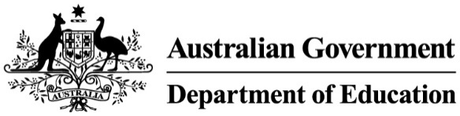

National Industry PhD Program
The two streams will provide PhD candidates with the opportunity to undertake a research project with an industry application, equipping candidates with the skills and experience to work at the interface of university and industry research sectors.
 | Additional funding provided under the program | Existing funding or allocation | Total stipend amount PhD candidates receive
Stream 1: Industry Linked PhDs Outstanding PhD Candidates undertake a research project co-designed by university and industry, with opportunities to be embedded in an industry setting | Stipend top-up from government = $7k  Stipend top-up from Industry Partner = $10k (min) | Research Training Program (RTP) stipend under the Research Block Grant (or equivalent) = $34k (min) | $51k (min)
Stream 2: Industry Researcher PhDs Highly capable industry professionals undertake a PhD project in partnership with a university while retaining industry employment and full salary benefits | $46K > | Employers to receive subsidy to support staff salary and other costs, per annum, up to four years from government
Participating University  Receive $12K per PhD for both streams | $12k > | Participating universities to receive annual administration fee from government
Notes
1 Funding rates are 2025 amounts, provided per annum for up to four years for a full-time PhD candidate (up to 8 years for a part-time PhD candidate at 50 per cent of the full-time rate).
2 Other equivalent (non-RTP) stipends need to be provided at the RTP stipend base rate as a minimum.
3 Industry Linked PhDs are also provided with a 12-week training program.

