

***Submission to***



1

**Quality Initial Teacher Education Review**

**July 2021**

**Summary**

Every child in Australia deserves, and is entitled to, equity of access to the opportunities that education can provide for them to learn, achieve, and thrive. The Australian Curriculum, Assessment and Reporting Authority (ACARA) advocates for this fundamental right, stating that “all children are entitled to rigorous, relevant and engaging learning opportunities...aligned with their individual learning needs, strengths, interests and goals”. The delivery of a rigorous, relevant and engaging curriculum starts with appropriately preparing and resourcing our graduate teachers. Beginning at Standard 1.5.1 of the Australian Professional Standards for Teaching, it is expected that graduate teachers will “Demonstrate knowledge and understanding of strategies for differentiating teaching to meet the specific learning needs of students across the full range of abilities”. Less than 10% of Australian universities that offer pre-service education degrees include a stand-alone unit in gifted education. **Initial teacher education settings are failing to equip graduate teachers with the skills, tools and resources they rightfully deserve to meet the educational needs of over 400 000 gifted students in Australian schools.**

**Contact: Mrs Melinda Gindy *President***



**Introduction**



2

“Initial teacher education (ITE) aims to ensure that graduate teachers start their teaching career with the necessary knowledge, skills and dispositions to be successful teachers in any Australian school.” (DESE, 2021)

The Australian Association for the Education of the Gifted and Talented (AAEGT) recognises the integral work of teachers with students from a diverse range of backgrounds and learning needs. It acknowledges the importance of all students to have equity of learning opportunities and to strive for excellence. For the purpose of this submission, the AAEGT considers: “**Does initial teacher education ensure that graduate teachers start their teaching career with the necessary knowledge, skills and dispositions to be successful teachers *of gifted children* in any Australian school?”**

In 2001, the [Australian Senate Committee](https://www.aph.gov.au/~/media/wopapub/senate/committee/eet_ctte/completed_inquiries/1999_02/gifted/report/c01_pdf.ashx) on the Education of Gifted and Talented Children identified **gifted students as the most educationally disadvantaged students in this country.** However, 20 years later, gifted students and their learning needs are still not referenced in any of the key national or federal government documents. Gifted students are not referenced in the key AITSL documents. A unit on gifted education is not a requirement for the registration of a preservice degree at any Australia University. Is this omission beneficial to the preservice teachers, gifted students or Australia as a whole?

**Gifted students**

Gifted students are those who have the potential for high achievement, or who are demonstrating advanced achievement. Research evidence confirms that without appropriately challenging and supportive educational opportunities, gifted children may underachieve, dropout and experience emotional disturbance and impaired wellbeing. There are over **400,000 gifted children in schools across Australia.**

Gifted students are recognised in policy by all Australian state and territory education bodies, as well as numerous catholic and independent school bodies across the country. Most sectors and schools reference Gagnés’ Differentiated Model of Gifted



documents in gifted education.



3

and Talent (Gagné, 2020) as the theoretical basis for their policies and support

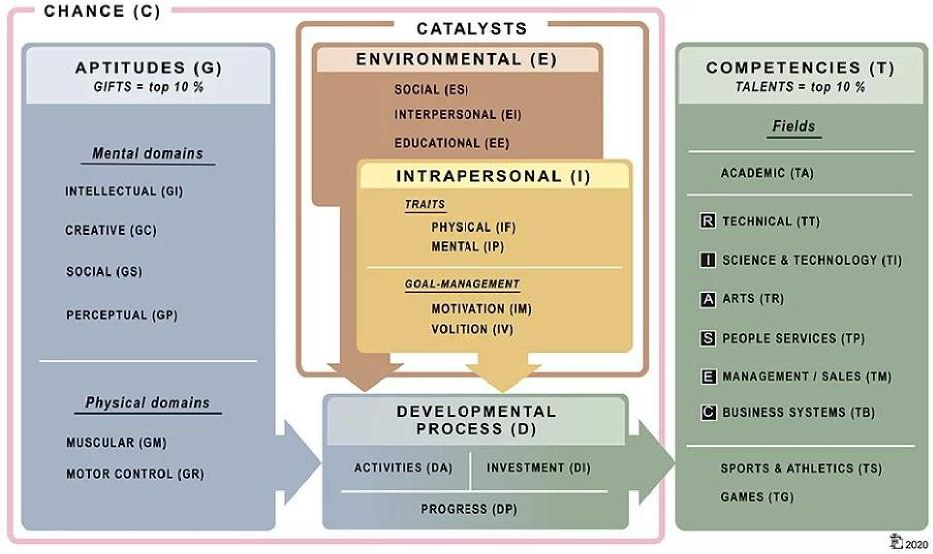

(Gagné, 2021)

The latest Australian Bureau of Statistics school enrolment data identifies that there were 4,006,974 students enrolled in schools across Australia in 2020 (ABS, 2021). When applying the use of the DMGT (Gagné, 2020) – referenced in every state and territory of Australia – it is therefore recognised that the nation has more than 400,000 gifted students enrolled in schools.

“Gifted students are in every school and every mainstream classroom across Australia. In each mainstream classroom of 30 students, 3 or maybe even 5 are gifted students”. (Ronskley-Pavia, 2021).

Despite inclusion of gifted students in education policy within every state and territory of Australia, at the federal level, gifted students are not referenced and are not included. The direct omission of gifted education from national documents governing education, initial teacher education and the Australian Professional Standards for Teachers should be seen as of out of step to the state and territory education sectors. It is a continuing oversight that initial teacher education programmes and the



students.



4

guiding national documents do not include explicitly and intentionally included gifted

**What is the current situation in Initial Teacher programs across Australia?**

As the term “gifted” is currently not found in any Australian Professional Standards for Teachers documents, it is no surprise then that the vast majority of Australian universities that provide courses in teacher education do not provide a compulsory unit in gifted education. In fact, the number may be as low as only three, and all are located within the same state (Gindy, 2016).

**Previous Education Inquiries and Recommendations relating to Gifted   
Education and Initial Teacher Education**

Many different government enquiries have considered gifted education and recommended the need for initial teacher education to include a compulsory unit on gifted education. Some of these include:

* Report by the Senate Select Committee on the Education of Gifted and Talented Children 1988,

“Recommendation 2: **The Committee recommends to teacher training institutions the pre-service training course include sufficient information about gifted children to make student teachers aware of the needs of the children and the special identification techniques and teaching strategies which the student teachers will have to use with the gifted on graduation**.” (p. 177)

* Senate Inquiry into the Education of the Gifted and Talented 2001, amongst its hearings found:

“The main theme that emerged in the inquiry is the **need for better teacher training (both preservice and inservice) so that teachers are better able to identify the gifted and make provision for their special needs**. Better curriculum support is also essential so that teachers can differentiate the curriculum for the gifted.”

And



“The Commonwealth should propose to MCEETYA that State and Territory education authorities should require, as a condition of employment, that newly graduated teachers have at least a semester unit on the special needs of gifted children in their degrees. **This should include training in identification of gifted children and the pedagogy of teaching them**”.



5

Recommendation 14 (paragraph 4.67)”

* Productivity Commission Research Report, Schools Workforce, April 2012, which reported:

“...it is also important to recognise the learning needs of gifted and talented

students who have the potential to excel beyond the achievements of an average student.” (p. 268)

**Examples from Current Research**

Peer-reviewed research into gifted education continues throughout Australia and around the world. To improve the outcomes of gifted students, it is critical that governments, policy makers and senior education officials are aware of current, effective research in gifted education. Furthermore, they have a responsibility to undertake constructive, positive actions ensuring all relevant documents and policies at a national level accurately reflect and include the learning needs of Australian gifted students.

A selection of recent research looking at preservice teacher education and gifted learners highlighting essential points is summarised below.

**Predictors of Attitudes to Gifted Programs/Provisions: Evidence From Preservice Educators, J. Jung (2014)**

* “To enhance the level of preservice teacher support for specialist gifted programs and provisions ... it may be useful to focus on communicating messages that dispel the notion that gifted students are in an advantaged, privileged, superior, or otherwise unequal position to nongifted students.” (p. 255).



gifted programs/provisions may be to encourage interaction between preservice teachers and gifted individuals.” (p. 256)



6

+ “An alternative or complementary strategy to enhance support for special

**Preservice Teacher Attitudes towards Giftedness, D. A. Troxclair (2013)**

+ Troxclair (2013) found that preservice teachers’ attitudes reflect societal myths towards giftedness; specifically, the myths surrounding elitism, ability grouping, and acceleration.

+ Troxclair’s (2013) results also replicated previous research identifying that acceleration is widely misunderstood as an appropriate option for some gifted students. Preservice teachers need to become fully acquainted with research findings in this area, especially the research that reports no negative social and emotional impact to gifted students as a result of appropriate acceleration.

**Do stereotypes strike twice? Giftedness and gender stereotypes in pre-service teachers’ beliefs about student characteristics in Australia, S. Matheis et al. (2020)**

+ When teachers have little or no knowledge about identification and effective education strategies for gifted students, learning opportunities and outcomes for gifted students are reduced and negatively impacted by stereotypes. In Australia, research continues to identify continuing trends in negative attitudes towards gifted education. According to Matheis and colleagues, some of the concerns include:

1. Gifted children who are accelerated have negative social and emotional outcomes.
2. Teachers prefer to teach average students rather than gifted students.
3. Teachers hold less than positive attitudes towards fostering effective pedagogy for gifted students.

+ The study included research on gender stereotyping and gifted students. Mathesis (2020) revealed that pre-service teachers in Australia endorsed the disharmony hypothesis, suggesting that gifted individuals are equipped with high intellectual ability, but show adjustment difficulties compared to



stereotypes are not in line with authentic student characteristics, implying a substantial risk for discrimination when relying on such stereotypes.



7

individuals with average ability, and “typical” gender stereotypes. These

+ Matheis and colleagues conclude that contact with gifted students during their initial teacher training combined with the inclusion of mandatory modules on the education of the gifted would reduce these risks.

**Threat or challenge? Teachers’ beliefs about gifted students and their relationship to teacher motivation Matheis et al. (2017)**

+ This study examined teachers’ beliefs about gifted students in Australia and Germany and the type of competencies teachers need to be successful as educators of gifted and talented students.

+ Amongst several conclusions, Matheis and colleagues identified that teacher education should “aim to improve knowledge of gifted students’ characteristics and identification of the gifted, with an intention to foster motivation to engage with the gifted and raise self-efficacy for teaching them”. (p.19)

**Learning to Be a Teacher of the Gifted: The Importance of Examining Opinions and Challenging Misconceptions, Plunkett and Kronborg (2011)**

+ This large study examined the importance of an elective preservice teacher training course in Gifted Education. Involving 332 preservice teachers at Monash University, Australia, the results of this study reinforced the benefits to teachers having completed a dedicated unit in gifted education.

+ Significant findings included:

1. Strong positive growth and understanding in: the perceived social value of giftedness, the acceptance of giftedness, ability grouping of gifted learners, and, acceleration of gifted learners.
2. Participants agreed that gifted students’ needs often get ignored and they require support at school level.

+ This research article also contains excerpts from preservice teachers’ journal reflections. An entry outlines why Gifted Education should be a compulsory part of Initial Teacher Education in Australia:



I do wonder about all those who – due to unavailability of the



8

“But,

subject, timetable reasons or otherwise – have not been exposed to this educational issue. I worry because for all the excellent information provided on the characteristics of gifted students, the problems with identification, cultural disparity, and grouping and acceleration alternatives, our response to these issues turns so much on the attitude and knowledge of the teacher. Without an appreciation of what we’ve covered in this course, a teacher is unlikely to instinctively be on the lookout to respond positively and appropriately to the needs of gifted students. This is a real shame. Until there is broader education about giftedness, I feel as though many of the myths and misunderstandings that have punctuated this issue for decades (eg. the ‘zero-sum’ idea that investing in ‘gifted’ and ‘handicapped’) will continue to be peddled.” (p.43)

**The current performance of our high achievers on a global scale**

So, how are Australia’s high achieving students currently performing compared to our global peers? The below graphs demonstrate the performance of Australian students in the Programme for International Student Assessment (PISA) from when the programme was first established in 2000 to the latest available 2018 data (OECD, 2019). Scientific literacy and Mathematical literacy have steadily declined for students achieving in the top bands. Reading literacy may have plateaued slightly over the recent test but is still statistically lower than initial results. Overall, this graph highlights declining achievement averages for our high performers. **Given that Australia’s poor international results in 2009 were a catalyst to the establishment of the Australian Institute for Teaching and School Leadership (AISTL) and subsequent development of the Australian Professional Standards for Teachers (APST), it is a significant concern that there has been no positive impact on the performance of our highest performers since their introduction.** It is even more concerning that the results are in decline across all three areas of reading literacy, mathematics literacy and scientific literacy.



(OECD, 2019)

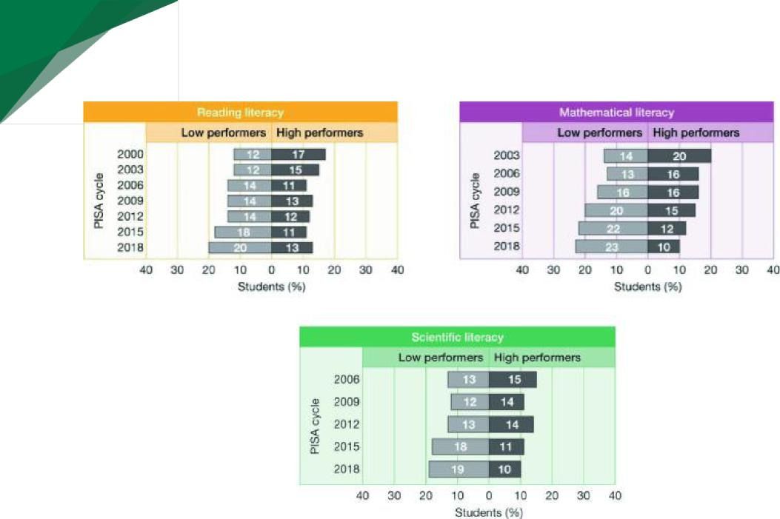

9

“Whatever their motivation, more and more countries are participating in PISA testing and politicians are using the results to drive educational reform.” (Baird et al., 2011)

A number of researchers have analysed what top performing economies have in common and it appears that PISA success comes with placing greatest significance on recruiting, developing and retaining high quality teachers (Ingvarson, [et.al](http://et.al)., 2014). It is understood that those countries who have adopted stringent policies on high quality teaching correspondingly demonstrate high levels of student performance (Masters, 2015). Intervention in improving student outcomes should come from improving and investing in high quality teaching.

**To improve our achievement levels as a nation on a global stage, we need change.** Australia needs to improve the knowledge and skills preservice teachers obtain while participating in ITE by providing a stand-alone preservice unit in gifted education. A quality unit in gifted education in an Australian university would provide the following benefits to graduates:



appropriately identified as gifted,



10

1. Increase the number and diversity of students being properly and

1. Equip teachers with the knowledge and skills to implement programs and provisions for gifted students in all schools,
2. Equip teachers with the knowledge to develop effective curricula and differentiated instruction to meet the needs of gifted students,
3. Provide targeted acceleration opportunities in line with gifted students’ needs,
4. Equip teachers with the skills to encourage self-awareness, self-regulation, self-efficacy, personal empowerment, leadership and self-advocacy in gifted students,
5. Improve achievement scores and reduce underachievement seen in gifted students, and
6. Develop high quality partnerships with the parents of gifted students.

While Australia does not presently have a current national standard for a course in gifted education, progression could be considered through Australian universities exemplars that include in their elective units on gifted education, along with international perspectives. An example of a well-designed standard is the USA NAGC-CEC Teacher Preparation Standards in Gifted and Talented Education which can be found at:<https://files.eric.ed.gov/fulltext/ED562612.pdf> .

**Preparing ITE students to be effective teachers**

To improve equity of educational outcomes and improvement towards excellence in learning around Australia, there have been a number of recent educational reform initiatives including: the introduction of the AISTL, the development of the Australian Professional Standards for Teachers, and the improved structure of ITE degrees. Many educational inquiry recommendations, synthesised with continuous new research in the field of Gifted Education, recommend that teachers need to complete a course in gifted education to effectively meet the needs of gifted students. However, these recommendations are still yet to be included in any federal education documents or policies, nor are they substantiated within the system of teacher education in Australia.



not rare; they do not only appear in the private system; they are not only in the school three suburbs over. **Gifted students are in every mainstream classroom and every school in Australia.** Research and recommendations continually emphasise the significant need for a compulsory unit of gifted education in every initial teacher education course around the country as an essential and equitable way to effectively prepare graduate teachers for the real classroom.



11

One in ten students within our Australian classrooms are gifted. These students are

The development and implementation of the (APST) aimed to ensure consistency, rigour and improvement across Australia’s teaching workforce. However, the APST does not explicitly reference gifted**. The omission of gifted students from the standards has led to universities removing gifted education courses as a compulsory unit, reducing the opportunity to elect to study a unit in gifted education or providing no unit in gifted education at all.** Anecdotal reports from our members indicate that some ITE programs only offer one 2-hour lecture on gifted education for their entire 4 years of training. As a result, graduate teachers are ill-equipped to effectively meet the needs of gifted learners in their classrooms.

**Professional experience of preservice teachers as part of the preparation for   
teaching gifted students in the classroom.**

Preservice teachers gain valuable experience and insight into gifted students when they are exposed to them during their preservice years. (Jung, 2014; Plunkett & Kronborg, 2011). Often preservice teachers in their own school years may not have been exposed to ability grouped or accelerated of gifted students. One option may be to encourage practicum placements in schools with high enrolments of gifted students, in some cities in Australia a selective school would be one such place, for at least part of the requirements of preservice training.

**Conclusions and Recommendations**

“The quality of an education system cannot exceed the quality of its teachers”

McKinsey Report

(Mourshed et al., 2007, p.19)



delivered by teachers in mainstream classrooms in Australia. It is essential for teachers during initial teacher training to develop an understanding of the learning needs, appropriate pedagogies and identification processes for gifted students so that they can effectively provide a rigorous, engaging learning experience when they commence classroom teaching.



12

Quality teaching, and thus a quality education for gifted students is primarily

“Improving teacher quality is considered an essential reform as part of Australia’s efforts to improve student attainment and ensure it has a world class system of education” (AISTL, 2011, p.2). A world class system of education must include the provision of effective educational practices for gifted learners starting with the appropriate resourcing within our ITE courses.

The Australian Association for the Education of the Gifted and Talented Limited makes the following recommendations.

1. The Australian Professional Standards for Teachers are amended to include the requirement for teachers to be able to identify and meet the diverse learning needs of all gifted students.
2. All Initial Teacher Education degrees and programs contain a compulsory unit on Gifted Education, and this unit is designed to meet key standards of knowledge in gifted education.
3. Preservice teachers’ practicums incorporate a mandatory experience in working with, and programming for, gifted students.



The Australian Association for the Education of the Gifted and Talented (AAEGT) is pleased to be able to contribute this submission to the 2021 Quality Initial Teacher Education Review. The AAEGT is comprised of members from all states and territories in Australia. They include university researchers/academics, educational consultants, schools, principals, teachers and parents. Furthermore, members represent a diverse population incorporating a variety of cultural backgrounds and geographical locations, including metropolitan, regional, rural and remote members.

**About the Author**



13

The purpose for which the AAEGT is established is to advance education by promoting and protecting the educational entitlement and well-being of the gifted and talented. The AAEGT pursues this purpose through a range of activities and services that may include but are not limited to:

(a) Providing national leadership in Gifted and Talented Education.

1. Advocating on behalf of our members for the educational and well­being needs of gifted and talented students.
2. Working with politicians and governments towards legislative and policy inclusion of gifted and talented students to achieve their recognition and inclusion in schools and Australian society.
3. Promoting research and advancing scholarship in Gifted and Talented Education.
4. Collaborating to provide and communicate evidence about gifted and talented students, their intellectual and affective needs, and appropriate educational provisions.
5. Recognising outstanding practice and eminence in the scholarship of Gifted and Talented Education.



**References**



14

Australian Bureau of Statistics. (2021). *Data on students, staff, schools, rates and ratios for government and non-government schools, for all Australian states and territories.* Downloaded from:<https://www.abs.gov.au/statistics/people/education/schools/latest-release>

Australian Institute for Teaching and School Leadership AITSL (2013). *Annual Report: Promoting*

*excellence in the profession of teaching and school leadership.* Australian Institute of Teaching and School Leadership.

Gagné, F. (2020): *Differentiated Model of Gifted and Talented.* Downloaded from:   
<https://gagnefrancoys.wixsite.com/dmgt-mddt>

Gindy, M. (2016) AAEGT Gifted Awareness Week Media Release 2016. Download from: <http://www.aaegt.net.au/?page_id=1170>

Ingvarson, L.C. & Rowe, K. (2007). *Conceptualising and Evaluating Teacher Quality Substantive and Methodological Issues*. ACER

Jung, J. Y. (2014). Predictors of attitudes to gifted programs/provisions: Evidence from preservice educators. *Gifted Child Quarterly*, *58*(4), 247-258.

Matheis, S., Kronborg, L., Schmitt, M., & Preckel, F. (2017). Threat or challenge? Teacher beliefs

about gifted students and their relationship to teacher motivation. *Gifted and Talented International*, *32*(2), 134-160.

Matheis, S., Keller, L. K., Kronborg, L., Schmitt, M., & Preckel, F. (2020). Do stereotypes strike twice? Giftedness and gender stereotypes in pre-service teachers’ beliefs about student

characteristics in Australia. *Asia-Pacific Journal of Teacher Education*, *48*(2), 213-232.

Mourshed, M. Chijoke, C. and Barber, M. (2010) How the world’s most improved school systems keep getting better, New York: McKinsey Company. Available: <http://mckinseyonsociety.com/downloads/reports/Education/How-the-Worlds-MostImproved-School-Systems-Keep-Getting-Better_Download-version_Final.pdf>

Plunkett, M., & Kronborg, L. (2011). Learning to be a teacher of the gifted: The importance of examining opinions and challenging misconceptions. *Gifted and Talented International*, *26*(1­2), 31-46.

Ronskley-Pavia, M. (2021) *G&T Course Introduction.* Professional Learning Hub, Griffith University, Australia. Available at<https://www.youtube.com/watch?v=Hz1jIQ-FwZY&t=2s>

Troxclair, D. A. (2013). Preservice teacher attitudes toward giftedness. *Roeper Review*, *35*(1), 58-64.

Australian Association for the Education of the Gifted and Talented

Australian Public Company Limited by Guarantee

ACN 057 423 202

