*Graduate Teachers need   
techniques not   
strategies.*

[June 29, 2021](https://assistantprincipalsofficeblog.wordpress.com/2021/06/29/graduate-teachers-need-techniques-not-strategies/)[monkrob](https://assistantprincipalsofficeblog.wordpress.com/author/monkrob/)[Edit](https://wordpress.com/post/assistantprincipalsofficeblog.wordpress.com/1004)

The [Quality Initial Teacher Education Review 2021 Discussion Paper](https://www.dese.gov.au/quality-initial-teacher-education-review/resources/quality-initial-teacher-education-review-2021-discussion-paper) is worth reading.

It is an honest and open discussion of Initial Teacher Education(ITE) in Australia. The paper has many data sets showing strengths and weaknesses of the current system as well as data on the effectiveness of changes recently implemented. I’d recommend all Australian Education Leaders read the paper and prepare a response.

I would like to comment specifically on Section 4: Are graduate teachers ready for the classroom?

The methodology to answer this question is simple. Ask the graduate teachers and ask the schools. There is clear evidence that Graduate teachers have been surveyed. Systematic data from the schools is not really included.

Graduate teachers were largely positive about their ITE courses, although the effect of COVID did cause a significant drop in satisfaction in 2020. Note the effect of online learning on the total % positive ratings of the undergraduate experience. To enjoy University fully you really need to be there.

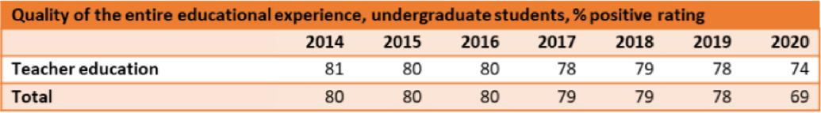



At the end of the ITE course students are assessed against the Graduate Teacher Standards.

The Graduate Teacher Standards set out requirements for understanding and implementing effective teaching strategies. Research and workplace knowledge suggest these teaching strategies contribute to successful learning outcomes for students. The relevant focus areas at the graduate level include:

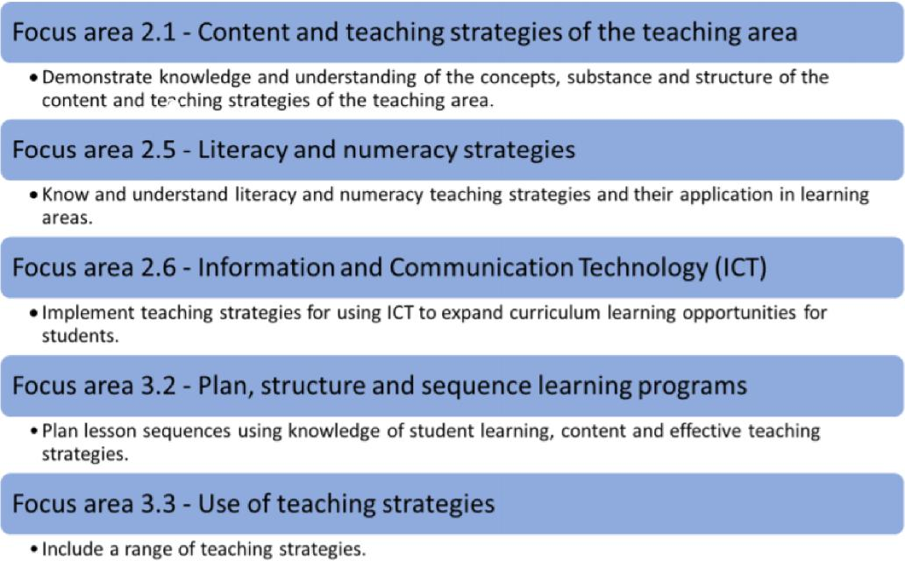

Graduate Teachers were asked to comment on how well prepared they were for different aspects of teaching. Here is a summary of the results.

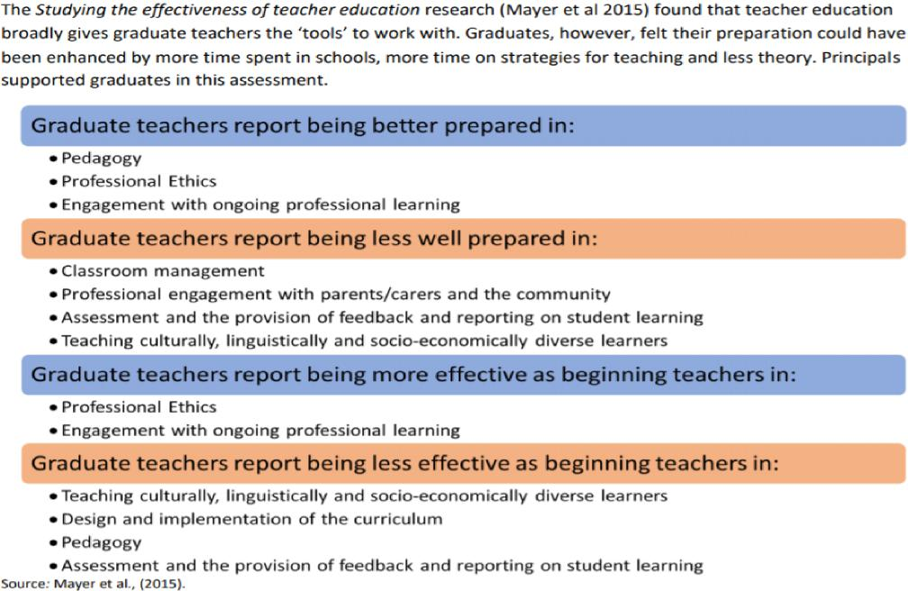

It is the focus of Graduate Teaching Standards that contribute to the above results. You hit what you aim at.

The most common aspect of teaching Graduate Teachers said they were less well prepared for was Classroom Management. The standards for graduate teachers focus on strategies rather than techniques. Classroom management is best taught by giving teachers techniques rather than strategies.

Dough Lemov in Teach Like a Champion makes the difference between strategies and techniques clear.

*I call these tools “techniques,” not “strategies,” even though the teaching profession tends to use the latter term. To me, a strategy is a generalized approach to problems, a way to inform decisions. A technique is a thing you say or do in a particular way.*

Grad teachers need to learn classroom management techniques in their ITE courses.

Imagine teaching your junior football team to centre the ball when coming out of the backline then get numbers behind the ball and move the ball quickly into the forward line. That may be a great strategy to win football games but if the kids cannot kick the ball or tackle effectively the strategy

will not work. You have to teach them the technique of kicking and tackling first. When the basic techniques are mastered you can move on to strategy.

When looking at the graduate teaching standards above it is clear that classroom management techniques are not included. Classroom management techniques are what graduate teachers most need to develop. Without them statements like “Include a range of teaching strategies” are unachievable.

When I ask our Student Teachers, “How much work on classroom management techniques do they do in the ITE course?” their answer is always, “Not enough!”

The ITE providers often tell me that the purpose of teaching rounds is to learn these techniques. Learning classroom management techniques while on teaching rounds is like learning to ride a bike by entering the Tour de France. You need some level of proficiency before you can start.

*Learning classroom management techniques   
while on teaching rounds is like learning to ride   
a bike by entering the Tour de France*

Techniques that Graduate Teachers need to practice and perfect are:

* Teaching students how to enter the classroom.
* How to gain student attention
* How to teach common classroom routines like think pair share, collecting equipment, getting into groups.
* How to manage students responding to classroom questions eg Hands Up, Cold Call, Coral Response.
* Graded consequences for students who are interfering with the learning of others.

My feedback to the review is to specifically build more “running the room” techniques into the ITE course. This should also extend to engagement and communication with parents, carers and other stakeholders.