

*1 August 2021*

Quality Initial Teacher Education Review Secretariat
  
Department of Education, Skills and Employment
  
Australian Government

Canberra ACT 2600

[ITEReview@dese.gov.au](mailto:ITEReview@dese.gov.au)

Dear Review Panel

**Good to Great Schools Australia Submission to the Quality Initial Teacher Education Review**

**1. Introduction**

We appreciate the opportunity to make a submission to the Quality Initial Teacher Education Review (the Review). The review discussion paper refers to the intention that this review “build upon the significant reforms arising from the Teacher Education Ministerial Advisory Group (TEMAG) report” of 2014.

It is now seven years later. This current review represents the *second* policy inquiry into teacher education in Australia *within a decade*. That this review follows a previous review that focused on the same issue raises questions about the efficacy of the previous report and its recommendations. The fact that the government has commissioned this review must indicate that the previous TEMAG recommendations have not yielded the results that the government wants from initial teacher education. Were the recommendations misplaced, wrongly directed or insufficient in terms of achieving the improvement in teacher education sought by TEMAG and the federal government? It seems to us that this review must answer this question. To simply adopt the view that this current initiative “builds upon” the TEMAG report is liable to rest on an assumption that the previous policy recommendations were correct. They may not have been.

International evidence on school system change presented by McKinsey & Company in 2010 (Mourshed, Chijoke and Barber, 2010) showed that a step change in school system performance has

302-310 Sheridan Street, Cairns North, Queensland, 4870 |PO Box 278, North Cairns Queensland, 4870

Tel: (07) 4042 7200 | Fax: (07) 4051 3556 |[info@goodtogreatschools.org.au](mailto:info@goodtogreatschools.org.au) | [www.goodtogreatschools.org.au](http://www.goodtogreatschools.org.au) | ABN 93 141 269 016

Page 2 of 22

taken *an average of six years* to effect: about the same time between these two inquiries into teacher education. Australia either does education *policy* badly or it does education policy *implementation* badly. In our submission the expert panel should be explicit about where it is that its recommendations follow or depart from the rationale provided by TEMAG and its recommendations. “Building upon” policy misconception or implementation failure is not going to take the country forward. As the discussion paper says, Australia’s performance in both absolute terms and relative to other countries has been declining for two decades. We cannot afford for another six to seven years to pass before we make another iteration on the endless journey of fixing initial teacher education.

**2. Focus of this submission: the needs of remote, regional and indigenous-majority schools**

Good to Great Schools Australia (GGSA) has for ten years worked in partnership with the Queensland Department of Education in respect of primary school delivery in three schools in Cape York Peninsula. We’ve gained significant experience in teacher recruitment and teacher preparation for service in remote schools. We recruit teachers in collaboration with the Queensland Department, including school leaders. We also have significant experience gained from implementing literacy support programs funded by the Federal Government in various school jurisdictions: Queensland, Western Australia and the Northern Territory.

We have worked with schools in remote and regional areas. We have worked mostly in indigenous-majority schools but also in mainstream schools with a minority of Indigenous students. We have much practical experience and implementation data related to disadvantaged schools in remote and regional communities.

Based on our experience, we identify five problems – important and urgent – facing these disadvantaged schools that are decentralised from urban centres, and particularly those in Indigenous communities.

302-310 Sheridan Street, Cairns North, Queensland, 4870 |PO Box 278, North Cairns Queensland, 4870

Tel: (07) 4042 7200 | Fax: (07) 4051 3556 |[info@goodtogreatschools.org.au](mailto:info@goodtogreatschools.org.au) | [www.goodtogreatschools.org.au](http://www.goodtogreatschools.org.au) | ABN 93 141 269 016

Page 3 of 22

**2.1 The problem of lack of knowledge of explicit instruction in teaching**

This problem was raised in the previous TEMAG review. Whether it was effectively addressed is a question. The expert panel should ask this question, because it is a critical one. Indeed, in our view it is *the central question* facing initial teacher education. Everything else is secondary.

Our submission is that it is the preponderance of social constructivist modes of teaching and the dearth of explicit instruction in teaching practice that is the cause of the underperformance of Australian schools. This preponderance in Australian schools and classrooms of whole language literacy learning, inquiry learning, discovery learning, project learning – now often branded as ‘balanced literacy’ and ‘child-centred learning’ now that evidence of their inefficacy is unavoidable – is an old debate about pedagogy that is still unresolved in Australian schools policy. We point to the outcomes of McKinsey & Company’s 2017 report on the 2015 PISA (Program for International Student Assessment) data for the Oceania region (Chen, Dorn et. al, 2017). McKinsey’s analysis shows that school systems that are high performing in the Asia region are those where the preponderance of learning is the result of teacher-led instruction rather than inquiry learning. There needs to be a balance of both but it needs to strongly favour teacher-led instruction.

**Exhibit A: The best outcomes combine both teaching styles (Oceania example)**





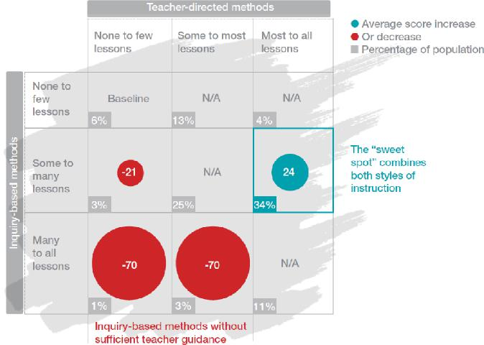

(Chen, Dorn, et. al, 2017, p. 42)

302-310 Sheridan Street, Cairns North, Queensland, 4870 |PO Box 278, North Cairns Queensland, 4870

Tel: (07) 4042 7200 | Fax: (07) 4051 3556 |[info@goodtogreatschools.org.au](mailto:info@goodtogreatschools.org.au) | [www.goodtogreatschools.org.au](http://www.goodtogreatschools.org.au) | ABN 93 141 269 016

Page 4 of 22

Despite the increased recognition of the evidence base for explicit and teacher-led instruction (Hattie, 2009; GGSA, 2014) over the past decade and a half going back to Professor Ken Rowe’s National Inquiry into the Teaching of Literacy in 2005 (Rowe K, 2005) – this is still not reflected in the vast majority of initial teacher education courses in Australia. This is either ignorance or defiance on the part of ITE providers, whichever it is, it is this sheer *obscurantism* that is the core problem of initial teacher education in Australia. Continuing to ignore this reality – that the great majority of initial teacher education providers refuse to follow the evidence, is a disservice to Australian education. If the purpose of this review is to be achieved then the expert panel needs to confront this *refusal to follow the evidence as the number one problem* in the preparation of teachers for classroom.

It is absurd that frameworks like the Victorian Education Department’s HITS (High Impact Teaching Strategies) identify explicit instruction as high impact, but initial teacher education – not the least in the state of Victoria – ignores it. There is little evidence that any change has occurred since the 2014 TEMAG report in terms of inclusion of explicit instruction pedagogy in teacher education courses.

Research reported in a 2019 paper by Jennifer Buckingham and Linda Meeks (p. v1) showed:

* Only five (4%) of the 116 literacy units reviewed had a specific focus on early reading instruction or early literacy; that is, how to teach beginning readers in the first few years of school. In a further 30 (26%) of the unit outlines, early reading or early literacy was mentioned in some form but was included with other literacy content.
* In 81 (70%) of the 116 literacy units reviewed, none of the five essential elements of effective evidence-based reading instruction were mentioned in the unit outlines. All five essential elements were referred to in only 6% of literacy unit outlines.
* None of the unit outlines contained references to the Simple View of Reading. The specific model or theory mentioned most frequently in the unit outlines was the Four Resources / Four Roles of a Reader model which was referred to eight times. The sociocultural model or view of reading was referred to nine times.
* Thirteen (15%) of the lecturers and unit coordinators that could be identified had specific expertise in early reading instruction or literacy, most with a particular interest in early literacy development among Indigenous and other children from non-English speaking backgrounds. Forty-seven (55%) had research interests and expertise in other aspects of literacy, most often digital and multi-modal literacies. Twenty-five (30%) of the literacy lecturers or unit coordinators had research interests and expertise in areas other than literacy, such as maths or music.

302-310 Sheridan Street, Cairns North, Queensland, 4870 |PO Box 278, North Cairns Queensland, 4870

Tel: (07) 4042 7200 | Fax: (07) 4051 3556 |[info@goodtogreatschools.org.au](mailto:info@goodtogreatschools.org.au) | [www.goodtogreatschools.org.au](http://www.goodtogreatschools.org.au) | ABN 93 141 269 016

Page 5 of 22

* A review of the content of the six most commonly prescribed text books found that none contained sufficiently accurate and detailed content that would allow graduate teachers to use effective, evidence-based instruction, and many contained information that was inadequate and/or misleading.

The authors concluded:

Initial teacher education students, and the children they eventually go on to teach, are being short-changed. The lack of progress by universities in reforming and improving the quality of ITE in preparation to teach reading, despite the findings of numerous reports and inquiries, is apparent in the large number of students in Australian schools who struggle with reading (Buckingham and Meeks, 2019, p. vi).

Buckingham and Meeks were reporting on the situation *four years after* TEMAG. Their research clearly indicates the efficacy of TEMAG’s recommendations in relation to the inclusion of explicit instruction of reading in teacher education courses around the country. It had no effect.

**2.2 The problem of high teacher and school leadership turnover**

Turnover is a crippling problem. There is no prospect that remote schools will ever achieve and sustain improvement as long as teacher and school leadership retention is so low. This issue is routinely recognised and just as routinely ignored by putting it in the ‘too hard basket’.

**Exhibit B: Teacher and teaching assistant turnover is crippling in remote schools**

302-310 Sheridan Street, Cairns North, Queensland, 4870 |PO Box 278, North Cairns Queensland, 4870

Tel: (07) 4042 7200 | Fax: (07) 4051 3556 |[info@goodtogreatschools.org.au](mailto:info@goodtogreatschools.org.au) | [www.goodtogreatschools.org.au](http://www.goodtogreatschools.org.au) | ABN 93 141 269 016

Page 6 of 22

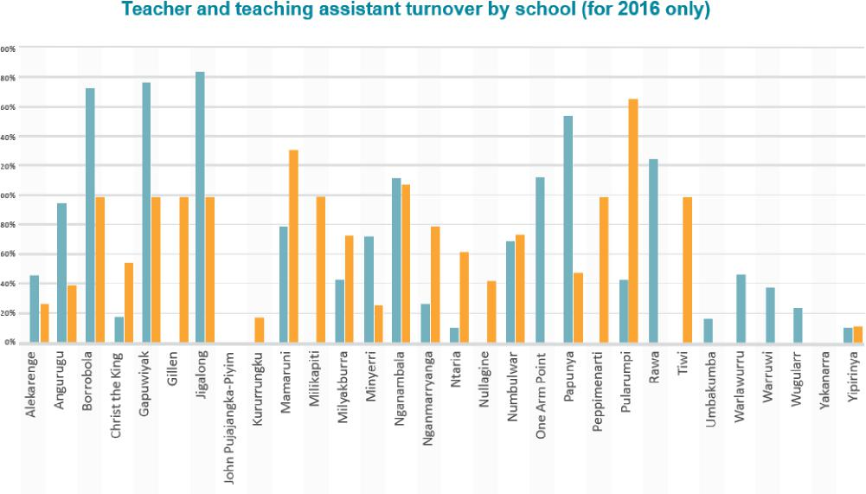

(Good to Great Schools Australia, 2017, p. 19)

Remote incentive schemes developed by school systems have had some but limited effect and proposals to provide opportunities for financial support for teachers, such as waiving HECS fees after two years at a remote school (Abbott, 2018), have not and in our view, will not, solve this problem.

At the moment, Cape York schools are doing well if they retain teachers for at least three years and school principals for five. The Cape York Aboriginal Australian Academy’s record with retention is better than other schools in the Cape York region.

302-310 Sheridan Street, Cairns North, Queensland, 4870 |PO Box 278, North Cairns Queensland, 4870

Tel: (07) 4042 7200 | Fax: (07) 4051 3556 |[info@goodtogreatschools.org.au](mailto:info@goodtogreatschools.org.au) | [www.goodtogreatschools.org.au](http://www.goodtogreatschools.org.au) | ABN 93 141 269 016

Page 7 of 22

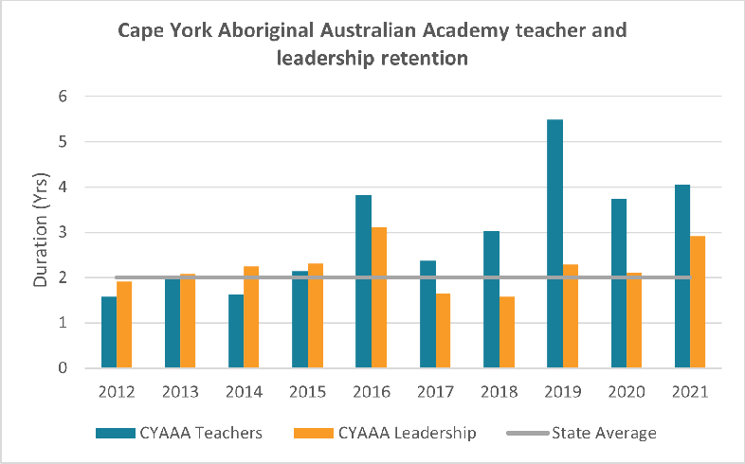

**Exhibit C: Teachers and leaders stay longer at the Cape York Aboriginal Australian Academy (CYAAA)**

Many teachers are between five and ten years service and there is a significant return of alumni to the Academy, where teachers have gone south and subsequently returned north. The Academy’s success is due to a number of factors, the main one being *the existence of an effective school programme that has continuity and which is on a continuous cycle of improvement*: teachers in remote schools who feel they are making a difference are more prepared to make longer and stronger commitments to remote schools.

The proposals put forward in this submission are aimed at providing a robust and effective solution to the critical problem of high teacher and school leadership turnover.

In our submission the outcomes of this review can help resolve this problem of teacher and school leadership retention for regional and remote schools. Career pathways for teachers moving from urban centres to remote areas and back again are critical to the resolution of the retention and turnover issue. We hope the opportunity for this resolution is not lost through a narrow focus on teacher education without looking at the career pathways that are integral to initial teacher education as well as subsequent professional development.

302-310 Sheridan Street, Cairns North, Queensland, 4870 |PO Box 278, North Cairns Queensland, 4870

Tel: (07) 4042 7200 | Fax: (07) 4051 3556 |[info@goodtogreatschools.org.au](mailto:info@goodtogreatschools.org.au) | [www.goodtogreatschools.org.au](http://www.goodtogreatschools.org.au) | ABN 93 141 269 016

Page 8 of 22

**2.3 The problem of insufficient teacher numbers and recruitment difficulties**

If Australian schools generally are experiencing teacher shortages, then the problem is more acute in remote areas and particularly indigenous-majority schools. During the ten years that we have operated the Cape York Aboriginal Australian Academy, insufficient teacher numbers has been a perennial problem. The Queensland Department of Education struggles to ensure sufficient teacher numbers in remote schools and the recruitment of high-quality candidates prepared to serve in remote areas is an ongoing challenge. This needs to be resolved if remote schools are to be improved and for improvements to be sustained. Awareness of this problem is long-standing and many initiatives have been taken to try and address it, but an effective solution has not been found yet. It is our submission that the proposals we are making will go a long way towards resolving the problem of insufficient teacher numbers and the recruitment of quality teachers to remote schools.

There is a further point we wish to bring to the attention of this review and that is our belief that remote indigenous schooling requires *more teacher numbers* to be allocated to these schools than normal resource allocation formulas provide. Our view is that because the learning gaps facing indigenous students are so large, each classroom needs double the teaching effort of mainstream classrooms. The ideal classroom following a Response to Intervention (RTI) model would have one teacher presenting tier one group instruction, one teacher aide delivering tier two instruction to a small group, one teacher aide supervising independent work and one teacher delivering tier three one-on-one remediation and reteaching.

**Exhibit D: The Response to Intervention model includes individualised and small group support for students who need additional tutoring to maintain progress through literacy and numeracy**

302-310 Sheridan Street, Cairns North, Queensland, 4870 |PO Box 278, North Cairns Queensland, 4870

Tel: (07) 4042 7200 | Fax: (07) 4051 3556 |[info@goodtogreatschools.org.au](mailto:info@goodtogreatschools.org.au) | [www.goodtogreatschools.org.au](http://www.goodtogreatschools.org.au) | ABN 93 141 269 016

Page 9 of 22

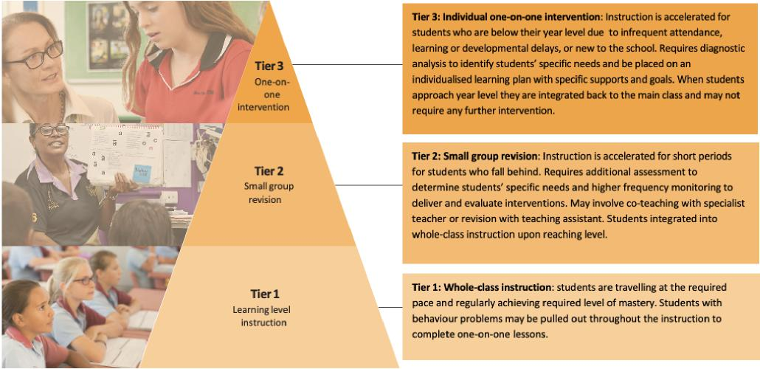

(Good to Great Schools Australia, 2020, p.15 )

We have seen this model work beneficially in our Academy. The reduction of class sizes is not where the answer lies, it is increasing the teaching effort within the classroom. When faced with the learning gaps that exist in remote schools *we need to double the teacher numbers*.

In our submission the proposals we are putting forward would enable an increase in the teacher numbers in disadvantaged classrooms.

**2.4 The problem of lack of preparation and experience**

The third problem is that the way in which teacher incentive programs work is that inexperienced teachers fresh out of university are the most likely to be available to take up teaching positions in remote schools. The most-needy schools therefore end up with the most inexperienced and unprepared teachers. This is a well-known problem that has never been resolved.

By definition, more experienced teachers with young children will have relocated to their preferred schools in regional and urban centres. In the Queensland context it means that teachers with families are aiming to get a place at a school in the south east of the state, in Brisbane and the Gold and Sunshine Coasts. In fact, remote schools become a training and preparation ground for many teachers who learn on the job in remote schools and then return to relatively advantaged schools in

302-310 Sheridan Street, Cairns North, Queensland, 4870 |PO Box 278, North Cairns Queensland, 4870

Tel: (07) 4042 7200 | Fax: (07) 4051 3556 |[info@goodtogreatschools.org.au](mailto:info@goodtogreatschools.org.au) | [www.goodtogreatschools.org.au](http://www.goodtogreatschools.org.au) | ABN 93 141 269 016

Page 10 of 22

the southeast when they are in their teaching prime. This is a good thing for these advantaged schools but not a good thing for remote schools.

It has been our experience with our Academy that we have turned unprepared, untrained and inexperienced teachers into effective educators because of the nature of our teaching and learning program and the professional development that we provide, so that our schools are actually providing a pipeline of high-quality teachers to southern schools. An advantage for urban schools and a disadvantage for remote schools.

Our submission is that the proposals we put forward here will increase the number of experienced and prepared teachers spending a minimum service period in remote schools. This can be done if career pathways are normalised around the urban-to-remote-back-to-urban cycle. Experienced teachers who are assured of a return posting in their place of preference in the southeast will be more amenable to recruitment to remote schools. This is where our partner school concept is critical.

**2.5 The problem of lack of continuity in school improvement and disruption caused by professional turnover**

The high rates of turnover of teachers and school leaders in remote schools and indigenous-majority schools is highly debilitating for school improvement and its sustenance.

It is the professional capital of the school’s teaching faculty that sustains school improvement (Fullan and Hargreaves, 2012). Governance, student performance and parental and community demand are also important factors for ensuring school improvement and sustaining it – but the professional capital of the school’s educators is paramount. You can’t improve a school without the teachers carrying the improvement. They need to develop as educators and they need to carry forward their professional capital to their new peers over time.

High turnover cruels any chance of this happening. Therefore remote schools are characterised by constant ‘chopping and changing’ in pedagogy and curriculum and disruption of school improvement strategies and processes. With every new school leader a new adventure is launched with varying degrees of hope and enthusiasm. This Groundhog Day plays out every other year in

302-310 Sheridan Street, Cairns North, Queensland, 4870 |PO Box 278, North Cairns Queensland, 4870

Tel: (07) 4042 7200 | Fax: (07) 4051 3556 |[info@goodtogreatschools.org.au](mailto:info@goodtogreatschools.org.au) | [www.goodtogreatschools.org.au](http://www.goodtogreatschools.org.au) | ABN 93 141 269 016

Page 11 of 22

remote schools, and sometimes, in GGSA’s experience with the Literacy for Remote Schools Programme, within a 12-month period (GGSA, 2017).

**Exhibit E: Instructional leader and school principal turnover is crippling in remote schools**

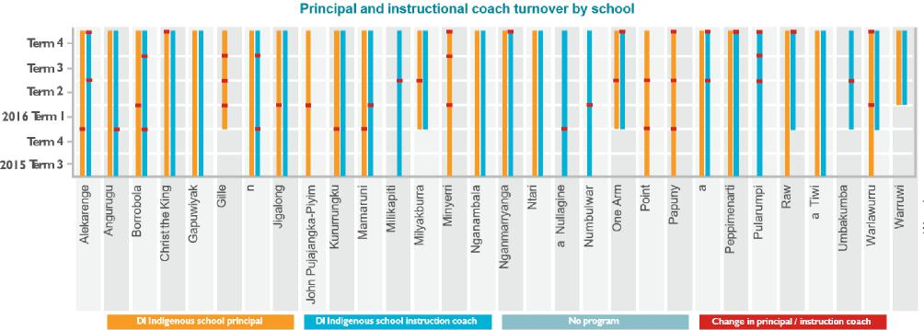

(Good to Great Schools Australia, 2017, p. 18)

Evaluations of school attendance and student performance in these remote schools try to ignore the debilitating effect of high turnover rates in the expectation that such schools can miraculously embark on improvement without solving the egregious problems of staffing and turnover. This is both unfair and nonsensical. We need to resolve the turnover problem.

**3. Problems with ITE**

In this part of the submission we wish to focus on the specific problems of initial teacher education. Reading the discussion paper released on this review and its focus on the details of the initial teacher education experience seems to us to be apt to mislead. These details may help finetune a successful system of initial teacher education, but as long as we are focused on the minutiae, we are liable to miss the main messages. In our submission these main messages are by now staring us in the face. We cannot ignore them. They have to be confronted and they need to be resolved with effective policy responses.

302-310 Sheridan Street, Cairns North, Queensland, 4870 |PO Box 278, North Cairns Queensland, 4870

Tel: (07) 4042 7200 | Fax: (07) 4051 3556 |[info@goodtogreatschools.org.au](mailto:info@goodtogreatschools.org.au) | [www.goodtogreatschools.org.au](http://www.goodtogreatschools.org.au) | ABN 93 141 269 016

Page 12 of 22

**3.1 University courses are not responsive to school needs**

This is plain. The ITE providers are not responding to school needs; they may or may not be cognizant of those needs, but even if they are, they are not minded to respond to them.

The reliance placed by TEMAG on using accreditation processes to insert necessary reforms into teacher education course offerings dodged the issue. Australia has a very large number of such courses: *450 degrees across 48 providers* (Buckingham and Meeks, 2019). This compares to the highest performing school system in our region, Singapore, which has *three degrees and just one provider*: the National Institute of Education (National Institute of Education Singapore, 2021).

TEMAG should have made stronger recommendations tying provider funding to requisite reforms. Whilst accreditation is the domain of the relevant state bodies, funding is the domain of the Commonwealth. This is where the Commonwealth needed to oblige the ITE providers to meet the Commonwealth’s reform requirements.

This is especially so in the light of the fact that the National Inquiry into the Teaching of Literacy is now *more than 15 years old* and neither the state or territory school system owners, and only a few of the 48 ITE providers, have implemented its recommendations in relation to the teaching of reading. The Rowe report recommendations remain as valid now as they did in 2005. If we want to understand Australian schools underperformance over the past twenty years – notwithstanding the increase in schools funding during this same period – we need to acknowledge that the Commonwealth’s inability to ensure school systems and ITE providers adopted and implemented crucial reforms such as the Rowe report recommended, is at the centre of this failure.

Schools are not getting the teachers they want and need. The schools are the ultimate customers of the ITE providers but these providers have no need to be responsive to their customers. *This is the disconnect that needs to be addressed*. Schools need to be empowered to demand the teaching personnel that they need. Instead of being passive recipients of the graduates produced by the providers, schools need to be in a position to make demands of these providers to ensure that they get the best teachers they can.

302-310 Sheridan Street, Cairns North, Queensland, 4870 |PO Box 278, North Cairns Queensland, 4870

Tel: (07) 4042 7200 | Fax: (07) 4051 3556 |[info@goodtogreatschools.org.au](mailto:info@goodtogreatschools.org.au) | [www.goodtogreatschools.org.au](http://www.goodtogreatschools.org.au) | ABN 93 141 269 016

Page 13 of 22

**3.2 Explicit, direct and teacher-led instruction marginalised in university teacher education courses**

The analysis undertaken by Buckingham and Meeks (2019) tells the story of the marginalisation of explicit, direct and teacher-led instruction in ITE courses. In what has become the landmark study of what works in school education internationally according to the evidence, John Hattie’s Visible Learning (Hattie, 2009), Hattie describes the disconnect between the proven efficacy of one such pedagogy – the Direct Instruction program, of which our organisation has much experience and knowledge – and its rejection in teacher education courses:

Every year I present lectures to teacher education students and find that they are already indoctrinated with the mantra “constructivism good, direct instruction bad”. When I show them the results of these meta-analyses, they are stunned, and they often become angry at having been given an agreed set of truths and commandments against direct instruction. Too often, what the critics mean by direct instruction is didactic teacher-led talking from the front; this should not be confused with the very successful “Direct Instruction” method as first outlined by Adams and Engelmann (1996). Direct Instruction has a bad name for the wrong reasons, especially when it is confused with didactic teaching, as the underlying principles of Direct Instruction place it among the most successful outcomes (Hattie, 2009, p. 204-205).

You would think that out of 450 courses some of them would deal with direct, explicit and teacher-led instruction. None of them do, or do so in a cursory way. This is the failure that needs to be addressed. This is the disjunct that needs to be addressed. The disjunct between what the evidence says constitutes effective teaching and what Australia’s ITE providers are failing to teach to the country’s future teachers.

**3.3 ITE reviews focus too much on teachers rather than teaching whereas international evidence points to the short-term return on teaching focus**

302-310 Sheridan Street, Cairns North, Queensland, 4870 |PO Box 278, North Cairns Queensland, 4870

Tel: (07) 4042 7200 | Fax: (07) 4051 3556 |[info@goodtogreatschools.org.au](mailto:info@goodtogreatschools.org.au) | [www.goodtogreatschools.org.au](http://www.goodtogreatschools.org.au) | ABN 93 141 269 016

Page 14 of 22

It is true that fixing initial teacher education is a necessary challenge if Australia is to improve its schools performance. This has proven to be an immense challenge to really meet over the past two decades. Not much progress has been made.

But ITE and reforms aimed at lifting teacher quality are by definition long term reforms. They will not yield improved classroom performance in the immediate or even intermediate term. If we put in place effective reforms today they will not contribute to a step change in performance within the timeframe established by McKinsey in their 2010 study: six years (Mourshed, Chijoke and Barber, 2010).

In its 2007 study, McKinsey & Company identified three driving factors of school system improvement: getting the right teachers in place, effective instruction and ensuring every child in the system benefits (Barber M and Mourshed M, 2007). ITE is about McKinsey’s first requirement: getting the right teachers into place. We urge the expert panel to have regard to McKinsey’s analysis and recommendations in its 2007 and 2010 reports. These provide a compelling playbook for the Commonwealth to adopt in relation to school system improvement generally, and teacher education and professional development specifically.

However we also wish to bring into relief the second component of McKinsey’s factors: effective instruction. This is a question of teaching rather than teachers. The verb rather than the noun. Much can be done with the verb in the immediate and intermediate term whilst we are waiting for the noun to arrive as a result of reformed ITE policies. The latter may or not materialise. However the former – improved instruction – is something that can be done in short order. This is what the Commonwealth must not lose sight of and which we recommend the expert panel does not shy away from.

Much can be done to improve Australian schools through focusing on instruction rather than just putting all our eggs in the instructor basket. Our proposals in this submission are aimed at equipping teachers with the ability to deliver effective instruction as much as achieving quality ITE.

302-310 Sheridan Street, Cairns North, Queensland, 4870 |PO Box 278, North Cairns Queensland, 4870

Tel: (07) 4042 7200 | Fax: (07) 4051 3556 |[info@goodtogreatschools.org.au](mailto:info@goodtogreatschools.org.au) | [www.goodtogreatschools.org.au](http://www.goodtogreatschools.org.au) | ABN 93 141 269 016

Page 15 of 22

1. **Principal reform proposal: Attach 20 percent of all ITE places to schools rather than universities**

Our principal reform proposal is for the Commonwealth to allocate a certain and significant percentage – say 20 percent – of ITE places to schools rather than to providers. These schools would apply for an allocation. They would establish ITE partnerships with providers according to their needs and including arrangements for clinical work to be undertaken at their school and at satellite schools that are connected to their hub. This will enable these schools to have input on course content and delivery and will make providers responsive to school needs.

Schools would jointly advertise with providers and recruit and accept ITE student applications according to their required criteria. High performing schools would be eligible to take ITE students and provide opportunities for clinical practice at their schools. Both private and high performing public schools with necessary capabilities would be eligible to take students.

Funding to cover student places would still be paid directly to providers but under this arrangement they would needs schools to be involved in the selection of these scholarships, so they can get the teachers they need. High performing schools could act as hubs for smaller schools in remote and regional areas where they would provide a pipeline of ITE students and graduates to these satellite schools. In this way smaller schools can take advantage of this new responsive ITE system even where they don’t have the capacity to administer and host ITE students themselves.

1. **ITE and placement of mainstream teachers for indigenous-majority schools in a school clinic model attached to high performance schools**

Related to our principal reform proposal, we propose that ITE placements be allocated to high performance schools that are in partnership with remote indigenous-majority schools. This is so that these high performing schools can provide a pipeline of teachers for remote schools by operating a clinical model at their school. These schools will benefit but they will also benefit their remote school partners. These hub schools would be located in urban and regional centres where teacher and school leadership turnover is stable and there is proven high performance.

302-310 Sheridan Street, Cairns North, Queensland, 4870 |PO Box 278, North Cairns Queensland, 4870

Tel: (07) 4042 7200 | Fax: (07) 4051 3556 |[info@goodtogreatschools.org.au](mailto:info@goodtogreatschools.org.au) | [www.goodtogreatschools.org.au](http://www.goodtogreatschools.org.au) | ABN 93 141 269 016

Page 16 of 22

This hub model would have the advantages of Shanghai’s empowered management program, which is an effective needs-based approach to improvement where schools ‘pair’ on practitioner-based support to lift performance.1

Hub schools should have consistent explicit instruction pedagogy with partner schools so that beginning teachers can learn at the high-performance school and then undertake service in remote schools after they have gained knowledge and experience. They could complete a remote service period and return to their hub school at their completion. Furthermore, experienced teachers from these hub schools could also be recruited to serve in remote schools. The consistency of pedagogy and expectations as well as curriculum, would be shared across hub schools and their remote school partners.

Attaching ITE scholarships to these hub schools linked to university providers will make this partnership viable. Hub schools will see benefits for themselves in such arrangements as well as providing critical partnership support to needy schools. The movement of teachers to and from remote schools can be stabilized and the professional capital of remote schools can be retained and continuously improved over time.

Hub schools should be financially supported to host ITE scholarship students in their on-campus clinics.

**6. ITE and placement of Community Teachers for indigenous-majority schools in a school clinic model attached to GGSA and a university partner**

Our third reform proposal is specific to Indigenous teachers in indigenous-majority remote schools. Queensland’s Department of Education has long recognised Community Teachers as a career

1 Armstrong, P. (2015). Effective school partnerships and collaboration for school improvement: a review of the evidence. London: United Kingdom Department of Education.

Jensen, B., & Farmer, J. (2013). School Turnaround in Shanghai: The Empowered-Management Program Approach to Improving School Performance. Washington: Center for American Progress. Retrieved from <http://files.eric.ed.gov/fulltext/ED561063.pdf>

302-310 Sheridan Street, Cairns North, Queensland, 4870 |PO Box 278, North Cairns Queensland, 4870

Tel: (07) 4042 7200 | Fax: (07) 4051 3556 |[info@goodtogreatschools.org.au](mailto:info@goodtogreatschools.org.au) | [www.goodtogreatschools.org.au](http://www.goodtogreatschools.org.au) | ABN 93 141 269 016

Page 17 of 22

opportunity for remote Indigenous educators to transition from Assistant Teachers to Teachers in their local primary schools.

Queensland is the only state or territory with a Community Teacher category in their teaching award, distinct from Assistant Teachers. It is set out in the Queensland: Teaching in State Education Award – 2016. It provides that:

* Community teacher A means any person who has completed an associate diploma course approved by the Director-General of DoE as an appropriate minimum qualification for employment as a community teacher A in Aboriginal and Torres Strait Islander Community Schools; or a course considered to be equivalent by the Director-General of DoE.
* Community teacher B means any person who has completed a certificate course approved by the Director-General of DoE as an appropriate minimum qualification for employment as a community teacher B in Aboriginal and Torres Strait Islander Community Schools; or a course considered to be equivalent by the Director-General of DoE.
* Assistant teacher means any person employed in an Aboriginal and Torres Strait Islander Community School to assist registered teachers and/or community teachers in the classroom and related duties.

For mature Indigenous people the best way to become a community teacher is to secure a position in the local school as a Teaching Assistant. Teaching Assistants can undertake study part or full-time whilst working.

In Northern Queensland this study to date has been a Diploma of Aboriginal and Torres Strait Islander Education, a two-year qualification.

Teaching Assistants complete the training part-time (approximately 20 hours/week study time). They undertake a mandatory 100 hours vocational placement in their local school, which is supervised and signed off by the principal.

302-310 Sheridan Street, Cairns North, Queensland, 4870 |PO Box 278, North Cairns Queensland, 4870

Tel: (07) 4042 7200 | Fax: (07) 4051 3556 |[info@goodtogreatschools.org.au](mailto:info@goodtogreatschools.org.au) | [www.goodtogreatschools.org.au](http://www.goodtogreatschools.org.au) | ABN 93 141 269 016

Page 18 of 22

Once they complete a Diploma of Aboriginal and Torres Strait Islander Education they are deemed a Community Teacher and can teach in their local school, but they are not eligible for teacher registration so can only teach in their own community.

They can become eligible for teacher registration if they undertake a Bachelor of Education (Primary) which means they can teach anywhere in the state.

We firmly believe that the Community Teacher award position in Queensland represents an important part of the solution for a sustainable teacher force in remote indigenous-majority schools. Community Teachers, if properly trained, can provide the stability and continuity needed in school pedagogical practice in remote schools where teachers from outside of these communities have limited-service periods. As external teachers cycle in and out, Community Teachers can carry the school culture and the school’s pedagogy forward. The improvements are not lost and there is a greater chance to retain achievements and sustain progress.

The need is to provide Community Teachers – and Teaching Assistants who precede Community Teachers – with effective ITE that is within their capabilities and which is effective for classrooms. This is where we have much experience, because over a decade we have seen local Community Teachers and Assistants benefit from the delivery of a scripted instruction program (Direct Instruction) which obviates the need for lesson planning and development, and sequencing instruction – instructional design knowledge that routinely eludes mainstream teacher graduates.

The scripted programs and the training, professional development and coaching they receive from GGSA means that these Teaching Assistants and Community Teachers become a real asset to their schools. Fully trained, these Community Teachers are indistinguishable from their Bachelor of Education colleagues in terms of delivering the learning programs and achieving student progress.

GGSA has developed on-line teacher training and development modules that are linked to AITSL standards. The Mastery Teaching Pathway standards for principals and teachers reflect the Australian Institute for Teaching and School Leadership’s (AITSL) *Australian Professional Standard for Principals* (Principal Standards) and *Australian Professional Standards for Teachers* (Teacher Standards).

302-310 Sheridan Street, Cairns North, Queensland, 4870 |PO Box 278, North Cairns Queensland, 4870

Tel: (07) 4042 7200 | Fax: (07) 4051 3556 |[info@goodtogreatschools.org.au](mailto:info@goodtogreatschools.org.au) | [www.goodtogreatschools.org.au](http://www.goodtogreatschools.org.au) | ABN 93 141 269 016

Page 19 of 22

ITE scholarships should also be provided to Community Teacher candidates. Our organisation, which has the capacity to provide the professional development and training for Teaching Assistants and Community Teachers, would partner with an ITE provider to ensure these candidates attain necessary diplomas, and eventually for a proportion of them, to articulate into Bachelor of Education courses to become registered, mainstream teachers.

Our point is that ITE scholarships should apply to Community Teachers (indeed how could this category be excluded?) and that this represents an enormous opportunity to build a local community teaching force for the future of remote schooling.

There is an opportunity to link a Community Teachers Professional Learning program with Minister Ken Wyatt’s announced co-design of a new version of the Community Development Program (CDP), which could really stimulate an Indigenous teaching force strategy for remote schools. Increasing jobs for Teaching Assistants in remote schools can be the foundation to kickstart a pipeline of local education Assistants, Community Teachers and eventually – registered Teachers – coming through remote schools, and supported by the professional learning provided by GGSA’s Mastery Teaching Program, described in section 7 below.

Please see attached (Attachment 2) for a brief overview of the potential to develop a local Indigenous teaching force.

**7. Mastery Teaching Pathway**

GGSA’s proprietary Mastery Teaching Pathway is a fully developed complement to the theory component of an ITE course which is focused on explicit, teacher-led instruction. It represents the professional learning that provides the effective teaching practice that would make an ITE theory course most effective for schools and classrooms. The MTP is where practice meets theory.

GGSA’s MTP is explicitly and comprehensively mapped against AITSL standards. Staff from AITSL worked with GGSA in examining and certifying the consistency between MTP and the AITSL’s

302-310 Sheridan Street, Cairns North, Queensland, 4870 |PO Box 278, North Cairns Queensland, 4870

Tel: (07) 4042 7200 | Fax: (07) 4051 3556 |[info@goodtogreatschools.org.au](mailto:info@goodtogreatschools.org.au) | [www.goodtogreatschools.org.au](http://www.goodtogreatschools.org.au) | ABN 93 141 269 016

Page 20 of 22

standards. Since the TEMAG recommendations of 2014 GGSA’s MTP is at least one instance of the report’s recommendation being followed and implemented. We are unaware of other instances.

We are reluctant to attach this material to this submission because it is proprietary to GGSA. GGSA would be happy to demonstrate the entire course design including the accompanying on-line training modules to this review. The attached brochure describing the 2020 version of the MTP gives an overview (Mastery Teaching Pathway 2020).

The Mastery Teaching Pathway’s professional learning program provides to school leaders, teachers, instructional coaches and teaching assistants the very classroom effective teaching practices that ITE courses are not providing to student teachers. All that needs to be added is educational theory and students utilising the MTP will be equipped with both theory and practice when they complete their ITE course. This course would be focused on explicit instructional pedagogy.

As well as articulating a professional learning program mapped against AITSL standards, with a full suite of on-line training and in-classroom assessment of proficiency and mastery, the professional learning and effective teaching is seamlessly linked to school improvement cycles of practice at the classroom, school and community levels. The professional learning is linked to effective teaching which in turn is linked to school improvement.

GGSA is also developing a suite of tablet-based data tools that will complement and support the MTP for school instructional leaders to use and for classroom teachers and students to use.

We would be happy to take the expert panel through the MTP and these associated innovations.

**8. Conclusion**

We commend our submission to the expert panel. We have done much policy and program design work – including course designs, on-line training modules, teacher standards and recognition – that relates to the policy proposals recommended in this submission.

302-310 Sheridan Street, Cairns North, Queensland, 4870 |PO Box 278, North Cairns Queensland, 4870

Tel: (07) 4042 7200 | Fax: (07) 4051 3556 |[info@goodtogreatschools.org.au](mailto:info@goodtogreatschools.org.au) | [www.goodtogreatschools.org.au](http://www.goodtogreatschools.org.au) | ABN 93 141 269 016

Page 21 of 22

We would be very happy to dilate any of the proposals or ideas raised in our submission.

Your sincerely

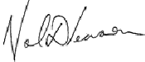

Noel Pearson

Co-Chair

**Good to Great Schools Australia**

302-310 Sheridan Street, Cairns North, Queensland, 4870 |PO Box 278, North Cairns Queensland, 4870

Tel: (07) 4042 7200 | Fax: (07) 4051 3556 |[info@goodtogreatschools.org.au](mailto:info@goodtogreatschools.org.au) | [www.goodtogreatschools.org.au](http://www.goodtogreatschools.org.au) | ABN 93 141 269 016

Page 22 of 22

**REFERENCES**

**Abbott T** (2018) *Statement to Parliament on remote indigenous education.* Available at <http://tonyabbott.com.au/2018/12/statement-parliament-remote-indigenous-education/>

**Armstrong, P**. (2015). *Effective school partnerships and collaboration for school improvement: a review of the evidence*. London: United Kingdom Department of Education.

**Barber M and Mourshed M** (2007) *How the world’s best performing school systems come out on top.* McKinsey & Company.

**Buckingham J and Meeks L** (2019) *Short-Changed: Preparation To Teach Reading In Initial Teacher*

*Education*. Available at <https://www.researchgate.net/publication/336019904_Short->   
Changed_Preparation_To_Teach_Reading_In_Initial_Teacher_Education

**Chen L, Dorn E, Krawitz M, Lim C and Mourshed M** (2017) *Drivers of Student Performance: Insights from Asia.* McKinsey & Company.

**Good to Great Schools Australia** (2014) *Effective Instruction The keystone to school reform*. Cairns: Good to Great Schools Australia.

**Good to Great Schools Australia** (2017) *Implementation Report: Learning from the First Two Years of the Literacy for Remote Primary Schools Program 2015–2017*. Available at <https://goodtogreatschools.org.au/wp-content/uploads/2017/03/Good-to-Great-Schools-Australia-Effective-Instruction-20140306.pdf> (accessed 29 May, 2020)

**Good to Great Schools Australia** (2020) *Effective Instruction and Effective Governance to Improve Disadvantaged Indigenous Schooling with a Focus on Developing a Community-based Education Workforce.* Unpublished proposal to the Australian Government.

**Good to Great Schools Australia** (2021) *Mastery Teaching Pathway.* Unpublished.

**Hattie J** (2009) *Visible learning. A synthesis of over 800 meta-analyses relating to achievement*. New York: Routledge

**Jensen B and Farmer J** (2013). *School Turnaround in Shanghai: The Empowered-Management Program Approach to Improving School Performance*. Washington: Center for American Progress. Available at <http://files.eric.ed.gov/fulltext/ED561063.pdf>

**Mourshed M, Chijoke C and Barber M** (2010) *How the world’s most improved school systems keep getting better.* McKinsey & Company.

**Rowe K and National Inquiry into the Teaching of Literacy** (2005) *Teaching Reading: Report and Recommendations*. Department of Education, Science and Training Australia. Available at <https://research.acer.edu.au/tll_misc/5>

**Teacher Education Ministerial Advisory Group** (2014) *Action Now: Classroom Ready Teachers.* Available at <http://www.studentsfirst.gov.au/teacher-education-ministerial-advisory-group>

302-310 Sheridan Street, Cairns North, Queensland, 4870 |PO Box 278, North Cairns Queensland, 4870

Tel: (07) 4042 7200 | Fax: (07) 4051 3556 |[info@goodtogreatschools.org.au](mailto:info@goodtogreatschools.org.au) | [www.goodtogreatschools.org.au](http://www.goodtogreatschools.org.au) | ABN 93 141 269 016