**‘It’s my education!’**

The Disability Standards for Education Must Centre Disabled Young People

Youth Disability Advocacy Service

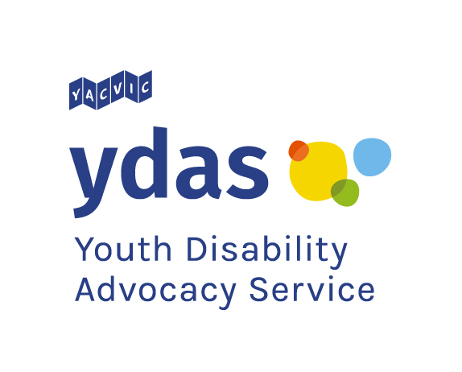September 2020



Youth Disability Advocacy Service respectfully acknowledges the Aboriginal and Torres Strait Islander people of this continent. We pay our respects to the ancestors and Elders past and present of all Aboriginal nations in Victoria. We particularly acknowledge young Aboriginal and Torres Strait Islander people as the emerging generation of Elders and leaders.

Table of Contents

Hearing from Young People 4

Youth Disability Advocacy Service 4

Methodology 4

‘The Standards are Really Important' 5

Perceptions of the Disability Standards for Education 5

Knowledge of the Standards 6

Knowledge is Power 6

A Missing Link 6

Recommendation 1 6

Youth Participation in Decision-Making 7

Youth Participation in the Standards 7

Disabled Students are Locked Out 7

Recommendation 2 8

‘Close the Loopholes’ 9

Fighting for the Right to Education 9

‘Standards not Rules’ 9

Recommendation 3 10

Improving Implementation 11

Reliance on Rare Allies 11

(In)Visible Solutions 12

Recommendation 4 13

Complaints, Feedback, Discrimination and Bullying 14

Disappointing Disparity 14

Uncommunicated Feedback and Complaints Processes 14

Recommendation 5 15

References 16

# Hearing from Young People

Youth voice and participation is the fundamental principle that will ensure the Disability Standards for Education are powerful and effective. This report centres the voices and experiences of disabled young people who YDAS considers the key stakeholder in the discussion about inclusive education.

### Youth Disability Advocacy Service

Youth Disability Advocacy Service (YDAS) is an advocacy organisation that works with disabled young people who are aged 12 to 25. We work with disabled young people in Victoria to make sure they can speak up and are being treated fairly. YDAS is a core agency of Youth Affairs Council Victoria (YACVic). YDAS is a member of the Australian Coalition for Inclusive Education (ACIE).

### Methodology

Disabled young people with diverse experiences of education were involved in a two-hour, in-depth focus group session facilitated by a disabled young YDAS staff member. Two participants of the focus group were each involved in further one-on-one semi-structured interviews for one-hour conducted by the same disabled young YDAS staff member. We spoke with young people aged between 15 and 20 years old who are learning at TAFE, university, public and private mainstream schools, and public specialist school.

In the focus group and interviews, disabled young people were asked to share their experiences of education, their reflections on the Standards and their recommendations for change. The young people adeptly connected their personal experiences with system level forces, identifying specific changes that should be made. Their insights into the application of the Standards are valuable and unique. The disabled young people we spoke with demonstrated a strong commitment to improving access to education for all young people. Importantly, they really wanted better outcomes for other disabled young people.

# ‘The Standards are Really Important'

### Perceptions of the Disability Standards for Education

The Disability Standards for Education set the framework for disabled students’ access to education. They represent Australia’s implementation of Article 24 of the *Convention on the Rights of Persons with Disabilities*.[1] They aim to ensure that disabled students can access and participate in education on the same basis as other students by identifying the obligations of schools to provide accessible and inclusive education.

Disabled young people recognise the value of the Standards in shaping more inclusive and accessible education. However, based on their experiences, and those of their peers, the aims of the Standards are not yet fully realised. From their perspective, reasonable adjustments that would improve their access to and engagement with education are not easily obtained.

‘[Now I know what the Standards are] I have the resources to back myself when talking to my school... The Standards are incredibly important. They allow disabled students to have the same access and without them, we would be set behind.’

Luca, 17 year old living in Melbourne

‘The Standards are really important. They set the grounds for what schools need to do, what questions they need to ask new students. The schools need to know the rights of the child they have in their care 7 hours!’

Alex, young person living in Melbourne



# Knowledge of the Standards

### Knowledge is Power

The Disability Standards for Education set the framework for all discussions around disabled students’ access to education. The more disabled students understand their rights to accessible education, and the legislation that enables them, the better equipped they are to get the education they deserve. Disabled young people expressed that they either had limited understanding of the Standards or wished they knew more about them earlier.

### A Missing Link

The lack of awareness among disabled students is especially concerning given disabled students’ experience of schools failing to initiate conversations with them about reasonable adjustments with students who are entitled to them. Placing the onus onto students to begin this conversation is problematic. Disabled young people argued that they should have been introduced to the Standards years earlier than they did. Many had heard of the Standards, but admitted that they did not know where to access them, how to understand them or how to use them to advocate for more inclusive education.

‘It's hard [to ask for reasonable adjustments] because obviously we didn't know what the Standards were. How can we speak up if we don’t know what the Standards are? It's hard to know, whether [the Standards] were met or not. The Standards are so grey that the schools could say that they are meeting them when more could be done’

Luca, 17 year old living in Melbourne

#### Recommendation 1

**Communicate the Standards to empower young people**

* Proudly and actively promote the existence and importance of the Disability Standards for Education directly to disabled young people in ways that are accessible and engaging to them
* Communicate to disabled young people specific information about:
  + What reasonable adjustments they are entitled to
  + How to speak up to request reasonable adjustments
  + Their rights as disabled young people in accessing education

# Youth Participation in Decision-Making

### Youth Participation in the Standards

The Standards specifically state that students, or an ‘associate of the student’ should be consulted about their disability and access needs. This provision correctly recognises that disabled people are the experts in their own disability and access needs. It correctly identifies that the disability can be experienced differently by different people. It also aligns with best practice for working with young people; the principles of youth participation and Student Voice.[2][3]

Students know what reasonable adjustments will work best for them. Disabled young people recognise that the Standards work best when they are meaningfully involved in shaping their implementation.

### Disabled Students are Locked Out

In practice, students are infrequently and tokenistically included in these discussions if not locked out altogether. Failing to meaningfully consult with disabled students and include them in decision-making around their access needs demonstrates a lack of respect for their agency and lived experience.

‘The young person should decide what is reasonable, not schools’

Alex, young person living in Melbourne

‘Sometimes they deemed it inappropriate for me to be in the meetings [about my education and access], which is bizarre because it's fundamentally about me!... or I was just there to observe what was happening rather than being one of the main people on the table’

Luca, 17 year old living in Melbourne

**Oscar’s Story**

At my mainstream school, I was one of the first kids with a disability, and they didn’t know how to accommodate to me. My teacher’s aide would actually do all the work for me instead of me, even though I wanted to do it. I think I should have the right to learn what everyone else is learning.

In Year 7, my school had a meeting about my disability and access needs. In that meeting was the Deputy Principal (Specialist Education), the Learning and Support Co-ordinator, my mum, my year level leader, my teacher’s aide, a lady from the Department of Education but not me. In that meeting that had a really important discussion about my education, but I wasn’t there! I felt betrayed. Betrayed. Because I wanted to go. That meeting was about my education! Of course I wanted to go!

Everyone should be able to be part of that conversation about what they are learning.’. I’ve been in special education since year eight. And I’ve loved it ever since year eight. I felt that I was supported in that environment and I felt like that I belonged there. If my mainstream school supported me better, I would have stayed



#### Recommendation 2

**Embed youth voice in the implementation of the Standards**

* Ensure the young person is actively involved in all meetings, discussions and decisions about reasonable adjustments
* Ensure that the final say about reasonable adjustments rests with the young person
* Support disabled students to advocate for reasonable adjustments and equal education by:
  + Increasing capacity of advocacy organisations to assist in discissions about reasonable adjustments
  + Increasing funding and support for training programs for disabled young people
* Encourage flexibility from education institutions in allowing students to communicate and participate in the way in the way that suits best

# ‘Close the Loopholes’

### Fighting for the Right to Education

The Standards support disabled students to request and receive reasonable adjustments to participate alongside everyone else. The intention and framework are valuable, but in practice it is difficult for students, parents, and school staff alike to negotiate. Disabled young people talked about lengthy and sometimes fruitless negotiations between themselves, their parents, and the education provider. They felt that the power in negotiations lie with the education provider, who would often use excuses to avoid making changes.

‘At uni, I had to hustle to get anything implemented’

Xavier, 20 year old living in regional Victoria

‘It feels like you need to be super determined or have really determined and supportive parents fighting for you to get anything done’

Camellia, 20 year old living in Melbourne

‘It’s so ironic, really, that all my requests for access fell on deaf ears’

Camellia, 20 year old living in Melbourne

‘The ball’s in the school’s court, they get to decide. My school had the means for it [to implement reasonable adjustments] so they agreed to do it’

Blair, 15 year old living in Melbourne

### ‘Standards not Rules’

The difficulty that disabled young people have faced in accessing education, coupled with the difficulty they have experienced in negotiating reasonable adjustments, results in a shared perception that the Standards are insufficiently enforced. Disabled young people told us that the language of the ‘Standards’ implies that they are aspirational rather than an enforced minimum.

They are ‘Standards’ not ‘Rules’. It means that they are just guidelines. It means that there are schools below it, that aren’t meeting the Standards. It’s phrased as a goal rather than a baseline. If it’s taking 15 years to meet a goal that’s a fundamental human right, that says a lot about the state of things

Blair, 15 year old living in Melbourne

I think it’s time to close the loopholes. These [reasonable adjustments] are specific things that we need to access education, they are not up for debate!

Luca, 17 year old living in Melbourne



#### Recommendation 3

**Enforce the right to accessible and inclusive education for students by closing loopholes**

* Ensure schools understand and meet their obligations under the Standards
* Remove loopholes for schools to deny necessary adjustments based due to a lack of resources or interpretation of the Standards
  + Increase resources for public mainstream education providers to provide reasonable adjustments to remove the excuse of unjustifiable hardship
  + Increase accountability measures for schools, notably private schools, to report on and provide reasonable adjustments



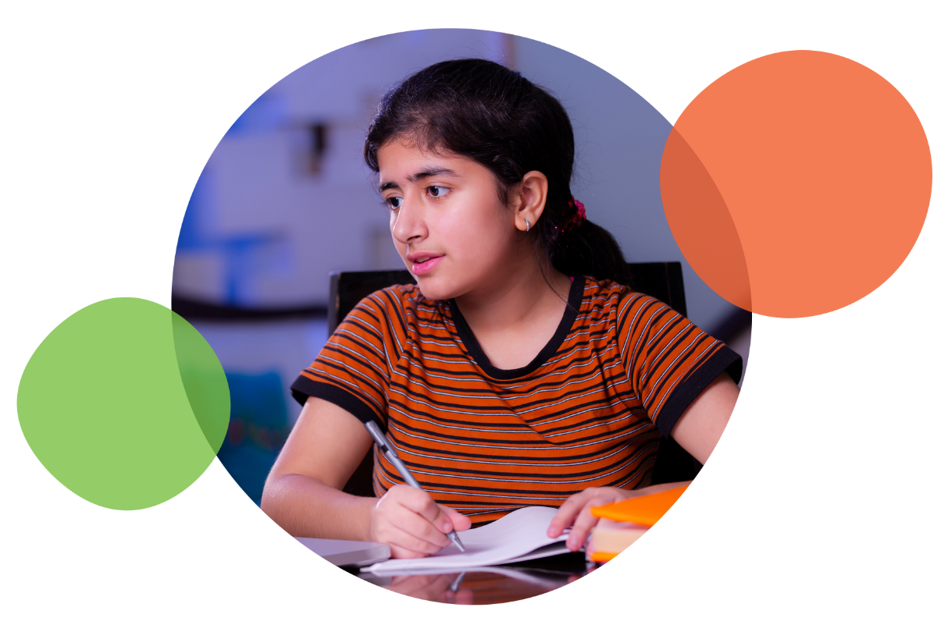

# Improving Implementation

**The Right to an Inclusive Education**

Disabled people have the right to inclusive education.1 Inclusive education involves all students learning together, with the appropriate supports in place.[4] Disabled young people we spoke with detailed how their difficulties in accessing reasonable adjustments resulted in them moving to segregated education in order to have their access needs met. For these young people, their experiences at mainstream school were defined by inaccessibility and difficulty.

### Reliance on Rare Allies

The quality of disabled students’ experiences in education was highly dependent on the presence of allies within the system. Skilled, experienced and understanding staff make positive differences in the quality of disabled students’ access to education and ability for the student to advocate for their needs. Unfortunately, many disabled young people spoke about the lack of awareness or interest in understanding disability and the value of reasonable adjustments. This lack of awareness is a major barrier to disabled students’ access to education.

Young people identified that teachers and other school staff had varying understandings of the Standards and how to engage with disabled people. Staff who had completed disability awareness and inclusion training demonstrated better understanding of the Standards and were more likely to provide reasonable adjustments. The training increases understanding of disability, the rights of disabled people to education and the responsibility of education providers to be accessible and inclusive.

‘How can we expect anything from teachers if they don’t understand?’

Luca, 17 year old living in Melbourne

‘There should be a mandatory class for all new teachers on disability awareness and inclusion. And the teachers should share information between themselves’

Alex, young person living in Melbourne

‘It should be an all-of-school approach, not just in the classrooms. For example, when I went to my careers counsellor, he tried to convince me that I shouldn’t go to university, even though I wanted to, because of my disability. He had such low expectations of me‘

Camellia, 20 year old living in Melbourne

‘Some of my teachers didn’t have a clue, even my own class teacher! They didn’t know what my rights were’

Alex, young person living in Melbourne

### (In)Visible Solutions

The Standards are intended to cover all types of disability but outcomes for disabled students differ depending on nature of their disability. Disabled students discussed the stark difference between their experiences of the Standards being implemented depending on whether their disability was visible or not. Often, education providers refused to provide reasonable adjustments to students whose disabilities were invisible. Disabled students said that staff simply could not understand the impacts of invisible disabilities and believed that any adjustment would be unnecessary.

‘Educational access is mostly based on what people can see’

Camellia, 20 year old living in Melbourne

**Luca’s Story**

Having the two [visible and invisible disabilities] **I see how much harder it is for people with invisible disabilities**. If the staff can't see it, their comprehension is that it doesn't affect you as much. My physical disability doesn't get questioned, but if I want the same accommodation for a learning disability - invisible disability - as for my visible disability it doesn't happen. I went from having to fight for everything and having to prove everything, because you basically couldn't see my disability to now, I can say, ‘Oh, I'm in a wheelchair. I need this.’ And they're like, ‘Oh, yeah, that's so easy’. For example, I originally asked to be able to leave classes five minutes early to get to the lockers so there was less action there. I was getting some sensory overload that was challenging. They refused that. But later, when I started using a wheelchair, I asked to leave class early again and they immediately said I could.



#### Recommendation 4

**Improve the implementation and consistency of the Standards**

* Mandate and support the delivery of disability awareness and inclusion training to all teaching and support staff at all government schools, public universities and TAFEs, and highly recommend this for private schools, private universities and other education providers, in order to provide consistency
* Develop and provide specific information about invisible and episodic disabilities and the responsibilities of education providers in providing access for students with them

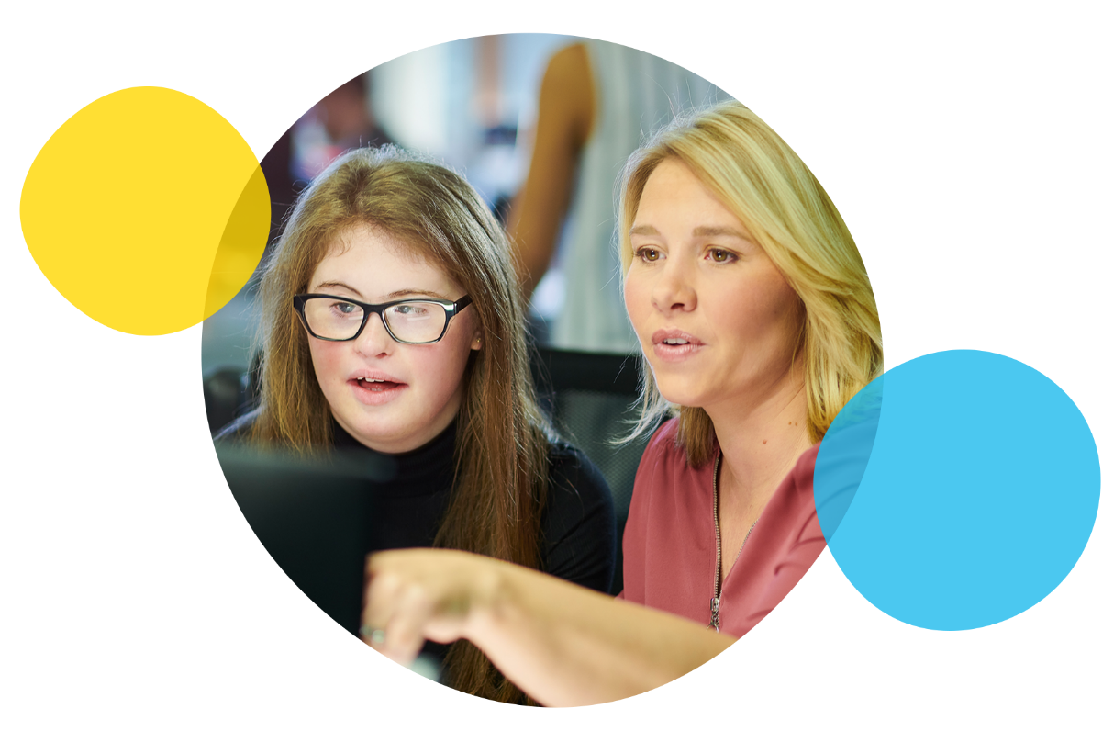

# Complaints, Feedback, Discrimination and Bullying

### Disappointing Disparity

There were large variations in the experiences of disabled students when reporting instances of discrimination or bullying. The Standards lay out the rights of students to be free from bullying and discrimination and the role of education providers in ensuring this, but there remains a trend of inaction. Some students reported numerous experiences of discrimination and bullying that had not been adequately responded to.

‘I feel like in regards to like victimisation and harassment... that was genuinely met reasonably well. I feel like that’s part of the Standards that schools typically do much better in’

Luca, 17 year old living in Melbourne

‘When I got bullied... I didn’t know what my rights were’

Alex, young person living in Melbourne

‘When I was getting bullied, the school they did nothing really.... they wouldn’t support me through it’

Oscar, 18 year old living in Melbourne

### Uncommunicated Feedback and Complaints Processes

Students identified that they were unaware of the correct procedures to pursue if they had complaints around the Standards or in the instances where they experienced discrimination or bullying. Additionally, disabled young people reported feeling unwilling to come forward if they had a complaint or feedback, especially after an experience of bullying or discrimination, due to the unfair effort required by the student and their supports to participate in this process.

‘How are we, as disabled young people, supposed to speak out about our rights and what we need if we don’t have any evidence to back it up?’

Luca, 17 year old living in Melbourne

‘Not everyone has supportive parents, or even parents that have the ability to put their time and energy into fighting for our rights’

Luca, 17 year old living in Melbourne

#### Recommendation 5

**Improve access to complaints and feedback processes, especially for instances of discrimination and bullying**

* Increase young people’s awareness of and access to formal complaints and feedback processes
* Mandate schools operate internal complaints and feedback systems
* Ensure all processes are accessible and appropriate for young people, taking into consideration different access needs
* Meaningfully embed student voice in systems for complaints



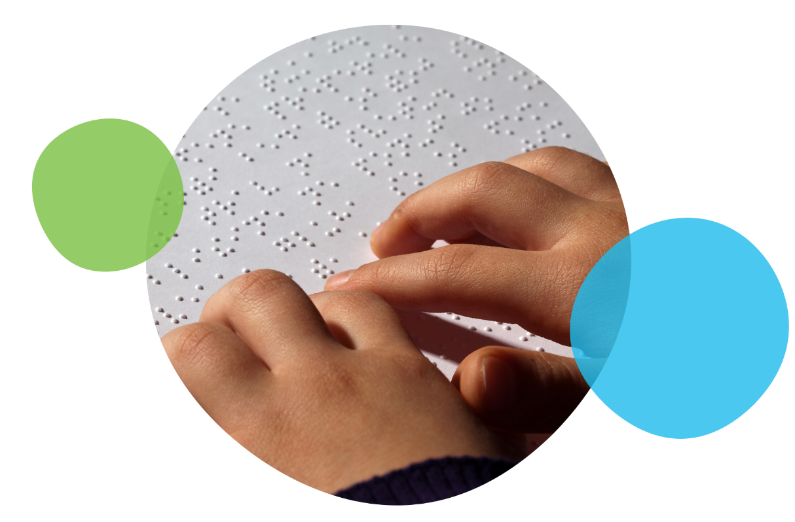

# References

1. UN General Assembly (2007). *Convention on the Rights of Persons with Disabilities* : resolution / adopted by the General Assembly, 24 January 2007, A/RES/61/106, retrieved from <https://www.un.org/development/desa/disabilities/convention-on-the-rights-of-persons-with-disabilities.html>
2. Youth Affairs Council Victoria (2020). *Yerp* (online resource). Retrieved from <https://yerp.yacvic.org.au/>
3. Victorian Student Representative Council (2017). *Policy Platform*. Melbourne, Victoria. p3. Retrieved from <https://www.vicsrc.org.au/>
4. Cologon, K. (2019). *Towards inclusive education: A necessary process of transformation*. Children and Young People with a Disability Australia. Collingwood, Australia.