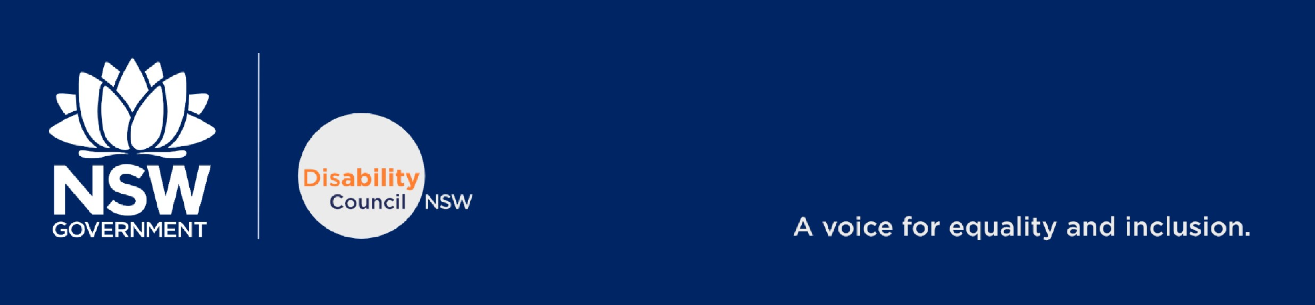D20/1463548

The Department of Education, Skills and Employment

Dear review committee members,

**Re: 2020 Review of the Disability Standards for Education 2005**

The Disability Council NSW (the Council), is a statutory body that provides independent advice to the NSW Government on policies and advances the equality, inclusion and interests of people with disability. The Council would like to thank the Department of Education, Skills and Employment for reviewing the Disability Standards for Education 2005 (the Standard) and giving broader community, particularly students with disability and their parents an opportunity to provide input on this matter.

It is widely acknowledged that a person with a disability face specific challenges in the pursuit of their right to education resulting in reduced access to mainstream education, it is therefore extremely critical to remove all educational barriers and adopt an approach that is inclusive to all. Noting the important role of education in the future pathways, the Council submits the following concerns, comments and recommendations for your consideration:

* The legislative framework aimed at eliminating discrimination against students with disabilities is complex, and it is difficult for schools, students and their families to understand and navigate.The legislation lacks clarity in its key terms, and it is difficult for all parties to interpret how the Standards are best applied in practice. The Council recommends the review to bring clarity to the legislation so that it is easily understood by all.
* Difficulties arise from the discrepancy between the broad definition of disability in the Disability Discrimination Act and the Standards for Education 2005, and the narrower, more medically-based definitions of State and Territory education departments. The Council recommends that the review bring clarity to the definition of disability.
* At presentenforcement of compliance with the legislation depends on the willingness and ability of an individual complainant to pursue a claim of discrimination or breach of the Standards. Few cases (complaints) proceed to court and conciliation outcomes are confidential. The Council believes that enforcement should be the norm and should not be dependent on individual preference.
* There are inconsistent levels of access and outcomes for students with disabilities across Australia’s eight educational jurisdictions because each jurisdiction interprets the federal legislation differently. The Council believes that the interpretation of legislation should be universal across the jurisdiction.

Disability Council NSW provides independent advice to government on policies and advances the equality, inclusion and interests of people with disability. [www.disabilitycouncil.nsw.gov.au](http://www.disabilitycouncil.nsw.gov.au/)

* There are failures in the inclusion of students with disability and the continuing existence of discrimination in the form of exclusionary practices. Education effects independence and future employment perspective. Therefore, the Council recommends the review to identify educational barriers and adopt an approach that improves the experience of people with disability at school.
* The matter of reasonable adjustment is problematic, and there is a lack of systematic guidelines to assist schools in determining reasonable adjustments. The Council strongly recommends the review to develop guidelines to bring clarity to the concept of reasonable adjustments.
* Unjustifiable hardship that can be claimed by education providers is contentious, and the interaction between the concepts of reasonable adjustment and unjustifiable hardship is unclear and difficult to establish. The Council recommends the review to bring clarity between the concepts of reasonable adjustment and unjustifiable hardship.

Additionally, Council members have received information from various individuals on issues negatively influencing the educational progression of children with disabilities, particularly in public schools:

**Lack of disability education and awareness:**

* Council members have seen and heard from various sources that children in school are not supported to engage with children with disability. An incident was recently brought to the Council’s attention that a school in regional NSW advised a family that a student with Muscular Dystrophy to not bring their power chair to school as they could be bullied. The student can walk without the power chair but needs it to prevent fatigue and to independently go around the school to play with others. Incident like this is extremely disappointing. To have a long-term harmony and positive experiences within the school environment, the educational system needs to raise awareness to bring attitudinal change from early on so that difference becomes the norm. School is perfect place to inculcate understanding about disability, diversity, empathy and inclusion; but most importantly that it is okay to be friends with someone who has a disability. The Council believes that this can be achieved by providing a well nurtured and inclusive environment that supports relationship building.

**Provision of 1:1 funding:**

* While it is pleasing to know about the provision of 1:1 funding to support specific students, Council members have heard various incidents where the funding was not used for the intended purpose. Members have heard that even though the funding is provided for 1:1 support in the classroom, in practice, the funding is often used to support the teacher as a second pair of hands rather than giving the required attention to a student who needs 1:1 support. Therefore, the student is missing out on vital learning opportunities; and for the parent, this issue is hard to monitor.

The Council thanks the Department of Education, Skills and Employment once again for allowing us to comment on such an important review that affects the future pathways of children with disability.

Yours sincerely,

**Mark**

**Tonga**

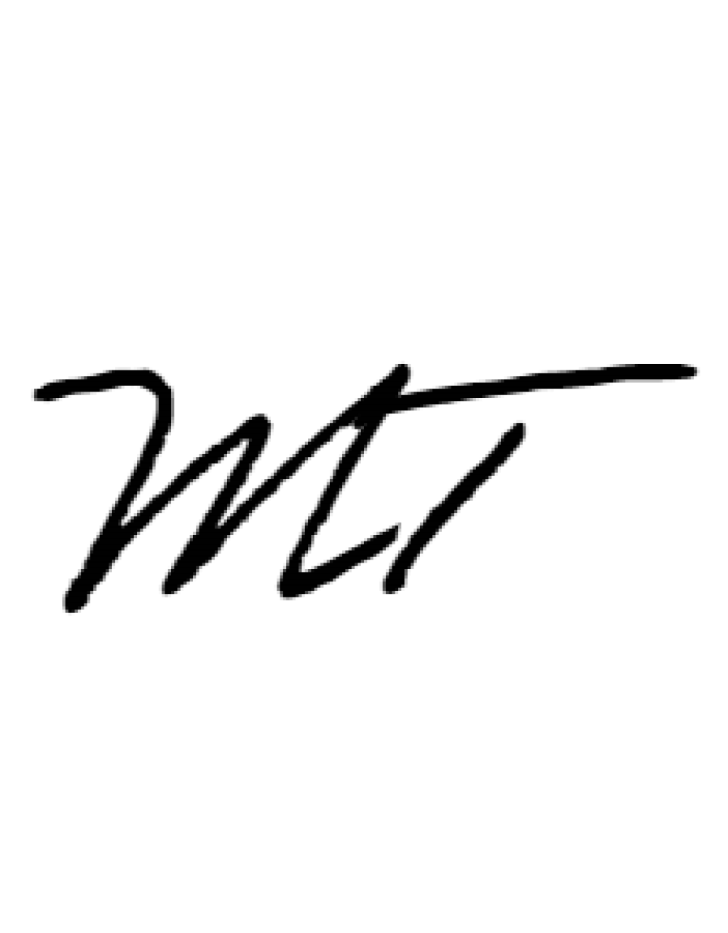

Chair – The Disability Council disabilitycouncil@facs.nsw.gov.au