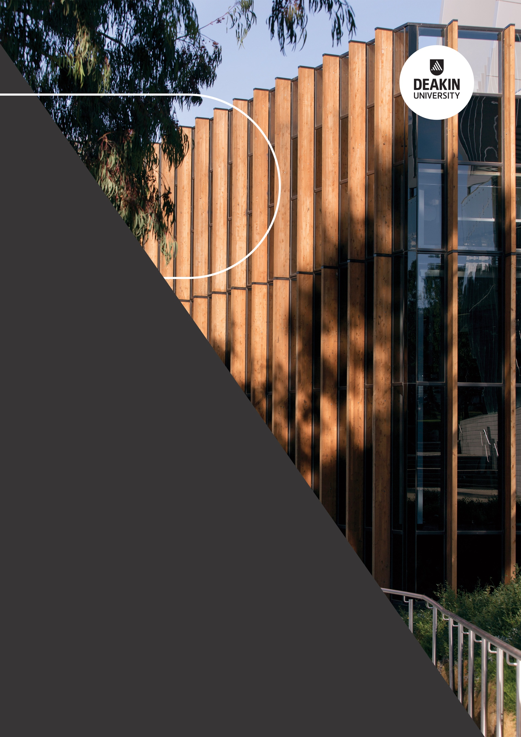

2020 Review of the Disability Standards for Education 2005

Submission by Deakin University

September 2020

2020 Review of the Disability Standards for Education 2005

Submission by Deakin University, June 2020

# Introduction

Deakin University is pleased to contribute to the Department of Education, Skills and Employment’s 2020 Review of the Disability Standards for Education 2005.

As an organisation, Deakin would like to be recognised as a world-class, inclusive and progressive university where students, staff and the community come to us to grow and prosper through access to knowledge and the experiences that are on offer. [The Deakin University Act 2009](https://www.legislation.vic.gov.au/in-force/acts/deakin-university-act-2009/007) states that the University aim’s to be a catalyst for positive change for the individuals and the communities we serve. Embedding diversity and inclusion as a University strategic priority supports our ambition of being a place where the whole community grows and flourishes.

Deakin aims to provide greater access to education to talented students regardless of their background and make a tangible positive difference for the First Peoples of this country by advancing Reconciliation and moving Indigenous Knowledges into the mainstream of Australian life. Deakin will be defined by those we include, and the opportunities we create.

Deakin supports the notion that the Standards are making a positive difference towards students with disability being able to access education and training opportunities on the same basis as students without disability. The Standards provide a good framework for promoting access and participation in education and there has been significant improvement in the experience, awareness accessibility and use of the Standards since recent reviews in 2015 and 2010.

We do acknowledge that, as per the Disability Discrimination Act 1992 (DDA), further work needs to be done to:

* eliminate, as far as possible, discrimination against persons on the ground of disability in the areas of education and training
* ensure, as far as practicable, that persons with disabilities have the same rights to equality before the law in the area of education and training as the rest of the community
* promote recognition and acceptance within the community of the principle that persons with disabilities have the same fundamental rights as the rest of the community

Deakin is providing feedback to five specific areas of the Standards that are key issues for the University and the sector more broadly.

**Deakin University makes three recommendations to the review committee:**

* Recommendation 1: That the Australian Government work with key stakeholders including higher education institutions, state and territory governments and peak bodies to improve the consistency of funded supports for people with disabilities in post-compulsory educational settings to ensure equitable access across settings.
* Recommendation 2: Consideration be given to addressing transition between education sectors, and the intersection with employers contributing to education, (such as through placements), and education material providers (such as software developers and publishers).
* Recommendation 3: Provide a stronger commitment at a national level to shift the emphasis in the Standards from adjustments and accommodation, to inclusion first. Consider the Standards be updated to define and reference inclusive practices/universal design along with reasonable adjustments in all the areas covered by the standards.

**Deakin University Specific Comments to the Standards**

**Access and participation in education supporting people with disability to participate fully in society and maximise their opportunities**

Australia has introduced important policies aimed at increasing equity group participation. These include the demand driven funding system and specific equity initiatives such as the Higher Education Participation and Partnerships Program. The Standards have been influential in providing a positive framework to encourage access and participation for students with a disability in all levels of education since their implementation in 2005. Disability is referenced in various parts of the United Nations Sustainable Development Goals (SDGs)[1] and specifically in parts related to education. Goal 4 on inclusive and equitable quality education and promotion of life-long learning opportunities for all focuses on eliminating gender disparities in education and ensuring equal access to all levels of education and vocational training for the vulnerable, including persons with disabilities. In addition, the proposal calls for building and upgrading education facilities that are child, disability and gender sensitive and also provide safe, non-violent, inclusive and effective learning environments for all. Further work at the Federal Government level to increase the access and participation opportunities for students with a disability could be achieved through:

* More support in the implementation of the Standards at enrolment, especially during the transition from secondary education to university. Easy to understand and interpret version of the Standards should be provided to all prospective students as part of enrolment processes in all education settings.
* Consideration to addressing transition between education sectors, and the intersection with employers contributing to education (such as through placements) and education material providers (such as software developers and publishers).
* More flexible application processes and alternative pathways where disability has affected schooling/secondary education.
* Providing clarity for students about understanding their rights under law and what processes they can follow if they experience difficulties or issues. Providing clear information about where and how to seek support to ensure they have equitable access to services and information.

**Success and retention of students with disability**

Due to the success of the Standards, greater numbers of Australians with disabilities are taking up higher educational pursuits. Students with disability are the fastest growing equity group in Higher Education, with a growth rate of 50 per cent compared to all students between 2013 – 2018[2]. It would be good to see the adoption of targets for success and retention of students with disability, similar to the targets set recently in the National Regional, Rural and Remote Tertiary Education Strategy (2019)[3]. Without targets and an expectation of reporting against these it is difficult to measure progress towards important goals.

The Standards need to be matched with funding commitments if there are to be real advances in success and retention for students with disability. Funding continues to be one of the major issues confronting education providers to date and reforms currently being proposed under the Job Ready Graduates Package are limited to a focus on select equity groups and may exclude other underrepresented or disadvantaged groups, such as students with disability. This is also prevalent in the Performance-Based Funding for the Commonwealth Grant Scheme[4] in which disability is notably absent from the recommendations, including Recommendation 12, which states that ‘Equity group participation should be a performance measure’. We are heartened by the Minister for Education’s assurance that this group will be considered through other measures/reforms, potentially arising from this Review of the Disability Standards for Education 2005 and the resulting recommendations.

**Shift of emphasis from adjustments and accommodation, to inclusion first**

The Standards and guidance notes have a focus on making reasonable adjustments and accommodations for people with disability. While this is a necessary step, the first strategy should be to anticipate the needs of students with disability and apply inclusive practice principles to accessing and participating in education at all levels.

A stronger commitment at a national level to Universal Design for Learning as a framework for inclusive curriculum could help guide universities on how to embed effective inclusive approaches to teaching and learning. The Standards could be updated to define and reference inclusive practices/universal design along with reasonable adjustments in all the areas covered by the standards. The legislation needs to change from having the onus on the student to complain or request adjustments toward encouraging providers to spend on and adopt universal design principles. It is disappointing that inclusive curriculum and assessment approaches are beyond the scope of the Standards as these are probably the most effective way to ensure that those students who choose not to share information about their disability have a reasonable chance of accessing formats and approaches that enable them to participate and be assessed on an equitable basis with other people.

**Awareness and capacity building**

Awareness of the Standards among people with disability and their peers is intermittent and is likely to be lower among groups who experience additional disadvantage, including people who are Aboriginal or Torres Strait Islander, from new communities, from low socio-economic backgrounds or who live in rural and remote Australia. Increased and sustainable professional development across the whole education sector will help to increase knowledge and awareness and translate to better implementation of the Standards.

At Deakin, while the Standards are known by the Disability Resource Centre and those in the diversity and inclusion areas of the University, they are not well known or understood beyond this. A review of the Standards offers an opportunity for a ‘relaunch’ of the Standards. Preferably accompanied by national resources and training, the publicity and requirements would serve as great way to reintroduce the Standards to all in the sector, and to allow them to consider the role and responsibilities they have to play in meeting the objectives of the Standards.

The Standards provide a good framework for understanding rights and obligations, but their effectiveness is diminished by reliance on a complaints-based enforcement mechanism. The Standards establish minimum expectations, and do not articulate broader aspirations of social inclusion, achievement of individual potential or inclusive education. Deakin supports changes that raise the bar in terms of the expectations of education providers set within the Standards and linking their function to broader objectives of social inclusion.

Exemplars of best practice could be developed to accompany the Standards and should be accessible to both education providers and to students with disability and their parents/ guardians and support workers. These exemplars should be general and sector specific, updated annually and be informed by case law. The Higher Education Participation and Partnerships Program (HEPPP) has recently piloted this practise as part of 2020 reporting obligations from participating institutions.

**General layout and relevance**

The language used in the Standards and the guidance notes could be simplified and if this were done it may be possible to add the content of the guidance notes to the Standards. Measures for compliance would benefit from updating to consider aspects such as digital accessibility more explicitly. The sections covered by the Standards are generally still relevant, but would benefit from a review and updating to reflect current language. Transition is not covered by these sections and could be added to identify the responsibility of the various sectors to consider, improve on and apply the Standards to transition.

1. https://www.un.org/development/desa/disabilities/about-us/sustainable-development-goals-sdgs-and-disability.html
2. Koshy, P. (2019). Equity Student Participation in Australian Higher Education: 2013 – 2018. National Centre for Student Equity in Higher Education (NCSEHE), Perth: Curtin University
3. Commonwealth of Australia 2019, National Regional, Rural and Remote Tertiary Education Strategy https://docs.education.gov.au/system/files/doc/other/national_regional_rural_and_remote_tertiary_education_strategy.pdf
4. Wellings, P., Black, R., Craven, G., Freshwater, D., & Harding, S. (2019). PERFORMANCE-BASED FUNDING FOR THE COMMONWEALTH GRANT SCHEME Report for the Minister for Education – June 2019. Department of Education, Skills and Employment. Retrieved from https://docs.education.gov.au/system/files/doc/other/ed19- 0134_-_he-_performance-based_funding_review_acc.pdf