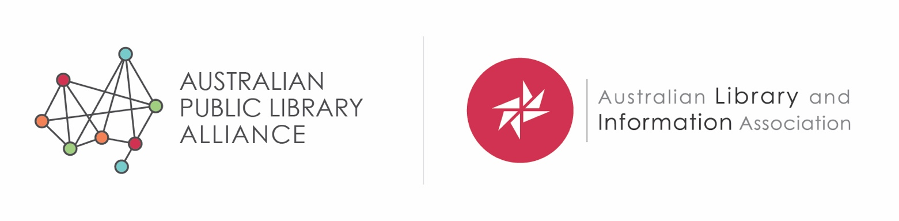

**Submission in response to the Australian Government Disability Standards for Education 2020 Review**

**25 September 2020**

**1. About us**

**Australian Library and Information Association**

The Australian Library and Information Association (ALIA)[1] is the professional organisation for the Australian library and information services sector. On behalf of our 5,000 personal and institutional members, we provide the national voice of the profession in the development, promotion and delivery of quality library and information services to the nation, through leadership, advocacy and mutual support. ALIA is the peak body for public, school, university, TAFE and special libraries. We work closely with the Council of Australian University Librarians and National and State Libraries Australia.

Over many years, we have developed and refined a policy for [library and information services for people with a disability](https://www.alia.org.au/about-alia/policies-standards-and-guidelines/library-and-information-services-people-disability) and we offer a [biennial grant](https://www.alia.org.au/about-alia/awards-and-grants/326/twila-ann-janssen-herr-research-award-disability-services) for ALIA Members to carry out research into improving services for library users with disability. ALIA is a founder member of the [Australian Inclusive Publishing Initiative](https://aipi.com.au/) and our members work for disability organisations, providing people with Braille, audio and large print books.

**ALIA Schools**

ALIA Schools is an important part of the Association. It promotes the interests of school libraries and teacher librarians, provides opportunities for professional development, advocates for school libraries with state and local groups, identifies and analyses current trends in teacher librarianship, and maintains the profile of teacher-librarianship within ALIA.

There are more than 9,000 schools in Australia. Almost all schools have a library of some description, but they vary enormously in terms of staffing, facilities and resources. The role of the school library is to support the core business of learning and teaching and provide for student wellbeing. It is essential that all students experience success in their learning and that all teachers have the right resources to teach effectively. Schools libraries provide a range of programs and services that include and are not limited to explicit teaching of information and literacy skills, growing collections of print and digital resources, offering learning spaces for classes, small groups or individuals, ensuring safer online experiences and being inclusive for all members of its community.

At the high end, there are flagship libraries with IT hubs and more than a dozen members of staff which includes qualified teacher librarians. At the lower end, there are schools with a few shelves of books and a member of staff with responsibility to look after those resources as well as have a teaching or administration role.

School libraries play a vital role in supporting the needs of students living with disability. This can be identified by the provision of safe, accessible spaces, through the variety of collections and resources and through participation in school initiatives or programs that foster good educational and social outcomes. The same is true of all the libraries represented by ALIA – public, school, TAFE, university, law, government, health and other special libraries.

**2. School libraries and the Disability Standards for Education**

The role of the school library is to support learning and teaching, in line with the policies and protocols of the broader school.

* All students have the right to fully participate in their learning and have positive experiences in education.
* All staff in schools, particularly teachers, participate in professional learning that improves teacher practice and enables all students to be successful in their learning.

In the experience of ALIA Schools members, the Standards make a positive difference because they not only draw attention to the need to accommodate students of all abilities, but also drive action.

Awareness of the Standards is good in school libraries and has been raised still further since the introduction of Nationally Consistent Collection of Data. Since 2018, schools have been explicit in making adjustments for students and documenting this evidence, with teacher librarians often preparing evidence for the adjustment.

School libraries support students who require adjustments through the provision of resources, safe learning environments, active participation in following school protocols and in making the required adjustments.

The Standards at present deliver an overview for the holistic consideration of providing a positive education experience. There is always a need to continue to raise awareness of the Standards, not just in schools but in the wider community, for example, through a public education campaign. School libraries are well placed to support this, as central hubs for the school community, engaged with teachers, students and parents.

**3. Opportunities for improvement**

Qualified staff

School libraries with a qualified teacher librarian are best positioned to follow their school’s protocol to make sure students with a disability can maximise their opportunities. This is because teacher librarians are part of the teaching staff, participate in professional learning, and keep up-to-date with the very latest requirements.

Guidance notes

Guidance notes provide useful clarification but would be of greater benefit if written in plain English.

Priority students

Any opportunity to improve learning for Aboriginal and Torres Strait Islander students with a disability must remain a priority.

Inclusive publishing

*Disability Standards: Part 6 Standards for curriculum development, accreditation and delivery: 6.3.c Measures for compliance: “the course or program study materials are made available in a format that is appropriate for the student and, where conversion of materials into alternative accessible formats is required, the student is not disadvantaged by the time taken for conversion.”*

School libraries are designed to be safe, inclusive and accessible spaces, with staff who support all students, using the best resources and technology which are available to them. Unfortunately, the standard print books available to school libraries are not always suited to the needs of students with disabilities, especially print disabilities, and for this reason, ALIA is a strong supporter of the Australian Inclusive Publishing Initiative (AIPI)[2].

The aim of AIPI is to transform publishing workflows in Australia so that accessible files are integral to the process. This would mean all books would be able to be converted into the formats required by students and others living with print disability, dramatically increasing the volume of reading and study material available to them.

**4. In conclusion**

School libraries and teacher librarians are strong supporters and implementers of the Standards. We welcome the opportunity to contribute this submission and would be pleased to provide further information if required.

**Contact:**

Sue McKerracher, CEO, Australian Library and Information Association (ALIA)

9-11 Napier Close, Deakin ACT 2600 **t**  02 6215 8215 **m** 0404 456 749

**w** [www.alia.org.au](http://www.alia.org.au/) **e** [sue.mckerracher@alia.org.au](mailto:rob.miller@alia.org.au)

1. Website [www.alia.org.au](http://www.alia.org.au)
2. Website <https://aipi.com.au/>