

**Independent Review into Regional, Rural and Remote Education**

Victorian Farmers Federation Submission

# The Victorian Farmers Federation

The Victorian Farmers Federation (VFF), Australia’s largest state farmer organisation and only recognised consistent voice on issues affecting rural Victoria, welcomes the opportunity to comment on the Independent Review into Regional, Rural and Remote Education.

Victoria is home to 25 per cent of the nation’s farms. They attract neither government export subsidies nor tariff support. Despite farming on only three per cent of

Australia’s available agricultural land, Victorians produce 30 per cent of the nation’s agricultural product. The VFF represents the interests of our state’s dairy, livestock, grains, horticulture, flowers, chicken meat, pigs and egg producers.

The VFF consists of a nine person Board of Directors, with seven elected members and two appointed directors, a member representative General Council to set policy and eight commodity groups representing dairy, grains, livestock, horticulture, chicken meat, pigs, flowers and egg industries.

Farmers are elected by their peers to direct each of the commodity groups and are supported by Melbourne-based staff.

Each VFF member is represented locally by one of the 230 VFF branches across the state and through their commodity representatives at local, district, state and national levels. The VFF also represents farmers’ views on hundreds of industry and government forums.



**David Jochinke**

President

**Victorian Farmers Federation**

**Farrer House**

**24 Collins Street Melbourne 3000**

**p 1300 882 833**

**f 03 9207 5500**

**e vff@vff.org.au**

**w www.vff.org.au**

# Curriculum

Limited availability of subjects offered in country schools and by post compulsory providers in rural and regional areas can be seen as a contributing factor to the lower participation of young people from rural and regional areas in higher education. It is critical that schools and training providers are enabled with connectivity and ICT tools to support student access to a broad range of subjects, even if all subjects cannot be offered face to face within small rural schools.

The VFF believes there would be significant benefit in ensuring that every Victorian school graduate has basic financial literacy skills, such as how to prepare a budget, file for an ABN, complete a tax return and understand basic accrual accounting. This would not only benefit agriculture students, who would then be better positioned to manage their farm business, but also more broadly ensure that all Victorians possess a basic level of financial competency.

The Victorian farming community has expressed ongoing concern about the availability of agriculture and horticulture employees over many years. The VFF maintain their support of agriculture and horticulture subjects being offered in both primary and secondary schools.

The importance of working with career advisors in secondary schools to improve understanding of career opportunities in the food and fibre sector also cannot be underestimated. The Food and Fibre Careers Project (2015) collated a significant number of valuable resources. These resources are in addition to the many other classroom resources that industry bodies have developed. The VFF is aiming to have these resources centralised and made available through an online portal that would allow all teachers, careers advisors and students to simply navigate and gain access to the wealth of agriculture information and learning tools currently available.

## Teachers

The ability to attract and retain professionals in rural areas is an ongoing concern. Longer term contracts or permanent positions for teachers in rural areas may be one solution.

Links to universities and teaching graduates should be explored to encourage young people to move to rural areas.

## Entrepreneurship and schools

Industry has an important role to play in establishing a connection for students between the curriculum and the reality of working in the industry. Industry links build the credibility of school programs and provide meaningful transition pathways for students to further study or work.

The significant costs associated with delivering agriculture programs are a barrier that may be overcome by partnering with industry and local community organisations. We also know that education programs must relate to their local agriculture industries to be effective, and small rural schools would need to rely on industry and community connections to establish localised programs.

We need to make it easier for young people to engage with employers in order to retain them in the region and address youth unemployment. Community and industry connections have an important role to play in mentoring students and supporting transition between education and economic development. Students can be inspired by work experience placements, providing motivation to work harder to achieve their career aspirations. Promoting programs such as work experience and making them simple for industry and employers to be involved in is a simple step that could make a real difference.

The educational opportunity in agriculture is now much broader than traditional school programs. The AgTech (agriculture technologies) revolution is upon us, representing an opportunity for significant growth and benefit to the agricultural industry through increasing productivity and reducing input costs, making growers more competitive. Uptake of digital agriculture technologies has the potential to generate an additional $252 million in on-farm revenue each year in Victoria, equivalent to an 11-16 per cent improvement in the industry’s current Gross Value of Production (GVP) (Birchip Cropping Group, 2017). The increasingly complex nature of modern agriculture requires a highly trained workforce and continuing to attract skilled people into agricultural careers will be paramount for success.

### AgTIDE project

The recently proposed AgTIDE project in the Wimmera Southern Mallee in regional Victoria is aiming to establish an ecosystem of facilities, expertise and services to support local AgTech trials and adoption. Hands-on education and training will be available for farmers, students and professionals in the latest farming technology through partnerships with Longerenong College (Ag College), Skillsinvest (RTO) and Federation University (research organisation). Through inclusion of school students in the education and training mix of large scale regional projects such as AgTIDE, students will be exposed to the latest farming technology, offered the highest quality learning experience, and motivated to realise their career aspirations through local industries and training.

## ICT

The VFF and the ACCC share the view that rural and regional Australians are relatively disadvantaged from participating in contemporary Australian (online) social and business activities because of poor connectivity. Extent of coverage is not the same as quality of coverage. The VFF strongly advocates that telecommunications for rural and regional Australians must come with a minimum quality standard as a consumer guarantee.

Evidence shows a digital divide exists between regional and metropolitan Victorians. It is a priority to improve mobile and digital connectivity in Victoria for the benefit of our communities. Without access to fast internet, remote education services will not be effective. A lack of connectivity limits the ability to offer many of the educational programs that could assist rural schools and training providers to improve the quality of the student experience including offering a broader range of subjects, links to a more diverse student cohort and student support services.

Fast, reliable, digital connectivity in the family home, something metropolitan families take for granted, is just as important for schools students to realise their full potential. It is impossible for country students to compete if their access to online tools and resources are limited by a lack of connectivity. It creates time, knowledge and attitudinal disadvantages in relation to at-home study that can have long-terms impacts on results and access to further education.

Connectivity and technology, also provides the potential for people to work and connect for work, from anywhere in the world, including rural communities. Our regional communities could realise a number of economic development benefits through the provision of appropriate telecommunications infrastructure.

The VFF also aims to make Victoria a pilot state for mobile and digital programs that benefit those in agriculture, particularly rural and regional Australia. The innovative AgTIDE project in the Wimmera Southern Mallee is one such project that requires connectivity to be established through an improved underlying telecommunications network to enable the proposed DATAfarm at Longerenong College and Grower Cooperative across 50 farms to become a reality.

## Access

Current funding arrangements do not acknowledge that repairs, services and professional development cost more for country schools. Without the right systems, it is difficult for country schools to deliver the high quality learning experience we expect. Integration of community resources and facilities could alleviate funding stresses, for example early childhood education, childcare and subsidised day care can be co-located to improve flexibility, staffing efficiencies, and transition for students and families.

The VFF support innovative place-based, collaborative solutions to the current fragmented education system such as those proposed to be trialled in the Wimmera Southern Mallee through the Regional Partnership. These trials are expected to provide vital insight to innovative service delivery for early years that coordinates health, early years and schools. The focus is on better use of existing facilities and resources, rather than big spending programs.

School buses continue to be a point of contention in rural areas. They are a vital service for students and families. The VFF hope that common sense will prevail to ensure school bus services provide appropriate coverage for all families in regional and rural areas, and are run in the most effective and efficient manner possible, while keeping our children safe. Transport in rural areas is the most important component of access for students, yet school bus issues are often dismissed as low level. The cost of running services is not prohibitive, and buses support all families to access education, particularly our most vulnerable. Expanding transport services for VET and further education students is also an important issue, as is the provision of services for children with special needs. A coordinated approach is critical to ensure efficiency across broad geographic areas.

## Transition to further study

Regional centres find it challenging to provide TAFE programs that meet the needs of the local community due to a lack of funding. Many young people are forced to move away from rural areas or do not enrol in further study due to a lack of locally available options. Improved access to TAFE and training programs in regional areas will provide a local pathway for students, encourage young people to remain in regional areas and support economic development.

## Conclusion

Education from early childhood to further study is critical to the sustainability of our regional communities, and to the future of regional industries such as farming. The VFF support innovative approaches, and most importantly, approaches to delivering education that are co-designed with the community to ensure they meet community needs. Thank you for the opportunity to provide a submission to the review.

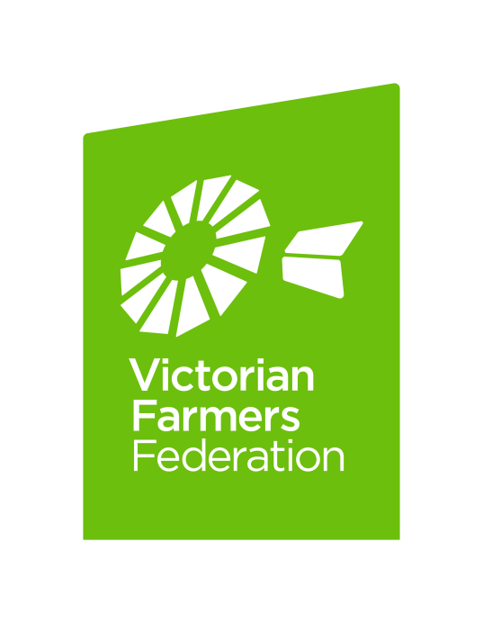

**Victorian Farmers Federation**

**Farrer House**

**24 Collins Street Melbourne 3000**

**p 1300 882 833**

**f 03 9207 5500**

**e** [**vff@vff.org.au**](mailto:vff@vff.org.au)

**w** [**www.vff.org.au**](http://www.vff.org.au/)