Response to the IRRRRE, using feedback from teachers, parents and community members in South West Victoria. Data analysis from open sources by Ian Tebbutt. Highlighting lack of need for access to specialised services in rural and regional areas.

IRRRRE Response

Ian Tebbutt

[IanTebbutt@gmail.com](mailto:IanTebbutt@gmail.com)

0401 451 298

# Introduction

I have awaited the IRRRRE Discussion paper with interest. As a parent of two girls in Yrs 2 and Yr5, living in regional Australia in Port Fairy I have a strong personal interest in this process. I want our region and others in Australia to be as strong as possible both economically and for our community. To do that we need to attract new families and immigrants, support jobs growth and demonstrate that quality of life is often better in rural/regional Australia and especially in housing, much better value.

I have also spent many hours crafting this analysis from open datasets, much of this work will be made available online – I use Tableau so it will go up on Tableau public. I’d really appreciate some feedback on what in here is useful, and any further analyses you might want prior to my putting it on line.

Living and working in regional Victoria is a joy, the community is more supportive, the hassles of life are less, the cost of housing is considerably cheaper. There are numerous benefits, and they can be summed up as just a better quality of life. I have been fortunate enough to live in many great cities, and at this stage in my life, with two primary age children, I cannot imagine how much more stressful our lives would be if we were in an urban environment.

However, as everyone realises there are some down sides to the rural and regional life. I’ve discussed this submission with local educationalists, health providers and above all many parents. I also spoke to our local state MP, Roma Britnell, who gave an interesting focus on the benefits of living in a regional area. I have three areas of interest

1) Rural and regional Australia can combine strong economic growth with good quality of life

2) Addressing poor education outcomes is a foundation stone to drive that growth

3) In the next decade innovation will address some of the issues of rural/regional living, education, health, communications, logistics, and isolation are all being impacted be disruptive change.

We see education holistically as part of our overall community, and the challenges that face education are shared in health, in work and in our communities more broadly. There is a single underlying issue

**it is harder to get access to quality specialised services when in rural and regional areas.**

# Challenges for Teachers

An absolute common theme when talking to teachers is that children today have many more challenging behaviours making education an increasingly complex job. Those challenges are shared in urban areas, the key difference is we often don’t have the specialised skills on the ground.

We have a huge base of talent, but as with many things in rural and regional Australia that talent is isolated. We are working to improve education and the lives of our young people, but without the support that those initiatives would have in an urban environment. The following paragraph is a direct quote from an email and sums up some of the challenges we’re facing.

From a professional ‘on the ground’ ‘observation’ perspective I have seen a number issues which appear to be impacting our young people’s and families’ **mental health, learning and educational outcomes**in homes and schools. The most obvious appear to be…… overstimulated nervous systems, behavioural concerns, anxiety, low social/emotional intelligence and most commonly poor attention/organisational skills…… Children in general appear highly distracted as a result of how stimulated and busy we are in our lives/amount of platforms we function on. Those that fit into diagnostic categories/with trauma histories are at even more a disadvantage.

# Access to child psychologists, as an example

The links between health, education and especially the impact that we can have at a young age is crucial. My background is in data analysis so I have pulled together some data to back up the information from teachers and parents. Using publicly available sources from the Medicare Benefit Scheme I have compared the number of child psychologists between urban and rural Victoria.

Child Psychologists in Victoria

Figure 1 Child Psychologists In Victoria (source MBS Data - [Department of Health](http://www.health.gov.au/internet/main/publishing.nsf/Content/PHN-MBS_Data)) (Figures in yellow are estimates)

Rural and Regional areas of Victoria have 25% of the population, but only 13% of the child psychologists. To handle demand, each of those practitioners is delivering more services than their urban counterparts, but that only goes part way to solving the problem. We have half the number of practitioners that we need, and this is a microcosm of similar issues with many of the required services.

In short access to service is far worse in rural and regional areas that it is in urban. This does not have to be the case, but in order to address these short falls in availability we need to have policy and awareness.

So how can we address these problems, I see three approaches

1. We persuade those professionals who work with young people to migrate out of the cities to some of the rural areas
2. We make an increased use of communication technology, especially internet, telemedicine and in the near future use of VR to deliver services
3. We (re)train local people in these much needed skills offering subsidised education, through online/external university courses

# Disruptive Technology and the impact on Rural/Regional

Virtual and augmented reality will have a huge impact on the access to services, in the next decade. These technologies have been promised as the ‘next big thing’ for many years, the difference is that we are now reaching the ever steepening part of the exponential growth in technologies’ capabilities.

We already have advanced, learning systems that can diagnoses better than humans, understand natural language and so on. VR/AR removes the need for travel, and that physical barrier is one of the main issues with access to service. This is an area that schools and health services need factor into their future state planning.

# Investment is Required

The cost information in this section is sourced from The Cost of Unresolved trauma report from [BlueKnot](http://www.blueknot.org.au/Portals/2/Economic%20Report/The%20cost%20of%20unresolved%20trauma_budget%20report%20fnl.pdf).

Those children who experience abuse have ongoing health issues as adults, their brains can change from learning mode to survival mode. I have identified that we have issues accessing specialised services, and the maps below show that larger numbers of rural/regional children are on protection orders. The blueknot report states the lifetime cost of child hood trauma can be $600,000, and the budget impact is at least $6.8B. A small investment into services will reap huge benefits.

Models that reduce sensory stimulation in the classroom (sensory tents/headphones with music therapy/sensory fiddle toys)….. or quiet spaces in schools that can provide time out or integrate kids into the learning environment have positive outcomes (nurture room/rise room/sensory room).

We need a whole of School approach to Health and Wellbeing, providing resources/support/intervention to children/staff and families (kidsmatter, Achievement Program, Peaceful Kids) is another way to strengthen health/wellbeing partnerships and strengthen individual support in the school communities.

In conversation with teachers an effective and very low cost initiative is the increased use of teacher’s assistants in schools. The assistants can focus on those students who need more nurturing and attention, this has the dual benefit of letting the main teacher work with the rest of the class and provides a supportive environment for those children with challenging behaviours.

As you’re aware the teachers’ assistant role is low pay, and there is little money to employ more people in this role. An expansion of that program, specifically targeting rural and regional areas, will bring huge benefits. This is as much a population health issue, as one of education.

# Beyond the Bell

A local initiative in South West Victoria is [Beyond the Bell](http://www.beyondthebell.com.au/pages/about/vision) . BTB is working well to address some of these education short. The organisation engages with schools, parents, pupils and other stakeholders and has brought together interested parties into six local groups. Their efforts are well known in the schools and they have been instrumental in the creation of nurture rooms, and supportive environments for children.

# VCAMS Indicators – children on protection orders

The costs, both social and economic, of this lack of access can be huge. The VCAMS indicators measure key outcomes for children and young people ([Victorian Department of Education](http://www.education.vic.gov.au/about/research/Pages/vcamsindicator.aspx)).

I have looked at many of these indicators and find that rural/regional areas are comparable to urban, in most instances rural/regional performs slightly below urban in a similar fashion to the NAPLAN scores. However, there are a few measures in which rural/regional are trailing far behind urban, and these are the very areas which need specialised support.

For instance, for teenage pregnancy, and violence either perpetrated byor against young people the figures for rural/regional areas are awful.

Below I have shown the figures for the rate of children on protection orders. In the very centre of Melbourne this figure is the state high of 19.42, but the surrounding suburbs have much lower rates in the range 2.5 to 5. 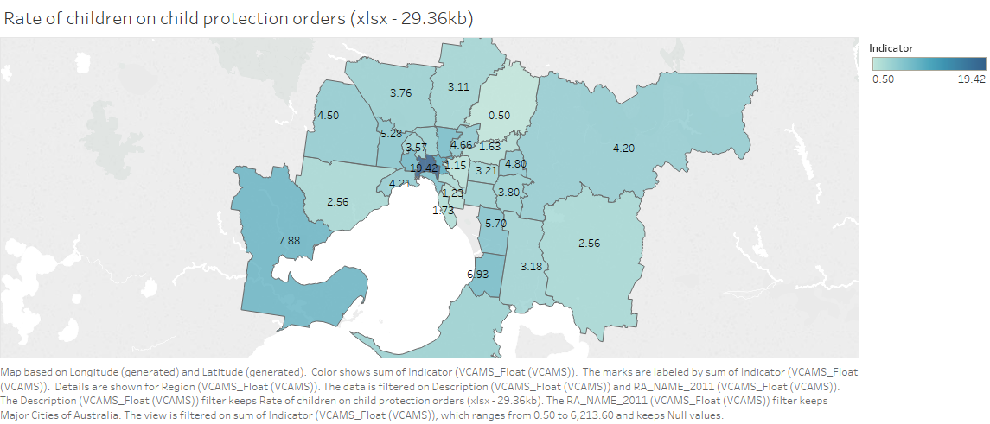

Figure 2 - Rate of Children on Protection Orders – Urban (VCAMS Data)

Now compare those figures with those in rural/regional Victoria. Here we are seeing most regions with figures of >10. This disparity in rates shows the need for good services in regional areas is huge. In fact the reason these figures are so high, is the access to the services we need for vulnerable children, those with developmental issues and so on is much higher.

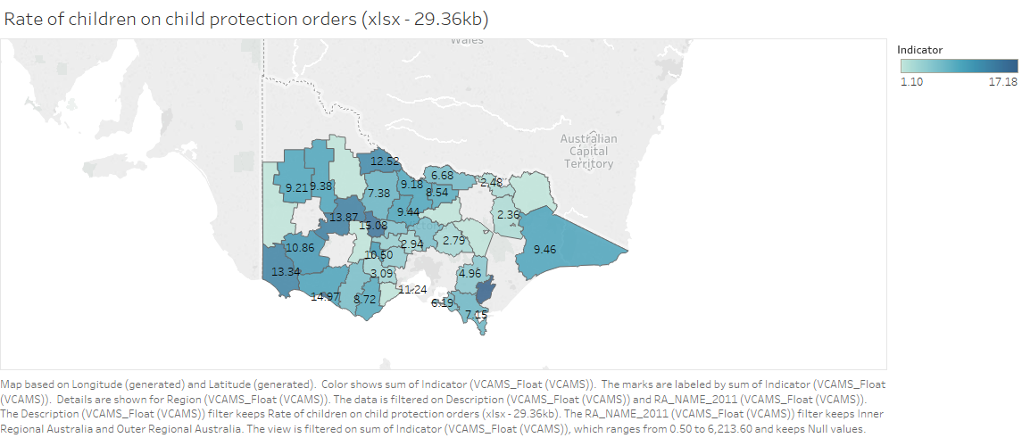

Figure 3 Rate of Children on Protection Orders – Rural/Regional (VCAMS Data)

# Medical Students attitude to rural/regional

As an example of how attitudes can be changed, our local hospital in Warrnambool, is used by Deakin University for training clinicians. Initially, when the medical school was placing students, coming to Warrnambool was the less preferred option, with students preferring to train in Melbourne or Geelong. However, the situation is now different, as students actual experience of living in rural/regional areas became known there is now strong demand to come to Warrnambool for clinical training. The lifestyle is better, there is a greater variety of roles and responsibilities for the students to take on, the cost to the students is lower. Overall urban students are finding that living and working in here is better for them. We need to get that positive message out, and attract talent, especially migrants who predominantly arrive and stay in urban areas.

# Work and Education in Rural and Regional Australia

I have recently been contracted to look at the future of work in Australia, and how the external (online) courses offered by Universities can support the new jobs. That has given me further insight into the demographics of Australia, how the jobs are changing and where they are. From that work there are some clear trends, job growth for professionals, where the university analysis focused, is dominated by education and health. Those two fields employ 50% of professional Australians and are growing quickly – far more quickly than the mining boom, and much better distributed in the non-urban areas.

The numbers of external university students in rural and regional areas is increasing rapidly. The rise of MOOCs and online campuses means that for university education access is now very good and getting better. The use of technology by the universities should be used as a role model for health, government and other services. The universities offer an identical online experience regardless of location, be it urban or rural. They do this because their students want convenience, which online offers and many urban students do not make use of the physical university infrastructure. We would also like similar equal access from health, which is lagging far behind in it’s use of online technologies.

# Top Rural/Regional Industries

In rural and regional areas agriculture is important, but as your paper recognises the number of people employed in Agriculture is falling. However, the fact that you highlight that shows a common misconception, just because most of the agriculture is rural/regional does not mean most of the rural/regional jobs are in agriculture, education and health again are dominant.

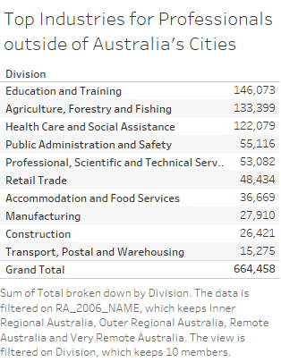

Figure 4- Top 10 Industries of Employment Rural/Regional Australia – Source ABS Census 2011

# Ag Tech and Innovation

The innovation opportunities in AgTech, especially the use of IOT, drones, sensors, and automated machinery is huge. As a learning opportunity these are the skills that rural/regional and more so TAFE and Universities can offer. These skills are transferable to many other industries and are great opportunity for economic growth in rural and regional areas.

# Knowledge Economy and NBN

The job opportunities in rural, regional Australia are different from urban. For instance working as a Data Analyst, there is a lot of local work but it is often contracted to city based consultants. I on the other hand work for city based organisations, even though I’m based in regional Victoria. In the main IT is an urban pursuit and the ABS figures confirm that.

However, the knowledge economy of which I’m a part, can now be highly distributed. This trend will increase rapidly, especially as professionals realise that you can live and *work* outside the urban environment. Increasing house prices, space to raise children, and aging population are all strong trends that may help to move talent from the cities to the regions. These are areas that need to be investigated, and policy put in place, so that the skills that we need, can be delivered, maybe families with part time work/child raising responsibilities or older Australians very happy to work, but with no need for a standard 5 days 37.5-hour week.

These knowledge jobs underline the absolute need for good internet connectivity. The NBN for those on fibre is a good innovation, sky muster on the other hand is already over subscribed with over 80% of users reporting performance issues.

# Population Demographics

Australia is heavily urbanised society, there are 16 cities and centres of population with over 100,000 people. They account for 75% of the population the other 25% are distributed as we see below, there are over 1M people in towns 20,000 to 49,999 and also in smaller settlements of the size 1000 to 4,999. This analysis is in part based on the thought that the size of a settlement is important, not just how far from a city it happens to be. This initial analysis just scratches the surface, I envisage applying cluster analysis and then predictive modelling techniques to derive a cost/benefit analysis of education and growth in regional/rural Australia.

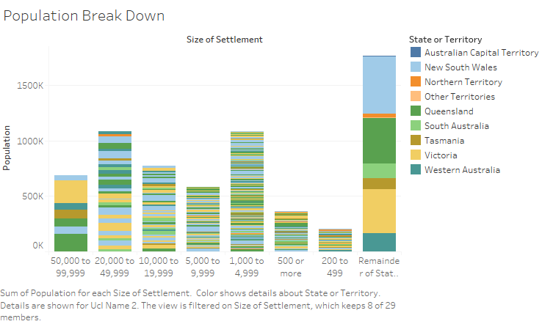

I have analysed the data from the basis of does size of settlement always correlate with academic outcomes? The answer is broadly yes – the larger cities have higher average Naplan scores. As the settlements get smaller so the Naplan scores reduce, however the difference in Naplan score in settlements below 100,000 residents is very small indeed. Looking at Reading, Writing and Numeracy for ages 3, 5, 7, and 9 the range from least good to best is 2% or less. In some instances, the best score are largest towns, in other instances the best score is tiny settlements of 500-999 people.

The data shows us that the difference in Naplan scores for younger children is quite marked, as they get older the ranges get much closer. This could be as a result of education bringing students to the same level, access to the underlying NAPLAN data from myschools would make this analysis much easier. You can also clearly see the Naplan scores for larger settlements is slightly higher across the board.

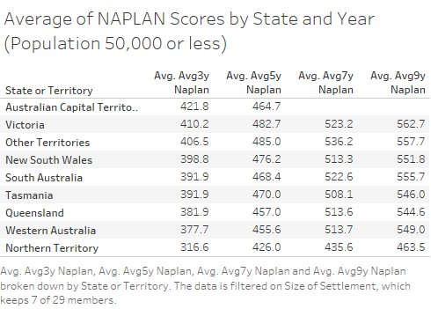

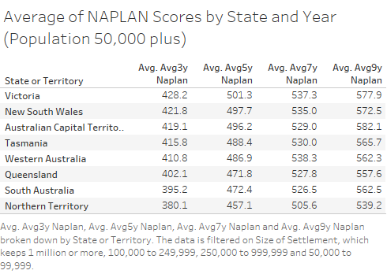

However, there is a strong correlation between remote settlements and Naplan scores. But again that finding doesn’t hold true in all instances. I have mapped the results below and this will be available online soon, using that tool you can zoom in on an area of Australia, find the size of a settlement, from the size of the dot on the map, and using the colour bands see what the Naplan attainment is. Note I have used data from Aurin for the Naplan scores.

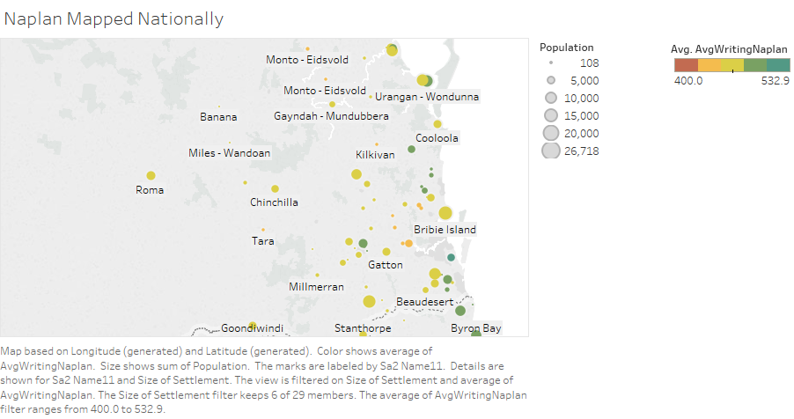

Looking further south there’s an increase in higher scores.

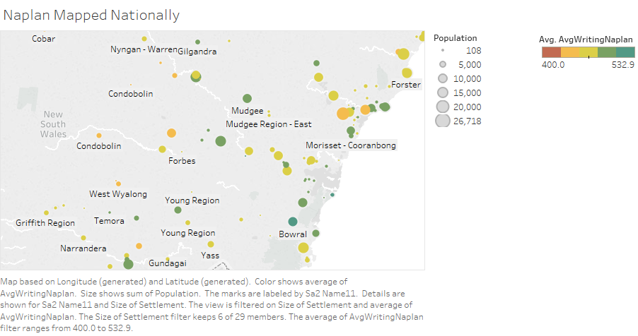Looking at the whole of Australia we see that most of the good results for Naplan Writing in smaller settlements are south of that classic line drawn from Adelaide to Brisbane.

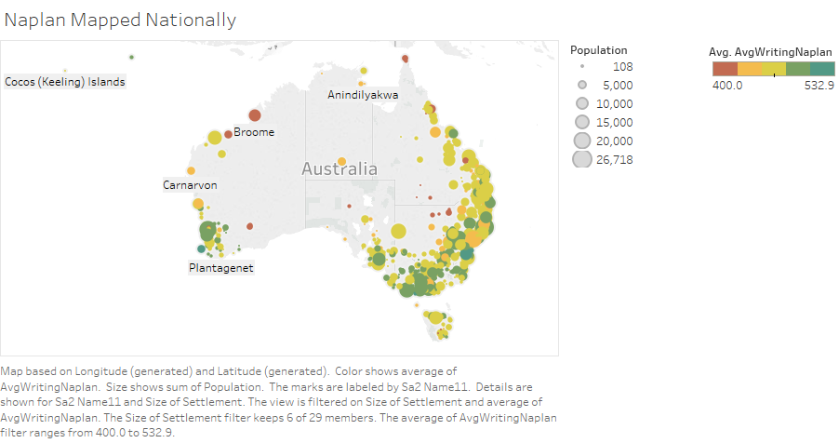

# Appendix A – Data Sources

Population, demographics data and LGA mapping regions from [www.abs.gov.au](http://www.abs.gov.au)

Naplan scores from www.aurin.org.au - University of Canberra - National Centre for Social and Economic Modelling, (2011): SA2 OECD Indicators: ACARA NAPLAN Data; accessed from AURIN Portal on 2017-08-29.  
  
When using these data in published research, the authors need to include the following attribution in the text:  
'These estimates are produced by NATSEM's Spatia Microsimulation model, which is described further in Tanton et al (2011)'

VCAMS Data on child and young person metrics - <http://www.education.vic.gov.au/about/research/Pages/vcams.aspx>

Medicare benefit scheme data - <http://www.health.gov.au/internet/main/publishing.nsf/Content/PHN-MBS_Data>