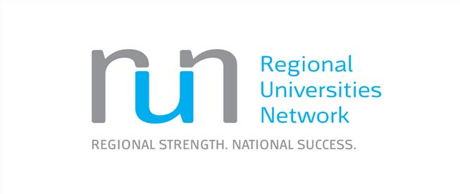

# Regional Universities Network (RUN)

# Submission to the Independent Review into Regional, Rural and Remote Education

# Recommendations

* Education should be seen as a major lever to drive economic development in regional Australia. Issues, policy and funding around school education and transition to work or further education should not be seen in isolation from other issues around regional economic development. Governments should ensure that relevant policy settings are consistent and working together across the school, higher education, industry and regional development space. e.g. parts of the Government’s proposed higher education reforms will be damaging to regional education, students and communities.

* Encouragement should be given by all levels of Government through policy and programs for regional and other students to undertake further study, and employment, in regional Australia. Students who study in the regions at a tertiary level are more likely to stay in the regions to work.

* Lifting Year 12 completions and tertiary education attainment in the regions must be a priority. Programs to support aspiration raising for students are critical, as are professional development programs for teachers. Regional universities are playing a key role in delivering these programs. Long-term funding commitment is required for the programs to change behaviour in the long-term.

* Enabling programs and alternative pathways to higher education help many regional students to succeed at university, and must be encouraged and supported.

* Various programs and initiatives are operating to encourage entrepreneurialism and connection students and the community and business – these should be expanded and persisted with in the long-term.
* Better and up-to-date careers advice is needed in schools. Careers advisers can be supported including via outreach from regional universities.

* One of the most significant reasons students drop out of university courses is financial hardship. More programs/scholarships to assist and support students financially in the regions would assist.

# General Comments

The Regional Universities Network (RUN) endorses the five convictions which inform the Independent Review into Regional, Rural and Remote Education discussion paper:

* Vibrant and productive rural communities are integral to Australia’s sustainability and prosperity – socially, economically and environmentally.
* Focussing on ideas and options for rethinking and reframing education in regional, rural and remote areas is likely to be more productive than simply concentrating on “the problems”.
* Student achievements and beyond-school opportunities are shaped by a diverse blend of inschool and community and home factors, as well as interactions between them.
* Government and department/secor policy settings are very significant in developing possibilities for change together with the work of parents and communities.
* Improvement in education is achieved by exploring how existing resources can be used more effectively, not just be allocating more of them.

Our submission addresses a number of the Terms of Reference, largely in terms of the

general/background points made, but also with respect to answers to some of the specific questions posed in the discussion paper.

Issues, policy and funding around school education and transition to work or further education should not be seen in isolation from other issues around regional economic development. Lifting the educational achievements of regional school students will positively impact on their post school achievements, and regional and the national economic performance. Governments should ensure that relevant policy settings are consistent and working together across the school, higher education, industry and regional development space.

Regional universities play a significant role in regional Australia. They are anchor institutions for their regions, and contribute significantly to regional economies. Through their presence in regional communities and outreach activities to schools they encourage aspiration for university study and professional vocations. Around three-quarters of those who study at university in the regions stay in the regions to work where they enrich regional economies and communities, and provide professional role models for regional school students. Only a quarter of those students who go to capital cities to study at university return to the regions. We are therefore of the view that there should be more incentives/encouragement for regional school students to study at regional university campuses.

# The Regional Universities Network (RUN)

Through their teaching and learning, research and innovation, and regional development and service functions, regional universities make a fundamental contribution to regional Australia and the 30 per cent of Australians who live there. Regional universities have made strategic decisions to invest in those areas of education and research that resonate with the needs of their regions and which enable them to make strong contributions to regional development. They help to educate their communities’ future professional workforce and enhance the social and cultural amenity of their regions through the contributions of their students, staff and facilities. Sixty to eighty percent of RUN graduates are employed in regional Australia within months of graduating.

RUN comprises six universities with headquarters in regional Australia: CQUniversity, Federation University Australia (Fed Uni), Southern Cross University (SCU), the University of New England (UNE), the University of Southern Queensland (USQ), and the University of the Sunshine Coast (USC). RUN universities play a key role, educating over 112,000 higher education students[1] (about 9 per cent of

Australia’s total enrolments), employing more than 7,300 staff[2], and managing annual revenues of $1.7 billion and combined assets of $3.6 billion[3]. They deliver services through more than 60 campuses and learning centres, encompassing all states except Tasmania. They are among the leading employers in their communities.

The Australian economy is moving from a heavy reliance on mining and manufacturing to a new era in which skills, knowledge and ideas will become our most precious commodities. By improving opportunities for people to access higher education, RUN universities help unlock the full human and innovative potential of regional Australia for the national good. The jobs and industries of the future will need highly skilled university graduates who can connect regional Australia with the global, innovative economy. We need to generate new jobs and industries through innovation to make regional economies more resilient. Our regional dual sector universities are particularly wellplaced to ensure the offering of the full spectrum of qualifications across the Australian

Qualifications Framework and to meet regional, rural and remote skills demands. Through university study and research, students become more highly skilled, and are better prepared to be creative, entrepreneurial and flexible to meet future job challenges.

The RUN universities enable the best use of regional human capital and resources and contribute to educational opportunities, economic prospects, innovation and community capabilities for the more than 30 per cent of Australians who live outside the capitals. They are one of the largest and most visible physical, intellectual, cultural and sporting assets in their regions and cities. The teaching and learning activities, research and innovation and service functions of regional universities contribute to: human capital development; regional governance and planning; community development; health and ageing; arts, culture and sport; environmental sustainability; and industry and business development in regional Australia. Staff and students play active and visible roles in their communities and contribute to regional capacity building, including internationally. Regional universities are major employers across a wide range of occupations, and purchasers of local goods and services.

RUN universities teach around 112,000 students or around 9 per cent of enrolments at Australian public universities.[4] They educate 23 per cent of Australia’s domestic, regional and remote students at the undergraduate level, 16 per cent of its low socio-economic status (SES) students and 17 per cent of its Indigenous students. They also enrol 28 per cent of external students and 33 per cent of domestic students in enabling courses. Many students are first in family to attend university.

RUN universities have strong connections with their communities and other educational providers including schools and VET. Students in regional and remote Australia move relatively frequently between the VET and HE sectors, reflecting the close relationships which often exist for pathways, articulation and infrastructure-sharing between institutions from both sectors in the regions.

Two RUN universities, CQUniversity and Federation University Australia, are dual sector institutions offering extensive certificate and diploma vocational education and training programs to around 17,000 students in addition to higher education programs. This ensures that regional, rural and remote school students have an opportunity to achieve quality learning outcomes and careers as they move seamlessly between secondary and tertiary education (both VET and Higher Education) without having to relocate to metropolitan areas, thus avoiding the ‘brain drain’ so often cited in research around regional education and economic development.

Three RUN universities host, or plan to host, university colleges which deliver a range of secondary and post-secondary programs e.g. Southern Cross University College offers pathways to success at university for both domestic and international students. Programs include: preparation programs, undergraduate courses and English language courses.

RUN universities are also major providers of enabling courses which are non-award courses which prepares students for general and/or discipline specific university study. A third of Australia’s students who undertake enabling programs study at RUN universities.

Compared with major metropolitan universities, the proportion of students at RUN universities who are admitted as traditional year 12 school leavers on the basis of their ATAR score as is relatively low. Many RUN students are admitted on the basis of alternative criteria and articulation pathways, such as vocational qualifications gained as part of secondary or post-secondary education, other higher education study, and relevant work experience.

People who study in the regions largely stay in the regions to work. A study undertaken for RUN demonstrated that 60 – 80 per cent of employed, recent graduates of RUN universities were employed in regional Australia.[5] A report by Cadence Economics for Universities Australia has estimated that for every 1000 university graduates entering the workforce 120 new jobs are created for people without a university degree.[6] Regional universities therefore boost regional employment more broadly than just through their graduates.

RUN universities are also leaders in mature age and professional education, educating people throughout their lives, and contributing to changing skills needs in the workplace. RUN universities are well- represented and well respected in the delivery of enabling courses that allow mature-aged students the educational opportunities that they may have been denied as school-leavers. This is a particular issue in the regions where the mobility required to study further in a metropolitan area is often not an option.

# Educational outcomes for regional Australians

Regional Australia is characterised by lower rates of higher education participation than in our capital cities. This is an important equity issue for the individuals concerned and has implications for the economic development of their communities.

The gap has started to narrow in recent years, largely due to the introduction in 2012 of the demand driven system of student funding, which allows universities to enrol as many eligible students as they wish in bachelor degrees. However, the proportion of the working age population with Year 12 and bachelor degree or higher attainment levels still remains significantly lower in regional and remote areas when compared to major cities.[7] In 2014, about 15-19 per cent of working age Australians living in regional and remote areas held a bachelor degree or above (there are lower levels of attainment with increasing distance to major cities) compared with around 33 per cent of the population in major cities.

In 2015, the proportion of persons aged 25-34 years with Year 12 or above was above 80 per cent in major cities and between around 61 to 64 per cent in regional Australia.[8] The proportion of 25-34 year olds with a bachelor degree or above in major cities was about 42 per cent compared to around 21 to 18 per cent in regional Australia (becoming lower further away from major cities). Significantly, the proportion of regional Australians with a bachelor’s degree or above in inner and outer regional areas has marginally declined from 2014 to 2015.[9]

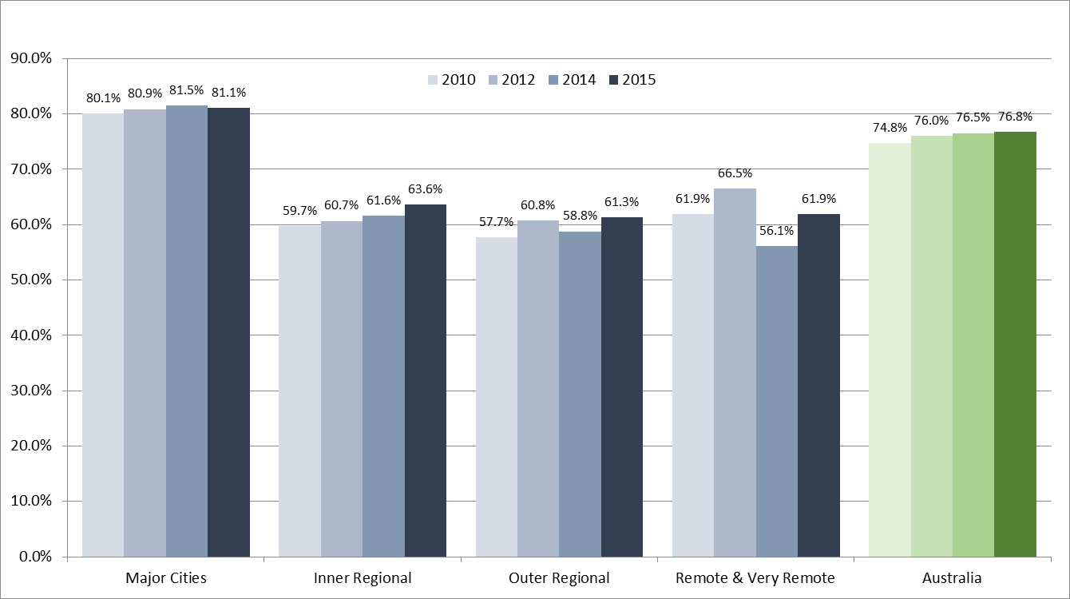

**Fig. 1 The proportion of persons aged 25-34 years with Year 12 or above, by remoteness area, year (based on Australian Bureau of Statistics data).**

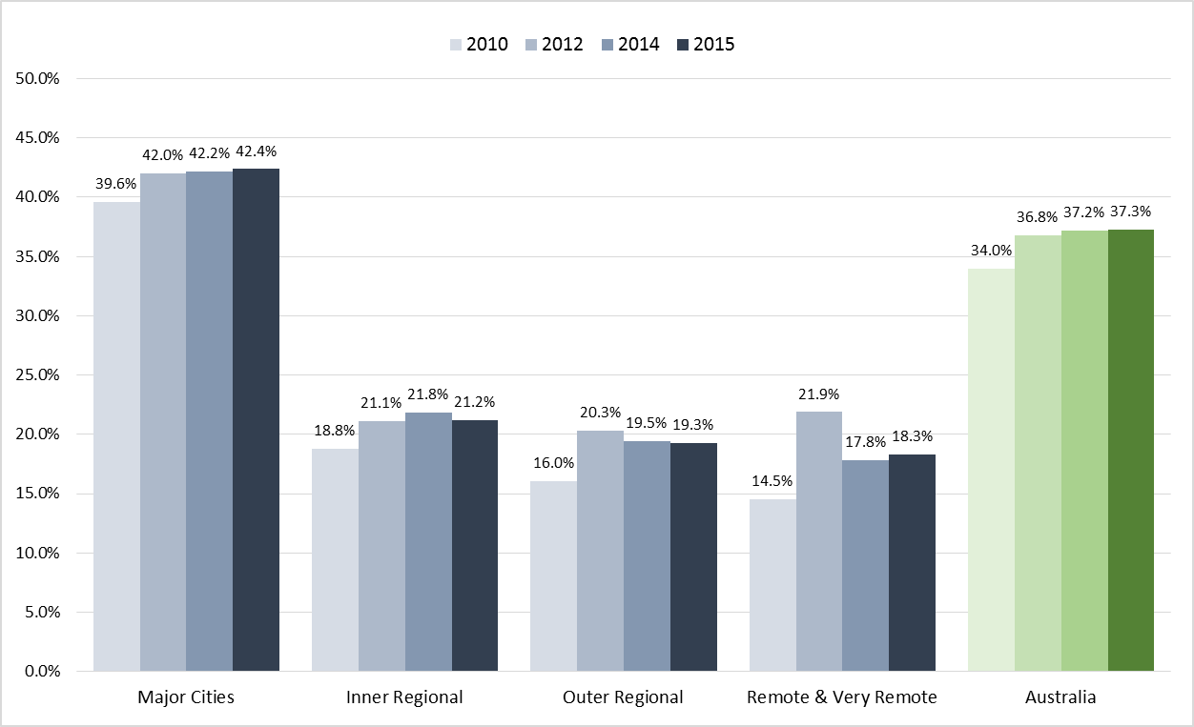

**Fig. 2 The proportion of 25-34 year olds with a bachelor degree or above, by remoteness area, year**

**(based on Australian Bureau of Statistics data)**

Increasingly, there will be the need for more highly skilled workers who are university graduates as automation take over more low skilled jobs. Within two decades, more than 40 per cent of Australian jobs that exist today may disappear as technology reshapes entire industries, professions and work practices.[10] Regional Australia will be the worst affected part of the nation, due to the high proportion of low skilled jobs. The regions need more highly skilled, university-trained professionals to drive the innovative industries of the future.

It is therefore vital that increased Year 12 completion and university participation continues to be a priority in regional Australia, and that regional universities are adequately supported in the task of supporting the success of regional students in their studies.

# Consistency of Commonwealth policy associated with the role of regional universities and regional Australia

The Federal Government has announced a range of policies that will assist regional Australia, its students, universities and communities. These include some of the measures in the higher education reform bill (Higher Education Support Legislation Amendment (A More Sustainable, Responsive and Transparent Higher Education System) Bill 2017), such as retaining the demand driven student system, easing the capping arrangements on sub-bachelor programs, providing funding for new regional study hubs, and providing funding certainty for the Higher Education Participation and Partnerships Program. These initiatives will complement other Government programs (such as Regional City Deals, the new Regional Growth Fund, the Regional Jobs and Investment Package, and the decentralisation of Government bodies) and encourage people to work and live in regional Australia.

However, other elements of the Government’s higher education reforms will be damaging to the regions. For example, the efficiency dividend of 2.5 per cent per annum on Commonwealth Grant Scheme (CGS) / teaching funding in each of 2018 and 2019 will reduce the capacity of universities, both regional and non-regional, to adequately service their communities. This will have a detrimental economic and social impact across Australia.

For regional universities, Commonwealth Grant Scheme (CGS) funding is used to support not only a wide range of teaching, learning and research functions, but also contributes to the many ways our universities provide for our students and their communities. Universities do not receive separate funding for regional development so our universities experience added pressure on their CGS funding compared with metropolitan universities.

The higher education reforms may also work to further lower the participation rate of regional students in higher education. The proposed increase in student contributions may deter some students, particularly those who are mature age and / or part-time.

The proposed decrease of the first threshold for the repayment of student loans from around

$52,000 to $42,000 is a significant change and will disproportionately affect low income households. Financial circumstances have been shown to be a major contributor to students dropping out of university.

Policy contradiction at the Commonwealth level is highlighted in the new Rural and Regional Enterprise Scholarships program for regional students to study STEM subjects in higher and vocational education. Despite the limited duration and impact of the program, RUN welcomes these scholarships as a means to help alleviate the financial stress faced by many regional students. However, the mechanism to allocate scholarships to students does not encourage students to study at regional campuses. Around three quarters of regional students who go to a metropolitan university to study never return to work in the regions. This initiative, as currently conceived, is thus likely to contribute to the further loss of human capital in regional Australia.

# Answers to Some Consultation Questions

# 

*6.2.3 What professional development should be available for teachers, schools and communities?*

All teachers require professional development opportunities to maintain and extend their professional expertise and competence, and to maintain their accreditation. Universities offer a wide range of professional development opportunities for teachers, including workshops and short programs and formal programs offered at the postgraduate level. Many programs attract funding as Commonwealth supported places or via student fee paying arrangements.

Some of the more innovative approaches to professional development, or school and community outreach, are supported as special initiatives, via programs such as the Commonwealth’s Higher Education Participation and Partnerships Program (HEPPP) and the (former) Australian Maths and Sciences Partnerships Program (AMSPP).

Many outreach activities supported under the HEPPP program include professional development for school teachers and careers advisors, either on a formal basis or via exposure to information about higher education pathways and opportunities, and current entry requirements. Teachers located at rural and remote schools may not be able to attend campus visits or other professional development sessions in person. In a welcome development, the Government announced in the 2017 Budget that funding for HEPPP would be legislated, providing future funding security for the program.

The AMSPP, which was funded in the 2012-13 Budget, was intended to improve student engagement in maths and science courses at university and schools through innovative partnerships between universities, schools, and other relevant organisations. A total of $21.6 million was committed to 22 projects. RUN partnered with the Australian Mathematical Sciences Institute (AMSI) among other organisations in the *Maths and Science Digital Classroom* project. Part of the project involved supporting teachers in a number of regional schools so that they could better encourage and help students in the study of maths and science. While this project was an excellent start, a sustained effort and ongoing support is required to make a real difference in this difficult area.

Another area in which there is a gap in provision is professional development support for teachers who wish to deliver units in entrepreneurship. RUN universities have recently established an entrepreneurship working group and its members have identified professional development for teachers as a priority area for future collaborative effort.

Universities also work in collaboration with industry bodies and schools to increase teachers’ and students’ awareness of specific industry sectors and of possible future careers. An example is the Queensland Minerals and Energy Academy (QMEA). QMEA is an industry-schools partnership which offers programs and experiences for students and teachers and provides a pipeline of employees into the resources sector and other related STEM industries. Most of the 39 schools involved in the initiative are based in regional Queensland.

TheGippsland Access and Participation (GAP) project is an established and valued part of the Gippsland educational landscape, and a key community engagement activity that showcases students and programs. The project is designed to increase teacher capacity and student engagement in STEM disciplines throughout Gippsland, a region with historically low participation and performance in VCE science and maths and low rates of university enrolment. The GAP team offers a range of activities in partnership with Gippsland secondary schools, including:

* VCE assessors’ meetings for senior secondary teachers; and
* Maths and science curriculum workshops for junior/ mid secondary teachers.
* VCE workshops for Year 12 Biology, Chemistry and Physics;
* A 3-day science summer school for Year 9-11 students;
* Themed challenge days in both mathematics and science for middle year students;
* An annual science and maths ‘Roadshow’ that delivers a range of engaging activities designed for Years 7-10 to regional and remote students; and
* ‘Imagine University’ visits for primary and junior secondary students.

*6.2.4 What innovative approaches could be taken to support a high quality teaching workforce for regional, rural and remote school communities?*

Approaches which could be taken to support a high quality teaching workforce for regional, rural and remote school communities include:

* Regional undergraduate teacher education scholarships;
* Teacher access to scholarships for relevant post-graduate qualifications;
* Teacher access to high quality professional development that THEY have identified;
* Recognition of quality teaching service in regional, rural and remote communities; and
* Additional funding incentives to support regional university pre-service teachers be placed in rural and remote schools. Schemes like USC’s coast to country – funded by philanthropy – result in teaching students opting to be placed in rural and remote schools.

*6.4.1 What new and innovative approaches are you aware of that improve the connection between schools and the broader community?*

Some examples from RUN universities are outlined below:

## Social Innovation Studio Gladstone (#SISG3)

The eight-day social innovation studio run in February 2017 brought together students from a range of disciplines and regions to focus on innovative strategies to address problems experienced by three not-for-profit (NFP) organisations in Gladstone, Queensland. Through a process of actionlearning and human-centred design, the student teams were mentored to understand the organisations, their clients, and the economic and environmental issues that are affecting the Gladstone region. Students were introduced to three organisations with various areas of focus including supporting young people with disabilities to earn a meaningful living; supporting the developing of creative recycling opportunities; and supporting inclusive practices to welcome people of different cultures to the region.

Outcomes of the Studio model, which has been run in Gladstone for the past three years with different organisations have included the development of two social enterprises, the evolution of new business models including new sales channels and product streams for NFP organisations, and a growing focus in the region on supporting socially inclusive innovation. Students undertaking the Studio for academic credit have variously described the experience as being ‘life-changing’ and ‘directly contributing to my ability to get my first job after completing my degree’.

Four other CQUniversity regions are now exploring the Studio model as a way of connecting the University, its students and community partners in a collaborative approach focussed on regional economic development and social cohesion.

## The Big Idea competition

Social enterprise is a model of business that has a dual focus on creating a sustainable, self-sufficient business while also directly contributing to positive economic, educational or social outcomes for people experiencing disadvantage. CQUniversity’s participation since 2014 in The Big Idea competition allows students from across Australia to develop a social enterprise business plan to address a specific issue in their region. Student teams are mentored by staff across the University to understand a social issue, such as food insecurity, homelessness or long-term unemployment within the context of their region. Students are then supported to use innovative socially-oriented practices through a design-thinking model to develop ideas that form the basis of a plan for a social business to address the issue.

## Social Innovation Orientation Program – ‘Everyone a Changemaker’

In 2018, CQUniversity will launch an online orientation program which guides students through a self-paced introduction to social innovation history, current megatrends and ‘wicked issues’, and the role that CQUniversity is playing in addressing entrenched social issues locally and internationally. Students will be introduced to foundational skills including human-centred approaches to looking at social issues, and will be able to reflect on their own ability to apply socially-inclusive thinking as they move into a discipline-specific degree.

## Embedding social innovation into CQUniversity curriculum

CQUniversity’s commitment to social innovation education has resulted in the introduction of a new graduate attribute - ‘Social Innovation Mindset’, which will guide the development of curriculum focussed on social innovation skills, attributes and capabilities across undergraduate programs.

## 6.4.2 What motivates regional, rural and remote students to succeed and how can they be supported to realise their aspirations?

Better careers advice is needed in schools to provide students with information relevant to today’s careers and changing world. Students need qualifications that will give them transferable and higher level skills that will help them in the range of careers they will participate in throughout their working lives. Various new methodologies, such as the use of “virtual reality”, can assist students visualise jobs and professions that they have no exposure to.

Careers advice and outreach activities by universities are crucial in helping students understand their options for post-secondary or further education. The provision of student readiness diagnostics is also a useful tool for allowing students and mentors to assess whether preparatory or bridging courses might be a useful step in preparing students for a successful transition to higher education. Specifically-targeted funding for such outreach and preparation activities should be directed towards rural and remote students, whose opportunities to access such resources is much less than that of their metropolitan counterparts.

The presence of a university campus in a region can raise aspiration for university study.

Outreach activities from universities to schools, such as those funded under the Higher Education Participation and Partnerships Program (HEPPP), designed to increase and support the participation in higher education of students from low SES backgrounds and other equity groups at university, has assisted regional students. The program has been crucial to informing regional students about postschool education and training and lifting aspirations for post-school study.

Without HEPPP funding, RUN’s outreach activities couldn’t happen at the same scale. Regional universities are faced with the tyranny of geography in terms of their large student catchment areas – HEPPP funding covers the costs of travel over hundreds of kilometres for staff and students to visit communities, and to bring potential students to university campuses. RUN is pleased that the Government has proposed legislating the HEPPP in the Higher Education Support Legislation

Amendment (A More Sustainable, Responsive, and Transparent Higher Education System) Bill 2017.

Widening participation activities that have been funded under the HEPPP fall into three sequential groups. Firstly outreach activities to schools and community groups to raise awareness of and aspiration for university study. These activities involve establishing relationships with students through their schools and are targeted at students from late primary through to the middle secondary years. The focus of these activities is to demystify university and build confidence that ‘people like us’ can go to university. These activities involve key influencers: parents / carers and teachers, student role models /mentors and importantly, experiential learning activities. The second group of activities involve those that promote access to university and include pathways on-campus programs, admissions procedures and aimed at promoting enrolment at university. The third group of activities focuses on supporting students once they have accepted an offer and includes scholarships, to increase affordability / relieve some of the (non-HECS related) financial burden.

The nature of the work is built on stable long-term relationships between education providers and their communities. Major change cannot be achieved in a few years.

All RUN universities have significant outreach projects. Some specific projects of note follow (further details and information about specific projects can be provided by individual universities):

* *Opening Doors* and *Choices* projects (USQ) which involve outreach to schools have resulted in increased participant aspiration and awareness levels concerning pathways to higher education.
* *Student experience day* events (USQ) report a 60 per cent rise in interest of previously disinterested participants in attending university and 86 per cent of student participants indicating that event attendance helped them learn about possible career choices.

* In 2016 SCU’s Equity and Diversity Office Outreach Programs continued to work with students from partner primary and high schools to provide experiences that are educational, exciting and increase understanding and motivation towards higher education. The *Stellar and UNI-BOUND* Programs worked with 7,009 students from 27 primary schools, 3 central schools and 21 high schools in the Gold Coast/Tweed Region, Northern Rivers, Clarence Valley and Coffs Harbour Regions. In 2016, students participated in 97 events which included a combination of on-campus events and inschool workshops. In 2016, 105 students commenced *Head-Start,* 87 successfully completed the course (83%). Of the 2016 Year 12 students and 2015 Year 11 students who successfully completed the program, 62 students were made an offer to study at SCU in 2017.

* *ACCESS4U* Year 11-12 (SCU). Forty-one students participated in 2015, and 60 per cent successfully completed the program with 19 post-access offers made (SCU).

* *Gippsland Access and Participation (GAP) Project* (FedUni) – an integrated and comprehensive program of activities involved secondary maths and science teachers and students from across Gippsland. Teacher feedback on activities is positive, encouraging and reflective. Student feedback indicates greater involvement and awareness.

* *Discord to Harmony* (FedUni) – addressing the challenges of mature aged VET students in partner institutions as they adjust to higher education. An online space was developed to give the students a place to connect with other students, give support, and confidence in tackling the skills required for higher education.

* *Access and Pathways Strategy (USC) –*A whole of University strategic approach focused on the pre-enrolment period for undergraduate students including Widening Participation, and other various pathways to admission. Key to the strategy is systematic management of current entry points through which students might enter higher education. A number of these access points are linked to pathways programs, such as Headstart. This pathway program enables Year 11 and 12 students to study up to two first year undergraduate courses at USC whilst completing high school. Student Experience feedback indicates that the program helps demystify university and increase awareness of career pathways. On average, there is a 42% conversion rate of these students into undergraduate programs at

USC and overall 60% of students responded at the end of semester they intend to go onto higher education*.*

* The *Growing Regional and Agricultural Students in Science (GRASS)* program (UNE) engages teachers and students in target schools from rural, remote and low socioeconomic regions, engendering strong links and widespread participation in the educational access activities. The UNE GRASS program inspires students towards careers in science, and helps develop a greater understanding of the science-based careers supporting agriculture that are available via a tertiary pathway. Analysis has been completed to confirm the students who have completed this UNE GRASS IPS and who then decide to continue studies at UNE are performing at a higher grade point average (GPA) and are making faster progress to completion of their degrees when compared with their peers at the university.

* The primary goal of **UNE’S Schools and University Connect Project** is to provide direct support schools with high numbers of students from low SES backgrounds in developing pathways to university. Professional learning is provided for school staff based on successful initiatives that have proved to increase retention and access to university study. Specific sessions are held with Aboriginal Education Officers, careers teachers, and school leadership personnel responsible for student aspirational engagement. There are programs for parents; training to improve communication between schools, parents and the community; university campus visits; a mentoring model that places pre-service teachers and social work students in schools as mentors; and engaging Careers teachers in professional learning based on increasing access to university of students from low SES backgrounds.

* The **UNE Discovery Voyager Program** will take science out of the lab and into schools of ~7,000 students to *deliver an interactive science program at primary and secondary schools* around the New England (NE), North West (NW) and North Coast (NC) regions of NSW, into at least 5 of the 10 most disadvantaged areas in NSW (Bundarra, Myall Creek, Nambucca, Tenterfield, Kempsey). In 2017 we will add a science show “The Sound Factor”, an interactive physics performance which can be performed to whole schools. Participants experience up to four activities designed to engage and stimulate curiosity, collaboration and creative thinking. The **primary goal** is to inspire and provide direction for rural and remote-based teenagers in NSW. Students from low SES, indigenous, remote and rural areas, and small schools, are often unable to join programs like this due to prohibitive costs associated with travel, catering and attendance fees.

The RUN *Maths and Science Digital Classroom Project,* funded under the Australian Maths and Science Partnerships Program (AMSPP), played a key role in engaging school students in regional Australia in the study of maths and science and enhancing the teaching of these subjects. Understanding maths and science is crucial for a range of careers important to regional Australia – for example, health, engineering, teaching and business. Schools in regional Australia struggle to maintain equivalent educational standards in maths and science as compared to those in metropolitan areas. RUN universities, partnered with the Commonwealth Scientific and Industrial Research Organisation, the Primary Industry Centre for Science Education, and the Australian Mathematical Sciences Institute, worked to capture the imagination of students through exciting and relevant case studies, for example, in astronomy and environmental science. [11]

## 6.4.3 Are there untapped priorities in rural and remote settings, which, if utilised, could help students realise their potential?

Increasing the number of enabling and pathway diplomas will help regional students transition into university in an environment where the majority of the population are not degree holders.

## 6.4.4 What role does/could the philanthropic sector play in improving outcomes for regional, rural and remote students in relation to school achievement and post-school transition?

One of the most significant reasons students drop out of university courses is financial hardship.[12]  The philanthropic sector (e.g. Country Education Foundation) provides grants and assistance to disadvantaged rural and regional students to access further education, training and careers. More grants and scholarships of this type would be invaluable to assist students in further studies. Scholarships for students to study at regional universities would help ensure that regional Australia gets the professionals it needs for the smart economy of the future – around three quarters of those who study at university in the regions stay in the regions to work [13] whereas only about a quarter of those students who go to capital cities to study ever return to the regions. [14]

A report by Cadence Economics for Universities Australia has estimated that for every 1000 university graduates entering the workforce 120 new jobs are created for people without a university degree.[15] Regional universities therefore boost regional employment more broadly than just through their graduates.

## 6.5.3 What are the main barriers to regional, rural and remote schools realising the full potential benefits of ICT?

Affordable and reliable high speed internet access must be available to regional, rural and remote schools. Lack of appropriate access is a major barrier to schools realising the full potential of ICT. Support services and help lines are also important.

Commonly, the lack of other infrastructure such as the availability of public transport, access to adequate childcare other caring facilities, and the cost and distance of travel to campus are compounded by lack of reliable high speed internet as an alternative to face-to-face learning.

Access to teacher professional development can be an issue.

## 6.6.1 What other (as well as Pathways in Technology (P-TECH) model) entrepreneurial education opportunities exist for regional, rural and remote schools?

A number of RUN universities have or are developing active innovation centres/incubators/accelerators and are teaching and developing entrepreneurial skills in students. There are some outreach activities that involve engaging with regional, rural and remote schools in entrepreneurialism including activities of the Innovation Centre Sunshine Coast, located on the USC campus at Sippy Downs (e.g. CoderDojo programs, teaching 7-17 year olds how to code).

The UNE SMART Region Incubator is a project developed with funding support from the NSW Government’s $12 million Building Business Innovation Program. One of the objectives of the business incubator is to help build prosperous, resilient regional communities. It provides an environment for small to medium start-up businesses to build a robust, innovative framework.

## 6.6.3 Are there other examples where entrepreneurial education has improved outcomes for regional, rural and remote students?

The UNE SMART (Sustainable Manageable Accessible Rural Technologies) Farm which showcases the latest technologies aimed at improving productivity, environmental sustainability, safety, workflow and social/business support networks on Australian farms. The [SMART Farm Innovation Centre,](http://www.une.edu.au/research/research-centres-institutes/smart-farm/sfic) linked via AARNet and the national broadband network (fibre, terrestrial wireless AND satellite, serves as a research, education and outreach facility and is a national demonstrator site, serving as a test-site for new technologies, the SMART Farm is a connected classroom where the community as well as students of all ages can access the [latest data streaming](http://www.une.edu.au/research/research-centres-institutes/smart-farm/smart-farm-data) in from a range of field, animal and machinery sensors.

## 6.6.4 What gaps need to be addressed to help students transition successfully to further study, training or work?

Areas for focus are:

• Accurate career advice to ensure students select a relevant pathway; • Pathway details and opportunities across the AQF spectrum; and • Mentorship programs for first year students.

Both State and Federal governments are giving increased attention to employment issues in regional Australia. Labour market data (lmip.gov.au) indicates unemployment and underemployment rates are persistently higher in areas outside the capital cities. Adjustment to the realities of the changing nature of work is not experienced uniformly across the country and the strategy for ‘jobs and growth’ in the regions is complicated.

Youth Action NSW released a policy paper on Tuesday 18 July 2017 with recommendations to NSW Government on improving career guidance in

schools.  [https://d3n8a8pro7vhmx.cloudfront.net/youthaction/pages/393/attachments/original/150 0359553/2017-07-18__Career_paper__formatted__FINAL__RS.pdf?1500359553](https://d3n8a8pro7vhmx.cloudfront.net/youthaction/pages/393/attachments/original/1500359553/2017-07-18__Career_paper__formatted__FINAL__RS.pdf?1500359553)

The recommendations include assisting schools to develop a minimum level of career guidance, strengthening support for career advisers and tailoring programs for the disadvantaged. Creating linkages between schools, industry and tertiary education is a key element of this proposal. The report discusses the additional barriers to career transition facing regional students, those with a disability, and those from migrant or indigenous backgrounds.

## 6.9.1 Are there changes that should be made to education, training and employment policies and practices which would improve post school opportunities for regional, rural and remote young people?

RUN proposes the following recommendations:

* Education should be seen as a major lever to drive economic development in regional Australia. Issues, policy and funding around school education and transition to work or further education should not be seen in isolation from other issues around regional economic development. Governments should ensure that relevant policy settings are consistent and working together across the school, higher education, industry and regional development space. e.g. parts of the Government’s proposed higher education reforms will be damaging to regional education, students and communities.

* Encouragement should be given by all levels of Government through policy and programs for regional and other students to undertake further study, and employment, in regional Australia. Students who study in the regions at a tertiary level are more likely to stay in the regions to work.

* Lifting Year 12 completions and tertiary education attainment in the regions must be a priority. Programs to support aspiration raising for students are critical, as are professional development programs for teachers. Regional universities are playing a key role in delivering these programs. Long-term funding commitment is required for the programs to change behaviour in the long-term.

* Enabling programs and alternative pathways to higher education help many regional students to succeed at university, and must be encouraged and supported.

* Various programs and initiatives are operating to encourage entrepreneurialism and connection students and the community and business – these should be expanded and persisted with in the long-term.

* Better and up-to-date careers advice is needed in schools. Careers advisers can be supported including via outreach from regional universities.

* One of the most significant reasons students drop out of university courses is financial hardship. More programs/scholarships to assist and support students financially in the regions would assist.

1. Department of Education and Training, 2016, Selected Higher Education Student Statistics, 2015
2. Department of Education and Training, 2016, Selected Higher Education Staff Statistics, 2016
3. Department of Education and Training, 2016*, Finance 2015, Financial Reports of Higher Education Providers*
4. Department of Education and Training data, 2015.
5. RUN, 2013, *Economic Impact of the Universities within the Regional Universities Network*, page 10. Available from [http://www.run.edu.au/cb_pages/news/Economic_Impact_Study.php.](http://www.run.edu.au/cb_pages/news/Economic_Impact_Study.php)
6. Cadence Economics, 2016, *The Graduate Effect: Higher Education Spillovers to the Australian Workforce*.

   Report for Universities Australia. Available from https://www.universitiesaustralia.edu.au/Media-andEvents/commissioned-studies/The-graduate-effect--higher-education-spillovers-to-the-Australian-workforce
7. Australian Bureau of Statistics, 2014, *Education and Work 2014* Cat no. 6227– analysis based on data downloads.
8. Australian Bureau of Statistics, 2015, Education and Work Australia, May 2015. Analysis based on data cubes 2 and 7.
9. Australian Bureau of Statistics, 2015, Education and Work Australia, May 2015. Analysis based on data cubes 2 and 7.
10. Durrant-Whyte, H, McCalman, I, O’Callaghan, S, Reid, A, & Steinberg, D, 2015, “The impact of computerisation and automation on future employment”, in Committee for Economic Development of Australia, Australia’s Future Workforce?, CEDA, Melbourne, p.58.
11. Information available at: [https://www.aare.edu.au/publications-database.php/10242/the-rundigital-classroom-project-integrating-scientific-research-into-classroom-teaching-in-regiona;](https://www.aare.edu.au/publications-database.php/10242/the-run-digital-classroom-project-integrating-scientific-research-into-classroom-teaching-in-regiona) https://www.slideshare.net/mkeppell/regional-universities-network-maths-and-science-digitalclassroom.
12. Devlin M. and McKay J. 2017 Facilitating Success for Students from Low Socioeconomic Status Backgrounds at Regional Universities. Research Report, Federation University Australia.
13. RUN, 2013, *Economic Impact of the Universities within the Regional Universities Network*, page 10. Available from [http://www.run.edu.au/cb_pages/news/Economic_Impact_Study.php.](http://www.run.edu.au/cb_pages/news/Economic_Impact_Study.php)
14. Hillman and Rothman (2007) referenced in ACER (2011) ‘Higher education & community benefits: The role of regional provision’, Joining the Dots, Research briefing, Vol 1, No. 5, September 2011
15. Cadence Economics, 2016, *The Graduate Effect: Higher Education Spillovers to the Australian Workforce*.

    Report for Universities Australia. Available from https://www.universitiesaustralia.edu.au/Media-andEvents/commissioned-studies/The-graduate-effect--higher-education-spillovers-to-the-Australian-workforce