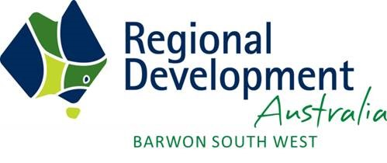

Regional Development Australia Barwon South West submission to the
Independent review into regional, rural and remote education
August 2017

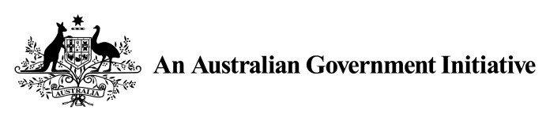

Contents
1. Purpose 2
2. Key Recommendations 3
3. Context and Mission 3
4. Improving education outcomes is a key priority in the Barwon South West region 4
4.1 Specific work with education outcomes as a focus undertaken by BSW RDA and project partners 7
5. Innovative approaches to support improved access and achievement 8
5.1 Case Study A – Beyond the Bell 8
5.2 Case Study B – Dream Real – Geelong Careers 12
5.3 Case Study C – The Geelong Project 13
6. Regional Forum 15
7. Conclusion 15
8. Appendix A – Research into Education Aspiration for Regional Victoria, 2013 Regional Policy Advisory Committee 15

Purpose
Regional Development Australia Barwon South West (RDA BSW) welcomes the opportunity to provide a submission to be considered in the Independent review into regional, rural and remote education. The submission is responding to the review’s key objective to ‘identify innovative and fresh approaches to support improved access and achievement of students and their transition to further study, training and employment’.
RDA BSW is committed to improving the region’s education outcomes. The purpose of this submission is to demonstrate, through examples of best practice, that innovative, place-based approaches are required to support regional students in education and the transition to employment.
Evidence demonstrates that educational disadvantage is often specific to place. Through key place-based projects outlined in this paper, RDA BSW is working towards an ambitious target to lift the region’s education attainment levels to be at least the equivalent of the Victorian average by 2022.
RDA BSW believes that Commonwealth needs to work with State and Territory governments to develop policy and accompanying initiatives and interventions to address lower than average attainment levels in regional Australia.

Key Recommendations
RDA BSW would like to submit the following recommendations to be considered in the review:
- Support place-based approaches that are developed with an understanding of the unique enablers and constraints within each region/area, and have a simultaneous focus on building human capital, promoting innovation and working to support transition from education into the jobs of the future.
- Program/project sustainability is critical to achieving improved education outcomes. Long-term planning and commitment, which sits outside political cycles and program funding rounds, is required to support targeted place-based approaches. Measures of success need to be determined over a longer term or broken down into smaller measurable components that align with trigger points along the education continuum.
- That the case studies outlined in this report be considered by the Commonwealth as best practice models, and that any initiative piloted by the Commonwealth in this region build on work already underway.
- The RDA BSW Committee would welcome further discussion and requests that the Independent Review Committee consider undertaking a regional forum in the BSW region.
- That the review consider the importance of aspiration to educational outcomes, as demonstrated in the paper ‘Research into Education Aspiration in Regional Victoria’, prepared by KPMG in 2013.

Context and Mission
The RDA BSW region is made up of the area from Queenscliff to the South Australian border and includes two state regions (Barwon and Great South Coast) and nine local government areas, as shown below:


Colac-

Otway

Greater Geelong

Surf
Coast

Queenscliffe

Moyne

Corangamite

Warrnambool
Southern
Grampians

Glenelg

Barwon

Great South Coast
The Committee is made up of 11 members drawn from across the region. Like other RDA Committees, RDA BSW Committee’s core responsibilities are: to be a key facilitator of strategic change and economic, social and environmental development in the region; to be the link between government, business and the community; and to facilitate whole of government responses to opportunities in the community.
The RDA BSW executes its core responsibilities by:
- Enabling and encouraging regional prosperity, monitoring progress in key areas
- Leveraging regional advantages and build sector strengths
- Promote regional capabilities/investment opportunities
- Support increase in exports/greater Asian presence
- Reduce barriers to job/economic growth i.e. infrastructure development, policy alignment

Improving education outcomes is a key priority in the Barwon South West region
Education attainment, retention and skills have a direct bearing on individual health, business activity and workforce growth. Education retention and attainment rates are a primary concern for the BSW region. This concern is particularly acute in rural localities where student outcomes can be affected by access to training, learning options, technology barriers and social disadvantage. Education outcomes influence employment, wellbeing, regional business growth and productivity, all key drivers of regional prosperity.
Year 12 participation and completion and post-secondary qualification rates across the region are below the Victorian average and significantly lower than metropolitan Melbourne. As outlined in RDA BSW’s Regional Road Map (2013-2016), RDA BSW has set an ambitious target to improve education outcomes in the region.
By 2022, the region’s education attainment levels will be at least the equivalent of the Victorian average.
The BSW region has a number of areas with a high level of socioeconomic disadvantage, characterised by lower levels of income, lower educational attainment, high levels of unemployment and unskilled occupations. The extent of this disadvantage impacts on all strategies to further transform the BSW region and improve its integration into the global knowledge economy.
Attainment levels in the Barwon South West region vary across the region, with barriers and causes often unique to place, so much so that one collective impact approach to improving education outcomes for the region has developed six individualised local action plans.
It’s within this context that is important to note that the BSW region is, at many times for different reasons, best considered as being made up of two sub-regions (Barwon and Great South Coast.
The sub-regional Strategic Plans for both G21 (incorporates Barwon region) and Great South Coast (GSC) highlight improving education outcome as a top priority for each region. Both Regional Partnerships (Victorian Government Advisory Committees) that operate in the BSW region have highlighted the need for government and the community to take action to improve education outcomes.
Great South Coast Region: Warrnambool (C); Moyne (S); Glenelg (S); Corangamite (S); Southern Grampians (S)
INDICATOR | METRO MELBOURNE | REGIONAL VIC | GSC | WARRNAMBOOL | MOYNE | GLENELG | CORRANGAMITE | SOUTHERN GRAMPIANS
Unemployment rate (Q1 2017) % | 5.93 | 5.52 | 4.70 | 4.97 | 3.19 | 6.20 | 3.64 | 4.96
Youth (15-24) unemployment rate(2011) % | 12.37 | 11.06 | 9.35 | 10.64 | 8.26 | 11.05 | 6.56 | 7.53
Non Year 12 Completion (2011) % | 40.53 | 60.83 | 63.48 | 58.65 | 61.57 | 68.89 | 67.66 | 63.92
People 15+ with Bach Deg or higher non-school qual 2011 % | 50.11 | 31.3 | 29.65 | 33.20 | 30.35 | 23.71 | 26.03 | 31.27
Youth (15-19) not engaged in school or employment % | 4.80 | 6.62 | 5.50 | 5.47 | 4.98 | 5.49 | 4.92 | 6.58
Performance of Great South Coast region and LGAs compared to Metropolitan Melbourne
N/A | Significantly  weaker | Weaker | About the same | Stronger | Significantly  stronger
While unemployment is lower in GSC than metropolitan Melbourne, non-year 12 completion is significantly higher. Similarly, the proportion of people with Bachelor degrees in Great South Coast is approximately twenty percentage points lower than that of metropolitan Melbourne. This may indicate that people in GSC, due to poorer education outcomes, are not qualifying for higher wage jobs and therefore not participating in the economy to their fullest potential.
Specific challenges raised by regional advisory groups and community in the GSC region include:
- higher levels of children assessed as developmentally vulnerable in two or more domains in some of the small towns within the region
- young people leaving the region
- low Year 12 or equivalent retention rates
- risk factors for children and young people in rural and regional Victoria: - anxiety and depression
  - complex needs and challenging behaviours
  - trauma
  - socio-economic disadvantage
- poor oral language skills

Barwon Region: Geelong (C); Colac Otway (S); Surf Coast (S); Queenscliffe (S)
The Barwon region has significant pockets of disadvantage and evidence suggests that is considerable overlap between disadvantage and unemployment; and disadvantage and lower levels of education and low skilled occupations. Educational attainment, attendance, engagement and retention are lower in disadvantaged communities in the Barwon region.
INDICATOR |  |  | METRO MELBOURNE |  | REGIONAL VIC |  | BARWON |  | GEELONG |  | COLAC OTWAY | SURF COAST |  |  | QUEENSCLIFFE
Unemployment rate(Q1 2017) % |  |  | 5.93 |  | 5.52 |  | 5.77 |  | 6.29 |  | 4.64 | 2.88 |  |  | 2.86
Youth (15-24) unemployment rate  (2011) % |  |  | 12.37 |  | 11.06 |  | 11.46 |  | 12.03 |  | 7.89 | 8.55 |  |  | 15.25
Non Year 12 Completion (2011) % |  |  | 40.53 |  | 60.83 |  | 54.54 |  | 54.70 |  | 65.18 | 46.02 |  |  | 44.00
People 15+ with Bach Deg or higher non-school qual 2011 % |  |  | 50.11 |  | 31.30 |  | 36.23 |  | 35.74 |  | 26.61 | 43.31 |  |  | 50.63
Youth (15-19) not engaged in school or employment % |  |  | 4.80 |  | 6.62 |  | 6.11 |  | 6.32 |  | 6.60 | 4.08 |  |  | 3.76
 |  | Performance of Barwon region and LGAs compared to Metropolitan Melbourne
 | N/A |  |  | Significantly  weaker |  | Weaker |  | About the same |  | Stronger |  |  |  | Significantly stronger

The proportion of young people not in education or employment (NEET) is higher in Barwon than both metropolitan Melbourne and regional Victoria. The data also indicates that the proportion of NEET young people varies considerably across the Barwon LGAs.
It is also worth noting that in several indicators, the Barwon region as a whole is performing better than regional Victoria as a whole: non-year 12 completion, for example, is lower than for regional Victoria. Similarly, Queenscliffe has a greater proportion of people with Bachelor degrees or equivalent than metropolitan Melbourne. However, when broken down into LGA level, it is evident that outcomes are much poorer in Geelong and Colac Otway. This variation demonstrates how disadvantage can become entrenched in specific ‘pockets’ and highlights the need for a place-based approach.
Specific challenges raised by regional advisory groups and community in the Barwon region include:
- lifting learning and development outcomes in early years in disadvantaged communities
- increasing participation in Maternal and Child Health Services and early education
- lifting literacy and numeracy achievement and learning growth in secondary schools
- improving attendance in secondary schools
- improving attendance and VCE completion rate for Aboriginal students
- reducing percentage of early school leavers
- poor broadband capacity for our region’s schools

Specific work with education outcomes as a focus undertaken by BSW RDA and project partners
RDA BSW recognises the need to advocate for and support innovative, place-based approaches that strive to improve learning outcomes in our region. RDA BSW has actively contributed to projects and commissioned work to improve education outcomes and better understand the opportunities and challenges the region faces.
Specific work includes:
- BSW Tertiary Education Attainment Strategy (2012)
- Regional Policy Advisory Committee – Research into Education Aspiration for Regional Victoria (2013) – Appendix A
- Beyond the Bell – project funding support
  - Strengthening our Future Workforce $46,000 for $74,000 project (2014)
  - Beyond the Bell Action Plan Stage 1 $50,00 for $150,00 project (2015)

Innovative approaches to support improved access and achievement
Conventional government responses to the complex issue of education and aspiration in regional areas can be ineffective if the responses are fragmented, short term and not designed to address the multiple and connected factors and causes.
Targeted approaches designed with local people to address the challenges and opportunities of individual place and communities are likely to have a greater chance of success compared to programs that are centrally designed and rolled-out across the whole state or nation.
Determining the evidence base of what works is complex and initiatives need to be measured over a longer term (often across the course of a generation) or broken down into smaller measurable components that align with trigger points along the education continuum.
Common barriers to achieving success in targeted place based approaches tend to be:
- Program sustainability (political and financial)
- Lack of long term supporting policy
- Securing long-term stakeholder commitment
Solving complex issues with multiple interdependencies, multiple stakeholders, multiple funding sources and multiple agencies with different accountabilities requires a strong governance model and a commitment from government to work across departments to ensure a whole of government approach.
The following case studies represent place-based partnership approaches that are working with local community, education providers, government and business to support achievement of students and their transition to further study, training and employment.
Case Study A – Beyond the Bell
The following case study demonstrates a concerted, place based, community collaboration to improve Year 12 or equivalent attainment rates by supporting the region’s youth along the education continuum.
As George Otero has found from running well over a thousand community and school workshops in Australia, the UK and the USA, “when a community and its school work together, especially in what seem to be difficult social and demographic contexts, education happens in many new ways. Interventions do not happen just at school, these happen in a community which loves and cares for people by providing a multitude of educational options in partnership” (2012, p. 9).
Beyond the Bell (BtB), a collective impact project (the largest of its kind in Australia) has, over the past seven years since its inception, commenced a thirty year strategy to reverse the trend of attainment (and retention) for young people. The project encompasses six municipalities, over 1,000 people were involved in the development of the strategic plan. Now, with six Local Action Groups (LAG), a formal board
(governance) structure, some backbone support and community capacity building initiatives delivered, BtB is on course to deliver on its intended aims.
The key feature of BtB is collaboration. Schools, health providers, University of the Third Age, charities, regional agencies (eg water board), Indigenous community, government departments, community, local government and so on, are partners, members and active supporters of BtB. The education sector is well represented – early childhood, primary, secondary, alternative, further and higher education providers, private, special development and departmental representatives. This diverse participation means that innovative interventions are a real feature of BtB.
Each of the six LAGs have chosen priorities agreed at grassroots level as a focus. Examples include: literacy and reading projects, transition, systems mapping and vulnerability. Nurturing Rooms now exist for troubled or disadvantaged children in Moyne and Warrnambool where they are welcomed to ensure they start the school day with a sense of security and calm while also developing their social, emotional and oral language skills.
The Glenelg Local Action Group identified a significant number of children failing to transition well into their first year of primary school. The group was concerned for children developmentally unable to learn and vulnerable on one or more of the Australian Early Development Census indicators. There are a number of vulnerable families in Glenelg with a high rate of attendant issues including family violence, and a high number of Indigenous families.

Stepping Stones – a BtB Local Action Group initiative
The Stepping Stones to School project aims to improve the transition of children between kindergarten and school settings. It employed a worker to build the capacity and connection between providers and families. The project officer works directly with vulnerable families and school settings identifying children at risk or with developmental delays. In this way, Stepping Stones has enabled stronger support for parents and ensured necessary transition information is in place. The project officer also works with professionals at kindergarten and school to identify and resolve issues to reduce barriers to transition. Draft protocols for co-operation between the sectors are now in trial. A strong, successful element of Stepping Stones was the ‘Key Messages’ project which proved to be a valuable mechanism for raising awareness of parenting issues and techniques.
Issues of geography, service delivery, short term and changes in funding and staffing, disparities in social and education standards within small populations are all challenges faced by rural communities and especially by the Glenelg group. Evaluation so far has indicated that Stepping Stones is making progress in addressing these challenges. Stronger relationships, increased awareness, knowledge and skills, community commitment, have all improved as a result of this collaborative effort. However, the greatest outcome has been the improvement to children involved. These include a child with significant behavioural issues supported in an appropriate setting and away from trigger factors; intervention and mediation to ensure extra kindergarten participation for a young Indigenous boy; identifying where assessments have not occurred and remedying this; mediating where cultural issues have impacted on children’s transition; improving enrolment processes. Working with families, establishing trusted relationships, confidence and respect, accessing nuanced information and gaining access to the appropriate people at school have been highly effective in brokering change.

Continuum of Need – a BtB interagency collaboration initiative
The Continuum of Need project (CoN) is a framework to establish a common understanding and shared language to categorise the range of risk factors and child and family needs that impact on young people’s lives and aspirations. Collaborators include government departments, community agencies, local government and community. It is anticipated that better coordination of services will be more effective. Based on a UK model, CoN focuses on interagency collaboration to support young people with needs and takes a Team Around the Learner (TAL) approach.
The pilot CoN takes place in the municipalities of Colac Otway and Corangamite to address year 12 completion rates. An ICSEA report showed that socio-educational disadvantage was more prevalent and increasing in public schools. Over three quarters of children in these shires are at government schools. Corangamite has 78% in the lowest two quartiles of ICSEA.
Currently, the CoN project has identified the benefits of a grass roots approach with a neutral agency to roll out this cross-community initiative. This has enabled the two project workers to work across all sectors, objectively identifying strengths, weaknesses and opportunities to reduce the ‘silo’ situation and to enhance collaboration and best practice and enables vulnerable learners and families to reach their potential.
There is a waiting list for schools to join the CoN project. Parents and caregivers have responded positively to the project, appreciating being a central component. Project learnings suggest the approach has the potential to empower families, learners, schools and service provides to achieve better outcomes for the region’s children and young people.
These examples and others demonstrate effective community efforts. The Growing Greater Readers (GGR) project in Southern Grampians and three other similar programs across the region show that families and communities are increasing their love of books and reading. GGR partners with the local library, schools, Mulleraterong Special Development School and the Mens’ Shed amongst many others. Book boxes are in most cafes and agencies across the shire. It is a sound example of a grassroots community initiative.
Research conducted in the region indicates that many young people and families lack appropriate networks and role models to assist in developing positive aspirations. Even participating in work experience can be problematic with issues of distance and transport also playing a role here. BtB is driving programs to assist the motivation, aspirations, participation of young people to succeed. It is possible that rural, remote and regional areas can build successfully on bonding as well as bridging social capital to ensure the effective use of networking to achieve outcomes which centralized service providers aren’t able to do alone.

Project sustainability
In developing solutions and maintaining its supporting infrastructure, BtB has looked to the philanthropic sector, slowly developing enough credential and successful outcomes to begin to attract some pockets of funding. The Victorian Government, BSW RDA and local government have enabled critical, timely funding to support the organisation. Prior to this, BtB existed entirely upon volunteers’ time, expertise and commitment, the participation of community supporters and contributions of time and resources of quite small agencies.
What has been shown in previous research is that short-term funding and parachuted ‘best practice’ programs are not the best answer to addressing long term socioeconomic and educational change in this rural region. Private sector funding can be problematic because businesses are relatively small and have a lot of call for donations from communities. Similarly ‘burnout’ of volunteers is a threat while strong social capital can be a bonus.
Certainty of funding, service and education provision across all sectors, robust business environment and funding partnerships between all sectors are major considerations in a sustainable BtB.
The Great South Coast community is a leader in working together to enable young people to succeed. Beyond the Bell will know they have succeeded when 90 percent or more of young people in the region are achieving Year 12 or equivalent by 2030.
BtB seems to be on track to become an outstanding example of ‘soft’ regional infrastructure. Continued resourcing will be the key. BtB is helping to build improved social inclusion and social capital, to develop
skills and maintain a younger, enabled population profile, and ultimately become a critical part of a more resilient and future-proofed regional community in the Great South Coast.

Case Study B – Dream Real – Geelong Careers
The Dream Real – Geelong Careers project demonstrates a collaborative partnership aimed at improving attainment and transition to work outcomes for students in the Geelong region.
Research conducted by the National Centre for Vocational Education Research (NCVER) and Monash University by Webb, Black, Morton, Plowright and Roy (2015) identifies various contributing factors to lower aspirations to access higher education in rural, regional and remote students, including lower levels of parental encouragement to access higher education, less exposure to a diverse range of employment opportunities and general community belief that university courses do not necessarily offer a rewarding career.
The project was launched by Geelong Region Local Learning and Employment Network (GRLLEN) in 2014 with the aim of connecting the region’s school leavers with pathways for range of trending industries in the Geelong region. New and high skilled jobs are being created but the skills of the region’s jobseekers are often not compatible with the employment needs of the region’s transitioning economy. At the same time youth unemployment has risen to alarming levels with young people ill prepared for making a successful transition from education into work.
After extensive consultation with young people and their parents, it became evident that both an ongoing information campaign and a resources hub was needed to:
- make regional labour market data accessible and useful
- demonstrate the alignment, where possible between subjects, courses and training pathways with the “trending” or growth Industries in the region
- provide “real life” exposure to the realities of the world of work in the Geelong region
- provide a tool that could be used at all stages of the career and employment journey.

Local partnership
Geelong Careers is a multi-layered and sustained partnership built up over several years between the key players working in the youth transition ecosystem: the region’s youth, employers and industry networks, education and training organisations (including schools), health and wellbeing providers, economic development and employment providers, local councils, community groups and government agencies. The overarching goal of the Geelong Careers Partnership is to build shared understanding of the needs of young people as they make their pathway and career decisions and negotiate the world of work.

Project outcomes
- All secondary schools in the region have been trained in the use of the Geelong Careers site and report using Geelong Careers in some way with their students.
- Geelong Careers has 4000 job seeker members, a live job feed of between 400-1000 jobs on any given day, with an average of 33,181 page views per month, with 35% of users under the age of 30.
- Careers teachers working with the GRLLEN to develop curriculum mapping and classroom resources report increased engagement from their students given the “real life” careers experiences they can access through Geelong Careers. “My students appreciate the ability to see where the opportunities are likely to be in the future and to make a plan for future training and experience based on real data!” Gavin Wake, VCAL teacher Gordon TAFE
Geelong Careers continues to be monitored. Data on transition to work and training outcomes will become available in the longer term.

Case Study C – The Geelong Project
The Dropping Off the Edge Report (Vinson, Rawsthorne, Beavis, & Ericson, 2015) provides one of the best insights into the profound impacts of multiple disadvantage which occur in some regional, rural and remote locations. These include high rates of criminal convictions and juvenile offending, long, short term and sporadic employment, lack of formal qualifications and deficit education generally, low family income, domestic violence and mental health problems. They often combine to produce a “web of disadvantage… in which the opportunity constraining effect of one form of disadvantage can reinforce the impact of one or more other forms of disadvantage” (p. 10).
The Geelong Project (TGP) is a unique model with the capacity to systematically identify and reach vulnerable families and youth prior to crises to avert adverse outcomes such youth homelessness, early school leaving, offending and escalating drug and alcohol issues.
TGP is a collective impact project, in which a community’s support resources work collaboratively to a common vision and practice framework using the same data measurement tools (place-based, data informed practice with a strong measurement of outcomes regime).
TGP, led by Time for Youth with partners Swinburne University and Geelong Region Local Learning and Employment Network, with schools and community partners, is grounded in community collaboration.
Key service delivery characteristics include:
- Population screening for risk using a series of indicators on an Australian Index of Adolescent Development AIAD) survey instrument combined with local information from schools and a brief screening/engagement interview – this methodology allows risk to be rigorously assessed and a precrisis response delivered.
- Collaborative referral decision-making by the school and early intervention workers through a single point of entry. In-school welfare staff work in a formal cross-sectoral collaboration with external early intervention youth and family workers - to support the entire identified at-risk cohort but dynamically and efficiently over time.
- A flexible and responsive practice framework with three levels of response ‘active monitoring’, ‘short term support’, and ‘wrap around’ support for complex cases. Student and family support based on expressed need varies from one point in time to another and the capacity of the TGP early intervention platform to operate flexibly is a key to achieving efficiencies.
- Youth-focused and family-centred support for vulnerable families and young people. Family dysfunction is a precursor to many adverse outcomes for young people meaning that working with a young person must involve working with family members.
- Robust outcomes measurement, monitoring and evaluation as an embodied component of the model informing practice decision-making as well as client outcomes according to the TGP program logic.
Outcomes
During the pilot phase of less than one full year, TGP proactively identified and intervened with 95 young people and 43 family members, where homelessness and school disengagement were identified at high risk.
Through population screening and a cohort approach to reducing risk, The Geelong Project has begun to achieve outcomes in preventing youth homelessness and has begun to indicate effects on early school leaving.
- Prevention of homelessness outcome: TGP has achieved a 30% reduction (from 900 to 600) in adolescents entering the Specialist Homelessness Service system from 2012-13 to 2015-16.
- Improved educational outcome: Improved school engagement of 50% since 2013 - from 8.9% or 197 highly at-risk students to 4.6% or 100 students.
Improving outcomes for at risk youth requires a long term commitment, across community and government. Without targeted intervention there is significant risk of the young person becoming homelessness and leaving school early. In less than a year TGP is demonstrating strong outcomes. Long term partnership and long term funding support is required to ensure this innovative, place based approach continues to build on these early outcomes and effect real change.

Regional Forum
There are so many more examples of innovative, place-based partnership programs aimed at improving education outcomes and linking our region’s youth with further study and employment options. The RDA BSW Committee would welcome further discussion and requests that the Independent Review Committee consider undertaking a regional forum in the BSW region, and hear first-hand from our stakeholders about innovative approaches to address this very important and complex issue.

Conclusion
RDA BSW believes that a clear Commonwealth policy and accompanying initiatives, developed in partnership with State and Territory governments, to address lower than average attainment levels in regional Australia, will increase the vitality of regional communities and open up opportunities for growth and a more prosperous future for regional Australia.

Appendix A – Research into Education Aspiration for Regional Victoria, 2013 Regional Policy Advisory Committee
RDA BSW Chair, Mr Bruce Anson was on the previous Victorian Government’s Regional Policy Advisory Committee (RPAC) when the Research into Education Aspiration in Regional Victoria was commissioned.
Regional Development Victoria (RDV), at the request of the Regional Policy Advisory
Committee (RPAC), commissioned KPMG to research the social and cultural factors that influence aspiration and engagement in education for students in regional Victoria.
RDA BSW supports the recommendations outlined in the report. The following is a copy of the Executive Summary which highlights the report’s findings and recommendations.
A copy of the full report can be found at RPAC Research in Education Aspiration in Regional Victoria Full Report and would provide useful research relevant to the review.

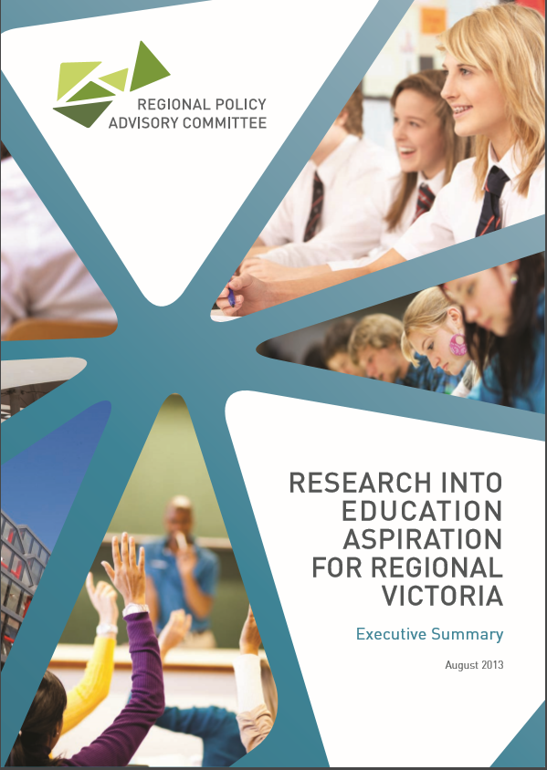
Contents
Foreword 3
About the Regional Policy Advisory Committee 4
Executive Summary 6
Project Scope 6
Project Rationale and Methodology 8
Key Findings 10
Recommendations 14

Accessibility
2
If you would like this publication in an accessible format, such as large print or audio, please phone 13 22 15 (voice calls), or email rdv@vic.gov.au
This document is also available in an accessible format on the internet at www.rdv.vic.gov.au/rpac
© Copyright State of Victoria 2013.
This publication is copyright. No part may be reproduced by any process except in accordance with the provisions of the Copyright Act 1968.

Contact
Regional Policy Advisory Committee
Secretariat
Level 12, 1 Spring Street
Melbourne VIC 3000
T 03 9452 5284
W www.rdv.vic.gov.au/rpac
For a copy of the comprehensive final report on Education Aspiration
for Regional Victoria visit www.rdv.vic.gov.au/rpac

Foreword
Education and skills are critical to the achievement of strong economic growth and the development of vibrant and sustainable communities.

This is as true for regional and rural areas as it is for metropolitan ones. Yet, it is an unfortunate fact that educational attainment and participation rates in regional Victoria remain persistently below those of Melbourne.
The Regional Policy Advisory Committee (RPAC), considers the improvement of these rates to be among the highest priorities for regional development. This report is the result.
In undertaking this work, RPAC was particularly keen to explore the social and cultural factors that influence educational aspiration and engagement in education among students in regional Victoria.
Accordingly, the study focused on:
> reviewing the available evidence relating to the key factors, existing interventions and demonstrated effectiveness of programs which seek to raise the level of education aspiration in regional Victoria.
> providing an evidence base to inform policy and program development focusing on the needs, gaps and success factors identified.
The Committee regards this report as being of great potential value to policymakers and regional communities and institutions, it provides some clear directions for improving aspiration among regional students.
I would particularly like to thank the RPAC
Working Group - Mark Byatt, Ross Lake and Val Lang for its efforts in conducting this research.
On behalf of RPAC, I commend this report and look forward to communicating the findings and recommendations to governments, education bodies and other interested parties to raise awareness and understanding of this important issue.
Ian McClelland
Chair - Regional Policy Advisory Committee

4
About the Regional
Policy Advisory Committee
The Regional Policy Advisory Committee was established under legislation to provide independent advice to the Minister for Regional and Rural Development and Minister for Regional Cities on priorities in regional Victoria; and to monitor and advise on the impacts of legislation and policy decisions on regional and rural Victoria.
Chaired by Ian McClelland OAM, the Committee comprises the chairs of the five non-metropolitan Regional Development Australia committees (RDA’s) plus two other members who have been selected for their experience and expertise in regional industry and community issues.
RPAC has a broad focus to provide external advice to government on the regional impacts of policy and legislation, long-term priorities to support regional growth and prosperity plus any other regional policy matters referred to the Committee by government.

The Members of RPAC are:
- Chair - Ian McClelland OAM
Mr McClelland is most noted as being the founder and is former Chairperson of the Birchip Cropping Group; a highly successful farm support and agricultural research organisation in Victoria’s north-west. Mr McClelland was awarded the Medal of the Order of Australia for service to agriculture, particularly through the development of sustainable crop production systems, and innovative farming and land management practices.
- Mr Bruce Anson
Chairperson of the Barwon South West RDA Committee.
Mr Anson has a career in local government spanning over 40 years, and is currently the Chief Executive Officer of Warrnambool City Council.
- Mr Stuart Benjamin
Chairperson of the Grampians RDA Committee.
Mr Benjamin is a Director of Elmstone Property Group, a land and construction group operating in western Victoria. He is also the Chair of Ballarat Regional Tourism, the peak tourism industry body for that region.
- Mr Mark Byatt
Chairperson of the Hume RDA Committee.
Mr Byatt has been the Mayor of Wodonga since 2008. He has lived in the Hume region for the majority of his life, and is an executive leader with extensive experience in both public and private business sectors including construction, local government, vocational education and training, transport, and tourism.

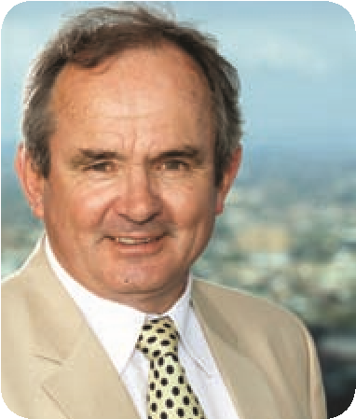
- Ms Jenny Dawson
1.
2.
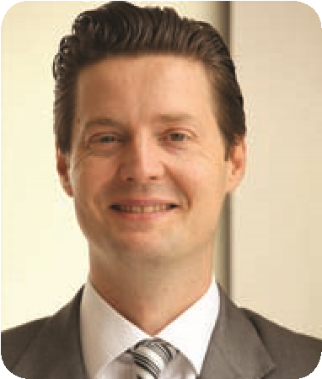
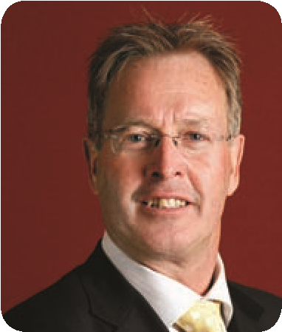
Chairperson of the Loddon Mallee RDA Committee. Ms Dawson is the inaugural Chair of the Regional Development Australia Loddon Mallee Committee; and is also a Non-Executive Director of Bendigo and Adelaide Bank and Chairs their Audit Committee. She also chairs Sandhurst Trustees; is a Trustee for the Anglican Diocese of Bendigo and has recently retired from the Board of Goulburn-Murray Water. Ms Dawson is a Fellow of the Institute of Chartered Accountants and member of the Australian Institute of Company Directors.
3.
4.
- Mr Richard Elkington
Chairperson of the Gippsland RDA Committee.


Mr Elkington worked for more than 40 years in the Latrobe Valley power generation industry and held a number of senior positions. He is a Director of East Gippsland Water and was previously Chair of Gippsland Water. He is also a member of the Clean Coal Victoria Advisory Committee and a long-term member of the Executive Council of the Victorian Employers’ Chamber of Commerce and industry.
5.
6.
- Mr Ross Lake OAM
General Manager of TASCO Inland; a major fuel and oil distributor based in Mildura. Mr Lake received the Medal of the Order of Australia for service to arts administration, to social welfare, and to the community.

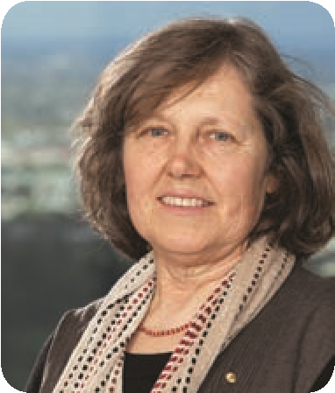
- Ms Val Lang AM
7.
8.
Ms Lang is a graduate of the Australian Rural Leadership Program and Victorian representative for Australian Women in Agriculture.
Ms Lang was made a Member of the Order of Australia for service to women living in rural and regional communities, particularly by improving social and economic conditions through the Foundation for Australian Agricultural Women,
and to the environment, health and education sectors.

Project Scope
Young people in regional Victoria are less likely to complete secondary and post-compulsory qualifications than their metropolitan counterparts.

Project scope
Regional Development Victoria (RDV), at the request of the Regional Policy Advisory Committee (RPAC), commissioned KPMG to research the social and cultural factors that influence aspiration and engagement in education for students in regional Victoria. This study focused on:
> reviewing the evidence available relating to the key factors, existing interventions and demonstrated effectiveness of programs which seek to raise the level of education aspiration in regional Victoria; and
> providing an evidence base to inform policy and program development based on the needs, gaps and success factors identified.

Educational attainment in metropolitan and regional Victoria
6
Executive Summary
This project was commissioned by RPAC because of its concern that the disparity in educational attainment for metropolitan and regional Victorian students is a critical factor limiting the growth and prosperity of Victoria’s regional areas. Despite the known economic, social, health and other benefits associated with education, there continues to be a high level of disparity in educational attainment for Victoria’s metropolitan and regional students at the secondary school and post-compulsory education levels. For example:
> The average apparent retention rate of Years 7-12 Victorian Government school students is 1.25 times higher

in metropolitan schools (90 per cent) compared to those in regional areas (70 per cent).
> Across the entire school system, metropolitan students are on average 1.13 times more likely to complete Year 12 than their regional counterparts.
> Metropolitan students are more likely to participate in higher education or higher-level Vocational Education and Training (VET) courses (i.e. Certificate IV or above) than their regional counterparts. Conversely, regional students are 2.5 times more likely to enter full-time employment directly following school completion than metropolitan students.

Apparent retention rate – Years 7-12 students, Victorian government schools, 2003-2012
Metropolitan areas
Regional areas
Apparent retention rate
(
per percentage
)
84
87
71
87
71
86
70
84
69
86
69
67
86
67
88
69
89
70
90
70
%
100
90
%
%
80
%
70
60
%
50
%
40
%
%
30
20
%
10
%
0
%
2003 2004 2005 2006 2007 2008 2009 2010 2011 2012
Source: Department of Education and Early Childhood Development, Summary Statistics – Victorian Schools (Victorian Government, 2012) Table 22.

Destinations of Year 12 (or Equivalent) Completers, 2012
Metropolitan areas
Regional areas
Percentage of Year 12
or equivalent) completers
(
%
50
%
40
%
30
%
20
%
10
%
0
Bachelor Degree
Certificate IV+
Certificate I-III
Apprenticeship
Traineeship
Employed Full-Time
Employed Part-Time
Looking for work
NILFET
60
%
Source: Department of Education and Early Childhood Development, The On Track Survey 2012: The Destinations of School Leavers in Victoria - Statewide Report (Victorian Government, 2012) Table 11.

Project Rationale and Methodology
A literature review, mapping of existing interventions, workshops and surveys have been employed to develop a holistic view of regional education aspiration.

Project rationale
In light of the disparities in educational attainment between metropolitan and regional Victorian students, and the demonstrated benefits associated with school completion and gaining postcompulsory education qualifications, there is a need for policymakers to:
Understand the nature of ‘education aspiration’ – including the factors that
influence the development of education aspiration, and how (and when) they are
formed.
1
Identify the barriers to aspiration to, and participation in, education in regional
Vict
orian communities.
2
Consider appropriate interventions which seek to raise education aspiration
and overcome any barriers to their development and expression, including the
combination(s) of interventions which are demonstrated to have the greatest
impact and effectiveness.
3
Consider the range of programs, policy levers and interventions currently in
operation in Victoria which seek to raise education aspiration and overcome
barriers to participation in education.
4
Contrast current Victorian offerings against better-practice approaches to
improve education aspiration to pinpoint gaps in the system and/or opportunities
for program enhancement and improvement.
5

Project methodology
A range of activities were undertaken as part of this study, including:
- A literature review of Australian and international evidence concerning the factors and interventions impacting upon student education aspiration.
- Mapping of current policies, programs and interventions in Victoria that seek to directly influence student aspiration.

- Workshops and surveys with stakeholders to: > Test literature review and mapping
findings.
> Identify and develop case studies with demonstrated effectiveness for detailed analysis to identify applicable lessons learnt for future policy development in Victoria.
- A ‘gap analysis’ of current initiatives in Victoria, drawing on findings from the literature review, mapping exercise, workshop and survey responses and case study analysis to identify current gaps in current initiatives in Victoria and suggested potential future interventions and policy levers.

Key Findings
Regional students face a range of barriers to education aspiration and participation, although no single barrier is determinative.
Why is aspiration important in determining educational outcomes?
The formation of education aspiration occurs at a very young age. Indeed, Gottfredson’s theory of Circumscription and Compromise indicates that this process commences as early as three years of age, although the expression of aspiration does not occur until early adolescence.
As outlined below, a range of factors influence a student’s education aspiration.
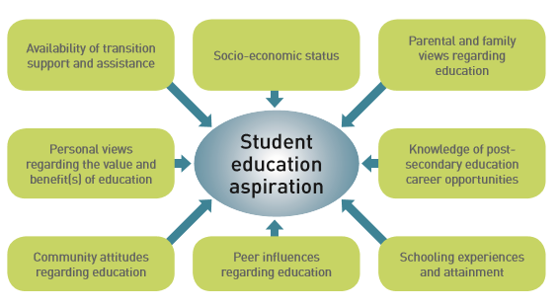
Given this, interventions which seek to raise education aspirations must be appropriately targeted and operate before a child commences internal rationalisation processes which eliminate potential career and education opportunities.

Available Australian and international literature suggests that the major barriers which prevent the development of aspiration and inhibit students’ participation in education and the learning process include:
> | Retention in and completion of secondary education.
> | Personal characteristics and motivations towards education, which are shaped by family, community and peer influences.
> | Awareness of and exposure to post-school education opportunities.
> | Provision of and access to post-secondary education opportunities which may be influenced by geographic isolation and financial constraints.
> | A lack of transition support and assistance for those regional students who elect to undertake post-school qualifications.

Interventions to improve education aspiration
In view of the above, interventions and supports must be multi-faceted to ensure that each barrier is addressed. Such a multi-faceted approach must:
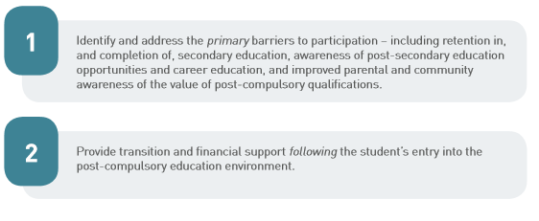

A total of 94 initiatives which seek to raise student aspiration were identified across Victoria

Mapping exercise overview

The mapping of current Victorian interventions identified a total of 94 initiatives designed to raise student aspiration towards school completion and progression to further education and training currently in operation throughout Victoria. The interventions identified canvassed a range of criteria and different parameters, including:
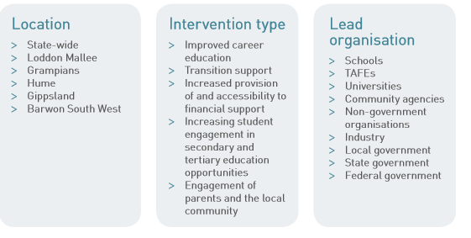
The analysis does not include the range of interventions undertaken by the Department of Education and Early Childhood Development (DEECD) and other bodies that focus on improving student engagement, retention and learning experiences, but only indirectly address student aspiration.

Current Victorian initiatives tend to focus on increasing participation in higher education or improving school retention. Only fifty-two per cent are multi-faceted.
Key findings from the mapping include: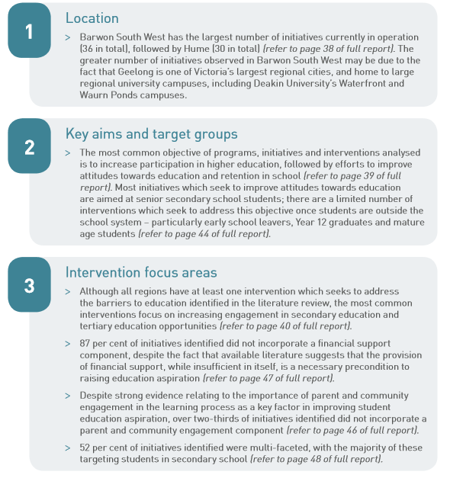 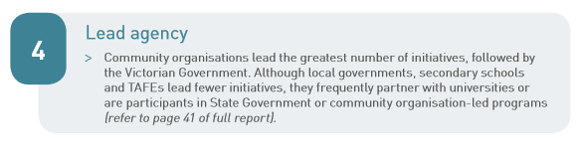
Recommendations
Governments and communities are advised to focus on raising aspiration in the early years, and increasing the prevalence of multi-faceted interventions.

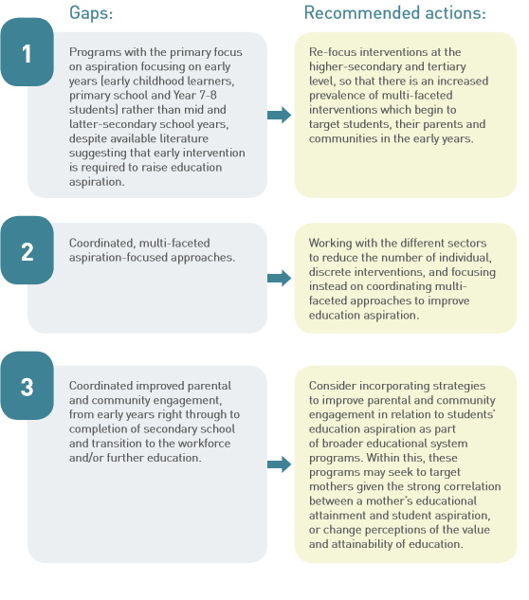-


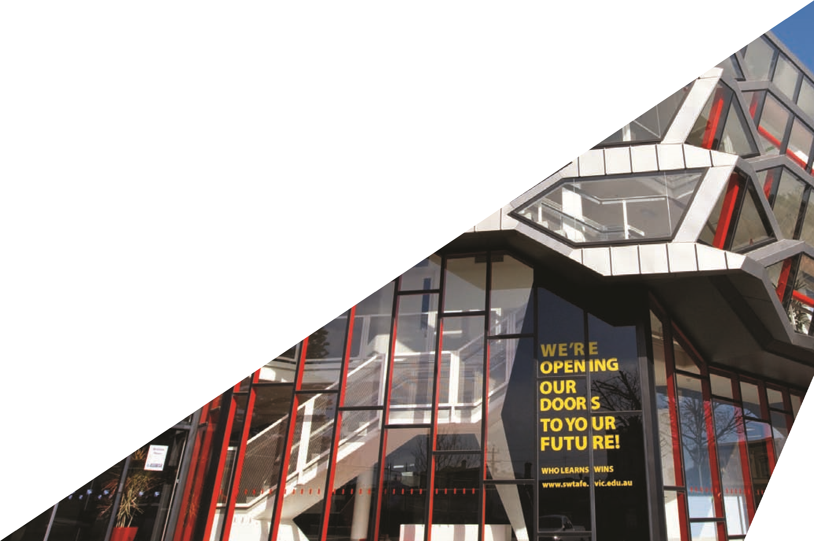
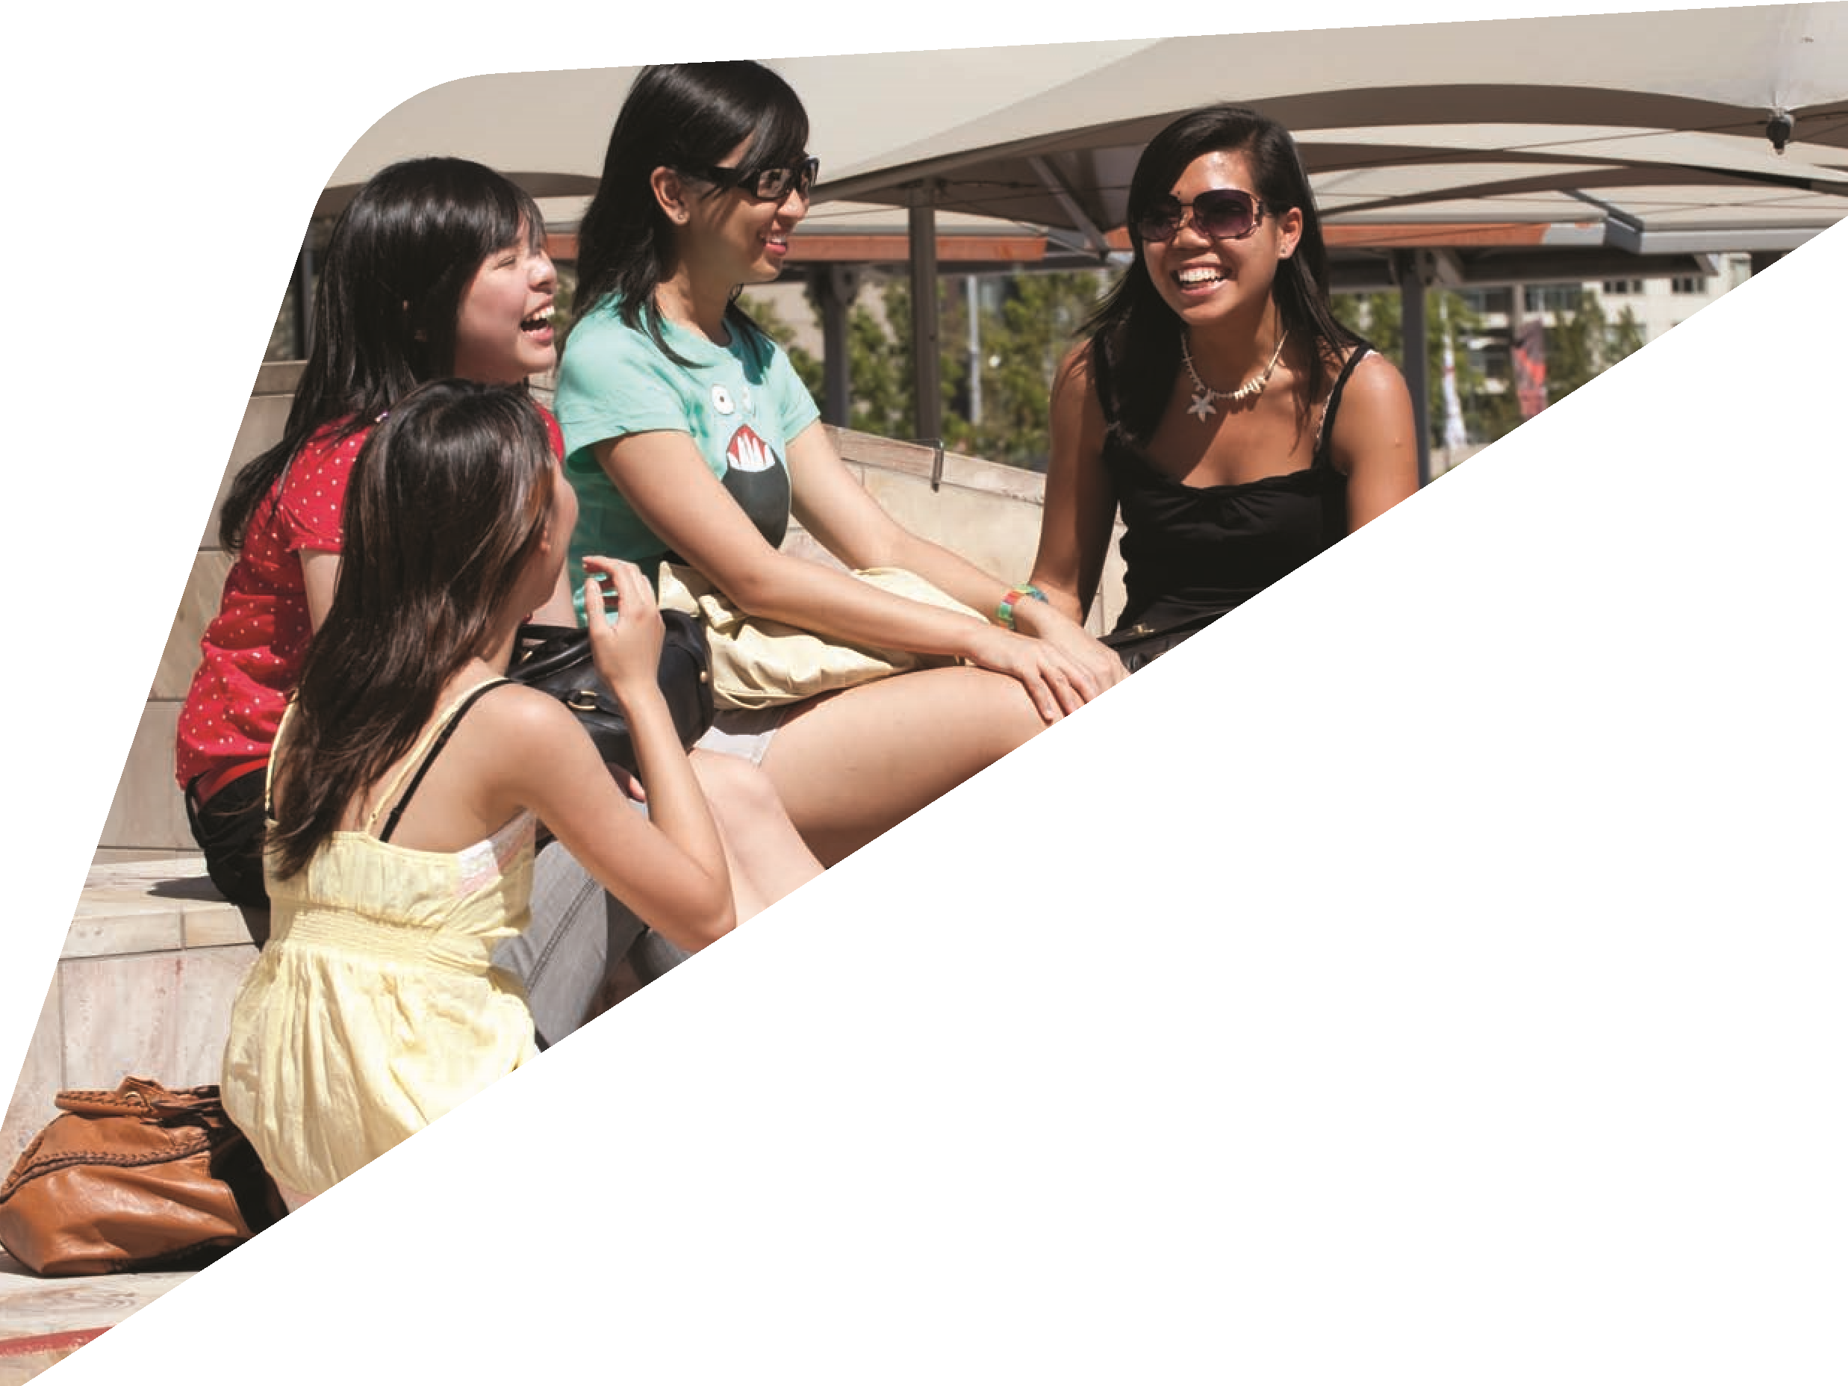

www.rdv.vic.gov.au/rpac
For a copy of the comprehensive
final report on Education Aspiration
for Regional Victoria visit
www.rdv.vic.gov.au/rpac

Regional Development Victoria Information Portal
Great South Coast Regional Partnership State of the Region Report August 2017
Barwon Regional Partnership State of the Region Report August 2017
Barwon Regional Partnership State of the Region Report August 2017
Source for case study – Beyond the Bell Board
Independent review into regional, rural and remote education – Discussion Paper 2017, Emeritus Professor John Halsey
ICSEA is a scale which allows for fair and reasonable comparisons among schools with similar students. ICSEA stands for the Index of Community Socio-Educational Advantage
Source for case study - Geelong Region Local Learning and Employment Network (GRLLEN)
Independent review into regional, rural and remote education – Discussion Paper 2017, Emeritus Professor John Halsey
Case study prepared by Associate Professor David Mackenzie from Swinburne University and Peter Jacobson, Youth Services Manager, Barwon Child Youth Families, and provided by GRLLEN Aug 2017.
Independent review into regional, rural and remote education – Discussion Paper 2017, Emeritus Professor John Halsey
Department of Education and Early Childhood Development, Summary Statistics – Victorian Schools (Victorian Government, 2012) Table 22.
Productivity Commission, Report on Government Services 2013 (Australian Government, 2013) Table 4A.110.
Department of Education and Early Childhood Development, The On Track Survey 2012: The Destinations of School Leavers in Victoria - Statewide Report (Victorian Government, 2012).
Leslie Morrison Gutman and Rodie Akerman, ‘Determinants of aspirations’ (Research Report No 27, Centre for Research on the Wider Benefits of Learning, University of London, 2008) 3.
Education and Training Committee, Parliament of Victoria, Inquiry into Geographical Differences in the Rate in which Victorian Students Participate in Higher Education (2009).

