**Submission to the Independent Review into**

# Regional, Rural and Remote Education

Submitted by:

Ron Broadhead

Executive Officer

Northern Mallee Local Learning and Employment Network

29 August 2017

**Background:**

NMLLEN is a not for profit Incorporated Association whose mission is:

***Brokering strategic partnerships with stakeholder groups resulting in better outcomes in education, training and employment for young people aged 10-19 years.***

NMLLEN’s region is located in North West Victoria and covers the Rural City of Mildura and Robinvale (Swan Hill Rural City).

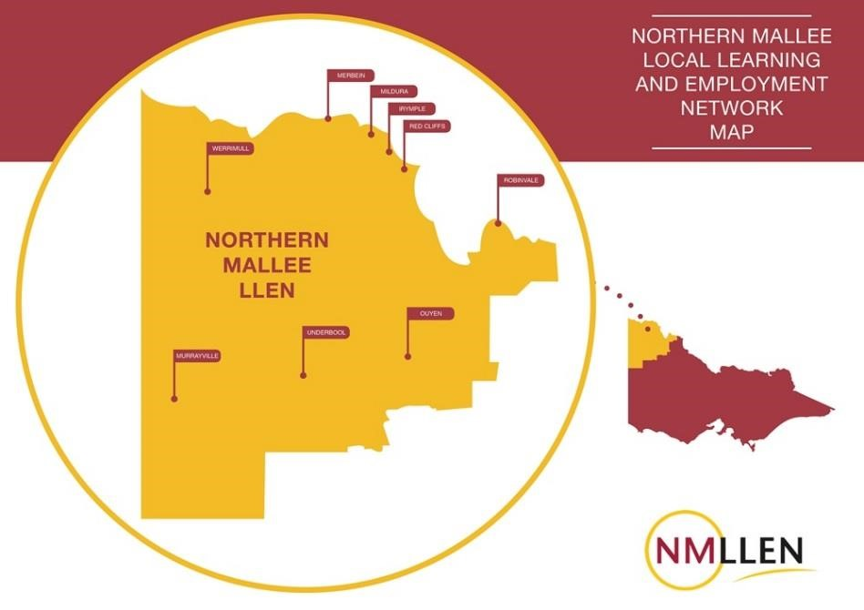

# Theme: Transitioning beyond school

**Student Destinations and Pathways**

TABLE A: Year 12 Completion Destinations

|  | Mildura LGA | Victoria |
| --- | --- | --- |
| Bachelor Degree | 34.81% | 54.18% |
| Cert I-III | 4.07% | 2.55% |
| Cert IV + | 6.67% | 12.03% |
| Apprenticeship | 9.63% | 5.54% |
| Traineeship | 3.70% | 2.52% |
| Deferred | 16.30% | 9.70% |
| Employed F/T | 4.81% | 3.29% |
| Employed P/T | 14.44% | 6.33% |
| Looking for Work | 5.56% | 3.33% |

Source: On Track /NMLLEN

TABLE A lists the proportion of Year 12 Completers in the NMLLEN Region who completed their Year 12 in 2016.

Typically, there are approximately 550 students who complete Year 12 in the NMLLEN region each year.

This table illustrates the percentage of 2016 Year Completers (who completed Victorian Certificate of Education VCE or the Victorian Certificate of Applied Learning VCAL) and their respective destinations.

Points of interest are:

1. The greater percentage of Victorian students (54.18%) going to university compared to the NMLLEN region (34.81%)
2. The higher proportion of NMLLEN region students progressing onto apprenticeships (9.63%) than the State (5.54%)
3. The low proportion of NMLLEN region students (6.67%) progressing onto Certificate IV or higher compared to the state (12.03%)
4. The very high proportion of NMLLEN region students that defer (16.3%) compared to the state (9.7%)
5. The very high proportion of NMLLEN region students (14.44%) in part time employment compared to the state (6.33%).

Comments:

* (a) and (d) need to be considered together. Previous studies by John Polesel (Univ. of Melb.) and others have indicated that about 7 out of every 10 rural students that defer, go onto university the following year. The high deferral rate reflects the economic costs borne by families in enabling their son or daughter to relocate to Melbourne or Adelaide to pursue university studies. Many students defer so as to work in order to qualify for the Independent Living Allowance or save as much as they can before commencing their studies.

If you take into account those that progress onto university after deferring for 12 months, the proportion of Year 12 completers going to university rises to 46.22% (estimated). Similarly, the State figure rises to 60.98% (estimated) which is a 14.75 percentage points gap, down from an initial 19.37 percentage points gap.

* Apprenticeships are a strong pathway for Year 12 completers in this region (nearly double the state average).
* The low proportion of NMLLEN region’s students progressing onto Certificate IV, Diploma or

Advanced Diploma studies is of concern. This may reflect a lack of appropriate courses offered at the

local TAFE Institute (Sunraysia Institute of TAFE) due to ‘thin’ markets, or the choice of University over TAFE.

* The very high proportion of Year 12 completers in part time employment in the NMLLEN region. This may reflect a high degree of underemployment or that students, after completing Year 12, maintain their existing part time job they had whilst at school, while they try to find full time employment.

Overall comment.

Parents and students are faced with difficult and complex choices about future educational pathways. There is an almost automatic assumption that every child entering secondary should go to university. Secondary schools in this region see their prime purpose is to prepare young people for university. The oversupply that is now occurring in some graduate markets (which is likely to become more prevalent in the future) means that parents and young people need access to up to date information on the changing labour markets and the opportunity costs of choosing one educational pathway over another. For example, the choice between a university pathway (including relocating and living in a city away from home; accumulating a HECS debt; and the prospect of unemployment) or a vocational pathway to skills training at the local TAFE leading to employment. This choice is overlaid with the ‘value’ that is placed by society on someone who has a university degree over someone that does not. In the end it is about balance. What is the ‘right’ proportion of young people leaving rural communities to pursue higher education and the proportion who remain to forge a career in rural and regional industry.

Overlaid on the above is the changing nature of work and how the new world of work will impact on rural and regional communities.

Observing the local education scene over the past 30 years, it appears that more young people are ‘disengaging’ from education, and of those that remain, increasingly more young people do not know what they want to do in terms of future career directions and hence educational pathways. They aimlessly continue through schooling to Year 12 to go to university with no idea what they want to do.

Recent discussions with industry by the Victorian Skills Commissioner to identify future skill needs and employment growth opportunities highlighted the following:

* The horticultural and agricultural industries of this region see strong growth due to improved international markets for fresh food and produce, especially by Asian markets. This growth has a spill over effect into transport, logistics, warehousing, business services and other support industries.
* For industry to respond to this growth there is a shortfall of skilled labour across a wide range of employment categories.
* A realisation by industry that it needs to work much more closely with schools to promote and inform young people and parents of these employment opportunities and the vocational pathways to these opportunities. However, the school sector is heavily geared to university entrance and less to vocational pathways. The challenge will be to strengthen vocational education and training in schools.

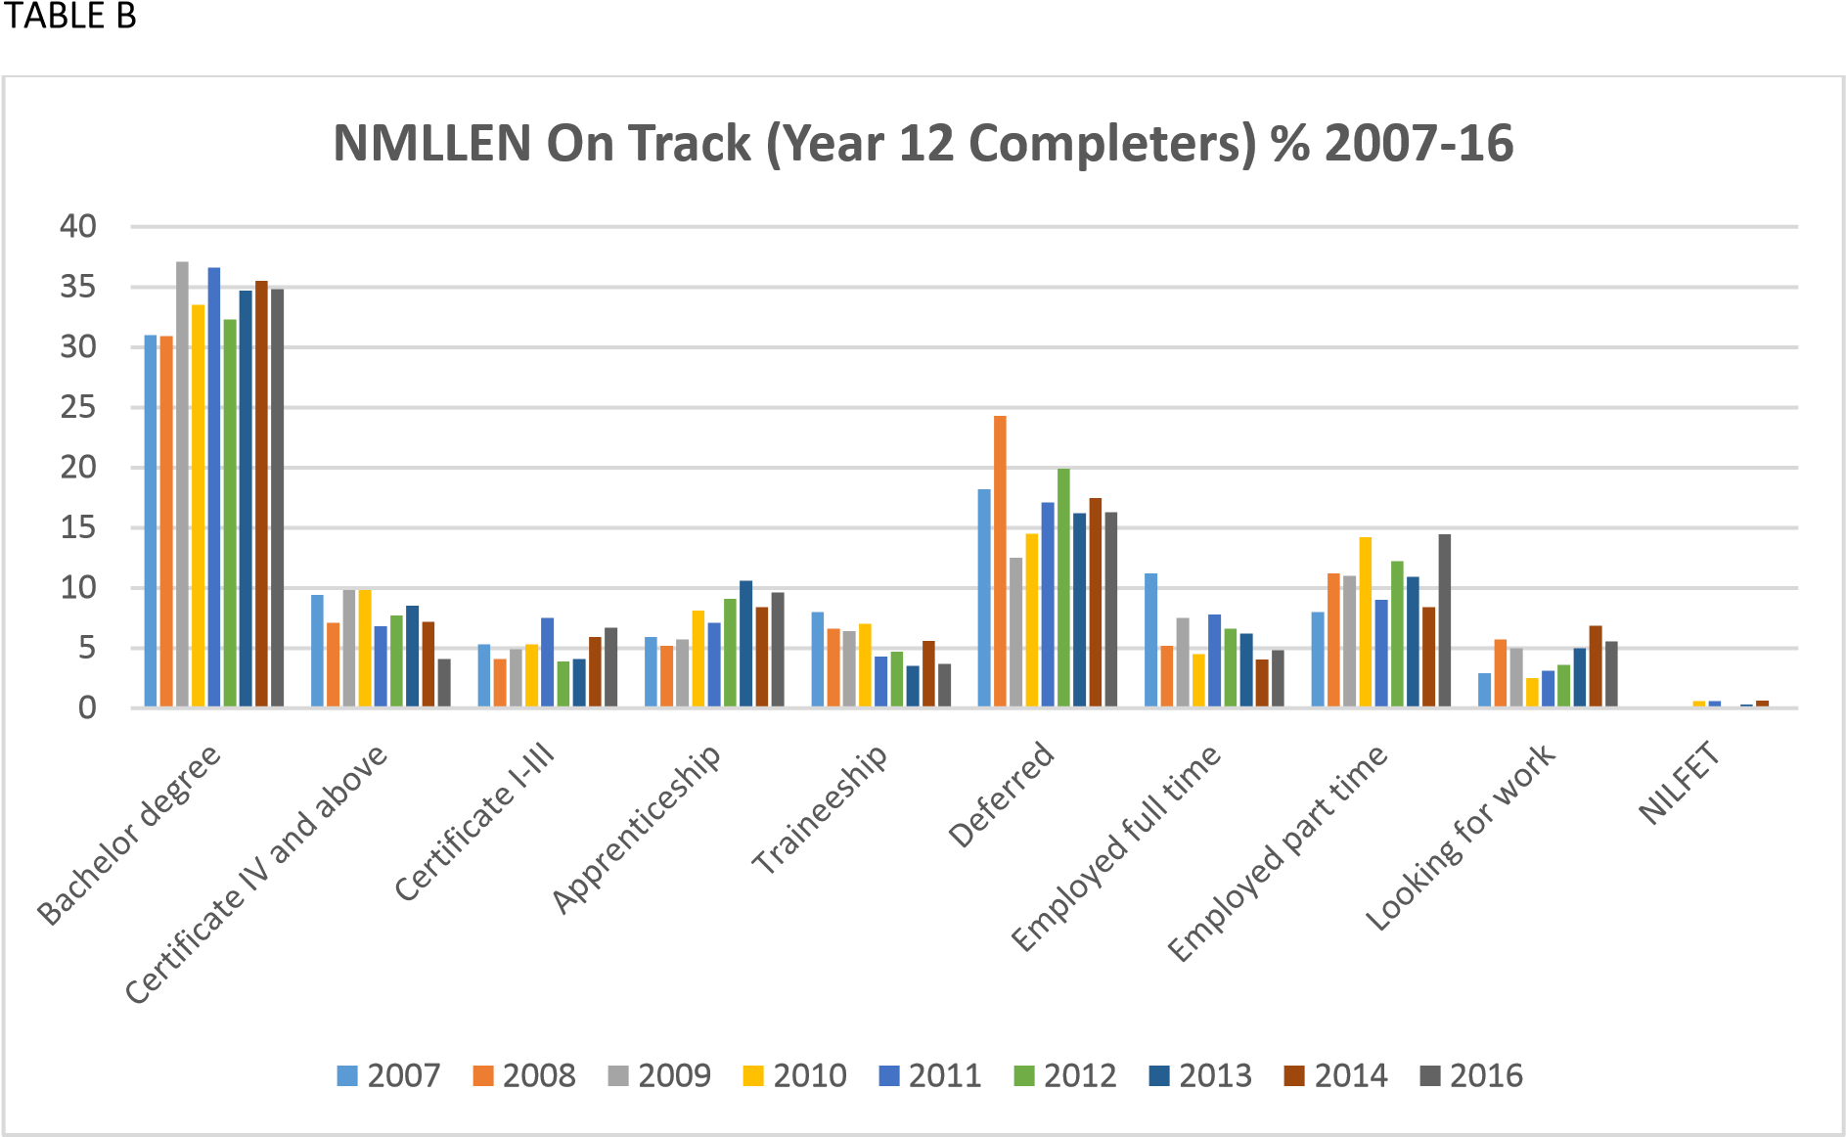

TABLE B illustrates the trends in destinations for Year 12 completers in the NMLLEN region.

Trends include:

* Increasing proportion of Y12 completers going to university.
* Declining proportion of Y12 completers enrolling in higher level TAFE courses (Cert IV +)
* Increasing proportion of Y12 completers enrolling in entry level TAFE courses (Cert I-III)
* Increasing proportion of Y12 completers entering apprenticeships
* Declining proportion of Y12 completers entering traineeships
* Declining proportion of Y12 completers gaining full time employment
* Increasing proportion of Y12 completers gaining part time employment
* Increasing proportion of Y12 completers looking for work

Comments:

* The impact of reduction of employer subsidies for taking on traineeships has contributed to this decline. Discussions with industry indicate that they believe that traineeships are a good vehicle for recruiting young people into their organisations and see a good future for this model.
* More needs to be done to address the decline of young people entering higher level TAFE courses.
* Continue to build support for apprenticeships.

# Theme: School and community

Sub theme: Addressing disengagement

## Background

The ABS Census data in 2006 and 2011 gave statistical evidence of a persistent and increasing issue in the Northern Mallee region. Too many young people were not completing their secondary schooling and were not moving into further training or employment.

**Table 1: Percentage of young people not in paid employment or education/training (Mildura LGA**

| Age |  | 15-19 |  |  | 20-24 |  |  | 15-24 |  |
| --- | --- | --- | --- | --- | --- | --- | --- | --- | --- |
| 2011 | Males | Females | **Total** | Males | Females | **Total** | Males | Females | **Total** |
| 167 | 158 | 325 | 272 | 352 | 624 | 439 | 510 | 949 |
| 9.0% | 8.7% | 8.8% | 18.9% | 24.7% | 21.7% |  |  |  |
| Age |  | 15-19 |  |  | 20-24 |  |  | 15-24 |  |
| 2006 | Males | Females | **Total** | Males | Females | **Total** | Males | Females | **Total** |
| 156 | 160 | 316 | 203 | 303 | 506 | 359 | 463 | 822 |
| 8.5% | 9.0% | 8.8% | 15.7% | 22.0% | 19.0% |  |  |  |

Source: ABS Census data 2006, 2011

## FLO in Schools and FLO Connect

An opportunity to begin to address this issue arose through Youth Partnerships – a Victorian Government initiative to design and test new ways for the education, youth and family support, justice, homelessness and mental health sectors to work more collaboratively in supporting young people experiencing problems. The key goal of Youth Partnerships (YP) was to improve engagement in education and training and to reduce the escalation of social, individual and behavioural problems for vulnerable young people.

The YP pilot program for the Northern Mallee involved a partnership including the Department of Education and Early Childhood Development (DEECD), Mildura Rural City Council, NMLLEN and local secondary schools to develop and support Flexible Learning Options in School Programs for students at risk of disengaging.

Flexible Learning Options in schools (FLOiS) Programs were established in six local secondary schools as part of the Youth Partnerships Northern Mallee Project set up in 2012.

The schools involved were:

Chaffey Secondary College Irymple secondary College Merbein P-10 College

Mildura Senior College

Red Cliffs Secondary College

Robinvale College

FLOiS Programs consisted of individual learning programs, community programs and case management for students who were at risk of disengaging from education too early. Schools dedicated staff and other resources to the program and they were supported by a DEECD Project Officer. Across the six schools there were 80 students involved in the program in 2012 and 90 students in 2013.

NMLLEN has supported the schools since the beginning of the project at the strategic level as well as with communications and data collection. The data collection includes information about the programs in each school as well as tracking the engagement and destination of students who had been engaged in the FLOiS programs.

Funding for the Youth Partnerships Pilot Program ceased in 2014. Five of the six schools continued to offer FLO in schools programs to their students in 2014 while at the same a new re-engagement setting known as FLO Connect was opened in Mildura in February 2014.

FLO Connect is a cooperative arrangement with Red Cliffs Secondary College as the host school with Mildura Rural City Council as a co-located partner to provide case management for the young people. Much work and support was also contributed by DEECD, NMLLEN and other community agencies. FLO Connect was an extension of the FLOiS programs to offer a pathway for students who had already disengaged and left school to reconnect and explore further education, training and employment options.

**Table 18: Number of students reported as remaining engaged in education, training or employment in the year following engagement in FLO program:**

|  |  | Education | | Training | | Employment | | Total engaged | | Other | |
| --- | --- | --- | --- | --- | --- | --- | --- | --- | --- | --- | --- |
| Year engaged in FLO | Program | No | **%** | No | % | No | **%** | No | **%** | No | % |
| 2012 | FLOiS | 22 | **36** | 14 | **23** | 7 | **11** | 43 | **70** | 19 | 30 |
| 2013 | FLOiS | 39 | **64** | 5 | **8** | 2 | **3** | 46 | **75** | 15 | 25 |
| 2014 | FLOiS | 75 | 75 | 18 | 18 | 3 | 3 | 96 | 96 | 4 | 4 |
| FC | 36 | 86 | 4 | 10 | 2 | 5 | 42 | 66 | 22 | 34 |
| Total | 111 | **64** | 22 | **13** | 5 | **3** | 148 | **85** | 26 | 15 |
| 2015 | FLOiS | 86 | 80 | 6 | 6 | 2 | 2 | 94 | 88 | 13 | 12 |
| FC | 37 | 55 | 14 | 21 | 5 | 7 | 56 | 84 | 11 | 16 |
| Total | 123 | **71** | 20 | **11** | 7 | **4** | 150 | **86** | 24 | 14 |
| 2016 | FLOiS | 79 | 77 | 10 | 10 | 4 | 4 | 93 | 90 | 10 | 10 |
| FC | 60 | 69 | 6 | 7 | 5 | 6 | 71 | 82 | 16 | 18 |
| Total | 139 | **73** | 16 | **8** | 9 | **5** | 164 | **86** | 26 | 14 |

Table 18 provides a snap shot of the enrolments in the FLO in Schools (FLOiS) program 2012-16 and the FLO Connect (FC) program 2014-16 and the associated outcomes ie. the number/proportion of students who were still engaged in education, training or employment the following year.

In summary, FLO in Schools was designed to keep young people at high risk of leaving school to remain engaged with school, whilst FLO Connect was designed to re-engage young people who had left education.

• FLO in Schools outcomes have increased from 70% in 2012 to 90% in 2016. • FLO Connect outcomes have increased from 66% in 2014 to 86% in 2016.

**In combination, both these programs will have a significant impact on the ABS data to be published in October 2017, of young people who are not engaged in education, training or employment.**