

**Professor Colin Stirling**

President and Vice-Chancellor

GPO Box 2100

Adelaide SA 5001

Telephone: +61 8 8201 2101

Email: [colin.stirling@flinders.edu.au](mailto:colin.stirling@flinders.edu.au) [www.flinders.edu.au](http://www.flinders.edu.au/)

28 February 2019

The Hon Robert S French AC Suite 2, Level 13

Allendale Square

77 St George's Terrace Perth WA 6000

Dear Mr French

# Review of Freedom of Speech in Higher Education Providers

Thank you for your letter dated 8 February 2019 requesting our comments in relation to the draft Model Code provided under cover of the letter.

Flinders University is an institution that has a strong commitment to defending and promoting freedom of speech and welcomes the opportunity to work collaboratively with the Review and provide comments in relation to the draft Model Code. We set out our comments below

– first, an overarching comment in relation to the need for a Code and secondly, some specific comments in relation to the terms of the draft Code.

# Need for a Code

Our first overarching comment relates to the need for a Code. We note the point made in your letter that you have not been persuaded that a *'free speech crisis'* exists in the Australian higher education sector. We agree with that observation and accordingly, are surprised that a Code is being proposed at all. In our view, a Code is unnecessary.

We understand that the Code is intended to be voluntary, in that, universities will be free to adopt the Code in full, partially or not at all. However, there will be a strong expectation on the part of the Government for most, if not all, universities and higher education providers to adopt the Code. Otherwise, what is the point of enacting one?

As you would be aware, there is no right of freedom of speech enshrined in Australian law. However, the strong expectation that the Code will be adopted will result in universities and other higher education providers being subject to what is akin to a freedom of speech law, when such a law does not exist anywhere else in Australia.

We do not support the concept of a Code as it is unnecessary and creates one set of rules for higher education and another for the rest of the community.

# Specific comments on the terms of the draft Code

Should a Code be enacted notwithstanding our views above, we make the following specific comments in relation to the terms of the draft Code.

* 1. Underpinning principle

**inspiring**

**achievement**

We note the principle expressed in the draft Code that all staff and students in Australian universities should have the same freedom of speech as *'any other person in Australia'.* We agree that that is a reasonable principle. However, the draft Code as currently written goes beyond that principle and on the face of it seeks to create more expansive freedoms of speech in the Australian higher education sector than in the general community.

The freedom of speech enjoyed in the general community is subject to competing interests and rights such the strategic, commercial, operational and organisational interests, property rights and employer rights of the organisations with which they are associated or employed by. The draft Code on the other hand explicitly or by implication either rejects these interests and rights or requires them to be subservient to free speech, in particular:

* + - the 4 permissible constraints to free speech referred to in paragraph (1) under the **Objects** section are exhaustive, which implies that none of the other interests and rights referred to above are permissible constraints;
    - paragraph (3) under the **Operation** section which requires the Code to prevail over all rules, by-laws, policies etc of the university;
    - paragraph (4) under the **Operation** section which effectively requires free speech to prevail over the university's powers under contract or workplace agreements and property rights;
    - the 3 permissible constraints to free speech referred to in paragraph (1) under the **Principles of the Code** section are exhaustive, which implies that none of the other interests and rights referred to above are permissible constraints ***(NB.*** curiously, the 3 constraints referred to in this section do not include conditions imposed by law or legal duties of care as permissible constraints, as referred to in the Objects, the effect of which would be that the exercise of free speech in universities would not be subject to conditions imposed by law or legal duties of care);
    - paragraph (3) under the **Principles of the Code** section when read together with the *"academic freedom"* definition, which effectively prohibits the university from taking any disciplinary action against academic staff even if they breach their employment obligations by disclosing confidential information or damaging their employer's interests by bringing the university into disrepute through their comments and opinions;
    - paragraph (4) under the **Principles of the Code** which requires the university to *"take all reasonable steps"* to negotiate its contractual, funding and other agreements in such a way as to minimise any constraints on free speech;
    - paragraph (6) under the **Principles of the Code** which restricts the right of the university as a property owner from having absolute discretion in choosing whether to refuse or allow an external speaker onto its land.

Organisations, employers and property owners outside the higher education sector do not have any of these restrictions imposed on their rights and powers. They are not required to treat free speech as a *"paramount value"* in their dealings with employees, members, customers, business associates, suppliers and others, nor are

they required to interpret their contractual and property rights and powers in such a way as to give effect to free speech. They are also able to take disciplinary action against employees who breach their employment obligations by bringing the employer into disrepute through their comments and opinions.

The terms of the Code clearly goes beyond the principle of ensuring that all staff and students in Australian universities have the same freedom of speech as *'any other person in Australia'.*

* 1. Freedom of speech and academic freedom

We note the attempt to distinguish between freedom of speech and academic freedom in the draft Code. However, we think that it creates significant confusion or worse, two separate freedom of speech regimes in the university, one for academic staff and students, and another for non-academic staff.

For example, paragraph (3) under the **Principles of the Code** section states that the exercise of academic freedom by academic staff or students shall not constitute misconduct or attract any penalty or adverse action. There are no constraints expressed in paragraph (3) on the exercise of academic freedom (unlike paragraph

(2) which expressly refers to reasonable and proportionate regulation) nor are there any in the 7 sub-paragraphs making up the definition of *"academic freedom"* on page 2 of the draft Code. Does this mean that the expression of views and opinions by academic staff or students is not subject to reasonable and proportionate regulation or any of the other permissible constraints expressed in the Code, but that same expression of views and opinions by other persons (eg. non-academic staff) is subject to such regulation? Is it intended that academic freedom is not subject to any of the constraints expressed in the rest of the draft Code?

We can only assume that this was unintentional but as currently drafted it is open to that type of argument or interpretation.

* 1. Application of the Code

The draft Code is expressed to apply to the university's governing body, officers, employees, decision making organs and the student representative body, but not students or visitors. We assume that this is an error as various provisions of the draft Code as currently drafted apply to students and visitors.

I reiterate that Flinders University strongly supports free speech and is committed to defending and promoting it on our campuses. However, we do not believe a Code is necessary and to the extent that one is enacted, it should reflect the freedom of speech and constraints applicable to *'any other person in Australia',* no more and no less.

We have no objection to this response or the response to your previous letter being published on the departmental website. For your information, we have provided a copy of this letter to Universities Australia.

Please do not hesitate to contact myself or Mr David Lim, University Secretary via [david.lim@flinders.edu.au](mailto:david.lim@flinders.edu.au) should you have any queries or wish to discuss any aspect of our response.

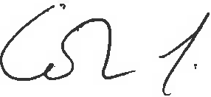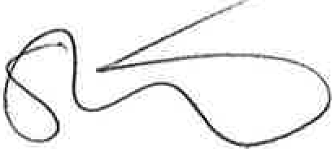Yours sincerely

Professor Colin Stirling President and Vice-Chancellor

*cc. Universities Australia*

**Mr David Lim University Secretary**



GPO Box 2100

Adelaide SA 5001

P: : +61 8 8201 2887

[david.lim@flinders.edu.au](mailto:david.lim@flinders.edu.au) [www.flinders.edu.au](http://www.flinders.edu.au/)

*File ref: CF16/236*

1 March 2019

The Hon Robert S French AC Suite 2, Level 13

Allendale Square

77 St George's Terrace

PERTHWA 6000

Dear Mr French

I write in response to your letter to our Chancellor, Mr Stephen Gerlach AM, regarding the Review into Freedom of Speech at Australian Universities and the opportunity to make a submission to the Review.

Mr Gerlach would like to express his agreement with the letter that was sent on 28 February 2019 from our Vice-Chancellor commenting on the draft Model Code proposed by the French Review.

Thank you for the opportunity to provide our views on this subject. Yours sincrely

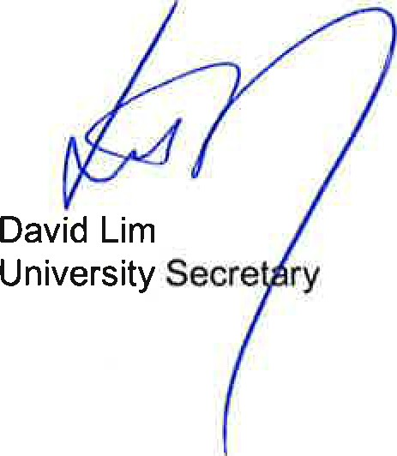



# INSPIRING

**ACHIEVEMENT**

