**OFFICE OF THE VICE- CHANCELLOR**

**Professor S Bruce Dowton**

MB BS MD FACMG FRACP

Vice-Chancellor and President

# MACQUARIE

## University

SYDNEY· AUSTRALIA

13 March 2019

The Hon Robert S French AC Suite 2, Level 13

Allendale Square

77 St George's Terrace Perth WA 6000

Email: freedomofspeechreview@education.gov_au

sulcsj@bigpond.com

Dear Mr French

#### Review of Freedom of Speech in Higher Education

**Response from Macquarie University on the Draft Model Code (Draft Code)**

Thank you for your letter of 8 February 2019 on the Draft Model Code and the opportunity to make the following points.

1. The University is committed to the principles of academic freedom, freedom of speech and freedom of association. It has policies in place which protect these freedoms and an Enterprise Agreement which provides for these freedoms in a legally binding and agreed way and which has been developed over time with mutual understanding between staff and the University.

The proposed implementation of the Draft Code as a legislative rule which enshrines "paramount values" is not appropriate. It will create uncertainty and potentially give rise to unnecessary disputes and litigation. There is a real risk that the Draft Code will become a default ground of complaint or defence in matters of student or staff conduct even where the principles set out in the Draft Code are tangential to the substance of the matter. The relationship between Principles (2) and (3) of the Draft Code is not clear.

*If a code is considered necessary, we suggest a statement of principles which Universities agree to implement through their policies, procedures and Enterprise Agreements.*

1. Key terms in the Draft Code are not sufficiently defined and not used consistently. We appreciate that this is acknowledged in your letter.

The definition of academic freedom in the Draft Code for example, includes *freedom to make public comment on any issue in their personal capacities..."* and therefore includes at least a significant element of freedom of speech generally. This is confusing.

Macquarie University NSW 2109 Australia

T: +612 9850 7440

**E:** [vc@mq.edu.au](mailto:vc@mq.edu.au) mq.edu.au

ABN 90 952 801 237

CRJCOS Provider 00002J

Page 1of2

# MACQUARIE

## University

SYDNEY · AUSTRALIA

In addition to the terms *freedom of lawful speech; freedom of speech; freedom of intellectual inquiry* and *academic freedom,* the Draft Code also uses the term *lawful expressive conduct.*

### We suggest definitions of key terms and that those terms are used clearly and consistently in the document.

1. The Draft Code does not address sufficiently the legitimate constraints and responsibilities which should attach to freedom of speech or academic freedom. Examples of this are:
   1. actions which may inhibit freedom of speech/academic freedom;
   2. the requirement to act reasonably and in good faith;
   3. the University's obligations to provide a safe working environment; and
   4. in particular, the need to avoid associating speech or actions with the University when the speech or actions are not within that person's field of scholarship/research. This creates a significant and inappropriate risk for the University.

*The Draft Code should make better provision for reasonable responsibilities of those who are exercising the rights conferred by the Code and make more comprehensive provision for the balancing and management of competing rights and interests.*

Again, I wish you well with your Review and of course would be happy to provide any further information you might need.

Sincerely

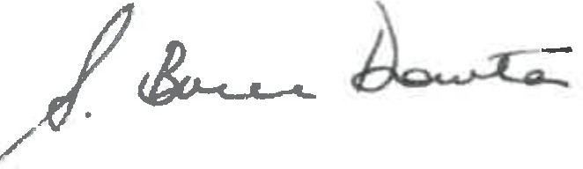

S Bruce Dowton