The Hon Robert S French AC Suite 2, Level13

Allendale Square

77 St George's Terrace Perth, WA 60000

email: [freedomofspeechreview@education.gov.au](mailto:freedomofspeechreview@education.gov.au)

21th January 2019

## Dear Mr French,

Thank you for the opportunity to provide feedback and comment on the Freedom of Expression and Intellectual Inquiry in Higher Education.

The preamble to the *Batchelor Institute of Indigenous Tertiary Education Act* (the Act) establishes the Institute as:

*“an educational institution for the tertiary education of Indigenous people of Australia* and the provision of other educational and training programs and courses, and facilities and resources for research and study, and for related purposes”.

## The Institute is unique in that it is the only dual-sector, Aboriginal and Torres Strait Islander tertiary education and training provider in Australia. This impacts directly on the strategic, operational, governance, legislative and cultural requirements of the Institute.

The following is provided in relation to the information that you sought in your letter to our CEO, Professor Steve Larkin of 29 November 2018.

1. **University statutes, regulations, rules or by-laws, not available on the University website, relating to expressive conduct by staff or students or persons visiting the University for the purpose of delivering speeches or lectures or otherwise engaging in public discussion.**

The Institute has the following relevant documents:

* 1. Staff Code of Conduct (See Attachment A)

*s2. Academic Freedom: means the right to examine, criticise and challenge* ideas, methods and structures in the spirit of a responsible and honest search for knowledge, but does not include a protected privilege to speak out on matters about Batchelor Institute which are not in the individual staff

Batchelor Campus

C/O Post Office, Batchelor NT 0845

ABN 32 039 179 166

Freecall 1800 677 095

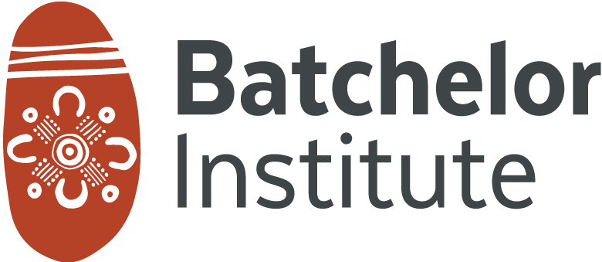Email [enquires@batchelor.edu.au](mailto:enquires@batchelor.edu.au)

**batchelor.edu.au**

*member’s area of expertise or where they may reasonably be expected to* not have all pertinent facts, to deride or defame individuals, groups or Batchelor Institute or to ignore the policies or decisions that have been formally made by Batchelor institute, or those which Batchelor Institute is required by law to observe;

# Administrative codes, policies or principles relating to the above including internal audit and risk policies and practices and standard provisions in academic employment contracts.

## The Institute has the following policies:

* 1. Free Intellectual Inquiry Policy (See Attachment B)

s1.2. *Academic freedom is the right and responsibility of all staff and students at* the Institute. This freedom is particularly important to Batchelor Institute since as an Indigenous institution it has the responsibility to hear and honour Indigenous voices, and to encourage researchers to challenge the established ways of acquiring and interpreting knowledge pertaining to Indigenous peoples, particularly that which has permeated and persisted from Australia’s colonial heritage.

s1.4. *A fundamental philosophy of the Institute is the Both-ways approach. While* originally a philosophy of education that brings together Indigenous Australian traditions with western academic disciplinary contexts it also frames many of the administrative, operational and support activities of the Institute; including the Institute’s approach to academic freedom and intellectual inquiry. Both-ways impacts how the Institute views issues of academic freedom and intellectual inquiry, because integral to both-ways thinking are principles of respect, tolerance and diversity; which are aimed at the well-being and protection of individuals, families, clans and communities.

## Communication Standards Policy (See Attachment C)

S3. *All staff and student communications in which the Institute has a reasonable* interest must be made in a way that reflects:

* + - *the Institute’s core values.*
    - *the induction provided to all staff and students with specific emphasis on an appreciation for Aboriginal and Torres Strait Islander knowledges and cultures and the Both Ways approach.*
    - *Does not breach any laws or other Institute policies and specifically must not communicate any offensive, discriminatory, pornographic or illegal content.*
    - *Does not foreseeably risk a financial loss or reputational harm to the Institute, or its staff, students or stakeholders.*

## Fair Treatment, Equal Benefits and Opportunity Policy (See Attachment D)

*s1. Batchelor Institute of Indigenous Tertiary Education (The Institute) supports* the concept of equal opportunity and is committed to providing all staff, students and potential students with a working and learning environment which values diversity, respects differences and provides an environment that is safe, healthy, positive, supportive and free from all forms of harassment, bullying and discrimination.

# Any of the above categories which deal with the topic of academic freedom.

## See above.

1. **The reports of relevant non-confidential reviews which your university may have undertaken in relation to its rules, policies and practices in this area.**

Nil

1. **Any observations that you would like to make which you think might be helpful to the Review.**

There are various conceptual understanding and practical applications and challenges which impact on freedom of expression and inquiry at the Batchelor Institute. Intellectual expression and inquiry are important practices which have the potential to empower Aboriginal and Torres Strait Islander people. It also allows opportunities for the diversity between Aboriginal and Torres Strait Islanders to be reflected.

Being a dual sector organisation, the application of freedom of expression and inquiry at the Institute is not limited to the higher education area. The principle applies across both the VET and Higher Education sectors as well as other corporate areas. The challenge is ensuring the responsibilities attached to the right of freedom of expression are upheld and demonstrated in an appropriate manner.

Unlike other educational organisations, Batchelor Institute is driven by valuing the rights of Aboriginal and Torres Strait Islander peoples to fully participate in, and contribute to, high value dual sector education, training and research. In recognising this, there is a requirement to allow a freedom of expression and inquiry that enables Aboriginal and Torres Strait Islander knowledges, experiences and cultural contexts to be included within a mainstream academic disciplinary approach. An example of this at the Institute has been the conduct of Indigenous Knowledge Forums where participants have been able to come together in an environment of cultural safety where issues can be freely discussed.

Overall, the approach of the Institute is to affirm the aspiration of self-determination and empowerment of Aboriginal and Torres Strait Islander peoples through our work, courses and research; while enabling this to be achieved in an environment where our students and staff are culturally and intellectually safe, and able to engage in free expression, inquiry and discourse.

Please do not hesitate to contact me if you require further information. Yours sincerely,



**Dr Peter Stephenson**

**Acting Chief Executive Officer**

Phone: (08) 8939 7345

[peter.stephenson@batchelor.edu.au](mailto:peter.stephenson@batchelor.edu.au)

Attachments:

1. Staff Code of Conduct,
2. Free Intellectual Inquiry Policy,
3. Communications Standards Policy, and
4. Fair Treatment, Equal Benefits and Opportunity Policy.