

Australian Lesbian Health Coalition’s (ALHeC’s) Submission to Former Chief Justice of the High Court Robert French’s
Review into University Freedom of Speech

17th January, 2019

Secretariat for Freedom of Speech Review Quality and Access Branch
Higher Education Group
Australian Government Department of Education and Training Via email: freedomofspeechreview@education.gov.au

Dear Hon Mr Robert French AC,

Thank you for the opportunity to make a submission to the Review into University Freedom of Speech.

We agree that there is an urgent need ‘to promote and protect freedom of expression’ and, particularly, ‘freedom of intellectual inquiry in higher education’ – in the context of both national and international trans-activists’ efforts to de-platform feminists and lesbians from even being able to speak in public at universities.

We provide evidence which we hope will inform the Review into University Freedom of Speech’s deliberations as to how universities’ Standards, policies and practices are - or are not - being employed to promote and protect freedom of expression and freedom of intellectual inquiry.

In acknowledgement of the specific - and complex - challenges and needs of indigenous Australians, the Australian Lesbian Health Coalition respectfully requests that special consideration be given by this Review to freedom of speech as it affects the human rights of Aboriginal and Torres Strait Islander peoples

About the Australian Lesbian Health Coalition (AlHeC)

The Australian Lesbian Health Coalition (ALHeC) was founded by, and for the benefit of, lesbians, in recognition that discrimination against lesbians can often be different from discrimination against gay men, bisexual, transgendered and intersex people, by virtue of their sex. Hence, lesbians often experience the intersecting forces of both sexism and heterosexism (Brennan and Hungerford, 2011; Szymanski, 2005). Lesbians face these

discriminations not only from the broader community, but also from within the GLBTI community/ies.
ALHeC is a grassroots organisation representing almost 600 lesbians in every State and Territory of Australia. Our main activities include promoting lesbians’ health and human rights; challenging discrimination against lesbians; and undertaking research, policy analysis, advocacy, and training.

Introduction

Feminists’ and lesbians’ freedom of expression and intellectual inquiry in universities are both under siege throughout the world. We do not say this lightly - and we will present evidence to back up this statement.
We quote both Australian and overseas case studies, since the Terms of Reference of this Review include comparing international experience with Australian universities’ Standards, policies and practices.
So the question becomes: freedom of speech for whom? Who gets to speak? And why is it usually feminists and women who are no-platformed at universities, i.e. forbidden to speak, or censored in different ways? (Although there are occasional exceptions, such as Bob Carr at last year’s Brisbane Writers’ Festival). The term ‘no-platform’ means to un-invite an invited speaker.
Alcoff proposes a ‘growing recognition that where one speaks from affects the meaning and truth of what one says, and thus that one cannot assume an ability to transcend one's location. A speaker's location (which I take here to refer to their social location, or social identity) has an epistemically significant impact on that speaker's claims and can serve either to authorize or disauthorize one's speech’ (1991-’92:6-7). An argument could be made that male-to- female transgendered people are failing to ‘transcend’ their original location as males, with culturally-based male entitlement, when they no-platform feminist speakers. Whereas feminists and lesbians cannot ‘transcend’ their culturally-devalued location as women. It is, hence, fashionable for transgendered people’s freedom of speech to be given more weight, and credence, than feminists’ and lesbians’ freedom of speech.

McLellan (2010) and Hawthorne (2015) elaborate further on the theme espoused by John Stuart Mill, in On Liberty, that the only reason why free speech should be curtailed should be when it will cause harm. They both draw a distinction between free speech and fair speech, using the analogy of free trade and fair trade. Hawthorne (2015) suggests that free trade, like free speech, is speech for the powerful, by the powerful. Whereas fair speech, like fair trade, takes account of context and the idea of fairness - as opposed to the person with the loudest voice or highest connections being heard (which ties in with Alcoff’s notion of location).
McLellan argues that, ‘When speech belongs to the powerful, those with little or no power have little or no access to speech. For free speech to be universally free, it must be
fair’ (2010:17).
ALHeC agrees with McLellan that, ‘Integral to the free speech debate is the question of whether or not an individual’s right to free speech should include the right to cause harm to
others (2010:65). The ‘harm’ that the transgender lobby is endeavouring to cause to feminists and lesbians is, firstly, in forbidding them to speak in public and, secondly, in belittling and ridiculing them if they do. If this argument is valid, then not allowing feminist, or lesbian, invited guests to speak in public forums at universities harms them by denying them their free/fair speech.

The Meaning of University Freedom of Speech - at an Organisational Level
Terms of Reference number 3 of this Review into University Freedom of Speech states that it will: ‘Assess international approaches to the promotion and protection of free expression and free intellectual inquiry in higher education settings, and consider whether any of these approaches would add to protections already in place in the Australian context’. The University of Chicago, in its statement on free speech, of 25 August, 2016, is a useful exemplar, which could well be followed by all Australian universities.
O’Neil reports Dean of Students John (Jay) Ellison as challenging incoming students with the following statements: ‘Our commitment to academic freedom means that we do not support so-called “trigger warnings,” we do not cancel invited speakers because their topics might prove controversial, and we do not condone the creation of intellectual “safe spaces” where individuals can retreat from ideas and perspectives at odds with their own’ (25 Aug, 2016 Online).
Schulman’s book, Conflict is not Abuse: Overstating Harm, Community Responsibility, and the Duty of Repair defines ‘trigger warnings’ as ‘advisories to students that assigned texts may contain material that would “trigger” or remind them of past traumas, which they then would have the right to decline to read or view[My Italics]’ (2016:93).
O’Neil continues: "You will find that we expect members of our community to be engaged in rigorous debate, discussion, and even disagreement. At times this may challenge you and even cause discomfort," Dean of Students John (Jay) Ellison wrote. The university embraces this discomfort because one of its "defining characteristics is our commitment to freedom of inquiry and expression. Civility and mutual respect are vital to all of us, and freedom of expression does not mean the freedom to harass or threaten others," Ellison explained.
Nevertheless, free inquiry and free expression are much more valuable than the sensitivity of students’ (25 Aug, 2016 Online).
So Ellison’s university would not countenance no-platforming of invited speakers who were prepared to engage in potentially challenging, ‘rigorous debate, discussion, and even disagreement’ (25 Aug, 2016 Online).
However it seems that, at some Australian and international universities, it is debateable whether this freedom of intellectual inquiry and freedom of expression are routinely practiced. Alcoff proposes a reason for this, in that ‘errors are unavoidable in theoretical inquiry as well as political struggle, and moreover they often make contributions. The desire to find an absolute means to avoid making errors comes perhaps not from a desire to advance collective goals but a desire for personal mastery, to establish a privileged discursive position wherein one cannot be undermined or challenged and thus is master of the situation. From such a position one's own location and positionality would not require constant interrogation and critical reflection; one would not have to constantly engage in this emotionally troublesome endeavor and would be immune from the interrogation of others. Such a desire
for mastery and immunity must be resisted (1991-’92:6-7). Trans-activists feel that they can maintain their own positions of power by stifling debate and dialogue

Case Studies of Australian and Overseas Universities’ Standards, Policies and Concrete Examples of Freedom – or Lack of Freedom – of Speech.

Case Study 1: Dr Caroline Norma, Sydney
Rather than being prepared to enter into dialogue with people whose views they do not share (i.e. feminists and radical lesbians) there is a well-developed pattern, among transgendered activists in Australia and elsewhere, of seeking to influence universities, and other organisations, to remove feminists and lesbians from conference panels, events, and speaking opportunities. But, as Schulman points out, ‘The problem with shunning is that it keeps information that can be productive out of the realm of consideration’ (Schulman, 2016:93).

What follows is an example of an attempt by trans-activists and the pro-prostitution lobby to no-platform Dr Caroline Norma, a feminist who campaigns against sexual exploitation and violence against women and girls. Dr Norma’s presentation of the facts (28 Dec 2018.
Online) is backed up by an independent article by authors at Honi Soit magazine (Luthria, Thorne, & Zhang, Dec 13, 2018, Online).

‘Five days before I was scheduled to speak at a conference on Historical Materialism at the University of Sydney [interstate from where she lived], I received an email from the organizers, explaining that they had refunded my registration fee and struck me from the conference program. They told me that comments I’d made in an online opinion piece three years earlier [Norma, 28 Oct 2015, Online) made my attendance inconsistent with “the commitment of the Historical Materialism Sydney conference organizers to creating an inclusive space for people with diverse gender identities.”

I’d proposed the talk, “Keeping alive the myth of property in the person: Prostitution in today’s capitalism.” I did eventually give this speech, but only after repeated appeals to be reinstated to the conference program. I approached the conference lead organizer and its keynote speakers, and then the chair of University of Sydney’s academic board. Responses were slow from all until I suggested my exclusion would expose the University to institutional risk, given an upcoming review by the Australian federal government into “university freedom of speech.”

I ended up delivering my paper on a panel alone, though, because, as I was told the evening before, my two fellow female presenters originally scheduled for the panel elected to move to other slots in the timetable. They might have been influenced by an “open letter” posted to social media demanding I be no-platformed from the event and encouraging attendees to boycott my presentation. Indeed, it was mostly boycotted. To date, I have received no word of apology from either the University of Sydney or conference organizers for this slight on my professional reputation, or for their breach of principles of academic good conduct, found in the University of Sydney’s own Charter of Academic Freedom, which commits the University to “promoting and supporting… principled and informed discussion of all aspects of knowledge and culture” (28 Dec 2018. Online).
Surely these values espoused by Sydney University conflict with the behaviour of ‘the organizers, explaining that they had refunded my registration fee and struck me from the conference program’.

In their article, Academic Boycott of Caroline Norma at USyd Conference, Luthria, Thorne, & Zhang reproduce the Open Letter on the Conference page, in which its authors ‘protest Caroline Norma’s presence and presentation’ (Dec 13, 2018) (Online) and the revised pages of the Conference program, showing that her fellow panel members had chosen not to present in the same session as her.

Luthria, Thorne & Zhang wrote: ‘Historical Materialism Sydney Conference attendees boycotted a panel today, featuring controversial academic Dr Caroline Norma, who has been widely criticised for transphobia and anti-sex worker rhetoric. Originally scheduled on a panel of three, her two fellow presenters requested to be placed in different rooms, such that Norma spoke on a solo panel.

The action was led by conference presenter Riki Scanlan from the University of Sydney, who posted an open letter to Caroline Norma in the conference’s Facebook event late on Tuesday 11 December (Dec 13, 2018, Online).

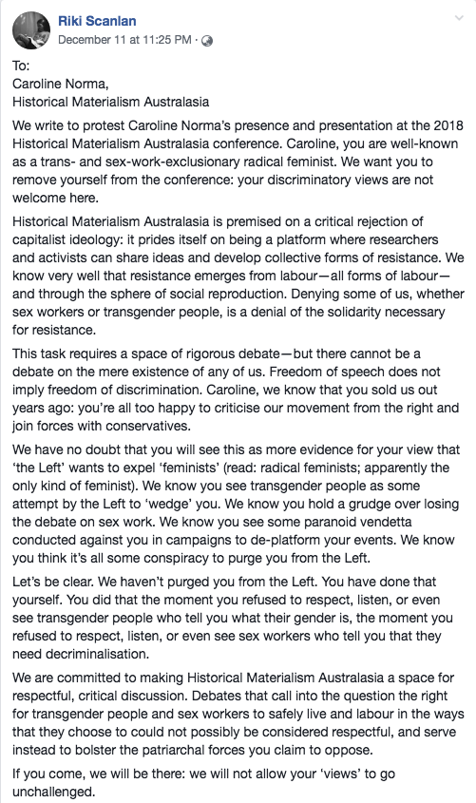

‘The open letter calling for the removal of Norma from the panel was signed by 55 students from various factions and degrees as well as high-profile figures including Lee Rhiannon, a
former Greens MP, Imogen Grant, the immediate past president of the USyd Student Representative Council, and Philip Roberts, an associate lecturer at the University of York.

‘Following the open letter, and at their request, other presenters were placed on different panels. Norma thus spoke on a solo panel, chaired by a conference organiser (Luthria, Thorne & Zhang, (Dec 13, 2018, Online).
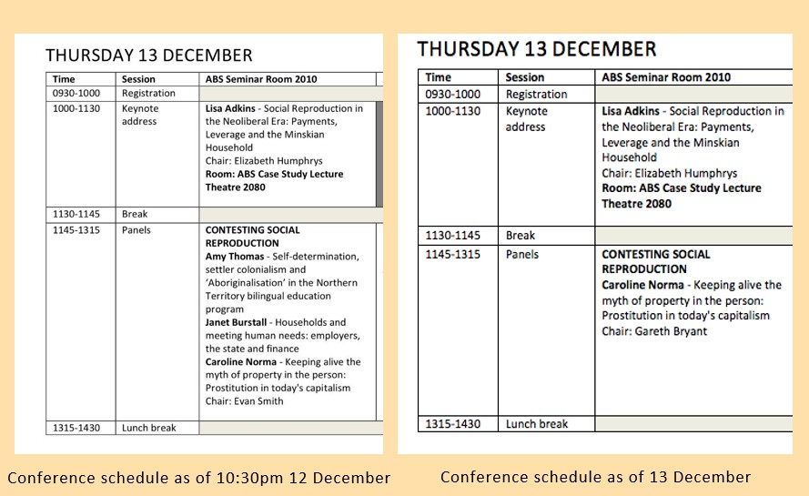

Late changes to the schedule removed Caroline Norma from a group panel

‘The organising committee of the conference declined to comment to Honi on any scheduling changes made. Honi has reached out to the USyd School of Social and Political Sciences for comment.

“This conference should be about theorising, understanding and challenging sexism. But the approach of people like Norma is undercutting that fight.” [Her topic was ‘Keeping alive the myth of property in the person: Prostitution in today’s capitalism’]

‘Earlier in the year, USyd students protested controversial commentator and sex therapist Bettina Arndt. After being allowed to speak by the university, Arndt was met by students outside the event who took issue with her questioning the validity of a campus rape epidemic.

‘Another Usyd academic and senior lecturer, Dr Tim Anderson was suspended last week over the “offensive” content of his lecture slides. Anderson included an image of an Israeli flag, partially altered to include a superimposed swastika. Since then, the National Tertiary Education Union have released a statement in support of Anderson’s right to academic autonomy. Anderson will meet with the University’s Review Committee later this month’ (Luthria, Thorne & Zhang, Dec 13, 2018, Online).
It is difficult to reconcile Scanlan’s statements that the Conference ‘...prides itself on being a platform where researchers and activists can share ideas and develop collective forms of resistance [to capitalism]’....This task requires a space for rigorous debate. a space for
respectful, critical discussion. If you come, we will be there: we will not allow your “views”
to go unchallenged’ (Scanlan, Open Letter to Historical Materialism Conference,11 Dec 2018, Online) with the fact that the Open Letter was seeking to no-platform Dr Norma.

Case Study 2: Julie Bindel and Dr Renate Klein, Melbourne

Visiting UK journalist, writer and researcher, Julie Bindel, and Dr Renate Klein, long-term women‘s health activist, were due to speak at the Kaleide Theatre at RMIT University in Melbourne on 1 August, 2018 (see attached poster). They were given one day’s notice that that would no longer be possible, for ‘security’ reasons.

Case Study 3: Dame Jenni Murray, Oxford, UK

According to Braidwood (8 Nov 2018, Online), ‘Jenni Murray, best known for hosting BBC Radio 4’s Woman’s Hour, has pulled out of a talk at Oxford University for “personal reasons,” after students accused her of being “transphobic.”

BBC broadcaster Murray had been due to speak at a [sic] Oxford University History Society event on Saturday (November 10) for the group’s “Powerful British Women in History and Society” series.

However, Oxford University History Society said in a Facebook post on Wednesday (November 7) that Murray would no longer speak at the event, which is being hosted by Oxford University’s Oriel College.

“We are sad to announce that Jenni Murray is now unable to make it to this event, and has cancelled for personal reasons,” the post read.

It comes after three groups, run by Oxford University Student Union, signed an open letter calling on their institute to “publicly condemn” Murray and “if possible, cancel the event.”

“Oxford SU LGBTQ+ campaign believe that inviting publically transphobic speakers to the university, without challenge, further marginalises and unnecessarily compromises the welfare of trans students and staff,” the letter read.

The letter was signed by Oxford SU LGBTQ+ campaign, Oxford University LGBTQ+ Society, and Oxford SU Women’s Campaign.

It went on to cite an article by Murray in The Sunday Times from March 2017, which was headlined: “Be trans, be proud — but don’t call yourself a ‘real woman.'”
[The open letter stated that] “The decision to invite Murray to Oxford in this capacity, to promise her a microphone and the undivided and uncritical attention of a room, is a decision to propagate, validate, and normalise institutionalised transphobia” (Braidwood, 8 Nov 2018, Online).

The authors of this submission are not aware of the values espoused by Oxford University in relation to freedom of speech on that University’s campus, but we would be surprised if the Open Letter - signed by three groups run by Oxford University Student Union - calling for Dame Jenni Murray to be publicly condemned and no-platformed (Braidwood, 8 Nov 2018, Online) were to align with those values.

Case Study 4: Barbary Clarke, Footscray, Melbourne

Barbary Clarke, who was not a high-profile speaker and had no presence on social media, spoke at Decolonizing Feminism, Building Solidarity on 20 Mar, 2017, to celebrate International Women’s Day, at Victoria University, Metro West, Footscray.
Loving Feminist Literature, the organisation run by a Victoria University staff member, which organised the event, called for ‘a live reading of a feminist text that influences (participants’) work and life (and for) for bold, brazen and irresistable feminist perspectives that dismantle the interlocking structures of racism, sexism, colonialism, hetero/homo- normativity’ ’
In 80 words, out of a 1,313-word speech on Deep Colonisation, after addressing issues of entrenched racism (Rose, 1996, Atkinson, 2002); disability (Highley, 2015); sexism and heterosexism (Rich, 2003), Barbary Clarke stated her subject position on sexual identity. ‘According to the 2013 revision of the Sex Discrimination Act there can be no men’s violence against women, because the definitions of ‘woman’ and ‘man’ have been expunged.
Although the Act protects LGBTI people from discrimination, it does not protect lesbians against the horizontal violence of transgendered people - because both have protected attributes under the law. So we lesbian-feminists cannot assert our freedom to associate with lesbians-born-women, without the presence even of pre-operative transgendered people, who claim to be women’ (Clarke, 20 Mar 2017).
The words ‘horizontal violence’ might seem rather harsh, to some - although they do not, to women who have been dragged through the legal system, twice, to silence them - but the following video clip (author unknown), available at https://www.youtube.com/watch?v=77affpcFpYU&amp;feature=youtu.be (which was taken at the International Women’s Day March, 2018, not on a university campus) will offer some understanding of what feminists and lesbians are facing, daily, from trans-activists. For example, being called ‘violent bitches’ for displaying an IWD March sign reading ‘Women’s safety before men’s feelings’.
Before Clarke finished speaking, trans-activists stood up between her and the audience, accusing her of being transphobic and demanding, during a 20-minute harangue, that she should apologise. She was told she needed to ‘go and get her mind de-colonised’. The entire event was disrupted and Facebook ran hot, for days, with comments both pro- and against her
speech. Soon, comments that supported Clarke’s viewpoint began disappearing from the event’s Facebook page.



Loving Feminist Literature

20 March at 23:15 ·

Thank you to all of you attending our event this evening. There was unfortunately an awful transphobic comment made by one of the readers which made the space unsafe for trans women, gender fluid and non-binary people [My italics]. This is unacceptable and the organisers deeply regret what people had to endure. We will take specific measures to ensure this does not happen again and as a small gesture of solidarity, will donate to a trans health charity to work better in solidarity. Thank you to all who contributed from the stage and the floor to work through this.

LikeShow More Reactions

CommentShare


Loving Feminist Literature Hi, we will be deleting transphobic comments on the page but especially on this thread. A) We don't want trans people to be expanding any more energy or labour explaining or having to beg for their humanity. B) The transphobic comments here are clearly antagonistic & designed to hurt trans people. This is clearly not an opportunity for education or discussion. If this makes some women feel that we are silencing you--we are. We are here to silence and not give visibility/space to transphobes, and this includes cis+/lesbian women. Being queer does not mean you cannot be oppressive towards people in other ways. There is to be no discussion that doesn't begin with the fundamental truth that trans women are women, biology is not gender and trans women do not carry male privilege. You can disagree with us, just not here. If you continue to disregard the basic requests we have made, we will block you [My italics] Thank you and again we are very sorry for what happened and our failures in how we handled the situation.
Like · Reply · 10 · 21 March at 11:26 · Edited

See Appendix 1 for details of the supportive comments that were deleted.

Someone called Xa Ba posted the accusation that Clarke had made ‘extremely violent transphobic comments’

Xa Ba

23 March at 15:19 ·
‘...the speaker made...violent transphobic comments. and deceitfully engaged in vocalising
unscripted and extremely violent transphobic comments in quick successions’.

Feminism must PRIORITISE trans identities that exist at the intersections of race and class. This will NOT happen in the absence of an honest and critical political analysis.

See more
LikeShow More Reactions CommentShare

Schulman proposes that, ‘The word “violence” has expanded far beyond the field of physical assault to also mean emotional abuse and, unfortunately, emotional conflict where there is no abuse. In recent years we see “violence”...being ascribed to social criticism, efforts to understand phenomena, and social and psychological analysis’ (2016:92). Hence, the fact that Clarke’s honestly-expressed subject position was characterised as ‘extremely violent’ in order to ‘disauthorize’ her speech (Alcoff, 1991-’92:7) and avoid having to engage in a productive dialogue.

There follow two tweets which could not be directly addressed to Clarke, because she had no social media presence.
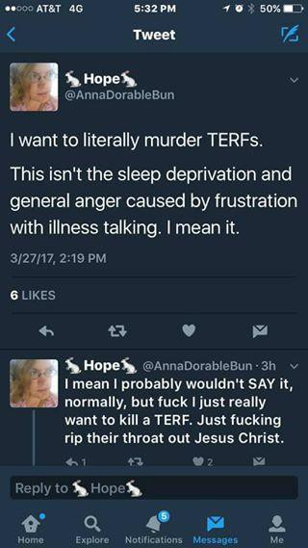

These might be said to express a violent intent, or at least mindset, towards what are derogatorily-termed ‘TERFS’, or ‘transgender exclusionary radical feminists’.

Eight days after the event, one of the people who had attended wrote, in a magazine article, titled TERFs uprising - Trans exclusionary radical feminists gatekeeping womanhood, that ‘The problem with “trans inclusive feminism” is that its premise is still based on cis supremacy. It’s the cis women who are centred in this idea of feminism “(F)eminism
without trans women is not feminism”’ (Lee, 28 Mar 2017, Online). So it seems, now, that women, themselves, are not even allowed to have the freedom of speech to define feminism, but that transgendered people are entitled to do so.

Case Study 5: Julie Bindel, Manchester

‘The high-profile feminist writer and campaigner Julie Bindel has dropped out of a student- run debate at the University of Manchester after allegedly receiving hate mail.

‘The lesbian writer and co-founder of the Justice For Women campaign says she has been sent 30 unsavoury messages, some including death and rape threats, with three so severe that she reported them to the police.

‘Bindel was invited to speak at the Manchester Debating Union event against the motion that porn empowers women, but her role in the lineup alongside No More Page 3 founder Lucy Holmes and former porn actress Renee Richards was met with fierce criticism from students and transgender activists.

‘Following the announcement of the speakers, a demonstration was organised by Loz Webb, trans representative for the university’s LGBTQ Society. Webb felt that it was wrong to give a platform to someone with "a track record of transphobia" during Welcome Week, when making all students feel safe and included is particularly important.

‘Bindel said that she chose to back down because her presence risked shutting down debate of an issue she feels is highly worthy of discussion. “I was coming to debate pornography. I was censored from speaking about something that has nothing to do with 'transgenderism', nothing at all,” she said.

‘Bindel reacted to claims on social media that her appearance would make trans people feel unsafe, calling the suggestions “ludicrous”’ (Author unknown, 12 Sep 2013).

Bindel was attending a debate about pornography - not anything to do with transgendered people - so why was there ‘fierce criticism’ from ‘transgender activists’ at her potential presence? And how did they expect a debate to happen if one side of it was not represented? And why did they feel authorised to organise a rally to no-platform her? And who were the 30 people who thought it was all right to send her ‘death and rape threats’? And what were the police and the Manchester University administration doing to ‘promote and protect freedom of expression and freedom of intellectual inquiry in higher education’ as per Terms of Reference 1 of this Review? Did the University not have written Standards, policies and practices to protect freedom of speech? And, if they did, why did they not uphold them in this
case? Was Julie Bindel no-platformed, thus denying her ‘freedom of expression’? Or does her own decision not to participate mean that the issue was not one of freedom of speech?

While it was not filmed on a university campus, the video footage of trans-activists physically preventing her from attending a discussion on the UK Gender Recognition Act in this clip https://www.youtube.com/watch?v=sBll45tSKzc which was posted, unedited, by Julie Bindel, demonstrates how far trans-activists will go to prevent feminists from exercising their freedom of speech. Schulman (2016) outlines a strategy of ‘overstating harm’ as one way of preventing others from speaking. Mr Webb’s claim that Julie Bindel’s participation in the debate ‘would make trans people feel unsafe’ (Author unknown, 12 Sep 2013) would certainly have held no water with Chicago University’s Dean of Students, John (Jay) Ellison, who rightly refuses to ‘condone the creation of intellectual “safe spaces” where individuals can retreat from ideas and perspectives at odds with their own’ (25 Aug, 2016 Online).

Conclusion

We will leave it up to Hon Mr Robert French AC and the Review Secretariat to decide whether or not University Freedom of Speech has been upheld by the universities quoted in this submission; whether or not feminists and lesbians have had, or should have had, their freedom of expression and freedom of intellectual inquiry promoted and protected in higher education settings, as per Terms of Reference number 3 of this Review; and whether ‘realistic and practical options that could be considered to better promote and protect freedom of expression and freedom of intellectual inquiry’ could usefully be developed, or clarified, through revision of universities’ Standards, or via ‘development of a sector-led Code of Conduct’ as per Terms of Reference number 4 of this Review into University Freedom of Speech. Our simple hope is that we have provided Mr French with some awareness of the situations facing feminists and lesbians who are invited - then, often, un-invited - to speak on university campuses.

We trust our submission will be useful and we would welcome the opportunity to provide Hon Mr Robert French AC with any further information he might require.

Yours sincerely,

Barbary Clarke Convenor – Victoria
Australian Lesbian Health Coalition Email: barbary.clarke@optusnet.com.au
Postal address: PO Box 168, Brunswick East, Vic 3057
References

Alcoff, L. (Winter, 1991-1992) The Problem of Speaking for Others. Cultural Critique, 20:5-32. Available online at http://www.jstor.org/stable/1354221

Atkinson, J. (2002) Trauma Trails: The Transgenerational Effects of Trauma in Indigenous Australia. North Melbourne: Spinifex Press

Author unknown (12 Sep 2013) (Online). Death Threats Force Feminist Campaigner Out of University Debate Available at https://www.independent.co.uk/student/news/death-threats-force-feminist-campaigner-out-of- university-debate-8821362.html

Author unknown (No date. Online) Trans woman harasses radical feminists at IWD [March 2018]. Available at https://www.youtube.com/watch?v=77affpcFpYU&amp;feature=youtu.be

Bindel, J. (23 Apr 2018) Julie Bindel confronts trans MRAs at the We Need To Talk About Sex (#weneedtotalk) event. Available on Youtube at https://www.youtube.com/watch?v=sBll45tSKzc

Braidwood, E. (8 Nov 2018, Online). Jenni Murray cancels Oxford talk after ‘transphobic’ remarks. Available at https://www.pinknews.co.uk/2018/11/08/jenni-murray-oxford-university-transphobic-womans-hour- bbc/?utm_source=newsletter&utm_medium=email&utm_campaign=PNnewsletter

Brennan, B., & Hungerford, E., (Aug 1, 2011) Open letter to the CSW Communications Procedure, Human Rights Section, UN Women, New York

Hawthorne, S., (2015). Bibliodiversity: A Manifesto for Independent Publishing. North Melbourne: Spinifex Press. Also available as an e-book from http://www.spinifexpress.com.au/Bookstore/book/id=269/

Highley, K. (2015). Dancing in my Dreams: Confronting the Spectre of Polio. Melbourne: Monash University Publishing

Lee, I. (28 Mar 2017) (Online). TERFs Uprising - Trans exclusionary radical feminists gatekeeping womanhood. Available at http://archermagazine.com.au/2017/03/terfs-gatekeeping-womanhood/

Luthria, K., Thorne, L., & Zhang, A. (Dec 13, 2018) (Online). Academic Boycott of Caroline Norma at USyd Conference. Available at http://honisoit.com/2018/12/academic-boycott-of-caroline-norma-at-usyd-conference/

McLellan, B., (2010) Unspeakable: a feminist ethic of speech. Queensland: OtherWise Publications. Also available as an e-book from http://www.spinifexpress.com.au/Bookstore/book/id=208/

Norma, Dr C. (28 Dec 2018) (Online). The Australian left gives away its anti-feminist game. Available at https://www.feministcurrent.com/2018/12/28/australian-left-gives-away-anti-feminist-game/

Norma, Dr C. (28 Oct 2015) (Online) Transgenderism - The Latest Anti-Feminist Wedge of the Left. Available at https://www.abc.net.au/religion/transgenderism-the-latest-anti-feminist-wedge-of-the-left/10097710

O’Neil, T. (25 Aug 2016) (Online). University of Chicago Defends Free Speech Against 'Safe Spaces'. Available at https://pjmedia.com/lifestyle/2016/08/25/university-of-chicago-defends-free-speech-against-safe- spaces/

Rich, A. (2003). Compulsory Heterosexuality and Lesbian Existence (1980). Journal of Women's History,
15(3): 11-48

Rose, D.B. (1996) Land Rights and Deep Colonising: The Erasure of Women, Aboriginal Law Bulletin, 3(85): 6-13.

Scanlan, R. (11 Dec 2018, Online). Open Letter to Historical Materialism Conference. Available online via http://honisoit.com/2018/12/academic-boycott-of-caroline-norma-at-usyd-conference/

Schulman, S. (2016). Conflict is not Abuse: Overstating Harm, Community Responsibility, and the Duty of Repair. Vancouver: Arsenal Pulp Press

Szymanski, D.M., (2005) Heterosexism and Sexism as Correlates of Psychological Distress in Lesbians, Journal of Counseling and Development, 83(3)355-360
Appendix 1 – Evidence of Facebook Posts Supporting Barbary Clarke’s Presentation at Decolonising Feminism IWD Event, 20 Mar 2017, Which Were Subsequently Deleted and their Post-ers Blocked – Edited for Brevity.

https://www.facebook.com/groups/1575512856091580/permalink/1639402706369261/



Carmen Chesson

20 March at 20:43

Decolonising Feminism event tonight (Melbourne) was ONE SPEAKER IN before it was hijacked by 2 trans activists (including key speaker Clare Land) in the name of transphobia, trans exclusion and apparent violence that was experienced from the first speaker.

Barbary Clarke is an older, well-versed, lesbian radfem who gave a remarkable presentation about some of her favourite feminist authors and readings, making connection from these to the current status surrounding lack of lesbian women recognition, and specifically data collection and specialised care in the health system/services, and its consequences this has been compounded by the human rights commission decision to change their definition/classification of gender in 2013, which doesn't consider male or female in their own right, making for a confusing space if you want human rights commission to ever support you in a case.

Clare stood up at the end of Barbary's talk to say 'but what about trans women' and comment on how her language was transphobic.

It was so disrespectful to Barbary when it was agreed at the opening that we would all listen respectfully and remain open during the discussion, and specifically leave questions until the q&a later.

It put the next speaker Sangeetha on the spot right before she spoke about her chosen literature, forcing her make attempts to pacify the trans feels before she could get on with her presentation, ultimately changing the tone of room rapidly.

Not satisfied with the response, they stood near the stage in front of other attendees, waiting for the next speaker to finish before going on stage to call the event to a halt until Barbary's trans violent speech was addressed and ensured upcoming speakers language and discussion would be trans inclusive.

I expected more from Clare Land whose writing, work and activism has sparked critical thinking around this topic for me and was my main reason for going tonight. She had her chance to speak later in the eve and could have spoken to this more then, rather than
intimidate and disrupt other speakers who clearly put time and effort into their thoughtful presentations. (Is that not the behaviour of a coloniser?? Check yourself Land).

I was fucked if I was going to sit and listen to her when her actions sent a message that the other speakers stories, experience and insights didn't matter, or that of the people who came along to listen to everyone.

I bailed!! Gobbolino Kitcat stuck around but the outcome was as predicted so she left shortly after too.


Gobbolino Kitcat Yes it was silencing101.

After the second interruption by the trans activists the mc was forced to come on and tried to patch it up but made the mistake of asking the trans invaders how they felt. They responded "awful and terrible " so she agreed to halt the talk and told everyone to go to an immediate break.

They were talking for ages in the break but just as it reconvened Barbary packed up her books and left the room.

They reconvened by saying Barbary was sorry and was leaving to stop the trans ppl from feeling bad. (Sorry I was trying to record but I was so angry I messsed up so I can't say exact words they used.) Like · Reply · 4 · 20 March at 21:00 · Edited



Fraser Janet They totally proved Barbary's point. She is a great scholar, an elder in the
feminist community and a huge asset to the under researched lesbian health arena. I'm shocked and horrified. This is wildly inappropriate male violence in women's space. Hello, Vancouver library. I am livid to hear this went down. Disgusting and vile.
Like · Reply · 23 · 20 March at 21:00



Cindy Renate Thank you for the update. I am glad I bailed at the last minute but so enraged to
hear of this disrespect and derailment of a women's space.
Like · Reply · 3 · 20 March at 21:08



Paige Gleeson That's infuriating. When will the erasure of women end
Like · Reply · 3 · 20 March at 21:10


Monica Campo This makes me so sad and angry . How was what she was saying transphobic anyway ? And they asked her to LEAVE ? I'm so fucking angry
Like · Reply · 7 · 20 March at 21:25



Jacqueline Gwynne FFS. Did anyone film them?
Like · Reply · 5 · 20 March at 21:27



Arabella Ward Maybe we need to stand up at such events and argue back to the transppl, say
that their behaviour is silencing etc our usual comebacks, but focusing on the fact that they are silencing women.
Like · Reply · 12 · 20 March at 21:28

Jacqueline Gwynne They are not doing themselves any favours and are driving more women
to radical feminism.
Like · Reply · 8 · 20 March at 21:28

Arabella Ward As long as that is what happening and not intimidating women into hiding and
staying out of the public, or the laws will be changed like in the US and no one stands up to them.
Like · Reply · 1 · 20 March at 21:30


Emilio Silver Plenty of women are intimidated by trans activists - I've been dealing with a massive incident on the feminist page of my home town, where a woman cried transphobia, and then the whole group asked to go to closed status to avoid friends or ppl taking screenshots of their comments to use against them. And they weren't transphobic comments either. Lots of ppl are scared to stand up to them.
Like · Reply · 8 · 20 March at 21:40 · Edited



Caroline Leonora Boreham I asked whether discussion of whether there is, or isn't, such a
thing as 'a trans-ideology', should be 'allowed' on Facebook or not. I was told that even asking the question was 'harmful discourse'. I thought it was just critical theory (when I was at university, critical theory was just considering whether things were ideologies or not and nothing was off bounds!). I started the discussion thinking maybe the phrase 'trans ideology' was a bit strong. I ended the discussion creeped out by the Orwellian-ness of the phrase 'harmful discourse'.
...See more
Like · Reply · 9 · 20 March at 21:50


Ari Miller There has to be some recourse we can take to respond/disarm/go on the offence in these situations, in real time, when they happen?
I can (sadly) imagine instances like this are going to happen more and more. We NEED to have a way to deal with it!
Any ...See more
Like · Reply · 10 · 20 March at 22:35


Davina Theresa Simpson Ah women, I feel your pain over this, I really do.

We will eventually persevere, but it will take time, and cunning. We can do that. The general tide will turn on trans, it will. We just have to ride it out. Of course, no one will give us credit for being whistleblowers, but that is par for the course.

Peak trans is happening all over. Even some of the libfems are waking up "hang on, how come dudely-born is in charge of this feminist meeting, when he sounds like every other dude?"

Like · Reply · 17 · 20 March at 23:15


Kate Bunting The organisers response: "Thank you to all of you attending our event this evening. There was unfortunately an awful transphobic comment made by one of the readers which made the space unsafe for transwomen, gender fluid and non-binary people. This is unacceptable and the organisers deeply regret what people had to endure. We will take specific measures to ensure this does not happen again and as a small gesture of solidarity, will donate to a transhealth charity to work better in solidarity. Thank you to all who contributed from the stage and the floor to work through this."

...See more
Like · Reply · 2 · 20 March at 23:33


Kate Drury If only we women really did hold so much power in public spaces! Such bullshit.
Like · Reply · 7 · 20 March at 23:37

Jacqueline Gwynne Bullying really isn't a good way to have people include you. They are the ones making it an unsafe space.
Like · Reply · 8 · 20 March at 23:37

Jacqueline Gwynne It is only ever transwomen (aka MEN), never trans men.
Like · Reply · 11 · 20 March at 23:39

Kate Drury Trans men are enjoying their new found privilege.
Like · Reply · 5 · 20 March at 23:40 · Edited



Amber-lea Drinnan Wow! This is insane. Has anyone reached out to Barbary in solidarity?
Like · Reply · 6 · 21 March at 00:43

Jacqueline Gwynne It's not just silencing of feminists. It's the silencing of women.
Like · Reply · 8 · 21 March at 08:02


Tasha Rose Is there video?! This is reprehensible!
Like · Reply · 1 · 21 March at 08:05



Tessa Anne god this makes me angry
Like · Reply · 1 · 21 March at 08:07

Tessa Anne I have just been communicating with Barbary via email after hearing of this and she is so relieved to hear that there are many women supporting her here xoxo
Like · Reply · 11 · 21 March at 08:59

Tasha Rose They're deleting critical comments.
Like · Reply · 1 · 21 March at 10:17


Elizabeth Robertson Well I've been banned from commenting now 😡
Like · Reply · 21 March at 11:35
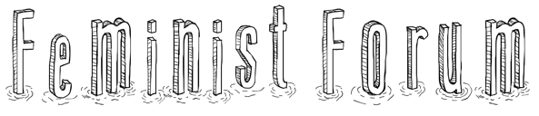

WEDNESDAY 1st AUGUST 2018 5:30PM – 7:30PM
Building 8 @ RMIT – 360 Swanston Street Level 2, Kaleide Theatre

PANEL DISCUSSION: ABOLITIONIST DEBATES
Sex work mythology and abolitionist reality: International battle-lines
Julie Bindel will critique the global ‘sex workers’ rights’ movement and how its ‘happy hooker’ narrative has come to shape our perceptions of what is misleadingly named as ‘the oldest profession’. She describes alternative efforts to raise the public’s consciousness of the harm of prostitution and efforts to lobby governments to do something about it. Julie's analysis aims to give voice to women who have survived the abusive reality of prostitution.

Julie Bindel is a journalist, writer, broadcaster and researcher. She has been active in the global campaign to end violence towards women and children since 1979 and has written extensively on rape, domestic violence, sexually motivated murder, prostitution and trafficking, child sexual exploitation, stalking, and the rise of religious fundamentalism and its harm to women and girls. Julie has authored over 30 book chapters and reports on a range of topics relating to violence and abuse of women and girls. She contributes regularly to a variety of media outlets including The Guardian newspaper and Sky News.


Surrogacy as reproductive prostitution: The time for abolition is now
Renate Klein will underline the many similarities between all forms of surrogacy and prostitution. She argues that it is misogynist, racist and classist patriarchy that makes it seem acceptable to use women as ‘workstations’ (to borrow Julie Bindel‘s term) in both surrogacy and prostitution. These are both international multibillion businesses that need to be stopped. They can never be regulated to become ‘ethical’ or ‘work‘ as pro-prostitution and pro- surrogacy supporters demand.

Dr Renate Klein is a long-term women‘s health activist who has been working on surrogacy and other reproductive technologies since the early 1980s. She is a founding member of FINRRAGE (Feminist International Network of Resistance to Reproductive and Genetic Engineering) and Stop Surrogacy Now (stopsurrogacynow.com).
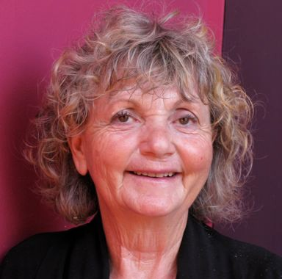

All those interested in feminist ideas are welcome
Enquiries & RSVPs: catwaustralia@gmail.com








Addendum to
Australian Lesbian Health Coalition’s (ALHeC’s) Submission to Former Chief Justice of the High Court Robert French’s
Review into University Freedom of Speech

28th January, 2019

Secretariat for Freedom of Speech Review Quality and Access Branch
Higher Education Group
Australian Government Department of Education and Training Via email: freedomofspeechreview@education.gov.au

Dear Hon Mr Robert French AC,

ALHeC provides this further information (published online after the deadline for submissions) for consideration by the Review into University Freedom of Speech. It is not another case of a feminist being no-platformed by a university.

It does, however, provide valuable evidence of how even a feminist Rector of Edinburgh University, the elected Chair of the University’s governing body, can be condemned by people and groups within her own institution, but also have her professional reputation attacked on social media.

In our view, even though what Ann Henderson ‘said’ was in the form of a re-tweet on social media, we believe that other people telling her that she was not allowed to say what she had said amounts to a threat to her freedom of speech.

We hope you agree.

Yours sincerely,

Australian Lesbian Health Coalition
Women get treated far worse than men in Labour’s transgender debate 26 Jan 2019

https://blogs.spectator.co.uk/2019/01/women-get-treated-far-worse-than-men-in-labours- transgender-debate/amp/

James Kirkup

26 January 2019 12:57 PM

[EDITED FOR BREVITY]

“[Ann] Henderson is a Scottish trade unionist and community worker who is currently serving as rector of Edinburgh University, elected by staff and students to chair the university’s governing body.
Edinburgh University student newspaper [accused] her of transphobia. Her crime? She
retweeted about a meeting organised by A Woman’s Place UK, a feminist group largely run by left-wing women who organise public meetings to discuss changes to gender recognition laws to make it easier for men to change their legal gender and be recognised as women. The group worries such changes will undermine the legal and social standing of women, where ‘women’ is taken to mean ‘adult human females’.
[T]he mere fact of Ann Henderson sharing a tweet about that event with her 1,200 or so followers was enough to bring down condemnation from the university Labour Club, the Students’ Association and merit coverage in Scotland’s national press. Henderson has also been criticised by Lily Madigan, a transgender Labour activist and women’s officer, for the earlier offence of following WPUK on Twitter.
....But now Henderson has a new job. She was this week elected chair of the Labour Party National Executive Committee’s equalities sub-committee.
This, according to LGBT Labour, a party group, is an outrage. ‘We are appalled by the election of Ann Henderson to the chair of the Labour Party NEC equalities sub-committee given her history of sharing material that has been described as transphobic,’ the group said
What does this tell us? Three things, I think.
First, it says something about the threshold for offence in this area. Never mind what a person (woman) might themselves do or say or even think. Simply sharing something that some other people find offensive is enough for that person (woman) to be put beyond the pale, unfit to hold office.
Second, it’s a reminder that the wider issue of transgender rights and equality law is still deeply painful in Labour circles. Without rehashing a long, long story, the party allows ‘self- identified’ women to stand on all-women shortlists, something that some Labour feminists believe is not just wrong but possibly unlawful.
Third, this is yet another example of a woman in this debate being treated very differently to a man. Henderson is under fire from trans-rights activists, for nothing more than retweeting a tweet noting that WPUK were holding a meeting with MPs.
So what would those ‘appalled’ activists say about an MP who actually sat down to talk to a group that has been, in their accusatory words, ‘described as transphobic’?

2
Well, that depends on who the MP is, it seems. In September, according to the group, a Labour MP did indeed meet a Woman’s Place UK and listened to their concerns about gender law reform and Labour’s policies. The MP’s name is John McDonnell and he is the Shadow Chancellor.
And if LGBT Labour or any of the other activists seeking to burn Ann Henderson for nothing more than a retweet have condemned him for outrageous transphobia, I can find no evidence of their outrage.
In short, a woman taps ‘RT’ once and is condemned. A man does rather more than that and nothing happens. Make of that what you will, but always remember: the gender debate is all about equality”.

THIS IS LILY MADIGAN’S TWEET [EDITED FOR BREVITY]

https://twitter.com/lesbianleftie/status/1024449962795577344


✊🏻Lily!🏻Madigan🏻☭ @lesbianleftie

.@AnnHend88977240 I'm considering voting for you in the NEC elections. I was wondering why you follow the anti-trans hate group Woman's Place UK? The group has referred to trans kids as mutilated/sexual predators.. (1/2)

5:21 PM - 31 Jul 2018

21 Retweets 141 Likes

1.
✊🏻Lily!🏻Madigan🏻☭ @lesbianleftie 31 Jul 2018

They have disseminated ‘resources’ that claim trans people are not at high risk for suicide/violence & encouraging educators to treat trans kids as mentally ill, & repeatedly refer to trans women as violent men, ‘parasites’, & rapists. Why are you following them? (2/2)

5 replies 3 retweets 64 likes

3
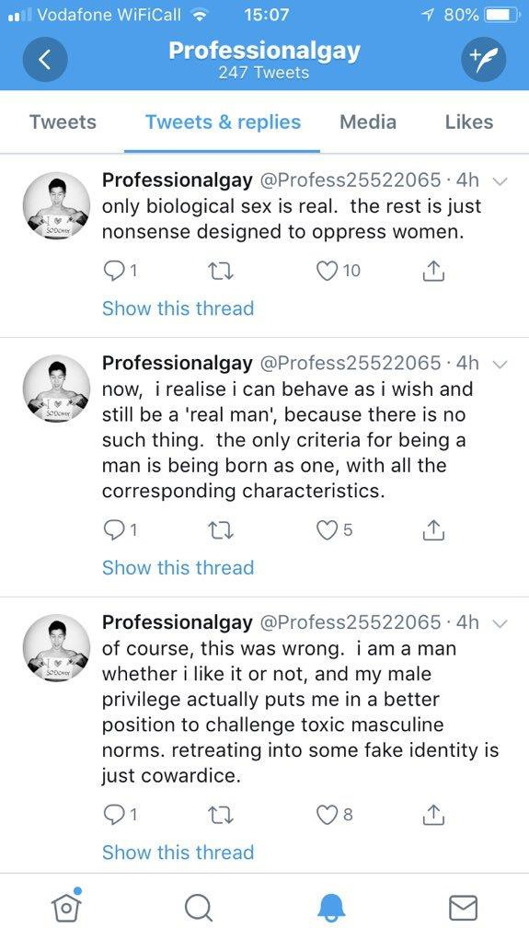

- replies 0 retweets 7 likes

1. Emma @Brompton_Road 1 Aug 2018

Replying to @lesbianleftie @madigan_lily

Has someone actually stopped to think that Ann may be following Woman's Place because she wants to make an informed decision on her understanding of the groups aims. This hysteria is helping no one.

- reply 0 retweets 6 likes

- • J. 'Legumekuman' Adams @Gerkuman 1 Aug 2018

4
You can investigate a group without following them on twitter. Pretty easily in fact.

1 reply 0 retweets 2 likes

• •
✊🏻Lily!🏻Madigan🏻☭ @lesbianleftie 1 Aug 2018

Emma is transphobic. Likes to misgender trans women. I wouldn’t waste the time, lovely x

0 replies 0 retweets 7 likes

1.
✊🏻Lily!🏻Madigan🏻☭ @lesbianleftie 1 Aug 2018
Replying to @DannyH89

I don’t follow anyone I don’t support, let alone a hate group.

3 replies 0 retweets 4 likes

- • tinkerbell @FairyMary56 1 Aug 2018

Maybe you should, in order to hear differing views and widen your horizons. If you want to be an MP you need to know what people’s views /thoughts are .

- reply 0 retweets 9 likes

- • Dimmeh Looming @TheDimmeh 1 Aug 2018

Why would anyone wanna follow a group that actively harasses, threatens and lies about a minority they're a part of. ?

- replies 0 retweets 3 likes

- • Tweet unavailable

5

- Dimmeh Looming @TheDimmeh 2 Aug 2018

Replying to @DannyH89 @FairyMary56 @madigan_lily

Because people like this've been been debated. Constantly. They won't change their mind and soley exist to make our lives hell. So. No.

2 replies 0 retweets 0 likes

- • Tweet unavailable
• Dimmeh Looming @TheDimmeh 2 Aug 2018

Replying to @DannyH89 @FairyMary56 @madigan_lily

I've tried. Many have tried. It's not worked. So why should someone have to sit there and constantly read the harassment and risk their mental health for legitimately no reason?

- replies 0 retweets 0 likes

1. Eliza @Eliza_Cuppa 1 Aug 2018

Replying to @lesbianleftie @madigan_lily

Your comments are libellous against A Women’s Place.

- reply 0 retweets 12 likes

- • Louise Dragonfly
🏻🏻♀️ @dragonflylej 1 Aug 2018

No they are a bigoted hate organisation, who's aim is to destroy the rights of transgender people - both by preventing any improvements and then by dismantling existing rights. Wake up and smell the roses sweetie.

1 reply 0 retweets 4 likes

6

- • Eliza @Eliza_Cuppa 1 Aug 2018

You’ve just libelled them too! Hope you’ve all got good lawyers.

1 reply 0 retweets 3 likes

- • Louise Dragonfly
🏻🏻♀️ @dragonflylej 1 Aug 2018

What have I said that's inaccurate? Where is anything of substance from any of their members that supports the rights of transgender people?

- replies 0 retweets 2 likes

1. Jill Huish @yeahthatwoman 31 Jul 2018

Replying to @lesbianleftie @madigan_lily

Yeah, tell us, @AnnHend88977240 !

- reply 0 retweets 6 likes

- • Anubis101 @MichelleAnubis1 1 Aug 2018

I’m waiting to hear before I vote. Please answer. Or I’ll assume you’re non-inclusive and won’t back you.

- replies 0 retweets 3 likes

1. Lisa Beth Black @lisabethblack2 1 Aug 2018

Replying to @lesbianleftie @madigan_lily

7
I'd like to know too. Thanks for picking this up Lily.

- reply 0 retweets 2 likes

- • femalenotCIS @c0ncernedw0man 1 Aug 2018

They are not a hate group. Keeping women safe is not hate. Debate is not hate.

0 replies 0 retweets 6 likes

Paula Jayne #GTTO @ginger_pooch 1 Aug 2018

Replying to @lesbianleftie @madigan_lily

I asked Ann the same question days ago, she must be extremely busy as I’m still waiting a reply too.

0 replies 0 retweets 3 likes

8

