

Review of the loading for students with disability 2019–public submission

Australian Government Department of Education

Stakeholder type: Government

Jurisdiction: National

# Submission

## Introduction

The Australian Government Department of Education (the department) welcomes the opportunity to make a submission to the National School Resourcing Board for the review of the loading for students with disability.

The introduction of the Nationally Consistent Collection of Data on School Students with Disability (NCCD) provided a reliable indicator to determine funding for students with disability based on the adjustment required for a student to receive a quality education.

The department has worked closely with all education authorities through the Joint Working Group to Provide Advice on Reform for Students with Disability (the Joint Working Group) to embed the NCCD in schools, build capacity and quality assure the collection. National collaboration has been critical to the successful implementation of the NCCD and will continue to play an important role in supporting future priorities to ensure the best educational outcomes for students with disability.

The findings and recommendations from recent projects commissioned by the department under the Australian Government’s $20 million NCCD Continuous Improvement Package have informed this submission. The national projects aim to address the learning needs of students with disability, build school capacity and inform continuous improvement and assurance initiatives.

## Background

### Commonwealth loading for students with disability, since 2018

All schools have been required to participate in the NCCD since 2015, and since 2018, the collection has been used to calculate the Commonwealth loading for students with disability. From 2018 to 2029, the Commonwealth will invest an estimated $28.8 billion for the student with disability loading. On average, funding for students with disability will grow by 5.1 per cent each year over this period.

Funding is based on a per student amount at each of the top three levels of adjustment in the NCCD model —supplementary, substantial and extensive – as shown in Table 1.

#### Table 1: 2019 students with disability loading by NCCD level of adjustment

|  | **Base per student  amount in 2019** | **Supplementary** | **Substantial** | **Extensive** |
| --- | --- | --- | --- | --- |
| **Primary student** | $11,343 | 42%  ($4,764) | 146%  ($16,561) | 312%  ($35,390) |
| **Secondary student** | $14,254 | 33%  ($4,704) | 116%  ($16,535) | 248%  ($35,350) |

The NCCD captures a fourth level of support provided within ‘quality differentiated teaching practice' (QDTP), which does not attract additional funding. This category represents personalised learning that is applied without drawing on additional school resources.

The NCCD was implemented in response to the recommendation of the Review of Funding for Schooling (the Gonski review) that a student with disability loading be based on a national definition and ‘scaled for different levels of adjustment to better reflect need’.[1]

The differences in school contexts and student needs requires a funding approach that allows approved authorities the flexibility to pool and redistribute funding. This enables approved authorities to achieve economies of scale and respond to local needs, while holding them accountable for the use of public funds and the outcomes achieved from the funding.

### Previously…

A flat rate of 186 per cent of the base per student amount for students with disability attending mainstream schools and 223 per cent for students with disability attending special schools applied before 2018, and eligibility was based on varying state and territory definitions of disability.

The flat loading potentially underestimated the costs of supporting a student with significant needs, while overcompensating those with a lower level of need. Differing state and territory definitions and eligibility criteria resulted in a student with the same disability being funded in one state but not another. This resulted in serious funding inconsistencies.

The setting for the student with disability loading was only ever intended to be an interim measure pending the finalisation of the NCCD. The use of NCCD as an input to the student with disability loading resulted in better targeted and nationally consistent funding for students with disability.

### The NCCD is not about a medical diagnosis

The student with disability loading provides resources to help schools meet the cost of educational adjustments provided to the students.

The NCCD focuses on the level of adjustment provided to a student based on their functional needs, rather than disability type. The collection captures all students receiving adjustments to support their access and participation in learning due to a disability – not just those with a medical diagnosis.

The NCCD aligns to education authorities’ obligations to provide reasonable support to enable students with disability to access education, as set out under the Disability Discrimination Act 1992 (DDA) and the Disability Standards for Education (DSE).

The connection between the NCCD and student with disability loading has meant that education authorities and schools are investing more into teacher resources to support their identification (and necessary adjustments) for students with disability. Education systems are moving away from funding students based on their disability to funding based on the adjustments needed to support their educational needs.

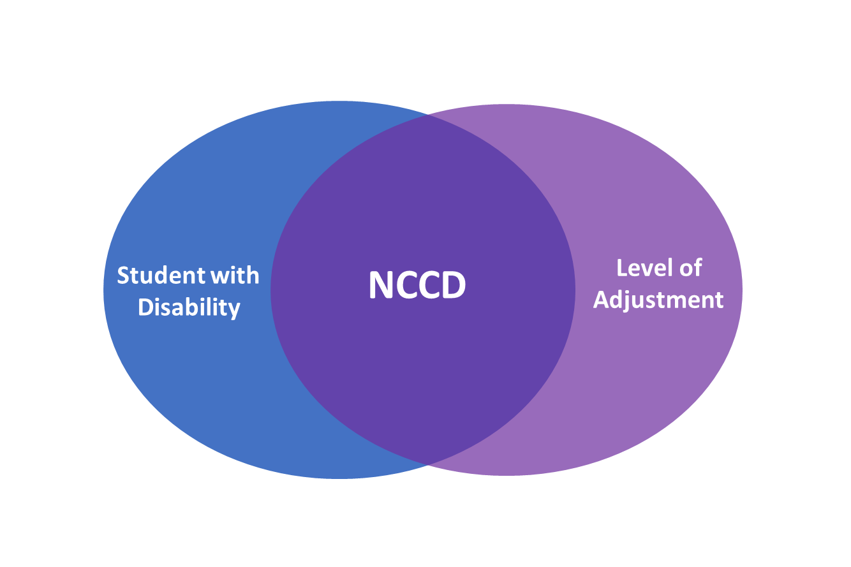

## Student with disability loading and funding to schools

### Cost drivers that informed the current loading

The best efforts to date derived a loading based on the median costs of providing adjustments at the supplementary, substantial and extensive levels. The research used to derive this loading was based on the 2013 NCCD collection and a sample of 75 schools through a survey that sought to explore actual costs as well as test the impact of different factors and school contexts on per student costs.

The department acknowledges that it is timely to review the methodology behind the loading calculations and supports the Board’s efforts to undertake a bottom-up approach to cost adjustments using actual case studies and the expertise of practitioners.

### Interaction with other funding

Fundamental to the Commonwealth recurrent funding arrangements is a model that is simple, nationally consistent and based on need. The student with disability loading is one of six loadings calculated to address disadvantage.

These loadings are not mutually exclusive. While a portion of Commonwealth funding is attributable to the student with disability loading, this is not the only funding that these students attract.

Further, the base funding that all students attract is flexible and may be used to enhance support for students with disability, including those in the (unfunded) QDTP category.

There are also differing approaches to funding loadings across states and territories. Analysis of the student with disability loading must take into account the manner in which the various loadings applied across the sector interact with each other within the needs-based model.

### Flexibility in funding provides for inclusive education

At the heart of the approach to providing students with disability funding to schools, rather than directly to students, is the importance of inclusive classrooms. Students with disability educated in inclusive classrooms tend to have better academic and social outcomes due to challenging curriculum and increased opportunities to interact with same age peers. In inclusive classrooms, students with disability acquire skills they will need to function effectively as part of mainstream society.

Inclusive education necessitates schools making significant adjustments and accommodations to classroom material, activities and curriculum content. The entire classroom and the whole school is involved, not just the individual student.

Inclusion should be considered an opportunity, as well as an obligation. Implementing inclusion provides opportunities for teachers to learn highly sophisticated skills that make them a better teacher for all learners with a range of diverse abilities. The result is higher quality education for all students.

Providing resources directly to the school (as opposed direct to the student) under an inclusive model is a cost-effective way to support the needs of students with disability while enhancing the educational experience for all students in a sustainable manner. ‘Buying’ adjustments for individual students does not provide the same expanded benefits.

## Afforded flexibility requires accountability

The differences in school contexts and the varying needs of individual students demands an approach to the use of funding that allows some flexibility. The department provides the funding to approved authorities who have the ability to apply it in ways appropriate to meeting the needs of the schools and students in their varying school contexts.

Schools report concerns about the lack of transparency of how NCCD funding is allocated from approved authorities to schools. Systems and schools are best placed to determine how different sources of funds may be pooled to provide necessary adjustments to students. This means the funding amount that schools receive may differ from what is allocated through the Commonwealth funding model.

The flexibility afforded to systems and schools needs to be balanced with appropriate levels of accountability.

The department notes that the terms of reference of the current review do not extend to the distribution of funds to schools once received by approved authorities.

### NCCD publication

Each year the department collects NCCD data from all jurisdictions, which is published on ACARA's National Report on Schooling Data Portal. The data provides information on students with disability receiving adjustments nationally, by sector and by state and territory.

As shown in Table 2 below, the number of students with disability identified through the NCCD has increased from 18 per cent of total students enrolled in 2015 to 19.3 per cent in 2018, with the greatest shift recorded in the QDTP level.

#### Table 2: School students receiving education adjustment due to disability, 2015 to 2018

| Year | QDTP* % | Supplementary % | Substantial % | Extensive % | Total % | Total Number |
| --- | --- | --- | --- | --- | --- | --- |
| 2015 | 5.5 | 8.2 | 2.8 | 1.5 | 18.0 | 674,323 |
| 2016 | 5.7 | 8.0 | 2.9 | 1.5 | 18.1 | 685,911 |
| 2017 | 6.2 | 8.2 | 3.0 | 1.5 | 18.8 | 724,624 |
| 2018 | 6.4 | 8.3 | 3.1 | 1.5 | 19.3 | 753,232 |

*refers to quality differentiated teaching practice (QDTP)

The increasing number of students identified in the NCCD from 2015 to 2018 is likely due to improved understanding and application of the NCCD model by school staff, leading to better identification of student needs.

While the NCCD requires schools to collect information about adjustments provided to students, it does not measure the effectiveness of the adjustments or the improvement in educational outcomes for these students over time.

## Findings from continuous improvement projects

To build knowledge and ensure quality of the NCCD, the Government committed $20 million over four years from 2017-18 to augment ongoing continuous improvement activities. Working closely with the Joint Working Group, the department has commissioned a range of capacity building and assurance projects under this measure. The initial focus was on capacity building to ensure that teachers and schools have the knowledge and evidence required to make accurate assessments under the NCCD.

Schools and systems have developed a good understanding of the NCCD however further work is required in the short to medium term to build further capacity, particularly for small and remote independent schools.

Project focus has now shifted to investing in resources to ensure compliance, which should further improve data quality. Key initial findings are provided below.

### Capacity building for sectors and schools has improved student support and data quality

Under the NCCD model, teachers make evidence-based decisions about the level of adjustment provided to students who require additional support to access education due to disability. The model relies on the professional knowledge, practice and judgements of teachers and school staff who are best placed to identify and respond to the educational needs of their students.

By its very nature, the NCCD uses a qualitative (non-binary) measure in the form of teacher judgement, backed by evidence.

One of the most significant project to date is the development of the NCCD Portal which was launched in February 2019 (<https://www.nccd.edu.au/>). ThePortal is an interactive platform housing information on the NCCD, along with national training materials and resources for school leaders, teachers, support staff, parents and carers. The Portal has been well received by the sector and is now the primary source of NCCD information used by schools.

With the data collection now maturing, the department’s priority is shifting to assurance activities, while still maintaining a focus on capacity building in areas that schools find challenging.

### Financial incentives

Funding tied to the number of students included in the NCCD may lead to a perverse incentive to include more students in the count and more at the higher levels of adjustment. Research commissioned by the department shows that in cases where students present on the cusp of the levels, for example between QDTP and supplementary, there is a tendency for school staff to err towards counting a student at the higher level. On the other hand, there is no incentive for schools to accurately report scaling down adjustments when this is appropriate, with the accompanying reduction in financial support.

In addition, the support needs of students do not always remain the same over time, and may increase or decrease. For example, there are some health conditions where, as a student ages, the ability to self-manage may lessen the adjustments required. The development of a national unique student identifier may capture data of this type, and will enable schools to monitor progress and intervene when necessary.

### Special and special assistance schools

The NCCD model in its current form may not be meeting the needs of ‘special schools’ or ‘special assistance schools’. A threshold issue is the differences in definitions of ‘special’ or ‘special assistance school’ across states and territories. From a nationally consistent viewpoint, the department would encourage a move towards a consistent definition of these schools.

The administrative burden on staff at special and special assistance schools is greater than in mainstream schools. Related is the comparative difficulty in quantifying adjustments made for students in an environment that caters specifically to high need students. Research indicates that special schools tend to under-report students in the NCCD, despite provision of adjustments for the vast majority of their students.

Meeting the NCCD evidentiary requirements and assurance processes can be challenging for these schools.

### Primary and secondary schools

Research has shown that primary school staff make more accurate assessments of the adjustments provided for students with disability than their counterparts in secondary schools. This reflects the fact that primary teachers spend their time with one class and know the needs of the students intimately.

In contrast, teachers at secondary schools may see individual students for a class or two each week along with a number of other teachers, and their role in relation to students in the NCCD is limited. In some large schools, responsibility falls to a Learning Support Coordinator or Disability Coordinator to work with all involved teachers to collect the data and implement adjustments. The importance of a whole-of-school approach to the NCCD and strong leadership is therefore paramount in secondary schools.

## The department’s assurance objectives

The department undertakes a number of assurance activities to monitor the quality and consistency of the NCCD as part of its remit to provide the community and government with information about schools and students with disability in Australia and ensure the appropriate use of taxpayer funds.

From 2018, the NCCD is collected as part of the annual Australian Government School Census and is therefore subject to the department’s post enumeration assurance process. This is an evidence-based validation of census submissions on a statistically significant sample of both random and targeted non-government schools. In Term 1 and 2 of 2019, the department validated 206 school census returns for 2018. Planning is underway for the 2019 post enumeration.

In April 2019, the department commissioned a further assurance project to review NCCD data and processes in 41 non-government schools which reported major changes between 2017 and 2018 NCCD data. Preliminary findings indicate that the changes were mainly due to schools’ improvement in their understanding of the NCCD model and change in personnel responsible for the NCCD data collection and submission.

### Resourcing impact on schools

Schools report that the NCCD has led to increased training requirements and increased workload, particularly in relation to the requirement to retain evidence of the education adjustments. Large schools with greater numbers of staff are able to absorb the impact. Similarly, schools in the Catholic and government systems have greater access to centralised resources, including NCCD support staff, alleviating some of the administrative burden. This level of support is typically not available to independent schools and small schools located in remote locations. As there is no funding attached to QDTP, there is some evidence to suggest that students who fall in that category may not be identified in the NCCD due to the associated workload.

The department recognises the need to balance compliance and reporting requirements that ensure appropriate use of taxpayer money with administrative burden on time poor school staff. Schools are not required to create new or additional evidence for the purposes of the NCCD. Evidence to support the NCCD should be drawn from classroom practice in place to meet the obligations set out in the DDA and DSE.

With the support of the Joint Working Group, the department has developed a number of resources to assist school staff in the administration of the NCCD. This includes the interactive NCCD Portal which provides nationally consistent information and resources that can be accessed free of charge by educators and parents.

The department has commissioned work to develop guidance and templates to assist schools in documenting and storing evidence for NCCD reporting. The templates have been piloted with a number of independent schools to test if they are fit-for-purpose and useful. The templates will be made available on the NCCD Portal for schools to use on an opt-in basis from Term 1 in 2020.

More broadly, the Government is committed to reducing red tape for teachers so they can focus on teaching and not on paperwork.

### Future assurance activities

The department is currently reviewing the mix of assurance and capacity building activities conducted to date and planning for enhancements in the future. Research indicates that schools are generally performing well in implementing the NCCD and the resources and training provided by the NCCD Portal are being extensively used. This is leading to improved consistency of application and quality of data and the department is interested to see the 2019 NCCD results when they become available.

Future capacity building will focus on strategic projects that will deliver the greatest impact, and may include targeted support for specific schools, or types of schools, that struggle to meet the requirements of the NCCD.

Departmental activity and projects will however, focus more on assurance over the next two years. Enhanced NCCD assurance processes will take effect in 2020, for the 2019 collection. The process will have regard to the constraints inherent in the NCCD model, including the reliance on teachers’ qualitative assessments; the obligations to protect the privacy of individuals in relation to sighting of evidence; and limited opportunities to ascertain that adjustments have actually been provided to students.

Future assurance activities will be cognisant of the school context and may require differentiated approaches to suit different circumstances. Noting these challenges, NCCD assurance forms part of the department’s broader school funding assurance framework that takes a risk-based approach to assurance and compliance activities.

Findings and recommendations from commissioned projects and the results of the 2019 post enumeration exercise will inform the department’s priorities, along with recommendations from this review.

The department welcomes the opportunity to discuss its submission with the Board, and looks forward to the outcome of the review.

1. Review of Funding for Schooling: Final Report 2011 Recommendation 27 <https://docs.education.gov.au/system/files/doc/other/review-of-funding-for-schooling-final-report-dec-2011.pdf>