


Job-ready Graduates
  - Higher Education Reform Package 2020

Contents
Reform is a national priority 4
Key objectives 8
Reform agenda 9
Phasing of budget initiatives 10
A simpler funding system with improved incentives and accountability 11
Addressing pressures arising from population growth and disparities in attainment 12
Participation and attainment in regional Australia 14
Improving support for university study in areas of future economic need 14
Unused places and over-enrolments 16
How have we calculated the new rates? 19
Cost of delivery 21
National employment priorities 21
The outcome of these reforms is a better alignment of investment with national priorities 23
Provide greater flexibility for universities to provide places where they are needed 23
Dedicated funds to foster closer industry engagement 24
A carefully targeted transition period 25
Reducing financial barriers for students to undertake study at providers of their choice and supporting different pathways to further education 27
Expanding opportunities for regional, rural and remote students 28
We need a regional, rural and remote education strategy that will lift attainment rates 28
Tertiary Access Payment for outer regional and remote school leavers 29
Access for Indigenous students from RRR areas to demand-driven Commonwealth-supported university places. 30
Additional Regional University Centres (RUCs) and strengthening the RUC program. 30
Refocussing the Higher Education Participation and Partnerships Program and new competitive Regional Partnerships Project Pool 32
Enhancing the research capacity of regional universities. 33
Improving Fares Allowance 33
Appointing a Regional Education Commissioner 33

A better integrated tertiary system 35
Universities and industry collaborating to provide high-level skills to workers 35
A new tertiary qualifications framework for Australia’s future education and training needs 35
Providing students guaranteed access to their academic records from closed providers 36

Reform is a national priority
Australians can be proud of the way our community and institutions responded to the unprecedented crisis of COVID-19. However, the pandemic has highlighted vulnerabilities across all sectors of Australia’s economy, and the higher education system is no exception. A strong economic recovery will depend on knowledge-intensive jobs held by Australians who are highly skilled, creative and flexible. Fostering these characteristics needs to be the key goal of our education and training sectors as we move forward.
The International Monetary Fund predicts that, as a result of the pandemic, Australia is about to experience its worst economic contraction since the great depression – alongside many other countries. The higher education system has a critical role to play in supporting Australians through this period. It will need to meet an unexpected spike in demand from school leavers, and provide more options for upskilling and reskilling workers who have lost jobs due to COVID-19. It will need to focus on delivering more graduates in areas of industry and community priority, and work more closely than ever before with industry to ensure graduates have the job ready skills and experience they will need in a challenging labour market. And it will need to ensure existing disparities in participation and attainment – particularly in the regions and for Indigenous Australians – are addressed both for reasons of equity and for the economic and productivity benefits that closing these gaps offer for the nation as a whole.
Experience shows demand for higher education tends to increase in times of economic slowdown. In 2009, the first year after the Global Financial Crisis, higher education applications increased by 5.6 per cent on the previous year (National Applications, Offers and Acceptances Data Collection). Generally speaking, every percentage point increase in the youth unemployment rate (15-19 year olds) can be expected to produce a similar percentage point increase in school leaver higher education applications. To consider a worst case scenario, if youth unemployment were to rise from 16.4 per cent to 30 per cent this could increase demand from Year 12 students by 20,000 places or more per year (The Department of Education, Skills and Employment’s internal analysis, 2020). It is critical that we provide extra capacity in the system to respond to these demand pressures.
Tertiary education is a key driver of employment and income. Graduates enjoy an income premium of around 60 per cent over those without tertiary qualifications. Nearly all the gains in employment over the last forty years (96 per cent) have been made by people with tertiary qualifications (Certificate III or higher). This trend is expected to continue. In 2019, for the first time, demand for workers with a bachelor degree or higher qualification was the largest category of employment (Figure 1).

Figure 1 – Employment by educational attainment, ‘000
Source: ABS, Education and Work, 6227.0
Tertiary qualified workers also have greater employment security during periods of recession, when unemployment increases faster among those without a tertiary qualification (Figure 2).

Figure 2 - Unemployment by educational attainment, ‘000
Source: ABS, Education and Work, 6227.0
In addition to the benefits for individuals, the level of educational attainment among a nation’s population is a key driver of the economic productivity that is vital for quality of life and for enabling the services and infrastructure that support it. Arresting the decline in labour force productivity growth that Australia has experienced in recent years must be a top national priority in the recovery period (Figure 3). Higher education will be an important part of the solution, increasing the supply of highly skilled and knowledgeable workers able to drive innovation within business, develop and adapt to new technologies, and undertake basic and applied research.
Increasing graduate numbers alone is not enough. Improving industry-university collaboration in teaching and research is equally critical to ensuring graduates leave the higher education system with the skills and experience needed to succeed in the workforce. This requires education providers and industry to work together much more closely than they have traditionally done, and the incentives in the system need to be realigned to support this outcome. Increased collaboration offers benefits for everyone, allowing students to gain the skills they need for the workforce, providers to respond to the demand for these skills from students and employers, and employers to benefit from job ready graduates and the new, ground-breaking research and development needed to drive productivity growth (Figure 3).

Figure 3 - Labour force productivity and educational attainment of working age population, Australia
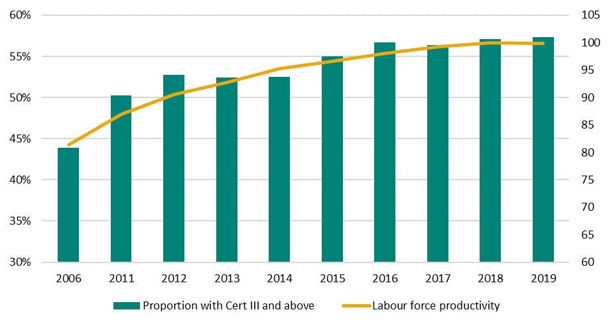
Source: ABS - 5204.0 Australian System of National Accounts 2018-19.
As we respond to the economic imperatives brought about by the COVID-19 crisis, we must ensure that Australia’s regions are not left behind. There is a significant disparity in participation and attainment for people from regional and remote areas and Indigenous Australians, which is holding back the contribution regional Australia can make to our economy and society more generally.
The Productivity Commission report, The Demand Driven University System: A Mixed Report Card found the demand driven system did not improve outcomes for regional and remote students, or Indigenous students. It also did not address the additional barriers these students face, such as substantial relocation costs.
As well as supporting greater fairness and equity, addressing this gap will have important economic and productivity benefits for the nation. The Government’s response to the National Regional, Rural and Remote Education Strategy provides a comprehensive way forward to address this disparity.

Key objectives
This reform package is built on five key principles:
Agile — Labour demands are rapidly evolving and Australia requires a higher education system that keeps pace with the changing needs of the economy and produces graduates with the right skills at the right time.
Focused — The higher education system needs greater focus on serving students and matching graduate skills to employer needs.
Innovative — An education system that supports innovative forms of learning and features flexible approaches to education and training that provide tailored learning solutions to students.
Informed — Prospective university students require timely and accurate information on career pathways and employment prospects stemming from fields of study.
Efficient — As a nation we need to ensure that education funding delivers efficient and effective outcomes for the national economy.
The focus of these reforms shifts our attention to jobs of national importance, such as teaching, nursing and STEM fields, and support for regional Australia. The sector has a fundamental role in preparing students for the future workforce and the higher education funding architecture must encourage this goal. Recent initiatives and key reviews have also provided a strong foundation upon which to re-shape higher education and help create a more integrated tertiary system.
Within the higher education funding system there are opportunities to restore growth, better align funding with the average cost of delivery, offer greater flexibility and provide incentives to produce graduates in disciplines that support the national interest. Through restructuring the Government’s investment in higher education this way, we can increase accountability and maximise outcomes for all Australians.
It is crucial for the system to produce job-ready graduates, who meet the needs of employers and the future workforce. Industry and universities must create greater links to ensure course content is increasingly relevant, includes effective work placement opportunities, increased collaboration, and also promotes research that delivers for industry, driving job growth, business opportunities and productivity gains.
We already know the higher education sector needs to better support students from regional and remote Australia. Halving the gap in attainment rates between regional and remote students and metropolitan students will not only benefit individuals, it will drive productivity for the regions and the Australian economy. Increasing student places and bolstering the research capacity of regional universities is required to foster potential and opportunity in regional communities. The National Regional, Rural and Remote Tertiary Education Strategy set out the direction and actions for essential effort in our regions, and the Government’s response, through targeted measures, puts key actions into place.
Higher education reform commencing from 2021 is essential to delivering the skills and job outcomes that will drive productivity and economic recovery.
Educating graduates for the jobs of the future
- Rebase funding to align with cost and increase focus on the national interest
- Incentivise students and universities to focus on work relevant qualifications
- Support growth in tertiary qualified workforce
Better regional outcomes
- More opportunity for regional students
- Support growth corridors and economic opportunity, delivering higher productivity and a $25 billion dividend in 2050
A more integrated tertiary system
- Deliver new provider standards, a better qualifications framework and a national repository of tertiary qualifications
- Improve integration and alignment of costs
Preparing the way for sustainable growth
- Next steps should consolidate the reforms to microcredentials and short courses
- Expand the options for students to engage with higher education to get the result they want

Reform agenda
- A simpler funding system with improved incentives and accountability
- Expanding opportunities for regional, rural and remote students
- A better integrated tertiary system

Phasing of budget initiatives
 | 2021 | 2022 | 2023 | 2024 | 2025 and beyond
Funding reforms | Existing funding clusters and student contributions adjusted for commencing students. Continuing students grandfathered.
Funding reforms | Establish National Priorities Industry Linkage Fund (NPILF) and Indigenous, Regional, Low Socio-Economic Status (SES) Attainment Fund (IRLSAF). Establish transition fund for affected universities. Establish review mechanism to refine methodology for distribution of NPILF and IRLSAF. |  |  | Revised NPILF and IRLSAF distribution models implemented.
Funding reforms | Increase number of commencing places, including increase for undergraduate qualifications in areas of national priority. Institutions bid for places for each funding agreement period. |  |  | Second round of commencing priority places allocated.
Funding reforms | Increase funding for non-medical domestic bachelor places by 3.5 per cent for regional, 2.5 per cent for high-growth metropolitan and 1 per cent for low growth metro campuses per annum.
Funding reforms | Establishment of a new funding envelope for Commonwealth supported places (CSPs) at Table A providers, with all Commonwealth Grant Scheme (CGS) funding indexed by the consumer price index (CPI).
Funding reforms | Provide additional CGS funding for Table B provider University of Notre Dame Australia.
Funding reforms | Reduce the FEE-HELP loan fee to 20 per cent.
Opportunities for regional, rural and remote students | Broaden the scope of the Higher Education Participation and Partnership Program (HEPPP) to include regional/remote and Indigenous students and establish a Regional Partnerships Project Pool.
Opportunities for regional, rural and remote students | Introduction of the Tertiary Access Payment for regional school leavers.
Opportunities for regional, rural and remote students | Introduce a guaranteed place (demand driven CSPs) for regional and remote Indigenous bachelor students at Table A universities.
Opportunities for regional, rural and remote students | Establish up to eight additional Regional University Centres (RUCs) and provide further support for existing Centres
Opportunities for regional, rural and remote students | Provide additional funding to enhance the research capacity of regional universities and establish partnerships with larger, research-focused institutions or industry.
Opportunities for regional, rural and remote students | Improvements to Fares Allowance
Opportunities for regional, rural and remote students | Establish a Regional Education Commissioner.
Better connected tertiary system | Undertake the expanded Industry 4.0 Advanced Apprenticeship Pilot.
Better connected tertiary system |  | Redraft of Australian Qualifications Framework.
Better connected tertiary system | Tertiary Education Quality and Standards Agency (TEQSA) to assume control of student records from higher education providers that cease operations.

A simpler funding system with improved incentives and accountability
This suite of funding reforms is carefully calibrated to meet specific issues and pressures. Collectively, they will simplify the system for both institutions and students, and restore real growth in a targeted manner, making our funding system more efficient by maximising the amount of available funding.
These reforms will provide the funding needed to support an additional 39,000 university places by 2023 and almost 100,000 places by 2030.
Current problem | Our reform strategy
Pressures from a growing population  Our current funding arrangements will come under increasing pressure in the 2020s as a larger cohort of 18 year olds move into higher education. | Provide more CSPs, growing the number of places substantially in the long term.  Return to CPI indexation of funding for bachelor students, maintaining the value of places over time.
Low participation and attainment in regional Australia  Participation and attainment in regional areas of Australia, and for regional Aboriginal and Torres Strait Islander Australians, is much lower than in the cities and for non-Indigenous Australians. | Provide a Tertiary Access Payment that will encourage regional and remote students to access tertiary study immediately after Year 12 by providing a one-off payment of $5,000 for outer regional or remote students who relocate to undertake full-time, high-level tertiary education.  Introduce demand driven funding for regional Indigenous students and provide more places for regional university campuses.
Current funding system doesn’t incentivise study in areas of industry need  Incentives in the current funding system could encourage sub-optimal choices for students and institutions, leading to poorer labour market outcomes and returns on investment in higher education. | Align funding with contemporary data on the cost of delivering university education.  This will mean for approximately 60 per cent of students, there will be no increase to student contributions, and Australia’s world-leading HECS-HELP loans system will continue to ensure that eligible students face no up-front cost barriers to higher education attainment.
Providing greater flexibility for universities to provide places to match demand  Universities currently receive funding for bachelor, postgraduate, and sub-bachelor students through different streams.  This leads to inefficiencies in funding allocations, where some universities are unable to fill places at some levels, while they enrol more students than they are fully funded for at other levels.  This is even more pronounced between institutions, with some universities unable to enrol enough students to reach their funding caps, while other universities are over-enrolled. | Allow universities to deliver the level of education students are demanding by introducing a “funding envelope”, combining funding for Commonwealth supported places across levels of higher education.  Allow universities to trade places, making the most out of public investment in the university sector
Fostering closer engagement with industry  Universities are currently expected to engage closely with businesses and industry to ensure they provide relevant education and produce graduates who are ready to be productive employees.  However there is no dedicated stream of funding for this purpose, so universities need to direct some of the “profit” from student funding to carry out these important functions. | Establish the National Priorities Industry Linkage Fund (NPILF) – to recognise the Government’s commitment to job-readiness and industry relevance as a priority for universities, students, and business.  This commitment incentivises work-integrated learning such as internships, extending the Industry 4.0 advanced apprenticeship pilot and fostering closer university-industry research collaboration.

Addressing pressures arising from population growth and disparities in attainment
Without reform, the number of fully funded commencing bachelor places in the Australian higher education system will decline over time. This is because bachelor-level funding is currently indexed to population growth, which is projected to increase more slowly than CPI. This means that, while costs continue to increase for universities due to salaries and other expenses, funding in inflation-adjusted terms will decrease.
At some point under the current policy, universities will need to reduce the size of commencing cohorts, or else reduce expenditure on teaching and learning, potentially compromising the quality of the education they offer to students.
This is happening at the same time as the Australian economy requires more high skilled workers than ever. Prior to the COVID-19 pandemic, projections from the Department of Education, Skills and Employment show that of the 1.1 million jobs forecast to be created between 2019 and 2024, 484,600 or 45 per cent will require a bachelor or higher-level qualification (2019 Skill Level Projections — five years to May 2024) (Figure 4).
Figure 4 - Projected change in employment by qualification to 2024 (thousands)
Source: Department of Education, Skills and Employment. (2020). 2019 Skill Level Projections five years to May 2024.
In addition, a population bulge colloquially known as the ‘Costello baby boom’ is moving through the population and will impact university enrolments in the mid-2020s (Figure 5).
Figure 5 - Population growth (Index, 2017=100) – 18yo vs 18-64yo
Source: ABS Cat 3222.0, population projection B

Participation and attainment in regional Australia
As noted in the final report of the National Regional, Rural and Remote Tertiary Education Strategy, the higher education attainment rate in regional Australia is significantly lower than in metropolitan areas. Individuals in regional, rural and remote (RRR) areas are less than half as likely to gain a bachelor or above qualification by the time they are 35, compared to those from metropolitan areas. People living in regional areas account for 27.3 per cent of people aged 15-64 years, but only 21.5 per cent of domestic undergraduate enrolments. Increasing the educational attainment of regional communities would have a significant positive impact on the broader economy, as well as on the individuals and communities they live in (Figure 6).
Figure 6 - Education attainment rates
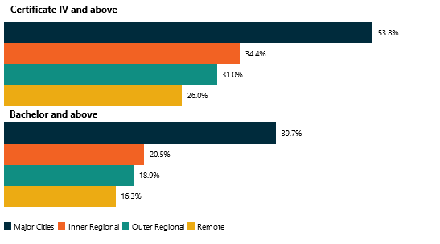Source: ABS, 2016, Census of Population and Housing.

Improving support for university study in areas of future economic need

Better aligning funding with the cost of teaching will fix distortions in the funding system and ensure universities can respond to student preferences rather than funding incentives
Providing CPI indexation for bachelor place funding prevents this funding being eroded substantially over time. It means that bachelor funding will maintain its real value, in line with the other buckets of funding in the CGS.
New growth funding is designed to put the funding where the nation needs it most. It provides a 3.5 per cent boost to funding for regional campuses to address the gap in attainment. It provides 2.5 per cent additional funding per annum for campuses located in high-growth metropolitan areas, to allow those to grow in line with the population, especially in outer-metropolitan growth corridors. And it provides 1 per cent growth funding per annum for other campuses to allow them to keep up with population growth in the cities.
Extra, targeted funding will be provided in national priority areas and courses to boost skills in the workforce where they are needed. Initially providing 300 commencing places in 2021, this will increase to 900 by 2024, and 2000 commencing places per year by 2030.
Importantly, the Government will also remove caps on funding altogether for Indigenous students from regional areas undertaking bachelor degrees at university. The Government believes that every capable Aboriginal and Torres Strait Islander should have the opportunity to gain a higher education and removing caps for these students is an important reform to address the disparity in educational outcomes (Figure 7).
Providing a boost to funding for regional campuses responds to Recommendation 1 of the Napthine Review to ‘improve access to study options for students in RRR areas’. A key finding of the Napthine Review was that regional and remote students have less access to tertiary education options in their local community, and in order to increase university participation rates, some lifting of the current caps on funding for university places would be necessary.
Figure 7 - The reform package addresses these issues to provide growth where it is needed
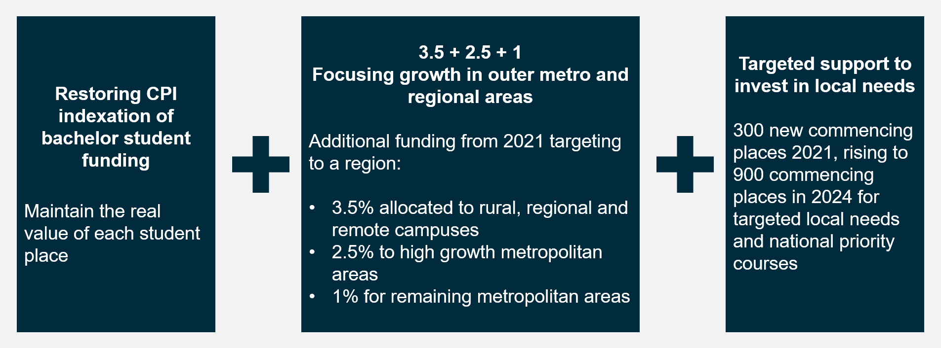

Unused places and over-enrolments
The most recent university estimates of student load suggest that in 2019, around a third of universities were over-enrolled in one bucket of funding, and over-enrolled in the other. That is, they may have more bachelor students than their funding allows for, and fewer postgraduate or sub-bachelor students than their funding allows for, or vice-versa.
The redesign of the funding clusters will continue to see government pay more than half of the costs of Commonwealth supported places overall, but with some rebalancing of contributions across fields of study to address a number of growing economic imperatives:
- The relative costs of delivering different courses have changed over recent years
- The economy is changing and there is a need to increase the level of support going to fields of study that will contribute to national priorities and future prosperity
- Funding reform is needed to create room for some further growth in places, which is critical if Australia is to maintain attainment rates and growth in productivity to support a globally competitive economy into the future.
The redesign will see some students paying less while others will pay more (Figures 8 & 9).

Figure 8 - Current funding arrangement (2021 projected rates)

Commonwealth Contribution: 8 Clusters
Cluster 1  $2,237 | Cluster 2  $6,226 | Cluster 3  $11,015 | Cluster 4  $11,462
- Law & Economics  - Management & Commerce | - English  - Philosophy & History | - Social Studies, Political Science & Behavioural Science  - Maths  - Architecture  - IT  - Other Health | - Teaching
Cluster 5  $13,547 | Cluster 6  $15,125 | Cluster 7  $19,260 | Cluster 8  $24,446
- Communications  - Clinical Psychology  - Creative Arts  - Languages  - Allied Health | - Nursing | - Engineering  - Science | - Agriculture  - Environmental Studies  - Medical  - Dental  - Veterinary Science

Student Contribution: 3 Bands – based on private returns
Band 1  $6,804 | Band 2  $9,698 | Band 3  $11,355
- English  - Social Studies, Political Science & Behavioural Science  - Teaching  - Communications  - Clinical Psychology  - Creative Arts  - Languages  - Nursing | - Maths  - Architecture  - IT  - Other Health  - Allied Health  - Engineering  - Science  - Agriculture  - Environmental Studies | - Law & Economics  - Management & Commerce  - Medical  - Dental  - Veterinary Science

Figure 9 - New funding arrangement (2021 projected rates)

Commonwealth Contribution: 4 Clusters
Cluster 1  $1,100 | Cluster 2  $13,500 | Cluster 3  $16,500 | Cluster 4  $27,000
- Law & Economics  - Management & Commerce  - Social Studies, Political Science & Behavioural Science  - Communications | - Teaching  - Clinical Psychology  - English  - Maths  - Allied Health  - Other Health  - Architecture  - IT  - Creative Arts | - Nursing  - Languages  - Engineering  - Environmental Studies  - Science | - Agriculture  - Medical  - Dental  - Veterinary Science

Student Contribution: 4 Bands
Band 1  $3,700 | Band 2  $7,700 | Band 3  $11,300 | Band 4  $14,500
- Teaching  - Clinical Psychology  - English  - Maths  - Nursing  - Languages  - Agriculture | - Allied Health  - Other Health  - Architecture  - IT  - Creative Arts  - Engineering  - Environmental Studies  - Science | - Medical  - Dental  - Veterinary Science | - Law & Economics  - Management & Commerce  - Social Studies, Political Science & Behavioural Science  - Communications

How have we calculated the new rates?
A range of evidence has informed the new model for funding arrangements and other considerations, notably a calculation of private and public benefits, cost of delivery and national employment priorities.

Private and public benefits
An analysis of public and private benefits provides an indicator of the expected marginal public and private returns to be gained from a student choosing one course of study compared to another (Figure 10).
Private benefits | Public benefits
Using average full-time income, analysis shows that returns vary considerably across fields of education.  However, graduates in all fields of study tend to do better than those without these degrees, highlighting the strong case for continuing support and investment in higher education. | The new model for funding also incorporates a broader assessment of public benefits, including:  - employment participation – we need to encourage study in fields with higher employment outcomes  - proportion of graduates employed as managers and professionals – an investment in professional qualifications leads to professional employment  - completion rates – higher completion rates represent better value.

Figure 10 - Public and private return on investment by Field of Education
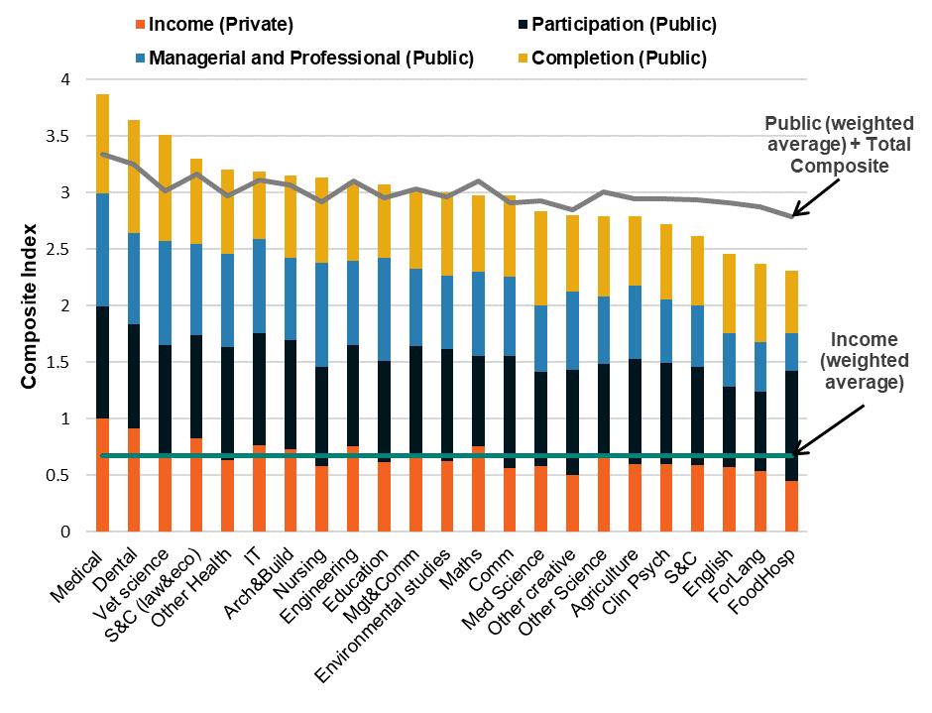
Source: ABS Census 2016, HEIMS

Cost of delivery
An analysis of current total combined government and student funding compared to costs of delivery shows some fields are over-funded, while others are underfunded.
Social studies, science, behavioural science, creative arts, nursing and education for example, are currently over-funded on average. While law, commerce, accounting, management and agriculture are all under-funded on average.
The new streamlined four cluster and band structure provides an opportunity to recalibrate total base funding in line with evidence on the cost of delivery (Figure 11).
Figure 11 - A new funding model better matched to cost
Current Model 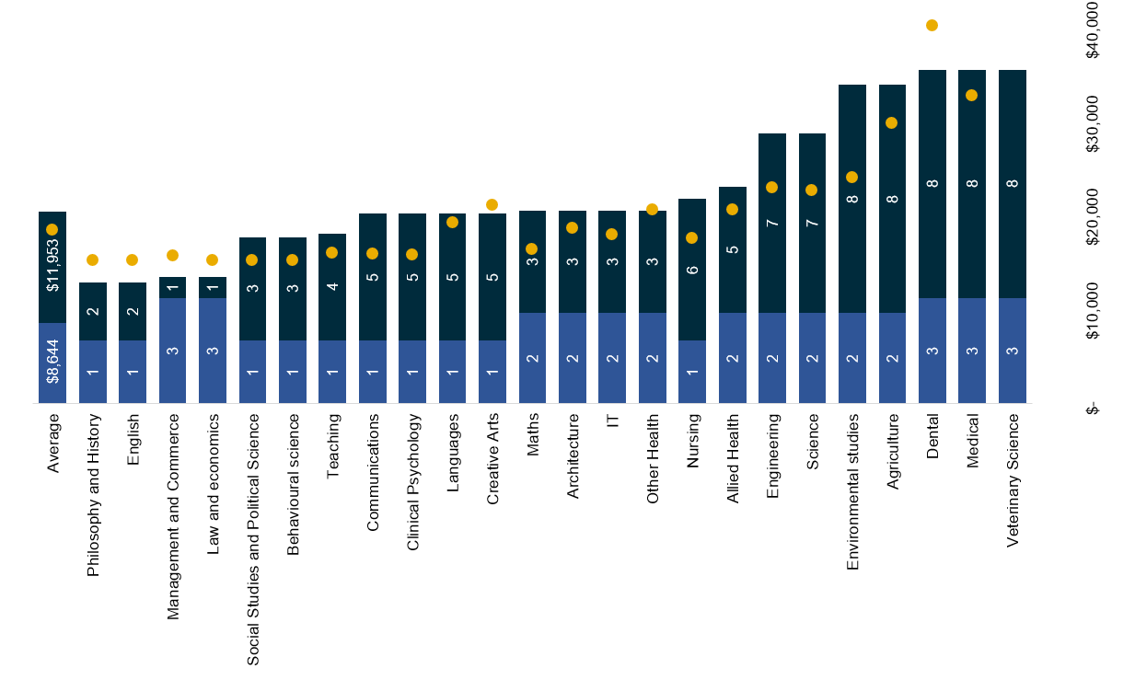
New Model
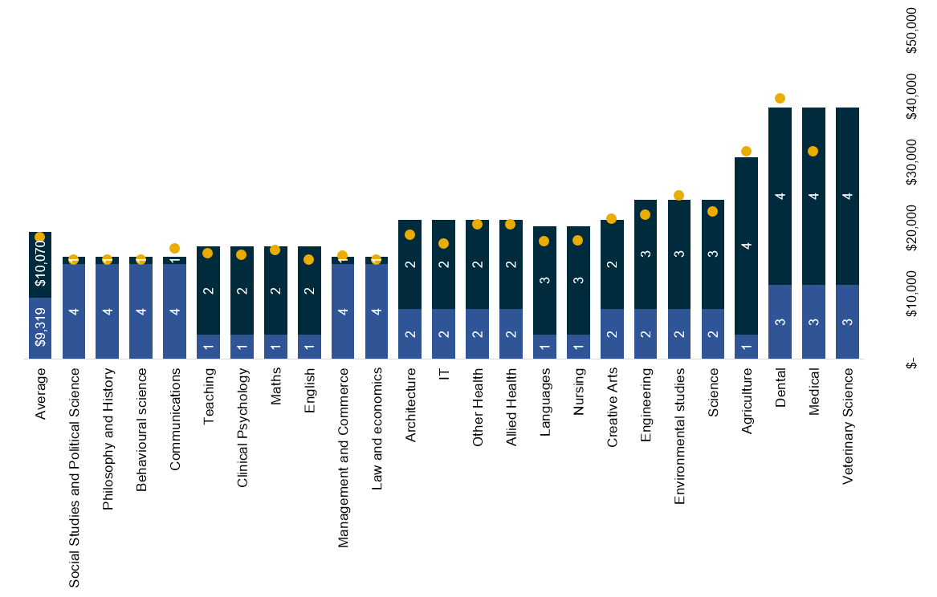
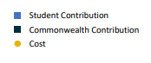

National employment priorities
The changing nature of the Australian workforce in coming decades will have direct implications for the skills and education required of workers. The new funding model is therefore informed by national public benefit considerations.
For example, fields of education such as maths, foreign languages and agriculture all have relatively low public returns, but are important to broader national priorities. Science, technology, engineering and mathematics (STEM) related disciplines will be important to Australia’s future economy.
We must do what we can now to ensure there is a pipeline of skilled workers in these priority fields, working to prevent future skills shortages the impact on the Australian economy (Figure 12).
Figure 12 - Total new jobs projected to be created by 2023 as a proportion of all new jobs
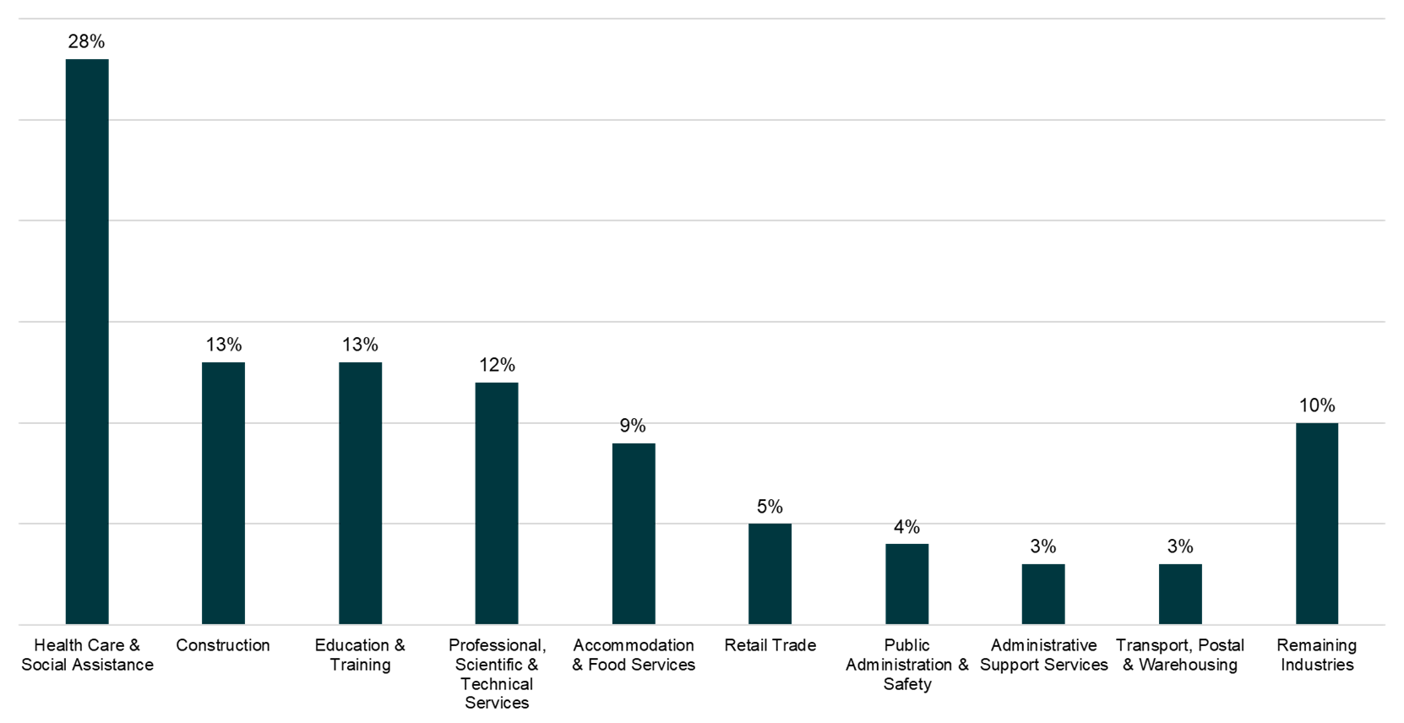
Source: Department of Employment, Skills, Small and Family Business. (2019). Australian Jobs: Industry Outlook

The outcome of these reforms is a better alignment of investment with national priorities
This new funding model allows for a more nuanced approach to determining the share of costs met by the Government and students in each field. It also increases the share of costs met by the Government for courses that produce higher public returns or which contribute to identified national priorities.
With the competing pressures on the higher education system, the Government needs to maintain fairer cost-sharing arrangements for taxpayers, while also encouraging study in fields most necessary for the jobs of the future and positioning Australia to capitalise on opportunities to increase productivity and national prosperity in the decades ahead.
Like many countries around the world, as access to higher education has been expanded, there has been a long-term decrease in the share of funding met by government. Despite this trend, the Government still on average meets more than half of the costs for Commonwealth supported places.
The new funding model means 60 per cent of students will have lower or unchanged fees in priority areas, and will allow Government to create growth in the sector to build a skilled and qualified workforce. In addition, the HELP loan scheme will ensure that, even if a student faces increased fees for their study, their access to higher education is based on their ability to succeed rather than their capacity to pay upfront.

Provide greater flexibility for universities to provide places where they are needed
By providing universities greater flexibility they can be more responsive to local demand, and thereby ensure more graduates are job-ready and more likely to engage in the local economy.
The Government listens to the higher education sector, and the sector has said that it supports this kind of flexibility. About a third of the respondents to the 2019 “Consultation paper on the reallocation of commonwealth supported places for enabling, sub-bachelor and postgraduate” stated that institutions should be given the flexibility to manage their CSP allocations.
The Government gave some additional flexibility to universities flexibility to shift funding to where it is needed through the Higher Education Relief Package. This will be extended to give freedom to move funding between bachelor, postgraduate and sub-bachelor places, as well as trade CSPs with each other (Figure 13).

Figure 13 - Commonwealth Grant Scheme funding envelope
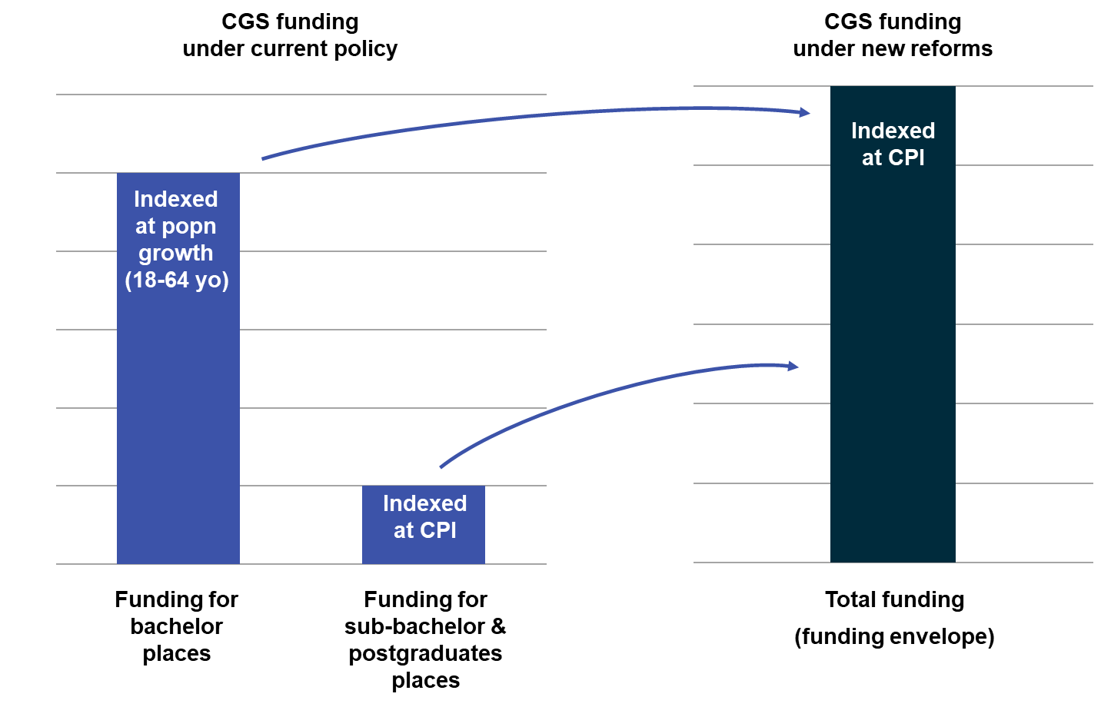

Dedicated funds to foster closer industry engagement
This signature reform will both simplify current programs, and introduce a new and unique funding stream to target the Government’s key priority of producing job-ready graduates (Figure 14).
The new NPILF will provide a dedicated funding stream for universities to carry out the vital functions of engagement with industry, development of industry-relevant course material, optimisation of course mix for local economies, and provision of work-integrated learning opportunities for students.
This reform recognises that these functions currently exist in universities, but relying on “profits” from student fees, or cross-subsidisation of funding for learning and teaching is a piecemeal approach to ensuring the sector produces enough of this human capital.
The new IRLSAF is a consolidation of existing equity programs to streamline administration and finances, thus increasing efficiency while maintaining the functions of the donor programs, and the focus on equity and access. Government will work with the sector on the design of the fund in the long-term, to improve universities’ ability to facilitate access to higher education for disadvantaged and vulnerable cohorts.
Universities gain additional flexibility in how they meet their engagement and social obligations, however, they will also have new expectations for transparency and accountability. Universities are high-performing institutions, and both Government and the wider community expect good outcomes from the significant public funding these institutions receive.
The two new funds will make Government and community expectations for universities clear in terms of the outcomes they achieve for their graduates, their engagement with the business community, and their ability to expand access and participation in higher education. Embedding performance-based funding in the NPILF, and requiring universities to report on the cost of teaching on a more ongoing basis will also bring greater accountability to the sector.
Figure 14 - Driving growth: a simpler funding model better matched to need
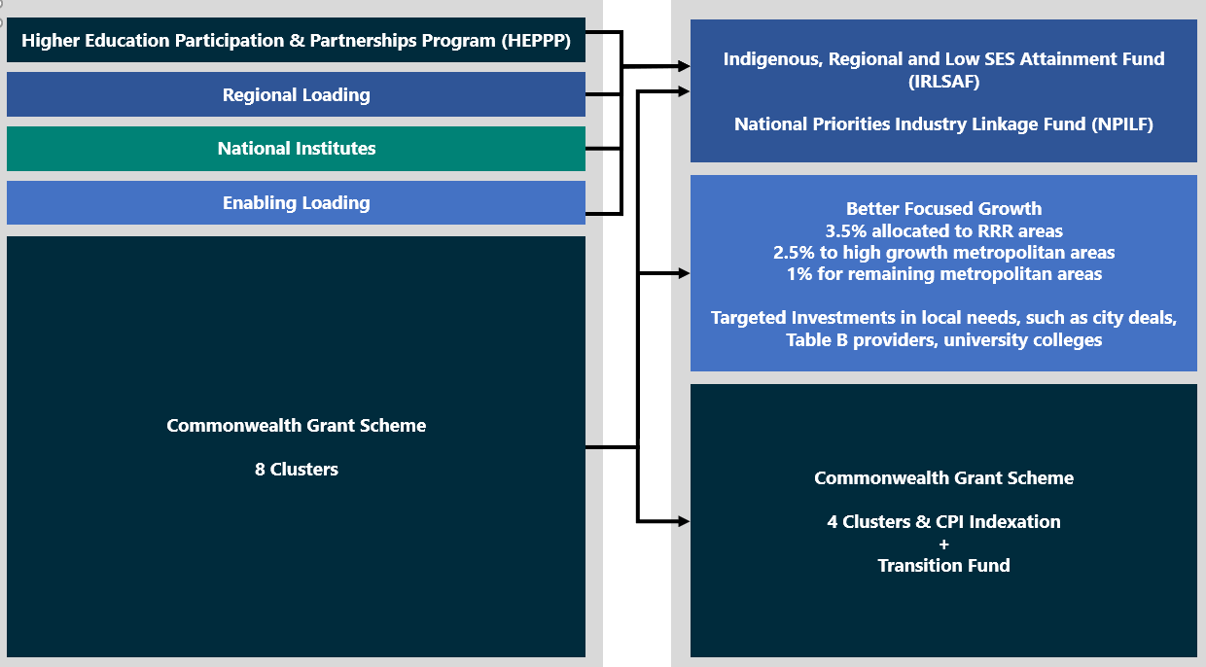

A carefully targeted transition period
This reform package has been carefully designed to ensure that universities can maintain their revenue over the first three years of implementation. A $705 million transition fund will be established and distributed to universities in such a way that ensures fairness across the sector.
A key component of the reform package is funding cluster realignment, which commences from January 2021 and encourages students to enrol in courses that are going to give them the best employment outcomes after graduation. From 2021, all new and existing students studying teaching, nursing, agriculture, and STEM will pay less for their qualifications. Students already enrolled and undertaking subjects where student contributions are to increase will be exempt from these rises.
Changes to the funding clusters will not change the HECS-HELP loans scheme. Students enrolled in a Commonwealth supported place will continue to have access to income contingent loans to pay for their student contributions, ensuring these students have no immediate out of pocket costs.

Scenario 1
Matthew is currently enrolled in a nursing degree as a Commonwealth supported student. Matthew is studying full-time and plans to graduate at the end of 2021.
From 1 January 2021, the student contribution for a full-time student enrolled in nursing will be $3,700.00. Before 1 January 2021, the student contribution for a full-time student enrolled in nursing was $6,804.00. Matthew will pay $3,104.00 less in student contributions for his final year of study in 2021.

Scenario 2
Kellie is currently enrolled in a law degree as a Commonwealth supported student. Kellie is studying full-time and plans to graduate at the end of 2021.
From January 2021, the student contribution amount for a full-time student enrolled in law will increase from $11,355.00 per year to $14,500.00. Kellie was enrolled in a law degree prior to January 2021 and therefore only needs to pay the lower student contribution for the duration of her degree.

Scenario 3
Khadija is a Year 12 student seeking to enrol in an Arts degree with a major in political science. Khadija is seeking to commence studies in semester 1, 2021.
Political science aligns with the society and culture field of education. From 1 January 2021, the student contribution for a full-time student studying society and culture is $14,500.00 per year. Before 1 January 2021, the student contribution for the same course would have been $6,804.00 per year. Khadija will not be enrolled in her course until after 1 January 2021. She will need to pay the higher student contribution amount for any society and culture course she enrols in.

We are also reducing financial barriers for students to undertake study at providers of their choice and supporting different pathways to further education

From 1 January 2021, approximately 50,000 higher education students who take out a FEE-HELP loan each year for an undergraduate full fee-paying place will have a reduction in their loan fee from 25 per cent to 20 per cent.
Existing loan fee arrangements have created an imbalance for students seeking loan assistance between courses at non-university higher education providers (NUHEPs), and courses at universities. Currently, full-fee paying higher education students at NUHEPs that access a FEE-HELP loan incur a loan fee of 25 per cent, while students accessing a non-state subsidised VET course and use the VET Student Loans program incur a 20 per cent loan fee.
Reducing the loan fee to 20 per cent will ensure there is loan fee equity between NUHEPs offering undergraduate courses and registered training organisations offering courses eligible for VET Student Loans. This is a step towards a more level playing field between VET and higher education loan options, as well as towards a closer alignment of HELP arrangements for universities and NUHEPs. A more equitable playing field, both between and within sectors, will encourage competition for students and improve their tertiary study options.

Expanding opportunities for regional, rural and remote students

We need a regional, rural and remote education strategy that will lift attainment rates
Education participation and attainment rates continue to be significantly lower in regional and remote Australia compared to metropolitan areas. Individuals in RRR areas are less than half as likely to obtain a bachelor or above qualification by the time they are 35, compared to those from metropolitan areas. People living in regional areas account for 27.3 per cent of people aged 15-64 years, but only 21.5 per cent of domestic undergraduate enrolments.
Improving tertiary education outcomes in regional, rural and remote areas will provide substantial benefits to individuals, regional and remote communities and the nation as a whole. Tertiary education is crucial to the future of Australia’s regional economies, ensuring our nation has individuals with the necessary skills for the jobs of the future.
Halving the gap in attainment and participation rates in regional and remote areas by 2030 would increase GDP by 0.6 per cent by 2050, or around $25 billion.
A National Regional, Rural and Remote Education Strategy (the Strategy) was developed by the Regional Education Expert Advisory Group (EAG) led by the Hon Dr Denis Napthine. The Strategy focusses on improving tertiary education outcomes for regional, rural and remote individuals. The Strategy built on the work of Emeritus Professor John Halsey’s Independent Review into Regional, Rural and Remote Education.
The National Regional, Rural and Remote Tertiary Education Strategy final report (Napthine Review) was released by Minister Tehan on 28 August 2019. The report makes seven recommendations and proposes 33 individual actions to improve regional and remote tertiary education outcomes.
The recommendations are:
- Improve access to tertiary study options for students in RRR areas
- Improve access to financial support, to support greater fairness and more equal opportunity
- Improve the quality and range of student support services for RRR students to address the challenges of transition and higher rates of attrition
- Build aspiration, improve career advice and strengthen RRR schools to better prepare RRR students for success
- Improve participation and outcomes for RRR students from equity groups including low SES students, Indigenous students, students with disability and remote students
- Strengthen the role of tertiary education providers in regional development and grow Australia’s regions
- Establish mechanisms to coordinate the implementation effort and support monitoring of the Strategy.
Based on priority actions identified by stakeholders for the implementation of the Strategy, the Government is implementing a range of reforms aimed at improving participation and attainment rates of regional and remote individuals, while also supporting regional universities and communities.
The Government is investing over $400 million over four years from 2020-21 through its response to the Napthine Review. This includes the 3.5 per cent growth in places for non-medical domestic bachelor places in regional areas per annum noted earlier ($145 million over four years). This adds to the more than $600 million it has committed since 2016 to support regional higher education.

The Government is investing $159.1 million over four years for a Tertiary Access Payment for outer regional and remote school leavers to provide greater access to tertiary education
The Tertiary Access Payment will significantly benefit school-leavers who live in outer regional and remote Australia to access tertiary education. Based on current Department of Education Skills, and Employment data, an estimated 8160 tertiary students will be eligible for this payment in 2021. This measure will encourage and assist regional and remote students to access tertiary study immediately following school (year 12), rather than taking a gap year.
It provides a one-off, non-indexed payment of $5,000 to school-leavers from outer regional or remote areas who relocate to undertake full-time, higher-level tertiary education. These payments will be demand-driven to have the flexibility to respond to increased tertiary participation.
This payment will be available for students who are from an outer-regional, remote or very remote area (as per the Australian Statistical Geography Standard remote classifications) enrolled in a Certificate IV or above qualification, with duration of at least one year, and relocating to study at an institution at least 90 minutes by public transport from their home (either in another regional location or a metropolitan location). Students must commence their further study in the year immediately following completion of Year 12.
There will also be a combined parental income cut-off for this payment of $250,000. The payment will be made in two parts, an initial $3,000 payment following confirmation of a student’s enrolment, and a further $2,000 payment later in the academic year.

The Government will provide $17.1 million over four years to enable Indigenous students from RRR areas to access demand-driven Commonwealth-supported university places
The Napthine Review highlighted the increased challenges and very low higher education participation rates for Indigenous students in regional and remote areas. In 2016, the participation rate for Indigenous students from regional and remote areas was 2.6 per cent, less than half the rate for all regional and remote students (5.3 per cent) and just over a third of the rate for people from metropolitan areas (7.3 per cent).
This fund is demand driven and will allow an estimated 160 additional Aboriginal and Torres Strait Islander students from regional and remote areas to undertake higher education in 2021, rising to over 1,700 new students by 2024. It will also enable universities to provide better support for Indigenous students by providing funding capacity that aligns with enrolment levels. It will also have flow-on benefits for Indigenous communities, including in remote locations, through providing professional services and other enterprises requiring university educated workforces.
The Government will invest $21 million over four year to establish up to eight additional Regional University Centres (RUCs) and strengthen the existing RUC program, including through establishing a central support network and funding a comprehensive evaluation of the program
The Regional University Centres (RUC) program is a new and innovative program aimed at supporting students that remain in their home communities and wish to undertake further study. The Australian Government is already supporting the establishment and operation of 25 RUCs across Australia, following the announcement of nine new RUCs on 1 June 2020 (Figure 15).
These activities will benefit students in regional and remote areas, through the support they receive from the presence of well-run and well-supported RUCs. The 16 RUCs established and operating in 2019 supported approximately 1,000 regional and remote students. Among the current RUCs, two support entirely or mostly Aboriginal and Torres Strait Islander student cohorts, playing a critical role in bolstering the Government’s Closing the Gap target to improve tertiary education outcomes for Aboriginal and Torres Strait Islander peoples.

Figure 15 - Distribution of Regional University Centres

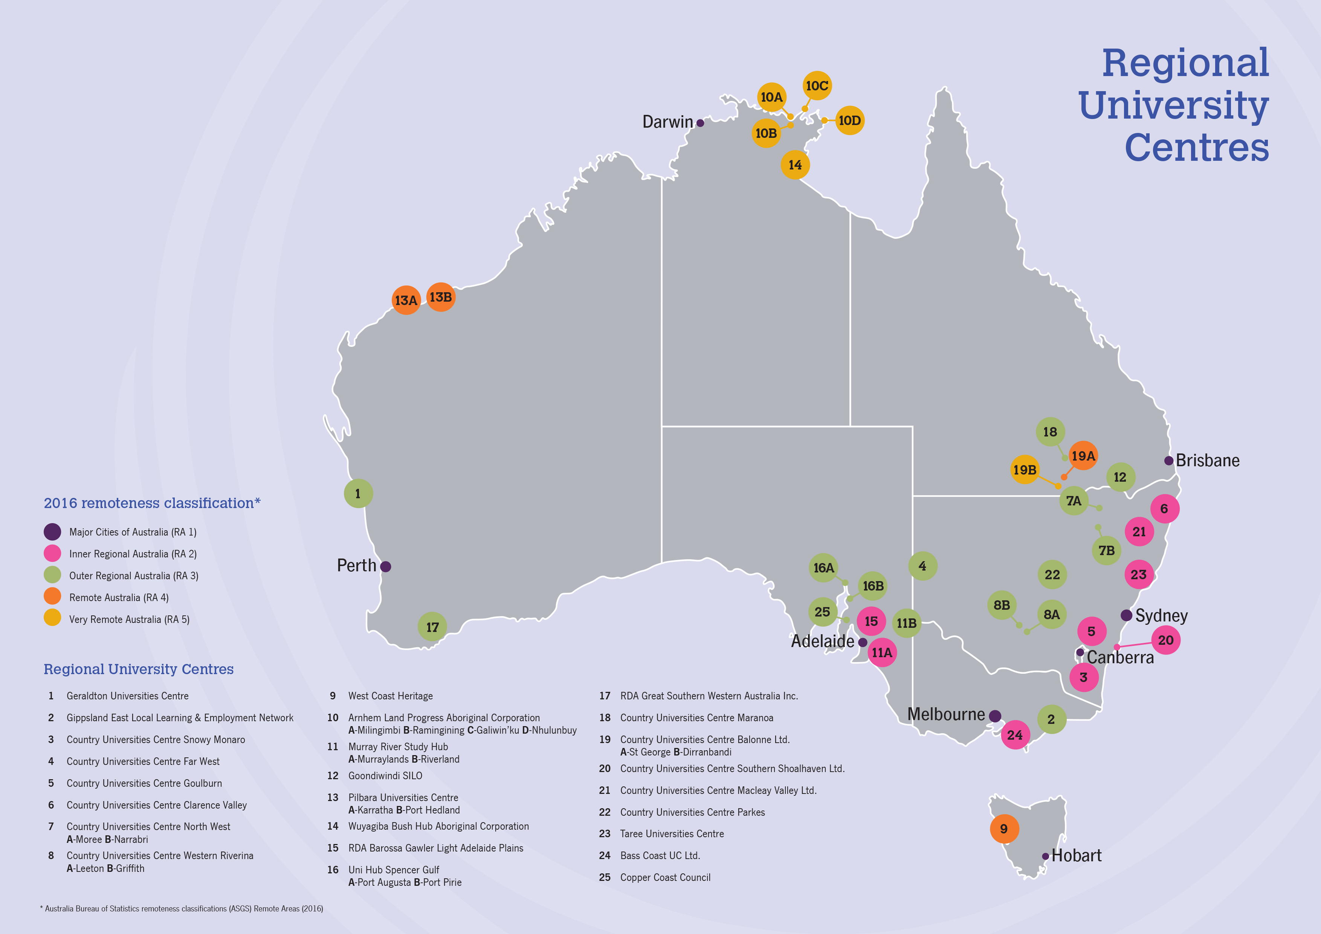

Refocussing the Higher Education Participation and Partnerships Program (HEPPP) to support regional and remote students, Indigenous students, as well as those from low socio-economic status (SES) backgrounds, including the creation of a new competitive Regional Partnerships Project Pool component of $1.8 million per year.
Figure 16 - From 2021, HEPPP allocations will better support regional, remote and Indigenous students
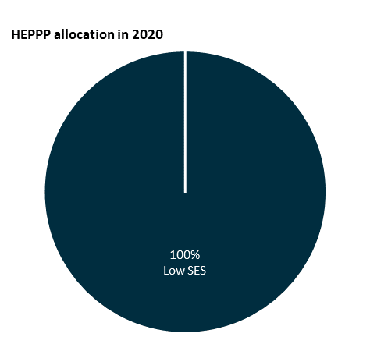
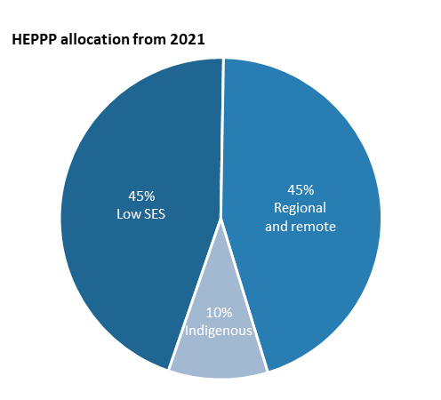

Regional and remote students and Indigenous students often face cumulative challenges that can make it more difficult to access and complete higher education. Approximately 125,000 additional students from regional and remote areas and Indigenous students will be able to benefit from measures put in place by their universities through HEPPP funding. Table A universities will be able to expand HEPPP funded activities to support regional, remote and Indigenous students to access and complete higher education, providing a greater skill base for regional and remote communities (Figure 16).

The Government will provide $48.8 million over four years to enhance the research capacity of regional universities by implementing a grants program focused on encouraging regional institutions to establish partnerships with larger, research-focused institutions, either in Australia or overseas, or with industry
The geographical isolation of universities in regional and remote areas makes networking and relationship building difficult. The higher cost of travel to and from regional and remote areas compared to between metropolitan areas results in researchers in regional and remote areas requiring greater justification for attending an event or meeting outside the region.
This proposal will positively impact regional universities through delivery of additional funding to undertake research. This is expected to have positive flow-on effects for local business and the community.
The program will be ongoing and run annual funding rounds, providing three years of initial funding for successful applicants, with the possibility of an additional two years funding to a limited number of high performing projects. To be eligible, an institution must be a regionally headquartered Table A provider under the Higher Education Support Act 2003 (HESA). Institutions will be able to apply through a merit-based selection process, with funding to commence in 2021.

The Government will provide $0.725 million to improve Fares Allowance
Currently, students must be receiving Youth Allowance, Austudy or the Pensioner Education Supplement (PES) for six months before they can access a return trip home under Fares Allowance during their first year of study.
This change will reduce the waiting period from six months to three months, to allow students to travel home in the mid-year break in their first year. All other aspects of Fares Allowance and the eligibility criteria will remain the same.

Additionally, $6 million over four years will be allocated to appointing a Regional Education Commissioner, including associated administrative support, to oversee the implementation, monitoring and success of the Strategy
The Napthine Review recommended that the implementation of the Strategy will require coordinated effort across education sectors, as well as with the states and territories. The Commissioner will have an important role to play in bringing these efforts together, and ensuring the Strategy is implemented in a cohesive manner. It will benefit all education stakeholders from early childhood through to higher education, both nationally and across jurisdictions, to improve tertiary education outcomes in regional and remote areas.
The Commissioner will execute a number of key projects related to the recommendations and actions of the Napthine Review:
- Developing improved geographical classification tools and establishing data monitoring systems to enable more accurate information regarding education provision across regional and remote Australia
- Evaluating current support services for regional and remote students, in order to identify existing support services, disseminate information and encourage best-practice intervention and offerings that universities should provide their students
- Investigating ways to facilitate reliable internet access for regional and remote students to assist them in their tertiary studies, and other priority projects to address gaps in internet access
- Mapping of current provision of tertiary access programs, including careers advice and VET in Schools, to identify gaps in regional and remote provision as well as examples of best practice
- Investigating best-practice methods of retaining students to Year 12 in regional and remote areas. The Napthine Review found that the relative educational disadvantage faced by children in RRR areas is a factor throughout school, with students less likely to complete Year 12.

A better integrated tertiary system

Universities and industry collaborating to provide high-level skills to workers

The Government is continuing to support university-industry collaboration by providing an additional $3.7 million over two years from 2021 to expand the Industry 4.0 Advanced Apprenticeship Pilot into a two-year Associate Degree qualification.
Extending the pilot for a second year will allow participating workers to obtain an Associate Degree in Advanced Manufacturing, focused on highly in-demand Industry 4.0 skills. New Industry 4.0 microcredentials will also be developed as a component of the course and made available for wider use. This pilot of longer-form work integrated learning within the higher education sector aims to equip graduates with skills that are directly relevant to their current and future work roles. The pilot will strengthen links between universities and industry to ensure learners and employers get the skills they need and that we are building a higher skilled workforce in sectors that are vital to Australia’s future productivity.

A new tertiary qualifications framework for Australia’s future education and training needs

At a cost of $3.1 million over three years, the Government will undertake essential work to progress the recommendations of the Australian Qualifications Framework (AQF) Review.
The AQF underpins Australia’s education and training system. It defines the essential learning outcomes for all types of regulated qualifications in Australia, from the Senior Secondary Schooling Certificate, through vocational education and training (VET) qualifications, to bachelor degrees and post-graduate qualifications in higher education.
A review of the AQF was undertaken by an Expert Review Panel chaired by Professor Peter Noonan. The Panel’s final report was released on 24 October 2019 and made 21 recommendations. The Government is now working to progress the Review’s recommendations, with state and territory governments, to ensure Australia’s qualifications can meet the needs of twenty first century learners and employers. This will include:
- making it easier for students to move between vocational training and higher education
- improving the responsiveness of Australia’s tertiary system to industry needs by enabling better recognition and greater uptake of microcredential qualifications, and
- ensuring qualifications incorporate the skills and general capabilities that best support students to be job ready and succeed in a modern workplace.
A reimagined AQF will ensure Australia’s tertiary qualifications are flexible and robust enough to meet the future education and training needs of the economy and the wider community.

Providing students guaranteed access to their academic records from closed providers

The Government is allocating $2.0 million over four years to enable the Tertiary Education Quality and Standards Agency (TEQSA) to have the legislative authority and the capacity to assume control of student records from a registered higher education provider, in the event the provider ceases operations.
This measure will provide TEQSA with similar legislative powers to those of the Australian Skills Quality Authority to ensure that ceasing providers supply the regulator with a copy of their student records within 30 days of ceasing operation. Funding provided to TEQSA will enable it to develop the required capability and ICT infrastructure so that it can securely collect, store and manage student academic records of providers that cease operation.
This measure will allow current and former students of closed higher education providers to obtain their academic records from TEQSA in an efficient manner, including details of qualifications earned. This measure has particular importance for international students, who may have difficulty advocating on their own behalf to secure academic records where their higher education provider collapses.

