
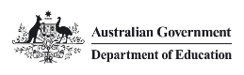

Reconciliation Action Plan
  - August 2023–25
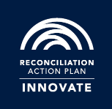
Copyright

With the exception of the Commonwealth Coat of Arms, the Department’s logo, any material protected by a trade mark and where otherwise noted all material presented in this document is provided under a Creative Commons Attribution 4.0 International (https://creativecommons.org/licenses/by/4.0/) licence.
The details of the relevant licence conditions are available on the Creative Commons website (accessible using the links provided) as is the full legal code for the CC BY 4.0 International (https://creativecommons.org/licenses/by/4.0/legalcode).
The document must be attributed as the Department of Education Reconciliation Action Plan August 2023–25.

Contents
Acknowledgement of Country 5
Guwanyi wingara yirabana: Artwork Story 6
Our vision for Reconciliation 9
Message from the Secretary 10
Message from First Nations Champions 12
Message from the Reconciliation Australia CEO 13
Our business 16
Our RAP 20
Our RAP Journey 22
IBEB Committee 27
Actions 30
Relationships 30
Respect 34
Opportunities 38
Governance 42
Contact details 46

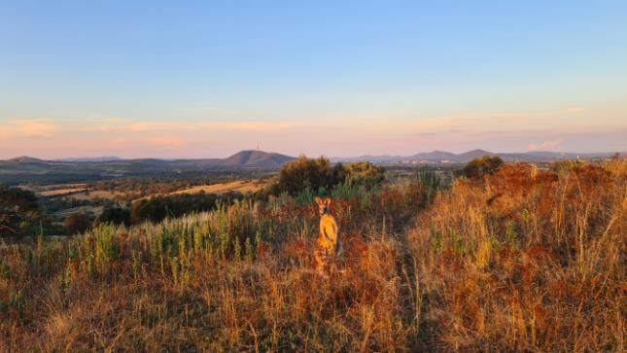
NGUNNAWAL, Oakey Hill Nature Reserve, ACT
Photo by: Caitlyn Lymbery, HERI Group

Acknowledgement of Country
The Department of Education acknowledges the Traditional Owners and Custodians of Country throughout Australia and their continuing connection to land, waters and community. We pay our respects to them and their cultures, and Elders past and present.

MIRIWOONG, Kelly’s Knob Lookout Kununurra, WA
Photo by: Rick Jackson, ECY Group

Guwanyi wingara yirabana: Artwork Story
Guwanyi wingara yirabana is an original Aboriginal artwork that captures our story, amplified through the process of collective creation.
Guwanyi wingara yirabana means ‘tell and listen, think and journey’ in Dharug/Darug language. It reflects the department’s purpose – to create a better future for all Australians through education as it depicts education’s reach and ability to enable people to fulfil their potential at every life stage.
Central to the artwork is the depiction of a multi-layered learning journey that ebbs and flows through life but is always supported and valued. It reflects our collective resolve to create a better future for all Australians through education.
The symbolism of yarning circles – yidigi – feature across the learning journey as safe places, where everyone is respectful and equally heard. A place where people listen, engage, connect, and understand. The people we support – children, teachers, families, and stakeholders – are at the centre of these circles, showing the benefits of education flowing through to communities.
The ripples from the centre and flowing through to communities illustrate the positive impact of education getting bigger and bigger as life goes on.
The boomerangs and contour lines, always together, depict an aerial view of Country to remind us of reciprocity – what we put out, we get back – and that the highs and lows that will be overcome if we persist.
Guwanyi wingara yirabana also encapsulates the presence and influence of our Aboriginal and Torres Strait Islander Network – their connection to Country, support for mob, and their perspectives and lived experiences that radiate out to inform our work and cultural capability as a foundation for Reconciliation.
The marks on the canvas were made by many hands in a powerful gesture showcasing reconciliation in action, and a willingness to work together as a united team to make lasting change through education, connection, and culture.
The artwork was commissioned by the Department of Education and created by Trevor Eastwood from Dalmarri with department staff during 2023 NAIDOC Week celebrations. Trevor is a descendant of the Ngamba people on the Barwon River, part of Kamiloroi Country.

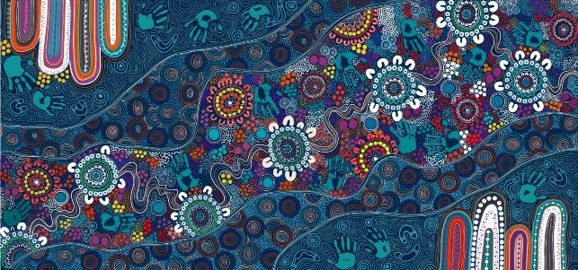

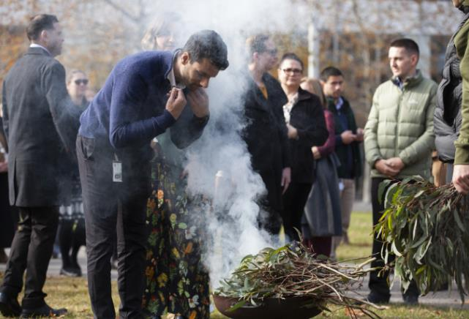

Our vision for Reconciliation
Our vision is for a reconciled Australia where Aboriginal and Torres Strait Islander peoples, cultures and heritages are valued and respected, and our shared history is recognised and accepted as a foundation for unity, equality, and enduring positive change.
As the Department of Education, we recognise the integral role of education in reconciliation – to inform and foster pride in Aboriginal and Torres Strait Islander histories, cultures, and contributions and build deep and respectful relationships that contribute to unity and equality for all Aboriginal and Torres Strait Islander peoples and communities.
By delivering on our purpose – to create opportunities through access to quality education – from early childhood to school and further education, we see the potential of education to help all Australians achieve their potential and contribute to a society that respects diversity, including the richness of Aboriginal and Torres Strait Islander cultures across Australia.
Education is equally fundamental to engaging our people in our reconciliation journey. We are making progress, and our Innovate RAP reflects our growing maturity and sophistication as we seek to do more to fully embed reconciliation into our culture and society – where Aboriginal and Torres Strait Islander peoples have the same opportunities as other Australians.
Our Innovate RAP is formed around the four pillars of reconciliation – Relationships, Respect, Opportunities, and Governance. By implementing this plan, we will put into practice strategies and initiatives to advance reconciliation and create a pathway to achieving our ambition of delivering a Stretch RAP to embed reconciliation in how we work and what we do to achieve our vision for a reconciled Australia.
We aspire to have First Nations peoples restored to a place of equity, dignity and respect. We are committed to this journey and building a culturally safe and competent workplace grounded in dignity and respect, where relationships with staff and stakeholders are strong and productive.
We know that a highly capable, culturally safe First Nations staff cohort is central to meeting our aspirations, and to meeting the nation’s need for an education system that embraces self-determination and reflects First Nations needs and interests.
To achieve this ambition, we will improve our representation of First Nations peoples and develop and support their career opportunities.
We will implement our Innovate RAP over the next two years to deliver on our commitments. Education will play a key role as we establish a shared understanding and commitment to implementing this plan.

Message from the Secretary

The Department of Education contributes to Australia’s economic prosperity and social wellbeing by creating opportunities and driving better outcomes through access to quality education. We can only achieve this for all Australians through fully committing to reconciliation and by creating opportunities for our First Nations peoples in all our work, and particularly in those priority reform areas that help us close the gap.
The department has undergone significant periods of change over the last three years, and it is important to acknowledge this journey and its impact on the way we work. We have a strong history of commitment to reconciliation through our celebration of First Nations cultures, our engagement with First Nations communities, our commitment to recruiting First Nations staff, and in our development of the cultural competency of all our staff. We now have the opportunity to reaffirm that commitment through our new Reconciliation Action Plan, and by taking meaningful action in our department that advances reconciliation.
Our Reconciliation Action Plan commits us to implementing genuine actions that advance reconciliation and create meaningful opportunities for First Nations peoples, both within the department and broader communities. Our Reconciliation Action Plan is based on sincere and respectful relationships and genuine partnerships with the community including First Nations peoples; on embedding reconciliation principles, actions, and behaviours in all we do; supporting specific initiatives and activities that improve the lives of First Nations people through education; and on the celebration of the vibrant living cultures of our First Nations peoples.
Delivering a strong and practical Reconciliation Action Plan by committing to these initiatives is one of my key priorities for the department over the coming years. By continuing to work together – within the department, across the Australian Public Service and with First Nations peoples and organisations in a collaborative way – we can make a real and continuing positive impact to reconciliation in Australia.
Tony Cook PSM
Secretary
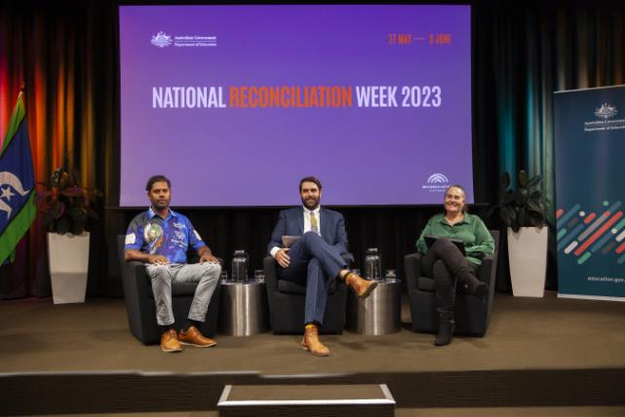

Message from First Nations Champions
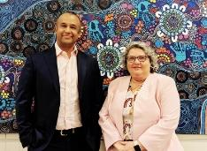
As the department’s First Nations Champions we are pleased to launch our Reconciliation Action Plan 2023–25. This is an important plan that provides the foundation for us to take meaningful actions to advance reconciliation. We stand together to show our commitment to reconciliation.
Our commitment is to model behaviours consistent with reconciliation and the four pillars upon which our Reconciliation Action Plan is based:
- building and maintaining strong relationships
- strengthening our cultural integrity
- creating opportunities for First Nations peoples
- ensuring effective governance structures and processes are in place to guide the implementation of our RAP.
We will work collegiately and enthusiastically to raise awareness of actions we can all take to make positive change. We will engage with you, and we will listen.
As we are guided by the department’s aim to align its policies, strategies, and investment towards achieving the best possible outcomes with First Nations peoples and communities, and specifically through the opportunity quality education and lifetime learning presents, we will ensure that opportunity and prosperity for First Nations peoples is at the heart of our work.
Strengthening relationships between First Nations peoples and non-Indigenous peoples benefits everyone.
Rajan Martin and Robyn Beutel
First Nations Champions

Message from the Reconciliation Australia CEO
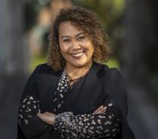
Reconciliation Australia commends the Department of Education on the formal endorsement of its third RAP, an Innovate Reconciliation Action Plan (RAP).
Since 2006, RAPs have provided a framework for organisations to leverage their structures and diverse spheres of influence to support the national reconciliation movement.
With close to 3 million people now either working or studying in an organisation with a RAP, the program’s potential for impact is greater than ever. The Department of Education continues to be part of a strong network of more than 2,200 corporate, government, and not-for-profit organisations that have taken goodwill and transformed it into action.
The four RAP types – Reflect, Innovate, Stretch and Elevate – allow RAP partners to continuously strengthen reconciliation commitments and constantly strive to apply learnings in new ways.
An Innovate RAP is a crucial and rewarding period in an organisation’s reconciliation journey. It is a time to build the strong foundations and relationships that ensure sustainable, thoughtful, and impactful RAP outcomes into the future.
An integral part of building these foundations is reflecting on and cataloguing the successes and challenges of previous RAPs. Learnings gained through effort and innovation are invaluable resources that the Department of Education will continuously draw upon to create RAP commitments rooted in experience and maturity.
These learnings extend to the Department of Education using the lens of reconciliation to better understand its core business, sphere of influence, and diverse community of staff and stakeholders.
The RAP program’s emphasis on relationships, respect, and opportunities gives organisations a framework from which to foster connections with Aboriginal and Torres Strait Islander peoples rooted in mutual collaboration and trust.
This Innovate RAP is an opportunity for the Department of Education to strengthen these relationships, gain crucial experience, and nurture connections that will become the lifeblood of its future RAP commitments. By enabling and empowering staff to contribute to this process, the Department of Education will ensure shared and cooperative success in the long-term.
Gaining experience and reflecting on pertinent learnings will ensure the sustainability of the Department of Education’s future RAPs and reconciliation initiatives, providing meaningful impact toward Australia’s reconciliation journey.
Congratulations Department of Education on your Innovate RAP and I look forward to following your ongoing reconciliation journey.
Karen Mundine
Chief Executive Officer
Reconciliation Australia
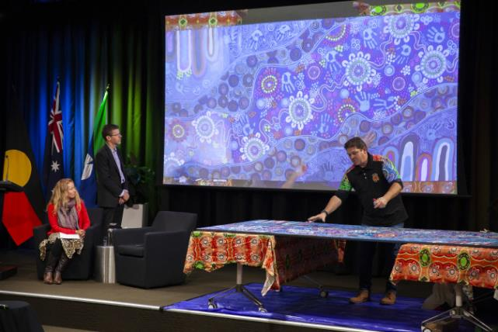

CASE STUDY 1
Strengthening our connection to culture and building our cultural competency through the creation of our Reconciliation Action Plan artwork
During National NAIDOC Week 2023, our department came together to celebrate the history, culture and achievements of Aboriginal and Torres Strait Islander peoples. The centerpiece of our celebrations was creating a new Aboriginal artwork to be used by our Aboriginal and Torres Strait Islander Network and feature on our Reconciliation Action Plan.
The department engaged Dalmarri who are renowned Aboriginal artists, passionate about teaching, engaging and connecting all communities to Aboriginal traditions, knowledge, skills and culture.
Over three days, Dalmarri representatives met with staff at every level to learn about the role of the department, and our commitment to enabling all Australians to access quality education from early childhood and care – to schools and youth, and beyond to higher education and lifelong learning.
Inspired by our purpose, Dalmarri created the artwork, describing our story in Aboriginal symbols and iconography to illustrate why we are here, our impact, and commitment to Closing the Gap.
The artwork features a central journey line representing lifelong learning. The journey line intersects with yarning circles representing people coming together as equals and with respect to support children and students through our work. Ripples are repeated and radiate out from a central point, illustrating our connection to stakeholders and the broader Australian community. Boomerang icons remind us that everything we put out, we get back, while the contours around the boomerangs, represent the challenges we need to overcome to achieve our purpose.
Guided by Dalmarri, staff had the opportunity to make their mark and contribute to the artwork, and to see themselves in our purpose, our journey and in our commitment to reconciliation. The act of making a mark and contributing to the artwork was symbolic of ‘reconciliation in action.’ Staff were able to add a hand print, dot and line markings.
The story of our artwork and its creation will be used as a basis to engage staff in the process of reconciliation, sharing ownership and accountability for implementing our actions, and striving for better outcomes for all First Nations peoples.

Our business
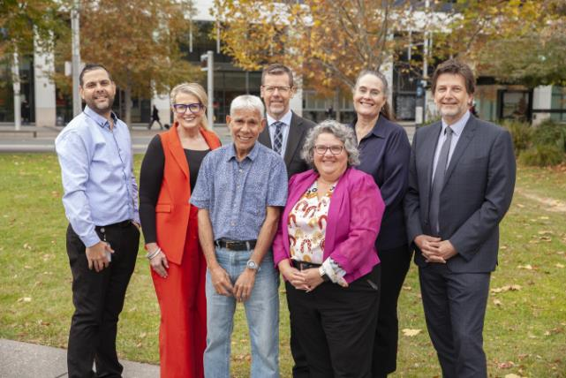
The Department of Education (the department) creates opportunities and drives better outcomes through access to quality education and learning. We deliver government policies and programs that support the Australian community – from early childhood and care to schools, higher education, and youth.
Our purpose is set across two outcomes:
- Improved early learning, schooling, student educational outcomes and transitions to and from school through access to quality childcare, support, parent engagement, quality teaching and learning environments.
- Promoting growth in economic productivity and social wellbeing through access to quality higher education, international education, and international quality research.
Departmental offices are in all states and territories across Australia, and we have a network of employees located internationally. As at June 2023, the department employed 1,545 people, 3% or 46 who identify as First Nations persons across 8 office sites in Australia. Our focus remains on realising the benefits of a diverse workforce and strengthening our inclusive culture – working to build a respectful and productive workplace where our people can apply their skills, knowledge, and expertise to deliver outcomes for all Australians.
More information on the purpose, priorities and operating context can be found on the department’s website.

Our commitment to Closing the Gap
Under the National Agreement on Closing the Gap, the department has responsibility for five of the 17 socioeconomic targets across Priority Reforms 1 to 4:
- children are engaged in high quality, culturally appropriate early childhood education in their early years
- children thrive in their early years
- students achieve their full learning potential
- students reach their full potential through further education pathways
- youth are engaged in employment or education.
We are committed to developing a Closing the Gap Strategy that will change the way we work to improve partnership arrangements we have with First Nations stakeholders – to implement the priority reforms and achieve the department’s Closing the Gap targets.
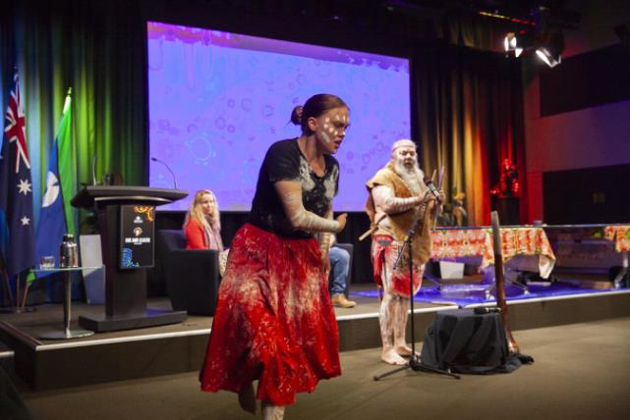

CASE STUDY 2
The department’s important role in Closing the Gap
The Department of Education is seeking to create a future in which policy making that impacts the lives of Aboriginal and Torres Strait Islander peoples is done in full and genuine partnership. Prior to the Machinery of Government changes in July 2022, the department was responsible for the following Closing the Gap targets:
- Target 3: By 2025, increase the proportion of Aboriginal and Torres Strait Islander children enrolled in Year Before Fulltime Schooling (YBFS) early childhood education to 95%.
- Target 4: By 2031, increase the proportion of Aboriginal and Torres Strait Islander children assessed as developmentally on track in all five domains of the Australian Early Development Census (AEDC) to 55%.
- Target 5: By 2031, increase the proportion of Aboriginal and Torres Strait Islander people (age 20–24) attaining year 12 or equivalent qualification to 96%.
- Target 6: By 2031, increase the proportion of Aboriginal and Torres Strait Islander people aged 25–34 years who have completed a tertiary qualification (Certificate III and above) to 70%.
- Target 7: By 2031, increase the proportion of Aboriginal and Torres Strait Islander youth (15–24 years) who are in employment, education or training to 67%.
- Target 8: By 2031, increase the proportion of Aboriginal and Torres Strait Islander people aged 25–64 who are employed to 62%.
In collaboration with NIAA and stakeholders, the department has contributed to the Commonwealth Implementation Plan setting out how the Closing the Gap targets will be met and is committed to developing a departmental Closing the Gap Strategy.
In the 2021–22 Federal Budget, the Government announced new initiatives to improve outcomes for Aboriginal and Torres Strait Islander families:
- An ongoing investment in preschool education of around half a billion dollars annually to benefit Aboriginal and Torres Strait Islander children.
- Increase in the Child Care Subsidy for families with more than one child in care under the age of 6, and removal of the annual cap, lowering the out-of-pocket costs for more than 250,000 families, including many Aboriginal and Torres Strait Islander families.
- Investment in a $122.6 million Child Care Package as part of the Closing the Gap Implementation Plan. This includes:
  - An additional $81.8 million to support the expansion of the Connected Beginnings Program from 22 to 50 sites nationally by 2025 including $44.8 million delivered through the Department of Education. This initiative aims to provide Aboriginal and Torres Strait Islander children and their families with holistic support and timely access to existing early childhood, maternal and child health, and family support services.

  - An additional $29.9 million to support the expansion of the Community Child Care Fund Restricted (CCCFR) program. The expansion of the CCCFR will benefit up to 3,500 children by helping to reduce barriers to childcare and increase the access to high quality and mostly Aboriginal and Torres Strait Islander run services.
  - $9 million towards the Early Years Education Program replication trial to support vulnerable and disadvantaged children from birth to three years to bridge the gap to school readiness. The trial is a multi-disciplinary model that offers high quality, intensive early education and care and wrap around support to redress harm and overcome trauma to support at risk and disadvantaged children’s learning and development. This measure includes a dedicated co-developed Aboriginal and Torres Strait Islander site.
  - $1.9 million to trial a new early learning teaching model to strengthen literacy and numeracy through explicit instruction, with a focus on improving outcomes for Aboriginal and Torres Strait Islander children as they get ready for school.
- Funding of $16.6 million, delivered through the NIAA, enabling boarding providers to support the wellbeing and engagement of Aboriginal and Torres Strait Islander boarding students.
We recognise and acknowledge that it is critical for the department to partner with Aboriginal and Torres Strait Islander peoples on our journey of Closing the Gap and that their voices are elevated in shared decision making around education and programs that affect Indigenous communities in Australia.
Under the National Agreement on Closing the Gap, all governments have committed to establishing an Early Childhood Care and Development Policy Partnership, bringing together representatives from the Coalition of Peaks, Aboriginal and Torres Strait Islander experts, and Australian, state and territory governments. The department is working in partnership with the SNAICC – the National Voice for our Children, the peak body representing the interests of Aboriginal and Torres Islander children and families – to establish the Policy Partnership, which will drive Aboriginal and Torres Strait Islander community-led early childhood outcomes on Closing the Gap.


Our RAP
The RAP August 2023–25 is the department’s commitment to progressing reconciliation in our day-to-day work. The RAP was developed by our Indigenous Business is Everyone’s Business (IBEB) Committee, in consultation with staff from across the department. Workshops were facilitated by Supply Nation businesses to hear directly from employees in a wide range of management levels, backgrounds, and experiences, as well as feedback via an online survey where participants’ privacy was assured. This consultative approach identified widespread support for reconciliation within the department.
The IBEB Committee is responsible for overseeing the development and implementation of the department’s Reconciliation Action Plan (RAP) across all aspects of the department’s work and promoting the Indigenous Business is Everyone’s Business Framework.
Our RAP is aligned with the Commonwealth Aboriginal and Torres Strait Islander Workforce Strategy 2020–24 and Closing the Gap 2020: Priority Reform 3 – Transforming Government Organisations, reflecting the ongoing investment we make in our First Nations workforce and our dedication to a culturally safe environment. Externally, the RAP guides the department in providing national leadership across youth and education pathways through forming positive partnerships with First Nations stakeholders and with other jurisdictions.

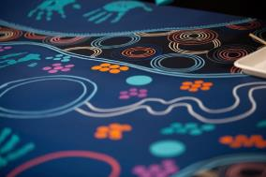


Our RAP Journey
We began our reconciliation journey with Reconciliation Australia in 2014 by establishing our first RAP (Stretch 2014–17). The department made meaningful progress towards reconciliation by developing and implementing our second Stretch RAP in 2018. Our reconciliation journey changed significantly when the former Commonwealth departments of Education and Employment came together on 1 February 2020 and split again on 1 July 2022. The machinery of government changes and the challenging work environment during the COVID-19 pandemic impacted our ability to deliver on our actions and develop a new RAP. During this time, we focused on establishing internal governance structures and building on previous RAP achievements. We have embraced this journey by celebrating our successes and acknowledging and growing from our challenges.
Over the last 12 months, as the new Department of Education, we have acknowledged the challenges of developing and implementing a new RAP. We believe our Innovate RAP provides an opportunity to strengthen and build a solid foundation of reconciliation as a newly formed entity and leverage our unique position within the education framework to advance reconciliation with First Nations peoples. We seek to improve, simplify and embed the actions in our RAP while introducing new opportunities to guide and shape our approach as we move towards our goal of a Stretch RAP in 2025.
Our RAP will be owned by all of us with a shared responsibility to ensure reconciliation is an intrinsic element of our workplace culture, a key requirement under the Closing the Gap. Through genuine actions that will create meaningful opportunities for First Nations peoples, the RAP ensures the principle of Indigenous business is everyone’s business is at the heart of our work.
We recognise there is still a way to go to successfully embed reconciliation throughout the department in our ‘business-as-usual’ work. Senior executive involvement and leadership at all levels is critical to achieving our reconciliation goals and lifting overall employee engagement.
Recruitment plays an important part in reaching our goal of increasing First Nations representation and providing meaningful career pathways. Promoting timely and consistent updates on our RAP progress raises awareness and ensures the RAP becomes part of our everyday workplace operations. Employee engagement is essential to the journey of reconciliation. Our First Nations Champions and IBEB Committee members promote activities nationally and we continue to ensure we have appropriate representation from across the department involved in engagement activities and the work of the Committee.

The department is committed to developing our understanding, value and recognition of Aboriginal and Torres Strait Islander cultures, histories, knowledge, and rights through cultural learning. We provide cultural awareness training as an essential training requirement for all employees. The program includes:
- the importance of family and kinship
- the stolen generation and intergenerational trauma
- getting to know the culture and impacts of colonisation
- working together
- moving forward and celebrating success.
Employees who have participated in learning activities report an increase in cultural awareness and interest in supporting reconciliation. Providing more opportunities will further drive awareness and education, and better enable our employees to be drivers of change.
Our work in connecting employees across the department with our Aboriginal and Torres Strait Islander Employee Network, of engaging with First Nations educational leaders through the department’s Indigenous Education Consultative Meeting forum, the Aboriginal and Torres Strait Islander Education Advisory Group of Education Ministers Meeting, and the National Aboriginal and Torres Strait Islander Education Council, and supporting participation in the Jawun Secondment Program are examples of how we are delivering on our commitment to strengthen relationships with First Nations peoples.
Our case studies highlight some of the key achievements in our reconciliation journey.
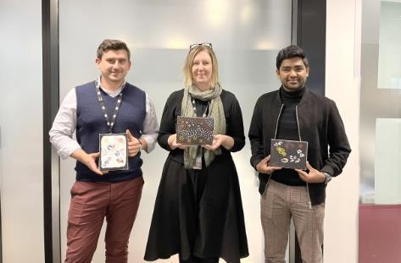

CASE STUDY 3
Jawun secondment: Indescribably incredible, rewarding and life-changing
The Jawun secondment program is a cultural immersion experience where secondees are placed with an Indigenous organisation for six weeks and apply their skills and knowledge to help complete a project while building cultural capability. Secondees work with professionals from around Australia drawn from corporate, government and philanthropic sectors. For Alexander Bell-Rowe, the Jawun secondment was an indescribably incredible experience and totally life-changing.
Alexander writes:
My Jawun secondment took me to Broome, in the West Kimberley. I worked for two organisations, Nyamba Buru Yawuru, the body corporate for the Yawuru people who are the traditional owners of the Broome area, and KRED Enterprises, an Aboriginal consultancy that works with native title holders.
With Nyamba Buru Yawuru, I worked on summarising a regulatory framework relating to live export in Western Australia, a key interest for Nyamba Buru Yawuru due to their control of a vast cattle station (Roebuck Plains) just east of Broome and its associated export depot. I used my experience in government law to research and develop a practical and helpful summary of both state and federal legislation and highlight the risk points for Nyamba Buru Yawuru in assuming control of the Roebuck export depot.
For KRED, I worked on drafting an MoU between KRED and another Broome-based Aboriginal organisation relating to future business development opportunities. I drew on years of experience drafting interdepartmental MoUs to create a useful document.
Through my Jawun secondment, I learned more about Aboriginal culture in 3 days than in all 31 years in Canberra. Every interaction was a learning opportunity, from working on projects that had a very tangible effect on the lives of Aboriginal people in the West Kimberley to the more informal interactions I had hanging out with the footy team I played for.
Importantly, I learned about the barriers and strategies for engaging with Aboriginal communities and the reality of life. I will always consider these lessons and insights to inform our work.
The Jawun secondment created an opportunity to learn about Aboriginal culture through cultural immersion. I enjoyed every aspect of the experience, from making lifelong connections with my new friends and colleagues in Broome to feeling part of the Jawun family. There were so many highlights. The pictures say it all.
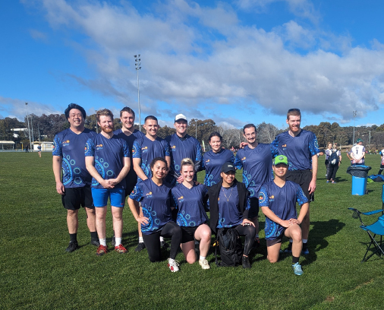

IBEB Committee
The IBEB Committee is responsible for championing the philosophy of Indigenous business is everyone’s business across all aspects of our work, including overseeing the implementation and reporting progress of the RAP.
The Committee provides strategic direction and oversees:
- the department’s broader First Nations employment priorities
- RAP development and implementation
- the department’s commitments under the Commonwealth Aboriginal and Torres Strait Islander Workforce Strategy 2020–2024
- engagement with First Nations employees on IBEB issues through the employee network
- establishment and maintenance of external relationships with partners who have an active role in First Nations employment initiatives.
The Committee is co-chaired by the department’s two First Nations Champions, Robyn Beutel, a Kuku Yalanji woman and Rajan Martin, and includes representatives from the Aboriginal and Torres Strait Islander Employee Network and two senior executives from each Group.
Position | Member
Co-chairs | Robyn Beutel, Assistant Secretary, School Assurance Branch, Schools Group  Rajan Martin, Assistant Secretary, Governance, Quality and Access Branch, Higher Education Group
External representative | Senior Fellow in the Practice of Business, The Australian National University
Corporate and Enabling Services Group | Assistant Secretary, Financial and Resource Management  First Assistant Secretary, People, Parliamentary and Communications
Higher Education, Research and International Group | Assistant Secretary, Tertiary Policy Branch  Assistant Secretary, Research Policy and Programs
Schools Group | Assistant Secretary, Student Engagement, Wellbeing and Closing the Gap  Assistant Secretary, Data, Regional Policy and Education Equity
Early Childhood and Youth Group | Assistant Secretary, Early Learning Programs and Youth  First Assistant Secretary, Child Care
Aboriginal and Torres Strait Islander Network | Aboriginal and Torres Strait Islander Network co-chairs
Advisors | Director, HR Strategy and Operations  Indigenous Liaison Officer  Assistant Secretary, People Branch
Secretariat | People Branch

CASE STUDY 4
Jawun secondment experience: Two way‑transfer of knowledge
Jawun is all about people helping each other. For Jessica Phelan, the secondment was an opportunity to learn about First Nations culture while assisting to create a framework to measure the effectiveness of education programs delivered in remote communities.
Jessica writes:
I undertook a Jawun secondment in the Cape York region of Queensland, where I assisted with designing and measuring education programs. This involved helping to draft a framework and develop a measurement instrument, assessing available data and identifying fidelity measures to evaluate the program’s success.
As part of the two-way skills transfer, I used my policy development and implementation background to conceptualise how the organisation’s range of projects being developed and delivered linked together to identify efficiencies and assist with decision-making. In return, I learned about the different teaching methods used in remote classrooms and some of the challenges faced by Indigenous students and teachers in remote communities supported by the organisation.
The highlight of my experience was the people – we met some amazing people in remote communities who generously shared their stories and experiences. First Nations culture is diverse, and what I learned only scratched the surface. Working alongside others passionate about improving outcomes for Indigenous students and families was also incredibly rewarding. I also learned so much from the others in my cohort, and we got to adventure in some remarkable parts of far North Queensland.
I decided to participate in Jawun to broaden my understanding of First Nations culture and gain a better perspective of the impacts (good or bad) that government decisions can have on stakeholders.
The experience took me outside my comfort zone, but the benefits have lasted. I constantly reflect on, test, and reconsider my thinking. I take time to consider the bigger picture in my day-to-day work – and ask myself how my work contributes to our purpose, and do I need to change my approach to better consider others?
I now have a better understanding of how decisions made by the government translate to on-the-ground implementation and delivery of services. This has highlighted the importance of authentic consultation in policy development and the fundamental right of all Australians to access education regardless of background, location and culture.
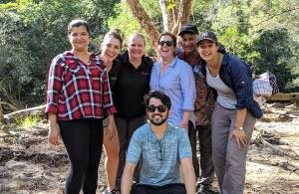
CASE STUDY 5
Kirra Services
The department engaged Kirra Services, a Canberra-based Indigenous business, in a four-year contract valued at $9.6 million to supply Dell laptops. The contract expires in 2024 and the business is expected to provide the department with over 3,000 laptops during this time.
Kirra Services was established in 2017 and is a majority-owned and Supply Nation certified Indigenous information technology company.
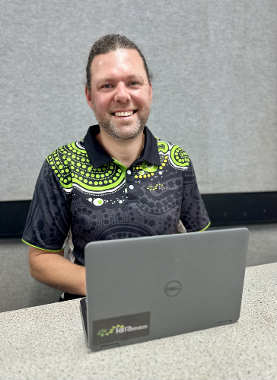

ACTION
Relationships

Actions
The department’s Executive collectively take responsibility for the actions that support our RAP.

Relationships
Developing meaningful relationships with First Nations peoples, communities and organisations is important to our reconciliation journey. Meaningful relationships with First Nations peoples are integral to creating opportunities that drive better outcomes for the department and enable the delivery of policies and programs to support the Australian community – from early childhood and care to schools, higher education and youth.

Actions and deliverables | Timeline | Responsibilities
1. Establish and maintain mutually beneficial relationships with First Nations stakeholders and organisations.
Establish and maintain two formal partnerships with First Nations communities or organisations | December 2023 | Lead  Director – Closing the Gap Partnerships Policy  Sponsor  Assistant Secretary – Student Engagement, Wellbeing and Closing the Gap
Leverage relationships with First Nations stakeholders and organisations to develop and implement a department engagement plan | July 2024 | Lead  Director – Strategic Communication  Sponsor  Assistant Secretary – Communications Branch
Develop guiding principles to inform how we will work collaboratively with First Nations stakeholders and organisations | June 2024 | Lead  Director – HR Strategy and Operations  Sponsor  Assistant Secretary – People Branch
2. Build relationships through celebrating National Reconciliation Week (NRW).
Organise and celebrate at least one national NRW event each year, including:  - site specific NRW activities where possible  - circulation of Reconciliation Australia’s NRW resources to all employees. | 27 May – 3 June 2024 & 2025 | Lead  Director – HR Strategy and Operations  Sponsor  Assistant Secretary – People Branch
IBEB Committee members to participate in an external NRW event | 27 May – 3 June 2024 & 2025 | First Nations Champions
Encourage and support senior leaders and employees to participate in at least one external NRW event | 27 May – 3 June 2024 & 2025 | First Nations Champions
Register all our NRW events on Reconciliation Australia’s website | May 2024 & 2025 | Lead  Director – HR Strategy and Operations  Sponsor  Assistant Secretary – People Branch
3. Promote reconciliation through our sphere of influence.
Conduct a workshop with Reconciliation Australia to define unique commitments to promote reconciliation within the education sector | March 2024 | Lead  Director – HR Strategy and Operations  Sponsor  First Assistant Secretary – People, Parliamentary and Communications Division
Develop and implement a strategic plan to raise awareness and support employee engagement in reconciliation | July 2024 | Lead  Director – HR Strategy and Operations  Sponsor  Assistant Secretary – People Branch
Communicate our commitment to reconciliation publicly by promoting our achievements through our website, meetings and events | October 2023 | Lead  Director, Strategic Communications  Sponsor  Assistant Secretary – Communications Branch
Explore opportunities to positively influence our external stakeholders to drive reconciliation outcomes | December 2023 | Lead  Director – HR Strategy and Operations  Sponsor  Assistant Secretary – People Branch
Collaborate with RAP organisations to implement actions to advance reconciliation, including portfolio agencies | April 2024 | Lead  Director – HR Strategy and Operations  Sponsor  Assistant Secretary – People Branch
4. Promote positive race relations through anti-discrimination strategies.
Conduct a review of HR policies and procedures to identify existing anti-discrimination provisions, and future needs | July 2024 | Lead  Director – HR Strategy and Operations  Sponsor  Assistant Secretary – People Branch
Communicate our Managing Workplace Discrimination and Harassment Policy | July 2024 | Lead  Director – HR Strategy and Operations  Sponsor  Assistant Secretary – People Branch
Consult with First Nations employees and/or advisors and employee support officers to ensure existing HR policies and procedures align with anti-discrimination provisions | July 2024 | Lead  Director – HR Strategy and Operations  Sponsor  Assistant Secretary – People Branch
Provide education, support and communication of departmental anti-discrimination policies, including provision of opportunities for all senior leaders to undertake cultural awareness training to better understand the effects of racism | December 2024 | Lead  Director – HR Strategy and Operations  Sponsor  Assistant Secretary – People Branch
All senior leaders to publicly support anti-discrimination campaigns, initiatives, or stances against racism in accordance with the APS employment principles and APS Values and Code of Conduct | July 2024 & 2025 | First Nations Champions

ACTION
Respect

Respect
The department understands, respects and values the cultures, histories, knowledge, and rights of First Nations peoples. We apply this understanding to our work and our interactions and continue to raise awareness and build capability. Respect for First Nations cultures, histories, knowledge and rights strengthens our cultural integrity through embedding an inclusive workplace culture that enables the delivery of policies and programs that support all Australians.
To demonstrate this, we are providing more opportunities for our people to learn and grow their APS career and mentor our future leaders. We are proud of the strength and resilience of First Nations peoples, the oldest surviving culture in the world, and believe this should be celebrated.

Actions and deliverables | Timeline | Responsibilities
5. Increase understanding, value and recognition of First Nations cultures, histories, knowledge, and rights through cultural learning.
Consult local Traditional Owners and/or Aboriginal and Torres Strait Islander advisors to inform our cultural learning strategy | March 2024 | Lead  Director – HR Strategy and Operations  Sponsor  Assistant Secretary – People Branch
Conduct a department-wide review of cultural learning needs, programs and resources, including the need for trauma informed training | October 2024 | Lead  Director – HR Strategy and Operations  Sponsor  Assistant Secretary – People Branch
Develop, implement and communicate a cultural learning strategy document for our staff | October 2024 | Lead  Director – HR Strategy and Operations  Sponsor  Assistant Secretary – People Branch
Provide and promote online and face-to-face cultural awareness training for all employees in accordance with the department’s essential training program | December 2023 & 2024 | Lead  Director – HR Strategy and Operations  Sponsor  Assistant Secretary – People Branch
6. Demonstrate respect to First Nations peoples by observing cultural protocols.
Provide an Acknowledgement of Country or other appropriate cultural protocols at important meetings | October 2023 & 2024 | All Employees
Increase employee understanding of the purpose and significance behind cultural protocols including Acknowledgement of Country and Welcome to Country | December 2023 | Lead  Director – HR Strategy and Operations  Sponsor  Assistant Secretary – People Branch
Refresh and promote the department’s Aboriginal and Torres Strait Islander Cultural Protocols Guide | March 2024 | Lead  Director – HR Strategy and Operations  Sponsor  Assistant Secretary – People Branch
Invite a local Traditional Owner or Custodian to provide a Welcome to Country or other appropriate cultural protocol at significant events | September 2023 & 2024 | All Employees
7. Build respect for First Nations cultures and histories by celebrating NAIDOC Week.
IBEB members to participate in an external NAIDOC Week event | First week in July 2024 & 2025 | First Nations Champions
Review and promote the departmental Cultural Leave Policy to remove barriers to employees participating in NAIDOC Week | June 2024 | Lead  Director – HR Strategy and Operations  Sponsor  Assistant Secretary – People Branch
Support all employees to participate in an external NAIDOC Week event | July 2024 & 2025 | Lead  Director – Internal Communication  Sponsor  Assistant Secretary – Communications Branch
Support and fund local NAIDOC Awards, including education awards | July 2024 & 2025 | Lead  Director – HR Strategy and Operations  Sponsor  Assistant Secretary – People Branch
8. Promote recognition and respect through showcasing and celebrating First Nations cultures, stories, histories and diversity through art and design.
Develop relationships with First Nations artists local to our National and State Offices to develop First Nations artworks for our corporate branding and our reconciliation journey | May 2025 | Lead  Director – HR Strategy and Operations  Sponsor  Assistant Secretary – People Branch
Partner with local First Nations artists to commission a collection of works for display in common areas on all levels in our National Office | December 2024 | Lead  Director – HR Strategy and Operations  Sponsor  Assistant Secretary – People Branch
Ensure all First Nations artwork in our offices are labelled or accompanied by information explaining who the artist is, where they are from and the story of the work | December 2024 | Lead  Director – HR Strategy and Operations  Sponsor  Assistant Secretary – People Branch
Promote the use of our Yarning Room for meetings and departmental audio-visual productions, as it showcases the story of our reconciliation journey | March 2024 & 2025 | Lead  Director – Internal Communications  Sponsor  Assistant Secretary – Communications Branch

ACTION
Opportunities

Opportunities
With responsibility for five of the 17 Closing the Gap socioeconomic targets across Priority Reforms 1 to 4, we are committed to providing opportunities by implementing the reforms and achieving the targets. We aim to improve the social and financial wellbeing of First Nations peoples and their broader communities through our commitment to a diverse workforce and the Indigenous Procurement Policy.
We champion the benefits of diversity and offer First Nations peoples meaningful career and development opportunities in a safe and inclusive environment, where their skills, knowledge and experiences are valued in their teams and across the department.

Actions and deliverables |  |  |  | Timeline | Responsibilities
9. Improve employment outcomes by increasing First Nations recruitment, retention, and professional development.
Understand the current First Nations workforce profile to inform future employment and development opportunities |  |  |  | July 2024 | Lead  Director – HR Strategy and Operations  Sponsor  Assistant Secretary – People Branch
Engage with the Aboriginal and Torres Strait Islander Network and non-Indigenous employees where relevant to consult on recruitment, retention and professional development activities |  |  |  | March 2024 | Lead  Director – HR Strategy and Operations  Sponsor  Assistant Secretary – People Branch
Review HR and recruitment procedures and policies to remove barriers to First Nations participation in our workforce |  |  |  | December 2023 | Lead  Director – HR Strategy and Operations  Sponsor  Assistant Secretary – People Branch
Develop and implement a First Nations recruitment, retention and professional development strategy |  |  |  | July 2024 | Lead  Director – HR Strategy and Operations  Sponsor  Assistant Secretary – People Branch
Review the department’s progress against the employment and career development outcomes in the Commonwealth Aboriginal and Torres Strait Islander Workforce Strategy 2022–2024 |  |  |  | June 2024 | Lead  Director – HR Strategy and Operations  Sponsor  Assistant Secretary – People Branch
Advertise job vacancies through multiple channels to effectively reach First Nations applicants |  |  |  | December 2023, 2024 & 2025 | Lead  Director – HR Strategy and Operations  Sponsor  Assistant Secretary – People Branch
9. Improve employment outcomes by increasing First Nations recruitment, retention, and professional development. (continued)
Increase First Nations employee representation to support Commonwealth portfolio targets with the aim of achieving the following annual targets: |  |  |  | June 2024 & 2025 | Lead  Director – HR Strategy and Operations  Sponsor  Assistant Secretary – People Branch
Level | 2023 | 2024 | 2025 | June 2024 & 2025
APS4–6 | 5% | 5% | 5% | June 2024 & 2025
EL1–2 | N/A | 5% | 5% | June 2024 & 2025
SES | N/A | 3% | 3% | June 2024 & 2025
Support First Nations employee participation in an annual First Nations employee conference |  |  |  | August 2023, 2024 & 2025 | Lead  Director – HR Strategy and Operations  Sponsor  Assistant Secretary – People Branch
Participate in Whole-of-Government Affirmative Measure recruitment including programs such as the Indigenous Apprenticeship Program and Indigenous Graduate Pathway |  |  |  | December 2023 & 2024 | Lead  Director – HR Strategy and Operations  Sponsor  Assistant Secretary – People Branch
10. Increase First Nations supplier diversity to support improved economic and social outcomes.
Maintain commercial relationships through meeting the annual Indigenous procurement portfolio targets set by the National Indigenous Australians Agency (NIAA) Indigenous Procurement Policy |  |  |  | June 2024 & 2025 | Lead  Director Procurement and Grants  Sponsor  Assistant Secretary – Financial and Resource Management
Review and update procurement practices to remove barriers to procuring goods and services from First Nations businesses |  |  |  | June 2024 & 2025 | Lead  Director Procurement and Grants  Sponsor  Assistant Secretary – Financial and Resource Management
Enhance collaboration with Supply Nation and maintain corporate membership |  |  |  | October 2023 & 2024 | Lead  Director Procurement and Grants  Sponsor  Assistant Secretary – Financial and Resource Management
Develop targeted internal communications to promote the benefits of engaging First Nations businesses |  |  |  | September & March 2024 & 2025 | Lead  Director Procurement and Grants  Sponsor  Assistant Secretary – Financial and Resource Management
Ensure employees who undertake procurement complete the essential training on the Commonwealth Indigenous Procurement Policy and continue to promote this training across the department |  |  |  | June 2024 & 2025 | Lead  Director Procurement and Grants  Sponsor  Assistant Secretary – Financial and Resource Management

ACTION
Governance

Governance
We will put in place effective governance structures and processes to keep the department accountable and guide the implementation of our RAP.

Actions and deliverables | Timeline | Responsibilities
11. Establish and maintain an effective RAP Working Group (IBEB Committee) to drive governance of the RAP.
Maintain First Nations representation on the IBEB Committee | February 2024 & 2025 | Executive Board
Apply, review, and update the IBEB Committee Terms of Reference | February 2024 & 2025 | IBEB Committee
The IBEB Committee meets at least four times per year to monitor and drive RAP implementation and governance, progressing issues out of session when required | August & November 2023, March, May, August & November 2024 & 2025 | IBEB Committee
12. Provide appropriate support for effective implementation of RAP commitments.
Establish sufficient resourcing to support RAP implementation, oversight and management | September 2023, 2024 & 2025 | Deputy Secretary – Corporate and Enabling Services
Outline expectations in performance and development agreements for all employees alignment with RAP initiatives | August 2023, 2024 & 2025 | All employees
Embed appropriate systems and capability to track, measure and report on RAP commitments | October 2023 | Lead  Director – HR Strategy and Operations  Sponsor  Assistant Secretary – People Branch
Appoint First Nations Champions from senior management | March 2024 & 2025 | Executive Board
Provide updates on RAP progress at Executive Board meetings | May & November 2023, 2024 & 2025 | Lead  Director – HR Strategy and Operations  Sponsor  Assistant Secretary – People Branch
13. Build accountability and transparency through reporting RAP achievements, challenges, and learnings both internally and externally.
Contact Reconciliation Australia to verify that our primary and secondary contact details are up to date, to ensure we do not miss out on important RAP correspondence | June 2024 & 2025 | Lead  Director – HR Strategy and Operations  Sponsor  Assistant Secretary – People Branch
Contact Reconciliation Australia to request our unique link, to access the online RAP Impact Measurement Questionnaire | August 2024 & 2025 | Lead  Director – HR Strategy and Operations  Sponsor  Assistant Secretary – People Branch
Complete and submit the annual RAP Impact Measurement Questionnaire to Reconciliation Australia | September 2024 | Lead  Director – HR Strategy and Operations  Sponsor  Assistant Secretary – People Branch
Communicate RAP progress to all employees via IBEB Committee communique | March, May, August & November 2023, 2024 & 2025 | Lead  Director – HR Strategy and Operations  Sponsor  Assistant Secretary – People Branch
Publicly report against our RAP commitments, including reference in the corporate plan and annual report | August & October 2024 & 2025 | Lead  Director – HR Strategy and Operations  Sponsor  Assistant Secretary – People Branch
Participate in Reconciliation Australia’s Workplace RAP Barometer | May 2024 | All employees
Submit a traffic light report to Reconciliation Australia at the conclusion of this RAP | June 2025 | Lead  Director – HR Strategy and Operations  Sponsor  Assistant Secretary – People Branch
14. Continue our reconciliation journey by developing our next RAP.
Register via Reconciliation Australia’s website to begin developing our next RAP | January 2025 | Lead  Director – HR Strategy and Operations  Sponsor  Assistant Secretary – People Branch
Commence the development of the next RAP and encourage senior leader and employee involvement | January 2025 | Lead  Director – HR Strategy and Operations  Sponsor  Assistant Secretary – People Branch

Contact details
If you have any questions or comments on our RAP please email Reconciliation@education.gov.au or call (02) 6121 5000.

NGUNNAWAL, Murrumbidgee River, Mt Tennent
Photo by: Sasha Emery, HERI Group



2545

