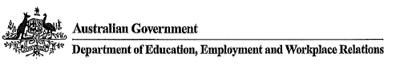
The Department's total expenditure on Credit cards in the 2010-11 financial year is: $17,331,959.53
The total number of credit cards that are currently active in the department:
As at the June 2011 statement DEEWR had 4,271 active cards.

