

# Better understanding the impact of health and social factors on student completion

We combined health, tax, welfare and demographic data with bachelor’s degree student data, and simulated a randomised control trial, to show the significant social and health risk factors that prevent Australians from completing their bachelor’s degree studies within six years. While institution attended and study load still had the largest impact on student completion rates, we were able to unearth new factors that drive student success and predict student completions with 80 per cent accuracy.

## Impact on higher education bachelor completion rate, 2011–2016, all other variables being equal

| Work and study (+13%) | Students who receive study assistance (+7%) | Gap year (no impact) | Students with disability (-2%) |
| --- | --- | --- | --- |
| Full-time students who worked while studying were 13 percentage points more likely to complete. Earning up to $30,000 per year for full-time students was associated with higher completion rates.  80% of students worked while studying. | Full-time students who received study assistance were seven percentage points more likely to complete. This effect was higher for some students; up to 18 percentage points for full-time students in the 25–29 age bracket, and up to 12 percentage points for students living with disadvantage. | There was no statistically significant difference in the completion rates of students who took a gap-year. These students were one percentage point more likely to complete their studies, relative to their peers. | Students who lived with disability were two percentage points less likely to complete once all other factors were taken into account.  There is a growing proportion of students who identify as living with disability. |

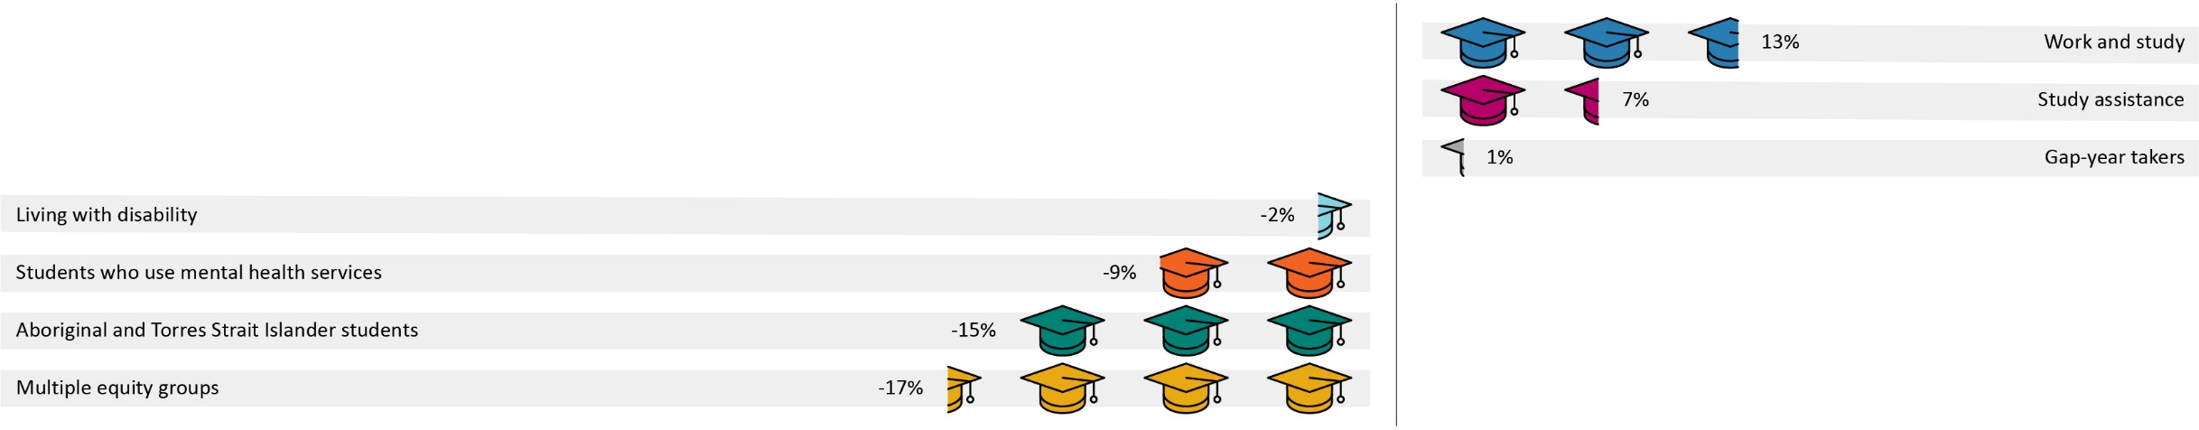

| Mental Health (-9%) | Aboriginal and Torres Strait Islander students (-15%) | Multiple equity groups (-17%) |
| --- | --- | --- |
| All other variables being equal, students accessing mental health services were nine percentage points less likely to complete. Students with a known mental health condition that accessed mental health services during study had a higher chance of completing their studies.  30% of students used mental health services and this proportion is growing. | Aboriginal and Torres Strait Islander students were on average 15 percentage points less likely to complete. These students also tended to start university at an older age.  The reduction in completion rates was mitigated with study assistance, in some cases by up to 21 percentage points. | Belonging to multiple equity groups reduced completion rates on average by 17 percentage points. In some cases, the reduction was as high as 30 percentage points.  Income support helped overcome these disadvantages, increasing completion rates for students with low Australian Tertiary Admission Ranks and/or belonging to multiple equity groups. |

Source: Multi-Agency Data Integration Project (2016)