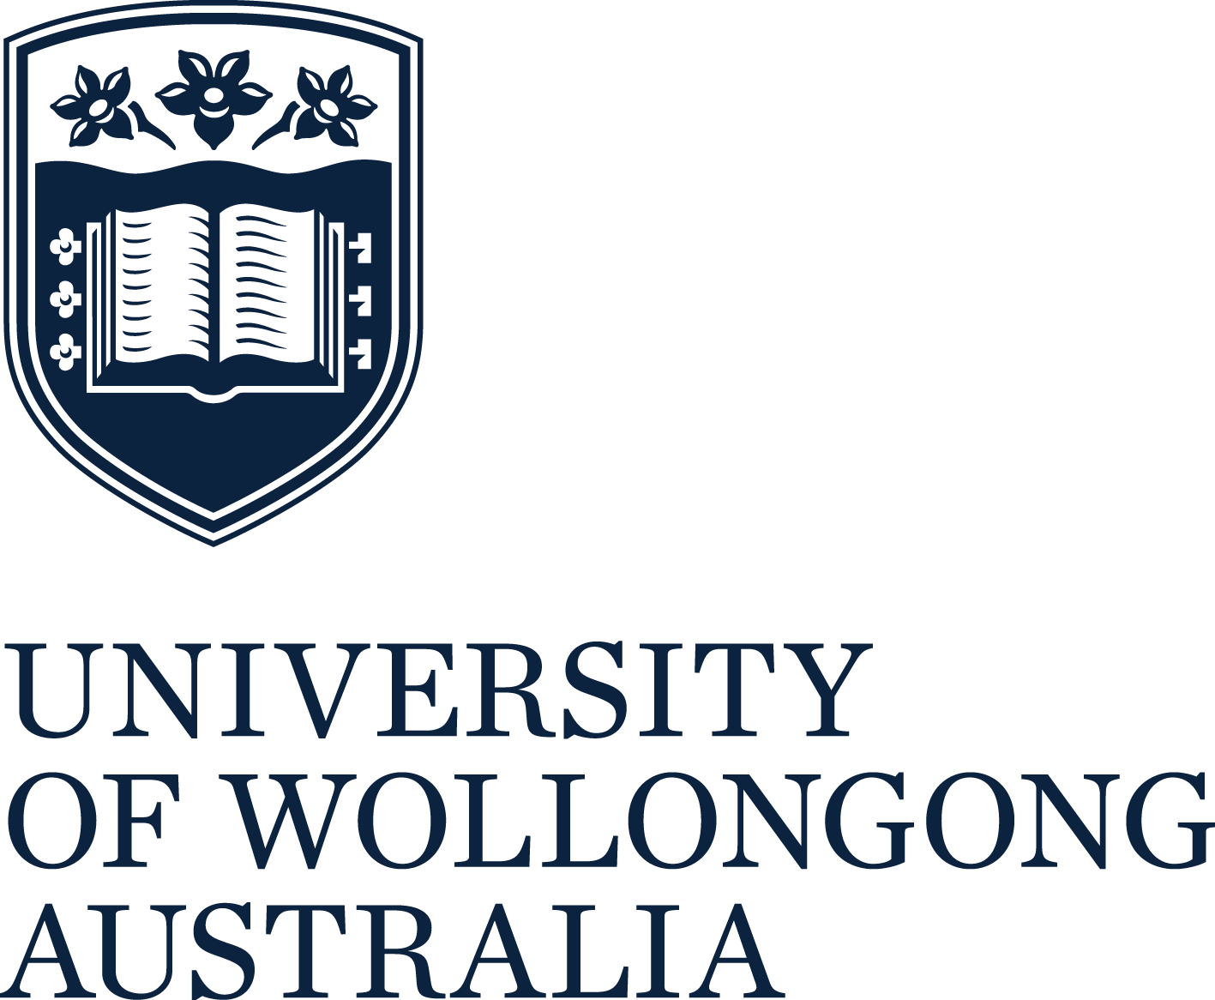
Access & Participation
Plan 2020
The University of Wollongong (UOW) is committed to providing the opportunity for students to access and succeed in higher education, as well as supporting their capacity to make informed choices that embrace their socio-cultural background.  Equity outcomes, strategies and key activities aim to increase access, participation and success of people from underrepresented backgrounds in higher education.  The extended version of ‘UOW’s Access & Participation for Student Equity: A Framework for HEPPP Implementation 2018-2020’ is available on our website www.uow.edu.au/dvca/heppp. | UOW has identified strategic targets to increase the participation of individuals from underrepresented backgrounds in higher education, by continuing to diversify its domestic undergraduate cohort.  UOW has undertaken an institution-wide approach to the access and participation of equity students in higher education. The guiding principles of our strategy influence the design and implementation of a number of equity-focused initiatives that are funded through core university funding, Indigenous Student Success Program (ISSP) funding, Australian Disability Clearinghouse on Education and Training (ADCET) funding and HEPPP funding.  UOW is entering the final year of its three year ‘Access & Participation Enabling Plan for Student Equity: 2018 – 2020’. All activities, as described in Table 1, are underpinned by three guiding principles.
GUIDING PRINCIPLE 1: Promoting success across the student lifecycle



COMPLETION
Dedicated WIL and careers programs
Career awareness raising and next step programs
Programs that target student completion
TRANSITION & RETENTION
Transition and success programs
Re-engagement strategy
Embedding into existing support systems
ACCESS
Tangible pathway programs (Year 12 and non-school leavers)
Contextualised Admission pathways
PRE-ACCESS
Schools outreach activities
(Year 1-Year 11)
Community outreach activities (non-school leavers)

GUIDING PRINCIPLE 2: A whole of institution approach at every stage of the lifecycle to ensure that student equity and success is everyone’s responsibility

GUIDING PRINCIPLE 3: Students and their success are at the centre of our approach
TRANSITION & RETENTION
- To encourage a sense of purpose and promoting positive decision-making by ensuring the relevance of degrees for students
- Integrate students into the fabric and relevant supports at UOW and develop help-seeking behaviour
- To foster a sense of belonging and connection to UOW
PRE-ACCESS
- For every student to consider university as an option that embraces their socio-cultural background and creates connectedness to the University
- To empower students to become effective navigators
- To enhance student’s capacity to make informed choices
COMPLETION
- To prepare students with transferable skills that will benefit them through all stages of their life
- To increase student accessibility to opportunities that will increase their competitiveness in the workforce
- To increase student awareness and capacity to make decisions post-higher education
- To ensure students are making informed decisions and effectively navigating their degree through to completion

ACCESS
- To develop admission pathways that embraces and celebrates diversity
- To ensure the transparency and any barriers of the admissions process are reduced
- To invest in students to enable their aspirations

These principles will guide the development of activities, evaluation tools and measures of success as outlined in the table below, in order to achieve the strategic goals identified by the University.
Table 1: Equity outcomes, strategies and key activities that aim to increase access, participation and success of people from low SES backgrounds

PHASE | ACTIVITY | EVALUATION TOOL | MEASURE OF SUCCESS
Pre-Access | Design and implementation of pre-access (outreach) programs that are underpinned by Aboriginal knowledges, and increase the capacity of students to make informed decisions and navigate their post-school pathway. | - Number of schools engaging in pre-access activities  - Number of students engaging in pre-access activities to provide a pipeline to HE  - Pre & post survey data to track student awareness of higher education  - Reflective log maintained by staff as part of Jindaola Program and engagement with local Aboriginal communities. | - Maintaining the level of engagement in pre-access activities from 2019 to 2020 with 150 schools and 10,000 students engaged each year.  - 70% of program participants demonstrating increased awareness of the pathways to access higher education.  - All Pre-Access activities have been redesigned with Aboriginal perspectives and knowledges for 2021 delivery that is supported by the local Aboriginal community.
Access | Implementation of tangible pathways for Year 12 and non-school leaver students into higher education embedded with Aboriginal knowledges, such as Year 12 University  Preparation Program, Year 12 Summer Master Classes Program, and enabling programs. | - Number of students engaging in access activities to provide a pipeline to HE  - Tracking student articulation to higher education  - Pre & post-survey data to demonstrate increase in student capacity towards higher education  - Reflective log maintained by staff as part of Jindaola Program and engagement with local Aboriginal communities. | - 10% increase in prospective students participating in Equity Access activities each year (NB: 1,200 in 2019).  - 85% of prospective students participating in Equity Access activities articulating to higher education.  - 15% increase in student’s perceived capacity to access higher education after completing an Equity Access initiative.  - All Equity Access activities have been redesigned with Aboriginal perspectives and knowledges  for 2021 delivery that is supported by the local Aboriginal community.
Access | Implementation of contextualised admissions initiatives for both school leavers and non- school leavers including AccessUOW, as well as equity considerations embedded into all UOW admissions processes. | - Number of students engaging in access activities to provide a pipeline to higher education | - In 2019, UOW’s participation rate of students from LSES backgrounds was 17.7%. We are currently reviewing our data and targets for LSES student participation.
Transition & Retention | In 2018, UOW designed and implemented the Achieving Purposeful Transitions Framework and Action Plan, which identified 26 priorities over the next three years to enhance the success of equity students at UOW. As such, the following activities will be implemented in 2020:  - First Generation Program  - Pre-commencement and Curriculum embedded interventions to support high attrition and high equity courses  - Student Success Coaching Model, underpinned by a self-assessment tool  - Contextualised transition and first year induction programs | - Number of students engaging in transition and retention activities  - Tracking student retention at University  - % of students who exit UOW re-enrolled in their preferred degree within 12 months  - Pre & post survey data to measure students sense of purpose and perceived barriers to higher education  - % of equity students applying for scholarships  - % of equity students being retained at UOW | - 70% of students from LSES backgrounds across UOW’s five major first year courses engaged in the Transition programs.  - Increase from 2018 in the percentage of students in UOW’s five major first year courses being retained at UOW.  - 10% increase in sense of belonging, awareness of support services and confidence in asking for help after participating in a Transition program.
Transition & Retention | Continuing to deliver successful transition and retention activities to add value to the existing support mechanisms in place:  - Maths Support  - Regional Campus Student Support*  - Peer Assisted Study Sessions (PASS)
Transition & Retention | Embedding of a re-engagement plan that supports the re-entry of equity students who have withdrawn from the institution. |  | - 20% of students from LSES backgrounds who withdraw from university engage in a re- engagement initiative.
Transition & Retention | Implementation and ongoing review of a best practice model for the dissemination of equity scholarships that improve student retention and are linked to non-financial support mechanisms. |  | - 70% of equity students applying for equity scholarships.  - 95% of equity students in receipt of an Equity Scholarships are being retained at UOW.  - Delivery of a student success package to all incoming Equity Scholarship students.
Completion & Transition Out | Design and implement programs that increase student accessibility to opportunities that will increase their employment beyond university, including the provision of WIL equity scholarships. | - Number of equity students who are financially supported by the university to engage in WIL activities. | - 20 UOW Equity students supported financially by the University to participate in WIL activities (pilot for 2020).
Evaluation | All UOW HEPPP funded activities are supported by a bespoke HEPPP Evaluation Framework, led by researchers in the School of Education.
* Please note that additional supports, particularly counselling services, have been deployed to our Regional Campuses (which have high proportions of students from low SES, regional, rural and remote backgrounds, as well as Aboriginal and Torres Strait Islander students) which were impacted by the bushfires.

Partnerships and collaborations
UOW will continue to collaborate with our strategic partners in order to increase the impact and outcomes for our students. These partners include:
- 155 primary and high schools in our geographical footprint (55 high schools, 100  primary schools) | - Equity Practitioners in Higher Education Australasia and National Centre for Student Equity in Higher Education
- Catholic Education Office (Wollongong and Goulburn/Canberra Diocese) | - AIME (Australian Indigenous Mentoring Experience)
- Department of Education (Wagga and Ultimo Regions) | - Smith Family
- St George Illawarra Dragons | - TAFE NSW
- University of Newcastle and University of New South Wales through the NUW Alliance | - Regional Development Australia

