


Capacity to Contribute Data Validation and Quality Assurance Process
  - Funding for non-government schools

Contents
Background 3
Overview of the Australian Bureau of Statistics’ Independent Assessment 3
Annual Data Validation and Quality Assurance Process 4
What is a quality gate? 5
How are quality gates used to validate a DMI score? 5
Further Information 8

Last updated: | April 2024

Background
Australian Government funding for non-government schools reflects the policy position that responsibility for funding is shared between the Commonwealth, the state and territory governments, and the parents and guardians of students attending those schools. The capacity to contribute (CTC) of a school is the anticipated capacity of the school community to financially contribute towards the school’s operating cost. CTC is used to discount the Schooling Resource Standard (SRS) base funding amount for these schools. From 2020, the Direct Measure of Income (DMI) is used to determine CTC for non-government schools.
The DMI links parent and guardian names and addresses collected through the annual Student Residential Address and Other Information Collection to data from the Person Level Integrated Data Asset (PLIDA – formally known as MADIP). PLIDA is a secure data asset combining information on health, education, government payments, income and taxation, employment, and population demographics (including the Census) over time. The participating agencies are the Australian Bureau of Statistics (ABS), Australian Taxation Office (ATO), Department of Education, Department of Health and Aged Care, Department of Social Services, Department of Home Affairs and Services Australia. Each participating agency collects personal information related to its functions or activities and discloses this information to the ABS for the PLIDA as authorised by law.
This document provides a summary of the process that is used to validate a DMI score. An overview of the methodology used to calculate a DMI score is provided in Direct Measure of Income (DMI) Methodology.

Overview of the ABS Independent Assessment
In 2019, the ABS undertook an independent assessment of the fitness-for-purpose of the DMI score as a representation of school community median income. The ABS report confirmed that:
- the DMI score is based on a statistically sound approach which makes use of the best available data for measuring the median income of school communities
- overall, the DMI is considered fit-for-purpose
- in most cases, median incomes produced using the DMI are expected to be fit-for-purpose estimates of true school community median incomes.
While the ABS considered that overall, the DMI is fit-for-purpose it made the following recommendations to further improve quality.
Recommendation 1: Review data linking methods to improve linkage rates.
Linkage (coverage) rates underpinning the direct measure are high. While this creates a high-quality result for the majority of schools, some schools have lower linkage rates. Annual improvements to data linkage capabilities, commencing in 2020, will improve overall linkage rates. In addition, investment in improving linkage methods for some sub-populations may result in further quality improvement for some school communities.
Recommendation 2: Consider further options for estimating income when Adjusted Taxable Income (ATI) is not available.
In the DMI, adjusted taxable income (ATI) is the primary source of income data. In 2019 ATI was available for 77 per cent of parents. For other parents, an alternative income estimate is sourced from information such as payment summaries or social services data. This is robust for the purpose of estimating DMI. However, given the richness of the other data available, there may be opportunities to further improve data quality using imputation, but this requires further exploration.
Recommendation 3: Investigate options to improve timeliness on a regular basis.
While the DMI score is considered a timely statistic overall, the ABS recommends that options to improve timeliness be investigated on a regular basis. These investigations should consider new opportunities to directly measure income which may arise due to changes in reporting requirements within the tax and other administrative systems.

Annual Data Validation and Quality Assurance Process
The independent assessment in the ABS report is a point in time analysis and was based on data, calculations and results used to calculate a DMI score using data from the 2018 and 2019 Parent and Other Information Collection. In addition to a point in time assessment, the report also includes a data quality and validation framework that can be used annually.
The Department worked in partnership with the ABS to develop the data quality and validation framework. The framework will be used annually to assess if data are fit for purpose, reliable and robust. Under this framework data, calculations and results will be assessed in line with the ABS’s seven dimensions of quality – institutional environment, relevance, timeliness, accuracy, coherence, interpretability and accessibility.
The framework will be used by the department to better understand the quality of the data so it can decide whether it is appropriate to use a DMI score to calculate funding for a school. From 2022 or a later year, where it is not appropriate to use the DMI methodology, the refined area methodology will be used to calculate a refined area-based (RAB) score.
The process is comprehensive and covers a wide scope of quality assurance activities including:
- Evaluating the end-to-end process for calculating a CTC score based on the ABS Capacity to Contribute Data Quality Framework
- As part of this evaluation applying quality metrics to the calculation of a DMI score to test the accuracy of data inputs, data calculations and results
- As part of this evaluation considering unique circumstances of schools as part of the testing of the accuracy of data inputs, data calculations and results

What is a quality gate?
Quality gates are check points placed throughout the statistical production process to support the identification and treatment of statistical quality risks. This is a standard statistical practice that has been applied to the production of a DMI score.
Diagram 1 describes the components of a quality gate. It shows that quality gates consist of a set of quality checks, called quality measures. At each quality gate, roles are assigned so it is clear who owns, manages and approves the passing of data through a gate. Tolerances are set at each gate and are determined in consultation with stakeholders to support a robust quality assurance process in the context of practical constraints. Actions are taken depending on the pre-defined tolerance levels associated with each quality measure.
Diagram 1. Key components of a quality gate
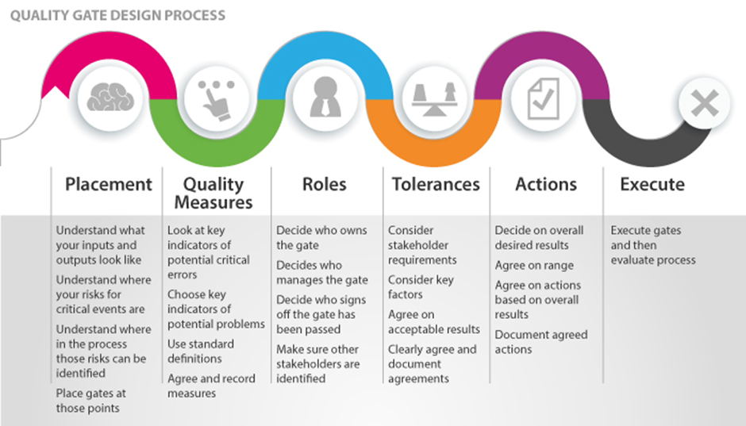

How are quality gates used to validate a DMI score?
The ABS Capacity to Contribute Data Quality Framework outlines how each of the standard components of a quality gate (as shown in Diagram 1) have been applied to the calculation of a DMI score.
Diagram 2 shows the following five quality gates that have been placed in the DMI production process at critical points in the process to support statistical quality throughout the DMI production process:
- Quality Gate 1: Collect and prepare input data supports data governance and the quality and the completeness of each input dataset
- Quality Gate 2: Standardise, link and assemble identifies major errors in the source data that impact on linkage quality and flags unexpected linkage quality outcomes for follow-up
- Quality Gate 3: Examine school scores supports the validation of DMI scores, the identification of DMI scores with potential quality issues, and decision-making by the Department about cases in which the DMI score may not be the most fit-for-purpose estimate and should not be used
- Quality Gate 4: Protect privacy and release checks that all final privacy and confidentiality protections are applied in accordance with legislative requirements so that data can be released from the ABS DataLab
- Quality Gate 5: Review and evaluate provides for annual review of the quality assurance processes
The quality measures used for DMI processes at each gate have been co-designed by the department and the ABS and are published in the ABS Capacity to Contribute Data Quality Framework. The department also applies business rules that are broadly aligned with the ABS Capacity to Contribute Data Quality Framework. In particular for Quality Gate 1, these business rules are used during the Address Collection process and to prepare data to calculate a school’s annual DMI score.
Diagram 2. Data Validation and Quality Assurance Process in creating DMI scores
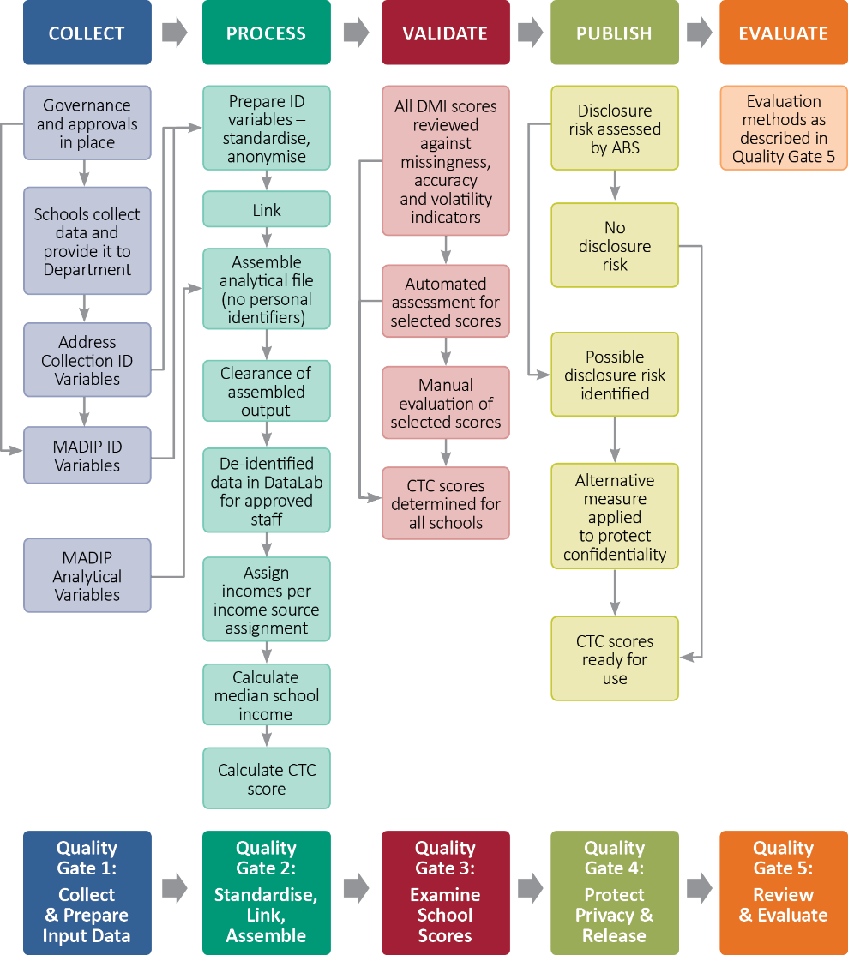
Diagram 3 provides an overview of how the five quality gates outlined in Diagram 2, in combination with quality measures and tolerances outlined in the ABS Capacity to Contribute Data Quality Framework, will be used as major decision points in the decision-making process that could trigger an action.
As an illustration, at Quality Gate 3, a change in score of more than six points (a tolerance) may trigger a manual review (an action). The department (who owns the gate) would then investigate whether there are any unique circumstances, an economic shock for example, that may explain this sudden change. If it is satisfied that the change in the score is in keeping with expectations, it will pass the DMI score at Quality Gate 3 and move to Quality Gate 4.
Diagram 3. Overview, DMI quality gates and decision-making process
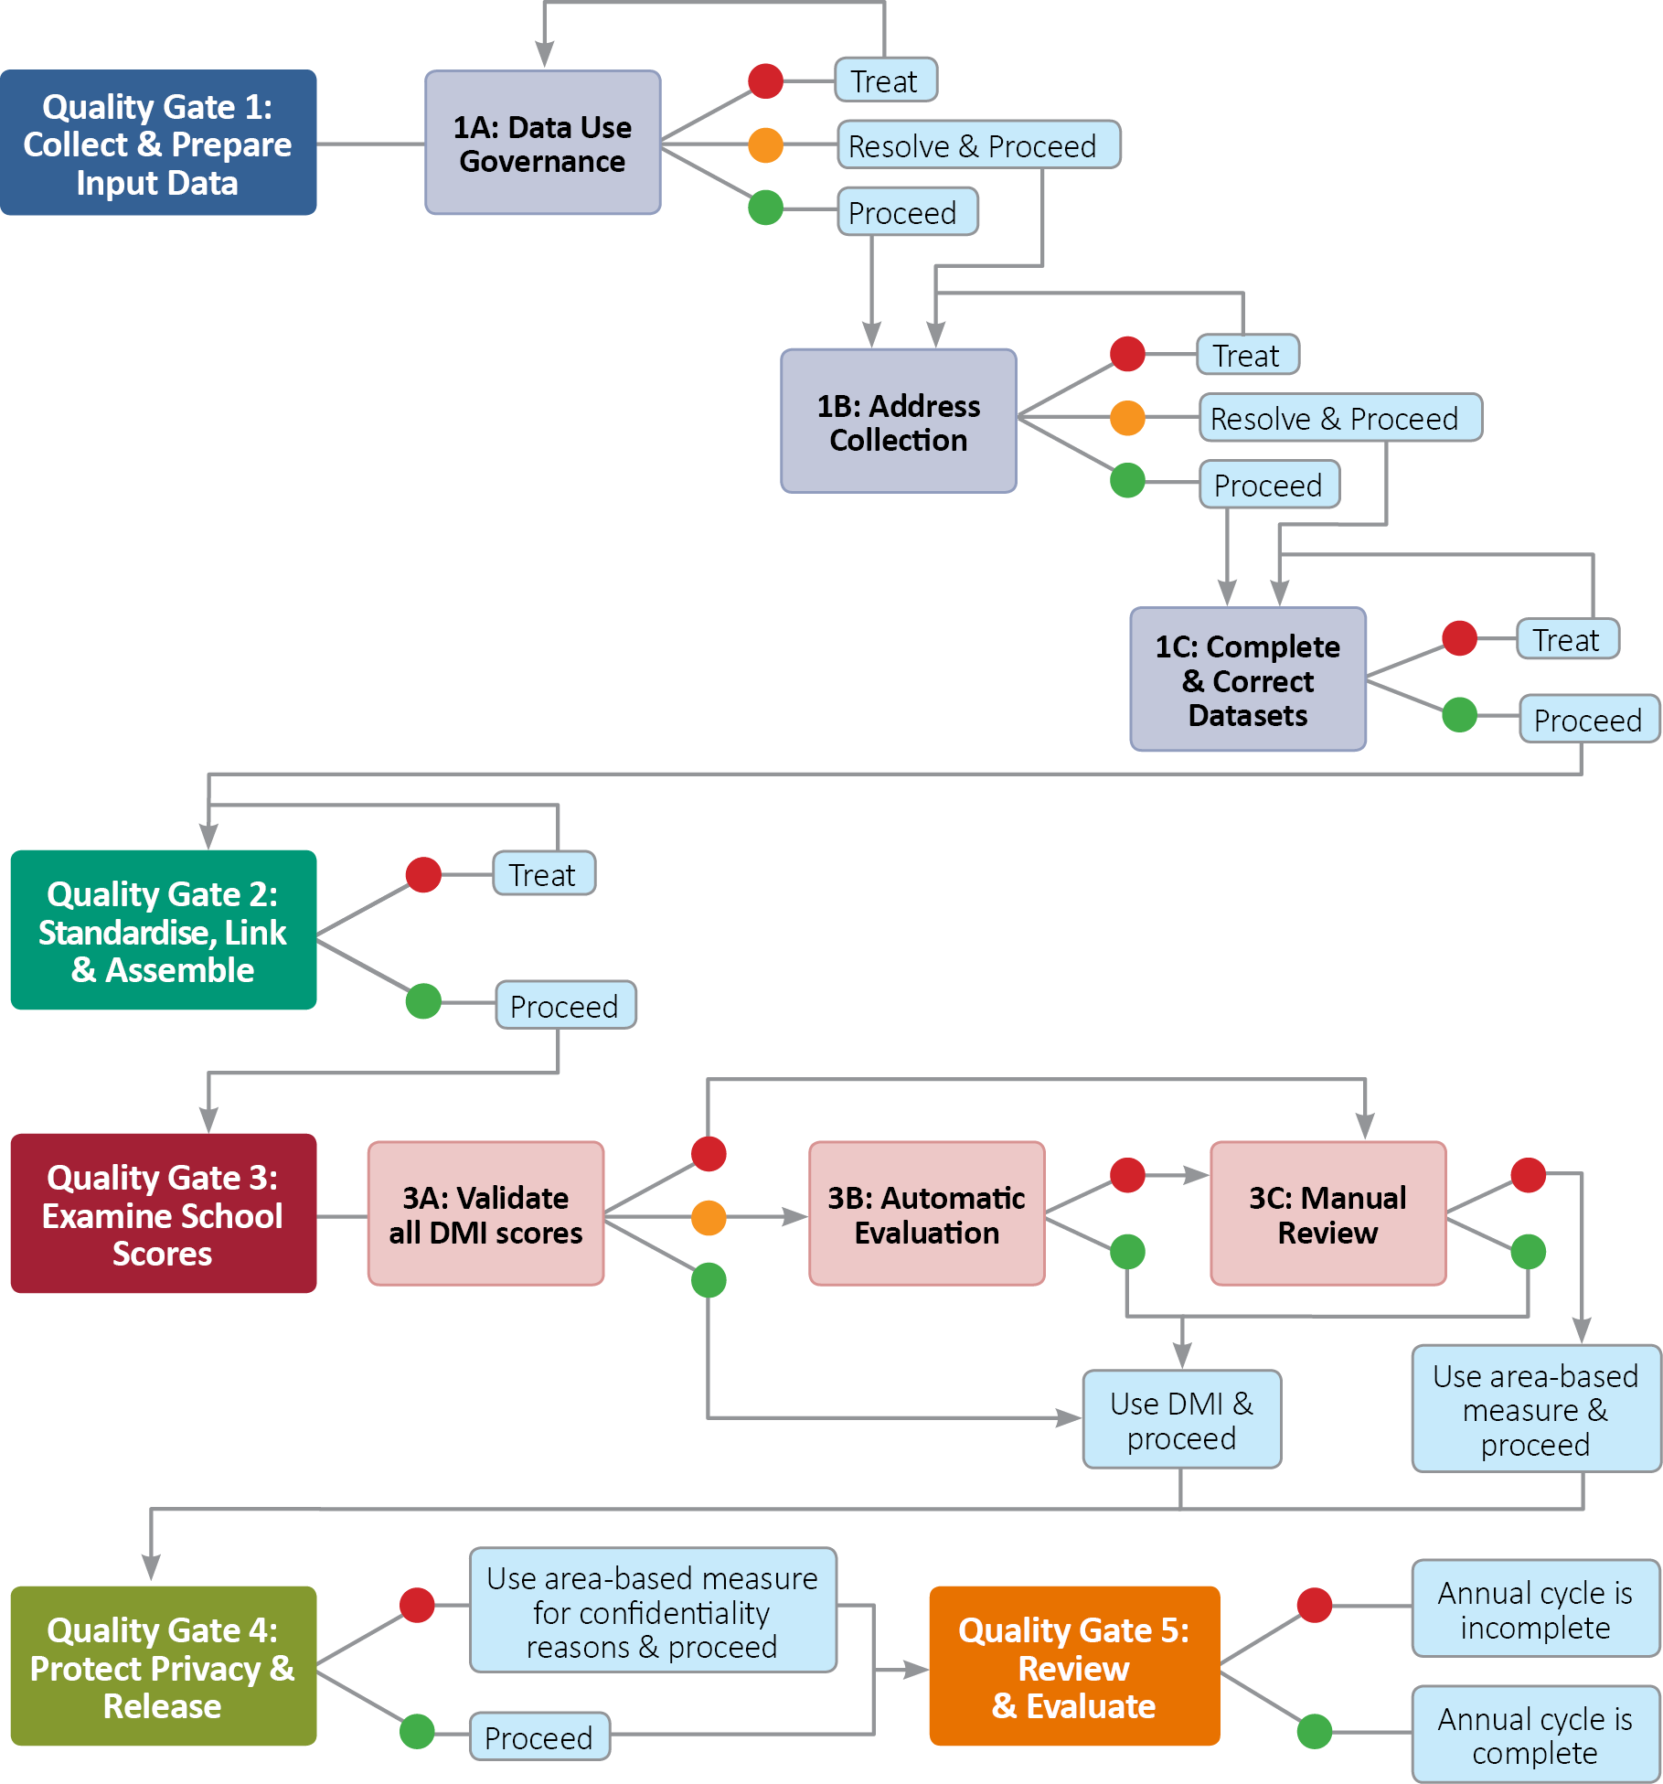

Further Information
Further information about how the Australian Government’s provides funding for schools can be found on the Department’s website at Funding for schools.
Further details of the Capacity to Contribute Data Validation and Quality Assurance Process are published in the ABS Capacity to Contribute Data Quality Framework.

