Department of Education, Skills and Employment

Feedback on the Mitchell Institute’s Report:

Australian Investment in Education: Early Childhood Education and Care

The Department of Education, Skills and Employment (the Department) welcomes the Mitchell Institute’s Report Australian Investment in Education: Early Childhood Education and Care, which was published on 16 February 2020.
However, there are a number of inaccuracies with the report, which the Department has communicated to the Mitchell Institute. The Department looks forward to continuing to work with the Mitchell Institute in relation to amending the report.
The Mitchell Institute Report stated:
“In 2018, government investment in ECEC fell for the first time in at least a decade.” Page 3
“These figures show that total government investment in ECEC has been rising steadily since 2008 and peaked in 2017. However, in 2018, expenditure in ECEC fell slightly, most likely due to the introduction of the new Child Care Subsidy.”(Page 6)

Department’s Recommended Revision
“These figures show that total government investment in ECEC has been rising steadily since 2008 and peaked in 2017. However, in 2018, expenditure in ECEC fell slightly due to the impact of compliance measures in the family day care sector.”

Department’s Explanation
The attribution of the slight decrease in funding in 2017-18 to the introduction of the Child Care Subsidy (CCS) is incorrect. CCS was not introduced until 2018-19. This decrease is due to the impact of compliance measures in the family day care sector.
The Mitchell Institute Report stated:
“The Child Care Subsidy redistributed government support with a greater emphasis on supporting low and middle-income families. Research has shown mixed effects of the subsidy, with many lower income families reporting a decline in child care costs, but a greater proportion of families reporting an increase” (Baxter et al., 2019). (Page 6)

Department’s Recommended Revision
“The Child Care Subsidy redistributed government support with a greater emphasis on supporting low and middle-income families. Departmental data indicates that 90% of families receive a subsidy rate of between 50% and 85% of their hourly fee (up to the hourly rate cap). The December 2019 quarter ABS CPI data shows that out-of-pocket child care costs remain 4.2 per cent lower than their peak in the June 2018 quarter.”

Department’s Explanation
The December 2019 quarter ABS CPI data shows that out-of-pocket child care costs remain 4.2 per cent lower than their peak in the June 2018 quarter (prior to the commencement of CCS). Data on out–of-pocket costs published in the 2020 RoGS demonstrates an increase in affordability for low income families (while not specified in the report, this is likely to include families on incomes up to $75,000). Departmental data indicates that 90% of families receive a subsidy rate of between 50% and 85% of their hourly fee (up to the hourly rate cap).
The Mitchell Institute Report stated:
“These figures also show that in terms of size, the Australian Government dominates total investment, accounting for 82% of recorded ECEC expenditure in 2018. This expenditure occurs mainly through various subsidies for child care services (all types of ECEC except preschool).” (Page 6)

Department’s Recommended Revision
“These figures also show that in terms of size, the Australian Government dominated total investment in ECEC in 2017-18. This expenditure occurs mainly through various subsidies for child care services and the provision of preschool funding to the states under the Universal Access National Partnership.”

Department’s Explanation
The proportion of 82% quoted in the report is incorrect. For the purposes of RoGS reporting, the Australian Government’s contribution to preschool education through Universal Access funding is counted as state expenditure, this is because historically the jurisdictions were unable to separate it from the information, they provided to the Productivity Commission. As such the percentage of Australian Government spending on early education and care is actually higher and does include preschool.
The Mitchell Institute Report stated:
“The vast majority of government expenditure, 83.5% in 2018, is in the form of child care subsidies, with preschool delivery accounting for the remaining proportion of expenditure.” (Key Points, Page 3)

Department’s Recommended Revision
“The vast majority of government expenditure, (more than 80% in 2017-18), was to support child care, with preschool delivery accounting for the remaining proportion of expenditure.”

Department’s Explanation
The 83.5% of expenditure reflects all government expenditure on child care, including Services Australia’s administrative costs and Department of Education, Skills and Employment (DESE) administrative costs (including staff wages). However, some of DESE’s administrative costs should be included as part of the delivery of preschool.
The Mitchell Institute Report stated:
“How much do Australian families and carers invest in ECEC?” Pages 8-9 and produced the below table.
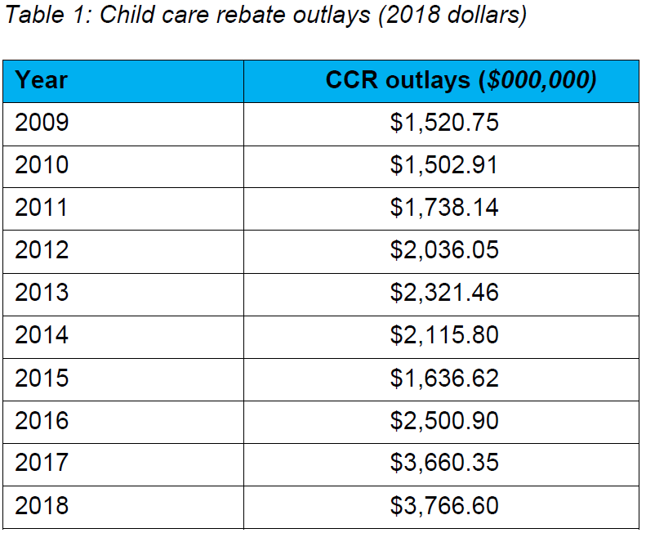
Department’s Recommendation
This whole section of the report would need to be rewritten using the correct data. Please see explanation below.

Department’s Explanation
This chapter attempts to estimate the amount of private expenditure on ECEC. The methodology used to estimate out of pocket expenses is not correct.
The estimates of CCR used in the Mitchell Institute report are incorrect. The figures appear to have been taken from the Department of Education’s (and its predecessors) annual reports. Due to Machinery of Government changes that occurred in a number of financial years, the annual reports do not reflect the total expenditure of the relevant financial year, rather they only cover some of the year. The 2014-15 and 2015-16 figures are of particular concern as the child care portfolio was moved to the Department of Social Services before being moved back to the Department of Education. Therefore, only a fraction of the total amount of CCR was recorded in the Department of Education’s annual report.
The department has provided actual expenses for CCR, CCB and CCS (see table below). Figures are derived from relevant portfolio agencies Annual Reports and Final Budget Outcomes. In the financial years where there were Machinery of Government arrangements figures have been consolidated from both agencies respective publications.
Year | CCB (000) | CCR (000) | CCS (000) | ALL (000)
2008-09 | $2,103,048 | $1,185,064 | $0 | $3,746,471
2009-10 | $2,000,062 | $1,304,429 | $0 | $3,803,912
2010-11 | $2,207,970 | $1,562,590 | $0 | $4,310,357
2011-12 | $2,327,285 | $1,887,422 | $0 | $5,049,983
2012-13 | $2,589,308 | $2,179,853 | $0 | $5,800,113
2013-14 | $2,985,423 | $2,601,982 | $0 | $6,420,027
2014-15 | $3,551,579 | $2,989,234 | $0 | $7,196,486
2015-16 | $3,629,725 | $3,361,747 | $0 | $7,360,988
2016-17 | $3,648,992 | $3,627,409 | $0 | $7,566,491
2017-18 | $3,246,593 | $3,766,600 | $0 | $7,353,374
2018-19 | $0 | $0 | $7,440,349 | $7,708,802
The Mitchell Institute Report stated:
“Child care subsidies are subject to a further range of variables based on income. The Child Care Subsidy, which began in 2018, is means tested. In 2019/2020, an eligible family with a combined income below $68,163 receives a subsidy of 85% of their child care fees up to an annual limit.”(Page 10)

Department’s Recommended Revision
“Child care subsidies are subject to a further range of variables based on income. The Child Care Subsidy, which began in 2018, is means tested. In 2019/2020, an eligible family with a combined income below $68,163 receives a subsidy of 85% of their child care fees up to an hourly rate cap. “

Department’s Explanation
This statement is incorrect, the CCS annual limit only applies to families with an annual income above $188,163. The hourly rate cap applies to all families.

