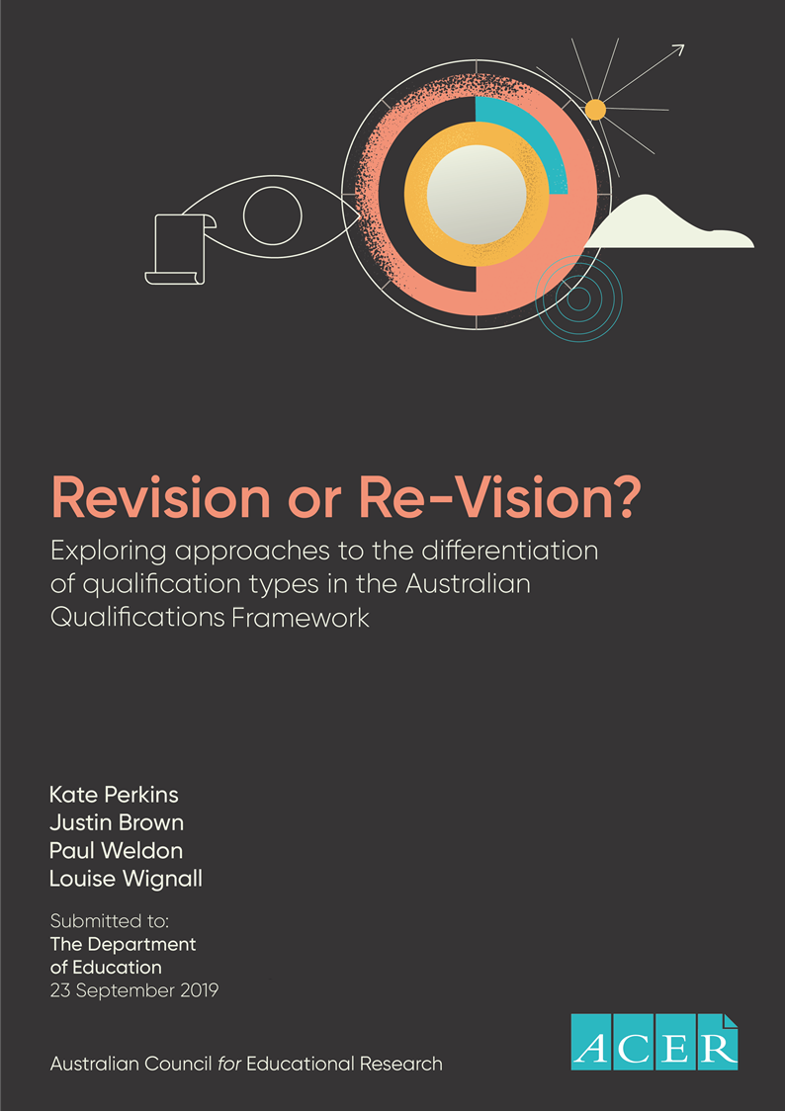

Table of Contents
EXECUTIVE SUMMARY 8
Part I: Conceptual and technical analysis of the AQF learning descriptors 9
Part II: Feasibility study to develop alternative models 10
Recommendations and Conclusions 13
PART I: ANALYSIS OF THE AQF DESCRIPTORS 15
1 Introduction 16
1.1 Methodology 16
1.2 Structure of this report 17
2 Qualifications frameworks and descriptors 18
2.1 The role of qualifications frameworks 18
2.2 The framing of learning outcomes in qualifications frameworks 19
2.3 International approaches to learning outcomes 20
2.4 Features of an effective Learning Outcomes Matrix 29
2.5 Key messages 32
3 The AQF Learning Outcomes Matrix and descriptors 34
3.1 The role of descriptors in the AQF 34
3.2 The AQF Learning Outcomes Matrix 37
3.3 Key messages 41
4 AQF descriptors: technical analysis 42
4.1 Establishing the scope 42
4.2 The technical analysis 42
4.3 Knowledge descriptors 43
4.4 Skills descriptors 49
4.5 Application of Knowledge and Skills (AKS) descriptors 55
4.6 Key messages 56
5 Identifying possible ways forward 58
5.1 Revision of the current learning outcome descriptors 58
5.2 Two alternative models 60
6 Conclusions 63

PART II: TESTING THE FEASIBILITY OF ALTERNATIVE APPROACHES 67
7 The feasibility study 68
7.1 Background 68
7.2 Methodology 69
7.3 Structure of Part II 70
8 Towards a new conceptual base 71
8.1 Role, purpose and scope of the new matrix 71
8.2 Rationale 72
8.3 Redefining the Knowledge domain 73
8.4 Redefining the Skills domain 76
8.5 Redefining the Application of Knowledge and Skills domain 79
8.6 Determining the number of bands 84
8.7 Feasibility of the working models 85
8.8 Feasibility of a shift to qualification design specifications 86
8.9 Key messages 87
9 The prototype and qualification type specification 88
9.1 Conceptual base 88
9.2 The prototype matrices: key features 89
9.3 Using the prototype to differentiate qualification types 90
9.4 Using the new matrix within individual qualifications 93
9.5 The prototype addresses many current AQF issues 93
9.6 Key messages 94
10 Comparing current and alternative approaches 95
10.1 Potential benefits and limitations for stakeholder groups 95
10.2 Appraisal of Model A (a modification of the current AQF descriptors) 97
10.3 Appraisal of Model B (new conceptual base; Knowledge and Skills bolted to band) 98
10.4 Appraisal of Prototype Model (a new conceptual base that is unlocked at level) 99
10.5 Key messages 103
11 Conclusions and recommendations 104
11.1 Conclusions 104
11.2 Recommendations 107
References 108

APPENDICES 113
Appendix A: Terms of Reference 114
Appendix B: Mapping of qualifications frameworks 116
Appendix C: Text-based review of the AQF 117
Appendix D: Writing learning outcomes 145
Appendix E: Knowledge - Testing the suitability of current AQF definitions/focus areas 147
Appendix F: Sample descriptors 149

List of Tables
Table 2.1: NQFs with variations from the KSC trichotomy 22
Table 2.2: Qualifications frameworks: Common design approaches 33
Table 4.1: An analysis of AQF Knowledge levels criteria 44
Table 4.2: Levels criteria: Analysis of Kinds of Knowledge across ten levels 45
Table 4.3: A comparison of Knowledge in levels criteria and qualification type descriptors 46
Table 4.4: Analysis of field descriptors within Knowledge levels criteria 48
Table 4.5: Levels criteria: mapping of breadth, depth and kinds of knowledge 49
Table 4.6: Skills: Qualification type descriptors related to ‘solutions to problems’ 53
Table 4.7: Qualification types and skills related to information management 54
Table 4.8: Application of Knowledge and Skills: analysis of levels criteria 57
Table 5.1: The AQF Learning Outcomes Matrix does not meet effectiveness criteria 59
Table 6.1: Key features of the AQF 64
Table 7.1: Summary of project methodology 69
Table 8.1: Application: A2 and A3 draft Focus Areas and descriptors 84
Table 9.1: Prototype working definition and focus areas 90
Table 9.2: Using the prototype to specify qualification types 92
Table 9.3: The prototype: Potential to address broader issues identified as part of consultations 94
Table 10.1: Staying with the status quo: Summary of benefits and limitations 98
Table C1: Analysis of AQF levels criteria 119
Table C2: Knowledge levels criteria: types of knowledge 120
Table C3: Knowledge levels criteria: field descriptors and qualifiers 122
Table C4: Knowledge levels criteria: breadth, depth and kinds 123
Table C5: Knowledge levels criteria: categorisation of breadth, depth and kinds 124
Table C6: Knowledge qualification type descriptors levels 1 to 8 125
Table C7: Knowledge domain: qualification type descriptors level 8 126
Table C8: Knowledge qualification type descriptors levels 9 and 10 127
Table C9: Knowledge-a comparison of levels criteria and qualification type descriptors 128
Table C10: Analysis of Skills levels criteria 130
Table C11: Scales underpinning Skills levels criteria 131
Table C12: Application of Skills 131
Table C13: An analysis of Skills qualification type descriptors 133
Table C14: Skills qualification type descriptors applied to information management 134
Table C15: Skills qualification type descriptors applied to problem solving 135
Table C16: Application of Knowledge and Skills analysis of levels criteria 137
Table C17: Application of Knowledge and Skills analysis of levels criteria logic 139
Table C18: Application of Knowledge and Skills: filling the gaps 139
Table C19: Application of Knowledge and Skills 141
Table C20: Analysis of the summary 143
Table D1: The basic structure of learning outcomes statements 145
Table D2: Exemplifying the vertical dimension of learning outcomes 145
Table D3: Domains of learning, levels of sophistication and common verb associations 146

List of Figures
Figure ES.1: An integrated view of the prototype elements 11
Figure ES.2: Prototype domains foster graduate Personal Practical Knowledge (PPK) 11
Figure ES.3: Prototype with a possible variation 12
Figure ES.4: AQF qualification design features and context-specific learning outcomes 13
Figure 1.1: Structure of Part I report 17
Figure 2.1: A comparison of the AQF and EQF (EU, 2016, p.19) 22
Figure 2.2: Constructing a LOM starting from existing qualifications 24
Figure 2.3: Bloom’s Taxonomy (Cognitive domain) 25
Figure 2.4: Visual representation of Learning Progression in Qualifications Frameworks 29
Figure 2.5: A Learning Outcomes Matrix as a discrete set of reference points 30
Figure 2.6: A three-tiered Learning Outcomes Matrix 31
Figure 3.1: Effective differentiation provides the basis for effective application 35
Figure 3.2: The AQF: effective differentiation of qualification types is key 35
Figure 3.3: The AQF LOM levels and qualification types are almost synonymous 37
Figure 3.4: The current AQF LOM is presented as a two-tiered matrix 39
Figure 3.5: The AQF LOM with taxonomy made explicit 39
Figure 3.6: The 3 AQF domains are locked at level 40
Figure 4.1: Qualification type descriptors: application of Skills 51
Figure 5.1: Features of Working Model A (Modified AQF) 58
Figure 5.2: Features of Working Model B with trial definitions 60
Figure 5.3: Features of Working Model C with trial definitions 61
Figure 6.1: The purpose and applications of the AQF 65
Figure 7.1: Part II report structure 70
Figure 8.1: An integrated model of Knowledge, Skills and Application 72
Figure 8.2: The Butler Model of Human Action (1996) 73
Figure 9.1: An integrated view of the prototype’s elements 88
Figure 9.2: Prototype domains operate individually and collectively 88
Figure 9.3: Prototype with variations 89
Figure 9.4: AQF qualification design features and context-specific learning outcomes 91
Figure 9.5: Designing qualifications using prototype descriptors 93
Figure 10.1: Three Working Models 96
Figure 10.2: The prototype (variation 2) 100

Acronyms
ACER Australian Council for Educational Research
AKS Application of Knowledge and Skills
AQF Australian Qualifications Framework
CEDEFOP European Centre for the Development of Vocational Training
DoE Department of Education
DET Department of Education and Training
EQF European Qualifications Framework
KSC Knowledge, Skills and Competence
LOM Learning Outcomes Matrix
NQF National Qualifications Framework
NZQF New Zealand Qualifications Framework
SOLO Structure of Observable Learning Outcomes
UNESCO United Nations Educational, Scientific and Cultural Organisation
VQA Victorian Qualifications Authority

EXECUTIVE SUMMARY
The Contextual Review informing the current Australian Qualifications Review (AQF) Review reported that:
‘…there is considerable feedback across regulators, providers, professions, industry and government agencies that the descriptors of levels and qualifications are not as effective as people would wish them to be. The 2018 [AQF] review will need to focus on the language, presentation and underpinning concepts of the AQF to make it more easily understood and implemented.’ (PhillipsKPA, 2018, p.74)
In December 2018, the AQF Review Panel released a discussion paper outlining a number of options for change, including the improvement of the AQF learning outcomes descriptors. Stakeholder feedback on this particular aspect of the Review supported the need to improve the clarity of the current descriptors.
In March 2019, the Department of Education commissioned the Australian Council for Educational Research (ACER) to conduct:
- a conceptual analysis of the most appropriate way to develop and present a taxonomy of learning outcomes within a qualifications framework; and
- a technical analysis and revision of the Knowledge, Skills and Application of Knowledge and Skills descriptors used in the AQF.
ACER undertook this work between April and June 2019. The findings, conclusions and recommendations arising from this work are presented in Part I of this report.
Based on these findings, ACER was subsequently commissioned by the Department to undertake Part II, to:
- develop two alternative models that: (a) reflect the new conceptual base developed in Part I; (b) comprise a set of revised domain definitions (along with a new typology for each domain); and (c) include some example descriptors to indicate how descriptors could operate;
- develop ways in which the two models might be utilised in the specification of qualification types; and
- analyse and report on potential benefits and limitations of the models.
ACER undertook this project between July and September 2019. The findings, conclusions and recommendations arising from this work are presented in Part II of this report.
Both Parts I and II were undertaken as desk-based activities. While a number of workshops were conducted with the AQF Panel, the opportunity to conduct in-depth testing and validation of the models was not within scope of the project. This is acknowledged as a limitation of the work.
Part II of this project was highly exploratory and was undertaken to inform the policy deliberations of the AQF Panel and the Department. The prototype presented in this part should be seen as a starting point for ongoing testing, trialling and development involving stakeholders and users of the AQF.

Part I: Conceptual and technical analysis of the AQF learning descriptors

Part I Findings
Internationally, qualifications frameworks tend to apply a common design. At the centre of each design is a description of levels of learning outcomes typically arising from completion of a qualification in a formal education and training system. These learning outcomes descriptors are central to the differentiation of one qualification type from another. As a general rule, descriptors are presented within a matrix with a taxonomic structure, incorporating overarching domains of learning (e.g. Knowledge, Skills and Competence); sub-strands or ‘focus areas’ for each domain (e.g. breadth and depth of knowledge), and descriptors across a number of levels. Collectively, these elements constitute the taxonomy.
The analysis undertaken for Part I has identified that a number of conceptual assumptions bedevil qualifications frameworks, including the current AQF. At their core, these assumptions relate to: (a) a lack of a coherent and transparent conceptual base; (b) an inconsistent internal logic, particularly in regard to approaches to the indication of progression and differentiation from one level to the next; and (c) a lack of clarity and transparency in the taxonomy that underpins the descriptors.
The descriptors written in National Qualifications Frameworks (NQFs) are written in a context-agnostic style, meaning that by their nature they are generic and somewhat ill-defined. Yet, the research literature is clear: learning outcome statements are most appropriately written to reflect specific aims and objectives within a particular context.
Reviews of NQFs internationally suggest that the introduction of generic learning outcome descriptors has been under-theorised and under-conceptualised. The application of descriptors to qualifications frameworks is not an exact science but reviews of NQFs internationally suggest that pragmatism appears to take precedence over conceptualisation. A key issue identified is that most descriptors appear to have been designed to describe features of existing qualifications, thus making it difficult to describe learning progression in a conceptually defensible manner.
While acknowledging these limitations, Part I identifies a set of guiding principles and features that are likely to increase the effectiveness of descriptors in qualifications frameworks (ES Box 1)

ES Box 1: Features of an effective Learning Outcomes Matrix (LOM)

An effective Learning Outcomes Matrix (LOM) should be designed as a discrete component of the framework, with a conceptually sound internal logic, providing a common language and set of independent reference points against which to describe key qualification specifications, (current and future). Features include:
- explicit principles, rationale and a conceptually based classification system to underpin content decisions;
- a visual presentation that makes it possible to track progression across domains and focus areas (e.g. as a three-tiered matrix);
- a number of stages of progression;
- descriptors with sufficient detail to enable differentiation of learning progression across a number of stages or levels, with the number of levels determined by the extent to which such distinctions can genuinely be made.

Part I Conclusions
Part I concluded that the AQF‘s learning outcomes matrix and descriptors did not meet many of the criteria that characterise an effective LOM.
- There is no clearly articulated conceptual base or line of sight from the taxonomy to the descriptors.
- The descriptors are, in effect, determined by the scope and spread of qualification types. This locks the framework into a fixed representation of the present scope of qualification types in the post-secondary education and training system in Australia. There is currently no logical way of incorporating any new qualification type (this includes, but goes beyond, micro-credentials);
- The current descriptors are not performing their central function – they do not provide meaningful differentiations across ten levels.
ACER reported that the current AQF descriptors (i.e. levels criteria and qualification type descriptors) were not doing the job for which they were intended to do. They were not providing a sound basis for the description of qualification types that would also differentiate them from each other.
The issues that stakeholders had identified (e.g. lack of clarity, ambiguity) could not be addressed by revising the language of the current AQF, because the language issues were a symptom of a deeper problem, namely that the AQF domains and taxonomy do not provide appropriate scaffolding for the description of learning outcomes at each level, nor for differentiating progression from one level to another. As a result, ACER concluded that it was not possible to address the issues identified by stakeholders, or by the ACER technical analysis (detailed in Appendix C), without making substantial changes to the scaffolding upon which the descriptors have been built.
ACER presented the Review Panel with several conceptual models that might offer a way forward. Testing the feasibility of these models formed the basis of work commissioned in late June 2019, and undertaken between July and September of 2019.
It was recognised that the work would be highly exploratory. Given the complexity of the tasks, the new territory to be covered, and the very short time frame, it was agreed that there would be no expectation that ACER would deliver any fully developed alternative to the current AQF.

Part II: Feasibility study to develop alternative models
Part II of the project led to the development of a prototype with two variations. The prototype has a new conceptual base reflecting a constructivist view of learning. It differs from the current AQF taxonomic structure in four fundamental ways in that it moves from:
- a matrix that is strongly influenced by perceptions of existing qualification types to one that provides a set of independent reference points;
- descriptors focused on graduate learning outcomes to descriptors of qualification type design features;
- specifying qualification types using all descriptors across three domains ‘locked at level’, to differentiating qualifications on the basis of a small set of design features; and
- describing universal generic future contexts within which context-specific information, ideas and skills will be applied to a focus on application within qualification learning contexts.
The prototype maintains the AQF domain labels but redefines them. It is based on the principle that the three domains and the Essential Capabilities interact to foster learning, with application in learning contexts playing a key role throughout. As depicted in Figure ES 1, in practice, these elements are inextricably entwined.
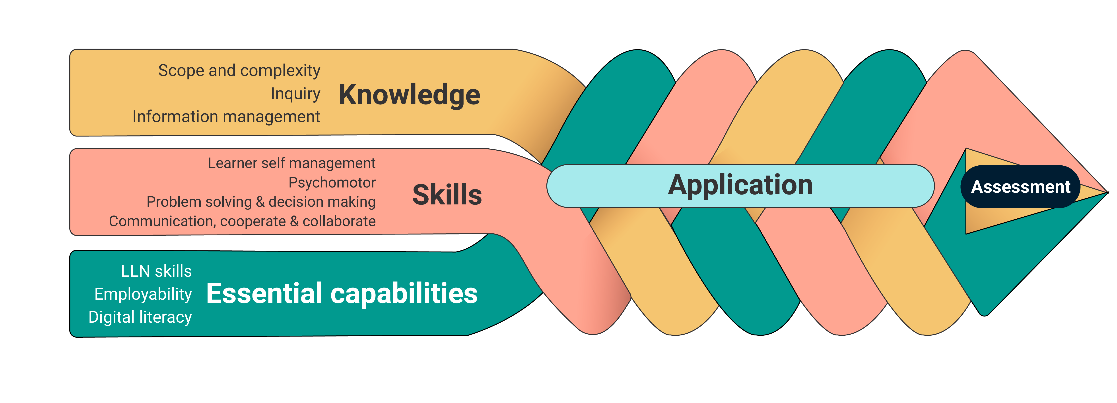
Figure ES.1: An integrated view of the prototype elements
The ACER team recognises that in the design of formal qualifications, attention is paid to each element – to the selection of public information and skills to be fostered, to the practice fields within which they are applied, and to the conditions under which they are assessed. Explicit attention to each of these areas, as well as a consideration of how they interact with each other, maximises the potential for learning. Thus, the domains should be considered both individually and collectively, as in Figure ES 2.

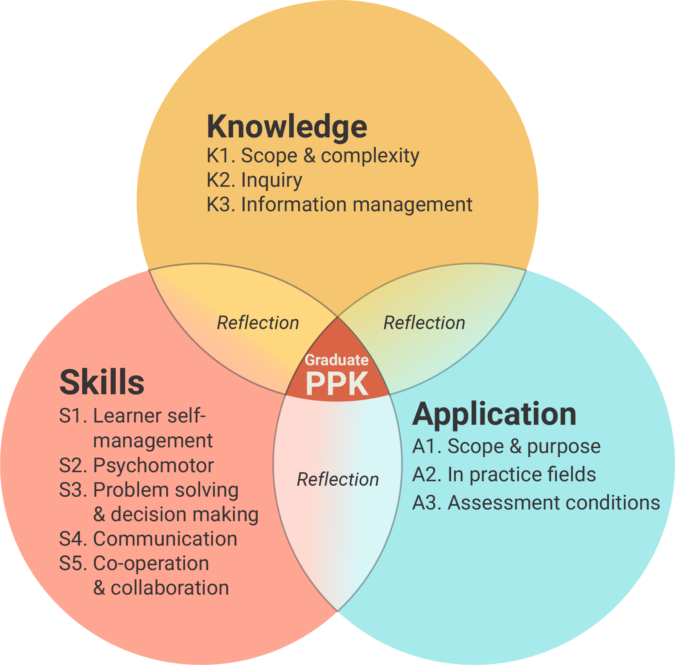
Figure ES.2: Prototype domains foster graduate Personal Practical Knowledge (PPK)

The prototype provides a way of teasing out these individual domains, with detailed descriptors that make it possible to ‘zoom in’ on specific areas as required.
In Figure ES.3, the prototype is presented in two forms to capture different ways of envisaging and describing the Application domain.
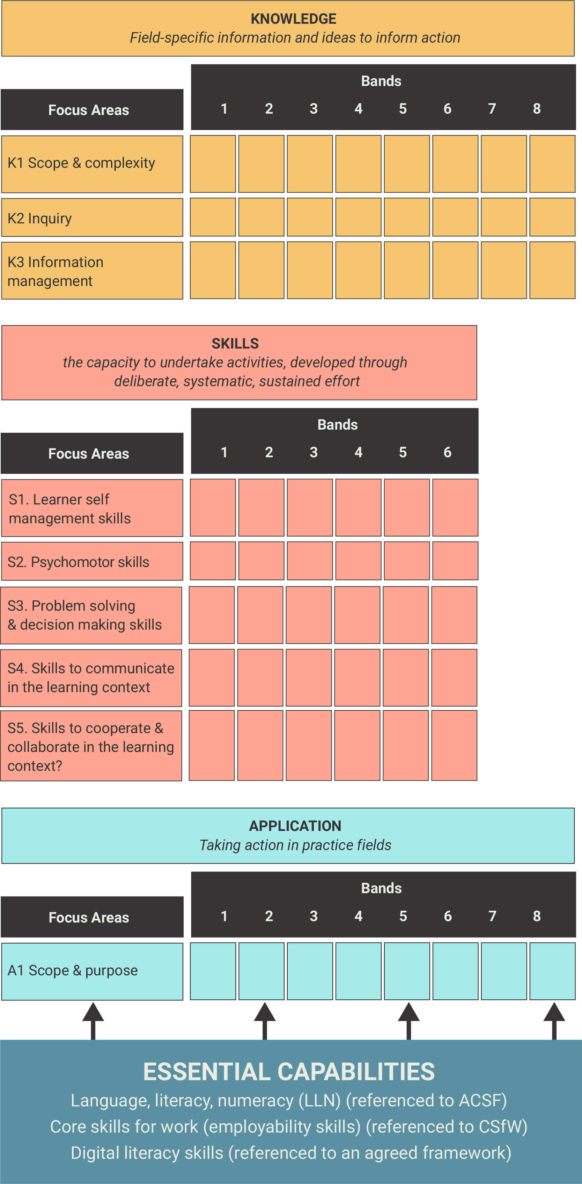 | 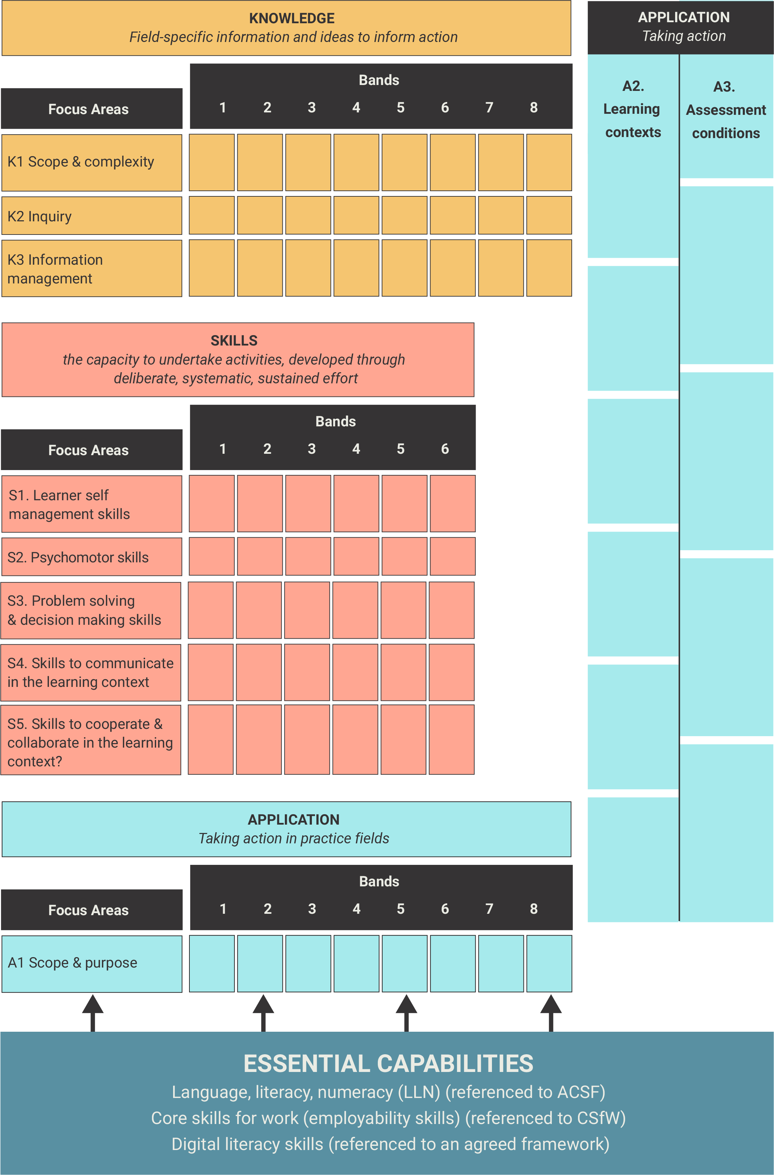
Figure ES.3: Prototype with a possible variation
The prototype offers a blueprint for the development of a practical matrix that will facilitate teaching, learning and assessment within individual qualifications, while also providing the scaffolding that enables the AQF to achieve one of its central purposes, which is to effectively differentiate qualification types.
The prototype describes Knowledge, Skills and Application across multiple bands against a set of focus areas that could be used in different configurations to differentiate one qualification type from another. These focus areas have been selected because they appear to be integral to formal learning and assessment. Almost all can be described across continua with identifiable and describable ‘change’ points.
For those AQF users who need it, the new approach proposed here provides a level of detail that has not been available before. There are a number of potential benefits outlined in this report and, for the most part, the fundamental architecture is consistent with the taxonomic structure as described in the current AQF. However, the authors stress that the prototype requires further testing and validation to ensure its robustness, applicability and relevance, now and into the future.

Recommendations and Conclusions

Recommendations
- Recognise the need for a new AQF matrix.
- Use the prototype as the starting point for the development of a new approach that builds on, and enhances, the new conceptual base.
- Design the matrix development process as a change management process that will develop stakeholder interest and ownership, while establishing and ensuring that the underpinning principles and concepts are reflected in the detail.

Supporting Conclusions
The findings in Part I and Part II support the above recommendations. However, further context to these conclusions includes the following observations and caveats to the ACER work.
Descriptors of learning outcomes may not be the most effective approach
Most of the literature on the identification, design and application of learning outcomes relates to their use within individual qualifications, where there is a clear scope and context. This is a critical difference to their use in qualifications frameworks where it is not possible to specify a set of generic aims and objectives that would apply across all individual qualifications within a qualification type. As such, the current AQF descriptors are not anchored to a clear conceptual and theoretical base.
For these reasons, ACER supports a move to the development of descriptors of qualification design features. When used as differentiators of qualification types, this places the onus on the designers of an individual qualification to ensure that it actively reflects the specifications. Each qualification can then develop learning outcomes statements or competency statements specific to their aim and context, but with a direct line of sight back to the AQF (See Figure ES.4).
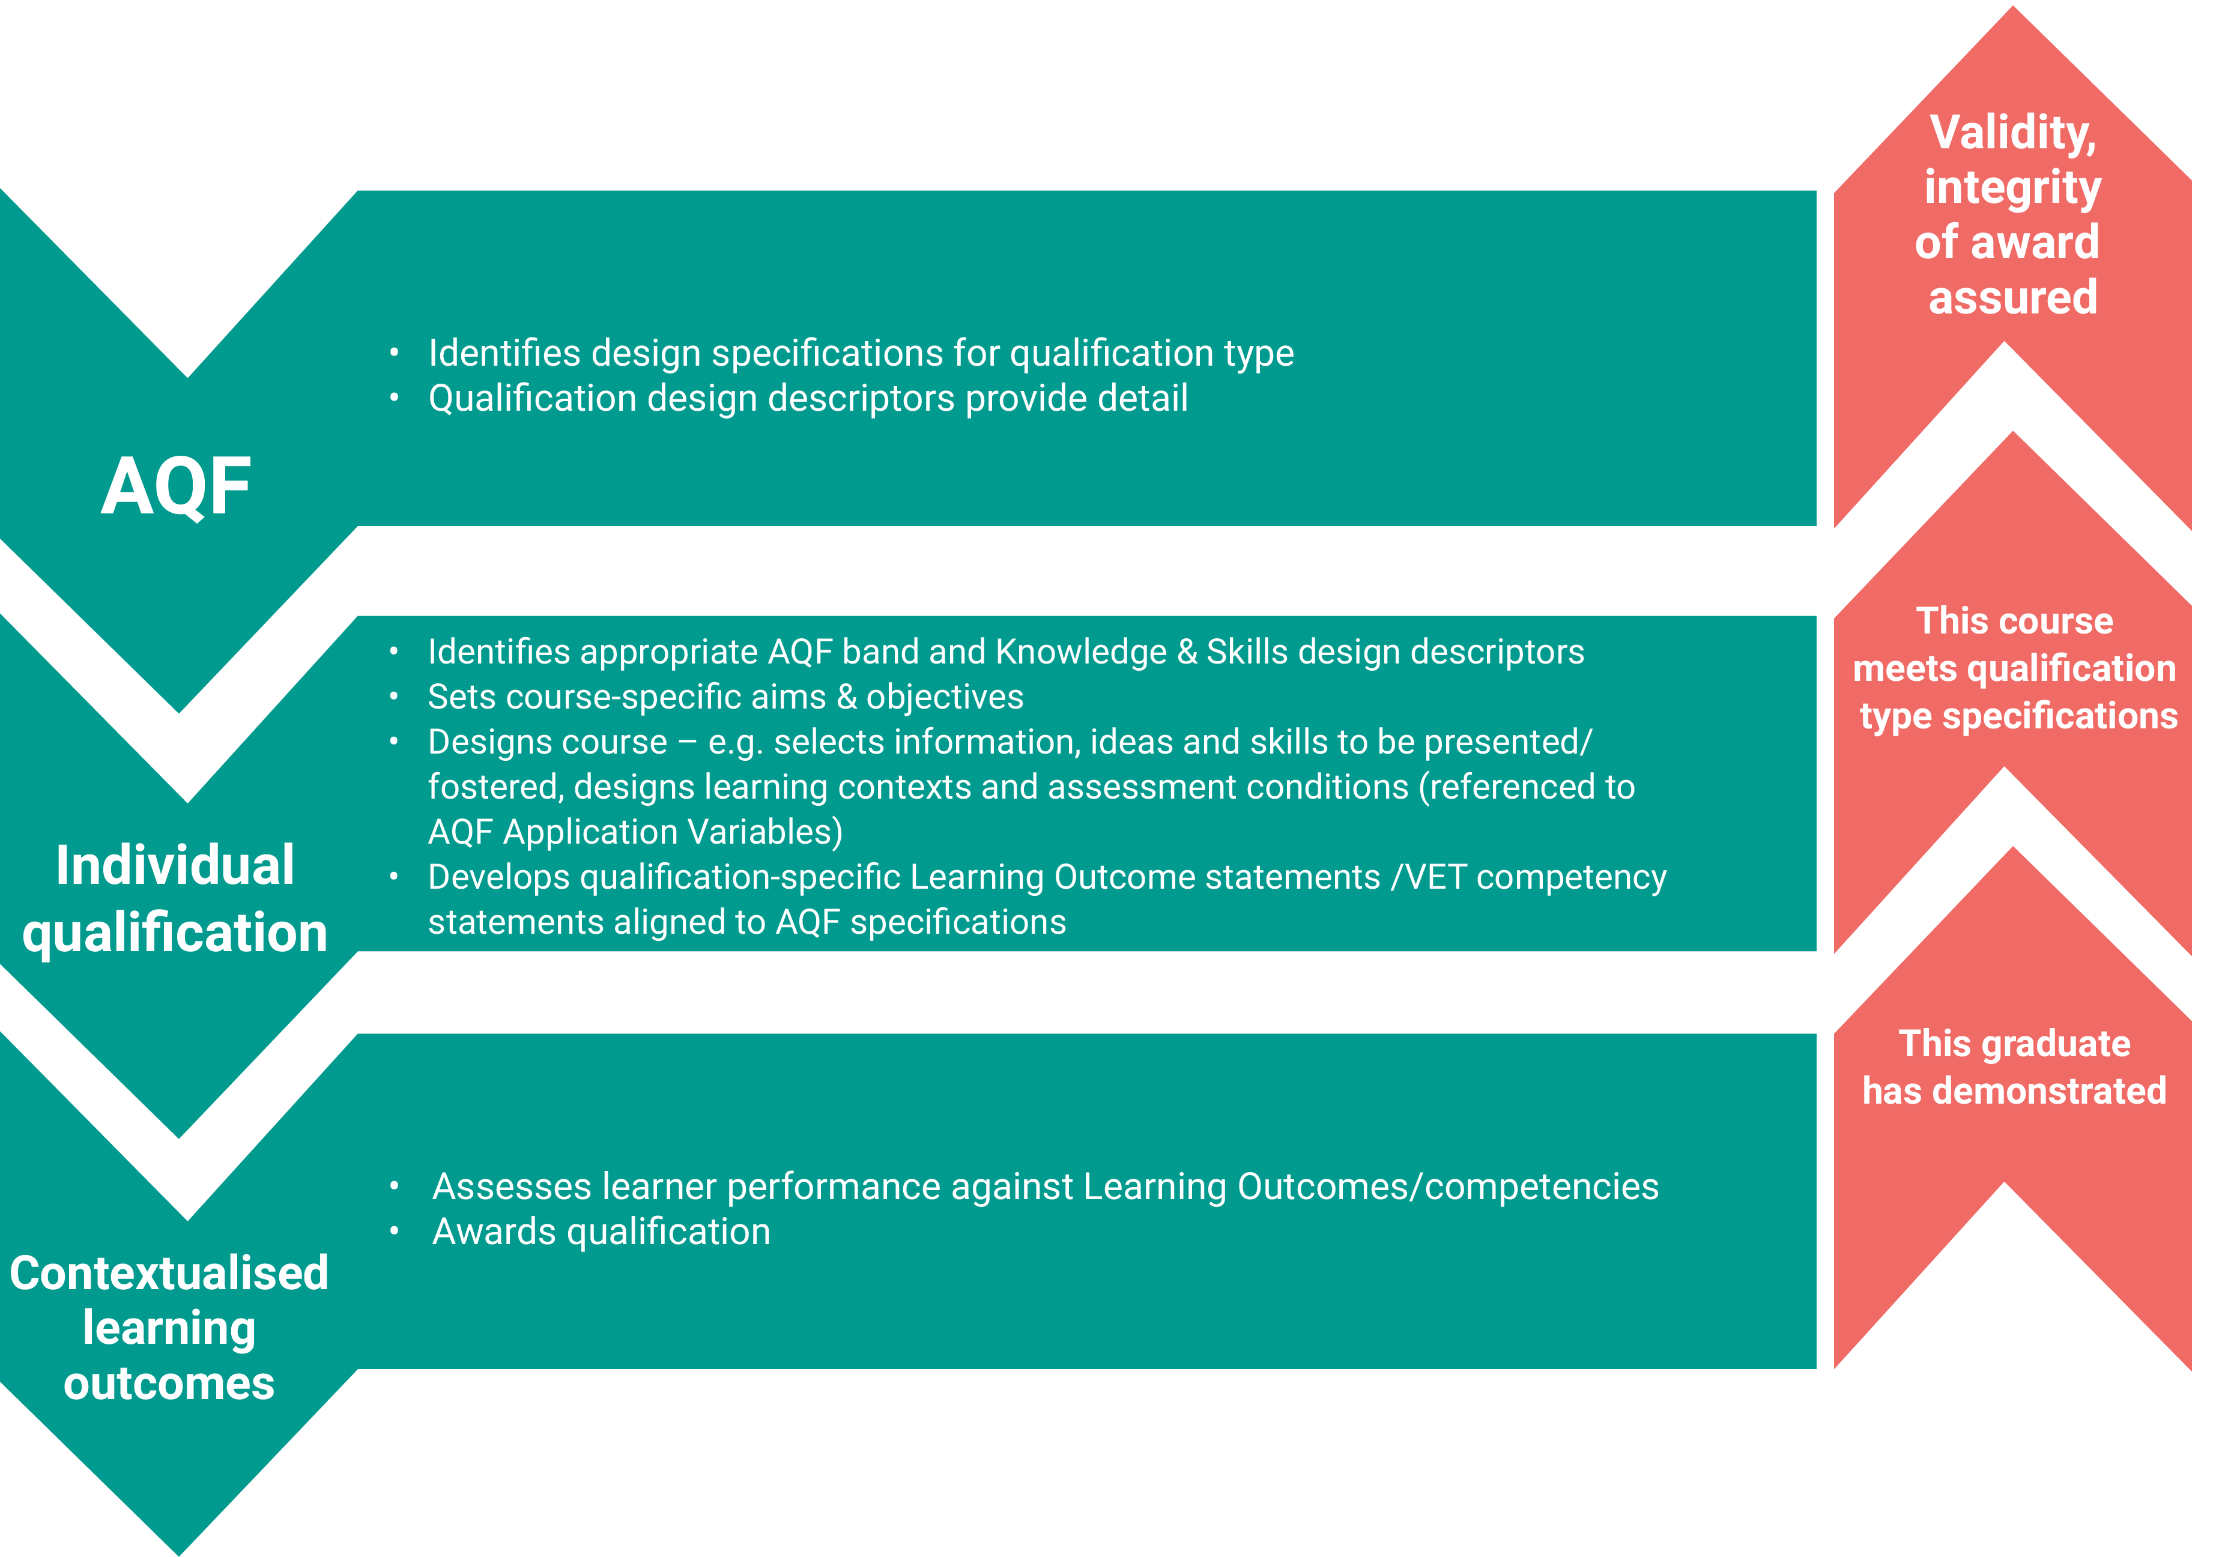
Figure ES.4: AQF qualification design features and context-specific learning outcomes
The AQF does not provide a basis for effectively differentiating qualification types
The AQF is used for a range of purposes. It is used by potential students, graduates, employers, unions, education providers, and regulators, as well as used as an international reference point. To be effective in its roles, the AQF must provide a way of clearly differentiating one qualification type from another. The ACER analysis demonstrates that the current construct does not actually do this.
This raises questions about its various applications. Analyses of various international NQFs suggests it is time to challenge the assumption that the AQF provides a basis for international comparisons. While the domain ‘labels’ are similar, the definitions and/or the associated taxonomies can differ significantly. These may reflect different philosophies about learning and/or the unique political agendas that influence the focus and emphasis of each NQF. The AQF also has more levels (10) than many equivalent frameworks. This can also make attempts to ‘align’ with others quite problematic.
The current construct anchors the AQF to what has been, with no mechanism to facilitate what needs to be
The current approach locks the AQF into the present scope of qualification types, which for the most part reflect the past. Because the learning descriptors are not independent of existing qualifications, they cannot be used as a robust mechanism for evaluating and classifying the new qualification types that are already emerging (albeit tentatively) and those that will undoubtedly continue to emerge. Nor could it be adjusted easily, to reflect the evolution of existing qualification types.
The prototype developed in this work offers a viable starting point for a more flexible and future-oriented approach that could deliver many benefits
With further testing and development, the prototype has the potential to provide a range of benefits for each stakeholder group, including:
- increased precision and detail to describe and differentiate qualification types;
- the creation of reference points that are independent of, but linked to, qualification types;
- a re-balancing of notions of qualification status and parity of esteem;
- a reduction in duplication in the AQF document; and
- the potential to address broader issues identified by the AQF review.
If introduced carefully and incrementally, a new clearer matrix has the potential to produce real improvements in the short, medium and long-term.
The prototype needs further development
The prototype should not be seen as a finished, or almost finished, product. It has been developed over a few short months. Even though the elements it contains represent the distillation of a considerable amount of literature, and extensive conceptualising and experimenting, they are still very much a work-in-progress.
However, the prototype is developed to the extent that it demonstrates the feasibility of a new approach. If this is taken further, it should involve extensive stakeholder consultation and trialling. This could be designed as change process in its own right. In the process, and through their input, the matrix itself can only be strengthened, as long as the underpinning principles and constructs are not compromised by competing interests. If the prototype is taken forward, one body needs to take carriage of the process, including taking responsibility for ensuring that the integrity of the construct is clearly established and maintained.

PART I: ANALYSIS OF THE AQF DESCRIPTORS

Introduction
The Contextual Review informing the current Australia Qualifications Review (AQF) Review reported that:
‘…there is considerable feedback across regulators, providers, professions, industry and government agencies that the descriptors of levels and qualifications are not as effective as people would wish them to be. The 2018 [AQF] review will need to focus on the language, presentation and underpinning concepts of the AQF to make it more easily understood and implemented.’ (PhillipsKPA, 2018, p.74)
In December 2018, the AQF Review Panel released a discussion paper outlining a number of options for change, including the improvement of the AQF descriptors of learning outcomes. Stakeholder feedback on this particular aspect of the Review supported the need to improve the clarity of the current descriptors.
In March 2019, the Department of Education commissioned the Australian Council for Educational Research (ACER) to conduct:
- a conceptual analysis of the most appropriate way to develop and present a taxonomy of learning outcomes within a qualifications framework; and
- a technical analysis and revision of the Knowledge, Skills and Application of Knowledge and Skills descriptors used in the AQF.
ACER undertook this work between April and June 2019. The findings, conclusions and recommendations arising from this work are presented in Part I of this report.

Methodology
The methodology for Part I involved five components, which were:
- a review of the purposes, features and issues associated with qualifications frameworks and descriptors internationally, leading to the identification of key features of an effective learning outcomes matrix;
- a consideration of the role of descriptors in meeting the objectives of the AQF, and of broader features of the AQF with the potential to impact on learning outcome design;
- a detailed technical analysis of the descriptors (levels criteria and qualification type descriptors) in the current AQF, and an evaluation of the effectiveness of the taxonomy on which they are based;
- the development of a revised version of descriptors to demonstrate the extent to which issues identified could be addressed within the current construct; and
- the design of several prototypes to illustrate alternative approaches that might be considered.

Structure of this report
Part I of this work is structured in five sections. It begins with an analysis of existing qualifications frameworks and the ways in which descriptors have been used for that particular purpose. It looks at the broader roles of these frameworks, the framing of learning outcomes, international approaches and the critical features and components.
With that understanding of the fundamental components, the ACER team presents an analysis in two parts: a conceptual analysis and a technical analysis. The conceptual analysis critiques the underpinning assumptions that sit beneath the descriptors to identify areas that have potential to be resolved with alternative approaches. Secondly, the technical analysis offers a linguistic analysis of the taxonomic structure underpinning the current AQF. A primary purpose of this exercise was to identify the types of verbs, qualifiers, intensifiers and so on that have been used to describe progression and denote differentiation at each level of the framework.
Based on these findings, ACER developed three working models (A, B and C) for further testing and development. These are described in terms of their component parts and the team offers alternative approaches of framing and assembling these to resolve some of the issues identified in the conceptual and technical analysis.

Figure 1.1: Structure of Part I report

Qualifications frameworks and descriptors
This section presents a review of the available Australian and international literature. Its purpose is to summarise the approaches taken internationally when defining and applying descriptors to qualifications frameworks, and to identify the potential of these approaches for application to the Australian context.

The role of qualifications frameworks
About 160 countries have National Qualifications Frameworks (NQFs), almost all of which have been developed in the last decade. New Zealand and Australia were pioneer countries, developing their NQFs in 1991 and 1995 respectively, making them among the first in the world. While there is some scope for customisation, an international review of qualifications frameworks conducted for UNESCO (Keevey and Chakroun, 2015, p.89) found that:
‘…all the qualifications frameworks are based on the same conceptual design: qualifications using learning outcomes, and a set of hierarchical levels against which the qualifications are pegged based on an application of a set of level descriptors.’
Although we can trace their origins to a common conceptual design, qualifications frameworks have diverse stated purposes and functions, depending on the framing and context in which they are designed, developed and implemented, along with the principles that underpin them. Commonly stated objectives include to: (1) increase transparency; (2) promote lifelong learning; (3) increase mobility; and/or (4) modernise education and training (CEDEFOP, 2017, p.45).
While ‘…qualifications frameworks provide important tools to recognise learning’ (Keevy and Chakroun 2015, p.94), they may also have a broader intention and purpose. Raffe (2009, p.25) suggests that a qualifications framework may be introduced (or revised) to act as:
- a communications framework, designed to make the system more transparent and easier to understand; or as
- a reforming framework, designed to improve the system in specific ways, e.g. by enhancing quality, increasing consistency, filling gaps in provision or increasing accountability; or as
- a transformational framework designed to drive change towards a transformed system, without explicit reference to existing provision.
A communications framework will seek to reflect what already exists and, in so doing, may reinforce the status quo while limiting the potential for change. A pre-requisite for either a reforming or a transforming framework is the provision of a sufficient level of detail to influence what is taught, learned, assessed, audited and, ultimately, valued.
While there are similarities in some objectives, there are also important differences in the way in which NQFs are defined, and in their stated purposes and principles. For example, the stated purpose of the New Zealand Qualifications Framework is to ‘optimise recognition of educational achievement and its contribution to New Zealand’s economic, social and cultural success’, and one of its six objectives is to contribute ‘to Māori success in education by recognising and advancing mātauranga Māori (NZQA, 2011, p.2). The National Framework of Qualifications of Ireland (NQAI, 2003) also set out to be a reforming framework, and this is reflected in the choice of aims, objectives and principles (See Box 2.1).
Box 2.1: The National Framework of Qualifications of Ireland (2003)
The Irish NQF is defined as:
‘The single, nationally and internationally, accepted entity through which all learning achievements may be measured and related to each other in a coherent way and which defines the relationship between all education and training awards.’
Overarching objective
To support lifelong learning and promote a culture in which the learner is at the centre of the qualifications system.
Key principle
‘To create a single reference frame for all Qualifications – regardless of form or origin – available to all learners in Ireland’
(Collins et al., Framework Implementation and Impact Study, 2009)
Aims
- To promote the flexibility and integration of qualifications and to facilitate the development of alternative learning pathways;
- To establish learning outcomes as the common reference point for qualifications and the recognition of non-formal and informal learning; and
- To respond to the need for qualifications on the part of individuals, society and the economy. This entails increasing the range of qualifications available to learners and recognising diverse kinds/forms of learning.
Objectives
- to bring coherence to the qualifications system,
- to relate all qualifications to each other and promote the quality of awards.
- To shift the focus of qualifications from inputs to learning outcomes;
- To create new relationships between qualifications, introduce new classes or award-types of qualifications and create a clearer distinction between programmes and qualifications.
- To introduce a new language and set of concepts, including the levelling of qualifications, learning outcomes and award-type descriptors.

Whatever the purpose, context and framing environment, The European Centre for the development of vocational training (CEDEFOP) argues that descriptors ‘… should reflect and support the objectives of the [qualifications] framework’ (2017, pp.59–60). Refer to Appendix B for a mapping of level descriptor domains and progressions from a number of NQFs and the European Qualifications Framework (EQF).

The framing of learning outcomes in qualifications frameworks
At the centre of each design is a description of levels of learning outcomes, typically arising from completion of a qualification in a formal education and training system. Learning outcomes, including the conceptual base and taxonomic structure that underpin them, are central to the differentiation of one qualification type from another.
Descriptors are generally presented in some form of matrix and taxonomic structure. Ideally, the nature and content of these descriptors are informed by domains and sub strands of each domain (collectively which constitute a taxonomy or typology). Keevy and Chakroun (2015, p.151) define these levels as ‘the increased complexity of process, learning demand, responsibility, and application of different types of learning’, suggesting that:
‘…at the core of a comparison of level descriptors, and the progression across different domains of learning, is the ability to compare learning outcomes, which can be understood as ‘statements that describe the different types of learning required from a learner…
‘A statement, using learning outcomes, that describes learning achievement at a particular level of a qualifications framework and that provides a broad indication of the types of learning that are appropriate to a qualification at that level.’
It is important to acknowledge that NQFs, including the AQF, have a preference for framing descriptors as learning outcomes statements in terms of graduates’ knowledge, skills and application of knowledge and skills (competence). This approach is distinct from what the qualification offers (e.g. work integrated learning) or what is covered within the qualification (e.g. highly-specialised trades). The ‘learning outcomes’ approach projects forward, to say what the ‘graduates will’ know and be able to do – but must do so using generic language and nomenclature without context and without reference to a field of study or discipline. In contrast, a ‘qualification design’ approach, for instance, would not project forward but rather describe what was actually offered as part of the qualification. These two approaches are not mutually exclusive.
The terms ‘level descriptor’ and ‘learning outcomes descriptor’ often appear to be synonymous in the NQFs and literature reviewed. There is also the potential for confusion between different kinds of ‘descriptors’. For example, in the AQF Review Discussion Paper (Australian Government, 2018, p.21) the Panel notes that:
‘…most other countries use level descriptors, not the descriptors for qualification types, to outline knowledge and skills. They then use the qualification type descriptors to describe other qualities that apply to qualification types only, such as credit arrangements.’
Notwithstanding issues with the various descriptors, the Panel’s observation reinforces an important message: that descriptors are only one – albeit very important – way in which qualifications frameworks seek to differentiate one qualification type from another. They are likely to be accompanied by other specifications (e.g. qualification descriptors) that must be met if an individual qualification is to satisfy the conditions stipulated for a specific qualification type.

International approaches to learning outcomes
This section summarises an analysis of the approaches used for determining and presenting learning outcomes within the frameworks. It draws on several large-scale studies that have been conducted in the last five years, the PhillipsKPA Contextual Review for the Australian Qualifications Framework (2018), and on additional analysis conducted by ACER.

Internationally, qualifications frameworks have a lot in common
The conceptual review of international practice identified a number of common themes in qualification framework design. Most NQFs:
- have similar structures (e.g. three domains – Knowledge, Skills, Competence or Application (KSC/A), with descriptors described across a number of ‘levels’;
- ‘lock to level’ with the KSC trichotomy moving up levels in lock-step formation;
- use outcomes-based ‘learning outcomes’ statements to project forward what knowledge and skills graduates will ‘know’ and ‘be able to do’; and
- utilise one or more learning taxonomies (often Bloom’s taxonomy) in the description of progression, but may not make the conceptual base for these statements explicit (e.g. limited/no reference to underpinning concepts, rationale for selection of taxonomies) and/or may apply various taxonomies inconsistently.
Most NQFs, including the AQF, appear to have been strongly influenced by the features and expectations of existing qualifications. In other words, they are attempts to impose logical, systematic structures on systems that have evolved idiosyncratically, and sometimes in a highly fragmented fashion, over an extended period of time. There is also a tendency to revert to pragmatism to create a framework that has stakeholder buy-in and support.
One consequence of this is that the adoption of common domains (KSC/A) and structures – and a certain amount of cutting and pasting from one NQF to another – tends to obscure the fact that NQFs may not be as similar as they appear. It also leads to an articulation of what is, in effect, hierarchical but non-linear progression. Since 2008, most NQFs take their cues from each other based on a common set of labels and definitions. These include:
- Knowledge (learning to know)
- Skills (learning to do)
- Competences (learning to be).
Often referred to as ‘KSC’, these three domains are ‘… found in the majority of level descriptors of qualifications frameworks, including sectoral, national and transnational examples’. (Keevy and Chakroun, 2015, pp.53-60). However, despite their ubiquity, the authors warn that these domains ‘… are in themselves contested concepts, and interpretations vary across contexts’ (ibid, p.32). CEDEFOP (2017, pp.56–57) observes that ‘… the classification of learning outcomes statements into domains (such as knowledge, skills and competence) does not necessarily aid assessment as these elements are often combined’.
Overall, there is a high degree of consistency in the general structure of qualifications frameworks. Keevy and Chakroun (2015, p.33) note that:
‘In qualifications frameworks, qualifications are developed using learning outcomes, and the set of hierarchical levels they consist of are described with a set of level descriptors. These descriptors are also formulated using the same learning outcomes language, yet they are divided into different domains, again based on specific contextual decisions. These domains are mostly referred to as sets of like competences (or in some cases, competencies) which describe progression across the levels.’
In the majority of cases, progressions are presented in tabular or matrix form. However, the Focus Areas are often not made explicit in the diagrammatic representation and are not always explained elsewhere in the document. However, there are important and notable variations across NQFs that may be of interest to Australia. For example, in terms of the ‘competence’ domain, Keevy and Chakroun (2015, p.143) find that:
‘…a distinguishing feature of domains used in the meta-level qualifications frameworks is the inclusion of a wider set of competences, such as autonomy, responsibility, communication, and social, professional and vocational competence’.
Although not always categorised under the Competence domain, these and other elements also feature in a small number of NQFs, as identified by Phillips KPA (2018, pp. 40–41) and shown in Table 2.1.

Table 2.1: NQFs with variations from the KSC trichotomy
Scotland | Finland | Germany | Hong Kong | The Netherlands
Adds  generic cognitive skills; communication, ICT numeracy skills; autonomy; accountability; working with others. | Adds  Responsibility; management; entrepreneurship; evaluation; key skills for lifelong learning. | Divides each level descriptor into  Professional competence which includes:  Knowledge (breadth and depth) Skills (instrumental and systemic judgement)  Personal competence which includes:  Social competence (team/leadership skills, involvement, communication)  Autonomy (autonomous responsibility, responsibility, reflectiveness and learning competence) | Adds application, autonomy and accountability; communications; IT; numeracy. | Adds the specific context in which the learning outcomes are achieved for each level.
Source: PhillipsKPA (2018, pp.40–41)

Based on international comparisons, Keevy and Chakroun (2015, p.91) observe that:
‘… all qualifications frameworks use level descriptors to peg qualifications on a hierarchical set of levels that number between 4 and 12, but mostly between 8 and 10’.
However, many national qualifications frameworks cover the entire education system – for example, Portugal has eight levels describing exit level Primary school through to Doctorate studies. The majority of national and regional qualifications frameworks have only five or six bands against which qualifications gained in post-compulsory schooling are plotted, and it is accepted that several qualification types will be defined against similar criteria. New Zealand has 10 levels of qualification types, which are further grouped into six bands.
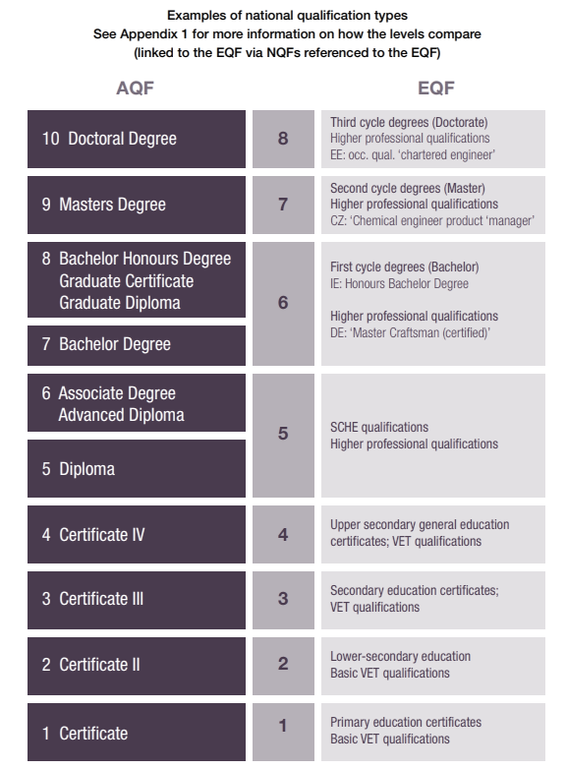
Despite having some ‘banding’, Australia’s framework has more levels than many national or broader regional qualifications. This makes direct alignment problematic. There may also be issues associated with alignment based on descriptors, as uncovered in the process of developing the European Qualifications Framework (EQF). Established in 2008, the EQF is a regional common reference framework, with the purpose of improving the transparency, comparability and portability of qualifications in Europe.
Figure 2.1: A comparison of the AQF and EQF (EU, 2016, p.19)

In 2016, a Working Party of EQF and AQF representatives came together to develop ‘a better functional understanding and appreciation of AQF qualifications and respective learning outcomes in Europe, and a better understanding of the EQF in Australia’ (European Union, 2016, p.1). The report found that there were some commonalities in each framework, e.g. levels in both the AQF and EQF are defined by descriptors in terms of learning outcomes that ‘broadly reflect what is acquired when a learner completes a qualification type that is situated on or referenced to the framework’. However, although the Working Party found that a ‘best fit’ equivalence could be made between the two frameworks, the comparison between the two frameworks demonstrated that the levels only ‘matched’ up to level 4, with differences from levels 5 onwards (See Figure 2.1).
The Keevy and Chakroun (2015) report on international level setting found that the inclusion of lower level qualifications within national frameworks has:
‘particular significance for supporting learners who have basic skills or lack confidence; there is also substantial evidence that providing recognition for achievements at these levels is an encouragement to learners to take further steps on the qualifications ladder.’
Both the UK and German qualifications frameworks acknowledge that providing lower level qualifications that are not linked directly to labour market outcomes is critical to the concept of lifelong learning. In Germany in particular, this commitment is also reflected in stated principles that underpin the design of the qualification framework and its taxonomy. This in turn has an impact on the nature and content of its descriptors.

The use of learning outcomes in qualifications frameworks is ubiquitous but under-theorised
Qualifications frameworks are highly social and political documents, and, if they are to be operationalised, it is reasonable to expect a degree of pragmatism in their design. That said, NQFs should still be able to demonstrate an internal logic grounded in a transparent and robust conceptual framework. Reviews of NQFs internationally suggest that pragmatism appears to take precedence over conceptualisation.
It appears that the introduction of learning descriptors has been highly under-theorised and is in need of further work. As Keevy and Chakroun (2015, p.48) observe:
‘…the regression towards pragmatism when facing conceptual difficulties permeates the literature on qualifications frameworks over the last twenty or more years. This includes the debates related to both domains and types of learning outcome and competence, and levels.’
They argue that this is an ‘untenable situation, and should be addressed as countries and regions allocate more resources to review qualifications framework developments.’ (ibid, p.48)
The majority of qualifications frameworks rely on learning outcomes descriptors as reference points. However, a review of the literature suggests that this decision has not necessarily been informed by learning theory – at least not in a transparent way that can be readily tracked across all formal education and training sectors and qualifications.
CEDEFOP (2017, pp.43–44) argues that descriptors cannot be developed ‘… in isolation from broader context where learning inputs are considered’, which also suggests that they cannot be developed without an awareness of, and presumably, some accommodation of existing approaches and expectations. At the same time, this suggests that descriptors should be both contemporary and future-focused, ‘remaining open to the explorative and to what has yet to be experienced and articulated’. The question is – to what extent can a pragmatic approach to current qualifications influence the construct that underpins learning outcomes statements before the conceptual foundations and internal logic collapse?
Based on a mapping of level descriptor domains and progression across a wide range of NQFs, Keevy and Chakroun (2015, p.143) found there was generally ‘… a lack of an explicit conceptual framework [to underpin] level descriptors in general’, and/or ‘… a very low level of explicit articulation of what these models are’ and concluded that much of the conceptual work to date has been ad-hoc.
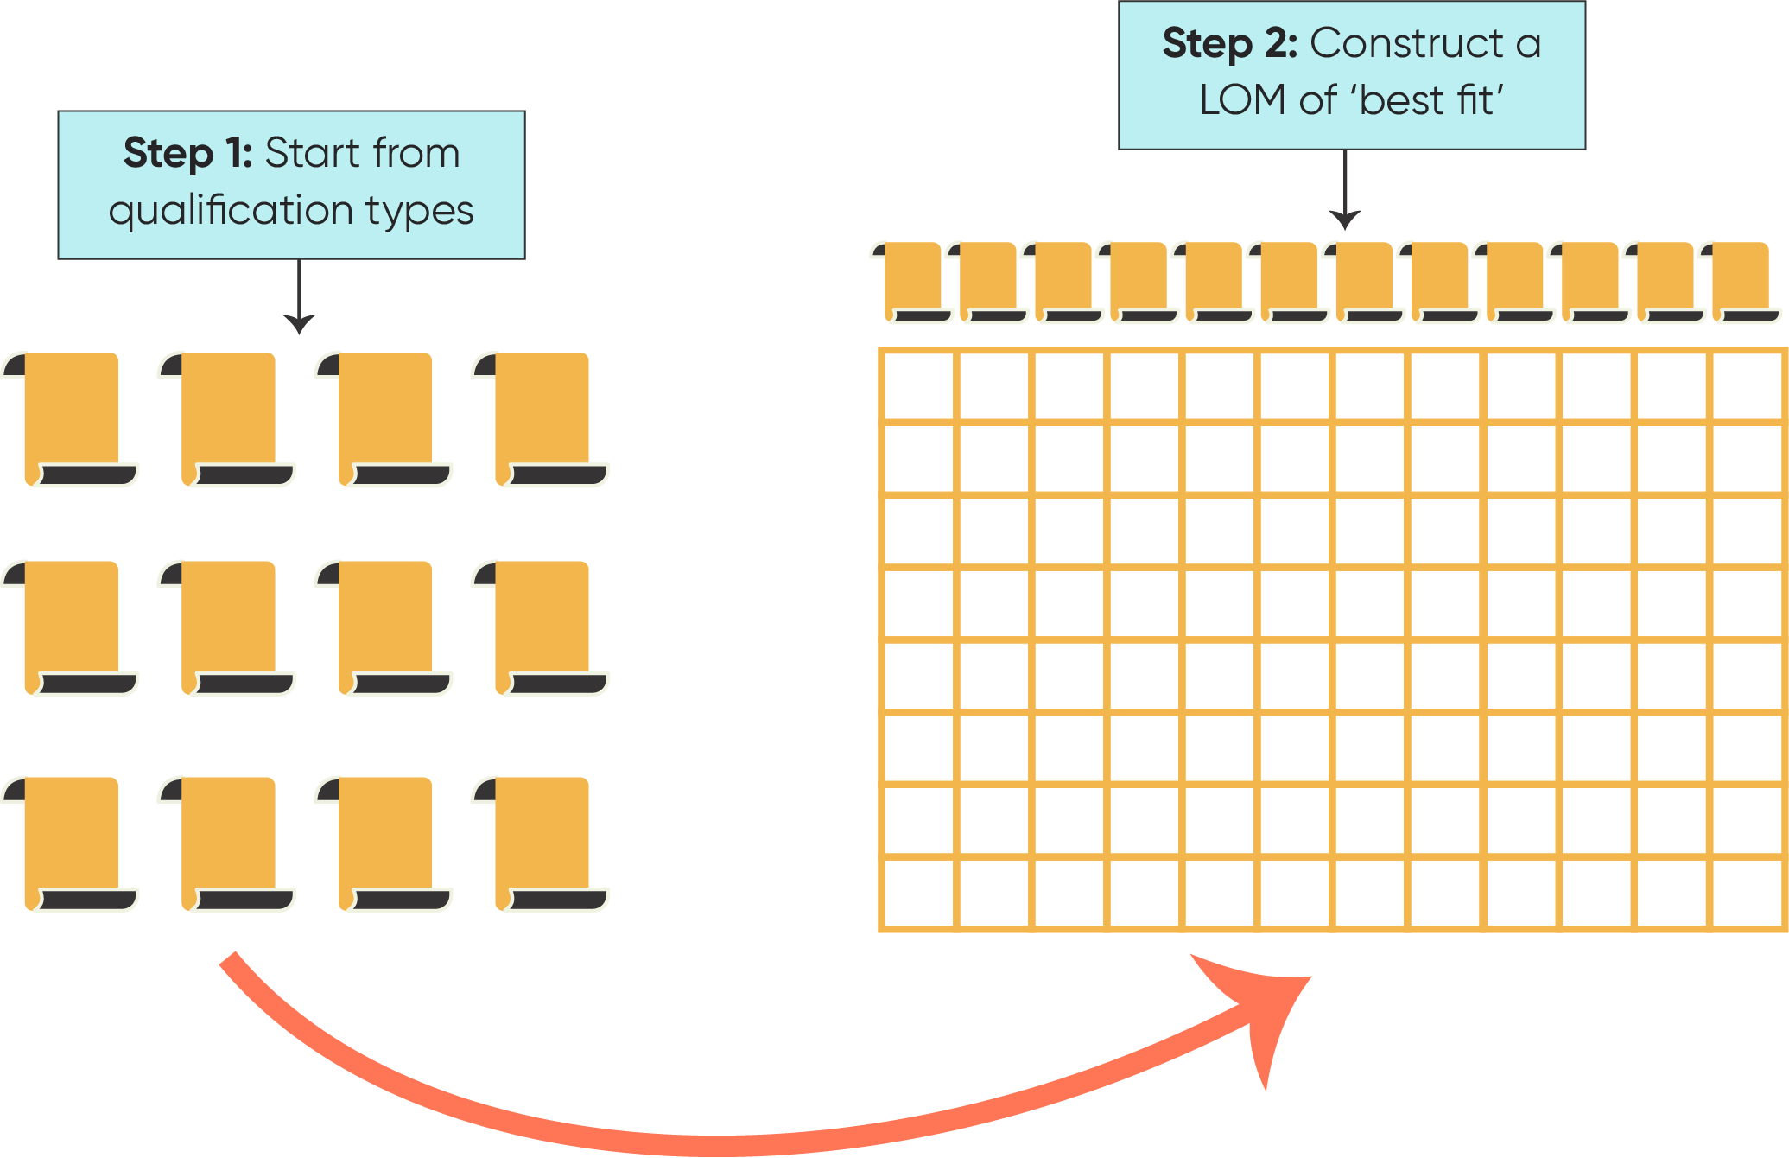

Figure 2.2: Constructing a LOM starting from existing qualifications

Similarly, Coles (2006, p.13) argues that ‘… the development of a hierarchy of levels that recognises all kinds of learning for qualifications demands some theoretical or descriptive basis that is independent of current forms of qualifications and current education and training infrastructure’. However, in reality, ‘Most frameworks emerge from a consideration of what exists already in the qualifications system. This pragmatic starting point will make it difficult to use any kind of theoretical referencing of levels.’ (ibid).
Figure 2.2 illustrates the approach, which starts from existing qualification types and constructs a LOM of ‘best fit’ based on current and historical understandings of Knowledge, Skills and Competences in each qualification type.
Although Coles was writing in 2006, this approach still appears to underpin the design of most NQFs internationally. This may help to explain, not only why there are such variations in the number of levels, but also why there is often limited differentiation between levels.
A further consequence of the widespread adoption of Approach 2 is the difficulty this creates for the writing of learning outcomes descriptors. For example, the National Qualifications Authority of Ireland and Irish Universities Association observed:
‘In order to be relevant across the full spectrum of awards within a given educational system, the learning outcomes underpinning [qualification] frameworks are necessarily written at a high level of generality.’ (NQAI, p.49).
A matrix created without immediate reference to existing qualifications has the potential to incorporate descriptors with greater precision than has usually been the case, while still remaining relevant to the full spectrum of qualifications. Further information on the writing of learning outcomes is included in Appendix D.

Learning taxonomies play a critical role in the selection of domains, focus areas and progression
While existing qualifications appear to have a strong impact on the design of many NQFs, the impact of learning taxonomies on learning outcome descriptors can also be seen. However, UNESCO ‘s study on ‘Level-setting and recognition of learning outcomes’ (Keevy and Chakroun, 2015) within qualifications frameworks found that these taxonomies are not necessarily referenced nor systematically applied.
The most influential appear to be Bloom’s Taxonomy of Educational Objectives: Cognitive Domain (Bloom & Krathwohl, 1956, 1984) and the revised version (Anderson & Krathwohl, 2001). There is also some use of the SOLO Taxonomy (Biggs & Collins, 1982) and of the Model of Skills Acquisition (Dreyfus & Dreyfus, 1985). It is important to note that these learning taxonomies were developed for purposes other than the ‘pegging’ of qualification types to learning outcomes. They predate the emergence of all or most qualifications frameworks and incorporate ‘levels [that] were assigned to learning long before the advent of qualifications frameworks’ (Keevy and Chakroun, 2015, pp.48–49). Importantly, they aim to describe individual learner progression. Within study for any formal qualification, each learner could be at a different stage.
Both Bloom’s original and revised taxonomies are rooted in a strongly behaviourist tradition. Bloom’s six categories are ordered from simple to complex, and from concrete to abstract, and each level must be mastered before moving to the next higher level and each level becomes more challenging as you move higher (See Figure 2.3).
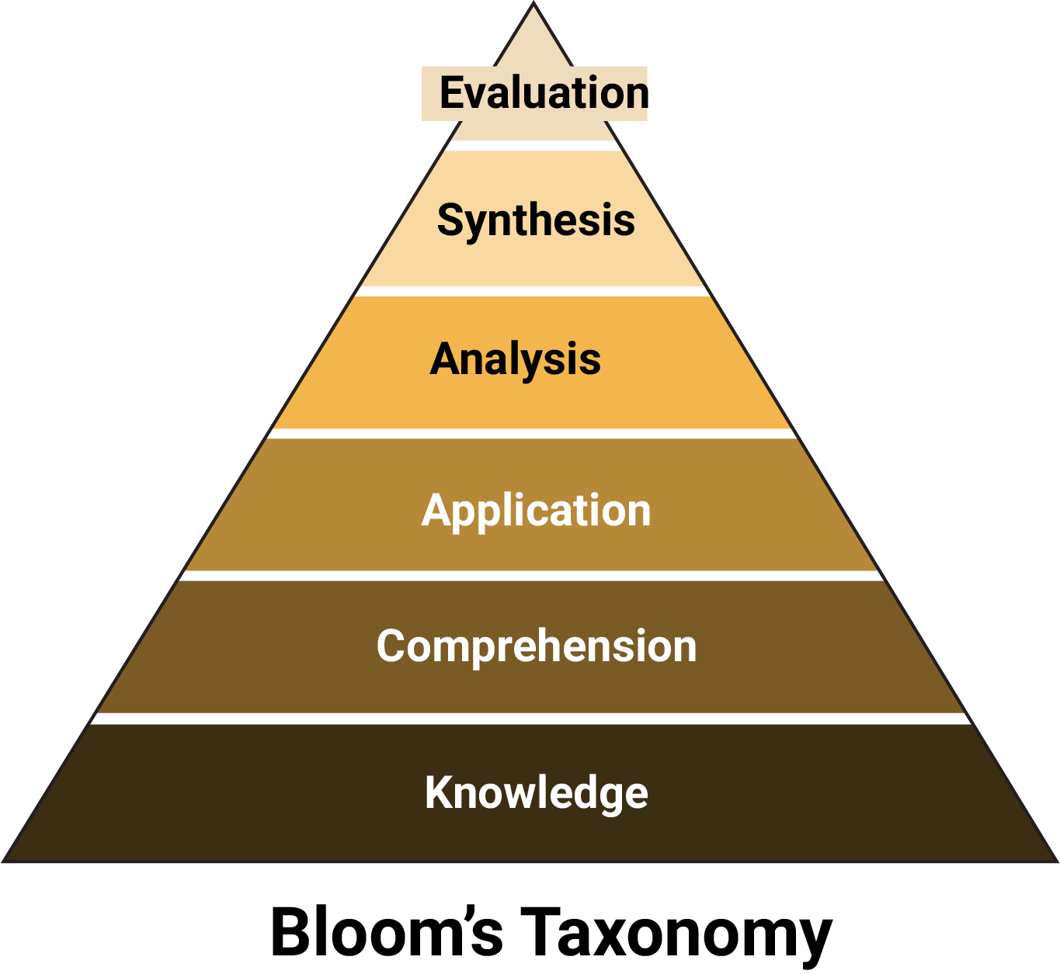
Figure 2.3: Bloom’s Taxonomy (Cognitive domain)
Thus, ‘Knowledge’ (in this construct, referring to basic factual information) must be mastered before ‘Comprehension’, and ‘Comprehension’ must occur before ‘Application’ is possible.
When referring to the way in which an individual learns, this seems to negate the potential for experiential learning by doing and reflecting on what happens. When this ‘taxonomy’ is applied to a new area entirely – qualification levels – the resulting descriptors suggest that students in the lowest qualifications are only capable of ingesting very basic information and learning rudimentary skills, with limited comprehension or application. This would infer that there is no conceptual thinking or analysis involved.
In the revised Bloom’s Taxonomy, ‘creativity’ is placed at the top of the pyramid, which may explain why NQF descriptors referencing new ideas usually begin only at the highest levels. Thus, the use of Bloom’s in NQFs has the potential to misrepresent – and actively work against – what we understand about learning. It could readily be argued that any senior secondary or post-secondary qualification should be engaging a learner in all, or most, of the kinds of thinking described in Bloom’s. The differentiating point, however, will be in the level of sophistication expected/required.
A further conceptual challenge is that both versions of Bloom’s have six levels, whereas the majority of NQFs describe eight or more. Taxonomically, how can these levels be ‘stretched’ to encompass all qualification types?
The main alternative to Bloom’s, the SOLO (Structure of Observed Learning Outcomes) Taxonomy (Biggs and Collis, 1982) makes this aspect even more challenging. It only has five levels of ‘understanding’, with each stage involving the previous and adding something to it. ‘Understanding’ is described as an increase in the number and complexity of connections learners make as they progress from low to high levels of competence (CEDEFOP, 2017, pp.36–37). The focus is on depth and quality of understanding, rather than quantity of information, and there is a recognition that learning is shaped by prior knowledge, misconceptions, learning intentions and strategies. However, once again, it is important to remember that this taxonomy was developed to conceptualise the learning journey of an individual, not to provide a hierarchy of levels where each encapsulates (and compartmentalises) a kind of learning that is to be actively encouraged within a qualification type.

There are widespread issues in the articulation of progression and most ‘lock to level’
All qualifications frameworks use level descriptors to peg qualification types against a hierarchical set of levels. A common feature internationally is to assume that progression across the levels (this is often represented in diagrams as steps or fans as in Figure 2.4) in each domain will occur, and be evident, at the same rate. Based on their mapping of qualifications frameworks internationally, Keevy and Chakroun (2015, p.61) argue that:
‘… a one-size-fits-all approach to setting levels for KSC has significant limitations. This poses several challenges to the formulation of level descriptors … level descriptors are essentially sets of learning outcomes that are organized across two dimensions: levels and domains. The most commonly used domains are knowledge, skill and competence, with competences sometimes broken down into more subdomains. Learners are expected to progress vertically through the levels in each of the domains, but no distinction is made between the type of progression required in the separate domains…’
This locked at level approach (see Box 2.2) inevitably forces illogical points of progression and differentiation in the descriptors.
Box 2.2: What is meant by ‘locked at level’?
Most qualifications frameworks, including the AQF, denote progression across knowledge, skills and competence (application) in lock-step across all three domain areas.
That is, for Level 3, all qualifications have Level 3 knowledge, skills and competence (e.g. not a spiky profile of Level 3 knowledge, Level 4 Skills and Level 2 Competence).
There is an underlying assumption, therefore, that the descriptors must characterise all qualifications at this level as broadly of the same configuration.

A key challenge sits with the diversity of qualifications (as distinct from qualification types) that must be classified within the taxonomy. The conceptual framework underpinning these descriptors – to the extent that there is one – usually assumes that all qualifications within a qualification type fall within the same level when it comes to knowledge, skills and competence / application. As Keevy and Chakroun (2015, pp.48–49) argue ‘… some learning outcomes need to focus more on knowledge, understanding, skill and the ability to do; while other learning outcomes (or in some cases, sets of learning outcomes) need to focus more on the application of the knowledge and skills – also referred to as competences.’
As an alternative to the locked at level approach, Keevy and Chakroun (2015, p.151) propose developing two hierarchies: one for skills and knowledge, and another for competences. Rather than becoming concerned with preferring one taxonomy over another, they argue that it may be best to use those taxonomies that are fit for purpose rather than choosing one for the sake of consistency. This opens the way for a hybrid scenario:
‘Progression in the knowledge and skills can be described using the Bloom taxonomy … and the progression in the competences domain with the Dreyfus model of skills acquisition.’
This would also make it possible to have variable numbers of differentiating points (e.g. 1–10 for Knowledge and 1–5 for Competence). However, the authors acknowledge that ‘… the implementation of two hierarchies, and the subsequent need for some form of synchronicity between the two domains, will have to be tested in practice’. (ibid, p.62)
A further alternative could be what Coles (2006, p.14) argues is ‘an interesting option for defining level descriptors’, which is to develop a two-tier system.
‘At the top level the descriptors will cover all education and employment sectors and be generic. Under this level sectors are invited to write specific level descriptors that suit the purposes of the sector. These specific descriptors can be easily related to the generic ones. The advantage of this approach is to maintain high levels of relevance in the descriptors for the users.’
When the content of an NQF is strongly influenced by perceptions about existing qualifications in that jurisdiction, progressions from one level to another are unlikely to be clearly differentiated. The subsequent overlay of a taxonomy, such as Bloom’s, is unlikely to adequately address this issue. For example, in a study of the NZ Qualifications Framework at that time, Cosser (2000) found that:
‘… a difficulty with the NZQA level descriptors is that one cannot consistently trace, in schematic fashion, the progression from one aspect of a level descriptor to another – despite the assertion in the New Zealand level descriptors document that any level (higher than Q2) “has greater complexity of process, learning demand, responsibility, and application than the [previous] level whose knowledge, skills and attributes it encompasses”.’
More recently, Keevy and Chakroun (2015, p.55) found a widespread lack of consistency in the way progression was articulated within NQF learning descriptors, and limited differentiation between one level and another. For example, ‘… in many instances reference is simply made to ‘complexity’, ‘increasing complexity’, ‘depth of learning’ or ‘quantum of learning’.
ACER’s review of a range of NQFs found that many incorporated at least some focus areas that were not ‘strong’ enough in their own right to differentiate or be ‘stretched’ across all the levels in that framework. This may go some way to explaining why few NQFs make the Focus Areas at Tier 2 explicit within the taxonomic structure (e.g. describing how depth of knowledge progresses across 10 levels). They are more likely to combine references to elements of the taxonomy into multi-dimensional descriptor statements that make it difficult to immediately identify the gaps, blurring and repetition across levels.
Another issue identified by Keevy and Chakroun was that:
‘Level descriptors [in current qualifications frameworks] assume that learning outcomes are cumulative by level. This assumption, that KSC at one level include those at lower levels, means that domains must be read together to give a true indication of level. This is an important aspect of progression in level descriptors that is not well articulated or adequately conceptualized.’ (ibid)
Progression is not only an issue within each domain. Keevy and Chakroun argued that an important consideration should be ‘… the extent to which progression can take place in both horizontal and vertical dimensions, and the complexities that arise with such a conceptualization’ (ibid, p.62). They suggest that progression is better defined in other recognition methodologies, where the focus is mainly on levels of proficiency (as in the Programme for the International Assessment of Adult Competencies (PIAAC), Literacy Assessment and monitoring programme (LAMP) and the Programme for International Student assessment (PISA)), but also includes the notion of minimum benchmarks (for instance in subject benchmark statements, SBS) and a taxonomy of descriptor variables (as in O*NET). Unsurprisingly, Keevy and Chakroun (ibid, p.143) find that:
‘…the purpose of the methodology has a direct bearing on the domains that are used. So, for example, learning metrics (such as PISA, STEP, LAMP and PIAAC) include specific focus areas such as numeracy and literacy, while occupational classification systems include job and worker-related domains (see for example O*NET and DESCO)’.
This is an important reminder of the importance that learning outcomes are most appropriate when written with specific aims and for a particular context.

Visual representation sends a signal of what is valued as it is the public face of the framework
While some qualifications frameworks, such as the New Zealand Qualifications Framework (NZQR) rely on a matrix presentation alone, qualifications frameworks are generally presented in a visual form intended to capture the key features in a way that is accessible to all stakeholders. The approach adopted will influence perception (See Figure 2.4). For example,
- a ladder or a staircase suggests a linear and sequential hierarchy leading to the level representing the highest achievement (interestingly, the message of Germany’s DQR staircase seems to run counter to the stated principle that each qualification level should always be accessible via various educational pathways);
- a wheel, such as used in the AQF, could be interpreted as non-linear and perhaps non-hierarchical, with each qualification seen as an equal contributor to the whole;
- a semi-circle (an increasingly popular choice) suggest a fan of choices, starting at level 1. Other information may be incorporated, (for example, the Irish fan indicates the Awarding bodies for each Award).

Australia (Wheel)  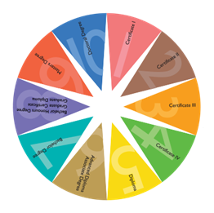 | Germany (Steps)  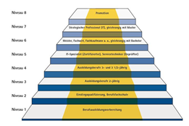
Ireland (Fan)  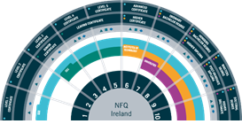 | New Zealand (Table / Grid)  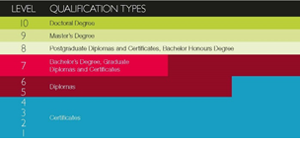

Figure 2.4: Visual representation of Learning Progression in Qualifications Frameworks

Features of an effective Learning Outcomes Matrix
Through the review of the international literature, a consideration of current practice and drawing on the extensive experience of team members in regard to framework design, ACER identified the features of an effective Learning Outcomes Matrix (LOM) for use within a qualifications framework.

The role of a LOM within a qualifications framework
It is important to acknowledge that a Learning Outcomes Matrix is only one, albeit critical, component of any qualifications framework. It should ideally be treated and designed as a discrete component, providing a common language and set of reference points against which to describe key qualification specifications, (past, current or yet to be imagined). While maintaining a degree of separation from existing qualifications, the LOM should reflect and support the principles underpinning the qualifications framework and be mindful of its stated aims, objectives and priorities.
A discrete Learning Outcomes Matrix should be developed from an explicit conceptual base. It can then be used as a central reference point for specifying agreed learning outcomes for individual qualification types. These become a key component of a broader set of specifications – or rules – for each type (Figure 2.5).

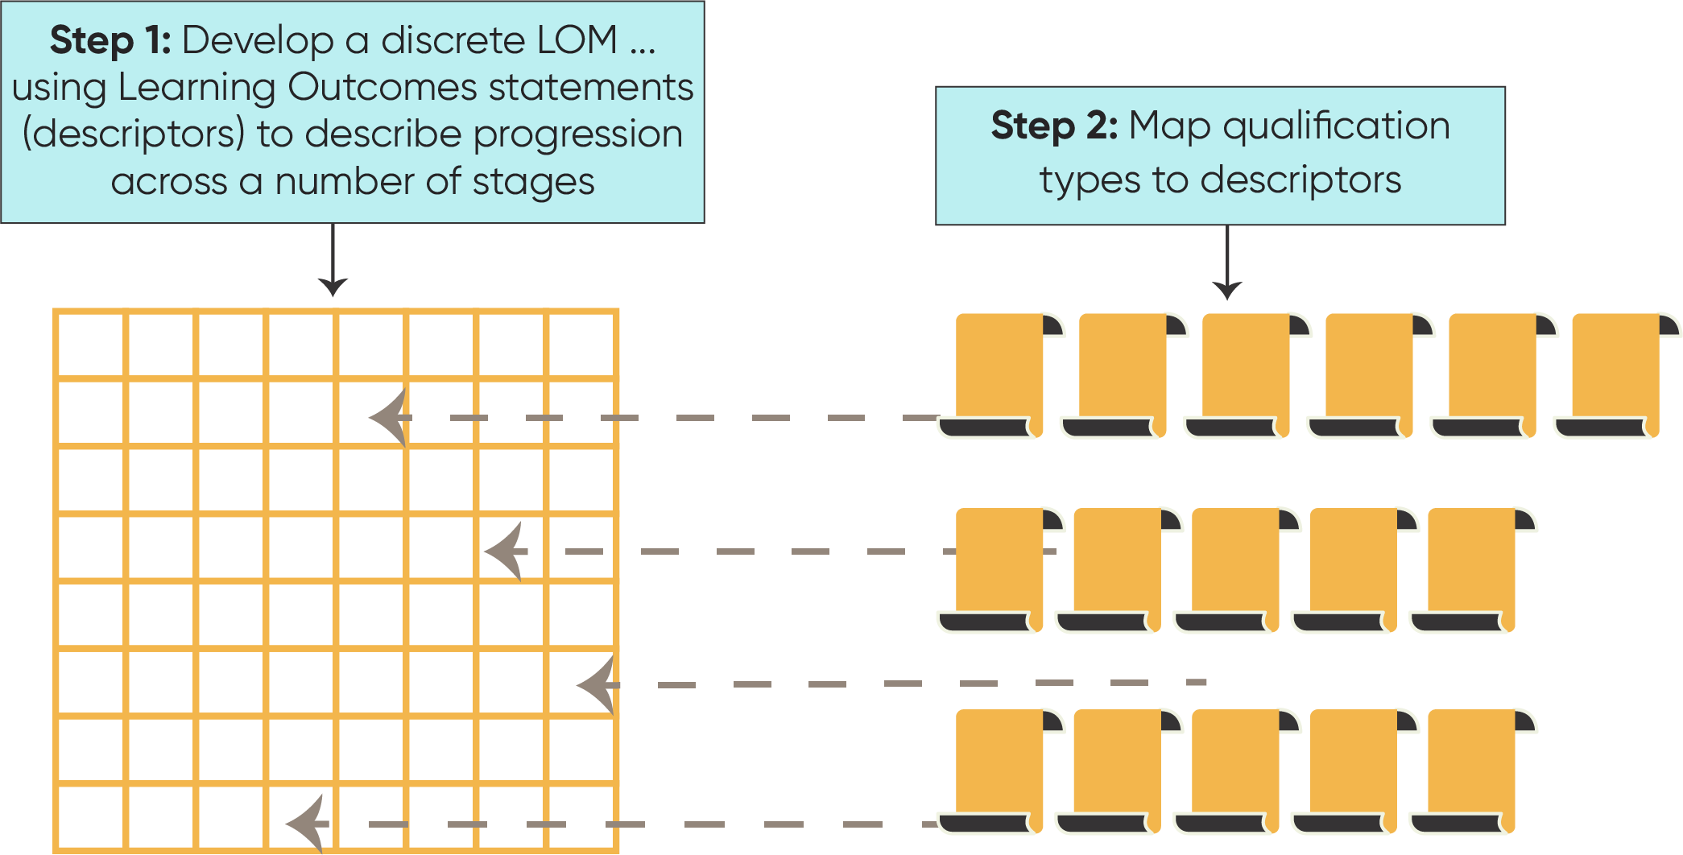
Figure 2.5: A Learning Outcomes Matrix as a discrete set of reference points

This approach makes it possible to:
- design, redesign and audit existing individual qualifications with a reasonable degree of consistency in those areas that have been deemed to be important;
- introduce and calibrate new qualification types within a jurisdiction (including micro-credentials and skills sets) without needing to create new ‘levels’; and
- calibrate individual qualifications from other jurisdictions.
It also makes it possible to change specifications, if and as required, without necessarily changing the Learning Outcomes Matrix itself.

Design features
As a starting point, ACER suggests that an effective Learning Outcomes Matrix (LOM) should:
- be built as a three-tiered structure (incorporating a set of domains, focus areas and learning outcome descriptors), underpinned by a set of principles and a classification system with an explicit conceptual base; and
- describe progression across a number of stages, with the number determined by the extent to which useful differentiations against each focus area can be made.
These features are outlined in more detail below and are then used to consider approaches to the design of qualifications frameworks internationally, and the approach adopted for the current AQF.
- A three-tiered structure to provide the scaffolding and reference points
The Learning Outcomes Matrix itself may also have its own internal aims and principles and be designed on the basis of a conceptual base/model (empirically or theoretically based) informed by research about learning. It can be represented as a three-tiered matrix, with a set of domains (Tier 1), a set of Focus Areas for each domain (Tier 2), and descriptors for each Focus Area (Tier 3). These should have enough detail to enable differentiation of learning progression across a number of stages or levels. Ideally, the number of stages will be driven by the ability to logically and realistically identify /describe progression). As depicted in Figure 2.6, an effective Learning Outcomes Matrix will incorporate three tiers:
Tier 1: A small number of Domains (high level organisers) with clear definitions;
Tier 2: A set of Focus Areas, representing key themes or strands within each domain, and
Tier 3: A set of descriptors for each Focus Area with enough detail to describe each stage of progression across a number of stages.

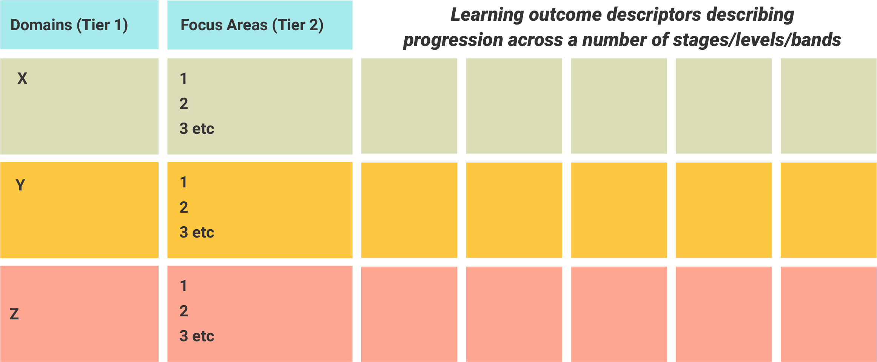
Figure 2.6: A three-tiered Learning Outcomes Matrix

- Explicit principles and a conceptually based classification system to underpin content decisions
Decisions about which Domains and which Focus Areas to incorporate should be driven from an explicit conceptual base, drawing on research evidence and conceptual models. This then influences the nature and content of descriptors. In a robust Learning Outcomes Matrix, ACER contends that the selection of Focus Areas should be influenced at least in part by their ability to provide points of differentiation across a number of levels. Ideally, the number of levels is in fact determined by the number of useful differentiations that are possible.
- Clearly differentiated and detailed descriptors
The effectiveness of almost every AQF-related application will rest on the level of detail provided by the descriptors, and the degree to which this enables differentiation of bands and qualification types linked to those bands. CEDEFOP (2017, p.33) suggests that ‘… learning outcomes are best understood as an approach that can be adapted to and applied in different policy, teaching and learning settings. It follows that there is no single correct or apt way of approaching them’.
However, drawing on an in-depth review of NQFs developed over the last 25 years, CEDEFOP (ibid, pp.43–44) offers a set of principles for the development of learning outcome descriptors. The authors argue that descriptors should:
- remain open to the explorative and to what has yet to be experienced and articulated;
- be defined and written within a broader context where learning inputs are considered;
- evolve as an iterative process involving all stakeholders, rather than being the result of cutting and pasting learning outcomes from elsewhere.
Learning Outcome descriptors capture the differentiations in Focus Areas across a number of ‘stages, ‘levels’ or ‘bands’ of progression. Ideally, the number of bands described for each Focus Area should be determined by the number of useful differentiations that can actually be made, rather than an artificial matching to a desired number of levels that match qualification types.

Evaluating current NQFs against the LOM design criteria
Table 2.2 summarises the features that characterise an effective Learning Outcomes Matrix and compares these to practices common across qualifications frameworks internationally. Although there were individual NQFs that met some of the criteria for an effective Learning Outcomes Matrix, ACER was unable to identify any that might provide exemplars to inform a revision of the AQF.

Key messages
The design of qualifications frameworks is not an exact science, but ACER has identified a set of principles that should be taken into consideration. The matrix should:
- Be designed as a discrete component of the framework with a conceptually sound internal logic, providing a common language and set of independent reference points against which to describe key qualification specifications, (past, current or yet to be imagined).
- Reflect and support the principles underpinning the qualifications framework and be mindful of its stated aims objectives and priorities.
- Have its own internal aims and principles and be designed on the basis of a conceptual base/model (empirically or theoretically based) informed by research about learning and assessment.
- Be presented in a three-tiered matrix that makes the conceptual base clear, with a set of domains (Tier 1), a set of Focus Areas for each domain (Tier 2), and descriptors for each Focus Area (Tier 3).
Each tier within the matrix should have just enough detail to enable differentiation of learning progression across a number of stages or levels. Ideally, the number of stages will be driven by the ability to logically and realistically identify /describe progression.
While a critical aspect of a discrete set of descriptors is its explicit conceptual base, this does not preclude the potential for decisions about structure, content and emphasis to reflect context-specific objectives and principles. Thus, although is likely to be common ground, it is reasonable to expect that every qualifications framework will have some unique elements.
Internationally, qualifications frameworks do indeed vary in their purposes and coverage. However, there are many commonalities in terms of design. These are summarised in Table 2.2. The similarities may be attributed at least in part to a kind of on-going self-referencing, self-reinforcing system that has emerged over the last 20 years.
The major study conducted for UNESCO (Keevy and Chakroun, 2015, p.48) reached the conclusion that the introduction of learning descriptors has been highly under-theorised.
‘…the regression towards pragmatism when facing conceptual difficulties permeates the literature on qualifications frameworks over the last twenty or more years. This includes the debates related to both domains and types of learning outcome and competence, and levels.’
The authors argue that this is an ‘untenable situation, and should be addressed as countries and regions allocate more resources to review qualifications framework developments’.
Table 2.2: Qualifications frameworks: Common design approaches
 | Key features of an effective LOM | National Qualifications Frameworks  Common approaches
Principles/  Rationale | - A discrete, coherent and conceptually-based construct used as a reference point for specification of qualification types  - Explicit rationale, principles | - Rationale/principles and approach usually not articulated, so hard to comment or compare  - Most LOMs are not discrete – seem to have developed from existing qualifications to learning outcomes descriptors (which explains idiosyncratic nature of many learning outcomes descriptors)
Structure | - Three explicit tiers  - A small number of domains  - A set of Focus Areas that stem from each domain and are each capable of providing the scaffolding for a number of differentiated stages (Tier 2);  - A set of learning outcomes descriptors with sufficient detail to inform course design, accreditation, comparison etc (Tier 3).  - Selection of domains and focus areas reflecting research about learning | - Two or three tiers, with Tier 2 often implied, not explicit  - Under-conceptualised domains, focus areas and learning outcomes descriptors that often incorporate elements copied from other qualifications frameworks  - Limited detail in descriptors  - Selection of focus areas that are not strong enough individually to differentiate across all levels. May explain why many NQFs do not make Tier 2 explicit, and combine references to elements of the taxonomy into multi-dimensional descriptors that try to mask gaps and repetition
Domains | - Knowledge, Skills, Competence, (KSC) should not be accepted as the only, or best, way of classifying | - Most use Knowledge, Skills and Competence (KSC) but no consistency of interpretation  - Some countries add other domains, such as social competence, generic skills, foundation skills
Taxonomy/  typology | Keevy and Chakroun (2015) advise:  - develop/select a taxonomy that is fit for purpose rather than choose one for the sake of ‘consistency’  - recognise that each domain needs its own taxonomy (e.g. consider SOLO, Dreyfus and Dreyfus (1985) Model of Skills Acquisition))  CEDEFOP (2017) also supports consideration of Dreyfus and Dreyfus (1985) Model of Skills Acquisition | - Most use Bloom’s taxonomy (cognitive) or knowledge-based (but not Bloom’s affective or psychomotor/skills-based domains)  - Bloom’s cognitive is often applied across all domains (but seldom used in an explicit manner in formulation of level descriptors)  - Competence domain often includes autonomy, responsibility, communication, social/professional/vocational competence
Number of levels/stages/ bands  Basis for progression | In a ‘fit for purpose’ taxonomy with an explicit conceptual base, levels in the LOM will be determined by:  - what is conceptually logical, feasible and realistic in relation to learning progression  - the degree to which progression can be usefully described/ differentiated  - If each domain and its sub-strands are conceptually determined, it is quite possible that the number of feasible levels will vary from one domain to the next | - Numbers vary from 5 to 12, with 8 favoured, but often covers all levels of schooling and tertiary education  - Number of levels not usually driven from a conceptual base.  - Likely to be influenced by a jurisdiction’s existing qualifications and/or copying of other qualifications frameworks  - Learning Outcomes frameworks developed for use in other contexts do not have 10 differentiated levels
Locking at level | Keevy and Chakroun advise – distinguish between level setting methods used for Knowledge and Skills and those used for Competence | - Most assume that progression occurs uniformly across all domains  - All domains have the same number of levels

The AQF Learning Outcomes Matrix and descriptors
This section provides a context for the technical analysis of the AQF descriptors. It:
- considers the role of the descriptors in meeting the objectives of the AQF, incorporating a proposal regarding a new way of perceiving the AQF’s essential purpose;
- identifies broader features of the AQF with the potential to impact on learning outcome design.

The role of descriptors in the AQF
As stated earlier, CEDEFOP (2017, pp.59–60) argues that learning outcomes descriptors ‘… should reflect and support the objectives of the [qualifications] framework’. The current edition of the AQF (2013, p.8) identifies seven objectives (Box 3.1). However, it could be argued that these are a list of uses to which the framework may be put. No single objective provides an overarching purpose or raison d’etre for its existence.

Box 3.1: Objectives of the AQF (2nd Edition 2013, p.8),
The objectives of the AQF are to provide a contemporary and flexible framework that:
- accommodates the diversity of purposes of Australian education and training now and into the future
- contributes to national economic performance by supporting contemporary, relevant and nationally consistent qualification outcomes which build confidence in qualifications
- supports the development and maintenance of pathways which provide access to qualifications and assist people to move easily and readily between different education and training sectors and between those sectors and the labour market
- supports individuals’ lifelong learning goals by providing the basis for individuals to progress through education and training and gain recognition for their prior learning and experiences
- underpins national regulatory and quality assurance arrangements for education and training
- supports and enhances the national and international mobility of graduates and workers through increased recognition of the value and comparability of Australian qualifications
- Enables the alignment of the AQF with international qualifications frameworks.

In considering the role of AQF descriptors, and their potential for revision, it is critical to identify the essential purpose of the AQF. In undertaking an analysis and revision of the AQF learning outcomes, ACER has worked from the premise that the main purpose of the AQF is ‘to ensure the validity, reputation and perceived value of formal qualifications gained through the Australian education and training system’.
If the AQF is to fulfil this purpose, it must clearly differentiate between qualification types, and be transparent about how these differentiations have been made. The nature, degree and clarity of differentiation relies on there being sufficient direction and detail. This detail is also required if the AQF is to provide a valid basis for the accreditation, auditing and comparison of individual qualifications, and inform course design (see Figure 3.1).
The detail that makes it possible for the AQF to be applied in these ways should reside primarily in the learning outcome descriptors.
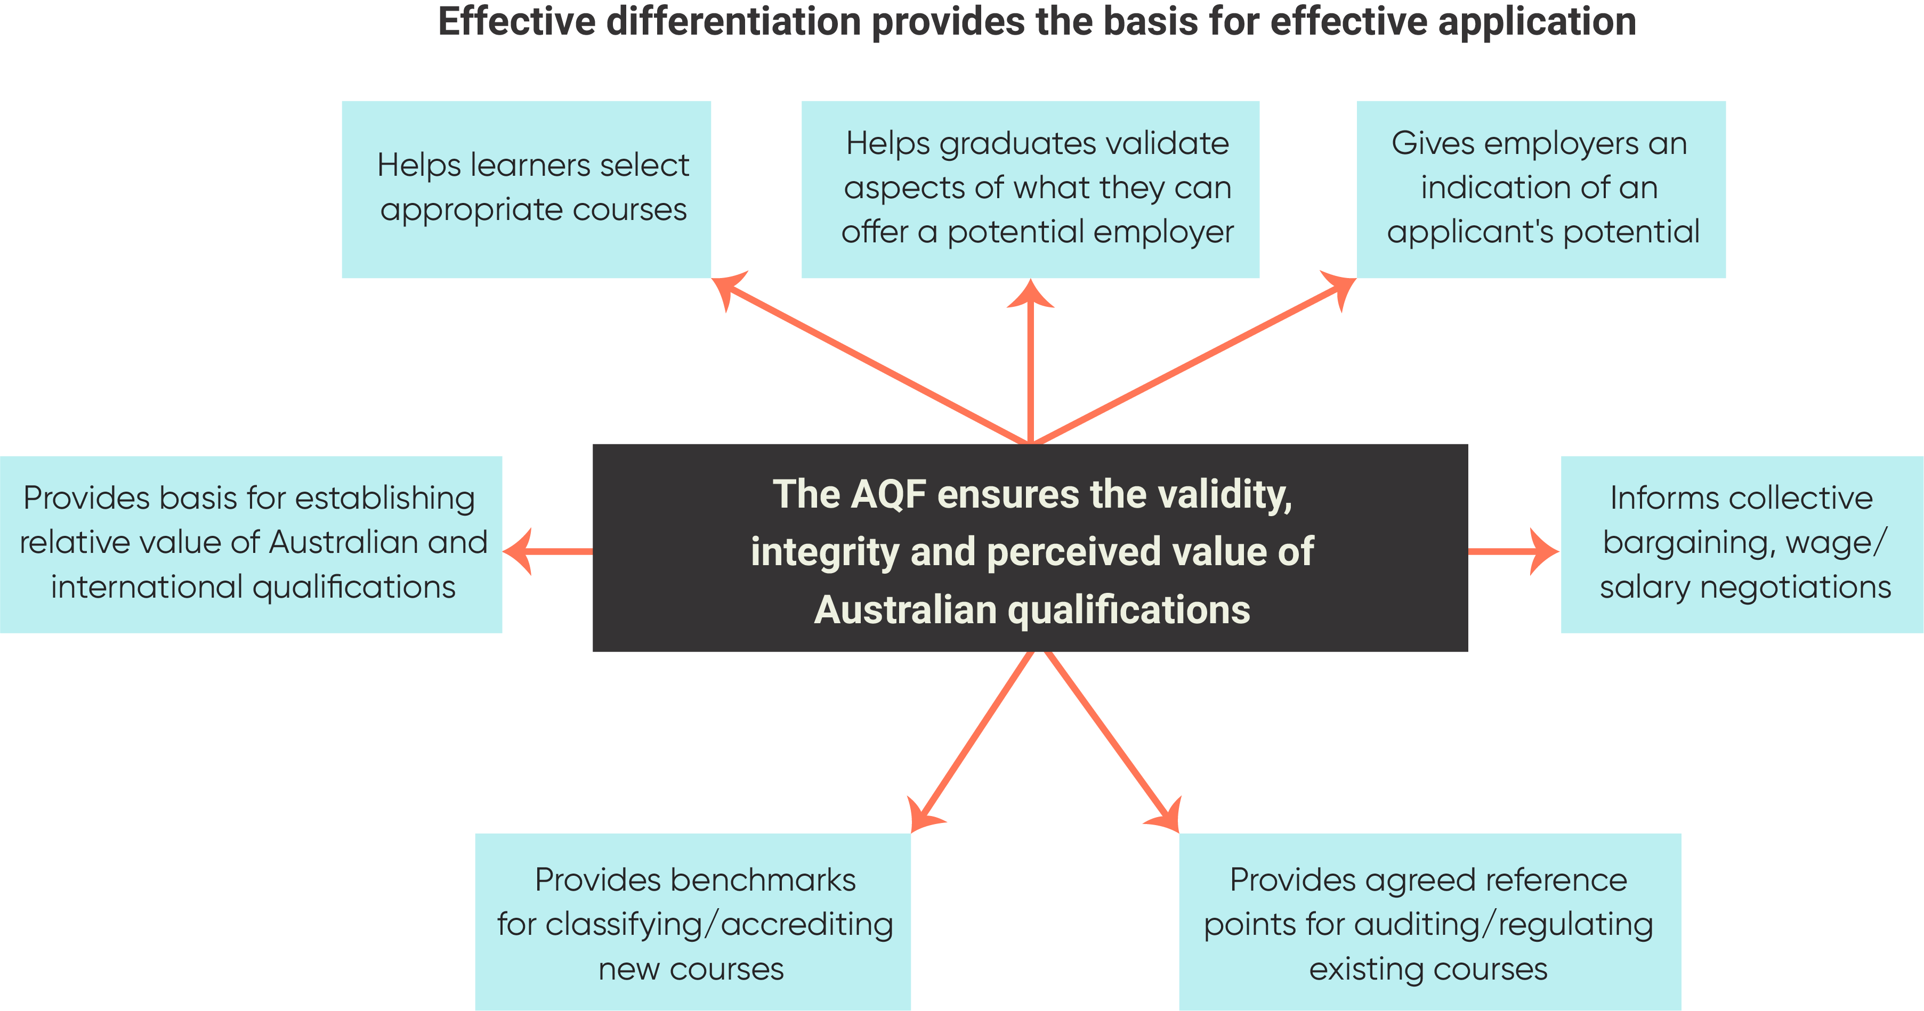
Figure 3.1: Effective differentiation provides the basis for effective application

Although not explicitly included in the AQF’s current objectives, a robust set of descriptors has the potential to influence what is taught, learned, assessed – and valued – within the Australian education and training system (See Figure 3.2). In other words, the AQF has the potential to contribute to the improvement of the education and training system – but only if the learning outcome descriptors describe and differentiate progression from one stage or level to the next with some precision.

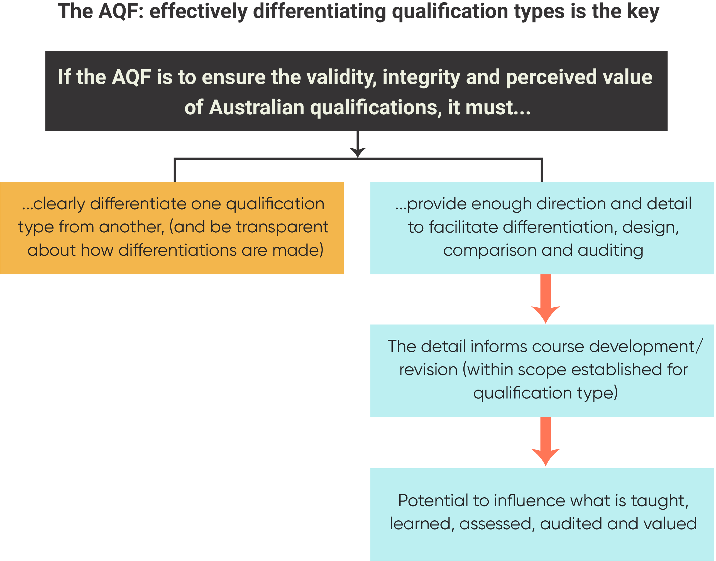
Figure 3.2: The AQF: effective differentiation of qualification types is key
Box 3.2: The German NQF has a set of principles and an explicit rationale
The German Qualifications Framework for Lifelong Learning (DQR) aims ‘to facilitate orientation in the German educational system and to assist with the comparability of German qualifications in Europe’.
The DQR’s key principles reflect agreed European Qualification Framework principles, including the need to promote the validation of non-formal and informal learning, ‘paying particular attention to those citizens most likely to be subject to unemployment or insecure forms of employment, for whom such an approach could help increase participation in lifelong learning and access to the labour market’.
Other stated principles include that each qualifications level should always be accessible via various educational pathways. As part of its reforming agenda, the DQR is seen as ‘an opportunity to further embrace the principle that the important thing is what someone can do, not where he or she has learned to do it’, with the overall effect being ‘to strengthen lifelong learning’ (DQR. 2011, p.6).
The impact of explicit principles on scope, domains, focus areas and descriptors can be seen in NQFs that make their principles explicit, such as the German DQR (See Box 3.2).
Although some principles can be inferred from its objectives, the AQF does not have clearly stated principles in the document itself. It does not, for example, explicitly seek to strengthen lifelong learning through an attempt to validate learning that occurs outside of formal education and training or improve provision of education for marginalised groups.
Nor is there an explicit rationale to explain design decisions regarding its learning outcomes matrix (e.g. regarding the selection of why domains and taxonomy).

Current descriptors are a product of their history
The nature and emphasis of the current AQF descriptors reflects, to an extent, the various iterations of the AQF, with some aspects dating back to the original version published in 1995. Since then, the AQF has been through five more iterations, the latest being in 2013. This updated the 2011 edition, which was the result of a significant review aimed at ensuring that qualification outcomes remained relevant and nationally consistent, continued to support flexible linkages and pathways and enabled national and international portability and comparability of qualifications.
The revised AQF (2011) was based on a taxonomy of learning outcomes, explicit levels and a measure of volume (or time) of learning. An attempt was also made to remove the separation between qualifications accredited through the vocational education and training sector and those from the Higher Education sector that had been a feature of previous versions.
There was no separate learning outcomes ‘matrix’ until this time because there were no levels of progression. As Keating (2006, p. 65) explains:
‘… a decision was made in 2002 to take out any mention of ‘levels’ in the description of the framework. This was made under pressure from the business sector to ensure that qualification levels could not be linked to industrial awards, and thus acknowledged the AQF’s major and arguably only tangible function: that of a set of descriptors for assembling VET qualifications from the industry derived units of competency.’
In its review of international qualifications frameworks, Keevy and Chakroun (2015, p.55) note of the AQF:
‘… The early intent to promote parity between different qualification types, without referring to levels, did not gain traction. The retrospective introduction of levels was based on the existing qualifications.’
In the subsequent (2007) edition, descriptors were intended only to ‘distinguish adjacent qualifications’ (AQF 2007, p.4), and the characteristics encapsulated in the descriptors were quite deliberately designed to reflect agreed expectations about each qualification type. Although there was no acknowledged taxonomy, the wording included reference to the same sub-strands that still provide the backbone of the 2013 version, e.g., breadth, depth and complexity of knowledge and skills, and their application to problems of increasing complexity – with reducing amounts of supervision and increasing amounts of individual discretion. Progression was generally signalled with (poorly-defined) qualifiers such as, demonstrate basic practical skills; apply a defined range of skills; apply a range of well-developed skills etc.
A review of earlier versions of the AQF shows that the learning outcomes descriptors in each have been reworked versions of those that came before. The 2011 version is no exception. It maintains a significant amount of wording from the 2007 version, but much of the content can be traced back all the way to the first version in 1995.

The AQF Learning Outcomes Matrix
As discussed in the last section, ACER has suggested that an effective Learning Outcomes Matrix (LOM):
- is designed as a discrete set of reference points for the differentiation of qualification types;
- has an explicit rationale and conceptual base;
- is presented in a way that makes it possible to track progression in the domains and focus areas (e.g. as a three-tiered matrix);
- incorporates a number of stages, with the number determined by the extent to which distinctions can genuinely be made against focus areas; and
- does not necessarily lock domains at level unless it can be demonstrated that progression does in fact occur in lock step.
This section evaluates the AQF against these criteria.

The AQF Learning Outcomes Matrix is not a discrete entity
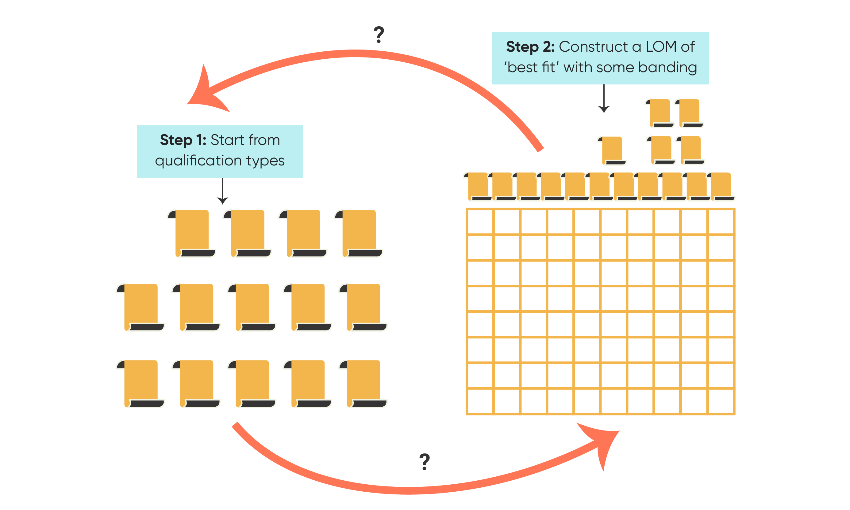

Figure 3.3: The AQF LOM levels and qualification types are almost synonymous
The AQF presents learning outcomes statements in two almost identical matrices. The first, which we will call the LOM, encapsulates AQF levels criteria defined by a taxonomy that is outlined elsewhere (AQF, 2013, p.11). These levels criteria are presented in a two-tier matrix, with three domains and 10 levels, (with level 1 having the lowest complexity).
The second matrix outlines specifications for 14 AQF qualification types. It uses qualifications type descriptors that incorporate level criteria from the LOM. A ‘criterion’ is a principle or standard by which something may be judged, whereas, a ‘descriptor’ is simply a word or expression used to describe or identify something. However, the nuanced difference is not readily apparent in the AQF, where the levels criteria and qualification type descriptors are almost the same.
In effect, Level 1 of the LOM is Certificate I of the second matrix, Level 4 is Certificate IV, Level 7 is the Bachelor degree etc. The only disruptions to the pattern are at levels 6 and 8, where ‘banding’ has occurred, and potentially at level 9 where three different types of Masters degree are banded at the same level but are distinguished from each other through the qualifications type descriptors.
The main difference is that the qualification type descriptors incorporate some detail that could just as easily have been included in the LOM. Although the reasons for this are not stated, it may have something to do with the decision to band some qualifications, as the additional information in the qualification type descriptors helps differentiate qualifications pegged at the same LOM level (See Figure 3.3).
In understanding the relationship between the two matrices, a complicating factor is that there are differences that cannot be easily explained. The AQF Review Discussion Paper noted this:
‘…unlike frameworks in other countries, the AQF has descriptors of knowledge and skills and their application for both levels and qualification types. Sometimes the descriptors for levels and qualification types repeat or contradict each other, which AQF users can find confusing’. (PhillipsKPA, 2018, p.64).

The rationale and conceptual base are difficult to determine
The AQF document provides very limited commentary on the rationale for its design. However, on p.11 of the 2013 version, there are brief references to the taxonomy that supposedly informs the levels criteria (and, by implication, the qualification type descriptors). The taxonomy is implicit in Figure 3.4 and explicit in Figure 3.5. One of the aims of the detailed technical analysis was to see if it was possible to discern the reasoning behind the choice of themes described here. However, as will be discussed in the next chapter, it was difficult to establish any consistent interpretation.

The Learning Outcomes Matrix only has two tiers
The visual LOM incorporates only Tier 1 (domains) and Tier 3 (descriptors). The taxonomy that supposedly underpins the AQF/LOM levels criteria is not explicit in the matrix (See Figure 3.4). This is important because they are also not easily identifiable within the descriptor statements themselves. The descriptors are written as an amalgam of comments. As will be discussed in detail in the next section, it is not possible to map the descriptors back to the individual Focus Areas (from the taxonomy on p.11) that are supposed to have informed their design.
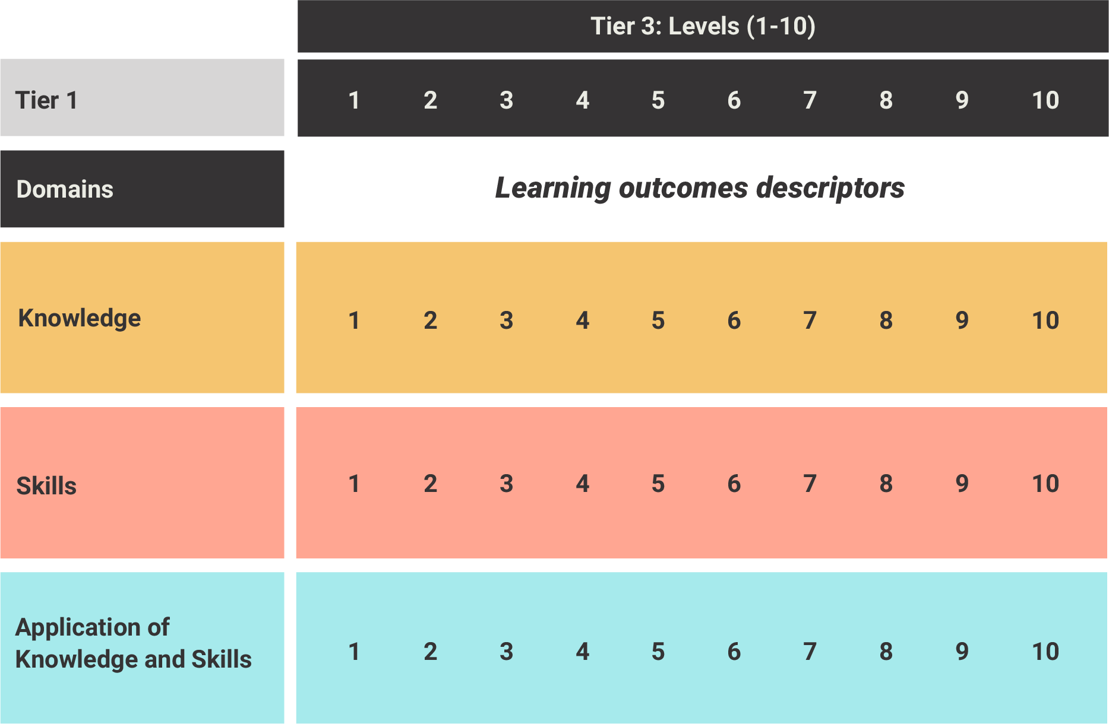
Figure 3.4: The current AQF LOM is presented as a two-tiered matrix

Figure 3.5 demonstrates what the AQF would look like with three explicit tiers, i.e. with Tier 2 Focus Areas added.
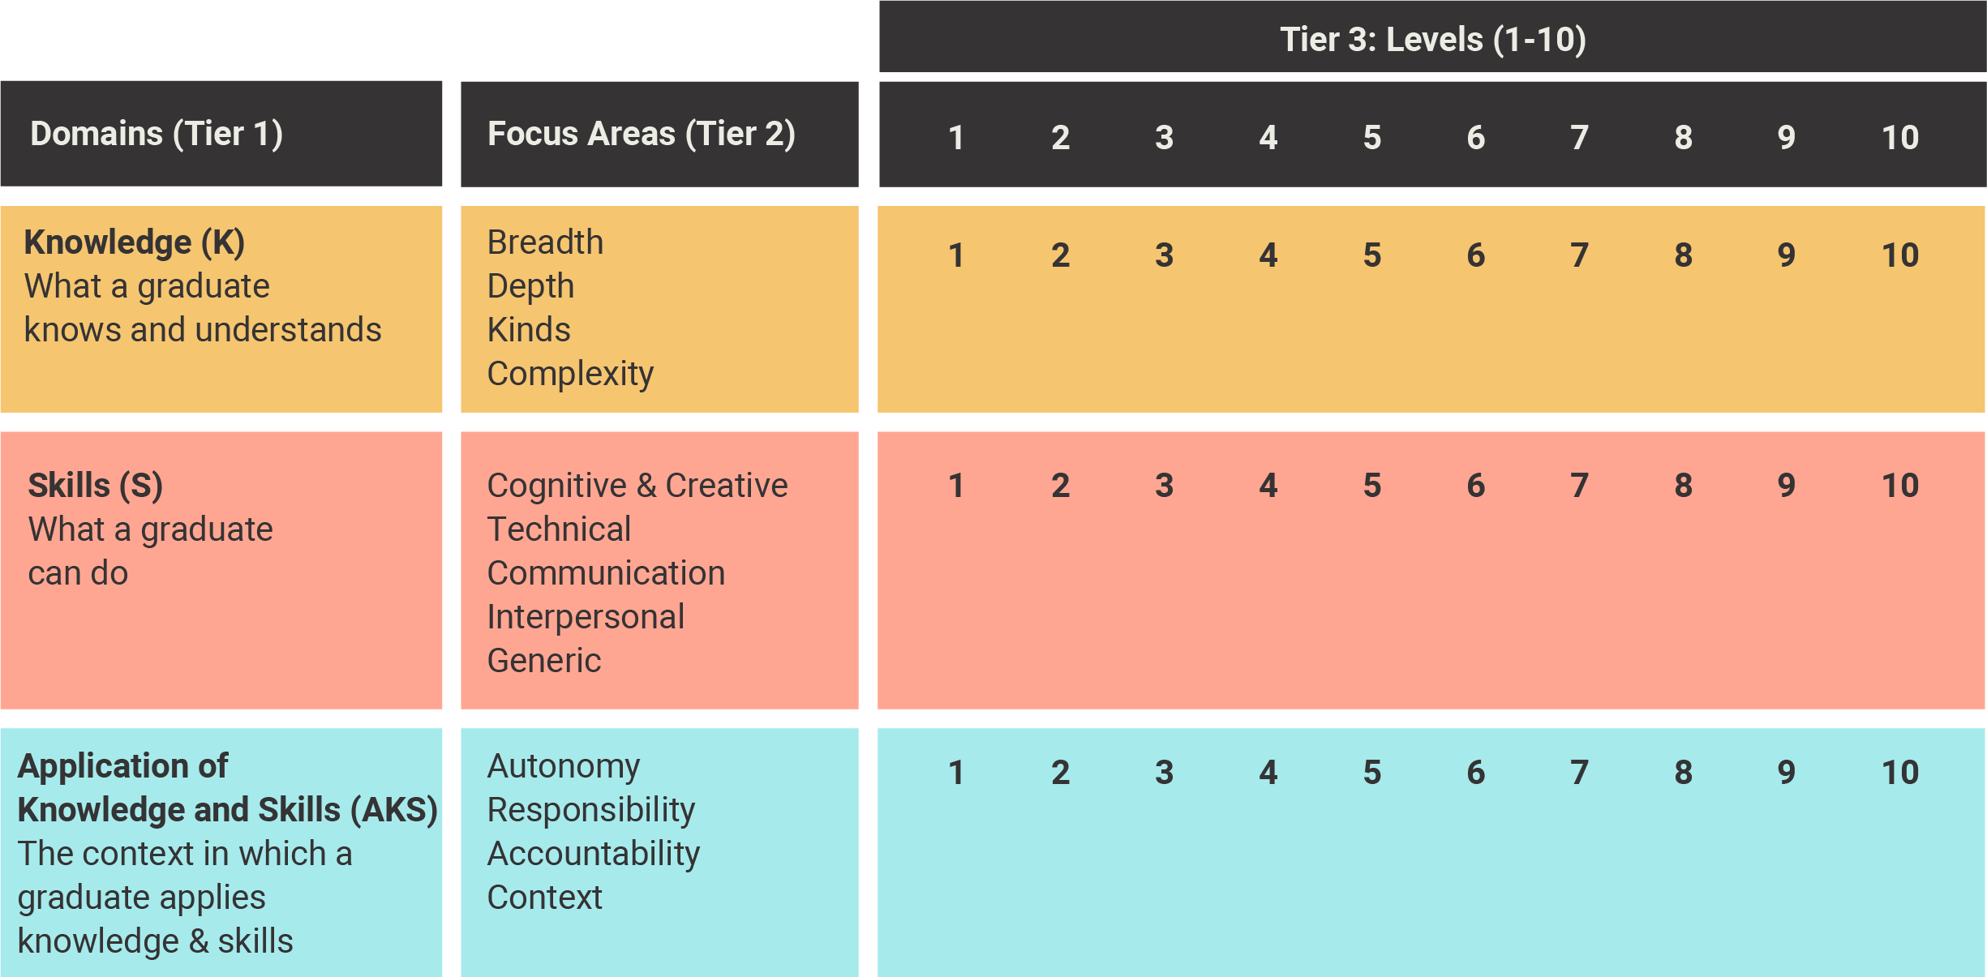
Figure 3.5: The AQF LOM with taxonomy made explicit

It is difficult to track progression across ten levels
Issues with differentiation were identified during the AQF Review consultation process. The ACER technical analysis shone a light on many of the underlying reasons for problems with repetition, inconsistency and ambiguity. One of the findings was that the Focus Areas are not conceptually ‘strong’ enough to provide the basis for ten points of differentiation. Depending on the Focus Area, discernible levels range from four to seven. Please refer to Appendix C for further detail.

Domains are locked at level
When used to describe qualification types, all domains are ‘locked at level’. This means that progression is assumed to occur at a similar rate in each domain. Thus, each qualification within each qualification type must ensure that its graduates develop and demonstrate knowledge and skills to the level of sophistication described in the Knowledge and Skills domains, and that they are able to apply them in the situations beyond the learning context that are described in Application of Knowledge and Skills. This is indicated by the dotted arrows in Figure 3.6.

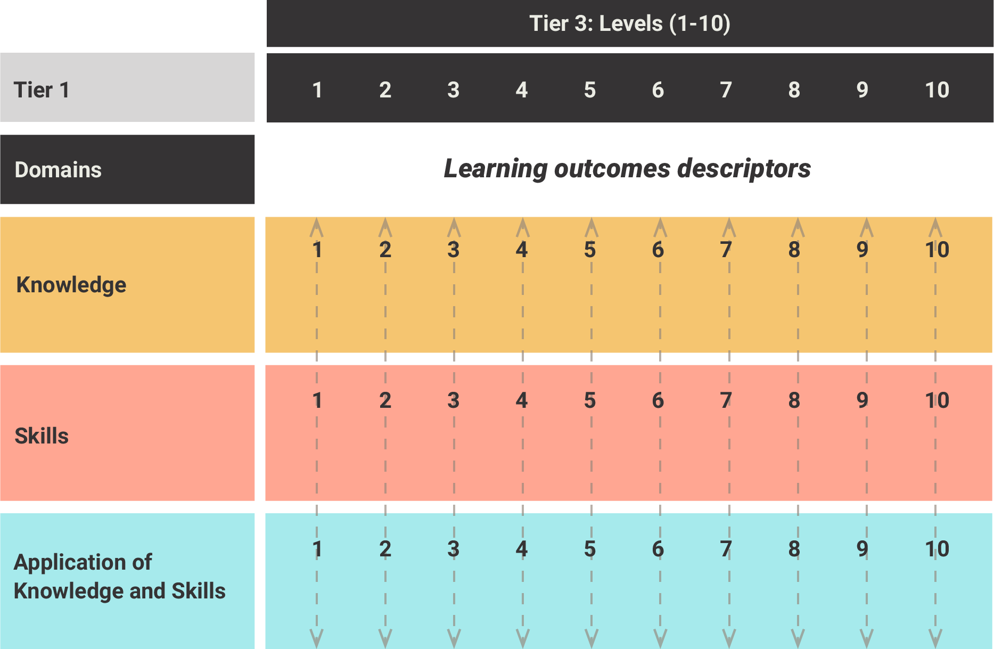
Figure 3.6: The 3 AQF domains are locked at level

Key messages
Based on this conceptual analysis of descriptors, the following findings have been made.
- If the AQF is to fulfil its key purposes, it must clearly differentiate between qualification types, and make the basis of this differentiation transparent. The nature, degree and clarity of differentiation relies on there being sufficient direction and detail.
- Although some principles can be inferred from its objectives, the AQF does not have clearly stated principles in the document itself. Nor is there an explicit rationale to explain design decisions regarding its levels criteria matrix (e.g. regarding the selection of domains and taxonomy).
- The AQF utilises descriptors of learning outcomes within two not quite identical matrices, without explaining how decisions were made about which elements were included in each.
- Tier 2 Focus Areas that should underpin the levels criteria are not explicit in the visual taxonomic structure. Descriptors in each domain are an amalgam of these, which makes it difficult to map the descriptors back to the individual Focus Areas that are supposed to have informed their design.
- While the AQF approach appears to have much in common with other NQFs, it has more levels than most equivalent frameworks and its domain definitions and taxonomy do not necessarily align with those used in other frameworks.
Drawing on the literature, ACER has identified a set of criteria that characterise an effective Learning Outcomes Matrix. Against these criteria, the AQF:
- appears to have been designed with the intention of being discrete, but has been strongly influenced by the nature of current qualification types;
- provides only a brief rationale, which does not provide any information that could be used as a basis for understanding the design decisions that had been made;
- does not incorporate Focus Areas in its visual presentation, and presents descriptors against each domain rather than against specific focus areas; and
- incorporates levels of progression that lack clear definition across ten levels.

AQF descriptors: technical analysis
As a pre-cursor to undertaking a revision of the AQF descriptors, ACER undertook a text-based review of both the learning outcomes criteria used to describe levels, and those used as qualification type descriptors. We refer to these as levels criteria and qualification type descriptors respectively. In the following discussion, we distinguish between levels criteria and qualification type descriptors when appropriate and use the general term descriptors when statements refer to both types of learning outcomes descriptor.
Given the complexity of the full analysis, this section presents an overview of findings, illustrated with some examples of the detailed approach that was undertaken. Each of the three domains (Knowledge, Skills, and Application of Knowledge and Skills) is considered separately before overall conclusions are outlined. The full report and accompanying evidence can be found in Appendix C.

Establishing the scope
ACER’s brief was to conduct a technical analysis prior to a revision of the current descriptors. One of the early challenges was the somewhat inexplicable overlap between the levels criteria and the qualification type descriptors. The two matrices use the same domains, but the qualification type descriptors usually provide more detail, particularly in the Skills domain. This detail would have been quite appropriate for the LOM, but there is no explanation for the design decisions underpinning either set of reference points.
In trying to work out what those decisions might have been, a complicating factor was that the qualification type descriptors are not consistently an extension of the levels criteria. There are cases when the levels criteria mention detail not included in the qualification type descriptors. For example, in Skills, level 1 criteria include skills to ‘identify and report simple problems’, but Certificate I qualification descriptors do not.

The technical analysis
Combining and enhancing the current descriptors required a better understanding of how they had been constructed. To do this, several different approaches were employed. Initially, two team members working independently attempted to classify the elements that made up each set of descriptors without reference to the taxonomy on p.11 of the AQF. They found it difficult to distil the essence of a taxonomy from the descriptors themselves. Where they could, it was not possible to trace the thread consistently across all levels. When the two analyses were compared, there was a high degree of consistency, but when compared with the stated taxonomy, it became clear that various elements were not well represented.
This led us to conduct a systematic linguistic analysis to identify strengths and weaknesses in the language of both the levels criteria and the qualification type descriptors, and provide insights into conceptual underpinnings. Acknowledging their differences, the process was designed to explore a set of inter-related questions for each:
- How are the ten levels differentiated?
- What scales are used, or on what basis is each level defined?
- How are the levels criteria/qualification type descriptors defined and expressed?
- How are the dimensions of the three domains defined and described across the ten levels?
The analysis involved an in-depth look at the language used in each of the ten levels, with reference to the claim that the framework is based on a taxonomy ‘designed to enable consistency in the way in which qualifications are described as well as clarity about the differences and relationships between qualification types’ (p. 11).
In addition, some consideration was given to a comparison between elements of the levels criteria and qualification type descriptors to see whether different descriptions and scales were being applied.
We have made the assumption that the taxonomy on p.11 applies to both the levels criteria of the AQF LOM and qualification type descriptors.

Knowledge descriptors
In the AQF, ‘Knowledge’ is defined as, ‘What a graduate knows and understands’. The AQF taxonomy on p.11 indicates that the Knowledge domain is described in terms of breadth, depth, kinds of knowledge and complexity. Information about these is limited. The AQF states that:
- depth of knowledge can be general or specialised;
- breadth of knowledge can range from a single topic to multi-disciplinary area of knowledge;
- kinds of knowledge range from concrete to abstract, from segmented to cumulative; and
- complexity of knowledge refers to the combination of kinds, depth and breadth of knowledge.

Finding 1. The AQF Knowledge descriptors do not differentiate progression across ten levels
In a robust learning outcomes matrix, ACER contends that the selection of sub-strands (focus areas) within a domain should be influenced, at least in part, by their ability to provide points of differentiation across all levels. Thus, it should be possible to see each of the AQF ‘sub-strands’ for Knowledge described across ten clearly differentiated stages of progression. This is not the case. In reality, there are, at best, only seven points of differentiation.
This can be seen in Table 4.1, where we have split the levels criteria at each level into a three-part structure – a level descriptor, a description of ‘knowledge type’ and a description of the ‘field’ (or area) of knowledge. The wording for each level is read across columns, with each row representing a different level.
While there appear to be seven qualifiers that could act as differentiators, there are only five distinguishable progressions. This is due to:
- ‘blurring’ across three levels (4 to 6), which are all presumably ‘broad’, even though level 5 has no qualifier; and
- the lack of detail to explain the difference between ‘broad’ and ‘broad and coherent’, (levels 6 and 7), and between ‘advanced’ and ‘advanced and integrated’ (levels 8 and 9).
Similarly, on the face of it, there are seven descriptors with the potential to differentiate one level from another. All are related to four types of knowledge: factual; procedural; technical; and theoretical. Only theoretical knowledge is defined – as ‘requirements relating to, or having the character of, theory rather than practical application’).
Table 4.1: An analysis of AQF Knowledge levels criteria
Lvl | Graduates at this level will have:
Lvl | Qualifier | Knowledge type |  | Field
1 | foundational | knowledge | for | everyday life, further learning and preparation | for initial work
2 | basic | factual, technical and procedural knowledge | of | a defined area | of work and learning
3 | no qualifier | factual, technical, procedural and some theoretical knowledge | of | a specific area | of work and learning
4 | broad | factual, technical and some theoretical knowledge | of | a specific area or a broad field | of work and learning
5 | no qualifier | technical and theoretical knowledge | in | a specific area or a broad field | of work and learning
6 | broad | theoretical and technical knowledge | of | a specific area or a broad field | of work and learning
7 | broad and coherent | theoretical and technical knowledge | with depth in | a specific area or a broad field | of work and learning
8 | advanced | theoretical and technical knowledge | in | one or more disciplines / areas of practice
9 | advanced and integrated understanding | complex body of knowledge | in
10 | systemic and critical understanding | complex body of knowledge | at the frontier of | a discipline / professional practice

It is difficult to determine why certain combinations of knowledge types have been allocated at each level. This becomes immediately apparent when the four kinds of knowledge are replaced by the letters A, B, C and D, as in Table 4.2.

Table 4.2: Levels criteria: Analysis of Kinds of Knowledge across ten levels
Level | Knowledge type
1 | Knowledge (not defined)
2 | A, B, C
3 | A, B, C and some D
4 | A, B and some D
5 | B and D
6 | D and B
7 | D and B
8 | D and B
9 | Complex knowledge (not defined)
10 | Complex knowledge (not defined)

A further complicating factor is that it not possible to determine:
- whether each level builds on (or assumes competency at) the previous level (so that the levels are cumulative); or
- whether different types of knowledge are assumed to ‘appear’ at different levels.
There are some suggestions of the latter – for example, theoretical knowledge only appears for the first time at level 3, while procedural knowledge disappears at level 4.
These examples are taken from the levels criteria. As demonstrated in Table 4.3, the qualification type descriptors are largely similar to the levels criteria. Where there are differences, many appear to be arbitrary changes in terminology. For example,
- At level 1, ‘foundational knowledge’ in the levels criteria becomes ‘basic fundamental knowledge and understanding’ in the qualification descriptor for a Certificate 1.
- At levels 3 and 4, ‘technical knowledge’ is modified by ‘some’ in the criteria but not in the qualification descriptors.
- At levels 7 and 8, ‘theoretical and technical knowledge’ in the criteria is replaced by ‘body of knowledge’ (7) and simply ‘knowledge’ (8) in the qualification type descriptors.

Table 4.3: A comparison of Knowledge in levels criteria and qualification type descriptors
Knowledge domain
Levels criteria |  |  |  | Qualification type descriptors
Lvl | Qualifier | Knowledge descriptor |  | Lvl | Qualification | Qualifier | Knowledge descriptor
1 | foundational | knowledge |  | 1 | Cert I | basic fundamental | knowledge and understanding
2 | basic | factual, technical and procedural knowledge |  | 2 | Cert II | basic | factual, technical and procedural knowledge
3 |  | factual, technical, procedural and some theoretical knowledge |  | 3 | Cert III |  | factual, technical, procedural and theoretical knowledge
4 | broad | factual, technical and some theoretical knowledge |  | 4 | Cert IV | broad | factual, technical and theoretical knowledge
5 |  | technical and theoretical knowledge |  | 5 | Diploma |  | technical and theoretical knowledge
6 | broad | theoretical and technical knowledge |  | 6 | Adv Dip | specialised and integrated | technical and theoretical knowledge
6 | broad | theoretical and technical knowledge |  | 6 | Assoc Degree | broad | theoretical and technical knowledge
7 | broad and coherent | theoretical and technical knowledge |  | 7 | Bachelor | broad and coherent | body of knowledge
8 | advanced | theoretical and technical knowledge |  | 8 | Honours | coherent and advanced | knowledge
8 | advanced | theoretical and technical knowledge |  | 8 | Grad Cert | specialised | knowledge
8 | advanced | theoretical and technical knowledge |  | 8 | Grad Dip | advanced | knowledge
9 | advanced and integrated | understanding of a complex body of knowledge |  | 9 | Masters (course-work) | a | body of knowledge
9 | advanced and integrated | understanding of a complex body of knowledge |  | 9 | Masters (research) | a | body of knowledge
9 | advanced and integrated | understanding of a complex body of knowledge |  | 9 | Masters (extended) | a | body of knowledge
10 | systemic and critical | understanding of a substantial and complex body of knowledge |  | 10 | Doctoral Degree | a substantial | body of knowledge

Finding 2. There are a number of assumptions that should be challenged
In the levels criteria, the assumption appears to be that Knowledge descriptors will move from ‘basic’ to ‘complex’, but there are few details to indicate what this might entail at any level. This is not helped by the lack of consistency at either end of the matrix. Level 1 does not appear to be related to any other level and is not described in the same way. Levels 9 and 10 use entirely different terminology that is closer in meaning to discipline / field of practice than it is to the types of knowledge used in previous levels.
‘Factual’ and ‘procedural’ knowledge are only referenced at the lower levels, with ‘procedural’ disappearing at Level 4 and ‘factual’ at level 5. These terms are not defined in the glossary, but there is a sense that they are being used to encapsulate only basic, non-conceptual information. However, it would be reasonable to argue that both factual and procedural information will play some kind of role at every level. Perhaps these kinds of knowledge have been subsumed into technical knowledge?
The introduction of ‘(some) theoretical knowledge’ at Level 3 implies that theoretical knowledge is not appropriate, or possible, at Levels 1 and 2. However, a focus on (some) ‘theory’ can, and should, occur at any level, but at different levels of sophistication. The same observation would apply to factual and procedural knowledge, but in reverse.
The AQF glossary defines theoretical knowledge and concepts as, ‘those knowledge requirements relating to or having the character of theory rather than practical application’. Technical knowledge is not defined, but technical skills are described as ‘the operational skills necessary to perform certain work and learning activities’, so perhaps this means operational knowledge (which could incorporate information about operational procedures).
At level 6, the order of ‘technical’ and ‘theoretical’ knowledge is reversed. This may be intended to signal the traditional difference between vocational education and training (VET) and Higher Education (HE). However, is it necessarily applicable to vocationally-oriented fields undertaken within the HE sector? When considering learning progression more generally, it is also worth exploring the apparent assumption that learning becomes increasingly focused on theory, with a corresponding reduction in the focus on technical knowledge.

Finding 3. The Knowledge typology does not develop consistently across levels
‘Technical’, ‘theoretical’, ‘factual’ and ‘procedural’ are adjectives being used as qualifiers of ‘knowledge’. In this sense they constitute a typology. They are abstract concepts that cannot be easily separated or delineated across levels of progression. For example, it is quite possible for one paragraph of an oral or written text to contain information of all four kinds. It is also conceivable that this could occur within texts in any field of study, and possibly within any qualification type. In reality, the difference across levels are more likely to relate to:
- the complexity of the texts themselves; and
- the cognitive, language, literacy and/or numeracy skills involved in locating, interpreting and evaluating the relevance and usefulness of the information and ideas involved.
Perhaps in recognition of this, the phrase that begins each of the levels criteria for Knowledge also features an adjectival qualifier that attempts to relate to a scale, i.e. foundational, basic, advanced. However, these qualifiers do not scale, and, in fact, do not appear to be on the same scale.
‘Basic’ and ‘advanced’ can be seen to scale and are similar to novice/expert scales. ‘Broad’ appears at levels 4, 6 and 7 (but not at 3 and 5 which have no qualifier). ‘Broad’ does not sit on the basic-advanced scale. Rather, it appears to be synonymous with ‘wide’, but perhaps with a connotation of ‘shallow’, suggesting a lack of depth, rather than ‘narrow’ or ‘focused’.
The qualifiers for understanding – ‘coherent’ (level 7) and ‘integrated’ (level 9) - are not clearly on a scale at all. Their inclusion implies that the prior level is not coherent or not integrated. This is a particular issue at level 7, given that ‘coherent’ leads to ‘advanced’ (which, presumably, presupposes coherence) at level 8.

Finding 4. ‘Field of knowledge’ adds no useful information for differentiation purposes
The second part of the Knowledge levels criteria is a descriptor that we have labelled ‘field of knowledge’. Its features at each level are described in Table 4.4. Conceptually, it is unclear why this descriptor is necessary, as it does not appear to add to the notion of level, or to act as an effective qualifier. Rather, it appears to be an attempt to describe the diversity that occurs within current qualifications within a type. This is one of many examples of the LOM being driven by perceptions and expectations of current qualifications.

Table 4.4: Analysis of field descriptors within Knowledge levels criteria
Level | Field descriptor
1 | for | everyday life, further learning and preparation | for initial work
2 | of | defined area | of work and learning
3 | of | specific area | of work and learning
4 | of | specific area / broad field | of work and learning
5 | in | specific area / broad field | of work and learning
6 | of | specific area / broad field | of work and learning
7 | with depth in | one or more disciplines / areas of practice
8 | in
9 | in
10 | At the frontier of | discipline / professional practice

Finding 5: The Knowledge taxonomy is not well conceptualised
The Knowledge domain is intended to describe outcomes in terms of ‘breadth’, ‘depth’, ‘kinds’ and ‘complexity’. ‘Complexity’ is defined as a combination of the first three. At each level, the learning outcomes that make up the levels criteria are written as a combination statement. In effect, the AQF LOM is describing complexity using ‘breadth’, ‘depth’ and ‘kind’ as sub-themes. However, when these sub-themes are made explicit as Tier 2 Focus Areas, and the current levels criteria are mapped to each, it becomes apparent that the three sub-themes are not all clearly or commonly present at each level. Nor is it clear how they individually (or even collectively) scale from level 1 to level 10.
Table 4.5 presents an attempt to indicate where statements may be intended to refer to each sub- theme. It illustrates the fact that many of the terms neither build on, nor relate to each other. In addition, the words used to refer to ‘depth’ (general or specialised) are somewhat confusing, as they conflate with ‘breadth’ – general to broad and specialised to narrow. (For example, the use of ‘specific area / broad field’ in the Knowledge levels criteria reads more clearly as related to ‘breadth’, not ‘depth’).
The gaps and inconsistencies raise questions about the validity of defining ‘complexity’ as a combination of the three sub-themes.

Table 4.5: Levels criteria: mapping of breadth, depth and kinds of knowledge
Knowledge
Level | Depth | Breadth | Kinds
1 | foundational | everyday life, further learning and preparation | foundational, preparation
2 | basic | defined area | factual, technical and procedural knowledge  defined area
3 |  | specific area | factual, technical, procedural and some theoretical knowledge  specific area
4 | broad | specific area / broad field | factual, technical and some theoretical knowledge
5 |  | specific area / broad field | technical and theoretical knowledge
6 | broad | specific area / broad field | theoretical and technical knowledge
7 | with depth in | one or more disciplines / areas of practice | theoretical and technical knowledge
8 | broad and coherent | one or more disciplines / areas of practice | theoretical and technical knowledge
9 | Advanced  Complex body of knowledge | one or more disciplines / areas of practice  Complex body of knowledge | Complex body of knowledge
10 | advanced and integrated understanding  Complex body of knowledge | At the frontier of a discipline / professional practice  Substantial and complex body of knowledge | Systemic and critical understanding  complex body of knowledge

Skills descriptors
In the AQF, skills are defined as ‘what a graduate can do’. The AQF taxonomy reports that the Skills domain incorporates the sub-strands (Focus Areas) of:
- cognitive and creative skills involving the use of intuitive, logical and critical thinking;
- technical skills involving dexterity and the use of methods, materials, tools and instruments;
- communication skills involving written, oral, literacy and numeracy skills;
- interpersonal skills; and
- generic skills, defined as Fundamental skills (literacy, numeracy); People skills (working with others, communication); Thinking skills (decision making, problem solving); and Personal skills (self-direction, integrity).
The apparent overlap between the generic skills and the first four skills types is not explained.

Finding 6: The Skills taxonomy focuses mainly on the way in which skills are applied
The Skills domain purports to be about ‘cognitive’, ‘technical’, ‘communication’ and ‘interpersonal’ skills. However, in the levels criteria;
- cognitive, technical and communication skills are only described in terms of what a graduate can do with these skills;
- there is no detail to establish how the skills have been conceptualised, or to get a sense of the degree of sophistication expected at each level. This must be inferred from statements about what a graduate can do, which are expressed mainly in terms of the types/complexity of problems they are expected to solve; and
- there are no references to interpersonal skills at all.
The qualification type descriptors provide more detail than the levels criteria.
The technical analysis of the qualification type descriptors demonstrates that the ‘doing’ relates to thirteen different types of application (See Box 4.1)
Box 4.1 Skills domain: 13 applications of skills
 | Cognitive, technical, communication, and/or creative skills required to:
1 | Manipulate information/knowledge
2 | Solve problems
3 | Demonstrate understanding/mastery of knowledge and/or theoretical concepts
4 | Communicate known solutions/provide technical information/transfer knowledge/disseminate research results
5 | Express ideas and perspectives/ present knowledge and ideas/ present an argument
6 | Generate and/or evaluate new ideas
7 | Think/reflect critically
8 | Design, use and /or evaluate research
9 | Complete tasks
10 | Use tools/equipment
12 | Guide activities
13 | Participate in everyday life

In Figure 4.1 (below), it can be seen that the Skills applications articulated across the most levels relate to interacting with information and ideas (e.g. identifying, thinking about, presenting and/or creating) and to problem solving. In several cases, a given skill appears at only some levels. For example:
- a specialist category of research skills begins at Level 8 (and is specific to Honours, Research Masters and Doctorates);
- creative thinking skills (e.g. described in terms such ‘ to generate … complex ideas and concepts at an abstract level’) appear from level 5 (but are not referenced at all in the levels criteria);
- ‘Providing technical information’ only appears at level 3, and ‘providing technical advice’ only appears at level 4; and
- ‘Critical thinking’ does not appear until levels 7 and 8, while ‘critical reflection’ appears in levels 9 and 10.
Terminology also changes. For example, levels 1 to 6 involve skills to do things with information (e.g. ‘identify’, ‘analyse’, ‘compare’). However, ‘information’ is not mentioned at Levels 7 and 8, (where references are made to ‘knowledge’. ‘Information’ reappears at level 9 but is replaced by ‘knowledge’ at level 10. (In contrast, in the levels criteria, ‘information’ is not mentioned at levels 1 or 10, but is used at levels 2–9. However, in the descriptors for levels 1 to 4, graduates will simply ‘have’ information to undertake activities and solve problems. There is no specific mention of skills to manipulate information until level 5, when graduates will ‘analyse information to complete a range of activities’).


Figure 4.1: Qualification type descriptors: application of Skills

Finding 6: In Skills, there is limited information about the skills themselves
In the levels criteria, each Skills statement opens with reference to a combination of skill types .The combination varies (for reasons that are not explained), but collectively the set incorporates cognitive, technical, communication, analytical and creative skills. As per the Skills definition, the focus is on application. For example, at level 7,
Graduates at this level will have well-developed cognitive, technical and communication skills to select and apply methods and technologies to:
- analyse and evaluate information to complete a range of activities;
- analyse, generate and transmit solutions to unpredictable and sometimes complex problems; and
- transmit knowledge, skills and ideas to others.
When considered alone, this statement rests on the qualifier ‘well developed’ and the reference to ‘unpredictable and sometimes complex problems’. The other dot points could apply at virtually any level. There is limited detail about the nature of the broad range of skills that might be classified under the heading of cognitive, technical, communication etc.
In the levels criteria, the roles that might be played by cognitive, technical and communication skills are further obscured through the practice of ‘bundling’, i.e. they are all rolled into single learning outcomes statements that provide no information about the skills themselves, nor indicate how they might interact to enable the actions described. When the three skill types are ‘unbundled’, gaps and apparent inconsistencies become obvious.
The qualification type descriptors provide somewhat more useful detail. For example, at level 7.
Graduates of a Bachelor degree will have:
- cognitive skills to review critically, analyse, consolidate and synthesise knowledge;
- cognitive and technical skills to demonstrate broad understanding of knowledge with depth in some areas;
- cognitive and creative skills to exercise critical thinking and judgement in identifying and solving problems with intellectual independence;
- communication skills to present a clear, coherent and independent exposition of knowledge and ideas.
However, when these statements were teased out at each level, a number of issues were identified.
Table 4.6 provides an example of how this applied to ‘solving problems’. It therefore refers only to those skill types that are actually indicated to be involved in problem solving in some way. It shows that ‘problems’ are characterised in two ways: by using a qualifier of breadth (limited range, variety); and by indicating the level of a problem (simple vs complex, predictable vs unpredictable).
The skill types involved appear to change arbitrarily, e.g.
- levels 1 and 10 have no reference to solving problems (although this might be implied at level 10);
- at levels 2, 3 and 6 (Diploma), only cognitive and communication skills are required;
- at levels 4, 5 and 9, technical skills are also required (but not in 6, 7 and 8); and
- creative skills (to generate new ideas) are only required at levels 7 and 9 for problem solving, (although they are referenced at level 6 in relation to expressing ideas and perspectives).
There is no logical progression regarding the complexity of problems. This is most noticeable at levels 6, 7 and 8.
Problems are characterised as ‘predictable’ or ‘unpredictable’, with those at higher levels also being described as ‘complex’. The concept of unpredictability is interesting. Is this relative to the graduate or is it a more general statement? Dreyfus and Dreyfus (1985) might argue that novices and advanced beginners (who, by definition, have little or no practical experience in a particular field), would find many problems ‘unpredictable’ because they lack the insight gained through working in a specific context for an extended period of time. However, there are many things in the world that are ‘unpredictable’ on a grander scale.

Table 4.6: Skills: Qualification type descriptors related to ‘solutions to problems’
Qual type | Lvl | Skill type | Area of application | Level of solution/ response | Nature of problem |  | Additional
Cert I | 1
Cert II | 2 | cognitive, technical and communication skills | to apply and communicate | known solutions | to a limited range of | predictable problems
Cert III | 3 | cognitive, technical and communication skills | to apply and communicate | known solutions | to a variety of | predictable problems | and to deal with unforeseen contingencies using known solutions
Cert IV | 4 | cognitive, technical and communication skills | to apply and communicate | technical solutions of a non-routine or contingency nature | to a defined range of | predictable and unpredictable problems
Diploma | 5 | cognitive, technical and communication skills | to analyse, plan, design and evaluate | approaches | to | unpredictable problems and/or management requirements
Adv Diploma | 6 | cognitive and communication skills | to formulate | responses | to | complex problems
Assoc Degree | 6 | cognitive, communication and analytical skills | to interpret and transmit | responses | to sometimes | complex problems
Bachelor Degree | 7 | cognitive and creative skills | to exercise critical thinking and judgement | in identifying and solving |  | problems | with intellectual independence
Honours | 8 | cognitive skills | to review, analyse, consolidate and synthesise knowledge | to identify and provide solutions | to | complex problems | with intellectual independence
Grad Cert & Grad Dip | 8 | cognitive skills | to review, analyse, consolidate and synthesise knowledge | and identify and provide solutions | to | complex problems
Masters research; courseworkextended | 9 | cognitive, technical and creative skills | to investigate, analyse and synthesise |  |  | complex information, problems, concepts and theories | and to apply established theories to different bodies of knowledge or practice
Doctorate | 10

A similar situation is identified when Skills levels criteria related to information processing and management are analysed. In Table 4.7, it can be seen that the skill type changes arbitrarily, with no logical development, e.g.
- At levels 2, 4 and 6 only cognitive skills are required;
- At levels 1, 3, 5 and 6, communication skills are also required;
- At Levels 3 and 9 technical skills are included;
- Creative skills are only introduced at level 8.
Table 4.7: Qualification types and skills related to information management
Qualification type | lvl | Skill type | Skill method | Level of information |  | Range
Certificate I | 1 | cognitive and communication skills | to receive, pass on and recall |  | information | in a narrow range of areas
Certificate II | 2 | cognitive skills | to access, record and act on | a defined range of | information | from a range of sources
Certificate III | 3 | cognitive, technical and communication skills | to interpret and act on | available | information
Certificate IV | 4 | cognitive skills | to identify, analyse, compare and act on |  | information | from a range of sources
Diploma | 5 | cognitive and communication skills | to identify, analyse, synthesise and act on |  | information | from a range of sources
Advanced Diploma | 6 | cognitive and communication skills | to identify, analyse, synthesise and act on |  | information | from a range of sources
Associate Degree | 6 | cognitive skills | to identify, analyse and evaluate |  | information and concepts | from a range of sources
Bachelor Degree | 7
Honours/ Grad Cert & Dip | 8
Masters (research, coursework extended) | 9 | cognitive, technical and creative skills | to investigate, analyse and synthesise | complex | information, problems, concepts and theories
Doctorate | 10 | specialised cognitive,  technical and research  skills in a discipline area | to generate original knowledge and understanding to make a substantial contribution to a  discipline or area of professional practice

Finding 7: The approach to Skills appears to be simplistic
The way in which individual skills are described raises questions about the underpinning theoretical constructs. For example:
At lower levels, the communication skills construct appears to be based on a simplistic and unrealistic ‘transmit and receive’ model that does not carry over to the higher levels. At these levels, there is a strong emphasis on communication purposes and modes that are most likely to be valued within Higher Education (e.g. communication skills to demonstrate an understanding of theoretical concepts (L8) or to justify theoretical propositions (L9);
Despite the claim that the AQF incorporates interpersonal skills, there are no direct references to any skills that might be grouped under this broad heading , e.g. there are no direct references to skills needed to build and maintain relationships, and only one indirect reference from which the requirement for such skills might be inferred (i.e. where Level 4 refers to ‘communication skills to guide activities and provide technical advice’);
The bundling of skill descriptors, and the lack of detail around ‘technical’ skills, means there is almost no explicit reference to psychomotor skills, even though these play a key role in vocationally-oriented qualifications across the levels;
With the exception of problem solving, there are virtually no references to the development and demonstration of the ‘generic’ skills that play a critical role in the selection, adaptation and application of information and skills learned in one context to another. These include skills to:
- identify/clarify and/or set goals;
- plan and organise how to achieve them;
- make decisions;
- work effectively with others in various capacities; and
- think creatively (as opposed to skills to create something, such as an artwork, that is judged by others to be ‘creative’).
Creativity skills are mentioned in passing, but do not appear until Level 5 in the qualification type descriptors, and not at all in the levels criteria. The idea that creative thinking does not have a place at lower levels of the learning hierarchy may have been influenced by Bloom’s (revised) taxonomy, which is predicated on the notion that individual learners can only have new ideas once they have progressed through the other cognitive domains. This is a highly contested view. For example, de Bono (1992) argues (and demonstrates) that logical/analytical thinking and lateral thinking are different ways of perceiving. Training in analytical thinking techniques can actively work against the potential for an individual to envisage other ways of doing something.

Application of Knowledge and Skills (AKS) descriptors
In the AQF, the Application of Knowledge and Skills domain is defined as ‘the context in which a graduate applies knowledge and skills’. The context refers to situations in which it is anticipated graduates might apply what they have learned, i.e. when they are beyond the learning context.
The AQF p.11 taxonomy envisages that post-graduation contexts may range from ‘established and limited to broad parameters, and the known to a changing range of contexts, and specialised and diverse contexts, while tasks may range from known and routine, to specialised, to unknown situations’. Application is expressed in terms of autonomy, judgement, responsibility, adaptability and accountability’.

Finding 8: The ‘graduates will’ approach is problematic
A technical analysis of the criteria and descriptors identified problems similar to those in the other domains (See Table 4.8 at the end of this section and Appendix C). Rather than provide a detailed critique of the content here, ACER believes it is more important to raise questions about the whole premise of this domain.
In effect, the domain projects forward to describe a graduate’s ability to apply knowledge and skills in new work or study contexts beyond the learning environment. The assumptions that underpin the descriptors are open to challenge. For example:
- that all qualifications within a qualification type (e.g. Bachelor degree) are equally likely to lead to employment at a certain hierarchical level;
- that all qualifications at a level provide the same opportunities for practical application of knowledge and skills that are the focus of the course; and
- that these opportunities are sufficient for a graduate to ‘hit the ground running’.
At the higher levels of the AKS domain, descriptors appear to be describing behaviours that would be characterised as proficient or expert in the Dreyfus and Dreyfus Model of Skills Acquisition (1980). For example, at level 7:
‘Graduates at this level will apply knowledge and skills to demonstrate autonomy, well developed judgement and responsibility in contexts that require self-directed work and learning within broad parameters to provide specialist advice and functions.’
Research across diverse fields suggests that such behaviour develops over a number of years, and comes, not from formal study alone, but from years of practical experience and deep reflection (See also Schon, 1983; Ferry & Ross-Gordon, 1998; Misko, 1995; Daley, 1999; Billet, 2001). It may be more useful and realistic to describe learning outcomes associated with the application of knowledge and skills within the learning context. This would make it possible to distinguish qualifications directly aligned to workforce outcomes and/or required for entry and/or professional certification.

Key messages
Based on this technical analysis of descriptors in the current AQF, the following findings have been made.
- The AQF levels criteria do not appear to have been developed or used as a set of discrete reference points independent of current qualifications.
- The rationale for the levels criteria is not explicit, and it is difficult to identify any consistently applied conceptual base reflecting theories about learning and learning progression.
- It is difficult to identify a rationale for the differences between the levels criteria and the qualification type descriptors.
- The lack of an explicit taxonomy in the two matrices, and the practice of ‘bundling’ makes it difficult to immediately identify inconsistencies and gaps, but these become obvious once descriptors are unbundled and mapped back to the taxonomy on p.11.
- The mapping reveals the fact that the individual elements of the taxonomy do not effectively differentiate progression across ten levels.
- The Skills taxonomy focuses on the way in which skills are applied without providing any clear indication of features of the skills themselves;
- The ‘graduates will’ approach is particularly problematic when describing the application of knowledge and skills in future contexts.
The AQF domains and taxonomy do not provide appropriate scaffolding for the description of learning outcomes at each level, or for differentiating progression from one level to another. Thus, it is not possible to address the issues identified by stakeholders, or by the ACER technical analysis within the current construct. Most changes would involve arbitrary decisions that might simply create further ambiguities and confusion.

Table 4.8: Application of Knowledge and Skills: analysis of levels criteria
 | Graduates will demonstrate: |  |  |  | as: | within: |  | to provide:
Level | Autonomy | Level of judgement | Adaptability | Level of responsibility | Job description? | Type of context | Level of parameter | Specialist advice and functions
1 | Graduates at this level will apply knowledge and skills to demonstrate  autonomy |  |  |  |  | in highly structured and stable contexts | and within narrow parameters
2 |  | and limited judgement |  |  |  | in structured and stable contexts | and within narrow parameters
3 |  | judgement |  | and to take limited responsibility |  | in known and stable contexts | and within established parameters
4 |  | judgement |  | and limited responsibility |  | in known or changing contexts | and within established parameters
5 |  | judgement |  | and defined responsibility |  | in known or changing contexts | and within broad but established parameters
6 |  |  |  |  |  | in contexts that are subject to change | within broad parameters | to provide specialist advice and functions
7 |  | well-developed judgement |  | and responsibility |  | in contexts that require self-directed work and learning | within broad parameters | to provide specialist advice and functions
8 |  | well-developed judgement | adaptability | and responsibility | as a practitioner or learner
9 |  | expert judgement
10 |  | authoritative judgement | adaptability | and responsibility | as an expert and leading practitioner or scholar

Identifying possible ways forward

Revision of the current learning outcome descriptors
The analysis of the AQF descriptors identified significant issues with the conceptual base and assumptions that underpin them. This may provide evidence that explains the ambiguities and general lack of clarity identified by stakeholders during the Panel’s consultation process.
After discussion with the Review Panel, ACER made an attempt to revise the current Knowledge and Skills domains to the extent possible without making major changes to the existing construct. Referred to as Working Model A (see Figure 5.1), this slightly modified version of the AQF:
- maintained the existing domain definitions and taxonomy;
- made the taxonomy explicit in the matrix;
- combined the levels criteria and qualification type descriptors where feasible; and
- revised descriptors where there was a logical and/or conceptually justifiable reason to do so.

Working Model A

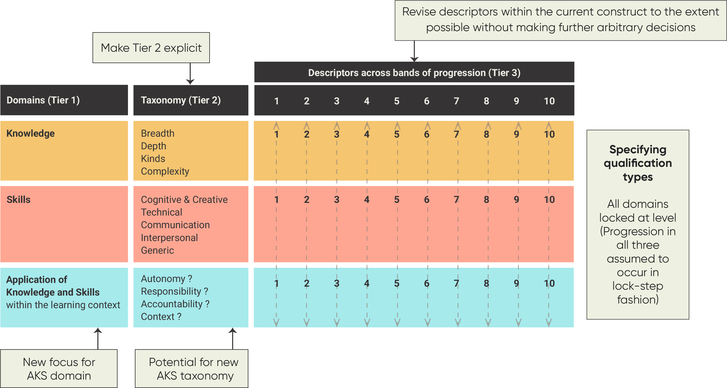
Figure 5.1: Features of Working Model A (Modified AQF)
Gaps, unnecessary repetitions and inconsistencies were addressed when it was possible to make decisions with some sort of logical and/or conceptual basis. Where this was not the case, questions and issues were recorded. The main changes made to the AQF Knowledge and Skills domains are presented in Attachment 1, with a small sample of the questions and comments relating to boxes that could not be addressed without making an arbitrary decision.
Model A demonstrated the significant difficulties involved in a revision based on changes to language alone. A review of the AQF against the key features of an effective learning outcomes matrix (Table 5.1) reinforced the need for major conceptual and structural changes.
Table 5.1: The AQF Learning Outcomes Matrix does not meet effectiveness criteria
 | Key features of an effective learning outcomes matrix | The AQF approach
Principles/  Rationale | A discrete, coherent conceptually-based construct used as a reference point for specification of a qualification type  Explicit rationale, principles  Defined & written in broader contexts where learning inputs are also considered | Not discrete. Strongly influenced by current qualification types, plus historical decisions (e.g. incorporation of Australian Standards reflected in Levels 1 to 6, more recent changes to levels 7 to 10 to strengthen references to research)  Focus on learning outputs  No clear rationale or principles to explain conceptual base, assumptions etc.
Structure | Three explicit tiers  A small number of domains  A set of Focus Areas that stem from each domain and are each capable of providing the scaffolding for a number of differentiated stages (Tier 2);  A set of descriptors with sufficient detail to inform course design, accreditation, comparison (Tier 3).  Selection of domains and focus areas reflects research about learning e.g. research on ‘situated learning’ (Lave & Wenger, 1991)  Increasing complexity of learning is intrinsically linked to context & setting.  In writing learning outcomes, context plays a key role | Tier 2 referenced elsewhere, but not explicit in matrix  Decision to provide additional detailed learning outcomes descriptors in qualification specifications (with lack of consistency between the two)  Qualification type descriptors likely to be the main reference point for users
Domains | Knowledge, Skills, Competence, (KSC) should not be accepted as the only, or best, way of classifying | Knowledge, Skills, Application of Knowledge and Skills
Taxonomy/  typology | Keevy and Chakroun (2015) advise:  develop/select a taxonomy that is fit for purpose rather than choose one for the sake of ‘consistency’  recognise that each domain needs its own taxonomy (e.g. consider SOLO, Dreyfus and Dreyfus (1985))  CEDEFOP (2017) also supports consideration of Dreyfus and Dreyfus (1980) model of skills acquisition | No clear conceptual underpinnings  Some evidence of Bloom’s cognitive domain
Number of levels/bands  Basis for progression | In a ‘fit for purpose’ taxonomy with an explicit conceptual base, levels in the LOM will be determined by:  what is conceptually logical, feasible and realistic in relation to learning progression  The degree to which progression can be usefully described/ differentiated  If each domain and its sub-strands are conceptually determined, it is quite possible that the number of feasible levels will vary from one domain to the next  Could learn from occupational classification standards (e.g. O*NET, ISCED) | Tied so closely to current qualification types, limited possibilities for introduction of new qualifications, micro-credentials etc.  Reinforces VET/HE divide  Behaviourist?  Limited detail, with very little of the information providing a means to differentiate one level from another  No consistency – descriptors jump around across levels, disappear/reappear; can’t tell if meant to be additive or consecutive
Locking at level | This approach reflects assumptions that need to be challenged  Keevy and Chakroun (2015) advise – distinguish between level setting methods used for Knowledge and Skills and those used for Competence | 3 domains locked at level

After further discussion with the Review Panel, it was agreed that work on Model A would not be continued at this point. Rather, additional work would be undertaken to explore the feasibility of two alternative models (Working Models B and C) that ACER had proposed.

Two alternative models
ACER proposed that Working Models B and C be built on the same new conceptual base, which would incorporate revised domain definitions and a new taxonomy. The reconceptualised domains, focus areas and descriptors would aim to reflect contemporary thinking about learning. The design would be informed by the findings from the literature review regarding features of an effective learning outcomes matrix.
The main differences between B and C would be in the number of levels/bands described for each domain, and in the ways in which each might be applied in the specification of qualification types. Key features of the two models are outlined in Figures 5.2 and 5.3.

Working Model B
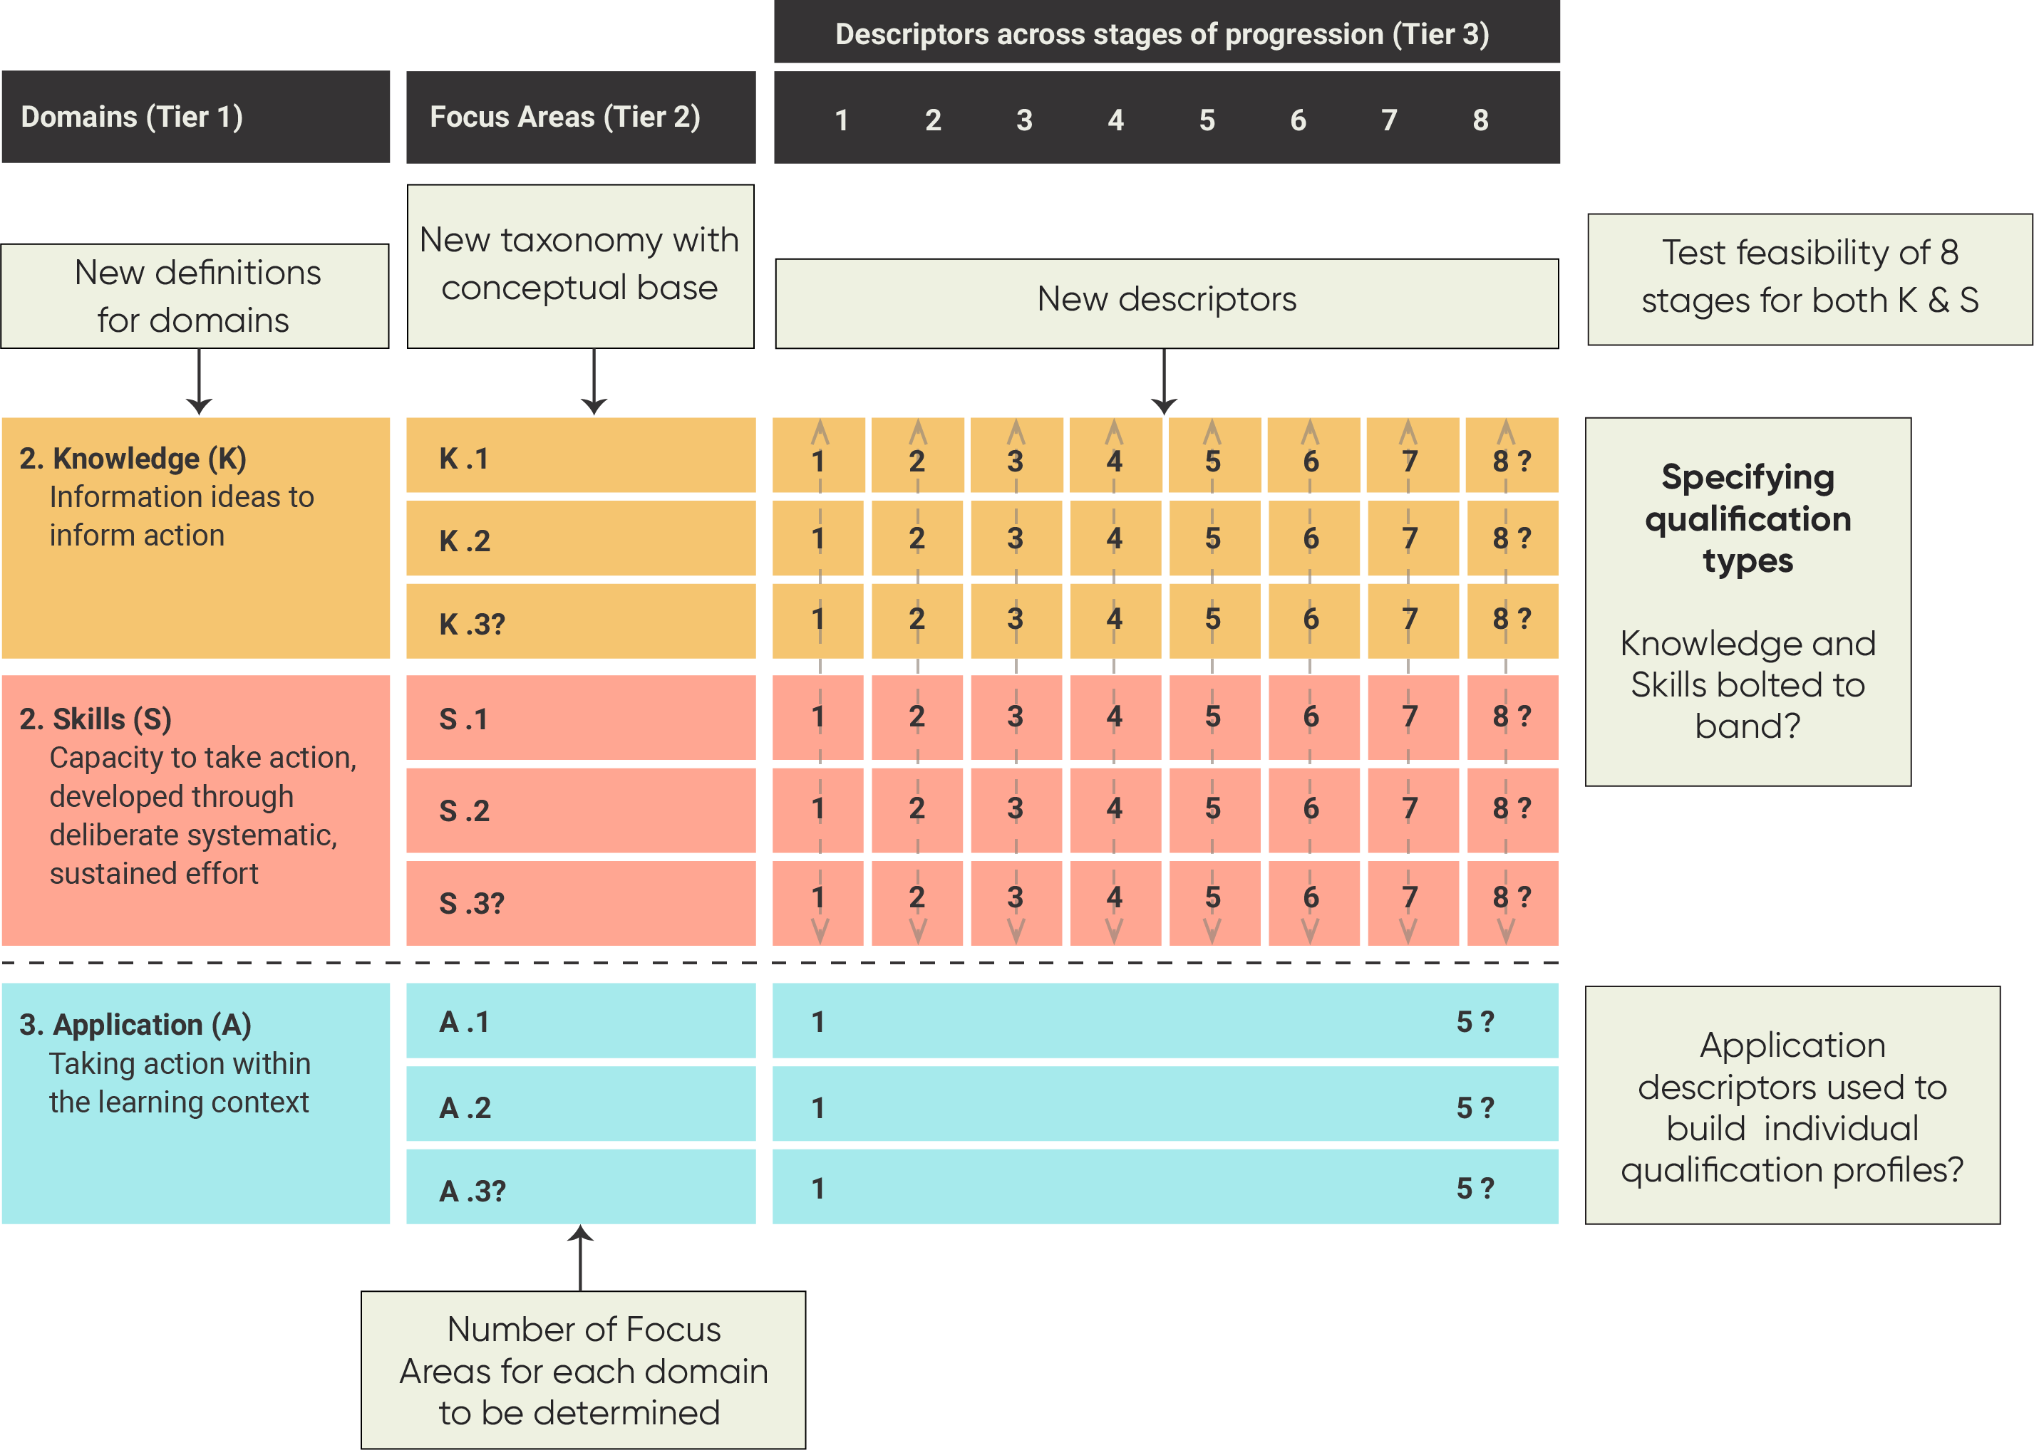
Figure 5.2: Features of Working Model B with trial definitions

Working Model C
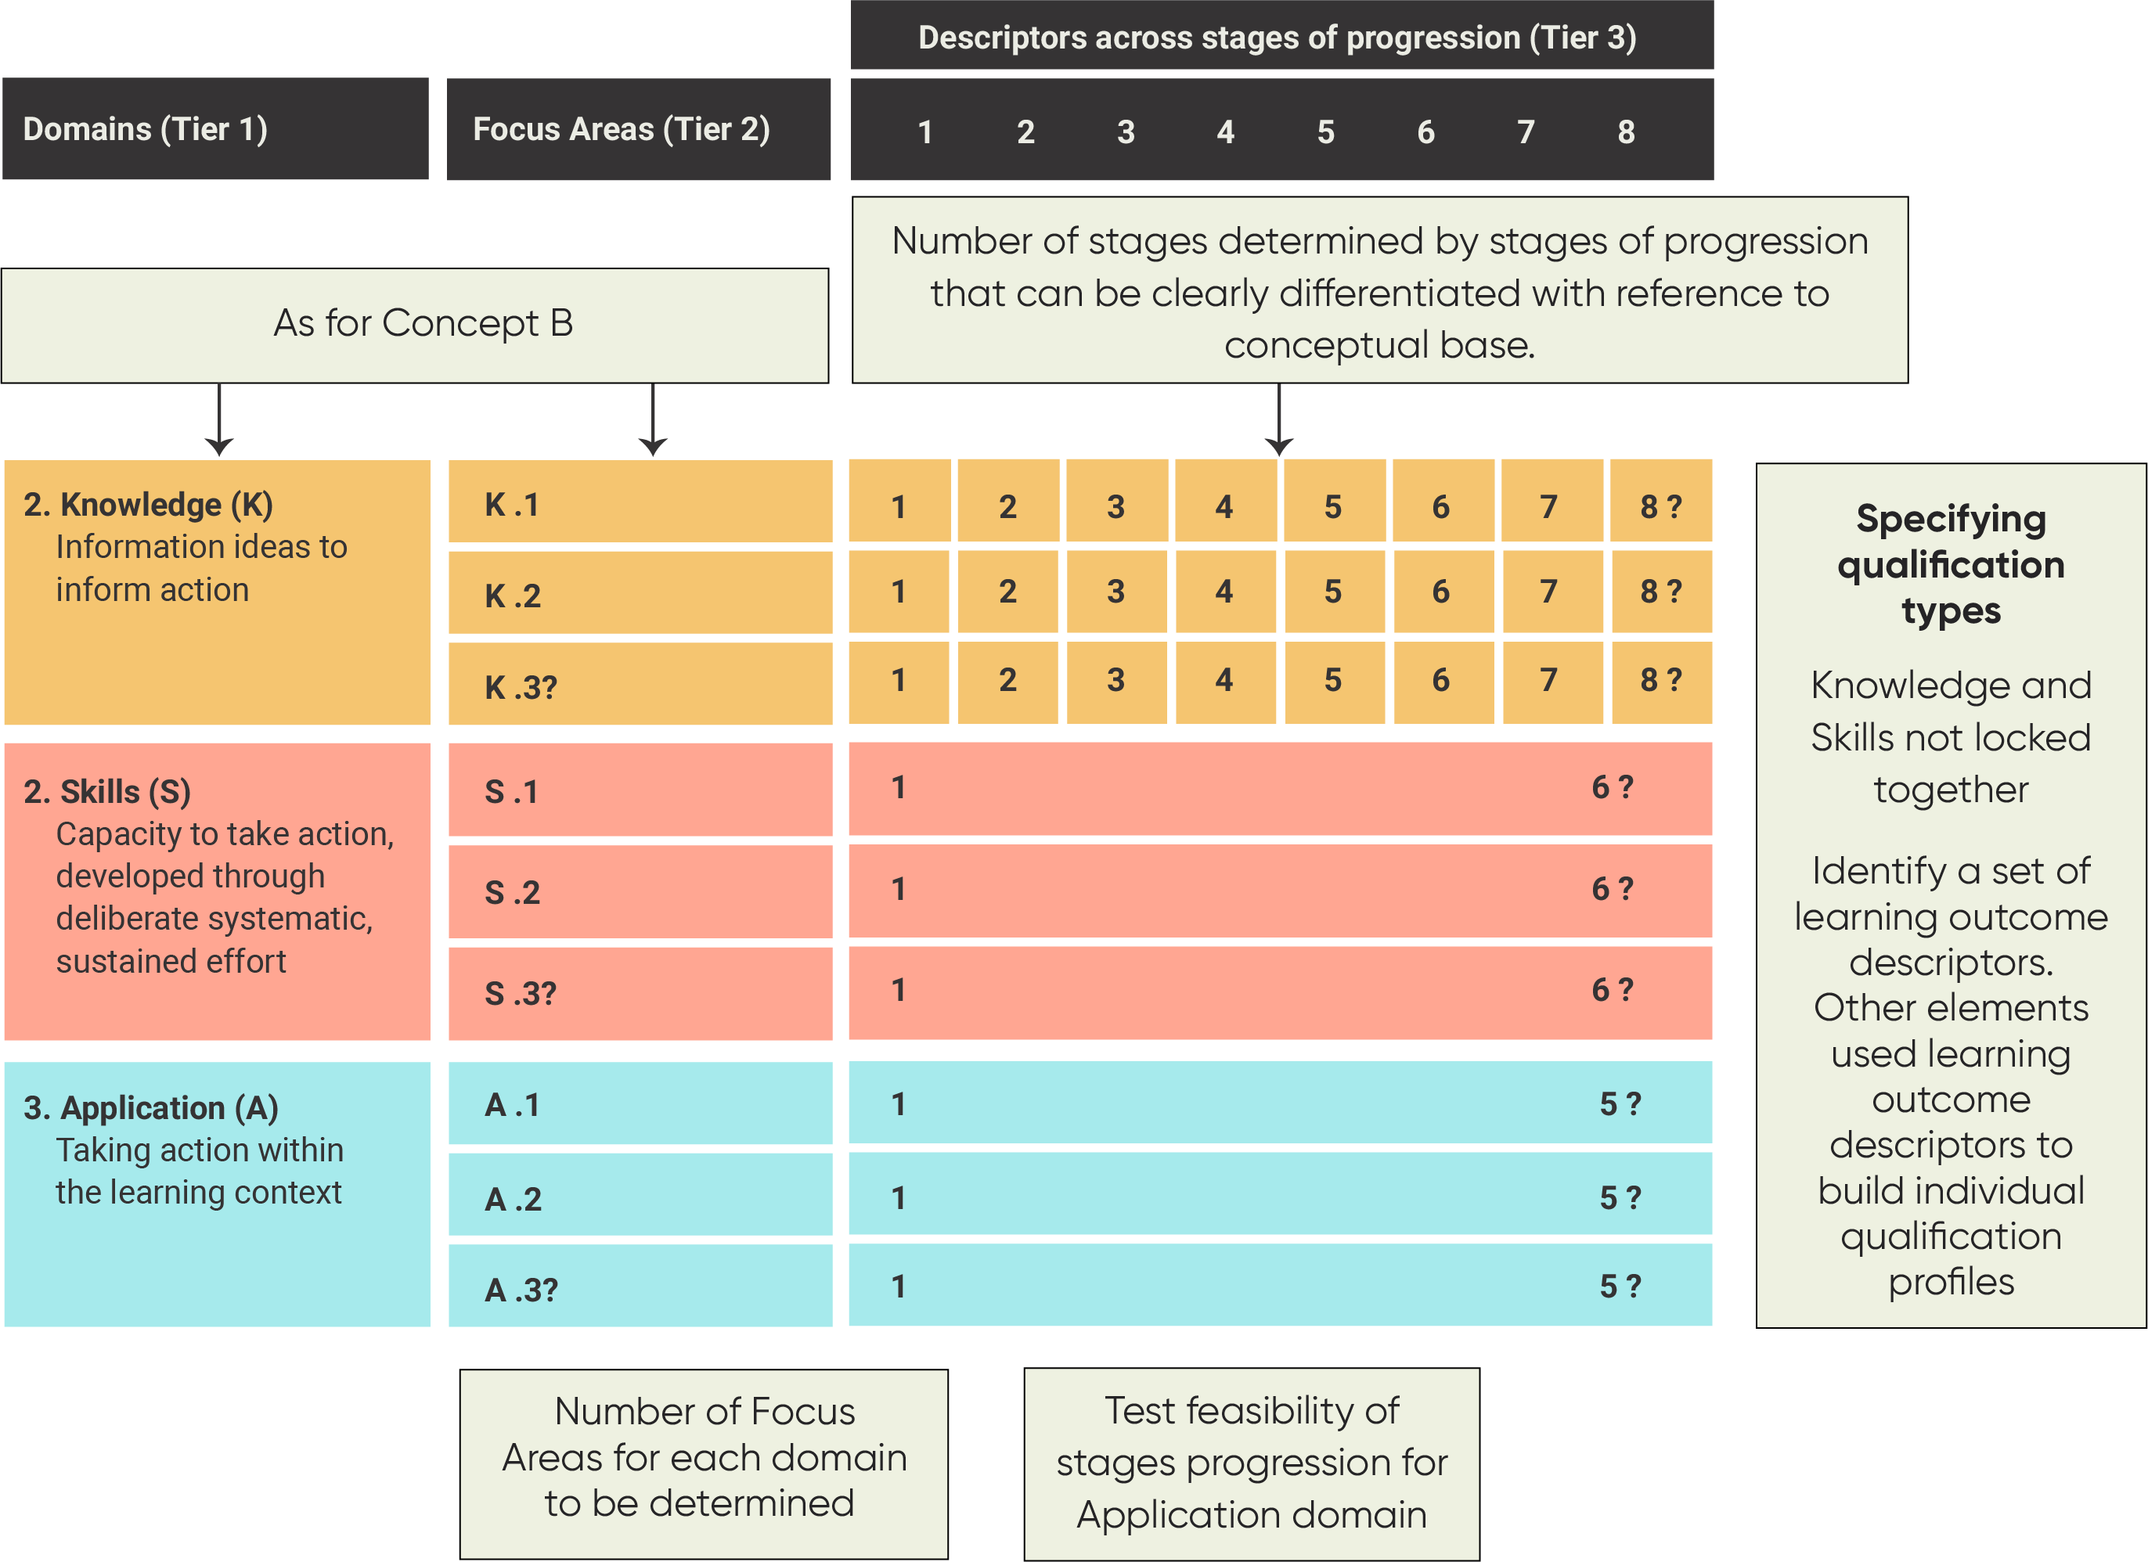
Figure 5.3: Features of Working Model C with trial definitions

Key questions to be considered include:
- Do the initial domain definitions provide an appropriate base for reframing each of the three domains?
- When combined, do they provide an appropriate ‘big picture’ view of the learning that occurs in formal education and training?
- Which themes might reflect a constructivist view of learning and provide a way of differentiating multiple bands?
- How many usefully differentiated bands appear to be possible for each domain?
- What happens when descriptors focus on qualification design features rather than learning outcomes?
- How might either of the models be used as part of a broader specification of qualification types?
Table 5.2 provides a comparison of the two models and the ways in which it was envisaged they might be used as part of qualification specification.

Table 5.2: Summary comparison of Working Models B and C
 | Working Model B  Knowledge & Skills bolted to band | Working Model C  All domains unlocked at level
Structure | - Tier 2 Focus Areas is explicit, with a new AQF taxonomy providing a set of Focus Areas against which learning outcome descriptors are written | - Same as B
Domains | - New definition for all domains | - Same as B
Descriptors | - New descriptors against Tier 2 Focus Areas  - Feasibility of describing qualification design features rather than Learning Outcomes tested | - Same as B
Bands | - Eight bands for both Knowledge and Skills if feasible  - Application might have fewer bands, and/or not be described as a progression | - Eight bands for Knowledge if feasible  - Skills and/or Application might have fewer bands  - Application may not be described as a progression
 | Qualification type specification
Domain links | - Knowledge and Skills ‘bolted to band’ i.e. progression across all Focus Areas assumed to occur to the same degree (as specified by the number of the bands  - Application ‘freed’ | - Domains operate independently of each other
From matrix to specification | - All Knowledge and Skills Focus Areas used in qualification type specification  - Agreements re the Knowledge and Skills descriptors that best reflect expectations about a qualification type  - Application – individual qualifications specifying the band that best reflects the opportunities offered within their courses and the conditions under which graduates have demonstrated the application of what they have learned. | - A small set of Focus areas (potentially from any domain) mandated for a specific qualification type  - Skills – agreements re how many Skills to be actively fostered and assessed in an individual qualification  - Application – agreements about how descriptors might be used if not presented as a progression
Banding | - Some qualification types placed in the same band (as already occurs in the current AQF). | - Same as B

Conclusions
The purpose of the original brief provided to ACER by the Department was to conduct:
- a conceptual analysis of the most appropriate way to develop and present a taxonomy of learning outcomes within a qualifications framework; and
- a technical analysis and revision of the Knowledge, Skills and Application of Knowledge and Skills descriptors used in the AQF.
This section outlines the main conclusions from Part I.

There are significant issues with the current AQF descriptors
The research literature identifies a set of principles and criteria that could be used to assess the effectiveness of learning outcomes when applied to qualifications frameworks. ACER found that the AQF‘s learning outcomes matrix and descriptors do not meet many of these criteria.
In summary, the analysis concludes that:
- While the AQF was introduced in 1995, the learning outcomes statements – as they appear in the current edition – were not introduced until 2011. Their rationale and purpose, and their relationship to the ‘qualification type’ descriptors, is not clear. This has created an awkward relationship between the level descriptors and the more detailed qualification type descriptors.
- There is no explicit rationale, conceptual base or line of sight from the taxonomy to the descriptors.
- The descriptors are, in effect, determined by the scope and spread of qualification types. This locks the framework into a fixed representation of the present scope of qualification types in the post-secondary education and training system in Australia. There is currently no logical way of incorporating any new qualification type (this includes, but goes beyond, micro-credentials).
- The current descriptors do not provide meaningful differentiation across ten levels. The technical analysis suggests that there are, at best, six to eight levels of actual differentiation depending on the domain. Against some elements of the taxonomy there are fewer than six.
- At the domain level, the AQF assumes that progression will occur uniformly and in lock-step in all three domains (they are ‘locked at level’).
- The descriptors adopt the ‘graduate will’ approach. By extension, all qualifications within a type are assumed to be in a position to offer opportunities to develop the knowledge and skills described) and, by implication, to have formally assessed their knowledge and skills. Thus, the descriptors are seeking a meaningful point of differentiation, but are attempting to do so on the basis of what graduates will know and be able to do, regardless of whether there were opportunities offered to develop this knowledge and/or skills (and/or their application) as part of meeting the requirements of the course. This is particularly problematic for the Application of Knowledge and Skills domain because the future application of knowledge and skills is unknown at the point of graduation and cannot be meaningfully described out of context.
Key points are summarised in Table 6.1.
Table 6.1: Key features of the AQF
Features | Current approach in the AQF
Principles / rationale | There is no explicit rationale for the conceptualisation of the construct Knowledge, Skills and Application
Descriptor statements | Outcomes / outputs based on graduate K, S, AKS
Taxonomy | Stated conceptual base (AQF, p. 11) not always evident in the descriptors
Levels | ‘Progression’ descriptors strongly influenced by qualification types (and qualifications)
Domain progression | Assumes uniform progression across all three domains (locked at level)
General capabilities | Some referenced in taxonomy or descriptors, others seen to be province of institutions/providers but rationale unclear

Descriptors of learning outcomes may not be the most effective approach
The review raised questions about the use of learning outcomes statements in the context of a framework that is attempting to differentiate qualification types. Most of the literature on the identification, design and application of learning outcomes relates to their use within individual qualifications, where there is a clear scope and context. This means that learning outcomes statements can be designed and assessed against the aims and specific objectives of that qualification.
It is not possible to specify a set of generic aims and objectives that would apply across all individual qualifications within a qualification type. Therefore, the current AQF descriptors are not anchored to anything concrete. Instead it must make claims that all ‘graduates will’ have demonstrated knowledge and skills as described. Such a statement implies that all qualifications of a particular type have actively fostered and formally assessed each graduate against the learning outcomes statements reflected in the AQF. However, there does not appear to be any explicit statement in the AQF to this effect.
Despite the fact that all national qualifications frameworks incorporate learning outcomes, there are several reasons to explore alternatives to this approach.

The AQF does not provide a basis for effectively differentiating qualification types
As depicted in Figure 6.1, the AQF is used for a range of purposes. To be effective in any of these roles, it must provide a way of clearly differentiating one qualification type from another. The ACER analysis demonstrates that the current construct does not actually do this. This raises questions about its various applications.
Although it was not within the project’s scope to explore each of these in detail, analyses of various international NQFs suggests it is time to challenge the assumption that the AQF provides a basis for international comparisons. While the domain ‘labels’ are similar, the definitions and/or the associated taxonomies can differ significantly. These may reflect different philosophies about learning and/or the unique political agendas that influence the focus and emphasis of each NQFs. The AQF also has more levels (10) covering post-year 10 education and training than many equivalent frameworks. This can also makes attempts to ‘align’ with others quite problematic.

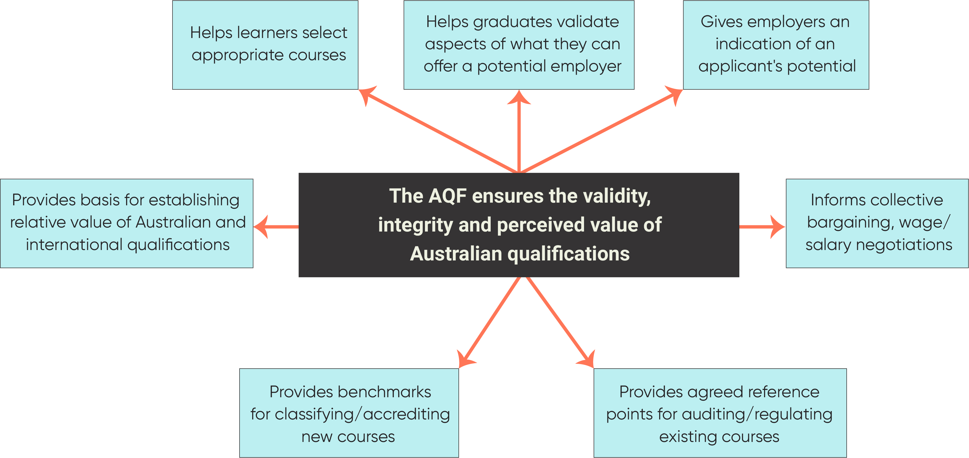

Figure 6.1: The purpose and applications of the AQF

Issues cannot be addressed within the current construct
Perhaps the most significant finding is that the shortcomings with the current AQF cannot be adequately addressed without some form of re-conceptualisation.
The technical analysis uncovered significant issues with the taxonomic structure – some common to all NQFs, some idiosyncratic to the AQF – that cannot be ‘fixed’ through a revision of the language. The general lack of clarity, specific ambiguities and widespread inconsistencies are symptoms only, stemming from the real problem, which is the lack of a sound conceptual base. In the absence of such a foundation, decisions about how to change the descriptors will be arbitrary and may well create as many problems as they solve.
Therefore, ACER cannot recommend a full ‘revision’ of the current learning descriptors, as this will simply compound the problems.

Testing the potential of a new approach
The current construct locks the AQF into the present scope of qualification types. It provides no justifiable basis upon which to incorporate new types or make adjustments to reflect changes in the focus and emphasis of existing types. As formal education and training evolves, the current AQF will have no way of reflecting this. In its current form, it also has the potential to limit such evolution, for the wrong reasons.
A new approach would need to provide a future-focused AQF, while also addressing the immediate issues identified through stakeholder consultation and the ACER analysis.
This new approach would need to be:
- sufficiently generic to capture the broad sweep of qualifications within the qualification type, but also sufficiently detailed to provide a basis on which to design, audit and/or compare individual qualifications, each with its own learning outcomes and assessment criteria;
- sufficiently applicable to the present, while providing the flexibility to include future and emerging qualifications;
- sufficiently applicable to represent interests of governments, students and employers etc., while also providing the flexibility to incorporate future and emerging interests; (this may include shorter-form credentials, and recognition of non-formal and informal learning, as is occurring in some other countries and regions).
There is also potential to:
- reflect similarities and differences between qualifications with professional and occupational outcomes and those with broader educational purposes, including within the same qualification type; and
- show that learning pathways are flexible, but not necessarily hierarchical, while still representing increasing complexity.

The Working Models could be used to develop a new way forward
There is potential to reframe the AQF’s domains, focus areas and descriptors so that they:
- genuinely differentiate qualification types;
- provide common reference points that can be used to inform individual qualification design, accreditation and regulation, international comparison and other functions; and
- provide better signals about the focus and emphasis of qualifications to help prospective students selecting courses of study and to potential employers of graduates.
There is no readymade matrix that could, or should, be appropriated for this purpose. However, although other NQFs suffer from many of the same weaknesses as the AQF, several contain features that could inform the development of a new model, as do learning outcomes frameworks developed for other purposes.
The further development of Working Models B and C could offer a starting point for change. While neither may be ‘the answer’, the process of testing the feasibility of a new conceptual base and different approaches to the specification of qualification types may lead to a viable new approach.

PART II: TESTING THE FEASIBILITY OF ALTERNATIVE APPROACHES

The feasibility study
This section outlines the background, methodology and structure for Part II of the project.

Background
In light of the findings of the conceptual and technical analysis, the project was extended to include Tasks 4 and 5 (outlined in Box 7.1). It was recognised that the work would be highly exploratory. Given the complexity of the tasks, the new territory to be covered, and the very short time frame, it was agreed that there would no expectation that ACER would deliver a fully developed alternative to the current AQF.
Due to the unavoidable time constraints, it was further agreed that the partially modified version of the current AQF (Model A) produced as part of Task 2 would not be further developed at this point in time.
The main focus of the new work is on testing key ideas within Working Models B and C, including:
Box 7.1: Project Tasks 4 and 5
Task 4
Develop two alternative Learning Outcomes Matrices (LOMs) reflecting the same new conceptual base, revised domain definitions and new typology (Tier 2 focus areas) for each domain. The main differences will be in the number of levels/bands described for each domain, and how each might be applied for the specification of qualification types. Provide some example descriptors to indicate how descriptors could operate.

Task 5
a) Develop ways in which the two models might be utilised in the specification of qualification types.
b) Including work undertaken as part of Task 2, analyse and report on potential benefits and limitations of all three models.
- the feasibility of developing a matrix that could be used for the differentiation of qualification types, but was not derived from/driven by historical perceptions of existing qualification types;
- the impact of new domain definitions and the introduction of explicit Focus Areas;
- the number of different stages that could usefully be described against each Focus Area within a domain; and
- the level of detail required to maintain the AQF’s ability to accommodate individual qualifications covering diverse fields, while strengthening its ability to support consistency in those areas essential to maintaining the validity, integrity and reliability of formal qualifications awarded in Australia.
When considering how the new matrices might be used, key areas to be considered included:
- the impact of de-coupling the three domains (i.e. no longer assuming that performance in each of the three domains proceeds at the same rate); and
- the idea that qualification types might be differentiated using only a small set of Focus Areas, with other Focus Areas providing descriptors that individual courses could use to signal their emphasis to prospective students and employers.
The original conception of Task 4 referred to the development of a Learning Outcomes Matrix. However, very early in the feasibility process, a decision was made in consultation with the Panel Chair, to consider the potential to describe qualification design features rather than learning outcome descriptors.

Methodology
The key aspects of the project methodology are outlined in Table 7.1.
Table 7.1: Summary of project methodology
Phase | Actions
Establish role and scope | - Range and type of qualifications to be described confirmed
Define domains and potential Focus Areas | - Further conceptual work to clarify the general role, goals and nature of the instrument being developed, including consideration of the appropriateness, benefits and limitations of describing qualification design specifications rather than graduate learning outcomes
- An extensive review of relevant literature (e.g. re taxonomies/typologies, concepts, principles and models of learning, knowledge, information, psychomotor skills, problem types)
- Consultation with other ACER specialists beyond the AQF project team
 | - Mapping of the Threshold Learning Outcomes (TLOs) developed by a number of university disciplines between 2010–12 (and mostly focused on generic descriptors of TLOs for Bachelor degrees);
 | - The identification of themes with the potential to serve as Focus Areas or to be incorporated into descriptors
 | - Further analysis of other national qualifications frameworks to review the ways in which these themes have/have not been represented elsewhere and to identify approaches and wording that might be useful
Identification of draft Focus Areas and bands | - Testing of provisional domain definitions and themes through the development of scales and draft descriptors across a set of bands (with one intention being to see how many bands could be developed against each focus area)
Testing for consistency | - Analysis of draft descriptors to identify gaps and inconsistencies (to the limited degree possible within the timeframe)
Feasibility assessment | - Feasibility of Working Models A, B and C (and aspects within them) considered
Prototype development | - The development of a prototype with a new conceptual base; working definitions and a draft taxonomy for each domain; and examples of descriptors for selected Focus Areas
Benefits & Limitations | - Potential benefits and limitations of the prototype and the current AQF considered
Conclusions and recommendations

It was not possible to develop all aspects of the prototype. However, it was possible to develop and assess the feasibility of various aspects of each working model and roll these into the prototype with two variations. Having reached this point, it was possible to comment on the benefits and limitations of the initial Working Models and consider how the prototype might be used as part of a broader specification of qualification types.

Structure of Part II
Part II of this report reports on the findings of the feasibility study.
- Section 8 describes the rationale for the domains and focus areas that were developed to underpin Working Models B and C, outlines findings regarding the number of bands and considers the general feasibility of Models A, B and C.
- Section 9 presents the prototype that emerged from the study, and considers ways in which its two variations might be utilised to differentiate qualification types;
- Section 10 provides a brief appraisal of the benefits and limitations of the prototype, compared to Working Model A (modified AQF) or the current AQF without modification.
- Section 11 outlines ACER’s conclusions and recommendations.

Figure 7.1: Part II report structure

Towards a new conceptual base
This section:
- outlines the rationale for, and features of, the new conceptual base underpinning Working Models B and C;
- considers the potential of each model to differentiate qualification types, and the ways in which this might be done; and
- considers the viability of a shift from descriptors focused on learning outcome to descriptors focused on qualification design features.

Role, purpose and scope of the new matrix
It was envisaged that the proposed matrix would operate within the full AQF, providing a common language and reference points to assist with the specification of each qualification type. To do this effectively, it would need to have sufficient detail to make meaningful differentiations across a number of bands. For specification purposes, the AQF would also provide additional information about the requirements of each type. This would be external to the matrix itself and could be changed as required without the need for changes to the matrix itself.
The matrix would also provide the high-level architecture against which individual qualifications could be designed, evaluated and/or compared. A key principle was that it should provide just enough detail to provide useful scaffolding in this regard, without becoming prescriptive and restrictive.
The matrix would be applicable to learning that is facilitated, demonstrated and assessed through formal education and training provided by approved Australian institutions and regulated through state/territory education departments, nationally accredited VET and HE. There was an expectation that the qualifications covered would generally be undertaken by individuals over the age of 15, and would thus incorporate senior secondary education, but not primary, junior secondary schooling, pre-accredited ACE or professional/industry certification.
Currently this scope encompasses Senior Secondary Certificates through to PhDs, but it was recognised that the new matrix should also provide a basis for incorporation of new full qualifications or micro-credentials in the future.
The clear focus on formal education and training helped define the scope and emphasis of the matrix, and influenced the development of domain definitions. As Misko (2008, p.10) observes:
Formal learning, as the name implies, has a highly structured set of learning arrangements … characterised by defined aims and objectives and a recognisable and espoused written curriculum structure …
This type of learning is … associated with identifiable and recognisable educational sectors … Depending on the parent sector, formal training and learning programs are established to deliver a body of general, technical, vocational or professional skills and knowledge.
Successful learning (affirmed by successful performance in tests of knowledge and/or practical skills) may also lead to formal academic or industry qualifications, licences or accreditations. These outcomes may be used to help holders obtain a job, perform a job, change jobs or acquire a promotion … start or progress a business venture or enter further formal studies to acquire further qualifications.
Thus, in formal study, individual qualifications:
- focus on a definable body of knowledge and skills related to a specific field, discipline or industry (‘field’ will be used to encompass all);
- have a clear, stated purpose, which in turn influences the selection of the information, ideas and skills that will become the focus of attention, and the ways in which they are presented, applied and assessed;
- adopt a structured approach, with stated aims and objectives, scope, curriculum and assessment conditions and requirements; and
- award a qualification on the basis of successful performance (determined in a variety of ways).

Rationale
It was agreed with the Review Panel that the names of the three current AQF domains and associated three-domain structure would be retained, if possible. A potential issue with describing key features of formal education and training in three separate domains is that it has the potential to suggest that the domains exist in isolation from the other, even though this is clearly not the case in practice. Figure 8.1 illustrates this interaction, utilising a set of working definitions.

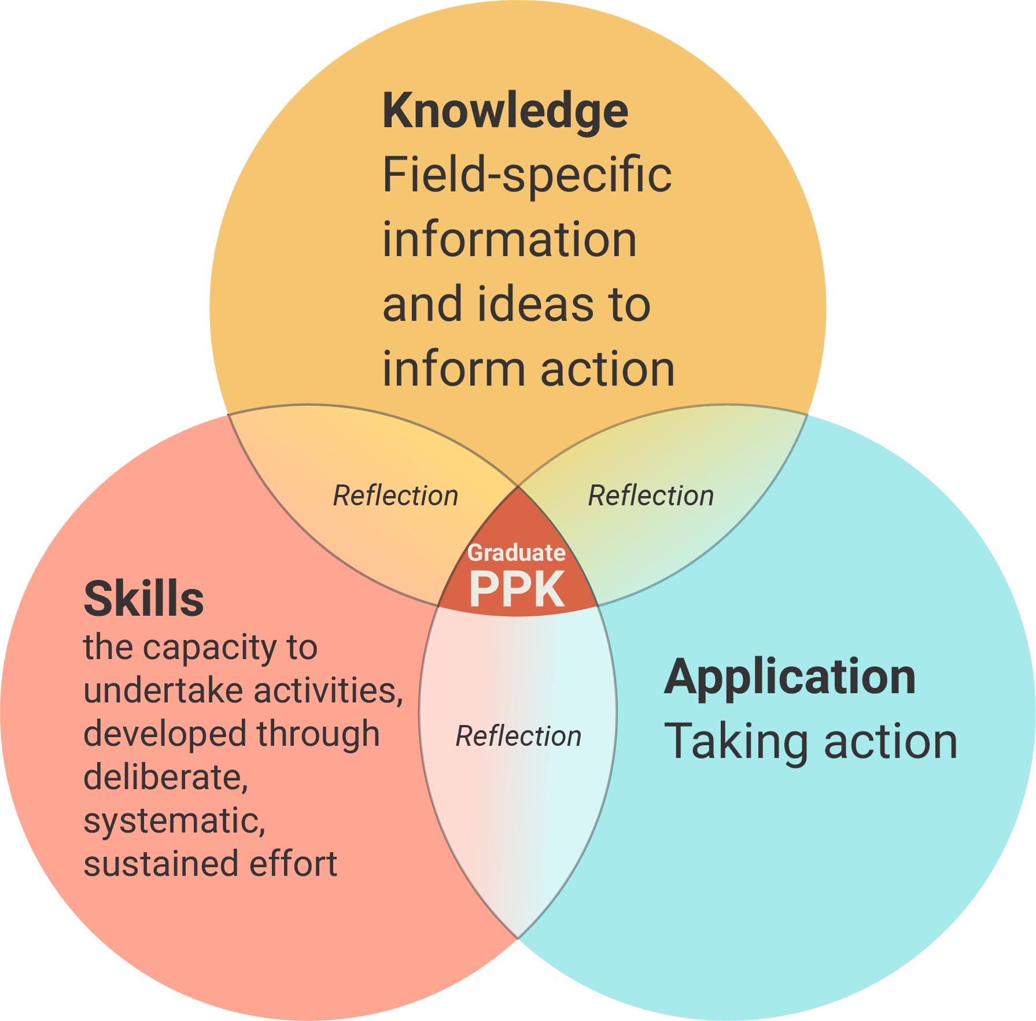
Figure 8.1: An integrated model of Knowledge, Skills and Application

In developing a new conceptual base, we adopted a constructivist approach to learning, and drew on a range of models and theories as we sought to identify appropriate ways of differentiating the three domains so they could be described, while still maintaining a sense of how learning occurs when they are combined in different configurations.
We worked from the principle that the matrix approach would provide a way of zooming in and zooming out. For example:
- zooming in on a domain makes it possible to highlight areas that are considered essential to the fostering of learning within and across qualification types (e.g. the choice of Skills incorporated as Focus Areas sends strong messages that qualifications should actively facilitate their development);
- zooming in on the design features within a Focus Area should provide just enough detail for qualification designers, auditors and others to stay within the scope of the qualification type, and draw attention to features that could be emphasised as part of the learning process;
- zooming out provides a ‘big picture’ focus on the way in which the three domains are best integrated to foster learning.
This being said, it should be recognised that the matrix is an artificial construct, within which the three domains will continually overlap in some way or another. These overlaps should not be seen as a cause for concern, as long as they do not hamper the potential utility of the zoom in feature.

Redefining the Knowledge domain
A key feature of formal qualifications is that they invariably introduce learners to a curated selection of domain-specific information and ideas, e.g. observable facts, theories, principles, models, accepted procedures and short cuts, and established and/or disputed concepts. Eraut and Hirsch (2104) call this ‘codified knowledge’. Butler (1996) calls it ‘public information’ and distinguishes it from what an individual actually ‘knows’, (which he calls ‘personal practical knowledge’ or ‘PPK’). He suggests that an individual’s PPK is developed over a lifetime and incorporates what has been learned in many circumstances, for example through observation and practical experience, informal ‘instruction’ and advice – and possibly through formal education and training (See Figure 8.2). Tacit knowledge is part of an individual’s PPK.
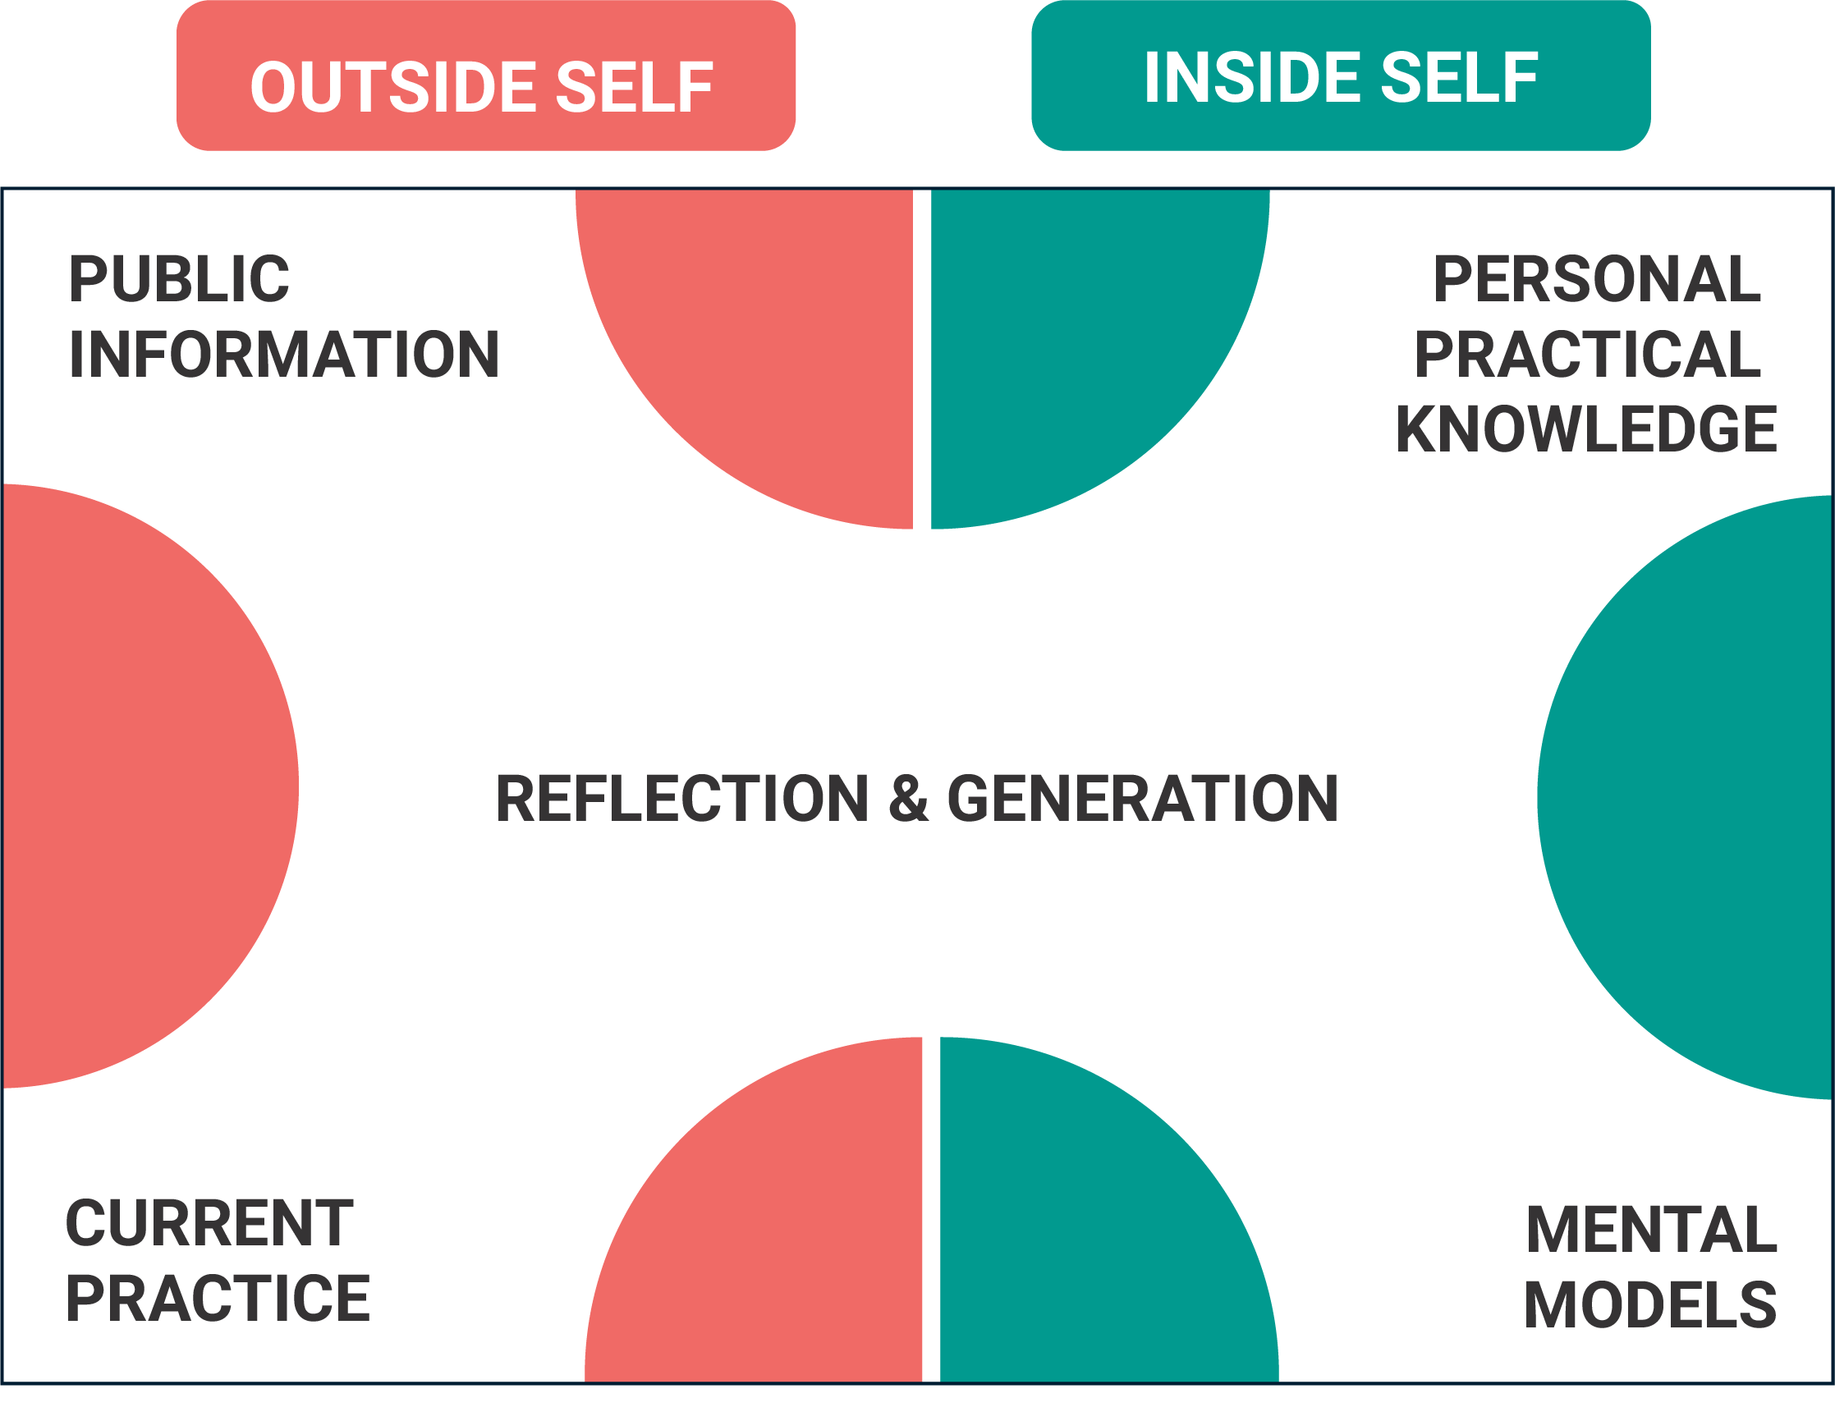
Figure 8.2: The Butler Model of Human Action (1996)
The public information incorporated into a qualification is selected with an end in mind. To contribute to that end, the generic intention is that a learner will engage with, and internalise all, or some, of the public knowledge presented. In a constructivist view of learning, the information and ideas presented in formal education and training are not simply ‘transferred’ to be retained in their original form. Each learner enters study with a personal, unique PPK, and this in turn influences what new information has an impact, how it is linked to prior knowledge, and how it challenges and/or changes their PPK. Thus, only some of the public information presented will be retained long-term, and the very act of ‘comprehension’ is likely to involve changes to the original input.
When seen from this perspective, it would seem that the current AQF definition that Knowledge is ‘what a graduate knows and understands’ is actually making a claim about graduates’ PPK. It is difficult to see how this could be applied generically to all graduates of an individual qualification, let alone to all graduates of all qualifications within a qualification type.
In the new conceptual base we put the emphasis back on the public information because it offers a way of differentiating qualification types. There appeared to be commonalities in the scope and complexity of information and ideas incorporated into qualifications of different types, and a degree of alignment regarding expectations about the ways in which learners undertaking qualifications of different types would interact with, and manipulate, public information.

Knowledge: working definition and focus areas
With the intention of focusing on public information rather than PPK, we proposed a new working definition for the Knowledge domain: Field-specific information and ideas to inform action. Within a construct based on qualification design features, this definition emphasises the choices that are made when an individual qualification is being developed. It provided us with a springboard for the identification of more specific focus areas that could help differentiate the public information of one qualification type from that of another.
Drawing on relevant literature and a review of other frameworks (for example, several related to Information literacy), various potential focus areas were tested to see if they had the potential to be generalisable across diverse individual qualifications. This might also provide a way of grouping sub-sets of qualifications as a ‘type’. The process included the development of many iterations of sample descriptors. The current AQF Focus Areas were also tested as part of this process but were found to be largely unworkable for a range of reasons.
For example, in considering kinds or types of knowledge, we found many different terms and classification systems (e.g. Knowledge might be general, common, concrete, abstract, explicit, tacit, factual, procedural, situational, technical, technological etc.). It was not feasible to allocate particular kinds of public knowledge to any qualification type. A case could be made for qualification types at any band to utilise various kinds. The differences were more likely to be in the complexity of the sources of this information, and in the nature and complexity of tasks involving the manipulation of information and ideas (e.g. evaluating, analysing, synthesising).
See Appendix C for a more detailed analysis of issues with the current AQF Knowledge Focus Areas.
By the end of the feasibility study, three new draft Knowledge Focus Areas had been identified. These had ‘survived’ testing through the development of sample descriptors and benefited from feedback from the Review Panel and members of the AQF Secretariat.
- K1: The scope and complexity of the public information that learners are expected to access and understand as an integral part of undertaking a qualification within a qualification type
- K2: Inquiry, which encompasses the skills to identify, locate, evaluate and acknowledge sources of information
- K3: Information management which encompasses the skills to manipulate information in various ways, e.g. comparing, synthesising.
The draft focus areas are premised on the understanding that individual qualifications within a type will be designed to foster learners’ capacity to:
- identify the public information and ideas they need;
- incorporate aspects of these into their Personal Practical Knowledge; and
- become increasingly adept at evaluating, adapting and applying information and ideas from multiple sources of increasing complexity to tasks of increasing complexity.
In KI, complexity refers to both source (written, oral or visual) complexity and task complexity. Kirsch and Mosenthal (1990) and Kirsch (2001) suggest that a number of variables interact to determine the level of difficulty of information processing tasks, e.g. task complexity increases as:
- the length and complexity of the text increases;
- the type of process required to respond to a question about a text increases in complexity;
- the kind of information required to respond to a question about a text increases in complexity;
- the lack of correspondence between the information in the text and the question increases;
- the degree of inference required increases (cited McLean, Perkins, Brewer and Wise 2012, p.16)
Task complexity is also influenced by familiarity and predictability.
Whatever its complexity, public information is basically inert data until learners begin to manipulate it in various ways (e.g. combine, contrast, identify patterns and inconsistencies). Although it could be argued that the cognitive skills involved in this transformational process could be part of the Skills domain, they have been incorporated into Knowledge for two main reasons:
- they are essential to activating the public knowledge that is presented as an integral part of any formal qualification; and
- expectations about the degree of sophistication of these skills have a significant impact on the scope and complexity of the information, ideas and activities incorporated into a qualification.
Sample descriptors for Knowledge are outlined in Appendix F.

The role of foundation skills
To access and comprehend the public knowledge within an individual qualification, learners need literacy and/or numeracy skills to varying degrees of sophistication. As Eraut and Hirsch (2014, p.11) suggest:
‘the creation and use of codified knowledge … depends on the associated skills of reading, listening, writing and transforming material of differing complexity and content. These skills, and other skills like reasoning or arithmetic, are part of the practical knowledge of formal education, but also play a key role in most working contexts and in everyday life.’
In locating and interacting with public information, technology is also critical. Fraillon et al. (2019) observe:
‘At the conceptual level, CIL [Computer information Literacy]-related skills are increasingly being regarded as a broad set of generalizable and transferable knowledge, skills, and understandings that individuals can use to manage the cross-disciplinary commodity that is information.
‘The possibilities that CIL holds for integrating and processing information are seen to transcend the mere implementation and use of computer technologies within any single learning discipline.’
Despite the close connection with the Knowledge domain, the ACER team made the decision to reference LLN skills, and core skills for work not addressed as part of Skills (see below) in the Essential Capabilities area of the prototype. There were several reasons for this:
- learners require them for all three domains;
- context has a strong influence on the degree of sophistication required; and
- there are existing frameworks that can be used by qualification designers to establish and describe the appropriate levels of sophistication required, e.g.
  - the Australian Core Skills Framework (ACSF) (Australian Government, 2013) provides detailed descriptors for performance in reading, writing, oral communication and numeracy. Its five levels cover the LLN skills relevant to all qualification types within the AQF’s scope, from Certificate I to PhD.
  - The Core Skills for Work developmental Framework (CSfW) offers similar detail and coverage of ten non-technical skills, described in five stages from novice to expert.

Redefining the Skills domain
The current AQF Skills domain is defined as ‘what a graduate can do’. This is then described largely in terms of managing information and developing and transmitting solutions to problems of increasing complexity. Although descriptors begin with a reference to various combinations of ‘cognitive, technical and communication skills’, there is little useful information about the nature of specific skills that might be incorporated under each broad heading, or the levels of sophistication that might be required.
This is not surprising. In 2011, there were no reliable frameworks providing reference points that would help describe such progression. However, since then, the Core Skills for Work developmental Framework (CSfW) (Australian Government, 2013) has demonstrated that it is possible to describe increasingly sophisticated performance in a set of ‘non-technical’ skills that play a critical role in all aspects of performance.
Despite the fact that they are often referred to as ‘transferable’, research into near and far transfer suggests that the degree of transferability from one situation to another depends on how closely the new situation resembles that in which the skills and knowledge were developed and previously applied – and that the resemblance needs to be very close (See Perkins and Salomon, 1992; Misko, 1995; Adey, 1997). Misko’s (1995) comprehensive review of the literature on generic skills suggests that while the purpose of all learning is ‘transfer’, a broad range of factors may affect the degree to which this occurs, or whether it occurs at all. Importantly, Misko found that ‘transfer’ is more likely to occur when individuals learn explicit ‘transferability skills’ incorporating strategies to assist them to adapt, apply and build on what they have learned in other parts of their lives to the new situation.
Carnevale et al (2011, p.9) identify the importance of learning how to adapt and apply these skills within specific contexts.
‘Skills are most easily learned and most useful when they are learned and used in particular knowledge domains. The application of problem-solving skills by a lawyer is substantially different than the application of problem-solving skills by scientists, teachers, and managers, for example.’
The level of skill sophistication required is not necessarily linked to the level of complexity of the ideas and information central to a field, or to an individual qualification. The work of Hager et al. (1996) and recent research conducted by ACER (Perkins and Wignall, 2018, unpublished) has demonstrated that some non-technical skills play more important roles than others in different contexts and are adapted and applied in very different ways. This supports the contention that generic skills are context-sensitive and best developed in context.
This all pointed to a need to allow for greater flexibility for individual qualifications to focus on skills that are ‘mission critical’ to their learning contexts, by unlocking the Focus Areas within the Skills domain itself in some way.

Skills: Working definition and focus areas
As a starting point for reframing this domain, ACER initially redefined Skills as ‘the skills required to take action’. This was progressively redefined to ‘the capacity to undertake activities, developed through deliberate, systematic, sustained effort’.
Unlike Knowledge, this domain did not lend itself to the identification of key themes. Rather it quickly became apparent that the Focus Areas should be a selection of skills, each of which would then need to be described using key themes pertaining to that skill area.
A key question was, which skill areas should be incorporated? Taking our lead from the AQF Review Panel, we looked for skills with characteristics that:
- performance develops over time;
- it is possible to enhance performance within a context through formal teaching and the provision of opportunities for practice;
- it is possible to differentiate and describe stages of performance;
- there is potential to provide explicit formative feedback on performance and rate performance as part of summative assessment.
Used as a starting point, the CSfW focuses on a set of ten Skill Areas that are learnable, assessable and possibly teachable. These were identified through extensive national consultations conducted in 2012 and 2013, which involved employers and employer peak bodies, representatives from across the education and training sectors, government and other interested parties.
A recent ACER review of international approaches to generic skills (Perkins and Wignall, 2018, unpublished) identified a strong alignment between the ten skill areas identified in the CSfW and those that have been identified and encapsulated in other frameworks globally. This study also drew attention to the fact that many of the skills identified as ‘future skills’ (e.g. entrepreneurship) are actually composites, made up of a number of non-technical skills, field specific information and attitudes, and usually require sophisticated performance. These were not considered appropriate for the Skills domain.
Decisions regarding skills for inclusion in the matrix were also influenced by the very nature of formal qualifications. To be successful, learners need various combinations of skills, to varying degrees of sophistication. Four skill areas identified as integral to any kind of qualification were:
- learner self-management skills;
- skills to identify and solve problems and make decisions;
- skills to communicate in the learning context; and
- skills to connect and collaborate in the learning context.
In many fields, but not all, learners also need psychomotor skills. These skills are central to a broad range of vocational qualifications and may be developed and demonstrated to a high degree of sophistication. However, in the current AQF they are given no explicit recognition, being incorporated under a general reference to ‘technical’ skills.
Formal qualifications have a key role in helping learners develop combinations of these skills as part of their courses of study. While learners need these skills to be successful, they do not need them all to the same degree. Nor is the same degree of sophistication likely to be required for all individual qualifications within a qualification type.
The five skill areas outlined above form the basis of the draft Focus Areas for the Skills domain. See Appendix F for sample descriptors for Identify and solve problems and make decisions and psychomotor skills and a partly developed version of learner self-management skills.

Issues for further consideration
A case can be made for the inclusion of learner self-management, problem solving and communication skills, on the basis that they are clearly integral to participation in formal education and training, and in assessment. However, the inclusion of skills to connect and collaborate needs further discussion. Even though it can be argued that learning is socially constructed, and that the skills to connect and collaborate are integral to this, strategies to enhance these skills may not be taught as part of a qualification and, despite an increasing focus on group projects, assessment is more likely to be of an individual rather than of a group. At the same time, these interpersonal skills increasingly are being singled out as critical to all aspects of work and life.
If the prototype is developed further, consideration will need to be given to whether skills to connect and collaborate belong in the Skills domain or should be referenced within General Capabilities. This consideration should take into account the potential for any skills not explicitly described in the Skills domain to be assumed rather than actively fostered within a qualification. There is also the need to consider what message is being sent.

Redefining the Application of Knowledge and Skills domain

The current AQF approach
The current AQF describes Application of Knowledge and Skills in terms of ‘the context in which a graduate applies knowledge and skills’. Application is expressed in terms of the levels of autonomy, responsibility and accountability that graduates will assume in contexts beyond the course of study itself. These contexts may range from the predictable to the unpredictable, and the known to the unknown, while tasks may range from routine to non-routine (AQF, 2013, p.11).
The AQF Review Panel (Australian Government, 2018) questioned several assumptions that appear to underpin this domain, namely that application is uniform across qualification types at the same level; and that autonomy and responsibility increase in lock-step with the level of knowledge and skills.
‘Application of knowledge and skills varies across qualification types even at the same level. It does not necessarily increase in complexity with the level of knowledge and skills, as would be expected in a taxonomy. Level of autonomy is one of the descriptors of application of knowledge and skills. Many people with trades qualifications (Level 3) and Diplomas and Advanced Diplomas (Levels 5 and 6) work with much higher levels of autonomy and responsibility when they graduate than people with degree and post-graduate qualifications (Levels 7 and above).
‘The level of autonomy and responsibility achieved by some qualifications at lower AQF levels appears to be understated in the AQF. This may help to create and perpetuate poor perceptions of the outcomes from some qualifications provided in the VET sector.’
The Panel suggested:
‘It may be necessary to have a means of defining the context for learning outcomes, such as autonomy and responsibility, in the application of knowledge and skills domain of the AQF taxonomy. For example, it may be the case that graduates of qualifications that have occupational outcomes and involve on the job learning, or have professional licensing requirements, may have a greater degree of autonomy in the relevant field after completing their study than other graduates.’
ACER agreed with the Panel’s observations regarding autonomy and responsibility, and also suggested that the current AQF approach was drawing a long bow in (a) trying to generalise about the level of autonomy and responsibility associated with the job role that a graduate of a qualification type might be expected to undertake; and (b) in making claims about the capacity of graduates to perform effectively in ‘professional’ and ‘leadership’ roles, particularly if they have little or no industry experience.

A new working definition
This led to the proposal that this domain should be reframed as, ‘taking action within the learning context’. This would focus attention on learner performance in areas that individual qualifications could genuinely claim to have facilitated and assessed.
Taking action triggers the learning process. As learners select and apply what they believe to be the most appropriate information, skills, strategies and resources for a specific situation, they begin to identify the differences between theory and practice. Self-reflection on what happens when public knowledge and new skills are applied, helps learners assimilate what they have been learning into their PPK, particularly when informed by skilful debriefings and specific actionable feedback (Butler, 1996; Costa and Kallik, 2004). It is also through action that the nature and degree of learning is evaluated and upon which formal assessments are based.
In developing this approach further, ACER utilised Figueiredo’s (2005, p.134) definition of a ‘learning context’ as a ‘set of circumstances which are relevant in a learning event’. Figueiredo suggests that, ‘all kinds of teaching and learning strategies correspond to learning contexts’ (See Box 8.1).

Box 8.1: Rethinking ‘learning contexts’

A classroom, for instance, is a learning context. A Web site offering online courses is also a learning context. Within a classroom, a lecture, a laboratory assignment, a shared project, the discussion of a case study, all are learning contexts. All kinds of teaching and learning strategies correspond to learning contexts. Many of the most dynamic fields of current research in learning and education, like Computer Supported Cooperative Learning (CSCL), Situated Learning, or Learning Communities are concerned with learning contexts. Hundreds of expressions currently used in education – such as project based learning, action learning, learning by doing, case studies, scenario building, simulations, Socratic dialogues, panel discussions, role playing – pertain to the issues of learning contexts. (Figueiredo, 2005, p.134)

This definition has value because it places the focus on what a learner is doing rather than on the physical location of the learning itself.
In formal education and training, taking action might involve, for example:
- implementing standard operating procedures; taking steps to identify and address a client’s needs;
- designing, building/manufacturing, growing/caring for, tending/maintaining, predicting, planning, implementing, marketing, teaching;
- creative interpretation (e.g. of a piece of music, a ballet, an approach to building design);
In academic disciplines in particular, taking action might involve:
- writing an extended text or giving a formal presentation to demonstrate command of learning objectives while cultivating higher order thinking skills;
- conducting original research, to develop new understandings that might inform your own subsequent actions, and/or those of others).
Any opportunity for application is also likely to involve other skills to a greater or lesser extent, e.g.
- Task management skills – the ability to do more than one thing at a time and manage tasks appropriately;
- Contingency management skills; requirements to respond to irregularities and breakdowns in routine within a task, as part of a group activity, job role etc.;
- Job/role environment skills (where relevant) – the ability to deal with the expectations and responsibilities of an external work/community environment.
The situations within which action involve activities and associated problems. These can range from those that are simple and highly structured, with set routines, a limited set of controlled variables and one acceptable right answer, (or ‘known solution’), to those that are complex and ‘loose’, with multiple interacting variables, and potential for widely different interpretations and possible responses.
Within an individual qualification, taking action is also likely to involve any, or all, of the following (once again, at different levels of sophistication):
- assessing the situation to identify priorities and critical issues;
- deciding what action to take (drawing on information and ideas learned during the qualification, combined with PPK);
- deciding which skills and resources to utilise and in what ways;
- developing and evaluating options;
- putting an approach in place; and
- monitoring what happens and making adjustments as required.

Application within the learning context prepares learners for application beyond the learning context
Formal qualifications aim to prepare learners to take action in future contexts. These are likely to be education-oriented (i.e. involve further study in the same field or a different one), work-oriented or personal/ community-oriented. Some qualifications are clearly designed as preparation for specific job roles (e.g. disability support worker), some have a somewhat more generic application (e.g. business courses) and some are more ’general’ again (e.g. arts degrees). Moodie et al. (2015) identified four distinct categories of individual qualifications within mid-level qualification types that spanned VET and Higher Education. This supports our original contention that the focus of the Application domain should be on action within the learning context.
Nothing can fully prepare an individual for real-life contexts, because all but the most simplistic situations will involve uncontrolled, unpredicted and/or unpredictable variables that will affect how graduates of a qualification apply what they have learned.
Within learning contexts, the kinds of opportunities that learners have, to apply what they are learning, can actively assist them to prepare for what is to come. There is an expanding body of literature suggesting that ‘authentic’ learning contexts that seek to create circumstances that resemble real contexts can be beneficial in this regard. Authentic activities and associated problems provide ‘practice fields’, where learners can experiment, make mistakes and learn from them, without the degree of risk that would exist in a real work or community-based context.
Jonassen (2007, p.31) argues that,
‘Virtually all research on situated learning shows that knowledge that is constructed in the context of solving problems in problem-based environments is more meaningful, better integrated, better retained and more transferable … Knowledge that is constructed when solving problems has a different ontological state than traditional lessons’.
When assessment is also ‘authentic’, learners demonstrate that they can adapt and apply the skills and knowledge they have developed to the kinds of tasks and problems they will encounter as graduates. Eraut and Hirsch (2014, p.17) contrast this with assessment that involves ‘artificial and de-contextualized testing tasks’. While these authors observe that ‘there is no one best way for describing complex knowledge in use’, they suggest that observation of performance is one of the main approaches available. In making an assessment, other information also needs to be taken into consideration, including:
- the setting in which [assessment] took place, and features of that setting that affected or might have affected the performance;
- the conditions under which the performance took place, e.g. degree of supervision, pressure of time, crowdedness, conflicting priorities, availability of resources;
- the antecedents to the performance and the situation that gave rise to the performance;
- other categories of expertise that may be involved.
While Figueiredo suggests that the learning location may be of limited importance, this could downplay the potential impact of application that actually does occur in real-world contexts. Where learners are engaged in both on and off the job learning, as in an apprenticeship or internship, Eraut and Hirsch (2014, p.3) observe that:
‘capability is obviously influenced by learning but also current capability influences the ability to learn. Capability is required by job performance but is also developed through job performance. The context in which the individual is working and learning influences how their capabilities are perceived, how they perform and how they learn.’

Application: What employers want to know
When graduates apply for jobs or promotion, and reference their qualifications, employers want to know if they will be able to adapt and apply what they have learned to situations in the employer’s context. While there can be no guarantees in this regard, useful indicators might include information about:
- the contexts within which learners have applied information and skills during their courses;
- the degree to which they were expected to self-manage the process; and
- the contexts within which application of skills and knowledge was assessed.
In VET, many industries consider assessment under real-world – or closely simulated – conditions, to be so important that this is stipulated in the assessment conditions of each unit of the training package. For graduates of other qualifications, evidence of practice and assessment in authentic and/or real-world contexts can be used as an indicator of ‘transferability’, demonstrating that they have adapted and applied learning in situations with additional variables and a level of unpredictability.
However, while individual qualifications may provide this information, it is not possible to make generalisations within and across qualification types.

Application: qualification design decisions
Within individual qualifications, choices about the nature and variety of practice fields and summative assessment contexts will be influenced by a number of factors, e.g. the field and purpose of the course; the number of learners; access to external sites; resources, including mentors; efficiencies; traditional expectations associated with the education and training sector; and the requirements and expectations of industry/professional bodies or government regulators.
Not all qualifications are well suited to, and/or in a position to provide real-world practical experiences as part of the learning process, or in final assessments. Despite employer calls for ‘work ready’ graduates, some qualifications, such as those in the liberal arts and sciences, are designed to introduce learners to the threshold concepts and practices of a discipline. They are more suited to continuing study, (and potential employment in academia), than to direct transfer of course-related knowledge and skills to any specific work or community context (See Moodie et al, 2015, for research which identified four distinct types of qualification within mid-level qualification types offered in VET or HE).
Thus, the ‘practice fields’ and assessment contexts offered by individual qualifications are as diverse as the courses themselves. For example, they may:
- be entirely institutionally/provider-based (including on-line), entirely work-based or community-based, or somewhere in between;
- range from answering simple, highly structured problems with one right answer, to exploring and evaluating possible responses, to complex issues involving multiple variables;
- involve written responses to a scenario with no practical component, or expect learners to respond to unpredictable dilemmas under pressure in role plays and simulations, or in work-like settings with real clients (such as in a school-based café);
- involve institution-based set projects with a clear set of requirements, or challenge learners to identify, organise and conduct their own projects in a work or community setting;
- incorporate structured work placements or be specifically designed to incorporate on-the-job practical experience and off-the-job training (such as in an apprenticeship).

Application: Draft Focus Areas
Drawing on the literature review, ACER identified and tested a range of possible focus areas, including those used in the current AQF (but recast for the new context).
This process proved to be challenging, raised many questions, and led to multiple changes within and across domains. For example, a consideration of the current AQF focus areas of autonomy and responsibility reinforced the need to highlight learner self-management skills within the matrix. These were initially considered as part of Application, then shifted to Essential Capabilities and later moved to Skills.
There were three possibilities for Application focus areas:
- A1 Scope and purpose
- A2 Practice fields
- A3 Assessment conditions.
However, as with the other aspects of the prototype, these will need further development and field testing. In the process, other more effective approaches may well be identified.
- A1 is fairly straightforward and encapsulates generic statements about the nature of activities and associated problems that learners within a qualification type are likely to engage with. These statements are reminiscent of those in the current AQF Skills domain. They are presented across eight bands (See Appendix F for a sample set).
- A2 and A3 are highly experimental and represent a significant departure from what has become the norm for qualifications frameworks. However, they are a first attempt to acknowledge the critical importance of the ways in which learners learn how to adapt, apply and ultimately demonstrate knowledge and skills in action. They are not presented across bands because this would imply a degree of progression that may not be realistic. Rather, they are presented as a menu of options.
Table 8.1 provides an example of the kinds of descriptors it might contain. However, if it is to be developed further it will be most useful if it is developed in consultation with stakeholders.
Table 8.1: Application: A2 and A3 draft Focus Areas and descriptors
 | Application Focus Area 2  Practice Fields |  | Application Focus Area 3  Assessment conditions
 | Individual qualifications provide opportunities for application of field-related information, ideas and skills |  | Individual qualifications formally assess application of knowledge and skills
A2.1 | - within activities and problems with a small number of controlled variables | A3.1 | - in situations that are very similar to those experienced during the learning process
A2.2 | - to activities and problems with a number of controlled variables, intended to reflect aspects of real-world contexts relevant to the course of study | A3.2 | - in controlled situations where a small range of variables differ from those considered during the learning process
A2.3 | - to ‘authentic’ activities and issues involving multiple variables and reflecting real-world situations and associated problems | A3.3 | - in controlled situations where a number of variables are unpredictable and differ from those encountered during the learning process
A2.4 | - through project-based activities involving ill-defined, real-world issues with multiple interpretations explored in context | A3.4 | - through small-scale community/work-based or field/discipline-specific projects
A2.5 | - to activities and problems that arise as part of structured work placements undertaken for short periods of time | A3.5 | - through large-scale, complex community/work- based or field/discipline-specific projects
A2.6 | - to activities and problems that occur as an integral part of a structured on- and off- the-job learning process over an extended period of time | A3.6 | - in on-the-job contexts where some variables are unpredictable and differ from those encountered during the learning process
 |  | A3.7 | - in multiple on- and off-the-job contexts where a number of variables are unpredictable and differ from those encountered during the learning process

The three Application Focus Areas are seen as being independent of each other. However, there is a potentially close relationship between A1 and the descriptors in the Knowledge bands.
A1 has the potential to be used as a differentiator of qualification types. However, A2 and 3 could not be ‘bolted to band’, but this should not decrease their usefulness. If well designed, A2 and A3 could provide information that prospective students, employers and graduates would use and value.
Once agreed upon, the descriptors would provide a common set of reference points that individual qualifications could use to signal key features of the approaches to learning and assessment that are integral to their offerings. This would require AQF guidelines about how the descriptors should be used (for example, it might be decided that choices should be made on the basis of the main emphasis of an individual qualification or, alternatively, that a qualification can select a range of descriptors that cover the different types of learning contents and assessment conditions utilised). Institutions/providers using these reference points would do so knowing that their claims would be auditable.

Determining the number of bands
As part of developing the working models in what later became Part 1 of the project, ACER had proposed the use of the term ‘band’ rather than ‘level’. This was seen to be more appropriate in a model that was no longer ‘locked at level’. The new terminology would also serve to differentiate the new approach from the current one. There was a possibility that it might also reduce the suggestion that qualification types in some bands were somehow of less value than those in others.
One of the intentions of the Feasibility study was to identify the maximum number of bands that could usefully be described against the focus areas of each domain. One of the criteria for the selection of any draft focus area was that it should be ‘strong’ enough to drive a set of descriptors across multiple bands. In our search for a set of appropriate focus areas, we explored a number of different avenues. For both Knowledge and Skills, we found that many themes identified through the literature were unable to ‘hold the line’ across eight bands (and none that did this for more than eight bands) – unless we made very fine distinctions that were in reality of little practical value. Indeed, within the sample descriptors, we acknowledge that there are still some examples of ‘distinctions’ of this kind. However, we believe that with some further work these issues could be addressed.
For potential focus areas in Knowledge, we found it was usually possible to describe design features at each end of the continuum (e.g. for Bands 1 and 2, and for Bands 7 and 8), but far more difficult to make meaningful differentiations in between.
For example, Bennet and Bennet (2008) discuss depth of knowledge in terms of surface, shallow and deep. While the conceptualisation and explanations are compelling, the distinctions cannot be ‘stretched’ to cover eight bands. A consideration of the authors’ definitions suggested that ‘surface’ and ‘shallow’ knowledge could describe the public information utilised in all qualifications from Bands 1 to 6 and, to some extent, in Bands 7 and 8. The authors’ definition of ‘deep’ knowledge described the degree of insight and understanding developed by an expert through extensive reflective practice over many years. This went well beyond the experience expected of someone undertaking a qualification in Band 7 or 8. Therefore descriptors for these bands might most appropriately be described as ‘learning to go deeper’ and ‘getting deeper’.
It was not possible to develop more than six descriptors against any of the three Skills Areas that were trialled. In the various iterations that led to the development of the sample sets outlined in Appendix F, the number of bands moved between five and six several times. As it was not possible to develop samples for two of the proposed Skill Areas within the project’s timeframe, we cannot predict the number of bands for these with any certainty. However, we are fairly confident that all proposed Skill Areas can have at least five bands, and that six is quite possible.

Feasibility of the working models
On the basis of the previous work done on Model A, and the development of the conceptual base for Models B and C, it was possible to rule out both Models A and B.
- Further exploration of the current AQF Focus Areas within the new construct had confirmed the difficulty of using them to describe focus areas across 10 levels, or even across eight, thus confirming earlier findings regarding Model A.
- It had not proved possible to describe any of the Focus Areas in Skills across more than six bands. This ruled out Model B, where Knowledge and Skills were to be bolted to band – unless the number of Knowledge bands was reduced to six, which was not the preferred position of the Review Panel.
A further complication for Model B was the implication that all Knowledge and Skills focus areas would be bolted to band. There was no evidence identified to suggest that progression in each of the Skills Focus Areas was likely to occur at the same rate, or that all individual qualifications within a qualification type would be well-suited to fostering the development and demonstration of all focus areas. However, the main features of Working Model C did appear to be feasible. Therefore, this model was used as the foundation for the development of two slightly different prototypes. These are outlined in Section 9.

Feasibility of a shift to qualification design specifications
There is a logic to the proposal to move from learning outcomes descriptors to qualification design features. The literature refers almost entirely to course-related learning outcomes, and highlights the following three basic requirements.
- All learning outcomes must be assessable and measurable.
- Learning outcomes collectively lead to achievement of the aims of the program.
- There should be a sufficient number to secure adequate information for comprehensive assessment.
Any qualification that adopts a learning outcomes approach also has an explicit aim and associated objectives related to some aspect of a defined field of study. Aims and objectives are a necessary pre-condition for the design of learning outcomes that are measurable and assessable within the context of that program, and also impact on the ideas and information, skills and practice fields that will form the basis of instruction. In practice, the majority of learning outcomes descriptors will be specific to the unit/course, particularly those that encapsulate expectations about a learner’s understanding of the domain-specific information and ideas that have been presented.
In contrast, within qualifications frameworks, a statement of purpose can only be crafted for a qualification type. Learning outcome descriptors must therefore try to capture a set of common outcomes from diverse qualifications within the type, irrespective of field. Thus, such statements can only be ‘high-level’ and context-free. Yet, in the AQF, for example, the statements themselves are couched in terms of ‘Graduates will …’. This assumes that:
- it is possible to identify single statements that apply across all qualifications of a particular type;
- each individual qualification within a type is in an appropriate disciplinary or educational context to help learners develop and demonstrate ‘knowledge’ and ‘skills’ that can be equated across the type; and
- graduates have been explicitly assessed in these areas, and met or exceeded the requirement.
Thus, it could be argued that the descriptors in the AQF, and other NQFs, are attempting to differentiate a highly diverse set of graduates – not qualification types – from one level to the next.
This is problematic. Therefore, ACER had hypothesised that the design features approach might provide a way to focus attention more clearly on factors that differentiate qualification types. The impact on the design of focus areas and descriptors was further explored throughout the feasibility study.
Descriptors were originally developed in both formats. However, we found that the focus on qualification design features made it easier to tease out, describe and ultimately differentiate focus areas in each domain. Once these design features were written it was much easier to apply them to specific examples of qualifications within a type. It was also easier to write context-specific learning outcomes statements that where consistent where they needed to be to conform to type, and be tailored in other respects. In effect, the qualification design descriptors were acting as the bridge between Working Models C and individual qualifications.
However, if this approach appears to be a bridge too far, the sample descriptors we have developed as examples could be converted to learning outcomes statements relatively easily. In fact, we have experimented with the presentation of psychomotor skills so that the statements in each box appear to be learning outcome statements. This might be an approach worth pursuing further.

Key messages
- The development of a matrix to differentiate qualification types is not an exact science. While there is no single source of evidence to inform the process, the feasibility study suggests that it should be possible to draw on the literature to develop a contemporary and coherent conceptual base.
- Although not fully developed, the working definitions and draft Focus Areas could provide the scaffolding for consultation and further refinement. By the very nature of the process, it is likely that this will provide insights and improvements that will enhance the current models.
- Of the three models originally proposed, only Model C appeared to have the potential to be used in the differentiation of qualification types.
- The shift to qualification design descriptors could provide the missing link between the AQF and individual qualifications, facilitating consistency where this is important, while supporting flexibility as required.

The prototype and qualification type specification
Following feedback from the Review Panel, ACER developed a prototype based on Model C. This was followed later by a slightly different version which shares the same conceptual base, but with additional Focus Areas in the Application domain.
This section provides general comments on the conceptual base, key features of the matrix and a consideration of how the prototype variations might be used for qualification type specification.

Conceptual base
The prototype is based on the principle that the three domains and the Essential Capabilities interact to foster learning, with application playing a key role throughout. As depicted in Figure 9.1, in practice, these elements are almost inextricably entwined.
Figure 9.1: An integrated view of the prototype’s elements
However, in the design of formal qualifications, attention is paid to each element – to the selection of public information and skills to be fostered, to the practice fields within which they are applied, and to the conditions under which they are assessed. Explicit attention to each of these areas, as well as a consideration of how they interact with each other, maximises the potential for learning.

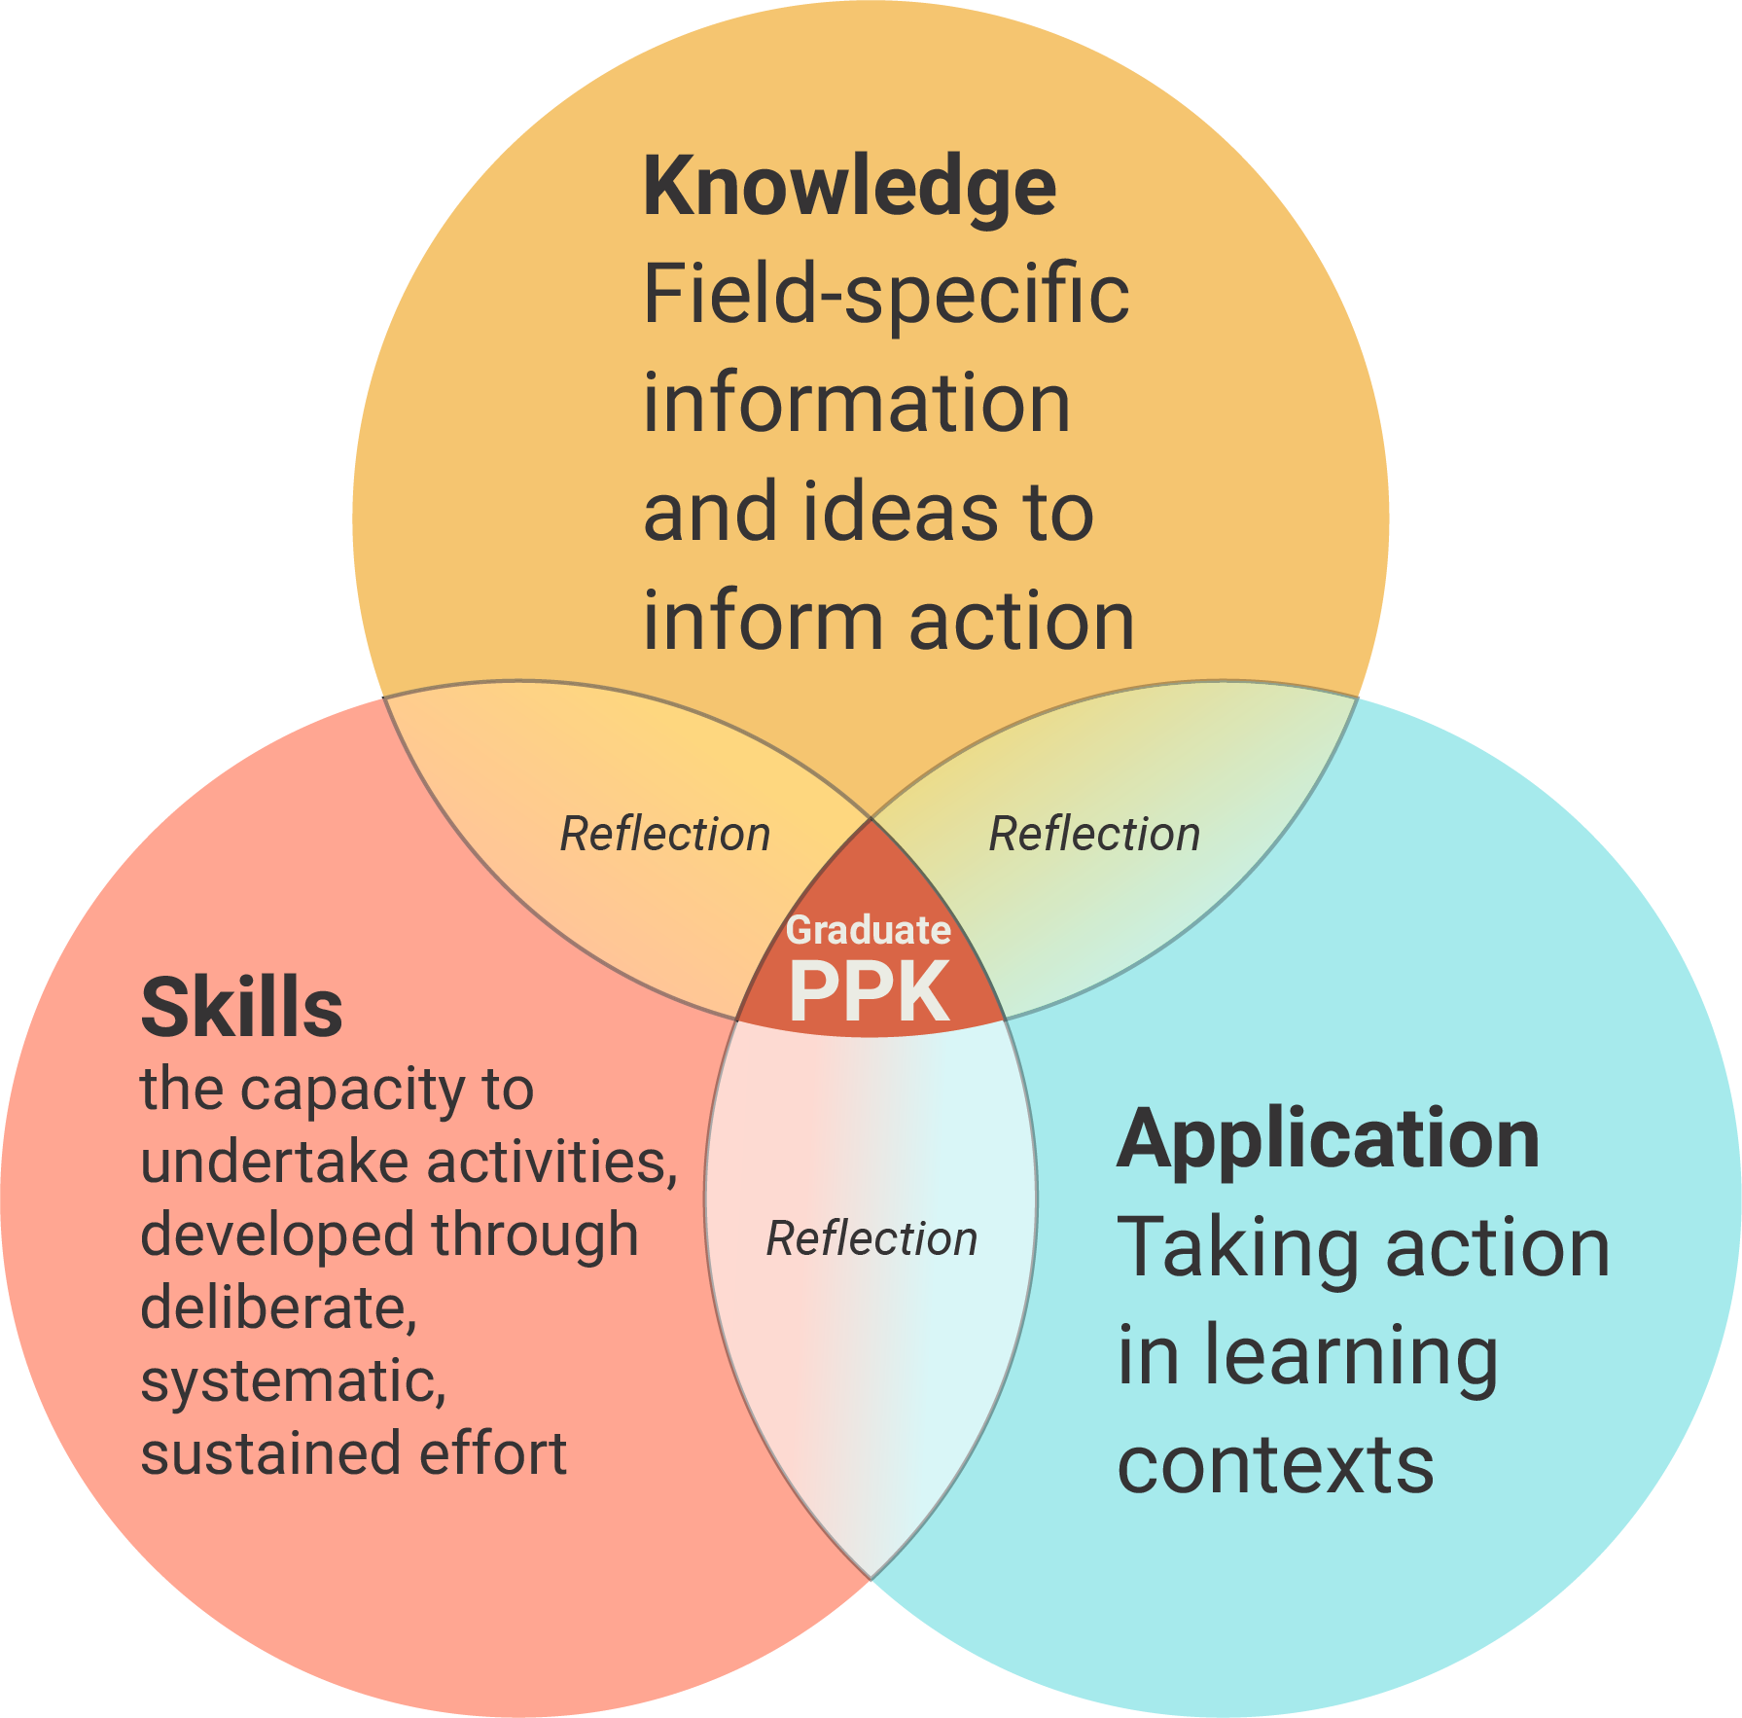
Figure 9.2: Prototype domains operate individually and collectively
The AQF qualification design matrix provides a way of teasing out these individual domains, with detailed descriptors that make it possible to ‘zoom in’ on specific areas as required.
The prototype matrix reflects four major conceptual shifts, which are a move from:
- a framework that is strongly influenced by perceptions of existing qualification types to one that provides a set of independent reference points;
- descriptors focused on graduate learning outcomes to descriptors of qualification type design features;
- specifying qualification types using all descriptors across three domains ‘locked at level’, to differentiating qualifications on the basis of a small set off design features; and
- describing universal generic future contexts, within which context-specific information, ideas and skills will be applied, to a focus on application within qualification learning contexts.

The prototype matrices: key features
The two prototypes variations incorporate the same domains, focus areas and descriptors, except in regard to Application (see Figure 9.3).
Figure 9.3: Prototype with variations

Domains and Focus Areas
The domains and focus areas are as described for Model C in Section 8 (see Table 9.1). It is important that these are seen as work in progress, not as a completed product.
Table 9.1: Prototype working definition and focus areas
3 | Working definition | Draft Focus Areas
Knowledge | The information and ideas needed to inform action | K1. Scope and complexity
 |  | K2. Inquiry
 |  | K3. Information management
Skills | The capacity to undertake activities, developed through | S1. Learner self-management
 |  | S2. Psychomotor
 |  | S3. Identify & solve problems and make decisions
 |  | S4. Communicate in learning contexts
 |  | S5. Connect & collaborate in learning contexts
Application | Taking action in learning contexts | A1. Scope and purpose (variation 1 & 2)
 |  | A2 Practice fields (variation 2)
 |  | A3 Assessment conditions (variation 2)

The draft Focus Areas have been selected for a combination of reasons. Each of those in prototype variation 1:
- is highlighted in the relevant literature relevant to each domain, and/or to learning more generally;
- can be described across a continuum with describable ‘change’ points; and
- is ‘strong’ enough to support the differentiation of multiple change points.
A2 and A3 meet the first criterion, but do not lend themselves to a continuum approach because the factors involved in the selection of practice fields and assessment conditions vary widely across fields.

Different but perhaps not so different?
Although it reflects a reframing of the three domains, it is important to note that the prototype incorporates many aspects of the current AQF, albeit in different configurations, e.g.
- the three domain labels have been retained, although Application has been shortened;
- the focus areas that were supposedly part of Skills are now explicitly described;
- the emphasis on ‘doing’ that had been the centre piece of Skills has become the emphasis of Application.

Using the prototype to differentiate qualification types

A focus on qualification design features
The sample descriptors are written as qualification design features. When used as differentiators of qualification types, this places the onus on the designers of an individual qualification to ensure that it actively reflects the specifications. Each qualification can then develop learning outcomes statements or competency statements specific to their aim and context, but with a direct line of sight back to the AQF (See Figure 9.4).
Figure 9.4: AQF qualification design features and context-specific learning outcomes

A perception-changing activity
ACER envisages that the prototype descriptors (when further developed and refined) would be used by a designated body/group of stakeholders as a common language and set of reference points for the specification of qualification types. This process could help build a greater appreciation of the important roles played by different qualification types, and perhaps begin to address any lingering historical perceptions that some qualifications are of greater worth than others.

Differentiation only needs a small set of descriptors
We suggest that differentiations can be made without needing to use all of the domains, focus areas and associated descriptors. If this principle is accepted, it provides a way of identifying and agreeing on those features that are critical to the determination of a qualification type and the maintenance of the validity and integrity of the Australian qualification system. These are the areas where consistency across diverse individual qualifications really matters. At the same time, it allows some flexibility where this really matters – and acknowledges this. Although this appears to be a major departure from the current situation, it is important to note that it is not actually changing anything. The ‘locked at level’ approach in the current AQF is basically a pretence.

There are several ways in which descriptors could be used as differentiators
As currently envisaged, any of the Focus Areas and descriptors except A2 and A3 could be used to differentiate qualification types, although some may lend themselves to this more than others.
As the three domains are not ‘bolted to band’, decision makers could differentiate one qualification type from another in a number of different ways. Table 9.2 outlines three of these with some observations.
Table 9.2: Using the prototype to specify qualification types
 | Possible approaches | Example | Observations
 | Designate: | Qualification Type X must reflect:
a | all Focus Areas of one band within each domain | Knowledge (K) Band 4  All Skills (S) Band 3  Application (A) Band 3 | Assumes all skills required AND to same degree of sophistication across diverse qualifications  Could reproduce issues with current AQF if the focus is on matching band numbers rather than selecting best descriptor
b | one band for K  one band for A  a range of bands for S | K Band 4  A Band 3  S Bands 2–3 | Allows for some differences in degrees of sophistication but does not address variation in actual Skills requirements (especially psychomotor)
c | one band for K  one band for A  a range of Focus Areas & bands for Skills | K Band 4  A Band 3  S 3 Focus areas at Bands 2–3 | Realistic, flexible – Allows for a ‘spiky profile’ within Skills  Still sets some minimum expectations for all domains, but does not use all Focus Areas of descriptors

There is potential for the bands in Application A1 ‘Scope and purpose’ to align with those in Knowledge, but this would need to be tested further.
As currently envisaged, the Focus Areas of Knowledge are seen as an integrated whole but, due to the design of the Skills domain, the Focus Areas could be ‘split’ and managed in various ways.
Treating each Skills Focus Area individually, and allowing some room for individual qualifications to nominate those skills that are most pertinent to their courses, would recognise:
- that individual qualifications cannot, in reality, actively foster and assess all types of skills that might be described in the AQF Skills domain; and/or
- that any or all of these skills may not be required to the same degree of sophistication in all individual courses within a qualification type.

The Application variation – A2 and A3
Although not all Focus Areas and associated descriptors would be mandated, those that are not would not be de-valued. This is particularly relevant to the A2 and A3 Application Focus Areas, which have the potential to become highly visible signals:
- to prospective students about the emphasis and opportunities provided by different courses; and
- to potential employers of graduates regarding what these graduates have demonstrated they know and can do, and under what conditions.
If further developed, these two Focus Areas could be used as a nationally agreed set of descriptors. This has the potential to improve transparency, helping prospective students choose between courses of study, and providing employers with the kind of information they have been asking for.

Using the new matrix within individual qualifications
If a new matrix incorporating features of the prototype were to be introduced, qualification designers could use it as a reference point, as outlined in Figure 9.5. These reference points could be provided to those accrediting or auditing the qualification. If the matrix incorporated A2 and A3, references to descriptors could become standard reference points incorporated into qualification course outlines and awards.

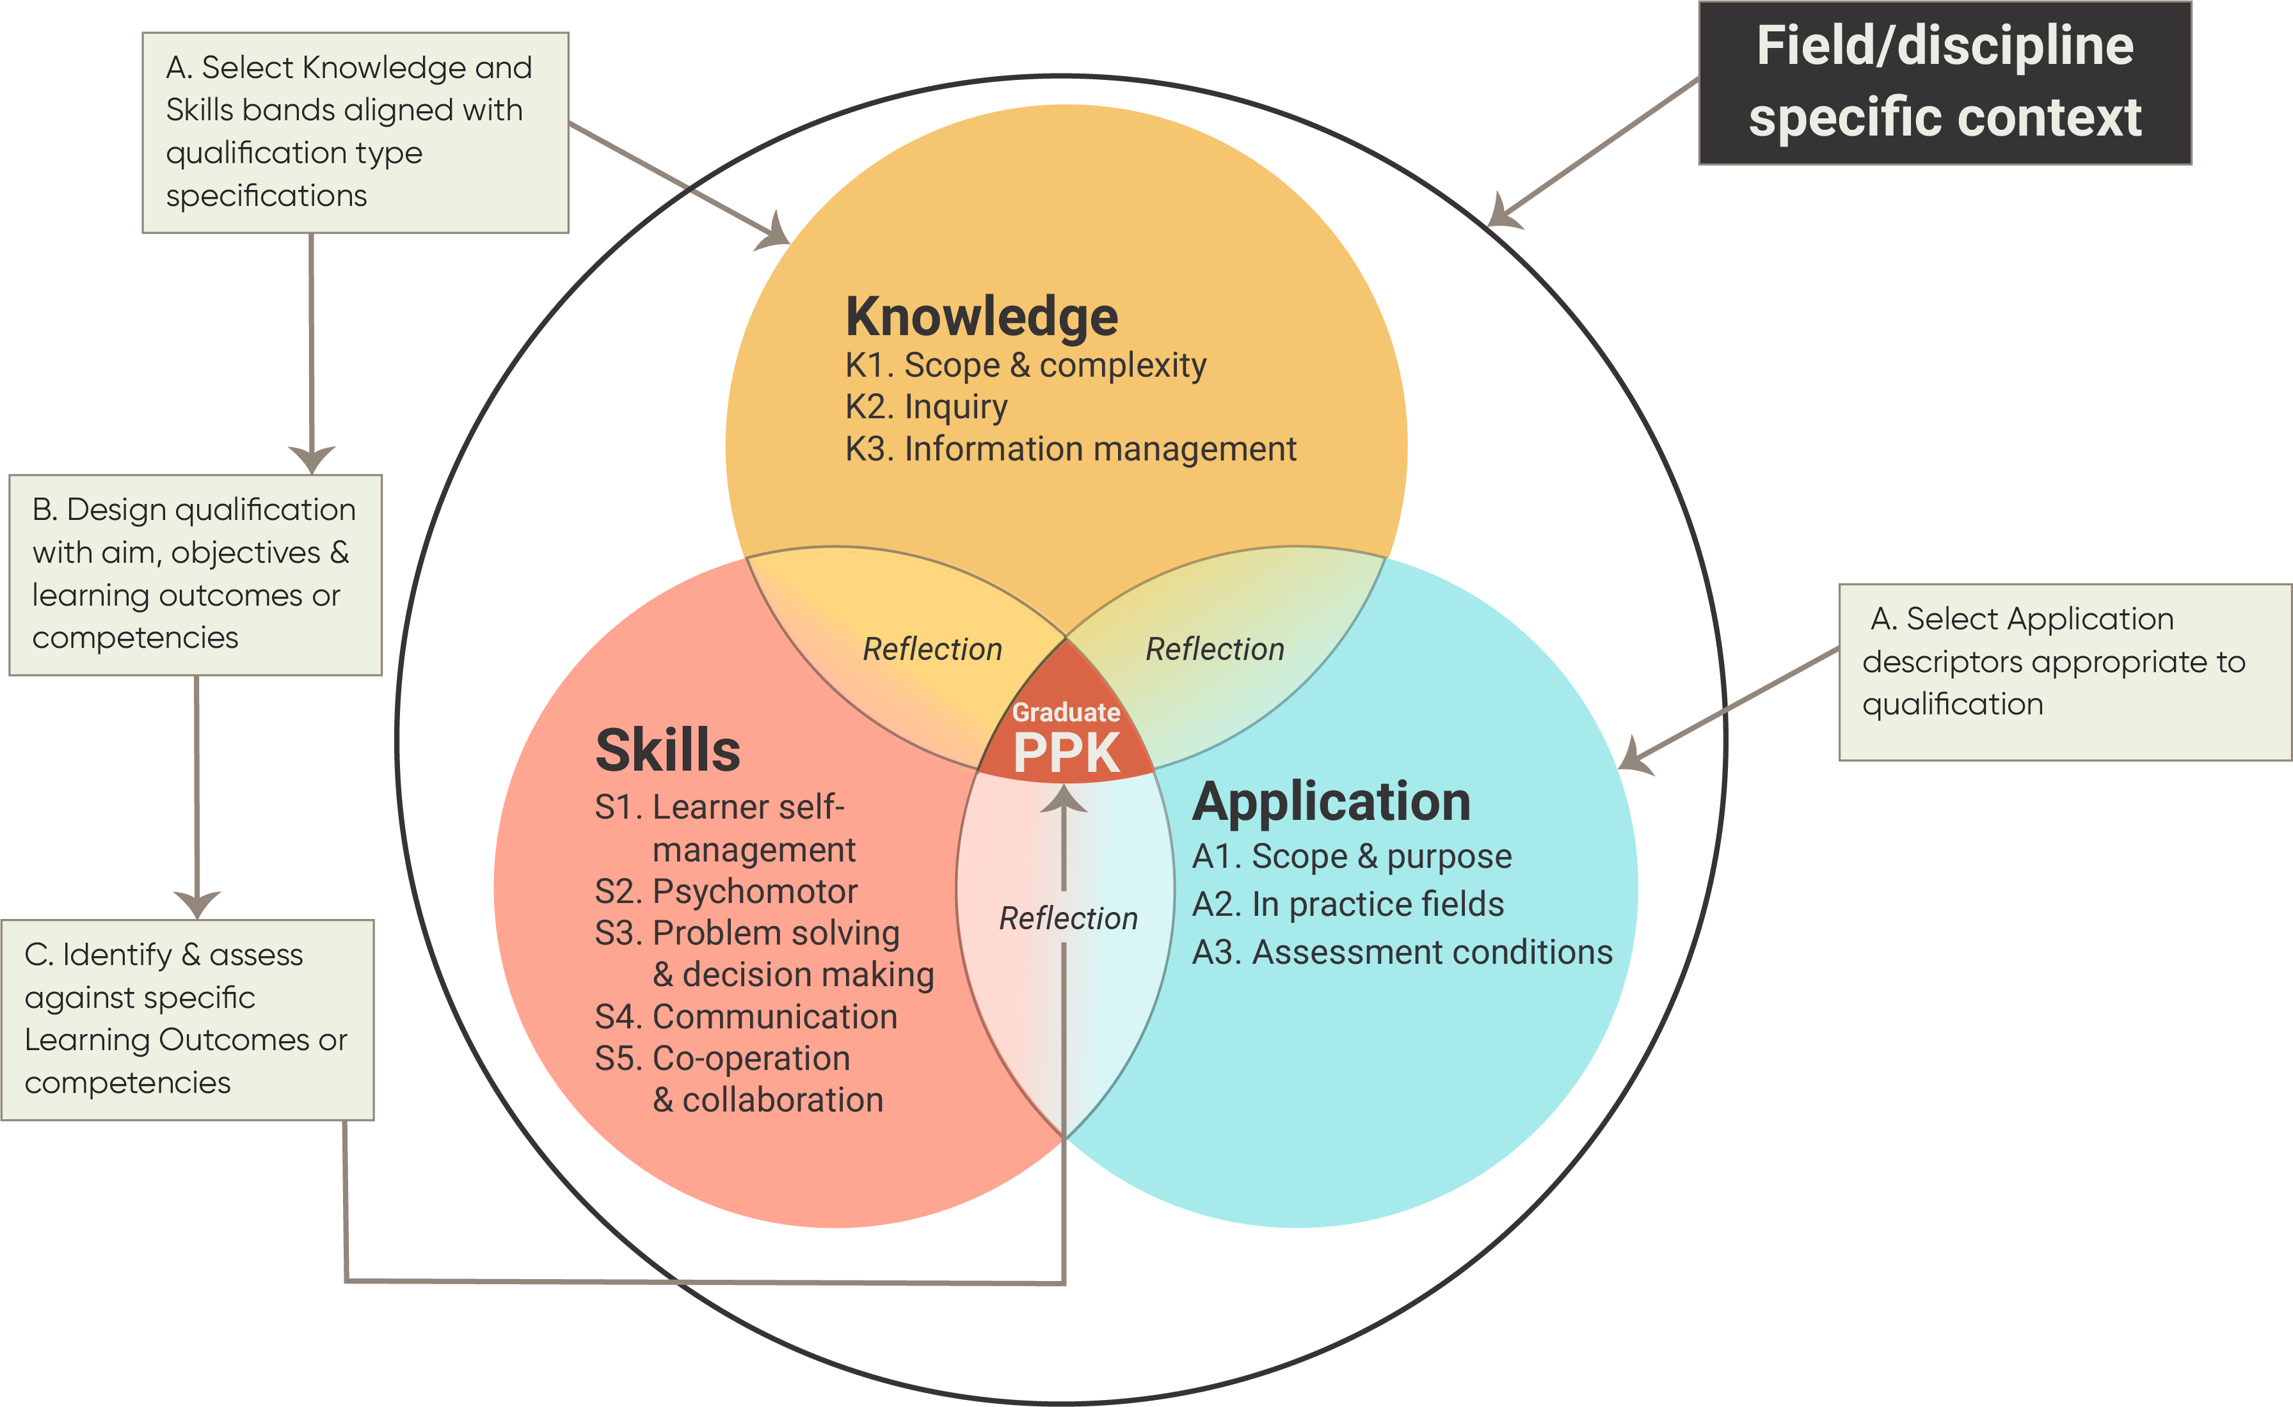

Figure 9.5: Designing qualifications using prototype descriptors

The prototype addresses many current AQF issues
Although only partially developed, the prototype appears to have the potential to address a number of issues with the current AQF that were raised by stakeholders. These are outlined in Table 9.3. Although the original issues are described in relation to learning outcomes descriptors and levels, the general issues are the same.

Table 9.3: The prototype: Potential to address broader issues identified as part of consultations
 | Issues identified by the AQF Review Panel | Current AQF | Prototype
1 | How to balance learning outcomes for qualifications with professional and occupational outcomes with learning outcomes for qualifications with broader educational purposes | ✗ | ✓
2 | How to reflect the contextual nature of some descriptors | ✗ | ✓✓
3 | How to show that learning pathways are flexible and not hierarchical  while representing the increasing complexity portrayed in a levels-based qualifications framework | ✗ | ✓
4 | How to provide flexibility for future change in the types of learning outcomes that will be valued by employers, students and providers | ✗ | ✓✓
5 | How to encompass learning outcomes that can be provided through both full qualifications and shorter-form credentials, as well as through formal, non-formal and informal learning. | ✗ | ✓✓
6 | Reducing duplication and length | ✗ | ✓?

Key messages
- Formal learning involves a constant interplay between many elements, some of which are encapsulated in the prototype. Although these elements are inextricably intertwined in practice, in the design, delivery and assessment of formal qualifications, attention is paid to each in an effort to maximise the potential for learning.
- The prototype offers a blueprint for a practical matrix that will facilitate teaching, learning and assessment within individual qualifications, while also providing the scaffolding that enables the AQF to achieve its central purpose – to effectively differentiate qualification types.
- The prototype describes Knowledge, Skills and Application across multiple bands, against a set of focus areas that could be used in different configurations to differentiate one qualification type from another. These Focus areas have been selected because they appear to be integral to formal learning and assessment, and almost all can be described across continua with describable change points.
- The Focus Areas A2 and A3 could be seen as the most significant of the proposed departures from the norm. However, if further developed in conjunction with stakeholders, they have the potential to become a valued way of providing information about the learning contexts and assessment conditions involved in individual qualifications.
- Although it reflects a reframing of the three domains, it is important to note that the prototype incorporates many aspects of the current AQF, albeit in different configurations.
- The prototype appears to have the potential to address identified issues with the current AQF descriptors. It could also go some way to addressing a number of the broader issues with the current AQF that were raised by stakeholders.

Comparing current and alternative approaches
In this section, we consider the potential benefits and limitations of the various models that have been explored as part of this project.

Potential benefits and limitations for stakeholder groups
Parts I and II have resulted in the assembly of three working models for further testing and development. In Figure 10.1, these are intentionally positioned on a continuum of change.
An appraisal of each is conducted below to identify both benefits and limitations for a range of stakeholder groups, with a caveat on the assumption that users of the AQF do so for different and diverse purposes. The effect of any change will register on a continuum of direct to indirect, depending on the stakeholder group. While the descriptors perform an important function, only a minority of stakeholders of formal education and training in Australia need to drill down into the technical detail of each descriptor. Even fewer need to do so across all bands.
Several groups will be indirectly affected by AQF decisions, most noticeably students and individual employers. Such groups are unlikely to pay attention to the detail of the AQF (or even know it exists). Nevertheless, it is important that these indirect beneficiaries of an effective AQF are considered as part of this discussion.

Figure 10.1: Three Working Models
Working Model A  (modified current AQF) | Working Model B  (new conceptual base, Knowledge and Skills locked at level) | Working Model C  (new conceptual base, unlocked at level)
- Tier 2 Focus Areas will be made explicit, with the existing AQF taxonomy being ‘revealed’. | - Tier 2 Focus Areas is explicit, with a new AQF taxonomy providing a set of Focus Areas against which learning outcome descriptors are written.  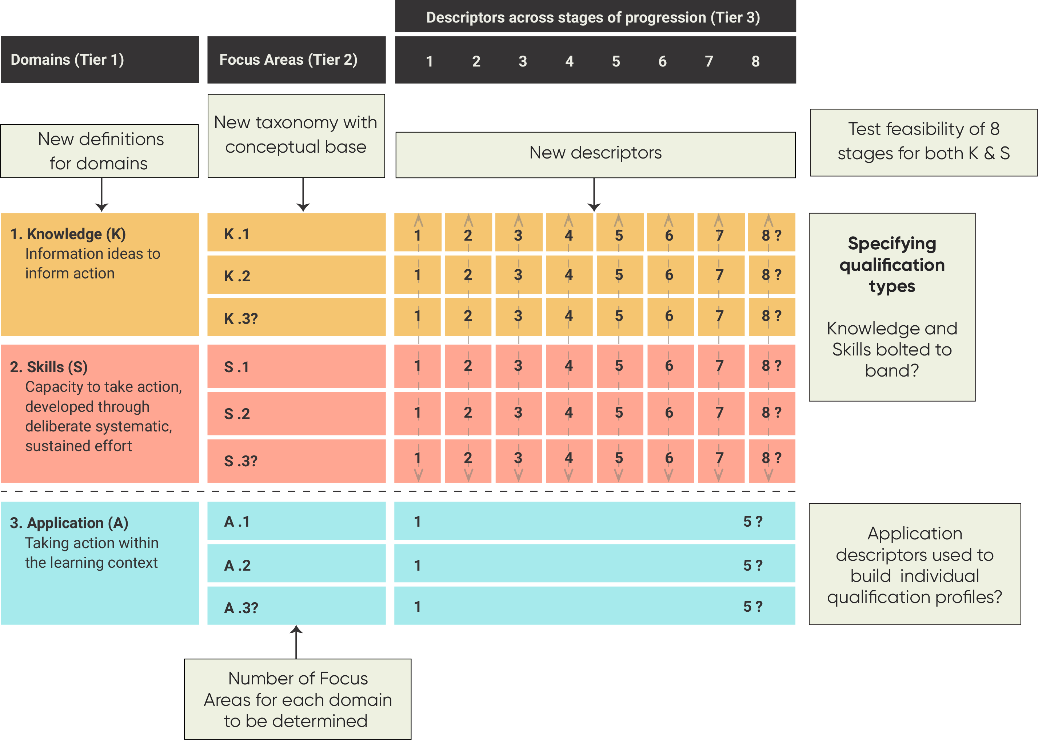 | - Working Model C will have the same (new) domain definitions and taxonomy as Working Model B.  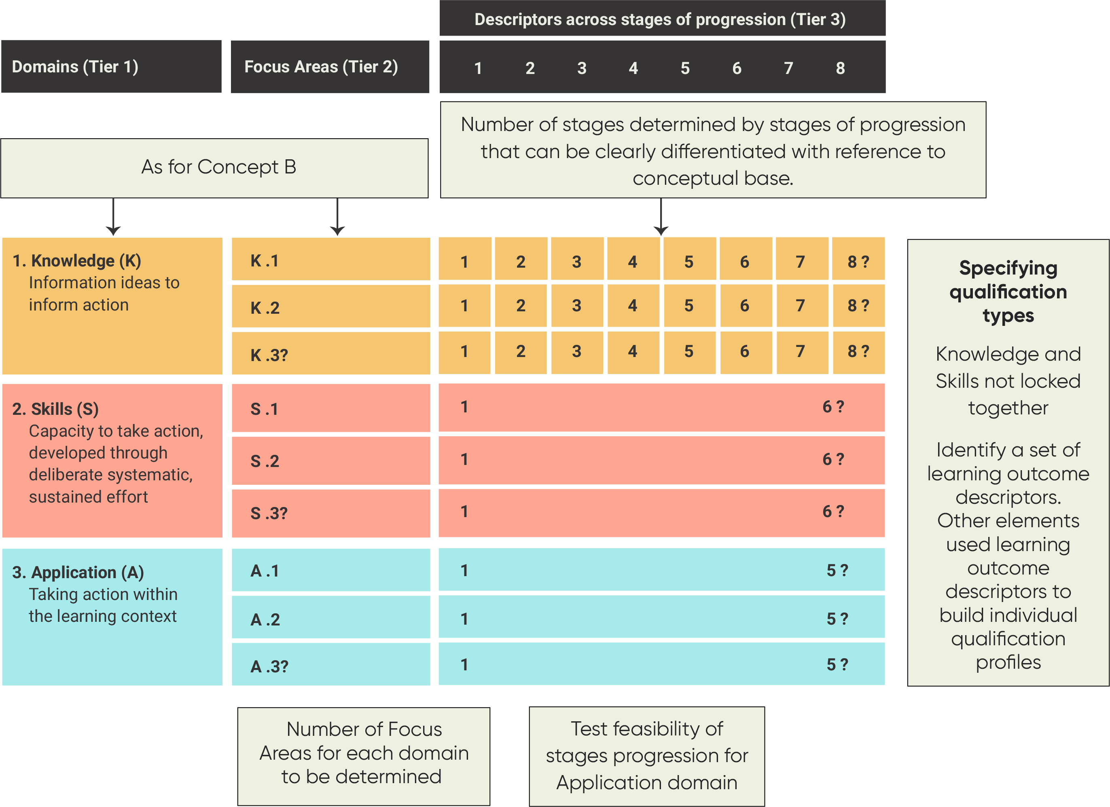

Appraisal of Model A (a modification of the current AQF descriptors)
The extensive stakeholder consultations conducted by the Panel as part of the review of the AQF identified a broad range of issues that different groups had encountered in trying to apply the AQF in their contexts to achieve their specific purposes. Although there was a widespread assumption that many of these issues could be addressed if only the descriptors were clearer, the ACER analysis identified fundamental conceptual and technical issues that strongly suggested this was not possible within the current AQF construct.
Despite this, an attempt was made to do so. Working Model A does not address any of the issues with the current AQF identified either by stakeholders through the consultations, or by ACER through its independent analysis of the descriptors. Rather, by making the taxonomy explicit in Tier 2 of the matrix (the Focus Areas), attention is actually drawn to the shortcomings of the current approach.
As explained in Part I, inserting Tier 2 demonstrates that the current taxonomy does not provide a viable way of differentiating ten levels of graduate performance, (or even eight). Without an explicit rationale and conceptual base, there is no logical way to fill the gaps or address the ambiguities of language, other than to make arbitrary judgments.
A further complication is that trying to combine the learning outcome descriptors and qualification descriptors from the two matrices may have raised more issues than it resolved. It made clear the difficulties of developing a set of reference points within the current construct that were independent of existing qualifications, and also showed that the existing qualifications do not represent a conceptual and/or logical progression of performance in the areas described.
If there is no appetite for a new AQF construct, such as that presented in the prototype, it could be argued that it might be preferable to remain with the current AQF as it is, rather than fiddle with it as in Model A. Although there are serious drawbacks in maintaining the status quo – most notably the inability to make meaningful amendments, or use current descriptors to ‘calibrate new qualifications, including the fact that it fails to address any concerns raised by stakeholders during the AQF Review – it might bring more benefits than Model A. Most notably, staying with the status quo would maintain the equilibrium of many course designers, their institutions, and possibly the governing bodies of their systems (see Table 10.1).

Table 10.1: Staying with the status quo: Summary of benefits and limitations
Benefits of retaining the current two-matrix AQF | Limitations of the current two-matrix AQF
Although there are course designers and others at institutional level who recognise the significant shortcomings of the current AQF in practice, staying with the status quo will maintain the equilibrium of many course designers, their institutions, and possibly the governing bodies of their systems;  - Course designers /training package writers have learned to live with the AQF. They are comfortable with its ‘requirements’ and have developed and documented their course offerings/training packages against its levels. This is relatively easy to do because the current AQF is so ‘loose’ and lacking in detail that it should be possible to demonstrate alignment without necessarily making many changes at all.  - A number of HE disciplines and sectors within the VET system have established agreed context-specific interpretations of the current AQF matrix;  - Those comparing Australian and international qualifications seem to have develop their own system for doing this.  - Industry awards in some vocational areas at some AQF levels (particularly in the trades) are tied to the current levels. There is potential for a range of problems if these arrangements are disrupted. Staying with the current AQF would avoid this.  Maintaining the current AQF matrices will maintain, and potentially reinforce, the fabric of formal and tacit agreements that have been established since the last AQF revision in 2011. As some of those who see this as a desirable state are in positions of influence, maintaining the current AQF matrices quo could save having to convince them otherwise. | The current AQF has some serious limitations.  - While there is little doubt that it provided useful scaffolding as HE institutions moved into learning outcomes mode, it lacks the substance to support further developments in this area.  - The levels criteria in the Learning Outcomes matrix are overridden by/subservient to the qualification type descriptors in the Qualifications Framework. Both sets reflect an attempt to place a structured framework over existing qualification types, while attempting to ignore the elephant in the room – the significant differences in approaches to Knowledge, Skills and Application in the three education and training sectors delivering the qualifications within the AQF scope.  - It cannot be amended effectively within its current construct, and due to its close connection with current qualifications, it is difficult to envisage how new/novel qualification types might be incorporated. Thus, even if it is appropriate at this moment in time, it will need to change in the relatively near future.  - More specifically, it does not provide the level of detail to:  - support individual qualification design with consistency in those areas where this is important for the integrity and validity of qualification types, either within fields or across qualification types;  - support RPL or transition/pathway arrangements, particularly from the VET sector to the HE sector;  - provide signals to students and prospective employers about the emphasis of individual courses, or of qualification types;  - facilitate international comparisons;  - inform quality assurance processes and decisions at institution or sectoral level.

Appraisal of Model B (new conceptual base; Knowledge and Skills bolted to band)
Working Model B and C have the same conceptual base, the benefits of which are considered below in the discussion of the prototype developed on the basis of Model C.
Model B also has a number of limitations that effectively rule it out of consideration.
Firstly, the AQF Review Panel had requested that a minimum of eight bands be identified for the Knowledge domain, if at all possible. As Working Model B incorporated the idea that Knowledge and Skills would be bolted to band in the specification of qualification types, the two domains would need to have the same number of bands. However, it does not appear to be possible to develop eight clearly differentiated descriptors of any of the proposed individual Skill Areas. Therefore, to adopt Model B, both domains could have five or six bands only.
Even if this were accepted as a way forward, the inclusion of detailed descriptors of psychomotor skills highlights the pitfalls of assuming that every individual qualification within a qualification type will be able to help its graduates develop and demonstrate the full set of skills described to a designated degree of sophistication. Although not as stark, there are similar issues with the other skills in this domain.
The research identifies the importance of learning how to adapt and apply these skills within specific contexts, and also demonstrates that the level of sophistication required is not necessarily linked to the level of complexity of the ideas and information central to a field, or to an individual qualification. This suggests the need to unlock the Skills domain itself in some way, which is also not possible within Model B.

Appraisal of Prototype Model (a new conceptual base that is unlocked at level)
The prototype based on Working Model C incorporates the new conceptual base and unlocks all three domains. (The version incorporating all three Focus areas is discussed below and depicted in Figure 10.2).
With further testing and development, the prototype has the potential to provide a range of benefits for each stakeholder group.
- Increased precision and detail to describe and differentiate qualification types
The AQF is critical to qualification design, review and redesign. In this context, the descriptors are intended to ensure that the content and emphasis of the course meets the requirements to be classified against a particular qualification type.
To do their jobs effectively, course designers/Training Package writers need a matrix with a reasonable and sufficient level of detail. This detail needs to reduce the degree of interpretation at individual qualification level, while maintaining the flexibility needed for contextualisation. In practice, qualification designers usually know the AQF level/qualification type for which they are aiming. They may only pay close attention to the descriptors in that band, and perhaps those immediately above and below. The introduction of a new set of reference points will require some rethinking in this regard. However, this should simply confirm that the vast majority of individual qualifications meet the qualification type specifications. The process also has the potential to draw attention to areas that qualification designers might otherwise have taken for granted. (This has been identified as one of the major benefits of mapping qualifications to the ACSF and CSfW).
As new-style qualifications are developed that may challenge some accepted ideas about content, emphasis and delivery, the matrix should be helpful for determining the most appropriate classification. In the Australian system, fine detail could be particularly useful at the interface between the school, tertiary education and training sectors, and at the cross-over between education and training delivered in the VET sector and in the Higher Education sector.
Importantly, it could provide a degree of guidance that could improve consistency in those areas where this is deemed to be important for the differentiation of qualification types. With further development, the prototype could improve clarity and develop a shared understanding of these areas, within and across disciplines within a qualification type. At the same time, it should provide the flexibility for individual qualifications to facilitate and assess student learning in a contextually appropriate way.

Figure 10.2: The prototype (variation 2)

For those who need to compare Australian and overseas qualifications, an enhanced version of the prototype would provide considerably more usable information than is currently available, making it possible to make (and defend) informed decisions about the relationship between specific Australian and overseas qualifications and between qualification types, including those with similar nomenclature.
If international comparisons are to be undertaken with any rigour, it should be made at the level of descriptors. Although Training Package competencies can fulfil that requirement in vocational areas, the AQF matrix should provide sufficient detail about the Australian expectations of different qualification types across all levels of the formal education and training system.
At the level of individual qualifications, the prototype’s detail would make genuine comparison possible for the first time. This could be of value to applicants seeking recognition of qualifications gained overseas, as it would provide a set of transparent reference points. However, as this might provide a basis for challenging rulings made, some might choose to see this as a limitation.
- Improved information on course specialisation, emphasis and focus
In the main, we suggest that students will be more focused on descriptions of individual course offerings and related learning outcomes than on the AQF itself. However, as discussed earlier, they may well respond positively to nationally recognised references to AQF bands and associated descriptors in a freed matrix, particularly in regard to Skills and Applications. For students and graduates, there are also benefits to having an AQF with the precision to recognise the unique and idiosyncratic nature of individual qualifications within qualification types. Although there is potential for misrepresentation – as there is now – the imprimatur of the AQF raises the stakes.
Providers already describe their course offerings in some detail, so that potential students have some idea of the emphasis and types of opportunities provided, and the specific learning outcomes the individual units and overall course aim to achieve. The AQF matrix, as it stands, plays little or no direct role in this, but there is potential that a new matrix could provide a set of national reference points, particularly for Application. Providers could use these reference points to reinforce and formalise these institution-level signals. A potential downside might be that there will always be room for interpretation. However, this is also a major limitation of the current Application of Knowledge and Skills domain, which makes sweeping claims that are simply adopted by all qualifications in the qualification type as a default position.
At the institutional/provider level, a new AQF matrix could provide a reference point for regulatory purposes. With the right kind of detail, it might also have the potential to support the development and description of recognised pathways, particularly between education and training sectors.
Providers could use the Skills and Application bands and descriptors to signal the particular strengths of their course offerings to prospective students and employers of graduates. Employer groups have long called for graduates with the ability to apply the information, ideas and skills they have ‘learned’ in work contexts. Referencing individual qualification design features to an overarching national framework could provide an increased degree of veracity to a course. This could even become a new currency that would benefit course providers, graduates and employers.
The matrix could be used to support professional conversations and decision making about:
- the selection of the information, ideas and skills that will become the focus of a course;
- the levels of sophistication of ‘inputs’;
- expectations regarding the minimum levels of sophistication a graduate should demonstrate in different areas; and
- the nature and degree of scaffolding.
The matrix could also be used as part of quality assurance processes, not only within a field/discipline but as a way of developing/maintaining consistency across disciplines, in those areas where this is deemed to be important.
Similarly, for employers, this might also provide a way for graduates to draw attention to the areas of their course offerings that might be of most relevance to prospective employers. For example, where employers are interested in knowing more about the nature of an applicant’s practical experience, a reference to a descriptor in the ‘Application’ domain could be used as part of the evidence within a CV. Graduates seeking to work overseas may also be able to indicate where and how their qualification meets or exceeds the requirements and expectations of an equivalent qualification type in another country.
- The creation of reference points that are independent of, but linked to, qualification types
It was beyond the scope of this project to undertake a study of regulatory requirements or regulator needs and expectations. However, it is reasonable to assume that aspects of the regulatory role are made possible and/or easier when there is an agreed set of reference points in place that would provide sufficient detail to confirm or challenge the level of learning within a particular qualification type and within a particular band.
In quality assurance processes within institutions there may be less focus on the fine detail of the descriptors, and more on ensuring courses can be shown to meet the guidelines. Within education and training sectors, there may a greater focus on decisions about sequencing of information, ideas and skill development across bands and/or qualification types. Although this may involve consideration of a number of bands, no one sector is likely to pay close attention to, or actively use the descriptors for, all bands of the matrix.
- A re-balancing of notions of status and parity of esteem
The prototype provides an alternative approach to representing the increasing complexity portrayed in a levels-based qualifications framework. However, it does not represent a way of constructing a progression that is not by its nature ‘hierarchical’. Across the bands, the information, ideas and skills introduced become more complex and challenging, as do the activities and problems to which they must be applied. At the same time, the nature and degree of support a learner receives when undertaking these challenges decreases as the learner takes increasing responsibility for various aspect of the learning process.
One of the issues sitting behind concerns about hierarchy, is the concern that knowledge, and qualifications that emphasise information and ideas, are unfairly afforded a higher status than those that place greater emphasis on practical skills, incorporating the increasingly skilful use of one’s own body and/or tools (in conjunction with the cognitive skills needed to guide/inform their application). In this regard, we would argue that the prototype lays the groundwork for a change in these perceptions. Psychomotor skills are comprehensibly described across six bands, and the level of sophistication expected can be signalled without needing to be linked to a particular approach to ideas and information.

- A reduction of duplication in the AQF document
Although the prototype is unlikely to have major issues with duplication, it is currently longer than the original AQF. While we recognise the need for a quick reference document for some stakeholders in particular, our main aim in this early stage of the process has been to test concepts, identify potential focus areas and explore the features of descriptors that would support the differentiation of qualification types and signals about key features of individual courses.

Key messages
With further testing and development, the prototype has the potential to provide a range of benefits for each stakeholder group, including:
- increased precision and detail to describe and differentiate qualification types;
- the creation of reference points that are independent of, but linked to, qualification types;
- a re-balancing of notions of qualification status and parity of esteem;
- a reduction in duplication in the AQF document; and
- the potential to address broader issues identified by the AQF review.
Limitations are more likely to be related to transition and initial implementation. However, if introduced carefully and incrementally, a new clearer matrix has the potential to make many users’ jobs easier in the medium term.
Retention of the current AQF has many limitations, as outlined throughout this report. However, there are some benefits, the chief amongst them being that, in the short term, nothing will have to change.
If there is no appetite for a new AQF construct, such as that presented in the prototype, it could be argued that it be preferable to remain with the current AQF as it is, rather than cosmetically revise the descriptors (Model A). Although there are serious drawbacks in maintaining the status quo, most notably the inability to make meaningful amendments, or use current descriptors to ‘calibrate new qualifications, (including the fact that it fails to address any concerns raised by stakeholders during the AQF Review), it might bring more benefits than Model A, simply because it would involve no change at all.

Conclusions and recommendations
Part I made clear the importance of ensuring that the descriptors, and the taxonomic structure that underpins them, aligns with the purpose of the AQF. The matrix of descriptors must support the framework to achieve these purposes. If the major purpose of the AQF is to ensure the validity, integrity and value of the qualifications issued by Australia’s formal education and training sectors, a critical role of the descriptors is to provide the basis for specifications that make it possible to describe the key features of qualification types and differentiate between them.

Conclusions
Based on the findings of Parts I and II, the following conclusions can be drawn.

It is time to question assumptions underpinning the AQF
The current AQF levels criteria and qualification descriptors appear to be based on a number of assumptions that need to be challenged. For example,
- that the most appropriate way to ensure consistency of qualification types is to specify learning outcomes;
- that it is possible to develop useful learning outcomes statements for a qualification type, even though they are not related to a defined scope, aim and objectives (as is expected in individual qualifications, where this approach was originally applied);
- that progression occurs at the same rate across all domains, meaning they can be ‘locked at level’;
- that all individual qualifications within a type are in a position to actively facilitate the development of these outcomes and/or formally assess them; and
- that all qualification types universally prepare graduates for post-graduation roles with similar characteristics in terms of supervision, leadership etc.
Although these kinds of assumptions are reflected in many other NQFs, we suggest that this is not a good enough reason to continue with them. They have led to a situation where unrealistic and unachievable claims are being made about what any graduate of any qualification within a qualification type will know, understand and be able to do, and about the level of responsibility they will be ready to assume, presumably from the day they graduate. This is not an appropriate foundation upon which to build a future-focused framework with the potential to have wide-reaching implications for teaching, learning, credentialing, accreditation and employment.

There are significant issues with the current AQF matrix
The assumptions go some way to explaining the issues with the current AQF construct. These problems cannot be systematically addressed within the current structure.
The current construct and taxonomy does not provide an adequate basis for differentiating qualification types across multiple levels. In many cases, the only ‘differentiation’ from one level to the next rests on minor word changes, but these are not enough to sustain ten or, in many cases, even six or eight distinct bands. If the AQF were to be revised without making changes to the conceptual base, the only way forward would be to make arbitrary changes to wording (as shown by Model A in Attachment 1).

The prototype offers a viable starting point for a more flexible and future-oriented approach
The prototype developed during Part II of the project reflects four major conceptual shifts, which are:
- a move from a framework that is strongly influenced by perceptions of existing qualification types, to one that provides a set of independent reference points;
- a move from descriptors focused on graduate learning outcomes, to descriptors of qualification type design features;
- a move from specifying qualification types using all descriptors across three domains ‘locked at level’, to differentiating qualifications on the basis of a small set of design features; and
- a move from describing universal generic future contexts within which context-specific information, ideas and skills are expected to be applied, to a focus on application within qualification learning contexts where they have been observed being applied.
The prototype offers a blueprint for the development of a practical matrix that will facilitate teaching, learning and assessment within individual qualifications, while also providing the scaffolding that enables the AQF to achieve its central purpose, which is to effectively differentiate qualification types.
The prototype describes Knowledge, Skills and Application across multiple bands against a set of focus areas that could be used in different configurations to differentiate one qualification type from another. These focus areas have been selected because they appear to be integral to formal learning and assessment. Almost all can be described across continua with identifiable and describable ‘change’ points.
Although it reflects a reframing of the three domains, it is important to note that the prototype incorporates many aspects of the current AQF, albeit in different configurations, e.g.
- the three domain labels have been retained, although Application has been shortened;
- the focus areas that were supposedly part of Skills are now explicitly described;
- the emphasis on ‘doing’ that had been the centre piece of Skills has become the emphasis of Application.
For those AQF users who need it, the new approach provides a level of detail that has not been available before, but the general areas remain the same. Thus, it should be possible to map existing qualifications to a new version of the AQF built using this prototype as a starting point. Psychomotor and skills to cooperate and collaborate are now explicit, thus making it possible for individual qualifications that foster these skills to acknowledge and reference the important skills development work they do.

A new approach could deliver many benefits
With further testing and development, the prototype has the potential to provide a range of benefits for each stakeholder group, including:
- increased precision and detail to describe and differentiate qualification types;
- the creation of reference points that are independent of, but linked to, qualification types;
- a re-balancing of notions of qualification status and parity of esteem;
- a reduction in duplication in the AQF document; and
- The potential to address broader issues identified by the AQF review.
‘Limitations’ are more likely to be related to transition and initial implementation. However, if introduced carefully and incrementally, a new clearer matrix has the potential to make many users’ jobs easier in the medium term.

Model A is not a viable option
For the range of reasons discussed throughout the report, ACER does not believe that Model A offers a useful way forward. Given the costs involved in any form of change, the benefits would be minimal. Retention of the current AQF also has many limitations, as outlined throughout this report. However, if there is no appetite for a new AQF construct, such as that presented in the prototype, it could be argued that it might be preferable to remain with the current AQF as it is, rather than fiddle with it as in Model A.
Although there are serious drawbacks in maintaining the status quo, most notably the inability to make meaningful amendments, or use current descriptors to ‘calibrate new qualifications’, (including the fact that it fails to address any concerns raised by stakeholders during the AQF Review), it might bring more benefits than Model A, simply because it would involve no change at all.
If the main purpose of the AQF is to ensure the validity, reputation and perceived value of formal qualifications gained through the Australian education and training system, then the current AQF LOM does not provide the wherewithal to do this. However, many stakeholders appear to have found a way to interpret it to suit their own circumstances. Some may not wish to disturb the status quo because the current arrangement appears to be very comfortable. The AQF lacks the detail that would be required to genuinely question whether an individual qualification adequately reflects the qualification type it is claiming.
If lack of consistency is a cause for concern, then the current AQF LOM needs to be changed. It also needs to be changed if there is any possibility that new qualification types might be introduced in the future.
The feasibility study suggests that the prototype based on Model C would provide an alternative that could help to enhance consistency in those aspects where it is actually important. Where flexibility is required, the matrix would provide a common language and set of reference points for individual courses within a qualification type to design and describe where they put their emphasis. Although not the primary reason for developing a new matrix, there is the potential that it could also influence the areas in which individual qualifications decide to put that emphasis (for example, by focusing attention on the need to explicitly teach information literacy skills or problem-solving strategies).
A particular feature of the prototype is the explicit description of psychomotor skills. This makes it possible to signal that a vocational qualification, is fostering the development of sophisticated specialist skills involving the use of one’s own body and/or tools. These skills are ‘buried’ in the current matrix.

The prototype needs further development
The prototype is exactly what it says it is – a prototype – and should not be seen as a finished, or almost finished, product. It has been developed over a few short months. Even though the elements it contains represent the distillation of a considerable amount of literature, and extensive conceptualising and experimenting, they are still very much a work in progress.
However, we believe the prototype is developed to the extent that it demonstrates the feasibility of a new approach. If this is taken further, it should involve extensive stakeholder consultation and trialling. This could be designed as change process in its own right, gradually bringing different groups ‘on board’.
In the process, and through their input, the matrix itself can only be strengthened, as long as the underpinning principles and constructs are maintained. If the prototype is taken forward, one body needs to take carriage of the process, including taking responsibility for ensuring that the integrity of the construct is clearly established and maintained.

Recommendations
- Recognise the need for a new AQF matrix.
- Use the prototype as the starting point for the development of a new approach that builds on, and enhances, the new conceptual base.
- Design the matrix development process as a change management process that will develop stakeholder interest and ownership, while establishing and ensuring that the underpinning principles and concepts are reflected in the detail.

References
Adey, P. (1997). It all depends on the context, doesn’t it? Searching for general, educable dragons. Studies in Science Education, 29(1), 45–92. https://doi.org/10.1080/03057269708560093
Anderson, L. W., and Krathwohl, D. R. (2001). A taxonomy for learning, teaching and assessing: A revision of Bloom's taxonomy of educational objectives. New York: Longman.
Australian Government (2013). The Core Skills for Work Developmental Framework. Canberra. Retrieved from https://www.employment.gov.au/core-skills-for-work-developmental-framework
Australian Government (2018). Review of the Australian Qualifications Framework. Discussion Paper. Expert Panel for the Review of the Australian Qualifications Framework, Australian Government. Retrieved from https://docs.education.gov.au/system/files/doc/other/aqfrdiscussionpaper_0.pdf
Australian Qualifications Framework Council. (2011). Australian Qualifications Framework, Adelaide. Retrieved from https://web.archive.org/web/20111027062858/http://www.aqf.edu.au/Portals/0/Documents/Handbook/AustQuals%20FrmwrkFirstEditionJuly2011_FINAL.pdf
Australian Qualifications Framework Council. (2013).Australian Qualifications Framework. Second Edition January 2013. Retrieved from https://www.aqf.edu.au/aqf-second-edition-january-2013
Bennet, A. & Bennet, D. (2008). The depth of knowledge: surface, shallow or deep? VINE, 38(4), 405-420. https://doi.org/10.1108/03055720810917679
Biggs, J. & Collis, K. (1982). Evaluating the quality of learning: The SOLO Taxonomy. New York: Academic Press.
Billet, S. (2001). Learning in the workplace: Strategies for effective practice. Sydney, NSW: Allen & Unwin.
Bloom, B. and Krathwohl, D. (1956 and 1984 revised). Taxonomy of Educational Objectives, Handbook I: Cognitive Domain, New York: Addison-Wesley and Co.
Butler J. (1996). ‘Professional development: Practice as text, reflection as process and self as locus’, Australian Journal of Education 1996; 40 (3), pp. 265–83.
Care, E & Kim, H. (2017). Let’s Aspire, but Be Realistic: What Skills Can Be Taught for the 21st Century? Brookings Institute Tuesday, January 17, 2017. https://www.brookings.edu/blog/education-plus-development/2017/01/17/lets-be-realistic-and-that-doesnt-mean-we-cant-aspire/
Carnevale, A.P., Smith, N., Melton, M. (2011). STEM. Science Technology Engineering Mathematics. State-Level Analysis. Centre in Education and the Workforce, Georgetown University. https://cew.georgetown.edu/wp-content/uploads/2014/11/stem-complete.pdf. Last accessed October 12, 2018
CEDEFOP (2017). Defining, Writing and Applying Learning Outcomes: a European Handbook. Luxembourg: Publications Office. <http://dx.doi.org/10.2801/566770>
Coles, M. (2006). A Review of International and National Developments in the Use of Qualifications Frameworks. Turin: ETF.
Collins, T., Kelly, F., Murdoch, M., Raffe, D., Murphy, A. (2009). Framework Implementation and Impact Study, Report of Study Team, National Qualifications Authority of Ireland.
Cosser, M. (2000). Towards the development of level descriptors in the NQF: a point of departure. SAQA Bulletin, 4(1), 3–13.
Costa, A. L., Kallick, B. (2004). Experts in assessment: Assessment strategies for self-directed learning. Thousand Oaks, Calif: Corwin Press.
Daley B. (1999). Novice to expert: An exploration of how professionals learn. Adult Education Quarterly, 49(4), 133–48. https://doi.org/10.1177/074171369904900401
De Bono, E. (1992). Serious Creativity, London, United Kingdom: HarperCollins.
DQR. (2011). The German Qualifications Framework for Lifelong Learning. Retrieved from https://www.dqr.de/media/content/The_German_Qualifications_Framework_for_Lifelong_Learning.pdf
Dreyfus, H., & Dreyfus, S. (1985). Mind over machine: The power of human intuition and expertise in the era of the computer. New York: Blackwell Publishers.
Dreyfus, S. & Dreyfus, H. (1980). A five-stage model of the mental activities involved in directed skill acquisition. Washington, DC: Storming Media. https://doi.org/10.21236/ADA084551
Eraut, M. & Hirsch, W. (2014). The Significance of Workplace Learning for Individuals, Groups and Organisations. Economic and Social Research Council (ESRC) Centre on SkilIs, Knowledge and Organisational Performance. Retrieved from http://www.skope.ox.ac.uk/wp-content/uploads/2014/12/Monogrpah-09.pdf
European Union (2016). Comparative Analysis of the Australian Qualifications Framework and the European Qualifications Framework for Lifelong Learning: Joint Technical Report. Retrieved from https://publications.europa.eu
European Union (2018). Descriptors Defining Levels in the European Qualifications Framework. Retrieved from https://ec.europa.eu/ploteus/en/content/descriptors-page
Ferry N & Ross-Gordon, J. (1998). ‘An inquiry into Schon’s epistemology of practice: Exploring links between experience and reflective practice’. Adult Education Quarterly; 48 (2).
Figueiredo, A. (2005). Learning contexts: A blueprint for research. Interactive Educational Multimedia, 11, 127–139.
Fraillon, J., Ainley, J., Schulz, W., Duckworth, D., & Friedman, T. (2019). International Computer and Information Literacy Study 2018: Assessment Framework. Melbourne, Australia: Australian Council for Educational Research. Retrieved from https://research.acer.edu.au/ict_literacy/14
Guilford, J.P. (1956) The structure of intellect. Psychological Bulletin, 53(4), 267-293. https://dx.doi.org/10.1037/h0040755
Hager, P., McIntyre, J., et al. (1996). Workplace Keys: Improving Your Training with the Key Competencies. Sydney, NSW Department of Training and Education Coordination and the Commonwealth Department of Employment, Education, Training and Youth Affairs. Retrieved from https://vital.voced.edu.au/vital/access/services/Download/ngv:755/SOURCE2
Herrington, J. (2006, October) Authentic e-learning in higher education: Design principles for authentic learning environments and tasks. World Conference on E-Learning in Corporate, Government, Healthcare, and Higher Education, Chesapeake, Va, 2006.
IBE-UNESCO (2018). General Education System Quality Analysis/Diagnosis Framework (GEQAF). Switzerland. Retrieved from http://www.ibe.unesco.org/en/general-education-system-quality-analysisdiagnosis-framework-geqaf.
James, L., Guile, D., & Unwin, L. (2013). Learning and Innovation in the knowledge-based economy: Beyond clusters and qualifications, Journal of Education and Work, 26(3), 243–246. https://doi.org/10.1080/13639080.2011.653556
Jonassen, D. H. (2007). A Taxonomy of meaningful learning. Educational Technology, 47(5), 30–35. Retrieved from https://www.jstor.org/stable/44429440.
Karni, A., Meyer, G., Rey-Hipolito, C.H., Jezzard, P., Adams, M., Turner, R., & Ungerleider, L. (1998). The acquisition of skilled motor performance: Fast and slow experience-driven changes in primary motor cortex. Proceedings of the National Academy of Sciences, 95(3), 861-868. https://doi.org/10.1073/pnas.95.3.861
Keating, J. (2006). Post‐school articulation in Australia: A case of unresolved tensions. Journal of Further and Higher Education, 30(1), 59–74. https://doi.org/10.1080/03098770500432039
Keevy, J., & Chakroun, J. (2015). Level-setting and recognition of learning outcomes. Paris, France: UNESCO. Retrieved from http://unesdoc.unesco.org/images/0024/002428/242887e.pdf
Kennedy, D., Hyland, A., & Ryan, N. (2007). Writing and using learning outcomes: A practical guide. Implementing Bologna in you institution, C 3.4-1.
Kirsch I. S. (2001). The International Adult Literacy Survey (IALS): Understanding what was measured. Princeton, NJ: Education Testing Service.
Kirsch I.S. & Mosenthal P.B. (1990). Exploring document literacy: Variables underlying the performance of young adults. Reading Research Quarterly, 25(1), 5–30. http://dx.doi.org/10.2307/747985
Lave, J., & Wenger, E. (1991). Situated learning: Legitimate peripheral participation. Cambridge, New York: Cambridge University Press.
Leiner, H. C., Leiner, A. L., & Dow, R. S. (1989). Reappraising the cerebellum: What does the hindbrain contribute to the forebrain? Behavioral Neuroscience, 103(5), 998–1008. https://doi.org/10.1037/0735-7044.103.5.998
Marzano, R., & Kendall, J. (2007). The new taxonomy of educational objectives. Thousand Oaks, CA: Corwin Press.
McLean, P., Perkins, K., Brewer, K. & Wyse, L. (2012). The Australian Core Skills Framework. Canberra, Australia: Australian Government.
Misko, J. (1995). Transfer: Using learning in new contexts. Adelaide, Australia: NCVER.
Misko, J. (2008). Combining formal, non-formal and informal learning for workforce skill development. Adelaide, Australia: NCVER.
Moodie, G., Wheelehan, L., Fredman, N., & Bexley, E. (2015). Towards a new approach to mid-level qualifications. Adelaide, Australia: NCVER.
National Framework of Qualifications (NFQ). (2003). Quality and qualifications Ireland. Retrieved from https://www.qqi.ie/Articles/Pages/National-Framework-of-Qualifications-(NFQ).aspx
National Qualifications Authority of Ireland (NQAI) (2011, 4 June). National qualifications frameworks and the European overarching frameworks: supporting lifelong learning in European education and training. Report on the Bologna Expert Conference, Dublin Castle, Ireland.
New Zealand Qualifications Authority (NZQA) (2011, 2016). New Zealand Qualifications Framework. Wellington, New Zealand: New Zealand Government. Retrieved from https://www.nzqa.govt.nz/assets/Studying-in-NZ/New-Zealand-Qualification-Framework/requirements-nzqf.pdf
Perkins, D. & Salomon, G. (1992). ‘Transfer of learning’, International Encyclopaedia of Education (2nd edition), Pergamon.
Perkins, K., & Wignall, L. (2018). Mission Critical: Taking a Hard Line on Soft Skills. Report for the Victorian Government [unpublished].
PhillipsKPA (2018). Contextual Research for the Australian Qualifications Framework Review: Final report, Melbourne: Canberra, Australia: Department of Education and Training. Retrieved from https://docs.education.gov.au/node/50811
Piaget, J. (1985). The equilibration of cognitive structures: The central problem of intellectual development. Chicago, IL: University of Chicago Press.
Raffe, D. (2009). Towards a dynamic model of qualifications frameworks. (Discussion document No. 2). Project on Qualifications Frameworks: Implementation and Impact. Geneva, Switzerland: International Labour Office.
Romiszowski, A. (2009). Fostering skill development outcomes. In C. M. Reigeluth & A. A. Carr-Chellman (Eds.), Instructional-Design Theories and Models, Volume III: Building a Common Knowledge Base (pp. 199-224). New York, NY: Routledge.
Schon D. (1983). The Reflective practitioner: how professional think in action. New York City, N.Y.: Basic Books.
Simpson E. J. (1972). The Classification of educational objectives in the psychomotor domain. Washington, DC: Gryphon House.
Tan, Ü. (2007). The psychomotor theory of human mind. International Journal of Neuroscience, 117(8), 1109-1148. https://doi.org/10.1080/00207450600934556
Veer, R. van der. (1996). Henri Wallon's Theory of Early Child Development: The Role of emotions. Developmental review, 16(4), 364-390. https://doi.org/10.1006/drev.1996.0016

Additional reading
Although not cited explicitly in the text, the following items were used in preparing this report and may be of interest to the reader.
Anderson, L. W. (2005). ‘Objectives, evaluation, and the improvement of education’. Studies in Educational Evaluation, 31 (2), pp. 102–113.
Bouder, A. (2003). ‘Qualifications in France: towards a national framework?’ Journal of Education and Work, Vol. 16, No. 3, pp. 347–56.
Dave, R.H. (1970). ‘Psychomotor levels’, in R.J. Armstrong (ed.), Developing and Writing Behavioural Objectives, pp. 20–21. Tucson, Arizona: Educational Innovators Press.
Edwards, D., Perkins, K., Pearce, J., & Hong, J. (2015). Work Integrated Learning in Australian Universities, Melbourne: ACER. https://www.chiefscientist.gov.au/wp-content/uploads/ACER_WIL-in-STEM-in-Australian-Universities_June-2015.pdf. Last accessed Novice 12th, 2018.
Eurspace (2019). Framework for Defining Learning Outcomes (Knowledge, Skills, Competence). https://eurspace.eu/ecvet/pedagogicalkit/framework-for-defining-learning-outcomes-knowledge-skills-competence
Harrow, A. (1972). A Taxonomy of Psychomotor Domain: A Guide for Developing Behavioral Objectives. New York: David McKay.
Jonassen, D. & Hung, W. (2015). All Problems Are Not Equal: Implications for Problem-Based Learning in The Process and Structure of PBL. https://www.researchgate.net/publication/273459514.
Jonassen, D.H. (2000). ‘Toward a design theory of problem solving’, Educational Technology: Research & Development, 48 (4), pp. 63–85.
Jonassen, D.H. (2003) ‘Using Cognitive Tools to Represent Problems’, Educational Technology, Volume 47, No.5 (September–October 2007), pp. 30–35.
Lester, S. (2005). Novice to Expert: The Dreyfus Model of Skill Acquisition. Available at: www.sld.demon.co.uk/dreyfus.pdf
Muller, J. (2009). ‘Forms of knowledge and curriculum coherence’, Journal of Education and Work, 2009. 22-3205-226. https//:doi.org/10.1080/13639080902957905
National Centre for Vocational Education Research [NCVER] (2017). Australian Vocational Education and Training Statistics, Total VET Students and Courses. Adelaide: NCVER.
Perkins, K. (2017). What Do Employers Really Want: Helping Vocational Learners Crack the Code. Melbourne: Australian Council for Educational Research.

APPENDICES

Appendix A: Terms of Reference
The requirements were sub-divided into three tasks, each involving a set of underpinning requirements and tasks.
Task 1: Conceptual analysis of the most appropriate way of developing and presenting a learning outcomes taxonomy in a qualifications framework
This task involves investigating:
- what alternative approaches to delineating a learning outcomes taxonomy exist and could be considered for the AQF, having regard to other qualifications frameworks and other conceptual approaches that may not yet be utilised in any framework;
- whether an alternative approach would be an improvement over the current AQF approach.
The most appropriate learning outcomes taxonomy for the AQF may help it deal with some of the following challenges:
- how to balance learning outcomes for qualifications with professional and occupational outcomes, with learning outcomes for qualifications with broader educational purposes;
- how to reflect the contextual nature of some descriptors (see issues relating to the application of knowledge and skills descriptors);
- how to show that learning pathways are flexible and not hierarchical, while representing the increasing complexity portrayed in a levels-based qualifications framework;
- how to provide flexibility for future change in the types of learning outcomes that will be valued by employers, students and providers;
- how to encompass learning outcomes that can be provided through both full qualifications and shorter form credentials, as well as through formal, non-formal and informal learning.
Task 2: Technical analysis and revision of the knowledge descriptors and skills descriptors used in the AQF
- Conduct an analysis of the existing knowledge and skills descriptors for each AQF level and each qualification type, and establish: what characteristics of knowledge and skills are included at each level; at what level different characteristics are introduced; how and if the descriptors establish a difference between levels; and whether each characteristic is applicable to some or all levels.
- Examine descriptors of knowledge and skills used in three other qualifications frameworks (including the New Zealand Qualifications Framework). Determine whether there are characteristics of knowledge and skills that could be applied to the AQF to clarify the differences between levels without altering the current degree of complexity of learning outcomes for each level.
- Propose to the AQF Review Panel what characteristics of knowledge and skills should be described at each AQF level and whether the characteristic will apply to all 10 levels of the AQF or to a subset of levels.
- Agree with the AQF Review Panel what, if any, enterprise and social skills will be included in the AQF level descriptors. For the purposes of quoting for this work, assume without prejudice that skills/knowledge such as data literacy, digital fluency, communications and critical thinking will be included.
- Consider the grammatical, linguistic and conceptual underpinning of the clauses and words within the descriptors for each agreed characteristic of knowledge and skills and consider if there is any other preferable phrasing or vocabulary. Rewrite the AQF level descriptors for knowledge and skills to ensure the language and structure of the AQF is clear and logical, and that the knowledge and skills descriptors for each level are discrete but also create a coherent classification of levels of qualifications of increasing complexity.
- The expected outcome is clearer, better written and accurate AQF level descriptors that describe readily understood differences between levels.
Task 3: Technical analysis and revision of the application of knowledge and skills descriptors
Following direction from AQF Review Panel, the Panel Member will:
- Conduct an analysis of the existing application of knowledge and skills descriptors for each AQF level and qualification type and establish what characteristics of knowledge and skills are included at each level; at what level different characteristics are introduced; how and if the descriptors establish a difference between levels; and whether each characteristic is applicable to some or all levels.
- Examine descriptors of the application of knowledge and skills (often described as ‘competencies’) used in three other qualifications frameworks (including the New Zealand Qualifications Framework). Determine whether there are characteristics of the application of knowledge and skills that could be applied to the AQF to clarify the differences between levels without altering the current degree of complexity of learning outcomes for each level.
- Propose to the AQF Review Panel what characteristics of the application of knowledge and skills will be described at each level, and whether the characteristic will apply to all 10 levels of the AQF or a subset of levels.
- Consider the grammatical, linguistic and conceptual underpinning of the clauses and words within the descriptors for each agreed characteristic of the application of knowledge and skills, and consider if there is any other preferable phrasing or vocabulary. Rewrite the application of knowledge and skills level descriptors, to ensure the language and structure of the AQF is clear and logical and that the application of knowledge and skills descriptors for each level are discrete, but also create a coherent classification of levels of qualifications of increasing complexity.
Rewriting the descriptors may involve testing potential changes. This should be done with a limited number of relevant experts and the AQF Review Panel.
Task 4: Develop two alternative Learning Outcomes Matrices (LOMs) reflecting the same new conceptual base, revised domain definitions and new typology (tier 2 focus areas) for each domain. The main differences will be in the number of levels/bands described for each domain, and how each might be applied for the specification of qualification types. Provide some example descriptors to indicate how descriptors could operate.
Task 5: a) Develop ways in which the two models (B and C) might be utilised in the specification of qualification types.
b) Including work undertaken as part of Task 2, analyse and report on potential benefits and limitations of all three models (A, B and C).

Appendix B: Mapping of qualifications frameworks
 | Domains |  |  |  | Levels
 | Knowledge | Skills | Competences | Others | Number | Progression
Australia | Yes | Yes | Yes, but not explicit: reference is made to the application of knowledge and  skills | Generic learning  outcomes: fundamental skills, people skills, thinking skills, personal skills | 1–10 | No explicit description:  reference is made to complexity and depth of  achievement
Germany | Yes  (as part of  professional  competence) | Yes  (as part of  professional  competence) | Yes Professional  (including knowledge and skills); Personal (social competence and autonomy) | NA | 1–8 | The knowledge and skills contained in the description of professional competence at each higher reference level do not necessarily in every case include the knowledge and skills in the level below
Indonesia | Yes | Yes | Yes  Seen as overarching  domain | Science Distinguishes  between general  and specific  descriptors | 1–9 | No explicit  description
Malaysia | Yes  Knowledge of  subject area | Yes | Not explicit | Values,  attitudes and  professionalism | 1–8 | No explicit  description
Norway | Yes | Yes | Yes  General competence | NA | 1–7 | No explicit  explanation
Poland | Yes  (including  scope and  depth of  understanding) | Yes  (including  problem solving  and practical use  of knowledge;  learning) | Yes  Social (including  identity;  cooperation;  responsibility) | NA | 1–8 | No explicit  explanation
South Africa | Yes, but not  explicit  (including  scope of  knowledge;  knowledge  literacy) | No, not explicit | Yes  Applied competence |  | 1–10 | No explicit  explanation, some  references to the  Bloom taxonomy
EQF | Yes | Yes | Yes | Wider  competences:  autonomy and  responsibility;  learning  competence;  communication  and social  competence;  professional  and vocational  competence | 1–8 | Indicative levels provided through ‘brief indicators’;  Complementarity with Dublin descriptors also indicated
Source: Keevy and Chakroun 2015, p.193 – Annex 2: Mapping of level descriptor domains and progression

Appendix C: Text-based review of the AQF
This report presents a text-based review of the Australian Qualifications Framework (AQF). It takes an in-depth look at the language used in the levels criteria and qualifications type descriptors, with reference to the understanding that the framework is a taxonomy ‘designed to enable consistency in the way in which qualifications are described as well as clarity about the differences and relationships between qualification types’ (AQF, 2013, p. 11).

Levels criteria or qualification type descriptors?
The first version of this analysis began as a textual review of the levels criteria, which are expressed in a table on pages 13 and 14 of the AQF. This was based on the assumption that these criteria were intended to be discrete stand-alone levels, to which qualifications could be mapped, with the rest of the AQF providing detail specific to the qualifications themselves.
However, in our initial consideration of the possibility of revising the current AQF, it became clear that we also needed to take into account the qualification type descriptors (AQF, pp. 14–17), as these were clearly related to the levels criteria but included additional detail that could conceivably be incorporated into a new version. The levels criteria and qualification type descriptors are both expressed as learning outcomes and are both based on differentiating levels against the same domains (Knowledge, Skills and Application of Knowledge and Skills). In more cases than not, one level in the matrix of levels criteria equals one qualification.
With the exception of the multiple qualifications at a single level, (at 6, 8 and 9) where some variation appeared justified, it was unclear why there were differences between, for example, the level 1 criteria and the Certificate I descriptors. There is no discussion in the AQF to indicate which of the two tables came first. Nor is it possible to conclude that the levels criteria matrix is a summary of the qualification type descriptor matrix, or that the latter is an extension, or a more detailed version, of the former.
This is because each contains elements that the other excludes. For example, in the skills section:
- Level 1 levels criteria for Skills includes identifying problems but Level 1 qualification type descriptors do not.
- From Level 5, qualification type descriptors include creative skills but the levels criteria do not include these skills at all.
- Various ways of dealing with information are included in the levels criteria from level 2 to 9 but are excluded in qualification type descriptors at levels 7 and 8.
There is potential for confusion in the application of the AQF, and also in this review. In an attempt to address this, in the following pages we indicate when we are referring to levels criteria or to qualification type descriptors. Where comments apply to both, we use the general term ‘descriptors’.

Methodology
The review is a basic linguistic analysis of the AQF level summaries and levels criteria (pp. 12–13), and the qualification type descriptors (pp. 14–17). The analysis considers the following inter-related questions:

- How are the ten levels differentiated?
- How has the taxonomy been constructed and expressed?
- What scales are used, or on what basis is each level defined?
- How are the levels criteria/qualification type descriptors defined and expressed?
- How are the dimensions of the three domains defined and described across the ten levels?
There are four sections to the AQF levels criteria a summary, Knowledge criteria, Skills criteria, and the Application of Knowledge and Skills (AKS) criteria. The qualification type descriptors follow much the same format, with the summary replaced by purpose, and the addition of volume of learning (which is not included in this analysis).
Because the qualification type descriptors and the ten levels are largely synonymous, the qualification types descriptors are arguably more relevant in the current AQF than the levels criteria. In addition, the qualification types descriptors appear to extend the levels criteria. Indeed, it could be argued that the current levels criteria cannot be read as standalone criteria without reference to the qualification types descriptors. On their own, they are too broad and abstract to be used to differentiate domains at each level with any assurance.
In the following discussion of the levels criteria in each domain, tables have been used to provide a visual demonstration of the construction of each learning outcomes statement. Each level is in a row and reads across columns. Cells are merged vertically wherever the AQF uses the same wording over more than one level. In some cases, the linguistic construct at each level is broken down into components, with concepts reduced to letters and scales reduced to numbers.
Issues are raised through a series of dot points or paragraphs that consider the use of scales and concepts and how they relate across a domain. Following the consideration of each domain, some aspects of each are considered as they relate to each other.

Knowledge: analysis of levels criteria
Table C1 provides the full description of each Knowledge levels criterion.
We have split the levels criteria at each level into a three-part structure – a level descriptor, a description of knowledge type and a description of the field (or area) of knowledge. (The wording for each level is read across columns, with each row representing a different level).

Table C1: Analysis of AQF levels criteria
Level | Graduates at this level will have:
Level | Qualifier | knowledge type |  | field descriptors
1 | foundational | Knowledge (no specific type) | for | everyday life, further learning and preparation | for initial work
2 | basic | factual, technical and procedural knowledge | of | a defined area | of work and learning
3 |  | factual, technical, procedural and some theoretical knowledge | of | a specific area | of work and learning
4 | broad | factual, technical and some theoretical knowledge | of | a specific area or a broad field | of work and learning
5 |  | technical and theoretical knowledge | in | a specific area or a broad field | of work and learning
6 | broad | theoretical and technical knowledge | of | a specific area or a broad field | of work and learning
7 | broad and coherent | theoretical and technical knowledge | with depth in | a specific area or a broad field | of work and learning
8 | advanced | theoretical and technical knowledge | in | one or more disciplines / areas of practice
9 | advanced and integrated understanding | complex body of knowledge | in
10 | systemic and critical understanding | complex body of knowledge | at the frontier of | a discipline / professional practice

The analysis raises questions about how the Knowledge levels are formulated and differentiated.
- Has it been assumed that the Knowledge descriptors will move from ‘basic’ or ‘novice’ to ‘complex’ or ‘expert’ as levels move from 1 to 10?
- Does each level build on (or assume competency at) the previous level, so that the levels are cumulative, or are there different types of knowledge that appear at different levels? (The descriptors seem to suggest the latter – e.g. ‘theoretical’ knowledge only appears at level 4).
It also demonstrates the fact that the levels criteria for this domain do not adequately differentiate 10 levels.
While there appear to be seven qualifiers that could act as levels differentiators, there are only five distinguishable progressions. This is due to:
- ‘blurring’ across three levels (4 to 6), which are all presumably ‘broad’, even though level 5 has no qualifier; and
- the lack of detail to explain the difference between ‘broad’ and ‘broad and coherent’, (levels 6 and 7), and between ‘advanced’ and ‘advanced and integrated’ (levels 8 and 9).
Similarly, on the face of it, there are seven descriptors with the potential to differentiate one level from another. All are related to four types of knowledge:
- factual;
- procedural;
- technical (the operational skills necessary to perform certain work and learning activities);
- theoretical (knowledge requirements relating to, or having the character of, theory rather than practical application).
All levels criteria start with the phrase: ‘Graduates at this level will have …’ The use of a plural (graduates) rather than a singular (a graduate) turns the field descriptors, in particular, into catch-all descriptions. Between levels 4 to 9, these cannot be used to differentiate one level from another (e.g. specific or broad, one or more disciplines). This approach is an example of the impact that existing qualifications have had on the construction of the levels criteria.
Table C2 looks more closely at the sub-theme (or focus area) of ‘types of knowledge’
Table C2: Knowledge levels criteria: types of knowledge
Level | Qualifier | Types of knowledge
1 | foundational | knowledge
2 | basic | factual, technical and procedural knowledge
3 |  | factual, technical, procedural and some theoretical knowledge
4 | broad | factual, technical and some theoretical knowledge
5 |  | technical and theoretical knowledge
6 | broad | theoretical and technical knowledge
7 | broad and coherent | theoretical and technical knowledge
8 | advanced | theoretical and technical knowledge
9 | advanced and integrated | understanding of a complex body of knowledge
10 | systemic and critical | understanding of a substantial and complex body of knowledge

It can be seen that:
- Level 1 stands on its own and does not appear to be related to the other levels
- Levels 2 to 4 appear intended to build on different types of knowledge, however dropping ‘procedural’ knowledge at level 4 appears arbitrary (as does dropping ‘factual’ at level 5)
- The introduction of (some) ‘theoretical’ knowledge at Level 3 implies that theoretical knowledge is not appropriate or possible at Levels 1 and 2. Yet theoretical understanding is possible at all levels of education, albeit at different levels of sophistication.
- At level 6, the order of ‘theoretical’ and ‘technical’ knowledge is reversed, suggesting technical knowledge is a more important at level 5, and theoretical knowledge at level 6, implying that theoretical knowledge is the domain of higher levels of education. Although this may be reasonable, again it may better be thought of as a matter of degree – theoretical knowledge will be delivered at level 2 but will be more basic than at level 6, and the same would apply to factual and technical knowledge.
- Levels 9 and 10 use entirely different terminology that is closer in meaning to (synonymous with) discipline or field of practice than it is with the types of knowledge used in the previous levels. That is, Level 9: ‘advanced and integrated understanding of a complex body of knowledge in one or more disciplines or areas of practice’ could as easily be rewritten as ‘advanced and integrated understanding of a discipline or area of practice in one or more disciplines or areas of practice’.
A complicating factor in understanding the intention of kinds of knowledge is that the glossary only provides definitions for theoretical knowledge and concepts (‘those knowledge requirements relating to or having the character of theory rather than practical application’). ‘Technical’ knowledge is not defined, but technical skills are described as ‘the operational skills necessary to perform certain work and learning activities’, so perhaps this means operational knowledge (which could incorporate information about operational procedures). There is no explanation of ‘factual’ or ‘procedural’ knowledge
While there may be a conceptual base for decisions that have been made, the inclusion or exclusion of types of various knowledge seems somewhat arbitrary and potentially confusing for those who must use the AQF to design individual qualification – e.g. can there be no theory at Level 2? Is factual and procedural knowledge not relevant at level 6? Perhaps these are subsumed under technical/theoretical knowledge, which presupposes factual knowledge and arguably procedural knowledge. However, if this is the case, levels 2, 3 and 4 are inconsistent/confusing as they include different taxonomic levels of knowledge in the same statement.
Words like ‘technical’, ‘theoretical’, ‘factual’ and ‘procedural’ are adjectives, qualifiers of ‘knowledge’ – a typology. While these are ways that ‘knowledge’ can be viewed, or genres in which knowledge sits, they cannot be separated or delineated so clearly. They are abstract, and it is possible for one paragraph to contain elements of all four.
Perhaps in recognition of the above, the ‘knowledge’ phrase also features an adjectival qualifier. This more general qualifier is one of degree and more clearly attempts to relate to the scale, hence: ‘foundational’, ‘basic’, ‘advanced’. Unfortunately, the qualifiers do not scale and do not appear to be on the same scale, and, in the case of levels 3 and 5, there is no qualifier. The qualifier ‘broad’ appears at levels 4, 6 and 7, but not at 5.
‘Basic’ and ‘advanced’ can be seen to scale and are similar to novice/expert scales. However, ‘broad’ does not sit on this scale. Rather, it appears to be synonymous with ‘wide’ (but with the connotation of ‘shallow’, as it suggests a lack of depth more than opposing the notion of being ‘narrow’).
Perhaps the most surprising qualifiers are ‘coherent’ (level 7) and ‘integrated understanding’ (level 9). These are not clearly on a scale. Both ‘coherent’ and ‘integrated’ imply that knowledge at prior levels is neither. This is particularly the case with level 7’s ‘coherent’, given that this leads at level 8 to ‘advanced’ (which, presumably, presupposes coherence).
The second part of the Knowledge levels criteria describes the field of knowledge. Conceptually, it is unclear why this descriptor is necessary, as it does not appear to add to the notion of level nor as a qualifier for knowledge. As demonstrated in Table C3:
- Several of the descriptors appear to be synonymous: area / field / discipline;
- Qualifiers are also synonymous: defined / specific (i.e. changing level 2 to specific rather than defined has no impact on meaning or intent);
- The use of ‘one or more’ in levels 7, 8 and 9 suggest that multiple areas/disciplines are exclusive to those levels. Conversely, levels 8 and 9 are arguably more likely to specialise and therefore be narrower in their field of offering);
- There is no clear conceptual reason for the move from ‘specific area/broad field of work and learning’ to ‘discipline/areas of practice’. That level 7 moves to ‘discipline’ suggests it is linked to the move from largely VET qualifications (level 6 and below) to largely university qualifications. However, such a shift should not be identifiable in a discrete matrix.
- Level 10 has an even more arbitrary descriptor in the introduction of ‘professional practice’. It is not the case that level 10 is the first time a qualification relates to professional practice. It is unclear how the term is intended to be defined and what relevance it has.
- The use of prepositions is also interesting. There may be perceived differences in knowledge of an area and knowledge in an area. The former suggests both an overview and, to an extent, knowledge about something – almost the knowledge of an outsider. The latter suggests greater understanding and depth, or the knowledge of an insider.
Table C3: Knowledge levels criteria: field descriptors and qualifiers
Level | Field descriptor
1 | for | everyday life, further learning and preparation | for initial work
2 | of | defined area | of work and learning
3 | of | specific area | of work and learning
4 | of | specific area / broad field | of work and learning
5 | in | specific area / broad field | of work and learning
6 | of | specific area / broad field | of work and learning
7 | with depth in | one or more disciplines / areas of practice
8 | in
9 | in
10 | At the frontier of | discipline / professional practice

Knowledge is supposed to be described in terms of ‘breadth’, ‘depth’, ‘kinds’ and ‘complexity’ (p.11). These are further described as follows.
- Depth of knowledge can be general or specialised.
- Breadth of knowledge can range from a single topic to multi-disciplinary area of knowledge.
- Kinds of knowledge range from concrete to abstract, from segmented to cumulative.
- Complexity of knowledge refers to the combination of kinds, depth and breadth of knowledge.
Only complexity is actually defined – in terms of the other three aspects, which are not defined. Issues with ‘kinds’ of knowledge have already been discussed. The analysis also found that ‘breadth’ and ‘depth’ are not clearly present in the levels criteria at every level. While there are ways in which they might be deduced, there is no clarity on the extent to which each is intended to be present at each level, or how, as outcomes, they scale from level 1 to level 10.
‘Breadth of knowledge’ is particularly problematic as it seems less relevant to a level. It does not always follow that a higher level (or greater depth) of knowledge necessarily requires broader knowledge. This is highlighted in levels 5, 6 and 7, which indicate a specific area / broad field. It is unclear how a level can be both if ‘broad’ is part of a taxonomy and therefore on a scale.
In addition, the words used to refer to ‘depth’ (general or specialised) are somewhat confusing, as they conflate with ‘breadth’ – ‘general’ to ‘broad’ and ‘specialised to narrow’. For example, the use of ‘specific area / broad field’ reads more clearly as related to breadth, not depth.
Table C4 presents an attempt to indicate where statements may be intended to refer to ‘depth’, ‘breadth’ and ‘kinds’ of knowledge. Table C5 then attempts to categorise what the statements in Table C4 may intend. For example, under ‘breadth’, the use of ‘specific area or broad field’ suggests that breadth can be narrow or broad at these levels, while ‘defined’ and ‘specific’ both suggest a lack of breadth. In ‘depth’, terms like ‘foundational’ and ‘basic’ suggest a lack of depth (here termed ‘basic’ or ‘general)’.
Table C4: Knowledge levels criteria: breadth, depth and kinds
Level | Depth | Breadth | Kinds
1 | foundational | everyday life, further learning and preparation | foundational, preparation
2 | basic | defined area | factual, technical and procedural knowledge  defined area
3 |  | specific area | factual, technical, procedural and some theoretical knowledge  specific area
4 | broad | specific area / broad field | factual, technical and some theoretical knowledge
5 |  | specific area / broad field | technical and theoretical knowledge
6 | broad | specific area / broad field | theoretical and technical knowledge
7 | with depth in | one or more disciplines / areas of practice | theoretical and technical knowledge
8 | broad and coherent | one or more disciplines / areas of practice | theoretical and technical knowledge
9 | Advanced  Complex body of knowledge | one or more disciplines / areas of practice  Complex body of knowledge | Complex body of knowledge
10 | advanced and integrated understanding  Complex body of knowledge | At the frontier of a discipline / professional practice  Substantial and complex body of knowledge | Systemic and critical understanding  complex body of knowledge

Table C5: Knowledge levels criteria: categorisation of breadth, depth and kinds
Level | Depth | Breadth | Categorisation of ‘Kinds’
1 | basic | broad | concrete
2 | basic | narrow | concrete, cumulative
3 | general | narrow | concrete/ some abstract, cumulative
4 | general | narrow or broad | concrete/ some abstract, segmented/ cumulative
5 | general | narrow or broad | concrete/ some abstract, segmented/ cumulative
6 | general | narrow or broad | abstract/ concrete, segmented/ cumulative
7 | some depth | narrow or broad | abstract/ concrete, segmented/ cumulative
8 | great depth | broad | abstract/ concrete, cumulative
9 | great depth | broad | abstract/ concrete, cumulative
10 | great depth | narrow within a broad context | abstract/ concrete, cumulative

Observations
- The overuse of ‘broad’ in various places is confusing, particularly as it is used as a qualifier of knowledge in the same way as words like ‘basic’ and ‘advanced’, and therefore appears to be intended to relate to depth rather than breadth.
- Levels 4 and 6 are notable for this as they use ‘broad’ twice, once in the depth position (broad knowledge), and again in the breadth position (broad field).
- Indicators of depth do not really appear until Level 7 (although arguably a ‘defined’ or ‘specific’ area suggests the possibility of going into more depth, though this is likely to be unintentional at levels 2 and 3).
- The use of factual/technical/procedural at level 2 appears to be an attempt to equate the lower levels largely with ‘concrete’ knowledge, with the introduction of ‘theoretical’ knowledge at level 3 the point at which abstract knowledge is introduced. If this is the case, it is unclear why different terms have been used.
- Similarly, it is assumed that ‘specific area’ is related to cumulative knowledge, whereas ‘broad field’ allows for segmented knowledge. However, cumulative knowledge could also refer to depth, while segmented knowledge could refer to breadth.
The analysis demonstrates that the levels criteria matrix does not provide effective scaffolding for the Knowledge domain. It contains many elements that neither build on, nor relate to each other, the terminology is largely undefined and often unclear, and the ten levels are not clearly differentiated from each other. Furthermore, there is no clearly demonstrable alignment between the claimed taxonomy on p.11 and the learning outcomes statements in the levels criteria matrix on pp. 12–13.

Knowledge domain: qualification type descriptors
Tables C6, C7 and C8 set out the qualification type descriptors for the Knowledge domain. They have been placed in three tables to reflect the differences that occur at three different points. Much the same format is used from level 1 to the first qualification at level 8 (Bachelor degree with honours). However, the Honours degree specifically acknowledges the research component required, an aspect that appears again at levels 9 and 10, but not in the other level 8 qualifications (graduate certificate and diploma).
Table C6: Knowledge qualification type descriptors levels 1 to 8
Level | Qualification | Qualifier | Knowledge descriptor |  |  | Qualifier | Field descriptor |  | Research knowledge
1 | Certificate I | basic fundamental | Knowledge and understanding |  |  | in a narrow | area | of work and learning
2 | Certificate II | basic | factual, technical and procedural knowledge |  |  | in a defined | area | of work and learning
3 | Certificate III |  | factual, technical, procedural and theoretical knowledge |  |  | in an | area | of work and learning
4 | Certificate IV | broad | factual, technical and theoretical knowledge |  |  | in a specialised | field | of work and learning
5 | Diploma |  | technical and theoretical knowledge | and concepts with depth in | some areas | within a | field | of work and learning
6 | Advanced Diploma | specialised and integrated | technical and theoretical knowledge |  |  | with depth within one or more | fields | of work and learning
6 | Associate Degree | broad | theoretical and technical knowledge | with some depth in | the underlying principles and concepts | in one or more | disciplines
7 | Bachelor Degree | broad and coherent | body of knowledge | with depth in | the underlying principles and concepts | in one or more
8 | Bachelor Honours Degree | coherent and advanced | knowledge | of | the underlying principles and concepts | in one or more |  |  | and knowledge of research principles and methods

Observations on Table C6
As there are more qualifications than there are levels, an attempt appears to have been made to differentiate the knowledge to be obtained by graduates of qualifications considered to be at the same level. So, at level 6 the Advanced Diploma provides ‘specialised and integrated technical and theoretical knowledge’, whereas the Associate Degree provides ‘broad theoretical and technical knowledge’
This again raises the issue of the use of the word ‘broad’ in an hierarchical model. Arguably, it makes more sense to use it in the context of describing qualifications in a way that is complementary to the AQF levels criteria. If an Advanced Diploma, by its nature, is targeted to specialised knowledge, while an Associate degree is always more appropriately described as providing broad knowledge, then such terms may be appropriate as descriptors/criterion of a qualification. The use of a term like ‘broad’ then becomes problematic and confusing in the context of a level of knowledge that is not supposed to be tied to specific qualifications. This is further evidence that the levels have been created based on the qualifications, rather than the levels being a standalone, objectively hierarchical model, to which qualifications can be pinned using an objective set of criteria.
Observations on Table C7
This table focuses on the graduate certificate and diploma qualifications only. The format of the qualification type descriptors changes markedly. At first glance, the change is confusing, particularly if it is read in conjunction with the format of the previous levels. This is because the field descriptor (discipline or professional area) appears in the same place as in previous levels but, on closer examination, is being used for a completely different purpose. In the previous levels, the format has been (level of) knowledge within (extent of) field/discipline. This format does appear, but with different wording: (level of) knowledge within a body of knowledge.
Table C7: Knowledge domain: qualification type descriptors level 8
Level | Qualification | Qualifier | Knowledge desc | Knowledge boundary |  | Knowledge acquisition? |  | Qualifier | Field descriptor
8 | Graduate Certificate | specialised | knowledge | within a systematic and coherent | body of knowledge | that may include | the acquisition and application of knowledge and skills | in a new or existing | discipline or professional area
8 | Graduate Diploma | advanced

This is particularly confusing in the second half of the formulation, which includes what was previously the field descriptor (discipline or professional area). This is in part because of the (reasonable) temptation to use the same structure as has been used previously, which would mean that the formulation ‘that may include the acquisition of knowledge’ is related to the knowledge noun phrase that comes prior, rather than as a new standalone phrase incorporating the field descriptor in a new way. The use of the modal verb ‘may’ clarifies that the second half of the knowledge construct for graduate certificate and diploma is an add-on; it is not a requirement, but a possible inclusion – which leads to the question of why it needs to be there at all.
Table C8 shows that Levels 9 and 10 are similar to levels 1–7. Like level 7, they refer to the acquisition of a ‘body of knowledge’ rather than a type of knowledge (theoretical, technical etc.), and extend the concept by referring to a knowledge of ‘recent developments’ in a field (whereas levels 6-8 refer to ‘underlying principles and concepts’. Looking back at levels 6–8, this is also confusing, as only Level 7 refers to ‘a body of knowledge’. Level 6 refers to ‘theoretical and technical’ knowledge, and it could be argued that theoretical knowledge contains the underlying principles and concepts. The problem appears to be that of finding a way to extend the description of Knowledge to differentiate it across ten levels.
Table C8: Knowledge qualification type descriptors levels 9 and 10
Level | Qualification | Qlfier | Knowledge descriptor |  |  | Qlfier | Field descr | Qualifier | Research knowledge |  | Field descr | New knowledge
9 | Masters Degree (course-work) | a | body of knowledge | that includes the | understanding of recent developments | in a | discipline and/ or area of professional practice |  | knowledge of research principles and methods | applicable to a | field of work and/or learning
9 | Masters Degree (research) |  |  |  |  | in one or more | disciplines | advanced | knowledge of research principles and methods | applicable to the | field of work or learning
9 | Masters Degree (extended) | a | body of knowledge | that includes the extended | understanding of recent developments | in a | discipline and its professional practice |  | knowledge of research principles and methods | applicable to the | discipline and its professional practice
10 | Doctoral Degree | a sub-stantial | body of knowledge |  |  | at the frontier of a | field of work or learning | substantial | knowledge of research principles and methods | applicable to the | field of work or learning | including knowledge that constitutes an original contribution

Table C9 places the Knowledge level criteria and qualification type descriptors side by side (without the area/discipline wording). The comparison raises several important questions.
- Do either of these sufficiently delineate the levels so that the difference between each is clear?
- What is the difference between basic factual and technical knowledge (level 2), and broad factual and technical knowledge (level 4)? Is the difference the addition of theoretical knowledge?
- Why, in the criteria, does level 3 have some theoretical knowledge, while in the descriptors, level 3 has theoretical knowledge?
- Does the qualifier ‘some’ have any meaning?
These questions can be applied across the levels. It is important to note that the 10 levels are not clearly differentiated. Rather, there is a blurring of qualifiers and scales, and of knowledge types, that defies logic. This is further discussed below.
Table C9: Knowledge-a comparison of levels criteria and qualification type descriptors
Knowledge Levels criteria |  |  |  | Knowledge qualification type descriptors
Level | Qualifier | Knowledge type |  | Level | Qualification | Qualifier | Knowledge type
1 | foundational | knowledge |  | 1 | Certificate I | basic fundamental | Knowledge and understanding
2 | basic | factual, technical and procedural knowledge |  | 2 | Certificate II | basic | factual, technical and procedural knowledge
3 |  | factual, technical, procedural and some theoretical knowledge |  | 3 | Certificate III |  | factual, technical, procedural and theoretical knowledge
4 | broad | factual, technical and some theoretical knowledge |  | 4 | Certificate IV | broad | factual, technical and theoretical knowledge
5 |  | technical and theoretical knowledge |  | 5 | Diploma |  | technical and theoretical knowledge | and concepts with depth in | some areas
6 | broad | theoretical and technical knowledge |  | 6 | Advanced Diploma | specialised and integrated | technical and theoretical knowledge
6 | broad | theoretical and technical knowledge |  | 6 | Associate Degree | broad | theoretical and technical knowledge | with some depth in | the underlying principles and concepts
7 | broad and coherent | theoretical and technical knowledge |  | 7 | Bachelor Degree | broad and coherent | body of knowledge | with depth in | the underlying principles and concepts
8 | advanced | theoretical and technical knowledge |  | 8 | Bachelor Honours Degree | coherent and advanced | knowledge | of | the underlying principles and concepts
8 | advanced | theoretical and technical knowledge |  | 8 | Graduate Certificate | specialised | knowledge | within a systematic and coherent | body of knowledge
8 | advanced | theoretical and technical knowledge |  | 8 | Graduate Diploma | advanced | knowledge | within a systematic and coherent | body of knowledge
9 | advanced and integrated | understanding of a complex body of knowledge |  | 9 | Masters Degree (course-work) | a | body of knowledge | that includes the | understanding of recent developments
9 | advanced and integrated | understanding of a complex body of knowledge |  | 9 | Masters Degree (research)
9 | advanced and integrated | understanding of a complex body of knowledge |  | 9 | Masters Degree (extended) | a | body of knowledge | that includes the extended | understanding of recent developments
10 | systemic and critical | understanding of a substantial and complex body of knowledge |  | 10 | Doctoral Degree | a substantial | body of knowledge

In the AQF summaries (pp. 12–13), learning outcomes are referred to as ‘criteria’, while in the qualification type summaries (pp. 14–17), the learning outcomes are referred to as ‘descriptors’. It is unclear why this is the case. A criterion is a principle or standard by which something may be judged. A descriptor is a word or expression used to describe or identify something. It is clear from the tables presented that, in this case, there is no difference between criteria and descriptors. Arguably, both terms should apply equally: there is a description of learning outcomes in the Knowledge domain that serves as a criterion against which an instance of a qualification may be judged.
The lack of clarity raises the question of why two separate frameworks are required, given that the concepts and descriptions are basically the same. Given how similar they are, a further question is: why are there slight differences?
  - Why is level 1 knowledge described as ‘foundational knowledge’ and also ‘basic fundamental knowledge and understanding’?
  - Why does ‘understanding’ appear here and nowhere else? One possible reason may be that this is a nod to Bloom’s taxonomy and the common assumption, reinforced by the triangle in which the types of cognition are presented, that Bloom’s is hierarchical. In this reading of the model, ‘understanding’ is the second of six tiers, and lower order thinking, the inference being that those studying at level one are not capable of anything beyond ‘recall’.

Skills domain: levels criteria
Table C10 provides the Skills levels criteria in tabulated form. This full table includes levels nine and ten, largely to demonstrate that these levels are worded completely differently and are in a form that differs considerably from the form of the first eight levels. The greyed-out areas serve to show where an aspect of the criteria is not included at a given level.
The green highlighted words in the table suggest that the authors may have had Bloom’s taxonomy in mind, although the terms used in the levels criteria relate (in Bloom’s original taxonomy) to the cognitive domain (knowledge-based) rather than the psychomotor domain (action-based) that is usually equated with skills. The original Bloom’s taxonomy used the terms: knowledge, comprehension, application, analysis, synthesis, and evaluation. In the revised 2001 version the terms used are: remembering, understanding, applying, analysing, evaluating, creating. Although the word ‘create’ is not used in the criteria framework, the intention appears at level 10 (only): ‘to extend and redefine existing knowledge’. (‘Creative skills’ do appear in the descriptors, from level 5 on).

Table C10: Analysis of Skills levels criteria
Lvl | qualifier | skill type | discipline | qualifier | skill toolbox, level |  |  | activity level | level of solution | level and… | extent of problem | transmission
1 | Found-ational | cognitive, technical and communication skills |  |  |  |  |  | undertake defined routine activities | identify and report | simple | issues and problems
2 | Basic | cognitive, technical and communication skills |  | to apply appropriate | methods, tools, materials and readily available information |  |  | undertake defined activities | provide solutions to | a limited range of | predictable problems
3 | A range of | cognitive, technical and communication skills |  | to select and apply a specialised range of | methods, tools, materials and information |  |  | complete routine activities | provide and transmit solutions to |  | predictable and sometimes unpredictable problems
4 | A broad range of | cognitive, technical and communication skills |  | to select and apply a range of | methods, tools, materials and information |  |  | complete routine and non-routine activities | provide and transmit solutions to | a variety of | predictable and sometimes unpredictable problems
5 |  |  |  |  | methods and technologies, analyse information |  |  | complete a range of activities | provide and transmit solutions to |  | sometimes complex problems | transmit information and skills to others
6 |  |  |  |  |  |  |  |  | interpret and transmit solutions to |  | unpredictable and sometimes complex problems | transmit information and skills to others
7 | Well-developed | cognitive, technical and communication skills |  | to select and apply a range of | methods and technologies, analyse and evaluate information |  |  | complete a range of activities | analyse, generate and transmit solutions to |  | unpredictable and sometimes complex problems | transmit knowledge, skills and ideas to others
8 | Advanced | cognitive, technical and communication skills |  | to select and apply a range of | methods and technologies, analyse critically, evaluate and transform information |  |  |  |  |  | complex problems | transmit knowledge, skills and ideas to others
9 | Expert, specialised | cognitive and technical skills | in a body of knowledge or practice | to independently | analyse critically, reflect on and synthesise complex information, problems, concepts and theories | research and apply established theories to | a body of knowledge or practice |  |  |  |  | interpret and transmit knowledge, skills and ideas to specialist and non-specialist audiences
10 | Expert, specialised | cognitive, technical and research skills | in a discipline area | to independently and systematically | engage in critical reflection, synthesis and evaluation, develop, adapt and implement research methodologies | to extend and redefine existing | knowledge or professional practice |  |  |  |  | disseminate and promote new insights to peers and the community…

Table C11 shows that, for the first eight levels, the Skills criteria are set out largely building on each level. The initial wording provides for a level of cognitive, technical and communication skills, which can be used to select and apply a skills toolbox, including the use of information.
Table C11: Scales underpinning Skills levels criteria
Level | qualifier | skill type | qualifier | skill toolbox, level
1 | Foundational | cognitive, technical and communication skills
2 | Basic | cognitive, technical and communication skills | to apply appropriate | methods, tools, materials and readily available information
3 | A range of | cognitive, technical and communication skills | to select and apply a specialised range of | methods, tools, materials and information
4 | A broad range of | cognitive, technical and communication skills | to select and apply a range of | methods, tools, materials and information
5 | A broad range of | cognitive, technical and communication skills | to select and apply a range of | methods and technologies, analyse information
6
7 | Well-developed | cognitive, technical and communication skills | to select and apply a range of | methods and technologies, analyse and evaluate information
8 | Advanced | cognitive, technical and communication skills | to select and apply a range of | methods and technologies, analyse critically, evaluate and transform information
9 | Expert, specialised | cognitive and technical skills
10 | Expert, specialised | cognitive, technical and research skills

Observations
- Levels 1 to 8 all identify ‘cognitive, technical and communication skills’ and there is an attempt to quantify (or scale) the extent of these skills, moving from foundational to basic to a range to a broad range, to well-developed, to advanced.
- The qualifier is a mixture of breadth (range, broad range) and depth (basic/advanced).
- There are only six qualifiers across eight levels: this, and the conflation of breadth and depth in the scale, suggests that the current Skills taxonomy is not robust enough to build a scale across so many levels.
Table C12 focuses on the application of skills.
Table C12: Application of Skills
Level | activity level | level of solution | qualifier | level of problem | transmission
1 | undertake defined routine activities | identify and report |  | simple issues and problems
2 | undertake defined activities | provide solutions to | a limited range of | predictable problems
3 | complete routine activities | provide and transmit solutions to |  | predictable and sometimes unpredictable problems
4 | complete routine and non-routine activities | provide and transmit solutions to | a variety of | predictable and sometimes unpredictable problems
5 | complete a range of activities | provide and transmit solutions to |  | sometimes complex problems | transmit information and skills to others
6 | complete a range of activities | interpret and transmit solutions to |  | unpredictable and sometimes complex problems | transmit information and skills to others
7 | complete a range of activities | analyse, generate and transmit solutions to |  | unpredictable and sometimes complex problems | transmit knowledge, skills and ideas to others
8 | complete a range of activities | analyse, generate and transmit solutions to |  | complex problems | transmit knowledge, skills and ideas to others

Observations
- The use of the word ‘transmit’ as it applies to ‘solutions’ seems arbitrary as a qualifier. That is, Level 2 ‘provides solutions’ – which is the act of both working out a solution to a problem and either acting directly on it or telling someone who can act on it, because without one of those actions, a solution is simply known (worked out) but not enacted. Thus, arguably, providing a solution assumes transmission.
- Why ‘transmit’ and not ‘communicate’?
- ‘Provide’ and ‘generate’ as referring to a solution appear to mean the same thing.
- What does ‘interpret’ a solution mean? If it means ‘interpret data in order to generate a solution’ then how are solutions provided (generated) in lower levels?
- Presumably, ‘interpretation’ and ‘analysis’ are introduced because the problems are becoming more complex.
- There are two ways that problems are characterised: using a qualifier of breadth (limited range, variety), and indicating the level of a problem, which is also done in two ways: simple vs complex, and predictable vs unpredictable. For level, ‘sometimes’ is also used as a qualifier.
The Skills domain purports to be about ‘cognitive’, ‘technical’, ‘communication’ and ‘interpersonal’ skills. However, in the levels criteria:
- cognitive, technical and communication skills are only described in terms of what a graduate can do with these skills;
- there is no detail to establish how the skills have been conceptualised, or to get a sense of the degree of sophistication expected at each level. This must be inferred from statements about what a graduate can do, which are expressed mainly in terms of the types/complexity of problems they are expected to solve;
- there are no references to interpersonal skills at all.
The qualification type descriptors provide more detail than the levels criteria.
The technical analysis of the qualification type descriptors demonstrates that the ‘doing’ relates to thirteen different types of application. Table C13 shows that qualifications are differentiated by different constructs, none of which flows across all qualification types. In most cases there is a progression of sorts, however in several cases a given skill appears at different levels, with gaps in between. For example:
- levels 1 to 6 refer to the ability to do things with information. Levels 7 and 8 do not mention information, level 9 does, and level 10 does not;
- solving problems is mentioned in levels 2 to 9, but not 1 or 10;
- critical thinking only appears in levels 7 and 8, although critical reflection does appear in levels 9 and 10;
- providing technical information only appears at level 3 and providing technical advice only appears at level 4.

Table C13: An analysis of Skills qualification type descriptors
Table C14 focuses on the application of skills to information. The first thing to note is that, in the dot points about skills relating to information, the skill type changes arbitrarily and with no logical development. At levels 2, 4 and 6, for example, only cognitive skills are required. At levels 1, 3, 5 and 6, communication skills are also required. Levels 3 and 9 include technical skills, while level 9 introduces creative skills (which appears both rarely and arbitrarily over the various skills constructs). At no point are these skills described: they must be inferred from what a graduate can do with them
Table C14: Skills qualification type descriptors applied to information management
Qualification type | level | Skill type | Information management | Level of information |  | Range
Certificate I | 1 | cognitive and communication skills | to receive, pass on and recall |  | information | in a narrow range of areas
Certificate II | 2 | cognitive skills | to access, record and act on | a defined range of | information | from a range of sources
Certificate III | 3 | cognitive, technical and communication skills | to interpret and act on | available | information
Certificate IV | 4 | cognitive skills | to identify, analyse, compare and act on |  | information | from a range of sources
Diploma | 5 | cognitive and communication skills | to identify, analyse, synthesise and act on |  | information | from a range of sources
Advanced Diploma | 6 | cognitive and communication skills | to identify, analyse, synthesise and act on |  | information | from a range of sources
Associate Degree | 6 | cognitive skills | to identify, analyse and evaluate |  | information and concepts | from a range of sources
Bachelor Degree | 7
Honours/Grad Cert & Dip | 8
Masters (research, coursework, extended) | 9 | cognitive, technical and creative skills | to investigate, analyse and synthesise | complex | information, problems, concepts and theories
Doctorate | 10

The structure of skills relating to problem solving are shown in Table C15 and briefly discussed.
As with the area of information above, skill types appear at random across various levels. Certificate I and Doctorate do not include any skills specifically related to problems and solutions, although Level 1 in the learning outcomes criteria does include the ability to identify problems (Level 10 does not).

Table C15: Skills qualification type descriptors applied to problem solving
Qualification type | Level | Skill type | Skill method | Level of solution/ response | Level of problem |  | Additional
Cert I | 1
Cert II | 2 | cognitive and communication skills | to apply and communicate | known solutions | to a limited range of | predictable problems
Cert III | 3 | cognitive and communication skills | to apply and communicate | known solutions | to a variety of | predictable problems | and to deal with unforeseen contingencies using known solutions
Cert IV | 4 | cognitive, technical and communication skills | to apply and communicate | technical solutions of a non-routine or contingency nature | to a defined range of | predictable and unpredictable problems
Diploma | 5 | cognitive, technical and communication skills | to analyse, plan, design and evaluate | approaches | to | unpredictable problems and/or management requirements
Adv Diploma | 6 | cognitive and communication skills | to formulate | responses | to | complex problems
Assoc Degree | 6 | cognitive, communication and analytical skills | to interpret and transmit | responses | to sometimes | complex problems
Bachelor Degree | 7 | cognitive and creative skills | to exercise critical thinking and judgement | in identifying and solving |  | problems | with intellectual independence
Honours | 8 | cognitive skills | to review, analyse, consolidate and synthesise knowledge | to identify and provide solutions | to | complex problems | with intellectual independence
Grad Cert & Grad Dip | 8 & 8 | cognitive skills | to review, analyse, consolidate and synthesise knowledge | and identify and provide solutions | to | complex problems
Masters research, coursework, extended | 9, 9 & 9 | cognitive, technical and creative skills | to investigate, analyse and synthesise |  |  | complex information, problems, concepts and theories | and to apply established theories to different bodies of knowledge or practice
Doctorate | 10

Application of Knowledge and Skills (AKS): levels criteria
The application of knowledge and skills is primarily set out as the extent to which graduates are able to demonstrate autonomy, judgement, adaptability and responsibility. According to page 11 of the AQF, ‘application is expressed in terms of autonomy, responsibility and accountability’. It is unclear how or where accountability is defined in the levels criteria. As shown in the Table C16:
- ‘Autonomy’ is the only ability available across all ten levels. ‘Judgement’ is not available in Level 1 but is from Level 2 up; ‘responsibility’ is available from level 3 up; and ‘adaptability’ from Level 8 up.
- Autonomy and adaptability appear without adjectival qualifiers.
- Judgement has four qualifiers across nine levels: limited, well-developed, expert and authoritative.
- Responsibility has two qualifiers across eight levels: limited and defined.
- Adaptability is not included in the taxonomy but is included from level 8 on. It is not clear why adaptability is not available to graduates below level 8. This seems to be an arbitrary inclusion/exclusion.
The demonstration of autonomy, judgement, adaptability and responsibility is qualified by context. Page 11 of the AQF indicates that ‘context may range from the predictable to the unpredictable, and the known to the unknown, while tasks may range from routine to non-routine’.
- Context and parameter are only described from levels 1 to 7. From Level 8 they are replaced by a more general description – what a graduate is rather than the setting in which they apply what they know.
- Levels 6 and 7 have an additional application, that of the provision of services: ‘to provide specialist advice and functions’. It is unclear why the provision of services does not apply to any other levels below or above 6 and 7. This may relate to ‘tasks’.
- Except as noted in the previous dot point, there is no mention of tasks in the application criteria, and no use of a scale that relates to routine – non-routine.

Table C16: Application of Knowledge and Skills analysis of levels criteria
 | Graduates will demonstrate: |  |  |  | as: | within: |  | to provide:
Level | Autonomy | Level of judgement | Adaptability | Level of responsibility | Job description? | Type of context | Level of parameter | Specialist advice and functions
1 | Graduates at this level will apply knowledge and skills to demonstrate  autonomy |  |  |  |  | in highly structured and stable contexts | and within narrow parameters
2 |  | and limited judgement |  |  |  | in structured and stable contexts | and within narrow parameters
3 |  | judgement |  | and to take limited responsibility |  | in known and stable contexts | and within established parameters
4 |  | judgement |  | and limited responsibility |  | in known or changing contexts | and within established parameters
5 |  | judgement |  | and defined responsibility |  | in known or changing contexts | and within broad but established parameters
6 |  |  |  |  |  | in contexts that are subject to change | within broad parameters | to provide specialist advice and functions
7 |  | well-developed judgement |  | and responsibility |  | in contexts that require self-directed work and learning | within broad parameters | to provide specialist advice and functions
8 |  | well-developed judgement | adaptability | and responsibility | as a practitioner or learner
9 |  | expert judgement
10 |  | authoritative judgement | adaptability | and responsibility | as an expert and leading practitioner or scholar

The application criteria can be written as follows for the first seven levels (where Q=Qualifier level):
Graduates at this level will apply knowledge and skills to demonstrate:
- Autonomy and (no) judgement and (no) responsibility in (Q1) context and (Q1) parameter
- Autonomy and (Q1) judgement and (no) responsibility in (Q2) context and (Q1) parameter
- Autonomy and (Q2) judgement and (Q1) responsibility in (Q3) context and (Q2) parameter
- Autonomy and (Q2) judgement and (Q2) responsibility in (Q4) context and (Q2) parameter
- Autonomy and (Q2) judgement and (Q3) responsibility in (Q4) context and (Q3) parameter
- Autonomy and (Q2) judgement and (Q3) responsibility in (Q5) context and (Q4) parameter
- Autonomy and (Q3) judgement and (Q4) responsibility in (Q6) context and (Q4) parameter
In addition, Levels 6 and 7 also provide specialist advice and functions. From Level 8, the application criteria are written differently, with the addition of adaptability, the removal of context and parameter, and the addition of practitioner:
- Autonomy and (Q3) judgement and (Q4) responsibility and adaptability as (Q1) practitioner
- Autonomy and (Q4) judgement and (Q4) responsibility and adaptability as (Q1) practitioner
- Autonomy and (Q5) judgement and (Q4) responsibility and adaptability as (Q2) practitioner.
As this formulation indicates, the ten levels are created by the addition of new abilities and the increasing complexity of at least one of the boundaries in which they are practiced. The levels are blurred because the abilities and boundaries do not increase in complexity at each level. That is, given that autonomy has no pre-qualifier, its level is bounded by context and parameter. The difference in ‘autonomy’ between levels 1 and 2 rests only on the qualifier of context. The difference between levels 2 and 3 is in both context and parameter. The difference between levels 4 and 5 is in the qualifier of parameter only.
Similarly, ‘judgement’ lacks a pre-qualifier from levels 3 to 6 (although this lack appears to be used as a qualifier, as there is assumed to be a difference between (limited) judgement, judgement and (well-developed) judgement). Therefore, the level at which judgement should be applied is qualified by context and parameter.
Table C17 demonstrates how the construct of the AKS levels criteria can be formalised by replacing the qualifiers with a number, to indicate changing levels, and replacing descriptors with a letter.

Table C17: Application of Knowledge and Skills analysis of levels criteria logic
Level | Demonstrate: |  |  |  | As: | In: |  | To:
1 | 1 A |  |  |  |  | 1 X | 1 Y
2 | 1 A | 1 B |  |  |  | 2 X | 1 Y
3 | 1 A | 2 B |  | 1 D |  | 3 X | 2 Y
4 | 1 A | 2 B |  | 2 D |  | 4 X | 2 Y
5 | 1 A | 2 B |  | 3 D |  | 4 X | 3 Y
6 | 1 A | 2 B |  | 3 D |  | 5 X | 4 Y | 1 Z
7 | 1 A | 3 B |  | 4 D |  | 6 X | 4 Y | 1 Z
8 | 1 A | 3 B | 1 C | 4 D | 1 P
9 | 1 A | 4 B | 1 C | 4 D | 1 P
10 | 1 A | 5 B | 1 C | 4 D | 2 P

It should be noted that the ‘As’, ‘In’ and ‘To’ columns represent different constructs. They are not interchangeable and use of one does not invalidate or subsume another. As such, it is unclear why these are not replicated across all levels. It should be possible to fill in the greyed areas as in the example below, which argues the case for each construct to be used across all 10 levels, or none (but not some). Table C18 demonstrates how this could be achieved.
Table C18: Application of Knowledge and Skills: filling the gaps
as: | within: |  | to provide:
Job description? | Type of context | Level of parameter | Specialist advice and functions
as a novice or learner | in highly structured and stable contexts | and within narrow parameters | To provide?
as a novice or learner | in structured and stable contexts | and within narrow parameters | To provide?
as a worker or learner | in known and stable contexts | and within established parameters | To provide?
as a worker or learner | in known or changing contexts | and within established parameters | To provide?
as a worker or learner | in known or changing contexts | and within broad but established parameters | to provide advice
as a worker or learner | in contexts that are subject to change | within broad parameters | to provide specialist advice and functions
as a worker or learner | in contexts that require self-directed work and learning | within broad parameters | to provide specialist advice and functions
as a practitioner or learner | in contexts that require self-directed work and learning | within broad parameters | to provide specialist advice and functions
as an expert and leading practitioner or scholar | in contexts that require self-directed work and learning | within broad parameters | to provide specialist advice and functions

AKS: Qualification type descriptors
Table C19 presents the constructs used in the qualification type learning outcomes descriptors for application, based on their relation to the taxonomic elements provided on page 11 of the AQF. That is, application is expressed in terms of autonomy, responsibility and accountability, and in terms of context (predictable/unpredictable, known/unknown) and tasks (routine/non-routine).
As with the AQF levels, elements of the taxonomy are missing from some qualification types (as indicated by greyed cells). In some cases, it may be possible to argue that the element is mentioned indirectly. For example,
- level 3 does not use the term ‘autonomy’ but does mention discretion and judgement;
- levels 6, 7 and also 8 do not mention autonomy, but do use initiative and judgement, while Level 10 mentions intellectual independence, initiative and creativity;
- discretion, judgement and initiative may be alternate terms that relate to autonomy. Nonetheless, the presence or absence of the primary taxonomic term in different levels appears to be arbitrary.
When the differing contexts from each bullet point in the AQF table are placed together it becomes clear that there is considerable variation in taxonomic level even within a single level. In some cases, it is difficult to be certain which aspect of the taxonomy is being referenced. For example, the term ‘within broad parameters’ could refer to known and predictable contexts, or to routine tasks. The term ‘parameters’ is generally synonymous with boundaries, suggesting predictability. This means that it is unclear what the difference is between established and limited parameters, and between either of these and broad parameters. While ‘broad parameters’ suggests a less narrow remit, it still suggests known, predictable, routine, bounded contexts. As such, it remains unclear how the levels are differentiated and at what point (and to what extent) unpredictable, unknown contexts and non-routine tasks can be considered within the scope of a given level.

Table C19: Application of Knowledge and Skills
Level | Autonomy | Responsibility | Accountability | Context | Tasks
1 | with some autonomy |  |  | in defined contexts and within established parameters; in contexts that may include preparation for further learning, life activities and/or a variety of initial routine and predictable work-related activities, including participation in a team or work group
2 | with limited autonomy and judgement in the completion of own defined tasks | some responsibility for own outputs in work and learning | with some accountability for the quality of own outcomes | in a team environment; in known and stable contexts | own defined tasks; to complete routine but variable tasks in collaboration with others
3 | with discretion and judgement in the selection of equipment, services or contingency measures | in contexts that include taking responsibility for own outputs in work and learning including participation in teams and taking limited responsibility for the output of others |  | within established parameters | to adapt and transfer skills and knowledge within known routines, methods, procedures and time constraints
4 |  | with responsibility for own functions and outputs, and may have limited responsibility for organisation of others and for the quantity and quality of the output of others in a team |  | within limited parameters; in known or changing contexts | to specialised tasks or functions
5 | with personal autonomy in performing complex technical operations; with initiative and judgement to organise the work of self and others and plan, coordinate and evaluate the work of teams | with personal responsibility in performing complex technical operations with responsibility for own outputs in relation to broad parameters for quantity and quality |  | within broad but generally well-defined parameters; in known or changing contexts; in a range of situations | with depth in some areas of specialisation; to transfer and apply theoretical concepts and/or technical and/or creative skills

Level | Autonomy | Responsibility | Accountability | Context | Tasks
6 | with initiative and judgement in planning, design, technical or management functions with some direction |  | with accountability for personal outputs and personal and team outcomes | within broad parameters; in contexts subject to change | with depth in areas of specialisation; to adapt a range of fundamental principles and complex techniques to known and unknown situations; across a broad range of technical or management functions
7 | with initiative and judgement in planning, problem solving and decision making | with responsibility for own learning and work and in collaboration with others | with accountability for own learning and work, and in collaboration with others | within broad parameters; in paraprofessional practice; in a range of contexts and/or for further studies in one or more disciplines | to adapt knowledge and skills; to adapt fundamental principles, concepts and techniques to known and unknown situations
8 | with initiative and judgement; to make high-level, independent judgements in a range of technical or management functions | with responsibility for own learning, practice and personal outputs, in collaboration with others; all aspects of the work or function of others | with accountability for own learning, practice and personal outputs, in collaboration with others; all aspects of the work or function of others | in varied specialised contexts; in professional practice and/or scholarship; in diverse contexts; within varied specialised technical and/or creative contexts; within broad parameters | to adapt knowledge and skills; to initiate, plan, implement and evaluate broad functions; to plan and execute project work and/or a piece of research and scholarship with some independence
9 | with high-level personal autonomy; with creativity and initiative |  | with high-level personal accountability | to new situations and/or for further learning | to plan and execute a substantial research-based project, a capstone experience and/or professionally focused project/piece of scholarship
10 | with intellectual independence; with initiative and creativity | with full responsibility for personal outputs; to plan and execute original research | with full accountability for personal outputs | including in the context of professional practice; in new situations and/or for further learning | to plan and execute original research; with the ongoing capacity to generate new knowledge

Sections of the framework: the summary
The summary uses an adjectival qualifier to indicate the level of knowledge and skills, and then places this in the context of a level of work that directly links to a given level of knowledge and skills. The wording for each level is shown in the Table C20, reading across the rows for each level.
Table C20: Analysis of the summary
Level | Graduates at this level will have:
Level | Qualifier | knowledge and skills | level/type of work | Other | Further learning
1 |  | knowledge and skills | for initial work | community involvement | and/or further learning
2 |  | knowledge and skills | for work in a defined context |  | and/or further learning
3 | theoretical and practical | knowledge and skills | for work |  | and/or further learning
4 | theoretical and practical | knowledge and skills | for specialised and/or skilled work |  | and/or further learning
5 | specialised | knowledge and skills | for skilled/ paraprofessional work |  | and/or further learning
6 | broad | knowledge and skills | for paraprofessional/ highly skilled work |  | and/or further learning
7 | broad and coherent | knowledge and skills | for professional work |  | and/or further learning
8 | advanced | knowledge and skills | professional/highly skilled work |  | and/or further learning
9 | specialised | knowledge and skills | for research, and/or professional practice |  | and/or further learning
10 | systematic and critical | understanding of a complex field of learning and specialised research skills | for the advancement of learning and/or for professional practice

Bdegree (all Bachelor degrees) is Level 7. Additionally, an assumption has been made that each level of qualification is entirely distinct across all domains. That is, there are assumed (notionally) to be 10 levels of skills, and 10 levels of knowledge, and these move in lock-step with each other – to have knowledge at Level 7 must mean that one also has level 7 skills.
Arguably, there is some conflation here with pathways. That is, because one must have a degree in order to undertake a graduate diploma or a Masters, therefore it follows that the graduate diploma and Masters degrees must be at a higher level. In practice, this is not necessarily the case. For example, the (now defunct) Grad Dip in Teaching required a degree in a subject area but did not extend a student’s knowledge of that subject. Rather it introduced the student to how to teach that subject – to a new field (pedagogy, how to teach, and the skills of teaching – assessment, feedback etc.). It is arguable that the level of knowledge and skill taught in such a Grad Dip was the same as that taught in a Bachelor degree (as evidenced by the ability for students to also do a teaching qualification at the bachelor level).
To return to the initial questions:
- How are the ten levels differentiated?
- How has the taxonomy been constructed and expressed?
- What scales are used, or on what basis is each level defined?
- How are the learning criteria defined and expressed?
- How are the dimensions of knowledge, skills and their application defined and described across the ten levels?
The differentiation is blurred across the levels through the addition of a variety of elements at different points, which themselves remain the same across several levels. There is no clear differentiation, when referencing the levels against each other and there appears to be no external evidence-base on which the levels might be based.
The descriptors for the levels and qualification types do not appear to describe the elements of the taxonomy across each level – elements may be missing, or the same – and scales are also missing or unclear. In some cases, it is difficult to be sure what element of taxonomy is being described, or what scale is being used.
Any revision of the current AQF would need to ensure that the elements of taxonomy are more clearly articulated, and that the levels themselves are more clearly linked to scales and elements that can be clearly differentiated across the number of levels required.

Appendix D: Writing learning outcomes
The detailed study by CEDEFOP (2017) titled ‘Defining, writing and applying learning outcomes: a European handbook’ provides valuable insights into the writing of learning outcomes descriptors in qualifications frameworks. For example, Table D1 outlines a ‘basic structure’ for a learning outcomes statement, with examples.
Table D1: The basic structure of learning outcomes statements
The basic structure of learning outcomes statements …
... should address the learner. | ... should use an action verb to signal the level of learning expected | ... should indicate the object and scope (the depth and breadth) of the expected learning | ... should clarify the occupational and/or social context in which the qualification is relevant.
Examples
The student … | ... is expected to present... | ... in writing the results  of the risk analysis | ... allowing others to follow the process & replicate the results.
The learner ... | ... is expected  to distinguish  between | ... the environmental effects … | … of cooling gases used in refrigeration systems.

The vertical dimension (the levels)
Introducing the vertical dimension of learning outcomes statements is about indicating the level and complexity of learning. This will normally require referring to a hierarchy (implicit or explicit) of intended learning outcomes and achievements. The EQF exemplifies such a hierarchy, illustrated by the columns in Table D2.

Table D2: Exemplifying the vertical dimension of learning outcomes
 | The learner | The action | The object | The context
EQF level 3 | Learner is expected... | to take responsibility for | completion of tasks  in work or study | adapting own  behaviour to  circumstances in  solving problems
EQF level 4 | Learner is expected... | to exercise self-management  to supervise  take some  responsibility  evaluate and improve | routine work of others  work or study activities | within the guidelines of  work or study contexts  that are usually  predictable, but are  subject to change
EQF level 5 | Learner is expected... | to exercise management, supervise, review  develop | performance of self  and others | in contexts of work or study activities where there is unpredictable change

The horizontal dimension (the domains)
CEDEFOP (2017) suggests that introducing the horizontal dimension of learning outcomes statements is about ‘clarifying the object and the scope of the intended learning, notably by specifying the learning domains being addressed. Are we, for example, focusing mainly on theoretical knowledge or are we addressing practical or analytical skills?’ The report shows how the vertical dimension of learning outcomes can be described using different action verbs for different domains (the horizontal dimension), as illustrated in Table D3. Finally, CEDEFOP (2017) observes that:
‘Action verbs play a role when describing the horizontal dimension but need to be supported by clarification of the learning domains to be addressed. These domains are sometimes inspired by taxonomies like the one developed by Bloom, but are frequently adapted to national and institutional needs.’

Table D3: Domains of learning, levels of sophistication and common verb associations
Domain of learning | Levels of sophistication | Common verb associations
Cognitive (knowledge)  What will students know? | remembering,  understanding, applying,  analysing, evaluating,  creating | define, identify, describe, differentiate,  explain, apply, analyse, resolve, justify,  recommend, judge, create, design
Psychomotor (skills)  What will students be  able to do? | imitation, manipulation,  precision, articulation,  naturalisation | adapt, arrange, build, calibrate, construct,  design, deliver, demonstrate, display, dissect,  fix, mimic, operate, sketch, use, perform
Affective (attitudes,  values or habits of  mind)  What will students value  or care about? | receive, respond, value,  organise, characterise | ask, challenge, demonstrate, discuss,  dispute, follow, justify, integrate, practise,  judge, question, resolve, synthesise
Sources: Marzano and Kendall (2007); Kennedy et al. (2006); Anderson et al. (2001); Bloom and Krathwohl. (1956; 1984)

Appendix E: Knowledge - Testing the suitability of current AQF definitions/focus areas
AQF Knowledge |  | Observations | Could it be used in the prototype Qualification Design Framework? | Prototype suggestion
Definition | What a graduate knows and understands | - What is the conceptual base for this definition?  - Can ‘knowledge’ be transmitted? If so, is the expectation that a graduate has been successful because they have recalled an acceptable percentage of the information and ideas presented in a qualification?  - From a constructivist perspective, this definition suggests that claims are actually being made about graduates’ personal practical knowledge (PPK). Difficult to see how this could be applied generically across all graduates of an individual qualification, let alone all graduates within a qualification type.  - Superficially, sounds like a practical plain-speaking statement, but actually provides very limited information for a qualification designer, so all the work of defining a scope rests on the Focus Areas described in the p.11 taxonomy | - No. This definition is conceptually doubtful, and too vague to provide a useful basis for identifying possible Focus Areas.  - The adoption of a constructivist approach, combined with a shift to qualification design features led to a new working definition | Working definition: field-specific information and ideas to inform action  - Places the emphasis on the publicly available information that forms an integral part of any formal qualification  - recognises that the selection of information and ideas will be field-specific, and chosen with a view to how it might be used within that field
Focus Areas | Kind  AQF P11. Can range from concrete to abstract from segmented to cumulative | Learning outcomes criteria use five terms: foundational, factual, procedural, technical, theoretical  No mention for concrete and abstract  - Using definitions in AQF glossary, all of these ‘kinds’ of knowledge will be evident in any qualification type.  - Any differences are more likely to be in the emphasis and levels of sophistication /complexity  - Current learning outcomes criteria use various combinations as a way of trying to differentiate one level from another but assumptions behind these are unclear and simply appear to be inconsistent | - Not a useful differentiator on its own (or in combination with other Focus Areas)  - Concrete and abstract cannot be easily applied across multiple levels (How abstract is abstract? When does abstract start?)  - Are there other taxonomies or typologies that could help? | - Literature identified many different taxonomies/typologies for kinds of knowledge arising from various conceptual bases  - Term used in very different ways, e.g. James et al (2011, p. 244) argue that learning should be seen not only as the acquisition of specific technical (or component knowledge), but also in terms of routines and informal institutions (architectural knowledge)  - None provided features that could be used to differentiate (or describe) six of eight bands
 | Breadth  AQF p.11. can range from a single topic to multi-disciplinary area of knowledge | - The p.11 explanation refers only to range of topics but ‘broad’ is actually used in two ways: e.g. ‘Graduates at this level will have broad factual, technical and some theoretical knowledge of a specific area or a broad field of work and learning’  - In the first instance above, it is unclear what ‘broad’ means e.g. Is it a lot of topics (but with little depth)?  - In the second instance, it appears to be used, not as a differentiator of qualification types, but to differentiate some individual qualifications within this level from others (i.e. some qualifications cover a lot of topics within a specific area, while others cover a lot of topics within a broad field (is this made up of many specific areas?)  - What is a multi-disciplinary area of knowledge? | - The number of topics covered does not appear to be a useful differentiator.  - Multi-disciplinary appears to take breadth into a new realm- i.e. the number of disciplines that might be involved. (The International Bureau of Education (IBE-UNESCO, 2018) identifies three major types of contemporary approach to curriculum integration: multidisciplinary, interdisciplinary and transdisciplinary. | - Breadth did not provide a workable basis for descriptors that could differentiate across multiple bands and provide meaningful signals to qualification designers, regulators or others
 | Depth  AQF p11. Depth can be general or specialised | - This suggests a learner can go into depth in a specialised area (which makes sense), or in a general area (which does not) | Going into depth in a specialised area suggests:  - a ‘deep dive’ (conceptually)?  - Is it possible to ‘go into depth’ without engaging in challenging conceptual thinking?  - Does depth also require extended immersion (i.e. a sequential approach over time with a lot of practical application and reflection); or can it be achieved through a quick but intensive focus on a topic; or both? | - While there is a common-sense view that depth should be a differentiator, we have not yet identified a model that would provide a useful foundation for developing descriptors across multiple bands  - Bennet & Bennet (2008) discuss an individual’s interaction with public information (and the development of personal knowledge) as surface, shallow or deep.  - In this model, ‘deep’ thinking is the thinking of an expert who has spent many years not only thinking about a subject area, but acting on what happens, in order to develop new insights and deeper understanding  - Understanding something in depth appears to involve extended immersion, reflection and application  - Issue – how to represent this as a differentiator across multiple bands?  - This led us back to the nature and complexity of the thinking involved
 | Complexity  AQF p.11 refers to the combination of kinds, depth and breadth of knowledge | - Complexity is defined entirely in terms of kinds, breadth and depth  - Learning Outcomes descriptors do not contain any direct reference to complexity of knowledge in its own right | Complexity is seen as a composite of kinds, breadth and depth but:  - there are unresolved questions about their conceptualisation  - they do not provide a basis for differentiation across multiple bands individually or collectively | By moving the focus to public information and ideas, it is possible to tease out several potentially useful strands, e.g. Source or text complexity and the complexity of the tasks learners undertake (e.g. Kirsch and Mosenthal 1990; Kirsch 2001). Links to focus on expectations about ‘information literacy and the cognitive skills learners need to develop in order to activate the public information they encounter as part of their study (e.g. see Fraillon et al 2018, Eraut and Hirsch, 2014)

Appendix F: Sample descriptors
Prototype 1 and 2 Knowledge domain: information and ideas to inform action in a specified field. Sample descriptors for further discussion and development
 | At Band 1, qualifications | At Band 2, qualifications | At Band 3, qualifications | At Band 4, qualifications | At Band 5, qualifications | At Band 6, qualifications | At Band 7, qualifications | At Band 8 qualifications
Scope and complexity | - focus on a small selection of facts and procedures relevant to a narrowly defined role/field.  - utilise easily accessible, clearly presented written, visual and oral sources with limited requirement for interpretation | - focus on a selection of facts, procedures and basic principles relevant to a narrowly defined role/field  - utilise written, visual and oral sources of information and ideas with a clear relationship to the scope of inquiry | - focus on procedures and processes supported by a small range of principles and concepts  - utilise a range of written, visual and oral sources with some specialised vocabulary | - focus on procedural, process related information, principles and concepts  - Begin to utilise written, visual and oral sources containing concepts, some technical specificity, embedded information and specialised vocabulary | - focus on increasingly specialised procedural and process-related information, principles and concepts  - utilise technically specific written, visual and oral sources involving some complex concepts, embedded information and specialised vocabulary  AND/OR  - focus on introductory theoretical underpinnings and factual/ procedural information associated with a recognised discipline of knowledge  - begin to utilise written, visual and oral sources involving concepts, specialised vocabulary and some embedded information and discipline-specific terminology and symbolism | - focus on specialised procedural and process-related information, principles and concepts  - utilise technically-specific written, visual and oral sources involving complex concepts, embedded information and specialised vocabulary  AND/OR  - focus on domain-specific theories and practices associated with a recognised discipline  - utilise written sources with complex syntactic structures, technical specificity, specialised language and symbolism | - focus on highly specialised procedural and/or specialist information and ideas  - utilise multiple written, visual and oral sources, including texts with complex syntactic structures, highly embedded information, technical specificity, specialised language and symbolism | - Focus on advanced theoretical information and ideas at the forefront of a recognised discipline/ industry  - Utilise a broad range of written, visual and oral sources including highly complex texts incorporating technical specificity, specialised language and symbolism
Inquiry | support learners to  - identify relevant information in the simple oral, visual and written sources provided | support learners to:  - pose simple questions to be answered through inquiry  - recognise the purpose and features of some written, oral and visual sources  - apply a small set of strategies to locate information and begin to evaluate its relevance to their needs | support learners to:  - recognise the value of using a range of sources  - pose some search questions  - identify and evaluate relevance of information from sources with some conceptual and technical language  - consider what makes a source credible | assist learners to:  - pose search questions  - identify and evaluate the relevance of information and ideas  - consider source credibility | assist learners to:  - pose and begin to refine search questions  - identify and evaluate potential information sources  - identify and evaluate relevance and credibility of information and ideas | assist learners to:  - pose and refine search questions as part of an iterative research process  - conduct searches across multiple source materials  - critically evaluate the relevance, validity and credibility of information and ideas from a variety of sources | mentor learners to:  - design, evaluate, implement, analyse, theorise and disseminate research that makes a contribution to public knowledge  - conduct searches across multiple source materials, including from other disciplines  - critically evaluate the relevance, validity and credibility of information and ideas from a wide variety of sources | mentor learners to:  - design, evaluate, implement, analyse, theorise and disseminate research that makes a significant original contribution to public knowledge  - conduct searches across an extensive range of multiple source materials, including from other disciplines
Information management | help learners match information to the appropriate application with limited alteration | help learners summarise, sort, compare, sequence | help learners compare, sequence and interpret with simple extrapolation and inferencing | help learners sequence, interpret, integrate, extrapolate, infer, generalise | help learners:  - synthesise, extrapolate, infer, generalise  - begin to collect and undertake basic analysis of own data | help learners:  - design and undertake a structured piece of research/ project  - analyse, synthesise, theorise, select and apply conceptual models to aid understanding | expect learners to:  - design and undertake a structured piece of research/ project  - analyse, synthesise, predict, theorise/ develop new schema, hypothesise, model | expect learners to:  - undertake a complex piece of research or other major project  develop new schema, hypothesise, model, challenge and reframe, create new public knowledge

Prototype Skills domain: Identify and solve problems and make decisions: Sample descriptors for further discussion and development
Characteristics | At Band 1, qualifications focus on | At Band 2, qualifications focus on | At Band 3, qualifications focus on | At Band 4, qualifications focus on | At Band 5, qualifications focus on | At Band 6, qualifications focus on
Types, range, scope | - recognising and responding to a small set of highly obvious, predictable problems with clearly identifiable causes and pre-determined solutions | - recognising and responding to a small set of predictable problems with clearly identifiable causes and known solutions | - recognising and responding to a set of routine problems with largely known solutions, in order to restore agreed requirements /maintain the status quo  - learning to recognise early warning signs | - diagnosing and responding to a broad range of commonly occurring issues, some requiring adaptation of standard responses to maintain the status quo  - increasing focus on recognising early warning signs and averting problems  - learning to tackle problems with no immediately obvious cause or pre-determined solution | - learning to recognise and address a range of complicated, ill-structured problems, where root causes are not obvious and where there may be several possible courses of action | - developing responses to highly complex ill-structured problems with no clear root cause, multiple interpretations and no one right answer
Problem solving and decision making processes | - learning how to recognise that there is a problem, selecting and applying a response pre-determined by others  - following simple step-by-step processes for identifying and addressing problems within a limited scope | - using simple step-by-step processes to identify the problem and select an appropriate response, taking some situational factors into account | - selecting one response from several possibilities, taking situational factors into account  - applying step-by-step problem solving processes | - applying standard procedures for a broad range of routine problems, with scope for minor modifications  - developing diagnosis/ troubleshooting skills involving a logical systematic search for the source of a problem | - applying formal processes to articulate underlying beliefs and assumptions, and reframe perceptions of the situation  - separating symptoms from underlying causes, posing questions to better understand causality and redefine the problem  - using systematic processes to set goals, gather and analyse information and identify and evaluate possible options against agreed criteria | - enhancing ability to reframe perceptions of a situation in order to identify key issues, underlying causes and possible ways forward questioning, reframing, reinvention  - refining ability to articulate goals and identify key factors to be taken into account in decision making process (including own values and principles and stakeholder needs, power, values etc)
Reflection on processes/ solutions | - learning to recognise when a solution did not work as intended, and to consider ways to rectify this | - recognising where and why a solution worked or did not work as intended, and whether/how to change subsequent response | - recognising where and why a solution worked or did not work as intended, and whether/ how to change responses next time  - some discussion of grey areas | - reviewing responses to non-standard issues  - distinguishing between symptoms and root causes | - encouraging development of skills for deep reflection that may lead to refinement and/or re--conceptualisation of thinking | - engaging in deep reflection that may lead to refinement, re-conceptualisation and innovation

Feasibility study for psychomotor skill in the AQF

Rationale
Psychomotor abilities can be defined as the process of interaction between the perceptual systems (or five senses), the brain (where perceptual information is interpreted) and the body (where the individual reacts to such perceptual stimuli). Tan (2006) explains that ‘psycho’ refers to the mind or psyche, and ‘motor’ to the physiological body. More generally ‘psychomotor’ can be seen as the mind-body interaction, and ‘psychomotor abilities’ as those capacities which allow for effective interaction between the two and the environment (Tan, 2006).
Throughout a lifetime, human beings use the ability to perceive their own bodies through the senses, to become aware of themselves, others and the world around them; but the senses, although important, are not the only aspect of psychomotor development. The senses are conditioned by two other factors: space and time. Individuals learn what their particular body can do by testing out the role that ‘the body’ plays in various contexts, and by processing the various sensory feedback loops that come with differing experiences (van der Veer, 1996). The need to keep processing information across a lifetime means that the body is a ‘constant site of learning’ – the stimuli from experience, forming and reforming new patterns of understanding in the brain and contributing to an individual’s world view (Piaget, 1975).
The body, the senses and brain provide an individual with the ability to organise and regulate movement that constitutes the basis for learning, performance and – with practice – the mastery of certain skills (Karni et al., 1998). The literature suggests that there is an information-processing system relating movement and cognitive actions such as planning, reasoning, and emotion (Leiner et al., 1989).
Aspects such as two-hand coordination, visual processing, strength, stamina, reaction time, integrated perception, auditory reaction, leg strength, speech formation and concentration can be used in a variety of ways to carry out particular technical skills (at times supported by the use of specific tools and technology) (Guilford, 1956). Individuals may choose to use the body itself as the site for mastery – pitting their body against others, such as in sports, or using it as a performative tool, as in dance etc. Others may use certain movements and actions to assist them in processing information, e.g. use of fine motor skills to use a microscope, or provide evidence of the ability to use the body to manipulate and control objects to create a product, e.g. build a brick wall.
The environment and degree of uncontrolled variables in which a particular psychomotor skill is being performed is critical to the measure of performance. Romiszowski (2009) describes the performance of psychomotor skills within ‘closed tasks’, which require a response to a stable environment, and those performed in ‘open tasks’, which require continuous adjustment to account for unpredictable changing environments.
Another important factor explored by Romiszowski is the consideration of how ‘reproductive’ or ‘productive’ the movement needs to be. Reproductive skill is contained to applying standard known procedures, whereas productive movements require an increasing degree of strategy, planning and innovation.
Simpson’s (1972) psychomotor taxonomy defined Psychomotor skills as, ‘Actions which demonstrate fine motor skills such as use of precision instruments or tools (such as calibrations of machinery or manipulation of surgical instruments), or actions which evidence

Seven elements are further identified (See below)
Perception: The ability to use sensory cues to guide motor activity. This ranges from sensory stimulation, through cue selection, to translation.
Set: Readiness to act. It includes mental, physical, and emotional sets. These three sets are dispositions that predetermine a person’s response to different situations (sometimes called mindsets).
Guided Response: The early stages in learning a complex skill that includes imitation and trial and error. Adequacy of performance is achieved by practising.
Mechanism: This is the intermediate stage in learning a complex skill. Learned responses have become habitual and the movements can be performed with some confidence and proficiency.
Complex Overt Response: The skillful performance of motor acts that involve complex movement patterns. Proficiency is indicated by a quick, accurate, and highly coordinated performance, requiring a minimum of energy. This category includes performing without hesitation, and automatic performance. For example, in sport, players often utter sounds of satisfaction or expletives as soon as they hit a tennis ball or throw a football, because they can tell by the feel of the act what the result will produce.
Adaptation: Skills are well developed and the individual can modify movement patterns to fit special requirements.
Origination: Creating new movement patterns to fit a particular situation or specific problem. Learning outcomes emphasise creativity based upon highly developed skills.
Source: Simpson E. J. (1972). The Classification of Educational Objectives in the Psychomotor Domain. Washington, DC: Gryphon House.

Prototype draft Summary statements

Qualifications at Band 1 provide learners with the opportunity to reproduce appropriate movement responses, based on observation or direct instruction, in order to complete set closed tasks with an inconsistent level of performance and assurance.

Qualifications at Band 2 provide learners with the opportunity to perform relevant movements based on memory, to complete well-defined closed tasks with a reasonably consistent level of performance and assurance.

Qualifications at Band 3 provide learners with the opportunity to demonstrate complex coordinated movements, based on practice, to complete closed and some increasingly open tasks with a consistent level of performance and assurance.

Qualifications at Band 4 provide learners with the opportunity to skillfully perform, and modify where required, combinations and sequences of complex movement, in order to manage a range of closed and open tasks with automatic and consistent performance, with increasing ease and assurance.

Qualifications at Band 5 provide learners with the opportunity to adapt and adjust, combinations and sequences of complex movement, in order to manage a range of closed and open tasks with automatic and consistent performance, with increasing ease and assurance.

Qualifications at Band 6 provide learners with the opportunity to design and create new movement patterns or alternative creative strategies, to manage a range of closed and open tasks (or special situations) with automatic and consistent performance, with ease and assurance.

Prototype Skills domain: Psychomotor skills: Sample examples for further discussion and development
The qualification provides learners with the opportunity to: | Band 1 | Band 2 | Band 3 | Band 4 | Band 5 | Band 6
Use an analysis of sensory feedback to make decisions about the appropriate physical response/body movement or skills*  (Scale: reproductive to productive)  (Definition: Applying standard known procedures through to those requiring strategy, planning and innovation skills) | Reproduce appropriate movement responses  based on observation or direct instruction | Perform  relevant movements based on memory | Demonstrate complex coordinated movements based on practice | Skillfully perform, and modify where required, combinations and sequences of complex movement | Adapt and adjust, combinations and sequences of complex movement | Design and create  new movement patterns  or alternative creative strategies
Complete tasks  (Scale: closed to open tasks)  (Definition: Closed tasks require a response to a stable environment and open tasks require continuous adjustment to account for unpredictable changing environments) | To complete  set closed tasks | To complete  well-defined closed tasks | To complete closed and some increasingly open tasks | To manage a range of closed and open tasks | To manage a range of closed and open tasks | To manage a range of closed and open tasks (or special situations)
At an expected level of performance of consistency, ease and assurance  (Scale: inconsistent to consistent) | Inconsistent level of performance and assurance | Reasonably consistent level of performance and assurance | Consistent level of performance and assurance | Automatic and consistent performance with ease and assurance | Automatic and consistent performance with ease and assurance | Automatic and consistent performance with ease and assurance

*Which may or may not involve the use of tools and technology

NB: This example still has a number of boxes that are the same or very similar. It will need to be further developed to see whether it is possible to differentiate across six bands.
There is also a reference to ‘design and create’ at Band 6. This has been incorporated to highlight the need for further discussion about the role of design and creativity in earlier bands.

Prototype Skills domain: Learner self-Management skills Sample descriptors for further discussion and development
 | At Stage 1, qualifications support learners to… | At Stage 2, qualifications support learners to… | At Stage 3, qualifications support learners to… | At Stage 4, qualifications assist learners to… | At Stage 5, qualifications expect learners to… | At Stage 6, qualifications expect learners to…
General responsibility/  support | - build confidence to engage in learning activities where scaffolding reduces the need for risk taking | - take responsibility for some aspects of the learning process within a scaffolded environment | - take responsibility for learning in routine contexts  - and develop strategies to tackle some new learning challenges  - reflect on actions and outcomes, recognising and addressing issues identified  - independently access a range of support resources  - anticipate potential barriers to learning and ways to address these | - self direct learning in a range of familiar and less familiar contexts | - self direct and self regulate learning | - self direct and self regulate learning in contexts presenting high levels of challenge
Plan and organise | - set a learning objective and think about how to begin a new activity | - set some learning objectives and develop simple plans to achieve these  - identify some potential barriers to learning and develop a small repertoire of strategies to address these  - draw on prior knowledge to | - set learning goals and plans with achievable steps and timeframes, prioritised steps and timelines and awareness of need to make allowances for unforeseen events | - set learning goals and sequenced plans with steps and timeframes, prioritised steps and timelines  - Pose explicit questions to help focus planning, assess nature and scope of new tasks in unfamiliar contexts, identified established procedures where applicable, and develop formal plans with sequenced, prioritised steps and timeframes | - take responsibility for setting learning goals that may lead into unfamiliar contexts  - develop formal plans, allowing for different and possibly competing requirements and expectations | - Develop short/medium and long-term strategies to achieve specialised learning goals  - develop plans involving management of multiple variables, taking risks into account
Learning strategies |  | - develop and apply a small set of learning strategies, including those that facilitate self-reflection |  |  | - experiment with various approaches to learning and reflect on effectiveness in different situations | - draw on a broad range of strategies to facilitate learning
Reflection |  |  |  |  | - develop and use some formal processes to facilitate reflective practice  - seek and reflect on advice and feedback from a range of established sources | access and evaluate feedback and advice from a broad range of sources

Prototype Application domain: Sample descriptors for further discussion and development
Focus Areas | At Band 1, learners | At Band 2, learners | At Band 3, learners | At Band 4, learners | At Band 5, learners | At Band 6, learners | At Band 7, learners | At Band 8, learners
Scope and purpose | - adapt and apply knowledge and skills within a small set of well-defined activities  - recognise and begin to address some common problems associated with these | - adapt and apply knowledge and skills within well-defined, routine activities  - recognise and address simple, predictable problems associated with these | - adapt and apply knowledge and skills within a specified range of routine activities  - identify and address predictable problems, laying the foundations for managing some non-routine problems | - adapt and apply knowledge and skills within a broad range of routine, and some less routine, activities  - anticipate, recognise and address predictable, routine problems and an expanding range of non-routine problems | - adapt and apply knowledge and skills within multiple routine and non-routine activities  - anticipate, recognise and address an expanding range of predictable and less predictable problems  - begin to recognise issues that may not have obvious solutions | - adapt and apply knowledge and skills to a broad range of integrated and sometimes complex activities  - anticipate, recognise and address a wide range of predictable and some less predictable problems  begin to develop responses to issues that may not have obvious or immediate solutions | - adapt and apply knowledge and skills to complex activities involving multiple aspects  - solve complicated problems and explore complex issues with a view to finding an effective way forward | - adapt and apply knowledge and skills to address complex issues with multiple interpretations and possible solutions  - draw on specialised knowledge and practical experience in order to generate new knowledge

 | Application variable 1  Learning contexts |  | Application Variable 2  Assessment conditions
 | Individual qualifications provide opportunities for application of field-related information, ideas and skills |  | Individual qualifications formally assess application of knowledge and skills
A1.1 | - within activities and problems with a small number of controlled variables | A2.1 | - in situations that are very similar to those experienced during the learning process
A1.2 | - to activities and problems with a number of controlled variables, intended to reflect aspects of real-world contexts relevant to the course of study | A2.2 | - in controlled situations where a small range of variables differ to those considered during the learning process
A1.3 | - to ‘authentic’ activities and issues involving multiple variables and reflecting real-world situations and associated problems | A2.3 | - in controlled situations where a number of variables are unpredictable and differ from those encountered during the learning process
A1.4 | - through project-based activities involving ill-defined, real-world issues with multiple interpretations explored in context | A2.4 | - through small-scale community/work-based or field/discipline specific projects
A1.5 | - to activities and problems that arise as part of structured work placements undertaken for short periods of time | A2.5 | - through large-scale, complex community/work-based or field/discipline specific projects
A1.6 | - to activities and problems that occur as an integral part of a structured on- and off-the-job learning process over an extended period of time | A2.6 | - in on-the-job contexts where some variables are unpredictable and differ from those encountered during the learning process
 |  | A2.7 | - in multiple on- and off-the-job contexts where a number of variables are unpredictable and differ from those encountered during the learning process

Then Department of Education and Training
Idea derived from Care and Kim (2017)
Then Department of Education and Training
Although often referred to as a ‘taxonomy’, this tier is more likely to meet the definition of a ‘typology’. A ‘taxonomy’ is defined as ‘…the branch of science concerned with classification, especially of organisms’ (i.e. a taxonomy of fossils), and is developed from an empirical base. The taxonomies above may be better classified as ‘typologies’, a typology being defined as ‘… a classification according to general type, especially in archaeology, psychology, or the social sciences’. Hessler describes typologies as ‘useful fictions’ – mental constructs designed ‘to help one develop theory and methods of measurement’, but not measurable as such Researchgate: <www.researchgate.net/publication/257989754_Treatise_on_Zoology_-_Anatomy_Taxonomy_Biology_The_Crustacea_vol_4_part_A>
USA-based occupational classification system that includes job and worker-related domains
In this section, all page numbers provided in brackets as a reference refer to the AQF Second Edition January 2013, unless otherwise indicated.
Not directly shown in Figure 4.1 due to space issues
B and C
A, B and C
It will not be possible to present this level of detail in a summary version of the matrix, but in an electronic version, the detailed versions could ‘sit behind’ the summary version, for access by those users who need them (e.g. qualification designers).
Psychomotor abilities can be defined as the process of interaction between the perceptual systems (or five senses), the brain (where perceptual information is interpreted) and the body (where the individual reacts to such perceptual stimuli).
This version is included as an example of a stage in the iterative process involved in the development of each set of descriptors. Learner self-management was initially referenced in General Capabilities, then moved to Application, and then to Skills. As a way of testing this placement, a start was made on developing descriptors across bands, but it was not possible to fully develop this with reference to relevant literature within the time available.
Idea derived from Care and Kim (2017)
Practical skills, Social skills and responsibilities, Communication, leadership and teamwork skills, Problem-solving and scientific skills, Managerial and entrepreneurial skills, Information management skills
All page numbers provided in brackets as a reference in this section refer to the AQF Second Edition January 2013 document, unless otherwise indicated.

