Transitions from education to work
Income and Education – Education and Child Care Workforce
Higher educational attainment is associated with greater income for education workers

Income
In 2016, the average (mean) annual wages and salaries of those working full time in teaching, early childhood and child care varied by occupation (Figure 1). For example, a fulltime childcare worker with a bachelor degree earned on average $30,289 per annum less than an equivalent full time degree holder in early childhood (data not shown). This trend may be driven in part by a positive relationship between educational attainment and income. Child carers and Vocational Education teachers have more diverse levels of educational attainment (Figure 2) and the average salary for Vocational education teachers was lower in 2016 than the average salary of Primary and Secondary school teachers (Figure 1).

Figure 1. Average annual wages or salaries for those working full-time, by occupation, 2016
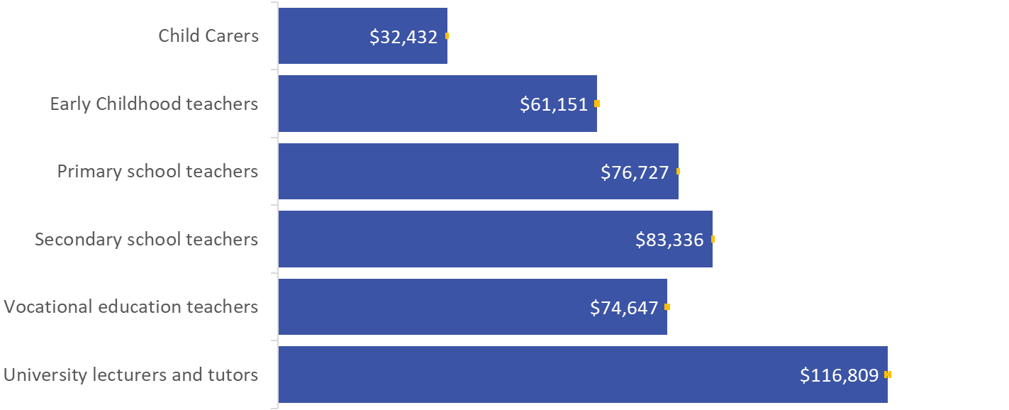
Source: Multi-Agency Data Integration Project 2016.
Notes: Reported data is average wages and salaries from personal income tax returns for the 2015-16 financial year, for people that worked full time (35 hours or more per week in the Census) in a relevant occupation in their main job. Occupations were classified according to the following four digit Australian and New Zealand Standard Classification of Occupations (ANZSCO 2013): Child Carers (4211), Early Childhood teachers (2411), Primary school teachers (2412), Secondary school teachers (2413, 2414), Vocational education teachers (2422) and University lecturers and tutors (2421). Special Education teachers were excluded. Census data is reported by any member of the household on behalf of other residents.

Educational attainment
Teachers are required to possess sufficient knowledge and skills to deliver high quality education. Multi-agency Data Integration Project data showed that the majority of Early childhood, Primary and Secondary school teachers had an Undergraduate Degree or higher (between 78 and 95 per cent) as their highest level of educational attainment (Figure 2). The majority of University lecturers and tutors (74 per cent) had postgraduate degrees (Doctorate or Masters) and earned a higher salary compared to those working in other institutions.
Over one third of Vocational education teachers had completed an undergraduate qualification (35 per cent) in 2016 and over one third of Child carers had completed a Diploma (38 per cent). Vocational Education and Training courses are required to be delivered by someone who has at least the level of vocational competencies that they are delivering, therefore the distribution across different levels of educational attainment is not unexpected in this sector.

Figure 2. Highest educational attainment for those working full-time, by childcare worker and teacher occupations, 2016
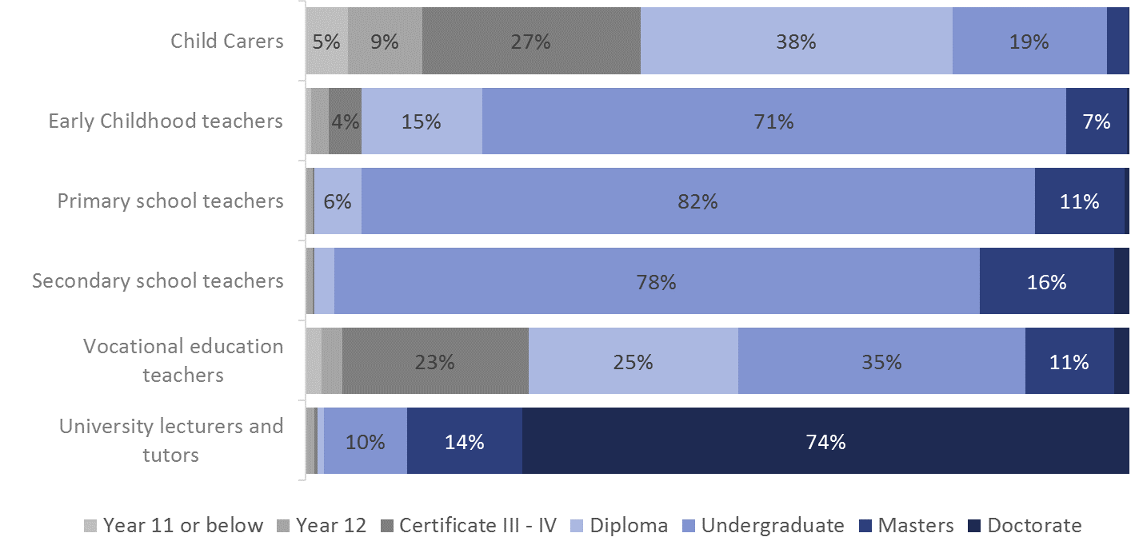Source: Multi-Agency Data Integration Project 2016. Reported data is the proportion of people with a known educational attainment working full time (35 hours or more per week in the Census) in a relevant occupation in their main job on Census night. Occupations were classified according to the following four digit Australian and New Zealand Standard Classification of Occupations (ANZSCO 2013): Child Carers (4211), Early Childhood teachers (2411), Primary school teachers (2412), Secondary school teachers (2413, 2414), Vocational education teachers (2422) and University lecturers and tutors (2421). Special Education teachers were excluded. Census data is reported by any member of the household on behalf of other residents.

Data and Methodology
The analysis in this paper used linked records from the MADIP Basic Longitudinal Extract 2011-2016 (2016 Cohort) (Cat. No. 1700.0, Microdata: Multi-Agency Data Integration Project, Australia) where persons were 15 years and over and employed full-time (worked 35 hours or more per week), resided in Australia on Census night (9 August 2016). Figure 1 has an added filter for those who submitted a Personal Income Tax return in the 2015-16 financial year. Figure 2 reports on a subset of those with a known highest level of educational attainment from the 2016 Census. Matching techniques were not used in this study.

Australian Skills Quality Authority (2019). Users’ Guide to the Standards for RTOs 2015, https://www.asqa.gov.au/standards/chapter-4/clauses-1.13-1.16, [Accessed 18/04/2019] ISBN 978-1-76051-836-3

