Stronger Education partnerships
Opportunities for Australian education and training providers in Indonesia


This project is supported by the Australian Government Department of Education through the Enabling Growth and Innovation (EGI) program. For further information, please visit the International Education Online <internationaleducation.gov.au>
This report complements Austrade’s Indonesia Market Action Plan (MAP), also funded through the EGI program and overseen by the Council for International Education and English Australia. The MAP aims to enable greater collaboration to strengthen the position of Australian education, training and research in Indonesia, and reflects core objectives of the National Strategy for International Education 2025 and the Market Development Roadmap AIE2025.
Disclaimer
This report, commissioned by the Commonwealth Department of Education and Training, has been prepared by the Australia-Indonesia Centre (AIC). The report is a general overview and is not intended to provide exhaustive coverage of the topic. The information is made available on the understanding that the AIC and the Commonwealth of Australia are not providing professional advice.
While care has been taken to ensure the information in this report is accurate, we do not accept any liability for any loss arising from reliance on the information, or from any error or omission, in the report.
We do not endorse any company or activity referred to in the report, and do not accept responsibility for any losses suffered in connection with any company or its activities.
About the Australia-Indonesia Centre
The Australia-Indonesia Centre is a bilateral research partnership initiative supported by both governments, leading universities and industry. Established in 2014, the Centre works to advance the people-to-people and institutional links between Australia and Indonesia in the fields of science, technology, education and innovation. We do this through a research program that tackles shared national challenges, and through engagement activities that promote greater understanding of contemporary Indonesia and strengthen bilateral research linkages.
To discover more about the Centre and its activities, please visit: the AIC website: <australiaindonesiacentre.org>
Authors:
Eugene Sebastian, Violet Rish & Kevin Evans.
Acknowledgements:
We wish to thank the many individuals and organisations who contributed their time and insights to this report. We are particularly grateful to Professor Abid Khan, Helen Brown, Helen Fletcher-Kennedy, Jesse Kartomi Thomas, Ghian Tjandaputra, Joanna Donagan and Febi Trihermato. The report also draws from an extensive program of consultations with stakeholders in Australia and Indonesia. We wish to also thank many people in the Commonwealth Department of Education and Training, the Department of Foreign Affairs and Trade and Austrade, all of whom made invaluable contributions to the report.

Contents
ABBREVIATIONS 4
EXECUTIVE SUMMARY 6
THE CONTEXT 10
INDONESIA’S EDUCATION AND TRAINING ENVIRONMENT 18
Higher Education 29
VOCATIONAL EDUCATION AND TRAINING 45
ENGLISH LANGUAGE training 56
schools 59
edtech 66
conclusion 71
Annexes 73
Annexe A: National priorities 73
Annexe B: Current Regulations for Foreign Education Providers 79
Annexe C: Employment of foreign workers 82
Annexe D: Financial regulation 85
References 86

ABBREVIATIONS
Austrade
Australian Trade and Investment Commission
ACICIS
Australian Consortium for ‘In-Country’ Indonesian Studies
AIC
The Australia-Indonesia Centre
BLK
Non-Formal Work Training Centres
BAN-PT
Indonesian National Accreditation Body for Higher Education
BAN-SM
Indonesian National Accreditation Body for Schools
BAPPENAS
Indonesian Ministry for National Development Planning
BKPM
Indonesian Investment Coordination Agency
DET
Australian Department of Education and Training
DFAT
Australian Department of Foreign Affairs and Trade
EdTech
Education Technology; Online / Blended Modes of Delivery
ELICOS
English Language Intensive Courses for Overseas Students
HE
Higher Education
IA-CEPA
Indonesia Australia Comprehensive Economic Partnership Agreement
IQF
Indonesian Qualifications Framework
LPDP
Indonesian Endowment Fund for Education (Tertiary Scholarships)
MoEC
Indonesian Ministry of Education and Culture
MoM
Indonesian Ministry of Manpower
MoRA
Indonesian Ministry of Religious Affairs
RISTEKDIKTI
Indonesian Ministry of Research Technology and Higher Education
SD
Primary School
SMP
Junior High School
SMA
Senior High School
SMK
Senior Vocational School
SPK
Joint Cooperation School
VET
Vocational Education and Training
Yayasan
Foundation or Not-For-Profit Entity

EXECUTIVE SUMMARY
Indonesia has a significant need for education and training services.
It has a young and expanding population and one of the world’s fastest-growing economies, but is facing a widening skills gap as it develops critical infrastructure and prepares for the jobs of the future.
For many reasons, Australian education and training institutions are uniquely well placed to help Indonesia realise its education, skills and training aspirations.
This report looks at how Australian providers can explore opportunities in Indonesia to the benefit of both countries.
Home to more than 260 million people, the majority of whom are under 30, Indonesia is the world’s fourth most-populous country, the biggest economy in Southeast Asia and one of the largest emerging economies in the world. With more than 50 million students attending over 250,000 schools, the World Bank ranks its education system as the fourth largest in the world, behind China, India and the United States.
Indonesia has had great success in expanding access to education, but quality issues remain. Authorities have recognised a growing skills gap in the economy, with an increasing percentage of the workforce considered lacking adequate levels of training. Indonesia’s long-term economic prosperity will reflect how well the country deals with this challenge, and its government has set an ambitious goal of adding 57 million skilled workers by 2030.
To meet this goal, Indonesia will need to partner with others, and it is expressing a new willingness to open its education sector to the world. Australian education and training providers are well placed, due to geography, history, reputation and other institutional alignments, to help Indonesia achieve its goals. Reflecting this, the recently signed Indonesia Australia Comprehensive Economic Partnership Agreement (IA-CEPA) has placed vocational education and training as a priority in the partnership.
While Australian institutions are already the destination of choice for Indonesian students studying abroad, this report aims to help Australian providers evaluate opportunities to establish or expand operations in Indonesia. It seeks to identify barriers to and opportunities for providers. It identifies the Indonesian national priorities relevant to Australian providers. It explores how local and foreign industry players active in Indonesia are navigating the regulatory environment to deliver education and training services.

A number of Australian providers are active in Indonesia. This report identifies three types of education partnership models, which we have categorised as general partnerships, strategic partnerships and joint ventures. Based on these models, it provides insights into types of in-country activities underway, the engagement approaches used, and the opportunities available and barriers to entry or expansion.
The report covers five sectors: higher education (HE), vocational education and training (VET), English language courses (ELICOS), schools and education technology (EdTech). Australian education providers have a range of views and approaches on their next steps, but all agree that Indonesia offer opportunities that are too important to ignore.

Key findings
- There is a large and growing demand for education and training in Indonesia. A small number of Australian providers are already actively pursuing their own agendas. Some are succeeding, some are at an early stage of business development, while some are revitalising their Indonesia strategy after seeing the rapid changes taking place in the country.
- These providers are using different approaches. A few concentrate on government engagement, offering training solutions or niche consulting. Some have chosen to deal exclusively with industry where it is relatively easier, and issues of funding are less of a concern. Others seek to partner locally in various ways to access the student market. Providers have consistently identified the importance of choosing the right partner.
- We identified three primary partnership models, each with a different degree of risk, institutional commitment and regulatory complexity. We have termed them general partnerships, strategic partnerships, and joint ventures. These demonstrate how some organisations are navigating Indonesia’s regulatory, policy and development environments, and each contains many lessons for Australian providers considering a presence in Indonesia.
- The vocational education sector may present a particular opportunity for Australian providers, due to both the scale of demand and Indonesia’s stated goal of boosting its skilled workforce. A number of Australian VET institutions have established operations in Indonesia.
- While the regulatory environment facing foreign providers may be complex, it is by no means prohibitive, as case studies in this report illustrate. Patience, commitment and the willingness to forge strong local relationships are seen as important ingredients in succeeding in Indonesia.

Sector-specific opportunities

Higher Education (HE)
- Some higher education providers use general partnerships as a lower risk strategy to establish or expand operations in Indonesia. These are generally the least complex and most flexible forms of engagement. Two types of activities are common: short-term arrangements responding to institutional capability needs; and collaborative coursework arrangements involving credit transfer and dual/double degrees.
- Strategic partnerships are the second most common model. These involve: higher education institutions using a licensing arrangement where they enter into a contract with a local partner to obtain the right to deliver programs in-country; and delivering joint degrees involving partnering with a local education institution and leveraging their program, facilities and services to deliver degrees in-country.
- Indonesia’s Law on Higher Education permits a wide range of direct engagement by foreign higher education providers in Indonesia. However, at present there is no standalone foreign branch campus operating in Indonesia. One foreign institution has been operating a joint venture with a private Indonesian university since 2014.
- The recent Ministerial Regulation 53 of 2018 potentially allows foreign universities to open a campus in Indonesia on a not-for-profit basis. Foreign providers will need to meet strict criteria and important details are still being finalised. Also the language used in the regulation lacks clarity on its potential application. For example it states that foreign campuses “can” be established in special economic zones. Does this mean they “can not” be established outside such zones. It suggests some further internal debates within the Indonesian higher education ecosystem are needed.
- According to the Department of Foreign Affairs and Trade, the recently signed IA-CEPA “automatically locks in future liberalisation for Australian universities setting up in Indonesia”, which means Indonesia will not impose any further regulatory restrictions on Australia should Indonesia open its higher education sector to any other country.

Vocational Education and Training (VET)
- Increasing the skilled workforce through VET is a priority for the Government of Indonesia. Improving the curriculum and the quality of teachers, along with enhancing partnerships with industry, are some of the key priorities.
- VET providers active in Indonesia use short-term commercial contracts to engage with government and business. These contracts are useful for developing business-to-business relationships, with a view to potentially establishing longer-term arrangements.
- Many providers are looking for opportunities for strategic partnerships. Some are looking to partner with the Government of Indonesia at national and provincial levels. Some are looking to industry/sectoral opportunities. The potential for strategic partnerships in the VET sector appears to be greater than in the higher education sector.
- There is a demand for a “train-the-trainer” model in collaboration with local institutions. This type of model is attractive to government – national and local – given the scale of skills needed.
- There are currently no Australian VET providers with a joint-venture partnership or standalone campus in Indonesia. Some VET providers exploring greater Indonesia engagement are considering a campus or training facility.
- Providers are looking for new financing models to support the delivery of training programs to government and the private sector. Some view non-accredited training, for example, a ‘train-the-trainer’ model, as a way of delivering programs at scale and cost.
- The IA-CEPA contains provisions allowing Australian ownership of up to 67 per cent for supplying certain technical and vocational training services. Any further relaxation of investment restrictions would automatically include Australian providers.

English Language Training
- English language tuition can be a bridging program supporting pathway to higher education, VET and schools. Providers are considering how to combine English tuition within a broader package, and whether they can employ online or blended learning.
- Most providers don’t see a model based on teaching English alone. English tuition fees are modest when compared to services such as VET, higher education and schools. Rather it is seen as a means of attracting students to other offerings, or as a component of a larger qualification.

Schools
- Indonesian schools are permitted to partner with foreign providers to operate as Joint Cooperation Schools (SPK) in Indonesia. Foreign partners must work with a local Indonesian education institute to establish a local non-profit foundation or Yayasan, be registered locally and have Indonesian citizens on their governing board.
- While few Australian schools currently deliver education services in Indonesia, Australian providers see schools engagement as essential not only for in-country opportunities, but also to build onshore pathways. The number of schools in Indonesia that teach an international curriculum demonstrates a potential market for Australian school education. There is strong brand recognition of Australian school education, but this has yet to be converted into significant opportunities. Increased schools engagement would benefit all sectors, and Australia is best placed to champion such engagement.
- VET providers could consider expanding foundation programs suited to Indonesian students to foster pathways to higher education in Australia. This has been attempted, but there are few examples.

EdTech
- Online/blended learning is integral to delivering modern educational services, and providers should consider how these platforms could be used at all levels.
- Although still in early days, Indonesia’s EdTech ecosystem is now in full take-off mode, with around 20 established EdTech firms operating in Indonesia across the school, English language and VET sectors.
- Australian providers wanting to add an online component to their offering might consider partnering with an emerging Indonesian EdTech firm, or one of the few foreign EdTech companies in Indonesia.
- Indonesian providers are keen to partner with Australian firms. Securing a place in this sector will become more complex in the medium term as established players reach the point of diminishing returns in accessing new clients.

THE CONTEXT
To continue to accelerate economic growth, Indonesia needs to add 57 million people to its workforce by 2030.
Australia is well positioned to contribute to Indonesia’s human capital development.
This report explores the opportunities available to Australian education and training providers in Indonesia.

Background
Education and training exports are Australia’s third largest source of foreign revenue. According to the Australian Bureau of Statistics, these exports were worth A$32.4 billion in 2017/18, a 15.5 per cent increase on the previous financial year. Indonesia’s young and large population, its close geographic proximity to Australia and its upwards economic trajectory make it a key potential partner for Australian education and training providers. But assessment of opportunities for Australian providers in Indonesia is limited.
The Australian Department of Education and Training commissioned the Australia-Indonesia Centre to assess opportunities for increased engagement by Australian education providers in Indonesia, identifying barriers and expansion opportunities in five sectors: higher education, vocational education and training (VET), English language courses (ELICOS), schools and education technology (EdTech).
This report explores the opportunities now available to Australian education and training providers in Indonesia, and supports the goals and objectives of the Australian Government’s first National Strategy for International Education 2025 and the Australian International Education 2025 (AIE2025). The National Strategy sets out a 10-year plan for developing Australia’s role as a global leader in education, training and research. Complementing the strategy, AIE2025 identifies what the sector collectively needs to do to capitalise: compete at scale, embrace borderless learning 24/7, unleash technology, sharpen market focus, attract global capital and maintain an Australian edge.
This report supports the goals and objectives of the Australian Government’s first National Strategy for International Education 2025 and the Australian International Education 2025 (AIE2025).
This report also acts as a country-specific extension to the 2015 Deloitte Access Economics’ research report, Growth and Opportunity in Australian International Education. While that report outlines the scope of onshore as well as in-country opportunities over the next decade, this report focused on education opportunities in Indonesia.
This report focuses on education and training relationships of various forms and potential partnerships between both countries, noting the deep, historic and extensive connections that already exist. This broad relationship is illustrated through the approximately 300 Memorandums of Understanding between Australian and Indonesian universities, more than 90 sister-school relationships, more than 5000 New Colombo Plan students who have studied in Indonesia to date, and organisations such as the Australia Indonesia Institute, the Indonesia Project, the Australian Consortium for ‘In-Country’ Indonesian Studies (ACICIS) and the Australia-Indonesia Centre. Australia Awards remains the largest and longest-running international scholarship program in Indonesia. This long-standing education relationship provides a strong basis for further engagement in Indonesia by Australian providers.

Methodology

Stage 1 Desk Research
- Review existing market information and data.
- Develop high-level insights into Indonesia’s education sector, its regulatory environment and policy context.

Stage 2 Qualitative research in Australia and Indonesia
- Conduct 41 face-to-face or telephone interviews with education and training providers, peak industry bodies and relevant government departments and agencies. Interviews were conducted one-on-one with senior representatives of institutions in Brisbane, Canberra, Melbourne, Sydney, Bandung and Jakarta.
- Develop deeper insights.

Stage 3 Case studies
- Based on the interviews, we developed a series of case studies exploring further how Australian education and training providers operate in Indonesia.

Current approaches
Consultations revealed that Australian education and training providers active in Indonesia have different views on what their next steps of engagement may look like, but all agree that Indonesia is too important to ignore.
There are a number of cautionary tales, but also some inspiring ones. The more experienced providers see Indonesia as a long game, and are prepared to invest time, effort and resources to build connections and increase their profile.
Some are successful in their education relationships. Others have struggled to find the right partner or the right model of engagement.
Those who have been in-country for a while often began with lower-risk activities. Some focused on short-course training supported largely through government development funds such as the Australia Awards. A small number of higher education (HE) institutions have pursued dual degree arrangements. Others have moved into niche offerings such as licensing their programs or joint-degree delivery.
Before 2013, Australian institutional activities focused on on-shore recruitment growth, ad-hoc articulation arrangements and small-scale research links. Since then, partially due to an influential McKinsey Global Institute report on the scale of opportunities in Indonesia, institutions have been more aware of its scope as a potential partner.

Higher Education
A number of institutions have chosen to pursue deeper engagement. Some have collaborated with Indonesia’s best universities in research areas such as health, climate change and eliminating dengue. Others have sought to build larger initiatives aimed at establishing networks of excellence in research and education. In 2014, Monash University, the University of Melbourne, the Australian National University and the University of Sydney formed a research consortium with Indonesia’s top seven research universities to establish the Australia-Indonesia Centre. The Centre has brought together more than 400 researchers to tackle shared challenges in energy, food, health, infrastructure and urban water.
Engaging the Indonesian alumni network has also taken a higher priority, as it is influential in senior levels of government, industry and society. More recently, some institutions have signalled their commitment by establishing offices in Jakarta. This helps with building a multi-layered engagement within the country, complementing student recruitment strategy, engaging alumni and acquiring market intelligence. More importantly, it brings immediacy to the relationships needed to open doors to high-level contacts in education institutions, government and industry.

Vocational Education and Training
In vocational education and training (VET), Australian providers have an established history in delivering skills programs for both government and industry in Indonesia, with some engaged for the past two decades. A number of these providers have managed to turn relationships into outcomes. Some of these began with the Australia Awards program, while others have focused on industry linkages. A common approach has been acquiring short-term opportunities that generate revenue and build brand awareness. These opportunities, as one senior VET sector executive pointed out, are about recovering costs and developing long-term sustainable partnerships with institutions or government ministries. Some VET providers are now in the early stages of developing models for delivering training at scale.

In-country education partnership models
There are a handful of Australian education and training providers already active in Indonesia. Some are succeeding in pursuing their agenda, while others are at an early stage of business development.
The ones that are succeeding use creative approaches to deliver their programs. A few focus on government engagement, offering training solutions or niche consulting. Some deal only with industry, as they find it is relatively easier, and issues of funding are less of a concern. Others seek to partner locally in various ways to access the student market.
The following page outlines the three partnership engagement models adopted by Australian providers to pursue education engagement in Indonesia in creative ways despite policy, regulatory and implementation challenges.

Three types of partnership models

General Partnership
Risk: Low
Features:
- Used as low-risk market entry strategy.
- Short-term contracts for service delivery through training or consulting, covering some teaching, training or curriculum development work. These activities respond to the needs of Indonesian organisations.
- Collaborative coursework arrangements are undertaken in two-ways: credit transfer or dual/double degrees. Credit transfer is when a student gains credit from a local institution to study at an Australian institution. Dual/double degree is where two institutions collaborate to deliver a common program. Students receive a qualification from each partner (as opposed to a joint degree, where a student receives one degree with two institutional testamurs). Regulatory requirements are minimal.
Types of activities:
- Short-term commercial contracts
- Collaborative coursework arrangements – credit transfer/dual degrees

Strategic Partnership
Risk: Medium to high
Features:
- Provider forms local partnership to access the broader student market.
- Finding the right partner is critical. At this level the local partner helps navigate the local environment and handle regulatory matters.
- There are two types of partnership: licensing and joint programs.
- Licensing involves an institution entering into a contract that grants a local partner the right to deliver its programs in-country.
- Joint programs involve students undertaking jointly awarded degrees entirely taught in-country.
Types of activities:
- Licensing agreement
- Joint degrees

Joint Venture
Risk: High
Features:
- Involves an entity partially or fully owned by a foreign education provider.
- Partnerships are either commercial or non-commercial.
- Students have access to an entire academic program through
face-to-face teaching.
- Foreign education provider awards credential or certification.
- There are current regulatory limitations on this type of model.
Types of activities:
- Includes opening a campus or training facility.
We found higher education and vocational education as the two sectors with activities in general and strategic partnership levels.
General partnerships were generally the preferred form of engagement. Higher education and vocational education institutions found this pathway to be lower-risk.
Strategic partnerships were fewer. Only one higher education institution currently has a substantive arrangement with a local private institution, offering joint degrees in business. Vocational education institutions were active in the strategic realm, however, a number of public and private vocational education and training providers interviewed, have engaged in discussions or are close to forming a significant partnership to deliver in-country training programs.
The report describes how some providers use these models to navigate Indonesia’s regulatory, policy and development environments. Case studies provide insights into different types of in-country activities and engagement models, the opportunities available and barriers to entry or expansion. The learnings could inform the strategies of Australian providers.

Figure 1.1. Type of activities under the partnership models.
Higher Education | Yes or No
General Partnership  - Short-term commercial  - Collaborative coursework | Yes
Strategic Partnership  - Licensing  - Joint degrees | Yes
Joint Venture  - Not-for-profit foundation | Yes

Vocational Education & Training | Yes or No
General Partnership  - Short-term commercial  - Collaborative coursework | Yes
Strategic Partnership | No
Joint Venture  - Not-for-profit foundation | Yes

ELICOS | Yes or No
General Partnership | No
Strategic Partnership  - Language training | Yes
Joint Venture | No

Schools | Yes or No
General Partnership | No
Strategic Partnership  - Licensing | Yes
Joint Venture | No

EdTech | Yes or No
General Partnership | No
Strategic Partnership | No
Joint Venture  - Online courses | Yes

Key knowledge and drivers
As the Indonesian education and training sector opens up, we asked Australian providers what key information they required to evaluate new or expanded in-country opportunities. We found they focused on three key areas.

1. Accessibility
- Understanding the size, geography and potential of the market for education and training services, and understanding student recruitment pathways.
- Scenario drivers: Demographics, potential numbers of students/trainees, affordability, access to quality.

2. Demand
- Understanding in-demand fields of education and their broad alignment with Indonesian goals, for example national and provincial strategies for innovation and human capital development.
- Scenario drivers: Fields of demand for study and skills development, national goals.

3. Flexibility to operate
- Gaining a clear understanding of the regulatory framework and what is and is not permitted, from setting up a presence, academic and administrative to visa requirements.
- Scenario drivers: Limits and restrictions on utilising expatriate labour, financial flows, location, ownership, curriculum issues.

INDONESIA’S EDUCATION AND TRAINING ENVIRONMENT

Why Indonesia?
Indonesia is large, young and growing. With more than 260 million people, it is the world’s fourth most populous country. Its economy, already the biggest in Southeast Asia and the 16th largest in the world. Consulting firm, PwC, predicts that its economy will be the fourth largest in the world by 2050.
With more than 50 million school students, Indonesia’s education system is, according to the World Bank, the third largest in Asia and the fourth largest in the world (behind China, India and the United States).
More than 21 million Indonesians are of college age (19-23 years) and more than half of all Indonesians are under the age of 30. About 67 million (26 per cent) are between the ages of 15 and 24, the third largest such cohort in the world after India and China.
Figure 2.1. Top 5 populations of 15 to 24-year-olds – 2014.
Source: United Nations Population Fund.
Country | Population | % of population
1. India | 356 million | 28
2. China | 269 million | 20
3. Indonesia | 67 million | 26
4. United States | 65 million | 20
5. Pakistan | 59 million | 32
Indonesia’s young population is also urbanising. Its cities are growing faster than those of any other Asian country, with the urban population increasing at 4.1 per cent per annum. The World Bank forecasts that 68 per cent of Indonesia’s population will be living in cities by 2025, with Deloitte predicting that 41 million of those city dwellers will be aged 15-29.

Demand for education is growing.
Euromonitor predicts Indonesian education industry revenues to grow at a compound annual rate of 10.3 per cent between 2016 and 2025, by which time they will be worth US$118 billion.
Indonesia’s young population is also urbanising. Its cities are growing faster than those of any other Asian country, with the urban population increasing at 4.1 per cent per annum. The World Bank forecasts that 68 per cent of Indonesia’s population will be living in cities by 2025, with Deloitte predicting that 41 million of those city dwellers will be aged 15-29.
Figure 2.2. Top five countries with highest future growth based on Compound Annual Growth Rate (CAGR) – 2016-25.
Source: Euromonitor International.
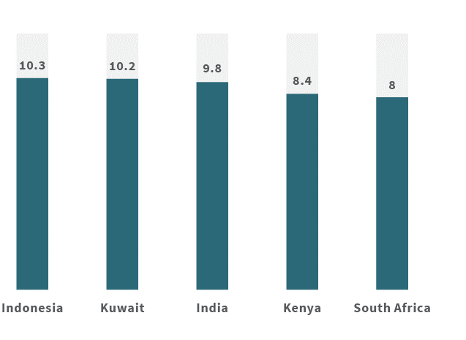
In the higher education sector, enrolments at Indonesian universities increased from 5.2 million in 2010 to 8 million in 2018. Enrolment rates are expected to double by 2024, the third fastest growth rate in the world after India and China.
In vocational education and training, there has been a notable increase in the number of students attending the country’s 13,710 vocational high schools (SMK). In the 2017/18 school year, 4.9 million Indonesians were studying at an SMK, an increase of 17 per cent in five years. In fact, for the first time, more Indonesian high school students were at a vocational rather than general high school (SMU).

Demand for offshore education and training
With a young and growing urban consumer class, Indonesian students are increasingly seeking offshore education opportunities.
The number of Indonesian higher education students studying overseas is growing steadily, reaching 46,000 in 2016 – up 30 per cent since 2011 (See Figure 2.3).
Figure 2.3. Indonesia’s Tertiary Education Outbound Student Market.
Source: UNESCO Institute for Statistics.
Year | Students
2011 | 35,378
2012 | 36,363
2013 | 39,553
2014 | 39,505
2015 | 44,845
2016 | 46,232
Indonesia is the third largest outbound HE market in Southeast Asia, after Vietnam and Malaysia (See Figure 2.4). Though Indonesia’s outbound numbers continue to grow, they are comparatively small for a country of Indonesia’s size and per capita income.
Figure 2.4. Outbound students from Southeast Asian countries – 2017.
Source: UNESCO Institute for Statistics.
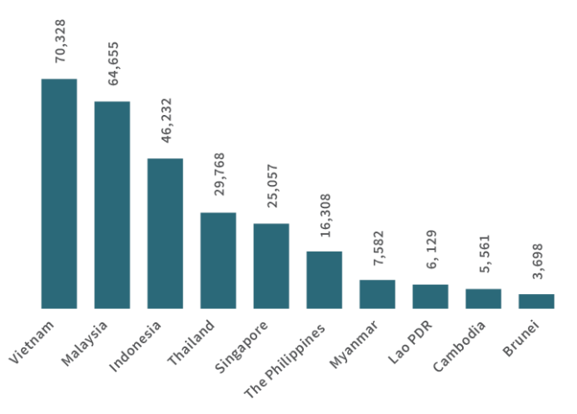

Demand for offshore education and training
Australia remains Indonesia’s top destination for higher education, attracting more than a quarter of Indonesian outbound students. After Australia, the leading destinations are Malaysia and the United States (See Figure 2.5). Malaysia has enlarged its market share over the last three years, overtaking the US. Its effective marketing, familiar cultural and religious environment, relative affordability and the presence of foreign-based campuses – such as Monash University Malaysia, Curtin University of Technology Sarawak Campus, University of Nottingham Malaysia campus and Swinburne University of Technology Sarawak campus – have made it an attractive destination.
Figure 2.5. Indonesia’s Top Five destinations for outbound higher education students 2017.
Sources: Malaysia – Ministry of Higher Education Malaysia, Unit Data, BPPPD, 2017; Japan Students Services Organization (JASSO), International students in higher education 2017; Australian Department of Education and Training, Higher Education Year to Date enrolments by nationality, 2017; US Open Door report 2017; UNESCO Institute of Statistics.
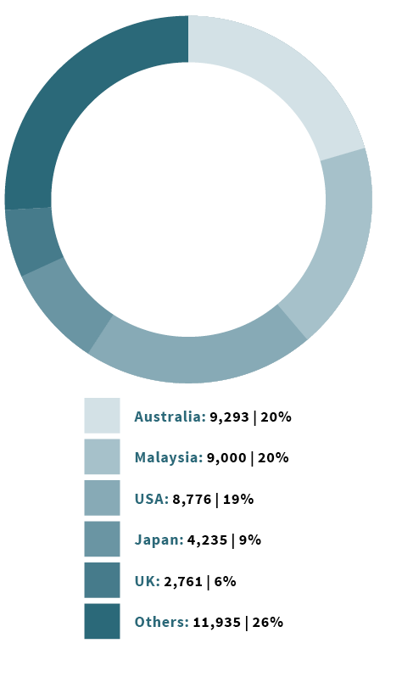
When VET and ELICOS are considered, enrolments are higher in Australia. There are more than 20,000 Indonesian students enrolled onshore – an annual growth rate of 6-7 per cent (See Figure 2.6). Enrolments are even higher if you factor in Australia’s offshore presence. In 2015, 2300 Indonesian students studied at Australian offshore campuses in Singapore and Malaysia.

Figure 2.6. Indonesian enrolment in Australia
Source: Department of Education and Training
Sector | 2015 | 2016 | 2017 | 2018
Higher Education | 8469 | 8732 | 9270 | 9883
VET | 8,190 | 8,579 | 8,264 | 8,675
Schools | 223 | 213 | 228 | 213
ELICOS | 1,733 | 1,542 | 1,358 | 1,263
Non-award | 644 | 681 | 838 | 861
Total | 19,259 | 19,747 | 19,958 | 20,895
Management and commerce courses are by far the most popular field of study for Indonesian students in both higher education and VET in Australia. It is followed by society and culture and food, hospitality and personal services (See Figures 2.7 and 2.8).
Figure 2.7. Field of Education in Australia – Higher Education 2017.
Source: Department of Education and Training.
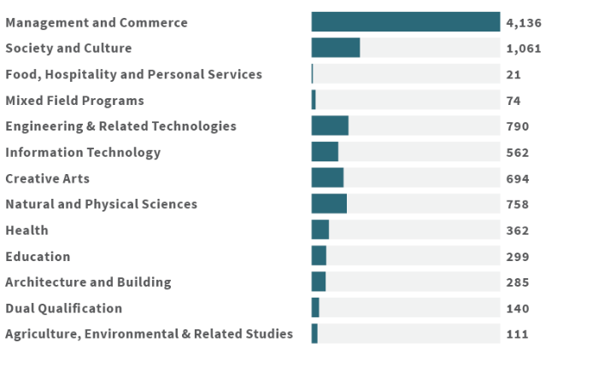
Figure 2.8. Field of Education in Australia – VET 2017.
Source: Department of Education and Training.
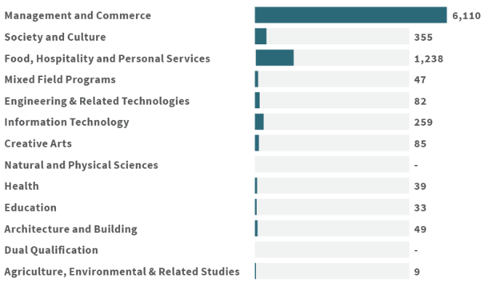

National priorities and emerging opportunities
While the demand in Indonesia for education and training continues to grow, so too does the nation’s skills gap.
Research from the International Labour Organisation indicates almost 20 per cent of the Indonesian workforce is underqualified for the work being undertaken, up from 11.5 per cent in 2006.
That lack of quality human capital poses a major challenge to the country’s economic and growth aspirations.
Despite successful efforts by the Government of Indonesia to improve access to education, domestic institutions continue to struggle to deliver the types of graduates the country needs.
In a 2017 survey by the British Council, only 37 per cent of Indonesian parents felt that a local university education offered value for money. The view from industry is similar. Two-thirds of companies surveyed by the World Bank in 2014 said finding qualified employees for professional and managerial positions was either difficult or very difficult. Almost 70 per cent of manufacturing employers said they struggled to find skilled engineers.
President Joko Widodo is committed to addressing the skills gap, calling for the “massive, massive development of human resources” and outlining major themes for human capital development:
- Creating work-ready graduates through vocational education and certification: The Ministry of Manpower (MoM) has launched the 3R program (Reorientation, Revitalisation and Rebranding) for the national network of Work Training Centres (Balai Latihan Kerja – BLK). The Centres are vocational education institutions supported by MoM but managed by local authorities. More than 300 centres across the country supply competencies-based training to more than 280,000 students. The President also set a target of establishing community training centres within 1000 Islamic boarding schools (Pesantren) by the end of 2019.
- Matching vocational schools’ education with industry-relevant skills: The Ministry of Industry has launched the Industry Vocational Education Program, which connects more than 1500 vocational high schools (SMK) with at least 560 industry partners across Java and Sumatra. The program adopts the German model of dual vocational training that aligns to the needs of the labor market.
- Calling for universities to innovate and create new areas of study in response to global trends: The President has called previously for universities to create a Faculty of Digital Economy, with majors in e-commerce and logistics and supply chain management. Five of 26 programs in the Government of Indonesia’s E-commerce Roadmap focus on human capital development: Improving public awareness of e-commerce platforms; developing policy-makers’ knowledge of the e-commerce ecosystem; establishing incubator programs for startups; realigning formal education curriculum with the digital economy; and training facilitators of digital economy.
- Responding to the challenges of the Fourth Industrial Revolution: The Ministry of Industry’s Indonesia 4.0 strategy focuses on building the capacity to adopt fourth industrial revolution technologies (artificial intelligence, internet of things, advanced robotics, wearables and 3D printing) within five priority manufacturing sectors: food and beverage, textiles and apparel, automotive, biochemistry and electronics.
Figure 2.10 outlines five government initiatives likely to influence future demand for education and training.
Figure 2.10. Indonesian government priorities likely to influence Indonesia’s demand for education and training.
Making Indonesia 4.0
- Aims to revive Indonesia’s manufacturing sector and improve its competitiveness.
- Ten key national priorities include developing human capital, building national digital infrastructure and boosting R&D.
- Five sectors of focus: Food & Beverage, Textiles & Apparel, Automotive, Electronics and Chemical.
Tourism
- Aims to attract 20 million foreign visitors by 2020.
- Plans to diversify beyond Bali. Ten new locations are under development.
- Will require addressing four major challenges that require appropriate skills and capabilities.
E-Commerce Roadmap
- A whole-of-government strategy to grow Indonesia’s ecommerce to US$130 billion by 2020.
- Five themes: Funding, Taxation, Consumer Protection, Human Capital Development and Communications Infrastructure.
Research, Technology & Higher Education
- Research, technology and higher education continue to play an important role in Indonesia’s innovation aspirations.
- Aims to enhance relevance, quantity and quality of higher education graduates.
- Focus on empowering science, technology and innovation for improving Indonesia’s national competitiveness.
Technical Vocational Education & Training
- Prioritises revitalisation of vocational colleges (under the Ministry of Manpower) in the areas of: Energy, Tourism, Transportation, Electronic, Telecommunication, Automotive, Healthcare, Food and Beverages and Agriculture.
(Further details in Annex A).

Overview of Indonesia’s education and training governance
Indonesia’s education and training services sector is regulated by several ministries, with implementing powers invested across national, provincial and local authorities.
In the government-funded sector, the national government leads on tertiary education, provincial authorities lead on senior schooling and local authorities lead on preschool and primary education. Post-school training centres are managed by local authorities. Accreditation is managed at the national level.
The regulatory environment, as in many countries, provides both incentives and disincentives for foreign service providers. International education providers have often had to find creative, ad-hoc solutions to operate effectively in their preferred sub-sectors.
A strong policy driver in Indonesia is the need to improve its citizens’ access to educational opportunities. This promotion of mass educational uptake has often led to compromise on matters of quality.
A second policy driver has been the view that the education system is a vital tool for forging a sense of national identity among students.
Reforms to rules governing the presence of foreign universities, work permits for foreign teachers and other such restrictions have been proposed, but progress has been slow.

Indonesia’s education and training key stakeholders
Ministry of Research Technology and Higher Education (RISTEKDIKTI)
Responsible for research, policy and oversight for tertiary education, as conducted by universities and polytechnics.
Ministry of Education and Culture (MoEC)
Responsible for preschool, primary school (Years 1-6), junior secondary (years 7-9) and senior secondary (years 9-12). Includes senior secondary vocational education and special education.
Ministry of Religious Affairs (MoRA)
Operates a parallel system from preschool through to tertiary level that educates approximately 20 per cent of students. An additional complexity is that many religious institutions, such as Muhammadiyah or the Catholic Church, manage their schools and universities not through MoRA but through the MoEC and RISTEKDIKTI – the difference being that these organisations’ religious schools teach the same material as state schools, instead of acting as schools of theology.
Ministry of Manpower (MoM)
Responsible for post-school training activities.
Other ministries
Other ministries operate their own post-school vocational education centres. Even so, these centres are overseen by RISTEKDIKTI in terms of certification.
Non-government sector
The non-government sector is very active from preschool to tertiary level.

Operating environment for establishing an in-country presence
The regulatory environment in Indonesia for foreign providers is complex, although, as this report illustrates, it has significant potential for Australian providers.
Key takeaways for providers across the schools, higher education and VET sectors:
- Foreign providers operating in the schools or degree conferring sector must join with an Indonesian partner to form a not-for-profit entity, often in the form of a foundation (yayasan), to operate. Foundations must be endorsed by the Indonesian Ministry of Justice and Human Rights. Foundations can establish businesses and enter into commercial contracts with other entities.
- The exception is in the non-accredited work training sector, where commercial foreign investment is allowed but capped at 67 per cent foreign equity (Presidential Decree 44 of 2016). There has been a recent Government decision to raise this to 100 per cent, but specifics remain to be fleshed out. The national investment agency BKPM (Badan Koordinasi Penanaman Modal) must endorse work training investments. While the policy has been announced, details on actual implementation are now being finalised.
- Fields of study must be accredited by the relevant ministry.
- Regulations on employment of foreign workers affect all sectors (See Annex C). Restrictions on recruiting and employing foreign labour is raised consistently by Australian providers as the biggest regulatory hurdle to deepening their engagement with Indonesia. Around the middle of this decade a stricter interpretation of rules around foreign workers resulted in a sharp drop in the number of work permits issued, although the situation has eased slightly in the past year.
- Foreign workers to be employed in Indonesia must be suitably qualified and be able to demonstrate how skills transfer will occur with their Indonesian colleagues. There are additional requirements around the hiring of foreign teachers and language teachers (See Annex B).
- It is possible to establish a quasi-presence in Indonesia (i.e. not a formal legal identity) through contractual partnerships with Indonesian institutions. The Indonesian partner is usually responsible for registration, as well as providing premises, teachers and student clientele. The international partner provides the expertise, curriculum and quality control. Commercial and regulatory realities in Indonesia mean most foreign institutions find this arrangement preferable, even though they are left somewhat exposed to the decisions of the local partner, and do not enjoy rights (e.g. recourse to litigation) that they would enjoy under incorporation.

Key points by sector:
- The enactment of Ministerial Regulation 53 of 2018 potentially allows foreign universities to open a campus in Indonesia on a not-for-profit basis. Foreign providers will need to meet strict criteria, and important details, such as the status of foreign workers, are noted in the RISTEKDIKTI regulation, however in implementation there will also be other ministries, most notably, Manpower ministry that will be involved in processing.
- A higher education institution can be established by government or a not-for-profit foundation (yayasan) or potentially a not-for-profit civil law association. An Indonesian citizen must serve on the board of a foundation with a foreign partner, as either chairman, secretary, or treasurer.
- A VET institution providing non-accredited training may hold up to 100 per cent foreign ownership, under Indonesia’s recently announced 2018 Negative List (updating Presidential Regulation 44 of 2016). While the policy has been announced, details on actual implementation are now being finalised.
- A school with a foreign partner (SPK) can be established as a not-for-profit foundation (usually a yayasan), with an Indonesian partner, including Indonesian citizens on its board. The foreign partner must also be recognised in its own country by relevant education authorities. The Ministry of Education and Culture must issue a licence and assess the curriculum.
(Details on regulations are provided at Annex B).

Operating environment for establishing an in-country presence.
Regulatory reforms aimed at opening the space for international engagement often encounter resistance as they move toward implementation. In May 2018 it was reported that a previously discarded regulation that would require foreign workers to speak Indonesian would be reintroduced. This issue has even been promoted in the 2019 Presidential Election debates. As elsewhere, broader political issues and economic factors impact on Indonesia’s education and training sector. Successful models of international cooperation need to navigate the various interest groups with care.

Higher Education
Higher Education
Key points
- Private higher education sector dominates enrolments.
- College and academy institutions make up 70 per cent of total sector enrolments.
- Private higher education institutions are predominantly small, have low enrolments, are expensive and varied in quality.
- RISTEKDIKTI is turning its efforts to lift the quality of its higher education sector.

Sector overview
Indonesia’s higher education system contains two main streams. The first, usually termed the national system, consists of most state and private tertiary education centres. These are divided into universities (universitas), institutes (institut), tertiary colleges (sekolah tinggi), polytechnics (politeknik) and academies (akademi). They are established and operate under the supervision of the higher education ministry, RISTEKDIKTI.
Universities, institutes and tertiary colleges can all confer bachelor’s degrees, while larger and more advanced centres can confer degrees up to doctoral level. Polytechnics and academies offer qualifications up to diploma level.
The Ministry of Religious Affairs manages the second group of tertiary education centres. These centres are, again, established as universities, institutes and tertiary colleges.
Adding a further dynamic is the fact that many tertiary education centres owned by faith-based organisations such as Muhammadiyah or by Catholic and Protestant Church groups are established and operate under the Ministry of RISTEKDIKTI. This is because, while owned by faith-based groups, these centres do not focus on theology and other issues of religious study within their curriculum.
In all, there are 4,652 tertiary education and training centres in Indonesia.
Figure 3.1 shows about 4,223 are privately owned. Colleges and academies make up over 70 per cent of the sector.

Figure 3.1. Number and types of tertiary education institutions.
Source: Ristekdikti, July 2018.
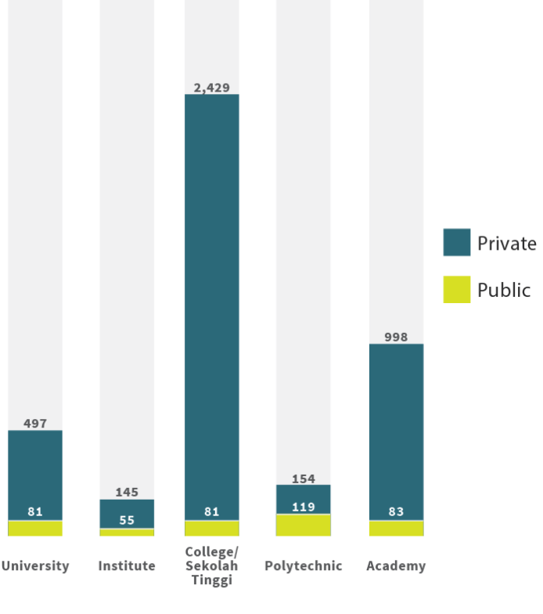
MoRA is responsible for an extensive network (58 state and 643 private) of Islamic Tertiary Centres, Islamic Institutes and State Islamic Universities, and several religious centres for the minority religions in Indonesia.

Size and potential higher education student numbers
Recent data on student enrolments across seven major regional zones (See Figure 3.2) shows the size and potential of HE student numbers. Java, with more than half of Indonesia’s population, has nearly 4 million students enrolled at public and private institutions. Sumatra has 1.3 million (from a population of 50 million) and Sulawesi 756,363 (from a population of 17 million).
Figure 3.2. Total Student Enrolments at public and private higher education institutions – 2017.
Source: RISTEKDIKTI Statistics.
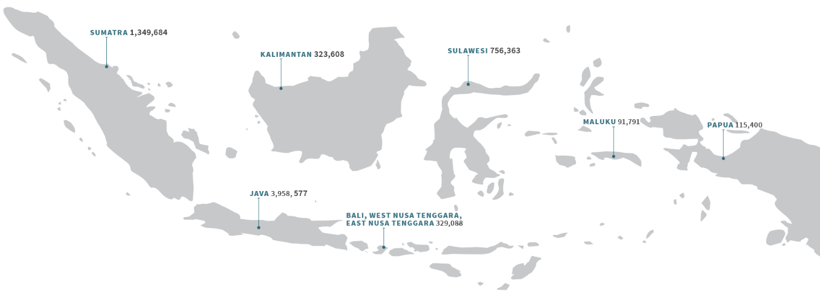
Jakarta is home to 10 million people, 30 per cent of whom are aged 15-29. It has over a million enrolled HE students. It also has the highest number of private enrolments, representing about 30 per cent of the total Java-based student numbers. West Java has the second most enrolled students, at 850,000, followed by East Java with 844,675 enrolments.

Access to quality is limited
Indonesia’s determination over past decades to widen educational opportunities has meant less focus on quality, but policy makers are increasingly turning their attention to raising standards. Access to quality HE in Indonesia is currently limited. Public universities consistently outperform private institutions in quality measures, but admissions are competitive and places limited.
International university rankings are one indicator of the quality, performance and maturity of the sector. In the QS 2019 world rankings, only 10 Indonesian universities were in the top 1000, all of them public. Three ranked within the top 500 – the University of Indonesia (292), Bandung Institute of Technology (359) and Gadjah Mada University (391).
Figure 3.4. Indonesian universities ranked in the QS World University Rankings 2019.
Source: QS World Universities Rankings.
University | Rank 2018 | Rank 2019
Universitas Indonesia | 277 | 292
Institut Teknologi Bandung | 331 | 359
Universitas Gadjah Mada | 400-410 | 391
Universitas Padjajaran | - | 651-700
IPB (Institut Pertanian Bogor) University | 751 – 800 | 701-750
Universitas Airlangga | 701-750 | 751 – 800
Universitas Diponegoro | 801-959 | 801-1000
Institut Teknologi Sepuluh Nopember | 801-959 | 801-1000
Universitas Muhammadiyah Surakarta | 801-959 | 801-1000
Universitas Brawijaya | 801-959 | 801-1000
Under the national public and private universities rankings 2019 produced by RISTEKDIKTI, public universities dominate. The number one ranked university is the Institut Teknologi Bandung. Followed by the University of Gadjah Mada located in Yogyakarta at number two and IPB University, located in Bogor, at number three.
Only 10 private universities appear in the national top 50. Universitas Islam Indonesia (Yogyakarta) is the highest ranked private institution, followed by Universitas Katolik Indonesia Atma Jaya (Jakarta) and Universitas Telkom (City of Bandung). All 10 ranked private universities are on Java.
The private institutions enjoy more than 68 per cent of the HE enrolments. These institutions however tend to be small, with low enrolments, higher fees and variable quality. A 2015 OECD and Asian Development Bank study found only 3 per cent of the 427 programs at private universities evaluated by the National Board for Higher Education Accreditation (Badan Akreditasi Nasional Perguruan Tinggi – BAN-PT) achieved an “A” rating, compared to 22 per cent of 1274 public universities programs.

Figure 3.5. Top 10 Public and Private Universities in 2018 based on RISTEKDIKTI.
Source: RISTEKDIKTI.
Top 10 Public Universities | City | Ranking
Institut Teknologi Bandung | Bandung | 1
Universitas Gadjah Mada | Yogyakarta | 2
Institut Pertanian Bogor | Bogor | 3
Universitas Indonesia | Depok | 4
Universitas Diponegoro | Semarang | 5
Institut Teknologi Sepuluh Nopember | Surabaya | 6
Universitas Airlangga | Surabaya | 7
Universitas Hasanuddin | Makassar | 8
Universitas Padjadjaran | Bandung | 9
Universitas Andalas | Padang | 10

Top 10 Private Universities | City | Ranking
Universitas Islam Indonesia | Yogyakarta | 29
Universitas Katolik Indonesia Atma Jaya | Jakarta | 30
Universitas Telkom | Bandung | 33
Universitas Atma Jaya Yogyakarta | Yogyakarta | 34
Universitas Katolik Parahyangan | Bandung | 35
Universitas Muhammadiyah Malang | Malang | 36
Universitas Muhammadiyah Surakarta | Solo | 38
Universitas Soegijapranata | Semarang | 39
Universitas Bina Nusantara | Jakarta | 40
Universitas Kristen Petra | Surabaya | 41

Competition
Competition for Indonesian students is increasing. Countries such as the US and UK are active in student recruitment with advertising campaigns, education fairs and outreach activities in schools. Some examples of Australia’s competitors’ activities include:
- The British Council is building connections through arts, culture and education and the creative economy – regularly holding public events and connecting UK schools with Indonesian schools.
- The UK’s Chevening scholarship supports high-achieving Indonesians to study in the UK. They have partnered with the Indonesian endowment fund (LPDP) to provide scholarships.
- Coventry University, Warwick University and King’s College London are active in Indonesia through joint degrees, capacity building, people-exchanges and targeted student recruitment.
- In research collaboration and through the Newton Fund, the UK is investing A$35 million in Indonesia between 2014 and 2021, with the Government of Indonesia providing 30 per cent matched funding.
- In 2011, the US opened @America at an up-market mall in Jakarta. The centre promotes American culture, education and technology by targeting the young and tech-savvy. It can host 300 people for lectures, teleconferences and education recruitment activities, and has an on-site education advisor.
- Japanese universities actively build partnerships with their alumni, especially those at local universities. They maintain research links with alumni by providing funding opportunities and publication assistance, creating networks of champions within Indonesian universities. The Japan Society for the Promotion of Science maintains an association of Indonesian alumni that promotes science exchanges and collaborative research networks.
- Foreign universities have recently started opening representative offices in Indonesia. These not only boost local presence but make a statement about long-term commitment. In-country offices contribute to student recruitment and alumni engagement, enrich market intelligence and bring immediacy to relationships with high-level contacts in educational institutions, government and industry. Institutions with in-country offices include: Ritsumeikan Asia Pacific University and Kyoto University (Japan); the University of Southern California and the University of Florida (US); and GROW (University of Groningen, Wageningen University, Radboud University) and Leiden University (Netherlands).

Fees
Price and affordability influence student decision-making, along with considerations such as quality, reputation, field of study, location and graduate employability. Students’ ability to pay higher fees is an important factor in institutional pricing strategies.
Fees at public universities in Indonesia tend to range between A$4000 to $6000 per annum. Fees for a bachelor’s degree at a ranked private university are similar. A Monash University Bachelor of Arts or Engineering offered at its Malaysian Sunway campus costs between $11,000 and $15,000 per annum. Studying RMIT’s Bachelor of Economics and Finance at its Ho Chi Minh campus in Vietnam costs about $15,000 per annum.
Figure 3.6. compares fees at private and public institutions in a range of disciplines.
Figure 3.6. Example of private and public higher education fees 2018 in AUD.
Institut Teknologi Bandung (ITB), Bandung, West Java (Public University)
Bachelor’s Degree Program: Business School / International Class
Fees in A$: $4000 – $8000 per annum
IPB University Bogor, West Java (Public University)
Bachelor’s Degree Program: Business and VET School / VET International Class
Fees in A$: $2400 – $6000 per annum
Universitas Indonesia (UI), Depok, West Java (Public University)
Bachelor’s Degree Program: Social Sciences / Medical International Class
Fees in A$: $2500 – $7000 per annum
Binus University, Jakarta, DKI Jakarta (Private University)
Bachelor’s Degree Program: Regular Stream / Accounting and IT (double degree) /
Online Information System Management
Fees in A$: $2,800 – $5,200 per annum
Universitas Pelita Harapan (UPH), Tangerang, Banten (Private University)
Bachelor’s Degree Program: Bachelors / Medicine
Fees in A$: $2,900 – $5,200 per annum

In-country partnership models: used by Australian providers
We found two types of common general partnership approaches used by Australian providers: short-term commercial and a collaborative coursework arrangement. Some HE providers use general partnerships as a low-risk market entry strategy.
Two types of arrangements are common: short-term commercial and collaborative coursework.

General partnerships

1. Short-term commercial
A short-term commercial can serve as a launching pad for a potential partnership. There are a small number of Australian providers that use this type of commercial activity to support a broader country strategy.
Short-term activities involve consultancy or training responding to institutional capability needs, usually funded by bilateral or multilateral development assistance agencies (e.g. Australia Awards) or business (local and multinational). Courses are specialised, flexible and responsive to particular organisational needs. Activities are conducted in Australia, in-country or a combination of both.
Providers can use short-term commercial activities as a first step towards larger-scale or longer-term relationships and commercial engagements.
Figure 3.6. Examples of short courses delivered by higher education institutions and funded through the Australian Government’s Australia Awards, 2017.
Source: Australia Awards in Indonesia 2017 courses.

Examples of institutions delivering short courses
1. University of Sydney
2. Queensland University of Technology
3. University of Queensland
4. University of Adelaide
5. Griffith University
6. University of Melbourne
7. Monash University
8. Deakin University
9. The Nossal Institute for Global Health

Examples of short course topics delivered
Leadership and management; Enterprise and entrepreneurship; Better public sector; Principal and teacher competencies; Sustainable tourism; Sustainable agriculture and aquaculture; Water and sanitation; Terrorism and countering violent extremism; Tropical health.

Examples of clients
Non-government organisations; BAPPENAS; Corruption Eradication Commission (KPK); Ministry of Education and Culture; Ministry of Finance.

Case study
The University of the Sunshine Coast’s (USC) partnership with the University of Cenderawasih (UNCEN) in Papua began as an Australia Awards grant for short-term fellowships to Australia. It has since developed into a province-wide leadership and professional development program for educators that has reached more than 2000 teachers and principals.
USC and UNCEN work directly with provincial and local governments. To make the model work, USC appointed a senior advisor based in Makassar to develop on-the-ground relationships and build trust. Each training workshop ran for two weeks and was conducted in various locations in Papua. A critical feature was the relationship building and stakeholder consultation during the program design phase.
The USC’s success means it is now looking to work with local governments elsewhere in eastern Indonesia, again in partnership with local universities.

2. Collaborative coursework
Collaborative coursework is the second form of general partnerships. Collaborative coursework arrangements are financially beneficial for students and providers.
It reduces the duration of study and the cost of studying abroad while enriching the student experience. It also serves as a recruitment pathway if resources and supported.

There are two types:
- Credit transfer: students gain credit from a local institution to study at an Australian institution. (See Case study of a Sydney university, right).
- Dual/double degree: two institutions collaborate to deliver a common program. Examples at undergraduate level include one year of study in Indonesia and two in Australia (1+2), or two years of study in each (2+2). A postgraduate model could be 1+1. Students receive a qualification from each partner. Collaborative coursework serves as an alternative student recruitment pathway.
Indonesian universities have collaborative coursework arrangements with a number of countries (See Figure 3.7). Australian universities have 36 programs, followed by The Netherlands (14), Taiwan (7) and Germany (6).

Figure 3.7. Countries with Double Degrees in Indonesia – 2017.
Source: Australia-Indonesia Centre.
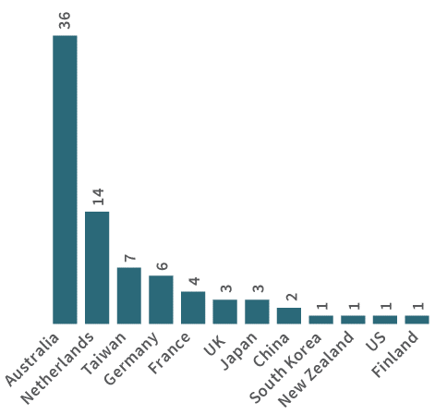
Double / Dual Degrees and Top Disciplines at Indonesia’s Top 10 Private and Public Universities – 2017.
Subject | Number
Business, Management & Accounting | 30
Engineering & IT | 23
Medicine, Health & Nursing | 9
Science | 8
Social Science & Law | 5
Digital Media & Communications | 3
Education | 1
Establishing a dual/double degree arrangement takes time. Besides assessing equivalency in course curriculum, matching content and agreeing on learning outcomes, these agreements need champions from both institutions to navigate institutional processes and hurdles.
In our interviews, some universities with collaborative partnerships said the proportion of students flowing to their institution remained small. Two issues stood out: student ability to afford the fees abroad, and student ability to meet English-language entry requirements.
Some institutions are responding to these issues in nuanced ways. Some concentrate their collaborative programs in Java, where affordability is less of a concern and the student catchment is larger with higher academic quality.
Others align their program with the increasing number of “international academic programs” (international courses) run by local institutions. These programs are undergraduate degrees that are taught in English and attract higher fees.

Some institutions are also collaborating with private institutions at undergraduate level, where students may have the ability and preparedness to pay higher fees. At a postgraduate degree level, they partner with public universities – though numbers are smaller, academic quality is higher. At both levels, students unable to afford fees abroad are sometimes able to access support through Indonesian scholarship programs, such as the LPDP. A dual/double degree program must have RISTEKDIKTI approval for students to access support.
From dual-degrees, the possible next step for providers is a joint degree, either partly or entirely taught in-country. Joint degrees are discussed in the next section.

Case study
A Sydney-based university, successful in recruiting Indonesian students onshore, recently expanded its Indonesia strategy. Its goal: to build partnerships through education and research collaboration. To support its strategy, it committed to invest an appropriate level of resources and take a coordinated ‘whole-of-institution’ approach. Its short- to medium-term focus (2-4 years) was to establish a small representative office in Jakarta to support engagement and explore niche dual-degree opportunities at a postgraduate level. A team began by meeting Australian embassy and Austrade staff to gain a better understanding of the market, a picture of how other institutions were managing in-country opportunities, and insights into key policy priorities and relevant ministries.
The team then met relevant ministries and state agencies to understand policy priorities and identify opportunities. They eventually selected two areas: environmental law and financial crime and governance accounting. The team then met two public universities. These partners each agreed to set up a double Masters (1+1) degree: one university offered environmental law, the other financial crime accounting. Each partnership also involved establishing research collaborations and PhD Cotutelle (where candidates jointly enrol, are jointly supervised and spend time at two universities). In financial crime accounting, the institutions managed to secure Government of Indonesia scholarships for 20 staff from relevant state agencies to take the course. There have been challenges in working with public universities, in terms of flexibility and timelines, but successful tactics have included finding the right faculty dean and focusing on cultivating the relationship through regular visits, research collaboration and capacity building. Having a representative office has helped considerably.

In-country partnership models: Strategic partnerships
We found two types of common strategic partnership approaches used by Australian providers:: licensing arrangements and delivery of joint degrees. Under this type of arrangement, providers enter into a strategic relationship with a local partner formalised by contractual cooperation or agreements.

Strategic partnerships

1. Licensing arrangements
Involves an institution entering in a contract with a local partner – usually a private, for-profit company – to grant the right to deliver its program in-country.
Licensing arrangements involves an institution entering into a contract to allow a local partner – usually a private, for-profit company – to deliver its program in-country. The local partner bears the significant overheads (e.g. employing staff, providing facilities, recruitment and marketing) and handles regulatory matters.
There are two types of licensing arrangements commonly used in Indonesia. In the first, the foreign institution’s degree is awarded on completion. Stricter controls are in place, especially on the use of brand and quality of program delivery. The same program is not generally licensed to more than one party within a particular country.
The other type of arrangement does not award or recognise the student’s degree. A local partner may advertise the program as being based on the foreign institution’s curriculum, but not claim it as the institution’s program.
Licensing has risks. Quality may be compromised if the local partner does not deliver the program to the licensor’s standards; reputation control may be a concern in the way recruitment and marketing are handled.

Case study
Monash College is a wholly owned company of Monash University, Australia. It was established in 1994 to provide services relevant to the university’s international education strategy. The college offers three types of pathways to the university: Diploma programs in various disciplines; English language courses from 10 to 60 weeks; and a Foundation Program – a pre-university program that provides guaranteed entry to Monash University if requirements and degree prerequisites are met. Monash College delivers its pathway and training services through various locations, with offshore partners in China, Indonesia, Singapore, Sri Lanka and Malaysia.
In 2002, Monash College established a licensing partnership with Jakarta International College (JIC) to deliver diplomas and Foundation Programs using Monash College’s curriculum. The program is one of the oldest and most successful pathway models in Indonesia. Programs are delivered in Jakarta, and the College has now expanded to Surabaya. The diploma program is taught for one year in-country, enabling transition to Monash Australia to complete second and third year.
The program provides a consistent stream of good students who perform very well when they get into university. Regulatory approvals, marketing and recruitment are handled by JIC. Monash College continues to maintain strict quality controls and monitoring of student standards and performance.
Finding the right local partner is key to a licensing arrangement. The right partner can help successfully navigate the regulatory environment. The partner also needs to understand the student market and be clear on its recruitment channels and marketing strategy.

2. Joint degree
The Joint degree is another common form of a strategic partnership. An institution partners with a local education institution and leverages their academic programs, teaching facilities and support services to deliver their degrees on-country. Joint degrees are particularly attractive to students because they are affordable. And they offer the scope to gain an internationally recognised degree without having to go abroad.
Joint degrees are particularly attractive to students because they are more affordable and offer the scope to gain an internationally recognised degree without having to go abroad.
The joint degree is another common form of strategic partnership. An institution partners with a local education institution and leverages their academic programs, teaching facilities and support services to deliver their degrees in-country. Joint degrees are particularly attractive to students because they are more affordable and offer the scope to gain an internationally recognised degree without having to go abroad.
Some key features of a joint degree:
- Programs are taught either partly or wholly offshore in English.
- There is agreement on how much credit to award for particular coursework.
- Students usually qualify with a single degree, or may be awarded a degree from each partner.
- Local partner handles regulatory approvals and compliance.
- Foreign and local academic staff jointly teach the program. Foreign academics usually conduct fly-in-fly-out intensive teaching, over several long days in the classroom. Local faculty teach the remaining part of the program.
- Local partner provides facilities, such as library resources and student support services.
- Indonesian regulations have until very recently only permitted foreign HE institutions to deliver courses and programs in Indonesia in partnership with an Indonesian university. Ministerial Decree 53 of 2018, however, has opened the way for foreign institutions to open campuses in Indonesia if they meet certain conditions. Some of these include being ranked in the top 200 in their field, offering at least two fields of study in STEM, and incorporating four core Indonesian components in the curriculum.
Securing approvals for joint degrees from RISTEKDIKTI is complex, while the process for establishing a campus is yet to be finalised and contains a number of uncertainties, including around permitted locations and employment of foreign staff.

Case study
In 2013, a Melbourne-based university formed a partnership with a Jakarta-based private HE institution to deliver a joint degree in business. The joint program was part of the Australian university’s two-stage strategy to enter the Indonesian market. The first stage involved a partnered delivery with the local private university on selected programs, and the second stage involved operation as a branch campus. Due to operational and regulatory hurdles, the second stage did not eventuate.
The partners instead agreed to deliver a joint degree program entirely in Jakarta.
Participating students graduate with three qualifications in three and a half years: an embedded diploma of Commerce, a Bachelor of Business and a Sarjana Ekonomi (Bachelor of Economy). The target market included students from the Jakarta area, international schools, the National Plus Schools, and various foundation studies and diploma studies providers.
Students undertake 12 Australian and 31 local university subjects. The program is delivered in two parts. Part one, undertaken over a year, sees students complete an Australian Diploma. After part two (year two and three), students are eligible for an Australian Bachelor degree and Indonesian Sarjana degree.
Australian subjects are co-taught by Australian and local academics. Australian lecturers fly in to deliver an intensive week at the start of each semester. Local staff, under guidance from Australia, deliver the remainder of the semester.
Poor execution or implementation can damage a foreign institution’s brand and reputation. Risks involved in joint degrees include:
- Failure to attract a sufficient number of students at the appropriate price.
- Poor delivery of the foreign institution’s curriculum.
- Poor-quality facilities and services such as information technology, library or academic services.

Joint venture
While Indonesia’s Law on Higher Education permits a wide range of direct engagement by foreign higher education providers in Indonesia, there is no-stand alone foreign branch campus operating in Indonesia.
Law 9 of 2009 on Legal Entities for Education and Law 12 of 2012 on Higher Education specify some of the conditions:
- Any foreign language instructors must be native speakers of the language.
- Institutional location can be anywhere in Indonesia subject to an economic needs test.
- A mutual recognition arrangement is required between relevant institutions on credits, programs and certification.
- Foreign education institutions providing services must establish a partnership with a local partner.
- Foreign education institutions must be accredited in their home country and listed by RISTEKDIKTI.
- The number of employees including educators and the leadership shall be 80 per cent Indonesian.
- Four mandatory subjects (Religion, Pancasila, Citizenship Education (Kewarganegaraan), Indonesian language) must be integrated into the curriculum and delivered by Indonesian educators.
- Students at the campus may include Indonesians, local foreigners as well as foreigners who come to Indonesia specifically to study.
International University Liaison Indonesia (IULI) is the only example we found of a joint-venture private university. IULI operates as a not-for-profit entity, in partnership with Indonesian institutions.

Case study
International University Liaison Indonesia (IULI) is a non-profit, Indonesian registered university. The legal body is a foundation (Yayasan International University Liaison Indonesia). The campus serves as a regional hub for the European University Consortium, led by the German Technische Universität Ilmenau. Academic operation started in August 2015.
At present there are more than 400 students, studying across three faculties, in 14 fields of study. Lectures are conducted in English and students complete a four-year bachelor’s degree, culminating with a research component, which can be completed abroad (in 2018 in Germany to obtain a double degree).
The Co-Chairman of the Board of Trustees and Founder noted that it took three years to establish the campus as a legal entity in Indonesia. Engagement with Indonesian ministries has been cooperative, with few restrictions over name, course content or location. However, the requirement to deliver at least 10 study programs, with at least six full-time academics in each, means a large up-front investment is needed and requires around 550 students to be viable. In addition, opening a campus requires ownership or at least a 25-year leasehold of one hectare of land, which can be extremely expensive in Jakarta.
While the university has been European-centred in the start-up phase, it has partnerships with universities from Russia (Kazan Tupolev University) and Singapore (Technische Universitaet Munich – Asia). Potentially, Australian universities could be accommodated.

Foreign campuses
Chapter 6 of the Law on Higher Education (Law 12 of 2012) outlined key conditions for the potential presence of foreign tertiary education campuses (FTEC) in Indonesia, with a concluding clause enabling the Minister to develop the implementing regulations. Ministerial Regulation 53 of 2018 of the Minister of Research, Technology and Higher Education represents this enabling regulation, which opens by observing that the intention of allowing foreign campuses is to raise the competitiveness of the nation. This regulation appears to be a major step toward Indonesia opening its tertiary education sector to more international engagement.
The regulation outlines the conditions for allowing an FTEC to operate in Indonesia.
- It is already accredited in its home country and listed by RISTEKDIKTI.
- It can be established in a special economic zone. It is unclear as to whether these centres can only be established in a special economic zone.
- It is established on a not-for-profit basis.
- It is, based upon the Ministry’s evaluation, ranked among the top 200 centres and/or fields of study.
- It is to open at least two fields of study.
- It is to apply a curriculum that is used in its home country as well as integrating four compulsory Indonesian subjects.
- It can be established as a university, institute, polytechnic, single-faculty, tertiary-level school or academy.
- It can appoint its own lecturers and education staff, including both expatriates and Indonesians.
The regulation as it stands indicates no restrictions on expatriate staffing, but other ministries’ restrictions may well apply. Interested centres should therefore ensure they are fully aware of all relevant laws. The Minister is responsible for conducting periodic evaluations of the foreign education centre and can cancel its permits on the basis of such an evaluation.
Applications for a permit will be able to be made using the new national online system, which has been designed to compress administrative layers in the permit-issuing process.

VOCATIONAL EDUCATION AND TRAINING
Vocational Education and Training
Key points
- VET is a national priority for Indonesia’s government.
- There is a large skills gap in the rapidly growing Indonesian economy.
- The Indonesia Australia Comprehensive Economic Partnership Agreement (IA-CEPA) has placed vocational education and training as a priority in the partnership.
- VET providers often leverage short-term contracts into ongoing commercial relationships.

Sector overview
Figure 4.1. Types of vocational education institutions in Indonesia.
Technical & Vocational Education
- Upper Secondary Schools
- Tertiary Vocational Education
- Public Technical Training Centres
- Private/Ministry Training Centres

There are four types of vocational education and training institutions in Indonesia:
- Upper secondary school – At the upper secondary school level, students can either study at a general senior high (Sekolah Menengah Umum, or SMU) or a more specialised vocational high school (Sekolah Menengah Kejuruan, or SMK). SMKs specialise in various vocational skills areas such as economics, tourism, agriculture, and aeronautics. They offer academic and non-academic subjects that focus on technical skills.
- Tertiary vocational education level – After high school, students can undertake VET at tertiary institutions to attain diplomas of different levels, requiring between two and four years of study. Besides stand-alone polytechnics, many Indonesian universities, institutes and colleges offer similar courses.
- Public technical training centres – Balai Latihan Kerja (BLK) provide non-formal technical education, and there are private, including foreign, Registered Training Organisations (RTOs). These BLKs and RTOs offer a wide range of vocational skills training to produce work-ready people.
- Private companies and government ministries/agencies – These provide training and apprenticeships to new and established members of their workforce through dedicated training centres.
Unlike the higher education sector, which is led solely by RISTEKDIKTI, Indonesia’s technical and vocational education and training is managed across a number of ministries.
- The Ministry of Education and Culture is responsible for SMK Years 10 to 12.
- RISTEKDIKTI is responsible for vocational tertiary education delivered by state and private polytechnics, as well as other tertiary centres that provide diploma conferring courses.
- The Ministry of Manpower has oversight of the BLK, which are now managed by local authorities. It also has an administrative interest in the operation of foreign RTOs and companies’ in-house vocational training centres.
- Many ministries also own and run polytechnics and colleges. For example, the Ministry of Tourism operates a network of six Sekolah Tinggi (Colleges) and polytechnics. The Ministry of Finance manages the State Accountants College (STAN).

VET as a national priority
President Widodo’s government is prioritising increasing the skilled workforce through VET. In 2016, the president announced a revitalisation of the country’s VET system, reoriented towards a demand driven system.
Improving the curriculum and the quality of teachers and enhancing partnerships with industry are some key priorities identified.
The Government has set an ambitious goal of adding 57 million skilled workers by 2030, roughly doubling the current skilled workforce (See Section 2 and Annex A). To meet the target, MoM estimates that it will need to produce 3.8 million skilled workers annually. To keep up with annual industrial growth of 5-6 per cent, the Ministry for Industry forecast that it needs to add between 500,000 to 600,000 skilled workers each year (See Figure 4.1.).
Demand for vocational education is acute. In the six priority sectors earmarked by the government as capable of absorbing a large number of workers – manufacturing, agribusiness, tourism, health, the digital economy and migrant workers – the Ministry of Manpower estimates that it needs more than 1 million new skilled workers annually. There are also ambitious nation-building programs, such as the 10 New Balis tourism initiative or the plan to add 35GW of new power generation capacity by 2024, that will require significant increases in Indonesia’s skilled workforce. It is not surprising that the Indonesia Australia Comprehensive Economic Partnership Agreement (IA-CEPA) has placed vocational education and training as a priority in the partnership.
Figure 4.2. Estimated annual number of additional skilled workers required per annum for key areas.
Source: Ministry of Manpower.
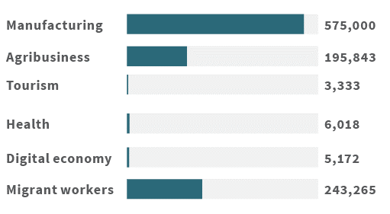
Since 2017, the Vocational Education-Industry Link and Match Program has involved 1,537 SMKs and 568 industry partners across nine provinces. According to the Ministry of Industry, six more provinces are planned for inclusion: South Sulawesi, Jambi, Bengkulu, South Sumatera, Bangka Belitung, and Lampung.

Competition
More countries are looking to partner with Indonesia to help it increase capacity while boosting prospects for their education services providers:
- Germany and Indonesia signed a Letter of Intent in 2017 to deepen their partnership in technical and vocational education and training. The German Corporation for International Cooperation (GIZ) will help Indonesia build an internship program for vocational students. Indonesia’s new Link and Match Program adopts aspects of the German vocational model.
- In January 2018, the United Kingdom and Indonesia’s MoEC signed a Memorandum of Understanding to cooperate in revitalising vocational education in SMK.
- Canadian vocational and pre-university institution LaSalle College (See Case study on Page 44) has a presence in Jakarta and Surabaya. It has established a not-for-profit foundation to deliver diploma programs in design.
Australia’s development assistance has in the past also had a VET focus. Australia had a lengthy, though not well documented, experience in developing the capacity of a number of Indonesian state-run polytechnics through the Indonesia-Australia Partnership for Skills Development in the early 2000s.

Size and potential market
In the VET sector, there are 13,710 SMKs. In the 2017/18 school year, 4.9 million young Indonesians were studying at an SMK, an increase of 17 per cent in five years. Figures 4.3 & 4.4 below illustrate the size and potential of the vocational education market. Jakarta has the largest number of privately enrolled students (91,679), followed by North Sumatra (52,075) and South Sulawesi (44,992)

Figure 4.3. Diploma Program enrolments in public institutions, 2017.
Source: RISTEKDIKTI Statistics.
Diploma Program (D1-D4) Public enrolments.
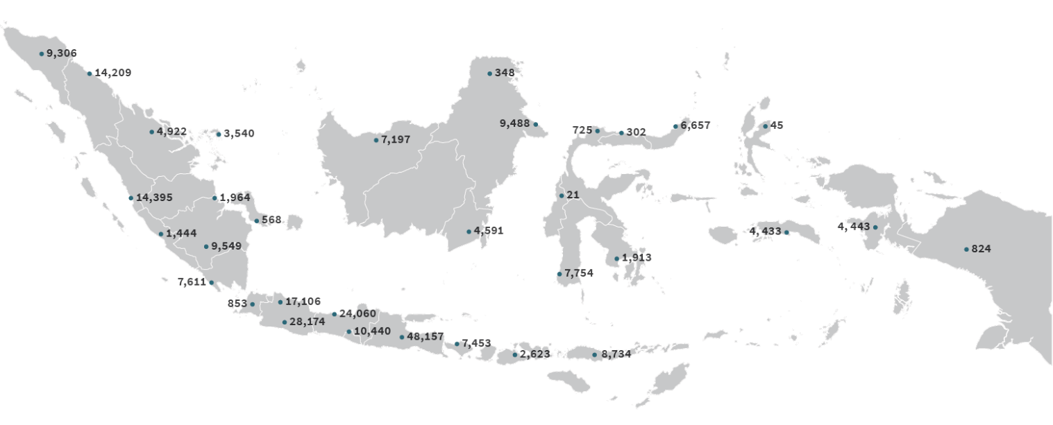
Figure 4.4. Diploma Program enrolments in private institutions, 2017.
Source: RISTEKDIKTI Statistics.
Diploma Program (D1-D4) Public enrolments.
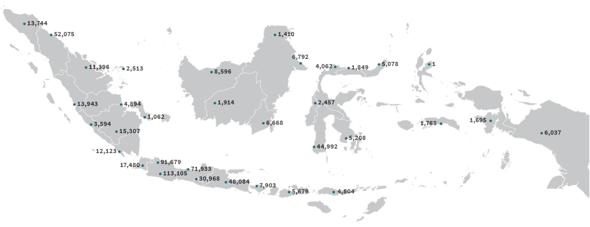

Fees
Figure 4.5 compares fees at private and public VET institutions across a range of disciplines.
Figure 4.5. Fees at selected public and private vocational education and training institutions. Fees quoted in Australian dollar.
Jakarta  State Polytechnic | LaSalle College Indonesia, Jakarta and Surabaya | Trisakti Tourism Institute, Jakarta
Public  Course:  Diploma IV  Fees: $50-$1,160 a semester | Private  Course:  Diploma IV Fashion Design  Fees: $24,829 in total | Private  Course:  Diploma IV Hospitality Regular / International (Guilin Tourism University of China)  Fees: $11,000-$17,000 in total

Trisakti Tourism Institute, Jakarta | Academy of Fine Arts and Design Jakarta | Jakarta Institute of Arts
Public  Course:  Bachelors in Hospitality and Tourism International (Thailand / Switzerland Joint Degree Programs)  Fees: $16,500 (+$10,000 for in-country study) to $25,000 (+ $38,000 for in-country study) in total | Private  Course:  Diploma III  Fees: $8,000 in total | Public  Course:  Diploma III/Bachelor in Film and Television  Fees: $5,500 in total / $11,000 in total

Partnership models

General partnerships
VET providers active in Indonesia use short-term contracts to engage with government and business.
They find these types of contracts useful for developing business-to-business connections that have the potential to become longer-term commercial relationships.
TAFE Queensland, for example, uses short-term training courses to turn government relationships into potential commercial outcomes. They develop links with decision-makers to build long-term relationships and gain insights into institutional challenges.
Some key points from our research:
- Many providers use general partnerships to identify opportunities and test new commercial partnership models.
- Financing models to handle the scale of Indonesia’s skill needs is still a work in progress.
- Almost all providers expressed interest in non-accredited training due to its feasibility to deliver at scale and in a cost-effective way.
- There are a growing number of Train-the-Trainer models, which are attractive to government at national and sub-national levels. There are opportunities in this type of model, particularly for online and blended delivery.
- VET providers found securing the right partner was more challenging than the regulatory context. A good partner helps navigate the regulatory environment.
- Providers highlighted obtaining foreign workers visas (See Annex C) and the not-for-profit foundation rules as a disincentive to investment.
- None of the providers we interviewed were involved in dual/double degree arrangements such as those being used by HE institutions. The model may merit further exploration, however, as more Indonesian premier VET providers are introducing “international classes” programs taught in English. For example, US-based VET provider Lone Star College is using the dual degree to complement their onshore recruitment strategy (See Lone Star case study).

Case study 1
TAFE Queensland has been successful in turning government relationships into commercial outcomes. Its engagement with Indonesia began more than seven years ago and it now has more traction than ever.
It recognises that Indonesia’s skills need is large and President Jokowi’s human capital development priority has bolstered their Indonesia efforts further. TAFE Queensland’s strategy has been to leverage Australian government support to help it engage Indonesia – for example, running Australia Awards short courses to build links with key ministries and develop more tightly focused commercial outcomes. TAFE Queensland delivers non-accredited training that might eventually to build to a full qualification. In tourism, for example, it delivers units of competencies in Training the Trainer. TAFE Queensland finds that this type of training has traction, is practical and relevant, and that “people see a tangible result straight away. It is also about sustainability, the domino effect, when one goes on to train others.” TAFE Queensland works closely with English language providers when it delivers training. Recently, TAFE Queensland has been looking outside of Jakarta. In some instances, it partners with colleges or delivers independently. In Bali, for instance, it trains general managers, presidents and heads of human resources from hotels across Indonesia. These links have helped it develop direct industry connections. “The point is about finding those relationships that lead to long-term sustainability. And you can’t expect to go in once or twice, thinking that you are going to get something out of it. It has taken seven years for us to build credibility.”

Case study 2
A Victorian based VET provider specialises in tourism, hospitality, food and events. Its involvement in Indonesia goes back more than 30 years. It began in 1988 and continued to work on and off in Bali, Surabaya, Bandung, Solo, Makassar and Yogyakarta. Its work is geared towards industry. It has identified the growing tourism sector and the huge human resource capabilities needed to keep pace with growth. It’s work started with aid projects – The Indonesia-Australia Partnership for Skills Development – aimed at developing industry competency standards for five sectors. It helped create Indonesia’s tourism and hospitality competency standards, with its work forming the basis of Indonesia’s national standards, qualifications framework, quality assurance framework, certification and accreditation. Since 2004, the provider has taken its work to the region, working with the ASEAN secretariat in Jakarta, and establishing a presence and partnerships in Singapore, Thailand and Vietnam. Finding the right partner in Indonesia is always a challenge. It has had agreements in place for the last 30 years with government ministries, however, agreements haven’t always turned into activities. The provider has chosen instead to focus on industry. Getting the right model of engagement with the Indonesian partner is important.

Case study 3
Lone Star College (LSC) is an American community college based in Texas that offers two-year associate degrees, both as pathways to a four-year degree in the United States and as stand-alone VET certificates. In 2012, Lone Star College and Sampoerna University (SU) established a formal partnership to develop the dual enrolment International Education Pathway Program, giving SU students an opportunity to earn US credits. Sampoerna University students enrolled in the Pathway Program receive a US associate degree after two years, and the credits count towards four-year US degrees. The program is sponsored by the Sampoerna Foundation, with an estimated 200 students enrolled each year.
In 2014, the partnership expanded to include a third party. Lone Star College and SU entered into a joint agreement with the Louisiana State University (LSU) College of Engineering to deliver an accredited engineering degree program in Jakarta. Students who complete the Lone Star College’s pre-engineering associate degree program and meet LSU transfer requirements will be granted a place in LSU engineering programs in computer science, electrical engineering, industrial engineering or mechanical engineering, delivered at Sampoerna University. This partnership shows a pathway for Australian education providers to partner not just with an Indonesian provider, but also with a third party, which doesn’t have to be based in Australia. Additionally, the case study shows that it is possible for universities, like SU and LSU, to partner with VET providers like LSC, which is a dual higher-education and VET provider.

Many VET providers are looking for opportunities to form strategic partnerships.

Strategic partnerships
Many VET providers are looking for opportunities to form strategic partnerships. Some are looking to partner with the Indonesian government at national and provincial levels. Some are looking to industry opportunities such as transport, logistics and supply chain. There are a few that are already working with government on small-scale training or providing skills or policy gap analysis.
The potential for strategic partnerships in the VET sector appears to be greater than in higher education, both in terms of numbers of possible partners and scale of operations. There is a demand for “train-the-trainer” models in collaboration with local institutions. This type of model is attractive to government – national and local – given the scale of skills needed. In on of our case studies, we focus on one Australian VET provider that is already delivering a train-the-trainer program in partnership with a nationally networked university.
As with general partnerships, delivering non-accredited training is of interest to providers. The question of the financial viability of these models still looms large. In the past, these types of projects attracted aid funding, which helped open up networks in key ministries and agencies.
Another area of interest is identifying training opportunities linked to large-scale government projects – for instance, training workers on infrastructure and transport development. More work is needed to help providers identify and connect into this growth area.
Some experienced VET providers already engaged in general partnership activities are exploring more substantive in-country positions either through strategic partnerships or joint ventures.
Some are looking to partner with the Indonesian government at national and provincial levels. Some are looking to industry opportunities such as transport, logistics and supply chain. There are a few that are already working with government on small-scale training or providing skills or policy gap analysis.

Case study
Holmesglen’s partnership with Muhammadiyah began with it offering a 10-week non-accredited practical English program for all students graduating from Universitas Muhammadiyah Tangerang and refurbishing a purpose-built language centre for the training. This was a high-volume, low-cost entry point for Holmesglen, forming the basis of what has become a broader, sustainable partnership. In early 2018 Holmesglen signed a Memorandum of Understanding with the Muhammadiyah universities network – which has more than 100 universities – to provide sector-specialised English language training to teachers using a train-the-trainer approach. Holmesglen operations provide professional services, with the use of fly-in fly-out staff where needed, although Indonesia-based native English speakers are employed under the original partnership in Tangerang. This short-term consulting model, more akin to a general partnership, is housed in a much longer-term partnership that is very much strategic. For Holmesglen this initiative is part of a broader brand-building exercise, and while it is in-country focused, pathways back to onshore student enrolments is part of that picture in the medium-term.

Case study
Sustainable Skills is a not-for-profit organisation that develops, supports and assists effective technical and VET systems worldwide. It is working with several Government of Indonesia departments to help improve Indonesia’s VET system. Since entering the Indonesian market two years ago, Sustainable Skills has found a country with a strong desire to build a VET system with a high degree of alignment with industry demand and a practical design that supports the needs of low-income communities. The Australian model, with its well-established industry-based competencies and modular course design, is very often the preferred choice for both qualitative and pragmatic reasons. The approach has been to work with Indonesian ministries that have developed plans to reform VET, take key principles of the Australian VET system, understand the local culture and develop solutions. The challenge is being prepared to build sound relationships, and there’s only one way to do this – be in front of people and let them know you’re truly interested in their problems.
Indonesians tell Sustainable Skills that they like their approach because they’re committed and don’t think several visits over six months will deliver success. Indonesia has major VET capacity constraints and a massive need to build skills. For example, it plans to deliver 35GW of new energy generation capacity by 2024. The Indonesian Government estimates the construction and operation of this system will create a million jobs. This creates a huge opportunity for Indonesia to build skills and bring more people out of poverty. These jobs require world-standard competencies and a training system that will deliver world standard skills, otherwise more foreigners will be required. Sustainable Skills is working with the Indonesian Government to develop plans to seize these opportunities.

Joint ventures
There are currently no Australian VET providers with a partnership or stand-alone campus. Some VET providers are considering greater Indonesia engagement in terms of a campus or training facility rather than working with an existing institution.
For vocational and adult education services (e.g. language education), under Indonesia’s Negative Investment List (Presidential Decree no 44 of 2016), up to 67 per cent foreign equity ownership is permitted in vocational and education training entities. In its revision of the presidential decree regarding restrictions on foreign investment, there had been proposals to raise the limit for foreign investment in training ventures to 100%. However, the timing for applying this new investment level for training ventures has yet to be announced.

Case study
LaSalle College Indonesia (LCI) is established as a not-for-profit foundation, with a corporate structure that consists of 50 per cent ownership by Canada’s LaSalle and 50 per cent by seven Indonesian investors. LCI was established in Jakarta about 15 years ago, later adding a campus in Surabaya. These campuses form part of a global network of 25 centres, including one in Melbourne. Given the breadth of the network, LaSalle campuses extensively share teaching and curriculum materials, although they remain open to collaboration with other education centres, especially in terms of avenues for articulation for their graduates. LCI is proposing to strengthen its capacity to teach not just technical skills in creative industries, but to include management of these sectors – where they see much need and interest, and little competition. Into the longer term, they are also looking at providing bachelor-level qualifications.

ENGLISH LANGUAGE training
English Language Training
Key points
- English language tuition is considered to cut across all sectors, as it is an important bridging program that supports higher education, VET and schools.
- From a regulatory and governance point, it aligns more with the VET sector, with some overlap with schools and higher education.
There are strict rules around the qualifications of foreign language teachers. For example, foreign educators teaching foreign languages in Joint Cooperation Schools (SPK) must be native speakers or hold a teaching certificate for the language, as well as holding Indonesian language proficiency as assessed through the Bahasa Indonesia for Foreign Speakers test. This is an ongoing challenge for foreign language centres.
Australian onshore enrolments have seen a slow but steady decline over the previous decade from just over 2,000 in 2002 to 1,361 in 2017. Some providers see the decline as partly reflecting the fact that English language tuition is now often packaged with diploma or degree programs, reducing the demand for standalone courses. Some point to the growing number of Indonesian providers offering English language courses, and that more schools are teaching the language. Online English language learning is also an emerging factor, and more work is needed to understand the changing dynamics in this sector.
There is still, however, an unmet demand for high-quality English language tuition in Indonesia. English First’s English Proficiency Index score for Indonesia in 2018 was low, at 51.58. It was ranked 51st of 88 countries worldwide, and 13th out of 21 in Asia, lower than Vietnam, Malaysia and the Philippines. This is despite English being a compulsory subject throughout junior and senior high school, with many primary schools offering it as an additional subject. Indonesian language providers still see face-to-face delivery as the preferred method of learning and teaching.
We did not come across any significant strategic partnerships in English language training between an Australian and Indonesian partner.

Case study
The Indonesia Australia Language Foundation (IALF) was established in 1983 as an AIDAB (now DFAT) funded project. Originally known as the Australian Language Centre (ALC), its task was to provide academic English preparation for awardees under the Australian Scholarship Scheme. In 1989 the ALC became an independent Indonesian educational foundation (yayasan) and was renamed the IALF.
Its board of governors had members of the Indonesian and Australian governments, but in 2006 the Australian government withdrew and the board now consists of 10 Indonesian representatives of government departments.
The IALF has centres in Jakarta, Surabaya and Bali and continues to provide training for the Australia Awards program, in conjunction with the managing agent for that project. The IALF provides courses in general and business English, teacher training, project management, IELTS preparation, and teaches Bahasa Indonesia to both expatriates and groups from overseas (e.g. Australian school groups at IALF Bali).
All three branches are official IELTS test centres and Jakarta is also a centre for the Pearson PTE Academic test – a relatively new international test. The IALF is cautious in deploying online platforms given the experiences of other groups who have moved faster than their market or client network.

Opportunities
English language tuition is important to any provider considering an in-country offering. Most do not consider it as a standalone opportunity, but as part of their broader package. Some are exploring options for online and blended learning.
Most providers don’t see much of a business model in teaching English alone.
Compared to services in the HE, VET and schools sectors, fees for English language teaching are modest (See Figure 5.1). Opportunities are best captured elsewhere, rather than applying the framework separately to ELICOS.
Figure 5.1. Sample of English Language Course Fees.
Provider 1: IALF Jakarta
Course: International English Language
Testing System (IELTS) Preparation (8 weeks)/
IELTS Preparation Plus (1 week)
Fee ($AUD):
$530 (50 hrs)/
$320 (25hrs)
Provider 2: IALF Surabaya
Course: Intensive English Program for Overseas Study 1 / Writing Articles for Academic Purposes
Fee ($AUD):
$1100 (160 hrs)/
$950 (25 hrs)
Provider 3: Jakarta International College
Course: Monash English Bridging Program
Fee ($AUD): $420
Provider 4: English First
Course: TOEFL Preparation
Fee ($AUD): $500 (around 60 hrs)
Provider 5: The British Institute (Kuningan, Jakarta)
Course: IELTS Preparation (5-18 weeks)
Fee ($AUD): $700 (75 hrs)

schools
Schools
Key points
- Indonesia’s school system is large, but there are issues with quality, in teaching and teacher training.
- There are opportunities for foreign organisations to be involved in Joint Cooperation Schools (SPK), but Australia has relatively small presence in this sector.
- There are many low-level partnerships between Australia and Indonesia in the form of sister schools and alumni networks.
- In the current regulatory environment, the most likely Australian involvement would be in the form of a state-led drive to provide curriculum, evaluation and perhaps certification in a licensing arrangement.

Sector overview
Based on student numbers, Indonesia has the fourth largest school system in the world, behind China, India and the US. There are more than 50 million students, 3 million teachers and 300,000 schools across the archipelago (See Figure 6.1).
Figure 6.1. Number of Students, Schools and Teachers in Indonesia 2017-18.
Data Source: Publikasi Statistik, Tahun Publikasi : Semua Tahun page, Ikhtisar Data Pendidikan Dan Kebudayaan Tahun 2017/2018 <http://publikasi.data.kemdikbud.go.id/index.php?thn=all&sek_id=&bpid=&pageNum=3>
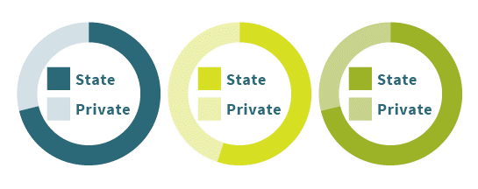
Category | State | Private | Total
Students | 35,595,056 | 14,439,462 | 50,034,518
Schools | 169,378 | 138,277 | 307,655
Teachers | 2,157,512 | 869,910 | 3,027,422
MoEC has primary responsibility for secular preschools, primary (years 1-6), junior secondary (years 7-9), senior secondary (years 10-12) and senior vocational education (years 10-12). MoRA has oversight of the Madrassa (a parallel system of Islamic schools that mirror the MoEC schools in terms of articulation), and educating just under 20 per cent of all school-aged learners. MoRA is also responsible for religious education in all schools and education centres.
The management of schools is decentralised, with provincial authorities having oversight of senior secondary schools and district governments running primary and junior secondary schooling.
The large number of Indonesian school students is due to the successful effort by the Government of Indonesia to improve access to education, even for those disadvantaged by poverty or remoteness. Each year the government spends 20 per cent of its budget on education, according to an Asia Philanthropy Circle 2017 report. This represents 3.35 per cent of GDP, lower than countries such as Vietnam, Malaysia or Thailand (Rosser 2018). However, gains in access have not always translated into an improvement in learning outcomes. The 2015 PISA results highlighted that 42 per cent of Indonesian 15-years-olds failed to meet minimum standards in reading, mathematics and science on standard international tests (Rosser, 2018). The government’s focus on human resource development may further assist in progressing conversations around system quality, and Australian agencies may be well placed to assist.
The sector is divided into national schools, Joint Cooperation Schools (SPK) and embassy schools. Besides SPK schools, the only other international schools are embassy schools. In these schools only children who are citizens of the nation concerned may be taught. The largest embassy schools in Indonesia are the embassy schools of Japan and the Republic of Korea.

Foreign partners are permitted in the SPK system. SPK schools must be established in cooperation with an Indonesian educational institution, be incorporated as a local non-profit foundation (yayasan), be registered locally and have Indonesian citizens on their board. Schools need a licence from MoEC, and must submit their curriculum to the ministry for accreditation. The school must be accredited or recognised by its home country, use at least some Indonesian teachers and include religious education. Teachers must be suitably qualified, with a bachelor’s degree as the minimum and a teacher’s certificate.
SPK schools were introduced in 2015, replacing International Standard Schools (ISS), which were criticised for reinforcing social inequality. ISS were introduced in 2003 with a plan to roll one out at each level of schooling in each district, building to a total of 874 schools by 2010. Each school was to draw upon the curriculum from an OECD country and teach core subjects in English. These schools were granted significant additional funds and were allowed to charge fees, with the aim of preparing students to study overseas. The program folded under mounting opposition, including from the Constitutional Court.
Long established international schools were folded into this new SPK model, replacing the word “International” with “Intercultural” or “Independent”, and some independent Indonesian schools have adopted curriculum material to become SPKs. These schools are able to recruit both foreign and Indonesian students. Some schools issue graduates with two qualifications, the Indonesian High School Certificate and one from another nation (including some Australian state-based certificates) or an international system such as the International Baccalaureate.
Restrictions on foreign teachers are extensive, including that they can be recruited only if the school can demonstrate to relevant authorities (e.g. the Ministry of Manpower) that they are doing a job that an Indonesian cannot. Once recruited, the expatriate teacher can only teach the subject or subjects specified in the request for expatriate recruitment. Essentially, a foreign teacher can only fill a position that has never been held by an Indonesian.
Recent figures from the MoEC show that there are 429 registered SPK schools across Indonesia – 178 at primary level, 157 at junior high and 94 at senior high. Australia currently has a very small presence in the market.
Fees at internationally aligned SPK schools can be very high – as much or more than an elite Australian private school (See Figure 6.3).

Figure 6.2. Map of SPK Schools by Province.
Source: Direktorat Jenderal Pendidikan Dasar dan Menengah website, Daftar Satuan Pendidikan Kerja Sama per Januari 2019 page <http://dikdasmen.kemdikbud.go.id/index.php/daftar-satuan-pendidikan-kerja-sama-per-november-2017/>
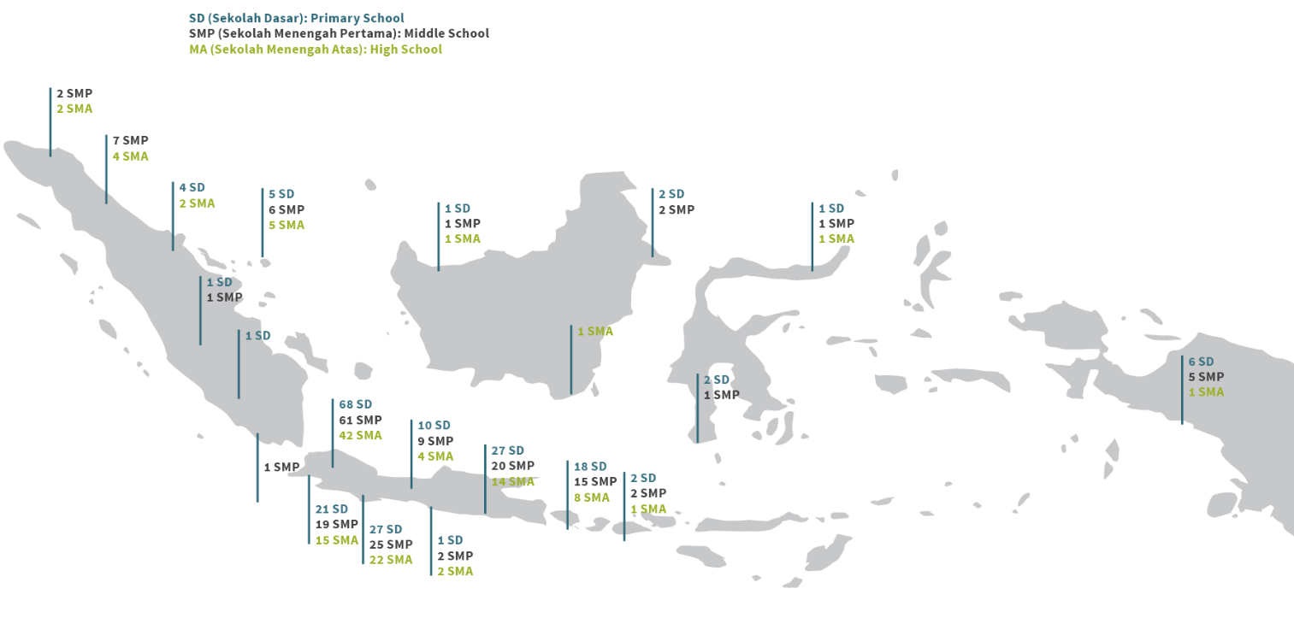

Figure 6.3. Examples of Foreign and Annual Fees at SPK Schools (Year 11-12).
Country | School | Location | Established | Students | Fees ($AUD)
New Zealand | ACG School Jakarta | South Jakarta | 2004 | 500 | 26,000
Australia | ACS Jakarta | East Jakarta | 1996 | 816 | 18,000
Australia | Australian Independent School | Bali & Jakarta | 1996 | 800 | 19,000
Canada | Bali Island Schools | Bali | 1985 | 300 | 29,000
Mixed expats | Bandung Independent School | Bandung | 1972 | 200 | 23,000
Indonesia | Beacon Academy | Jakarta | 2007 | 300 | 14,000
UK | British School Jakarta | Greater Jakarta | 1973 | 1450 | 36,000
Indonesia | Pelita Harapan School | Jakarta | 1993 | 1700 | 12,000
USA | Jakarta Intercultural School | Jakarta | 1951 | 2469 | 46,200
India | Gandhi Memorial International School | Jakarta | 1950 | 2000 | 10,000
France | Lycee Francais de Jakarta | Jakarta | 1967 | 500 | 20,000
Netherlands | Netherland Intercommunity School NIS Jakarta | Jakarta | 1967 | 300 | 23,000
New Zealand | New Zealand Independent School | Jakarta | 2002 | 175 | 17,000
Mixed expats | Medan Independent School | Medan | 1969 | 80 | 24,000
Indonesia | Sekolah Ciputra Surabaya | Surabaya | 1996 | 1300 | 13,000

Partnership models

General partnerships
Sister school relationships, with two-way visits and study tours, are the main form of general partnerships. There are many sister school networks between Australia and Indonesia, including more than 180 linkages through the Australia-Indonesia school partnerships program. The program, established in 2008, is an initiative of the Australia-Indonesia Institute and Asia Education Foundation.

Strategic partnerships and joint ventures
Australian education providers see merit in greater strategic partnerships in the schools sector in Indonesia. Under current regulations, this is unlikely to be an independent Australian school looking to set up a branch school in Indonesia. More likely it requires a state-led drive to provide curriculum, evaluation and perhaps certification in a licensing arrangement.
The number of SPK schools in Indonesia indicates a market for international curriculum in Indonesian schools. At this stage Australia is not a significant player. Organisations such as the International Baccalaureate are more active. The other alternative is running foundation programs in schools, alongside the national curriculum. For example, at Celebes Global School, students undertake both the Indonesian National Certificate as well as a Foundation Certificate from the International Institute of Business and Technology, Perth, which they can use to enter Australian universities.

Case study: The Australian Independent School (AIS)
The Australian Independent School (AIS) was established in 1996 as an initiative of members of the Australian expatriate community. The AIS now has three campuses, two in Jakarta and a growing one in Bali, which recently moved to a purpose-built campus with very well equipped facilities. The curriculum covers preschool to Year 12, with a strong special education component and capacity. Government regulations means the school can no longer call itself an international school. As the school has evolved, the origin of students has also widened. Only 14 per cent of students in the Jakarta campuses are Australian. About one-quarter are Indonesian, including dual nationals, and almost 20 per cent are Korean. Others students come from the UK, Netherlands, Japan, the Philippines and countries across South Asia. To secure GoI licensing and accreditation as an SPK, an offshore partner (i.e. an equivalent educational institution in the home country) also needs to be recognised. Indonesian students at the school need to be provided with education in religion, Indonesian civics and language. Restrictions on employing expatriate labour mean that once a position has been designated as for Indonesians, it cannot effectively be reopened. This reduces flexibility in deploying teachers to meet demand.

Case study: Sekolah Cita Buana
Cibun was a National Plus school, now an SPK school, established in the mid-1990s. It is owned by a foundation, Yayasan Cita Buana. The school operates from early childhood education to year 12. It also has a special education capacity. The school has about 550 students. A little over 5 per cent are foreign, and approximately 40 per cent are dual nationals. Since its early days, Cibun has used the ACT curriculum together with the Indonesian curriculum to allow students a double high school certification process. Cibun finds that the ACT system, versus options such as IB or the Cambridge system, is more flexible in teaching and content, more friendly to special needs students and considerably less expensive. Former principal Ita Rajasa said she loved the examination system used in the ACT, with its combination of multiple choice, short answer, short essay and also impressionistic essay. The ACT system, with less weighting on one final exam, allows for more creativity and flexibility in content, delivery and school based teaching. Teachers from the school regularly visit Canberra to exchange experiences and views with counterparts in the ACT. Similarly, officials from the ACT regularly visit Cibun to ensure standards are in line and to offer recommendations on future improvements. Cibun sees great value in this exchange.

edtech
EdTech
Key points
- Internet reach in Indonesia is increasing rapidly, and EdTech is a growing sector that has attracted attention from international players.
- Government of Indonesia is emphasising online learning to improve access to HE for those in remote areas.
- EdTech could complement Australian providers’ offerings and act as a pathway to further study.
- Involvement could come through provision of online learning services, whether directly or under licence, or in partnership with an existing Indonesian EdTech firm.

Sector overview
Indonesia has the largest and fastest growing digital economy in Southeast Asia. Enabled by an internet user base of 150 million, Indonesia’s digital economy has grown by 49 per cent between 2015-2018 to US$27 billion (A$38 billion). Its digital economy is set to grow further to US$100 billion (A$140 billion) by 2025, accounting for 40 per cent of Southeast Asia’s digital economy.
In 2018, the Government of Indonesia announced plans to expand online and distance learning to public and private universities. The decision to increase online education opportunities is a response to the low participation rate and lack of access to HE institutions in some rural areas and remote islands. According to RISTEKDIKTI, the current gross HE participation rate is only 31.5 per cent. In Singapore and South Korea participation rates are 80 and 92 per cent, respectively.
RISTEKDIKTI’s focus:
- Improve vocational and higher education by combining online education opportunities.
- Lift the quality levels of online teaching and improve graduates’ outcomes.

Indonesia’s Open University (Universitas Terbuka) is the leading supplier of online and distance education. It was established 34 years ago to provide Indonesians equal access to higher education. OU caters for students who live in remote areas out of reach of higher education institutions, and delivers programs through a mix of online, face-to-face, radio and television. OU has also expanded internationally. It now educates Indonesian migrant workers living in 36 countries.
OU is strengthening links with foreign institutions. It currently has a partnership with Maryland University, the University of California Los Angeles and the Massachusetts Institute of Technology. The partnership involves refining curriculum and learning software. This partnership arrangement indicated possible opportunities for Australian providers.
Indonesian regulations allow for online and blended learning. This is detailed in both Law 20 of 2003 on the National Education System (Article 31) and the MoEC Regulation 109, of 2013 on Distant Learning in Higher Education. The latter specifies that Indonesian universities can provide e-learning after obtaining permission from RISTEKDIKTI. But the regulations on foreign online degrees is unclear, requiring a student to submit their qualification to RISTEKDIKTI for recognition.
In May 2018 RISTEKDIKTI launched Indonesia’s own online/blended higher education learning platform – SPADA Indonesia (Online Learning System Indonesia). It hosts 776 courses from 51 universities and has been accessed by 14,931 students from 176 universities. Government of Indonesia online education initiatives are an area worth watching by international providers. Currently there are no foreign providers represented in SPADA.
RISTEKDIKTI also plans to establish an Indonesia Cyber Institute to oversee all online learning and manage accreditation. Few details are available. Government of Indonesia is currently developing an Online Learning Roadmap.

EdTech players
Although at an early stage, Indonesia’s EdTech ecosystem is expanding quickly. Around 20 established EdTech firms are operating in Indonesia, spanning school, university, English language and vocational online education.
The rise of Indonesian EdTech has been noticed by global investors. Ruangguru and HarukaEdu (See Case studies) participated in Google’s Launchpad Accelerator program and have secured investment from the UK (Pearson Affordable Learning Fund), Japan (CyberAgent Ventures), Singapore (UOB Venture Management) and local venture capital firms (East Ventures & Samator Education).

Ruangguru
Ruangguru (meaning teacher’s room/space) began in 2014 as a way to bring tutors and students together and now has 8 million students and teachers accessing its online learning platforms, supported by nearly 600 staff. There are six online platforms servicing K-12 students: self-learning tools, group chat learning, a digital classroom platform for teachers, an online tutoring and exam service. One of Ruangguru’s strengths is its innovative partnerships with government, both at the national and provincial level. The EdTech firm has partnerships with 32 out of 34 provincial governments to provide systems that allow public school teachers to manage classes by hosting learning materials, exams, and academic records. As a result, the system gives local authorities a much better way to track progress through real-time data, for free. For Ruangguru, these partnerships are also a user-acquisition strategy, because of the number of public schools in Indonesia. Co-founder Iman Usman says Ruangguru has three goals. The first two are better data to improve educational performance and reduce socioeconomic gaps among students through access to education. The third is to improve the quality of teaching staff, and this is where Iman sees opportunities for Australian involvement. The co-founder says there is also a lot of potential in developing programs in English training, employment skills, and workplace readiness. “I think we’re pretty much open, it’s just about the scheme and how we do all that.”

Quipper
Quipper is a company with substantial financial backing, experience in foreign markets and an offering based on helping young students to pass entrance exams. In 2014 it took this model into Indonesia and, according to Founding Member and Indonesia Country Manager Takuya Homma, the country has become its fastest growing market after Japan. There are now around 100,000 paying subscribers in Indonesia, and Quipper sees great potential as more families seek improved opportunities for their children. Quipper evaluates potential new markets based on the use of smartphones, internet penetration, and family expenditure on education. Takuya Homma says the improvement in internet access through phones in Indonesia in the past four years has become a significant factor. The online platform creates content using Government of Indonesia mandated curriculum and provides classes from grades 7 to 12, with all the material and classes taught in the national language. The classes are pre-recorded and also live. In the live sessions, students can ask the teacher a question online as part of a live chat. And while students can learn on their own, Mr Homma says that the live video classes are proving popular, as students can pace themselves against their peers and don’t feel that they are alone. The teachers are also seen as more than teachers. They are mentors to the students, and their success in teaching the material is tracked and used to determine where a customer is “switching off” from the class. Quipper uses this information to determine how to reignite a student’s interest. Each video is also rated by the students on the content and quality of teaching. Quipper says that one of the most important ingredients for success is to bring in teachers who are or can become skilled presenters and guide students in the best way for them, to ensure the learning experience is valuable. Quipper believes that a focus on quality, and not just quantity, will be a point of difference in a market that is going to become even more technologically competitive.

HarukaEdu
HarukaEdu started with the aim of giving people a less costly and more accessible way to undertake university studies and now has 4500 students and 100 staff. Established in 2013, HarukaEdu has agreements with 14 of Indonesia’s private tertiary institutions to offer blended and online distance learning. It is the only EdTech company that provides a degree program as an online option. HarukaEdu’s business model is based on assisting partner universities to connect with more students by providing the materials needed for online study, and a delivery system. The EdTech firm does not ask the universities for investment in the programs. Rather, it develops a relationship with campuses by working directly to help deliver courses, and provide accessibility. It covers four key areas:
- Working with professors and practitioners to design and develop the coursework, with students also being able to access all lectures, assignments and exams via the website.
- Developing the IT infrastructure, using eight platforms to support the university’s operational needs including student recruitment and alumni relations.
- Providing support for a university for the efficient management of running a degree program. This includes student registration, progress reports, billing and accounting, and IT maintenance. It also provides a 24/7 virtual help desk for students and lecturers.
- HarukaEdu makes an upfront investment with each partnership university to enable their online learning or degree programs with minimal investment and help avoid significant financial risks. As such they create a commercial partnership, rather than a contractor/vendor relationship with the campuses.

Successful Graduate
Successful Graduate Successful Graduate was founded in 2015, based on founding director Gordon Scott’s observations that while an Australian education is good for hard skills, students are not taught the soft skills that improve their employability. Through its online platform, Successful Graduate provides courses that teach students and graduates skills such as how to write a job application, prepare for an interview, build an online reputation and how to network. The courses are complemented by a series of blog articles and podcast episodes, covering key issues about employability. A key component of Successful Graduate’s business model is its industry partnerships. For example, the firm has partnered with TAFE Queensland to develop co-branded material for students enrolled in its courses. Successful Graduate has recently applied this model in Indonesia. In October 2017 it presented at TAFE Queensland’s conference in Jakarta while launching its Indonesian product at the Australian Embassy. During the same visit, Successful Graduate secured a partnership with Universitas Al-Azhar to trial its product in the Indonesian market. Successful Graduate has engaged Indonesian academics to translate both its courses and its website into Indonesian. The EdTech has a wide client base in the Asia-Pacific region, including clients in Malaysia, Fiji, PNG, Kiribati, Solomon Islands, and Vanuatu. It is now not only looking to partner with local Indonesian industry, but also with Australian education providers to jointly deliver education solutions in Indonesia. By providing employability assistance to students of Indonesian education providers, Successful Graduate hopes to become a leading EdTech player in the Indonesian market.

Opportunities
In this report, online/blended learning is considered to be complementary to VET, Schools and Higher Education. Providers should consider how technology platforms could enhance their in-country offering, across all models of engagement:
- For general partnerships, online platforms could enhance short-term consulting by providing preparatory and follow up support to enrich in-country training.
- For joint degrees, online material can be key to preparing students to succeed in study components undertaken in Australia and making shorter-term dual degrees more feasible and financially attractive for students.
- For strategic partnerships, online possibilities can open up options for licensing curriculum material, whether for teaching foundation programs, school curriculum or joint degrees. This makes strategic partnerships possible, even while operating a fly-in fly-out staffing model.
- In VET, online learning could make more attractive train-the-trainer models, which are central to Indonesia’s strategy for upskilling skills trainers at scale.
Further research on Indonesian student perceptions of online education is needed. The case studies suggest an audience eager to embrace online platforms, while other case studies have suggested hesitancy in adopting online components of courses. Experience with the adoption of new technologies elsewhere in Indonesia suggest people embrace new technologies readily once benefits are understood. There are few foreign EdTech companies in Indonesia, but the case studies point to not only the nation’s potential as a market, but also the potential for Australian providers to partner with emerging Indonesian EdTech firms to add an online component to their offering.

conclusion
This report explored opportunities for Australian education and training providers wishing to establish or expand their offshore engagement in Indonesia.
We focused on a number of providers already active in Indonesia and noted the different approaches used.
We categorised by sector their approaches into three models by sector: general partnerships, strategic partnerships and joint ventures.
What is clear is the scale of Indonesia’s education and training needs, and the potential for Australian providers to help one of our most important near neighbours secure its future as a modern and prosperous economy. Barriers exist, but can be overcome.

Conclusion
The report is broad in scope, giving overviews of five sectors and illustrating different models through case studies. This approach was intended to highlight potential entry points for Australian providers.
The report provides insights into the types of offshore activities underway, the engagement models used, the opportunities available and barriers to entry or expansion. What works for an individual provider will depend on its objectives in Indonesia and will require further detailed investigation to ascertain the appropriate model to advance its strategy.
Under each of the five sectors, the report identifies opportunities and possible entry points and draws conclusions, where possible.
The report identifies barriers to participation that include the difficulty of obtaining work visas, foreign ownership restrictions and a complex regulatory environment involving a large number of ministries. Despite these hurdles, Australian providers are active in Indonesia. Most enter the market through a general partnership, a lower-risk, shorter time-frame tactic that allows them to learn more about the Indonesian context, forge longer term partnerships and identify where they best fit. They may consider evolving to a more strategic partnership down the track.
“For those prepared to invest the time and energy, there are rewards to be had.”
For new entrants, a less formal and more flexible general partnership makes sense, and even for some seasoned players these opportunities are more appealing, as they avoid the complexity and risks of building a more permanent in-country presence. Many, however, are also looking for strategic partnerships or joint ventures.
Most of these models are in early stages of development and have yet to be tested. Providers who have enjoyed longer-term success in Indonesia emphasise the importance of patience, relationship building and demonstrating a commitment to the market.
The Government of Indonesia has recently indicated an openness to greater international involvement in its education and training system. Most providers are not anticipating fundamental regulatory change, but some are optimistic about pilot programs being rolled out as Government of Indonesia flagship initiatives.
The IA-CEPA contains provisions allowing Australian ownership of up to 67 per cent for supplying certain technical and vocational training.
According to DFAT, the agreement “automatically locks in future liberalisation for Australian universities setting up in Indonesia”.
The key question is whether this openness will be attractive enough to Australian education providers to overcome potential risks, including that of regulatory changes that may impact on room and capacity to operate. Australian education and training providers need to carefully assess the political-economic environment they are entering. They must also answer for themselves how their offering complements, rather than competes with, that of existing providers, and how can they enrich the education and training ecosystem in Indonesia overall. As in other traditionally restricted markets, failure to incorporate these domestic factors may complicate efforts to establish a successful operation in Indonesia.

Annexes

Annexe A: National priorities
Making Indonesia 4.0 has identified five sectors and 10 key national priorities.
Source: Ministry of Industry, 2018
Top Sectors | Example of areas of education & training focus
Food & Beverage | Food & agriculture; enterprise development; supply chain efficiencies; food innovation, packaging and design; international business
Textile & Apparel | Technology; design and production
Automotive | Logistics & supply chain; manufacturing; technology
Electronics | Nurture skilled labour force – Vocational school upgrade; foreign talent mobility program; Enhance innovation capabilities locally – eg. build national R&D centre, incentivise R&D in private sector; international business
Chemical | Technology; R&D activities (e.g. biofuel and bioplastic capabilities); international business
10 Key National Priorities
Priorities | Areas of focus
- Reform material flow | - Indonesia still relies on imports for raw material and high-value components  - Enhance domestic supply for basic materials  - Build capabilities for high-value component manufacturing
- Redesign industrial zones | - There is a large potential for improvement in nationwide industrial zoning  - Start new zoning from the priority sector, and build connectivity between industrial zones
- Accommodate sustainability plan | - There is a sustainability challenge through the improvement in Euro emission standard and recent palm oil ban  - Identify green growth opportunities and promote conducive environment for green investment
- Empower Small &  Medium Enterprises | - Build nationwide e-commerce platform, build technology banks, develop local small business foundations
- Build nationwide digital infrastructure | - Accelerate national development in broadband speed and digital capabilities  - Harmonise digital standards in line with global norms
- Attract foreign investment | - Engage in global top manufacturers and offer more attractive incentives  - Initiate dialogue with foreign governments for national level collaborations
- Upgrade human capital | - Reform education curriculum by adopting STEAM (Science, Technology, Engineering, Art and Math) education  - Upgrade vocational schools  - Leverage foreign talent
- Establish innovation ecosystem | - Indonesia lacks strong government – private R&D / innovation centres  - Develop a national innovation centre blueprint, optimise regulations, accelerate cross-sector collaborations & initiate a pilot project
- Incentivise innovation | - Commit to incentives across industries – includes tax incentives, subsidies and funding support (eg. Guarantees & capital injection)
- Re-optimise industry regulations and policies | - Indonesia needs to simplify policies by coordinating across ministries

Creating 10 “New” Bali will require addressing four major challenges that requires appropriate skills and capabilities
Tourism destinations earmarked for infrastructure development to drive tourism growth and meet the Government’s target of 20 million tourists by 2020 and with diversification of destinations to other parts of Indonesia.
Destinations include: Lake Toba, North Sumatera, Mandalika, Lombok (Special Economic Zone), Borobudur, Central Java, Komodo Islands, East Nusa Tenggara, Tanjung Kelayang, Bangka Belitung (Special Economic Zone), Tanjung Lesung, Banten (Special Economic Zone), Thousand Islands, Jakarta, Mount Bromo, East Java, Wakatobi National Park, East Sulawesi, Morotai, North Maluku (Special Economic Zone).
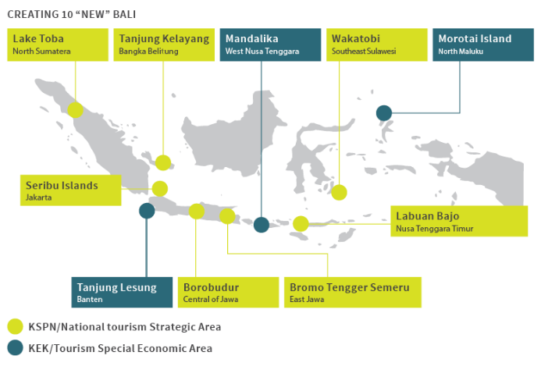

Addressing four main challenges | Example of areas
- Connectivity, basic services and tourist service infrastructure | (i) Air, water and road connectivity; (ii) Basic services and infrastructure – energy, health, ICT, logistics & supply chain etc; (iii) Tourism specific infrastructure and services
- Workforce skills and firm quality standards | Hospitality and management
- Investment and business climate | Policy and governance, business and management, enterprise development
- Coordination and implementation capabilities | Project management
Indonesia continues to push for a stronger digital economy with its E-Commerce Roadmap
Programs | Description
- Funding | - Run micro-credit programs to provide support to business app developers, business incubators and start-up mentorship  - Additional funding for digital small and medium enterprises (SMEs) as well as e-commerce start-ups
- Taxation | - Offer tax redemption for local start-up investors  - Simplify tax procedures and regulations for e-commerce ventures
- Consumer protection | - Regulate all electronic transactions  - Develop a progressive (national payment gateway)
- Education & human resource | - Education for all e-commerce ecosystem – continuing education program, national awareness campaign  - E-commerce for policy makers – capacity building programs  - Incubation programs for start-ups – especially to develop early stage start-ups  - Formal education programs to grow a talent pool – includes e-commerce curriculum, incentive schemes  - Develop e-commerce trainers / facilitators
- Communication infrastructure | - Strengthen through the national broadband development program
- Logistics | - Use the Sislognas Blueprint (logistics system) to speed e-commerce logistics delivery and reduce shipping costs  - Develop e-commerce logistics facilities for micro, SMEs  - Logistics system for rural to urban community
- Cyber security | - Increase security of electronic transaction activity  - Cybercrime  - Develop model of national supervision of e-commerce transaction
Source: Presidential regulation number 74 of 2017: E-commerce roadmap for the year 2017-2019
Research, Technology and Higher Education continues to play an important role in Indonesia’s innovation aspirations – Strategic objective and goals of RISTEK-DIKTI
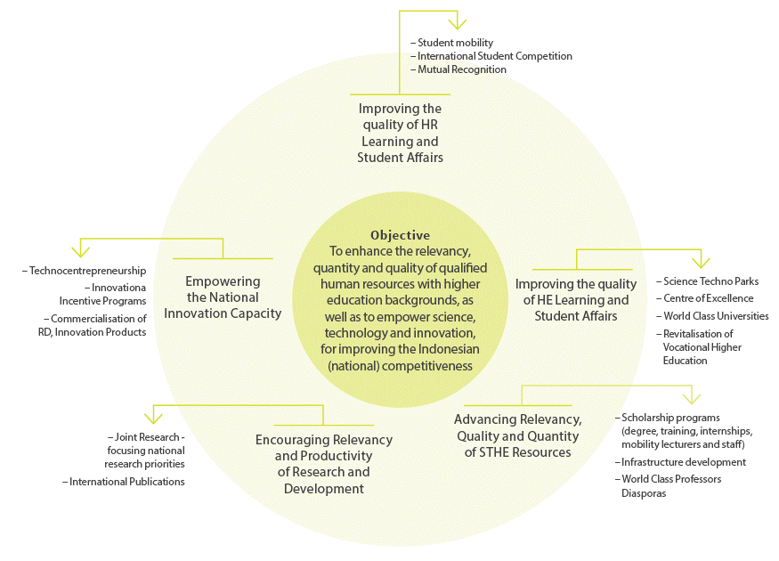
Source: RISTEK-DIKTI, 2018
The Government’s human resource capacity plan for the Technical and Vocational Education and Training Sector
Priorities
- Create a demand map for various professions that are linked and matched within the industry:
i. Reclassify professions (KBJI) and businesses (KBLI) into GICS and ISCO
ii. Verify obsolete and prospective professions
iii. Prioritize professions and businesses that are prospective and have attractive salaries
- Create a VET Roadmap that is based on the needs of the industry, among others:
i. Manpower Planning
ii. Determine Government Priority Sectors
iii. Accelerate Drafting of Competency Standards
iv. Revitalize VET Institutes v. Strengthening Accreditation Institutes
v. Accelerate Certification and Recognition of Workers
vi. Create a Strong Job Market Information System
vii. Apprenticeship and Placement System for Workers
- Development of VET, which includes:
a) Transformation for 60% of the workforce, among others:
i. Transformation of Subsistence Farmers;
ii. Transform Cleaners, Housekeepers, Baby Sitters and Caregivers;
iii. Transform Mining, Construction and Manufacture Workers;
iv. Transform General Clerks.
b) Government priority programs, among others:
i. The 35.000 MW electricity program.
ii. Land based programs.
iii. Program for 70.000 instructors in the farming sector.
c) Development of VET programs to support Industrial Zones and Exclusive Economic Zones (EEC) to fulfill the demand of workers that are recruited from VET institutes around these zones
d) Program for sectors that have (i) Strong Companies and Industrial Association, (ii) Good operating VET systems and (iii) Sectors with High Labour Demand, among others:
i. The Health Sector;
ii. Manufacture Sector;
iii. Tourism Sector;
iv. Transportation Sector.
Source: Ministry of Manpower
Link and Match: linking Vocational Education and business through the Industry Link and Match Program. The program connects industry partners with vocational schools (SMK), to align their curriculum with industry demand and enable 70 per cent practical work and 30 per cent classroom teaching.
3R Program – Balai Latihan Kerja (BLK – Work Training Centre):
The 3R (Reorientation, Revitalization, and Rebranding) program aims to improve the quality of BLKs by improving trainer capability, training facilities and infrastructure, competency standards and training programs, funding systems, and strengthening partnerships with industry. BLKs are managed by the Ministry of Manpower to provide competency-based training to the local workforce; there are 307 centres across Indonesia with a total of 286,272 students.

Other relevant initiatives:

Partnership for Australia-Indonesia Research (PAIR)
A new Australian Government funded program that focuses on addressing South Sulawesi’s development challenges relating to transport, water, energy and young people (their health, wellbeing, skills need and enterprise development). The program will begin in 2019 until 2022. It is led and managed by the Australia-Indonesia Centre.

SPADA Indonesia (Online Learning System)
In May 2018 the Indonesian Ministry of Research Technology and Higher Education (RISTEKDIKTI) launched Indonesia’s own online / blended higher education learning platform – SPADA Indonesia (Online Learning System Indonesia). It hosts 776 courses, from 51 universities and has been accessed by 14,931 students from 176 universities.

Special Economic Zones
Designated areas endowed with geo-economic and geo-strategic advantages where special facilities and incentives are extended to attract investment.
Areas include: Morotai, Maluku (2018 Priority), Tanjung Kelayang, Bangka Belitung (2018 Priority), Maloy Batuta Trans Kalimantan, East Kalimantan (2018 Priority), Bitung, North Sulawesi (2018 Priority), Sorong, West Papua (2018 Priority), Mandalika, Lombok, Tanjung Lesung, Banten, Arun Lhokseumawe, Aceh, Sei Mangkei, North Sumatra, Galang Batang, Riau Islands, Tanjung Api-Api, South Sumatera and Palu, Central Sulawesi.

100 Science Techno Park
Science Techno Park (STP) is a designated area to promote a culture of innovation and competitiveness of knowledge-based businesses. STP is a provider of the latest knowledge, technology solution providers, and developing advanced technology applications. More than 20 areas have been earmarked for the program across Indonesia.

Annexe B: Current Regulations for Foreign Education Providers
(This is only intended to provide a broad guide to a dynamic and changing regulatory space and is not a substitute for specific legal advice for an individual provider).
Summary | Regulations
Primary and Secondary Education: a school with a foreign partner (SPK) can be established in cooperation between a local Indonesian education institute and a foreign education institution that is accredited in its one country. A party must first establish a local not-for-profit foundation or yayasan which entails being registered locally and having Indonesian citizens on its board. Once established, the yayasan is required to obtain a licence from the Ministry of Education and Culture (MoEC) to establish the school, as well as to submit its curriculum to the Ministry for accreditation. | Minister of Education and Culture Regulation No 31 of 2014, on the provision of primary and secondary education between foreign and Indonesian institutions.
Higher Education Institutions: Higher Education institutions can only be established by the Government and / or a foundation or other not-for-profit entity, to achieve a higher education objective, in accordance with relevant laws and regulations. Article 12 of Government Regulation No. 63 of 2008 on Foundations, provides that with respect to the establishment of a foundation by a foreigner, one of the administrators serving as a chairman, secretary, or treasurer shall be an Indonesian citizen. Other conditions to be met, include:  - The foreign (Australian) education partner must be accredited in Australia and registered with RISTEKDIKTI.  - Location can be anywhere in Indonesia, subject to an economic needs test.  - A mutual recognition arrangement is required between relevant institutions on credits, programs and certification.  - Foreign education institutions providing services must establish a partnership with a local partner.  - The number of educators in the partnership must include at least 30 per cent Indonesian educators and the number of administrative staff shall be 80 per cent Indonesian.  - Religion, Pancasila, Citizenship Education and Indonesian language must be integrated into the curriculum and delivered by Indonesian educators. | Law 9 of 2009 on Legal Entities for Education  Law 12 of 2012 on Higher Education  Government Regulation No. 4 of 2014 on Establishment and Management of Higher Education Institutions  Government Regulation No. 63 of 2008 on Foundations.
Vocational Education and Training (including English language): under Indonesia’s 2016 Negative List (Presidential Regulation 44 of 2016), 67 per cent foreign equity ownership is permitted for vocational and education training entities offering qualifications below diploma level, otherwise the regulations require a not-for-profit model, with an Indonesian partner, as outlined under higher education. Similarly, to secondary and tertiary education providers, foreign entities providing language education services in Indonesia must also operate with a local Indonesian partner. | Law 9 of 2009 on Legal Entities for Education  Law 12 of 2012 on Higher Education  Presidential Decree 44 of 2016 on Negative Investment List
Employment of Foreign Workers: under Article 36, an expatriate to be employed in Indonesia must: have appropriate educational qualifications for the position; have certificates of competency or at least five years of work experience relevant to the position; provide a statement letter describing how the mandatory transfer of knowledge and skills to the Indonesian counterparts will be effected and evidenced by training reports; provide evidence of an insurance policy with an Indonesian insurance entity; and hold an Indonesian Taxpayer Registration Number (NPWP) if they have been working in Indonesia for more than six months they need to be enrolled in the National Social Security System. | Minister of Manpower Regulation 16 of 2015 on procedures for the employment of foreign workers.
Foreign Language Teachers: foreign educators teaching foreign languages in SPKs must be native speakers of a nation of that foreign language and/or holders of a teaching certificate for that language. The Director General for Secondary Education Decree No 1941 of 2014 on Technical Guidance to the Permendikbud No. 31 of 2014 specifies that foreign teachers in SPKs must have language proficiency and reference to the Bahasa Indonesia for Foreign Speakers (BIPA) test. However, a BIPA level is not specified. There have been recent changes with respect to foreign language teachers in the non-formal sector, loosening the requirements to allow for educators to hold any citizenship, bachelor’s degree and either five years’ experience or a relevant language teaching qualification. Further detail is expected on how these revised regulations will be implemented. | Minister of Education and Culture Regulation No. 10 and 20 of 2018 on Cooperation in Educational Management and Provision between Foreign Education Agencies and Education Agencies in Indonesia.  Presidential Decree 20 of 2018 and Ministry of Manpower Regulation 10 of 2018.
Foreign Teachers: foreign educators must obtain academic qualification, competencies, teacher’s certificate, must be healthy and have the ability to support the purpose of national education. Academic qualifications include: obtain a bachelor degree from an accredited higher education institution as the minimum; in accordance to the subject that s/he delivers in formal education: primary and secondary levels, including kindergarten; obtain a PhD degree from an accredited higher education institution as the minimum requirement in accordance to the subject that s/he delivers in higher education level; Educated in the subject area that s/he delivers from accredited higher education institution for teachers in non-formal education. | Ministerial of National Education Regulation 66 of 2009, on permits in hiring of foreigner instructors in formal and non-formal education in Indonesia.
Online / Blended Learning: the regulation relating to tech-based education or e-learning specifies that it can 1) be organized in various forms, modes, and scopes, supported by learning tools and services 2) organized by universities after obtaining ministerial permission 3) must be in accordance with national education standards (remain structured, both in the process of education and examination). | Law 20 of 2003 on National Education System (Article 31) and Minister of Education and Culture Regulation 109 of 2013 on Distant Learning on Higher Education.
Source: Department of Education and Training and The Australia-Indonesia Centre

Annexe C: Employment of foreign workers

Overview
Under Article 36 Paragraph 1 of Manpower Minister Regulation 16/2015 on procedures for the employment of foreign workers, an expatriate to be employed in Indonesia must first satisfy the following requirements:
have appropriate educational qualifications for the position;
- have certificates of competency or at least five years of work experience relevant to the position;
- provide a statement letter describing how the mandatory transfer of knowledge and skills to Indonesian counterparts will be affected and evidenced by training reports;
- provide evidence of an insurance policy with an Indonesian insurance entity; and
- hold an Indonesian Taxpayer Registration Number (NPWP) if they have been working in Indonesia for more than six months;
- be enrolled in the National Social Security System (Jaminan Sosial Nasional) if they have been working in Indonesia for more than 6 months.
The underlying philosophy applied for decades in Indonesia with regard to utilising non-Indonesian labour is how quickly can this foreign national be replaced by an Indonesian national. What does vary over time is the flexibility in defining the pace with which foreign occupied positions need to be “Indonesianised” and the number of foreigners who can be recruited and to what kind of positions within an enterprise.
On occasion there are proposals to incorporate new administrative procedures into the process for recruiting expatriate labour such as a need for the proposed recruitee to be competent to a certain standard in Indonesian language.
Some of these efforts to “protect” the domestic labour market have been informed by concerns about the potential “flooding” of the Indonesia labour market by people from elsewhere in ASEAN following the establishment of the ASEAN Community or from large nations like China.
As a result over the past few years there has been a tightening of the definitions and rules regarding eligibility to work in Indonesia resulting in a significant decline in the amount of expatriate labour deployed in Indonesia.
In many respects this more restrictive environment in the labour market reflects part of a wider move towards economic protectionism that has been a feature of economic policy debates in Indonesia in recent years. At the same time there do remain groups arguing for a more expansive perspective on economic development and accept the impact of these restrictions.
In the education and training sector, while the voices seeking to restrict the use of foreign labour remain strong, there are nonetheless signs of exceptions with recent proposals to permit campuses to use foreign lecturers, and on a long term basis, to support efforts to raise standards of teaching and research in Indonesian campuses.
Since its independence in 1945, Indonesia has not seen itself as an “immigrant” nation. As a result as a non-migrant nation, Indonesia sees all foreign labour as temporary and thus with an expectation of them returning home. Even so there do exist regularised pathways that permit the naturalisation of foreigners.
Regulations: Minister of Manpower Regulation 16 of 2015.

Employment of foreign teachers
Employment of Foreign Educators Law No 14 of 2005 provides that Indonesian teachers must have academic qualifications, competencies, teacher’s certificate, must be healthy and have the ability to support the purpose of national education.
Article 9 provides that an academic qualification as mentioned in article 8 must be obtained from attending bachelor degree program or a Diploma 4. This law appears to only apply to teaching qualifications for Indonesian teachers, but does not require them to have subject matter qualifications.
Ministerial decree No 66 of 2009, on the other hand, outlines regulations on permits to recruit foreigner instructors in formal and non-formal education in Indonesia. Article 3 (1): Foreign educators must have academic qualifications, competencies and valid teacher’s certificate. they must be healthy and have the ability to support the purpose of national education. Article 3 (2): Academic qualification as mentioned in paragraph (1) is determined as follows: They must have at minimum a bachelor degree from an accredited higher education institution in accordance to the subject that s/he is scheduled to deliver in formal education: primary and secondary levels, including kindergarten.
They need to have a PhD degree from an accredited higher education institution as the minimum requirement in accordance to the subject that s/he delivers in higher education level. Educated in the subject area that s/he delivers from accredited higher education institution for teachers in non-formal education.
In terms of practice, SPK schools note that once a position has been filled by a foreign national, they are able to remain and to continue working but only in that subject. Should they wish to be deployed to teach in another subject the school may face difficulties, especially if the position being filled is one that had been filled by an Indonesian national.
In essence the philosophy of permitting the use of foreign labour only until an Indonesian can fill the position remains evident here. As a result seeking to fill a position that had been filled by an Indonesian with a foreigner runs counter to this approach. As a result schools do face some inflexibility in terms of deploying their teaching staff across subjects to address their teaching needs.
Regulations: Law No 14 of 2005 on Teachers and Lecturers Minister of National Education Regulation No. 66 of 2009, on permits in hiring of foreigner instructors in formal and non-formal education in Indonesia.

Employment of foreign language instructors
Teachers must be native speakers of the foreign language they are to teach and must have the Indonesian teaching certificate for that language. Foreign educators teaching foreign languages in SPKs must be native speakers of a nation of that foreign language and/or holders of a teaching certificate for that language. The Director General for Secondary Education Decree No 1941 of 2014 on Technical Guidance to the Permendikbud No. 31 of 2014 specifies that foreign teachers in SPKs must have language proficiency and reference the Bahasa Indonesia for Foreign Speakers (BIPA) test. However, a BIPA level is not specified.

Regulations for Foreign Language Instructors
The requirement that foreign language instructors be both native speakers of the foreign language they are to teach, as well as the Indonesian language, has made recruitment of foreign teachers difficult. This is a major concern for the Alliance of Foreign Language Institutes (ALLBA), which represents a number of English language schools operating in Indonesia. An ALLBA policy brief from mid-2016 reports the “dramatic drop” in the number of qualified language instructors as a “...growing crisis” in the foreign language education sector. The brief references a case study using recruitment data from a foreign language institute in Indonesia showing that of 200 candidates applying for a teaching position, only nine candidates fulfilled MoEC’s requirements. Additionally we were informed by one of our interlocutors that there are more expatriate English Language instructors working in Singapore than in Indonesia.
Ministry of National Education Ministerial decree No 66/2009, Article 3 clause (3) specifies that foreign educators teaching foreign languages, in formal and non-formal education institutions, must be native speakers of the foreign language they are to teach, and must have the Indonesian teaching certificate (sertifikat pendidik) for that language.
Minister of Education and Culture Regulation No. 31 of 2014 on Cooperation in Educational Management and Provision between Foreign Education Agencies and Education Agencies in Indonesia. Article 9 clause (7) states that foreign educators teaching foreign languages in SPKs must be native speakers of a nation of that foreign language and/or holders of a teaching certificate for that language.
Regulations: Minister of National Education Regulation No 66 of 2009 on Conferring of Permits for Foreign Educators to Formal and Non-formal Education Centres in Indonesia. Minister of Education and Culture Regulation No. 31 of 2014 on Cooperation in Educational Management and Provision between Foreign Education Agencies and Education Agencies in Indonesia. Director General for Secondary Education Decree No 1941 of 2014 on Technical Guidance to Implement Minister of Education and Culture Regulation No. 31 of 2014.

Annexe D: Financial regulation
In 1970 Indonesia took the bold move to create an open Capital Account permitting the free flow in and out of funds. This principle has held largely in place in the decades that followed even during difficult economic times.
In August 1997 in the midst of the Asian Financial Crisis the Government floated the Rupiah. Since then the country has maintained this policy.
The Rupiah is a fully convertible and internationally traded currency. In terms of foreign investment, Indonesia is now rated by the key ratings agencies as being investment grade.
Some aspects of Indonesia’s financial system, especially monetary policy are managed by the Central Bank (Bank Indonesia), a constitutionally independent agency of the state. Other aspects, including prudential standards, of the country’s financial institutions are supervised by an independent Financial Services Authority, OJK.
Indonesia also operates an increasingly effective anti-money laundering regime through its Financial Tracking Agency, PPATK. This agency has seen some tightening of controls and reporting over flows of funds including funds to, from and within Indonesia. These controls and levels of reporting, however, are not especially onerous or complex.
There are two Australian banks that operate with full Indonesian banking permits, namely Bank ANZ Indonesia and the Commonwealth Bank. Other major Australian banks maintain other kinds of presence in Indonesia.
The establishment of not -for-profit entities does not mean they must be non-commercial. The legal regime governing institutions like foundations (Law 16 of 2001 on Foundations and Law 63 of 2008 on Implementing the Law on Foundations) provides for these foundations to manage commercial enterprises.

References
- Antara News 2018, Indonesia’s scientific publications overtake Singapore, viewed May 17 2018, <https://en.antaranews.com/news/115299/indonesias-scientific-publications-overtake-singapore>
- Asian Development Bank (ADB) 2018, Indonesia: Enhancing Productivity Through Quality Jobs, viewed May 10 2018, <https://www.adb.org/publication/indonesia-enhancing-productivity-quality-jobs>
- Australian Financial Review, Interview with Professor Ainun Na’im, hosted by The Australia-Indonesia Centre (AIC), Monday, 1 October 2018.
- Asia Philanthropy Circle 2017, Catalysing Productive Livelihood: A guide to education interventions with an accelerated path to scale and impact, viewed May 5 2018, <www.asiaphilanthropycircle.org/edu-giving-guide-indonesia/>
- British Council, 2014, Postgraduate student mobility trends to 2024, Education Intelligence, October <https://www.britishcouncil.org/education/ihe/knowledge-centre/global-landscape/report-postgraduate-mobility-2024>
- British Council, 2017, Education matters: Indonesia, Education Intelligence, 25 May –
<https://ei.britishcouncil.org/news/education-matters-indonesia>
- Burgess P 2016, Transnational Education and the Australian Schools Sector: A report on the nature, levels and models of offshore schools sector engagement, International Education Association of Australia (IEAA) viewed 16 May 2018, <https://www.ieaa.org.au/documents/item/774>
- Coleman, H 2011, ‘Paper 5 Allocating Resources for English: The Case of Indonesia’s English medium International Standard Schools’, in H Coleman (ed.), Dreams and Realities: Developing Countries and the English Language, British Council, London.
- CNN Indonesia 2018, Pemerintah Fokus Pendidikan Vokasi di Enam Sektor Galih Gumelar, viewed 7 May 2018, <https://www.cnnindonesia.com/ekonomi/20180419211720-92-292112/pemerintah-fokus-pendidikan-vokasi-di-enam-sektor>
- Dadush, U & Ali, S, 2012, In search of the middle class: A new index, The Carnegie Papers, Carnegie Endowment for International Peace, July – <https://carnegieendowment.org/2012/07/23/in-search-of-global-middle-class-new-index-pub-48908>
- Deloitte Access Economics 2015, Growth and Opportunity in Australian International Education: A report prepared for Austrade, viewed 3 May 2018.
- Department of Education and Training, 2015, Chinese government priorities, Australian Government Education Brief – China, November, p.2 – the following is a direct link to the PDF document file which is 463 kb in size, Department of Education and Training, 2015, Chinese government priorities, Australian Government Education Brief – China <https://china.embassy.gov.au/files/bjng/Country%20Brief%20China_November%202015.pdf>
- Department of Education and Training 2017, Submission 12, Joint Standing Committee on Trade and Investment Growth, Inquiry into the Trade Relationship between Australia and Indonesia: Leveraging our Advantages.
- Department of Foreign Affairs and Trade 2017, Submission 27, Joint Standing Committee on Trade and Investment Growth Inquiry into the Trade Relationship between Australia and Indonesia: Leveraging our Advantages.
- E27 2014, Ed-Tech startups in Indonesia helping fill education need-gap, viewed 15 May 2018,
<https://e27.co/ed-tech-startups-indonesia-helping-fill-education-need-gap/>
- English First 2017, English Proficiency Index, viewed 13 May 2018, <https://www.ef-australia.com.au/epi/>
- Ernst & Young 2018, Can the universities of today lead the learning for tomorrow? viewed 20 May 2018, <https://www.ey.com/au/en/industries/government---public-sector/ey-university-of-the-future-2030>
- Ernst & Young, 2018, Consortia opportunities and pathways for Australian SMEs delivering education and training services, viewed 3 July 2018, <https://www.austrade.gov.au/Australian/Education/Services/education-services-working-in-a-consortium>
- Euromonitor International, 2017, Indonesia set to show the strongest growth in its education industry, October, viewed 3 July 2018, <https://blog.euromonitor.com/2017/10/indonesia-education-industry.html>
- Finch, C. December 2014, The Indonesian Vocational Education and Training System, based on Endeavour Executive Fellowship to Indonesia.
- Gropello, E D Kruse, A Tandon, P2011, ‘Skills for the labor market in Indonesia: trends in demand, gaps, and supply (English)’, World Bank, Washington, DC, viewed 24 May 2018, <http://documents.worldbank.org/curated/en/840381468262793742/Skills-for-the-labor-market-in-Indonesia-trends-in-demand-gaps-and-supply>
- ICEF Monitor, 2018, China announces the closure of more than 200 TNE programs, ICEF Monitor, 11 July – <http://monitor.icef.com/2018/07/china-announces-closure-200-tne-programmes/>
- International Labour Organization, 2017, Indonesia Jobs Outlook 2017: Harnessing technology for growth and job creation, International Labour Organization, Jakarta – <https://www.ilo.org/jakarta/whatwedo/publications/WCMS_613628/lang--en/index.htm>
- Jakarta Post 2018, Ministry to bring back Indonesian language requirement for foreign workers, viewed 20 May 2018, <http://www.thejakartapost.com/news/2018/05/03/ministry-to-bring-back-indonesian-language-requirement-for-foreign-workers.html>
- McKinsey Global Institute 2012, The Archipelago Economy: Unleashing Indonesia’s Potential, viewed on 15 May 2018, <https://www.mckinsey.com/global-themes/asia-pacific/the-archipelago-economy>
- Ministry of Manpower, 2018, Pendidikan Vokasi Industri Wujud Implementasi Revolusi Mental, viewed on 11 June 2018, <http://www.kemenperin.go.id/artikel/18901/Pendidikan-Vokasi-Industri-Wujud-Implementasi-Revolusi-Mental>
- Morelink Asia Pacific 2007, Profiles of the International Education Markets in Selected Indonesian Provinces, report, commissioned by the Department of Education, Science and Training, Canberra
- Muhammad Z.R and Dikanaya T., 2018, Indonesia Seeks to Raise Human Capital, Asia Sentinel, January 8 – <https://www.asiasentinel.com/society/indonesia-raise-human-capital/>
- OECD /Asian Development Bank, 2015, Education in Indonesia: rising to the challenge, OECD Publishing, Paris – <http://dx.doi.org/10.1787/9789264230750-en>
- RISTEKDIKTI 2018, Number of Higher Education Institutions and Lecturers in Indonesia, viewed 18 May 2018, <https://forlap.ristekdikti.go.id/>
- RISTEKDIKTI 2018, Ministry Launches Hybrid Learning System, viewed 16 May 2018, <http://international.ristekdikti.go.id/2018/ministry-launches-hybrid-learning-system/>
- Rosser A 2018, ‘Beyond access: Making Indonesia’s education system work’, Lowy Institute, viewed 10 April 2018, <https://www.lowyinstitute.org/publications/beyond-access-making-indonesia-s-education-system-work>
- Rochmyaningsih, D 2018, ‘Indonesian plan to clamp down on foreign scientists draws protest’, Nature, <https://www.nature.com/articles/d41586-018-05001-7>
- Universities Australia 2006, International Links Data Survey, viewed 14 May 2018,
<www.universitiesaustralia.edu.au/global-engagement/international-collaboration/international-links/Link-Maps/Australian-universities-formal-agreements-by-country>
- Google & Temasek 2018, e-Conomy SEA 2018: Southeast Asia’s internet economy hits an inflection point. <https://www.thinkwithgoogle.com/intl/en-apac/tools-resources/research-studies/e-conomy-sea-2018-southeast-asias-internet-economy-hits-inflection-point/>
- White, H., 2018, The Jakarta switch – why Australia needs to pin its hopes (not fears) on a great and powerful Indonesia, Australian Foreign Affairs, Issue 3, July
- Zulfikar Rakhmat, M and Wijaya, A 2018, ‘Indonesia’s Unequal Higher Education’, Asia Sentinel, viewed on 25 May 2018, <https://www.asiasentinel.com/society/indonesia-unequal-higher-education/>

International Labour Organization, 2017, Indonesia Jobs Outlook 2017: Harnessing technology for growth and job creation, International Labour Organization, Jakarta.
Muhammad Z.R and Dikanaya T., 2018, Indonesia Seeks to Raise Human Capital, Asia Sentinel, January 8.
Coordinating Ministry for Economic Affairs; Research & Development Agency, Ministry of Transportation; Ministry of Research, Technology and Higher Education (RISTEKDIKTI); Ministry of Manpower.
Jakarta Post, 3 May 2018.
We did not explore the number of institutions with international academic programs
Key government initiatives aimed at VET reform, include: Making Indonesia 4.0; Vocational Education-Industry Link and Match Program; and the 3R (Reorientation, Revitalization, and Rebranding) Balai Latihan Kerja (BLK) or Work Training Centres (Annexe A).
Department of Education and Training, 2017.
The Government is seeking to address the human capital dimension by placing as a priority the redesign of the education curriculum to focus on STEAM subjects (Science, Technology, Engineering, Arts, and Mathematics) and working with industry players and foreign governments (for example, Germany’s dual system of industry vocational education) to improve the quality of vocational schools (SMK).

