

Child Care Subsidy Financial Integrity Strategy
  - 2023 - 2027


With the exception of the Commonwealth Coat of Arms, the Department’s logo, any material protected by a trade mark and where otherwise noted all material presented in this document is provided under a Creative Commons Attribution 4.0 International (https://creativecommons.org/licenses/by/4.0/) licence.
The details of the relevant licence conditions are available on the Creative Commons website (accessible using the links provided) as is the full legal code for the CC BY 4.0 International (https://creativecommons.org/licenses/by/4.0/legalcode)
The document must be attributed as the (Child Care Subsidy Financial Integrity Strategy 2023-2027).

Contents
Child Care Subsidy Financial Integrity Strategy 1
1. Purpose of the strategy 4
2. Legal and Regulatory Context 4
Family Assistance Law 4
The National Law 5
3. Functions to manage financial integrity 5
4. Vision and Objectives 8
5. Driving a Whole-of-System approach to Child Care Subsidy Financial Integrity 10
Objective 1 – Identify integrity risks across the integrity continuum that are targeted to achieving the department’s core outcomes, including early identification of emerging integrity risks 10
Objective 2 – Prioritising and coordinating response: Prioritise integrity risks by their value and develop targeted, fit for purpose responses through improved decision making and coordination 10
Objective 3 – Responding efficiently and effectively: Respond efficiently and effectively, including measuring performance to inform continuous improvement 11
6 Appendix 12
Glossary 12
Broader Legislative Framework 13
Best Practices Guidelines 14

1. Purpose of the strategy
The Child Care Subsidy Financial Integrity Strategy (Strategy) outlines the Australian Government Department of Education (the department) approach to financial integrity under the Child Care Subsidy (CCS) program and contains important information that supports the department to meet its regulatory obligations within the legislative framework, and effectively address fraud and non-compliance across the integrity continuum.
The Strategy provides a framework to support a whole of system, data-driven approach to identifying CCS financial integrity risks, prioritising and coordinating responses to risks, and measuring the efficiency and effectiveness of integrity activities and operations.

2. Legal and Regulatory Context

Family Assistance Law
The Australian Government is responsible for the administration and payment of CCS and Additional Child Care Subsidy (ACCS) for families. It does this under Family Assistance Law (FAL), which prescribes the entitlement families have to subsidies and the rules that apply to child care providers who provide subsidised care to children.
The FAL establishes the regulatory framework to manage child care financial integrity, including the obligations of child care providers and functions to manage the integrity of the CCS. FAL is a broad term encompassing the following legislation:
- A New Tax System (Family Assistance) Act 1999
- A New Tax System (Family Assistance) (Administration) Act 1999
- Child Care Subsidy Minister’s Rules 2017 (Minister’s Rules)
- Child Care Subsidy Secretary’s Rules 2017 (Secretary’s Rules)
- Any other instruments (including regulations) made under the A New Tax System (Family Assistance) Act 1999 and the A New Tax System (Family Assistance) (Administration) Act 1999
- Schedules 5 and 6 to the A New Tax System (Family Assistance and Related Measures) Act 2000
There are four types of child care providers which can be approved by the department to administer CCS and ACCS payments to families: Centre Based Day Care (CBDC); Outside School Hours Care (OSHC); Family Day Care (FDC); and In Home Care (IHC).
The department’s child care financial integrity functions also operate within a broader legislative framework, including the Public Governance Performance and Accountability Act and Rules, and Regulator Performance Guide (see Appendix – Legal instruments) that provide the guidance and legal obligations for the branch’s work. This Strategy has been developed to support compliance within this broader framework.

The National Law
Separately, state and territory government regulatory authorities are responsible for matters relating to the safety and quality of early childhood providers and services. This includes licensing and approving providers and services, monitoring and assessing the quality of the child care and early learning services being delivered in their jurisdiction. State and territory governments do this through the National Quality Framework under the National Law and National Regulations (National Law).
To be approved under the National Law, providers and services must meet the requirements of the National Quality Framework. The National Quality Framework provides a national approach to regulation, assessment and quality improvement for child care services across Australia. The Australian Children’s Education and Care Quality Authority (ACECQA) is an independent national authority that helps administer the National Quality Framework.
It is a condition of continued approval that providers comply with their obligations under both the FAL and the National Law.

3. Functions to manage financial integrity
The department delivers the following core operational functions to support financial integrity:
Provider Approvals manages the assessment process for approving providers to gain access to CCS payments on behalf of families and provides sector education about the requirements and ongoing conditions of CCS approval.
CCS Helpdesk provides frontline support for approved child care providers and services operating under the CCS program and manages the tip off line that allows parents, providers or their employees, and the public to raise concerns about practices relating to management of the CCS.
Integrity Capability and Engagement assists the ECEC sector with building their financial integrity capability through engagement activities and the delivery of an online learning platform, called Get Early Childhood Compliance Knowledge Online (Geccko). This function also supports collaboration across government agencies to protect the integrity of government payments.
Provider Audits examine governance of approved child care providers and services. This includes ensuring gap fee payments are made and being paid electronically in accordance with the legislative requirement.
Compliance Operations include undertake monitoring activities and investigation into alleged contraventions of the FAL, applying principles of best practice regulation to treat regulatory risk, including by taking administrative, civil and criminal sanctions. Compliance Operations partner with state and territory regulatory authorities under the auspices of the Joint Compliance Monitoring Program.
Fraud Investigations and Tactical Operations investigate allegations of CCS fraud, make referrals to the Commonwealth Director of Public Prosecutions (CDPP), support court proceedings and take part in joint tactical operations in collaboration with the Australian Federal Police and other government agencies.
The core operational functions above are supported by enabling functions that are critical to driving financial integrity in the ECEC sector. These functions include:
Intelligence Analytics provides crucial support for data driven decision making across the functions, including data analytics, reporting, intelligence, and current and emerging detection capabilities.
Integrity Policy and Governance provides policy advice on potential Integrity Priorities, supports governance arrangements, and monitors the department’s performance under the Portfolio Budget Statement.
Strategic Communication provides support for communicating with the sector including developing and implementing communication strategies for integrity initiatives and managing and evaluating the success of communication activities (websites, subscriber mailout, social and video content).
Exhibit 1.1 depicts the spectrum of financial integrity intervention responses across the compliance pyramid to address the different types of compliance behaviour in the sector.
Exhibit 1.1 Child Care Financial Integrity Compliance pyramid
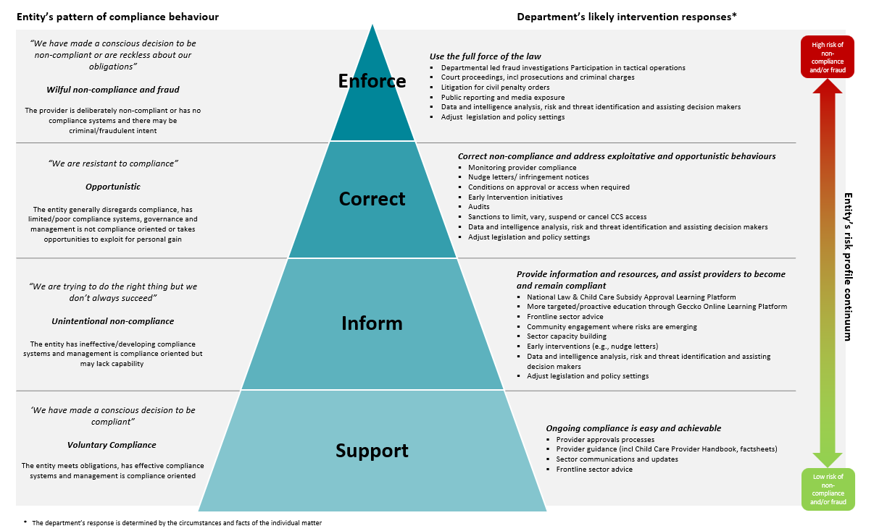

4. Vision and Objectives
This Strategy sets out a vision and objectives to support a whole of system and data driven approach over the next four years (Exhibit 2.1 provides a summary):

Vision: The vision for the department over the next four years is to: Deliver a world-leading, whole-of-system approach that efficiently and effectively protects the integrity of the Child Care Subsidy

- In this vision, integrity is reflected in the department’s core outcomes of CCS payment accuracy and savings to government resulting from integrity work.
- The department’s Portfolio Budget Statement (measure PM002 – Payment Accuracy) sets a target of ‘at least 90 per cent payment accuracy’. This sets a baseline for measuring the performance of integrity work under the Strategy and target that must be achieved.
- The department is committed to achieving the savings that government committed to deliver through the three recent CCS integrity Budget packages (in the October 2022-23, 2023-24 and 2024-25 Budgets) of $832.7 million over 5 years from 2022-23.

The department’s focus on the integrity of CCS payments seeks to enable the Government’s policy objective of supporting families to access affordable and quality child care. It does so by helping to ensure that payments are targeted towards care that is actually received, and because improving integrity maintains public confidence in and support for child care payments.

The Strategy identifies three objectives over the next four years to harness a whole-of-system approach and continue to mature the department’s integrity approach. The objectives are:
- Identifying integrity risks: Identify integrity risks across the integrity continuum that are targeted to achieving the department’s core outcomes, including early identification of emerging integrity risks.
- Prioritising and coordinating response: Prioritise integrity risks by their value and develop targeted, fit for purpose responses through improved decision making and coordination.
- Responding efficiently and effectively: Respond efficiently and effectively, including measuring performance to inform continuous improvement.

Exhibit 2.1: Summary of vision and objectives

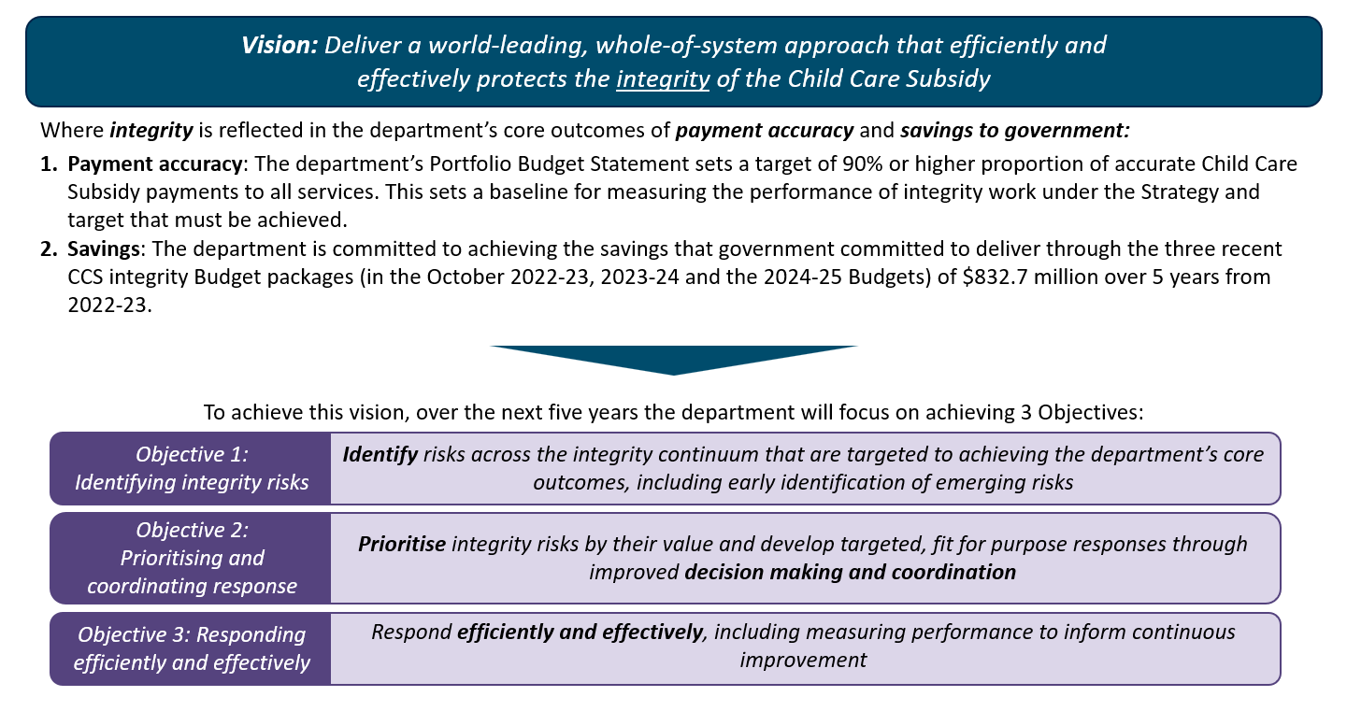

5. Driving a Whole-of-System approach to Child Care Subsidy Financial Integrity
The department drives a whole-of-system approach to:
- Ensure governance arrangements drive strategic prioritisation of integrity risks.
- Work cohesively, effectively, and efficiently across the department to improve the core outcomes of payment accuracy and savings to government, including by targeting Integrity Priorities and coordinating responses to high value integrity risks.
- Focus on measuring outcomes and ensure work is optimised to achieve outcomes.

Objective 1 – Identify integrity risks across the integrity continuum that are targeted to achieving the department’s core outcomes, including early identification of emerging integrity risks

The first objective ensures the department is proactively identifying high-value and emerging integrity risks and identifying them early using data.

This involves:
- Proactive identification of high-value integrity risks: Employ a large range of techniques to identify non-compliant and fraudulent behaviour in real-time. The techniques identify known and unknown non-compliance behaviours by using advanced and predictive analytics to target the highest value targets.
- Early identification of emerging integrity risks: Use data, including descriptive, statistical, and predictive analytics, to provide the evidence of emerging integrity risks and support earlier interventions.

Objective 2 – Prioritising and coordinating response: Prioritise integrity risks by their value and develop targeted, fit for purpose responses through improved decision making and coordination

The second objective seeks to prioritise responses to high-value integrity risks through improved decision making and coordination.

This involves:
- Centralising integrity risk prioritisation using governance processes to set clear Integrity Priorities and targeting work to the highest areas of value.
- Using the spectrum of proportionate regulatory tools in the Child Care Financial Integrity compliance pyramid: Ensure response represents the ’right’ balance of interventions throughout the compliance pyramid, including lighter touch interventions to larger groups of providers that provide a greater return-on-investment.
- Coordinated response and shared understanding of CCS integrity functions: Governance arrangements ensure work is allocated to the most appropriate areas and supports operational functions working collaboratively to deliver effective integrity activities.

Objective 3 – Responding efficiently and effectively: Respond efficiently and effectively, including measuring performance to inform continuous improvement

The third objective ensures operational responses are efficient and effective, including measuring performance to inform continuous improvement.

This involves:
- Managing and reporting data efficiently and effectively: Data assets are linked to provide a single source of truth and serve as the basis for streamlined reporting and analysis of reliable and repeatable information, including reporting of risks matched to operational needs.
- Measuring performance to inform continuous improvement: Continuous improvement guides the department’s integrity approach and provides a clear link between integrity activities with outcomes.
- Collaborating effectively with states/territories and other regulators: Regulatory approach to financial integrity in the system combines collaboration with states and territories and other regulators, particularly in intensive operations, to achieve mutually beneficial outcomes, such as sharing data to provide a shared view of provider behaviour and risk.
- Collaborating with the sector to understand and prevent non-compliant behaviour.

6 Appendix

Glossary
Term | Definition
Additional Child Care Subsidy (ACCS) | Provides extra help with fees to families facing barriers to child care. Additional Child Care Subsidy will usually cover all of a child’s child care fees.
Better child care regulation (BCCR) | Previous integrity measure introduced to streamline the regulatory system and reduce reporting duplication for service providers.
Cheaper Child Care Package | Legislation to provide higher rates of Child Care Subsidy to more Australian families from 10 July 2023.
Child Care Financial Integrity Functions | Activities undertaken by the department to address CCS fraud and non-compliance under Family Assistance Law and to help providers understand their obligations, ensuring the proper use of the subsidy.
Child Care Subsidy (CCS) | CCS is the main way the Australian Government helps families with child care fees. Providers must be approved by the Department of Education to receive CCS on behalf of families.
Child Care Subsidy Financial Integrity Risks | A potential threat or vulnerability to the financial integrity of the CCS program.
Community Child Care Fund Restricted (CCCFR) grant | Established in 2018 to support services to address obstacles to early childhood education and care.
Early childhood education and care (ECEC) | The early childhood education and care sector is made up of many different types of delivery settings, including centre-based day care, preschool, family day care and outside school hours care.
Family Assistance Law (FAL) | The basis for Commonwealth child care fee assistance and includes the Child Care Subsidy and Additional Child Care Subsidy.
Family Day Care (FDC) | Education and care provided by a qualified educator in the home. The National Law sets out the qualification requirements for staff working in FDC services.
Financial Integrity | Maintaining the accuracy, accountability, and reliability of CCS to protect the government payment program and ensure CCS funding is used for its intended purpose.
Gap Fees | Families who receive Child Care Subsidy are required to make a co-contribution to their child care fees via electronic means. Known as the gap fee this is the difference between a provider's fee and a family’s Child Care Subsidy amount.
Geccko Online Learning Platform | Geccko stands for ‘get early childhood compliance knowledge online.’ Geccko is designed to help providers, services and educators across all care types better understand their obligations under Family Assistance Law and encourage voluntary compliance. The platform is now available through the department’s website.
In Home Care (IHC) | A flexible form of early childhood education and care where an educator provides care in the child's home. It is restricted to families who cannot access other forms of care.
Integrity Savings | Savings that can be attributed to integrity actions that prevent child care subsidy being paid as a result of non-compliant or fraudulent activity.
National Law & Child Care Subsidy Approval Learning Platform | Two types of approval are needed to operate a service that offers Child Care Subsidy. The self-paced online learning modules are designed to assist prospective providers across all care types better understand the key common and unique requirements of applying for both National Law and Child Care Subsidy approval.
Nudge letters | Letters sent to providers as a reminder of their obligations under the legislation. These letters may be targeted or general in nature.
Payment accuracy | Payment accuracy is one of the Child Care Subsidy program's key performance indicators in the Department of Education’s Portfolio Budget Statement with a target of 90% payment accuracy. Payment inaccuracy is estimated based on gap fees not being paid or care being claimed when it did not occur at all or partially.
Whole of system approach | Approach to advocate all parts of the regulatory functions across the Financial Integrity Branch work together to respond to risk through shared understanding and collaboration.

Broader Legislative Framework
Act | Regulations/ Rules | Our Obligations
Public Governance, Performance and Accountability Act 2013 | Public Governance, Performance and Accountability Rule 2014  - Fraud Rule  - Debt Rule | PGPA Act 2013 requires the department to establish governance, performance, accountability framework that meet the standards under the Act, ensuring:  - we provide meaningful information to the Parliament and the public  - we use and manage public resources properly and  - we work cooperatively with others to achieve common objectives, where practical.  Fraud Rule, a legislative instrument, sets out key requirements of fraud control. The department must take all reasonable measures to prevent, detect and deal with fraud relating to the department.  Debt Rule (Recovery of Debts) sets out requirements for pursuing debts owing to the Commonwealth. It is relevant to accountable authorities and officials of non-corporate Commonwealth entities.
Child Care Act 1972 |  | Provisions around capital grants, recurrent grants, research grants and advisory committees in relation to child care.
Crimes Act 1914 |  | The Crimes Act sets out Commonwealth powers, authorities and obligations for dealing with Commonwealth criminal offences and related matters. Provides the basis for use of section 3E Search Warrants that are occasionally used during fraud investigations.  Provides for interviewing and questioning people in relation to alleged crimes.
Criminal Code Act 1995 |  | The Criminal Code Act 1995 sets out Commonwealth criminal offences that may apply for acts of dishonesty, fraud and abuse of public office. Criminal Code Act 1995 offences may apply to the misuse of Child Care Subsidies, the provision of false information and documents to the Department of Education and deliberate maladministration of the Family Assistance Law. Allegations of Child Care Subsidy fraud that could amount to Criminal Code Act 1995 offences are the basis for criminal investigation undertaken by the department.
Evidence Act 1995 |  | The Commonwealth Evidence Act provides the rules about how evidence can be used in judicial proceedings for fact finding purposes.
Regulatory Powers (Standard Provisions) Act 2014 | Regulatory Powers (Standard Provisions) Regulation 2015 | Establishes a framework of standard regulatory powers exercised by agencies across the Commonwealth. These include monitoring and investigative powers and provides the infringement notice scheme.
Acts Interpretation Act 1901 |  | The Acts Interpretation Act 1901 (Cth) establishes rules for the interpretation of Australian Acts and other legislation. The Act applies only to Commonwealth legislation, setting out general provisions including what material may be considered when interpreting an act, the meaning of words and expression commonly used in legislation and judicial expressions in legal proceedings and how legislation may be cited.

Best Practices Guidelines
Guidelines | Relevance of Guidelines to CCS Financial Integrity Work
Australian Government Investigations Standard 2022 | The AGIS articulates what entities should and must do to achieve the Australian Government’s standard while performing investigation tasks in terms of:  - Investigator personnel (professional stream, conduct, qualifications, competencies and mindset)  - Information and evidence management  - Investigation practices  - Quality assurance framework.
Commonwealth Fraud Control Framework 2017 | Outlines the Australian Government's requirements for fraud control. It requires Commonwealth entities to put in place a comprehensive fraud control program that covers prevention, detection, investigation and reporting strategies.  The three key documents in the framework are the:  - Fraud Rule which is a legislative instrument binding all Commonwealth entities. It sets out key requirements of fraud control  - Fraud Policy which binds non-corporate Commonwealth entities and sets out procedural requirements for specific areas of fraud control such as investigations and reporting  - Fraud Guidance (also known as the Resource Management Guide No. 201 - Preventing, detecting and dealing with fraud) which supports the Fraud Rule and Fraud Policy by setting out the Australian Government's expectations for fraud control arrangements within all Commonwealth entities.
Protective Security Policy Framework | Sets out government protective security policy and supports entities to effectively implement the policy across the following outcomes:  - security governance  - information security  - personnel security  - physical security.
Commonwealth Governance Structures Policy | The Governance Policy supports:  - creating fit-for-purpose governance structures for new government activities  - reviewing governance structures for existing government activities to ensure they remain appropriate.
Commonwealth Risk Management Policy | The Policy supports the requirements of section 16 of the Public Governance, Performance and Accountability Act 2013 which requires accountable authorities of entities to establish and maintain systems and appropriate internal controls for the oversight and management of risk.
Regulator Practice Guide | Under the Regulator Performance Guide, as a Commonwealth regulator, we are required to perform and report on our performance against the following expectations:  - Continuous improvement and building trust  - Risk based and data driven  - Collaboration and engagement.

Integrity risks are high-value where: - The risk directly threatens the achievement of our core outcomes of payment accuracy or savings to government - The risk is emerging and, if left unchecked, has the potential to threaten payment accuracy or savings in the future - The risk represents some other type of strategic threat to the efficacy of the payment system, as agreed through governance arrangements

