

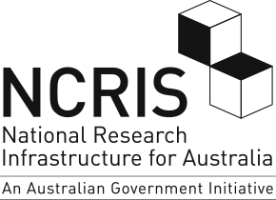

National Research
Infrastructure Census
REPORT
(2015-16, 2016-17)

Report prepared for:
Research Policy and Programs Branch
Research and Economic Group
Commonwealth Department of Education and Training


Wallis Market and Social Research achieved accreditation to the International Standard ISO20252 in September 2007. The Company is committed to maintaining administrative and operational procedures which comply with these accreditation requirements and to improving its performance in all aspects of the service it delivers to its customers.
Wallis is an active participant in the market research industry, with senior staff making significant contributions to the Australian Market and Social Research Society (AMSRS) and the Association of Market and Social Research Organisations (AMSRO). As such we actively pursue the ethical objectives of the industry.
In addition to having attained the highest Industry accreditation, Wallis also participates in the Australian Achiever Awards, which recognises the customer service excellence of Australian companies. The Company has been awarded a high commendation every year since the inception of these awards in 1999.
Wallis is an acknowledged leader in data protection and privacy. Our systems are OWASP certified and we are Privacy Awareness Week partners – committed to sharing our knowledge with others.

Table of Contents

1.0 2015-17 NCRIS Census Snapshot 1
2.0 Introduction 2
2.1 Purpose of the Project 2
2.2 Overview of the Census 2
2.3 Methodology 3
3.0 Utilisation of National Research Infrastructure 4
3.1 Overall Users and Usage 4
3.2 Types of Users 7
3.3 Capacity and Utilisation 12
3.4 User Experience: Measuring Satisfaction 13
4.0 Impact of National Research Infrastructure 14
4.1 Academic Impact: Publications and Citations 14
4.2 Promotional Activities 16
4.3 Enabling Government policies and programs 17
4.4 Commercial Impacts 19
4.5 Overall Impact: Key Advantages 20
5.0 Collaboration 22
6.0 User Charges and Funding 24
6.1 Users and user charges 24
6.2 Co-investment 25
7.0 People 27
7.1 Headcounts and Representation 27
7.2 Building Human Capacity 28
8.0 NRI Technology Platforms: Costs, Financial risk and future challenges 30
8.1 Costs and life-stage 30
8.2 Infrastructure Challenges for the future 31

Appendix 1 NRI Census form
Appendix 2 List of NCRIS projects invited to the census and their completion status

List of Figures

Figure 1 NRI Census Methodology overview 3
Figure 2 NCRIS Users, domestic and international across financial years 4
Figure 3 Average number of NCRIS Projects accessed by universities 7
Figure 4 Types of institutions using NCRIS infrastructure 8
Figure 5 Which Government agencies used your project’s infrastructure? 8
Figure 6 Proportion of facilities providing services to various fields of research 11
Figure 7 Proportion of facilities providing services to various industries 12
Figure 8 Methods of assessing user satisfaction 13
Figure 9 NCRIS Projects publication outputs: relative scores on Field-Weighted Citation Impact and top-10 citation percentile 14
Figure 10 Field-weighted citation impact, by year 15
Figure 11 Outputs in top citation percentiles (top 10%), by year 15
Figure 12 NCRIS-enabled publications: evidence of collaboration, by year 16
Figure 13 Has the facility participated in any promotional events? 17
Figure 14 Types of advice provided by facilities 19
Figure 15 What are the key advantages the project offers users? 20
Figure 16 Partnership in global research infrastructure, and plans for the future 23
Figure 17 Types of user service or support offered? 25
Figure 18 Funding Multipliers 26
Figure 19 Staff categories, as a proportion of headcount 27
Figure 20 Activities conducted to build technical skills or create career progression 28
Figure 21 Early-career researcher initiatives offered by projects 29
Figure 22 Estimated percentage of 2017 technology platforms to have reached their predicted end-of-life 30
Figure 23 Risks of technology platform failure and obsolescence 31

List of Tables

Table 1 Total users: By source 5
Table 2 Total uses: By source 6
Table 3 Services reported by TERN 9
Table 4 Services reported by BPA 10
Table 5 Technology Platform utilisation 12
Table 6 Proportion of Projects producing promotional articles / materials 16
Table 7 AURIN Roles in enabling government policy and program delivery 17
Table 8 AURIN Support of Government Priorities 18
Table 9 Number of commercialisation Outputs, by year 20
Table 10 Program-Wide Domestic Collaborative Arrangements in Place, by Year 22
Table 11 Program-Wide International Activities in Place, by Year 22
Table 12 Charging Structure, by User Types 24
Table 13 Program Wide User Charges Revenue 24
Table 14 Proportion of NCRIS Projects receiving cash and in-kind co-investment 26
Table 15 Program-wide Cash and In-kind contributions 26
Table 16 NCRIS Program-wide staffing 27
Table 17 Proportion of NCRIS staff that are female 27
Table 18 Program-wide Establishment and Replacement Costs 30

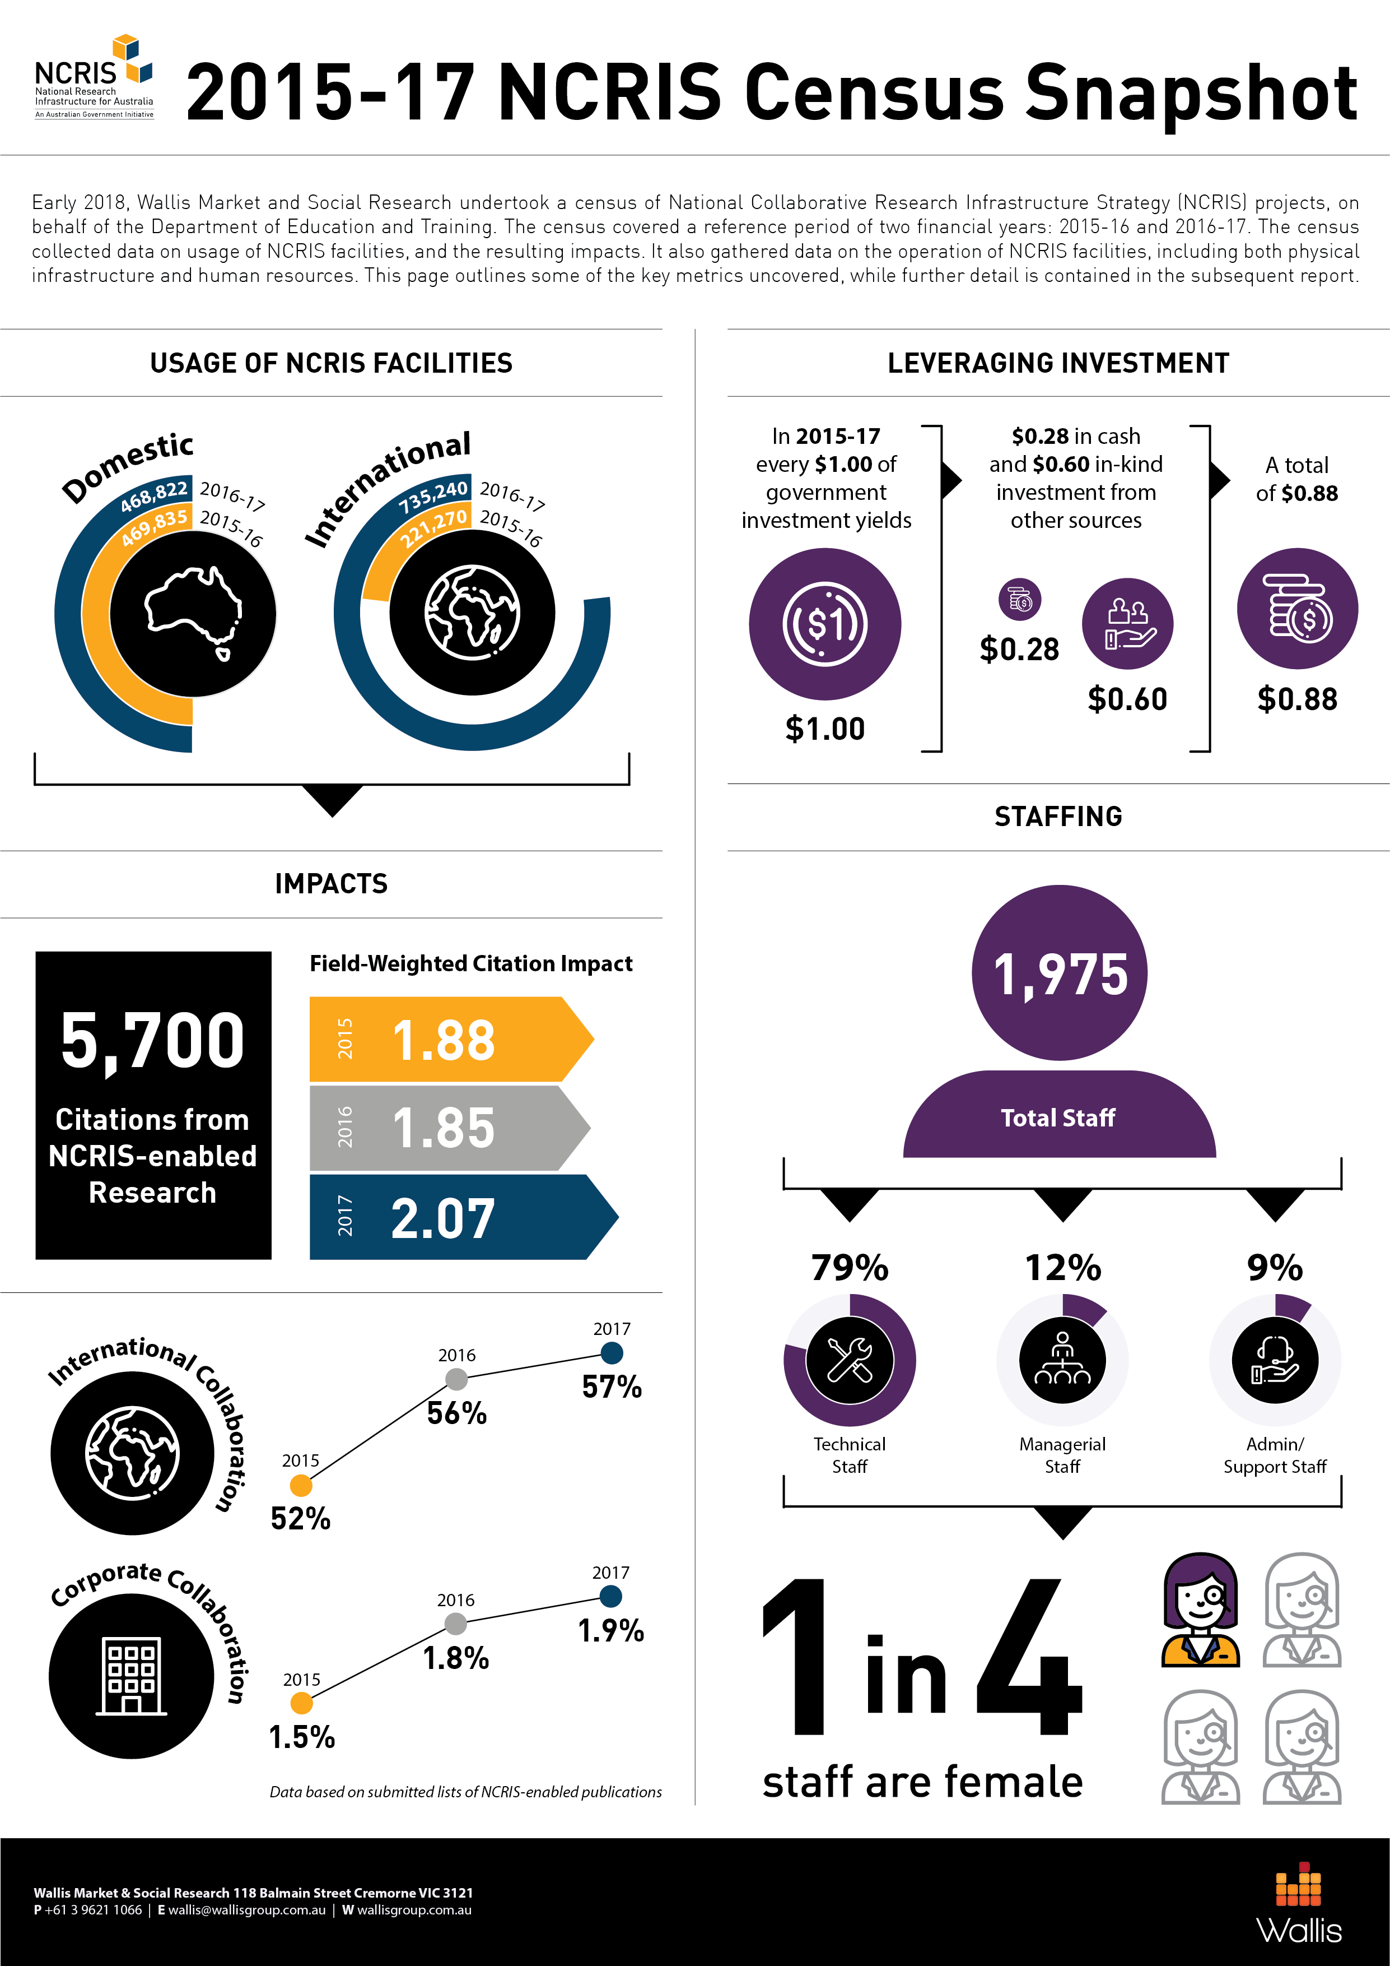
2015-17 NCRIS Census Snapshot

Introduction

Purpose of the Project

The Australian Government Department of Education and Training is tasked with providing an aggregated and detailed picture of how National Research Infrastructure (NRI) supports quality research that benefits Australia.
This exercise is an attempt to gather an overall, system-wide picture of Australia’s NRI: its scope, scale and reach. It is not an objective of this census to compare projects with one another.
Within the broader network of NRI, particular focus is applied to National Collaborative Research Infrastructure (NCRIS) projects. This report presents the aggregated data from across NCRIS projects.

Overview of the Census

The census has two reference periods: the 2015-16 and the 2016-17 financial years, with respondents requested to fill out a single form containing both reference years.
The census was undertaken across the full range of NRI that was considered during the development of the 2018 Research Infrastructure Investment Plan. Given that projects vary massively in terms of size, purpose, scope and structure, it should be understood that some of the questions may not have been equally relevant to all NRI facilities and contexts, and that NRI facilities cannot always be sensibly compared on all metrics.
With regard to NCRIS projects, of the 26 projects invited to participate, 24 of these completed the survey. One project was ceased in 2017-18 and was not able to provide data in time to support the census as a result of reduced resources. Another NCRIS project, the European Molecular Biology Laboratory Australia, did not have any Australian based infrastructure, and so was exempt from completing the census.
A list of all NCRIS projects that were invited to the census, as well as their completion status, is included in Appendix 2.
One NCRIS project, Research Data Services (RDS), completed the survey via a different form for each node as well as the head office (a total of 8 forms). These forms were then merged together to represent a single project for the purpose of this report. On the other hand, Australian Nuclear Science and Technology Organisation (ANSTO) National Deuteration Facility and ANSTO Nuclear Science Facilities (NSF) completed separate forms and are treated as separate projects for the purpose of this report.

Methodology

The approach to the project is shown below:
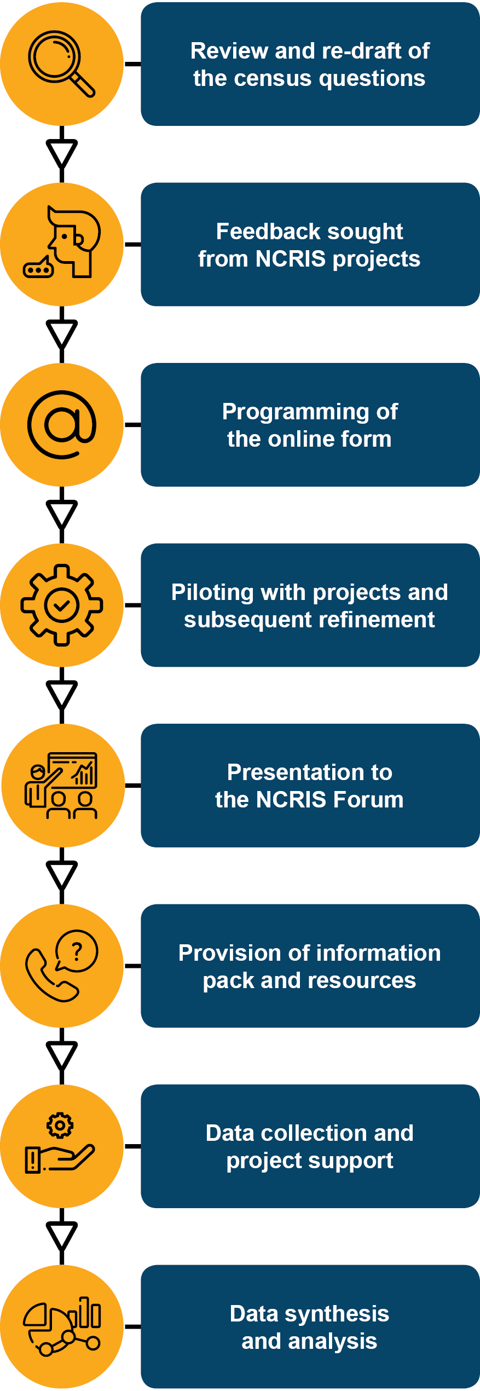
Figure 1 NRI Census Methodology overview
The first step in the methodology was a thorough review and redraft of the census questions. The Department provided the results of its internal consultations, which revealed priority areas for consideration. These were then assessed alongside the existing census instrument that had been used in 2015.
Once a draft census form was agreed between Wallis and the Department, it was shared (in MS Word form) with a small number of NCRIS projects. Feedback was received and incorporated into the next version of the census form.
Wallis then programmed the census form to allow online completion by projects.
The form was shared with a pilot sample of volunteer projects, and final feedback was received, evaluated and incorporated.
Wallis presented to the NCRIS Forum in Canberra, informing projects of the upcoming census exercise.
Prior to the commencement of fieldwork, census participants were sent an information pack. The information pack consisted of a glossary, a FAQ document, a list of survey sections, and a PDF of the full census form in order to help respondents prepare the information they would need ahead of the fieldwork period. Projects were also followed up via email and telephone to broach the project census and its requirements.
The finalised data collection was undertaken primarily with the use of an online form, as well as being supplemented by Excel templates. The online form was open from March 27th 2018 and remained open until May 21st 2018.
For the question concerning lists of publications, participants submitted these via an Excel template. Participants were also able to submit additional questions (e.g. lists of financial co-contributors) via Excel templates if they preferred this over using the online form. The projects received ongoing telephone and email support from Wallis.
Once received, data was collated, sense checked, and analysed, forming the basis of this report.

Utilisation of National Research Infrastructure

Overall Users and Usage

On the census form, participants had the option of either entering their number of users, or alternatively, their number of uses. They also had the option of entering both of these metrics. Participants were directed to decide this based on what was most relevant or appropriate to their project.
Of the 24 NCRIS projects, 21 (88%) of these completed the users option, while only 15 (63%) completed the uses option.

Total Users – Program wide
The chart below shows that while the number of domestic users has remained stable, the number of international users has more than tripled since 2015-16. This growth has all essentially come from the category ‘non-research users’, and from a single project, Atlas of Living Australia (ALA). If the growth in International non-research users of ALA were to be excluded, then total NCRIS 2016-17 usage would be practically unchanged since 2015-16.
Figure 2 NCRIS Users, domestic and international across financial years
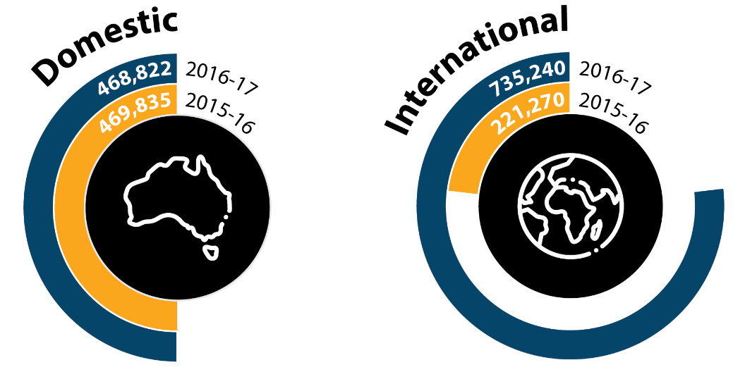

Excluding ‘non-research users’ (most of whom are accounted for by the ALA), the most prominent users of NCRIS Infrastructure are researchers from within universities and users from government departments. Users from within universities have increased strongly from 2015-16 to 2016-17, up by more than 5,000 between the two reference periods. On the other hand, users from government departments have contracted by over 2,500 users during the period.
Table 1 Total users: By source
 | Year | Domestic | International
Researchers from within Universities | 2015-16 | 33,295 | 12,697
Researchers from within Universities | 2016-17 | 38,939 | 11,291
Researchers from within Publicly Funded Research Agencies (PFRA) | 2015-16 | 2,118 | 360
 | 2016-17 | 2,078 | 302
Researchers from within Medical Research Institutes (MRI) | 2015-16 | 581 | 35
Researchers from within Medical Research Institutes (MRI) | 2016-17 | 719 | 48
Researchers from International organisations | 2015-16 | 73 | 231
Researchers from International organisations | 2016-17 | 120 | 363
Researchers from industry / commercial organisations | 2015-16 | 958 | 174
Researchers from industry / commercial organisations | 2016-17 | 1,277 | 202
Researchers from within other organisations | 2015-16 | 1,820 | 1,528
Researchers from within other organisations | 2016-17 | 2,200 | 1,385
Users from government departments (incl. local government) | 2015-16 | 20,058 | 998
Users from government departments (incl. local government) | 2016-17 | 17,484 | 998
Non-researcher users | 2015-16 | 382,368 | 189,740
Non-researcher users | 2016-17 | 368,019 | 704,358
Other (further) disaggregation unavailable | 2015-16 | 28,564 | 15,507
Other (further) disaggregation unavailable | 2016-17 | 37,986 | 16,293
Total | 2015-16 | 469,835 | 221,270
Total | 2016-17 | 468,822 | 735,240

A similar broad pattern is identified when ‘uses’ (rather than users’) is examined, with researchers from within universities being responsible for many uses of NCRIS facilities. Unsurprisingly, for some of the projects where ‘uses’ is the most logical metric, it is not possible to capture details on the individuals making such use, hence the high number of uses that are not possible to disaggregate. These typically came from computational or data services based projects such as Australian National Data Service (ANDS), National Computational Infrastructure (NCI) (responsible for some 89.4 million of the uses that could not be disaggregated) and RDS.
Other than the dramatic increase in domestic uses that could not be disaggregated experienced by NCI, there were some noticeable changes in uses experienced by the National eResearch Collaboration Tools and Resources project (NeCTAR). These included a sharp increase in domestic uses by researchers within other organisations, and a significant fall in the number of uses by researchers from within universities.
Table 2 Total uses: By source
 | Year | Domestic | International
Researchers from within Universities | 2015-16 | 199,458 | 20,122
Researchers from within Universities | 2016-17 | 155,817 | 24,450
Researchers from within Publicly Funded Research Agencies (PFRA) | 2015-16 | 22,747 | 3,915
 | 2016-17 | 29,163 | 13,050
Researchers from within Medical Research Institutes (MRI) | 2015-16 | 26,636 | 5,219
Researchers from within Medical Research Institutes (MRI) | 2016-17 | 35,903 | 10,085
Researchers from International organisations | 2015-16 | 70 | 5,506
Researchers from International organisations | 2016-17 | 49 | 11,034
Researchers from industry / commercial organisations | 2015-16 | 9,769 | 2,463
Researchers from industry / commercial organisations | 2016-17 | 14,850 | 7,821
Researchers from within other organisations | 2015-16 | 10,297 | -
Researchers from within other organisations | 2016-17 | 74,662 | -
Users from government departments (incl. local government) | 2015-16 | 5,795 | -
Users from government departments (incl. local government) | 2016-17 | 14,233 | -
Non-researcher users | 2015-16 | 457 | -
Non-researcher users | 2016-17 | 303 | 11,091
Other (further) disaggregation unavailable | 2015-16 | 9,658,253 | 3,802,996
Other (further) disaggregation unavailable | 2016-17 | 89,609,517 | 1,660,897
Total | 2015-16 | 9,933,482 | 3,840,221
Total | 2016-17 | 89,934,497 | 1,738,428

Types of Users

The figure below shows how many of the NCRIS projects on average had their facilities used by various categories of universities. To illustrate, on average, about 21 NCRIS projects provided facilities to users from any given Group of Eight university. In contrast, on average, only about 10 NCRIS projects provided facilities to users from any given Regional Network University. There is a clear correlation, where the higher ranked an Australian university is in terms of research impact, the greater the number of NCRIS facilities that university typically uses.
Figure 3 Average number of NCRIS Projects accessed by universities
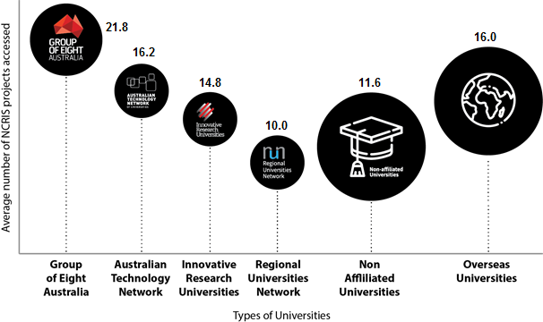

In terms of institutional users, 67% of projects reported that Australian Research Council (ARC) Centres of Excellence used their project’s infrastructure.
Figure 4 Types of institutions using NCRIS infrastructure
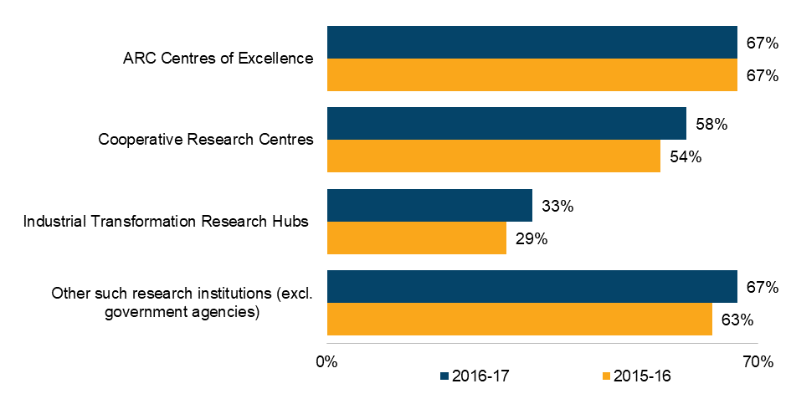
Over 90% of NCRIS projects reported that Publicly Funded Research Agencies (PFRAs) used their project’s infrastructure. Unsurprisingly, State and Federal Government usage was also relatively high (83% and 75%, respectively) compared with Local Government use of NCRIS facilities.
Figure 5 Which Government agencies used your project’s infrastructure?
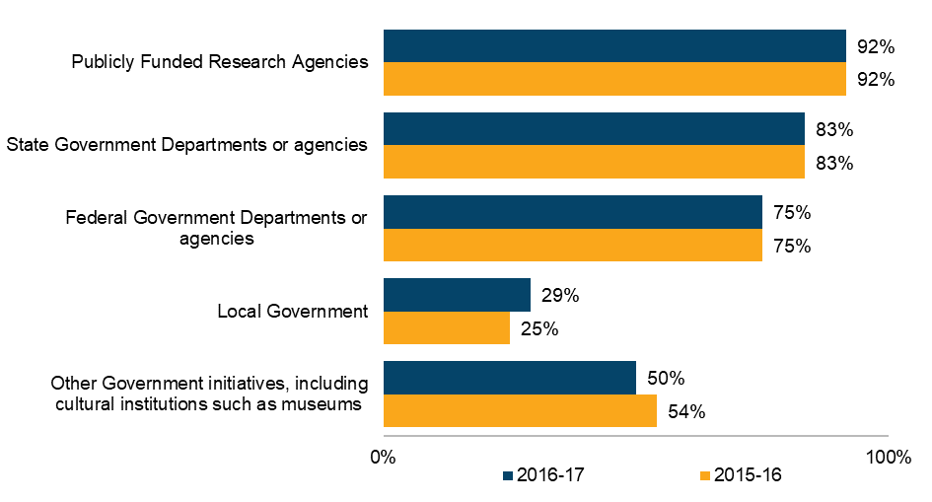

There was vast ‘cross-provision’ of services between all the various NCRIS projects, demonstrating a high degree of interdependency. Below, this interdependency is shown for two selected NCRIS projects. Though even with just two examples, the message is clear: NCRIS projects are involved in a considerable level of cross-provision of resources.
To illustrate, Table 3 displays the services reported by Terrestrial Ecosystem Research Network (TERN) .
Table 3 Services reported by TERN
NCRIS Project | Service
Atlas of Living Australia | Data layers
AuScope Limited | Co-location of instrumentation
Australian National Data Service | Provision of data for ANDS client base
Australian Plant Phenomics Facility | Data layers and sharing of infrastructure
Australian Urban Research Infrastructure Network | Shared infrastructure and data
Bioplatforms Australia | Provision of genetic samples from field observation sites
Groundwater | Co-location of infrastructure
Integrated Marine Observing System | Data layers
National Computational Infrastructure | Act as test bed
NeCTAR | Provision of leadership for development of cloud computing and virtual laboratories
National Imaging Facility | Provision of samples from field observation sites
Research Data Services | Analytical tools

As a second example, the below table displays the the services reported by Bioplatforms Australia (BPA).
Table 4 Services reported by BPA
NCRIS Project | Service
Atlas of Living Australia | Environmental Framework Initiative collaboration
AuScope Limited | BASE framework
Australian Animal Health Laboratory | Genomics
Australian National Fabrication Facility | ARC Nanobio photonics
Australian National Data Service | Bioscience Research Data Cloud
Australian Phenomics Network | Genomics
Australian Plant Phenomics Facility | Genomics, metabolomics
European Molecular Biology Laboratory Australia | Bioinformatics, committee membership
Groundwater | BASE framework
Integrated Marine Observing System | Marine Microbes framework
National Computational Infrastructure | Genomics, bioinformatics
NeCTAR | Biosciences DEVL
Research Data Services | Biosciences DEVL, RDC, Antibiotic Resistant Sepsis Pathogens framework
Terrestrial Ecosystem Research Network | BASE framework
Translating Health Discovery | Genomics, proteomics, metabolomics, monoclonal antibody, stem cells, bioinformatics

As shown below, nearly 80% of NCRIS projects are used by researchers from the Biological Sciences, making it the field of research that makes use of the highest number NCRIS facilities. As expected, sciences, medical, and engineering fields are the primary users of NCRIS facilities, which largely reflects the results of the 2014-15 census. While the humanities are less likely to use any given NCRIS project, it is interesting that all fields of research, even fields such as Philosophy and Religious Studies, nevertheless make some use of some NCRIS facilities. These tend to be data or computing services, such as NeCTAR or Pawsey Supercomputing Centre (Pawsey).
Figure 6 Proportion of facilities providing services to various fields of research
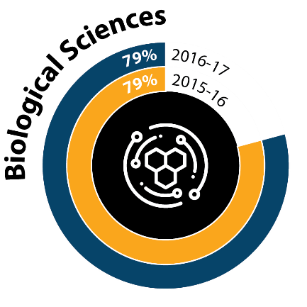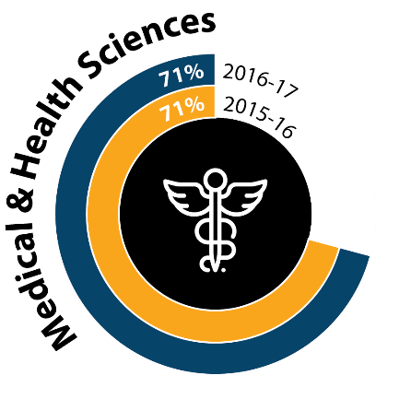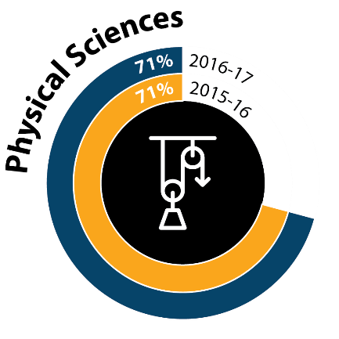
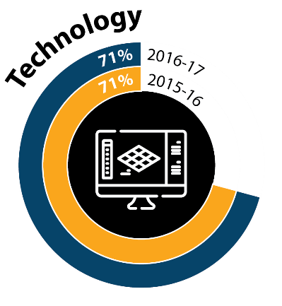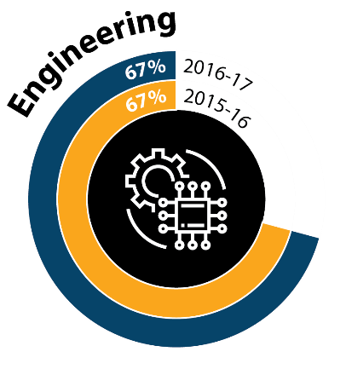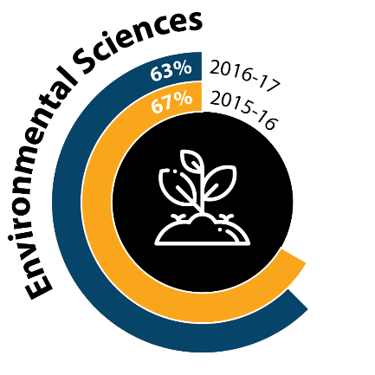

As expected, the ‘professional, scientific and technical services’ industry catergory makes use of the highest number NCRIS facilities. Beyond this, the next most relevant industries for NCRIS facilities are the primary industries of Agriculture, Forestry, and Fishing, as well as Mining. Over half of all NCRIS facilities made use of these primary industries. Half of NCRIS facilities made use of the Manufacturing industry too.
Figure 7 Proportion of facilities providing services to various industries
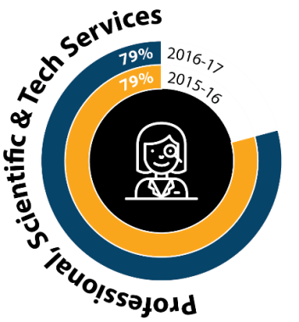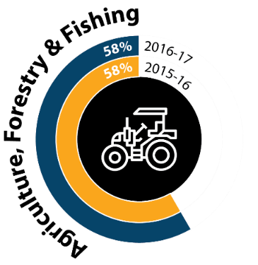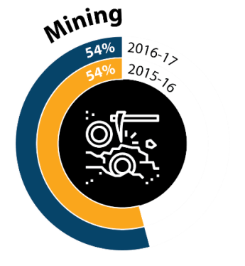
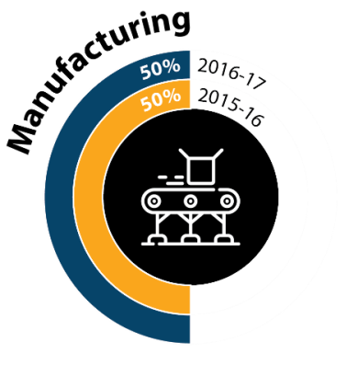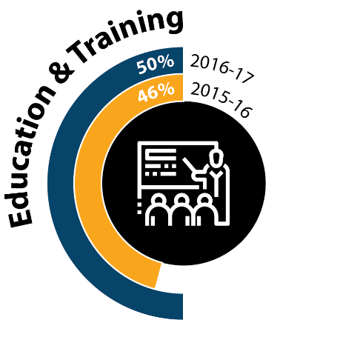

Capacity and Utilisation

It can be seen in Table 5 that the proportion of projects having at least one oversubscribed technology platform has not risen since 2015-16. Nearly 80% of NCRIS projects have at least one technology platform at an utilisation level of 90% or greater, suggesting strong general utilisation. This figure also appears stable across the two years, suggesting capacity issues, while not getting markedly better, are importantly not deteriorating either. However, a strong theme emerging later in the Census was the need to build capacity to keep up with ongoing growth and change.
Projects with the highest proportion of hardware platforms oversubscribed include Translating Health Discovery (THD), Integrated Marine Observing System (IMOS), NCI, Heavy Ion Accelerators, and ANSTO NSF. In terms of absolute numbers of oversubscribed platforms, the Australian Microscopy and Microanalysis Research Facility (AMMRF) has the most oversubscribed hardware platforms.
Table 5 Technology Platform utilisation
 | 2015-16 | 2016-17
Projects with any technology platforms >=90% used | 19 | 19
Projects with any technology platforms >=90% used | 79% | 79%
Projects with any technology platforms oversubscribed | 16 | 15
Projects with any technology platforms oversubscribed | 67% | 63%

User Experience: Measuring Satisfaction

The popularity of the various methods of measuring user satisfaction can be seen below. Most NCRIS projects are using a selection of techniques for user satisfaction measurement, with 79% having some form of formalised system. Given the high existing use of user-feedback, this creates the opportunity to learn from projects who do this well, and roll-out a more standardised approach to collecting such information across the NCRIS program.
Figure 8 Methods of assessing user satisfaction
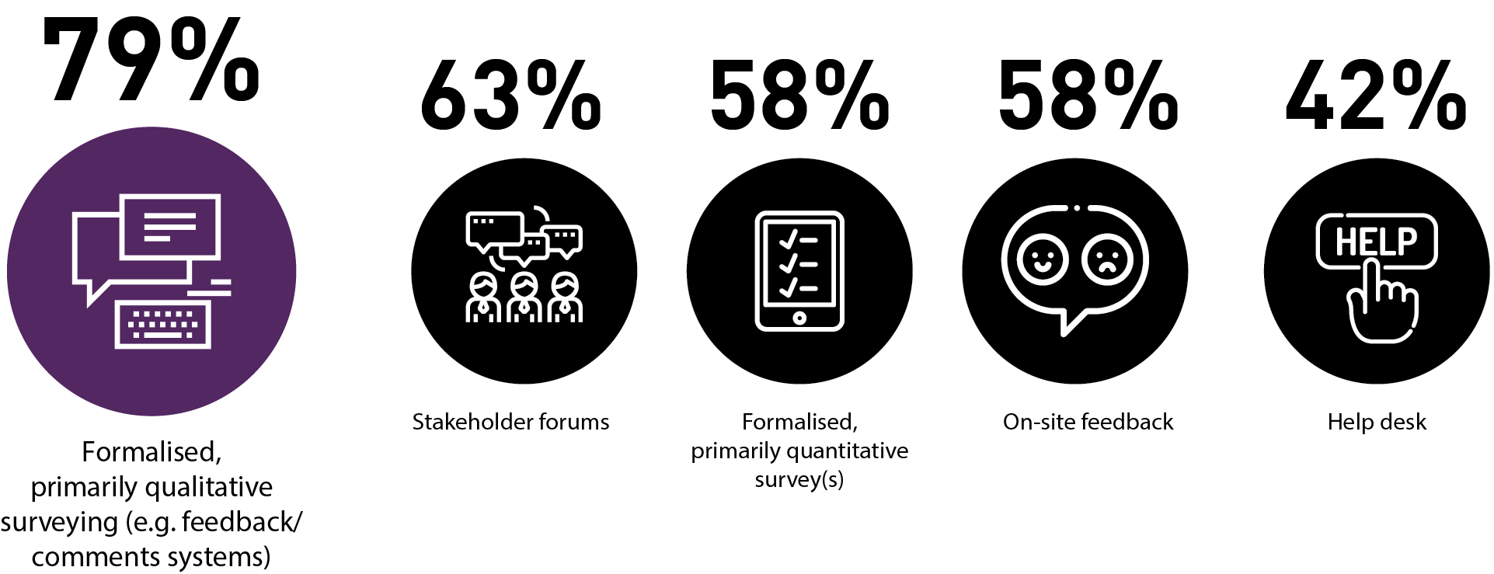

Impact of National Research Infrastructure

Academic Impact: Publications and Citations

The census captured details from 22 of the projects on academic publications that had been created from research that made use of NCRIS infrastructure. The lists of publicatons were examined by the Department, through SciVal, and key findings are outlined in this section.
The analysis revealed some 5,660 publications from across the 22 projects. The publication dates were spread across the three calendar years of 2015 (1,748 publications), 2016 (2,075 publications) and 2017 (1,837 publications).
These figures appear to be lower than the publication numbers reported in the 2014-15 census of 4,549 in 2014 and 5,659 in 2015. There could be a number of reasons for the apparent discrepancy, but a key reason is likely to be the elimination of duplicate publications that is achieved by running the publications through a centralised analysis. It is easy to imagine double counting occuring under the previous method, especially given the high levels of collaboration between NCRIS projects.
The chart below shows the Field-Weighted Citation Impact of each of the projects supplying publications data on the vertical axis, with the proportion of outputs in the top-10 citation percentile along the horizontal axis. The size of each bubble is proportional to the scholarly output (i.e. the number of publications) of each project. While the projects themsleves have been anonymised, the message is nonetheless positive. All projects reported Field-Weighted Citation Impacts above 1.0, as well has having at least approximately 20% or more of outputs rating in the top 10 citation percentile.
Figure 9 NCRIS Projects publication outputs: relative scores on Field-Weighted Citation Impact and top-10 citation percentile
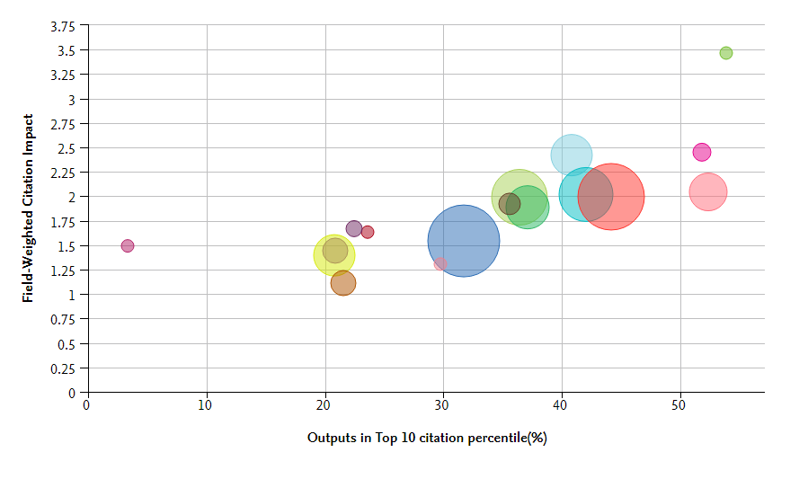
The Field-Weighted Citation Impact score for publications using NCRIS infrastructure has been well above 1.0 for the past few years. In 2017, the measure actually increased to 2.07, suggesting that the average publication emerging from NCRIS supported research has been cited more than twice as many times as would be expected for a similar publication in general.
Figure 10 Field-weighted citation impact, by year
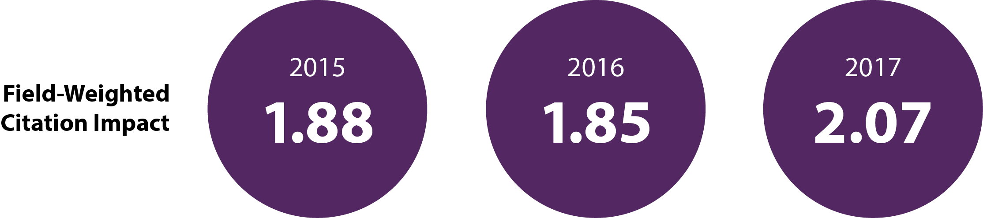
Publications created utilising NCRIS infrastrcture also tend to perform strongly in terms of citations. In 2017, almost four in ten of such publications (37.6%) performed in the top 10% of publications in terms of citations. This proportion has been increasing steadily since 2015, off an already impressive base.
Figure 11 Outputs in top citation percentiles (top 10%), by year
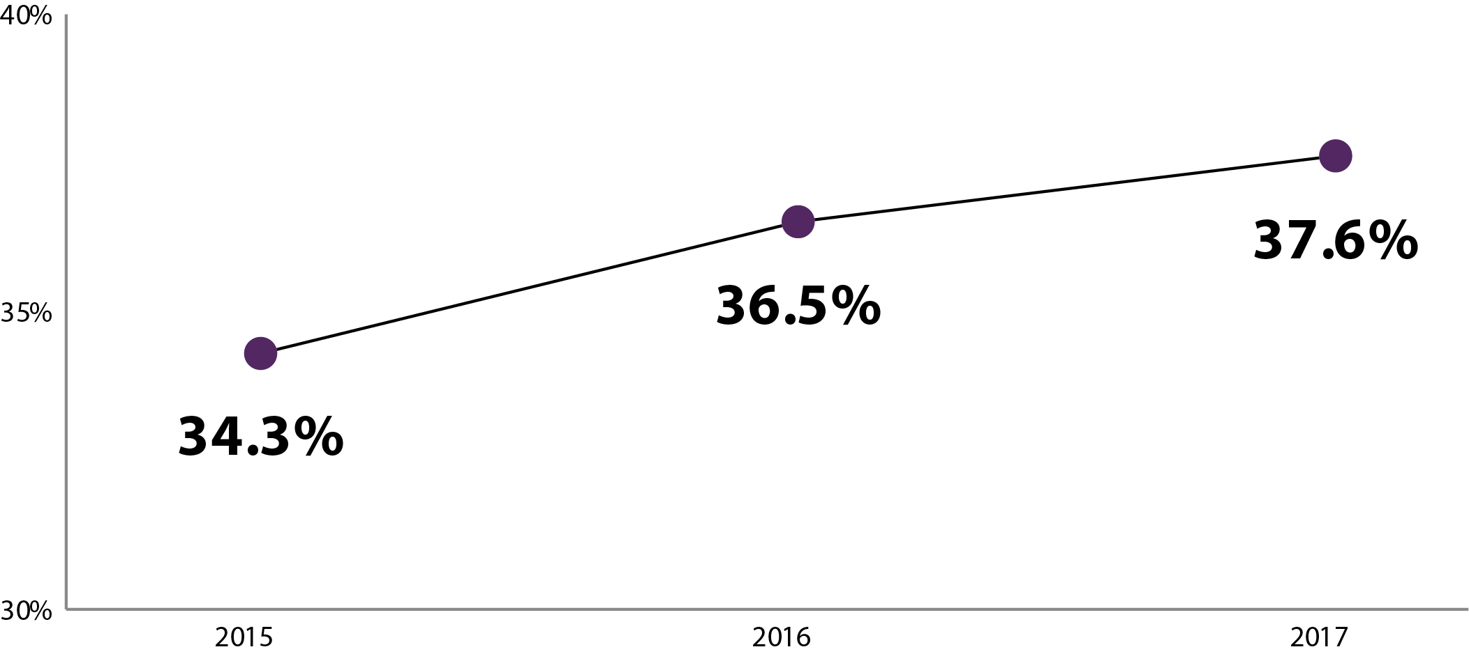
Exploring collaboration, the year-on-year figures provide pleasing results. The proportion of publications exhibiting international collaborations has risen from 52% in 2015 to 57% in 2017 (and as shown in section 5, many projects are wishing to expand their levels of international collaboration). While the proportion of academic-corporate collaborations evidenced is quite low, this figure, too, has been increasing year on year.

Figure 12 NCRIS-enabled publications: evidence of collaboration, by year

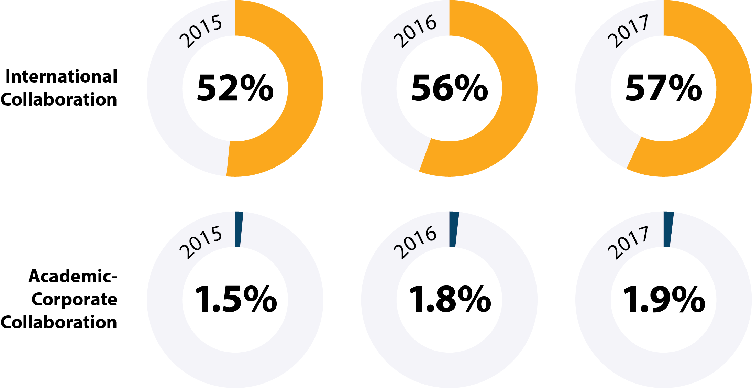

Promotional Activities

Twenty-one of the 24 projects responded that they had produced (or had published) some promotional articles or materials during the reference period. An examination of the census responses shows that newsletters are issued by many of the NCRIS projects, and that promotional materials sometimes include multi-media content (e.g. videos online).
Table 6 Proportion of Projects producing promotional articles / materials
 | 2015-16 | 2016-17
Yes | 88% | 88%
None / Not applicable | 13% | 13%
Although still highly popular as a promotional event, public outreach has become slightly less popular over the last three years. It would be interesting to understand whether this is a strategic decision by the projects that have moved away from public outreach, or whether it is in response to funding or resource constraints. Every NCRIS project has participated in conferences each year for the last three years.

Figure 13 Has the facility participated in any promotional events?
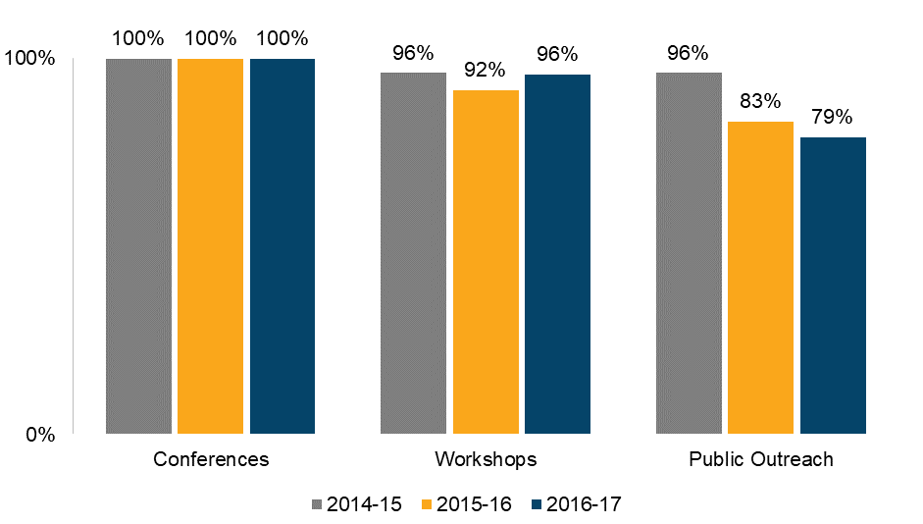

Enabling Government policies and programs

NCRIS projects are involved in a wide variety of policy areas. The raw data includes many examples, and the variety of initiatives underway makes them somewhat difficult to classify.
To illustrate, the example below shows the many ways that the Australian Urban Research Infrastructure Network (AURIN) enables government policy development and program delivery as well as supports government priorities.
Table 7 AURIN Roles in enabling government policy and program delivery
Please outline the role of the project in providing critical or operational services/functionality
to enable Government policies and program delivery...
(2015-16 and 2016-17 combined) | - AURIN assists all levels of government to deliver on their open data policies.  - Tools to enable the integration of data related to human settlements  - Federal, state and local government open data policies  - State of the built-environment reporting  - Monitoring the health and well-being of Australian citizens  - Health planning access at the local, state and federal government  - Monitoring Australia’s progress towards the Sustainable Development Goals  - Monitoring City Performance

Table 8 AURIN Support of Government Priorities
Please outline any key government priorities that are supported by the facility, and outline the nature of the support…
2015-16 | - Key indicators reported within the State of the Environment Report  - Resilient Melbourne strategy  - Identification of AURIN as a release authority for government. Productivity Commission, Public inquiry into Data Availability and Use  - AURIN supports key transport strategies for Local Government (i.e. Darebin walking strategy)
2016-17 | - Data Integration Partnership for Australia (DIPA) presentation at the inception meeting and assisting with setting the vision  - AURIN has been identified as a partner for monitoring city performance within the Cities National Performance Framework final report  - Department of Foreign Affairs and Trade, linking to AURIN to support the reporting of the Sustainable Development Goals (SDGs)  - AURIN supports key transport strategies for Local Government (i.e. Hobsons Bay Integrated Transport Strategy 2017-2030), City of Melbourne - Melbourne for all people strategy (update).  - The AURIN Economic Impact (Input-Output) Analysis Tool has been used by the South Australian Government for the allocation of resource royalties.
The following excerpts outline some of the ways vital Australian government services are dependent on NCRIS facilities.
Weather and climate modelling is critically dependent on NCI:
- Performance optimisation of key elements of Australia’s ACCESS weather/climate modelling suite for faster, improved weather forecasts, seasonal prediction and climate variability assessments
Weather and climate modelling is also critically dependent on AuScope Limited (AuScope), as is resource exploration, amongst other vital capabilities.
- Geospatial data products underpinning Government datum and mapping products supporting high precision spatial industries … To calculate atmospheric moisture underpinning climate and weather models … Critical to State Government resource exploration investment policy across most states and territories.

More than half of NCRIS projects have been called upon by the government to supply some form of advice or data in order to inform government decision making. This demonstrates that government departments and agencies recognise the expertise of NCRIS personnel.
Figure 14 Types of advice provided by facilities
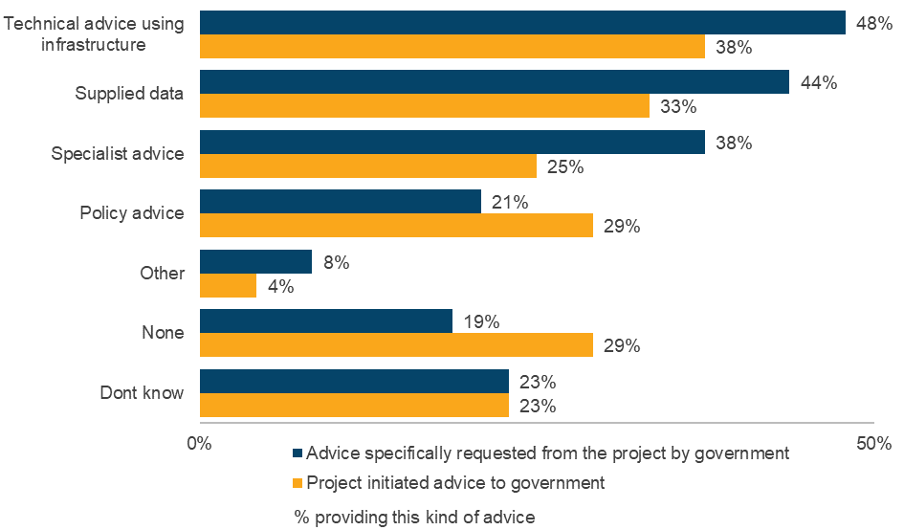

Commercial Impacts

Table 9 displays, at a total NCRIS program level, how many IP/commercialisation activities occurred during the reference periods as a result of infrastructure provided by the facility.
Although it appears that there is a lot of copyrighted material, it should be understood that 90% of the total in each year come from a single project, the AMMRF. With regard to clinical trials, nearly 90% of these are from THD.
Across most categories of commercialisation outputs, the trend is positive, with increasing outputs in 2016-17, relative to 2015-16. Categories that saw particularly strong growth included clinical trials and invention disclosures.

Table 9 Number of commercialisation Outputs, by year
 | 2015-16 | 2016-17
Copyrighted Material | 1108 | 1104
Clinical trials | 157 | 265
Proof of concept | 105 | 112
Invention Disclosures | 65 | 111
Patents | 40 | 46
Licences | 44 | 34
Process improvements | 14 | 13
Creative Commons-style licences | 2 | 6
Products introduced to market | 4 | 4
Plant Breeders’ rights | 8 | 4
New enterprises / spin-offs | 4 | 3
Some of the other benefits mentioned by projects included Trademark filings, the issuing of open source software licenses, and licensing data for use.

Overall Impact: Key Advantages

Over 90% of NCRIS projects responded that concentration of skilled technical staff as well as greater access to state-of-the-art research infrastructure were key advantages that they offered their users.
Figure 15 What are the key advantages the project offers users?
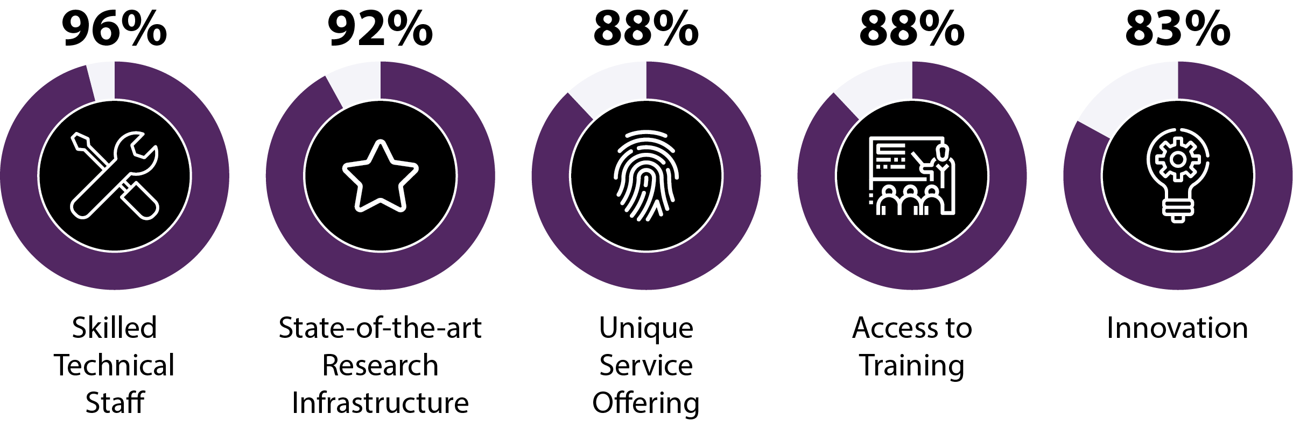
The measurement of impact was extremely diverse across projects. Some projects stated that they had no formal measure of research impact in place. Some used simple metrics such as user/usage metrics. Some projects used publications. Many projects had a much more complex, qualitative, and/or elaborate approach to evaluating their impact.

For example, the AMMRF had this to say about its impact in 2016-17:
- The AMMRF measures impact through a series of surrogate quantitative measures, as well as by case studies of research performed on our infrastructure. Our surrogate measures of impact include percentage of research publications in the top 10% of journals worldwide; how many patents include (or cite) work performed on our infrastructure, how many of our users come from outside the host facility; percentage of use by researchers from industry, amount of training of researchers.
- Highlights for the 2016-17 FY included:
  - AMMRF was awarded an Agility fund grant to upgrade our flagship instrument suite. In 2016 – 1540 publications
  - Incredible Inner Space, the AMMRF’s touring exhibition of micrographs, went on show in the gallery at the Australian Embassy in Washington DC with an opening event held on 23 March. The Hon. Julie Bishop, MP also dropped in on the day of the launch and presented a promotional video for the exhibition

Collaboration

Most projects have a variety of domestic collaborative arrangements. The high number of formal user consultative mechanisms stems from the AMMMRF, which makes up over half of the count for these in each of the reference periods. In terms of the high number of peer-review activities, the Australian National Fabrication Facility (ANFF) makes up a little under half of these in each of the reference periods.
Table 10 Program-Wide Domestic Collaborative Arrangements in Place, by Year
Domestic collaborative arrangements | Sum (2015-16) | Sum (2016-17)
Formal user consultative mechanism | 1623 | 1865
Peer-review activities (publications etc.) | 1714 | 1376
Invitations to speak at (domestic) international conferences, forums, meetings | 462 | 513
Collaborations with other Australian non-NCRIS projects | 339 | 464
Collaboration arrangements with NCRIS projects | 108 | 118
Formal collaborative arrangements with international research infrastructure providers | 91 | 106
Awards, commendations, used as exemplar | 21 | 22
Other | 226 | 226
The peer reviewing of publications is the most common international activity for NCRIS projects to engage in, and has also grown by nearly 60% since 2015-16. Amongst those projects with high counts in this area across both reference periods, TERN is the most prolific followed by Astronomy Australia Limited (AAL). However, the annual growth was almost entirely driven by NCI, which had a dramatic rise in the number of peer-review activities in 2016-17.
Invitations to speak at international conferences is the next most common international activity, and this was relatively stable across the reference periods. About a quarter of these are from BPA, but other than that, it is a very even spread of projects receiving conference invitations.
Table 11 Program-Wide International Activities in Place, by Year
International activities | Sum (2015-16) | Sum (2016-17)
Peer-review activities (publications etc.) | 915 | 1446
Invitations to speak at international conferences, forums, meetings etc. | 452 | 449
Visits from international bodies seeking advice | 128 | 127
International research infrastructure facility management bodies that the project was involved with | 89 | 106
Memoranda of Understanding (MoUs) | 51 | 55
Awards, commendations, used as exemplar | 31 | 38
Set-up selection processes and/or reviews of international research infrastructure | 21 | 20
Other | 72 | 109

As seen in the figure below, the vast majority of projects are involved with global research infrastructure.
As an example, the National Imaging Facility (NIF) stated that:
- National Imaging Facility has a Memorandum of Understanding (MoU) with the EuroBioImaging that recognizes the desire of both research infrastructures to enter a mutually beneficial alliance in supporting the advancement of scientific research. NIF is also a partner in Global BioImaging Project, funded by the European Commission’s Horizon 2020 Programme. UoM node of NIF is a participant in ADMI (Alzheimer's Disease), TrackHD (Huntington's Disease), Siemens 7T MRI Development, PET/CT Siemens scanner Development, and Monash node of NIF at MBI collaborates with Julich Forschungzentrum, a member of the Helmholtz Association of German Research Centres, which is one of the largest interdisciplinary research centres in Europe. Finally, UWA node of NIF is a partner in Nikon CoE.
Additionally, some two thirds of NCRIS projects plan to increase their involvement in global research and/or international collaboration in the future.
Figure 16 Partnership in global research infrastructure, and plans for the future
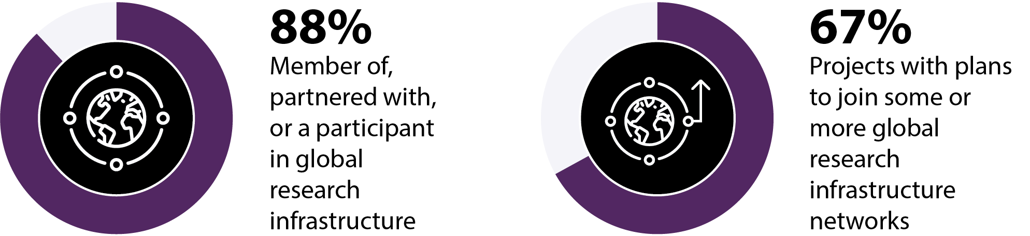

Projects tend to find that global or international participations often leads to further global or international opportunities.
For example, the Australian Plant Phenomics Facility (APPF) stated that:
- New plant phenotyping networks and centres are being established in China, India and other Asian nations, which provide a great opportunity to extend our international collaborations and for further commercialisation of APPF developed infrastructure (e.g. Phenomobile).

Some of the most frequent reasons for why projects would like further global engagement are expressed concisely by the Australian Phenomics Network (APN):
- To provide access to international best practice policies and procedures [as well as] to contribute and access international datasets and other resources.

User Charges and Funding

Users and user charges

It can be seen in Table 12 that, with the exception of one NCRIS facility which charges government users full cost, it is only industry users who are charged full cost for accessing NCRIS facilities. Even so, it is still just under half of applicable NCRIS facilities that charge industry users full cost. Academic researchers are typically charged either the marginal cost or no cost at all.
For some NCRIS projects, user interactions are such that a charging policy is not applicable. These projects have not been included in the formulation of the below table.
Table 12 Charging Structure, by User Types
User | No costs  (based on  merit selection) | No costs  (based on open access) | Marginal Cost | Full Cost | Other arrangement
Meritorious researcher | 24% | 33% | 24% | 0% | 19%
Early-career researcher | 19% | 29% | 33% | 0% | 19%
Other academic researchers | 10% | 30% | 45% | 0% | 15%
Industry | 0% | 11% | 16% | 47% | 26%
Government | 6% | 29% | 29% | 6% | 29%
Other user type | 0% | 33% | 17% | 0% | 50%
The total NCRIS revenue, from user-charging rose by 24% from the 2015-16 to 2016-17. However, in the same time, the median fell by 32%. Also, the median is much lower than the mean. This indicates that the distribution of project revenue is positively skewed, and that the growth has occurred primarily amongst the higher revenue earners. Both figures are also higher than the $64.7m reported in the 2014-15 census. This can be seen in the below table.
Table 13 Program Wide User Charges Revenue
Project revenue from User Charges | 2014-15 FY | 2015-16 FY | 2016-17 FY | % Change  year-on-year
Sum | $64,706,513 | $84,575,346 | $104,609,455 | 24%
Mean | $3,806,265 | $4,975,020 | $6,153,497 | 24%
Median | $582,000 | $1,234,606 | $841,940 | -32%

Table 13 includes only the revenue from the 17 NCRIS projects who reported receiving user-charging revenue during the 2015-17 period captured in the census.
All NCRIS projects provided user training to researchers, and 22 of the 24 projects provided technical advice on using their infrastructure. The chart below indicates NCRIS projects that are very strong in terms of training and assisting researchers to make the most out of their infrastructure. Support is not only offered at the initial data collection phase, as 19 NCRIS projects also provided ‘value added’ services such as performing analysis, investigation, research, or production for users. Some projects offered support even further along the research production chain. An example of such support comes from AURIN who has also provided users with advice on preparing data for publication.
Figure 17 Types of user service or support offered?
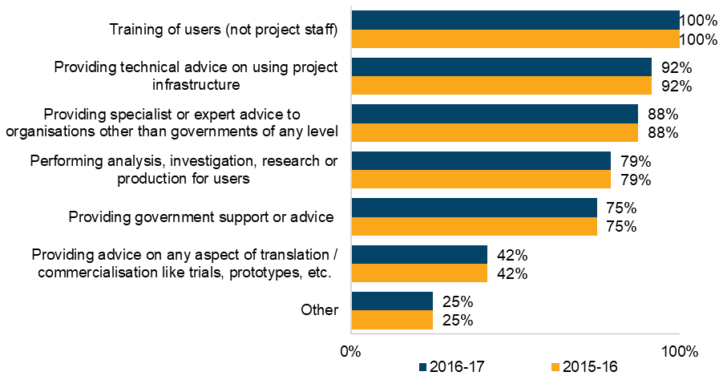

Co-investment

While Co-investment is not a condition of NCRIS program funding, the Commonwealth Government encourages collaboration and co-investment among universities, state and territory governments, PFRAs, independent and private sector research organisations, industry and philanthropy. Co-investment includes cash contribution, as well as in-kind contributions. In-kind co-investment typically takes the form of, but not limited to: staffing on cost, rent/space, legal support, HR support, or a portion share of capital and operating expenses to leverage on the partnership.
- Co-investment data is based on financial information provided by NCRIS facilities as part of developing the Research Infrastructure Investment Plan as well as the NRI Census.
The number of NCRIS projects that receive financial co-investment has increased since 2015-16, as shown in Table 14. Those receiving in-kind co-investment remained high, and steady at the rate of 79% of projects.

Table 14 Proportion of NCRIS Projects receiving cash and in-kind co-investment
 | 2015-16 | 2016-17
Financial co-investment excluding funding and grants | 67% | 79%
In-kind co-investment | 79% | 79%
None of the above | 21% | 17%
The sum of cash contributions has more than doubled since 2015-16, as shown below. However, it can be seen that the mean is much higher than the median and that the growth of the median contribution, while substantial is much less than the growth of the mean. This indicates that the distribution of contributions is positively skewed. The growth in cash contributions is primarily happening amongst those organisations that are already amongst the higher recipients of cash contributions.
There has not been any growth for in-kind contributions, and instead there has been roughly a 5% contraction, although it is possible this is because some in-kind contributions have become cash contributions.
Summing all cash and in-kind contributions together, there has been 14% growth since 2015-16.
Table 15 Program-wide Cash and In-kind contributions
Co-investment | 2015-16 |  | 2016-17
 | Cash | In-kind | Cash | In-kind
Sum | $54,973,386 | $250,705,450 | $111,110,878 | $237,857,298
Mean | $2,290,558 | $10,446,060 | $4,629,620 | $9,910,721
Median | $1,016,346 | $1,400,000 | $1,313,045 | $2,462,366
Combining the co-investment figures for 2016-17 with NCRIS funding figures provided by the Department, yields the funding ‘multipliers’ shown below. At the program level, we see that NCRIS projects are able to leverage some 28c in cash co-contributions, and 60c in ‘in-kind’ contributions for every $1 in core funding invested. This yields a total multiplier of 88c in the dollar, or very roughly approaching a one-to-one ratio.
Figure 18 Funding Multipliers
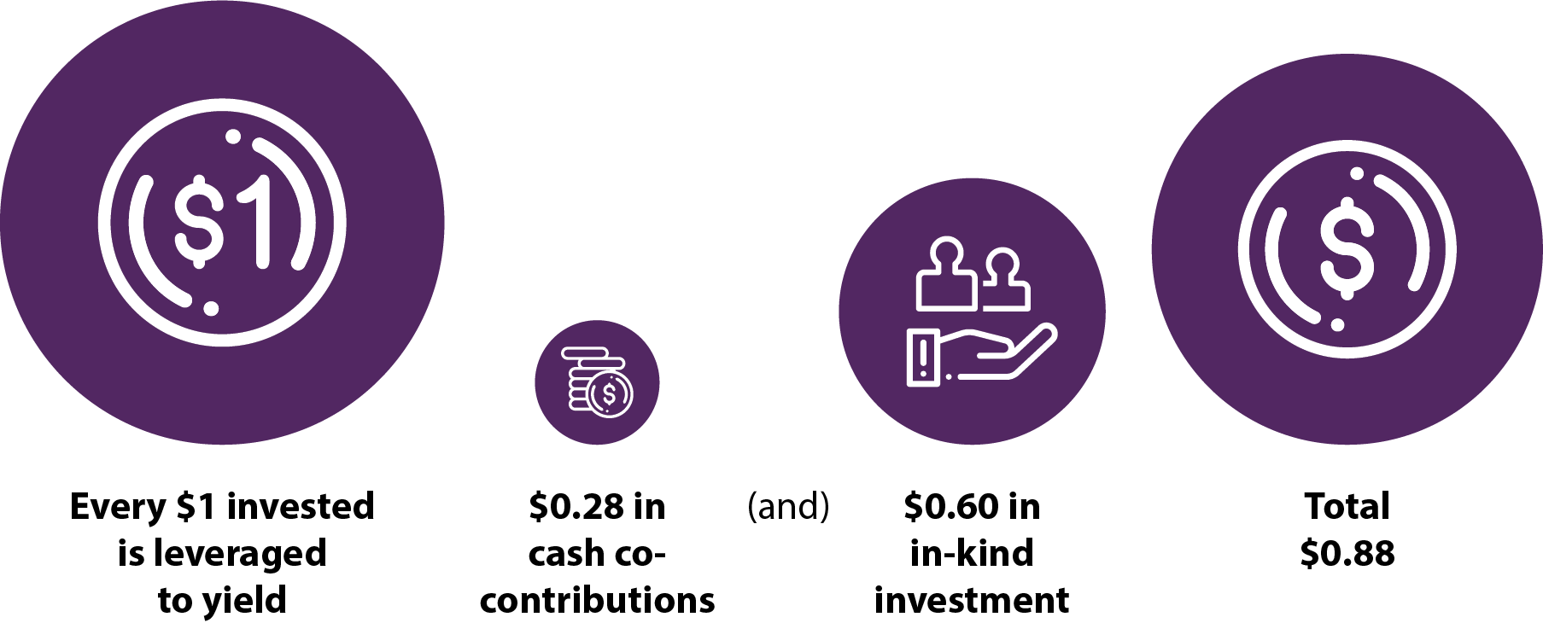
In addition to the co-investment information provided in the census, the above multiplier calculations are based on financial information provided by NCRIS facilities as part of the development of the Research Infrastructure Investment Plan.

People

Headcounts and Representation

The program-wide headcount was broadly stable from 2015-16 to 2016-17, at just under 2,000 positions. There was a modest 3% growth in the number of full-time equivalents (FTE) during the same period. These results are broadly similar to 2014-15, when the total headcount was listed as 2,023 (across 26 Projects).
Table 16 NCRIS Program-wide staffing
Total NCRIS | 2015-16 | 2016-17 | Change
Headcount | 1,963 | 1,975 | 1%
Full-time equivalent positions | 1,529 | 1,573 | 3%
The vast majority (79%) of staff employed at NCRIS facilities are employed as technical staff, with managerial staff making up 12%, and only nine per cent of headcount being administrative.
Figure 19 Staff categories, as a proportion of headcount
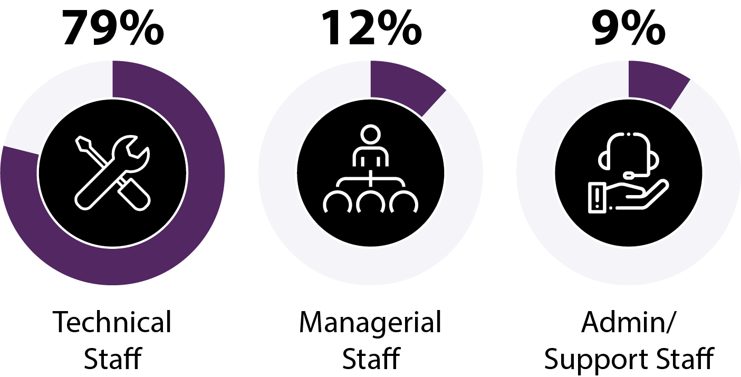
Across all the NCRIS projects, only one in four staff members are female, and this has remained steady since 2015-16. Therefore, this stands out as an area for improvement with regard to proportion of females employed by NCRIS projects. The project with the highest rate of female employment is the APN, of which 73% of staff are female. With regard to female leadership, five of the projects have a female employed as their most senior executive. These include the APPF, the Population Health Research Network, the ANFF, the AMMRF, and TERN.
Table 17 Proportion of NCRIS staff that are female
Total NCRIS | 2015-16 | 2016-17
Proportion of staff that are Female | 25% | 26%

Building Human Capacity

All NCRIS projects used participation in conferences as well as provision of training to create career progression opportunities. Every single activity on the list is offered by the majority of NCRIS projects. This indicates that NCRIS projects place a high degree of importance on training and professional development.
One of the more exciting activities mentioned was from the AMMRF, which has a program where employees shadow staff in an overseas facility.
Figure 20 Activities conducted to build technical skills or create career progression
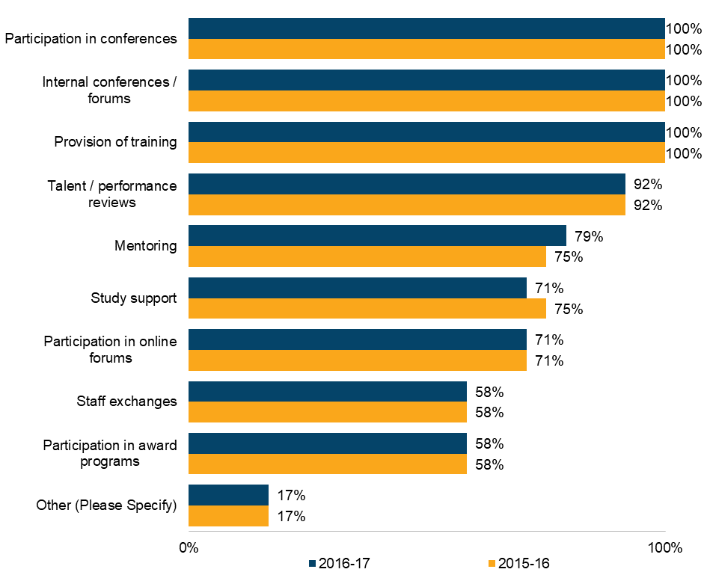

Conference attendance is also the most frequently employed early-career initative. More than half of the NCRIS projects also use initatives more specific to early-career researchers, such as targeted training workshops as well as mentoring. However, less than half of NCRIS projects target early-career researchers for staff positions. While only a quarter of NCRIS projects offered internships in 2015-16, in 2016-17 a third of NCRIS projects were offering internships.
Figure 21 Early-career researcher initiatives offered by projects
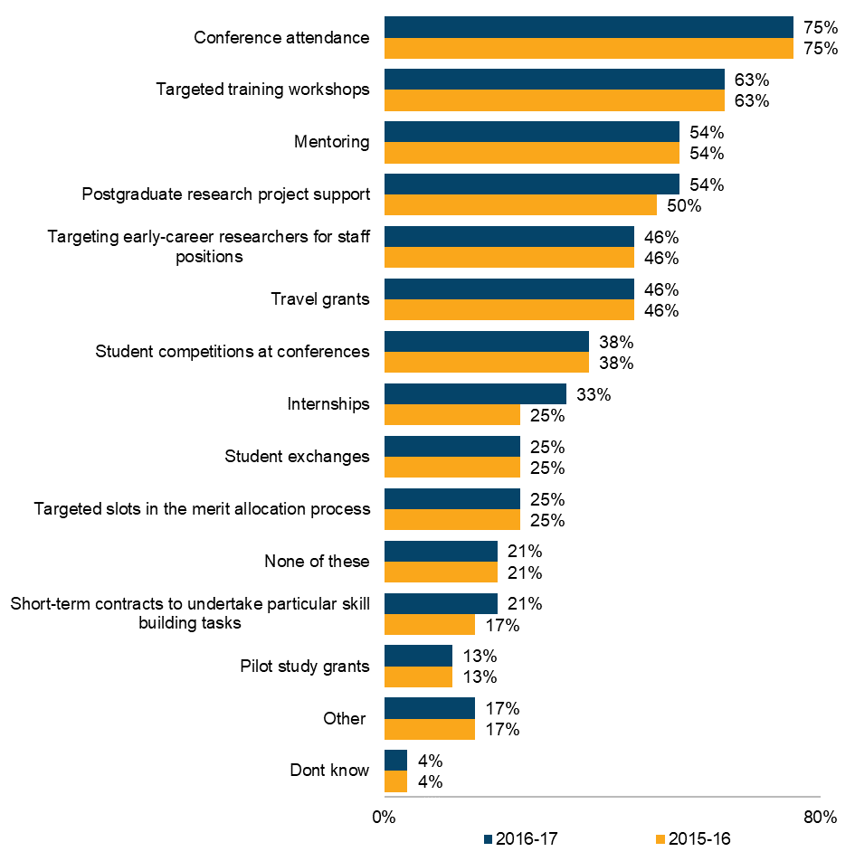

NRI Technology Platforms:
Costs, Financial risk and future challenges

Costs and life-stage

With regard to operational costs, the mean is over 5 times the median. This indicates that the mean operational cost is being dragged higher by a small number of projects with very high operational costs.
Table 18 Program-wide Establishment and Replacement Costs
 | Sum | Mean | Median
Establishment costs | $ 1,949,704,287 | $ 81,237,679 | $ 67,467,908
Replacement costs | $ 1,941,236,660 | $ 80,884,861 | $ 52,927,000
Operational costs | $ 1,172,061,124 | $ 48,835,880 | $ 8,668,551
The below chart displays the estimated percentage of technology platforms that will have reached their predicted end-of-life at a given date. It can be seen that 50% of technology platforms in existence in 2017 are estimated to have reached their end-of-life date by 2025. It should also be noted that 14% of technology platforms were considered to essentially have an indefinite lifespan, subject to funding.
Figure 22 Estimated percentage of 2017 technology platforms to have reached their predicted end-of-life

Half of the NCRIS projects have at least one technology platform with risk of obsolescence in the next four years. A similar proportion of NCRIS projects have at least one technology platform with the risk of some sort of failure during the same period.
Figure 23 Risks of technology platform failure and obsolescence
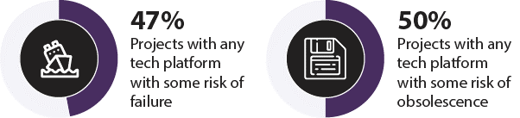
Comments about the end-of-life scenarios and risk of failure are as varied as the technology platforms themselves. The following is an example of a comment submitted by IMOS, which highlights the need for projects to have fiscal injections that allow for more than basic operation and maintenance, but rather investment in new technology.
- Without additional funding in the next four calendar years … deferred capital replacement and required technology refreshment will further erode our ability to respond to the Roadmap. We estimate that it would require another ~10% reduction of scope in 2019-21 to manage these issues on a flat budget. The Baseline Scenario therefore commits us to gradual reduction in scope over time, and the question will be at what point we no longer have a truly national scale, integrated, marine observing system.
The following is an excerpt of a comment about a technology platform with a significant risk of failure, coming from NCI about its National Peak High Performance Computing (HPC) System. It highlights the vital need to regularly plan ahead with regard to technology and infrastructure investment.
- There is significant risk of failure of the current supercomputer (now beyond its end-of-life) before it is replaced in 2019. There will be a major or even a complete loss of the service provided by Australia’s most powerful R&D supercomputer should it fail prior to the commissioning of the new system. This will impact the university sector, PFRAs, MRIs, industry, and NCRIS research infrastructure …. Regular investment in advanced technology is required to map future major infrastructure developments. Future major system upgrades cannot be planned accurately in the absence of an advanced technology testbed
The above comment was typical for computing based technology platforms found across various NCRIS projects, including (but not limited to) NeCTAR, Pawsey and RDS.

Infrastructure Challenges for the future

Some infrastructure challenges include the need to meet international standards, as well as the importance of funding not only for establishment, but maintenance / ongoing costs. This can be particularly important in an era where ongoing quality accreditations are essential.
As an example, below is a response from THD:
- INCREASING QUALITY DEMANDS ON EQUIPMENT AND SERVICES:
The capital equipment component of the current THD consortium is in serious need of refreshing, replacement and upgrade. Putting aside the operational, capacity and efficiency reasons for this need, it is likely that more and more facility users will require laboratories to be ISO-accredited (or similar) in order that a user can have confidence that the results can be used in regulatory submissions. Quality systems and their accreditation require a great deal of investment in terms of equipment maintenance, certification and staff training, as well as requiring dedicated FTE to act as facility quality managers. Thus it is imperative that future infrastructure investment goes beyond purchase and installation and includes resource for not only ongoing maintenance, but the establishment and maintenance of quality systems and accreditation.
Similarly, from the NIF:
- Maintaining the competitiveness status of the capability. Due to lack of Capital funding and Operational funding (for equipment maintenance), NIF technologies are no longer cutting-edge with many in urgent need of either upgrade or replacement. This leads to a decline in Facility usage and performance over time. Both Capital and Operational funding are required for development of a replacement plan for obsolete and an upgrade plan for non-obsolete technologies.
Some infrastructure challenges from NCRIS projects were concerned with the need to keep on top of new and/or rapidly developing technologies that are providing enormous opportunities in their sector. As an example, below is a response from AuScope about the opportunities set to be offered by UAV technology.
- The rapid development of new UAV and drone technologies will provide opportunities that have never before existed for the collection of geophysical and remote sensing data across Australia and Antarctica. Advances in swarm flight control software, miniaturisation of sensors and new sampling techniques provide very exciting opportunities. However regulations relating to UAV operation (CASA), data delivery and analysis workflows and cost of access to high quality UAVs and trained pilots create a barrier to entry for many research programs. AuScope hopes to address these challenges over the coming years.
Another theme is the vital need for computational infrastructure. These concerns are not only expressed by the many NCRIS projects whose facilities revolve around providing this computational infrastructure, but also those facilities who rely on the services provided by computational infrastructure facilities. For example, see this response from AAL:
- Computing and data research infrastructure as with many disciplines, computing and data research infrastructure is growing in importance to astronomy, and is becoming the critical bottleneck to the success of many new telescope projects. This is particularly true for radio telescopes; however, the scientific discoveries enabled by combining data-products from multiple telescopes operating at different wavelengths also requires appropriate computing and data research infrastructure for optical telescopes. Given the cost of modern high performance computing (HPC), Australia has taken a cross-disciplinary approach to funding and operating HPC, that is, NCI and the Pawsey centre are each funded to support a variety of scientific disciplines. While such a cross-disciplinary approach has advantages, it is critical that those HPC centres have the systems, processes, and technical capacity to understand and meet the needs of Australian-based astronomers.

The size of each bubble in the above chart is proportional to number of universities in the group/network
The chart does not include all NCRIS projects who completed the study. Some projects did not collect publications data, or otherwise provided only a partial list that was not necessarily representative of their entire list; hence they were not included in this chart.
Table has been re-percentaged to exclude ‘not-applicable’ responses.
This table includes only the 17 NCRIS projects who reported receiving user-charging revenue. The table also incorporates figures from the 2014-15 census.
Note that only 19 of the 24 NCRIS projects were able to provide a gender breakdown of their staff. The other five projects were unsure of their gender breakdown.
The substance of this comment has been addressed in the Research Infrastructure Investment Plan
The substance of this comment has been addressed in the Research Infrastructure Investment Plan

