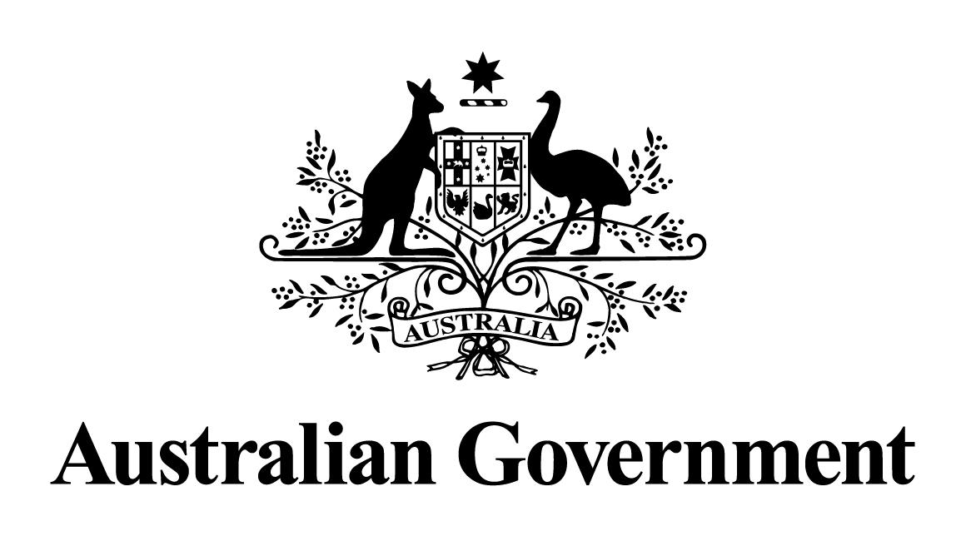
Australian Government response to the
Select Committee on Red Tape:
Effect of red tape on child care (interim report) August 2018

November 2018

Introduction
The Australian Government welcomes the interim report on the effect of red tape on child care by the Senate Select Committee on Red Tape (the Committee), which was tabled on
15 August 2018. The report makes seven recommendations. Additional comments were made by Coalition Senators and a dissenting report, without recommendation, was made by Labor Senators. This response addresses the recommendations of the Committee.
Overview
The Australian Government and state and territory governments have different roles and responsibilities in the early learning and child care sector. The primary role of the Australian Government within the sector is to provide families with financial assistance to help cover the cost of child care and to encourage workforce participation. The Australian Government is investing record sums to support Australian families to access quality child care and has recently introduced the most significant reforms to the early childhood and care system in
40 years.
State and territory regulatory authorities are responsible for the approval, monitoring and quality assessment of early learning and child care services in their jurisdiction. They are also responsible for making the necessary regulatory decisions to ensure families have confidence that their child is receiving quality education and care in a safe environment. They are supported in this role by regular review mechanisms built into the governance of the National Quality Framework (NQF) through the Council of Australian Governments (COAG) Education Council.
While predominantly the responsibility of state and territory regulatory authorities, the Australian Government recognises the need to reduce unnecessary red tape and administrative burden for child care services, so that educators can focus their efforts on providing quality early learning and child care for children. However, regulation of the early learning and child care sector is essential to ensuring the safety, health and well-being of children, and this is the absolute priority for families and the Australian Government.
The new child care package, which was fully implemented on 2 July 2018, seeks to reduce regulation where possible. The centrepiece of the new package, the Child Care Subsidy, replaces the previous Child Care Benefit and Child Care Rebate and is paid directly to service providers to pass on to families as a fee reduction, reducing complexity for both families and providers. It also allows services to offer flexible operating times that better suit their children and families, as well as their business needs.
Critically, the child care package is targeted to support those who work the most and earn the least and provides a generous safety net for children who may suffer disadvantage. This requires appropriate regulation to ensure financial assistance goes where it is needed to achieve better outcomes for Australian children and encourages parent workforce participation. The Australian Government must also ensure the integrity of child care fee assistance payments and takes non-compliance and fraud very seriously and is determined to track, detect and take strong action against dishonest individuals and organisations.

Recommendation 1
The committee recommends the Australian Government, through the Council of Australian Governments, expeditiously work toward reducing the regulatory burden in the Family Day Care sector, including by removing limits on the number of educators in each service.
Recommendation 2
The committee recommends that the Australian Government, through the Council of Australian Governments, promote and/or develop an evidence-base for staffing ratios and staffing qualifications in early childhood education and care, as a quality component of the National Quality Framework.
Recommendation 3
The committee recommends that, following establishment of the evidence-base for staffing ratios and staffing qualifications in early childhood education and care, the principles of the National Quality Framework be reviewed to ensure they appropriately reflect the evidence-base.
Recommendation 4
The committee recommends that, in reviewing the principles of the National Quality Framework, Australian, state and territory governments recognise that formal qualifications are not the only prerequisite for the provision of high quality child care, as this can also be provided by parents.
The Australian Government notes Recommendations 1 to 4.
The NQF is the result of an agreement between all Australian governments and provides a national approach to regulation, assessment and quality improvement for early childhood education and care services and outside school hours care services across Australia.
The objectives of the NQF include ensuring the safety, health and wellbeing of children and improving the educational and developmental outcomes for children attending education and care services, and promoting continuous improvement in the provision of quality education and care services.
Quality education and care provided by services is important to families and governments. This means families can go to work, study, and/or volunteer confident in the knowledge their children’s care and development are in good hands. The NQF was introduced in 2012 and is now a mature regulatory system.
State and territory governments are responsible for making and administering the legislation that gives effect to the NQF for early childhood education and care.
Given any change to the NQF requires the consensus of all Australian governments, these matters are best considered through the COAG Education Council, including the Early Childhood Policy Group. The Australian Government, through the Education Council, will continue to work with state and territory governments and the ACECQA as appropriate to achieve better outcomes for children.
As a national body, ACECQA works with all governments to provide guidance, resources and services to support the sector to improve outcomes for children. ACECQA is an independent statutory body, with their functions, powers and governance arrangements regulated under the legislation underpinning the NQF.
All Australian governments and the ACECQA are committed to look for efficient ways to implement elements of the NQF. The Australian Government also notes the need to continuously gather evidence and collect data to inform policy setting and government decision making.
In 2014, the Australian Government initiated and led a review of the NQF, in collaboration with state and territory governments. The purpose of the review was to ensure the goal of improving quality was being met in the most efficient and effective way, to identify opportunities to streamline requirements and to reduce unnecessary administrative burden.
This review was finalised in January 2017, and on 1 October 2017, recommended changes, which streamline and reduce regulatory burden for services, were implemented (by 1 October 2018 in Western Australia). On 1 February 2018, a revised National Quality Standard was introduced in all states and territories. The revised NQS provides greater clarity, uses clearer language and removes conceptual overlap between elements and standards. The number of standards has been reduced from 18 to 15, and the elements from 58 to 40.
Another review of the NQF is expected to be undertaken in 2019. The details, scope and governance of this proposed review are yet to be established by the Education Council.
Recommendation 5
The committee recommends that the Department of Education and Training provide a detailed annual report to the Department of Jobs and Small Business, to provide greater transparency about red tape reductions in early childhood education and care.
The Australian Government does not consider there is a need for Department of Education and Training to provide a detailed annual report to Department of Jobs and Small Business.
The Government has committed to ongoing review and evaluation of the new child care package to ensure its implementation and impact are understood. External evaluators have been engaged by the Department of Education and Training to conduct an independent evaluation by June 2021, as well as provide advice on ongoing evaluation activities that may be required between 2021 and 2023.
The scope of this impact evaluation does not include evaluating the regulations imposed on child care providers and services under the Education and Care Services National Law Act 2010 (National Law). Reporting arrangements for red tape reduction in National Law is a consideration for the COAG Education Council, noting there are regular statutory reviews of the National Law.
Recommendation 6
The committee recommends that the Department of Education and Training and the Department of Jobs and Small Business report in greater detail on the regulatory effect of implementing the Child Care Subsidy, including in relation to Activity Test.
Recommendation 7
The committee recommends that the Australian Government review the objectives of fee assistance to ensure that it is actually targeting maternal workforce participation and children from disadvantaged backgrounds.
The Australian Government notes Recommendations 6 and 7.
The independent evaluation of the child care package will consider the impact of the child care package on families, providers and services, including in relation to the Child Care Subsidy and the Activity Test.

