

# Task card

How to view and update organisation details in the Provider Entry Point

**Note:** Only certain special characters can be used in the PEP:

* full stop (.)
* comma (,)
* hyphen (-)
* slashes (/, \)
* apostrophe (‘).

All other special characters will cause an error in the system.

## 1(a) Updating Details (Provider in context)

## Screen shot of Manage Details, My Inbox, Prover and Service approval detail boxes

If you are a Provider, select ‘More details’ in the ‘Manage Details’ box of the Provider Entry Point (PEP).

## 1(b) Updating Details (Service in context)

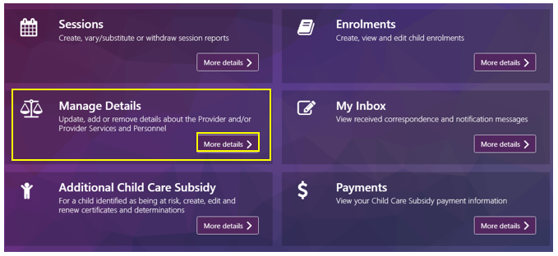

If you are a Service, select ‘More details’ in the ‘Manage Details’ box of the PEP.

## 1(c) Updating Details (Provider and Service in context)

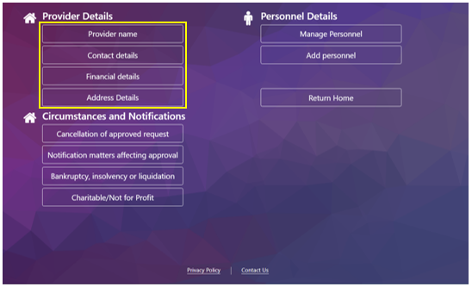

Provider Details: Select the information you wish to update:

* Provider name
* Contact details
* Financial details
* Address details

## 2(a) Update name details

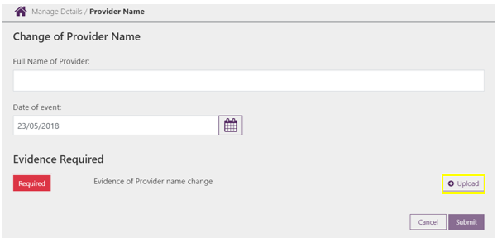

* **Full name of provider:** Insert the new details here.
* **Evidence required:** If evidence is required, it will be displayed here.
* **Upload:** Select this to upload and attach the required evidence.

## 2(b) Update name details – select your document

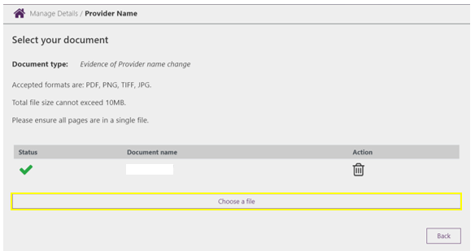

* **Status:** The status will update when evidence has been successfully added.
* **Choose a file:** Select and follow the prompts to attach evidence.

## 2(c) Update name details – edit evidence

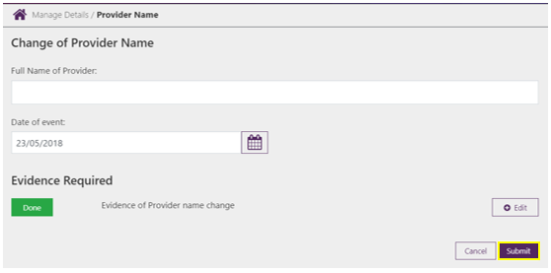

* **Edit:** Select ‘Edit’ if you need to change the evidence provided.
* **Submit:** Select ‘Submit’ to confirm changes.

## 2(d) Update name details – receipt

The confirm button is highlighted in the 'Receipt' screen.


**Receipt:** A receipt will present upon submission.

## 3(a) Update contact details

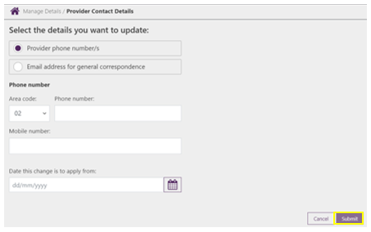

* **Select the details you want to update:** Select the relevant change you want to make and follow prompts to update information. You can choose the following options:
  + Provider phone number/s
  + Email address for general correspondence
* **Submit:** Select ‘submit’ to confirm changes. A receipt will be generated confirming the changes have been applied.

## 4(a) Update financial details

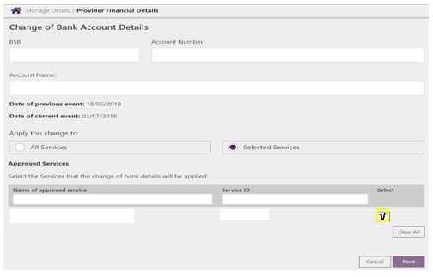

* **Date of current event:** Note that a change of bank account can only apply from the current date.
* **Apply this change to:** If you are a Provider select where you want the change applied to. Note that the following questions will not display if you are a Service.
* **Name of approved service:** If you are a Provider and ‘Selected Services’ is chosen, you will need to confirm which service/s you want to apply the changes to. You can do this by searching for a service individually or by choosing from the list presented and ticking the box on the right.

## 4(a) Update financial details – Summary

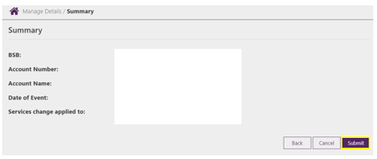

**Submit:** Select ‘submit’ to confirm the change. A receipt will be generated confirming the changes have been applied.

## 5(a) Update address details

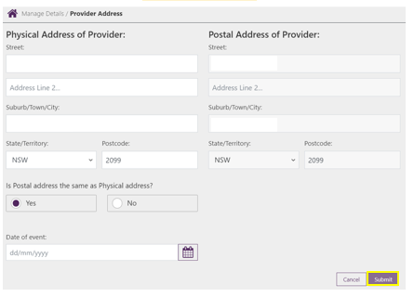

**Submit:** Select ‘submit’ to confirm changes. A receipt will be generated confirming the changes have been applied.