The potential for including school income and wealth in a measure of capacity to contribute

Prepared for the National School Resourcing Board

by Andrew Wade

April 2018
Report

Executive Summary
The Centre for International Research on Education Systems at Victoria University has been commissioned by the National School Resourcing Board (the Board), to prepare a report examining whether assessment of the capacity of non-government school communities, to contribute to the operational costs of their school, should incorporate school wealth.
The Board was tasked by Senator the Hon Simon Birmingham, to review the socio-economic status (SES) score methodology, which is used to determine the Commonwealth’s per student base recurrent funding contribution for individual non-government schools.
A broad definition of wealth has been applied in this report, encompassing both net assets (assets minus liabilites), alongside income derived by schools from sources other than government subsidies and school fees.
The current approach to estimating capacity to contribute (CTC)—the estimation of an SES score focussed on families of children attending non-government schools—has previously been criticised as not providing an accurate measure of school community CTC. This is primary because the SES score is derived from information about areas where non-government school families reside. However, it has also been criticised for not considering school wealth and the income schools may receive from alumni donations and other sources.
This report makes extensive use of financial data collected by the Australian Government Department of Education and Training (the Department) in the Financial Questionnaire for Non-Government Schools (FQ). However, the FQ is unable to provide a suite of data that comprehensively aligns with the defintion of wealth detailed above. In particular, balance sheet information (assets and liabilities) that would conceptually provide the closest measure of wealth is reported inconsistently by schools, and omits school-level informaton on most Catholic systemic schools. Rather, only school income data is available to measure wealth.
Working within the constraints of the available data, a wealth measure (or score) has been developed based on the ‘non-fee private income’ received by schools. This includes income from donations, rent and interest. Unfortunately, the FQ data collection does not ask schools to distinguish current school family income, from other sources (e.g. alumni).
Two approaches have been used to estimate a wealth score, each of which generates a score that is then standardised to have a mean of 100 and standard deviation of 15. This standardisation method is identical to that applied when estimating the school SES score.
The first approach uses a school’s ‘non-fee private income’ per student. The second uses the difference between a school’s ‘non-fee private income’ per student and base Schooling Resource Standard (SRS) value. The base SRS value is either the primary or secondary base rate, or a combination of the two for combined schools.
The resultant school wealth scores differ markedly from the SES scores estimated by DET using the 2016 ABS Census. These differences indicate that the two wealth scores contain different information to that in the SES score. As such, if applied in non-government school funding, there would be changes to the funding level received by individual schools.
The difference between scores is far more variable for the wealth score derived from the difference between a school’s ‘non-fee private income’ per student and base Schooling Resource Standard (SRS) value. This variability is driven, in part, by the different primary and secondary base SRS rates, and the compostion of primary and secondary students within schools.
Conceptually, incorporating school wealth into a measure of CTC, as derived from ‘non-fee private income’, could lead to an improved measure of the CTC of the broader school community. However, if such an approach was to be considered further, validation of the relevant FQ data is required to ensure schools are reporting consistently, and to to examine outlier values reported by individual schools. There is also a need to confirm whether non-fee private income is not being predominantly drawn from current school families also paying school fees.

Table of Contents
Executive Summary i
List of Figures iv
List of Tables iv
1. Introduction 1
2. Context 2
3. Analytical approach 6
4. Estimating school wealth using Financial Questionnaire data 15
5. Key findings and implications 22
References 23

List of Figures
Figure 3-1: Analysis framework 6
Figure 3-2: Measure options and features 8
Figure 3-3: Absolute measure-non-fee private income per student 9
Figure 3-4: Difference from base SRS: Absolute minus base SRS 10
Figure 3-5: Income received by schools from overseas students 13
Figure 3-6: Income received by schools from boarding students 14
Figure 4-1: Non-fee private income per student-Absolute value 16
Figure 4-2: Non-fee private income per student-difference from base SRS 18
Figure 4-3: Non-fee private income per student-difference from base SRS- school type 19
Figure 4-4: Wealth scores compared 20
Figure 4-5: Difference between the two scores and the proportion of primary students 21

List of Tables
Table 2-1: Previous criticism of the approach to measuring capacity to contribute 2
Table 2-2: Potential options for measuring CTC with school financial data 5
Table 3-1: Non-fee private income accounts included in the Financial Questionnaire 11
Table 3-2: Indexation rates 12

Introduction
The Centre for International Research on Education Systems at Victoria University has been commissioned by the National School Resourcing Board (the Board), to prepare a report examining whether assessment of the capacity of non-government school communities to contribute to the operational costs of their school should incorporate school wealth.
The Board was tasked by Senator the Hon Simon Birmingham to review the socio-economic status score methodology which is used to determine the Commonwealth’s per-student base recurrent funding contribution for individual non-government schools.
A broad definition of wealth has been applied in this report, encompassing both net assets (assets minus liabilites), as well as income derived by schools from sources other than government subsidies and school fees.
The current approach to estimating CTC—the estimation of an SES score focussed on families of children attending non-government schools—has previously been criticised as not providing an accurate measure of school community CTC. This is because the SES score is focussed on current families, and does not consider school wealth (i.e. assets minus liabilities) and the income schools may receive from alumni donations and other sources.
Cognisant of the criticisms of the current approach to estimating CTC, this report examines the potential of using financial information collected by the Australian Government Department of Education and Training (the Department) from non-government schools. This data collection is called the Financial Questionnaire for Non-Government Schools (FQ).

Structure of this report
This report is structured as follows:
- Section 2 provides an overview of the context surrounding consideration of school wealth. This includes criticism of the current SES score approach, and details of how school wealth measures have previously been used to allocate Australian Government funding to non-government schools. Finally the section identifies alternative approaches to measuring CTC based on school financial data.
- Section 3 details the analytical approach applied in the remainder of the report, alongside information on the available school financial data and its limitations.
- Section 4 examines two different approaches to generating a school wealth score.
- Section 5 identifies the key findings and implication of the analysis in the preceding chapters.

Context
This section details the context for why school wealth is being examined as a potential factor for measuring CTC. There are three elements to this context. Firstly, previous criticism of the current SES score approach to measuring CTC. Secondly, details of how school income was used prior to 2001 in determining Australian Government subsidies to non-government schools. Thirdly, two potential approaches previously raised for using school income, to determine Australian Government funding of non-government schools, are outlined.

Criticism of the SES score for measuring capacity to contribute
Three criticisms have been made regarding the omission of school income over the years since the implementation of the SES score in 2001. (see Table 2-1). All three criticisms argue that using the SES score alone, derived from information about the SES of areas where non-government school families reside, potentially mismeasures the CTC of a school’s community.
Table 2-1: Previous criticism of the approach to measuring capacity to contribute
Raised issue or concern | Detailed stakeholder issue or concern | Source
An SES-based measure of capacity to contribute is too narrow | Assessing the capacity to contribute by looking at characteristics of students’ families is too narrow in scope  Revenue from non-fee private recurrent income is not taken into account. | Watson (2004))
The SES score makes no adjustment for school wealth (i.e. income and assets) | The SES funding model led to large percentage funding increases to the ‘wealthiest, high-fee-charging schools’  Modest government funding increases were received by ‘poorer private schools’. | Maddox (2014)
Schools that set low fees to facilitate access are penalised | The SES score penalises schools that set low fees to facilitate student access  Base funding provided to schools should take into account both school SES, and school recurrent private income. | National Catholic Education Commission (2011)
Two papers—Watson (2004), and National Catholic Education Commission (2011)—argue that non-government school funding should not just be based on parental capacity to contribute.
Watson (2004) contends that measuring CTC using the SES score is too narrow, as it does not consider non-fee private income received by schools. They cite the example of a regional Queensland school receiving income from local businesses, placing it in the lowest funding category under the previous Education Resource Index (ERI) funding approach. However, based upon the SES of the areas from where this school’s students were drawn, it was assigned a below average SES score of 93.
In contrast, the National Catholic Education Commission (2011), in its submission to the Review of Funding for Schooling, argued the SES score penalises schools that set low fees to facilitate student access. This is because schools with a higher SES score may seek to maintain access by maintaining low fees. The conceptual example is used of schools with similar Australian Government funding levels (due to similar SES scores), but different levels of private resources, nevertheless attracting the same amount of Australian Government funding.
Finally, Maddox (2014) argued that the SES score does not consider the resources accumulated by a school in the past. This issue alludes to the omission of not only school fee income, but also accumulated resources (i.e. wealth).

School financial resources have been used previously to allocate funding
The predecessor of the SES score was the Education Resources Index (ERI), which was in place between 1985 and 2000. The ERI mechanism allocated schools to one of 12 Australian Government funding categories. This allocation was based on a school’s ERI rating, calculated by dividing a measure of financial resourcing per student, by a resourcing benchmark. Between 1985 and 1993, this resourcing benchmark was the ‘community standard of educational and financial resources’. This standard was replaced in 1993 by Average Government School Recurrent Costs (AGSRC) (Department of Employment, Education, Training and Youth Affairs, 1997).
An overview of the ERI funding mechanism is provided in Box 2-1. The main aspect of the ERI mechanism—the allocation of schools to a funding category—was underpinned by the higher of private income per student, or operating expenditure per student (net of government grants). With the ERI determining the majority of Australian Government funding received by non-government schools, it was criticised at the time for discouraging private investment. Furthermore, it was considered that the ERI was a disincentive for schools to raise additional income through fund raising or other means. Additionally, no consideration was made of school facilities and infrastructure, or the financial position of schools (i.e. assets or liabilities).
Box 2-1 Operation of the Education Resources Index funding mechanism
The ERI funding mechanism was underpinned by an assessment of the financial capacity of non-government schools. This assessment led to schools being given an ERI rating and then allocated to one of 12 funding categories. The highest financial capacity schools (ERI rating 0-10) were allocated to funding category 1. The lowest financial capacity schools (ERI rating of 88+) were allocated to funding category 12. For each funding category there was a corresponding per primary or secondary student funding rate. In 1997, funding category 1 schools were provided $501 and $795 per primary or secondary student respectively. Category 12 schools were provided $2,217 and $3,239 per primary or secondary student respectively.

A school’s ERI rating was determined by the percentage value generated by the following formula:
higher of:
Net Private Income per student (boarding and capital allowances deducted)
or
Operating Expenditure per student (State/Territory and Commonwealth grants deducted)
divided by:
Total Assessment Standard: ‘Community standard’ (1985 to 1993), AGSRC (1993 to 2001)
Equals:
ERI rating percentage

Under the ERI funding model, systemic schools were allocated to a single ERI rating and thus funding category, for their system. A system rating was determined from the enrolment weighted average of the individual ratings of each school within a system.

ERI funding to non-government schools was also influenced by several other requirements:
- Maintenance of Effort (MOE) and Private Income (PI)—schools were required to maintain their expenditure on recurrent resources, and to increase private income by at least 3 per cent per annum. Both these requirements had to be met if a school’s ERI rating changed to the extent that a school was allocated to a higher funding category.
- Limit on Private Income—schools were allowed to increase their private income by up to 5 per cent per year, without this affecting the school’s funding category.
- Funding Guarantees—If a school was assessed as moving into a lower funding category, funding was held, in nominal terms, at the pre-existing level until indexation of funding rates resulted in the lower category funding rate equalling the ‘guaranteed’ funding amount.
- Capital Concession—If approved by the Australian Government, schools could deduct private capital income in excess of a specified capital allowance, from the private income used in the ERI rating formula.
Source: Department of Employment, Education, Training and Youth Affairs (1997).

Options for measuring CTC with school financial data
Based upon the criticisms noted above, several potential options are identified for further consideration in this report (see Table 2-2). These use:
- Private recurrent income from endowments and donations
- Private income for recurrent purposes
- Operating expenditure (net of government funding)
- Assets and liabilities.
The first two options are based upon previous proposals made in conjunction with the criticisms identified in Table 2-1. The last two using operating expenditure and net assets, have been identified independent of previous research. It would also be possible to combine the last two approaches—operating expenditure and net assets.
The data required to explore the options identified in Table 2-2 is discussed in section 3, with the resulting analysis presented in section 4.
Table 2-2: Potential options for measuring CTC with school financial data
Financial element | Detailed proposal | Source
Non-fee private recurrent income | ‘a reformed SES-based scheme should include a mechanism for adjusting the SES score of schools which have substantial private recurrent income from endowments or donations.  The exclusion of fees avoids returning to the problems associated with the ERI-funding mechanism that led to the introduction of the SES score. | Watson (2004), p. 233
Private income for recurrent purposes | Base recurrent funding to schools should consider the private income for recurrent purposes used by schools.  Consideration of all school private income would have parallels to the earlier ERI funding mechanism. | National Catholic Education Commission (2011), p. 23.
Operating expenditure (net of government funding) | Using operating expenditure (net of government funding) would place the focus on what schools spend, and diminish any incentives created by using income.
Net assets (Assets minus liabilities) | Using net assets (assets minus liabilities).

Analytical approach
This section details the analytical approach applied in the remainder of the report, alongside the features of the FQ data, and the specific wealth score options examined in the remainder of the report.

Analysis framework
The analysis framework guiding the remainder of this report is detailed in Figure 3-1. This framework identifies each analysis step, starting with articulating the purpose of a school wealth measure, its potential application and estimation approach, alongside options for the resulting measure. Also identified is the need to consider conceptual issues associated with how the school wealth measure is applied, particularly the extent to which it duplicates or overlaps with other CTC estimates (e.g. the SES score).
Figure 3-1: Analysis framework

Measuring school wealth
Five distinct options for measuring school wealth have been identified:
- Fee income
- Non-fee private income
- Operating expenditure, net of subsidies, and expenditure on overseas students
- Net financial assets, comprising financial assets minus liabilities
- Combination of operating expenditure and net financial assets
Each of these would be considered on a per-student basis, with data for each measure collected by the FQ. For measures 1 to 3, the sub-options include either an absolute value, or the difference from a benchmark (e.g. the base school SRS) (see Figure 3-2).
There are either conceptual and data availability issues with each of the five measures. Conceptual issues include fee income potentially duplicating other measures of CTC (i.e. the SES score). For example, there is a risk of duplication in a measure based on fee income in conjunction with one based on CTC.
Non-fee private income is potentially subject to annual volatility, with it also not possible to distinguish between non-fee income provided current school families vis-à-vis others. Finally, non-fee private income (and other data in the FQ) does not capture margins made by schools on teaching-related activities (e.g. overseas students).
Measure 4—net assets—is conceptually the ideal measure of wealth. But it has two fundamental issues. Firstly, the treatment of fixed assets (e.g. buildings), which is likely to create distortions, and more significantly, data is unavailable for most Catholic systemic schools. Secondly, asset data is reported for the ‘parent entity’ of schools—in some cases parent entities undertake non-school activities, such as aged care.
After reconciling both the conceptual and data issues identified in Figure 3-2, options 1, 3, 4 and 5 are dismissed.
Only option two, non-fee private income, is explored further in this report. This measure can be developed with the available data and is distinct from the ‘realised’ CTC of the family of students at a school, as revealed by fees paid. To address year-to-year volatility, the following analysis uses a five-year average for the period 2012 to 2016. Data prior to 2016 is indexed to 2016 dollars using the Consumer Price Index (Australian Bureau of Statistics, 2018).

Figure 3-2: Measure options and features

Options for measuring non-fee private income
Two distinct approaches have been identified for measuring non-fee private income. The first involves using the unadjusted value of non-fee private income per student (known as the Absolute value). The second pertains to using the difference between the Absolute value and the base per student schooling resource standard (SRS) amount received by a school.

Absolute value
This measure is conceptually preferred if it is intended to treat all schools the same, regardless of the composition of either primary or secondary students. This means two schools with the same non-fee private income per student would receive same CTC index score, even if one was fully primary, and the other fully secondary.
A conceptual example of how this approach will operate is provided in Figure 3-3, where both primary and secondary schools are treated the same.
Figure 3-3: Absolute measure-non-fee private income per student

Difference from base SRS: Absolute value minus base SRS
This measure is conceptually preferred if there is a desire to treat schools differently, based on their composition of primary and secondary students, with a lower (or more negative) value indicating less wealth.
The base SRS amount per student in a school is based solely on the mix of primary and secondary students. As a result, the ‘difference to SRS’ CTC index will mainly differ from the Absolute approach due to the mix of primary or secondary students in a school.
A conceptual example of estimating the difference from base SRS for the same schools used in the Absolute measure example is provided in Figure 3-4. In the primary example, the school has a non-fee private income of $500. With the primary base SRS per student value in 2016 being $9,951, the resulting estimate is $9,451.
In the secondary example, after having a higher value than the primary school for the ‘Absolute value’ approach, the ‘difference from base’ is ($11,887)—less than the primary school. This position change is due to the secondary base SRS value ($13,087) being much higher than the primary value ($9,951).
Figure 3-4: Difference from base SRS: Absolute minus base SRS

Data available from the Financial Questionnaire

Data collection
The Department annually collects non-government school financial data in the FQ. The FQ encompasses income, expenditure, asset and liability data. It is akin to the information contained within standard financial statements, comprising an operating statement and balance sheet (Australian Government Department of Education and Training, 2017). This data is used by the Department for accountability purposes, to assess ongoing school and parent entity financial viability, in addition to populating school-level data reported on the My School internet site.

Data accuracy
The FQ has been in place for over a decade, with the Department periodically undertaking a range of validation activities. Schools are also required to ensure that their reporting of financial data, via the FQ, is consistent with their audited financial statements, which are also required to be submitted by schools to the Department.

Scope of data in following analysis
Two separate account items—Private income (RI.060) and Other capital income (CI.050) have been used to measure non-fee private income (see Table 3-1). Only income related to tuition activities is used. As noted in Figure 3-2, it is not possible to include in private income, the margins attained by schools on activities such as the schooling of overseas students and boarding. The extent of these two activities is discussed on pp. 12-14.
Table 3-1: Non-fee private income accounts included in the Financial Questionnaire
Private income: Item RI.060 - Tuition | Other capital income: Item CI.050 - Tuition
Income from telephone calls | Cash donations for capital purposes
Income for photocopying | Other capital receipts
Non-refundable enrolment and application fees | Gain on sale of land
Revenue from supporting groups (e.g. Church/Parish) | Gain on sale of buildings
Rents for school facilities | Gain on sale of plant and equipment
Interest/dividends | Gain on sale of shares
Donations for recurrent purposes (including income from fund raising) | Gain on sale of other investments
Liabilities forgiven | Gain on sale of other assets
Other income
Bad debts recovered
Source: Australian Government Department of Education and Training (2017).

Schools included within analysis
To reduce the risk of outliers and other distortions, non-government schools were required to meet three conditions to be included in the analysis reported in section 4:
- have a 2016 SES score—this requirement omitted schools exempt from having an SES score, comprising majority Aboriginal and Torres Strait Islander schools, special assistance schools and special schools
- not have any distance education students
- there is FQ data for at least three years (the period 2014 to 2016).
These three requirements meant that 2,503 schools are included in the section 4 analysis.

Data adjustments: Indexation
With average non-fee private income per student estimates using up to five years of data, it was necessary to index data to be in 2016 dollars. The indexation rates were estimated after first turning quarterly consumer price index (CPI) change data into annual values. The resulting rates are listed in Table 3-2.
Table 3-2: Indexation rates
Year | Index
2012 | 1.10592
2013 | 1.06670
2014 | 1.04275
2015 | 1.01973
2016 | 1.0
Source: Australian Bureau of Statistics (2018)

Gaps in the financial data collection
Margins derived by schools from overseas students and boarding are considered as non-fee private income. However, this specific information is not available. The magnitude of the gross revenues derived by schools from these two activities are discussed below to provide some indication of the magnitude of this omission. This analysis uses 2016 data only.

Income from overseas students
In 2016, among the 2,819 non-government schools reporting data in the FQ, 572 schools reported receiving a total of $235 million in overseas student income (comprising both tuition and boarding income). In 71 non-government schools, overseas student income comprised 5 per cent or higher of the school’s total income, with 78 schools receiving $1 million or more, and 7 schools $4 million or more. For schools with overseas student income, the average income was $410,182 (see Figure 3-5).

Income from boarding
In 2016, 173 schools received a total of $388 million in boarding income for both Australian and overseas students. In 63 schools boarding income accounts for 10 per cent or more of total income, and 20 per cent or more in 14 schools. A total of 72 schools received $2 million or more, and 8 schools $5 million or more.
Although boarding generates a significant income in schools—an average of $2.2 million in the 173 schools reporting this income—the extent to which boarding generates a margin for schools is unknown. It is understood from consultation undertaken by the Board that boarding is costly to provide, and margins are likely to be relatively low.
Figure 3-5: Income received by schools from overseas students
Income received by schools from overseas students
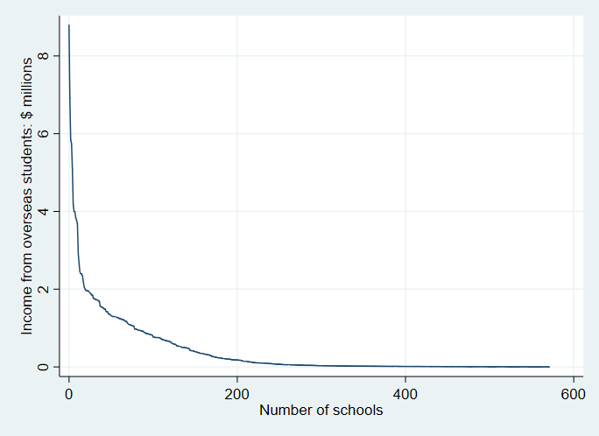
Reliance on overseas student income: per cent of total school income
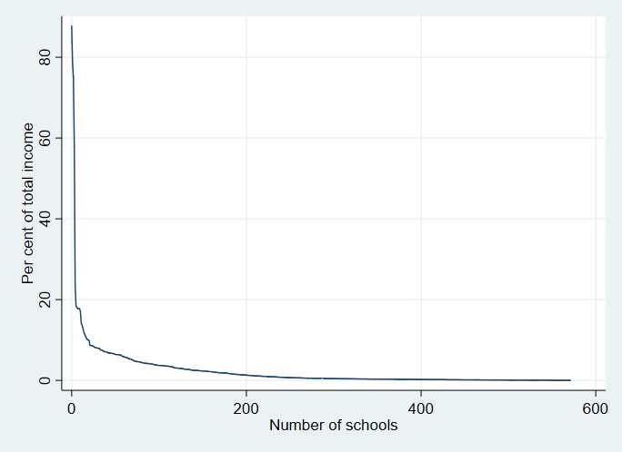
Source: Analysis of the 2016 Financial Questionnaire data collection. Account codes used to identify income from overseas students comprise RI_050T, RI_050B, RI_050S, CI_040T, CI_040B and CI_040S.
Figure 3-6: Income received by schools from boarding students
Reliance on boarding student income
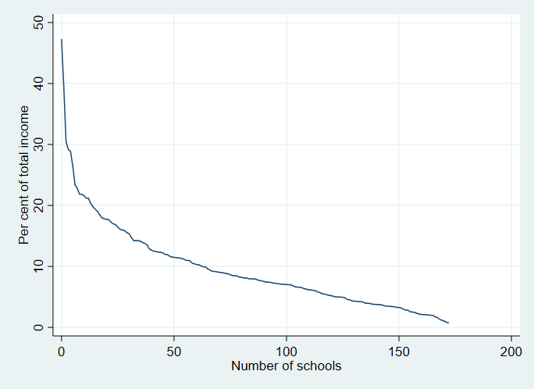
Income received by schools from boarding students
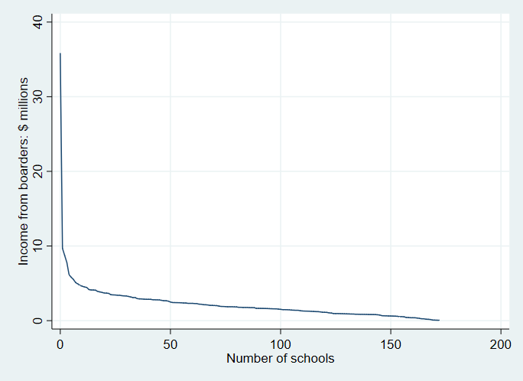
Source: Analysis of the 2016 Financial Questionnaire data collection.

Estimating school wealth using Financial Questionnaire data
This section details the estimation of school wealth score using non-fee private income received by schools. As identified in section 3, two methods using non-fee private income per student are explored for generating a wealth score. The first relates to the absolute value, the second to the difference from the base SRS.
The analysis below first uses kernel density graphs to compare the distribution of the Absolute value and difference from base SRS dollar amounts. This examination compares Catholic and independent schools.

Non-fee private income per student: Absolute value
The estimate of non-fee private income per student was generated using data from up to five years (2011 to 2016). An average was generated after first indexing the values to 2016 dollars. The resulting distribution of non-fee private income per student is presented in Figure 4-1 (upper), in which 90 per cent of schools have values between $143 and $1,961 per student.
The median value for Catholic schools is $394 per student, with the median value for independent schools $564 per student. The long red dashed line representing independent schools stretches far to the right, denoting there are 7 schools with non-fee private income per students of greater than $10,000 per student.
The distribution of the 2016 SES scores and the standardised non-fee private income per student values are quite different. As the non-fee private income values have a long upper tail, the standardised values extend to over 200, with the lowest value at 95, even though the average is 100. In contrast, the 2016 SES score for all schools ranges from 73 to 132.
The implication of this situation is shown in Figure 4-1 (lower), which plots the standardised values of non-fee private income per student against the 2016 SES score for each school. Once the standardised non-fee private income per student values exceed 120, they are more disparate than the SES scores. As a result there is a weak relationship between the two values. A strong relationship would see the dots in Figure 4-1 (lower) closely aligned in a line.
Figure 4-1: Non-fee private income per student-Absolute value
Distribution
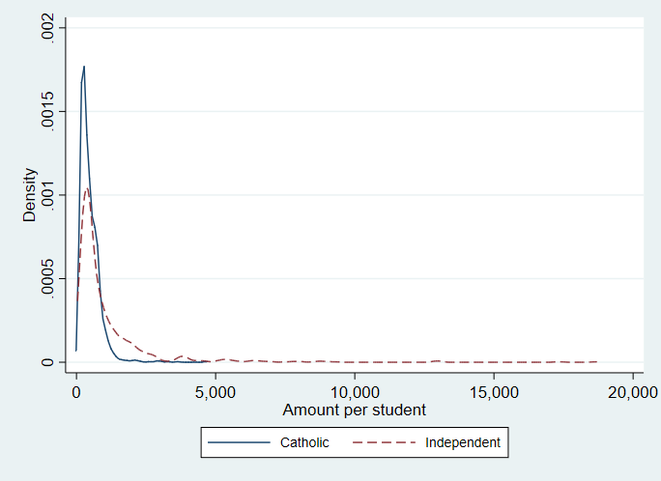
Standardised values vs. SES score (2016)
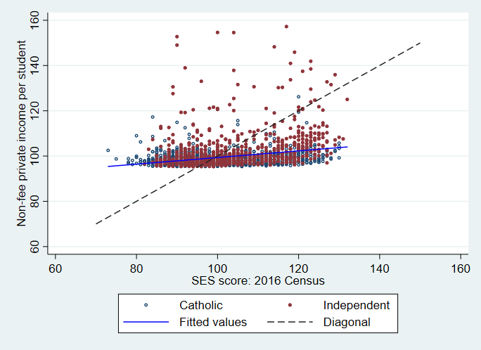
The weak relationship implies that the standardised non-fee private income per student values contains different information to that which is within the SES score, and if used to measure CTC, would generate alternative funding allocations to schools.
This weak relationship is explored by looking at the distribution of the original Absolute values for schools with similar SES scores. There are 277 schools with an SES score of between 99 and 101, with a median Absolute value of $349. However, the distribution of the Absolute values is wide, with 90 per cent of values falling between $54 and $8,852 per student.

Non-fee private income per student: Difference from base SRS
Estimates of the difference from base SRS were generated by first taking the school-level Absolute values, and deducting the relevant base SRS amount. The 2016 base SRS values were $9,951 for primary students, and $13,087 for secondary students. There is far greater variability in the resulting ‘difference’ values to that reported above for the Absolute values. This is largely due to the $3,000 difference between the primary and secondary base SRS amounts.
The distribution of the ‘difference’ values is presented in Figure 4-2, with the varying results for Catholic and independent schools reflecting the characteristics of each sector. The two sets of ‘peaks’ for Catholic systemic schools reflect that Catholic schools are either primary (represented by the right peak) or secondary (represented by the left peak). In contrast, most independent schools are combined, resulting in a single peak for this sector. Ninety per cent of values fall between -$12,732 and -$8,844.
The median value for Catholic schools is -$9,710 per student, and the median value for independent schools is -$10,764 per student. These values are much greater than those reported above for the Absolute values, due to the different primary student composition of each sector.
The second graph presented in Figure 4-2 plots the standardised values of the difference from base ‘SRS’ against the 2016 SES score for each school. This plot is far more dispersed than that for the Absolute values reported in Figure 4-1, with 90 per cent of the standardised values falling between 85 and 109. There is no relationship between the 2016 SES scores and the standardised difference from base SRS values.
This weak relationship is also explained by looking at the distribution of the original difference from ‘base SRS values for schools with similar SES scores. For the 277 schools with an SES score of between 99 and 101, the median value is -$10,525. However, the distribution of the original values is also very wide, with 90 per cent of values falling between -$12,748 and -$9,187 per student.
The differences between school sectors identified by the first chart within Figure 4-2 are diminished when the analysis is separated by school type (see Figure 4-3). This additional analysis pertains to school type—primary, secondary and combined—of which there is a similar distribution between sectors.
Figure 4-2: Non-fee private income per student-difference from base SRS
Distribution of amount per student
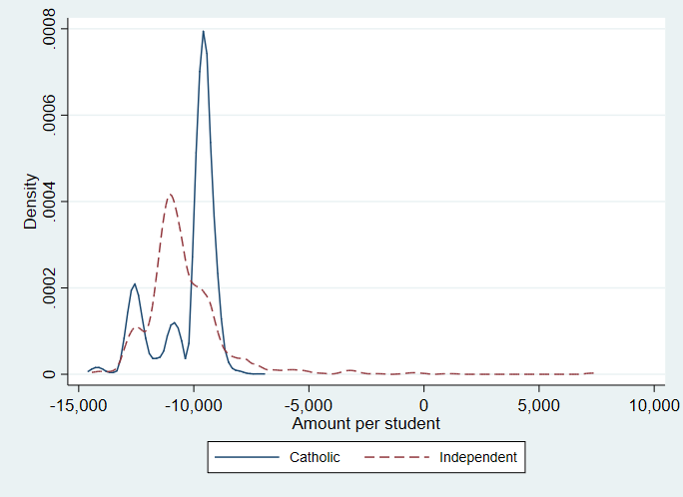
Standardised values vs. SES score (2016)
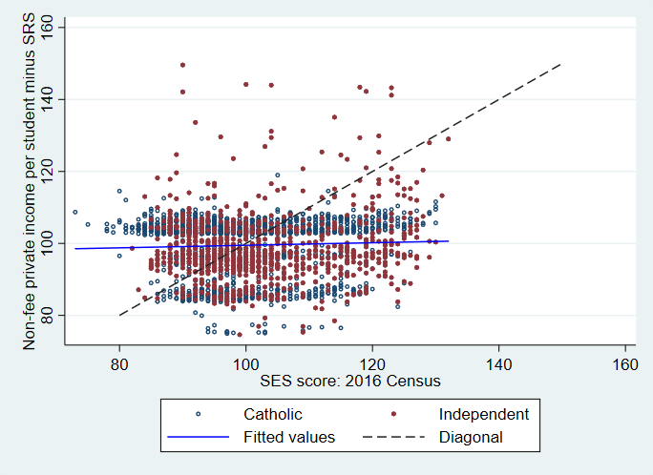

Figure 4-3: Non-fee private income per student-difference from base SRS- school type
Primary
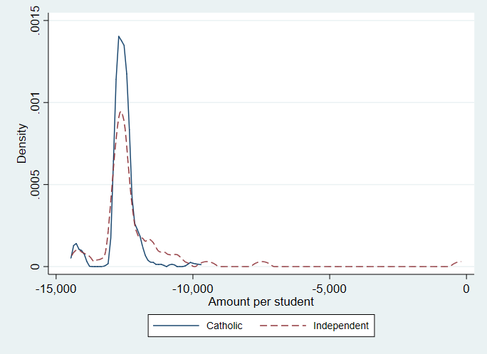
Secondary
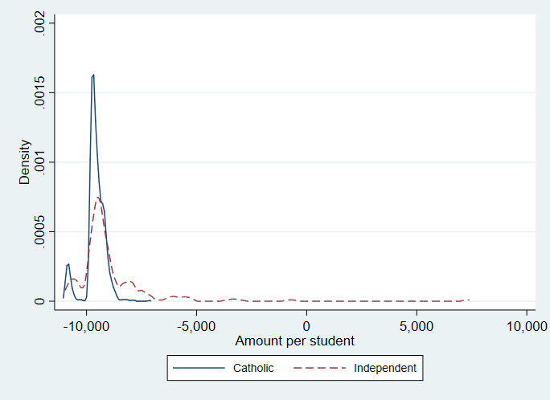
Combined
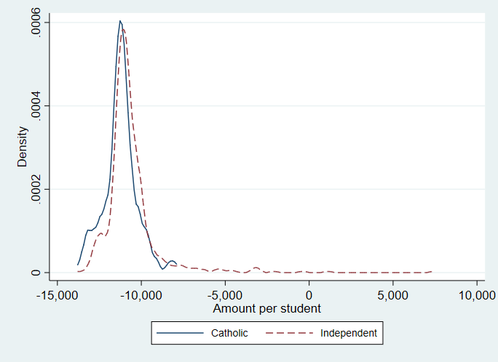

Wealth scores compared
The above analysis has compared the two wealth scores to the existing 2016 SES scores for individual schools. Figure 4-4 compares the wealth scores generated for both approaches; the Absolute value of non-fee private income per student and the difference from base SRS.
There is a correlation between both values, with no sector-based pattern observed. Patterns within Figure 4-4 are attributable to whether a school is primary or secondary, or whether a school is from Western Australia. Other outliers are primary student only and secondary student only schools. More generally, primary schools receive a higher wealth score when using the ‘difference from SRS’ approach, and vice-versa for secondary schools.
Figure 4-4: Wealth scores compared
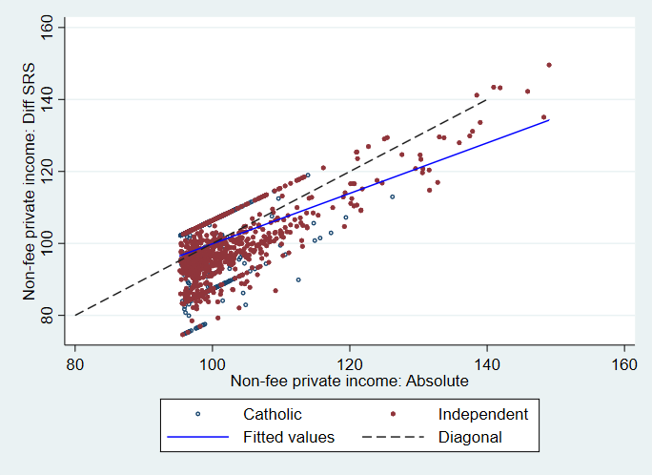
Secondary only schools
Primary only schools
WA secondary only schools
The extent that the difference between the two wealth scores depends upon the proportion of primary (or secondary) students in a school, is displayed in Figure 4-5. This is particularly apparent in independent schools, where the straight line of maroon dots stretches between schools having a proportion of primary students of greater than zero and less than one. The impact of the higher Western Australian school loading is also apparent in Figure 4-5.
Figure 4-5: Difference between the two scores and the proportion of primary students
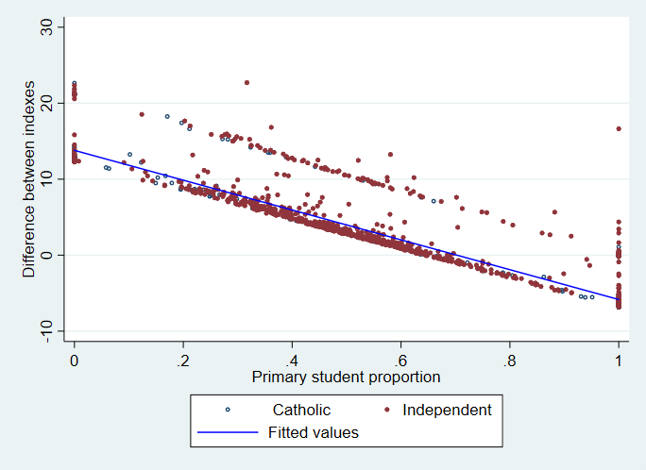
WA schools

Selecting a preferred score
The above analysis has found that it is technically feasible to estimate school wealth scores using data on non-fee private income per student. Both the estimated scores have a weak correlation with the 2016 SES score, indicating that the information on CTC contained in these two scores is additional to that in the SES score itself.
Deciding which wealth score is preferred is dependent upon an initial decision on how schools are to be treated on the basis of the proportion of primary (or secondary) students. In the absolute wealth score approach, all schools are treated the same, despite their proportion of primary students and different base resourcing requirements. This approach has the added benefit of being relatively straightforward to explain.
If there is an intent to reflect the different resourcing requirements of primary compared to secondary students, the difference from base SRS is preferred. It is noted, however, that the approach used to develop this score is more complex than that using the Absolute values. As primary and secondary students are treated differently in other elements of the SRS funding model, it may be more appropriate to maintain this differential treatment.

Key findings and implications
Conceptually, an ideal approach to incorporating school wealth into measuring CTC would draw upon school balance sheet data (school assets and liabilities). Unfortunately, this information is unavailable for many Catholic systemic schools. In this light, an alternative approach, using ‘non-fee private income’ data, is more comprehensive than an approach only measuring school family CTC (i.e. the SES score). This measure can also reflect income from the broader community, distinct from the contribution made by families to meet tuition costs.
This paper builds upon this observation to explore the feasibility of using school financial data on non-fee private income per student to estimate a school wealth score.
Two different wealth scores have been developed. One using the Absolute value of non-fee private income per student, the other based on the difference between the Absolute value and the base SRS amount received by schools.
The resultant school wealth scores differ markedly from each other, and also from the 2016 school SES score. These differences, particularly from the 2016 school SES score, indicate that the two wealth score contain different information on CTC to that in the SES score. If either of these wealth scores were used in the estimation of CTC, they would lead to a different funding amount being provided to schools than one based only on the SES score.
The methods for developing the two school wealth scores use FQ data for a purpose additional to its original intent. There is thus a need to confirm whether the specific data used (i.e. non-fee private income) is fit for purpose for this use. This includes ensuring schools are reporting consistently, examining outlier values, and assessing whether non-fee private income is not predominantly from current school families also paying school fees.

References
Australian Bureau of Statistics. (2018). Consumer Price Index, Australia, Cat. No. 6401.0, December 2017. Canberra: Australian Bureau of Statistics.
Australian Government Department of Education and Training. (2017). 2017 (2016 Data) Financial Questionnaire (FQ) for Non-Government Schools Instructions. Canberra: Australian Government Department of Education and Training.
Centre for International Research on Education Systems, Victoria University. (2017). The Socio-Economic Status (SES) score methodology used in recurrent school funding arrangements – Research Paper. Canberra: Australian Government Department of Education and Training.
Department of Employment, Education, Training and Youth Affairs. (1997). Schools Funding: Consultation Report. Canberra: Department of Employment, Education, Training and Youth Affairs.
Department of Employment, Education, Training and Youth Affairs. (1997). Schools Funding: Consultation Report. Canberra: Department of Employment, Education, Training and Youth Affairs.
Independent Schools Council of Australia. (2011). Review of Funding for Schooling: Submission. Canberra: Independent Schools Council of Australia.
Maddox, M. (2014). Taking God to School: The End of Australia's Egalitarian Education. Crows Nest: Allen & Unwin.
National Catholic Education Commission. (2011). Submission to the Review of Funding for Schooling. Canberra: National Catholic Education Commission.
Watson, L. (2004). Don't Throw Out the Baby with the Bathwater: The Case for a Reformed SES Funding Scheme. Australian Journal of Education, 227-238.

These, and other concerns, are examined in further detail within Centre for International Research on Education Systems, Victoria University (2017).
These, and other concerns, are examined in further detail within Centre for International Research on Education Systems, Victoria University (2017). This section draws extenisvely upon this previous report.
The ‘community standard’ reflected judgements about standards required in all schools. These included desirable class sizes; time allowances for teacher professional duties; and the number of specialist and ancillary staff (Wilkinson, Caldwell, Selleck, Harris, & Dettman, 2006).
The FQ identifies whether income is for ‘tuition’ or ‘boarding’, and whether from Australian or overseas students. The analysis is limited to tuition income from Australian students.
A kernel density graph is like a histogram showing the distribution of a variable. The key difference to a histogram is that a kernel density graph is smoothed, effectively averaging over variations in the data distribution.
The non-fee private income per student values are standardised to have an average of 100 and standard deviation of 15. Extreme outliers (greater than 160) of the standardised non-fee private income per student values are excluded from the scatterplot. This excluded seven schools.
. In 2016, Western Australian schools received an 11 per cent loading in their base SRS funding, meaning schools from this state, particularly secondary schools, are outliers in Figure 4-4. This loading no longer exists from 2018.

