

# Task card - how to view, create and update session reports in the Provider Entry Point

How to view, create and update session reports in the Provider Entry Point

Overview 1

Logging in 3

Creating a new session report (weekly overview) 3

Reporting an absence (weekly overview) 6

Additional information (weekly overview) 9

Creating a new session report (child overview) 11

Varying a session report 13

Withdrawing an existing session report (weekly overview) 17

Varying an existing session report (child overview) 20

Withdrawing an existing session report (child overview) 22

## Overview

This task card outlines how to:

* create a new session report
* report absences
* vary or withdraw a session report.

This task card is for providers that use the Provider Entry Point (PEP). If you use third-party software, contact your software provider for help.

Find more [task cards](https://www.education.gov.au/child-care-package/provider-tool-kit#toc-task-cards) for the PEP on our website.

If you need further assistance, contact the Child Care Subsidy Provider Helpdesk on 1300 667 276 9am to 5pm AEST or [via email](mailto:CCSHelpdesk@education.gov.au) anytime.

**Note:** Only certain special characters can be used in the PEP:

* full stop (.)
* comma (,)
* hyphen (-)
* slashes (/, \)
* apostrophe (‘).

All other special characters will cause an error in the system.

## Logging in

Step 1

Log in to the [Provider Entry Point (PEP)](https://proda.humanservices.gov.au/prodalogin/pages/public/login.jsf?TAM_OP=login&ERROR_CODE=0x00000000&URL=%2Fmga%2Fsps%2Foauth%2Foauth20%2Fauthorize%3Fscope%3Dopenid%26state%3DalN0hw9ovD%26client_id%3DGTzCa6CRNfBsRTdfljBa%26redirect_uri%3Dhttps%253A%252F%252Fbusinessonline.humanservices.gov.au%252Fmga%252Fsps%252Foidc%252Frp%252Fchildcaresubsidy%252Fredirect%252Fproda%26response_type%3Dcode&OLDSESSION=).

## Creating a new session report (weekly overview)

Step 1

From the PEP landing page, select **More details** in the **Sessions** tile.

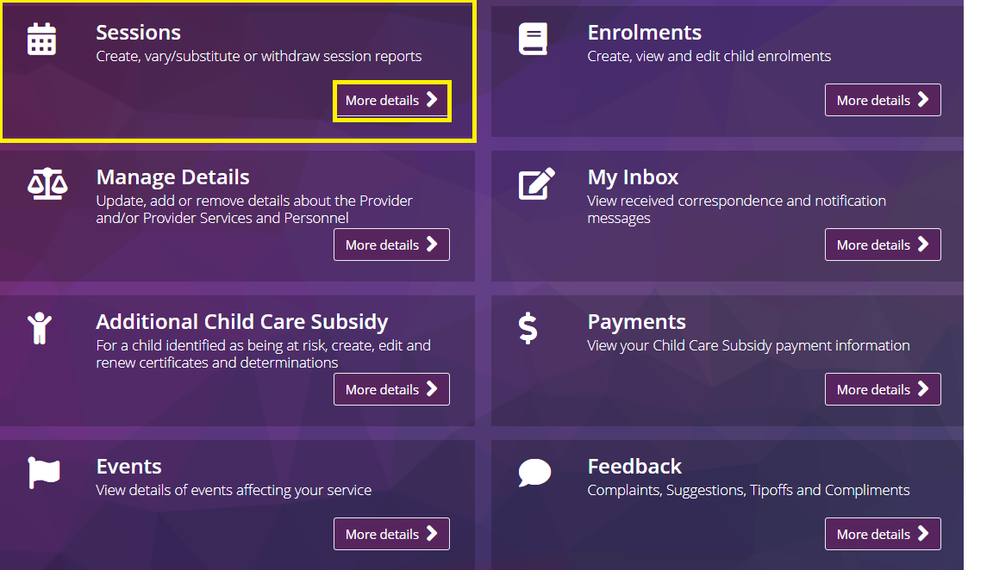

Step 2

The **Sessions of Care Reporting (weekly overview)** screenwill display the following fields:

* **Weekly overview**: provides a weekly view of all enrolments and sessions per period.
* **Total enrolments for this period**: this number is based on enrolments with at least one routine session in this week.
* **Reports requiring submission**: total number of outstanding reports requiring submission.
* **View button**: select this to select the period you want to view.

*Note: Session reports for each child can be submitted on the day that the last session of care for the week occurs. For example, if the last session of care for the week is on a Friday, you can submit the session report for that week at any time on Friday once the child has attended (or is confirmed as absent for absence reporting).*

Screenshot of sessions of care reporting page highlighting weekly overview tab, total enrolments for this period, reports requiring submission and view button highlighted.


Step 3

From the **Weekly Overview** screen, select **View** for the **Week Beginning** that you want to create a new session report.

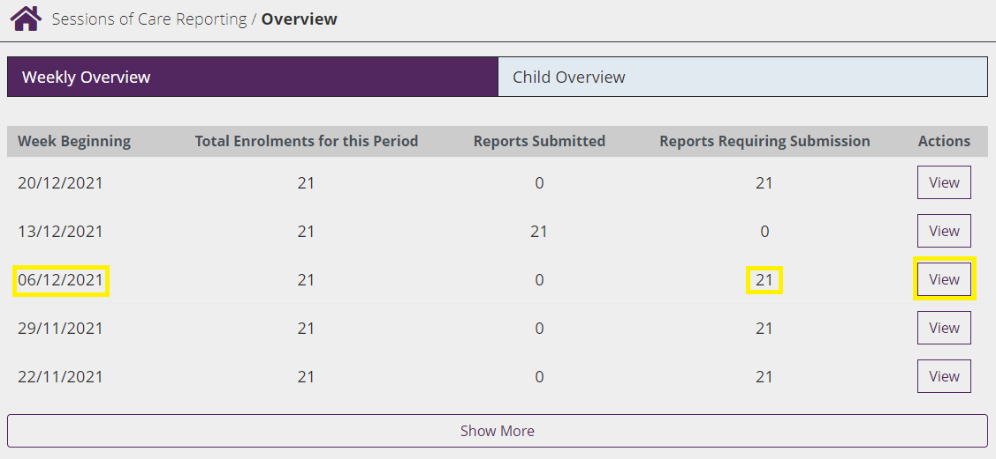

Step 4

From the **Update Session Report** screen, you can search for the child’s name via the **Name** field or locate the child’s details from the list provided.

Screenshot of sessions of care reporting update session report page highlighting viewable fields.


Populate the following fields:

* **Day of the week e.g. Monday**: Review session information by day.
* **Session**: Session data pre-fills based on enrolment information. Fields can be edited if needed, for example, to add in a casual session.
* **Start and end times**: Must use 24 hour clock.
* **Is preschool**: Mandatory field for Centre-Based Day Care (children aged 3-5 inclusive). See [here](https://www.dese.gov.au/child-care-package/child-care-provider-handbook/managing-and-reporting-sessions-care) for further details.
* **Fee per hour or per session**: Important - you can enter fees either per session OR per hour. So that entitlement can be correctly determined, please ensure that when entering fees, you choose the correct option and do not report the session fee as the per hour fee.

Step 5

Select **Submit All** to submit completed entries.

*Note: information will only be saved once you select submit. If you have not been doing anything in PEP for 30 minutes, the connection to the server will time out, which will require you to re-log in to PEP. You will lose any updates you have made if you have not submitted your updates. This is a security feature built into PEP.*

## Reporting an absence (weekly overview)

Step 1

From the **Weekly Overview** screen, select **View** for the **Week Beginning** that you want to notify of an absence.

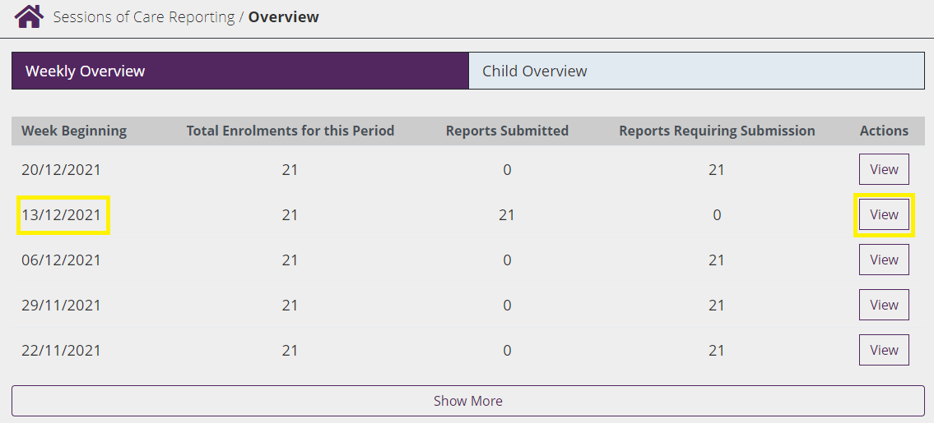

Step 2

You can search for the child’s name via the **Name** field or locate the child’s details from the list provided.

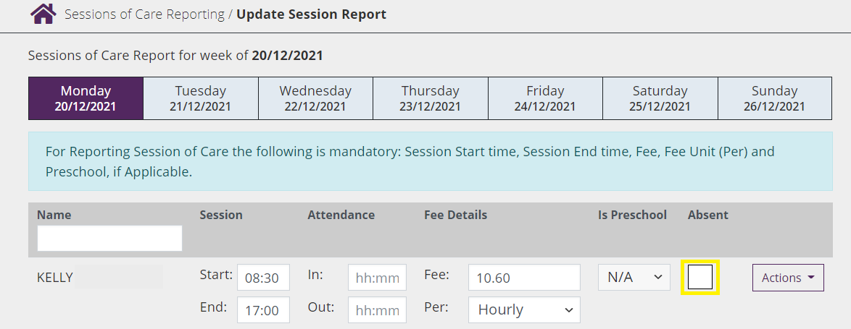

Step 3

Check the **Absent** check box to report an absence. This will produce other mandatory fields for you to complete.

Step 4

Select the **Absence Reason** from the drop-down menu**.**

The absence reason is needed to determine if additional absences can be paid (when a child has already reached 42 absence days for the year).

*Please note that ‘Prescribed’ absences reasons are only valid for absences in the 6 days before the child’s first attendance or the 6 days after the last attendance. These are not additional absences and will only be paid if the child has not reached their 42 absences for the year.*

*If the absence meets the criteria for both a ‘prescribed’ absence and an additional absence, select the additional absence reason to ensure the absence can be paid.*

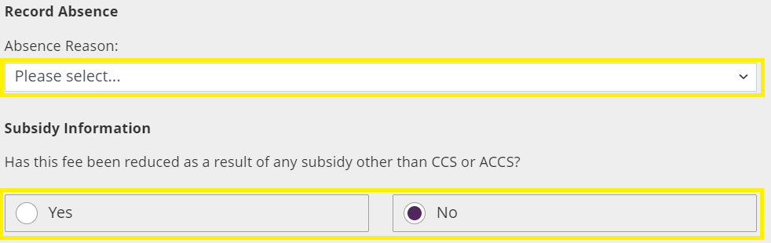

The **Educator**, **Subsidy Information**, **Update location/Transport Only** and **Session Address** sections will be pre-filled and can be edited if needed.

Step 5

Continue to make any necessary updates for the other children in care for the week.

Step 6

Select **Submit All** to submit completed entries.

*Note: information will only be saved once you select submit.*

Step 7

Confirm the information is correct.

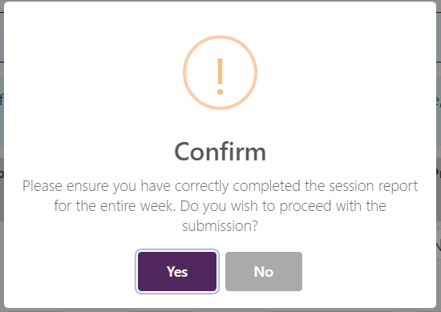

Step 8

A **receipt** will be generated when a new record has been submitted.

If a report has not been successfully submitted, the status will display as **Failed** and a reason provided. This will need to be rectified before resubmitting the session report again.

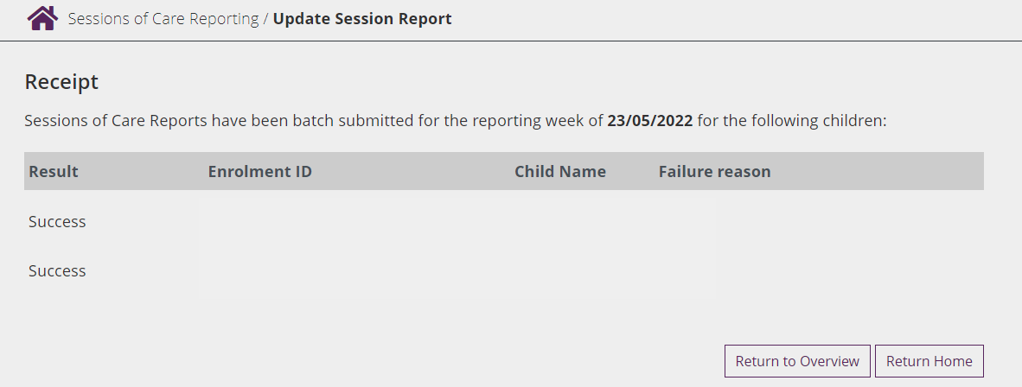

## Additional information (weekly overview)

Step 1

From the **Update Session Report** for the week, select one of the following from the **Actions** drop-down menu:

* **Advanced**: to view or change information.
* **Add Another Session**: to record another session of care for a child for the day. See Creating Session Report – Step 4 for details.
* **Subsidy information**: These fields will show when 'Advanced' is selected. You are required to indicate ‘Yes’ where the fee for the session of care has been reduced because of a payment you have received from a third party (e.g. the parent's employer) specifically to reduce the fee the parent is required to pay.
* **Update location/Transport only, Session Address**: Information in this section will be pre-filled and can be edited if needed.

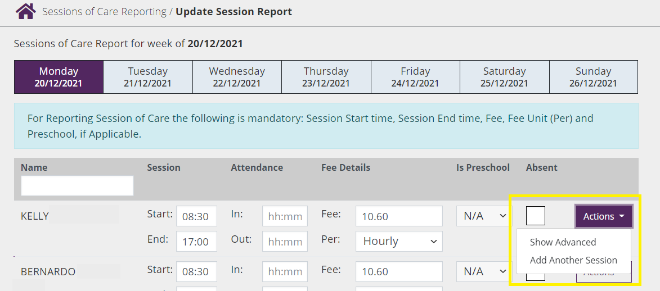

Step 2

Select **Submit All** to submit completed entries.

*Note: information will only be saved once you select submit.*

Step 3

Confirm the information is correct.



Step 4

A **receipt** is generated when a new record is submitted.

If a report has not been successfully submitted, the status will display as **Failed** and a reason provided. This will need to be rectified before resubmitting the session report again.



## Creating a new session report (child overview)

Step 1

From the **Sessions of Care Reporting** page, the **Child overview** can be used to view and search for a reporting period per child.

Use the **Child name** to manually search for a child individually.

**Select Create report** from the **Actions** drop-down menu to create a new report.

*Note: session reports can only be submitted after the sessions of care have occurred.*

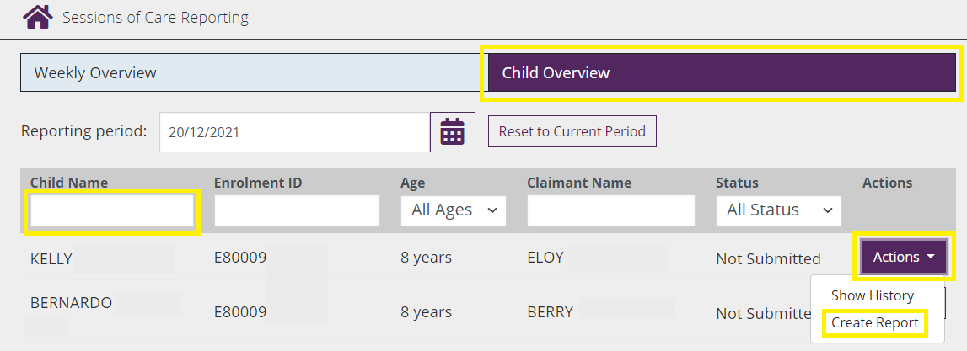

Step 2

Create a new session report (child overview) 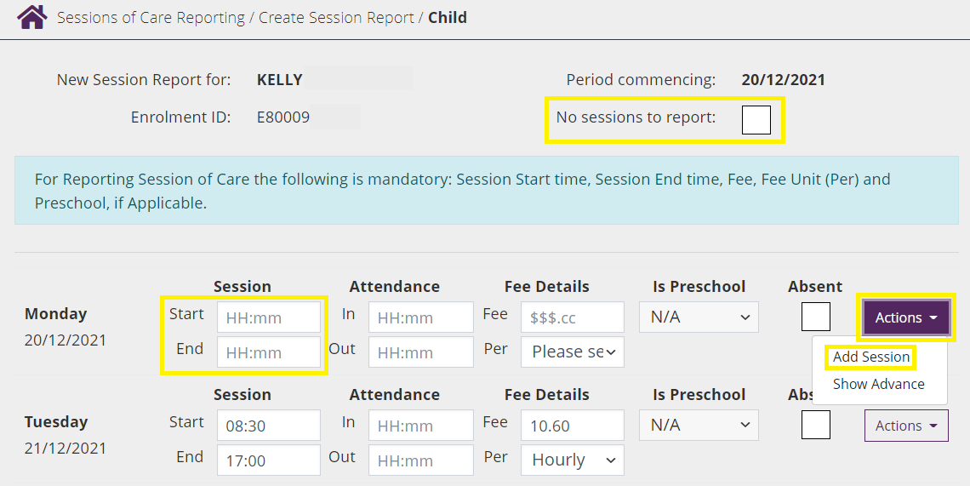

Step 3

Check the **No sessions to report** box if there are no sessions of care to report for the week – this includes attendances and absences.

Step 4

Actions drop down menu

Step 5

Add Session

Step 6

**Start and end times:** when entering start and end times, you must use 24 hour clock.

Step 7

Select **Add Another Session** to record another session for a child. Select **Advanced** to add/change additional session details**.**

Step 8

Select **Submit** when you are ready to submit the session report.

*Note that the information will only be saved once you select submit.*

Step 9

A **receipt** will be generated when a new record has been submitted.

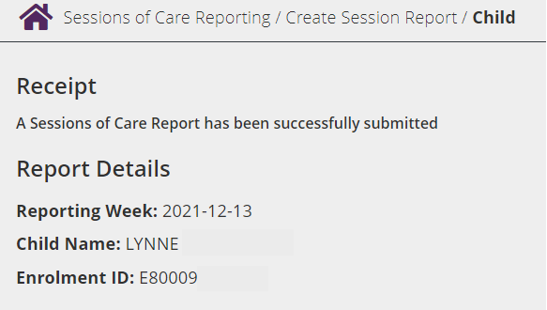

## Varying a session report

Step 1

From the PEP landing page, select **More details** in the **Sessions** tile.



Step 2

The **Sessions of Care Reporting** page will display.

The **Weekly overview** screen provides a weekly view of all enrolments and sessions per period.

**Total enrolments for this period** is based on enrolments with at least one routine session in this week.

**Reports submitted** is the total number of submitted session reports.

Screenshot of sessions of care reporting page highlighting weekly overview tab.
Total enrolments for this period, reports submitted and view button highlighted


Step 3

Select **View** from the Actions drop-down menu for the period you want to view.

Step 4

Select **Vary Report** from the **Actions** drop-down menu to vary a report that has already been submitted.

Only use **Vary Report** where a session report requires an update. If no sessions should have been reported, use **Withdraw Report** instead.

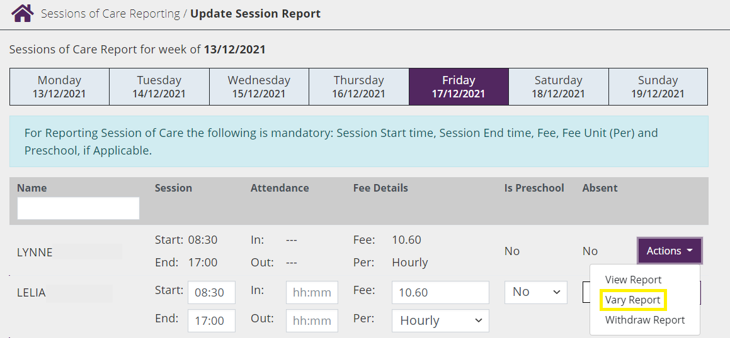

Step 5

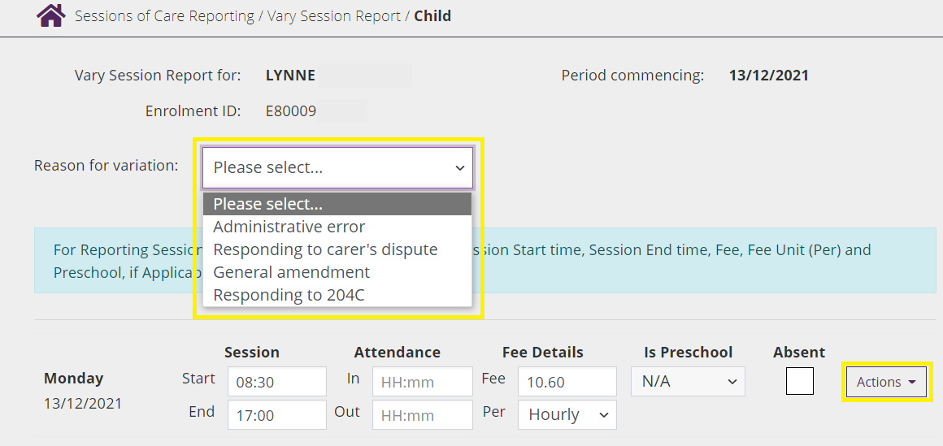

Select one of the following options from the **Reason for variation** drop-down menu and follow the relevant prompts:

* **Administrative error**: use where there was a mistake made in the original session report e.g. incorrect session start time
* **Responding to carer’s dispute**: use where a parent has disputed a session report
* **General amendment**: use where changes are being made before Sunday night of the session report week – before report has been processed and CCS paid (e.g. child attends another session after report submitted)
* **Responding to 204C**: only use if a 204C (compliance) notice has been issued requiring you to make a change to a session report

Step 6

From the **Actions** drop-down menu:

* **s**elect **Add Another Session** to record another session for a child on the same day
* select **Advanced** to change other details for the session.

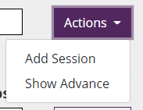

Step 7

Select **Submit** to proceed. Note that information will only be saved once you select submit.

Step 8

A **receipt** will be generated when a new record has been submitted.

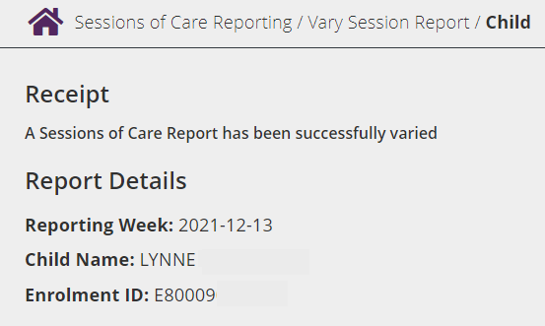

## Withdrawing an existing session report (weekly overview)

Step 1

**Select View** for the **Week Beginning** session of care report that you want to withdraw.

Screenshot of sessions of care reporting page highlighting weekly overview tab.
Total enrolments for this period, reports submitted and view button highlighted.


Step 2

Use the **Name Search Bar** or locate the Child’s details using the list provided.

Select **Withdraw Report** from the **Actions** drop-down menu to withdraw an existing report.

Only use **Withdraw Report** where a session report was not required to be submitted in the first place. If there are still sessions to be reported in the week, use **Vary Report** instead.

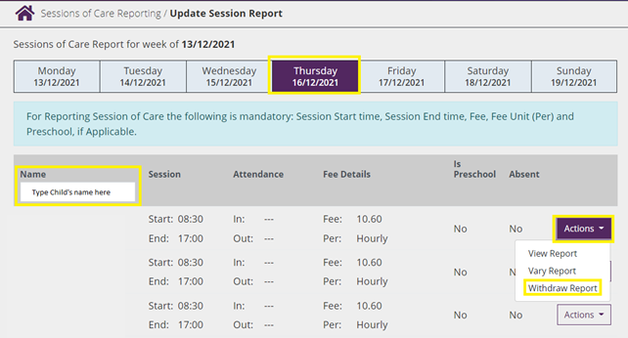

Step 3

Select the **Reason for withdrawal** from the drop-down menu.

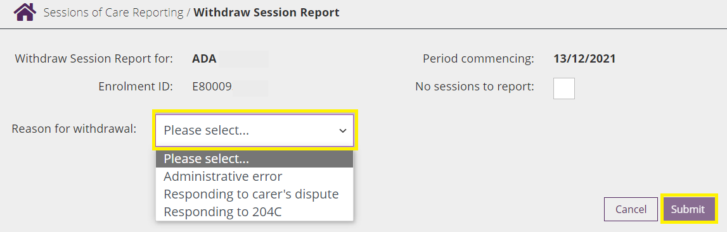

Step 4

Select **Submit** to proceed. Note that information will only be saved once you select submit.

Step 5

A **receipt** will be generated upon submission.

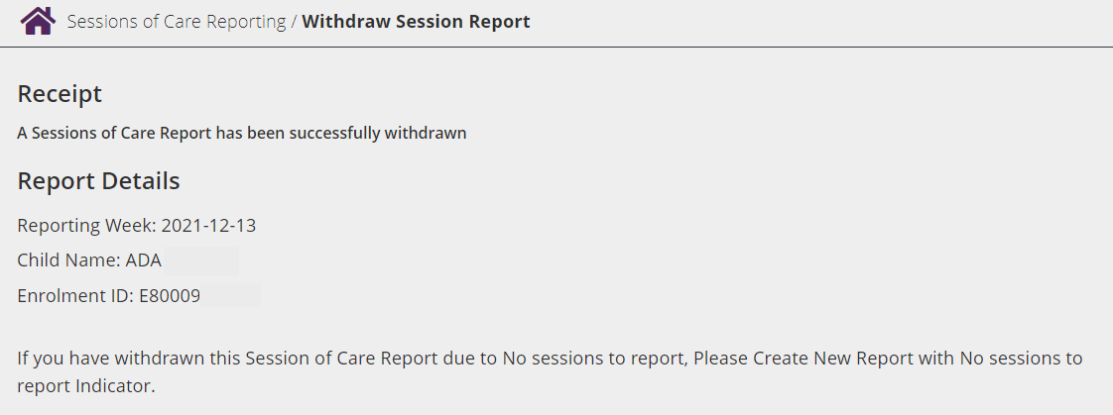

## Varying an existing session report (child overview)

Step 1

Select **Child Overview** from the **Sessions of Care Reporting** page.

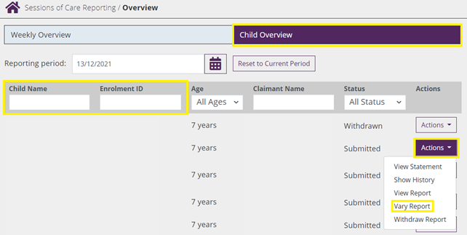

Step 2

You can search for child using the Child’s Name or Enrolment ID. Once you have located the child, use the **Actions** drop-down menu and select **Vary Report.**

Step 3

Select the **Reason for variation** from the drop-down menu and follow the relevant prompts:

* **Administrative error**: use where there was a mistake made in the original session report e.g. incorrect session start time
* **Responding to carer’s dispute**: use where a parent has disputed a session report
* **General amendment**: use where changes are being made before Sunday night of the session report week – before report has been processed and CCS paid (e.g. child attends another session after report submitted)
* **Responding to 204C**: only use if a 204C (compliance) notice has been issued requiring you to make a change to a session report

**S**elect **Add Another Session** to record another session for a child on the same day. Select **Advanced** to change other details for the session.

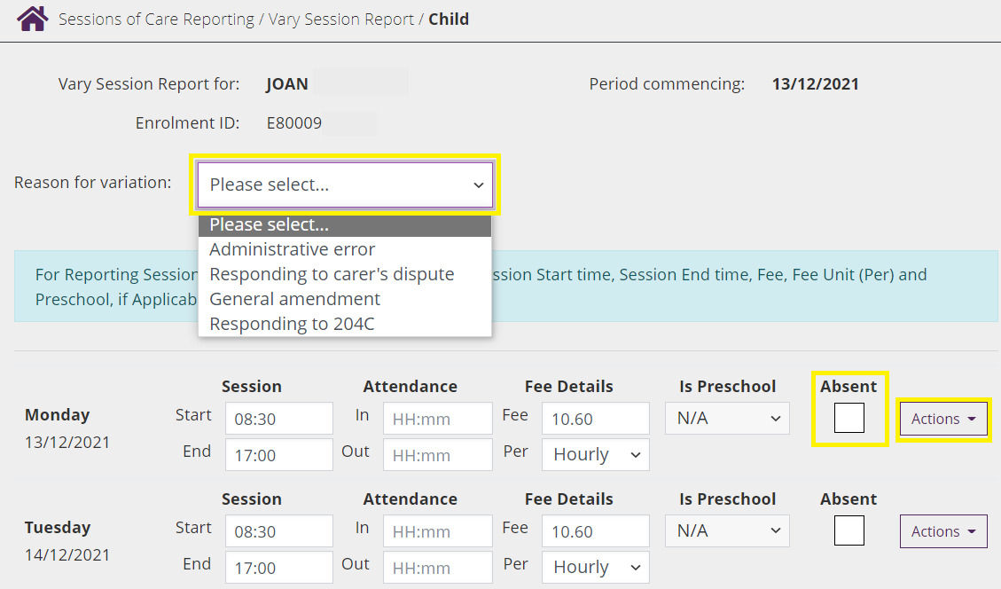

Step 4

Select **Submit** to proceed.

*Note that information will only be saved once you select submit.*

Step 5

A **receipt** will be generated upon submission.

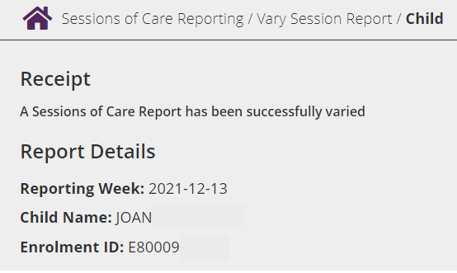

## Withdrawing an existing session report (child overview)

Step 1

Select Child Overview from the **Sessions of Care Reporting** page.

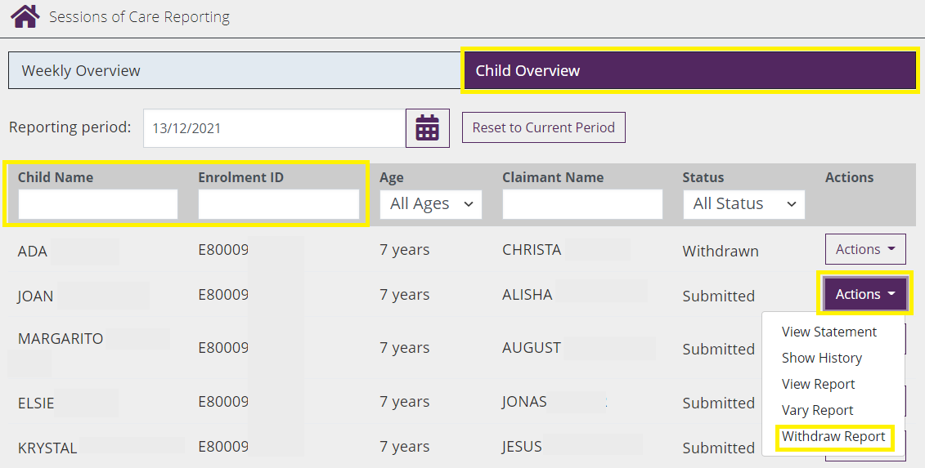

Step 2

You can search for child using the Child’s Name or Enrolment ID. Once you have located the child, use the **Actions** drop-down menu and select **Withdraw Report.**

Only use **Withdraw Report** where a session report was not required to be submitted in the first place. If there are still sessions to be reported in the week, use **Vary Report** instead.

Step 4

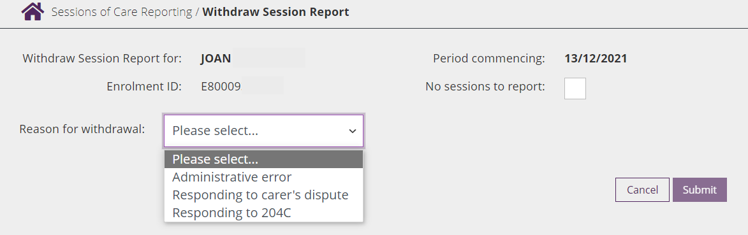

Select the **Reason for withdrawal** from the drop-down menu.

* **Administrative error**: use where there was a mistake made in the original session report e.g. incorrect session start time
* **Responding to carer’s dispute:** use where a parent has disputed a session report
* **Responding to 204C**: only use if a 204C (compliance) notice has been issued requiring you to make a change to a session report

Step 3

Select **Submit** to proceed.

*Note that information will only be saved once you select submit.*

Step 4

A receipt will be generated upon submission.

