National School Chaplaincy Programme Evaluation

Kantar Public Research Report

Prepared for:
The Australian Government Department of Education and Training

Table of Contents

1. Introductory information 4
2. Executive Summary 5
2.1 Summary of findings 7
3. Background information 17
3.1 Programme Information 17
3.2 Key Objectives 18
3.3 Methodology 19
3.4 Notes for this report 21
4. Details of results 22
4.1 How has the NSCP been delivered in schools? 25
4.2 How is the NSCP currently viewed? 36
4.3 What are the outcomes of the NSCP? 49
5. Conclusions of the evaluation 62
6. Appendices 63

In September 2016, TNS’ dedicated social and government research team re-branded, and is now called Kantar Public.
This new brand aligns with our global network of social researchers.
Kantar Public remains a part of the TNS Australia legal entity.
Our team, credentials, insurances and accreditations remain unchanged.
Please note that the data contained in this report has been prepared for the specific purpose of addressing the items contained in the project contract between Kantar Public Australia and The Australian Government Department of Education and Training. It may not be suitable for other applications. The use of this data for any other purpose should be discussed with the lead author. Kantar Public accepts no responsibility for unauthorized use of this data by a third party.
Kantar Public Australia Pty Ltd is ISO accredited to 20252:2012 and is compliant with this internal quality standard.
The Client agrees to use reasonable endeavours to comply with the ESOMAR and AMSRS Codes of Conduct and with the requirements of ISO 20252.

List of Figures & Tables

List of Figures
Figure 1: Student awareness of and interaction with the chaplain 25
Figure 2: How often students’ self-nominate/initiate contact with the chaplain 27
Figure 3: Parental awareness of the chaplain 32
Figure 4: Parental perception of required personality characteristics of chaplains 33
Figure 5: Summary of issues with the delivery of the NSCP 34
Figure 6: Student perceptions of the advantages of having a chaplain 36
Figure 7: Parental perceptions of the advantages of having a chaplain 40
Figure 8: Parental perceptions of the disadvantages of having a chaplain 42
Figure 9: Student perceptions of the disadvantages of having a chaplain 44
Figure 10: Levels of support for chaplaincy services and activities – views among others 45
Figure 11: Parental support for chaplaincy services and activities 46
Figure 12: Principal satisfaction with the NSCP and their views on student, teacher and parental satisfaction 47
Figure 13: The importance of chaplaincy services among principals, chaplains, parents and students 48
Figure 14: The main issues faced by chaplains at the school 49
Figure 15: The main issues faced by chaplains in government, independent and Catholic schools 50
Figure 16: Perception of how chaplaincy activities contribute to the wellbeing of students and the school community 53

List of Tables
Table 1: Sample composition: Quantitative surveys 23
Table 2: Sample composition: Qualitative sessions with parents 23
Table 3: Profile of NSCP schools 2016 24
Table 4: How often students’ self-nominate/initiate contact with the chaplain 26
Table 5: Activities delivered in schools reported by chaplains 28
Table 6: Principal and chaplain perceptions on the student opinion of the NSCP 37
Table 7: Principal and chaplain perceptions on the staff opinion of the NSCP 38
Table 8: Principal and chaplain perceptions on the staff opinion of the NSCP – negative responses 39
Table 9: Effectiveness of the Chaplaincy Programme in dealing with various issues 52
Table 10: How well does the NSCP contribute to various areas 55
Table 11: How well does the chaplain assist students with various issues 56
Table 12: Suggested NSCP improvements 60
Table 13: Profile of schools and principals 63
Table 14: Profile of chaplains 64
Table 15: Profile of parents 66
Table 16: Profile of students 67

Introductory information

The Australian Government committed $243.8 million to deliver the National School Chaplaincy Programme (NSCP). The programme assists over 3,000 schools to engage the services of a school chaplain. The aim of the NSCP is to support the emotional wellbeing of Australian school students by providing pastoral care services and strategies that support the broader school community.

The programme is operating over four years in the 2015, 2016, 2017 and 2018 school years.

The programme is funded by the Australian Government and delivered by the states and territories under the Project Agreement. The programme is delivered in accordance with the terms of the Intergovernmental Agreement Federal Financial Relations. A requirement of this agreement is an evaluation of the NSCP.

Under the agreement, each state and territory invited all schools (primary and secondary) in its jurisdiction to apply for NSCP funding. Each state and territory formed a cross sector panel consisting of government, Catholic and independent school representatives, to select and prioritise schools for NSCP funding. The programme commenced at the beginning of the 2015 school year.

The Australian Government Department of Education and Training required an evaluation to research the effectiveness of the NSCP in terms of how it is delivered, utilised and viewed within government, Catholic and independent schools. The overarching objective of this research was to understand the effectiveness of the NSCP, how the programme is implemented and, in particular, explore how the programme supports the emotional wellbeing of students and the broader school community. Feedback was gathered from principals, chaplains, students and parents.

Measurement of the outcome of ‘emotional wellbeing’ among students and the broader school community is a multi-dimensional factor which is highly individual and, as such, difficult to measure. In order to address the research question, the research objectives were deconstructed using a logical framework (provided on page 17). This established the grounding for all lines of enquiry from the outset, and underpins the analysis and reporting of recommendations.

Executive Summary
This report presents the main findings of the National School Chaplaincy
Programme (NSCP) evaluation research survey of principals, chaplains, parents and students in schools participating in the NSCP in 2016. The survey, which is the first formal evaluation of the programme, was conducted in October / November 2016. Following the survey, parent focus groups were held across Australia from December 2016 to February 2017.

The overarching objective of this research was to understand the effectiveness of the NSCP and, in particular, explore how the programme is implemented to support the emotional wellbeing of students and the broader school community. More specifically, the objectives were to understand:
- How has the NSCP been delivered across different schools?
- How is the NSCP currently viewed?
- What are the outcomes of the NSCP?

The surveys were sent to over 3000 schools participating in the NSCP in 2016, incorporating government, Catholic and independent schools. Only schools participating in the NSCP in 2016 were invited to complete the surveys. Surveys were not provided to non-participating schools.

Kantar Public provided survey links to the Australian Government Department of Education and Training, who distributed onto participating schools via state and territory education authorities. Principals were email the survey links for completion and email distribution to chaplains and parents. Chaplains and parents were invited to complete the online survey. Parents were asked to content to survey their child (aged 12 – 17 years) and where consent was provided the child was invited to complete the survey. All surveys were open for a period of two-weeks and participation was voluntary.
1.  Kantar Public provided survey links to the Australian Government Department of Education and Training. | 2.  Survey links were distributed by the Australian Government Department of Education and Training onto participating schools via state and territory education authorities. | 3.  Principals were emailed the survey links for completion and email distribution to chaplains and parents. | 4.  Chaplains and parents were invited to complete the online survey. | 5.  Parents were asked consent to survey their child (aged 12-17 years) and where consent was provided the child was invited to complete the survey.

A total of n=2147 participants took part in the survey. This included n=477 principals, n=498 chaplains, n=1038 parents and n=134 students. The surveys were conducted from 31st October to 25th November 2016. Based on the number of principals who responded it is estimated n=477 schools took part in the survey out of a total of n=3288 participating schools¹ a response rate of approximately 15%.
A sample of n=23 participants (parents) took part in the qualitative sessions. The qualitative sessions were conducted from 15th December 2016 to 1st February 2017. The findings in this report are based on responses to the survey and on feedback gained from the qualitative sessions. As participation was voluntary, parents and students who had no exposure to or contact with the Chaplaincy Programme may have been less likely to respond.

A summary of key findings from the research is provided overleaf (on pages 7-16). Overall, the findings of this research indicate the National School Chaplaincy Programme is delivering on its objectives of supporting the emotional wellbeing of students and the broader school community.

Summary of findings

How has the NSCP been delivered across different schools?

How many students utilise the chaplain service?
Awareness of the school chaplain among students surveyed was high, with 87% of students aware of the chaplain. Reported levels of student contact with the chaplain varied. One-quarter of students (25%) reported having a large amount of contact with the chaplain in the past year, and just over a quarter (28%) reported medium levels of contact. There were a quarter (24%) who reported low levels of contact and 21% who reported no contact.

Approximately 46% of students reported they had spent time with the school chaplain on an individual basis (both informal and formal activities). Actual reported engagement with the chaplain was higher among students, compared with principals’ perception of engagement: principals had estimated 30% of students utilising the chaplaincy services. Higher reported engagement among students may be attributed to an increased incidence of ‘one-on-one’ conversations occurring in an informal context, for example at recess or during school activities.

What activities/strategies are implemented by schools to support the wellbeing of students and the broader school community?
A wide variety of activities/initiatives are delivered in schools under the NSCP. These include activities/initiatives across different types of support, including:
- Delivery of specific programmes (breakfast clubs, boy/girl groups, music programmes)
- General support to the school community (working with staff/parents, providing student support)
- Classroom/school support (assisting teachers in the classroom, fundraising activities for the school)
- Informal support to students (lunchtime activities, cooking classes)
- Support on specific issues (delivering sessions on developing social skills, behaviour conflict, relationships, emotional wellbeing and resilience programmes)
- Formal support to students (one-on-one support (individual sessions) to students and parents)
- Family/community support (support to families or engaging/networking with the community)
- Assisting in out of school activities (attending school camps).

The most common activities/initiatives delivered under the NSCP across schools were:
- Breakfast clubs/food programmes
- School activity programmes
- Lunchtime activities
- Working with/supporting students
- Staff and parent support
- One-on-one support for students.

The activities/initiatives delivered were broadly similar across the three school types, with delivery of specific programmes, general support and classroom support having the highest number of mentions. Some of the key differences in delivery across school types included:

Chaplains in government schools were more likely to report:
- Classroom support (26%; compared to 16% in independent and 8% in Catholic schools)
- Higher levels of informal support (36%; compared to 23% in independent and 18% in Catholic schools)
- Higher levels of breakfast clubs/food programmes (42%; compared to 22% in independent and 3% in Catholic schools).

Chaplains in Catholic schools and independent schools were more likely to report:
- Delivery of religious studies* (26% in Catholic schools, 26% in independent, 7% in government schools)
- Higher levels of family support (21% in Catholic schools, 18% in independent, 6% in government schools).

Chaplains in Catholic schools were also more likely to report:
- Higher levels of community engagement (21%; compared to 3% in independent and 6% in government schools).

What drives or impedes delivery and use of the chaplaincy activities/services?
As seen with students, awareness of the school chaplain among parents is also high, with almost 9 in 10 parents (88%) aware of the chaplain. Although awareness of the school chaplain is high among parents, knowledge regarding their role is limited. In the qualitative sessions, parents were asked to describe how much they knew about the role of chaplain at their child’s school. During this exercise, parents were able to broadly describe what they perceived the role of the chaplain to be, however, overall there was a lack of knowledge regarding the actual role of the chaplain at their child’s school. There is an opportunity for schools to address the knowledge gap that exists among parents, increasing awareness of the chaplain’s role and sharing of the activities/initiatives that are being implemented to support the school community.

In the qualitative sessions, parents highlighted the importance of the ‘softer’ skills and personality traits required of chaplains in delivering chaplaincy services. Parents perceived the most important personality characteristics or ‘softer’ skills for a chaplain to embody to include: being a good listener, having patience and integrity, being kind, empathic and fun. These skills were perceived to be as important as having a formal qualification. Although parents were largely unaware of the qualifications required by chaplains (with the exception of a valid police and working with children check), they perceived the most important qualifications to include a qualification in psychology, counselling, youth services, child development or child care.

Few parents had experienced any negative issues with the school’s chaplaincy activities/services, with 91% reporting neither they nor their children had experienced any issues.

61% of principals had not experienced any negative issues. Of the 35% who reported a negative issue with the delivery of the NSCP, the main issues included:
- Availability of NSCP workers
- A preference for increased access to the chaplain and programme 5 days a week; and/or
- Funding issues.

These issues were mentioned by 9% and 8% of principals respectively. A few smaller mentions, (3%) included:
- Finding appropriately skilled chaplains
- Ensuring clarity on roles
- Maintaining open channels of communication
- Availability of chaplains (particularly challenging in isolated areas)
- Parents/families who do not support the programme
There were a few smaller mentions, which have been outlined in chapter 4.1 (on page 33).

Around half (46%) of chaplains have not experienced any issues. Of the 51% who had experienced an issue, these included:
- Availability issues – inadequate time to meet the needs of the school community (15%)
- Funding issues (9%)
- A need for increased understanding of their role (8%)
- Teachers resistant to work with the chaplain (5%)
- Parents/families not supporting the chaplaincy programme (5%)
- Religious aspect/think we are religious teachers (4%)
There were a few smaller mentions, which have been outlined in chapter 4.1 (on page 34).

What do students who utilise the programme consider to be the benefits of participation in the programme?
Students were asked to describe the positive aspects of having a chaplain/chaplaincy services at their school. The main advantages cited by students was that the programme provides an accessible figure for them to talk to/confide in (cited by 24% of students), someone who provides help and support with problems (22%) and provides guidance to students to help them understand or ‘figure things out’ (cited by 13% of students). 13% also reported the benefit of being encouraged in their faith, and for 11%, the programme provided someone they can trust to talk to other than a teacher or parent.

How is the NSCP currently viewed?

How are the chaplaincy services provided viewed by principals, students and parents?
Overall, there is a positive sentiment towards the NSCP and the programme is described with positive regard. The programme is reported to provide the school community with extra support, someone to talk to, and a confidential source providing support and guidance to the school community.

Principals and chaplains described the student opinion of the programme as ‘positive’, ‘high’ or ‘well-respected’ (cited by 46% of principals and 34% of chaplains).

- Principals considered chaplains under the NSCP to have developed positive relationships with students, and perceived the chaplain to be well-liked by students (26%)
- Principals stated chaplains provide students with support with emotional/social/home life issues (18%), having someone to talk to (17%) and someone they can trust/a confidential source (15%)
- Similarly to principals, chaplains considered the programme to provide students with someone they can talk to (33%) and someone they can trust/a confidential source (26%)
- 29% of chaplains considered students to appreciate the support, and perceived the programme to provide a support network for students (18%) and a ‘safe space’/friend to confide in (14%).

Principals and chaplains were asked to describe their perception on the staff opinion of the programme. As with the perceived student opinion, the staff opinion was also described positively. Staff were believed to value the input and support provided by the NSCP, in assisting staff in their roles, and in benefiting the wellbeing of students. Chaplains were considered to provide school staff with support, guidance and advice and were described as a valued and respected members of the school team.

There were few negative comments mentioned when describing the staff opinion of the NSCP among both principals and chaplains. The most significant negative comments mentioned by chaplains, regarding the staff opinion of the NSCP included:
- 9% of chaplains cited that not all staff appreciate the work they do; and
- 5% of chaplains cited that staff expected chaplains to be more available during the day.

Parents considered the key advantages of having a school chaplain/chaplaincy services to be:
- The provision of extra support (31%)
- Someone students can trust, that is not a teacher or parent (24%)
- Encourages students in their faith/spiritual aspect of their lives (15%)
- Someone students can talk to (12%).
There were a few smaller mentions, which have been outlined in chapter 4.2 (on page 39).

The advantages cited by parents in the online survey were mirrored in the parent qualitative sessions. Parents described chaplains as playing a crucial role for students in being an additional adult figure available to children, over and above the support provided by teachers and parents. Parents found comfort from the fact their children have access to an additional source of support.

Several parents considered one of the key advantages of a chaplain’s role was the fact that they are not restricted by the need to achieve specific outcomes, targets or quotas. Parents felt this enabled chaplains to focus their time on the wellbeing of students and the broader school community.

What are the unmet needs of the programme for students and the broader school community and how can these be effectively addressed?
Two-thirds of parents (65%) felt there were no disadvantages in having chaplaincy services at their child’s school. This was consistent across Catholic and independent schools, with 70% and 69% respectively, however, lower in government schools with 58%. There was no one dominating factor, but rather several smaller mentions. The top four largest disadvantages included:

- Religion: 11% of parents preferred religious views not be shared with their child* (this was mentioned by 18% of parents in government schools, compared with 7% in independent and 4% in Catholic schools)
- Limited availability i.e. chaplain/chaplaincy services not available every day/full time (6%)
- Need for skilled counsellors/an evidence based view (2%)
- Not shared family values or beliefs/lack of diversity in religious and cultural views (2%).

Over half of all students surveyed (54%) mentioned there were no disadvantages in having chaplaincy services at their school. The main disadvantages of the NSCP mirrored the feedback from parents, and included:

- Limited availability (not there enough) (5%)
- Religion (5%)
- Detracting from learning time/missing class (3%).

Is the programme supported?
The NSCP is well supported across the school community. Principals, chaplains and parents rated the support among the school community strongly, particularly among students.

91% of parents support having chaplaincy services and activities in their child’s school. Support of parents was high across all school types. Support was highest in Catholic schools with 96% followed by independent schools with 95% and government schools with 83%.

How satisfied are principals, students and parents with the chaplaincy services and the activities/strategies which underpin them?
Satisfaction with the NSCP is high. 85% of principals reported being extremely satisfied with the NSCP services and activities delivered in their school. Principals were asked to provide their views on the satisfaction of students, teachers and parents, which were as follows:
- 86% of students were considered to be extremely satisfied
- 81% of teachers were considered to be extremely satisfied; and
- 74% of parents were considered to be extremely satisfied.

How important is the NSCP in supporting the school community?
The NSCP is considered to be important to the school community. 88% of principals, 76% of chaplains, 77% of parents and 60% of students considered the NSCP to be important to the school.

The importance of the program increased with engagement, where students who had spent time with the chaplain were more likely to consider the NSCP to be important compared with those who had little or no contact.

What are the outcomes of the NSCP?

What impact does the programme have on students and the broader school community?
Chaplains under the NSCP reported dealing with a broad spectrum of issues. Peer and family relationships were the most common issues faced, with around 9 in 10 chaplains reporting dealing with these issues at school.

This was followed by approximately 8 in 10 chaplains who had reported dealing with behaviour management such as anger, grief and loss, sense of purpose and self-esteem, and around 7 in 10 chaplains, dealt with social inclusion issues, bullying and harassment and
self-image.

Approximately 1 in 10 chaplains had dealt with racism, sexuality, alcohol and drugs.

The main issues dealt with by chaplains were largely consistent across government, independent and Catholic schools, with peer and/or family relationships being the most common issues regardless of school type. Behaviour management was more likely to be mentioned by chaplains of government schools (83%) and Catholic schools (77%) compared with independent schools (which was significantly lower with 71%). 23% of chaplains in government schools, 18% in Catholic schools and 11% of chaplains in independent schools had dealt with violence.

Sense of purpose was the third most common issue reported in independent schools, and had been dealt with by 78% of chaplains (similar to government schools with 76% and Catholic schools with 74%). Chaplains of independent schools were more likely to report having dealt with
self-harm and suicide (52%; compared to 34% in government and 28% in Catholic schools), sexuality (21%; compared to only 10% in government schools) and academic achievement
(29%; compared to 8% in Catholic schools).

What are the perceived outcomes (both positive and negative) of the programme?
Principals, chaplains and parents considered the NSCP to be most effective in dealing with issues regarding sense of purpose and self-esteem, building peer relationships and social inclusion.

Sense of purpose and self-esteem was ranked highest across all target groups, with around 82% of principals, 89% of chaplains and 63% of parents rating the NSCP to be extremely effective in dealing with this issue.

Around 8 in 10 principals, 9 in 10 chaplains and 6 in 10 parents considered the NSCP to be extremely effective in dealing with:
- Sense of purpose and self-esteem
- Peer relationships
- Social inclusion; and
- Self-image.

Principals, chaplains and parents were more likely to be unaware (citing they ‘don’t know’) whether the programme was effective in dealing with issues such as alcohol and drug abuse, sexuality*, self-harm and suicide and issues of racism.
Chaplains stated that the activities/initiatives delivered under the NSCP contribute to the wellbeing of students and the broader school community by:
- Providing advice, guidance, mentoring or strategies (cited by 61%)
- Providing support for students, staff and/or parents (cited by 48%)
- Work towards building and developing relationships (43%); and
- Building confidence, resilience and/or self-esteem (33%).

Programmes such as breakfast clubs or food programmes assisted students with increased concentration, while formal support, such as one on one sessions, were reported to provide students with a safe and trusted environment.

Parents in the qualitative focus groups sessions considered ‘informal’ support (e.g. activities organised by the chaplain, interacting with students during recess or lunch, social activities/outings), to contribute towards building rapport with the students. This made students feel comfortable in approaching the chaplain for more formal structured support.

Is the programme perceived to contribute to:
A supportive and safe learning environment

An improvement in student engagement and connectedness and;

Creating an environment which promotes wellbeing?
The NSCP is considered to be most effective in supporting the emotional and social wellbeing of students. Almost 9 in 10 principals, 8 in 10 chaplains and 8 in 10 parents rated NSCP services and activities extremely well in contributing to supporting the emotional and social wellbeing of students. This finding strongly aligns with the overarching objectives and aims of the NSCP.

In addition to supporting the emotional and social wellbeing of students, the NSCP services and activities were also considered to contribute towards:
- Assisting students in dealing with crisis/loss situations e.g. family breakdown/death (84%), creating a caring learning environment (83%) and in providing accessible and on-going support for individuals (83%) - Principal survey
- Creating a caring learning environment (74%), modelling and teaching moral values (74%) and in contributing towards improving the morale of the school (72%) - Parent survey
- Modelling and teaching moral values (76%), to contribute towards assisting students in dealing with crisis/loss situations e.g. family breakdown/death (72%), and in providing accessible and on-going support for individuals (72%) - Chaplain survey.

Students considered chaplaincy services to be most effective in assisting those who have problems and in making the school a better place (cited by two-thirds of students).

Students also reported the programme to be effective in providing someone they can talk to (65%), encouraging students to do the right thing (64%), helping students who are lonely (63%) and helping students feel good about themselves (63%).

Around 63% of students considered chaplaincy services to contribute towards the school environment i.e. making the school a caring place and making students feel safe.

How could delivery of the programme be changed or improved in the future?
The main suggested improvements to the programme included increased availability/time allocation of chaplains and increased education/awareness on the role of chaplains. These findings were consistent across target groups.

Principals and chaplains felt the NSCP could be improved through increased time allocation and funding (having the chaplain funded for more days or in a full-time capacity). These two suggested improvements dominated with both principals and chaplains. A few smaller mentions (less than 5%) included increased training opportunities, an increase in the resource pool of chaplains/more staff available, and 3% expressed the desire for the programme to extend/continue into 2018.

15% of principals did not have any improvements or suggestions for the programme, and 12% of chaplains cited they would not change anything.

Both chaplains and parents cited the need for an increase in awareness of chaplaincy, the programme itself and the role of chaplains. This was suggested by 7% of chaplains and was the top overall suggested improvement among parents, with 24% of parents suggesting this change/improvement.

Similarly to principals and chaplains, 10% of parents suggested increased funding to extend the services/increase the availability of chaplains and 3% suggested the inclusion of an additional chaplain in order to have both male and female chaplains available for the male and female students of the school.

There were a small proportion of parents (4%) who suggested that chaplaincy services/chaplains should be removed from schools and who mentioned dislike of any religious aspect in the programme * (3%). These were both more likely to be mentioned by parents of students in government schools, compared with parents of independent and Catholic schools.

Overall, students were largely satisfied with the delivery of the programme. Around 40% did not have any suggested improvements and felt chaplains were ‘doing a great job’. Around 7% of students suggested the chaplain should be more visible and available, which aligns with feedback from both principals and chaplains.

Conclusions

Overall, there is a positive sentiment towards the NSCP and the programme was described with positive regard. Students were considered to have a high opinion of the programme and to benefit from having someone to provide additional support, someone to talk to and someone who is a ‘neutral’ person (not a teacher or parent) they can confide in.

The NSCP is delivered through a wide range of activities/initiatives which encompass different types of support. These include formal support (e.g. one-on-one individual sessions), informal support (e.g. lunchtime activities), delivery of specific programmes (e.g. breakfast clubs) and assisting in out of school activities (e.g. school camps). Activities/initiatives delivered across schools were largely consistent, and worked towards providing students and the school community with an accessible figure who provides support, encouragement and guidance.

The NSCP was considered to be effective in dealing with a range of issues, and most effective in dealing with issues regarding sense of purpose and self-esteem, building peer relationships and social inclusion. The programme was rated as performing extremely well in contributing to supporting the emotional and social wellbeing of students, which strongly aligns with the overarching objectives and aims of the NSCP.

Awareness of the NSCP is high, however, there is limited knowledge on the role of chaplains. There is an opportunity for schools to address the knowledge gap that exists among parents by increasing awareness of the programme, the chaplain’s role and the activities/initiatives performed that support the wellbeing of students and the school community.

The findings in this report are based on responses to the survey and on feedback gained from the qualitative sessions. As participation was voluntary, parents and students who had no exposure to or contact with the programme may have been less likely to respond.

Overall, few disadvantages were associated with the NSCP. There were a proportion of parents and students (particularly from government schools) who preferred religious views were not shared. This was driven by the perception that chaplaincy services included sharing or teaching of religious views and values, and was, therefore, felt better suited to private schools or religious families.

Suggested improvements for the programme included increasing the availability/time allocation of chaplains. A large proportion of principals, chaplains, parents and students communicated the need for the chaplain/chaplaincy services to be more available or available for more days. This would allow for the chaplain/chaplaincy services to adequately meet the needs of the school community.

In conclusion, the evaluation indicates the NSCP is considered to effectively support the wellbeing of students and the broader school community. The programme is regarded as important for the school and is well supported by the school community (i.e. by principals, chaplains, parents and by students). There is strong support for the programme to be continued.

Background information

Programme Information

The Australian Government has committed $243.8 million over four years from 2014-15 to 2017-18 to assist over 3000 schools to engage the services of a school chaplain. Consistent with the Government’s election commitment, the NSCP aims to support the emotional wellbeing of students through the provision of pastoral care services and strategies that support the broader school community.

The NSCP supports choice as one of its fundamental principles with participation in the programme by schools and students entirely voluntary. Chaplains may be from any faith and must not proselytise. Chaplains are required to respect, accept and be sensitive to other people’s views, values and beliefs, and to meet minimum qualification requirements. Chaplains must also comply with state and territory laws and policies in relation to child protection matters.

Previously, the Australian Government funded the National School Chaplaincy and Student Welfare Program (NSCSWP). The NSCSWP had no allocation of funding after 31 December 2014. On 19 June 2014, the High Court of Australia found that payments made under the NSCSWP were beyond the constitutional authority of the Commonwealth. As a consequence of the High Court decision in the Williams v the Commonwealth (2014) case and the new arrangements to fund the National School Chaplaincy Programme, through a project agreement with the states and territories, the Commonwealth has no ability to influence school selection.

The National School Chaplaincy Programme (NSCP) consists of the provision of chaplaincy services in Australian schools and is operating over four years (in the 2015, 2016, 2017 and 2018 school years). The programme is funded by the Australian Government and delivered by the states and territories under the Project Agreement. The programme is delivered in accordance with the terms of the Intergovernmental Agreement on Federal Financial Relations, and a requirement of this agreement is an evaluation of the NSCP. Participation in the Commonwealth-funded programme is voluntary, and schools are eligible to receive up to $20,000 per annum (or up to $24,000 for remote/very remote schools) to engage the services of a school chaplain

The Australian Government has administered in-school chaplaincy programmes since 2007. However, this is the first time the programme has been evaluated by the Australian Government Department of Education and Training.

Key Objectives

The Australian Government Department of Education and Training required evaluation research to measure the effectiveness of the NSCP in terms of how it is delivered, utilised and viewed in schools and, in particular, explore how the programme supports the emotional wellbeing of students and the broader school community.

Measurement of the outcome of ‘emotional wellbeing’ among students and the broader school community is a multi-dimensional factor which is highly individual and, as such, difficult to measure. In order to address the research question, the research objectives were deconstructed using a logical framework. This established the grounding for all lines of enquiry from the outset, and underpins the analysis and reporting of recommendations.

The research objectives were structured as follows:

Overarching objective: To understand the effectiveness of the NSCP
Does the program support the emotional wellbeing of students and the broader school community?
How has the NSCP been delivered across different schools? | How is the NSCP currently viewed? | What are the outcomes of the NSCP?
What activities/ strategies are implemented by schools to support the wellbeing of students and the broader school community? | How are the chaplaincy services provided regarded by principals, students and parents?  Is the programme supported? | What are the perceived outcomes (both positive & negative) of the programme?
What factors influence positively or negatively on implementation of chaplaincy services and activities? | How satisfied are principals, students and parents with the chaplaincy services and the activities / strategies which underpin them? | What impact does the programme have on students and the broader school community (including parents)?
How many students utilise the chaplain services? | How effective is the NSCP considered by the principal, chaplain, students and parents in supporting the wellbeing of students? | What have been the key outcomes of delivering the programme?
What do students who utilise the programme consider to be the benefits of participation in the programme? | Does the programme align to expectations? | Is the programme perceived contribute to:  - a supportive and safe learning environment?  - an improvement in student engagement and connectedness?  - creating an environment which promotes wellbeing?
What drives or impedes delivery and use of the chaplaincy activities / services? | What are the unmet needs of the programme for students and the broader school community and how can these be effectively addressed? | What are the critical success factors to support the emotional wellbeing of students?
How could the delivery of the programme be changed or improved in the future? | * | *
The results from this research will provide the Department with an understanding of how chaplaincy services and strategies are implemented in participating schools to support the emotional wellbeing of students and the broader school community.

Methodology

In 2016, over 3,000 schools participated in the NSCP. All of these schools were provided with the survey instruments to participate in the NSCP evaluation. The aim was to offer these schools the opportunity to take part in the research and offer their feedback. Participation in the evaluation was voluntary.

Design
A combination of both quantitative and qualitative research was used for this evaluation. Four target groups were identified for the research; principals, chaplains, parents and students.

An online survey was designed to gain feedback from principals, chaplains, parents and students. At the end of their survey, parents were invited to self-nominate if they wanted to take part in a group discussion (qualitative). The quantitative research was the primary data collection method, and was used to provide a robust evidence base.

The qualitative research was an exploratory tool to provide additional depth and used to support the quantitative findings. These sessions provided the ideal format for gaining a detailed understanding of parent perceptions of the programme through the exchange of thoughts, feelings and experiences.

A breakdown of participant numbers is provided on page 5.
- A sample breakdown has been provided in Table 1 on page 23.

A total of n=23 participants (parents) took part in the qualitative sessions. The qualitative sessions were conducted from 15th December 2016 to 1st February 2017.
- A sample breakdown has been provided in Table 2 on page 23.

Questionnaire
The survey instruments were specifically designed for each of the four target groups. These were designed to include both closed/scaled questions as well as open-ended spontaneous questions. This allowed core measures to be ‘quantified’ (such as perceived effectiveness, satisfaction etc.) by using pre-determined closed ended questions/scales and allowed for comparisons across target groups. The spontaneous (open-ended) questions allowed participants to provide detailed feedback in their own words, capturing any issues.

The survey instruments (provided in the Appendix) were shared with the states and territories for feedback, where appropriate changes were made to the survey instruments prior to programming of the online surveys. Kantar Public provided the finalised survey links to the Australian Government Department of Education and Training, for distribution to the states and territories.

The survey invitations were sent to the principal of all participating NSCP schools, and contained a link to their survey as well as links for distribution to the NSCP funded chaplains and parents of their school. Parents were asked to give consent for their child aged 12-17 year of age (students) to participate in the research at the child’s discretion.

The surveys were open to schools for a period of approximately two-weeks. No limit was placed on the number of interviews collected; as many as possible were collected over the period. The fieldwork was conducted between 31 October and 25 November 2016.

Qualitative sessions
At the end of the parent survey, parents were invited to participate in a group discussion (qualitative session) moderated by a Kantar Public moderator. Qualitative sessions were conducted in locations where parents had indicated a willingness to participate. A full qualitative discussion guide was developed in consultation with the Department, outlining the broad topics for discussion.

Due to the small numbers of self nominated participants mini groups or in-depth interviews were conducted. These sessions were held across the following locations:
- South Australia
- Western Australia
- Northern Territory; and
- Queensland.

The qualitative sessions were conducted between 15 December 2016 and 1 February 2017. A total of n=23 parents participated.

Analysis
All feedback gathered from both the quantitative and qualitative components of the research were integrated and consolidated during the analysis.

The quantitative data was processed into four data files, one for each of the target groups. All open-ended data was coded according to a code frame and incorporated into the data tables of results. The data for this evaluation was not weighted to be representative of all schools participating in the NSCP and has been reported as unweighted data to provide a realistic view based on only those who responded and provided feedback.

Notes for this report

Significant differences
Statistically significant differences between sub groups have been identified in the results. These have been shown by a red/green arrow or red/green text, to show a significantly higher or lower result across/within groups. The report details significant differences (at the 95% confidence level) across target audience or school type as outlined below.

Subgroups of interest
Category | Subgroups
Target audience | Principals, Chaplains, parents, students
School type | Government, Catholic, Independent

Limitations of the research
- In order to protect the confidentiality of participating schools, the contact details of the schools were not released to Kantar Public. As a result, generic survey links were required and were provided to the Australian Government Department of Education and Training for distribution. A generic survey link is a link which does not contain any identifiable information.
This distribution method resulted in the following limitations:
- From the response received, it is not possible to determine how many parents or students responded from one particular school vs multiple schools.
- No additional information/or alternative data sources e.g. socio-economic background, location, Indigenous status or non-English speaking background from public data available (such as My School) could be linked to a particular school. This information, therefore, needed to be captured within the survey or otherwise would have been unknown.
- Extracts from the group discussions are used to illustrate some of the issues raised. Each extract is denoted in italics and includes attribution as follows:
- Target audience, school type and state.
- In some cases, some of the content of extracts/attribution details may have been removed to protect participant confidentiality.
- Not all issues raised are included; rather the report provides a summation of the common aspects and issues encountered.
- The findings are based on feedback and responses from principals, chaplains, parents and students who participated in the research, and any limitations should be acknowledged.
- The findings in this report are based on responses to the survey and on feedback gained from the qualitative sessions.
- As participation was voluntary, parents and students who had no exposure to or contact with the Chaplaincy Programme may have been less likely to respond.
- Due to the number of responses received from students i.e. a total of n=134, analysis within this target audience (i.e. by school type, age or gender etc.) has been excluded in this report due to small sample sizes.

Details of results
This report presents the main findings of the evaluation research conducted with participating schools in the 2016 NSCP. Quantitative research was conducted with principals, chaplains, parents and students in October/November 2016 and qualitative sessions were conducted with parents between December 2016 and February 2017.

This is the first time an evaluation of the NSCP has been conducted by the Australian Government Department of Education and Training. The overarching objective of the research was to evaluate the effectiveness of the NSCP in schools. This report will focus on the following key areas:

4.1: How has the NSCP been delivered in schools?
This section provides an understanding on the types of activities/strategies which are implemented in schools to support the wellbeing of students and the broader school community.
This section includes:
- Estimated utilisation of chaplain services
- Activities/strategies implemented in schools
- Perceived benefits of the activities/strategies
- Factors which drive or impede delivery and use of chaplaincy activities/services.

4.2: How is the NSCP currently viewed?
This section includes the findings on how the chaplaincy services and activities delivered in the schools are viewed by the school community.
This section includes:
- Views towards chaplaincy and chaplaincy services
- Perceived advantages and disadvantages
- Levels of support for the programme
- Perceived effectiveness and levels of satisfaction.

4.3: What are the outcomes of the NSCP?
This section outlines the findings on the impact and outcomes (both positive and negative) of the programme on students and the school community.
This section includes:
- The impact of the programme
- Perceived outcomes of the programme
- Contribution of the programme in various areas
- Suggested improvements for the future.

A breakdown of the number of responses received to the survey and participation in the qualitative sessions have been outlined overleaf (on page 23).

Sample
The sample achieved in quantitative online survey and qualitative sessions have been outlined below.

Table 1: Sample composition: Quantitative surveys
Target Audience | Base n=2147 | Base %
Principals | 477 | 22%
Chaplains | 498 | 23%
Parents | 1038 | 48%
Students | 134 | 6%

School Type | Base n=2147 | Base %
Catholic | 142 | 7%
Independent | 845 | 39%
Government | 1160 | 54%

State | Base n=2147 | Base %
ACT | 15 | 1%
NSW | 640 | 30%
NT | 44 | 2%
QLD | 685 | 32%
SA | 272 | 13%
TAS | 57 | 3%
VIC | 168 | 8%
WA | 266 | 12%

Location | Base n=23
South Australia | 4
Western Australia | 3
Northern Territory | 6
Queensland | 10
Table 2: Sample composition: Qualitative sessions with parents

Profile of participating schools
The table below provides a profile of schools participating in the 2016 NSCP, compared to the profile of schools who participated in the research. The data shown in the sample is based on the responses received from principals. The data from principals has been used to avoid capturing multiple responses per school (e.g. from a principal, chaplain and several parents) as this would not accurately represent the proportion across school type or location. The data shows how the profile obtained in the research is similar or different to that of all schools participating in the 2016 NSCP.

Table 3: Profile of NSCP schools 2016 vs. sample achieved
School Type | Participating schools n=3288 | Participating schools % | Sample achieved n=477 | Sample achieved %
Catholic | 440 | 13% | 43 | 9% ⇩
Independent | 544 | 17% | 97 | 20%
Government | 2304 | 70% | 337 | 71%

State | Participating schools n=3288 | Participating schools % | Sample achieved n=477 | Sample achieved %
ACT | 39 | 1% | 6 | 1%
NSW | 749 | 23% | 114 | 24%
NT | 26 | 1% | 8 | 2%
QLD | 918 | 28% | 85 | 18% ⇩
SA | 460 | 14% | 95 | 20% ⇧
TAS | 122 | 4% | 26 | 5%
VIC | 611 | 9% | 49 | 10%
WA | 363 | 11% | 94 | 20% ⇧
*Data based on Principal responses only

The profile by school type largely matches the profile of participating schools, with approximately 71% representation of government schools and 20% Independent schools. There were a lower proportion of Catholic schools achieved in the sample, with 9% compared to 13% of participating schools.

The proportion by state was consistent for ACT, NSW, NT, TAS and Victoria. The sample achieved was over-represented in SA and WA, and under-represented in QLD.

How has the NSCP been delivered in schools?

This section of the report outlines the types of activities/strategies which are implemented in schools to support the wellbeing of students and the broader school community. It includes estimated utilisation of chaplain services, activities/strategies that are implemented by schools, the perceived benefits of these activities/strategies and the factors which drive or impede delivery and use of the chaplain and chaplaincy services.

How many students utilise the chaplain service?

Levels of awareness among students of the chaplain is high, however, claimed interaction or engagement with the chaplain varied considerably
The chart on the left below shows the proportion of students who were aware of the school chaplain. The chart on the right shows how much contact students reported having with the school chaplain over the past year. This could include speaking with the chaplain, being involved with an activity the chaplain has organised etc.

Figure 1: Student awareness of and interaction with the chaplain
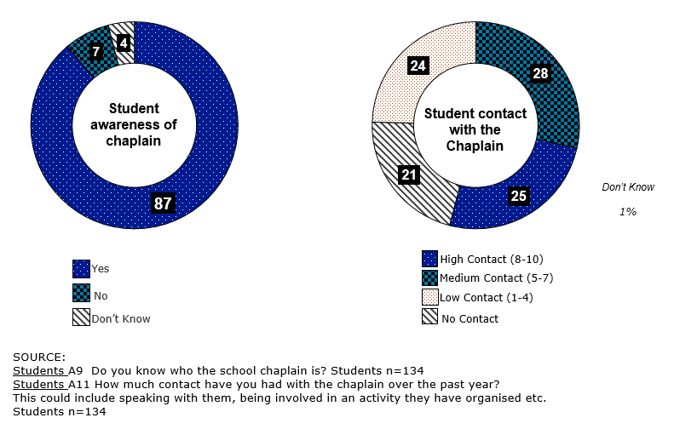

Awareness of the school chaplain among students is high, with 87% aware of the school chaplain.

Levels of student contact with the chaplain varied. 25% of students rated themselves as having a large amount of contact with the chaplain over the past year (i.e. rated their contact between 8-10 on a 10-point scale). 28% rated themselves as having medium contact (rating of between 5-7 on a 10-point scale), and 24% rated themselves as having low contact (rating between 1-4 on a 10-point scale). 21% had no contact with the chaplain in the past year.

Students were asked whether they had interacted with the chaplain through various activities (both informal and formal activities). Their levels of engagement were as follows:
- 82% of students had spoken with the school chaplain
- 61% had been involved in group activities run by the chaplain
- 54% had been in a class where the chaplain assisted/was present
- 46% of students had spent time with the school chaplain on an individual basis.

Just under a third (30%) of students are estimated to use chaplaincy services
The chart below, which is based on the principals data, shows the number of full time equivalent students in both primary and secondary school, compared with the number of students principals estimated to access chaplaincy services.

Table 4: How often students’ self-nominate/initiate contact with the chaplain
Number of full time students | Primary school n=405 | Secondary school n=182
Less than 100 | 23% | 25%
Between 100-400 | 52% | 34%
400+ | 25% | 41%
Average | 296.4 | 420.1

Number of students access or utilise  the Chaplain services | Primary school n=405 | Secondary school n=182
Less than 50 | 48% | 40%
Between 50-100 | 30% | 29%
100+ | 22% | 31%
Average | 90.0 | 123.5

In the analysis, responses were grouped in sub-categories (as shown above), and the average number of students calculated. Based on the estimations provided by principals, around 30% of students overall utilise the chaplaincy services.

Reported engagement with the chaplain was higher among students, with 46% reporting they had spent time with the school chaplain on an individual basis. Higher reported engagement among students may be attributed to an increased incidence of informal ‘one-on-one’ conversations, for example at recess or during activities.

Chaplains were asked how often students self-nominate/initiate contact with the chaplain when they need help, captured in the chart below.

Figure 2: How often students’ self-nominate/initiate contact with the chaplain
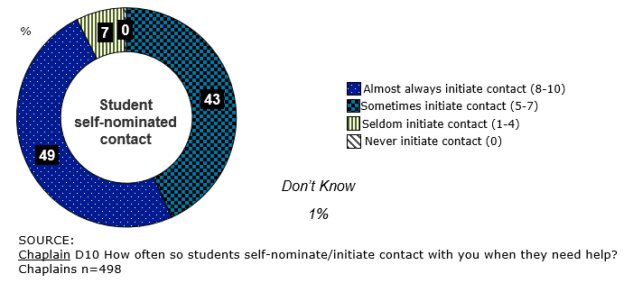

Almost half (49%) of students were considered to frequently seek or initiate contact with the chaplain when help was needed. This is in line with the proportion of students who have reported to have spent time with the school chaplain on an individual basis (46%).

There were only 7% of students who were considered to rarely self-nominate or initiate contact with the chaplain when they needed help.

What activities/strategies are implemented by schools to support the wellbeing of students and the broader school community?

A wide variety of activities/initiatives across different types of support were delivered in schools
Principals, chaplains and parents were asked to list the activities or initiatives delivered in the school as part of the chaplaincy programme. The table below shows the list of activities based on the responses received from chaplains. Multiple responses could have been provided by chaplains, which may result in the percentages adding to more or less than 100%. Responses were coded and categorised into overarching themes as indicated by the light blue headings.

Table 5: Activities delivered in schools reported by chaplains
Activities delivered (%) | Chaplains
Delivery of programs | 78%
Breakfast clubs / food | 34%
School activities | 26%
Boy and Girl groups | 11%
Seasons for growth | 8%
Parenting | 6%
Chaplain event/days | 5%
Drum beat | 5%
Rock and Water | 4%
Gardening programs | 4%
Other smaller mentions | 12%
General support | 58%
Working with students, staff & parents | 21%
Friendship programs | 11%
Mentoring | 11%
General student support | 8%
Meditation | 7%
Group programs/sessions | 5%
Choir/music | 5%
Someone to talk to/to listen | 4%
Referrals to other services | 4%
Other smaller mentions | 10%
Classroom/school support | 46%
Classroom support | 22%
Resources support | 13%
Religious studies | 13%
Professional development days | 3%
Assemblies | 2%
Fundraising | 2%
Staff morning teas/morning coffee | 2%
Newsletter articles | 1%
Informal support | 31%
Lunchtime activities/games | 26%
Craft groups/kite making/cooking classes | 8%

Activities delivered (%) | Chaplains
Support on specific issues | 28%
Social skills | 9%
Emotional wellbeing | 7%
Resilience programs | 5%
Self esteem/team building/confidence | 4%
Behaviour control/conflict | 4%
Transition to high/secondary school | 2%
Relationship support | 2%
Other single mentions | 2%
Formal support | 24%
One on one support | 20%
Open room /private room | 4%
Family community support | 18%
Community engagement | 12%
Family support | 6%
Out of school Activities | 16%
School camps |  | 12%
Meetings with parents/staff/child |  | 4%

*The NSCP agreement states chaplains are not permitted to proselytise. Delivery of religious studies in this instance was reported as part of the school curriculum.

Chaplains reported delivering a wide variety of activities/initiatives in their schools. These activities/initiatives spanned across a broad spectrum of areas and included:
- Delivery of specific programmes (breakfast clubs, boy/girl groups, music programmes)
- General support to the school community (working with staff/ parents, providing student support)
- Classroom/school support (assisting teachers in the classroom, fundraising activities for the school)
- Informal support to students (lunchtime activities, cooking classes)
- Support on specific issues (delivery of sessions on developing social skills, behaviour conflict, relationships, emotional wellbeing and resilience programmes)
- Formal support to students (one on one support (individual sessions) to students and parents)
- Family/community support (support to families or engaging/networking with the community)
- Assisting in out of school activities e.g. attending school camps.

The most common activities/initiatives mentioned by chaplains included:
- Breakfast clubs/food programmes (mentioned by 34%)
- School activity programmes (26%)
- Lunchtime activities/games (26%)
- Working with/supporting students, staff and parents (21%); and
- One on one support (mentioned by 20%).

The activities/initiatives were largely similar across the different school types, with the delivery of specific programmes, general support and classroom/school support being the top three activities/initiatives mentioned.

Chaplains in government schools were more likely to report the provision of classroom support (26%; compared to chaplains in independent and Catholic schools with mentions of 16% and 8% respectively), and reported higher levels of informal support (36%; compared with 23% and 18% for independent and Catholic schools), largely driven by lunchtime activities (30%; compared with 19% in independent and 13% in Catholic schools). Breakfast clubs/food programmes were also more likely to be reported by chaplains in government schools (42%; compared with 22% in independent schools and 3% in Catholic schools).

The delivery of religious studies was more likely to be reported in Catholic schools and independent schools (26% for both compared with 7% in government schools).

Higher levels of family and community engagement were reported in Catholic schools. 1 in 5 (21%) chaplains in Catholic schools reported these activities/initiatives compared with approximately 1 in 10 of chaplains in government schools who reported community engagement (10%) and family support (6%). 18% of chaplains in independent schools reported community engagement, which was largely in line with Catholic schools, however, only 3% reported family support.

Parents were most likely to report activities/initiatives such as the provision of classroom/school support (e.g. assisting teachers in the classroom, assisting with general school activities, breakfast clubs/food programmes, out of school activities and providing formal support to students). Parents of students in Catholic schools were more likely to report delivery of religious studies by chaplains (46%) compared with parents of independent schools (39%) and government schools (9%).

Below are several examples shared by parents during the qualitative focus group sessions on activities they were aware of being delivered in the schools by the chaplain/chaplaincy services:

“For my daughter in primary school, the chaplain was awesome. Because some kids are lost, they are adrift. [The chaplain] would provide a safe space for them to go to. [The chaplain] would have, like a pop up shop, a pop up chaplain or pop up ‘chappy’ in the corner. [The chaplain] would always have a range of activities and the kids would flow in. Especially for boys also, as they seem to talk when you’re doing something with them, rather than coming in for that chat. So in that process of having neutral activities happening, discussions come up and opportunities to connect in a relationship come up. The chaplain said to me at the end of the day, my daughter has made steps towards her, which is a really good thing for my daughter to do that. [The chaplain] has been able to do that through neutral activities and just being there [my daughter] has felt safe and confident to go to her.” (Parent, Independent school, WA)

“My kids get out of bed super early because they want to get to school on Tuesdays because the chaplain runs a pancake breakfast and they don’t want to miss the chaplains pancake breakfast. I don’t think the pancakes are anything special but I think they just love what it represents. I understand it is just one of the ways that the chaplains make themselves visible.” (Parent, Independent school, NT)

“Once a month they have a mac night and they have a BBQ and play games and do crazy hairstyles. Something where the students can just get out there with their own age group and meet different kids they wouldn’t hang with if there were normally at school, which has been really interesting for my daughter.” (Parent, Independent school, NT)

“Every Tuesday afternoon they have the staff Professional Development sessions. I know [the chaplain] has delivered some content as part of those. [The chaplain] is also involved with the Health and Physical Education (HPE) teachers and sessions for the senior students as well when they start looking at sexuality and substance abuse and a whole heap of complex issues.” (Parent, Independent school, QLD)

What drives or impedes delivery and use of the chaplaincy activities/services?

Although awareness of the school chaplain is high among parents, knowledge regarding their role is limited
The following chart shows the proportion of parents who were aware of the school chaplain. Parents were asked if they were aware the school had a chaplain, and students were asked if they knew who the school chaplain was.

Figure 3: Parental awareness of the chaplain
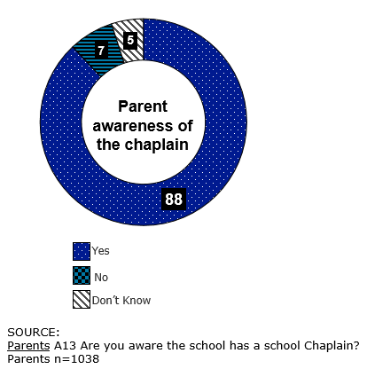

Similarly to students, awareness of the school chaplain among parents is high with 88% of parents aware of the school chaplain. Interaction with the chaplain among parents varied. For most parents, this included hearing about the chaplain through others (mainly their own child), or having a conversation with the chaplain themselves (including informal conversions, for example at school drop off):
- 80% had heard their child speak about the school chaplain
- 73% had spoken or had a conversation with the school chaplain; and
- 62% had heard a story about the school chaplain/chaplaincy services from other parents or children.

More direct engagement with the chaplain, included:
- Two-thirds of parents (65%) mentioned their child had visited or spent time with the school chaplain (both informal and/or formal engagement)
- The chaplain had visited the homes of 7% of parents – this included visits to the family in instances where there had been loss of a parent/grandparent, serious illness of a parent/family member and/or to visit the student if they were unable to attend school.

In the qualitative sessions, parents were asked to describe how much they knew about the role of the chaplain at their child’s school. Parents were able to broadly describe what they perceived the chaplain’s role to be, however, overall there was a lack of knowledge regarding the chaplain’s key role and responsibilities, the qualification required of chaplains and the activities being implemented in schools. There is an opportunity for schools to educate and inform parents regarding the role of chaplains in their school.

The qualitative sessions highlighted the importance of the ‘softer’ skills and personality traits required of chaplains. The following chart shows the personality characteristics described by parents during the qualitative sessions. The size of the word corresponds with the number of mentions i.e. the larger the word, the higher the mentions for this particular attribute.

Figure 4: Parental perception of required personality characteristics of chaplains
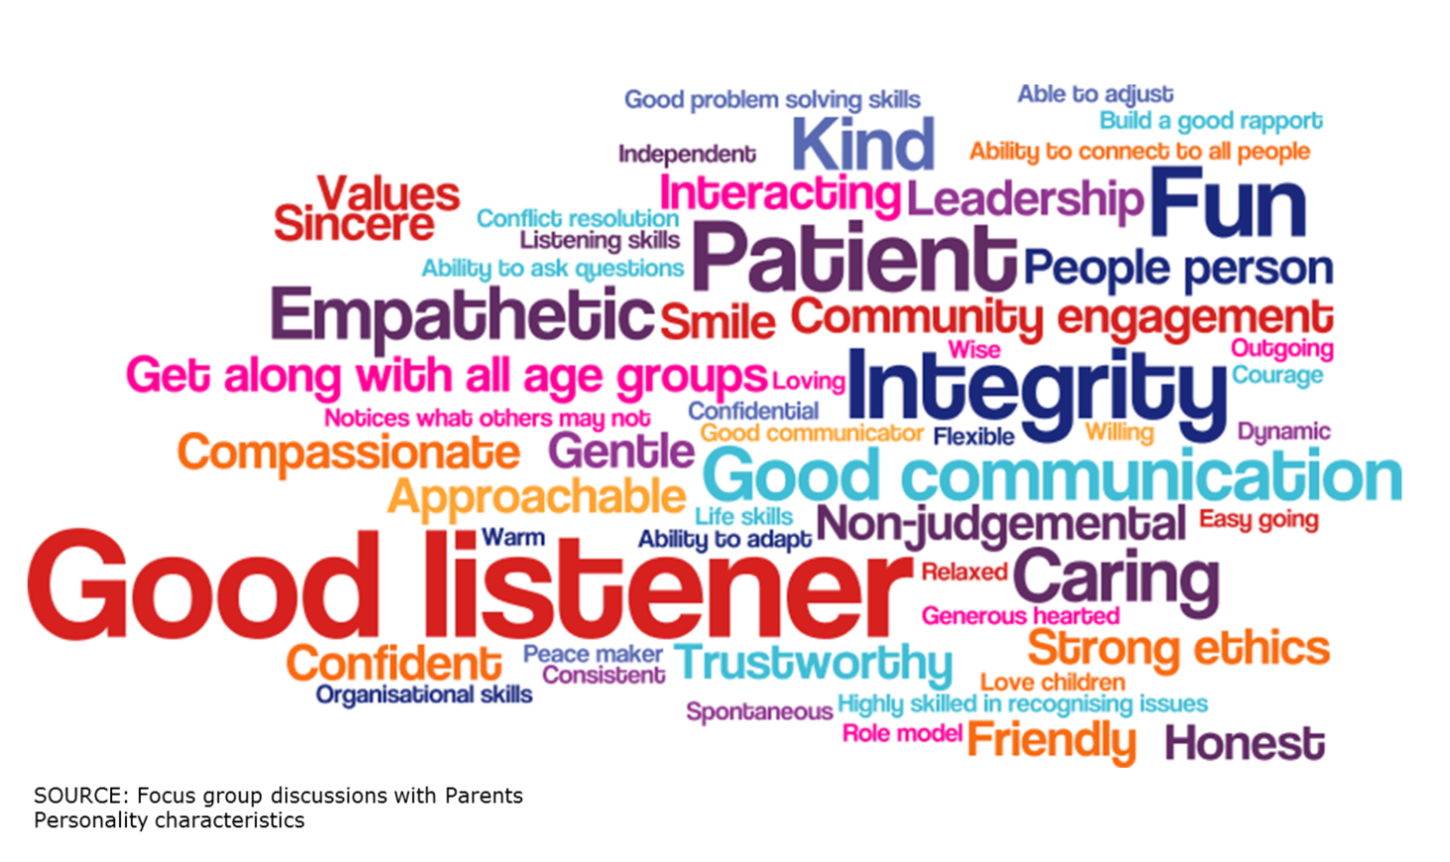

Parents identified the most important personality characteristics required of a chaplain to be: a good listener, having patience, integrity, being kind, empathic and fun. These skills were perceived to be as important as a formal qualification such as a certificate.

The most common qualifications cited by parents in the qualitative sessions, which were perceived to be the most important for chaplains to perform their role, included a qualification in psychology, counselling, youth services, child development or child care. Police checks and a suitable ‘working with children’ check were seen to be an essential, but standard requirement.

“Well you can have a formal qualification and be absolutely no good at your job. You can have the certificate in coaching skills or the certificate in youth work, but if you haven’t got the soft skills, the soft, the kind, the gentle, the listener, the communication skills… you’d hope the recruitment process and the selection would weed those people out who are not gentle and kind.” (Parent, Independent school, NT)

The following chart below shows the proportion of principals, chaplains and parents who spontaneously mentioned they had never experienced any negative issues with the delivery of the NSCP services.

Figure 5: Summary of proportion who have experienced a negative issue with delivery of the NSCP
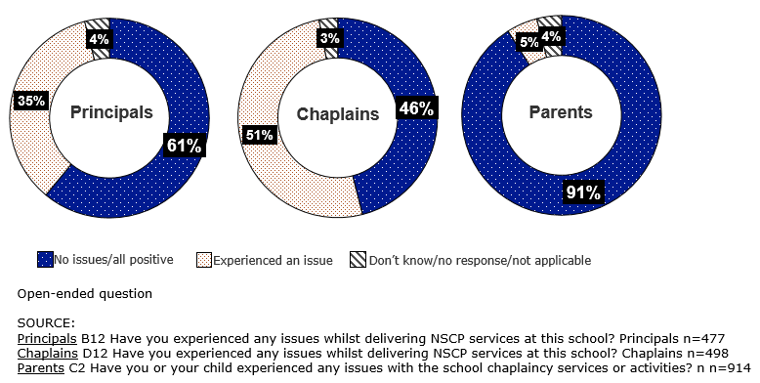

61% of principals had not experienced any negative issues in NSCP services at their school. The 35% of reported negative issues included:
- Availability issues, would like to have the service for 5 days / more access to the NSCP worker (9%)
- Funding issues (8%).

A few smaller mentions included:
- Sourcing chaplains with the appropriate skills/qualifications (3%)
- Clarity is required on roles and maintaining clear, open lines of communication (3%)
- Finding a chaplain has been difficult/difficult when in an isolated area (3%)
- Issues with some parents/families who do not support the chaplaincy programme (3%).

There were 13% other smaller mentions (below 2%), which included:
- Policy issues/guidelines (2%)
- Difficulties with keeping chaplains in their roles (1%)
- Some teachers being resistant to work with the chaplain (1%)
- Poor performance by chaplain (1%)
- No replacement when chaplains are ill (1%)
- 3% had no response/not applicable.

Around half of chaplains (46%) had not experienced any negative issues whilst delivering NSCP services. Of the 51% who had experienced some issues, these included:
- Availability issues i.e. the inability to meet the needs of the school community (15%)
- Funding issues (9%)
- A need for increased understanding of their role (8%)
- Some teachers were resistant to work with the chaplain (5%)
- Issues with some parents/families not supporting the chaplaincy programme (5%)
- Religious aspect/think we are religious teachers* (4%).

There were 12% other smaller mentions (below 4%), which included:
- The need for support/resources/own room/computer (3%)
- Issues with students/behaviour issues (2%)
- Policy issues/guidelines (1%)
- Unknown family circumstances/not told of the situation (1%)
- Getting access to the students due to school curriculum (1%)
- Chaplains who found their position challenging/felt the need for more professional development (1%)
- 3% had no response/not applicable.

91% of parents reported that neither they nor their child(ren) had experienced any negative issues with the school’s chaplaincy services.

Of the 5% who had experienced some negative issues, these included:
- Parents who didn’t like the religious aspect of chaplaincy activities/service as felt these were not for a government school environment (2%)
- Lack of skill working as a counsellor when they are not qualified to do so (1%)
- More time/should be available more (1%)
- Inappropriate lessons (1%)
- 3% had no response/not applicable.

What do students who utilise the programme consider to be the benefits of participation in the programme?

The main advantages for students of having a chaplain/chaplaincy services is that it provides an accessible figure for them to confide in, who is there to help and provide guidance.
Students were asked to describe the positive and negative aspects of having a chaplain at their school. The chart below shows the spontaneous responses provided by students when asked to describe the positive aspects. The negative aspects have been shown in chapter 4.2 (on page 43). Multiple responses could have been provided by participants, which may result in the percentages adding to more or less than 100%. All mentions of 4% or more have been shown below.

Figure 6: Student perceptions of the advantages of having a chaplain
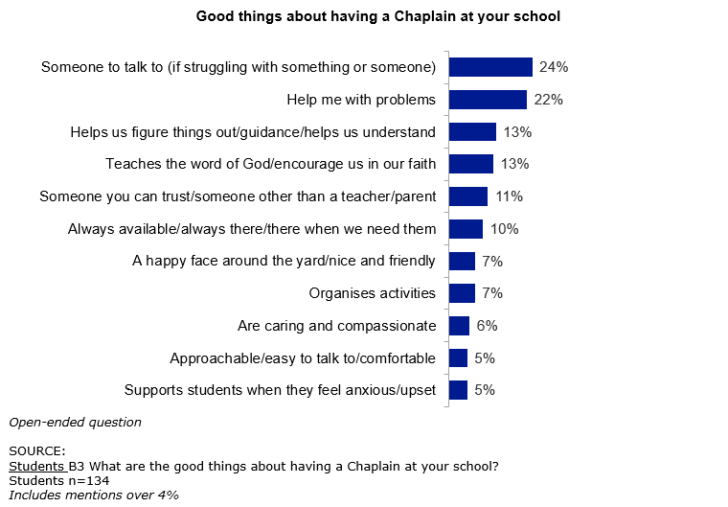

Students were also asked to describe the good things about having a chaplain at their school, using a spontaneous open-ended question. Around a quarter of students (24%) felt one of the good things about having a chaplain at their school was that it provides someone to talk to (22%), and someone to help with their problems (22%).

Around 1 in 10 students also felt the chaplain helped them ‘figure things out’, encouraged them in their faith, was someone you could trust and was someone who was always available when you needed them.

How is the NSCP currently viewed?

This section of the report outlines how chaplaincy services and activities delivered in schools are viewed by the school community. It includes the views of the school community towards chaplaincy and chaplaincy services, levels of support for the programme, overall levels of satisfaction and its perceived effectiveness.

How are the chaplaincy services provided viewed by principals, students and parents?

Overall there was a positive sentiment towards the NSCP. The programme is viewed as providing the school community with extra support, someone to talk to, and a confidential source providing guidance to the school community
The following table shows spontaneous responses provided by principals and chaplains when asked to describe their perception of the student opinion of the NSCP at their school. Responses were coded into themes and incorporated into the analysis. Multiple responses could have been provided by participants, which may result in the percentages adding to more or less than 100%. All mentions of 5% or more for principals and 10% or more for chaplains have been shown below.
Table 6: Principal and chaplain perceptions on the student opinion of the NSCP
Perceptions of the student opinion of the NSCP
Perceptions of Principals | - Positive/high opinion/well respected (43%)  - Have developed a great relationship/ fond of the Chaplain (26%)  - Supports students with emotional/social/home life issues (18%)  - Someone to talk to (17%)  - Someone you can trust/confidential/non-judgemental (15%)  - High appeal for the activities with the Chaplain/lunchtime activities (9%)  - High appeal for the programs/resources (8%)  - Students utilising the program/resources (8%)  - Gives them guidance/strategies (7%)  - Students appreciate the support (7%)  - Always available/there when students need them (6%)  - Students can share their problems/are approachable (5%)  - A valuable listener (5%)
Perceptions of Chaplains | - Positive/high opinion/well respected (34%)  - Someone to talk to (33%)  - Students appreciate the support (29%)  - Someone you can trust/confidential/non-judgemental (26%)  - Have developed a great relationship/fond of the Chaplain (18%)  - Provide a support network/another support person (18%)  - Provide a safe space/a friend (14%)  - High appeal for the programs/resources (12%)  - A valuable listener (12%)  - Someone to help/give guidance (10%)  - Students actively seek out/send their friends to the chaplain (10%)  - Students enjoy the fun activities/lunchtime activities (10%)

Principals and chaplains were asked to describe their perceptions of the student opinion of the NSCP at their school, using a spontaneous open-ended question. Overall, principals and chaplains considered there to be a positive regard for the programme among students. Principals and chaplains described the student opinion of the programme as ‘positive’, ‘high’ or ‘well-respected’. This sentiment was shared by almost half of principals (46%) and a third (34%) of chaplains. 1 in 4 principals (26%) considered the chaplain to be well-liked by students and felt a good relationship had been developed between students and the chaplain. The chaplain was considered to provide support to students, either emotional, social or support with ‘home issues’, and provide students with someone to talk to and someone they can trust.

The perceived student opinion of the programme among chaplains was largely positive. Chaplains considered students to appreciate the support provided to them, and as seen among principals, it provides students with someone they can talk to and someone they can trust, who is not a teacher or school staff member, providing support that is confidential and non-judgemental.

The following table shows the spontaneous responses provided by principals and chaplains when asked to describe their perception of the staff opinion of the NSCP at their school. Multiple responses could have been provided by participants, which may result in the percentages adding to more or less than 100%. All mentions of 5% or more have been shown below.
Table 7: Principal and chaplain perceptions on the staff opinion of the NSCP
Perceptions of the staff opinion of the NSCP
Perceptions of Principals | - Staff value their input/assistance/worthwhile resource (31%)  - Positive (27%)  - Provides valuable support/benefits students/student wellbeing (25%)  - Staff appreciate the extra support/ resources/feel relieved (20%)  - Staff seek out/utilise the Chaplain for advice and support (13%)  - Essential part of the team/integral to our school (13%)  - Well respected/highly regarded/valued member (7%)  - Caring/concerned/kind person/approachable (5%)
Perceptions of Chaplains | - Staff value their input/assistance/worthwhile resource (37%)  - Staff appreciate the extra support/ resources/feel relieved (30%)  - Provides valuable support/benefits students/student wellbeing (29%)  - Positive (21%)  - Someone they can talk to who they can trust/safe person (16%)  - Students are referred to my programs by staff/well utilised by the school (14%)  - Staff seek out/utilise the Chaplain for advice and support (14%)  - Essential part of the team/integral to our school (11%)  - Provide extra classroom support/work together in the classroom (10%)  - Always available/flexible (7%)  - Well respected/highly regarded/valued member (7%)  - Allows teachers to focus on teaching/their busy workload (6%)  - Caring/concerned/kind person/approachable (5%)  - Programs perceived to work well/can see the results/improvement (5%)

Perceptions among principals and chaplains on the staff opinion of the NSCP at their school were largely positive. School staff were considered to value the input and support provided by chaplains. This extra support was also seen to benefit the well-being of students. The chaplain was considered to provide advice and support to school staff, and be someone trustworthy they can talk to.

There were very few negative responses from principals and chaplains regarding their perceptions on the staff opinion. The table below outlines all negative perceptions that were cited.

Table 8: Principal and chaplain perceptions on the staff opinion of the NSCP – negative responses
Perceptions of the staff opinion of the NSCP
Perceptions of Principals | Negative responses included:  - Not all staff appreciate their good work (3%)  - Low opinion of NSCP (2%)  - Should be skilled/are not professionally trained (1%)  - Religious issues (1%)  - Should be more hours/available more during the day (1%)
Perceptions of Chaplains | Negative responses included:  - Not all staff appreciate their good work (9%)  - Should be more hours/available more during the day (5%)  - Religious issues (1%)  - Low opinion of NSCP (1%)
There were few comments describing the staff opinion of the NSCP negatively. The negative comments that were mentioned included:
- Not all school staff appreciate the work of chaplains
- Chaplains should be professionally trained/qualified
- A few mentions regarding religious issues; and/or
- Chaplains being more available or having an increased number of hours during the day.

The chart below shows the spontaneous responses provided by parents when asked to describe the advantages of having a chaplain/chaplaincy services at their school. Multiple responses could have been provided by participants, which may result in the percentages adding to more or less than 100%. All mentions of 5% or more have been shown below.

Figure 7: Parental perceptions of the advantages of having a chaplain
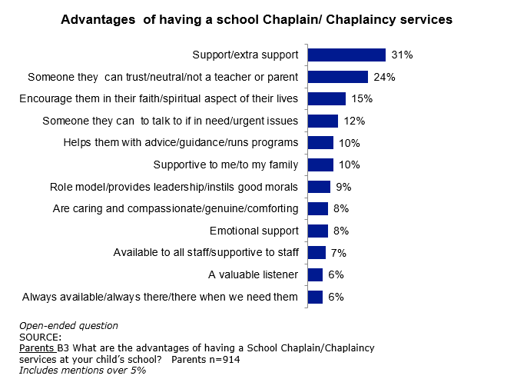
Parents were asked to describe the advantages of having a chaplain at their child’s school, using a spontaneous open-ended question.

Just under a third of parents (31%) spontaneously described the support or extra support the chaplain provides. Other advantages included having someone their children can trust, someone they can talk to, and someone who can encourage them in their faith/spiritual aspect of their lives. 1 in 10 parents (10%) also mentioned the advice and guidance provided by the chaplain to students, and the support given to parents or families.

The advantages cited by parents in the online survey were mirrored in the qualitative focus group sessions with parents. During the qualitative sessions parents described chaplains as playing a crucial role for students in being an additional adult figure available to children. This provides children with an additional source of support, over and above the support provided by parents and teachers. This is comforting for parents, knowing that there is another adult accessible to their child/children, who is unbiased and non-judgemental. Chaplains were considered to allow teachers to concentrate on teaching, providing an extra pair of eyes in the classroom, and being another avenue for students who are struggling.

Several parents cited one of the key advantages of the chaplain’s role is the time they have available and the fact that they are not outcomes based or curriculum focused. Unlike teachers, chaplains are not restricted by the need to ‘get through the curriculum’, they do not have to meet specific outcomes, targets or quotas i.e. they are not required to see a target number of students. Parents felt this enabled chaplains to focus their time on the wellbeing of students and broader school community.

“I think it is very important for children to have one more role model or mentor that is not associated necessarily with an authority figure or principal or teacher. I think it’s really good to have a mature adult available. To have someone who can help when there is a crisis or a situation, you just need someone, just an extra hand to help. I think it’s invaluable.” (Parent, Independent school, NT)

“There are a whole lot of stresses on their [students] life. Often the very last person a teenager wants to talk to is their parent. So knowing they’ve got an unbiased listening adult who doesn’t have an agenda is an incredible powerful force in that young adult’s life.” (Parent, Independent school, NT)

“My daughter, who is at the upper end of school, knows of several, not close friends in her group, but kids in her year, where both chaplains (we have both a male and female chaplain in our school), have been quite significant in helping troubled teens manage conflict at home or manage friendship dramas, particularly with the girls. She’s (my daughter) has always spoken really highly of either chaplain. They are approachable, the kids feel safe to share. From what I can gather, both chaplains manage that age group really well. They seem to be quite wise in the way they give advice or just gently help the young person to see a situation a little clearer.” (Parent, Independent school, NT)

“The chaplains have something the teachers don’t have, and that is time. What I have noticed in my daughters discussions with me when she randomly chats about friends, and these are 16-17 year olds, what she is seeing and saying about the chaplain is they just have time just to be with these young adults. If they are a skilled chaplain, and we are very blessed to have two very skilled chaplains, they just have a sense of which young adults are not traveling well. Sometimes they might hear from other kids and they have that ability to just walk alongside a really troubled young adult and just be able to give them… it’s like a sounding board for the young ones, but give them another way to look at the path they think they are stuck on and give them a sounding board to maybe show them there is another alternative.” (Parent, Independent school, NT)

What are the unmet needs of the programme for students and the broader school community and how can these be effectively addressed?

Parents and students were asked to describe the disadvantages of having a chaplain at the school. The chart below shows the spontaneous responses provided by parents. Multiple responses could have been provided by participants, which may result in the percentages adding to more or less than 100%. All mentions have been shown below.

Figure 8: Parental perceptions of the disadvantages of having a chaplain
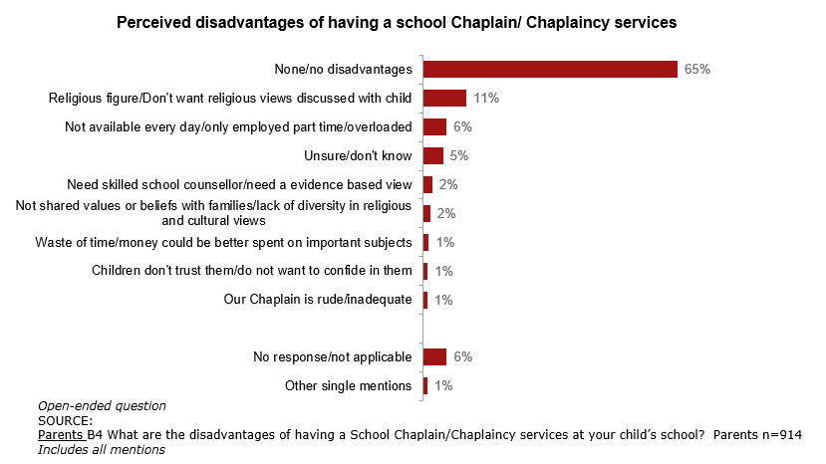

Two-thirds of parents (65%) felt there were no disadvantages in having a school chaplain. This was consistent across Catholic and independent schools, with 70% and 69% respectively, however, lower in government schools with 58%. There was no one factor dominating, but rather a range of smaller mentions. The largest disadvantage mentioned by parents was regarding religion, mentioned by 11% of parents, as they preferred religious views not to be shared with their child. Other smaller mentions included limited availability, the need for a skilled or evidence based role and the lack of diversity/shared values or beliefs with families.

These findings were closely aligned with the feedback gained during the qualitative focus group sessions. The majority of parents did not cite any disadvantages of having a chaplain or chaplaincy services in schools, however, the disadvantages that were mentioned included parents’ concerns with religion and the time/hours chaplains are available coming out most strongly:
- The limited hours/number of days chaplains were at some of the schools were perceived by parents to be a disadvantage. Parents expressed the desire to have the chaplain at the schools more often.
- For some parents, particularly parents of children in government schools, chaplaincy services were not considered appropriate for schools. This was driven by the perception that chaplaincy services included sharing or teaching of religious views and values, and was therefore felt better suited to private schools or religious families. This was explored during the qualitative sessions, in order to determine whether participants or their children had experienced a chaplain or chaplaincy services where religious views were unwillingly shared with themselves or their children, however, this was found to be based on their perception of the chaplain’s role and chaplaincy services, and was not based on an actual ‘lived’ experience.
- In these instances, where there were lower levels of support for chaplaincy services in schools, the position of the chaplain was considered to be better suited to a more qualified or skilled position, such as a psychologist, therapist or counsellor, who was felt to be more equipped to identify and manage issues that arise at school, particularly serious issues.
The quantitative survey indicated 18% of chaplains had a Certificate IV in Youth Work, 11% a Certificate IV in Pastoral Care and 17% an equivalent qualification. 70% of chaplains cited qualifications over and above the minimum qualification requirements, which included: diploma/advanced diploma/associate degree/bachelor degrees/honours/masters.

“My view is, with its religious view, I think it should be kept out of public schools. If they want to promote a religious basis then you can get this in a private school, or if the parents are religious then they can take the kids to church, and do it that way and in the home. Not in the public school” (Parent, Government school, SA)

“I think if you send your children to a Catholic school, I went to a Catholic school, so the religious undertones were there the whole way through and it was to be expected. But at a state school, I don’t believe they should have the religious undertones. ” (Parent, Government school, SA)

“I would say instead of a chaplaincy service, it would be more important to have a psychologist or a therapist here. Not relying on a chaplain as such. With a psychologist or therapist, they’ve got the skill sets. If there are underlying issues with the child they can identify that maybe the child has some sort of mental illness. The chaplain doesn’t have that skill set and can’t really address it. ” (Parent, Government school, SA)

“I think they need to be versatile in their skill set rather than just what they do. I think for the younger children especially, they need some formal qualification. Whether it is a TAFE counselling or youth services or whatever or a formal degree in psychology, as they move into high school I also think they should have core career advisory type skills to help with subject selection, career paths, industry links, connections and things like that. I think that is where the difference is now, whereas before it was a very airy fairy ‘kumbaya’ type position. Nowadays, especially in schools with the increasing pressures and the increasing problems that students are having, I think it needs to be taken a lot more seriously and they need to be offering a variety of services rather than just hand holding and that sort of thing ” (Parent, Government school, SA)

The chart below shows the spontaneous responses provided by students regarding the negative aspects of having a chaplain at the school. Multiple responses could have been provided by participants, which may result in the percentages adding to more or less than 100%. All mentions have been shown below.

Figure 9: Student perceptions of the disadvantages of having a chaplain
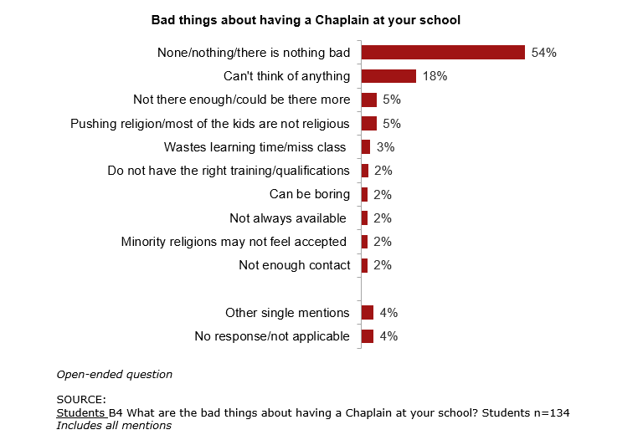

Over half of students (54%) mentioned there were no ‘bad things’ about having a chaplain at their school.

Almost 1 in 5 students (18%) were unable to think of anything. There were a few smaller mentions which were focused around the chaplain not being there enough/ limited availability, and religion (which were also mirrored by parents).

Is the programme supported?

The NSCP is well supported across the school community
Principals, chaplains and parents were all asked how well they considered the chaplaincy services and activities to be supported by the school community. Results for each target group have been provided below.

Figure 10: Levels of support for chaplaincy services and activities – views among others
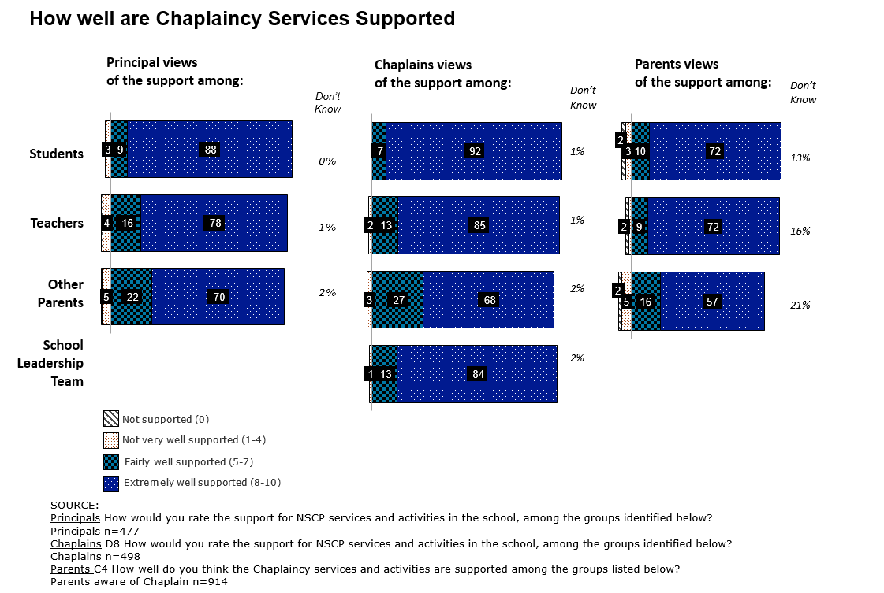

Principals, chaplains and parents rated the support of chaplaincy services among the school community strongly, particularly among students. 88% of principals, 92% of chaplains and 72% of parents considered the programme to be extremely well supported by students.

A similar trend was seen regarding the support of teachers; 78% of principals, 85% of chaplains and 72% of parents considered the programme to be extremely well supported among teachers.

The chart below shows the proportion of parents who support chaplaincy services and activities in their child’s school. The results for each of the three school types have also been included.

Figure 11: Parental support for chaplaincy services and activities
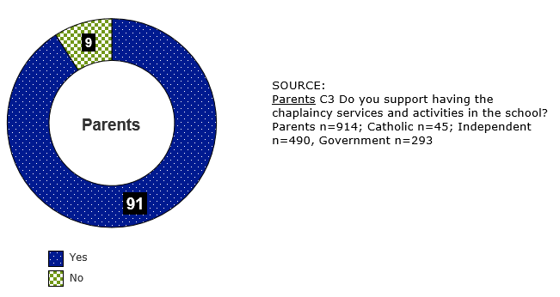

Category: % of Yes
School Type | Parents N=914
Catholic | 96%
Independent | 95%
Government | 83%

Support for the programme is high, with 91% of parents supporting having chaplaincy services and activities in their child’s school. Although support was high across all school types, support among parents in government schools was significantly lower, with 83% compared to 96% in Catholic schools and 95% in independent schools.

How satisfied are principals, students and parents with the chaplaincy services and the activities/strategies which underpin them?

Satisfaction with the NSCP is high
Principals were asked to indicate the overall satisfaction of the NSCP services and activities delivered in their school, using a 10-point scale. The chart overleaf on page 46 indicates the levels of satisfaction of principals and their views on the satisfaction of students, teachers and parents.

Figure 12: Principal satisfaction with the NSCP and their views on student, teacher and parental satisfaction
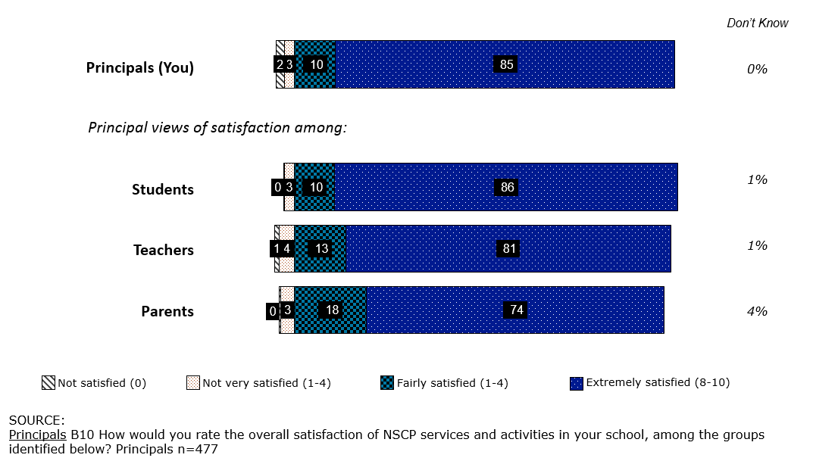

Principals were largely satisfied; with 85% being extremely satisfied with the NSCP services and activities delivered in their school. Principals perceived student, teacher and parent satisfaction levels to be high across all groups, with a large proportion of principals rating satisfaction as ‘extremely satisfied’:
- Approximately 9 in 10 (86%) students were considered to be extremely satisfied
- Approximately 8 in 10 (81%) teachers were considered to be extremely satisfied; and
- Approximately 7 in 10 (74%) parents were considered to be extremely satisfied.

How important is the NSCP considered by the principal, chaplain, students and parents in supporting the wellbeing of students?

The NSCP is considered to be important to the school community, and increases in importance with higher levels of engagement
The chart overleaf on page 47 shows how important principals, chaplains, parents and students consider the chaplaincy services delivered in schools to be.

Figure 13: The importance of chaplaincy services among principals, chaplains, parents and students
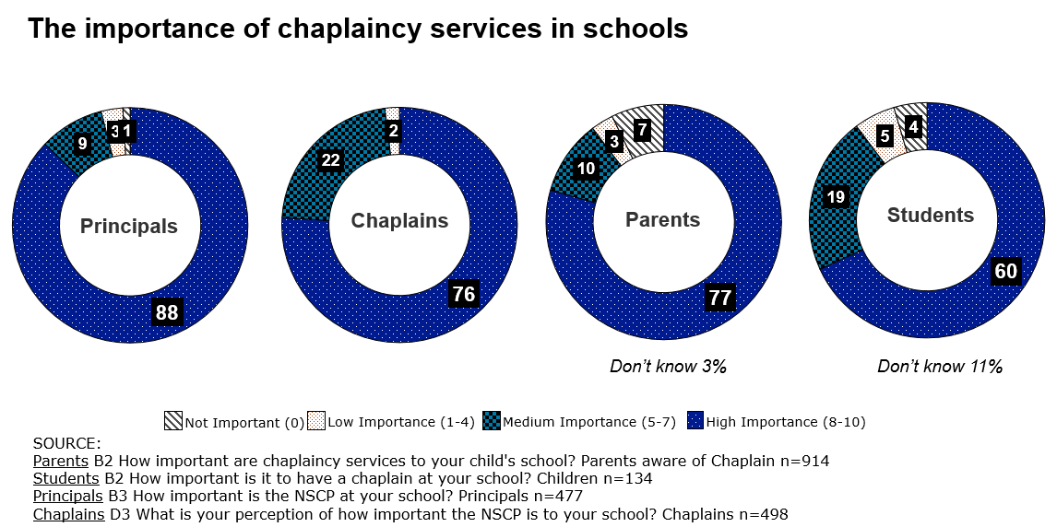

The NSCP is considered to be important to the school community. 88% of principals, 76% of chaplains, 77% of parents, and 60% of students consider the NSCP to be important to their school community.

There is a higher proportion of ‘don’t know’ among parents and students; these parents and students were more likely to have had little or no interaction with the school chaplain.

Significantly, the importance of the programme increases with increased engagement. Students who had spent time with the chaplain on an individual basis were more likely to consider the NSCP as important, with 81% rating it with high importance compared to 44% of students who had little contact, or 33% among students with no contact with the chaplain.

What are the outcomes of the NSCP?

This section of the report includes the findings on the impact of the programme on students and the school community, the perceived outcomes, both positive and negative, and the effectiveness of the programme in dealing with various issues. The suggested improvements for delivery of the programme in the future have also been included.

What impact does the programme have on students and the broader school community (including parents)?

Chaplains under the NSCP have dealt with a broad spectrum of issues, with peer relationships and family relationship being the most common
The main issues chaplains have dealt with at the school have been outlined in the chart below.

Figure 14: The main issues faced by chaplains at the school
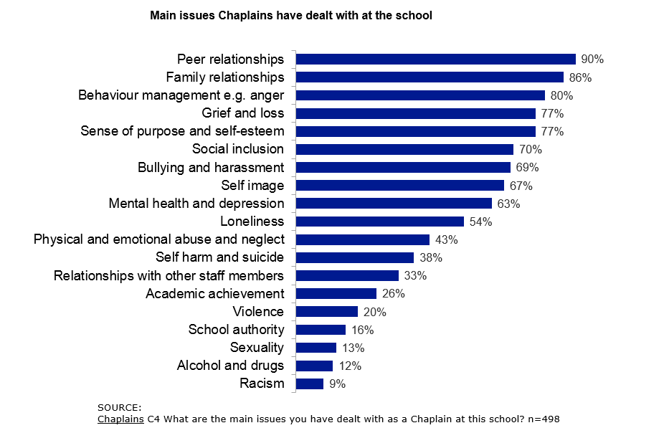
Chaplains were asked using a coded list of issues, which are the main issues they have dealt with as a chaplain at the school. Peer relationships and family relationships were the most common issues faced by chaplains, with around 9 in 10 chaplains having deal with these issues at the school. This was followed by:
- Around 8 in 10 chaplain’s having dealt with behaviour management e.g. anger, grief and loss, and sense of purpose and self-esteem
- Around 7 in 10 had dealt with social inclusion issues, bullying and harassment and self-image.

Approximately 1 in 10 chaplains had dealt with racism, alcohol and drugs and sexuality.
The main issues chaplains have dealt with at government, independent and Catholic schools have been outlined in the chart below.

Figure 15: The main issues faced by chaplains in government, independent and Catholic schools
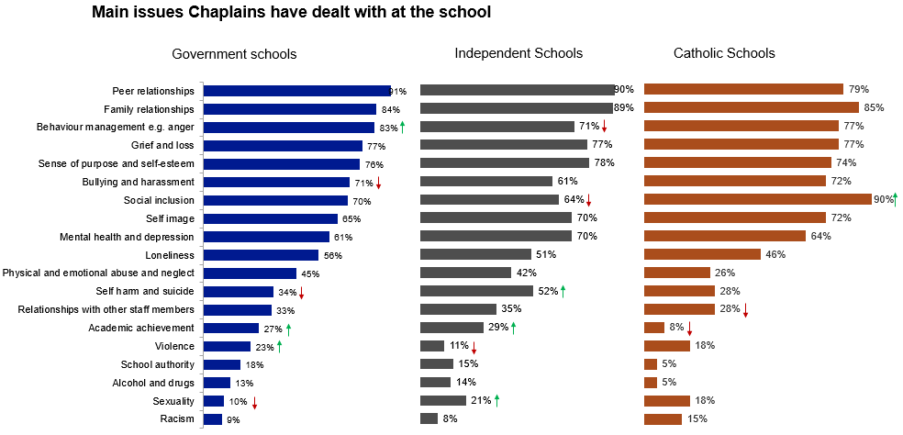
The main issues dealt with by chaplains were largely consistent across government, independent and Catholic schools, however, there were the following differences:

In government schools, the most common issues chaplains had dealt with were peer relationships (91%) and family relationships (84%). Behaviour management e.g. anger was the third most common, dealt with by 83% of chaplains.
- Behaviour management was more likely to be mentioned by chaplains of government schools (83%) and Catholic schools (77%) compared with independent schools (71%). Interestingly, although there were only around 23% of chaplains in government schools and 18% in Catholic schools who had dealt with violence, this was more likely to be reported in these schools compared to independent schools, where only 11% of chaplains had dealt with this issue.

In independent schools, the most common issues chaplains had dealt with were peer relationships (90%) and family relationships (89%), which is largely consistent with government schools. Sense of purpose was the third most common, and had been dealt with by 78% of chaplains (similar to that of government schools with 76% and Catholic schools with 74%).

Chaplains of independent schools were more likely to report having dealt with the following issues:
- Self harm and suicide (52%; compared to 34% in government and 28% in Catholic schools)
- Sexuality* (21%; along with Catholic schools at 18%, however, compared to only 10% in government schools)
- Academic achievement (29%; along with government schools at 27%, however, compared to only 8% in Catholic schools).

In Catholic schools, social inclusion was the most common issue dealt with by chaplains (90%), followed by family relationships (85%) and peer relationships (79%). As outlined above, chaplains of Catholic schools (along with chaplains in government schools) were less likely to have reported having dealt with self harm and suicide (28%, compared to 52% in independent schools), and were also less likely to have reported dealing with academic achievement (8%, compared to 27% in government and 29% in independent schools).

What are the perceived outcomes (both positive and negative) of the programme?

The NSCP is considered to be most effective in dealing with issues regarding sense of purpose and self-esteem, building peer relationships and social inclusion
Principals, chaplains and parents were asked how effective the NSCP was in dealing with a range of issues. The table below shows the proportion of principals, chaplains and parents who have rated the chaplaincy programme as dealing with each of these issues extremely well (i.e. rating between 8-10 on a 10-point scale).

Table 9: Effectiveness of the chaplaincy programme in dealing with various issues
% | Principals- Extremely well (8-10) | Principals -Don’t know | Chaplains - Extremely well (8-10) | Chaplains - Don’t know | Parents - Extremely well (8-10) | Parents -Don’t know
Sense of purpose and self-esteem | 82% | 1% | 89% | 1% | 63% | 25%
Peer relationships | 82% | 2% | 88% | 0% | 59% | 27%
Social inclusion | 80% | 2% | 88% | 1% | 56% | 31%
Self image | 75% | 5% | 87% | 1% | 55% | 33%
Family relationships | 70% | 7% | 77% | 1% | 52% | 37%
Bullying and harassment | 72% | 3% | 81% | 2% | 49% | 38%
Loneliness | 79% | 3% | 82% | 2% | 49% | 39%
Grief and loss | 78% | 6% | 86% | 2% | 47% | 43%
Mental health and depression | 70% | 8% | 75% | 4% | 45% | 44%
Relationships with other staff members | 67% | 7% | 74% | 3% | 44% | 45%
Behaviour management e.g. anger | 68% | 4% | 76% | 1% | 43% | 45%
Academic achievement | 46% | 9% | 53% | 10% | 42% | 41%
School authority | 57% | 15% | 67% | 7% | 42% | 45%
Physical & emotional abuse and neglect | 62% | 11% | 69% | 8% | 30% | 61%
Racism | 51% | 23% | 60% | 18% | 30% | 59%
Violence | 54% | 15% | 57% | 14% | 29% | 60%
Self harm and suicide | 51% | 25% | 63% | 17% | 29% | 62%
Sexuality | 40% | 30% | 44% | 25% | 26% | 63%
Alcohol and drug abuse | 36% | 35% | 38% | 30% | 24% | 66%

The NSCP was considered to be effective by principals, chaplains and parents in dealing with a range of issues. The issue of sense of purpose and self-esteem was ranked highest across all target groups, with 82% of principals, 89% of chaplains and 63% of parents rating the NSCP to be extremely effective in dealing with this issue.

Around 8 in 10 principals, 9 in 10 chaplains and 6 in 10 parents considered the NSCP to be extremely effective in dealing with:
- Sense of purpose and self-esteem
- Peer relationships
- Social inclusion; and
- Self-image.

Sense of purpose and self-esteem issues were reported to be one of the main issues dealt with by around 77% of chaplains. Peer relationships were reported as being dealt with by 90% of chaplains, social inclusion by 70% and self-image by 67% of chaplains.

The NSCP was also considered to be effective (rated as extremely effective) in dealing with:
- Family relationships (by 70% of principals, 77% of chaplains, and 52% of parents)
- Bullying and harassment (by 72% of principals, 81% of chaplains, and 49% of parents)
- Loneliness (by 79% of principals, 82% of chaplains, and 49% of parents)
- Grief and loss (by 78% of principals, 86% of chaplains, and 47% of parents)

The chaplaincy programme was perceived to be less effective when dealing with issues such as alcohol and drug abuse, sexuality, self-harm and suicide and issues of racism. There was a large proportion of principals, chaplains and especially parents, who cited they were unsure (i.e. ‘don’t know’) as to whether the programme was effective in dealing with such issues.

As outlined in chapter 4.1 (on page 28) there are a wide variety of activities/initiatives delivered in schools under the NSCP. The chart below shows how the activities/initiatives delivered in schools were considered by chaplains to contribute to the wellbeing of students and the school community.

Figure 16: Perception of how chaplaincy activities contribute to the wellbeing of students and the school community
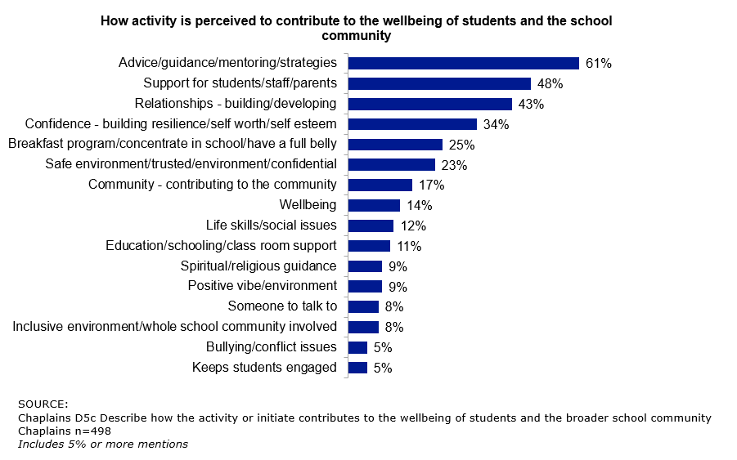

The activities/initiatives delivered as part of the chaplaincy programme were considered by chaplains to contribute to the wellbeing of students and the school community by:
- Providing advice, guidance, mentoring or strategies (cited by 61%)
- Providing support for students, staff and /or parents (cited by 48%)
- Working towards building and developing relationships (43%); and
- Building confidence, resilience and /or self-esteem (33%).

Programmes such as the breakfast clubs or food programmes assisted students with increased concentration, while formal support, such as one on one sessions, were reported to provide students with a safe and trusted environment.

Parents in the qualitative focus groups sessions considered the ‘informal’ type of support (activities organised by the chaplain, interacting with students during recess or lunch, social activities/outings), to all contribute towards building rapport with the students. These informal approaches then make students feel comfortable to approach the chaplain for more formal structured support.

Is the programme perceived to contribute to: a supportive and safe learning environment; an improvement in student engagement and connectedness; and creating an environment which promotes wellbeing?

The NSCP is considered by principals, chaplains and parents to most strongly contribute towards supporting the emotional and social well-being of students
The following table below indicates the proportion of principals, chaplains and parents who rated how well the NSCP services and activities contributes to a range of areas.

Table 10: How well does the NSCP contribute to various areas
% | Principals-Extremely well (8-10) | Principals- Don’t know | Chaplains- Extremely well (8-10) | Chaplains-Don’t know | Parents-Extremely well (8-10) | Parents-Don’t know
Supports the emotional wellbeing of students | 89% | 1% | 79% | 0% | 76% | 12%
Supports the social wellbeing of students | 88% | 0% | 78% | 0% | 76% | 12%
Assist students in dealing with crisis/ loss situations | 84% | 2% | 72% | 2% | 68% | 22%
A caring learning environment | 83% | 1% | 68% | 0% | 74% | 14%
Providing accessible & on-going support for individuals | 83% | 1% | 72% | 0% | 69% | 17%
Supports school staff and counsellors in the provision of student welfare services | 80% | 1% | 69% | 1% | 66% | 23%
Improving relationships between students | 80% | 0% | 63% | 0% | 69% | 17%
Modelling and teaching moral values | 80% | 1% | 76% | 1% | 74% | 14%
A supportive learning environment | 79% | 1% | 60% | 1% | 68% | 16%
Improving the morale of the school | 76% | 1% | 64% | 1% | 72% | 15%
An inclusive learning environment | 75% | 2% | 60% | 2% | 65% | 19%
An improvement in student engagement | 71% | 1% | 52% | 1% | 64% | 19%
Assisting students with specific needs allowing teachers to focus on teaching and student learning | 71% | 2% | 62% | 2% | Not asked | Not asked
Supports parents in the school community | 69% | 3% | 48% | 1% | 65% | 18%
Improving staff morale | 68% | 2% | 52% | 2% | Not asked | Not asked
Facilitating access / referrals to appropriate support mechanisms | 66% | 4% | 56% | 3% | 53% | 32%
Improving relationships between students and their families | 66% | 5% | 48% | 2% | 61% | 24%
Linking the school to the wider community | 64% | 2% | 42% | 1% | 58% | 22%
Assisting teachers in the classroom to deliver specific material | 54% | 4% | 40% | 7% | Not asked | Not asked

The NSCP services and activities were rated by almost 9 in 10 principals and 8 in 10 chaplains and parents to perform extremely well in contributing to supporting the emotional and social wellbeing of students. This is a positive finding as it strongly aligns with the overarching objectives and aims of the NSCP.

Contributing towards the emotional wellbeing of students and supporting the social wellbeing of students were rated as the top two areas by principals, chaplains and parents.

In addition to supporting the emotional and social wellbeing of students, the NSCP services and activities were also considered to contribute towards:
- Assisting students in dealing with crisis/loss situations e.g. family breakdown/death (84%), creating a caring learning environment (83%) and in providing accessible and on-going support for individuals (83%) - principal responses
- Modelling and teaching moral values (76%), contributing towards assisting students in dealing with crisis/loss situations e.g. family breakdown/death (72%), in providing accessible and on-going support for individuals (72%) - chaplain responses
- Creating a caring learning environment (74%), modelling and teaching moral values (74%) and towards improving the morale of the school (72%) - parent responses.

Students considered chaplaincy services to be most effective in assisting those who have problems, and in making the school a better place
The table below outlines how effective students perceive the chaplain to be in assisting students.

Table 11: How well does the chaplain assist students with various issues
% | Students - Extremely well (8-10) | Students -Don’t know
Helps students who have problems | 66% | 15%
Makes the school a better place | 66% | 12%
Provides students with someone they can talk to | 65% | 12%
Encourages students to do the right thing | 64% | 12%
Helps students who are lonely | 63% | 12%
Helps students feel good about themselves | 63% | 14%
Makes the school a caring place | 63% | 12%
Makes students feel safe | 63% | 14%
Helps students who are dealing with crisis/loss | 62% | 22%
Encourages students to be responsible | 60% | 16%
Helps stop bullying at the school | 59% | 12%
Helps students get along with each other | 58% | 13%
Encourages students to achieve at school | 54% | 17%
Helps students get along with their families | 46% | 29%

Two-thirds of students (66%) considered chaplaincy services to be most effective in assisting students who have problems and in making the school a better place. This was followed by students who felt the chaplain was effective in providing someone they can talk to (65%), encouraging students to do the right thing (64%), helping students who are lonely (63%) and helping students feel good about themselves (63%).

63% of students also considered chaplaincy services to contribute to the school environment, making the school a caring place and making students feel safe.

During the qualitative sessions, parents were asked to share a story/experience where a child had been impacted by NSCP chaplaincy services. Two examples of these stories have been outlined overleaf (on page 55 and 56) to demonstrate the impact of the chaplain and chaplaincy services on the school community.

Please note specific information has been removed/changed where necessary to protect the identity of participants.

Parent Participant Story #1
“I am a local Aboriginal woman, single mum of two teenage boys, now 13 and 16. I feel compelled to share my story in the hope that the chaplaincy programme remains in our schools to support our kids and their parents.
Eight years ago, the father of my sons left me and at the time my sons were only 5 and 8, so still very young to understand what was going on. I made the decision to transfer them from public school to private, due to being a single mum who was well aware of our public school system and for fear that my sons weren’t able to deal with the separation. I thought private schooling would be better equipped to deal with their emotional issues as I worked full time and was unable to cope myself emotionally.
At the beginning, we, (the school and I), had to work through some pretty significant issues and over time they grew.
- Bullying from their previous school
- Pain and hurt from the separation
- Eldest son being diagnosed with a rare condition preventing him from participating in various sporting events
- Youngest son involving himself with a girl who was self-harming
- Youngest son self-harming out of concern for this girl
- Clashes with teachers over attitude
- Anger issues that had built up
- Mums choice to have two relationships in the past eight years with men that weren’t very nice to me or my sons
I could deal with these issues at home but at school I relied on the teachers as I couldn’t be there and some of the issues only became evident when the boys were at school.
So after lengthy and regular meetings with the school principal, we agreed the only way forward was to keep in regular contact so we are effectively ‘on the same page’.
The chaplain at my son’s private school was truly a godsend. He would always take the time to mentor and nurture my sons, check in on their progress and ask the right questions, give them space to make decisions and always kept me in the loop with things or issues I needed to be made aware of.
The most heart breaking was when my youngest son was kicked in the stomach and head by his so called best friend, and when he began self-harming. This was a very scary time for me and I would have imagined it was for him too.
[The chaplain] spent many hours at school with my youngest, in an attempt to get to the bottom of the issues he had been experiencing.
As a single mum who has raised her sons to know right from wrong, there have always been external influences that have impacted on the outcome, whether it be another person, peer pressure or the need to do things to fit in.
Between the principal, the chaplain and I, we managed to pick up on what my youngest son had been doing in the bathroom with a razor. This was also thanks to his big brother who we had engaged to help us, as they’re very close.
For several months he had been cutting his legs without me knowing anything about it. He would then post pictures on social media for his friends to see and comment on, which as you can imagine caused a considerable amount of grief to his brother and I.
A meeting was held with the school and measures were implemented to monitor his behaviour, including being forbidden to continue seeing the girl who introduced him into that world.
Suffice to say, if it weren’t for the chaplaincy, my baby boy may not be here today! It is such a worthwhile cause, if it helps to save lives, it is simply worth its weight in gold.”

Parent Participant Story #2
“My son was having a few dramas and this particular chaplain was able to spend a few lunch time and recesses with him playing sport and things.
So there was some good things to come from that because he had the time and opportunity to do that, whereas other teachers knew what was going on but weren’t able to really prioritise the time.
The chaplain was free to go and deal with him and talk about other things. That has led to the point now, where that has developed a bit of an interest for my son in basketball and he is now playing a sport.”

How could delivery of the programme be changed or improved in the future?

The main suggested improvements of the programme included increased availability/time allocation of chaplains and increased education/awareness on the programme and the role of chaplains.
The table below outlines the spontaneous improvements/changes suggested by each of the target audiences. Multiple responses could have been provided by participants, which may result in the percentages adding to more or less than 100%. All mentions of 3% or more have been shown below.

Table 12: Suggested NSCP improvements
Suggested NSCP improvements
Principals | - More time allocation - full time / more days (42%)  - More funding (19%)  - All great/No improvements/none (15%)  - No response/Not applicable (6%)  - Better skilled counselling / more training for their role (4%)  - More staff / resources (4%)  - Make sure it extends/continues into 2018 (3%)
Chaplains | - More time allocation - full time / more days (30%)  - More funding - so we don't have to fundraise and we can focus on our role (25%)  - Would not change anything (12%)  - More awareness/ promote the role more/more education about the role (7%)  - Don’t know/unsure (6%)  - No response/Not applicable (5%)  - More PD opportunities available / training opportunities (4%)  - Documenting processes for clarity/what is expected of their role/school policy (4%)  - Easier funding process/use a different funding model (3%)
Parents | - More awareness of chaplaincy/the role/more communication on the programs (24%)  - Don’t know/unsure (20%)  - They are doing an excellent job/no improvements (14%)  - Educate parents about the service/communicate more with parents (12%)  - More funding to extend the services / better funding (10%)  - No response/Not applicable (7%)  - Remove them from schools (4%)  - Religious aspect/pursuing their own religious agenda (3%)  - Support staff for the chaplain (3%)  - A second chaplain employed for male students/chaplains for male and female students (3%)
Students | - No/no improvements, doing a very good job (40%)  - Don’t know/unsure (17%)  - Not applicable (11%)  - Being available every day/here more days of the week/full time (7%)  - Get to know more students/interacting with students/ those that don't need help (4%)  - Religion/pushing religion/use a different approach (4%)  - Give everyone a chance to be heard/primary and secondary students (4%)  - Run more programs/ activities/sessions (3%)

Principals and chaplains felt the NSCP could be improved through increased time allocation and funding i.e. having the chaplain funded for more days or in a full-time capacity. These two suggested improvements dominated for both principals and chaplains. A few smaller mentions included increased training opportunities, more training for the role and professional development.

A small proportion of principals also suggested an increase in the resource pool available/more staff (mentioned by 4%) and a desire for the programme to extend/continue into 2018 (mentioned by 3%).

15% of principals did not have any improvements or suggestions for the programme, and 12% of chaplains would not change anything.

Both chaplains and parents cited the need for an increase in awareness of chaplaincy, the programme and the role of chaplains. This was suggested by 7% of chaplains and was the top overall suggested improvement among parents, with 24% making this suggestion. 12% of parents also suggested greater education of parents and communication regarding the programme services.

Similarly to principals and chaplains, 10% of parents suggested increased funding to extend the services / increase the availability of chaplains and 3% suggested the inclusion of an additional chaplain in order to have both male and female chaplains available for the male and female students.

There were a small proportion of parents (4%) who suggested that chaplaincy services/chaplains be removed from schools. This was more likely to be mentioned by parents of students in government schools (6%), compared with 3% independent schools and 2% Catholic schools. 3% of parents cited they would change the religious aspect of the programme. Again, this was more likely to be mentioned by parents of students in government schools (6%), compared with 2% independent schools and 4% Catholic schools.

For students, around 40% did not have any suggested improvements and felt the chaplains were ‘doing a great job’. There were a few students (around 7%) who mentioned the chaplain should be more visible and available, which aligns to both principals and chaplains.

There is an opportunity to increase awareness, education and communication to parents on the chaplaincy programme, the services available and its role within the school.

“I think our school would probably love to employ the chaplain more and maybe it would have been easier to get someone with more work fraction. It’s really hard to find someone who only wants to work one or two days a week. People want a job. I think if there is anything our school would like, it’s probably for the chaplain to be there more.” (Parent, Independent school, NT)

Conclusions of the evaluation
Overall, there is a positive sentiment towards the NSCP and the programme was described with positive regard. Students were considered to have a high opinion of the programme and to benefit from having someone to provide additional support, someone to talk to and someone that is a ‘neutral’ person (not a teacher or parent) they can confide in.

The NSCP is delivered through a wide range of activities/initiatives which encompasses different types of support, from formal support (e.g. one-on-one individual sessions), informal support (e.g. lunchtime activities), delivery of specific programmes (e.g. breakfast clubs) to assisting with out of school activities (e.g. school camps). Activities/initiatives delivered across schools were largely consistent, and worked towards providing students and the school community with an accessible figure who provides support, encouragement and guidance.

The NSCP was considered to be effective in dealing with a range of issues, and most effective in dealing with issues regarding sense of purpose and self-esteem, building peer relationships and social inclusion. The programme was rated to perform extremely well in supporting the emotional and social wellbeing of students, which strongly aligns with the overarching objectives and aims of the NSCP.

Awareness of chaplaincy services is high, however, there is limited knowledge of the role of chaplains. There is an opportunity for schools to address the knowledge gap that exists among parents, by increasing awareness of the programme itself, and the chaplain’s role, and sharing/increasing communication on the activities/initiatives that are being implemented to support the wellbeing of students and the school community.

Overall, few disadvantages were associated with the NSCP. There were a proportion of parents and students (particularly from government schools) who preferred religious views were not shared. This was driven by the perception that chaplaincy services included sharing or teaching of religious views and values, and was therefore felt better suited to private schools or religious families.

The main suggested improvements for the programme included increasing the availability/time allocation of chaplains. A number of principals, chaplains, parents and students all communicated the need for the chaplain/chaplaincy services to be more available, available for more days or in a full-time capacity to adequately service and meet the needs of the school community.

In conclusion, the evaluation indicates the NSCP is considered to effectively support the wellbeing of students and the broader school community. The programme is regarded as important for the school and is well supported by the school community (i.e. by principals, chaplains, parents and by students). There is strong support for the programme to be continued.

Appendices

Profile of target audience groups
The table below provides a profile of the schools that participated in the research, based on the responses from principals. It outlines the location of the school, the length of time principals have been at the school, their perceptions on the proportion of students from different socio-economic backgrounds, Aboriginal and Torres Strait Islander descent, and students from culturally and linguistically diverse backgrounds. It also includes which years of current NSCP programme schools are participating in as well as the programmes the school has previously participated in.

Table 13: Profile of schools and principals
Location | Principals N=477 | Principals %
Metropolitan | 254 | 53%
Remote*** | 215 | 45%
Very Remote*** | 8 | 2%

Length of time at the school (for Principal) | Principals N=477 | Principals %
Less than 2 years | 164 | 34%
2-5 years | 136 | 29%
5+ years | 177 | 37%

Years participating in NSCP**** | Principals N=477 | Principals %
2015 | 409 | 86%
2016 | 444 | 93%
2017 | 358 | 75%
2018 | 313 | 66%

Previous participation (%Yes) | Principals N=477 | Principals %
**NSCSWP (2012-2014) | 283 | 59%
NSCP (2007-2011) | 133 | 28%

Socio economic backgrounds of students* | Principals %
Low (average) | 46%
Medium (average) | 43%
High (average) | 11%

Subgroups | Principals %
Proportion students who are Aboriginal or Torres Strait Islander descent* |  | 12%
Proportion of students who speak another language other than English at home* |  | 20%

*The proportion of students from different social economic backgrounds, from Aboriginal or Torres Strait Islander descent and/or those who speak another language other than English at home were estimated by the principal based on their perception.
** National School Chaplaincy and Student Welfare Programme (NSCSWP)
***Remote/Very Remote: classified as per the NSCP Agreement and self-selected by Principals during the survey
****Years participating in NSCP – Principals were asked to advise in which years they have elected to participate

There was a good spread of principals: 34% had been at the school for less than two years, 29% had been at their school between two to five years and 37% had been at their school for more than five years. Based on the perception of principals, around 12% of students were of Aboriginal and Torres Strait Islander descent and around 20% spoke a language other than English at home.
Around 9 in 10 schools participated in the 2015 and 2016 NSCP, 3 in 4 (75%) participated in 2017 and around two-thirds (66%) plan to participate in 2018.

The table below provides a profile of chaplains that participated in the research. It outlines the school type and state, the length of time chaplains have been with the school, their age, gender, qualification and the proportion who work solely at the one school compared to those that also work at other schools.
Table 14: Profile of chaplains
School Type | Chaplain N=498 | Chaplain %
Catholic | 39 | 8%
Independent | 114 | 23%
Government | 345 | 69%

State | Chaplain N=498 | Chaplain %
ACT | 6 | 1%
NSW | 137 | 27%
NT | 5 | 1%
QLD | 203 | 41%
SA | 54 | 11%
TAS | 19 | 4%
VIC | 24 | 5%
WA | 50 | 10%

Length of time at school | Chaplain N=498 | Chaplain %
Less than 2 years | 143 | 29%
2-5 years | 221 | 44%
5+ years | 134 | 27%

Gender | Chaplain N=498 | Chaplain %
Male | 181 | 36%
Female | 317 | 64%

Age | Chaplain N=498 | Chaplain %
21-29 years | 66 | 13%
30-39 years | 107 | 21%
40-49 years | 144 | 29%
50-59 years | 125 | 25%
60+ years | 55 | 11%
Prefer not to answer | 1 | 1%

Qualification | Chaplain N=498 | Chaplain %
Certificate IV in Youth Work | 87 | 18%
Certificate IV in Pastoral Care | 55 | 11%
Equivalent Qualification | 83 | 17%
Other qualification | 348 | 70%

Work at other schools | Chaplain N=498 | Chaplain %
No, only at this school | 320 | 64%
Yes, at other schools | 178 | 36%

Total | Chaplain N=498
Average number of days a week at the individual school | 2.5 days

The proportion of chaplains responding from the three different school types closely aligned with principals, with 8% from Catholic schools, 23% from Independent schools and 69% from Government schools (compared with 9%, 20% and 71% respectively among principals). Interestingly, there were a high proportion of chaplains who were located in Queensland, with 41% compared to 18% of principals.

As seen with principals, there was a good spread of chaplains who have been at the school for less than two years (29%), between two to five years (44%) and for more than five years (27%). A spread of ages responded, and approximately 36% of the chaplains who participated in the research were male.

The table overleaf (on page 63) provides a profile of parents who participated in the research. It outlines the proportion who responded from each of the three school types and the proportion across each state. It also includes the length of time their child/children have been at the school, the parent’s age and gender, and the proportion who are from Aboriginal and Torres Strait Islander descent and those that speak a language other than English at home.

Table 15: Profile of parents
School Type | Parents N=1038 | Parents %
Catholic | 54 | 5%
Independent | 574 | 55%
Government | 410 | 40%

State | Parents N=1038 | Parents %
ACT | 3 | 0%
NSW | 353 | 34%
NT | 26 | 3%
QLD | 353 | 34%
SA | 110 | 11%
TAS | 11 | 1%
VIC | 87 | 8%
WA | 95 | 9%

Length of child at school | Parents N=1038 | Parents %
Less than 1 year | 167 | 16%
1-3 years | 462 | 45%
3+ years | 629 | 61%

Gender | Parents N=1038 | Parents %
Male | 199 | 19%
Female | 833 | 80%
Prefer not to say/identify as other | 6 | 1%

Age | Parents N=1038 | Parents %
18-29 years | 15 | 1%
30-39 years | 212 | 20%
40-49 years | 598 | 58%
50-59 years | 181 | 18%
60+ years | 23 | 2%
Prefer not to say | 9 | 1%

Subgroups | Parents N=1038 | Parents %
Aboriginal or Torres Strait Islander descent | 27 | 2%
Speak another language other than English at home | 115 | 11%

Just over half (55%) of parents who participated in the research were from independent schools (compared to 20% among principals and 23% among chaplains), and around a third (34%) of parents were located in NSW and QLD.

19% of responses came from male parents, and almost 3 in 5 parents (58%) were aged between 40-49 years. Around 2% of parents were of Aboriginal and Torres Strait Islander descent and around 11% of parents spoke a language other than English at home.

The table below provides a profile of students that participated in the research. It outlines the proportion who responded from each of the three school types and the proportion across each state. It also includes their year at school, their age, gender, proportion from Aboriginal and Torres Strait Islander descent and those that speak a language other than English at home.

Table 16: Profile of students
School Type | Students N=134 | Students %
Catholic | 6 | 4%
Independent | 60 | 45%
Government | 68 | 51%

State | Students N=134 | Students %
ACT | 0 | 0%
NSW | 36 | 27%
NT | 5 | 4%
QLD | 44 | 33%
SA | 13 | 10%
TAS | 1 | 1%
VIC | 8 | 6%
WA | 27 | 20%

Year at school | Students N=134 | Students %
Year 6 | 20 | 15%
Year 7-8 | 42 | 31%
Year 9-10 | 52 | 39%
Year 11-12 | 20 | 15%

Gender | Students N=134 | Students %
Male | 64 | 48%
Female | 68 | 51%
Prefer not to say | 2 | 1%

Age | Students N=134 | Students %
12-14 years | 66 | 49%
15-17 years | 63 | 47%
Prefer not to say | 5 | 4%

Subgroups | Students N=1038 | Students %
Aboriginal or Torres Strait Islander descent | 6 | 4%
Speak another language other than English at home | 20 | 15%

51% of students who participated in the research were from Government schools, and 45% were from Independent schools (compared to 39% and 55% respectively among parents). 31% were in Year 7-8, 39% in Year 9-10 and 15% in Year 11-12, with almost half aged between 12-14 years and 47% aged between 15-17 years. There was an almost equal split between male (48%) and female (51%). Around 4% of students were of Aboriginal and Torres Strait Islander descent and around 15% spoke a language other than English at home.

Survey Instruments

Principal Survey:
Introduction
Thank you for agreeing to participate in this survey conducted by TNS Australia on behalf of the Commonwealth Department of Education and Training.
Before you begin:
This survey captures your views of the National School Chaplaincy Programme (NSCP). The NSCP began in 2015 and replaced the previous National School Chaplaincy Welfare Programme (NSCWP) which ran from to 2012-2014. The NSCWP is not being evaluated; we are only interested in your experience with the NSCP. For the purposes of this survey we are only interested in Chaplains engaged under NSCP funding at your school.
Your responses are very important and will be used in the NSCP evaluation and to inform future direction.
Queries:
Questions about the survey: [contact details]
Questions about the evaluation: [contact details]
Questions about the market research: [contact details]
To begin the survey:
To begin the survey, simply click on the button below. As you move through the survey please do not use your browser buttons. Instead, use the buttons at the bottom of each screen.

Completing the survey:
This survey will take approximately 15 - 20 minutes to complete. Please be assured:
- Your answers will be kept in absolute confidence.
- None of your responses are linked to you or to the school.
- Answers are used for statistical purposes only.
- Please complete the survey in one sitting.
- Participation is voluntary and you can stop the survey at any point.

Section A: About your school
A1. Sector: SR
Catholic | 1
Independent | 2
Government | 3

A2. Level: SR
Primary only | 1
Secondary only | 2
Both primary and secondary | 3

A3. Where is your school located? SR
Australian Capital Territory | 1
New South Wales | 2
Northern Territory | 3
Queensland | 4
South Australia | 5
Tasmania | 6
Victoria | 7
Western Australia | 8

A4. School classification type: SR
Please classify school location as per the NSCP agreement
Metropolitan | 1
Remote | 2
Very Remote | 3

A5. Number of full time equivalent teaching staff:
NUMERIC: ALLOW RANGE 0 - 9999

A6. Number of full time equivalent students:
NUMERIC: ALLOW RANGE 0 - 99999
Type in Number
IF S2=CODE 1 OR 3:
Primary school students
IF S2=CODE 2 OR 3:
Secondary school students

A7. To your knowledge what proportion of your students are from the socio-economic backgrounds listed below?
NUMERIC: MUST ADD TO 100%
 | %
Low socio-economic families
Medium socio-economic families
High socio-economic families
 | 100%
Prefer not to answer | 99

A8. To your knowledge what proportion of your students are from the cultural background listed below?
 | %
Aboriginal or Torres Strait Islander descent students
Culturally and linguistically diverse students
Unsure / don’t know | 97
Prefer not to answer | 99

A9. How long have you been the Principal at your school?
NUMERIC: ALLOW RANGE 0 - 999
Years: | Months:

A10. The NSCP began in 2015; what years are you participating? MR
2015 | 1
2016 | 2
2017 | 3
2018 | 4
A11a. Did your school participate in the National School Chaplaincy and Student Welfare Programme (NSCSWP) which ran from 2012 - 2014? SR
Yes | 1
No | 2
Unsure / don’t know | 97

IF YES (CODE 1) AT A11a ASK:
A11b. In which years did you participate in the 2012-2014 NSCSWP? MR
Please select years participated. Schools may have participated for 1 year or multi years.
2012 | 1
2013 | 2
2014 | 3

IF YES (CODE 1) AT A11a ASK:
A11c. Which service did your school have under the NSCWP? SR

Student Welfare Officer | 1
School Chaplain | 2
Both a Student Welfare Officer and a School Chaplain | 3

ASK ALL:
A12a. Was your school involved in the 2007- 2011 National School Chaplaincy Programme?
Yes | 1
No | 2
Unsure / don’t know | 97

IF YES (CODE 1) AT A12a ASK:
A12b. In which years did you participate in the 2007-2011 NSCP? MR
Please select years participated. Schools may have participated for 1 year or multi years.
2007 | 1
2008 | 2
2009 | 3
2010 | 4
2011 | 5

ASK ALL:
A13. What do you hope to achieve through the NSCP? OPEN-ENDED RESPONSE
Please write / list as much as you can think of

A14. To what extent have these hopes been realised?
0  Not well | 1 | 2 | 3 | 4 | 5 | 6 | 7 | 8 | 9 | 10  Extremely well | Don’t know/ N/A
0 | 1 | 2 | 3 | 4 | 5 | 6 | 7 | 8 | 9 | 10 | 99

A15. Why do you rate the achievement in this way? OPEN-ENDED RESPONSE
Please write as much as you can think of

Section B
Please tell us about your views towards the National School Chaplaincy Programme (NSCP).

B1. We are interested in your perception of the student opinion of the NSCP at your school? OPEN-ENDED RESPONSE
Please write as much as you can think of
B2. We are interested in your perception of the staff opinion of the NSCP at your school? OPEN-ENDED RESPONSE
Please write as much as you can think of
B3. How important is the NSCP to your school? SR
0  Not important | 1 | 2 | 3 | 4 | 5 | 6 | 7 | 8 | 9 | 10  Extremely important | Don’t know/ N/A
0 | 1 | 2 | 3 | 4 | 5 | 6 | 7 | 8 | 9 | 10 | 99

B4. Please describe how the NSCP has had a positive or negative impact on the following areas:
OPEN-ENDED RESPONSE
Students at the school | The broader school community | Parents of children at the school

B5. In the following table please:
- list the current NSCP activities or initiatives delivered in the school;
- give a brief description of each and;
- if relevant, describe how the activity or initiative contributes to the wellbeing of students and the broader school community.
OPEN-ENDED RESPONSES
- List of activities or initiatives | b) Brief description | c) How contributes

B6. How well do NSCP services or activities contribute to the areas listed below?
One response per row
RANDOMISE STATEMENTS
 | 0  Not well | 1 | 2 | 3 | 4 | 5 | 6 | 7 | 8 | 9 | 10  Extremely well | Don’t know/ N/A
A supportive learning environment | 0 | 1 | 2 | 3 | 4 | 5 | 6 | 7 | 8 | 9 | 10 | 99
A caring learning environment | 0 | 1 | 2 | 3 | 4 | 5 | 6 | 7 | 8 | 9 | 10 | 99
An inclusive learning environment | 0 | 1 | 2 | 3 | 4 | 5 | 6 | 7 | 8 | 9 | 10 | 99
An improvement in student engagement | 0 | 1 | 2 | 3 | 4 | 5 | 6 | 7 | 8 | 9 | 10 | 99
Supports the emotional wellbeing of students | 0 | 1 | 2 | 3 | 4 | 5 | 6 | 7 | 8 | 9 | 10 | 99
Supports the social wellbeing of students | 0 | 1 | 2 | 3 | 4 | 5 | 6 | 7 | 8 | 9 | 10 | 99
Assist students in dealing with crisis/ loss situations e.g. family breakdown / death | 0 | 1 | 2 | 3 | 4 | 5 | 6 | 7 | 8 | 9 | 10 | 99
Supports school staff and counsellors in the provision of student welfare services | 0 | 1 | 2 | 3 | 4 | 5 | 6 | 7 | 8 | 9 | 10 | 99
Facilitating access / referrals to appropriate support mechanisms | 0 | 1 | 2 | 3 | 4 | 5 | 6 | 7 | 8 | 9 | 10 | 99
Supports parents in the school community | 0 | 1 | 2 | 3 | 4 | 5 | 6 | 7 | 8 | 9 | 10 | 99
Improving relationships between students | 0 | 1 | 2 | 3 | 4 | 5 | 6 | 7 | 8 | 9 | 10 | 99
Improving relationships between students and their families | 0 | 1 | 2 | 3 | 4 | 5 | 6 | 7 | 8 | 9 | 10 | 99
Modelling and teaching moral values | 0 | 1 | 2 | 3 | 4 | 5 | 6 | 7 | 8 | 9 | 10 | 99
Linking the school to the wider community | 0 | 1 | 2 | 3 | 4 | 5 | 6 | 7 | 8 | 9 | 10 | 99
Improving the morale of the school | 0 | 1 | 2 | 3 | 4 | 5 | 6 | 7 | 8 | 9 | 10 | 99
Providing accessible and on-going support for individuals | 0 | 1 | 2 | 3 | 4 | 5 | 6 | 7 | 8 | 9 | 10 | 99
Assisting students with specific needs allowing teachers to focus on teaching and student learning | 0 | 1 | 2 | 3 | 4 | 5 | 6 | 7 | 8 | 9 | 10 | 99
Improving staff morale | 0 | 1 | 2 | 3 | 4 | 5 | 6 | 7 | 8 | 9 | 10 | 99
Assisting teachers in the classroom to deliver specific material | 0 | 1 | 2 | 3 | 4 | 5 | 6 | 7 | 8 | 9 | 10 | 99

B7. How effective is the NSCP in dealing with the issues identified below? One response per row
RANDOMISE STATEMENTS
 | 0  Not effective | 1 | 2 | 3 | 4 | 5 | 6 | 7 | 8 | 9 | 10  Extremely effective | Don’t know / N/A
Academic achievement | 0 | 1 | 2 | 3 | 4 | 5 | 6 | 7 | 8 | 9 | 10 | 99
Alcohol and drug abuse | 0 | 1 | 2 | 3 | 4 | 5 | 6 | 7 | 8 | 9 | 10 | 99
Behaviour management e.g. anger | 0 | 1 | 2 | 3 | 4 | 5 | 6 | 7 | 8 | 9 | 10 | 99
Bullying and harassment | 0 | 1 | 2 | 3 | 4 | 5 | 6 | 7 | 8 | 9 | 10 | 99
Family relationships | 0 | 1 | 2 | 3 | 4 | 5 | 6 | 7 | 8 | 9 | 10 | 99
Grief and loss | 0 | 1 | 2 | 3 | 4 | 5 | 6 | 7 | 8 | 9 | 10 | 99
Loneliness | 0 | 1 | 2 | 3 | 4 | 5 | 6 | 7 | 8 | 9 | 10 | 99
Mental health and depression | 0 | 1 | 2 | 3 | 4 | 5 | 6 | 7 | 8 | 9 | 10 | 99
Peer relationships | 0 | 1 | 2 | 3 | 4 | 5 | 6 | 7 | 8 | 9 | 10 | 99
Physical and emotional abuse and neglect | 0 | 1 | 2 | 3 | 4 | 5 | 6 | 7 | 8 | 9 | 10 | 99
Racism | 0 | 1 | 2 | 3 | 4 | 5 | 6 | 7 | 8 | 9 | 10 | 99
Relationships with other staff members | 0 | 1 | 2 | 3 | 4 | 5 | 6 | 7 | 8 | 9 | 10 | 99
School authority | 0 | 1 | 2 | 3 | 4 | 5 | 6 | 7 | 8 | 9 | 10 | 99
Self harm and suicide | 0 | 1 | 2 | 3 | 4 | 5 | 6 | 7 | 8 | 9 | 10 | 99
Self image | 0 | 1 | 2 | 3 | 4 | 5 | 6 | 7 | 8 | 9 | 10 | 99
Sense of purpose and self-esteem | 0 | 1 | 2 | 3 | 4 | 5 | 6 | 7 | 8 | 9 | 10 | 99
Sexuality | 0 | 1 | 2 | 3 | 4 | 5 | 6 | 7 | 8 | 9 | 10 | 99
Social inclusion | 0 | 1 | 2 | 3 | 4 | 5 | 6 | 7 | 8 | 9 | 10 | 99
Violence | 0 | 1 | 2 | 3 | 4 | 5 | 6 | 7 | 8 | 9 | 10 | 99

B8. How would you rate the support for NSCP services and activities in the school, among the groups identified below?
One response per row
RANDOMISE STATEMENTS
 | 0  Not supported | 1 | 2 | 3 | 4 | 5 | 6 | 7 | 8 | 9 | 10  Extremely well supported | Don’t know/ N/A
Students | 0 | 1 | 2 | 3 | 4 | 5 | 6 | 7 | 8 | 9 | 10 | 99
Teachers | 0 | 1 | 2 | 3 | 4 | 5 | 6 | 7 | 8 | 9 | 10 | 99
Parents | 0 | 1 | 2 | 3 | 4 | 5 | 6 | 7 | 8 | 9 | 10 | 99

B9. How many students access or utilise the chaplain services? If unsure please provide an estimate.
NUMERIC: ALLOW RANGE 0 - 99999
Type in number
Primary
Secondary

B10. How would you rate the overall satisfaction of NSCP services and activities in your school, among the groups identified below? One response per row
RANDOMISE STATEMENTS
 | 0  Not satisfied | 1 | 2 | 3 | 4 | 5 | 6 | 7 | 8 | 9 | 10  Extremely satisfied | Don’t know/ N/A
Students | 0 | 1 | 2 | 3 | 4 | 5 | 6 | 7 | 8 | 9 | 10 | 99
Teachers | 0 | 1 | 2 | 3 | 4 | 5 | 6 | 7 | 8 | 9 | 10 | 99
Parents | 0 | 1 | 2 | 3 | 4 | 5 | 6 | 7 | 8 | 9 | 10 | 99
You | 0 | 1 | 2 | 3 | 4 | 5 | 6 | 7 | 8 | 9 | 10 | 99

B11. How well do NSCP services meet the needs of the groups identified below?
One response per row
RANDOMISE STATEMENTS
 | 0  Not meeting needs | 1 | 2 | 3 | 4 | 5 | 6 | 7 | 8 | 9 | 10  Meeting needs completely | Don’t know/ N/A
Students | 0 | 1 | 2 | 3 | 4 | 5 | 6 | 7 | 8 | 9 | 10 | 99
Teachers | 0 | 1 | 2 | 3 | 4 | 5 | 6 | 7 | 8 | 9 | 10 | 99
Parents | 0 | 1 | 2 | 3 | 4 | 5 | 6 | 7 | 8 | 9 | 10 | 99
You | 0 | 1 | 2 | 3 | 4 | 5 | 6 | 7 | 8 | 9 | 10 | 99

B12. Have you experienced any issues whilst delivering NSCP services at your school?
OPEN-ENDED RESPONSE
Please write as much as you can think of
B13. To what extent have each of the following been an issue whilst delivering NSCP services at your school? One response per row
RANDOMISE STATEMENTS
 | 0  Not an issue | 1 | 2 | 3 | 4 | 5 | 6 | 7 | 8 | 9 | 10  Significant issue | Don’t know/ N/A
Reluctance of students to use the Chaplaincy services | 0 | 1 | 2 | 3 | 4 | 5 | 6 | 7 | 8 | 9 | 10 | 99
Lack of understanding of the programme among parents | 0 | 1 | 2 | 3 | 4 | 5 | 6 | 7 | 8 | 9 | 10 | 99
High turnover of Chaplain staff | 0 | 1 | 2 | 3 | 4 | 5 | 6 | 7 | 8 | 9 | 10 | 99
Lack of availability of skilled Chaplain staff | 0 | 1 | 2 | 3 | 4 | 5 | 6 | 7 | 8 | 9 | 10 | 99
Risk of Chaplains undertaking activities beyond their skill level | 0 | 1 | 2 | 3 | 4 | 5 | 6 | 7 | 8 | 9 | 10 | 99
Lack of support for the programme from school community | 0 | 1 | 2 | 3 | 4 | 5 | 6 | 7 | 8 | 9 | 10 | 99
Difficulty assessing the programmes impact | 0 | 1 | 2 | 3 | 4 | 5 | 6 | 7 | 8 | 9 | 10 | 99

B14. Are there any needs not being met by the NSCP in your school?
OPEN-ENDED RESPONSE
Please write as much as you can think of
B15. How could the NSCP be improved in your school? OPEN-ENDED RESPONSE
Please write as much as you can think of

Section C
Please tell us about the impact of the NSCP in your school.

C1. And lastly, we would like to hear an example of how the NSCP has impacted your school as a whole. You might prefer to share a story on how it has impacted a particular child or family (either positively or negatively). OPEN-ENDED RESPONSE
Please note: There is no need to provide any names or identifying information. Your school name will not be made public. We would like to use these stories as examples (and provide excerpts or quotes) to demonstrate how the NSCP has impacted your school.
Please write as much as you can

Section D

D1. Do you have any additional comments you would like to provide regarding the NSCP?

Section E: Consent

ONLY SHOW FOR STATES/SCHOOL TYPES WITH ‘GROUP DISCUSSIONS’:

E1. TNS will be conducting several group discussions with parents to hear their views and experiences with the NSCP. These will be 90-minute discussions held with approximately 8-10 parents who are aware of the programme. Parents who have completed the survey will be asked if they would like to participate in one of these discussions.
Please advise if you would be happy for us to contact parents from your school who have expressed interest in participating in one of the group discussions?
Yes, I would be happy for TNS to contact parents from this school who have expressed interest in participating | 1
No, please do not contact parents from this school | 2

Thank you for your time today. Your opinions and responses are extremely important to us.

Chaplain Survey:
Introduction
Thank you for agreeing to participate in this survey conducted by TNS Australia on behalf of the Commonwealth Department of Education and Training.
Before you begin:
This survey captures your views of the National School Chaplaincy Programme (NSCP). The NSCP began in 2015 and replaced the previous National School Chaplaincy Welfare Programme (NSCWP) which ran from 2012-2014. The NSCWP is not being evaluated; we are only interested in your experience with the NSCP. For the purposes of this survey we are only interested in Chaplains engaged under NSCP funding. Your responses are very important and will be used in the NSCP evaluation and to inform future direction.
Queries:
Questions about the survey: [contact details]
Questions about the evaluation: [contact details]
Questions about the market research: [contact details]
To begin the survey:
To begin the survey, simply click on the button below. As you move through the survey please do not use your browser buttons. Instead, use the buttons at the bottom of each screen.

Completing the survey:
This survey will take approximately 15 - 20 minutes to complete. Please be assured:
- Your answers will be kept in absolute confidence.
- None of the responses you give are directly linked to you as an individual or to the school.
- Answers are used for statistical purposes only.
- Please complete the survey in one sitting.
- Participation is voluntary and you can stop the survey at any point.
- We realise you may work at different schools. Please base all of your responses on the school you received the invitation and link from.

Section A: About your school
Please base all of your responses on the school from which you received the invitation and link to the survey.
A1. Sector: SR
Catholic | 1
Independent | 2
Government | 3

A2. Level: SR
Primary only | 1
Secondary only | 2
Both primary and secondary | 3

A3. Where is your school located? SR
Australian Capital Territory | 1
New South Wales | 2
Northern Territory | 3
Queensland | 4
South Australia | 5
Tasmania | 6
Victoria | 7
Western Australia | 8

Section B: About you

B1. Gender: SR
Male | 1
Female | 2
Identify as other | 3
Prefer not to answer | 99

B2. Which age group do you fit into? SR
18 – 20 years | 1
21 – 29 years | 2
30 – 39 years | 3
40 – 49 years | 4
50 – 59 years | 5
60+ years | 6
Prefer not to answer | 99

B3. What is your qualification? MR
Certificate IV in Youth Work | 1
Certificate IV in Pastoral Care | 2
Equivalent Qualification (as determined by the States) | 3
Other (please specify) | 98

B4. How long have you been the Chaplain at this school?
NUMERIC: ALLOW RANGE 0 - 999
Years: | Months:

B5. How many days a week do you work at this school as a Chaplain?
B6. How many hours per week do you work at this school as a Chaplain?
NUMERIC: ALLOW RANGE 0 - 999
Number of days a week:
Hours per week:

B7. Do you work as a Chaplain at other schools? SR
No, only at this school | 1
Yes, at one other school | 2
Yes, at several other schools | 3

Section C
Please tell us about your role as a Chaplain at this school.
C1. What activities are you involved in? OPEN-ENDED RESPONSE
Please write / list as much as you can think of
C2. What do you see as the main responsibilities of your role?
Please select as many as apply and add any additional responsibilities you are involved in that are not currently on the list. MR
Structured pastoral care with students | 1
Informal pastoral care with students | 2
Pastoral care of families | 3
Pastoral care of staff | 4
Informal school activities  – please provide an example | 5
Classroom activities  – please provide an example | 6
School events / trips  – please provide an example | 7
Crisis & trauma management | 8
Community / agency networking | 9
Professional development | 10
Programme administration | 11
Working with other school welfare staff | 12
Other (Please specify) | 98

SHOW RESPONSIBILITIES SELECTED IN C2:
C3. On average what proportion of time would you spend on each of these activities?
NUMERIC: MUST ADD TO 100%
Structured pastoral care with students
Informal pastoral care with students
Pastoral care of families
Pastoral care of staff
Informal school activities
– please provide an example
Classroom activities
– please provide an example
School events / trips
– please provide an example
Crisis & trauma management
Community / agency networking
Professional development
Programme administration
Working with other school welfare staff
Other (Please specify)
100%

C4. What are the main issues you have dealt with as a Chaplain at this school? MR
RANDOMISE STATEMENTS
Academic achievement | 1
Alcohol and drugs | 2
Behaviour management e.g. anger | 3
Bullying and harassment | 4
Family relationships | 5
Grief and loss | 6
Loneliness | 7
Mental health and depression | 8
Peer relationships | 9
Physical and emotional abuse and neglect | 10
Racism | 11
Relationships with other staff members | 12
School authority | 13
Self harm and suicide | 14
Self image | 15
Sense of purpose and self-esteem | 16
Sexuality | 17
Social inclusion | 18
Violence | 20

Section D
Please tell us about your views towards the National School Chaplaincy Programme. We are interested in your perception based on your personal experience.

D1. What is your perception of the student opinion of the NSCP at this school? OPEN-ENDED RESPONSE
Please write as much as you can think of

D2. What is your perception of the staff opinion of the NSCP at this school? OPEN-ENDED RESPONSE
Please write as much as you can think of
D3. What is your perception of how important the NSCP is to your school?
0  Not important | 1 | 2 | 3 | 4 | 5 | 6 | 7 | 8 | 9 | 10  Extremely important | Don’t know/ N/A
0 | 1 | 2 | 3 | 4 | 5 | 6 | 7 | 8 | 9 | 10 | 99

D4. Please describe how the NSCP has had a positive or negative impact on the following areas:

OPEN-ENDED RESPONSE

Students at the school | The broader school community | Parents of children at the school

D5. In the following table please:
- list the current NSCP activities or initiatives delivered in the school;
- give a brief description of each and;
- describe how the activity or initiative contributes to the wellbeing of students and the broader school community.
OPEN-ENDED RESPONSES
- List of activities or initiatives | b) Brief description | c) How contributes

D6. How well do NSCP services or activities contribute to the areas listed below?
One response per row
RANDOMISE STATEMENTS
 | 0  Not well | 1 | 2 | 3 | 4 | 5 | 6 | 7 | 8 | 9 | 10  Extremely well | Don’t know/ N/A
A supportive learning environment | 0 | 1 | 2 | 3 | 4 | 5 | 6 | 7 | 8 | 9 | 10 | 99
A caring learning environment | 0 | 1 | 2 | 3 | 4 | 5 | 6 | 7 | 8 | 9 | 10 | 99
An inclusive learning environment | 0 | 1 | 2 | 3 | 4 | 5 | 6 | 7 | 8 | 9 | 10 | 99
An improvement in student engagement | 0 | 1 | 2 | 3 | 4 | 5 | 6 | 7 | 8 | 9 | 10 | 99
Supports the emotional wellbeing of students | 0 | 1 | 2 | 3 | 4 | 5 | 6 | 7 | 8 | 9 | 10 | 99
Supports the social wellbeing of students | 0 | 1 | 2 | 3 | 4 | 5 | 6 | 7 | 8 | 9 | 10 | 99
Assist students in dealing with crisis/ loss situations e.g. family breakdown / death | 0 | 1 | 2 | 3 | 4 | 5 | 6 | 7 | 8 | 9 | 10 | 99
Supports school staff and counsellors in the provision of student welfare services | 0 | 1 | 2 | 3 | 4 | 5 | 6 | 7 | 8 | 9 | 10 | 99
Facilitating access / referrals to appropriate support mechanisms | 0 | 1 | 2 | 3 | 4 | 5 | 6 | 7 | 8 | 9 | 10 | 99
Supports parents in the school community | 0 | 1 | 2 | 3 | 4 | 5 | 6 | 7 | 8 | 9 | 10 | 99
Improving relationships between students | 0 | 1 | 2 | 3 | 4 | 5 | 6 | 7 | 8 | 9 | 10 | 99
Improving relationships between students and their families | 0 | 1 | 2 | 3 | 4 | 5 | 6 | 7 | 8 | 9 | 10 | 99
Modelling and teaching moral values | 0 | 1 | 2 | 3 | 4 | 5 | 6 | 7 | 8 | 9 | 10 | 99
Linking the school to the wider community | 0 | 1 | 2 | 3 | 4 | 5 | 6 | 7 | 8 | 9 | 10 | 99
Improving the morale of the school | 0 | 1 | 2 | 3 | 4 | 5 | 6 | 7 | 8 | 9 | 10 | 99
Providing accessible and on-going support for individuals | 0 | 1 | 2 | 3 | 4 | 5 | 6 | 7 | 8 | 9 | 10 | 99
Assisting students with specific needs allowing teachers to focus on teaching and student learning | 0 | 1 | 2 | 3 | 4 | 5 | 6 | 7 | 8 | 9 | 10 | 99
Improving staff morale | 0 | 1 | 2 | 3 | 4 | 5 | 6 | 7 | 8 | 9 | 10 | 99
Assisting teachers in the classroom to deliver specific material | 0 | 1 | 2 | 3 | 4 | 5 | 6 | 7 | 8 | 9 | 10 | 99

D7. How effective is the NSCP in dealing with the issues identified below?
One response per row
RANDOMISE STATEMENTS
 | 0  Not effective | 1 | 2 | 3 | 4 | 5 | 6 | 7 | 8 | 9 | 10  Extremely effective | Don’t know / N/A
Academic achievement | 0 | 1 | 2 | 3 | 4 | 5 | 6 | 7 | 8 | 9 | 10 | 99
Alcohol and drug abuse | 0 | 1 | 2 | 3 | 4 | 5 | 6 | 7 | 8 | 9 | 10 | 99
Behaviour management e.g. anger | 0 | 1 | 2 | 3 | 4 | 5 | 6 | 7 | 8 | 9 | 10 | 99
Bullying and harassment | 0 | 1 | 2 | 3 | 4 | 5 | 6 | 7 | 8 | 9 | 10 | 99
Family relationships | 0 | 1 | 2 | 3 | 4 | 5 | 6 | 7 | 8 | 9 | 10 | 99
Grief and loss | 0 | 1 | 2 | 3 | 4 | 5 | 6 | 7 | 8 | 9 | 10 | 99
Loneliness | 0 | 1 | 2 | 3 | 4 | 5 | 6 | 7 | 8 | 9 | 10 | 99
Mental health and depression | 0 | 1 | 2 | 3 | 4 | 5 | 6 | 7 | 8 | 9 | 10 | 99
Peer relationships | 0 | 1 | 2 | 3 | 4 | 5 | 6 | 7 | 8 | 9 | 10 | 99
Physical and emotional abuse and neglect | 0 | 1 | 2 | 3 | 4 | 5 | 6 | 7 | 8 | 9 | 10 | 99
Racism | 0 | 1 | 2 | 3 | 4 | 5 | 6 | 7 | 8 | 9 | 10 | 99
Relationships with other staff members | 0 | 1 | 2 | 3 | 4 | 5 | 6 | 7 | 8 | 9 | 10 | 99
School authority | 0 | 1 | 2 | 3 | 4 | 5 | 6 | 7 | 8 | 9 | 10 | 99
Self harm and suicide | 0 | 1 | 2 | 3 | 4 | 5 | 6 | 7 | 8 | 9 | 10 | 99
Self image | 0 | 1 | 2 | 3 | 4 | 5 | 6 | 7 | 8 | 9 | 10 | 99
Sense of purpose and self-esteem | 0 | 1 | 2 | 3 | 4 | 5 | 6 | 7 | 8 | 9 | 10 | 99
Sexuality | 0 | 1 | 2 | 3 | 4 | 5 | 6 | 7 | 8 | 9 | 10 | 99
Social inclusion | 0 | 1 | 2 | 3 | 4 | 5 | 6 | 7 | 8 | 9 | 10 | 99
Violence | 0 | 1 | 2 | 3 | 4 | 5 | 6 | 7 | 8 | 9 | 10 | 99

D8. How would you rate the support for NSCP services and activities in the school, among the groups identified below?
One response per row
RANDOMISE STATEMENTS
 | 0  Not supported | 1 | 2 | 3 | 4 | 5 | 6 | 7 | 8 | 9 | 10  Extremely well supported | Don’t know / N/A
Students | 0 | 1 | 2 | 3 | 4 | 5 | 6 | 7 | 8 | 9 | 10 | 99
Teachers | 0 | 1 | 2 | 3 | 4 | 5 | 6 | 7 | 8 | 9 | 10 | 99
School leadership team | 0 | 1 | 2 | 3 | 4 | 5 | 6 | 7 | 8 | 9 | 10 | 99
Parents | 0 | 1 | 2 | 3 | 4 | 5 | 6 | 7 | 8 | 9 | 10 | 99

D9. How many students access or utilise the chaplain services? If unsure please provide an estimate.
NUMERIC: ALLOW RANGE 0 - 99999
Type in number
Primary
Secondary

D10. How often do students self-nominate / initiate contact with you when they need help?

0  Never | 1 | 2 | 3 | 4 | 5 | 6 | 7 | 8 | 9 | 10  Always | Don’t know/ N/A
0 | 1 | 2 | 3 | 4 | 5 | 6 | 7 | 8 | 9 | 10 | 99

D10a. How many students have you referred to external health professionals or community support in the past two years i.e. in 2015 and 2016? If unsure please provide an estimate.
NUMERIC: ALLOW RANGE 0 - 99999
Type in number
Primary
Secondary

D11. How well do NSCP services meet the needs of the groups identified below?
One response per row
RANDOMISE STATEMENTS
 | 0  Not meeting needs | 1 | 2 | 3 | 4 | 5 | 6 | 7 | 8 | 9 | 10  Meeting needs completely | Don’t know/ N/A
Students | 0 | 1 | 2 | 3 | 4 | 5 | 6 | 7 | 8 | 9 | 10 | 99
Teachers | 0 | 1 | 2 | 3 | 4 | 5 | 6 | 7 | 8 | 9 | 10 | 99
Parents | 0 | 1 | 2 | 3 | 4 | 5 | 6 | 7 | 8 | 9 | 10 | 99

D12. Have you experienced any issues whilst delivering NSCP services at this school? OPEN-ENDED RESPONSE
Please write as much as you can think of

D13. To what extent have each of the following been an issue whilst delivering NSCP services at this school?
One response per row
RANDOMISE STATEMENTS
 | 0  Not an issue | 1 | 2 | 3 | 4 | 5 | 6 | 7 | 8 | 9 | 10  Significant issue | Don’t know/ N/A
Reluctance of students to use the NSCP services | 0 | 1 | 2 | 3 | 4 | 5 | 6 | 7 | 8 | 9 | 10 | 99
Lack of understanding of the programme among parents | 0 | 1 | 2 | 3 | 4 | 5 | 6 | 7 | 8 | 9 | 10 | 99
Lack of support of the programme from the school leadership team | 0 | 1 | 2 | 3 | 4 | 5 | 6 | 7 | 8 | 9 | 10 | 99
Lack of support of the programme from teaching staff | 0 | 1 | 2 | 3 | 4 | 5 | 6 | 7 | 8 | 9 | 10 | 99
Lack of collaboration with other staff who deal with student welfare issues (e.g. school psychologists or counsellors) | 0 | 1 | 2 | 3 | 4 | 5 | 6 | 7 | 8 | 9 | 10 | 99
Presentation of issues beyond your role or qualification level | 0 | 1 | 2 | 3 | 4 | 5 | 6 | 7 | 8 | 9 | 10 | 99
Difficulty assessing the programmes impact | 0 | 1 | 2 | 3 | 4 | 5 | 6 | 7 | 8 | 9 | 10 | 99

D14. How could the NSCP be improved in this school? OPEN-ENDED RESPONSE
Please write as much as you can think of

Section E
Please tell us about the impact of the NSCP in this school.

E1. Please can you share one example or story to illustrate how the NSCP has made a difference at this school? There is no need to provide any names or identifying information. Your school name will not be made public. We would like to use these stories as examples (and provide excerpts or quotes) to demonstrate how the NSCP has impacted this school.
OPEN-ENDED RESPONSE
Please write as much as you can think of
E2. What would you change about the delivery of the NSCP to improve the programme’s success?
OPEN-ENDED RESPONSE
Please write as much as you can think of
E3. Do you have any additional comments you would like to provide regarding the NSCP or the survey itself?
OPEN-ENDED RESPONSE

Thank you for your time today. Your opinions and responses are extremely important to us.

Parent Survey:
Introduction
Thank you for agreeing to participate in this survey conducted by TNS Australia on behalf of the Commonwealth Department of Education and Training.
This survey captures your views of the National School Chaplaincy Programme (NSCP). The NSCP began in 2015 and replaced the previous National School Chaplaincy Welfare Programme (NSCWP) which ran from to 2012-2014. The NSCWP is not being evaluated; we are only interested in your experience with the NSCP.
To begin the survey, simply click on the button below. As you move through the survey please do not use your browser buttons. Instead, use the buttons at the bottom of each screen.

Completing the survey:
This survey will take approximately 15 minutes to complete. Please be assured:
- Your answers will be kept in absolute confidence.
- None of the responses you give are directly linked to you as an individual or to the school.
- Answers are used for statistical purposes only.
- Please complete the survey in one sitting.
- Participation is voluntary and you can stop the survey at any point.
- For the purposes of this survey, please base all of your responses on the school from which you received the invitation and link to the survey.

Queries:
Questions about the survey: [contact details]
Questions about the evaluation: [contact details]
Questions about the market research: [contact details

Section A: About your child
A1. How many children do you have between the ages of 5 – 18 years that attend this school?
NUMERIC: ALLOW RANGE 0 - 999
Prefer not to say | 99 | CLOSE INTERVIEW
IF ‘0’ CLOSE INTERVIEW

A2. Please indicate the age and gender of your child(ren) who attend this school?
 | Male | Female
5 years | 1 | 2
6 years | 1 | 2
7 years | 1 | 2
8 years | 1 | 2
9 years | 1 | 2
10 years | 1 | 2
11 years | 1 | 2
12 years | 1 | 2
13 years | 1 | 2
14 years | 1 | 2
15 years | 1 | 2
16 years | 1 | 2
17 years | 1 | 2
18 years | 1 | 2
Other (Please specify) | 1 | 2

FOR EACH CHILD ASK:
A3. In what school year is your child(ren) at this school? MR
Year 1 | 1
Year 2 | 2
Year 3 | 3
Year 4 | 4
Year 5 | 5
Year 6 | 6
Year 7 | 7
Year 8 | 8
Year 9 | 9
Year 10 | 10
Year 11 | 11
Year 12 | 12
Other (Please specify) | 98

FOR EACH CHILD ASK:
A4. How long has your child(ren) been at this school?
NUMERIC: ALLOW RANGE 0 - 999
Years: | Months:
Section A: About the school
A5. Type of school: SR
Catholic | 1
Independent | 2
Government | 3

A6. Where is your school located? SR
Australian Capital Territory | 1
New South Wales | 2
Northern Territory | 3
Queensland | 4
South Australia | 5
Tasmania | 6
Victoria | 7
Western Australia | 8

Section A: About you
The next few questions are about you.

A8. Gender: SR
Male | 1
Female | 2
Identify as other | 3
Prefer not to answer | 99

A9. Which age group do you fit into? SR
18 – 20 years | 1
21 – 29 years | 2
30 – 39 years | 3
40 – 49 years | 4
50 – 59 years | 5
60 – 69 years | 6
70+ years | 7
Prefer not to answer | 99

A10. Which of these best describes your level of completed education? MR
Primary school | 1
Some secondary school | 2
Completed secondary school | 3
TAFE/ tech or college | 4
University | 5
Other (Please specify) | 98
Prefer not to answer | 99

A11. Are you of Aboriginal or Torres Strait Islander descent? SR
No | 1
Yes, Aboriginal | 2
Yes, Torres Strait Islander | 3
Yes, both Aboriginal and Torres Strait Islander | 4

A12. Do you speak a language other than English at home? SR
Yes | 1
No | 2

A13. Are you aware the school has a school Chaplain? SR
Yes | 1 | GO TO A14
No | 2 | GO TO A15
Don’t know / unsure | 3 | GO TO A15
Prefer not to say | 99 | GO TO A15

A14. Please indicate your level of interaction with the school Chaplain for each area below?
 | Yes | No | Don’t know / unsure
Have you ever spoken with or had a conversation with the school chaplain? | 1 | 2 | 99
Have you ever spoken with a member of school staff regarding the school chaplain or chaplaincy services or activities? | 1 | 2 | 99
Has your child ever spoken about the school chaplain or chaplaincy services or activities? | 1 | 2 | 99
Has your child ever visited or spent time with school chaplain? | 1 | 2 | 99
Have you ever heard a story about the school chaplain or chaplaincy services or activities from other parents or children? | 1 | 2 | 99
Has the school chaplain ever visited your home? | 1 | 2 | 99

A15. How often do you carry out the following activities?
 | Most of the time | Some of the time | Not at all / Never | Don’t know / N/A
Drop off / pick up duties at school | 1 | 2 | 3 | 99
Help at school activities or events | 1 | 2 | 3 | 99
Attend teacher / parent meetings | 1 | 2 | 3 | 99
Attend Parents & Friends (P&F) / Parents & Citizens (P&C) meetings | 1 | 2 | 3 | 99
Attend parent workshops | 1 | 2 | 3 | 99

A16. Are you part of the P&F/P&C or School committee?
 | Yes | No | Prefer not to say
Parents and Friends / Parent’s and Citizens committee | 1 | 2 | 99
School committee | 1 | 2 | 99

IF CODES 2, 3 OR 99 AT A13 PLEASE GO TO THE SECTION E: CONSENT
ALL OTHERS: CONTINUE TO B1

Section B
Please tell us about your views towards chaplaincy at your child’s school.

B1. Please describe what you consider to be the most positive or negative outcomes of the chaplaincy programme in your school, for the groups identified below? OPEN-ENDED RESPONSE
Please write as much as you can think of
OPEN-ENDED RESPONSE

Your child | Other students at the school | The broader school community | Parents of children at the school
B2. How important are chaplaincy services to your child’s school? SR
0  Not important | 1 | 2 | 3 | 4 | 5 | 6 | 7 | 8 | 9 | 10  Extremely important | Don’t know/ N/A
0 | 1 | 2 | 3 | 4 | 5 | 6 | 7 | 8 | 9 | 10 | 99

B3. What are the advantages of having a School Chaplain / Chaplaincy services at your child’s school?
Please write as much as you can think of
B4. What are the disadvantages of having a School Chaplain / Chaplaincy services at your child’s school?
Please write as much as you can think of
B5. Please describe the benefits students receive as a result of having a chaplain at the school?
OPEN-ENDED RESPONSE
Please write as much as you can think of
B6. Based on your child’s experience, how well has the Chaplain assisted with the areas listed below?
One response per row

RANDOMISE STATEMENTS
 | 0  Not well | 1 | 2 | 3 | 4 | 5 | 6 | 7 | 8 | 9 | 10  Extremely well | Don’t know/ N/A
A supportive learning environment | 0 | 1 | 2 | 3 | 4 | 5 | 6 | 7 | 8 | 9 | 10 | 99
A caring learning environment | 0 | 1 | 2 | 3 | 4 | 5 | 6 | 7 | 8 | 9 | 10 | 99
An inclusive learning environment | 0 | 1 | 2 | 3 | 4 | 5 | 6 | 7 | 8 | 9 | 10 | 99
An improvement in student engagement | 0 | 1 | 2 | 3 | 4 | 5 | 6 | 7 | 8 | 9 | 10 | 99
Supports the emotional wellbeing of students | 0 | 1 | 2 | 3 | 4 | 5 | 6 | 7 | 8 | 9 | 10 | 99
Supports the social wellbeing of students | 0 | 1 | 2 | 3 | 4 | 5 | 6 | 7 | 8 | 9 | 10 | 99
Assist students in dealing with crisis/ loss situations e.g. family breakdown / death | 0 | 1 | 2 | 3 | 4 | 5 | 6 | 7 | 8 | 9 | 10 | 99
Supports school staff and counsellors in the provision of student welfare services | 0 | 1 | 2 | 3 | 4 | 5 | 6 | 7 | 8 | 9 | 10 | 99
Facilitating access / referrals to appropriate support mechanisms | 0 | 1 | 2 | 3 | 4 | 5 | 6 | 7 | 8 | 9 | 10 | 99
Supports parents in the school community | 0 | 1 | 2 | 3 | 4 | 5 | 6 | 7 | 8 | 9 | 10 | 99
Improving relationships between students | 0 | 1 | 2 | 3 | 4 | 5 | 6 | 7 | 8 | 9 | 10 | 99
Improving relationships between students and their families | 0 | 1 | 2 | 3 | 4 | 5 | 6 | 7 | 8 | 9 | 10 | 99
Modelling and teaching moral values | 0 | 1 | 2 | 3 | 4 | 5 | 6 | 7 | 8 | 9 | 10 | 99
Linking the school to the wider community | 0 | 1 | 2 | 3 | 4 | 5 | 6 | 7 | 8 | 9 | 10 | 99
Improving the morale of the school | 0 | 1 | 2 | 3 | 4 | 5 | 6 | 7 | 8 | 9 | 10 | 99
Providing accessible and on-going support for individuals | 0 | 1 | 2 | 3 | 4 | 5 | 6 | 7 | 8 | 9 | 10 | 99

Section C
C1. In the following table please:
- list the activities or initiatives delivered in the school as part of the chaplaincy programme;
- give a brief description of each;
- describe what impact the activity or initiative has on students and the broader school community and;
- rate how well this activity or initiative contributes to the wellbeing of students.
We are interested in your perception based on your personal experience. If you are unsure or do not have any experience, please select ‘Unable to comment’ below.
OPEN-ENDED RESPONSES
- List of activities or initiatives | b) Brief description | c) Impact | d) Contributes:  0 = Not well  10 = Extremely well

Unable to comment | 99

C2. Have you or your child experienced any issues with the school chaplaincy services or activities?
OPEN-ENDED RESPONSE
Please write as much as you can think of
C3. Do you support having the chaplaincy services and activities in the school? SR
Yes | 1
No | 2

C4. How well do you think the chaplaincy services and activities are supported among the groups listed below?
One response per row
RANDOMISE STATEMENTS
 | 0  Not supported | 1 | 2 | 3 | 4 | 5 | 6 | 7 | 8 | 9 | 10  Extremely well supported | Don’t know / N/A
Students | 0 | 1 | 2 | 3 | 4 | 5 | 6 | 7 | 8 | 9 | 10 | 99
Teachers | 0 | 1 | 2 | 3 | 4 | 5 | 6 | 7 | 8 | 9 | 10 | 99
Other Parents | 0 | 1 | 2 | 3 | 4 | 5 | 6 | 7 | 8 | 9 | 10 | 99

IF CODES 0-4 AT ANY AT C4 ASK:
C5. In your opinion why are the chaplaincy services not supported? OPEN-ENDED RESPONSE
Please write as much as you can think of
C6. How well do the chaplaincy services meet the needs of the groups identified below?
One response per row
RANDOMISE STATEMENTS
 | 0  Not meeting needs | 1 | 2 | 3 | 4 | 5 | 6 | 7 | 8 | 9 | 10  Meeting needs completely | Don’t know / N/A
Students | 0 | 1 | 2 | 3 | 4 | 5 | 6 | 7 | 8 | 9 | 10 | 99
Parents | 0 | 1 | 2 | 3 | 4 | 5 | 6 | 7 | 8 | 9 | 10 | 99

C7. How could the chaplaincy services be improved at your school?
OPEN-ENDED RESPONSE
Please write as much as you can think of

C8. Based on your child’s experience, how effective have the chaplaincy services been in dealing with the issues identified below?
One response per row
RANDOMISE STATEMENTS
 | 0  Not effective | 1 | 2 | 3 | 4 | 5 | 6 | 7 | 8 | 9 | 10  Extremely effective | Don’t know / N/A
Academic achievement | 0 | 1 | 2 | 3 | 4 | 5 | 6 | 7 | 8 | 9 | 10 | 99
Alcohol and drug abuse | 0 | 1 | 2 | 3 | 4 | 5 | 6 | 7 | 8 | 9 | 10 | 99
Behaviour management e.g. anger | 0 | 1 | 2 | 3 | 4 | 5 | 6 | 7 | 8 | 9 | 10 | 99
Bullying and harassment | 0 | 1 | 2 | 3 | 4 | 5 | 6 | 7 | 8 | 9 | 10 | 99
Family relationships | 0 | 1 | 2 | 3 | 4 | 5 | 6 | 7 | 8 | 9 | 10 | 99
Grief and loss | 0 | 1 | 2 | 3 | 4 | 5 | 6 | 7 | 8 | 9 | 10 | 99
Loneliness | 0 | 1 | 2 | 3 | 4 | 5 | 6 | 7 | 8 | 9 | 10 | 99
Mental health and depression | 0 | 1 | 2 | 3 | 4 | 5 | 6 | 7 | 8 | 9 | 10 | 99
Peer relationships | 0 | 1 | 2 | 3 | 4 | 5 | 6 | 7 | 8 | 9 | 10 | 99
Physical and emotional abuse and neglect | 0 | 1 | 2 | 3 | 4 | 5 | 6 | 7 | 8 | 9 | 10 | 99
Racism | 0 | 1 | 2 | 3 | 4 | 5 | 6 | 7 | 8 | 9 | 10 | 99
Relationships with other staff members | 0 | 1 | 2 | 3 | 4 | 5 | 6 | 7 | 8 | 9 | 10 | 99
School authority | 0 | 1 | 2 | 3 | 4 | 5 | 6 | 7 | 8 | 9 | 10 | 99
Self harm and suicide | 0 | 1 | 2 | 3 | 4 | 5 | 6 | 7 | 8 | 9 | 10 | 99
Self image | 0 | 1 | 2 | 3 | 4 | 5 | 6 | 7 | 8 | 9 | 10 | 99
Sense of purpose and self-esteem | 0 | 1 | 2 | 3 | 4 | 5 | 6 | 7 | 8 | 9 | 10 | 99
Sexuality | 0 | 1 | 2 | 3 | 4 | 5 | 6 | 7 | 8 | 9 | 10 | 99
Social inclusion | 0 | 1 | 2 | 3 | 4 | 5 | 6 | 7 | 8 | 9 | 10 | 99
Violence | 0 | 1 | 2 | 3 | 4 | 5 | 6 | 7 | 8 | 9 | 10 | 99

Section D
Please tell us about the impact of the chaplaincy programme in your school.

D1. Please share an example on how the chaplaincy programme has made a difference for someone in the school community? There is no need to provide any names or identifying information. Your name or the name of the school will not be made public. We would like to use these stories as examples (and provide excerpts or quotes) to demonstrate how the NSCP has made a difference in your school.
OPEN-ENDED RESPONSE
Please write as much as you can think of
D2. Do you have any additional comments you would like to provide regarding the Chaplaincy programme or the survey itself?

Section E: Consent
ONLY SHOW FOR STATES/SCHOOL TYPES WITH ‘GROUP DISCUSSIONS’:
E1. TNS will be conducting discussion groups (less than 10 people) with parents to hear more about their experiences with the National School Chaplaincy Programme. The groups will be a relaxed conversation in a convenient location, led by a researcher from TNS. The session will last around an hour and thirty minutes and will be completely confidential. Participants will receive $80 as a thank you.
If your school participates, please advise if you would be interested in taking part in one of these group discussions. Not all parents will be approached for the group discussions (due to the limited number of groups in each state). If you choose to take part, please be assured the contact details you provide will not be linked to the survey data you have provided. This information will only be used to contact you for the group discussion.
Would you be interested in taking part in one of these group discussions and for TNS to contact you?
Yes, I am interested in participating and would be happy for TNS to contact me | 1
No, I am not interested, please do not contact me | 2

IF YES AT E1 ASK:
<Separate link to enter contact details separate to survey data>
Please provide your contact details below:
Please note: The contact details you provide below will not be linked to the survey data you have provided. This information will only be used to contact you for the group discussion.
You have already provided your child’s school location and type, however as the information collected here is separate to the survey data, please can you indicate your child’s school type, location and name below in order for us to contact parents located in the same area or school:

Name
Telephone number
Email address
Location of child’s school (i.e. State)
Post code of child’s school
School type (i.e. Government, Catholic or Independent)
Name of school

SHOW FOR STATES/SCHOOL TYPES WITH ‘NO GROUP DISCUSSIONS’ AND
FOR STATES/SCHOOL TYPES WITH ‘GROUP DISCUSSIONS’: IF NO AT E1 OR ASK AFTER CONTACT DETAILS HAVE BEEN PROVIDED:
E2. We are also interested in hearing about young people’s knowledge, attitudes and behaviours in relation to the National School Chaplaincy Programme. Before conducting surveys with young people we need to get parental/guardian permission.

Are you the parent or guardian of a 12 – 17 year old? MR

No, my child is younger than 12 years | 1 | GO TO CLOSING
Yes, 12 year old | 2 | GO TO E3
Yes, 13 year old | 3 | GO TO E3
Yes, 14 year old | 4 | GO TO E3
Yes, 15 year old | 5 | GO TO E3
Yes, 16 year old | 6 | GO TO E3
Yes, 17 year old | y | GO TO E3
Important information:
- The information provided by your child will be treated in the strictest of confidence
- Responses will not be linked to the child / their school / their parents
- In accordance with the Privacy Act, the information gathered is for research purposes only

The survey can be completed by any child you have who is aged 12-17 and attends the school from which you received the survey invitation, however only one child can take part.
E3. Would you be prepared to allow your 12-17 year old child to take part in this survey?

Yes | 1
No | 2

IF YES:
Thank you! If your child is available now, please click through to the next screen and the survey will begin for your child to complete.
If your child is not available now, please close this browser window; your child can click the link provided in the invitation email at a later time.
Please remember to inform your child who your school’s NSCP funded Chaplain is.

Thank you for your time today. Your opinions and responses are extremely important to us.

Student Survey:

Introduction
An information letter about the research has been provided within the survey invitation email. Please read through this information, and discussed it with a family member if necessary, so you can decide if you would like to take part.
Completing the survey:
This survey will take approximately 10 minutes to complete. Please be assured:
- Your answers will be kept in absolute confidence.
- None of the responses you give are directly linked to you as an individual or to the school.
- Answers are used for statistical purposes only.
- Please complete the survey in one sitting.
- Participation is voluntary and you can stop the survey at any point.

Queries:
Questions about the survey: [contact details]
Questions about the evaluation: [contact details]
Questions about the market research: [contact details]
Consent:
Would you like to take part in this survey?

Yes | 1
No | 2

IF YES:
Thank you for agreeing to participate in this survey conducted by TNS Australia on behalf of the Commonwealth Department of Education and Training.
To begin the survey:
To begin the survey, simply click on the button below. As you move through the survey please do not use your browser buttons. Instead, use the buttons at the bottom of each screen.
IF NO: PLEASE CLOSE THE SURVEY

Section A: About you
A1. How old are you? SR
Under 12 years | 1 | CLOSE INTERVIEW
12 years | 2
13 years | 3
14 years | 4
15 years | 5
16 years | 6
17 years | 7
18 years | 8
Over 18 years | 9 | CLOSE INTERVIEW
Prefer not to say | 99

A2. Gender: SR
Male | 1
Female | 2
Identify as other | 3
Prefer not to answer | 99

A3. Are you of Aboriginal or Torres Strait Islander descent? SR
No | 1
Yes, Aboriginal | 2
Yes, Torres Strait Islander | 3
Yes, both Aboriginal and Torres Strait Islander | 4

A4. Do you speak a language other than English at home? SR
Yes | 1
No | 2

A5. Year at school: MR
Year 7 | 1
Year 8 | 2
Year 9 | 3
Year 10 | 4
Year 11 | 5
Year 12 | 6
Other (Please specify) | 98

Section A: About your school
A6. Type of school: SR
Catholic | 1
Independent | 2
Government | 3

A7. Where is your school located? SR
Australian Capital Territory | 1
New South Wales | 2
Northern Territory | 3
Queensland | 4
South Australia | 5
Tasmania | 6
Victoria | 7
Western Australia | 8

A9. Do you know who the school chaplain is?
Yes | 1 | GO TO A10
No | 2 | GO TO A11
Don’t know / unsure | 3 | GO TO A11
Prefer not to say | 99 | GO TO A11

A10. Have you:
 | Yes | No | Don’t know / unsure
Spoken with the school chaplain? | 1 | 2 | 99
Spent time with the chaplain on an individual basis? | 1 | 2 | 99
Been involved with the chaplain through group activities run by the chaplain? | 1 | 2 | 99
Been in a class where the chaplain has assisted / been present? | 1 | 2 | 99

A11. How much contact have you had with the chaplain over the past year?
This could include speaking with them, being involved in an activity they have organised etc.
0  None | 1 | 2 | 3 | 4 | 5 | 6 | 7 | 8 | 9 | 10  A lot | Don’t know/ N/A
0 | 1 | 2 | 3 | 4 | 5 | 6 | 7 | 8 | 9 | 10 | 99

Section B
B1. What does the chaplain do at your school? OPEN-ENDED RESPONSE
Please write as much as you can
B2. How important is it to have a chaplain at your school? SR
0  Not important | 1 | 2 | 3 | 4 | 5 | 6 | 7 | 8 | 9 | 10  Extremely important | Don’t know/ N/A
0 | 1 | 2 | 3 | 4 | 5 | 6 | 7 | 8 | 9 | 10 | 99

B3. What are the good things about having a chaplain at your school?
Please write as much as you can
B4. What are the bad things about having a chaplain at your school?
Please write as much as you can
B5. How does the chaplain assist you or other students at your school?
Please write as much as you can

B6. How well does the chaplain assist with the areas listed below?
One response per row
RANDOMISE STATEMENTS
 | 0  Not  well | 1 | 2 | 3 | 4 | 5 | 6 | 7 | 8 | 9 | 10  Extremely well | Don’t know/ N/A
Provides students with someone they can talk to | 0 | 1 | 2 | 3 | 4 | 5 | 6 | 7 | 8 | 9 | 10 | 99
Helps stop bullying at the school | 0 | 1 | 2 | 3 | 4 | 5 | 6 | 7 | 8 | 9 | 10 | 99
Helps students who are lonely | 0 | 1 | 2 | 3 | 4 | 5 | 6 | 7 | 8 | 9 | 10 | 99
Helps students who have problems | 0 | 1 | 2 | 3 | 4 | 5 | 6 | 7 | 8 | 9 | 10 | 99
Helps students get along with each other | 0 | 1 | 2 | 3 | 4 | 5 | 6 | 7 | 8 | 9 | 10 | 99
Helps students get along with their families | 0 | 1 | 2 | 3 | 4 | 5 | 6 | 7 | 8 | 9 | 10 | 99
Helps students who are dealing with crisis/loss e.g. family breakdown or death | 0 | 1 | 2 | 3 | 4 | 5 | 6 | 7 | 8 | 9 | 10 | 99
Helps students feel good about themselves | 0 | 1 | 2 | 3 | 4 | 5 | 6 | 7 | 8 | 9 | 10 | 99
Makes the school a caring place | 0 | 1 | 2 | 3 | 4 | 5 | 6 | 7 | 8 | 9 | 10 | 99
Makes students feel safe | 0 | 1 | 2 | 3 | 4 | 5 | 6 | 7 | 8 | 9 | 10 | 99
Makes the school a better place | 0 | 1 | 2 | 3 | 4 | 5 | 6 | 7 | 8 | 9 | 10 | 99
Encourages students to achieve at school | 0 | 1 | 2 | 3 | 4 | 5 | 6 | 7 | 8 | 9 | 10 | 99
Encourages students to be responsible | 0 | 1 | 2 | 3 | 4 | 5 | 6 | 7 | 8 | 9 | 10 | 99
Encourages students to do the right thing | 0 | 1 | 2 | 3 | 4 | 5 | 6 | 7 | 8 | 9 | 10 | 99

B7. How much of an impact has the chaplain made on your school? SR
0  No  impact | 1 | 2 | 3 | 4 | 5 | 6 | 7 | 8 | 9 | 10  A huge impact | Don’t know / N/A
0 | 1 | 2 | 3 | 4 | 5 | 6 | 7 | 8 | 9 | 10 | 99

B8. Is there anything the chaplain could be doing differently at your school?
OPEN-ENDED RESPONSE
Please write as much as you can
B9. Please share examples about how the chaplain has made a difference to you or others? There is no need to provide any names or identifying information. Your name or the name of the school will not be made public. We would like to use these stories as examples (and provide excerpts or quotes) to demonstrate how the NSCP has made a difference to you or others.
OPEN-ENDED RESPONSE
Please write as much as you can

Section C
C1. Do you have any additional comments you would like to provide regarding the chaplaincy in your school or the survey itself?

Thank you for your time today.

Information provided by the Australian Government Department of Education and Training, accurate as at 8th February 2016.
The NSCP agreement states chaplains are not permitted to proselytise. Delivery of religious studies in this instance was reported as part of the school curriculum.
The NSCP agreement states chaplains are not permitted to proselytise. Delivery of religious studies in this instance was reported as part of the school curriculum.
The NSCP agreement states chaplains are not permitted to proselytise. Delivery of religious studies in this instance was reported as part of the school curriculum.
The NSCP agreement states a chaplain is an individual who is recognised by the school community and the appropriate governing authority for the school as having the skills and experience to deliver school chaplaincy to the school community. Chaplains must meet the minimum qualification requirements of a Certificate IV in Youth Work, in Pastoral Care or an equivalent qualification (as determined by the states).
The NSCP agreement states chaplains are not permitted to proselytise. Sharing of religious views/religion was explored during the qualitative parental group discussions and was based on perceptions among parents rather than on an experienced event.
See above
Sexuality was not defined as part of the quantitative questionnaire. References to sexuality in the qualitative parental group discussions included: sexual education talks and being there to discuss sexuality and relationships with students.
The NSCP agreement states chaplains are not permitted to proselytise. Sharing of religious views/religion was explored during the qualitative parental group discussions and was based on perceptions among parents rather than on an experienced event.
The NSCP agreement states chaplains are not permitted to proselytise. Sharing of religious views/religion was explored during the qualitative parental group discussions and was based on perceptions among parents rather than on an experienced event.
Information provided by the Australian Government Department of Education and Training, as per the Project Agreement. http://www.federalfinancialrelations.gov.au/content/npa/education/project-agreement/nat_school_chaplaincy.pdf
Information provided by the Australian Government Department of Education and Training, accurate as at 8th February 2016.
Information provided by the Australian Government Department of Education and Training, accurate as at 8th February 2016.
The NSCP agreement states chaplains are not permitted to proselytise. Delivery of religious studies in this instance was reported as part of the school curriculum.
The NSCP agreement states chaplains are not permitted to proselytise. Delivery of religious studies in this instance was reported as part of the school curriculum.
The NSCP agreement states chaplains are not permitted to proselytise. Sharing of religious views/religion was explored during the qualitative parental group discussions and was based on perceptions among parents rather than on an experienced event.
The NSCP agreement states chaplains are not permitted to proselytise. Sharing of religious views/religion was explored during the qualitative parental group discussions and was based on perceptions among parents rather than on an experienced event.
The NSCP agreement states chaplains are not permitted to proselytise. Sharing of religious views/religion was explored during the qualitative parental group discussions and was based on perceptions among parents rather than on an experienced event.
The NSCP agreement states chaplains are not permitted to proselytise. Sharing of religious views/religion was explored during the qualitative parental group discussions and was based on perceptions among parents rather than on an experienced event.
The NSCP agreement states chaplains are not permitted to proselytise. Sharing of religious views/religion was explored during the qualitative parental group discussions and was based on perceptions among parents rather than on an experienced event.
The NSCP agreement states a chaplain is an individual who is recognised by the school community and the appropriate governing authority for the school as having the skills and experience to deliver school chaplaincy to the school community. Chaplains must meet the minimum qualification requirements of a Certificate IV in Youth Work, in Pastoral Care or an equivalent qualification (as determined by the states).
The NSCP agreement states chaplains are not permitted to proselytise. Sharing of religious views/religion was explored during the qualitative parental group discussions and was based on perceptions among parents rather than on an experienced event.
The NSCP agreement states a chaplain is an individual who is recognised by the school community and the appropriate governing authority for the school as having the skills and experience to deliver school chaplaincy to the school community. Chaplains must meet the minimum qualification requirements of a Certificate IV in Youth Work, in Pastoral Care or an equivalent qualification (as determined by the states).
The NSCP agreement states chaplains are not permitted to proselytise. Sharing of religious views/religion was explored during the qualitative parental group discussions and was based on perceptions among parents rather than on an experienced event.
Social inclusion was not defined as part of the quantitative questionnaire. References to social inclusion in the qualitative parental group discussions included: activities to promote having someone to play with/meeting different students, managing friendship problems, encouraging student to better socialise and helping students to fit in.
Sexuality was not defined as part of the quantitative questionnaire. References to sexuality in the qualitative parental group discussions included: sexual education talks and being there to discuss sexuality and relationships with students.
Social inclusion was not defined as part of the quantitative questionnaire. References to social inclusion in the qualitative parental group discussions included: activities to promote having someone to play with/meeting different students, managing friendship problems, encouraging student to better socialise and helping students to fit in.
See above
Sexuality was not defined as part of the quantitative questionnaire. References to sexuality in the qualitative parental group discussions included: sexual education talks and being there to discuss sexuality and relationships with students.
The NSCP agreement states chaplains are not permitted to proselytise. Sharing of religious views/religion was explored during the qualitative parental group discussions and was based on perceptions among parents rather than on an experienced event.
The NSCP agreement states chaplains are not permitted to proselytise. Sharing of religious views/religion was explored during the qualitative parental group discussions and was based on perceptions among parents rather than on an experienced event.
The NSCP agreement states chaplains are not permitted to proselytise. Sharing of religious views/religion was explored during the qualitative parental group discussions and was based on perceptions among parents rather than on an experienced event.
Other qualification included responses provided in the ‘other specify’ option provided to chaplains. These included qualifications over and above the minimum qualification requirements. Mentions included: diploma/advanced diploma/associate degree/bachelor degrees/honours/masters. Multiple responses could have been provided by chaplains where more than one qualification was held, which may result in the percentages adding to more or less than 100%.
Length of child at school adds to more than n=1038/100% as parents could have had more than one child at the school in different school years.

