


Task card
  - How to add, update and remove child care personnel details in the Provider Entry Point
Overview 1
Before you begin 2
Logging in 5
Linking new personnel 6
Updating personnel details 7
Removing personnel from a role 9

Overview
This task card outlines:
- how to add, update and remove child care personnel
- what documents are required
- how to upload a document.
This task card is for providers that use the Provider Entry Point (PEP). If you use third-party software, contact your software provider for help.
Find more task cards for the PEP on our website.
If you need further assistance, contact the Child Care Subsidy Helpdesk on 1300 667 276 9am to 5pm AEST or via email anytime.

Before you begin
You will need the following information and documents in order to add staff personnel or update their roles. It would be beneficial to gather these before starting the process.

Persons with management or control of the provider

Information required
- Name, date of birth, position.
- PRODA RA number.
- Phone numbers and email address.
- Working with Children Card number, expiry dates and state or territory of card issue (if applicable).
- Past operations of or employment in a child care service.
- Details of financial management history.
- Details of involvement in other child care business enterprises.

Documents required
- Australian National Police Criminal History Check (commonly referred to as a police check).
- A current Working with Children Check (or equivalent) – if the person is required to hold this check under your jurisdiction’s regulations.
- National Personal Insolvency Index check (using the Bankruptcy Register Search service).
- A current and historical personal name extract search of the records of the Australian Securities and Investments Commission (ASIC).
- Evidence of a search of the ASIC Banned and Disqualified Register.

Persons responsible for the day-to-day operation of the service

Information required
- Name, date of birth, position.
- PRODA RA number.
- Phone numbers and email address.
- Working with Children Check number, expiry dates and state or territory of card issue (if applicable).

Documents required
- Australian National Police Criminal History Check (commonly referred to as a police check).
- A current Working with Children Check (or equivalent) – if the person is required to hold this check under your jurisdiction’s regulations.

Service contact

Information required
- Name, date of birth, position.
- PRODA RA number.
- Phone numbers and email address.

Documents required
- Australian National Police Criminal History Check (commonly referred to as a police check).
- A current Working with Children Check (or equivalent) – if the person is required to hold this check under your jurisdiction’s regulations.

Family Day Care / In Home Care educator

Information required
- Name, date of birth, position.
- PRODA RA number.
- Phone numbers and email address.
- Working with Children Check number, expiry dates and state or territory of card issue (if applicable).

Documents required
- Australian National Police Criminal History Check (commonly referred to as a police check).
- A current Working with Children Check (or equivalent) – if the person is required to hold this check under your jurisdiction’s regulations.
You will not be able to submit the form if you have not provided the required information or responses.

Important information
- Persons with management or control of the provider can add, update or remove the details of all child care personnel for the provider.
- Persons responsible for the day-to-day operation of the service can add, update or remove the details of child care personnel for the service or services they manage.
- Child care personnel may be allocated one of the following roles:
  - Persons with management or control of the provider
  - Persons responsible for the day-to-day Operation of the service (operational responsibility)
  - Service contact
  - Family Day Care (FDC) or In Home Care (IHC) educator.

Logging in

Step 1
Log in to the Provider Entry Point (PEP).

Step 2
Navigate to the home page of the provider or service where you want to add, remove or update personnel details.
It is important that you are in the appropriate provider or service context for the role of the personnel you are adding, removing or updating.
Select the Manage Details tile.
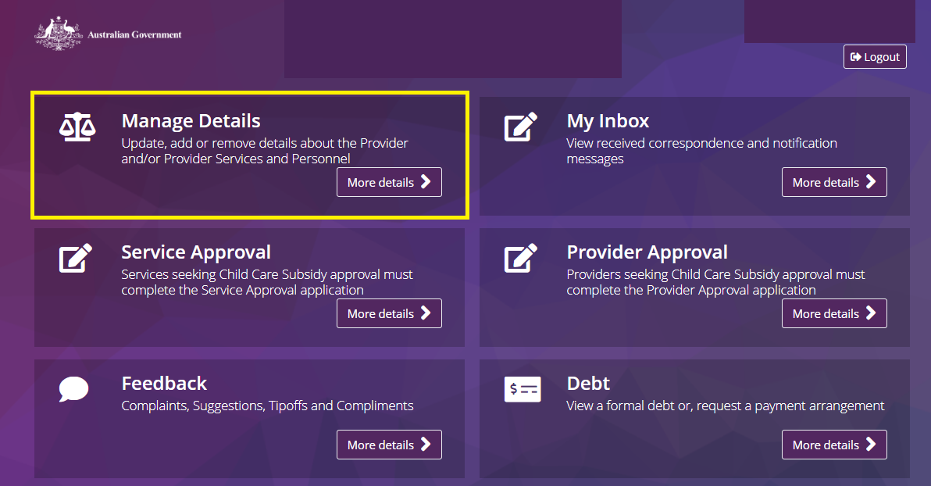

Linking new personnel

Step 1
Under Personnel Details, select Add personnel.
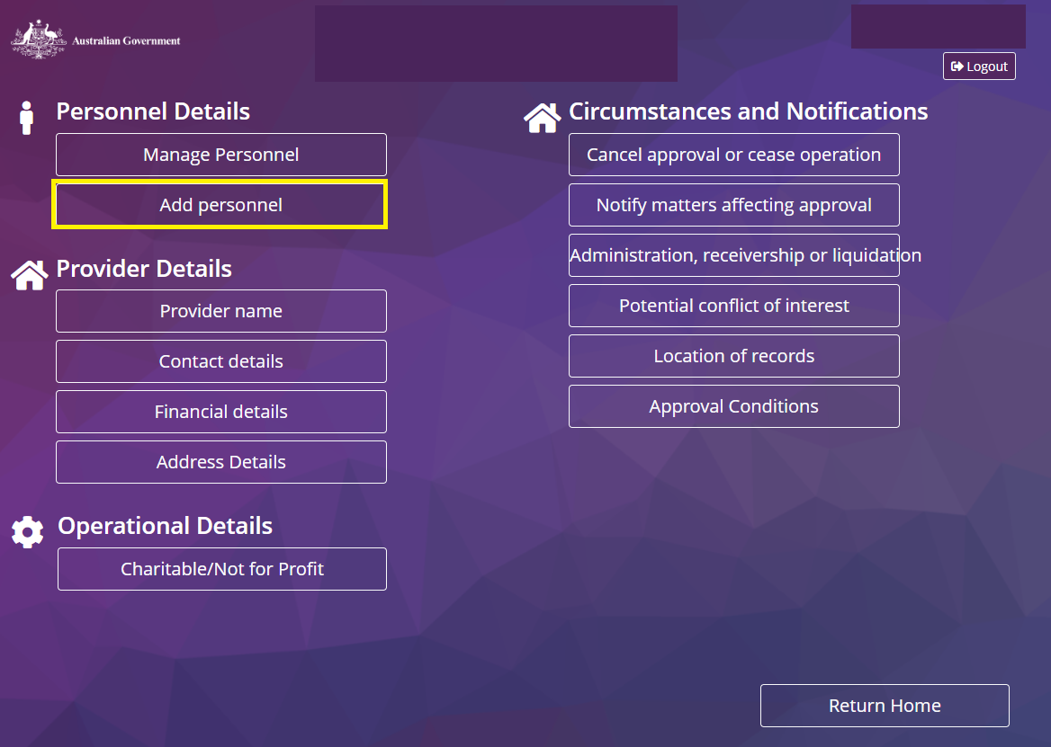

Step 2
Follow the on-screen instructions. Provide the information and documents you gathered before getting started.

Step 3
Review and edit details on the final page of the form using the Edit and Actions buttons. Select Submit to finalise.

Updating personnel details
Adding existing personnel to a new role

Step 1
Under Personnel Details, select Manage personnel.
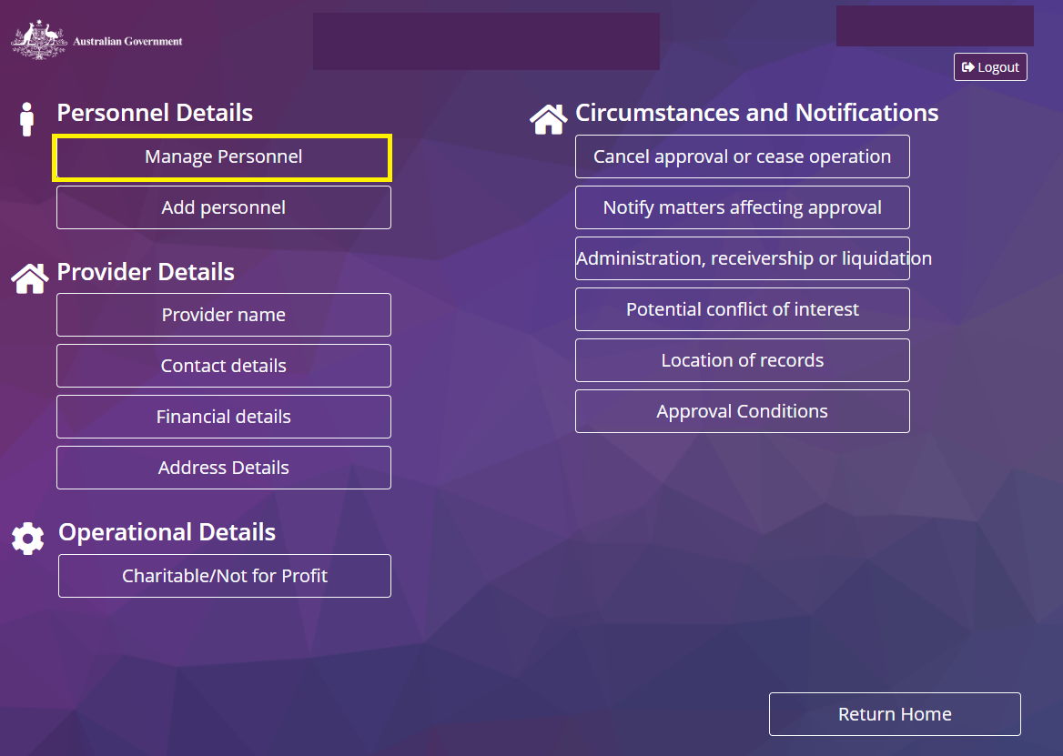

Step 2
Identify the individual whose details or role you want to change.

Step 3
From the Actions drop down menu, select Update Personnel Details to update the contact information.
Select from the other options to update other information. These options will vary depending on personnel role/organisational context.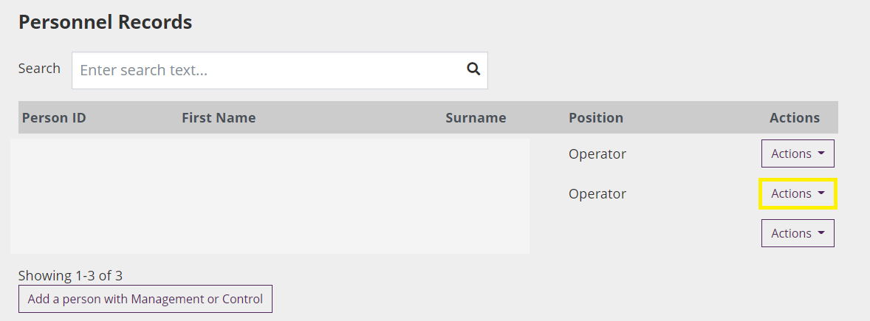

Step 4
Follow the on-screen instructions. Provide the information and documents, you gathered before getting started.

Step 5
Review and edit details on the final page of the form. Select Submit to finalise.

Removing personnel from a role

Step 1
Under Personnel Details, select Manage Personnel.

Step 2
Identify the person whose role is changing.

Step 3
From the Actions drop down menu, select one of the following:
- To add existing personnel to a new role, select Manage roles. Depending on the person’s existing role, you may need to provide additional information or documents.
- To remove personnel from a specific role, select Manage roles. Select the applicable role and End date.
- To remove a person with management or control of the provider from this role and any other role they may hold with the organisation, select Remove from the menu and follow the on-screen prompts.

Step 5
Select Submit to finalise.

