Independent Review into Regional, Rural and Remote Education

FINAL REPORT
Dr John Halsey
Emeritus Professor
Flinders University

January 2018
© Commonwealth of Australia 2018
Title: Independent Review into Regional, Rural and Remote Education – Final Report
Author: Emeritus Professor John Halsey
ISBN: 978-1-76051-392-4
Disclaimer
The information in this report is presented by the Department of Education and Training (Department) for the purpose of disseminating information to the public.
While the Department has made every effort to ensure that the material in this report is accurate and up-to-date, you should exercise your own independent skill and judgement before you rely on it. This report is not a substitute for independent professional advice and readers should obtain any appropriate professional advice relevant to their particular circumstances.
In some cases, the material in this report may incorporate or summarise views, standards or recommendations of third parties or comprise material contributed by third parties (‘third party material’). Such third party material is assembled in good faith, but does not necessarily reflect the considered views of the Department, or indicate a commitment to a particular course of action. The Department makes no representation or warranty about the accuracy, reliability, currency or completeness of any third party information. The Department is not liable for any loss resulting from any action taken or reliance made by you on any information or material in this report (including, without limitation, third party information).
Copyright
The Department of Education and Training (Department) supports and encourages the dissemination and exchange of information. All material produced by the Department constitutes Commonwealth copyright material.
Except where otherwise indicated, and save for the content in this report owned by third parties, the Department’s logo, the Commonwealth Coat of Arms, and any material protected by a trade mark, the Department has applied the Creative Commons Attribution 4.0 International Licence (https://creativecommons.org/licenses/by/4.0/).
The Department of Education and Training must be attributed as the author of the Commonwealth’s copyright material. As far as practicable, material for which the copyright is owned by a third party will be clearly labelled. The Department has made all reasonable efforts to ensure that this material has been reproduced in this report with the full consent of the third party owners.

Contents
Letter to the Minister 5
Executive Summary 6
Background 6
Process 7
PART 1: Framing the Report 12
Introduction 12
Purpose and structure 13
Achievements 14
The challenge 15
Impacts on learning and opportunities 16
Provocations 24
PART 2: Findings and Recommendations 31
Curriculum and assessment 31
Recommendation and Actions 37
Teachers and teaching 37
Recommendation and Actions 44
Leaders and leadership 45
Recommendation and Actions 48
Schools and community 48
Recommendation and Actions 54
Transitions 55
Recommendation and Actions 61
Philanthropy 62
Recommendation and Action 63
Entrepreneurship 64
Recommendation and Actions 66
Information and Communications Technology 67
Recommendation and Actions 69
Improving access 69
Recommendation and Actions 74

PART 3: Building Regional, Rural and Remote Capacities 75
Government structures and strategies 75
Recommendation and Actions 77
Conclusion 78
Appendix A Terms of reference 79
Purpose of the review 79
Scope of the review 79
Appendix B List of meeting and consultations 80
Appendix C: List of organisations and categories of individuals who provided a submission to the review 86
Organisations 86
Categories of Individuals 89
Acronyms and abbreviations 90
References 91

Letter to the Minister
Senator the Hon Simon Birmingham
Minister for Education and Training
Parliament House
Canberra ACT 2600

31 January 2018

Dear Minister,
On 2 March 2017 you announced the Independent Review into Regional, Rural and Remote Education.
You asked me to consider the key issues, challenges and barriers that impact on the learning outcomes of regional, rural and remote students and to identify innovative and fresh approaches to support improved access and achievement of these students in school and in their transition to further study, training and employment.
To undertake the Review, I have received and assessed submissions, consulted widely and extensively, and considered relevant research literature and reports.
I am very pleased to present you with my report into regional, rural and remote education.
My report makes eleven recommendations with a total of 53 actions to progress them.
I have used the recommendations and actions to develop four priority areas for your consideration:
- establishing a national focus for regional, rural and remote education
- leadership, teaching, curriculum and assessment
- ICT
- transitioning into and out of school.
I would like to express my appreciation to the team of officers in the Department of Education and Training who have provided outstanding support to enable me to conduct the Review.
The key challenge for regional, rural and remote education is ensuring, regardless of location or circumstances, that every young person has access to high quality schooling and opportunities.
I believe the report I have written for you provides a robust and practical basis for addressing the challenge.
Yours sincerely

Emeritus Professor John Halsey
Flinders University

Executive Summary
The key challenge for regional, rural and remote education is ensuring, regardless of location or circumstances, that every young person has access to high quality schooling and opportunities.
On 2 March 2017, the Deputy Prime Minister, the Hon Barnaby Joyce MP, and the Minister for Education and Training, Senator the Hon Simon Birmingham, announced the Independent Review into Regional, Rural and Remote Education (IRRRRE).

Background
The Review was tasked to:
- consider the key issues, challenges and barriers that impact on the learning outcomes of regional, rural and remote students
- identify innovative and fresh approaches to support improved access and achievement of these students in school and in their transition to further study, training and employment.
The Terms of Reference for the Review were to investigate:
- the gap in educational achievement between regional, rural and remote students and metropolitan students
- the key barriers and challenges that impact on the educational outcomes of regional, rural and remote students, including aspirations and access issues
- the appropriateness and effectiveness of current modes of education delivered to these students, including the use of information and communications technology and the importance of face-to-face regional, rural and remote education provision
- the effectiveness of public policies and programs that have been implemented to bridge the divide
- the gaps and opportunities to help students successfully transition from school to further study, training and employment
- innovative approaches that support regional, rural and remote students to succeed in school and in their transition to further study, training and employment.
In addition to the aims and Terms of Reference, five convictions about the importance of regional, rural and remote communities, learning and ways and means of driving improvements also shaped how the Review was conducted. They are:
- vibrant and productive rural communities are integral to Australia’s sustainability and prosperity - socially, economically and environmentally
- focussing on ideas and options for re-thinking and reframing education in regional, rural and remote areas is likely to be more productive than simply concentrating on ‘the problems’
- student achievements and beyond-school opportunities are shaped by a diverse blend of in-school and community and home factors, as well as interactions between them - context and relationships are always important
- government and departmental/sector policy settings are very significant in developing possibilities for change together with the work of parents and communities
- improvement in education is achieved by exploring how existing resources can be used more effectively, not just by allocating more of them.

Process
The Independent Review into Regional, Rural and Remote Education Report is informed by 340 submissions lodged by members of the public, government agencies, education authorities, private sector organisations and the philanthropic sector, and an extensive literature review. As well, face-to-face consultations were held in regional, rural and remote locations around the country and all of the capital cities. Details are available in Appendix B and Appendix C has a list of organisations and categories of individuals who provided submissions.
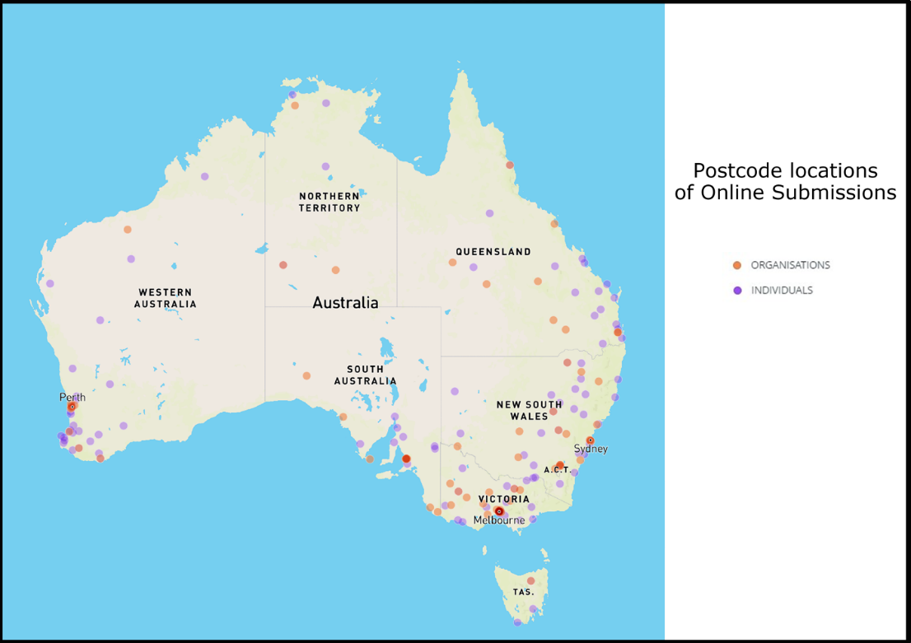
The location of online submissions provided to IRRRRE.
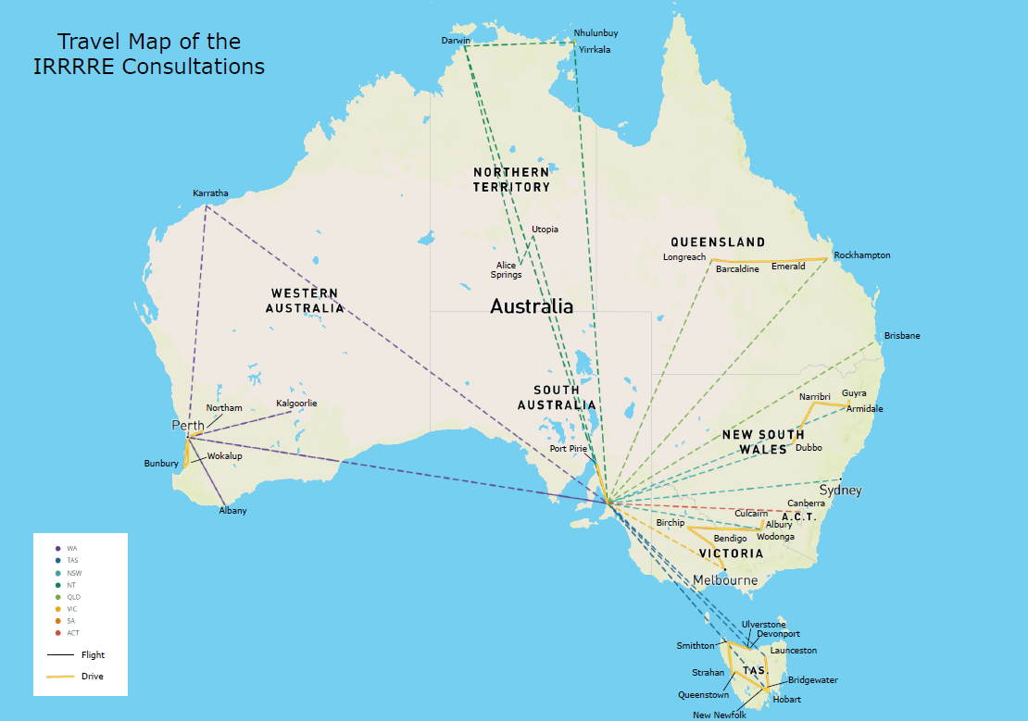
The locations Professor Halsey held consultations, forums and meetings.

The Regional, Rural and Remote (RRR) review commenced with an extensive literature review which focused predominantly on publications since 2006 and included relevant peer reviewed articles, reports and grey literature mainly from Australia, the USA and Canada, and then other OECD countries and elsewhere as appropriate.
From the literature review and other relevant sources, nine themes or factors were identified which have a major impact on students’ achievements and which also provide new opportunities, namely:
- Curriculum and assessment
- Teachers and teaching
- Leaders and leadership
- School and community
- Information and Communication Technology
- Entrepreneurship and schools
- Improving access – enrolments, clusters, distance education, boarding
- Diversity
- Transitioning beyond school
Details about each of these were published in the Discussion Paper written and distributed widely to assist individuals and organisations with making submissions to the Review and also the national schedule of consultations.

Differences in achievement
The achievements of RRR students have in the main lagged behind urban students for decades.
This is exemplified in the National Assessment Program- Literacy and Numeracy (NAPLAN) results, and two international tests of school students- the Programme for International Student Assessment (PISA), and the Trends in International Mathematics and Science Study (TIMSS).
In terms of successful completion of year 12 or equivalent qualification (at the level of Certificate III or higher) by the age of 19, there is the same pattern of outcomes as those already reported.
In relation to transition to university and the proportion of persons aged 25–34 years with a bachelor degree or above, there is also a decreasing trend with increasing remoteness.
For vocational education and training (VET) non-metropolitan participation rates are comparable with urban rates and completion rates for Certificate III exceed urban (38 per cent compared to 35 per cent), but at the diploma level the situation is reversed (10 per cent compared to 16 per cent).
The national statistics show there is a persistent relationship between location and educational outcomes when data for the various measures is aggregated.
The national statistics also raise very important questions about innovative ways to increase VET and university qualification rates with courses and programs that enhance the capacities of graduates to be creators of employment opportunities as well as consumers of them.
There is a diversity of factors, relationships and resources required for a student to learn, successfully complete school and commence a pathway beyond school which is personally rewarding and also makes a contribution to the wider society.
And, in practice, the contexts, factors, relationships and resources that impact on learning and opportunities don’t exist as discrete entities. Their interactions influence the learning, growth and nurturing of students from their early years through to school graduation and beyond.
Much is already being done by individual states and territories and in partnership with the Australian Government to ensure RRR students and families do have access to high quality education and do make a successful transition to further study, training and employment. Many examples and references to this have been included throughout the report.
However, much remains to be done to bridge the gap between the achievements and opportunities of RRR students and those most commonly associated with their urban counterparts.

Recommendations
Eleven recommendations have been made with fifty-three actions to progress them.
Together the recommendations and actions encompass curriculum and assessment, principals and teachers, ensuring that students get the best start possible to their education, expanding VET and university opportunities and pathways, philanthropy and entrepreneurship, ICT, improving the support available to move away from home, and building a high level national focus on regional, rural and remote education and training.
The recommendations are:
- Establish and/or refine processes for ensuring the relevance of the Australian Curriculum and state/territory assessment processes for RRR students and communities.
- Ensure RRR contexts, challenges and opportunities are explicitly included in the selection and pre-service education of teachers, initial appointment processes and their on-going professional support.
- Ensure RRR contexts, challenges and opportunities are explicitly included in the selection, preparation, appointment and on-going professional support of educational leaders.
- Ensure RRR children start school with a strong foundation for learning.
- Expand the availability, affordability and accessibility of high quality work experience placements, VET, dual VET/university options and two-year associate degree programs for RRR students.
- Support RRR students to make successful transitions from school to university, training, employment and combinations of them.
- Encourage the philanthropic sector to play a greater role in raising achievements and improving opportunities for RRR students.
- Improve opportunities for RRR schools to implement entrepreneurship in education through curriculum, teaching, system and cultural changes and building on good practice.
- Improve the availability, accessibility and affordability of ICT for RRR schools, teachers, students, parents and communities.
- Support RRR communities to implement innovative approaches to education delivery designed to improve education access and outcomes for students living in remote communities.
- Establish a national focus for RRR education, training and research to enhance access, outcomes and opportunities in regional Australia.

Priorities
Based on the recommendations and actions, four priorities have been identified to improve RRR education and opportunities.
The first priority is establishing a national focus for RRR education, training and research to enhance access, outcomes and opportunities. The critically important objective here is to create an entity that endures and provides a high and influential level of impact on the challenges and opportunities of RRR education. This could be achieved through the formation of a taskforce, the appointment of a Commissioner for RRR education along the lines of the recently appointed Commissioner for Rural Health or by using some other means.
The second priority is focussing on four critically important resources for successful learning and building young peoples’ futures — leadership, teaching, curriculum and assessment.
The essence of the recommendations and actions for leadership and teaching is that more has to be done to recognise the diversity of contexts, challenges and opportunities of leading and teaching in RRR schools and communities, particularly how people are prepared and supported for such appointments. Continuing to develop and refine ways and means of attracting and retaining experienced leaders and teachers to the most demanding schools and locations needs to be ‘front and centre’ of the planning and work to enhance RRR achievements and opportunities.
While there are strengths and benefits to having an Australian Curriculum and state/territory assessment processes, the issue of the relevance of these for RRR students and communities was raised during the Review. Increasing opportunities for students to learn about the historical, economic, social, political and environmental importance of rural, regional and remote contexts and communities in Australia is an important body of work to be undertaken.
Much has been researched and written about the fundamental requirements for a successful school; that is one which engages every student in rich and meaningful learning, values and respects them, and contributes to their community. Central to successful schooling are leaders, teachers and support staff who are dedicated to a place and its people, and who have the ingenuity and resources to take fundamentals for a quality education like curriculum and assessment and bring them to life in ways that are highly engaging. Doing this kind of work requires bespoke preparation, ongoing support and recognition that what is being done is valued locally and further afield.
The third priority is addressing the patchiness of ICT in RRR locations. The availability, accessibility and affordability of ICT for RRR schools, teachers, students, parents and communities have to be improved, and improved quickly. ICT is now and will only grow to become more so, integral to education and lifelong learning. To adapt a saying from the early days of telephones in the Outback, ‘I’d like ICT, I’d like ICT that works, and I’d like ICT that works all the time’. An ICT taskforce dedicated to RRR education with the necessary expertise, authority and resourcing is recommended to substantially improve access to and use of ICT.
The fourth priority focuses directly on transitioning into and out of school. There is still work that needs to be done to ensure all young children start school healthy and well prepared. As well, work needs to be done to drastically shorten the time it takes to have a child with a potential learning difficulty properly assessed and a specific program designed for them.
RRR students at or near the stage of making the transition from school to employment, training, further study or combinations of them, are often confronted with issues and costs which their counterparts in urban areas do not have to worry about. Expanding the availability, affordability and accessibility of high quality work experience placements, VET, dual VET/university options and
two-year associate degree programs for RRR students are all part of what needs to done. As well, allocating more support for RRR students to make successful transitions from school including for accommodation, travel and with day to day living expenses needs to be addressed.
The four priorities are not intended to suggest a lock step or fixed approach to progressing improvements in the achievements and opportunities of RRR students or that other issues are of lesser importance. It is very feasible to adopt a strategic selection or bundling of actions under several of the recommendations to get decisions made and work happening quickly on a range of fronts.
Further details about each of the recommendations and associated actions are set out in the report.
Brief descriptions of programs, initiatives and approaches which are making a real difference for young people and their futures, and point to what could and needs to be done to bring about overall improvements in RRR education have been included in the report.
The report also discusses the critical importance of RRR capacity building involving all levels of government and other agencies to expand opportunities for RRR young people and communities.
Making major changes in education in Australia has historically been slow and typically highly contested.
It is now time to step up the pace.

PART 1: Framing the Report

Introduction
Access to high quality education is essential so young people can acquire the knowledge, skills, attitudes and values to enjoy life and successfully transition to further study, employment and enterprise. Education is central to them being able to participate fully in a dynamic and increasingly complex world; it is critical for developing and nurturing human agency.
The key challenge for regional, rural and remote education is ensuring, regardless of location or circumstances, that every young person has access to high quality schooling and opportunities.
The Melbourne Declaration on Educational Goals for Young Australians agreed to by all Ministers of Education in December 2008 sets out two goals for schooling:
- Australian schooling promotes equity and excellence, and
- All young Australians become successful learners, confident and creative individuals, and active and informed citizens.
Through the Melbourne Declaration, Australian governments committed to working with all school sectors to improve educational outcomes for disadvantaged young Australians, including those from remote areas.
On 2 March 2017, the Deputy Prime Minister, the Hon Barnaby Joyce MP, and the Minister for Education and Training, Senator the Hon Simon Birmingham, announced this review into regional, rural and remote (RRR) education.
The Review was tasked to:
- consider the key issues, challenges and barriers that impact on the learning outcomes of regional, rural and remote students
- identify innovative and fresh approaches to support improved access and achievement of these students in school and in their transition to further study, training and employment.
The full Terms of Reference for the Review are in Appendix A.
In addition to the aims and terms of reference, five convictions about the importance of regional, rural and remote communities, learning and ways and means of driving improvements have also shaped the Review. They are:
- vibrant and productive rural communities are integral to Australia’s sustainability and prosperity - socially, economically and environmentally
- focussing on ideas and options for re-thinking and reframing education in regional, rural and remote areas is likely to be more productive than simply concentrating on ‘the problems’
- student achievements and beyond-school opportunities are shaped by a diverse blend of in-school and community and home factors, as well as interactions between them - context and relationships are always important
- government and departmental/sector policy settings are very significant in developing possibilities for change together with the work of parents and communities
- improvement in education is achieved by exploring how existing resources can be used more effectively, not just by allocating more of them.

Purpose and structure
The findings and recommendations of my investigations into regional, rural and remote education spanning the years of schooling, and the opportunities and transitions of young people to further study, training and employment are presented in this report.
The recommendations and actions for each to progress the findings are presented around the themes from the Discussion Paper I wrote for the Review. An overview of the themes is presented under the heading impacts on learning and opportunities on pages 8-16.
Where relevant I have included brief descriptions of programs, initiatives and approaches which have been highlighted as making a real difference for young people and their futures and point to what could and needs to be done to bring about overall improvements in RRR education.
The report also discusses the critical importance of RRR capacity building involving all levels of government and other agencies to expand opportunities for RRR young people and communities.
The submissions and consultations covered a wide breadth of matters related to RRR education and training – some beyond the remit of this Review.
Nevertheless, the overall messages of joined-up action to support RRR communities are clear. To do this, consideration is given to structures and processes at federal, state/territory and local levels to provide the overarching ways, means and imprimatur to drive and sustain improvements in the achievements and opportunities of RRR students.
In practice, the factors that impact on learning and opportunities do not exist as discrete entities. Rather it is the way they come together and are ‘brought to life’ that shapes the learning, growth and nurturing of students from their early years through to school graduation and beyond.
As with the Discussion Paper, I have written the report from a pro-active rather than a reactive standpoint. It is important to declare this upfront because during the consultations, and also in submissions, RRR education was often characterised by or associated with disadvantage, signalling a diminished sense of hope and future compared to urban and city locations.
Before reporting the findings and recommendations, there is a section on the overall achievements of RRR students and then the key challenge for RRR education.
This is followed by an overview of what impacts most significantly and persistently on students learning and opportunities. Four provocations are then presented to bring into sharp relief the urgency of taking action to improve the outcomes of RRR students.
The first provocation highlights the global importance of vibrant productive regional, rural and remote communities.
The second focuses on the major cost implications for individuals and society as a whole if decisive and effective action is not taken to improve the outcomes and transitions from schooling for RRR young people, their families and communities.
The third contribution emphasises the magnitude of the challenges of achieving the overall lift given the demographics, geography and cultural diversity of RRR Australia.
The fourth provides an overview of the impact on RRR individuals and communities of globalisation, digitisation and automation, as well as some of the opportunities arising from these.

Achievements
The achievements of RRR students have in the main lagged behind urban students for decades.

NAPLAN
The National Assessment Program—Literacy and Numeracy (NAPLAN) is an important national strategy designed to give schools, teachers and parents information about their students’ progress in annual assessments for Years 3, 5, 7 and 9.
Since 2008, NAPLAN has been used as a robust indicator of students’ learning outcomes, including the capacity to make comparisons between similar groups of students and schools across Australia. The general trend throughout 2017 continued to be decreasing attainment and increasing remoteness:
Across all five achievement domains, there is a consistent pattern in the results for Australia overall. Students attending schools in major cities geolocations have the highest mean scale score, followed by students attending schools in inner regional geolocations, then students attending schools in outer regional geolocations, then students attending schools in remote geolocations, and then students attending schools in very remote geolocations. [However], [t]his pattern is not always replicated within each jurisdiction. In Victoria and Queensland, there is little difference between mean scale scores for students attending schools in inner regional and students attending schools in outer regional geolocations in all domains. In South Australia, there is little difference between mean scale scores for students attending schools in outer regional and students attending schools in remote geolocations in all domains (ACARA, 2017, p.64).
As well:
The distributions of students in achievement bands are similar. For Australia overall, the highest percentage of students achieving at or above the national minimum standard attend schools in the major cities and the lowest percentage attend schools in very remote geolocations. As for achievement scores, this pattern is inconsistent across jurisdictions. (ACARA, 2017, p.64).

International comparisons
Two international tests of school students’ learning are receiving increasing attention in Australia and globally: the Programme for International Student Assessment (PISA), and the Trends in International Mathematics and Science Study (TIMSS).
The Organisation for Economic Co-operation and Development (OECD) noted what they termed an “urban advantage” in student performance in PISA results from 2009 (Organisation for Economic Development and Cooperation, 2013, p. 1). In a more recent document it was reported:
that children from poor households, ethnic minorities or rural areas are significantly less likely to make the transition from primary to lower secondary school and from lower to upper secondary school, and are more likely to be delayed in their progression through the grade levels (Organisation for Economic Development and Cooperation, 2016, p. 210).
In the Australian context of PISA, students were classed according to three geolocations: metropolitan, provincial and remote. The report of Australian students’ performance on the 2015 assessment indicated that as distance from metropolitan centres increased, scores decreased:
Students from metropolitan schools achieved significantly higher scores than students from provincial schools or remote schools. Students from provincial schools and students in remote schools did not score significantly different to each other (Thomson, De Bortoli, & Underwood, 2016, p. 56).
The situation is very similar for TIMSS- with increasing distance from metropolitan centres Australian students demonstrated lower scores for Years 4 and 8 levels of Mathematics and Science (Thomson, Wernert, O’Grady, & Rodrigues, 2016, pp. 25–26, 44–45, 63, 82).

Year 12, higher education and vocation education and training
In terms of successful completion of year 12 or equivalent qualification (at the level of Certificate III or higher) by the age of 19, there is the same pattern of outcomes as those already reported in this section; namely, a marked decline from 78 per cent for Major Cities to 43 per cent for Very Remote, with the difference between Inner Regional and Major Cities being 14 per cent (Mitchell Institute, 2015).
In relation to transition to university and the proportion of persons aged 25–34 years with a bachelor degree or above, there is also a decreasing trend with increasing remoteness. In 2014, the proportion of residents holding a degree was: Major City 42.2 per cent, Inner Regional 21.8 per cent, Outer Regional 19.5 per cent, and Remote and Very Remote 17.8 per cent (Universities Australia, 2015, p. 8).
For vocational education and training (VET) non-metropolitan participation rates are comparable with urban rates and completion rates for Certificate 3 exceed urban (38 per cent compared to 35 per cent), but at the diploma level the situation is reversed (10 per cent compared to 16 per cent) (Macintyre, 2017).
The national statistics show there is a persistent relationship between location and educational outcomes when data for the various measures is aggregated.
The national statistics also raise very important questions about innovative ways to increase VET and university qualification rates with courses and programs that enhance the capacities of graduates to be creators of employment opportunities as well as consumers of them.

The challenge
The key challenge for regional, rural and remote education is ensuring, regardless of location or circumstances, that every young person has access to high quality schooling and opportunities.
There is a diversity of factors, relationships and resources required for a student to learn, successfully complete school and commence a pathway beyond school which is personally rewarding and also makes a contribution to the wider society.
And, in practice, the contexts, factors, relationships and resources that impact on learning and opportunities don’t exist as discrete entities. Their interactions influence the learning, growth and nurturing of students from their early years through to school graduation and beyond.
Much is already being done by individual states and territories and in partnership with the Australian Government to ensure RRR students and families do have access to high quality education and do make a successful transition to further study, training and employment. Many examples and references to this have been included throughout the report.
However, more needs to happen which will require working productively with the organisational arrangements for schooling in Australia to harness the commitment and resources to drive improvements.
Australia’s schooling system has three sectors, each with different funding and organisational arrangements - state and territory owned and run government public schools, systemic Catholic schools and independent schools. Together these sectors educate 3.8 million students in over 9,000 schools annually.
In 2017, 65 per cent of students were estimated to have attended government schools, 19 per cent attended Catholic schools and 16 per cent attended independent schools.
State and territory governments have primary responsibility for policy, funding and delivery of school education. Each state and territory determines its policies on organisation of schooling, curriculum development and implementation within the context of the Australian Curriculum, course accreditation, student assessment and certification.
Constitutionally states and territories are the majority public funder of government schools while the Australian Government is a minority public funder of the government sector. For government schools, Commonwealth recurrent funding is passed directly to the state and territory governments. This is because states and territories are best placed to make decisions on how to use funding for their schools, together with their own funding.
Commonwealth funding for non-government schools is passed by the state and territory governments to the approved authorities for each school. Non-government education systems operating in the various states and territories are responsible for distributing the Commonwealth recurrent funding they receive to their member schools based on their own needs-based distribution.
The Australian Government also plays a lead role in national policy development and implementing nationally agreed reforms and leads Australia’s international engagement on educational matters.

Impacts on learning and opportunities
The RRR review commenced with an extensive literature review which focused predominantly on publications since 2006 and included relevant peer reviewed articles, reports and grey literature mainly from Australia, the USA and Canada, and then other OECD countries and elsewhere as appropriate.
From the literature review and other relevant sources, nine themes or factors were identified which have a major impact on students’ achievements and which also provide new opportunities, namely:
- Curriculum and assessment
- Teachers and teaching
- Leaders and leadership
- School and community
- Information and Communication Technology
- Entrepreneurship and schools
- Improving access – enrolments, clusters, distance education, boarding
- Diversity
- Transitioning beyond school
Details about each of these were published in the Discussion Paper written and distributed widely to assist individuals and organisations with making submissions to the Review and also the national program of consultations. Following is a selection from each to further elaborate on the scope, issues and opportunities of RRR education.

Curriculum and assessment
Curriculum is a critically important and an intensely contested aspect of education. There are many reasons for this but chief among them is that curriculum plays a defining role about what is taught and learnt in schools. A curriculum is selected from an almost infinite array of knowledge, skills and experiences. Many decisions have to be made about what to include, what to exclude and what to make optional.
Guiding these decisions are beliefs and values about the fundamental purpose of education and what constitutes worthwhile knowledge for a given society.
Assessment focuses primarily on finding out whether students have learnt what it is intended they learn. Like curriculum, assessment plays a very crucial role in the lives of students and a society more broadly because it identifies and rewards successful learning.
Bringing curriculum to life in ways that deeply engage students together with authentic, valid and reliable assessment is a major challenge for education in RRR contexts.
This is because at the heart of RRR education is a critical question about its purpose, and as a student might ask, ‘am I learning so I can leave my community, am I learning so I can stay locally, or am I learning so I have a real choice about what I do?’
As well, how a school uses curriculum and assessment to engage and motivate students has a great impact on their learning and their achievements.
The Australian Curriculum for Foundation to Year 10 has been endorsed by all states and territories. It sets the expectations for what all Australian students should be taught, regardless of where they live or the background from which they come. Each state and territory is free to deliver the Australian Curriculum in ways that are best suited to the students in local schools; this is true for regional, rural and remote areas.
Flexibility is also reflected in the Australian Curriculum’s recognition of student diversity, including students with disability, gifted and talented students, and those who speak English as an additional language or dialect.
The Australian Curriculum has a three dimensional structure that is intended to meet the learning needs of all students and to provide rigorous, relevant and engaging learning experiences across all areas of the curriculum. This design provides a strong foundation in the eight learning areas of English, Mathematics, Science, Humanities and Social Sciences, The Arts, Languages, Health and Physical Education and Technologies.
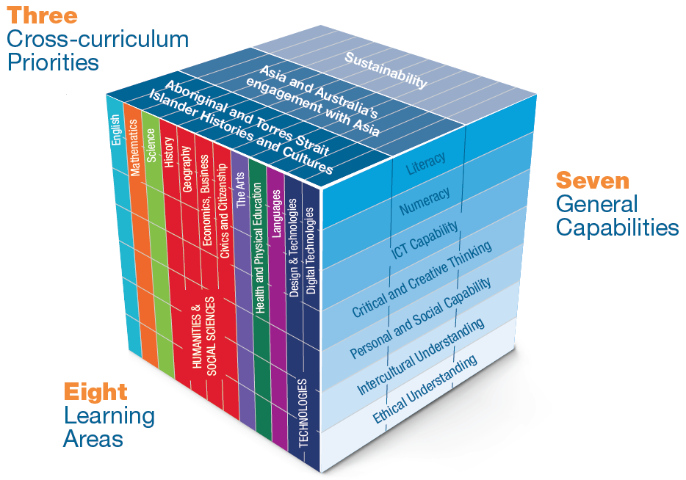

Changes which should be made to curriculum and assessment to improve the achievements of RRR students and their transition to further study, training and employment are reported on later.

Teachers and teaching
In schools teachers have the greatest impact on student learning (Hattie, 2009). It follows from this that having a highly competent teacher workforce for country schools is critical to raising the achievements of students in these schools and their transitions to further study, training and employment.
Schooling in Australia, including the preparation of teachers and the teacher workforce, is the constitutional responsibility of the states and territories. State and territory teacher regulatory authorities accredit initial teacher education courses and set requirements for teacher registration. Once teachers are working in schools, teacher employers (state/territory governments and non-government education authorities) are responsible for setting conditions of employment, including provision of, and resourcing for, professional development.
The Australian Government has a leadership role including supporting national policy reform. A key priority for the Government is to work with all education ministers through Education Council to progress national objectives to improve the quality of the teaching workforce.
Significant effort has been made by all governments to improve teacher quality – both pre-service and in-service. A key national development is the Accreditation of Initial Teacher Education Programs in Australia: Standards and Procedures, endorsed by all state and territory education ministers, which set high level requirements to ensure that all initial teacher education graduates meet the requirements of the Graduate career stage of the Australian Professional Standards for Teachers.
Governments are also investing in programs and incentives to place quality teachers into regional, rural and remote schools. For example, Western Australia offers additional allowances of up to $20,870 a year, relocation and housing expenses and additional leave to encourage teachers to move and work in regional, rural and remote schools.
The Australian Government is funding the Teach for Australia (TFA) program which
fast-tracks high calibre, non-teaching graduates, known as Associates, into disadvantaged schools through two years of intensive teacher training. TFA partners exclusively with schools serving low socioeconomic communities, including schools in regional and remote communities. To date over 230 Associates have been placed in schools in regional and remote communities, filling hard-to-staff teaching positions.
Notwithstanding the efforts of governments, attracting and retaining the best teachers for regional, rural and remote schools continues to be one of the most persistent challenges on the ‘education agenda’. The submissions to the Review and the consultations re-affirmed this many times over.

Leaders and leadership
The impact of school leadership is second only to classroom instruction among all
in-school related factors affecting student learning. School leaders play a key role in improving outcomes through their influence on the motivation and capacity of teachers, the school climate and environment and through engaging with school communities.
Substantial effort is being made by all governments to assist aspiring school leaders to develop the skills and knowledge they require to become effective school leaders.
As well, The Australian Institute for Teaching and School Leadership (AITSL) has developed the Australian Professional Standard for Principals which acknowledges that context is a crucially important factor for leadership, namely:
…context often affects the choice of leadership emphasis. Changed circumstances, such as appointment to a new school or implementation of a new policy directive, demand that leaders suit their leadership to their situation. Effective principals will apply the appropriate leadership emphasis that a school context demands (AITSL, 2015, p. 24, emphasis added).
AITSL has also developed leadership profiles that build upon the principal standard and provides a developmental framework that explains and exemplifies highly effective school leadership.
The capacity of leaders to form and sustain relationships which directly and indirectly contribute to the learning culture of a school is crucial, especially in locations where there is effectively no other option for families than the local school.
As well, principals contribute to the culture of a school through developing and driving a vision of education that ‘energises’ learning, and by making the organisational arrangements of a school work effectively, efficiently and inclusively.
Principals in small schools (say <100 students) are frequently required to teach the equivalent of at least one day per week. Juggling being a teacher and being the leader of a small school can be very demanding, especially if enrolments are in decline and a school’s viability is being questioned. This dominated many of the discussions with small school leaders during the consultation program and has been flagged as needing to be addressed.
Being a country educational leader often means taking on an extensive range and diversity of responsibilities in addition to being responsible for the quality of teaching and learning. Some of the major ones are school bus transport including route determinations and recruitment of drivers, staff housing and accommodation, and community organisation leadership expectations like serving on a local hospital board, becoming a member/player of a team and joining a service club.
Attracting and retaining school leaders for regional, rural and remote schools, as with teachers, continues to be a major challenge for most education systems. There are exceptions to this, as well as initiatives which have been developed to optimise effective leaders being appointed to schools regardless of location.

School and community
Families and communities play an enormous role in the lives of young people because they are such a potentially rich source of nurturing, encouragement and role modelling for students, which in turn contributes to how they value themselves and grow to understand who they are and can become.
Families and communities also play a vital role in building the culture of a school principally through the way they express how they value their school.
For students, a very important aspect of a school’s culture is the messages they ‘pick up’ directly and indirectly about their worth and their ability to learn and be successful. Saying and doing things which create a sense of hopefulness in students is very important.
Hopefulness is at the heart of building and nurturing students’ aspirations and expectations.
Central to building and maintaining a supportive school culture is trust. Trust between and among those associated with a school takes time to build (and just moments to destroy) and needs to be constantly attended to. This is especially the case in small population centres ‘where everyone knows everyone else’ and there can be a strong sense of ‘who is an insider, who is an outsider’, or who is a ‘local’ and who is a ‘blow in’.
As already stated student achievements and beyond school opportunities are shaped by a diverse blend of in-school and community and home factors, as well as interactions between them and knowledge of opportunities and what is happening in the wider world.
Common sense and research shows that children who grow up in a family where they are loved unconditionally, are safe, healthy and well fed, and are encouraged to explore ideas and possibilities, are more likely than not to be successful.
For some children and students, there are home and community factors which impact negatively on their success. Included here are poor health and a lack of regular nutritious food. It is very hard, or perhaps impossible, for students to concentrate on learning if they always feel hungry and are frequently unwell or ‘out of sorts’. These factors are compounded if their home life is very stressful, there is a long history of unemployment and underemployment, and there is always a looming sense of another problem being just around the corner.
The Review learnt of some very innovative and effective approaches to ensuring young children have a sound foundation for success when they start school.

ICT
Information and communication technology is a ubiquitous feature of education.
Due to location and even weather, access to high speed, reliable and value for money ICT services in regional areas is inherently more difficult than for metropolitan users. In light of this, the Government has committed to prioritising the National Broadband Network rollout to underserved areas where it is commercially and operationally feasible to do so.
ICT access is an issue not just for schools, but also for homes with school-aged children who attend day/boarding schools as well as those who study through distance education or home-schooling. NBN Co has recently expanded eligibility to include home-schooled students who are isolated for geographic/medical reasons. To be eligible, home-schooled students must be registered with a state and territory education department and receive the Assistance for Isolated Children (AIC) subsidy.
NBN Co has also developed a public interest premises policy (PIP) for schools in areas serviced by the Sky Muster satellite service. These schools can access extra data allowances and other concessions.
As well as these developments in technology and internet provision, the level of teacher expertise in delivering lessons using ICT also presents a challenge. This impacts on regional, rural and remote schools realising the full benefits of ICT and on-line learning. This applies to within school arrangements, between school arrangements focusing on expanding subject and pathway choices through combining and sharing resources and the delivery of ‘leading edge’ experiences from external centres of excellence. It also applies to students undertaking distance education.

Entrepreneurship
Entrepreneurial education has the potential to improve opportunities for students and youth in regional, rural and remote communities by shifting the focus of education from primarily preparation for employment to creation of employment.
Entrepreneurial education requires schools to reach out into their communities and beyond to explore and engage with ‘real world’ possibilities and as well as existing thriving businesses. It provides an ideal way for education to take the lead in building new
school/industry/community partnerships and in so doing, contexts are created where aspirations can be challenged and energised because students see first-hand, the link between education and training and economics. Critically important as well is human capital - the knowledge, abilities and skills of people - grows and in so doing, creates momentum for more success.
Entrepreneurship focuses on paying attention to possibilities and embraces risk pro-actively. It particularly zeroes in on how to turn ideas into enterprises. Entrepreneurial thinking requires a different approach to pedagogical practice, from teaching as telling to teaching as coaching, mentoring and providing resources such as just-in-time application of technology.
Pedagogy, curriculum, assessment, school design and structures, as well as relationships between teachers, students, parents, community and enterprises are all important to mainstreaming entrepreneurship.

Improving access
Access to education along with quality and affordability are very high priorities for regional, rural and remote students, families and communities. As previously noted, the Government provides a regional loading to help schools with the higher cost of education delivery in non-city areas. As well, the Government funds the Assistance for Isolated Children Scheme which provides financial support for the families of primary, secondary and certain tertiary students who are unable to attend an appropriate government school on a daily basis because of geographic isolation. The scheme provides allowances to help families with cost of boarding fees and distance education study.
School enrolments whether primary, secondary, combined, or for specialist services have a very critical impact on the education available in and for a community. This is because schools are essentially funded and resourced on the basis of enrolments — number, age, student learning needs - and school type and location.
The impact of the funding/resources/curriculum diversity relationship is particularly acute in the senior years of schooling. What is available, especially in a face-to-face way with a qualified teacher, continues to be a powerful benchmark and signal to students, parents and the community more broadly about the quality of a school’s program.
Distance education is used extensively in rural schools to complement what is available in a face-to-face way locally, as well as to provide a ‘full’ education for students in very remote or isolated areas or those who are highly mobile. Distance education has become inextricably linked to ICT, most particularly in the government sector and is becoming increasingly so in the non-government sector.
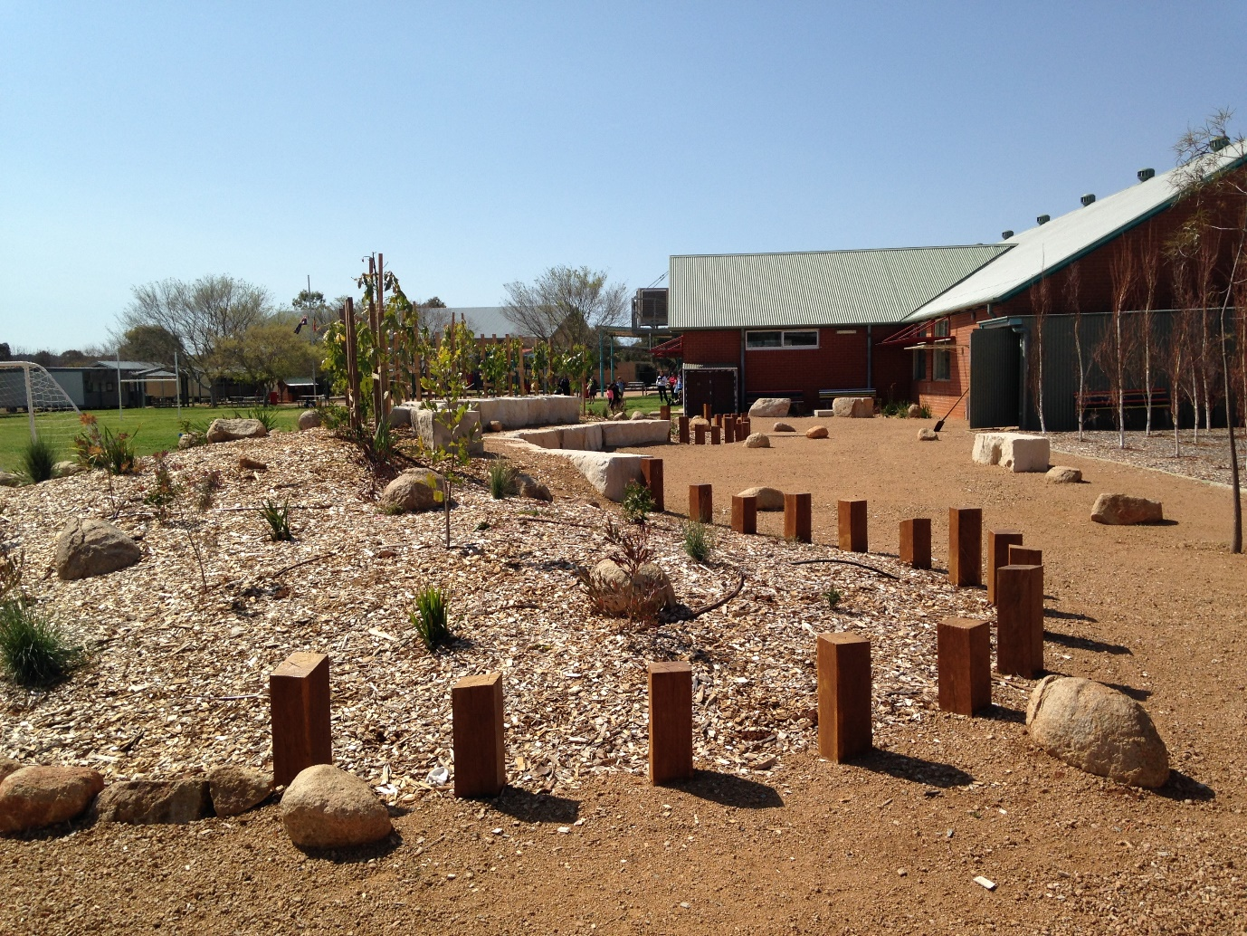
Distance education school in Dubbo, New South Wales.
In addition to distance education, there are many instances of schools working together to pool resources and work collaboratively for the benefit of all students in a district/region.
This can take considerable inter-personal skill as well as time especially given the dominant rhetoric and belief in competition as the way to achieve high levels of performance.
Boarding schools are another option for some rural students to access the education they require to successfully complete schooling and progress to further study and employment. These are mostly operated by the non-government sectors. Attendance at boarding school is expensive and can be emotionally taxing for regional families who may live too far away to access appropriate local secondary education.

Diversity
A major challenge for schools in regional, rural and remote communities is meeting the diversity of learning needs, interests and aspirations of all students, while at the same time, developing and nurturing social cohesion and harmony.
The Commonwealth, state and territory governments recognise that students who have additional learning needs require extra resourcing. All governments have adopted a needs-based school funding model to address the diverse learning needs of their student population.
At the Commonwealth level, schools attract a base per-student amount plus loadings to address school and student disadvantage. This includes a location loading to assist with the higher costs delivering education in regional and remote locations and extra funding to support students with disabilities, students from a low socio-economic background and Aboriginal and Torres Strait Islander students.
As declared by ACARA, “all students are entitled to rigorous, relevant and engaging learning programs… [that] encompass cognitive, affective, physical, social, and aesthetic curriculum experiences”.
Who are “all” students and how might regional, rural and remote schools ensure that the ACARA entitlement is a reality for them?
From an education sector perspective - government, Catholic and independent - “all” students are typically defined by reference to particular groups including Aboriginal and Torres Strait Islander students, gifted students, migrant, refugee or asylum seeker students and students with disabilities. The definition is further enriched by focussing on English languages and other dialect requirements, gender, location, religious beliefs, culture and the impact of poverty/wealth on opportunities.
From a parent’s perspective, “all” students means ‘a school will do whatever is necessary to ensure that my child/children is/are successful and happy’.
Responding positively to the diversity outlined above with dynamic teaching and learning where excellence, equity and inclusiveness are the signature features is crucially important for raising aspirations, achievements and opportunities.

Transitioning beyond school
Transitioning from school to further study, training, employment or combinations of these, is a major event for a young person and their family. For many who live in rural, regional and remote areas, this stage of life can be particularly challenging (as well as highly rewarding) because it often involves having to move away from home, family, friends and the familiarity and support of a community.
While there has been growth in the number of people from regional and remote areas undertaking an undergraduate degree over the last decade, they remain underrepresented in higher education. The Australian Government Department of Education and Training research suggests that under representation is more related to the lower likelihood of people from regional and remote areas applying for higher education than their likelihood of receiving or accepting an offer.
Fundamental to pursuing and realising opportunities beyond school is having access to and then being able to effectively use a suite of resources to turn aspirations and interests into reality.
Broadly there are two kinds of resources that are particularly important for regional, rural and remote young people and making decisions about their futures. They can be referred to as soft and hard resources. Soft resources include those which focus on raising aspirations, relationships, networks, values, and reasons for hope.
Hard resources are usually of a more quantifiable kind like money and allowances, entry scores for university and training programs, accommodation, availability of part-time work and transport logistics.
The financial burden of moving away from home can be an impediment to regional, rural and remote students choosing to undertake further study or training, or even successfully completing their studies.
The financial costs associated with relocating include start-up expenses for relocation; the costs of living (such as rent and food); the direct costs of education or training (such as tuition fees, textbooks and computer); the cost of traveling home during semester breaks; and the opportunity cost of forgone income while studying. As well as financial costs, the social costs associated with relocating away from networks of family and friends can be significant, particularly for young school leavers.
The Australian Government provides a range of financial support to students and tertiary institutions to increase participation by regional, rural and remote students. Apart from the Higher Education Loan Programme, a range of means-tested payments are available to support eligible students who are undertaking, or planning to undertake, approved post-secondary study or an Australian Apprenticeship. These payments include Youth Allowance, Austudy and ABSTUDY. Higher education students receiving student payments may also be eligible to receive the Student Start-up Loan and the Relocation Scholarship.
Another key practical matter facing regional, rural and remote students is high rental prices for on-campus accommodation which can also be hard to obtain due to high demand. These students also have difficulty in the private rental market due to their age and lack of rental history.
Government changes to some student payments have gone some way to ameliorate the financial burden, such as reducing the period regional and remote students need to be employed under the self-supporting criteria for Youth Allowance and ABSTUDY payments. However, accommodation costs remain a challenge for regional, rural and remote tertiary students.

Provocations

RRR and the global context
By the year 2050 the world’s population is expected to reach 9.8 billion (United Nations, 2017). For Australia, this means a population of around 35 million and, as we know, there is much debate about how robust this figure is and whether or not a bigger population will turn out to be ‘a good thing or a bad thing or….’ (Parliament of Australia Website, n.d).
So why is it so critically important to put RRR in the centre of our thinking and actions at all levels of government, in the private sector, and in the social and cultural life of our country?
In a word, survival!
Consider just four facts.
The majority of the food consumed daily in the world, and particularly in the developed world, is produced in RRR areas. Accessing food is already a major problem for nearly a billion people in developing countries. It is also a problem for many in developed countries. The food security of Australia, and the world more widely, is a critical issue and one that we cannot take for granted. Producing food, even if in many instances it has ‘gone the way of high tech’, requires enormous numbers of highly skilled and semi-skilled workers. As Pretty (2002) argues:
Without food, we are clearly nothing. It is not a lifestyle or add-on fashion statement. The choices we make about food affect both us, intrinsically, and nature, extrinsically. In effect, we eat the view and consume the landscape. Nature is amended and reshaped through our connections—both for good and bad (p.11).
Secondly, much of the world’s energy is sourced from rural and remote regions and many of the world’s fresh water supplies have their headwaters in rural locations and traverse substantial rural landscapes. In Western countries, between two and five thousand litres of water are used to produce the daily food for a single person (Arthus-Bertrand, 2009, p.134).
Thirdly, there is the profoundly important matter of arresting the decline of the natural environment, which includes the effects of climate change, and developing new paradigms for valuing it so that it, in turn, can do what it has always done—sustain life in all its complexity and diversity. To quote Pretty (2002) again:
…an intimate connection to nature is both a basic right and a basic necessity…we have shaped nature, and it has shaped us, and we are an emergent property of this relationship. We cannot simply act as if we are separate. If we do so, we simply recreate the wasteland inside of ourselves (pp.10-11).
Fourthly, there is the issue of maintaining territorial security. It is worth reflecting upon how the land mass of a nation will remain secured, as we move into a future with rising pressure on space for human habitation and all the requirements for progressing and sustaining it. Maintaining a purposeful presence in our RRR spaces and places is a ‘soft’ but significant contribution towards national security.
While these facts reflect traditional roles and origins of RRR communities, they are also relevant to employment, innovation and the future–and all are underpinned by education and training.
The national results profile of non-urban students clearly shows there is a significant gap to be made up.

The cost of inaction
Major differences in achievements and successful post school pathways between urban and rural, regional and remote children and young people, have persisted for decades (Review Discussion Paper, 2017, pp 15-18).
Given how much debate continues to swirl around funding for education, it is instructive to consider some outcomes relating to the cost of inaction, of not working to bridge the divide between rural, regional and remote educational opportunities and achievements and those in urban centres.
Firstly, research shows that people not in full-time work or study by age 24 and who continue in this way over a 40-year period, produce a cost impact on society of around $412,000 per person. The total fiscal and social cost of a lifetime of disengagement is $69.3 billion, using 2014 figures of 45,700 people (Lamb and Huo, 2017). This amount represents about 15% of all of the Australian Government budgeted expenditure for 2016-17 (budget.gov.au).
In a similar vein, it is well documented that one consequence of young people becoming disengaged from education before they complete their schooling is a greater propensity for them to drift into crime and then becoming involved in the juvenile justice system. The financial costs associated with this far exceed those of providing a ‘top quality’ education and there are major social implications and costs as well (Halsey & Deegan, 2015).
If for no other reason, education which fully engages young people and nurtures and builds their capacities throughout their formative years is a very sound investment; one which is repaid many times over during a lifetime.

Diversity, distance, demographics
The extensive travelling, I did during the Review highlighted the vast diversity, distances and demographics of the RRR contexts that must be understood and taken into account fully when deciding what needs to be done to create and sustain improvements. A way to appreciate aspects of these distinguishing characteristics is through reflecting on a selection of geographic and population ‘facts and figures’.
The landmass of Australia is 7.692 million km² (sixth largest in the world) and it has a population of almost 24.6 million. (The Australian Continent) Just over 4.5 million people live in 63% of the country comprising Western Australia (2.580m), South Australia (1.723m) and the Northern Territory which has a population of around a quarter of a million. (Australian Demographic Statistics) Further, while the overall population density is 3 per km², nationally it varies from 14,100 per km² in inner city Melbourne to 0.2 per km² in the Northern Territory. As well, there are only 18 population centres in Australia with 100,000 or more people, and this figure includes all of the capital cities. (Regional Population Growth)
Another perspective on the huge variability in the population density can be appreciated through a political lens—6 members of the 150-seat Australian Parliament represent people living in about
78 per cent of the country.
The Australian Bureau of Statistics uses five mainland remoteness categories based on road distances between locations and five different sized service centres, namely Major Cities, Inner Regional, Outer Regional, Remote Areas and Very Remote Areas. According to the Australian Bureau of Statistics, in 2016 there were 3,786,000 full time equivalent (FTE) students overall. Whilst most FTE students are enrolled in schools in major cities, those in other areas account for 29.3 per cent or 1,108,000 FTE students.
Australia’s schooling system has three sectors: state and territory owned and run government public schools, Catholic schools, and independent schools. Together these sectors educate students in over 9,000 schools. In 2016, 65 per cent of students attended government schools, 20 per cent attended Catholic schools, and 14 per cent attended independent schools.
The Australian Government Department of Education and Training data at the time of the Review listed over 4,400 non-metropolitan schools, accounting for 47 per cent of all schools in Australia. As well, there are over 2,100 schools in Australia with an enrolment of less than 100 and over 1700 of these schools are in RRR locations. Government schools in very remote areas make up 84 per cent of all schools.
State and territory governments have primary responsibility for policy, funding and delivery of school education within their jurisdictions. Each state and territory determines its policies on the organisation of schooling, curriculum development and implementation within the context of the Australian Curriculum. They also determine their strategies for addressing the gaps in outcomes for RRR students.
In thinking through changes that need to be made and ways of moving forward to build and maintain higher levels of achievement and much improved transitions after completing schooling, the differences (as well as the similarities) of the states and territories have to play a central role. This is especially the case in terms of population size and density as previously stated and the consequential arrangements and services that have been built overtime because of these factors. Perhaps the sharpest illustration can be seen between Victoria with a population density of
26 km² and 27 locations (not including the capital) greater than 10,000, and the Northern Territory which has a 0.2 population density and only one location besides Darwin with a population greater than 10,000.
With this mix of distance, diversity and demographics, it is unlikely that there will be one solution that can be delivered to suit such breadth and spread.
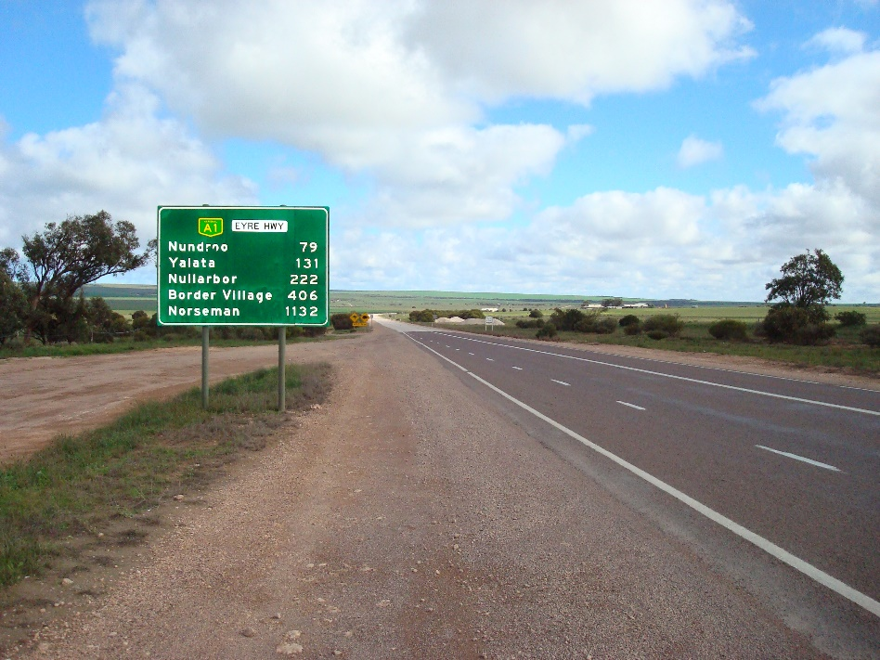
Distances are a key feature of RRR education

Globalisation, digitisation and automation—why they matter
The future of industry and employment in Australia is undergoing a period of rapid and significant change which is likely to continue for many years, if not decades. The impact of globalisation, digitisation and automation will increasingly affect what we do, and the way we do it, as well as who we are and how we relate to each other in families, groups, and communities, nationally and internationally (AlphaBeta, n.d). It will also impact on how we relate to and value the natural environment which is, when ‘all is said and done’, the bedrock for sustainability.
Access to high quality education and training is one of the most effective ways of ensuring that Australians are very well prepared for competitive global labour markets. This need is particularly acute in many if not most RRR locations and communities. There is also an urgent need to ‘look in new ways’ for opportunities to boost regional economic activity and capacity in ways that generate and distribute fairly the benefits of wealth on a more localised and interconnected communities scale. This in turn will improve the quality of life and increase employment opportunities.
Globalisation has been greatly facilitated by digital technologies, resulting in substantial increases in international trade. While such trade can generate net economic benefit in relatively high wage countries such as Australia, some industries and workers are particularly vulnerable. Employment in Australian manufacturing for example declined by around 150,000 people (about 15 per cent of the total) over the past 20 years at a time when employment in other sectors has been growing strongly (Hajkowicz, Reeson, Rudd, Bratanova, Hodgers, Mason & Boughen, 2016).
In addition, the workforces of emerging economies are rapidly increasing their education and skill levels in line with income growth. Ever faster world-wide internet connectivity is bringing these new workforces into greater competition with our domestic markets (Hajkowicz et al, 2016).
In a review of ‘digital disruption’ in Australia, the Productivity Commission (2016) found that increasing demand for high skilled workers due to technological change has played a role in the widening of the wage distribution. Ensuring the benefits from future technological developments are evenly spread will be an ongoing policy challenge for governments and communities, especially in relation to RRR Australia.
It is true there remain tasks that have proven difficult to automate and just because a job can be automated does not mean that it will be. This is a very important point. While automation and digitisation are frequently presented to be ‘inevitable and unstoppable forces’, as individuals, communities and a country as a whole, we have choices about what to prioritise, what to support, what to resist and what to reject.
Typically, workers with the ability to acquire new skills and engage in life-long learning will likely adjust more easily to changing labour demands. And the bar is likely to continue rising for the foreseeable future. Consequently, education and training are becoming ever more important.
So how will these developments impact regional, rural and remote communities?
The importance of RRR students’ access to high quality education and training at all ages and stages of life is intensified by changes in employment opportunities from new generation primary production, to growth in industries such as tourism, financial services and education. New skills and jobs have emerged as a result of the large-scale shift to a digital economy, particularly within specialised business services and education. Areas of growth and employment in regional Australia will require a highly skilled and qualified workforce (Vichie, 2017).
There is much that can be done and should be done to generate rewarding opportunities on a more localised scale and in interconnected ways using education and training together with a renewed commitment to valuing RRR contexts and communities.
The need for all young Australians to be successful learners, confident and creative individuals, as well as active and informed citizens, cannot be overstated. Research undertaken by the Mitchell Institute (Lamb & Huo, 2017) and Halsey and Deegan (2015) as quoted above, highlights the immense cost of having young Australians leave school early and grow up without the skills needed to thrive in the twenty‐first century.
To repeat, completion of school and high quality preparation for fulfilling lives and careers through further education and training are vital. We must do all that we can to ensure our education system is one that works well for all students.
It has been observed that our current education system teaches students to be effective within a highly structured system, yet Australia’s future workforce is likely to encounter considerable ambiguity and openness (Hajkowicz et al, 2016). The implications flowing from this include that our education system needs to change and do more to encourage innovative, entrepreneurial and flexible mindsets as Tucker (2017) asserts:
In an age in which the Internet provides access to an unimaginable bounty of information, the aim cannot be to fill the student’s head with information, but to provide a sound framework on which to hang it as well as the tools needed to sort out facts and sound analysis from clever lies and propaganda (p.7).
Further, the question posed by Watson (2017) is particularly relevant:
… are we equipping students with the right attitudes and skills to compete globally–and locally–in a market where value will be derived largely from human interaction and the ability to invent and interpret things that machines cannot? (p.7).
We need to equip students with skills, knowledge and capabilities which are complementary to advanced technology, instead of attempting to compete with it. Job tasks which are routine, repetitive, structured and rules-based are likely to be automated over coming decades. Training in specific tasks of this nature may hold lesser value than learning enduring concepts, knowledge and capabilities (Hajkowwicz et al, 2016).
This is not to suggest that higher education, while justifiably important, should be the intended path for all Australian school leavers. Lamb, Jackson, Walstab & Huo (2015) have highlighted the importance of vocational education and training as a particularly important pathway in education.
A major problem in education and training in Australia is the unproductive dichotomy that has developed between vocational and tertiary education pathways. As argued by Tucker (2017):
Schooling for a long time has drawn a line between “hands on” learning, which has been put in the domain of vocational training, and book learning, which has been the special privilege of the college bound…[yet] real learning rarely takes place unless it is used – not ten years from now but today — to solve interesting, real problems. So curriculum designers face a double challenge, to make the courses in the core curriculum much deeper, pointed much more at deep conceptual understanding and, at the same time, much more applied, much more integrated with doing things… (p.7).
Developments and improvements in information and communications technology are opening up new opportunities to address the persistent challenges experienced by RRR educators that arise from isolation and Australia’s dispersed population. Included here is the NBN rollout in regional areas which is over three quarters complete and provides greater accessibility for students in rural and remote locations.
In addition, the integration of digital learning resources into traditional education systems needs to be informed by a better understanding of when, where and how individualised teaching, face-to-face interaction, and co-curricular aspects of school life are best used together to add value to online teaching resources.
As well as higher competency in literacy and numeracy at the school level, the Productivity Commission (2016) has suggested that governments can further assist by:
- reviewing/evaluating current teaching methods and implementing teaching methods shown to lead to better learning outcomes
- reviewing how schools currently interact with the business community to deliver entrepreneurship and STEM learning
- increasing the flexibility of university qualifications, and
- improving information on employment outcomes for students to help inform student choice (pp 8, 69 & 85).
In short, the growing importance of career information is being increasingly recognised.
Each year, the Australian Government Department of Employment (2017) produces employment projections by industry, occupation, skill level and region for the following five-year period. These employment projections are designed to provide a guide to the future direction of the labour market.
It is important to note that when examining the employment projections by region, there are instances of significant variation between average employment projections for regional Australia in general, and projections for capital cities. The graph clearly shows that in most industries, larger growth is expected in the capital cities when compared to regional Australia.
Australian Government Department of Employment - Employment Projections
Given the existing challenges, and those that lie ahead, access to high quality education and training opportunities for RRR young people and communities are ‘non-negotiables’.

PART 2: Findings and Recommendations
A rich and diverse range of views were provided through submissions and consultations about what needs to be done to significantly improve the achievements and opportunities of RRR students. The findings and recommendations are informed by 340 submissions lodged by members of the public, government agencies, education authorities, private sector organisations and the philanthropic sector and an extensive literature review. As well, face-to-face consultations were held in 31 RRR locations around the country and all of the capital cities.
In making the recommendations, responsibility has not been assigned to any one level of government or authority. As described previously, there are layers of responsibilities and interactions between the Australian Government, and state and territory government, local government and other agencies, reflecting the arrangements of Australia’s education and training system. While some recommendations may well be considered as one or another’s formal responsibility, it is absolutely clear that improving achievements and opportunities for RRR students’ needs all to be involved.
As well, in making the recommendations, I want to again acknowledge that state and territory governments and education departments, the non-government sectors, the Australian Government, regional universities and training authorities, professional and special interest groups and bodies and individuals, are all active in the RRR education space in diverse and various ways. The recommendations and associated actions are offered as further ways and means to bridge the gap between RRR achievements and opportunities and those most widely reported for urban and city locations.

Curriculum and assessment
What is taught and agreed to be measured and publicly reported are some of the most powerful statements of a nation. Governments recognise the importance of curriculum and assessment as a foundation of student learning and agreed to establish the Australian Curriculum Assessment and Reporting Authority (ACARA) as an independent statutory authority with responsibility for the development of national curriculum, administration of national assessments and associated reporting on schooling in Australia.
The need for greater flexibility in the application of the Australian Curriculum to ensure relevance for contemporary RRR students and communities was highlighted in submissions and consultations around this theme. Constructing learning opportunities focussing on the interests, indeed passions, and abilities of RRR students as well as the use of real world and place-based approaches to learning were strongly advocated. So too was raising the profile and importance of RRR history, contexts and contributions to Australia as a whole.
Teachers in RRR schools need to be able to adapt curriculum to suit their local contexts and students, whilst also fostering wider connections and engagement, and to be highly skilled in doing so. Resourcing, teacher skill and experience, and the challenges posed by multi-grade classrooms were also highlighted as key issues for curriculum and assessment during visits and in submissions. So too was the challenge of developing and sustaining a culture that nurtures learning and values high achievement.
Curriculum and assessment challenges, as well as opportunities, in part arise out of the large range of school sizes, types, locations and cultural complexities in RRR Australia, as illustrated by just a small sample of the diversity of four schools visited during the Review. They are Dubbo College Senior Campus with around 450 students, the small Soapy Bore School in the Utopia Homelands approximately 250 kms north east of Alice Springs, Strahan Primary School in Tasmania with 63 students, and the Longreach School of Distance Education in central western Queensland.

Meeting the needs of Aboriginal and Torres Strait Islander students
Another challenging aspect of bringing the Australian Curriculum to life to create enduring benefits for students was highlighted during visits to remote Aboriginal and Torres Strait Islander communities and during consultations with community and education leaders, teachers, parents and students. The challenge is best captured through a question—how can an individually and community valued blend of traditional culture, ceremonial life and western knowledge as represented in the Australian Curriculum, be achieved? As well, Elders sought greater opportunity in the curriculum for learning about and valuing home and Homelands knowledge and life skills.
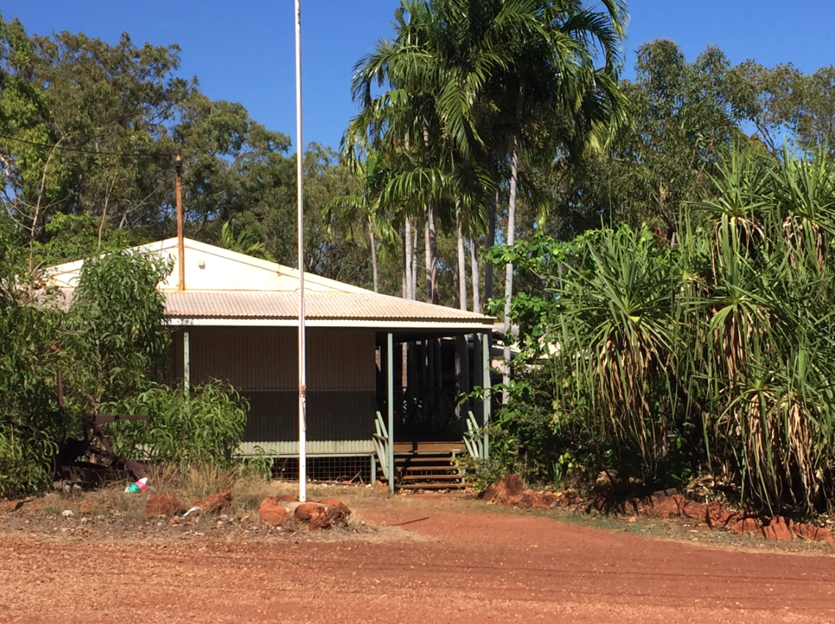
Professor Halsey visits a school in Yirrkala in Northern Territory.
There is robust evidence that progress is being made in raising the achievements of Aboriginal and Torres Strait Islander students in very important and valued ways. They include transitioning from home to school programs, literacy and numeracy, approaches to STEM grounded in place, cultural traditions and western scientific knowledge – otherwise known as Two Way Science – and increasing the number of Aboriginal and Torres Strait Islander students who complete their secondary education. There is also growing evidence of Aboriginal and Torres Strait Islander young people making successful transitions after finishing year 12. Consultations have highlighted that having staff dedicated to advising and supporting young people through transition points has proved to be especially beneficial.

National testing and assessments
Various submissions highlighted the merits and benefits of current national testing and assessment processes for RRR students (e.g. NAPLAN/ATARs), while other submissions expressed reservations and some negative views about them. Included was the view that NAPLAN testing is ‘metro-centric’ and does not provide sufficient connection to the in- and out-of-school lives of RRR students. An example was provided of a question asking what you could see at the busy train station – of which many RRR students have no experience and therefore no concepts to be able to respond accurately.
The example also raises another very important question: do RRR students (and others) have knowledge and skills which they value and find useful but which are not measured and therefore not valued more widely? For example, improvisation—the ability to solve a problem using what is at hand and not what you would ideally like to have. Another is spatial awareness and ability to ‘mud map’ complex relationships and networks between landmarks and people who live and work in a particular area.
Submissions and consultations point to the value of increasing the direct participation of RRR educators, students, parents/families, employers, relevant associations and regional development and governance bodies in the development of curriculum and assessments for the Australian Curriculum and NAPLAN. Consideration should also be given to increasing opportunities for RRR teachers to participate in state-wide and national assessment and moderation processes, for example by requiring that at least a quarter of participating teachers for year 11 and 12 assessment/examination panels and moderation processes be teachers from RRR schools.

The Australian Curriculum – implemented or interpreted?
A curriculum that is less aligned to subjects and more ‘place-based’ or ‘project-based’ and therefore more engaging and relevant for many RRR students is advocated in some submissions, consistent with other advice received. It is advised that the Australian Curriculum should be used more as a guide to be interpreted rather than implemented, and should be connected wherever possible with the community in which schools are located. While I support the thrust of this, it is also very important to ensure the more localised and place based approaches to curriculum do not inadvertently disconnect students from wider perspectives and opportunities.
In addition, while not disregarding the importance of content mastery, consultations advocated for a greater focus on skills development rather than content to foster community engagement, entrepreneurship and living and working in a local community. Increasing the profile and resourcing of STEM subjects and curriculum for building entrepreneurship capacities was also advanced, particularly for RRR communities trying to develop new types of economic livelihood.

Text Box 1
Pemberton District High School in Western Australia has attracted state-wide recognition for a number of its innovative approaches to teaching and learning. The school has received awards for Outstanding Learning Environments, Partnerships with the Community, Aboriginal Education and Science Teaching and Learning. As a Kindergarten to Year 10 school, Pemberton District High School participates in the primary school-focused Stephanie Alexander Kitchen Garden Foundation Program. This program incorporates sustainable agricultural practices and is complemented by the secondary school level Sustainable Agriculture Program and the Specialist Foods Program. These programs provide rich and valuable learning experiences that are respected in the region for the practical skills that they develop in many aspects of agriculture, including: growing quality produce; fencing; animal husbandry; agricultural skills; marketing; and commercial use of foods. The resulting produce is utilised and appreciated by local retailers and restaurateurs.
Source: Edith Cowan University Submission to IRRRRE
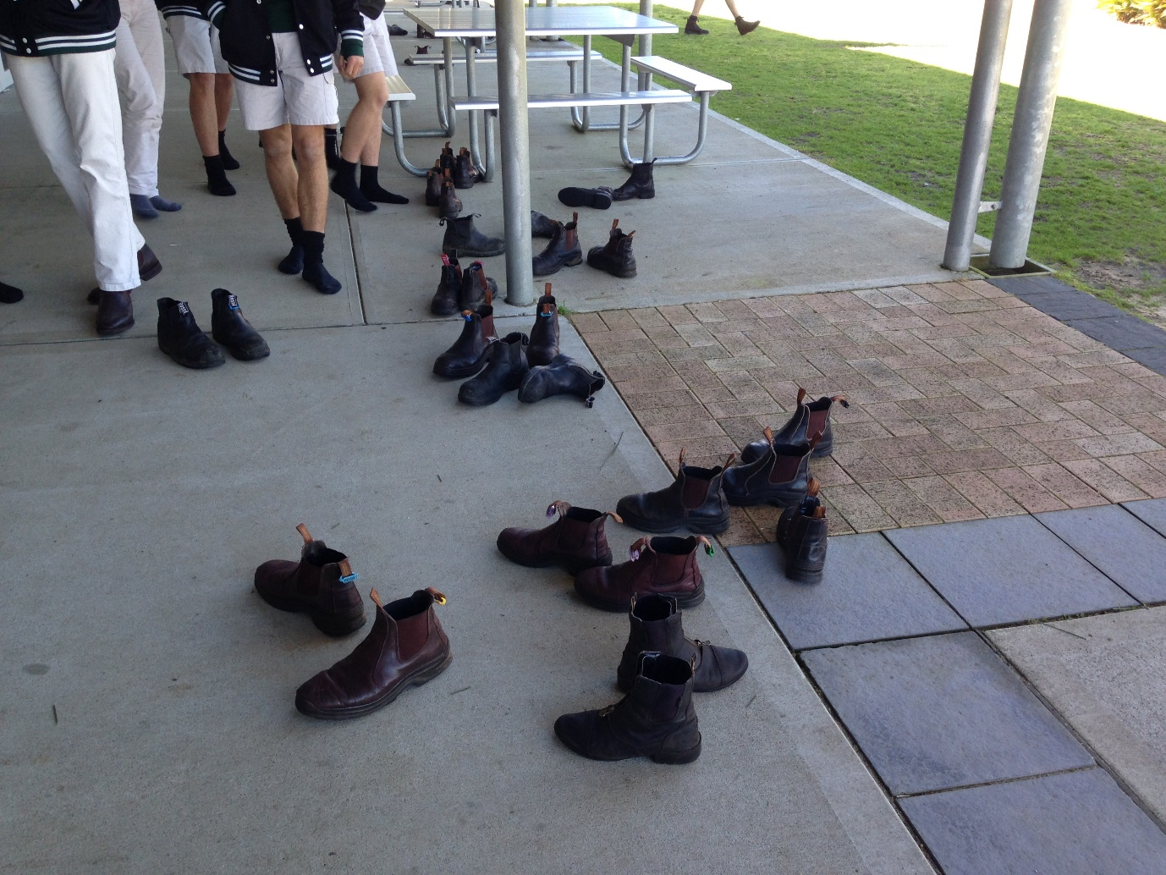
Agriculture students go for morning tea in Wokalup, Western Australia.
Schools in RRR areas also face a number of challenges when seeking to deliver a broad range of curriculum options for students. They include low enrolments and small class sizes, along with limited access to experienced teachers, particularly in specialist subject areas in the secondary years of schooling. Review submissions highlighted a number of examples of schools using innovative approaches, technology and distance education very effectively to ensure students could access the curriculum they required (see Text Box 1). As well, examples of schools and communities working together on local/regional arts and music festivals were highlighted as very important opportunities for expanding and enriching curriculum options. They also provide an alternative to sport which continues to be a very important feature of RRR community life.

Small RRR schools face additional challenges
As well as advocating for changes in curriculum emphasis, priorities and flexibility, concern was also raised about schools, particularly smaller ones, being overloaded by the breadth and depth of curriculum. This is neither a new concern nor one that has been dismissed by departments and agencies. Nevertheless, the message that schools were overloaded came through very consistently across all sectors of education and in all states and territories. In addition to curriculum load pressures, administration, reporting and accountability, and meeting complex compliance requirements were named as other causes of excessive workloads.
During two consultations, each in a different state, principals emphasised administration overload by referring to the number of emails that filled their inboxes— “up to 150 in 2 days and some of them include attachments”! Most came from their departments. While I have not personally been able to verify the accuracy of the claim, other leaders at the sessions were quick to support the figures. Assuming the figure is correct, and adding to it a plethora of other sources and kinds of administration workload, in a small school in particular where principals have a large teaching load, there is little time left for focussing on leading learning. Scaling back of the administration workload needs to happen to create more time for leading learning to be done and done well.
Submissions also highlighted how the ATAR system provides little benefit for regional students who do not wish to attend university. As well, assessment issues were raised in consultations and in some submissions, including the challenges associated with small schools and small class sizes and the limited opportunities for teachers and students in these situations to make effective professional and peer assessment comparisons.

Text Box 2
The NSW HSC Rural and Remote Marking Program (RRMP) allows teachers to gain knowledge, skills and understanding about the HSC marking process, including:
- Rural and Remote HSC marker program- a cross sectoral program that provides a number of marking positions in externally marked subject to RRR teachers
- HSC marking in regional centres
- Online learning — first online HSC marking course available in early 2018
- Online NAPLAN writing tests — online courses for marking the NAPLAN writing components – narrative and persuasive
- Visual Arts Marking Experience - rural and remote teachers spend two days at the Visual Arts marking centre in Sydney and are given hands-on experience with senior markers.

Source: The New South Wales Government Submission to IRRRRE

Senior secondary assessment and curriculum in RRR schools
Participation in year 11 and 12 annual state-wide assessment, examination marking and moderation process activities are critically important ways for teachers to gain in-depth understanding of ‘the required standards’, in addition to the guidance and support provided to them and to schools by curriculum and assessment experts and authorities.
However, field visits and submissions suggest there are a number of factors which effectively exclude RRR teachers from involvement in this high stakes professional development. The factors include the relative inexperience profile of RRR teachers and often their distance and isolation from cities and major regional centres. Text Boxes 2 and 3 highlight interesting approaches which are being used to address this issue.

Text Box 3
Traditional assessment practices in mathematics, including unit/topic tests, exams, and class tests, follow the one-size-fits-all model, which is not always appropriate, particularly in multi-age or multi-grade-level contexts. The Maths Pathway model provides a personalised model of assessment, in which each student is assessed according to the work that they do, and measured on the growth in learning and mastery that they demonstrate, rather than on arbitrary grade levels. Across 81 RRR schools, students have moved from an average growth rate of 0.51 years of learning / school year to an average of 1.30 years of learning / time. The program delivery cost is equivalent to a textbook for each student, which represents incredible value for the schools involved.
Source: Maths Pathway Submission to IRRRRE
Staying with the matter of senior secondary education, some assessment procedures that include a performance or production piece such as in music or dance, require students to travel to a major centre or capital city for their final assessment(s). While resources are provided, such as airfares to enable RRR students to attend the assessments, a significant impost is placed on RRR students compared to students in the city or major centre who only have to travel a few kilometres on public transport or via private means to attend and perform at an examination centre.
Another aspect of curriculum at the senior year levels of schooling that is causing widespread concern is accessibility to, and the affordability of, high quality VET certificate programs and pathways which are especially important and relevant for RRR students. Associated with this is the impact in some locations that the strong and relentless focus on gaining a high ATAR score has on lowering the status and value of pursuing VET options. As well, concerns were raised about the increasing complexity of work experience, especially in relation to completing risk assessments prior to placing students, and of finding sufficient appropriate placements.
The continuing mismatch between what is fundamentally valued and prioritised by schools in relation to the education of young people and their outcomes, and the more explicit requirements of employers and the world of work, is also a source of tension. It is especially acute in relation to literacy and numeracy standards and employment ready attributes like punctuality, reliability, ability to fit into a work culture and loyalty. While effort has been made to address this issue (see Text Box 4), more needs to be done.

Text Box 4
The Employment Pathways Curriculum Framework was developed to address the needs of secondary aged Aboriginal and Torres Strait Islander students with low literacy and numeracy levels. It aims to keep students engaged at school and in learning by targeting the Australian Curriculum - General Capabilities through contextualised, relevant and engaging project based learning. ESL levels and employability skills have been included in the curriculum framework to provide explicit focus on the development of skills and behaviours required to access employment beyond school. Teaching and learning resources have been developed to support implementation. Employment Pathways allow schools to develop teaching and learning opportunities that are contextualised to community and learner needs with a focus on general capabilities and employability skills. Teachers are supported through a range of teaching and learning resources that have an entrepreneurial or industry focus. 34 remote and very remote schools in the Northern Territory are using the Employment Pathways Curriculum Framework as the basis for secondary education provision from Term 3, 2017.
Source: Northern Territory Government Submission to IRRRRE

Recommendation and Actions

Recommendation
Establish and/or refine processes for ensuring the relevance of the Australian Curriculum and state/territory assessment processes for RRR students and communities.

Actions to progress this recommendation:
- increase opportunities in the Australian Curriculum for students to learn about the historical, economic, social, political and environmental importance of rural, regional and remote contexts and communities in Australia
- create and resource as required opportunities for direct consultations with RRR stakeholders and communities in the review of the Australian Curriculum in 2020
- facilitate and resource as required more opportunities for RRR teachers to participate in state-wide and national assessment and moderation processes
- support Aboriginal and Torres Strait Islander communities to continue to develop, implement and evaluate community valued blends of traditional culture, language and ceremonial life with the Australian Curriculum
- provide illustrations of good practice to RRR schools to demonstrate how the Australian Curriculum can be interpreted and used flexibly to suit local contexts
- reduce the impact of administration on workloads to create more time for teaching and leading learning

Teachers and teaching
Of the 233 online submissions the Review received (out of a total of 340 submissions), 192 rated teachers and teaching at a 6 or 7 on the 0 to 7 importance scale, and teachers and teaching was the highest rated on the importance scale of all the themes presented in the Discussion Paper. This is both not surprising and also very encouraging because extensive research shows that teachers have the most direct impact on children’s learning in schools. As well, life experiences are replete with stories that confirm this.
Notwithstanding the efforts of governments and others over many decades, attracting and retaining teachers for RRR schools continues to be one of the most persistent challenges on the education agenda. Another apparently very persistent aspect of staffing in rural schools is a belief that ‘the country is a good place for a teacher to start their career but not to devote their career to’.
Through submissions and in almost every consultation, the quality of teachers and teaching in RRR schools was identified as something that needs to be addressed. From the advice and inputs, five main action areas have been identified to drive teaching and learning in RRR schools and communities so that it is as good as, indeed better than, in ‘the best’ urban schools.
In making this declaration, it is very important to acknowledge there are exceptional teachers throughout RRR Australia doing, as one parent said, “amazing things for kids and communities”. As well, much is being done by governments, departments of education, sectors and professional associations to prepare and support teachers for teaching and living in RRR schools and communities. However, the bigger point is that in order to increase the achievements and expand successful transitions and pathways for RRR young people in and across the board, committed and highly effective teachers and teaching in every location for every year level is essential.
Before exploring this further, it is also very important to acknowledge the major contributions of ancillary staff to RRR education and opportunities. The expertise they bring to schools and services is diverse and essential to ensuring the day to day running of schools and the underpinning care of students. The diversity of expertise is also essential to the infrastructure of schools especially those which offer boarding, manage and share mobile facilities, operate school buses, hold sporting and cultural events, and run community school libraries and the like. As well, they are often ’local people’ and therefore they have a key role in building and maintaining school and community relationships.

Selection
Firstly, an especially significant stage in the formation of the human expertise a society requires is selection into a course or program to develop the knowledge, skills and dispositions to competently and confidently practice a vocation. This is especially so in relation to teaching given that schooling is compulsory. Other than by official exemption, there is no way anyone can avoid the influence of a teacher or teachers during their formative years.
It follows then that gaining entry into teaching should be a very considered matter, particularly in view of the range of teaching expertise required in RRR schools and the diversity of the locations and contexts of them. The Teacher Education Ministerial Advisory Group Report (TEMAG, 2014) elaborates further, namely:
Using simplistic approaches to select initial teacher education students will not lift the overall quality and capabilities of teachers being prepared for Australia’s classrooms. The Advisory Group believes that providers need to develop and implement sophisticated and transparent approaches to selection that take into account each applicant’s academic capabilities and the personal attributes needed for teaching (p.13).
Further to this TEMAG finding, during meetings in RRR locations in particular, a teacher’s commitment to place and people was also frequently advocated as being important to building student achievements and successful post school pathways. This in no way diminishes the value of their pedagogical and curriculum expertise in advancing outcomes for RRR young people. As well, ensuring that a high ATAR score is required for entrance into a teaching degree course was also often advised.

Text Box 5
Deakin Alliances in Teacher Education partners student teachers in extended placements with regional schools to contribute sustainably to curriculum offerings and student learning outcomes that focus on the needs of the school and community. Additionally Deakin’s Northern Territory partnership in teacher education sees student teachers spend time living and working in rural and remote communities. These examples flip thinking away from what might be delivered in RRR contexts to what RRR communities can bring to these debates.
Source: Deakin University Submission to IRRRRE
The key point is that selection into teaching for RRR schools and communities has to be targeted and nuanced to give prominence to the importance of the intellectual and personal qualities and attributes necessary to becoming a successful teacher in these contexts. This is not just about trying to ‘pick winners’ or reduce churning in the staffing of rural schools or eliminating dissonant perspectives or voices that might prove too disruptive or the like. Rather it is about foregrounding the challenges, demands and the rewards of teaching in RRR schools and communities and engaging teacher education candidates in a consideration of them as part of selection procedures.

Preparation
Secondly, extensive advice was provided about changes that need to occur during the initial preparation of teachers for teaching and living in RRR schools and communities. The urging here is underpinned by the fact that for many teaching graduates, a RRR school is their first appointment. Teacher employers in Australia have historically relied very heavily on ‘new teachers’ to fill country vacancies. They continue to do so.
Being a teacher in a RRR location, especially one that is very distant from a major centre with only a small school (say of less than 50 students) and one that is culturally diverse, presents a beginning teacher with many complex variables they have to work with as part of their commencement. Rural and remote contexts, while providing unique and challenging opportunities for teachers both professionally and personally, are also highly demanding. This is primarily because of small and thin density populations and a suite of characteristics that place significant value upon relationships and an appreciation of local knowledge. For teachers, small communities can accentuate their visibility and lack of anonymity and, frequently, the transient nature of their appointment. The combination of contextual factors and the profile factors requires knowledgeable and skilful negotiating and navigating by teachers to ensure they build their capacities and effectiveness. See Text boxes 5 and 6 as examples.
To help develop the skills and knowledge to be a successful teacher in a RRR school, substantial opportunities are required during initial teacher education for candidates to deeply engage with and reflect upon being a teacher in a RRR context. Relevant literature and research about this, including the role and importance of RRR locations and communities drawn from around the world, plus insights from other areas such as globalisation, development studies and rural sociology, need to be included in teacher education degrees and programs. Opportunities to learn with students preparing for other professions like social work, guidance, speech therapists and community nursing should also be widely available. As well, ways and means of developing relationships with parents, families and students to nurture aspirations and hope need to be included in a dedicated focus on preparation to be a teacher in a RRR school and community.

Text Box 6
A strategy by the Catholic Education Services, Diocese of Cairns, has been to offer students at the Australian Catholic University the opportunity to undertake their final year practicum at Cairns schools. The offer comes with supplied accommodation, a living allowance, and a guaranteed offer of a position on graduation, subject to a successful practicum outcome.
Source: Catholic Education Services, Diocese of Cairns Submission to IRRRRE
Also, additional opportunities are required to enable student teachers to teach and live in a RRR community for an extended period of time, say up to a term, before they graduate. This currently occurs in a number of universities in Australia and in various states including South Australia, Western Australia and Queensland, often with the support of funding from philanthropy and also considerable host-school goodwill.
Rural medicine in Australia has developed a very successful approach to educating and training General Practitioners in RRR locations. Funding to develop and implement the Rural GP program has been very considerable especially when compared to the funding allocated to teacher education practicums. The extended rural placements I was involved with at Flinders University granted students up to $5,000 for travel, accommodation and living expenses for a 10 week practicum. Using this amount as a guide, $10 million would fund around 2,000 placements per year.
Submissions and numerous discussions during visiting schools and communities strongly affirmed that pre-service teacher placements in RRR locations were a very effective way of attracting teachers to RRR schools and communities.

Improving RRR transfer processes
Thirdly, the appointment of a teacher to a rural or remote school typically requires relocation from a current place of residence. This is less likely to be the case in larger regional centres which have a range of school sizes, types and sectors, thereby facilitating more localised appointments and professional mobility. In either situation, however, the transfer in and out of schools can present a range of complex issues for the individual(s) involved, for schools and communities, and also for sectors and departments especially when schools and/or locations are generally known to be ‘hard to staff’.
When appointments require leaving present living arrangements, packing and travelling long distances, and negotiating and moving into ‘new’ accommodation and, in some instances shared accommodation, pressures generated by the changes can also have a significant impact on partners and families if they are involved.
Incentives of various kinds are used to help smooth the transition ‘out of the familiar and into the unknown’ (as well as to attract to ‘the unknown’) – such as a salary loading, cost of living adjustments, availability of housing coupled with rental assistance, additional support for professional development, accelerated promotion and, in some instances, a right of return agreement.
However, as submissions drew attention to and numerous consultations reinforced, very little is apparently done to assist partners and families, where involved, with making the transition and adapting to different circumstances including finding employment and making education arrangements for children.
In Barcaldine 580 kms west of Rockhampton in Queensland with a population of about 1,300 in the town and 2,800 in the Local Government Area, I learnt of an approach to recruiting and retaining highly qualified staff that ‘seems to tick all the boxes’ and could provide a model for education. It was developed and used by a privately owned engineering consulting firm that had started in the town and has operated there for the past seventy years.
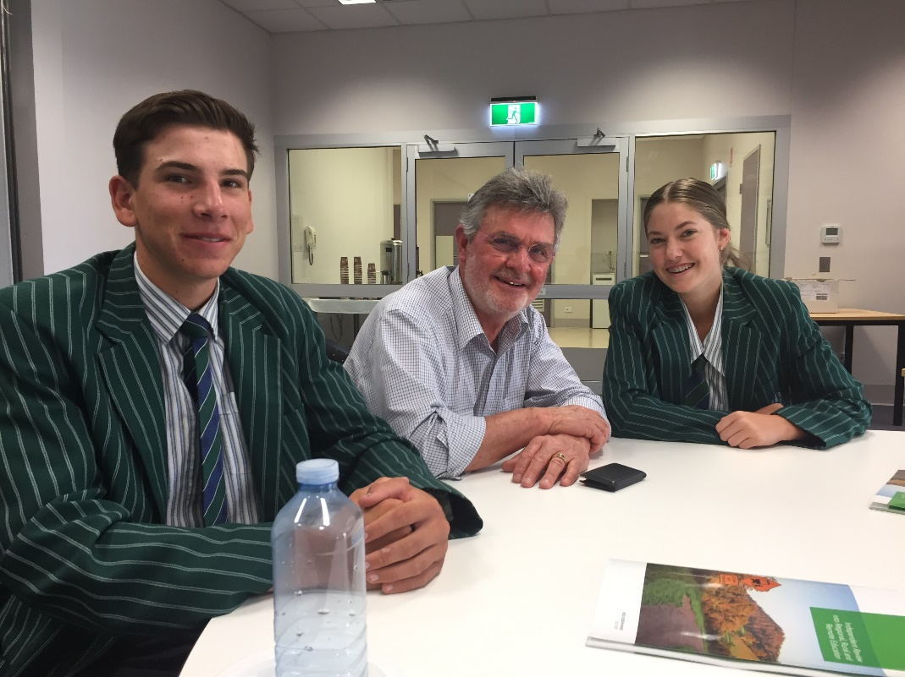
Professor Halsey with students from Rockhampton, Queensland.
Like a school, critical to the success of the business is being able to recruit and retain highly trained staff such as engineers and technicians so that the credibility and reputation of the business can grow and be sustained over an extended period of time. Virtually everyone that is employed or had been employed in the business was an ‘outsider’ to Barcaldine, including the firm’s founder. As with appointing teachers to RRR contexts, moving from a known to a relatively unknown context is integral to getting a job with the business. The cost of recruitment is real for the business because if a mistake is made it shows up in the annual profit and loss statement. So, the company is very motivated to do all that is possible to get the ‘right fit for a vacancy’.
Achieving this takes substantial time and includes meeting potential employees in their current location, being as informing as possible to them and their partner and children where this applies, about living and working in Barcaldine. Critical to what is offered is very good housing because the business cannot risk an employee’s enthusiasm for a new job, and hence productivity, being drained away every day after work by complaints and disappointments about the quality of housing.
If the meeting on the prospective employee’s home ground goes well, a fully funded return airfare and accommodation for all involved is paid for so they can see first-hand and begin to experience what it would be like to live and work in Barcaldine. Very importantly, there is a visit to and an inspection of the house that will become a home if the employment contract is signed off. As well, every effort is made to introduce the partner of the prospective recruit to local job opportunities, child minding and education facilities as well as a visit to the local shops and social venues such as restaurants, hotels, places of worship, health services and sporting facilities. For the company, it is very important that the family becomes engaged at an early stage in their possible relocation to a new home and new community; the same should also apply in education.

Experience and expertise
Another urgent priority is increasing the overall experience and expertise of teachers in RRR schools. This was put to me in a very direct way during a regional consultation held in South Australia — “all employees have to start their working life somewhere but we would like more teachers in our schools who are at the top of their game”.
Teachers who are widely recognised as being leaders in their field are frequently turned to for advice and assistance. Often they are educators who have extensive experience and may well have settled into a long term appointment in an urban or large regional centre. As well, changing their places of work and their private lives is probably not at the forefront of their thinking. Further efforts to attract teachers who have been certified at Highly Accomplished and Lead Teacher level of the Australian Professional Standards for Teachers to RRR schools need to be explored.
So how might this objective of having more ‘top of their game’ teachers in RRR schools be achieved?
Firstly, a combination of inviting and targeting of potential candidates is necessary. The targeting must address a key concern held very widely, namely, ‘if I do accept an appointment to a RRR school or cluster of schools, will I ever be able to get back to my current or another preferred location?’ It is very clear that employment packages which include an absolute guarantee to return to their originating/preferred school or workplace at the end of their RRR appointment unless they opt out of it, needs to be part of the mix of incentives.
Secondly, more needs to be done to grow the expertise of teachers who are already in RRR schools. Key to this is resourcing professional development which is delivered mostly in-situ and in partnership with a recognised professional development provider like a university or a peak professional body. Consideration should also be given to creating positons in RRR schools or clusters/groups of schools with a specific brief to build the capacities of teachers to optimise student achievements (see Text Box 7).

Text Box 7
CIN Educational Consulting in partnership with Charles Sturt University has been trialling an innovative professional learning project in four rural and/or remote schools in 2017. The selected rural and/or remote NSW, public secondary schools share the following key features:
a) relatively high percentage of students who identify as Aboriginal or Torres Strait Islander (>25%)
b) high percentage of students from low SES backgrounds
c) high staff turnover
d) principals in their first three years
e) relatively inexperienced executive and/or teaching staff
The four schools in the joint CIN/CSU Rural and Remote Project are Moree Secondary College, Wee Waa High School, Nyngan High School and Bourke High School.
The innovative features of the project include:
- In-school professional support provided every 5 weeks by highly experienced ex-school leaders with a deep understanding of the needs of principals, executive and teachers in regional, rural and remote schools.
- Intensive, in-school capacity building for executive and teaching staff in teams, pairs and one on one contexts focused on improving student learning
- A collaborative and repeatable cycle of improvement which builds the capacity of executive staff and of faculty teams focused on improving the learning of all students
- Evidence based classroom practice which improves student learning across all stages
- Collaborative leadership processes which build a strong sense of ownership and inclusivity
- Evidence based classroom practices becomes a central platform of the school plan over three years so the work is built into, not bolted onto, each school’s core operations
Source: Charles Sturt University Submission to IRRRRE
Departments, professional associations and others, such as local councils, could work together to raise the public profile and importance of being a teacher in a RRR school and community. Initiatives which build and nurture connections with communities and cultural understanding was consistently raised in submissions and during many of my discussions as being important for teachers so they understand both the challenges and the rewards of working in RRR schools and communities.

Reducing teacher turnover
The fifth critically important matter that needs to be addressed in relation to teachers is reducing their turnover rate in remote Aboriginal and Torres Strait Islander schools and increasing the overall experience of those who are appointed. This is not a criticism of the teachers who currently teach in these schools; rather these are issues that should be worked on to raise the achievements and improve the post school pathways for young people.
Beginning teachers have historically been one of the main sources of staffing for remote Aboriginal and Torres Strait Islander schools. While some succeed and make a very significant contribution to the children they teach, as I saw at the Soapy Bore Homeland School in the Northern Territory, there is more that can be done to build the capacities and experiences of early career teachers before they are appointed to remote schools. An initiative of Good to Great Schools Australia (GGSA) is very instructive here.
Like many other RRR schools, a significant ‘fact of life’ for GGSA is the appointment of beginning teachers and devoting considerable time, effort and resources to inducting them into the profession and building their competencies. However, many as soon as they are eligible apply for a transfer to another location. GGSA finds itself, as do other RRR schools, leaders and communities, doing significant training and development which others benefit from more than they do.
GGSA is exploring how the situation as briefly outlined could be flipped 180 degrees so that students benefit from early career teachers who have already had 2 to 3 years of very high quality induction and support into the profession, before being appointed. The flipping essentially involves GGSA working in partnership with a group of schools located in the South East of Queensland. These schools would receive new graduates and develop and nurture their capacities with the aim of an appointment to GGSA ‘down the track’ with the option of returning after a negotiated length of service. In essence, this orbiting between locations and contexts approach to teacher development addresses a pressing issue which is prevalent in numerous other RRR schools.
Of course there are personal matters which have to be worked through in order for the orbiting model to function effectively, as well as industrial and departmental processes and issues. Nevertheless, the approach is a valuable contribution towards building teacher experience and expertise for remote Aboriginal and Torres Strait Islander schools as well as RRR schools more generally.

Recommendation and Actions

Recommendation
Ensure RRR contexts, challenges and opportunities are explicitly included in the selection and
pre-service education of teachers, initial appointment processes and their on-going professional support.

Actions to progress this recommendation:
- ensure that the challenges and opportunities of RRR schools and contexts are explicitly included in the selection processes for teacher education degrees/programs
- ensure that a candidate’s academic and personal requirements for admission to a teaching degree/program are commensurate with developing the skills, knowledge and attributes to be a successful teacher
- provide funding and opportunities for initial teacher education students to undertake high quality extended professional experience placements in RRR schools and communities
- introduce a topic (suggest that it is weighted at the equivalent of a semester in size) into teacher education degrees on teaching and living in RRR schools and communities that students complete successfully as part of graduation requirements
- increase the number and diversity of experienced teachers appointed for extended periods to RRR schools by using targeted salary and conditions packages which include an absolute guarantee to return to their originating/preferred school or workplace at the end of a fixed term appointment
- improve the availability and diversity of in-school/locally based professional development for teachers in RRR schools and communities including by using visiting curriculum and pedagogy specialists
- implement up to a ½ term handover and induction period for teacher transfers to foster continuity of students’ learning in RRR schools where there is a history of frequent teacher turn-over and substantial student under achievement
- continue to improve the availability of quality accommodation, cost of living allowances, access to essential human services, and partner employment where applicable to attract and retain high quality teachers for RRR schools.

Leaders and leadership
Highly effective school leaders are critical in RRR settings because they play a key role in establishing and fostering a school climate for learning and achievement to flourish.
Attracting and retaining school leaders in RRR Australia continues to be a major challenge for most education systems. Education authorities and other employers use an array of incentives to attract principals to RRR schools. As with teachers, on numerous occasions during my discussions with principals I was told that availability of good quality, affordable housing is essential. The transition to principalship of a RRR school is complex and demanding enough without having to devote time and emotional energy to finding somewhere reasonable to live. And the tensions around this can be compounded if access to quality housing is also an issue for staff more generally.
Raising the status of being a RRR educational leader was identified as a major challenge, as it was for teachers and teaching. In submissions and frequently during discussions in communities and with professional associations, it was argued that the importance of being an educational leader in RRR schools and communities needs to be better understood and valued by systems and employers. I was told this would be a helpful contribution toward countering the widely held view that leadership of a country school is mostly a ‘stepping stone’ to becoming an educational leader in a major city, rather than a valuable career path in its own right.

Preparing principals for RRR schools
The preparation to become an educational leader of a RRR school varies widely and ranges from a Masters degree at Flinders University that focuses on RRR contexts and issues to working through a series of sub-ordinate positions linked to mentoring and/or professional development. Improving the early identification of aspiring educational leaders as well as improving their preparation and then providing mentoring following appointment, all take on added urgency and significance regarding RRR schools and communities due to the overall decline in the number of teachers aspiring to become principals.

Text Box 8
Leadership development programs delivered by the Australian Rural Leadership Foundation (ALRF) combine people from diverse industries, communities and backgrounds, to enable participants to develop a network of supportive leaders, who are all working for the greater good of Australia. ARLF programs develop leaders, by providing participants with experiences to:
• grow as an individual
• develop their leadership capabilities, including governance and decision making, and
• broaden their perspectives and learn from others.
Leaders in the ARLF program come from all sectors and walks of life in rural regional and remote Australia.
Source: Australian Rural Leadership Foundation Submission to IRRRRE
There is an opportunity to significantly improve the preparation, induction and on-going support of RRR educational leaders by diversifying the information, research and practice which has traditionally been used for such purposes (see Text Box 8). This was affirmed after considering advice received from Principals Australia Institute and member groups, Regional Development Associations, the Australian Rural Leadership Foundation, the Regional Australia Institute, the Australian Council for Educational Leadership, the Society for the Provision of Education in Rural Australia, the Australian Institute for Teaching and School Leadership, the Australian College of Educators, peak employer and parent groups as well as various universities. Inviting representatives from each of these groups with the power to co-opt others as required to design and then offer a RRR educational and community leadership postgraduate qualification is a high priority.

Role of principals in small RRR schools
One reason for the decline in educational leadership aspirants as presented in a number of submissions and during consultations is the compliance workload and how this hinders being an instructional leader. I was also told on numerous occasions that the increasingly high level of administrative and accountability workload in RRR schools needs to be addressed. This can be done by providing additional resources to schools, and by being much more targeted in relation to school size and type about what is communicated to schools and expected from them. Some specific data relating to this was briefly presented in the curriculum and assessment section. I was also told that in some RRR locations, the amount of time principals spend on recruiting is excessive and also stressful with some positions being advertised several times in order to “if I am lucky, attract just one applicant”.
I also encountered instances where regulatory requirements had significant negative consequences on leader workloads when applied in the field. Teacher registration is an example.
In one instance, renewal requirements imposed conditions on applicants that resulted in a rural school in the New England region losing its pool of relief teachers. In short, the relief teachers, most of who lived in the district and were highly valued by the school, said that the renewal requirements were too onerous and therefore had decided not to proceed with registration renewal. The principal agreed there had to be rigorous renewal processes but also that the realities of the contexts and conditions of RRR schools had to be more effectively factored into system wide policies.
Another instance, also relating to teacher registration, is national recognition. For RRR schools which rely on recruiting staff from around Australia such as happens in Alice Springs, I was told that having to deal with multiple teacher registration authorities is a waste of time and effort and needs to be fixed.
As stated earlier, there are over 2,100 schools in Australia with 100 or fewer students and most of these are in RRR locations. Typically, small schools have a principal who also has a substantial teaching load. During my discussions with leaders of small schools, it became very apparent there is significant potential to free up more of a teaching principal’s time for teaching and supporting learning by reducing their administration load. This could be achieved through clustering arrangements with several sites working in a partnership, as well as through the employment of a local shared services manager or similar to reduce duplication of administration work and improve the efficiency of systems (see Text Box 9).
Turning around a school which has a track record of persistent low achievement is complex and ‘plain hard work’. Integral to achieving significant improvements is introducing and persisting with some of the fundamentals required for success, such as clarity of purpose, high expectations of everyone associated with the school, a relentless focus on learning and assessing progress, good teachers who love what they do and want the very best for the children they teach, and more!
Some school and community situations are particularly demanding such as one remote example I became aware of during the Review where there had been 14 principals appointed over a 10-year period. Situations like this require departments/employing authorities to have the flexibility and resourcing to directly select and tailor the remuneration package of a leader to undertake a very complex body of work. There are precedents for this and they need to be maintained for particularly demanding assignments.

Text Box 9
At Gunbalanya School in Western Arnhemland, a co-principalship model is used. Under this model one school principal manages teaching and learning and the other co-principal (an educator from the local community) manages the community interface and student engagement. This model has been highly successful as it provides the capacity for a well-managed school that is connected and engaged with the community. This model has been particularly effective in growing the capacity of both co-principals and reduced principal turnover.
More than 20 remote principals are working with mentors and coaches to improve their leadership, management and community engagement skills. Mentors and coaches are matched with remote school principals based on the skill set that we need to develop with individual principals. All mentors and coaches are experienced professionals who have undergone coaching and mentoring preparation.
Source: Northern Territory Government Submission to IRRRRE
As well, consideration also needs to be given to appointing a small, specially selected and tasked ‘turn around team’ for especially demanding situations comprising for example a leader and, depending on the size, type and location of the school, two or three staff including support staff such as a business manager, a school based nurse, a home-school visitor as well as teachers.

‘Co-opetition’ and partnerships
In recent years in some RRR locations there has been an increase in the number of non-government schools, primarily established to provide choice for parents and to meet specific learning needs and interests.
During consultations, I was made aware by both parents and school leaders that the expansion of schooling options in RRR contexts also has some downsides. In central western Queensland, strong concern was expressed about the introduction of the ‘by-pass your local school’ policy which, it was claimed, had had a negative impact in the home town of the forum participant. Further, in some locations the competition for a static or even declining student population substantially inhibits any partnering between schools primarily because of fear of “losing numbers to the opposition”. Advice was also provided that schooling should be non-compulsory and this would significantly improve what is available because it would make schools become very responsive to what students wanted to learn.
On the other hand, there is also encouraging evidence of RRR educational leaders building partnerships at local and regional levels with employers, vocational education providers, regional universities, service providers, specialist advocacy groups and governance bodies to create opportunities and pathways for students. They are also being very proactive by working with a range of human service personnel and agencies to create a better start to school for children, especially from families who are struggling.
As well, in remote Aboriginal and Torres Strait Islander communities, I met with elders, school leaders and senior teachers (as well as parents, members of communities and students) and heard about leadership which is supporting new blends of traditional knowledge and ways with western curriculum that are in turn creating valued pathways beyond school.
An example of this is the Nhulunbuy School which has a Trade Training Centre as well as a purpose built boarding facility, and engages students in hospitality, engineering and maritime skills development, each helping to build a strong sense of purpose for learning and employment pathways. Another example is the way the Garma Festival is being used very creatively for language and cultural learning as well as the running of this complex and diverse event. There is further potential to be derived from both of these very valuable initiatives through leadership, authentic reporting of achievements and appropriate resourcing.

Recommendation and Actions

Recommendation
Ensure RRR contexts, challenges and opportunities are explicitly included in the selection, preparation, appointment and on-going professional support of educational leaders.

Actions to progress this recommendation:
- continue improving how educational leaders for RRR schools and communities are identified, prepared and supported
- increase the number and diversity of experienced educational leaders in RRR schools by using targeted salary and conditions packages which include an absolute guarantee to return to their originating/preferred school or workplace at the end of a fixed term appointment
- implement up to ½ a term handover and induction period for leaders to foster continuity of students’ learning in RRR schools where there is a history of frequent leadership turn-over and substantial student underachievement
- substantially expand mentoring and coaching by experienced principals for inexperienced educational leaders as a key strategy to building RRR leadership capabilities and capacities
- investigate the appointment of ‘turn around teams’ (such as a principal, a curriculum leader and a business manager) to schools with a persistent long term record of underachievement
- develop nationally consistent initial and renewal teacher registration requirements which fully recognise the diversity of RRR contexts and conditions
- continue improving the availability of quality accommodation, cost of living allowances, access to essential human services, and partner employment where applicable to attract and retain high quality leaders for RRR schools.

Schools and community
The achievements and opportunities of children and students are greatly helped when there is a productive and complementary relationship between their out of school life and the time they spend at school. This is sometimes referred to as a learning journey partnership; others have coined phrases such as ‘better together’ to describe it.
Taking this stance, however, in no way diminishes the complexities of developing and sustaining growth oriented partnerships between home, school and community. Neither is it intended to gloss over the fact that in some situations, problems in the home, tensions in a school and major economic decline in a community can produce very demanding challenges which can have negative consequences on the life chances of young people.

Schools and RRR communities
Schools in RRR communities, and especially small communities as already stated, are central to there being a community. This belief has been reinforced many times over during visits to RRR communities and in discussions with parents, community leaders, businesses, students, teachers and principals. The belief holds true independent of school size, type and location and there were instances of very small schools (say less than twenty enrolments) exhibiting the greatest intensity about it.
While school closures and consolidations have been a dominant feature of RRR education for many decades, there is a tenacious commitment to do whatever is needed to maintain schools in communities. Part of this tenacity comes from experiencing the withdrawal of services like banking, post offices, local health, regional works depots and the like and the profound impact these have had on the viability of a town or region. As well, this tenacity is buoyed by examples of small schools embracing ICT successfully to enrich students’ learning like the Snow Gums Learning Alliance (Snow Gums Learning Alliance), and reducing the limitations of low enrolments on an educational program.
So how might this tenacity for survival be used to help build the capacities of RRR communities and thereby contribute to raising the achievements of students and improving their opportunities?
In 2004 the Civil Renewal Unit in the United Kingdom’s Home Office Communities Group published a report titled Firm Foundations: The Government’s Framework for Community Capacity Building. The report introduced the concept of anchor organisations and how vital they are for community capacity building and, over time, helping to turn around decline and stagnation. Anchor organisations are what their name implies—something solid and grounded, ‘here for the long haul’ with sufficient presence, respect, and openness to working in partnership with others to grow and sustain worthwhile futures for individuals and communities.
In many locations throughout RRR Australia, the concept of anchor organisations could be explored as a way to create new and sustainable opportunities. The range of anchor type organisations in RRR locations is still quite extensive as already signalled: schools, regional universities and hubs, TAFE (more about this later) and other registered training organisations, regional development bodies, local businesses and industries, citizen interest groups, health services, philanthropy and others.
A commitment to the key features of the anchors approach will also be very important in building capacities and delivering a range of benefits for individuals and communities. They include a strong focus on localised control, addressing needs in a multi-purpose and holistic way, and a commitment to involving all sections of a community/region including those who are the most frequently marginalised.

Students with specific learning needs
Responding to RRR students who have specific learning needs and interests continues to be a very topical and often problematic issue. Government, the community and community organisations play a very important role in this. Notwithstanding efforts made by governments to provide a strong foundation for at-risk students when they commence schooling, consultations confirm that more needs to done.
Of particular concern is obtaining timely, appropriate and affordable early identification of potential learning difficulties, and disabilities, as well as exceptional talents and abilities. Some of the forums held in small towns stated that it could take 12 months or more from the time a school lodged a request for advice to receiving a first visit and a report on how to meet a specific learning need. As is well known, the early years are especially critical in terms of a child’s cognitive and emotional development. It is unacceptable that a 6 year old, for example, has to wait a year or more for an initial diagnosis so that targeted learning and support can commence.
Related to ensuring that individual situations are addressed in a timely and affordable way so students can optimise their learning and experience success from a young age, issues around ‘readiness for school’ were often raised during consultations. There is quite widespread concern about the level of readiness of some school commencers, particularly in relation to children starting school with undiagnosed ‘basic’ health issue problems like vision, hearing and poor nutrition, and the impact these have on ‘getting the grounding’ needed to enjoy life and be successful. As well, readiness for school issues were frequently associated with lower socio-economic factors, again often exacerbated if a town or community is grappling with major economic changes such as happens with the decline of an industry, the continuing withdrawal of essential human services and the steady decline of small businesses.
The consultation in Birchip in north-west Victoria highlighted very effective work being done by maternal and child health (MCH) nurses with families with young children. The MCH nurses provide services for children 0–3.5 years. Given the relationships and information the nurses build up over time, they are able to link families into specialist services such as occupational therapists and speech therapists.
Very importantly as well, because of their knowledge of families’ circumstances gained over time, they also connect parents and children into other services and activities like supported playgroups, new parents’ groups where parenting skills and approaches can be observed in an informal way, and where advice and support is available on a range of matters. The local school is also especially supportive and is well known for the care and attention it provides as well as its relentless focus on learning.
There are similar services in other states and RRR locations, sometimes with a different role title such as Community Nurse. Each was dedicated to working very pro-actively with families, often in partnership with pre-schools, schools and volunteer community support groups run by churches and others, to ensure children were healthy and well prepared to start school. As one person commented, “investment in the early years is really building the foundations for life”.

Universities and VET
Consistent with the potential of anchor organisations and especially groups of them for the development of new opportunities in RRR locations, fostering ways and means for different kinds of organisations to work together productively to create better opportunities for young people and communities was strongly advocated in submissions and in many meetings. As one person in the Western Australian Wheatbelt commented “silos [read bureaucracy, red tape and organisations working alone] trap and store stuff but we need to be able to use resources more flexibly to do what is needed here”. In addition to schools which have a much dispersed presence across RRR, universities and hubs with their substantial critical mass linked to their delivery footprint also provide major opportunities for driving innovation and creating new wealth generation for individuals and communities.
Universities like Central Queensland, Southern Cross, the University of the Sunshine Coast and other members of the Regional Universities Network (RUN) make very significant contributions to RRR Australia through more than 60 different locations. So do a number of other universities have a strong commitment to building the economic and social capital of regions, like the University of Tasmania, La Trobe, Charles Sturt and Flinders. These organisations have substantial capacity to do more for regions, especially by working in partnership with the other key anchors as listed above.
Some of these institutions are also engaged in delivering VET qualifications as ‘dual sector providers’, that is, universities that are also registered to teach VET, and/or already working closely with VET partners to collaborate and maximise the opportunities for students. While there have been some problems and underachievement with this approach, there have also been successes. It is the successes which shed light on ways of expanding post schooling opportunities for RRR students and the further policy work that needs to be done to embed them as mainstream options. An example is the La Trobe dual enrolment scaffolded model summarised in Text Box 10.

Text Box 10
La Trobe has recently established a sector-leading ‘dual enrolment’ model with partner TAFE institutions, which involves students enrolling simultaneously in a bachelor program and a VET diploma, with the option of either exiting after one year with the VET qualification or continuing on in the bachelor program. While La Trobe’s initial experience with this dual enrolment is very encouraging, there are significant policy and regulatory hurdles that stand in the way of this type of collaboration. For instance, because VET completions are not recognised in the collection of higher education data, students who exit early with a VET diploma are viewed as having ‘dropped out’, thus negatively contributing to attrition and retention rates. This represents a disincentive for institutions like La Trobe to pursue such a model particularly in the event of the government introducing performance funding based on student retention.
Source: La Trobe University submission
Another successful dual University and TAFE variation is the approach taken by the Central Queensland University which is described in Text Box 11.

Text Box 11
Central Queensland University (CQU) is a dual sector university that provides a large range of TAFE courses as part of an integrated structure with higher education. This is a result of the merger of CQU and the Central Queensland Institute of TAFE in 2014. In 2016, CQU streamlined IT services, aligned language across VET and higher education operations, integrated disciplines into single division ensuring greater collaboration between VET and higher education staff. CQU offers direct entry into enabling courses to help student progress in higher level courses. Many of these students are from disadvantaged groups including regional, rural and remote students. Through the VET in Schools (VETiS) program, CQU offers later year school students opportunities to study VET units contributing to their Queensland Certificate of Education.
Source: CQUniversity Annual Report 2016
However, to fully unlock the potential of a ‘new deal for RRR communities’ it is critical that VET and particularly the issues and problems consistently encountered during consultations about TAFE be addressed. Before delving into these, it is also important to recognise that high quality VET, where it is available, is playing a crucial role in helping young people develop the skills and knowledge they require to gain employment, build careers, start their own businesses and much more. The trouble is the major variability in access, availability and affordability and also the complexity of how to negotiate and navigate the way into and through a high quality VET pathway.
By way of illustration, an apprentice in Mount Gambier in South Australia has to travel to Adelaide for his off the job study; previously this could be done locally. There were similar accounts involving apprentices travelling from Kalgoorlie to Perth. Is a headline about road deaths of tired young apprentices driving to their courses needed to change this situation?
In addition, there is the enduring problem which has been ‘part and parcel’ of education in Australia for over a century, namely the status and value differential between a VET pathway and qualification compared with a university degree. The net effect of this issue is the worth and relevance of VET is diminished and discounted at a time when the exact opposite is required. One reason this is happening is the high visibility of university pathways and the fact teachers have been educated at universities and have a tendency to advise and advocate what is most familiar.
The conclusion I have reached is that nationally, TAFE has to be put back into the regions, closer to people, places and the heartland of much of Australia’s productivity. Sorting through the complexities and tensions between state and federal levels of jurisdiction and funding of TAFE is beyond the remit of this review. However, it is clear that the issues of adequate funding for TAFE, access to and the costs of programs for students, designing new flexible offerings and enhanced qualification scaffolding and recognition with universities must all be included in a ‘root and branch’ review.
Questions about TAFE delivering more applied degree offerings as well as rigorous skills training, plus a higher valuing of applied research to facilitate transitioning into emerging new fields of employment, should also be considered. A general review of the availability of training courses and access to training providers in RRR locations should also be undertaken. This should take into account the numbers and diversity of providers, quality, costs, regulation and effectiveness of contestable subsidy markets in RRR locations.

VET-in- Schools
The other very important component of improving the capacity of VET that requires some
changes to help lift student achievements and improve transitions to work and/or further study is VET-in–Schools (VETiS). As with many other aspects of education and training in RRR locations, VETiS has some outstanding initiatives which are very worthy of being replicated to suit particular contexts and needs.
Examples include the WA College of Agriculture- Harvey which is an RTO in five different areas, and the Big Red Truck Mobile Hospitality Trade Training Centre based in a cluster of five schools in central western Queensland. However, in some other locations consultations revealed a range of issues which impeded the provision of high quality, well-articulated VETiS. The issues were quite varied but the overall effect was one of limiting options and pathways for young people.

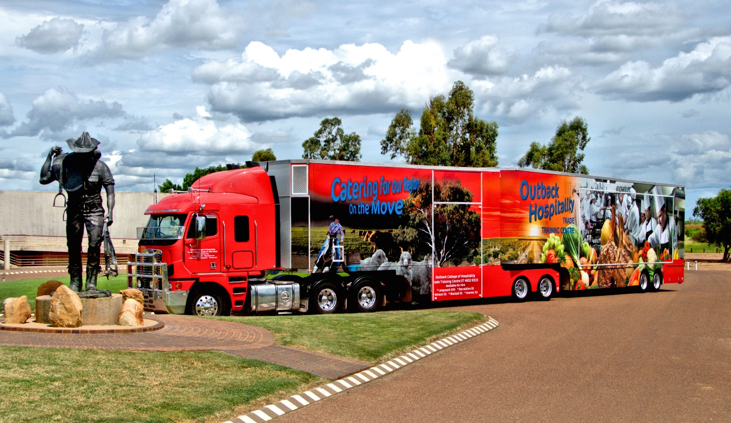
The Big Red Truck Hospitality Trade Training Centre on rotation at Barcaldine, Queensland.
Consistent with many other issues associated with RRR education, distance, low numbers, thin markets, availability, access and costs all impact on VETiS, as well as already flagged the status of VET compared to a university pathway. Also in common with progressing improvements in other areas, the use of ICT was advocated. In addition to the challenges of embedding VET options into a school’s curriculum and ensuring they are taught and assessed consistent with the required industry standards, consultations revealed a range of other more values based issues which impede the availability and uptake of VETiS and VET more broadly.
Firstly, schools are primarily staffed by teachers; overwhelmingly teachers have followed an academic pathway, ie universities. For many, perhaps most, vocational pathways and the business and industry environments are not within their personal experience. As well, universities also actively market to schools with ‘travelling university fairs’, and encourage schools to attend open days and the like. They also have outreach mentoring programs where university students work in schools to demystify going to university. In contrast to this, the level of marketing undertaken by vocational education providers is much less co-ordinated and much less pervasive, partly due to lack of funding. Secondly, for students who are undecided about their future, a university course seems a viable option especially when fees can be deferred. As well, the value of a vocational pathway is not fully understood and the potential income levels for those with higher vocational skills and qualifications are not widely promoted compared to earnings for most university graduates. The high status courses of law and medicine for example give an unrealistic view of the potential earnings for all university graduates. In addition, advice was received that employers often do not value VET pathways delivered by schools, as the learning is frequently considered to be substandard to that provided in a ‘real’ VET provider ie TAFE. While this is not true for all, it is another factor to be considered as is the low valuing of auspicing in some instances.

Associate Degrees
Another option for improving post school opportunities for RRR young people is diversifying the university pathway choices and reducing the length of time it takes to complete a qualification that is recognised and valued by employers. As already outlined, the dual VET/university scaffolding is an example of this. Another is the two year degree model which has been developed by the University of Tasmania. The flexible design of the degree includes the ability to exit after one year of successful study with a diploma and counting the full value of an Associate Degree towards completing a Bachelor level qualification. Text Box 12 provides further information about this innovative development which has the potential to enhance post school pathways for RRR students.

Text Box 12
University of Tasmania Associate Degree model provides a flexible mechanism to acquire new skills to begin a new career or for those seeking a pathway to a bachelor degree. The associate degrees take a shorter timeframe for completion with a duration of two years (full time) with the option to leave after one year with a diploma. New associate degrees are offered via blended delivery model including online, face-to-face learning, and a workshop component or industry location for students to practice skills and integrate theory. Units studied under associate degrees contribute to bachelor degrees, bridging the gap between VET and bachelor degrees. The associate degree model is also very supportive of students and there are no exams in their first year to help students transition and reduce pressure students may feel.
Source: University of Tasmania - Associate Degrees

Recommendation and Actions

Recommendation
Ensure RRR children start school with a strong foundation for learning.

Actions to progress this recommendation:
- ensure that early intervention trained personnel and programs are in place to help families and to connect them to relevant support agencies
- substantially reduce the waiting time (say to a maximum of three months) for specialist assessments of students with learning difficulties and disabilities and the subsequent development of specific learning plans for them.

Recommendation
Expand the availability, affordability and accessibility of high quality work experience placements, VET, dual VET/university options and two-year associate degree programs for RRR students.

Actions to progress this recommendation:
- significantly increase the number of people with industry/business experience working closely with schools and students to provide vocational pathways advice and to assist students to negotiate the training and/or employment pathway they want to follow
- work with TAFE institutions to develop regional strategies for TAFE delivery that brings TAFE closer into the regions
- increase the availability of flexible, responsive and affordable associate degrees, dual VET/university options and VET programs for current and emerging new industries
- fund a major Renewing the Regions national education and training initiative for at least 5 years to grow RRR employment opportunities and build the human capital required for vibrant, productive and sustainable RRR communities
- review providers of training servicing RRR locations to ensure that the range of offerings and their quality and costs are meeting individual, community and regional development requirements.

Transitions
Transitioning from school to further study, training, employment or combinations of them, is a major event for a young person and their family. For many who live in RRR areas, this stage of life can be particularly challenging, as well as highly rewarding, because it often involves having to move away from the security of home, family, friends and the familiarity and support of a community. And moving out and away from home base can also be a time and opportunity for a ‘fresh start’ and a chance to review and reflect upon what has been done and achieved to date, and essentially to dream about ‘the future—my future’. It can also induce fear and trepidation.
There is existing government support to help RRR students transition to higher education. The Higher Education Participation and Partnerships Program (HEPPP) aims to ensure that Australians from low SES backgrounds who have the ability to study at university have the opportunity to do so. The Rural and Regional Enterprise Scholarship provides up to $18 000 to RRR students to undertake STEM studies, including in agriculture and health fields. And for some RRR students who relocate for study, a Relocation Scholarship of (in 2018) $4,459 for the first year, $2,231 for the second and third years and $1,115 per year after that.
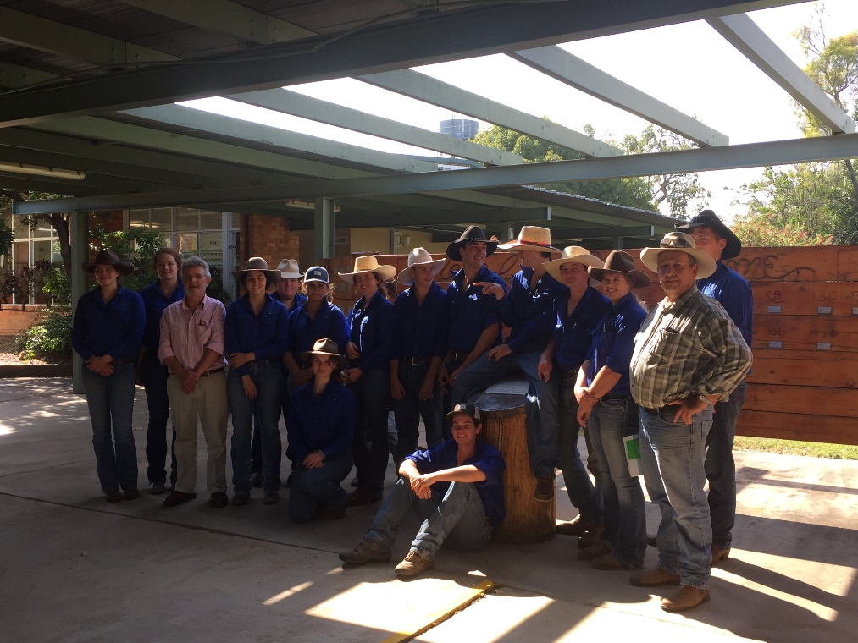
Professor Halsey with students and supervisors from an agricultural college in Emerald, Queensland.
While there are a range of payments and allowances to support RRR students, much more has to be done to support and smooth the transition of students from RRR schools and communities to employment, training, further study or combinations of them. This is very clear from the many contributions of young people, parents, teachers, principals and others during consultations and in written submissions, including from the Brotherhood of St Laurence, the Group of Eight, TAFE Directors Australia and James Cook University. It is also very clear that the movement of a young person away from their home and community usually has a very significant impact on those close to them, and the effect of this moving away also needs to be factored into improving the transition support.

Career information and advice
When should preparation for transitioning from schooling start?
There is no ‘one size fits all’ answer. Year 9 or thereabouts is widely seen as being particularly significant in terms of young people thinking about their future beyond school. For many in RRR schools however, working through what they would like to do after finishing school is limited by the thinness of advice and information about current and likely employment and careers and how to prepare for them. This is often intensified in situations where there is little employment diversity locally or family circumstances are such that on-going conversations about ‘what would you like to do, to be after you finish school’ are rare or do not occur.
For Aboriginal and Torres Strait Islander students, thinking about and planning for employment and a career after completing school can be especially challenging and problematic, primarily due to the complexity as well as the richness of the intersections of their culture and traditions with western concepts and expectations about careers (see Text Box 13).

Text Box 13
There is not a day that goes by where I don’t feel somewhat conflicted, that I am having to constantly adjust to ‘walk in two worlds’. As a young Aboriginal and Torres Strait Islander woman working in the public service, there is a constant feeling of responsibility to maintain my traditional heritage, cultural morals and values, and uphold the standard ethics that come with my position in Government.
It’s an interesting experience to try and explain. It’s like simultaneously wearing two masks and being two completely different people, but also trying to combine them in order to maintain balance and stay grounded. Sometimes, it can be overwhelming. Non-Indigenous people who work in Indigenous areas don’t have the same obligation to constantly bear the load of consciously dealing with Indigenous issues; they have the choice to leave it at their desks when they go home. This is not an option for an Indigenous person.
Being a young Indigenous woman, I have a responsibility to maintain a leadership role for those back in my community and more importantly my family. One small conversation with the right person can lead to more informed policy discussions that ultimately affect Aboriginal and Torres Strait Islander students in communities on the ground.
Without the support of my family being so far away from home, I wouldn’t be able to cope knowing I am not physically connected to my land and where I feel most like myself.
Source: Personal submission to the IRRRRE

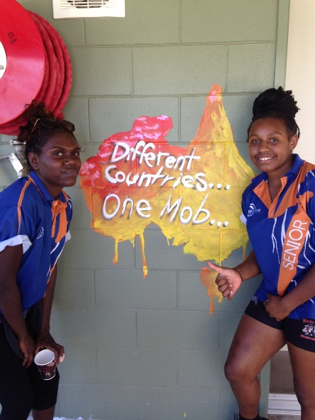
Two students from Nhulunbuy, Northern Territory.
It is important to ensure that all RRR students, schools, parents and communities have ready access to current career and employment information and advice with the same scope and standard as available in capital city locations, including access to careers information events which are typically held in large regional centres and capital cities.
Schools that have access to dedicated personnel to case manage students at risk of not making a successful transition have shown greater success with supporting their students to make informed choices about pathways beyond school.
There is work already underway on a National Career Education Strategy (NCES) following the advice of a multi-government NCES Working Group. The group identified that it will be important to build students’ skills and capabilities for the future through a planned program of learning, strengthening school and employer collaboration and career management and navigation. Importantly they identified that this work and the Australian Government’s commitment of $3 million should enhance and build on existing initiatives and good practices.

Accommodation
For students choosing to attend university, accommodation, living allowances and travel are the three big issues which dominated discussions about what needs to be done to improve the transition of RRR young to pursue further study, training and employment. There are also a range of social-emotional changes that are typically ‘part and parcel’ of a young person moving away from their community to commence another phase of their life that have to be attended to.
In relation to accommodation, there are two main problems. The first is finding suitable, affordable accommodation, the lack of a rental history and dealing with all the paperwork to secure it so there are no issues later on like extra payments, bond disputes and so forth. The second is cost.
The overall data on student accommodation shows that 3-4% of students use university based accommodation which is the most expensive but also provides the widest range of support services. Purpose built student accommodation accounts for a similar percentage of students and is less expensive and also provides fewer services.
The Australian Government in partnership with State and Territory governments has provided additional accommodation for students through the National Rental Affordability Scheme (NRAS) from 2008. NRAS has been accessed by nine universities in six states and territories for purpose built student accommodation. The target group for NRAS is low to moderate income Australians – people who may find it hard to pay market rental rates.
However, the majority of students who require accommodation, about 92%, use the private rental market. The private rental market remains the cheapest option, in most instances it is not purpose designed and has few if any ‘extras’. It is also the option which presents the most risks for students. Note: figures vary significantly for the ACT which has a long history of specialist accommodation provision for overseas students (Savills, 2017).
The cost of accommodation is a very big issue and one that hits the hip pocket regularly and ranges from around $25,000+ for full university based accommodation to purpose built student accommodation only for $12-13,000, to the private rental sector for $6-7000 plus per year.
During a regional consultation 230kms from a capital city a parent advised that he had paid around $160,000 over 4.5 years to fully support his two daughters to complete their degrees. He said no concessions were available to him to offset any of the costs. Another parent who was a teacher, as was his wife, had commenced fully supporting two children who were away studying at university. One of their salaries went directly into an account to pay for this. Again, there were no concessions. While both said “this is just what you have to do if you live in the country” they also reflected on the fact that if they lived in the capital city or nearby, none of this extra financial impost would be necessary.
Research commissioned by the Australian Government into the supply and affordability of university student accommodation suggests that reviewing the eligibility criteria of government support for students would be a useful action. It also proposed that more information on the costs of living and availability of different types of accommodation would assist students in making their study and living away from home choices.
In addition, the research conducted by Urbis (2017) shows that for RRR students while there are some accommodation guarantees, the number of beds allocated for them are limited. Generally, universities are looking to maximise occupancy and the allocation of beds is primarily on a ‘first in’ basis. This may tend to benefit international students whose university offers have been made and accepted far in advance of their arrival into Australia. In contrast to this, a domestic student applying using the standard university admissions process pending their Year 12 results in December, has a very short timeline to make all the necessary arrangements to take up a place in February of the following year.
The research suggests a number of ways to improve the availability and affordability of accommodation for RRR students while also acknowledging that other equity groups should also be considered in this mix.
Fundamentally universities need to balance the needs of their student population and supporting those who need it most, with their financial management as suppliers of accommodation. As the Urbis report highlights, universities are choosing to manage their accommodation supply through a mixture of options: private partnerships with commercial suppliers off campus, on-campus to university-owned and operated off-campus. There has been a significant increase in the supply of purpose built student accommodation over the past four years.
Improving the supply of accommodation is a different matter when looking at metropolitan versus regional city supply. The Urbis report found that around half of regional students study in capital cities and just over 60 per cent of students at regional campuses are from regional areas. By far the largest numbers of students at Australian universities moving to study are international students. By comparison only a small proportion of Australian students move away from home to study at university. There needs to be a caveat here that the more rural to remote a student is, the more likely they are to have to move away from home to study. For example, while a student living in Wagga Wagga has the choice of studying at Charles Sturt University, the only options for a student living in Brewarrina are to move away or study via distance education online, with the possibility of on-campus sessions during their studies.
As the Urbis study identified, over 80% of beds in regional locations are owned and operated by universities. Meanwhile, most joint ventures and private developments are occurring in metropolitan / capital cities. The costs of such investment are clearly much higher in metropolitan cities and accommodation supply can be ‘converted’ at any time to public use should there be a change in student demand for whatever reasons. In a regional area, all the risk associated with student accommodation needs to be borne by the university. As well, student accommodation is not necessarily a core business for universities, though using a private-public partnership approach to provision offers access to capital and upfront revenue.
Addressing the supply issue for student accommodation is inextricably linked with affordable housing more generally in metropolitan cities – especially the major capital cities. The cost of housing in metropolitan areas differs between cities and areas within cities and has a very significant bearing on the supply and cost of student accommodation as exemplified between inner Sydney versus outer Western Sydney. The Urbis report analysis identified that students moving to Sydney and Melbourne are most likely to struggle with affordability. This in effect matches the overall residential accommodation supply and affordability issues for non-students.
The challenge for RRR students is that they are just one subset of the overall population seeking accommodation. There are examples of universities choosing to give accommodation guarantees like the Australian National University, however there is no consistent model across the sector. This is certainly worth further follow up, noting again that universities must respond to the make-up of their student population in their own geographical context. There are also universities with vacant accommodation that struggle to fill their available beds. If more information about the availability of accommodation was provided in a consistent, accessible and transparent fashion, this could assist in better informed student choices for their university studies.
The Urbis research also highlights the potential for better ‘one-stop-shop’ information for RRR students to address some of the challenges including timing of offers, accessing private rental and accessing government support; these all take time and effort to deal with the paperwork. If a student receives their offer in January and is expected to relocate by the end of February, if not earlier, there are likely to be significant upfront costs with temporary accommodation, no income support while documentation is being progressed whilst also trying to prove to real estate agents they can afford to pay rent. The Urbis university case studies show that universities are well aware of the challenges here and have come up with various ways to support students.
The affordability question for RRR students must not be ignored. The Urbis research draws attention to the gap in prices for university on-campus accommodation compared to the private rental market. Many families and students would certainly prefer on-campus accommodation, particularly in the first year and while transitioning to living away from home and new environments. There is a perception that on-campus university accommodation provides more pastoral care services, or at least access to better support networks and a sense of ‘immediate friendship’ possibilities. This is certainly the approach taken internationally, notably in the USA/NZ contexts where there is often a requirement for first years to live in residences on campus. It should also be noted that the majority of students in the USA leave home to go to university.
The gap in affordability indicates that on-campus university accommodation is beyond the means of any student dependent on government income support alone. There is potential for more to be done by the universities to ensure scholarships and bursaries, and prioritisation of beds is targeted for on-campus accommodation.
In addition, the process of applying for Government financial assistance takes time. The Urbis consultation with some university accommodation managers provided anecdotal evidence that there are RRR students who do not receive their first Government payment until March indicating many need to borrow money to meet upfront costs such as relocating, upfront rents, bonds, and the like.

Overcoming delays in moving away
In numerous RRR locations young people recounted delays in moving away from home to go to university because “I had to earn a certain amount of money over a certain period to qualify for support”. While thousands of students go straight to tertiary study without this gap year or more, this is not the case for all RRR students who referred to the difficulty of meeting the criteria for the Independent Living Requirements.
In order to access Youth Allowance that is not subject to parental income testing, students must be deemed as ‘independent’, otherwise their student payment may be reduced due to the parental income test. Currently RRR students, whose parental income is under $150,000, may be deemed independent and qualify for financial support that is not subject to parental income testing, if:
- their parental home is in an inner regional, outer regional, remote or very remote area
- they need to move away from the parental home to study, and
- since leaving secondary school, they have:
  - from 1 January 2018, over a 14 month period, earned 75% or more of Wage Level A of the National Training Wage Schedule included in a modern award: there is no requirement to work for the entire 14 months thus recognising the seasonal nature of work in RRR communities, or
  - for at least 2 years, worked at least 15 hours each week.
Being deemed independent also depends on their parent’s income because the Government considers that if parents earn over a certain amount, they should be able to contribute to their child’s study costs.
The Government website states “If you claim in 2018, they must have earned less than $150,000 in 2016-2017 financial year. If their income has changed a lot, we’ll look at the current tax year”. https://www.humanservices.gov.au/individuals/enablers/dependent-or-independent-youth-allowance#a2
While it is recognised for families earning (in 2018) under $52,706 or less per annum that their children are eligible to automatically receive the maximum rate of Youth Allowance, what I heard during the consultations was that the requirement to earn a specified amount over a stipulated period is onerous for RRR young people. This was especially the case for low income families and in locations where employment is in short supply and very seasonal. In most instances the requirement greatly adds to the burden of making successful transitions to a university or a recognised VET pathway (for further analysis and discussion refer to Cardak, Brett, Bowden, Vecci, Barry, Bahtsevanoglou & McAllister (2017).
The impact of these requirements includes:
- delays in commencing a degree/recognised post school qualification and in some instances not proceeding at all
- later graduation compared with those who are able to commence their degree immediately following completion of year 12 or equivalent
- arguably a shorter working life as a graduate and also less time to earn an income at a higher level with consequent lesser contributions being able to be made to superannuation

Travel
The Government provides assistance by way of fares allowance and relocation scholarships to assist students who are living away from home to study as it recognises that many students need to travel home and re-connect with family and friends reasonably regularly as part and parcel of making a successful transition. This is especially so during the early stages when home sickness is a factor and, if not addressed, can impact on study and training outcomes and even lead to students deciding not to continue with their programs. The current Fares Allowance covers the cost of traveling from home to start studying, one return trip home and a trip back home at the end of the year, each year by booking your travel through the Department of Human Services or through a reimbursement.
However, submissions and consultations strongly identify the need for the current system to change. Consideration needs to be given to:
- investigating how a bona fide post-secondary offer to undertake higher education and/or further training to a student could be used to qualify for direct financial support for the student
- reviewing the parental income test rules in terms of whether they accurately reflect the ability of parents to provide support to their children who have moved away to study
- providing additional financial support to students and/or families to travel between university and home, in particular in a student’s first year of study, to recognise the importance of social supports for students
- reviewing current rates of the relocation scholarship and rent assistance to take account of recent trends in property prices
- providing incentives or scholarships to encourage more RRR students to take up further study and/or training at regional campuses of higher education or vocational education and training institutions

Recommendation and Actions

Recommendation
Support RRR students to make successful transitions from school to university, training, employment and combinations of them.

Actions to progress this recommendation:
- review current government income support policies and arrangements for RRR students from low income families who must move away from home to take up further study or training, to ensure they are able to commence immediately following school completion
- ensure that RRR schools can offer students and parents high quality career information and advice to grow aspirations and employment opportunities
- ensure schools or clusters of schools have access to dedicated personnel to case manage students at risk of not making a successful transition to further study, training, employment or combinations of them
- provide additional financial support to students and/or families for travel between university and home, in particular in a student’s first year of study
- establish dedicated RRR accommodation advisers and brokers in all states and territories
- require universities to prioritise beds and clearly identify accommodation support for RRR students, especially those coming from remote areas and Aboriginal and Torres Strait Islander students
- improve the provision of accommodation and income support information for RRR students.

Philanthropy
Philanthropy provides substantial funding to education in Australia. According to the Leading Learning in Education and Philanthropy (LLEAP) Report (Anderson & Curtin, 2014) it is around $24 million annually.
For RRR schools and communities, the Foundation for Rural and Regional Renewal (FRRR) has been very active and a significant supporter. It was established in 2000 by the Australian Government and the Sidney Myer Fund to meet the needs of rural and regional Australia. Its vision is “vibrant and adaptive rural, regional and remote communities” and its mission is “to champion the economic and social strength of Australia’s regional, rural & remote communities through partnerships with the private sectors, philanthropy and governments” (Foundation for Rural & Regional Renewal ).
Since 2000, FRRR has distributed over $70 million in grant funds to over 8,000 projects in RRR communities nationally. Those projects have on average leveraged the grant with a further 3:1 of cash and in-kind contributions towards the project. Of this, 22.4% has been focussed on enhancing educational opportunities and outcomes in smaller RRR communities, typically with populations under 10,000 (see Text Box 14).

Text Box 14
Tech Hub in the Scrub, is an idea conceived at the 2017 ABC Heywire Summit to help remote communities create tech hubs. The Foundation for Rural and Regional Renewal provided grants to remote communities to source equipment from banks and businesses in metropolitan areas that was superseded when they updated their computer hardware. The old hardware is then used in such tech hubs for the community to access services such as internet banking and to pursue online education options.
Source: Foundation for Rural and Regional Renewal Submission to IRRRRE
There have been ongoing efforts, albeit not always well known, to enhance philanthropic engagement with schooling. For example, Australian Schools Plus (ASP) was founded in 2013 as a direct result of Recommendation 41 in the 2011 Review of Funding for Schooling. It called for “a fund to provide national leadership in philanthropy in schooling, and to support schools in need of assistance to develop philanthropic partnerships.” ASP aims to build partnerships and attract donations for schools from their communities and beyond.
However, advice received from FRRR and others during the Review clearly shows there is significant potential to improve the contribution of philanthropy to RRR education and the impact it can have on raising achievements and improving opportunities beyond school.
Firstly, greater clarity around the responsibilities of government and opportunities for philanthropy would likely prove to be very helpful.
Secondly philanthropy often has greater flexibility than governments and can use this to highlight issues that may otherwise ‘slip under the radar’. Put another way as advised by FRRR:
Because of the more targeted and flexible nature of the philanthropic $, a key role of philanthropy may be to shine a light on the nuanced challenges and approaches required for RRR education and to either support the case for government funding to be directed where it may be lacking, or to support RRR educators and communities to innovate and develop approaches relevant to their context, which can be adopted by others where appropriate.
The Education Benalla Program which began in 2010 with a 20-year goal “...to raise the education and training completion rates of Benalla’s 17-to-24 year olds to equal or above the Victorian average” is a very good example of a community that has successfully leveraged philanthropy to develop a specific approach to address local challenges. More details on the program including its achievements to date can be found on the Tomorrow Today website.
Thirdly, taken overall, the philanthropic sector is not widely and well known, especially by RRR government schools. FRRR’s perspective in relation to this problem is both specific and comprehensive, namely:
Philanthropy has its own language, is often metropolitan based and is interested in different aspects of education to government – this can be challenging for schools applying for funding, and for the funders themselves in communicating and getting the kind of information that is needed to address their interests. This disconnect is something that can be addressed but requires shared understanding, simplification and broad dissemination of information. [As well] schools… often don’t have the right taxation status and are time poor for both applications and reporting.
Succinctly, unlocking the full potential of philanthropy to contribute to raising the achievements and opportunities of RRR students requires at least two things.
Firstly, better understanding and information flows between government, philanthropy, schools and their communities. Secondly, the development of resources and ‘hands on’ advice to make the processes of applying for funding and support from philanthropy and the subsequent reporting and accountability as accessible and user friendly as possible.

Recommendation and Action

Recommendation
Encourage the philanthropic sector to play a greater role in raising achievements and improving opportunities for RRR students.

Action to progress this recommendation:
- in partnership with philanthropy develop and promote widely a set of core principles to enable government, philanthropy, schools and communities to work together more collaboratively.

Entrepreneurship
Entrepreneurial education was affirmed in numerous submissions and consultation sessions as an important contribution to raising RRR student achievements and improving their transitions from schooling into high quality pathways. One contributor to the Review said that “entrepreneurship needs to be a foundation on which sustainable regional communities are built”. A number of submissions, including from the Australian Council of State School Organisations and a State Council, supported this view.
For entrepreneurialism to become a significant aspect of RRR education, the importance and relevance of strong linkages between schools, business, industry, the community in general and the tertiary sectors was consistently emphasised for two main reasons.
Firstly, to develop and leverage opportunities, expand knowledge to encourage aspirations, and provide mentors and hands on experiences to challenge learning. Secondly, to encourage young people to stay with or return to their communities, which is essential for the economic viability of RRR Australia, and also for expanding the social capital available to help sustain existing enterprises and initiate and progress innovative opportunities.
Another reason given for supporting entrepreneurship as a priority in RRR education is the level of uncertainty associated with some locations and communities and the impact this has on employment opportunities. In relation to this, respondents were consistent in advocating that schools should be encouraging students at all levels to be flexible and inventive in their approach to problem solving and fostering critical and lateral thinking (see Text Box 15).

Text Box 15
A cluster of five schools in remote central west Queensland have demonstrated how they have used vocational education to strengthen both school attainment to 100% achievement over the last two years, and post-secondary pathways in a very innovative way across an area of some 175,000 square kilometres.
Their mobile trade training centre provides senior students with training and real world experience in hospitality at the Certificate II level through a unique venue known throughout the region as ‘The Big Red Truck’.
The cluster schools each receive similar benefits with achievement and community engagement. The mobile centre is hired across the region for all types of functions, which also gives the students undertaking their training, plenty of hands-on experience. The students fulfil demands of local businesses for trained staff in the hospitality industry, which would otherwise be difficult to source. Close links are forged between business, industry and the schools via the Big Red Truck.
Whilst the venture is not cheap to run it is considered the benefits to students and the community far outweigh any negatives. It also teaches entrepreneurship to students as it is runs as an ‘in-demand’ business – many events in the area would not happen without it.
This initiative has recently received a major state wide award acknowledging its success in delivering innovative outcomes to very remote schools.
Source: School visit in central western Queensland
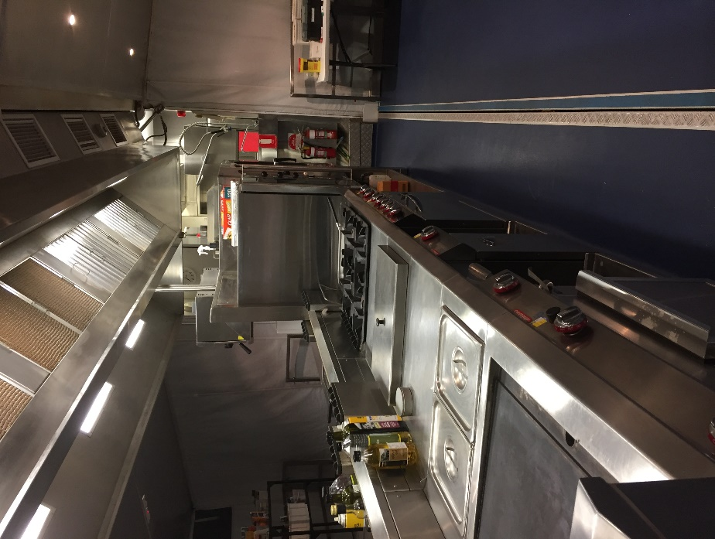
Equipment in the ‘Big Red Truck.’

Flexibility
A common thread of submissions and discussions during visits to communities and with others was that critical to the successful learning about entrepreneurship and ‘having a go at it’ are motivated, creative teachers who are not burdened by overly bureaucratic constraints.
In part this means genuine professional autonomy to use the Australian Curriculum as already described—as more of a guide than a set of tight prescriptions—to design and deliver learning that develops the behaviours, attitudes and skills for entrepreneurship. As well, for students to gain tangible benefits from engagement with entrepreneurship they need to learn and work with successful entrepreneurs. This in turn requires schools to be flexible about how time is allocated for this field of learning; typically extended ‘chunks’ of time rather than discrete 40-45 minute lessons are essential.
Time is a resource all schools share in common and there is very substantial scope to explore how it can be used to create more effective and efficient learning opportunities for students. For example, when the Hospitality Big Red Truck is in town in remote central Queensland, classes are rescheduled allowing blocks of hospitality lessons to be completed before the truck moves on to the next school.
For teachers, developing entrepreneurial behaviours, attitudes and skills requires a different approach to pedagogical practice, from teaching as telling to teaching as coaching, mentoring and provider of resources such as just-in-time application of technology. The curriculum needs to be based on a set of big ideas and questions to generate the conditions for students to explore their ideas and create solutions. Disciplinary learning needs to be the basis of inquiry to develop an idea rather than the basis of learning, with interdisciplinary curriculum to bring these factors together (see Text Box 16).

Text Box 16
Regional Development Australia in Tasmania is supporting initiatives which introduce students to entrepreneurship because it helps students to learn transferable and adaptive skills to transition from compulsory schooling, and equips students with business management and technical ability for their adult life. Regional Tasmania has gone through a long period of slow economic growth and it can be hard for students to see tangible opportunities worth further studying or opportunities creating access to employment. Entrepreneurship encourages self-determination to find the next opportunity.
The Nextgen Challenge is a weeklong session where teams of students from Years 9 and 10 develop and grow an idea for a successful business. The program partners with industry and education stakeholders to provide professional advice and encouragement to the students. Challenges are designed to fit with the Tasmanian economy so they are tackling contemporary issues. It is held three times a year in Hobart, Launceston and Burnie and began in 2010.
Source: Regional Development Australia Tasmania Committee Submission to IRRRRE
Further, schooling needs to move away from the dominant model of one teacher, one class, one subject, one year level, one classroom to a more flexible approach that allows students to generate ideas, work in teams, take risks, make mistakes and try again. This is a way of thinking about engaging children in education that does not lend itself readily to regulation and objective oversight – “necessary qualities for the bureaucrat but stifling for the creative, innovative and entrepreneurial mindset” as one contributor declared.

Text Box 17
Rural Inspire is a platform for young people, powered by a team of passionate young people from across rural and remote Victoria. The platform has the potential to support and raise the aspirations of young people in other states/territories.
“From our own personal experiences, we know that young people in rural Victoria need better access to opportunities, information, and networks, in order to achieve our dreams. We want to make young people across Rural Victoria better connected, and better informed. Rural Inspire is also here to show us what rural people have achieved; it's a celebration of the stories and success of people who have rural roots. It's a reminder that growing up in a rural place is not a burden. It's a catalyst for collaboration and new thinking”.
Source: Rural Inspire

Recommendation and Actions

Recommendation
Improve opportunities for RRR schools to implement entrepreneurship in education through curriculum, teaching, system and cultural changes and building on good practice.

Actions to progress this recommendation:
- encourage and resource schools in partnership with others involved and/or interested in entrepreneurship to design, implement, and drive changes required to expand entrepreneurship in RRR education
- provide funding to Primary Industries Education Foundation Australia to develop and in-service food and fibre entrepreneurship teaching and learning resources
- provide funding to expand the Country Education Partnership’s Rural Inspire initiative.

Information and Communications Technology
Frequently during visits and consultations around Australia as well as in submissions, ICT infrastructure and access were flagged as being absolutely fundamental to improving student achievements and pathways beyond school. Submissions from Curtin University and CISCO are just two examples that point to the power of ICT as a critical enabler of education access for RRR students.
However, just as frequently, the claim was followed by great concern at the patchiness of ICT in many if not most RRR locations and that this was greatly hindering realising its potential. Specifically, unreliable, inconsistent, inaccessible and costly ICT adversely impacts the ability of RRR students to overcome educational barriers due primarily to their location and being locked out of wider/global opportunities.
Consistent with this it was advised that ICT should be embraced as a transformative tool to help all students and not as a ‘minimal viable alternative’ to traditional teaching. Further, RRR teachers need on-going training and upskilling so they can fully utilise technology and embed ICT effectively into teaching and learning. Put another way, ICT is not just a capacity issue, it is also a capability issue.
When functioning optimally, ICT can lead to:
- more subjects and specialisations for students to access
- more professional development opportunities for staff and communities
- greater opportunity to build networks and share information locally, nationally and globally
- greater interaction and exposure for students through virtual technology
- quicker feedback times to students
- enhanced individualised learning
- better student access to information on transitioning beyond school, and
- enabling students to build ICT skills that will be necessary for future jobs.
Better infrastructure alone will not fix all the problems being encountered throughout RRR schools but it is fundamental to students, teachers and communities being able to fully capitalise on the benefits as outlined above and more. For example, ICT is indispensable to developing the role of entrepreneurship in improving achievements and beyond school pathways for RRR young people (see Text Box 14). This is because in this hyper connected digital era, ICT is essential to exploring fresh and innovative ideas, building networks locally and around the globe, and participating in e-based entrepreneurial seminars, workshops, learning pop-ups and the like.
One person summed up what is needed in a way that ‘nailed the point’ for me — “you need a no Netflix channel for education”. In other words, bandwidth has to be available when it is needed for genuine educational purposes. The patchiness referred to earlier is especially acute for students and families who basically have no option for accessing education other than via distance education.
Some of the ‘traditional’ supports associated with this mode of education, such as a reliable telephone service, also need to be factored in to the suite of measures required to ensure all isolated students have access to education. Timely repair and maintenance needs to be carried out to ensure access to education services is interrupted as little as possible. Extending access to Sky Muster Educational Port for tertiary students and students who return home from boarding schools during vacations and need to complete assignments and so forth, would help to ‘round out’ services to RRR students.

Innovative use of ICT in RRR schools
While there are major ICT infrastructure and service issues that need to be addressed urgently, there are also many instances where ICT is generating opportunities for students in RRR schools. These show how distance and the costs of delivery as barriers to accessing specialised education have been overcome. Three are briefly described here to illustrate some of the innovation and diversity being stimulated and supported with ICT.
The first is the Our Lady of the River Primary School near Berri in South Australia. The school uses ICT to connect students with a tutor in China. The school took this action because it was unable to attract a LOTE (languages other than English) teacher. ICT delivers specialised language curriculum and a native speaker teacher. The program has run successfully for 3 years, is widely supported in the school community and is now firmly embedded in the school’s curriculum.
The second example is Aurora College, the New South Wales Virtual Selective High School which caters for gifted and talented students with high academic ability who would otherwise not have the opportunity to attend a selective school due to their location. Using the latest technology is the key enabler. At Billabong High School in Culcairn in the Riverina District which had recently become a partner with Aurora College, a student was on line taking part in a real time session on robotics with an expert at the Australian National University. The student “loved the program” because he could stay at home, attend his local school and be with friends, play sport on the weekend and be challenged in his studies.
The principal is also a very strong supporter of Aurora because it has broadened the curriculum offerings available at the school to better meet the learning needs and interests of a group of students, albeit small in number, who are sometimes overlooked. In addition, being involved with Aurora has created staff professional development opportunities as well as benefiting the overall learning ethos of the school.
Thirdly, is an example from the Pathways in Technology (P-TECH) Australian Government initiative which is also a very significant vocational option. P-TECH offers secondary school students an industry supported education pathway to a STEM related post-school qualification. Students then have the option to continue their study at the tertiary level or pursue employment in a STEM related field, including job opportunities with the school’s industry partners.
At the Greater Burnie P-TECH in Tasmania four schools are partnering with local industry to boost young people’s interest and opportunities in technology-inspired careers. Burnie High School, Parklands High School, Yolla District High School and Hellyer College are working with local industry partners, including the Elphinstone Group, Jayben Australia, Maltec Engineering, TasFoods and Lion to give students work experiences in two different career pathways: engineering/advanced manufacturing and agriculture/food science. Industry bodies such as the Tasmanian Centre of Advanced Manufacturing and DairyTas are also supporting the pilot.
2018 will be the first year of the Greater Burnie P-TECH pilot and an immersion year for Year 9 students. Students will undertake a range of activities to familiarise themselves with the career pathways offered by industry partners and engage in research activities and project based learning tasks that develop the skills and knowledge required for the workplaces of today and the future. The Greater Burnie P-TECH partnership has grown in a matter of months from one school to four, and from one interested business to a number of small local businesses with an eye on supporting their local community and economy. The mix of industries involved has enabled diverse pathways for students through school and towards post school qualifications.

Recommendation and Actions

Recommendation
Improve the availability, accessibility and affordability of ICT for RRR schools, teachers, students, parents and communities.

Actions to progress this recommendation:
- establish a RRR ICT taskforce with the necessary expertise, authority and resourcing to substantially improve access to and use of ICT in education
- ensure that students and families who are reliant on distance education have continuous and affordable access to all of the teaching and learning delivered by Distance Education providers
- work with ICT providers to ensure that sufficient bandwidth on the NBN Sky Muster satellite service is always prioritised for bona fide educational purposes
- expand the NBN Sky Muster public interest premises definition to include homes in remote locations where school and tertiary students return out of term.

Improving access
Accessing education in RRR locations continues to be a very high priority and an intensely felt issue. As a parent remarked during a consultation, “when was this never the case”? During the era of expansion into rural Australia, access was primarily focussed around communities convincing ‘the authorities’ to provide a school. Today, with some risk of over simplifying, accessing education is essentially focussed on convincing ‘the authorities’ to retain a school and improve services.
Essentially, access to education in RRR locations and particularly in small rural and remote communities, is designed around two fundamental inputs. Firstly, numbers and year levels of students. Secondly, the funding a system allocates for educating the students plus, where applicable, the costs parents/families and others have to cover.
Using these basic inputs to ensure every student can access education always involves keeping a hotly debated question in mind—what is a fair and reasonable provision of education for a particular location and set of circumstances? The responses to this question vary widely, which is especially the case when considered from a parent and/or student’s perspective—the clients of a service—compared to the provider and major funder of a service.

Distance education
Distance education (DE) is one of the access flagships in RRR locations, especially for families with children who are unable to attend a school, usually due to the distance from home to the nearest suitable school. In addition to education, DE schools provide a very valuable range of services and events to support parents with educating and raising their children. DE schools also play an important community capacity building role, albeit with a community which is very widely dispersed and may only meet face-to-face once or twice a year.
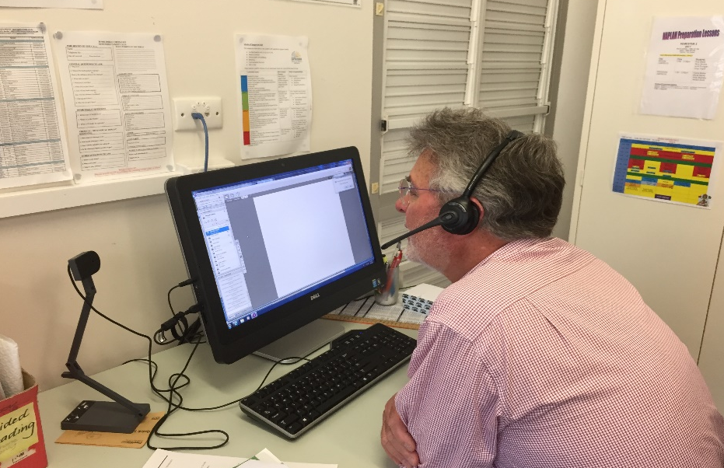
Professor Halsey experiencing distance education at Longreach.

Text Box 18
Bendigo Senior Secondary College established the Victorian Virtual Learning Network (VVLN) in 2009 to address a number of key issues that were impacting Victorian students’ participation in VCE subjects most significantly in regional and rural locations. The VVLN has developed complete online courses in key VCE subjects with engaging, digital online curriculum which are delivered to students across Victoria utilising broadband technology.
Through the VVLN senior secondary school students across Victoria now have significantly increased access to curriculum through the provision of high quality, interactive digital content which is delivered asynchronously, enabling students to access it any time, in any location.
In the design of the online courses, the focus is on creating an online experience for students with the learning amenity of a high quality face-to-face program, with the instructional role of the teacher embedded in the interactive digital lessons, as well as having an online teacher available to support students at any time.
Source: Bendigo Senior Secondary College Submission to IRRRRE
In recent years DE has broadened its role to deliver options which are not available at a local school (see Text Box 18). The issue of subject/curriculum choice for students as has already been reported is a recurring one in RRR schools. Although the use of web-based technology can increase subject choice, including for gifted and talented students and for those who have specific learning difficulties, it requires appropriate, reliable and affordable bandwidth, the patchiness of which has already been reported on. Discussions while visiting DE schools and other sites and services, highlighted that difficulties associated with distance education, primarily caused by the underperformance of basic technology, made some students choose a subject that was being offered face-to-face but which was not a good fit with their post school aspirations.
Another issue discussed during visits is that DE can be very isolating for students in studying at home and students in schools who use DE to access subjects not available at their local school. Technology, including better connectivity with the NBN, is helping to overcome this isolation through linking students to other students. The use of peripatetic learning area specialists and on site face-to-face support for regional senior students undertaking distance education are also helping to overcome some of these issues. While it is recognised that in small schools and individual school rooms on stations for example that it is impossible to have curriculum experts ready to help ‘at a moment’s notice’, it is essential that students using DE have access via reliable technology to a person who is a very ‘hands-on’ guide to help them with their learning.
Related to DE students needing to have ready access to a ‘hands on’ guide, the contributions of distance education home tutors who are usually parents of the children enrolled with DE schools, have been especially valuable over many years. After discussions with a number of these parents as part of the Review and on previous occasions as well as through reading submissions, it is time to formally recognise their expertise. A way to do this is by using the established protocols of Recognition of Prior Learning (RPL) as detailed in the Australian Qualifications Framework.(AQF) Regulatory and accreditation bodies would need to work with states and territories to ensure the necessary compliance and quality teaching requirements are met.
The RPL process should not be onerous but provide sufficient evidence to enable a confident determination of the level of an award, for example, a portfolio of the learning and skills a person has developed through being a distance education home tutor and an opportunity to speak about their experiences. The DE School they are associated with, or were, could be invited to assist with verification as well as determining the award. The criteria for AQF level 3 or 4 appear to be a good fit.

Clustering
As noted in many submissions, including from Glen Park Primary School, Social Ventures Australia and Christian Schools Australia, clustering of schools services is an important way to improve access to education and to support student outcomes.
Clustering is especially important for small schools to help with issues of teacher supply, curriculum diversity and other resourcing issues as well as providing valuable professional development opportunities. Submissions and consultations noted clustering and partnerships between small schools and urban schools. These initiatives are providing further opportunities to share resources and enable students to engage with a larger cohort and participate in a broader range of subjects. It is also the case that students in the large urban schools benefit from experiencing education with a RRR school. This is especially so if the RRR school is in a remote location or has developed a particular focus like aquaculture at the Cowell Area school in South Australia and the Circular Head Christian school in Smithton, Tasmania.
Cluster arrangements and partnerships which are effective and endure have a strong commitment to focusing on collaboration and open communication, and share taking the lead on initiatives (see Text Box 19).

Text Box 19
An Aboriginal Language and Culture Nest is a local network of communities, bound together by their connection to an Aboriginal language.
- Each Nest creates learning pathways for Aboriginal students, teachers and community members. The size, shape and form of the Aboriginal Language and Culture Nests are community driven.
- The establishment of the Aboriginal Language and Culture Nests enables Aboriginal people and communities across NSW to reclaim, revitalise and maintain their traditional Aboriginal languages.
By the end of 2016, 65 NSW schools and educational facilities were engaged in the Aboriginal Language and Culture Nests, with more than 5,300 students learning an Aboriginal language.
Source: New South Wales Submission to IRRRRE

Resourcing remote Aboriginal and Torres Strait Islander schools
A complex matter in remote Aboriginal and Torres Strait Islander schools working to increase access to high quality learning opportunities is how enrolments play such a determining role in what a school is resourced to do. This is because the funding of a school is primarily based on enrolments—the more students a school has, the more funding it generally receives, although application of the small school loading may skew this.
There are also other factors which attract funds such as isolation and the number of students who are entitled to receive specific learning support. Typically, enrolment data for a school is tied to a census date or period but enrolments may fluctuate quite significantly around it, which presents a particular issue in some Aboriginal and Torres Strait Islander communities, where students may move schools for cultural reasons throughout the school year. This creates a tension between a specific cut-off date for head counts, the resourcing a school consequently receives, and the subsequent programs a school can run and offer its students at any given time, which requires further investigation.
Rigorous and transparent processes for funding schools matched with appropriate accountability are essential. Also funding for education is not a ‘bottomless pit’. However, visits to remote Aboriginal and Torres Strait Islander schools and discussions with elders, leaders, teachers, parents and students show there is still work to be done to ensure the basis for resourcing remote Aboriginal and Torres Strait Islander schools is authentically informed by culture and language, ceremonial obligations and the Australian curriculum.

Boarding and access
In relation to boarding and access, there are two recurring issues. The first is the movement of students out of RRR communities to larger, urban areas. The second is the financial burden placed on families by boarding.
Establishing smaller, regional based weekday boarding facilities ‘closer to home’ is proposed by a number of jurisdictions to address both of these issues. The idea of weekday boarding means students can maintain their links with families and communities and fees and travel costs are reduced (see Text Box 20). There is also research to indicate that students who stay in regional areas are more likely to attend regional universities and upon graduation, return to regional areas.

Text Box 20
Week day boarding in regional NSW Catholic system is proving to be a successful strategy – it allows students to stay in a regional location maintaining links with family and community, allows students to play weekend sport and participate in the local community. It also keeps fees affordable, promotes attendance, and provides choice to remote and regional families. Students are bussed home each weekend - three or four private buses run on Friday nights and return early on Monday mornings. Under this model, where students can board for 4 nights and spend 3 nights at home, students can still access rural and isolated children’s allowances and Abstudy grants.
Source: Catholic Education Commission, NSW Submission to IRRRRE
For those who must leave their communities to board, especially Aboriginal and Torres Strait Islander students, strategies were advocated such as literacy and numeracy support, Skype facilities, a buddy system, providing accommodation and/or a travel allowance for visiting parents and cultural language recognition and transition support to assist with the retention and improved educational outcomes of boarding students.
Other suggestions to improve educational outcomes include more flexible school bus services and vacation times to meet harvest, cultural needs and the like. The philanthropic sector also has a valuable role to play in these communities. Initiatives supporting the equal access to resources and opportunities for RRR students focusing on student engagement, improving the ability to learn, student wellbeing, family and community engagement and equipment and infrastructure all help to provide more equitable access to education.
Students with special learning needs must also be considered in the context of accessing educational opportunities. They include gifted and talented students, those requiring a ‘second chance’ after extended suspension or similar and students with disabilities (see Text Box 21).

Text Box 21
Students from the North-West Coast of Tasmania who struggle to engage with mainstream schooling are offered a chance to take control of their education. The SPACE alternative learning program aims to encourage high school aged students to re-engage with learning. Students attend the Burnie campus for up to ten hours a week, and are offered access to music equipment, woodworking tools, kitchen facilities and computers. The Department of Education program provides a safe environment for young people to tackle cognitive, emotional or social challenges. There is a strong focus on literacy and numeracy. SPACE staff can connect students with community services if they require accommodation or mental health support. The Burnie campus is open four days a week and offers two daily sessions that run for up to three hours. The campus is a calm in the storm for many students. SPACE students are assessed using the Australian Curriculum Framework, and are encouraged to pursue a learning goal.
Source: The Advocate 2017, SPACE learning centre launched in Burnie, www.theadvocate.com.au/story/4771976/giving-burnie-kids-space/
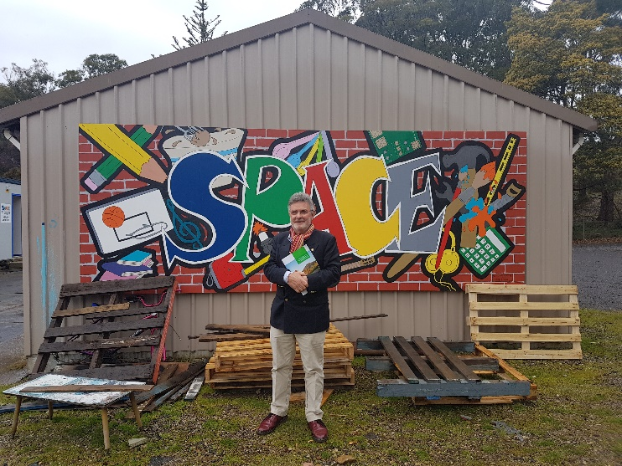
Professor Halsey at the Devonport, Tamania SPACE alternative learning program.

Recommendation and Actions
Recommendation
Support RRR communities to implement innovative approaches to education delivery designed to improve education access and outcomes for students living in remote communities.

Actions to progress this recommendation:
- ensure that high quality distance education services delivered by states and territories are available to every student who cannot access face-to-face schooling on a regular basis
- formally recognise using Recognition of Prior Learning processes or similar the expertise and contributions of distance education home tutors
- ensure that boarding services (including the provision of extra small scale facilities closer to the source of need), transport (including for pre-schoolers) and associated payments to students and/or parents optimise access to education
- examine the resourcing allocations for remote Aboriginal and Torres Strait Islander schools to ensure they are authentically informed by culture and language, ceremonial obligations, the Australian curriculum, and enrolments
- investigate the impact of appointing cluster administration managers on learning opportunities and outcomes.

PART 3: Building Regional, Rural and Remote Capacities
As stated at the beginning of this report, vibrant, productive RRR communities are integral to the long-term sustainability of Australia. Education and training plays a critical role in building the social fabric of communities, but also in developing social capital for economic prosperity. This view was brought into sharper focus through various submissions and consultations during this review.
The success of RRR communities requires sustainable collaborative efforts of governments, the private sector and existing regional bodies and strategies to develop and implement a long-term plan that puts regional, rural and remote education and development at the centre of the economic agenda for jobs and growth. In other words, what is needed is a roadmap that has government imprimatur and sets out strategic priorities that all parties collectively sign up to.

Vibrancy of Castlemaine, Victoria.

Government structures and strategies
With the federal system of government in Australia, powers are divided between the central government and the states and territories. Education and specifically schooling is frequently a contested matter and while much has and is being achieved, more can be done using their combined authority, power and responsibilities to improve education in RRR areas.
A clear message in many consultations was the need to bring together interested parties to collaborate and share good practice, whether this is ‘whole-of-government’ or a ‘place-based approach’ or ‘joined-up effort’. It seems that the strongest way to bring multiple parties together is through shared responsibilities, action and reporting. Creating a national focus for RRR education and training would provide the structure to enhance access and outcomes in regional Australia.
As with Bridging the Gap for Aboriginal and Torres Strait Islander people, a national focus can be actioned in a range of ways including by establishing a national RRR education and training strategy with a taskforce to implement and publicly report achievements against targets and/or to a Council of Australian Governments (COAG) working group. There are things underway and already in train to help inform this including the Regions 2030: Unlocking Opportunity, Department of Infrastructure and Regional Development: Regional, and the Regional Development Australia (RDA) initiative that bring together all levels of government to enhance the development of Australia's regions with its national network of RDA committees.
For other parts of government there are already regional strategies, for example the Department of Health with its National Strategic Framework for Rural and Remote Health to promote a national approach to policy, planning, design and delivery of health services in rural and remote communities. However, there is no such national strategy for RRR education and training. To achieve an enduring focus and concerted effort on a critically important national issue like raising the achievements and improving the post school opportunities of RRR students requires a dedicated national body to drive, monitor, evaluate and report on outcomes and progress.
Another option would be to appoint a person to a dedicated role such as a Commissioner, to lead this work. A recent example of this approach has been the Australian Government Department of Health’s appointment of a Rural Health Commissioner.
Bringing about much needed sustainable changes to RRR education broadly requires two kinds of building; understanding and access.
The first entails an understanding of what outcomes existing resource allocations achieve and how they can be improved. In the school sector, this work is in train through the Review to Achieve Academic Excellence which will report at the end of March 2018. Over the next decade there will be significant increased funding delivered for schools and it will be important to build understanding of how the regional loading as well as mainstream funding is used by states and territories and school systems to deliver RRR education.
Another possibility for gaining greater value by growing and shaping existing initiatives would be to draw on the current 52 Regional Development Australia Committees (RDAs) around Australia, and three regional investment officers for the external mainland territories, to build understandings between education and regional growth. While some RDAs are involved in the education sector, there could be concerted effort by all RDAs to engage with education as an active partner and include driving greater collaboration and connection between education (schools through to vocational education and universities) and local governing bodies as well as industry, other essential human services, ICT infrastructure and also philanthropy. And as already stated, the current limitations of ICT in RRR contexts are inhibiting its full utilisation as an enabling tool and skilling students for future employment opportunities. The need to give top priority to ICT in RRR areas is pressing.
The second kind of building understanding and access is learning how best to drive regional economic growth by recognising the role of education and training providers in all their roles – from employers to skills producers to providers of community facilities. As the Regional Universities Network has identified, its universities are integral economic drivers and employers and generators of skilled employees in regions and for regions. Ensuring that education and training providers are included as critically important stakeholders and employers in regional economics should extend to them being eligible for funding under such programs as the Regional Growth Fund and others.

Recommendation and Actions

Recommendation
Establish a national focus for RRR education, training and research to enhance access, outcomes and opportunities in regional Australia.

Actions to progress this recommendation:
- establish a national RRR education strategy and associated taskforce to drive greater coherence, coordination and access to high quality education and training in RRR Australia
- establish a dedicated national RRR education and training fund to fund the work required to improve the achievements and opportunities of young people living in these locations
- ensure that education providers, higher education and vocational education and training providers are eligible to apply for funding under existing regional funding schemes
- provide advice and support to all Regional Development Australia Committees so they can engage with education as an active partner.
- ensure legislation and programs which frame and impact on rural, regional and remote Australia recognise place and location as legitimate bases for resource allocation including the provision of essential services.

Conclusion
Access to high quality education is essential so young people can acquire the knowledge, skills, attitudes and values to enjoy life and successfully transition to further study, employment and enterprise, and participate fully in a dynamic and increasingly complex world.
The key challenge for regional, rural and remote education is ensuring, regardless of location or circumstances, that every young person has access to high quality schooling and opportunities.
There is much to celebrate and be proud of about RRR education in Australia especially given the ‘big picture’ dimensions of over one million students attending more than 4,000 schools across a landmass of about 7 million km².
However, the achievements of RRR students have in the main lagged behind urban students for decades.
This has to be turned around in the shortest time possible.
The Review has generated eleven key recommendations and actions for each to bridge the urban-rural divide. These encompass curriculum and assessment, teachers and educational leaders, improving post school pathways and opportunities, ICT, philanthropy and entrepreneurship, arrangements for schooling, and building the capacities of RRR communities.
Making major changes in education in Australia has historically been slow and typically highly contested. The time has come to step up the pace.
Joined-up federal, state/territory and local commitment and action are essential to provide the imprimatur to drive and sustain the diversity of decisions and resourcing required to improve achievements and opportunities for RRR students.
In practice, the factors that impact on learning and opportunities do not exist as discrete entities. Rather it is the way they come together and are ‘brought to life’ that shapes the learning, growth and nurturing of students from their early years through to school graduation and beyond.
“In a fundamental sense, we are what we pay attention to… Our attention is precious and what we choose to focus it on has enormous consequences… [our] choices change the world” (Fleischner, 2011, emphasis in original, p. 9).

Appendix A Terms of reference

Purpose of the review
The Regional Education Review will consider the key ideas, challenges, and barriers that affect the learning outcomes of regional, rural, and remote students.
It will provide recommendations on fresh approaches to support better access and achievement of these students, and their transition to further study, training, and employment.

Scope of the review
The Regional Education Review will investigate:
- the gap in educational achievement between regional, rural, and remote students and metropolitan students
- the key barriers and challenges that affect the educational outcomes of regional, rural, and remote students, including aspirations and access issues
- the appropriateness and effectiveness of current modes of education delivered to regional, rural, and remote students, including the use of information and communications technology, and the importance of providing face-to-face education
- the effectiveness of public policies and programs that have been implemented to bridge the divide
- the gaps and opportunities to help students successfully move from school to further study, training, and employment
- new approaches that support regional, rural, and remote students to succeed in school, and in their transition to further study, training, and employment.

Appendix B List of meeting and consultations

Independent Review into Regional, Rural and Remote Education public hearings (forums)
Date | Location | Forums
2 – 3 August  NT | Alice Springs | 2 Aug – Isolated Children’s Parents’ Association conference
2 – 3 August  NT | Alice Springs | 3 Aug – Alice Springs Community Forum
22 – 25 August  WA | Northam  Kalgoorlie  Bunbury  Albany | 22 Aug – Northam Community Forum
22 – 25 August  WA | Northam  Kalgoorlie  Bunbury  Albany | 23 Aug – Kalgoorlie Community Forum
22 – 25 August  WA | Northam  Kalgoorlie  Bunbury  Albany | 24 Aug – Bunbury Community Forum and Youth Forum
22 – 25 August  WA | Northam  Kalgoorlie  Bunbury  Albany | 25 Aug – Albany Community Forum
28 August  SA | Port Pirie | Port Pirie Community and Youth Forum
18 – 20 September  NSW | Guyra  Armidale  Narrabri  Dubbo | 18 Sep – Guyra Community Forum
18 – 20 September  NSW | Guyra  Armidale  Narrabri  Dubbo | 18 Sep – Armidale Community Forum
18 – 20 September  NSW | Guyra  Armidale  Narrabri  Dubbo | 19 Sep – Narrabri Community Forum
18 – 20 September  NSW | Guyra  Armidale  Narrabri  Dubbo | 20 Sep – Dubbo Community Forum
25 – 26 September  Tas. | Queenstown  Smithton  Strahan | 25 Sep – Queenstown Community Forum
25 – 26 September  Tas. | Queenstown  Smithton  Strahan | 25 Sep – Strahan Community Forum
25 – 26 September  Tas. | Queenstown  Smithton  Strahan | 26 Sep – Smithton Community Forum
4 – 6 October  Qld | Rockhampton  Emerald  Longreach | 4 Oct – Rockhampton Community and Youth Forum
4 – 6 October  Qld | Rockhampton  Emerald  Longreach | 5 Oct – Emerald Community Forum, Youth Forum and School of Distance Education Forum
4 – 6 October  Qld | Rockhampton  Emerald  Longreach | 6 Oct – Longreach Community Forum, Youth Forum, and School of Distance Education Forum
10 –11 October  Vic. | Bendigo  Birchip  Wodonga | 10 Oct – Bendigo Community Forum
10 –11 October  Vic. | Bendigo  Birchip  Wodonga | 10 Oct – Birchip Community Forum
10 –11 October  Vic. | Bendigo  Birchip  Wodonga | 11 Oct – Wodonga Community Forum
23 October  NT | Yirrkala | Yirrkala Community Forum and Youth Forum
31 October  WA | Karratha | Karratha Community Forum

Independent Review into Regional, Rural and Remote Education stakeholder consultations
Date | Location | Meetings with stakeholders
4 July  ACT | Canberra | Australian Chamber of Commerce and Industry
4 July  ACT | Canberra | Universities Australia
4 July  ACT | Canberra | Independent Schools Council of Australia
12 July  ACT | Canberra | University of Canberra / Society for the Provision of Education in Rural Australia
12 July  ACT | Canberra | Regional Australia Institute
12 July  ACT | Canberra | Australian Rural Leadership Foundation
12 July  ACT | Canberra | Australian Primary Principals Association
12 July  ACT | Canberra | ACT Education Directorate
17 July  NSW | Sydney | Australian Curriculum, Assessment and Reporting Authority
17 July  NSW | Sydney | National Catholic Education Commission
17 July  NSW | Sydney | Australian Council of Educational Leaders
21 July  NSW | Sydney | National Apprentice Employment Network
21 July  NSW | Sydney | Australian Association of Special Education
21 July  NSW | Sydney | NSW Department of Education
24 July  Qld | Brisbane | Regional Universities Network
24 July  Qld | Brisbane | Queensland Department of Education
31 July  NT | Darwin | NT Department of Education
1 Aug  NT | Utopia | Arlparra School Visit
2 Aug  NT | Alice Springs | NT Department of Chief Minister
7 August  Vic | Melbourne | Australian Education Union
7 August  Vic | Melbourne | Australian Council of State School Organisations
7 August  Vic | Melbourne | Social Ventures Australia
7 August  Vic | Melbourne | Australian Institute for Teaching and School Leadership
8 August  Vic | Melbourne | Australian College of Educators
8 August  Vic | Melbourne | 2017 FRRR ABC Heywire Youth Innovation Grants Event
15 August  TAS | Bridgewater | Jordan River Learning Federation
15 August  TAS | New Norfolk | New Norfolk High School
15 August  TAS | Hobart | Tasmanian Department of Education
15 August  TAS | Hobart | University of Tasmania
16 August  TAS | Launceston | New Stead College
16 August  TAS | Launceston | Brooks High School
16 August  TAS | Launceston | e-learning centre
21 August  WA | Perth | Western Australian Department of Education
21 August  WA | Perth | SIDE
22 August  WA | Perth | Australian Secondary Principals Association
22 August  WA | Perth | Australian Parents Council
23 August  WA | Kalgoorlie | Chamber of Commerce and Industry Kalgoorlie
23 August  WA | Kalgoorlie | Eastern Goldfields College
24 August  WA | Wokalup | Harvey Agriculture College Visit
29 August  SA | Adelaide | Principals Australia Institute
29 August  SA | Adelaide | Association of Independent Schools of SA
29 August  SA | Adelaide | SA Department for Education and Child Development
29 August  SA | Adelaide | Australasian Association of Distance Education Schools
12 Sept  ACT | Canberra | Department of Social Services
12 Sept  ACT | Canberra | Department of Education and Training- Higher Education Group
12 Sept  ACT | Canberra | Department of Employment
12 Sept  ACT | Canberra | Department of Industry and Regional Development
18 Sept  NSW | Guyra | Guyra Central School
20 Sept  NSW | Dubbo | Dubbo School of Distance Education
20 Sept  NSW | Dubbo | Dubbo Senior College
22 Sept | Teleconference | Mr David Gonski AC
25 Sept  TAS | Queenstown | West Coast Hub Visit
26 Sept TAS | Smithton | Smithton school visit
27 Sept TAS | Ulverstone | Ulverstone school
27 Sept TAS | Devonport | Devonport SPACE campus
29 Sept | Teleconference | Deans of Education
4 Oct  QLD | Rockhampton | Central Queensland University
5 Oct QLD | Barcaldine | The Outback College of Hospitality Trade Training Centre (Big Red Truck)
5 Oct QLD | Emerald and Longreach | Schools of Distance Education (Schools of the Air Forum)
9 Oct  VIC | Melbourne | Victorian Aboriginal Education Association Inc
9 Oct  VIC | Melbourne | Victorian Department of Education and Training
16 Oct | Teleconferences | Geraldton Uni Hub
16 Oct | Teleconferences | Country Education Partnership
16 Oct | Teleconferences | Cooma Uni Hub
17 Oct | Teleconferences | Good to Great Schools Australia
18 Oct | Teleconferences | Country Universities Centre
19 Oct | Teleconferences | Rural Youth Ambassadors
23 Oct  NT | Nhulunbuy | Nhulunbuy High School
30 Oct  WA | Karratha | Rural and Remote Education Advisory Council
31 Oct  WA | Karratha | Karratha Senior High School
13 Nov | Teleconference | Mitchell Institute

Appendix C: List of organisations and categories of individuals who provided a submission to the review

Organisations
AARNET Pty Ltd
Access Engineering
Association of Heads of Independent Schools of Australia
Australasian Council of Deans of Arts, Social Sciences and Humanities
Australian Association for Research in Education
Australian Association of Special Education, NSW Chapter
Australian Catholic Primary Principals Association
Australian Catholic University
Australian Curriculum Assessment and Reporting Authority
Australian Education Union
Australian Institute of Teaching and School Leadership
Australian Mathematical Sciences Institute
Australian Parents Council
Australian Primary Principals Association
Australian Rural Leadership Foundation
Australian Secondary Principals Association
Australian Technology Network of Universities
Batchelor Institute of Indigenous Tertiary Education
Bendigo Senior Secondary College
Big Picture Education Australia
Boarding Australia
Brotherhood of St Laurence
Cairns School of Distance Education Parents and Citizens Association
Casterton and District Community Education Stakeholders
Catholic Education Commission New South Wales
Catholic Education Diocese of Bathurst
Catholic Education Services – Diocese of Cairns
Catholic School Parents Australia
Central Australian Aboriginal Congress
Centre for Social Impact Swinburne
Charles Darwin University
Charles Sturt University
Christian Schools Australia
CIN Educational Consultancy
Cisco and Optus
Cokehill Consulting
Community Connections Growing Lachlan
Country Education Foundation of Australia
Country Education Partnership
Edith Cowan University
Equity Practitioners in Higher Education Australasia
Federation of Parents and Citizens of New South Wales
Good to Great Schools
Grattan Institute
Group West Apprenticeships Limited
Gwydir Shire Council
Hale School
History Teachers’ Association of Victoria
IMPACT Centre
Independent Education Union of Australia
Independent Schools Council of Australia
John Calvin School Albany
Kangaroo Inn Area School
Koonibba Aboriginal School
Macpherson Smith Rural Foundation
Macquarie Anglican Grammar School
Maths Pathway
Moree Plains Shire Council
National Centre for Student Equity in Higher Education
National Farmers’ Federation
National Tertiary Education Union
New England Regional Art Museum
New South Wales Primary Principals Association Rural and Remote Standing Committee
Northern Mallee Local Learning and Employment Network
Northern Territory Council of Government School Organisations
Primary Industries Education Foundation Australia
Queensland State P-10/P-12 School Administrators' Association
Questacon
Regional Australia Institute
Regional Development Australia
Regional Universities Network
Riverlands Montessori School
Rural and Remote Education Advisory Council
Rural, Regional and Remote Women’s Network Western Australia
Schools Plus
SiMERR
Society for the Provision of Education in Rural Australia
South East Secondary Schools Alliance
Stawell Secondary College
Studiosity
Sustainable Communities
Swinburne University of Technology
TAFE Directors Australia
TAFE Queensland
Teach for Australia
The Australian Association of Mathematics Teachers
The Australian Children’s Education and Care Authority
The Group of Eight
The Isolated Children’s Parents’ Association
The Mathematical Association of Victoria
The NSW Government
The Smith Family
The University of Adelaide
The University of Melbourne
The University of New England
The University of New South Wales
The University of Queensland
The University of Sydney
The University of Tasmania
The University of Wollongong
Think Square: Learn Happy
Tomorrow Today Foundation
Universities Australia
Upper Spencer Gulf Common Purpose Group
Victorian Ecumenical System of Schools
Victorian Farmers Federation
Wimmera Southern Mallee Regional Partnership

Categories of Individuals
Academics
Concerned Individuals
Employers
Parents
Principals
Students
Teachers

Acronyms and abbreviations
ACARA Australian Curriculum Assessment and Reporting Authority
AIC Assistance for Isolated Children
AITSL Australian Institute for Teaching and School Leadership
ASP Australian Schools Plus
COAG Council of Australian Governments
DE Distance Education
FRRR Foundation for Rural and Regional Renewal
FTE Full Time Equivalent
GGSA Good to Great Schools Australia
HEPPP Higher Education Participation and Partnerships Program
IRRRRE Independent Review into Regional, Rural and Remote Education
LLEAP Leading Learning in Education and Philanthropy
LOTE Languages other than English
MCH Maternal and Child Health
NAPLAN National Assessment Program - Literacy and Numeracy
NCES National Career Education Strategy
NRAS National Rental Affordability Scheme
OECD The Organisation for Economic Co-operation and Development
PIP Public Interest Premises policy
PISA Programme for International Student Assessment
P-TECH Pathways in Technology
RDA Regional Development Australia Committees
RPL Recognition of Prior Learning
RRR regional, rural and remote
RUN Regional Universities Network
STEM science, technology, engineering and mathematics
TEMAG Teacher Education Ministerial Advisory Group Report
TFA Teach for Australia
TIMSS Trends in International Mathematics and Science Study
VET Vocational education and training
VETiS Vocational education and training in schools

References
Australian Curriculum, Assessment and Reporting Authority. (2017). NAPLAN Achievement in Reading, Writing, Language Conventions and Numeracy: National Report for 2017, ACARA, Sydney.
https://www.nap.edu.au/docs/default-source/default-document-library/naplan-national-report-2017_final_04dec2017.pdf?sfvrsn=0
AlphaBeta, (n.d.). The Automation Advantage. http://www.alphabeta.com/wp-content/uploads/2017/08/The-Automation-Advantage.pdf
Anderson, M. & Curtin, E. (2014). LLEAP 2013 Survey Report: Leading by evidence to maximise the impact of philanthropy in education. Melbourne, Vic: ACER.
Arthus-Bertrand, Y. (2009). Home. New York: Abrams.
Australian Bureau of Statistics. (2017). Schools Data, Table 36a. http://www.abs.gov.au/AUSSTATS/abs@.nsf/DetailsPage/4221.02016?OpenDocument
Australian Government, (2017). Industry Employment Projections Report (release date August 2017), Canberra.
http://lmip.gov.au/default.aspx?LMIP/GainInsights/EmploymentProjections
Budget 2016 Statement 5: Expenses and Net Capital Investment Budget Paper Number 1 http://www.budget.gov.au/2016-17/content/bp1/html/bp1_bs5-01.htm DL 21112017
Cardak, B., Brett, M., Bowden, M., Vecci, J., Barry, P., Bahtsevanoglou, J. and McAllister, R. (2017). Regional Student Participation and Migration: Analysis of factors influencing regional student participation and internal migration in Australian higher education. National Centre for Student Equity in Higher Education. Curtin University.
Civil Renewal Unit. (2004). Firm Foundations: The Governments Framework for Community Capacity Building. London: Home Office.
Fleischner, L.T. (2011). The mindfulness of natural history. In L.T. Fleischner (Ed.), The Way of Natural History, 3-15. San Antonio: Trinity University Press
Hajkowicz, S.A., Reeson A., Rudd L., Bratanova A., Hodgers L., Mason C. & Boughen N. (2016). Tomorrow’s Digitally Enabled Workforce: Megatrends and scenarios for jobs and employment in Australia over the coming twenty years. Brisbane, CSIRO
Halsey, M. & Deegan, S. (2015). Young Offenders Crime, Prison and Struggles for Desistance. UK, Palgrave Macmillan.
Hattie, J. A. C. (2009). Visible learning: A synthesis of over 800 meta-analyses relating to achievement. London, UK: Routledge
Independent Review into Regional, Rural and Remote Education (2017). Discussion Paper, Australian Government, Canberra.
Lamb, S., Jackson, J., Walstab, A. & Huo, S. (2015), Educational opportunity in Australia 2015: Who succeeds and who misses out, Centre for International Research on Education Systems, Victoria University, for the Mitchell Institute, Melbourne: Mitchell Institute.
Lamb, S. & Huo, S. (2017). Counting the cost of lost opportunity in Australian education. Mitchell Institute, Victoria, Report 02/2017.
Macintyre, S. (2017). VET Data Analytics

Mitchell Institute (2015). Educational Opportunity in Australia Fact Sheet 6. Melbourne, Victoria: Mitchell Institute
Organisation for Economic Development and Cooperation. (2016). Excellence and Equity in Education. Retrieved from Paris: http://www.oecd.org/education/ pisa-2015-results-volume-i- 9789264266490-en.htm
Organisation for Economic Development and Cooperation. (2016). Excellence and Equity in Education. Retrieved from Paris: http://www.oecd.org/education/ pisa-2015-results-volume-i- 9789264266490-en.htm
Ostwald, C., Stuart, A., Chitale, C., Demain,L. & Laird, J.U. (2017). Regional Student Accommodation Assessment Interim Report, Urbis.
Parliament of Australia Website (n.d). https://www.aph.gov.au/About_Parliament/Parliamentary_Departments/Parliamentary_Library/pubs/BriefingBook43p/futurepopulation).
Pretty, J. (2002). Agri-Culture: Reconnecting People, Land and Nature. London: Earthscan Publications.
Productivity Commission, (2016). Digital Disruption: What do governments need to do? Canberra, Commission Research Paper.
Savills (2017). Market Report Australian Student Accommodation. http://www.savills.com.au/publications-pdf/savills-student-accommodation-market-report-2017.pdf
Teacher Education Ministerial Advisory Group Report. (2015). https://www.education.gov.au/news/teacher-education-ministerial-advisory-group-report-released
Thomson, S., De Bortoli, L., & Underwood, C. (2016). PISA 2015: a first look at Australia’s results (1742864171). Retrieved from Camberwell: https://www.acer.org/ ozpisa/
Thomson, S., Wernert, N., O’Grady, E., & Rodrigues, S. (2016). TIMSS 2015: A first look at Australia’s results. Retrieved from Camberwell: https://www.acer.org/timss
Tucker, M (2017). Educating for a Digital Future: Notes on Curriculum, (essay commissioned by the New South Wales Department of Education). https://education.nsw.gov.au/media/exar/Notes_Curriculum_MarcTucker.pdf
United Nations Department of Economic and Social Affairs (2017). https://www.un.org/development/desa/en/news/population/world-population-prospects-2017.html
Universities Australia. (2015). Higher Education and Research Facts and Figures. Canberra: Universities Australia
Urbis, (2017). Regional Student Accommodation Cost and Benefit Assessment. Urbis.
Vichie, K. (2017). Higher education and digital media in regional Australia: The current situation for youth. Australian and International Journal of Rural Education, 27(1), pp. 29–42.
Watson, R. (2017). On Education in the 21st Century, Occasional Paper Series (essay commissioned by the New South Wales Department of Education). https://education.nsw.gov.au/media/exar/On_Education_RichardWatson.pdf

The Melbourne Declaration on Educational Goals for Young Australians (2008) replaced the National Goals for Schooling in the Twenty-First Century (the Adelaide Declaration, agreed in 1999), which superseded the original National Goals for Schooling in Australia (Hobart Declaration, agreed in 1989).

