Estimating the public and private benefits of higher education

Australian Government Department of Education and Training

November 2016

Contents
Executive summary i
1 Introduction and context 1
1.1 Background 1
1.2 Overview of this report 6
2 Current evidence on the benefits of higher education 7
2.1 Defining the benefits from higher education 7
2.2 Empirical research on the public and private benefits of higher education 10
2.3 Implications for this study 22
3 Analytical approach 28
3.1 Overview of the analytical process 28
3.2 Underpinning data sources 31
4 Private market benefits from higher education 33
4.1 Descriptive statistics and model 34
4.2 Results and discussion 37
4.3 Limitations and assumptions 43
4.4 Implications 45
5 Public market benefits from higher education 46
5.1 Determining the labour market spillovers for those with and without higher education 47
5.2 Estimating broader market benefits with the CGE model 51
5.3 Results and discussion 56
5.4 Extending beyond the core analytical framework of this study 62
6 A dynamic view of the benefits to higher education 73
6.1 Structural reform in the tertiary education sector 73
6.2 Evolving linkages between education and the workforce 77
6.3 Short-term skills mismatch and industry cycles 79
6.4 Projected structural change in the economy 81
6.5 Implications 83
7 Implications of this research 85
7.1 Implications of the key findings 85
7.2 Final observations 87
References 88
Appendix A : Further discussion of the literature 91
Appendix B : Econometric analysis 97
Appendix C : CGE modelling 112
Appendix D : CGE Sensitivity analysis 124
Appendix E : Other considerations 130
Limitation of our work 132
Charts
Chart 4.2 : Average weekly real wages by qualification level (full-time employees only) 35
Chart 4.3 : Average weekly real wages by field of education (full-time employees only) 36
Chart 4.4 : Proportion of observed bachelor wage premium attributable to qualification effect 40
Chart 4.5 : Proportion of observed postgraduate wage premium attributable to qualification effect 41
Chart 5.1 : Educational attainment, by region 49
Chart 5.2 : wages, employment and participation by age for bachelor level engineering qualification holders 55
Chart 5.3 : Public and private benefits profile, Engineering bachelor level 58
Chart 5.4 : Public and private benefits profile, Arts bachelor level 58
Chart 5.5 : Summary of private share percentage point deviations for key sensitivities 62
Chart 5.6 : Probability of computerisation by occupation type, US labour market 65
Chart 5.7 : Proportion of employed persons aged 15-64 years in manager occupation, by main non-school qualification field 67
Chart 5.8 : Wage setting by sector 71
Chart 5.9 : Wage setting by ANZSIC-1 Industry 72
Chart 6.1 : Undergraduate and postgraduate commencements 74
Chart 6.2 : Field of education shares of bachelor commencements 75
Chart 6.3 : Comparison of bachelor, sub-bachelor and VET Diploma or higher commencements 76
Chart 6.4 : Comparison of provider mix, by commencements 77
Chart 6.5 : Shifts in discipline to industry mapping – Bus/Law, Engineering, IT, Science 78
Chart 6.6 : Shifts in discipline to industry mapping - Education, Art, Health 79
Chart 6.7 : 2006-2011 Greatest increase in unemployment, by detailed field of study 80
Chart 6.8 : 2006-2011 Greatest reduction in unemployment, by detailed field of study 80
Chart 6.9 : unemployment rate within 12 months of completing qualification 81
Chart 6.10 : Five industries with the largest demand for new university qualifications 82
Chart 6.11 : Industry mix of employment, 1985-86 to 2025-26 83
Chart B.1 : Average real weekly wages for all workers, by gender, full-time/part-time status and age 100
Chart B.2 : Average real weekly wages for all workers, by qualification level and age 101
Chart B.3 : Average real weekly wages for all workers, by hours worked 102
Chart C.1 : industry of employment for different disciplines (postgraduate and bachelor combined) 115
Chart C.2 : average annual earnings for different disciplines, incremental from high school averages 116
Chart C.3 : share of employment and wage for postgraduate and undergraduate graduates by discipline 116
Chart C.4 : Average unemployment rate for postgraduate and bachelor graduates by discipline 117
Chart C.5 : Smoothed age-specific wage relative to average (Engineering) 121
Chart C.6 : Smoothed age-specific participation rate (Engineering) 121
Chart C.7 : Smoothed age-specific unemployment rate adjustment relative to average (Engineering) 122
Chart C.8 : Total benefit decomposition profile, Engineering bachelor level 123
Chart D.1 : Skill-specific unemployment rates for sensitivity analysis 124
Tables
Table 1.1 : Current government and student contributions by funding cluster, 2016 5
Table 2.1 : Private benefits from attaining tertiary education in 2009 (2010 PPS USD) 14
Table 2.2 : Common higher education benefit measures 22
Table 2.3 : Recent empirical research on market benefits, and the gaps filled by this study 23
Table 4.2 : Wage premium of employed graduates, key regression results 37
Table 4.3 : Likelihood of employment, and labour force participation of graduates, key regression results 38
Table 4.4 : Attributable earnings lifetime premiums for bachelor and postgraduate qualifications 42
Table 4.5 : Relevant literature ranking of earning premiums by discipline 43
Table 5.2 : Labour market spillover analysis, key regression results 49
Table 5.3 : Relative private and public benefits by discipline, bachelor and postgraduate 57
Table 5.4 : Share of wages earned, by discipline, bachelor and postgraduate 57
Table 5.5 : Productivity vs. relative scarcity - share of wage uplift offset by fall in others' wages 60
Table A.1 : Proportion of total social market benefits to education attributable to public market benefits 92
Table A.2 : Proportions and estimates of social returns to Higher Education (OECD) 93
Table B.1 : Fields of education and average real weekly wages 98
Table B.2 : Average real weekly wages by field of education and qualification level 99
Table B.3 : Distribution of observations across ABS Remoteness Area, by state/territory 103
Table B.4 : Coefficient estimates on log weekly wages of employed graduates 105
Table B.5 : Wage premium of employed graduates, key regression results 106
Table B.6 : Coefficient estimates on likelihood of employment (given participation), and likelihood of labour force participation of graduates 107
Table B.7 : Example of regional average levels of education 109
Table B.8 : Coefficient estimates of labour productivity spillovers from higher education 110
Table C.1 : Model parameterisation data requirements and sources 112
Table C.2 : Mapping levels of education into skills 113
Table C.3 : Mapping fields of study into skills 113
Table C.4 : Shock generation data requirements and sources 118
Table D.1 : Select public-private shares for unemployment sensitivity analysis 125
Table D.2 : Select public-private shares for skill substitutability sensitivity analysis 126
Table D.3 : Select public-private shares for factor substitutability sensitivity analysis 128
Table D.4 : Select public-private shares for industry composition sensitivity analysis 129
Table E.1 : Relative benefits (labour endowment – hypothetical scenario) 131
Figures
Figure 2.1 : Illustration of the benefits of higher education 8
Figure 3.1 : Illustrative summary of approach 28
Figure 4.1 : Illustrative summary of approach 33
Figure 5.1 : Illustrative summary of approach 46
Figure 5.2 : The differences in the value of labour services for average high school leavers and graduates, attributing between qualification and demographics 54
Figure 5.3 : Illustrative summary of approach 63
Figure 6.1 : Mapping of higher education disciplines to industry, 2011 78
Figure A.1 : Illustration of the public-private benefits estimation by Chapman and Lounkaew (2011; 2015) 94
Figure C.1 : Premium adjustment framework for labour supply shock generation 120

Glossary
Acronyms
ABS | Australian Bureau of Statistics
ARIA | Accessibility/Remoteness Index of Australia
ASCED | Australian Standard Classification of Education
ATN | Australian Technology Network of universities
CGE | Computable General Equilibrium
CPI | Consumer Price Index
CSP | Commonwealth Supported Place
DDS | Demand-Driven System
GDP | Gross Domestic Product
GNP | Gross National Product
GO8 | Group of Eight universities
GTAP | Global Trade Analysis Project
HECS | Higher Education Contribution Scheme
HELP | Higher Education Loan Program
HILDA | Household Labour and Income Dynamics survey
IRR | Internal Rate of Return
IRU | Innovative Research Universities
NCVER | National Centre for Vocational Education Research
NPV | Net Present Value
OBPR | Office of Best Practice Regulation
OECD | Organisation for Economic Co-operation and Development
OLS | Ordinary Least Squares
PISA | Programme for International Student Assessment
PPS | Purchasing Power Scaled
RUN | Regional Universities Network
VET | Vocational Education and Training

Executive summary
It is well established that, on average, higher education graduates achieve higher labour market outcomes than those with lower level qualifications – employment rates are higher, average hours worked are higher and, most significantly, lifetime earnings are higher. Although part of this is due to a student’s innate ability and personal characteristics, a large part of this is due to formal education, including higher education.
The private benefits individuals receive from higher education reflect in large part the increased labour productivity that results from the knowledge and skills – the human capital – they accumulate through their study. This accumulation is a key driver of economic growth and living standards, with broader benefits ‘spilling over’ to the public through increases to government revenue, economic incomes (including wages) and greater levels of employment.
How higher education providers are funded for teaching and learning programs can play an important role in determining how many students graduate with different qualification levels, in different disciplines and across different providers. As such, the design of funding systems plays a critical role in supporting the accumulation of human capital in the economy and driving long-term economic growth.
Under current higher education funding arrangements, the total contribution towards teaching and learning at higher education providers (from both private and public sources) is capped by Government for the majority of students. In this context, the principles by which funding rates may be determined relate to estimates of efficient costs of delivery and the relative magnitude of private and public benefits from higher education.
This implies that student and government contributions towards the cost of higher education require an empirical evidence base of private and public benefits. In the context of the model of delivery for higher education qualifications, this evidence base is necessarily defined at the higher education qualification (e.g. bachelor vs. sub-bachelor) and discipline level (i.e. field of education), and potentially by provider type.
While there is extensive research on the aggregate private and public benefits from higher education, there is a relative dearth of empirical research that considers private and public benefits at the disaggregated levels noted above – and how these might change over time.
Against this backdrop, the Department of Education and Training engaged Deloitte Access Economics to further develop this empirical evidence base regarding the relative public and private benefits from higher education. This has been achieved by building on the existing base of research and employing new empirical methods to: (1) more comprehensively estimate the extent of private and public benefits from higher education; and (2) do so at a greater level of detail.
Depth and extent of the existing literature
Private and public benefits are known to have market and non-market dimensions (Table i):
- Market benefits are measured in terms of economic output, with public market benefits generally captured by income measures that result from increased levels of labour productivity.
- Non-market benefits – which may be measured in pecuniary or non-pecuniary terms – are broader in nature, and capture benefits to individuals and society that manifest, often indirectly, from higher levels of educational attainment and human capital.
For reasons of tractability in empirical analysis, previous studies primarily focus on quantitative measures of market benefits from higher education, with non-market benefits broadly referenced in qualitative terms.
  - : Common higher education benefit measures
 | Private | Public
Market | Increased earnings (through employment and productivity effects) | Net government receipts
Market |  | Labour productivity spillovers
Non-market | Improved health and wellbeing, pure consumption effects, etc. | Broader benefits like increased political stability, lower rates of poverty or reduced inequality.
Private market benefits
Some Australian studies have considered the private returns to higher education by qualification, discipline and provider (Daly et al., 2015; and Norton, 2014). These studies use an accounting method to measure the total returns to higher education over an individual’s lifetime, calculating total income for the average worker with a given higher education qualification, relative to the average worker with no post-school qualification.
These studies, while being detailed in their scope, typically over-estimate the causal return from higher education attainment. This is because they do not recognise the differences in demographic characteristics and innate ability between individuals who do and do not have a higher education qualification, thereby conflating demographic and inherent ability drivers of private wages and employment outcomes with qualification returns.
A number of Australian studies have sought to account for these inherent cohort biases in observed wage and employment outcomes through the use of econometric methods (Wilkins, 2015; and Leigh, 2008). However these studies, while providing more accurate measures of private benefits, have not determined a consensus view on the relative private benefits by higher education discipline (i.e. field of education).
Public market benefits
Relative to research on the private returns to higher education, few studies have sought to comprehensively estimate the public returns from higher education.
Recent studies by Norton (2012) and the OECD (2014) have measured public benefits solely through additional net receipts to government, which result from the higher income levels that follow from higher education attainment. Most notably, these studies have not sought to capture any broader market-based spillover benefits that result from increased levels of labour productivity due to higher levels of human capital in the economy.
Chapman and Lounkaew (2011, 2015) is the most notable Australian study that has sought to measure the broader public benefits from higher education. This study incorporates returns to government through taxation (like Norton, 2012) as well as additional spillover returns drawn directly from McMahon (2004). Overall, however, these public benefit measures are considered by the authors to be ‘uncomfortably aggregate’ in nature, and are not defined at a discipline, qualification or provider level.
Summarising the scope for this study to extend the established evidence base
Given the frame of reference regarding higher education funding provided above – and in light of the evidence required to systematically and confidentially inform this – a number of limitations exist in the current empirical evidence base. These gaps, which are summarised at Table ii, include:
- econometric estimates of private benefits that are defined at a discipline level, and
- robust estimates of broader market-based spillovers, defined at all levels of higher education.
As well as attempting to extend the evidence base in these areas, this study provides the first opportunity to bring all of these considerations together in a single contemporary and Australian-specific report.
  - : Recent empirical research on market benefits, and the gaps filled by this study
 | Private |  | Public
Benefits measured by: | Accounting methods | Econometric methods | Government receipts | Broader spillovers
Field of study | - Daly et al. (2015)  - Norton (2012) | Gap filled by this study | - Norton (2012) | Gap filled by this study
Qualification level | - Daly et al. (2015)  - Norton (2012) | - Wilkins (2015) – also looked at provider level  - Sinning (2014)  - Leigh (2008) | - Norton (2012) | Gap filled by this study
At an aggregate level | - Chapman and Lounkaew (2011, 2015)  - OECD Education at a Glance (2014) |  | - OECD education at a glance (2014)  - Norton (2012) | - McMahon (various)  - Chapman and Lounkaew (2011, 2015) – draws explicitly on McMahon
Analytical approach to this study
The analytical approach to this study progressed in a number of discrete but interrelated stages, summarised in Figure i, below. These stages build sequentially towards a comprehensive assessment of the private and public benefits of higher education at the qualification, discipline and provider level.
The step highlighted in dark blue represents the intermediate step to the final estimates of private and public benefits, which are achieved through the light blue steps. The final green step incorporates additional qualitative examinations of non-market benefits, as well as complex market benefits that are difficult to capture in existing modelling frameworks.
      - : Illustrative summary of analytical approach
Private market benefits
Step 1: The first measure in the determination of private market benefits is the gross wage premium (and difference in probability of employment) for those with a higher education qualification, by qualification level, discipline and provider type.
- This measure of wage gain is relative to those who enter the labour market with no post-school qualification (though is also reported for those with post-school VET and those with a bachelor qualification who have completed a post-graduate qualification).
Step 2: Recognising that a wide range of factors affect individuals’ earning outcomes, beyond just educational qualifications, econometric methods are used to separate the qualification effects from other factors (e.g. ability and demographic characteristics).
- The attributable qualification effects are separated from other factors using regression analysis of the Household Income, Labour Dynamics in Australia (HILDA) Survey.
- Wages and labour market status are estimated as a function of qualification level and field, in conjunction with age, demographic characteristics, cognitive ability, and other time/geographic fixed effects.
- From these statistical results, observed wage, employment and participation premiums are split into qualification effects and demographic/other effects.
- The qualification effect split is then incorporated into the post-tax earnings premium calculations, and the subsequent economy-wide simulations in Step 4.
Public market benefits
Step 3: Increasing the number of persons with a specific higher education qualification increases the productivity of the industry they enter, through their higher human capital. If demand for such workers were to be unchanged, it would also reduce the relative scarcity of workers with that level qualification, while increasing the relative scarcity of workers with no post-school qualification. The resultant impact on the wages of other workers in the labour market from these two effects is examined in this component of the analysis:
- the regression analysis conducted in Step 2 is extended to include a variable for the average qualification mix in a regional labour market;
- these estimates show how the local skills mix affects wages for those with and without higher education; and
- these results provide an empirical reference point, rather than a direct input, for the simulated wage changes that are part of the computable general equilibrium (CGE) analysis in Step 4.
Step 4: As the number of students with higher education qualifications rises, so does overall labour productivity (as estimated at Step 2), increasing output within industries. This increase in output leads to greater incomes for labour and capital holders, and also revenue for government through taxation of these factor incomes. These increased returns result in increased investment in the economy, generating increases in total employment and economic growth. These higher incomes stimulate further consumption and investment, causing additional flow-on economic activity. These public benefits are best measured through a dynamic economy-wide framework such as a CGE model, in terms of increased Gross National Product (GNP). The GNP measure of economic activity accounts for changes in foreign capital flows, which is likely in the context of increased investment, and so is the most appropriate organising framework here.
- Deloitte Access Economics’ CGE model of the Australian economy is applied here, simulating how the additional endowment of human capital in each industry drives growth in production;
- the effects of labour services from a particular higher education qualification are estimated by conducting simulations of the Australian economy in the CGE model;
- these labour services estimates are adjusted for demographic effects, which influence observed wage premiums and employment probabilities, as estimated in Step 2;
- wages are determined endogenously within the CGE model, simultaneously reflecting the relative scarcity effect (increased supply of graduates relative to non-graduates) and productivity effect (the pool of skills has expanded);
- the CGE model produces annual estimates of GNP impact over the 46 years of a typical working lifetime (aged 19-65) - these also account for variation in wages and likelihood of employment over a typical career; and
- the stream of annual GNP impact estimates are expressed as a single figure using a net present value (NPV) formula, from which the private benefits (an NPV of post-tax wage increments) are deducted to produce public benefits and private benefits estimates.
Broader public benefits
Step 5: There are a number of additional market and non-market public benefits that are understood to flow from higher education attainment, which are not captured in the quantitative analysis set out in steps 1-4.
- Comprehensively quantifying the likely magnitude of these benefits by field of study is a complex and extensive research exercise which cannot be conducted in a single analytical framework akin to the one applied here. Accordingly, this report provides a systematic categorisation of these broader public benefits, and the fields of study that they are most likely to be associated with.
Results from the analysis
Observed wage relativities
The charts below show the observed wage relativities for different study disciplines and qualification levels. As is widely acknowledged, there are significant differentials in observed wages across study disciplines and qualification levels. However, these are reflective of differentials in other characteristics such as demographics and cognitive ability which need to be accounted for in estimating the benefits attributable to the qualification itself.
    - : Average weekly wages by study discipline (full-time employees, 2012 dollars)
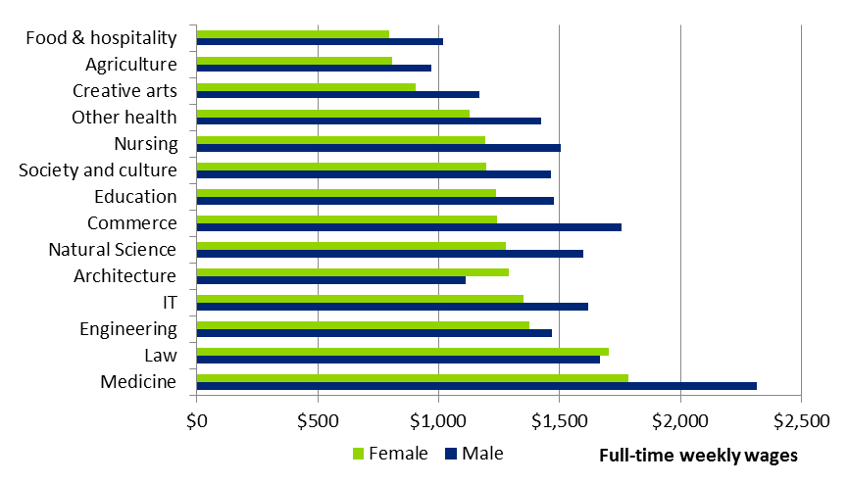
Source: Deloitte Access Economics, HILDA survey. Observations of wages from 2001-2014 are scaled to 2011-12 real dollars
    - : Average weekly wages by qualification level (full-time employees, 2012 dollars )
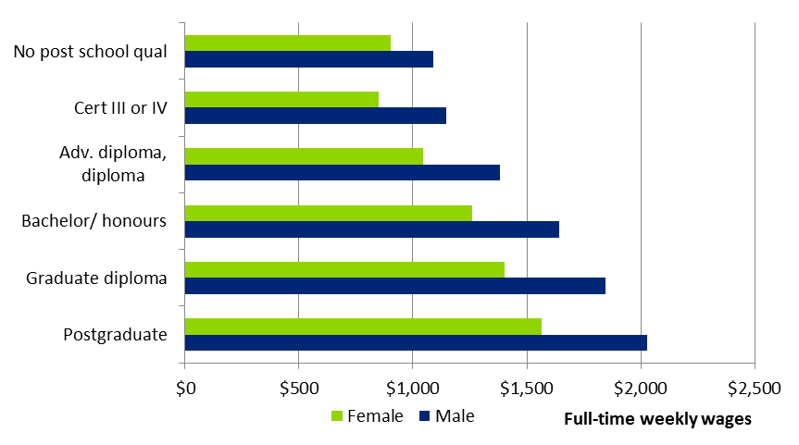
Source: Deloitte Access Economics, HILDA survey. Observations of wages from 2001-2014 are scaled to 2011-12 real dollars
Estimating private market benefits
After controlling for demographic and ability effects, econometric analysis on private market benefits, including combined wage and employment effects from higher education, demonstrates that:
- there are positive earnings premiums for postgraduate degree holders and bachelor degree holders, relative to those with no post-school qualification and relative to VET qualification holders in their respective field of study;
- wage premiums for sub-bachelor degrees are positive (noting they include Advanced Diploma and Diploma qualifications obtained through both VET and higher education providers), but statistically insignificant, meaning the findings of qualification effect for sub-bachelor degrees are less certain than bachelor or postgraduate qualifications;
- the disciplines of Other Health (Health less Medicine), Education, Engineering and Business have significant positive wage premiums, followed by Arts, Science, IT and Medicine which each have similar estimated returns;
- on average, 52% of the observed difference in earnings between bachelor degree holders and those without any post-school education can be attributed to qualification effects (rather than demographics or innate ability);
- most of the variability in the qualification effect share is across disciplines, rather than across qualification levels – the qualification effect explains 53% of the difference between postgraduate degrees and those without any post-school education (i.e. negligible difference to the bachelor result).
- when combining wage, employment and participation effects, the overall earnings premium for bachelor level studies attributable to the qualification is 50.4% of the observed differential; and
- there are some observed differentials in mean wages for qualifications by provider type. However, these effects are not statistically significant when age, demographics, and measures of cognitive ability are taken into account.
A summary of the relative private returns from higher education by level and discipline is summarised in Table iii below.
  - : Attributable earnings premiums for bachelor and postgraduate qualifications
 | Med. |  | Nurs. | Other Health | Educ. | Eng. | Mgmt | Law | Arts | Sci. | IT | Ave.

Bachelor level
Sample size (n) | 262 |  | 1,261 | 790 | 2,404 | 1,518 | 2,694 | 463 | 2309 | 1145 | 670 | 13,516

Percentage premium
Undiscounted | 107% |  | 94% | 92% | 47% | 51% | 37% | 58% | 20% | 35% | 39% | 49%
Discounted NPV | 75% |  | 84% | 82% | 38% | 43% | 30% | 47% | 18% | 26% | 32% | 41%

Dollar premium ($ million)
Undiscounted | $1.07 |  | $0.94 | $0.91 | $0.47 | $0.51 | $0.37 | $0.57 | $0.20 | $0.35 | $0.39 | $0.49
Discounted NPV | $0.22 |  | $0.25 | $0.19 | $0.11 | $0.13 | $0.09 | $0.14 | $0.05 | $0.08 | $0.10 | $0.12

Postgraduate level
Sample size (n) |  | 238 | 759 | 648 | 2,375 | 478 | 2,321 | 364 | 1,372 | 657 | 515 | 9,727

Percentage premium
Undiscounted | 102% |  | 129% | 104% | 56% | 54% | 48% | 77% | 28% | 49% | 51% | 67%
Discounted NPV | 59% |  | 109% | 74% | 37% | 35% | 30% | 61% | 16% | 28% | 32% | 46%

Dollar premium ($ million)
Undiscounted | $1.01 |  | $1.28 | $1.03 | $0.56 | $0.53 | $0.47 | $0.77 | $0.28 | $0.49 | $0.51 | $0.67
Discounted NPV | $0.17 |  | $0.32 | $0.22 | $0.11 | $0.10 | $0.09 | $0.18 | $0.05 | $0.08 | $0.10 | $0.14
Source: Deloitte Access Economics, HILDA Survey, ABS Census (2011). Premiums over lifetime earnings for those with no post-school qualification. Dollars are uprated from 2011 figures to 2016 using CPI. NPV calculations use a discount rate of 7%. Averages are volume-weighted, based on Census counts of qualification holders.
The findings from this analysis are in line with previous research that has used similar methodological approaches and data (e.g. Wilkins, 2015). Notably, the results from this study extend on this previous research to capture discipline-specific private benefits.
Empirical analysis of relative scarcity vs. overall productivity effects
The empirical analysis in the previous step set out to establish the effects of an individual’s own education on their wage. This analysis is then extended to understand how others’ wages are affected by the mix of qualifications in the workforce.
The results of econometric modelling following Moretti (2004) suggest that there are positive spillover effects from increasing attainment levels within a population for all other individuals in that population, regardless of whether they have higher education. That is, if 1% of workers in a labour market attained a higher education qualification (where previously they had no higher education), there would be an associated effect on the wages of the other 99% of workers in that labour market (a 0.07% wage premium).
The CGE results indicate that at the bachelor level, 82% of the partial equilibrium uplift in wages is retained as a general equilibrium productivity effect. The 18% reduction in wages reflects that the increased supply of graduates in the workforce places some downward pressure on wages for graduates.
A comparison of the empirical results and the wage simulations suggests that the CGE modelling provides a conservative estimate of the public benefits. The econometric result places greater emphasis on the productivity effect than the relative scarcity effect, suggesting that the general equilibrium uplift in wages should be more than 100% of the partial wage uplift.
However, it is important to note that the statistical significance of the econometric results are subject to the precise model specification selected. So, this result provides (only) an empirical reference point to the labour market simulations carried out in the CGE model.
Estimating public and private shares of market benefits
Relative private and public benefits are estimated directly through this study’s analytical approach. Public benefits from higher education are measured by simulating the impact on industries and the economy as a whole from increasing the supply/endowment of workers with specific higher education qualifications, and then netting off the estimated private benefits to these more highly qualified individuals.
Methodological considerations
Total economic returns to higher education qualifications are estimated by increasing the effective labour productivity of workers in the economy (by industry) in line with the estimated wage premiums determined from the previous econometric analysis. This approach effectively relies on the standard labour market assumption that observed wage effects are reasonable proxies for labour productivity. Workers’ productivity improvements are assigned to specific industries based on an empirically estimated concordance between higher education qualifications and disciplines, and specific industries of employment.
The effect of increasing the level of labour productivity in the economy on total economic output is determined through the dynamics of the CGE model. Due to the complementary way in which firms use labour and capital (as well as land and natural resources), the productivity of labour is a driver for the demand of other economic factors – in particular, capital. In this way, growth in the stock of skills in the workforce affects the stock of capital demanded in the economy, and therefore boosts net investment in businesses, which has further flow-on effects to total employment and ultimately, to total economic output (i.e. national income).
In practical terms, simulations in the CGE model of the Australian economy can be highly complex, as they incorporate a significant array of dynamic relationships between prices, factors of production and industries in the economy. Nonetheless, the conceptual dynamics of the CGE model are relatively straightforward. These dynamics imply that the key factors which will determine the relative private and public benefits from higher education are the capital-intensity of the industries which specific higher education graduates participate in, and the nature of skills substitutability in these industries (including relative capacity to absorb more skilled workers).
Results from the empirical analysis
The results from the empirical analysis, which align with the conceptual determinants outlined above, imply that:
- for bachelor degree qualifications, 45% of total market benefits are private (measured by post-tax earnings premiums), and 55% are public (measured by deviations in GNP less the private benefits);
- there is a relatively modest level of variability across disciplines, but those with the greater relative public return are Engineering, IT and Business, while the disciplines with the greater relative private return are Education, Arts, and Health;
- Engineering graduates typically work in manufacturing and mining, which are capital intensive sectors, so an increase in labour productivity will have a proportionally larger investment effect.
- Education graduates typically sit in lower income tax brackets, the sector is labour intensive, and their employers are more likely to be public sector, meaning company taxes are not applicable.
- there is no material difference between the average postgraduate degree and bachelor degree benefit shares. This is due to offsetting effects;
- Progressive taxation: observed postgraduate wages are generally higher, meaning they pay a marginally greater share of their income in tax.
- Compositional effect: bachelor degree holders tend to have qualifications in fields with greater public benefits.
- Postgraduate Arts students are more likely to enter the government services sector than their bachelor level Arts peers – this is driving the differential in benefits.
A summary of the relative private and public returns from higher education by qualification and discipline is provided in Table iv below.
Since the sub-bachelor econometric analysis did not show a statistically significant earnings premium, the public/private share estimates are characterised by a greater level of uncertainty than bachelor or postgraduate level qualifications. Given the econometric analysis did not reveal a statistically significant variation in earnings for qualification holders from different provider types, there is no evidence to suggest that the split of public and private benefits of graduate qualifications will differ according to provider type.

  - : Relative private and public benefits by discipline, bachelor and postgraduate
 | Medicine | Other Health | Educ. | Eng. | Bus. | Arts | Science | IT | Ave.

Bachelor level
Private benefits | 50% | 50% | 51% | 39% | 44% | 48% | 41% | 45% | 45%
Public benefits | 50% | 50% | 49% | 61% | 56% | 52% | 59% | 55% | 55%

Postgraduate level
Private benefits | 49% | 51% | 52% | 42% | 44% | 50% | 48% | 45% | 47%
Public benefits | 51% | 49% | 48% | 58% | 56% | 50% | 52% | 55% | 53%
Source: Deloitte Access Economics RGEM CGE model, HILDA Survey, ABS Census (2011). Averages are wage-volume weighted, based on Census counts of qualification holders. Shares use a NPV calculation at the 7% rate
At an overall level, the results from this analysis align with comparable estimates provided by McMahon (2004), which estimated that the ratio of public to private benefits was around 50:50 on average; while also providing detail on how these relative benefits differ based on qualification and discipline.
While the CGE model of the Australian economy is an effective mechanism for capturing complex market based productivity spillovers, it does not effectively capture all the possible public benefits from higher education. In particular, the disciplines that will tend to have conservative public benefit estimates are those which:
- feed into industries that have a greater share of higher education qualifications, and which are labour-intensive in their production – e.g. Medicine;
- map into industries that currently, or in the near future, are expected to experience higher education skill shortages due to sectoral growth – e.g. Other Health;
- are expected to experience growth in qualification demand that exceeds the growth in industry output – e.g. education, particularly early childhood education;
- are least likely to be replaced by computerisation and digital disruption into the future – e.g. food and hospitality;
- are most likely to produce entrepreneurs/business owners who more effectively harness and realise the economic benefits of technological progress – e.g. IT; and
- where the marginal social benefit of individuals’ work is less likely to be fully reflected in their wage – e.g. public sector such as Education, Health, and Creative Arts.
Notably, these fields of education are also those that are estimated to have the largest relative private benefit (or smallest relative public benefit) in the quantitative analysis above. This implies that the range of relative private and public benefits may in fact be narrower than is implied by this study’s central empirical results.
Limitations of this analysis
The benefits estimates summarised above are based on observed relationships. Looking forward, some of these relationships are likely to shift. Structural reform to the higher education system, in particular the demand driven system, has not markedly changed the discipline mix of higher education enrolments, but has altered the make-up of post-school training.
Wage differentials and relative unemployment rates across skillsets will fluctuate. Flows from education into the workforce will evolve over time. Using some understanding of the forward variability of these key relationships, the market benefits framework described can foreshadow how public and private benefits may shift in the future.
In addition to the main scenarios considered for the combination of postgraduate and bachelor level disciplines, a number of additional sensitivities were modelled. These demonstrate how uncertainty of existing relationships in the economy, or changes to the fundamental structure of the economy, could affect the public-private split of benefits to higher education. On the basis of the findings of this analysis, the private-benefit split of benefits is likely to lie within a five percentage point band around the central results. The direction and precise magnitude of the effects vary across disciplines.
Implications and conclusions
The results from this study represent a significant extension of the empirical base of evidence on the private and public benefits from higher education in Australia. Critically, for the first time, robust estimates of the relative private and public benefits are provided at a qualification and discipline level, expanding on previous research by Chapman and Lounkaew (2011, 2015), Norton (2014), and OECD (2014).
Looking forward, robust empirical evidence on the relative private and public benefits from higher education will continue to play an important role in supporting the effective design of higher education funding arrangements. However, it is only one piece of the policy optimisation puzzle.
Evidence on efficient costs of providing different teaching and learning programs, a rigorous understanding of the drivers of demand for higher education (including information for students), and the major influences on supply from different providers (including links to measurable student outcomes) are all important components.
Deloitte Access Economics

Introduction and context
The Department of Education and Training (the Department) engaged Deloitte Access Economics to develop an empirical base of evidence regarding the public and private benefits associated with higher education teaching and learning.
The analysis presented in this report seeks to provide a comprehensive and robust set of data on the relative private and public benefits from higher education in Australia, focussing on the dimensions of:
- discipline (i.e. field of study/education);
- qualification level; and
- type of higher education provider.

Background
Australia’s higher education system plays an important role in meeting the demand for high-skill workers across the economy, by producing graduates with the capabilities to develop and transform knowledge in order to create economic and social value.
The significant benefits that accrue to the economy and society from higher education create a role for government in supporting teaching and learning activities at Australian higher education providers. At the same time, the often significant private benefits realised by those who attain higher education qualifications underwrite the case for students directly contributing to the cost of their education. The incentives that higher education providers and students face, while influenced by a wide array of factors, are shaped by the signals created by government funding and students fees. Ensuring these signals encourage the system toward operating at its optimum is among the most important considerations for higher education policy.
By way of background, this section provides a brief outline of the history of higher education policy in Australia; especially as it relates to the funding of higher education teaching and learning. This overview helps contextualise the findings of this project against the historical backdrop of higher education policy development in Australia.

Policy context
After a period where government fully funded the cost of higher education in the 1970s and 1980s, the Australian Government introduced the Higher Education Contribution Scheme (HECS) in 1989. This policy allowed students to make a contribution towards the cost of their higher education without incurring any up-front costs.
The move toward students contributing to the cost of their higher education was motivated by the view that they benefit – potentially significantly – from higher education attainment. It also allowed for the higher education system to more sustainably expand in response to changing economic and demographic factors (including an increasing high school attainment rate), providing opportunities for more students to obtain a higher education qualification, without significantly increasing the cost burden to government (Chapman, 1997).
The original design of HECS saw students contribute a nominal $1,800 annual fee towards the cost of their education in eligible places. This contribution rate did not vary across disciplines and eligibility for HECS was restricted to bachelor degree programs at Australian universities. This student contribution comprised a relatively small portion of the total cost incurred by universities, with direct government contributions making up the balance.
Over the 1990s and 2000s, the Australian Government made a number of changes to the HECS regime, introducing a tiered contribution scheme which saw students in degree programs understood to have the greatest private return pay the highest fees (e.g. Law and Medicine) (Jackson, 2001).
The Australian Government increased (real) HECS contribution rates by between 33% and 122% in 1997, with the introduction of the tiered system, and then by up to 25% in 2005 (except for national priority fields of education) (Jackson, 2001; Department of Education and Training, 2015). Over time, eligibility for loans has also been extended to postgraduate places and some Vocational Education and Training (VET) places (Department of Education and Training, 2015).
The reviews and reforms that underpinned these changes were designed to allow for “varied HECS contribution levels to better reflect cost and public and private benefits” (Noonan, 2015, pp. 5) – a principle which has since continued to underpin the rate at which student and government contributions towards higher education programs are determined (Lomax-Smith, 2011).
Up until 2010, access to Commonwealth Supported Places (CSPs) at Australian higher education providers was restricted, with a cap effectively placed on student numbers for each higher education funding cluster. In response to the findings of the 2008 Bradley Review, the Australian Government introduced the ‘Demand-Driven System’ for Higher Education in Australia, which saw the caps on domestic bachelor student numbers removed.
In addition to the introduction of demand-driven arrangements, the 2008 Bradley Review made a number of recommendations with respect to funding for higher education, including a 10% increase in base funding for teaching and learning, accompanied by a new indexation system, and that base funding rates be regularly reviewed over time to reflect actual costs.
In response to this recommendation, the Australian Government commissioned a review of base funding for higher education, the 2011 Lomax-Smith Base Funding Review. The research commissioned as part of the Review found that base funding for higher education teaching and learning was on average adequate to meet the costs of teaching and scholarship, but not necessarily for each field of education or institution. In particular, the Review identified areas of underfunding to be addressed in the disciplines of accounting, administration, economics, commerce, medicine, veterinary science, agriculture, dentistry, and visual and performing arts (Lomax-Smith, 2011).
Importantly, Lomax-Smith (2011) established that total funding for higher education teaching and learning should be determined on the basis of average efficient costs for higher education providers. The Review then recommended that, given this determined cost, the balance of student and government contributions should be set at a fixed proportion with students contributing 40% and the Government contributing 60% of the funding for each CSP (Department of Education and Training, 2015).
These contribution proportions were determined largely on the evidence established by Chapman and Lounkaew (2011) in their study, commissioned by the Review, on the public benefits from higher education. This study, discussed in further detail in Section 2, considers the private and public and benefits from higher education only at an aggregate level, thereby prohibiting the Review reaching findings regarding private and public benefits at a discipline, qualification, or provider specific level. Indeed, the Review states that:
There is no evidence that the value of public benefits differs in a systematic way across disciplines of study. The Panel therefore considers that in establishing the appropriate balance of public and private contributions towards the cost of higher education, it is sufficient to make estimates based on aggregate average measures of public benefits. Lomax-Smith (2011, pp. 108)
In early 2013, the Australian Government, while accepting the intent of the established funding principles, made no significant changes to funding arrangements for higher education teaching and learning based on the Review’s recommendations (Department of Education and Training, 2015).
The demand-driven funding system for higher education was fully phased-in in 2012. By 2014, the Commonwealth supported equivalent full-time student load had increased from its 2008 levels of 440,000 to around 600,000.
In broad terms, this policy was introduced to realise untapped private and public benefits through increased access to and participation in higher education. By ensuring that participation in higher education is driven by the demands of industry and students, Australia is provided with greater certainty that the potential benefits from higher education to society are realised into the future. Indeed, the recent Kemp-Norton review of the demand driven higher education system concluded that:
Greater competition for student enrolments, and the opportunity for greater responsiveness to student demand, has driven innovation and lifted quality. In light of the benefits of the demand driven system, there is no persuasive case for the reintroduction of caps. (Kemp and Norton, 2014)
Importantly, the Kemp Norton review also made a number of recommendations that would see an expansion in the current demand driven system:
- all higher education providers should be eligible for CSPs when they and relevant courses have been approved by the Tertiary Education Quality and Standards Agency;
- non-university higher education providers accepting CSPs should do so on the same basis as public universities; and
- sub-bachelor higher education courses should be included in the demand driven system.
These recommendations, which are yet to be implemented, have important implications for the appropriate design and implementation of funding policy, particularly with regard to the contribution of students and the government towards the costs of higher education beyond CSPs at university providers.
In the recent 2016-17 budget, the Australian Government re-affirmed its 2014 policy to reduce the rate of government contribution towards CSPs by 20%. This change is intended to rebalance the proportion of contributions made by students and the government towards the cost of higher education teaching and learning to closer align with recent empirical research (see OECD, 2014). This funding change would have the potential to bolster the fiscal sustainability of the current higher education system, creating greater scope for it to be further expanded to include sub-bachelor places and (potentially) CSPs at non-university higher education providers (Kemp and Norton, 2014).

Motivations for this study
Ultimately, the challenge for effective funding support for higher education in Australia comprises a complex inter-relationship between education quality (and student outcomes), the nation’s long-term fiscal sustainability and the demand of the economy for specific higher education skills and qualifications into the future.
In this context, the principles of public economic theory suggest that government optimally contribute up to the value of the social marginal benefits that ‘spillover’ from university higher education, while students contribute up to the remaining costs for the supply of university teaching and learning services (Lomax-Smith, 2011; Chapman and Lounkaew, 2011; Rosen and Gayer, 2010; and Marginson, 2007).
Under current higher education funding arrangements, the total contribution towards teaching and learning for Commonwealth Grant Scheme supported courses delivered by higher education providers (from both private and public sources) is capped by government. The current framework of differential Commonwealth contributions and three levels of student contributions was introduced in the 1990s, and was intended to cover the cost of offering every course and recognise the shared public and private benefits of a student completing the course.
However, the combined Commonwealth and student contributions do not in all cases align with the relative cost of delivering different types of courses, potentially resulting in cross subsidies occurring across courses or for research activities. The relative split between the Commonwealth and student may also not reflect well the public and private benefits that result from higher education attainment (at a discipline level for bachelor degree programs).
Currently, the relative quanta of these private and public contributions varies significantly on a discipline basis (as outlined in Table 1.1) with an overall average split of private to public contributions of approximately 43% private to 57% public, based on a volume weighted average.
            - : Current government and student contributions by funding cluster, 2016
Funding cluster | Component | Student contribution | Commonwealth contribution | Proportion of contribution
 |  |  |  | Private | Public
1. Law, accounting, administration, economics, commerce |  | $10,440 | $2,059 | 84% | 16%
2. Humanities |  | $6,256 | $5,724 | 52% | 48%
3. Mathematics, statistics, behavioural science, social studies, computing, built environment, other health | Mathematics, statistics, computing, built environment or other health | $8,917 | $10,127 | 47% | 53%
 | Behavioural science or social studies | $6,256 | $10,127 | 38% | 62%
4. Education |  | $6,256 | $10,537 | 37% | 63%
5. Clinical psychology, allied health, foreign languages, visual and performing arts | Clinical psychology, foreign languages, or visual and performing arts | $6,256 | $12,455 | 33% | 67%
 | Allied health | $8,917 | $12,455 | 42% | 58%
6. Nursing |  | $6,256 | $13,905 | 31% | 69%
7. Engineering, science, surveying | Science, Engineering or surveying | $8,917 | $17,706 | 33% | 67%
8. Dentistry, medicine, veterinary science, agriculture | Dentistry, medicine or veterinary science | $10,440 | $22,472 | 32% | 68%
8. Dentistry, medicine, veterinary science, agriculture | Agriculture | $8,917 | $22,472 | 28% | 72%
Source: Department of Education and Training (https://docs.education.gov.au/node/37873)
While recent studies, including those commissioned as part of the 2011 Lomax-Smith Base Funding review, have examined the efficacy of these contribution rates in relation to relative private and public benefits, there is limited empirical evidence against which these relative contribution rates may be assessed at a discipline, provider or qualification level.
This is because these studies were limited to undergraduate and postgraduate levels only (i.e. they did not include sub-bachelor programs), and did not consider whether the relative public and private benefits varied between different types of institutions (including universities and non-university higher education providers). Importantly, these studies considered private and public benefits only separately, and the studies which gave consideration to public benefits of higher education did not contain a detailed breakdown by discipline, making it difficult to determine the relative public and private benefits by discipline.
This study seeks to significantly expand on the conceptual and empirical evidence base regarding the private and public benefits from higher education to inform this element of higher education funding policy.

Overview of this report
The remainder of this report is structured as follows:
- Section 2 establishes a taxonomy of the private and public benefits from higher education, before providing a strategic review of the empirical literature relevant to the Australian context;
- Section 3 builds on the findings from the review of the literature and outlines the analytical approach to this study;
- Sections 4 and 5 summarise the method and results from the analysis on each of the private and public benefits from higher education, respectively;
- Section 6 discusses the implications from the core analysis and modelling and how the inter-temporal dynamics of the economy may see these results change over time; and
- Section 7 briefly discusses the implications of the results from this study, outlines where extensions on the current analytical framework are advisable, and makes a number of final concluding observations.

Current evidence on the benefits of higher education
To inform the analytical approach, empirical methodology, findings and recommendations that comprise this study, a strategic review of the relevant conceptual and empirical literature on the private and public benefits from higher education was conducted. The findings from this review are presented in this section.

Defining the benefits from higher education
Higher education attainment can have a range of consequences on a person’s opportunities, productivity and decision-making over the course of their life, both inside and outside of the workforce. These consequences generate benefits that accrue to individuals, as well as society overall. This section discusses:
- the nature of these benefits through categorisation based on an established taxonomy;
- the concepts of human capital and signalling;
- how public benefits from higher education relate to private benefits; and
- the role of government in maximising the net social benefits of higher education.

Defining private and public economic benefits
Private benefits are those that accrue to the individuals directly involved in the market transaction or economic activity of interest. Acknowledging that in the case of higher education this may include benefits to providers, the focus of the analysis presented here – given its pertinence to higher education funding – is on the individual benefits or returns that students receive from investing in, and attaining a higher education qualification.
Public benefits are defined by their accrual to third parties who are external to the production (supply) or consumption (demand) of a good or service – that is, they accrue to parties removed from the core market transaction. These public benefits can also be described as ‘spillovers’ or ‘positive externalities’ to an economic activity.
The sum of all public and private benefits is assumed to completely and exhaustively comprise the total benefits that arise from a specific economic activity. These total benefits are often termed total ‘social’ benefits, as they comprise benefits that accrue to a society as a whole.

A taxonomy of the benefits to higher education
The private and public benefits generated by higher education attainment can have market and non-market dimensions. Market benefits are measured in terms of economic output generally captured by income measures that result from increased levels of labour productivity. Non-market benefits – which may be measured in pecuniary or non-pecuniary terms – are broader in nature, and capture benefits to individuals and society that manifest, often indirectly, from higher levels of educational attainment and human capital.
Non-market benefits are typically harder to quantify and are often associated with changes in behaviour and with social – as opposed to economic – outcomes. These may include: public health, greater levels of education, improved democratisation, human rights, political stability, lower criminal activity, reduced pollution, reduced poverty and inequality, and other, more informal, types of knowledge dissemination (Chapman and Lounkaew, 2011, 2015; McMahon, 2006; Norton, 2012).
Some of these benefits can be measured in pecuniary terms – for example, the value to increased health can be measured in terms of Quality Adjusted Life Years combined with the Value of a Statistical Life, a benefit which is expressed in dollar value terms. While others, such as improved human rights or political stability, are not easily measured in pecuniary terms.
Benefits that occur as an immediate result of an economic activity can be described as ‘direct’ effects and are more likely to be observed at an individual level – for example, post-graduate employment outcomes of students.
‘Indirect’ benefits are instead more likely to be observed at a ‘whole economy’ level, where the resulting circumstances of an economic activity reveal broader benefits – for example, lower unemployment rates that encourage wage growth (McMahon, 2004).
A summary of this taxonomy is provided in Figure 2.1 below, drawing on McMahon (2004). The sum of the total area presented in this figure can be interpreted as the total social benefits from higher education.
                - : Illustration of the benefits of higher education
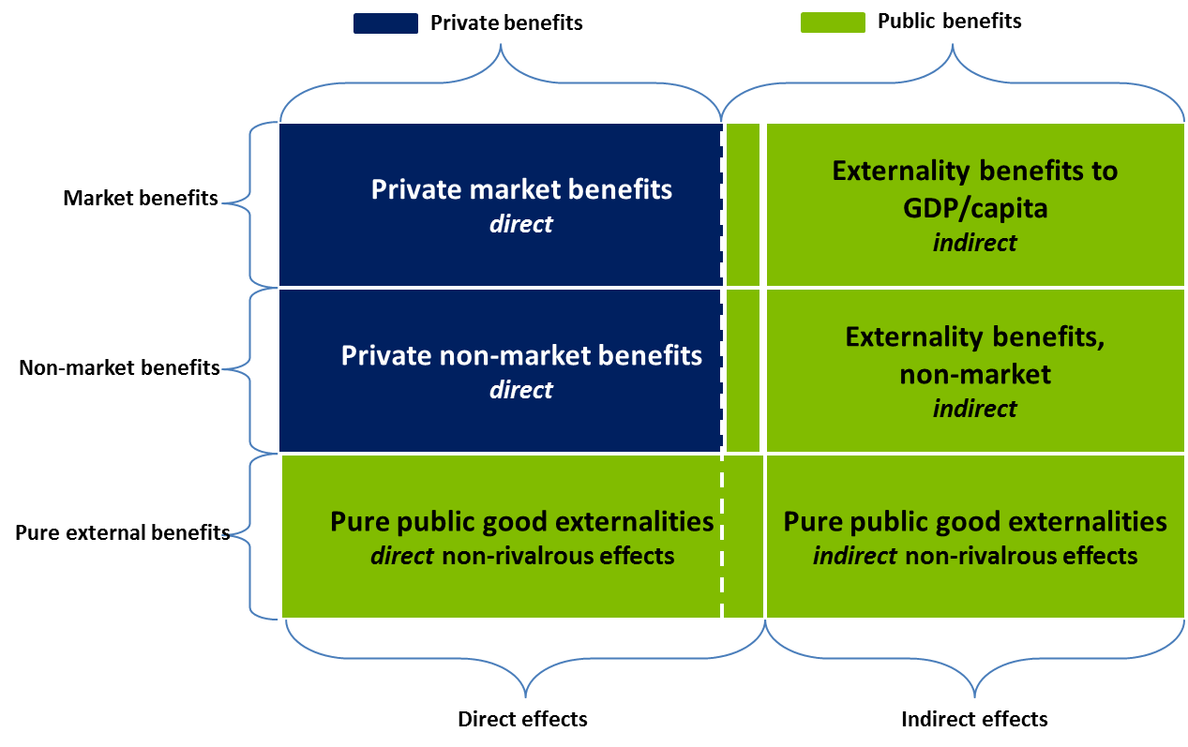
Source: Deloitte Access Economics based on McMahon (2004)

Private benefits – productivity or signalling?
Human capital theory suggests that education and knowledge drives overall productivity of labour, which is then reflected in the wages paid to individual workers. In this way, individuals’ education and innate human skills augment the productivity of their labour, in a similar way to traditional capital (i.e. physical machinery) – hence the term human or intellectual capital.
A related theory of the benefits from higher education suggests that any observed wage premiums attributed to higher education attainment should be discounted by the screening effect or signalling process of education. It is understood that, to some degree, higher education allows more highly capable individuals to identify themselves to employers and that more capable individuals will find the process of attaining higher education easier and more appealing. At the extreme, this would suggest that the value of education (at least on wages) is entirely inflated, in that these high-performing individuals would have been rewarded in line with their pre-existing labour productivity in any case.
In reality, and in support of the empirical literature, it is likely that higher education is partially a signal, and that there are still significant causal gains to human capital and subsequently, labour productivity from higher education attainment.

Understanding the link between public and private benefits
The taxonomy established above demonstrates that the public benefits from higher education generally arise indirectly through the returns that students themselves receive directly, as a result of their enhanced human capital attainment. That is, the magnitude of public market benefits from higher education attainment is largely driven by the increased labour productivity for individual students, which is captured—in part—by the increase in lifetime earnings realised by these students.
These indirect channels include increased levels of taxation and, therefore, revenue available to government (OECD, 2014). Other agents in the economy benefit too, as increased levels of labour productivity enhance the returns to physical capital and other factors of production, which leads to increased levels of investment, employment and wage and income growth for other workers, land and business owners.
The consistent link between private and public market benefits provides an indication of the extent to which their respective magnitude would be expected to vary between higher education levels, disciplines and providers. In particular, the nature by which specific industries utilise higher education skills and the process of production (including the ratio of physical capital to labour), among other factors (including the level of progressivity of the income tax system), would determine the magnitude of market-based spillovers from increased levels of productivity.
Further, the relative scarcity of workers with different skill levels (i.e. educational qualifications) – within and across industries – will affect the returns to wages that individuals realise from gaining specific forms of higher education, and these effects will be governed by the relative magnitude of labour demand and supply elasticities.
Finally, while the link between non-market private and public benefits is less clear, many of these public returns are understood to be highly correlated with rates of income and living standards more generally, which imply a strong link with private market returns, as described above. Indeed, McMahon (2004; 2006; 2009) has estimated that the quanta of total social (private and public) non-market benefits may be approximately equivalent in magnitude to the market benefits.
Noting this point however, non-market public benefits may differ across fields of education and provider type (Norton, 2012). This is due to the fact that productivity gains in particular industries may have very different flow-on non-market impacts. For example, productivity gains associated with health professionals (doctors or nurses) or teachers may have different flow-on non-market public benefits when compared to financial or business professionals (commerce, law), due to the importance of Australia’s health and education sectors to longer term social and economic outcomes.

The role of government
The economic policy rationale for governments to support higher education is the existence of a ‘market failure’ – specifically, the existence of the public benefits described above and the fact that, in the absence of government funding, the decisions by providers and students will not drive the system toward its socially optimal operation.
Economic theory suggests that students will choose to acquire knowledge where their expected private benefit is at least equal to their cost of education. If at least some public benefit exists, then this decision-making process will result in a suboptimal level of knowledge transfer activities.
In order to increase levels of knowledge and maximise the total net social benefit of higher education, governments need to be able to identify the public benefits being created, such that appropriate subsidies can be derived and applied. Identifying the relative split between public and private benefits may then inform the relative subsidy payments based on these dimensions.
It is important to note that other distortions may also cause the under-provision of higher education: myopia on behalf of the students, credit constraints arising from upfront costs and delayed benefits, and risk aversion associated with uncertainty of educational and employment outcomes. Hence, there is a widely acknowledged role for government in alleviating these distortions besides the subsidy of provision. For example, student loan facilities mitigate credit constraints, and information on career outcomes overcomes the myopia of individuals when making decisions with long-term personal consequences.

Empirical research on the public and private benefits of higher education
As a basis for the original empirical analysis undertaken as part of this study, a review of recent empirical research on the private and public benefits from higher education has been conducted. Due to the relative intractability of empirical methods towards measuring non-market benefits, this review largely focuses on studies of market benefits. The findings from this review are summarised in this section.

Private benefits
An extensive number of studies have attempted to calculate the private returns to education in Australia. In broad terms, these studies generally use accounting or econometric methods to calculate the returns from higher education to individual students.
Accounting approaches
Daly et al. (2015) use 2006 Australian Census data to implement an accounting approach to calculating the private benefits of higher education by field of education. The authors use net present value (NPV) and internal rate of return (IRR) calculations with adjustments for the length of degree, student earnings while studying, studying costs (e.g. books, equipment, fees), an ability measure, and temporal changes to future living standards.
The aim of this study (as with other accounting method analyses) is to capture the total costs and benefits associated with attaining a higher education qualification and how they vary on the basis of student characteristics and types of study (including field of education).
Norton (2012) uses a similar approach to Daly et al (2015) to consider the returns to higher education qualification for different higher education disciplines, by calculating lifetime earnings of graduates relative to the average person with no post-school qualification. This analysis also considers the proportion of graduates who receive net positive benefits from their higher education qualification, relative to the average person with no post-school qualification.
This study concludes that, on average, Australian higher education degree holders receive significant benefits from their qualification, with median net financial benefits equal to around $600,000 for the average male graduate and around $450,000 for the average female bachelor degree graduate (Norton, 2012).
These studies, while being detailed in their scope, over-estimate the causal return from higher education attainment because they do not effectively recognise the differences in demographic characteristics and innate ability between individuals who do and do not have a higher education qualification, thereby potentially conflating demographic and inherent ability drivers of private wages and employment outcomes with qualification returns (see also Box 2.1). In this regard, econometric methods towards estimating private benefits are considered to be more accurate.
Econometric approaches
A number of Australian studies have sought to account for inherent cohort biases in observed wage and employment outcomes through the use of econometric methods. Wilkins (2015) uses demographic characteristics and test-based cognitive ability measures within the Household Labour and Income Dynamics (HILDA) dataset in an attempt to provide a stronger basis for the causal effect of higher education on private earnings.
Wilkins (2015) uses regression methods to estimate earnings effects by gender for a number of educational attainment levels. By controlling for demographic and ability characteristics he is able to separate the specific qualification benefits from bias associated with specific cohort characteristics.
For example, females with a bachelor degree are found to earn, on average, 36% more than females who did not finish Year 12 after controlling for demographic characteristics. After also controlling for direct measures of cognitive ability, the estimated effect falls to 32% —this accounts for approximately 10% of the wage premium estimated using only demographic controls.
Wilkins’ 32% estimated effect for females with a bachelor degree relative to females who did not finish Year 12 can be compared to the actual observed difference between these individuals’ wages of around 59%. This comparison implies that 54% of the actual difference in earnings between these groups can be explained by qualification specific effects, and 46% by demographic and ability characteristics.
Leigh (2008) surveys the methods employed in the education literature used to overcome ability bias. He summarises that for the Australian context and in instances where the appropriate data or empirical methods are unavailable, an assumed 10% bias may be preferred to (downwardly) adjust simple OLS estimates.
Using HILDA data from 2001 to 2005, he estimates a 15% average increase in annual earnings for each year of university study (for completers), relative to those with only a Year 12 level or equivalent level qualification. This is broadly consistent with Wilkins (2015) findings, though Wilkins includes a richer set of demographic controls. The results also indicate that the gains materialise mostly in higher average earnings, rather than the number of hours worked, for individuals with higher education, compared to school education or non-tertiary post-school education. Leigh (2008) uses an assumed measure of ability bias (which is consistent with Wilkins (2015) results), this is in addition to experience and gender which are used to control for the differences in characteristics between cohorts of persons who do and do not have a higher education qualification.
Sinning (2014) uses HILDA data to compare lifetime earnings of graduates, utilising time and age-time interaction terms to take into account temporary and permanent variation in wages over time. He finds that graduates with bachelor degrees compared to individuals with Year 12 or below earn between 40-50% higher wages. The author uses a much broader counterfactual group but, more importantly, assumes prior ability biases to be small and thus ignores them.
Box 2.1: Average vs. marginal returns to higher education
The econometric studies outlined above provide estimates of the average effect of higher education attainment on wage and employment outcomes, controlling for observable characteristics. It should be noted that there is generally a degree of variance around this average, with some individuals (for a given profile of characteristics) receiving different returns to higher education.
The returns to the ‘marginal’ student are of interest in studies on the returns from higher education (see Chapman and Lounkaew, 2011). The marginal student can be appropriately defined as the individual who is indifferent between attaining a higher education qualification and not, based on their expected return from higher education (controlling for their individual characteristics).
Norton (2012) and Daly et al. (2015) demonstrate that there is significant variation in incomes for persons with higher education qualifications, and conclude that—compared to the average individual with no post-school qualification—there are variations in the NPV of benefits from higher education within discipline and qualification levels. However, this conclusion is not without its limitation, as their analyses fail to account for variations in characteristics other than educational attainment, which may cause this variation in earnings. Indeed, these studies’ estimated variations in NPV benefits are a less than fully accurate representation of the actual variation of returns from higher education and are not appropriate for the use in identification of the ‘marginal’ students, as defined above.
Econometric studies of the returns to higher education can allow for a more accurate characterisation of ‘marginal’ higher education students, as described above; however, more complex model specifications than those used in the current empirical literature are required to identify these students.
In particular, average effect sizes that are estimated while also controlling for observable student characteristics constitute appropriate evidence that the returns to higher education are always positive for individuals who chose to attain a higher education qualification (setting aside unobserved, individual specific, idiosyncratic factors). Further, student-level residual effects are not necessarily evidence of variations in benefits from the mean (in expected terms) since these idiosyncratic returns can be influenced by a wide array of variables once students enter the workforce.
To determine observed factors that may be used to identify marginal students, interaction terms between qualification variable and demographic characteristics may be required—however, current panel datasets generally contain insufficient observations to estimate these conditional effects robustly. Econometric studies that further explore these issues are considered an important area of further research.

Public benefits
Relatively few studies have rigorously explored the public benefits from higher education. A review of the literature from Australia and overseas has not revealed any studies that comprehensively and rigorously estimate the full suite of public benefits from education. Most Australian studies have taken the relatively narrow approach of focusing on net government receipts as a measure of public benefits from higher education. McMahon is the leading author who synthesises the empirical evidence on broader public benefits and the findings from his work are used by Chapman and Lounkaew (2011; and 2015) in the Australian context.
Net government receipts
The most common measure of public market benefits that has been canvassed in the literature is net government receipts (predominately through higher taxation revenue) that result from the higher wages earned by higher education graduates.
Norton (2012) adopts an accounting approach to estimate the public market benefits by field of education. He defines net public market benefits as the net present value of lifetime additional tax obligations less tuition subsidies. These intuitive results identify significantly greater public benefits from courses like medicine and law, with comparatively smaller benefits from nursing and humanities, and negative net benefits from performing arts graduates. However, as the author acknowledges, they fail to control for ability bias and focus on a single stream of direct monetary public benefits, without a consideration of any indirect effects (e.g. through labour productivity spillovers).
            - : Private benefits from attaining tertiary education in 2009 (2010 PPS USD)
 | Men |  |  |  | Women
 | Private |  | Public |  | Private |  | Public
 | $ | % | $ | % | $ | % | $ | %
Total benefits | 221,234 | 64 | 124,441 | 36 | 175,023 | 66 | 91,641 | 34
Net present value | 152,892 | 60 | 103,866 | 40 | 105,374 | 60 | 70,921 | 40
Internal rate of return (IRR) | 9.0% | n/a | 12.9% | n/a | 8.9% | n/a | 13.5% | n/a
Source: OECD Education at a Glance (2014)
This approach is also employed by the OECD (2014) at an aggregated level. To extend the range of public benefits (e.g. beyond that captured by Norton, 2012), this study also includes transfer savings from reduced housing benefits and social assistance. The results from this analysis suggest that the private benefits from tertiary education comprise around 60-66% of the total benefits. While private benefits are estimated to be larger in magnitude, the internal rate of return (IRR) to the public is larger than the private IRR. This is due to the relative private and public costs towards tertiary education in Australia (i.e. public costs are proportionally smaller than private costs).
Broader public benefits
McMahon (2004; 2006; and 2009) provides perhaps the most complete and comprehensive canvass of the empirical literature on education externalities, and is the first widely cited study to include a survey of efforts to appraise non-market public benefits (Chapman and Lounkaew, 2011; and 2015).
McMahon identifies the most common and accepted approach for calculating market benefits. First, estimate the total social rates of return to educational attainment using cross-country comparisons, then estimate the private returns to education based on individual earnings data using what is known as a Mincer-type equation. As the social return is assumed to be comprehensive, the difference between these returns is, by definition, the public market benefits (McMahon, 2004).
McMahon notes that these returns are often overestimated due to the lack of controls or dynamic considerations – in particular, temporal changes in technology and policy. As such, they may be considered to be an upper bound estimate of total benefits from educational attainment (Deloitte Access Economics, 2015).
McMahon synthesises the empirical results from across the literature to develop general results on the relative distributions of the types of benefits from education.
Comparing two different studies using this general method in the literature, McMahon posits that the average ratio of public-private market benefits is approximately even (i.e. 50:50). The bounds of these results are between 37% and 61% for the proportion of total social market benefits attributable to public market benefits. Furthermore, the ratio of public-private non-market returns is posited to be in proportion to the public-private ratio of market returns.
Building on the precedent set by McMahon, Deloitte Access Economics (2015) provides a measure of the total economic contribution of university higher education to the Australian economy through the development of a cross-country macro-econometric model of economic growth that extends upon the neo-classical Solow growth model adopted by Mankiw et al. (1992) and further discussed by McMahon (2004) in the context of higher education.
Based on this model, Deloitte Access Economics finds that the value that university teaching and learning adds to the productive capacity of the nation, through the development of the stock of higher education human capital, is estimated to $140 billion in GDP in 2014. That is, Australia’s GDP is 8.5% higher because of the impact that university education has had on the productivity of the 28% of the workforce with a university qualification. This total benefit is appropriately considered to be the total social (private and public) benefit from higher education.
In this paper, Deloitte Access Economics concludes that, while it is not possible to directly estimate the spillover public benefits from university higher education, estimates of the total contribution of higher education attainment—when compared with the private benefits to individuals’ wages and employment (as in McMahon, 2004)—point to the existence of material spillover benefits to the broader economy.
In perhaps the most influential recent study on public benefits from higher education in Australia, Chapman and Lounkaew (2011; and 2015) develop estimates of the value of the public benefit from higher education qualifications in Australia, as part of the Lomax-Smith (2011) Base Funding Review. Chapman and Lounkaew use HILDA data from 2008 to estimate the value of total externalities between approximately $10,600 and $16,000 (in 2014 terms) for an additional year of higher education.
In arriving at these estimates, Chapman and Lounkaew first calculate the private returns from higher education attainment. They first take average wages for bachelor degree holders and those without a post-school qualification from the ABS Census. Following a survey of the literature, Chapman and Lounkaew (2015) propose to use a range of 40% to 60% for the proportion of observed wage premiums to be attributable to human capital theory, compared to signalling theory (Barrett, 2012; Herault and Zakirova, 2011). Additionally, the authors assume a 10% ability or motivation bias for graduate students, however it is unclear on what basis this figure is determined or how it is applied in their calculations. Based on these assumptions, private returns attributable to qualification specific effects are estimated.
The authors then calculate the returns to government from higher tax returns that result from the higher incomes earned through the qualification effect outlined above. This forms the basis of their measure of public benefits.
To capture further non-market spillover effects that result from higher education they rely on results from McMahon (2004). In particular, they use the observation from McMahon (2004) that the value of non-market public benefits from higher education is proportional to 30% of the total social (public and private) market rate of return. This ratio is derived from the estimated market social rate of return from higher education (8.5%) and non-market public benefits (2.5%), which is used to estimate a relative ratio (2.5/8.5 ≈ 30%).
It is not clear, however, that this ratio is appropriately applied to the measure of public benefits estimated by Chapman and Lounkaew. This ratio relates total social (public and private) benefits to non-market public benefits. However, Chapman and Lounkaew appear to apply this ratio to a measure of public benefit only. Further, the use of ratios for rates of return to calculate non-market based spillovers measure based on a measure of net benefit is spurious, as it does not account for relativities in costs (against which benefits are measured to estimate rates of return). In particular, it should be noted that the base of this ratio (the 8.5% social rate of return) is based on method that does not explicitly include taxation revenue as a measure of benefit and so it is not generally applicable to Chapman and Lounkaew’s measure of public benefit.
Chapman and Lounkaew do not explicitly calculate a ratio of public to private benefits based on their results. Rather, they conclude that—in terms of funding policy—government would appropriately subsidise the base cost of a given higher education degree up to the value of the public externality.
The Lomax-Smith Base Funding Review concluded that Chapman and Lounkaew’s results suggest that public benefits account for approximately 40 to 60% of the average base funding amount (in 2010). The Review concludes that the Government would therefore appropriately contribute anywhere between 40 to 60% of the total base funding for a unit of study, with students contributing the balance (Lomax-Smith, 2011). It is based on this finding, and evidence from the OECD (2011), that the Review recommended that “the most appropriate balance of contributions is for the Government to contribute at the top end of the given range (60%) with students contributing the balance (40%)” (Lomax-Smith, 2011, pp. 109).
It should also be noted that the Lomax-Smith Base Funding Review notes “the difficulties in quantifying precisely the extent of public benefits from higher education” and therefore the limitations of Chapman and Lounkaew’s results (Lomax-Smith, 2011, pp. 109). Indeed, Chapman and Lounkaew also recognise that their results are ‘uncomfortably aggregate’, claiming that the literature to date has yet to attempt to rigorously partition similar results by field of education, or otherwise.
A more detailed review of the findings of Chapman and Lounkaew is provided in Appendix A of this report.
Neighbourhood spillovers
Where the approaches outlined in the previous section, and bulk of the literature, tend to focus on tax receipts from government as a measure of public market benefit, a branch of research attempts to identify the spillovers that accrue as increased wages and employment outcomes within communities and locales.
Moretti (2004) provides the leading international research with respect to neighbourhood wage effects that may result from higher concentrations of tertiary educated residents. The author uses a number of techniques to control for selection bias, in order to isolate a causal relationship between higher education and labour market outcomes.
The findings of this analysis suggest that a one percentage point increase in the concentration of tertiary qualifications in an American city raises average wages by 0.6 to 1.2% beyond the private market returns to education. When comparing this result for different groups of individuals, Moretti finds a 1.9% additional increase in wages for high school non-completers, a 1.6% increase for high school graduates and a 0.4% increase for university graduates.
The work also seeks to understand whether positive neighbourhood spillover effects can overcome negative scarcity effects – whereby, a relative oversupply of more highly educated workers can exert downward pressure on high-skilled wages. In this regard, the results suggest that there is a net positive effect from increasing the concentration of tertiary educated graduates, and thus productivity gains reign over labour supply changes. This result has not been replicated within the Australian context.
These results are consistent with conventional economic theory – where lower supplied (lower educated) workers receive greater marginal wage gains, compared to more highly supplied (higher educated) workers.
In an Australian context, Clarke and Skuterud (2011) examine a separate immigration question, however with comparable empirical research methods. The authors utilise 1% samples of Australian Census data from 1986 to 2005, restricting their sample to males between 25 and 59 in order to minimise sample selection issues from underlying differences in labour force participation. Their empirical method relies on panel data and the utilisation of fixed effects and regional unemployment data in order to isolate differences across country-of-origin and more relatedly, education groups. It is the method presented in Clarke and Skuterud’s work, rather than the findings, that are most relevant here.
Non-market public benefits
While measures of non-market benefits are discussed above in the context of McMahon (2004) and Chapman and Lounkaew (2011, 2015), a further review of the studies that consider non-market benefits, and their findings, is presented here.
Accompanying the findings of Norton (2012), Savage and Norton (2012) use econometric techniques, including propensity score matching, in order to estimate non-market public benefits. Their results show large positive relationships between education and civic group attendance, positive health behaviours and indicators, and social tolerance of cultures. They also find some evidence of positive relationships for reported life satisfaction and volunteering rates, while no relationship is found for job satisfaction. The authors do not attempt to assign monetary values to the size of their relationships, and thus their results are limited to the existence of any relationship.
McMahon (2004) presents a summary of research efforts which attempt to empirically identify specific non-market benefits. These regression-based estimates make some attempt to quantify outcomes that are typically qualitative in nature. Additional to the inherent measurement difficulties of assigning monetary values to non-monetary benefits, the problem of simultaneity bias – that is, both education and the outcome of interest are functions of each other, which a standard ordinary least squares (OLS) regression estimate does not consider – is particularly apparent.

Benefits by level of higher education
Private benefits
A range of literature identifies the private returns to higher education, for different qualification levels (i.e. sub-bachelor, bachelor and post-graduate). However, there is a relative dearth of research on the relative proportion of private and public benefits between post-bachelor, bachelor and sub-bachelor degrees.
Noting its relative robustness, available econometric evidence suggests that the level of social return to a sub-bachelor degree differs to that of a bachelor degree. For example, Leigh (2008) finds that the annual social return for a diploma or advanced diploma is 8%, compared to 15% for a bachelor degree. Wilkins (2015) also finds similar results, with returns to sub-bachelor degrees significantly lower than bachelor degrees.
Public benefits
While the observed difference in private returns from different higher education qualification levels implies that the level of public benefits vary on the basis of qualification level, this does not necessarily imply that the split between the private and public market benefits differs on this basis (Deloitte Access Economics, 2014). In general terms, it is possible that graduates from different levels of higher education will have different propensities to participate in different occupations and industries, which may affect the extent of market-based flow-on benefits that result from different qualification levels. However, no studies have explored this question in detail.

Benefits by field of education
Private benefits
Differences in private market benefits by discipline are likely to result from the pathways of employment, namely differences in sectors and job types. A number of studies have sought to measure the difference in private benefits by field of study (most notably, Norton, 2012; and Daly et al., 2015), however these studies rely on accounting methods in estimating benefits. The results from these studies are not considered an accurate representation of the variation in private benefits, as they fail to account for the differences in the characteristics of students who choose to study different disciplines.
Studies that use econometric methods to estimate private benefits from higher education have considered how benefits vary on the basis of discipline (namely Wilkins, 2015; and Sinning, 2014), however they tend to place limited weight on the accuracy of their estimates due to small sample sizes in the available requisite datasets (namely, HILDA). Other studies that have estimated effects on the basis of discipline have found variations in the statistical significance of different disciplines on wage outcomes, and highly varied orders of effects, depending on the dataset used and individual’s gender (see Carroll, 2014; Birch et al., 2009; and Koshy et al., 2016).
To date, no author has provided a consensus view of how private benefits from higher education may vary (using econometric methods).
Public benefits
The only study which seeks to capture public benefits by discipline is Norton (2012), whose benefit measure is limited to only additional net government receipts that result from higher earnings due to higher education attainment. No empirical study has been identified that seeks to measure public broader benefits from higher education at a discipline level (including labour productivity based spillovers).
It is likely that the field of education, and subsequent industry of employment, will influence both the size and distribution of public benefits from labour productivity spillovers. However, no study has sought to systematically estimate these effects.
Non-market public benefits
McMahon (2009) attempts to identify systematic non-market differences according to field of education in an international context. This study finds that:
- political science and law graduates are likely to strengthen civic institutions, political stability and the rule of law, which contribute and facilitate future economic growth;
- foreign language studies and international affairs graduates can positively contribute to trade and export markets;
- better health outcomes are associated with students with research and training in the life sciences, medicine, nursing, pharmacy, and applied life sciences; and
- quality of life can be improved by graduates in the performing arts, such as music, dance and theatre, as well as architecture, art and design.
While this study provides some qualitative guidance on how non-market public benefits may arise on the basis of higher education discipline, there is less empirical evidence to inform their relative magnitude (in pecuniary or non-pecuniary terms).

Benefits by provider type
Private benefits
It has been established in empirical research that higher education providers can impact the estimated private returns from higher education qualifications, though this impact is generally less significant than the variation across disciplines (Birch et al., 2009; Koshy, et al., 2016; Norton and Cherastidtham, 2014; and Wilkins, 2015).
Wilkins (2015) compares results across groups of universities and finds some differences between clusters of universities, but these are not statistically significant across gender and functional form.
Koshy, Seymour and Dockery (2016) utilise HILDA data to estimate differences in graduate earnings by university institution groupings. Differing from previous work in the Australian context, the authors utilise life-time wage profiles (versus starting graduate wages) and control for many more factors, notably field of education and industry of employment, which are well known drivers of wage variation. The authors find that field of study dominates the effects of institutional grouping. However, females who attend Go8 and ATN universities tend to have higher average wage outcomes compared to other universities, but this relationship disappears for males.
In contrast to the above studies which focus on institutional clusters of universities, Carroll (2014) explores differences in graduate starting wages for universities with a top 100 global ranking. The author uses the 2012 Graduate Destination Survey and global publication rankings. Additionally, Carroll attempts to control for non-random self-selection by students into ‘more prestigious’ universities, by using a two-step regression approach that incorporates a ‘selection bias control factor’. This additional control accounts for the propensity of a student to choose a top university based on the field of education, and indicators for capital city resident, part-time student and whether course fees were deferred.
Carroll’s baseline results, which control for age, gender, field of education and honours degrees, suggest that graduates from globally ranked universities earn on average 3% higher than their peers. After including a self-selection control, which does not have a significant or substantial effect on wages, this premium increases to 4.5%, holding all else constant. These effects are modest, and there is some uncertainty as to how effective student controls are in the analysis, particularly as the Graduate Destination Survey has limited available demographic characteristics and highly variable response rates across universities.
Studies that have sought to estimate differing private benefits on the basis of provider characteristics necessarily attempt to control for heterogeneity in student characteristics between providers, including prior academic ability, through the use of econometric methods. However, there is some uncertainty as to the robustness of these controls, and whether there are further unobserved student characteristics which may confound estimated effects on a provider basis. Indeed, Wilkins (2015) notes that the measured differences between clusters of universities are not very large and are sensitive to model specification.
Finally—with the exception of Carroll (2014)—the studies outlined above which consider private benefits by provider type have focused on institutional university clusters (Go8, ATN etc.), rather than individual institution or bespoke grouping. In principle, other higher education provider types and classifications may be considered when estimating relative private benefits (e.g. universities vs. NUHEPs). However, there are few if any reputable studies that have sought to estimate relative benefits on this basis.
Public benefits
While the magnitude of returns to higher education may vary across providers, this does not necessarily imply that the ratio of private to public benefits would vary across providers (Deloitte Access Economics, 2014). This is clear from the direct relationship between private and public benefits, as described above, which is most closely influenced by discipline and level specific effects (McMahon, 2006).
Indeed, the extent to which such variation would be expected to occur at a provider level is likely to be driven by more complex institution factors, as opposed to the market spillover effects associated with the industries that graduates are employed in, and the nature of their relative scarcity effects (Deloitte Access Economics, 2014).
Further, where such labour market factors are found to vary according to provider type, these are likely to be associated with student specific factors (including discipline related effects), rather than factors inherent to provider type and so could not be considered to be attributable to providers specifically (Norton, 2012; Norton and Cherastidtham, 2014).
Deloitte Access Economics (2014) investigated the extent to which the ratio of private to public benefits from higher education generated by non-university higher education providers (NUHEPs) might be expected to systematically vary from university providers. In this research it was determined that variations in the quality of institutions’ higher education degree programs (measured in terms of student’s private market outcomes) should not be directly used as a basis upon which to determine the contributions made by government and students in the context of relative private and public benefits.
A further exposition of this discussion is provided in Appendix A of this report.

Implications for this study

Overview of findings
Bringing the summary of the literature on the conceptual benefits from higher education outline above together, Table 2.2 outlines the primary benefits measures canvassed in the literature. These benefits in turn form the primary focus for the quantitative and qualitative analysis considered in this study.
            - : Common higher education benefit measures
 | Private | Public
Market | Increased earnings (through employment and productivity effects) | Net government receipts
Market |  | Labour productivity spillovers
Non-market | Improved health and wellbeing, pure consumption effects, etc. | Broader benefits like increased political stability, lower rates of poverty, reduced inequality etc.
As noted above, there is limited precedent in the empirical literature for providing robust quantitative estimates of the non-market returns to higher education (particularly in pecuniary terms). McMahon (2004; 2004; and 2009) provides some estimates at an aggregate level (i.e. across countries), but these estimates have limited applicability to Australia and cannot be said to vary on the basis of qualification and discipline.
Norton and Savage (2012) provide some basis for understanding how non-market benefits from higher education might manifest in Australia. However, their analysis is limited to more qualitative observations and has limited insight at the qualification and discipline level.
Due to the relative intractability of empirical methods towards measuring non-market benefits, the original quantitative analysis developed in this study therefore focuses on market-based benefits from higher education, measured at the qualification, discipline and provider-specific level.
Further, while private benefits from higher education are known to vary on the basis of provider, this study will focus its original empirical analysis for public benefits on qualification and discipline specific benefits. This strategic focus is in response to the findings of Deloitte Access Economics (2014) which suggest that it may not be conceptually appropriate (in general terms) to consider how relative private and public benefits vary on the basis of provider.
Noting this study’s focus on market-based benefits measured quantitatively at a qualification and discipline level, the review of the requisite literature outlined above is also used to further inform the areas of focus for original empirical research.
As summarised in Table 2.3, the most prominent gaps in the recent empirical literature are:
- robust discipline-level private returns to higher education measured using econometric methods; and
- broader market-based spill-over effects from higher education, measured at an aggregate level and—most significantly—at a discipline and qualification level.
            - : Recent empirical research on market benefits, and the gaps filled by this study
 | Private |  | Public
Benefits measured by: | Accounting methods | Econometric methods | Government receipts | Broader spillovers
Field of study | - Daly et al. (2015)  - Norton (2012) | Gap filled by this study | - Norton (2012) | Gap filled by this study
Qualification level | - Daly et al. (2015)  - Norton (2012) | - Wilkins (2015) – also looked at provider level  - Sinning (2014)  - Leigh (2008) | - Norton (2012) | Gap filled by this study
At an aggregate level | - Chapman and Lounkaew (2011, 2015)  - OECD Education at a Glance (2014) |  | - OECD education at a glance (2014)  - Norton (2012) | - McMahon (various)  - Chapman and Lounkaew (2011, 2015) – draws explicitly on McMahon
In seeking to provide a more comprehensive and robust empirical base on the private and public benefits from higher education, this study’s methodological approach directly bridges the gaps identified in the relevant literature summarised above. The following section outlines the specific implications of this literature review on this analytical approach, motivating the analysis and finding presented in the following sections of this report.

Implications for this study’s analytical approach
Private benefits
This study expands on previous econometric studies of the returns to higher education with a focus of estimating the returns to specific qualification levels, disciplines and providers. The analysis utilises micro-econometric modelling on a large panel dataset (namely, the HILDA dataset) to estimate the private returns from higher education across each dimension (qualification, discipline and provider), controlling for differences in cohorts and address ability bias (see Wilkins, 2015; Leigh, 2008; and Sinning, 2014, among others). These estimates include returns from higher education in terms of higher rates of employment, as well as higher wage premiums related to higher labour productivity.
A primary consideration in this approach is overcoming challenges faced by previous studies regarding sample size. Estimating effects for specific combinations of qualification, discipline and provider, while simultaneously controlling for observed demographic and ability characteristics, may mean that there are insufficient degrees of freedom available to develop robust estimates (Sinning, 2014). This challenge is overcome by a number of methodological approaches, which extend upon previous literature, including:
- strategically clustering disciplines of study into sufficiently large groups (with similar characteristics) to allow for statistically significant estimates to be generated, while also retaining meaningful variation in effects;
- independently estimating qualification, discipline and provider specific effects, thereby retaining sufficient degrees of freedom in the econometric analysis; and
- considering how qualification effects vary based on age, to capture the degree of persistence in the returns from higher education over the course of a person’s career.
The results from this analysis comprise a set of wage premium estimates, related to specific higher education qualification levels, disciplines and providers. These estimates are comparable to the results from similar studies (e.g. Wilkins, 2015). With the use of ABS Census data, it is also possible to use these results to measure comparable estimates to Norton (2012) and Daly et al. (2015), including net present value (NPV) measures of private benefits which can be used to calculate internal rates of return (IRR) or returns on investment (ROI).
The wage premium estimates obtained from the econometric analysis are then used to parametrise the individual labour productivity benefits associated with higher education attainment across the level, discipline and provider dimensions. These estimates are used as the basis for calculating broader market-based spill-over returns which comprise the primary measure of public benefits considered in this study.
Public benefits
This study incorporates the established measure of public benefit from higher education—net government receipts—and extends the measure of public benefits to include broader productivity-based spillovers from higher education.
While McMahon (2004)—and subsequently, Deloitte Access Economics (2015)—provides a method for measuring the total social return from higher education attainment at an aggregate level, this method does not tractably allow for a dimensional analysis of benefits (i.e. by qualification level, or discipline). Similarly, Chapman and Lounkaew’s reliance on estimates from McMahon (2004) does not effectively allow for estimates of public benefits to be derived that meaningfully vary across these dimensions.
The most prospective method for estimating broader market-based spillover returns from higher education involves using a dynamic model of the Australian economy to estimate how increases in levels of labour productivity attributable to higher education attainment impact other areas of the economy. This is achieved by simulating the total economic effects from increasing the level of supply of workers with specific educational qualifications or skills, the value of which is estimated using known productivity benefits caused by educational attainment (i.e. by using estimates of wage premium effects, as outlined above).
In particular, the effect of increasing the level of labour productivity in the economy on total economic output is determined through the dynamics of a Computable General Equilibrium (CGE) model. To be precise, due to the complementary way in which firms use labour and capital (as well as land and natural resources), the productivity of labour is a driver for the demand of other economic factors – in particular, capital. In this way, growth in the stock of skills in the workforce affects the stock of capital demanded in the economy, and therefore boosts net investment in businesses, which has further flow-on effects to total employment and ultimately, to total economic output (i.e. national income).
In practical terms, simulations of the CGE model of the Australian economy can be highly complex, as they incorporate a significant array of dynamic relationships between prices, factors of production and industries in the economy. Nonetheless, the conceptual dynamics of the CGE model are relatively straightforward. These dynamics imply that the key factors which will determine the relative private and public benefits from higher education are the capital-intensity of the industries which specific higher education graduates participate in, and the nature of skills substitutability in these industries (including relative capacity to absorb more skilled workers).
Two notable studies have used dynamic models of the Australian economy to estimate the total returns to areas of education (other than higher education).
- Deloitte Access Economics (forthcoming) use a CGE model of the Australian economy to simulate the effects of increasing the level of schooling quality in Australia (measured in terms of outcomes on the OECD Programme for International Student Assessment (PISA)), using econometrically estimated returns to wages from increases in cognitive ability (measured in terms of PISA scores).
- This study finds that increased labour productivity has significant flow-on effects to the economy, with a 5% increase in PISA scores found to increase Australia’s GDP by $12 billion (in 2066), through increased business investment and employment.
- Independent Economics (2013) use a CGE model of the Australian economy to simulate the impact of increasing the qualification levels of individuals with no post-school qualification to the level of a VET Certificate III or above.
- This study finds an internal rate of return of around 18% from investments in VET qualifications in Australia.
- Benefits are calculated as the changes to employability – increased propensity to participate in the labour force, to be employed, and to achieve full-time work – and productivity benefits in greater skills of workers.
- A key extension of this work is that it includes the benefits of students who do not finish their VET qualification, as well as the benefits accrued from students who complete a VET qualification, but which is not higher than their previous highest qualification (commonly, reskilling students).
Looking at the spillover effects from higher education, Cadence Economics (2016) use a CGE model of the Australian economy to estimate the effects from increased levels of workers with higher education qualifications. Their analysis finds that 120 additional jobs are generated for every 1,000 additional graduates that enter the workforce with a higher education qualification, and that there are significant spillover impacts on the wages of individuals without a higher education qualification.
While this analysis effectively demonstrates the linkages between labour productivity and total economic activity in the economy, the results from the analysis cannot be considered to be causal, and likely overestimate the true impact on the economy. In particular, the analysis does not appropriately capture the opportunity cost to the economy of increasing the level of higher education attainment in the workforce, in terms of the effective productivity of those without a higher education qualification.
Further, this analysis has no consideration for the dynamics of labour market demand in the economy, as it does not capture the substitutability of workers with different qualification levels. The Cadence analysis increases the level of labour productivity for the representative worker in the economy, without regard for the relative scarcity effects on wages for different types of labour and the extent to which businesses would optimally choose to employ and utilise the skills of workers with higher qualification levels, and substitute away from other factors of production (including other types of labour).
Neighbourhood econometric analyses effectively capture the causal impact of increased levels of higher education attainment by capturing both the productivity and relative scarcity effects on labour market outcomes, while controlling for industry structures and labour market demand (see Moretti, 2004 and Clarke and Skuterud, 2013). The analysis presented in this report considers these effects in the Australian context to understand the causal impact that higher education attainment can have on broader labour market outcomes by applying similar econometric methodologies to Australian data. The results of this analysis are then used to inform subsequent dynamic simulations of the Australian economy for specific educational qualifications and disciplines.
The above studies which consider the spillover productivity effects from higher levels of educational attainment limit their analysis to generic qualifications and consider only the impact on the economy as a whole. An important area of exploration for this study is to understand how the flow-on productivity effects from educational attainment vary on the basis of qualification and discipline.
As is discussed in further detail in the following sections of this report, to estimate the qualification and discipline specific public benefits from higher education, a mapping from qualification and discipline to occupation and industry of employment is developed. This mapping is then used to parametrise the simulations applied to the Deloitte Access Economics Regional General Equilibrium Model (DAE-RGEM) (the Deloitte Access Economics in-house CGE model). These simulations involve adding/removing skill levels of workers in the economy and analysing the total impact on gross domestic product (national income) relative to the net income benefits attracted by individuals who receive higher levels of educational attainment—thereby isolating the private and public benefits on a qualification and discipline specific basis.
Other considerations
While CGE models of the Australian economy are effective tools for capturing the spillover benefits from higher education, as discussed here and in subsequent sections, they do not capture all of the possible market-based benefits that may result from higher education attainment. As such, the original empirical analysis developed as part of this study goes some way in filling this gap in the empirical literature, but further research and analysis may nevertheless be required to understand the full range of public benefits. These further areas of research are discussed in further detail in Section 7, with some important findings provided to complement this study’s core empirical analysis.
Further, while this study’s focus is predominately on the private and public market benefits from higher education, findings from the literature on wider market and non-monetary benefits are considered qualitatively alongside these results. This allows for possible inferences to be made regarding the scale and scope of these additional benefits, and how they may systematically vary across disciplines, education levels and providers.

Analytical approach
The approach to the empirical analysis conducted to inform this report is presented in this section. This includes an overall snapshot of the process, to build an understanding of the role of each analytical component of the work, and the linkages between each empirical component. The key datasets used are described. Further detail on the methodology is contained in Sections 4 and 5, and technical detail is contained in Appendices B and C.

Overview of the analytical process
This section outlines the analytical process to understand the benefits of higher education, in particular the public and private shares of those benefits. The analytical process is stepped through in the same sequence as Figure 3.1 below. This figure is repeated at key stages of the report, to signpost which component is being discussed.
                - : Illustrative summary of approach
Source: Deloitte Access Economics

Wage gains as a primary measure of market benefits
In understanding the market benefits of higher education, the first measure is the wage premium for those with a higher education qualification. This measure of wage gains is relative to those who enter the labour market with no post-school qualification.
Wages vary over an individual’s career, so net present value (NPV) calculations are used to represent a series of wages over time in a single figure. Other important forms of wage dynamics, along with other structural dynamics, are covered in Section 6.
Wage differences are the obvious starting point to understand private market benefits from higher education. They are also the primary linkage to the public market benefits. This is because the market-based productivity of a worker is largely reflected in their wage. This is a widely-used convention in economics. It has also been examined critically in economics literature, discussed further in Section 5.2.1.

Qualification effects versus demographics effects in observed wage premiums
A wide range of factors affect wages between individuals in the labour force. Qualifications are a key influence, but an array of other variables are also important, including:
- demographics – gender, social/ethnic background, age;
- cognitive ability – innate ability and talent for a given job; and
- time or region specific factors.
In observing the average wage differences between different groups of qualification holders, these other factors may vary on average also. For example, Law bachelor holders may have different social backgrounds on average to those without a post-school qualification. When comparing observed averages across these groups, the average wage difference includes the effect of the qualification itself, but also includes effects of different demographics.
This step of the process uses econometrics to separate the qualification effects from other factors affecting wages. These are presented as a percentage share of the observed wage premium. These qualification and demographic effects are taken into account when calculating the private returns – that is, the NPV of the post-tax wage premium between individuals in the market. The concept of post-tax wage premiums is important, given this study is concerned with whether the benefits are accruing to private individuals or the broader public. This component of the study is the focus of Section 4.

The effects of higher education on others in the labour market
Moving beyond the private returns to education, the share of qualifications held in the workforce affects all of its participants. There are two predominant effects – relative scarcity, and overall productivity.
Different kinds of workers, with different levels of qualification, are partially substitutable for firms. For certain tasks, five less qualified workers may be as productive as four more qualified workers. In this highly simplified case, firms will choose whichever group is least expensive. However, this ratio will not hold for all tasks. There may be some tasks which require higher qualified workers and some tasks where qualifications are irrelevant. In this way, workers with different qualifications are partially or imperfectly substitutable for firms.
As a result of this partial substitutability, when there is a relative abundance of low-skilled workers in the workforce, firms will use low-skilled workers for more tasks, but not all. If the mix of qualifications increases in the workforce, there will be a relative scarcity effect: those with higher skills will be less scarce, and those with lower skills will be slightly scarcer. The wage patterns will reflect this: there will be downward pressure on wages for high-skilled workers, and upward pressure on wages for low skilled workers.
Skills of a particular kind, say from a certain field of study, may be more substitutable for firms than others. This is reflected in the observed wage differentials, but also sensitivity of firms’ responses to market wage changes. Skills of a certain kind may be in relative surplus in the economy, and it may be relatively easy for firms to find these skills as required.
Overall skills in the workforce, in this case the amount of formal qualifications held, is conventionally termed ‘human capital’ in the economy. This is because a worker may use acquired skills in a conceptually similar way to conventional capital, such as a piece of machinery, to create output. As the amount of human capital in the economy increases, the total amount of output will increase, as the overall productivity of the economy has risen. This will result in higher incomes to be shared amongst all parts of the economy involved in production, as well as tax revenue. This overall uplift in incomes will place upward pressure on wages for all parts of the labour force.
The net result of the relative scarcity and overall productivity effects is that there is a combined upward pressure on wages for lower-skilled workers, and opposing upward and downward pressure on wages for higher skilled workers.
The relative strengths of these effects is examined though the relevant literature, the labour market simulations within the CGE framework, and dedicated exploratory empirical analysis. This is discussed in Section 5.1.

Understanding the effects of higher education on the overall economy
As noted previously, the amount of higher qualification skills in the workforce is a determinant of overall labour productivity in the economy. If the stock of higher qualification skills rises, this boosts overall productivity, which has effects for the broader Australian economy.
Due to the complementary way in which firms use labour and capital (as well as land and natural resources), the productivity of labour is a driver to the demand for capital. In this way, growth in the stock of skills in the workforce will affect the stock of capital demanded in the economy.
An increase in the stock of capital is best thought of as net investment. Investment is an important component of GDP overall, so any changes in investment will be reflected in GDP.
Certain skill types, for example engineering, are employed in industries which involve a lot of capital, like manufacturing, mining and utilities. This means an increase in the productivity of these skillsets will have a proportionally large impact on demand for capital, which in turn generates a significant investment effect in the economy overall.
As introduced previously, if the stock of higher qualification skills rises, this boosts overall productivity, increasing output. This increase in output leads to greater incomes for labour, capital holders, and also revenue for government through taxation of these factor incomes. Incomes earned by labour and capital are re-spent partly within the domestic economy.
Hence, there are second-round expansionary effects to the investment effect associated with a rise in stock of higher qualification. In this way, the total market benefits of higher education are best captured using a general equilibrium model of the economy, which can simulate the full suite of market interactions in a comprehensive framework.

Understanding the broader public benefits of higher education
Besides the benefits that flow through the CGE framework, there are significant other market and non-market effects that result from these individuals electing to pursue higher education. These can be categorised as follows:
- private benefits: these include improved health and wellbeing for those graduates, and better outcomes for their families;
- general public benefits: these include increased political engagement, lower rates of poverty, and reduced inequality; and
- field-specific public benefits: in addition, there are certain benefits that are specific to the field of study chosen.
There are broad ranges of benefits for certain disciplines, which may include the following: increased quality of the health or education sectors, consumer surplus spillovers from increased skills in cultural or creative sectors, increased likelihood of transformative technology change; and increased knowledge diffusion.
Some of these effects may eventually lead to increased levels of economic activity as measured through GDP, but the transfer mechanism is not the typical market mechanism. For example, higher quality teaching will lead to better skills outcomes for the students, which will result in increased labour productivity when these students eventually enter the workforce. This will have longer-term positive consequences for the economy as measured by GDP.

Underpinning data sources

ABS Census of Population and Housing
The Census of Population and Housing is a comprehensive record of everyone who is in Australia on a single evening. It is the largest form of statistical collection undertaken in the country, and has provided a comprehensive snapshot of Australia’s people and household for more than 100 years. Census data is used to support the planning, administration and policy development and activities of governments, businesses, and communities. The Census is conducted every five years.
For the purpose of this report, the Census topics of most interest are (1) employment, including questions on the employment status, industry of employment, and average weekly wages of individuals, and (2) educational attainment, including the highest level of educational attainment and field of education. While this kind of information is recorded in the ABS Survey of Education and Work, the specific permutations and dimensionality of this data is uniquely available in the Census.

Household Income and Labour Dynamics in Australia (HILDA) survey
The Household Income and Labour Dynamics in Australia (HILDA) survey is a longitudinal survey that examines broad social and economic factors, with a particular focus on family, household formation, income and work. Whilst the majority of questions in the survey are repeated every year, there are also additional modules of questions in each year that relate to different specific topics.
The HILDA survey began in 2001 with 7,682 households, 19,914 enumerated persons and 13,969 respondent persons (who were interviewed). Of these original respondent persons, 8,112 (58%) remain in Wave 14. At Wave 11, a top-up sample of 4,009 individuals (2,153 households) was added to the survey to compensate for this attrition over time in the sample (Summerfield et. al., 2015).
Wave 12 (2012) of the survey included questions relating to human capital. These questions elicited data on the highest level of educational attainment, the field of education, the university attended and cognitive ability. This study uses this data to explore (and extend the existing literature on) the private wage gains from higher education (Section 4) and the labour market spillover benefits of higher education (Section 5.1).

Private market benefits from higher education
This section discusses the models and results used in the key econometric streams:
- determining the private gain, controlling for qualification, cognitive ability, and other demographic variables; and
- determining the labour market spillovers for those with and without higher education.
This is the first stage of the modelling discussed in Section 3 – see Figure 4.1. The key results of this section are summarised in Box 4.1.
                - : Illustrative summary of approach

Box 4.1: Key findings
- After controlling for demographics and cognitive ability, the regression analysis (Section 4.2.1) finds that there are positive wage premiums for postgraduate degree holders, (25% compared to an individual with no post-school qualification) and bachelor degree holders (17%).
- The wage premiums for sub-bachelor degrees and Certificate III/IV degrees are positive and negative, respectively, but statistically insignificant.
- There is also significant variation in the size of the wage premium across disciplines (Section 4.2.1). For example:
- an average Medicine qualification is associated with earnings that are 31% more than an average Arts qualification; and
- an average Food and Hospitality qualification is associated with earnings that are 13% less than an average Arts qualification.
- The share of observed wage premiums attributable to the qualification (as opposed to other demographic factors, Section 4.2.2) varies by field of education, with the largest shares at the bachelor and postgraduate levels for Nursing, Other Health, Medicine and Education.
- The net present value of wage premiums (attributable to the qualification effect, accounting for the likelihood of employment and participation) are shown below (and in Section 4.2.3).
- An average bachelor-level Medicine qualification is associated with 107% more earnings after tax over their lifetime than the typical earnings for no-post school qualification; whereas
- an average bachelor-level Arts qualification is associated with 20% more earnings after tax over their lifetime than the typical earnings for no-post school qualification.

 | Med. |  | Nurs. | Other Health | Educ. | Eng. | Mgmt | Law | Arts | Sci. | IT | Ave.

Bachelor level
Sample size (n) | 262 |  | 1261 | 790 | 2404 | 1518 | 2694 | 463 | 2309 | 1145 | 670 | 13,516

Percentage premium
Undiscounted | 107% |  | 94% | 92% | 47% | 51% | 37% | 58% | 20% | 35% | 39% | 49%
Discounted NPV | 75% |  | 84% | 82% | 38% | 43% | 30% | 47% | 18% | 26% | 32% | 41%

Dollar premium ($ million)
Undiscounted | $1.07 |  | $0.94 | $0.91 | $0.47 | $0.51 | $0.37 | $0.57 | $0.20 | $0.35 | $0.39 | $0.49
Discounted NPV | $0.22 |  | $0.25 | $0.19 | $0.11 | $0.13 | $0.09 | $0.14 | $0.05 | $0.08 | $0.10 | $0.12

Postgraduate level
Sample size (n) |  | 238 | 759 | 648 | 2375 | 478 | 2321 | 364 | 1372 | 657 | 515 | 9727

Percentage premium
Undiscounted | 102% |  | 129% | 104% | 56% | 54% | 48% | 77% | 28% | 49% | 51% | 67%
Discounted NPV | 59% |  | 109% | 74% | 37% | 35% | 30% | 61% | 16% | 28% | 32% | 46%

Dollar premium ($ million)
Undiscounted | $1.01 |  | $1.28 | $1.03 | $0.56 | $0.53 | $0.47 | $0.77 | $0.28 | $0.49 | $0.51 | $0.67
Discounted NPV | $0.17 |  | $0.32 | $0.22 | $0.11 | $0.10 | $0.09 | $0.18 | $0.05 | $0.08 | $0.10 | $0.14

Descriptive statistics and model
Descriptive statistics
This stream of econometric analysis aims to derive new estimates of the impact of higher education on wages and employment, building on the existing Australian literature characterised by Leigh (2008), Wilkins (2015), Sinning (2014) and Norton (2012). This literature, as described in Section 2, predominantly focuses on the returns to education by qualification level and provider type, and the links between the two (when factors that may also influence the impact of education on wages, such as cognitive ability and demographic characteristics, are controlled for in the regression analysis).
Chart 4.2 and Chart 4.2 below use HILDA data to illustrate the differences in average wages across qualification levels and study disciplines. These raw differences, however, also reflect differences in the characteristics of the people in the HILDA dataset, such as demographics and cognitive ability. These characteristics should be taken into account to estimate the benefits of the qualifications themselves.
              - : Average weekly real wages by qualification level (full-time employees only)
Source: HILDA, Deloitte Access Economics calculations. Observations of wages from 2001-2014 are scaled to 2011-12 real dollars, for equivalence with ABS Census data
Chart 4.2 illustrates observed weekly real wages for full-time employees, by field of education and gender. This analysis extends the existing literature by examining whether these returns to education systematically differ by field of education – in the Australian context using HILDA data, and after controlling for individual level characteristics – the results of which are presented in Section 4.2.
              - : Average weekly real wages by field of education (full-time employees only)
Source: HILDA, Deloitte Access Economics calculations. Observations of wages from 2001-2014 are scaled to 2011-12 real dollars, for equivalence with ABS Census data
Note that the fields of education available in the HILDA dataset are a somewhat more disaggregated version of the broad ASCED fields of education – such that there are 14 fields of education in HILDA, rather than the 12 ASCED fields. In the remainder of this analysis, some of these HILDA fields are aggregated together – namely:
- Creative Arts and Society and Culture (excluding Law) into Arts;
- Natural Science and Agriculture into Science;
- Engineering and Architecture into Engineering; and
- Food and Hospitality and Other into Food and Hospitality.
Empirical model
The specification chosen for the earnings model (conditional on employment) is estimated as an ‘augmented Mincer equation’, based on Mincer’s (1974) seminal work on the relationship between education and wages, and is augmented by key demographic and cognitive ability variables. The method used to estimate the effect of education on wages is a pooled OLS regression that utilises data from all waves of the HILDA survey. Standard errors are clustered at the individual level, to account for the likelihood that an individual’s wage in each period is correlated with their wage in the other periods.
The employment and participation models estimate the effect of higher education (including qualification level and field of education) on the likelihood of an individual to be employed, or participate in the labour force. These models are estimated using a linear probability model, which isolates the effect of higher education and controls for demographic and cognitive ability characteristics. Standard errors are similarly clustered at the individual level.
A full description of the variables included in the models, the full specification of the wage, employment and labour force participation models used are reported in Appendix B. Various specifications of each model were tested, and the rationale for the final specifications chosen are also included in Appendix B.

Results and discussion
This section presents the results of the econometric analysis of the private returns to higher education, focussing on:
- wage premiums from higher education, and impact of higher education qualifications on the likelihood of employment and labour force participation, by qualification level and field of education (Section 4.2.1);
- the share of observed wage premiums attributable to the qualification (taking into consideration the likelihood of employment and labour force participation, as opposed to other factors such as demographics) (Section 4.2.2); and
- the net present value of the wage premium associated with the qualification, at the individual level and post-tax, taking into consideration the likelihood of employment and labour force participation (Section 4.2.3).
Broadly, the results demonstrate that there is a link between qualification levels and field of education and wages, employment and labour force participation.

Wage premiums, likelihood of employment and participation
Wage premiums
Two forms of the model are considered – with and without age by qualification interactions. Table 4.1 presents the results from the model without age x qualification interactions. That is, the model includes age effects (real wage varies with age) and qualification effects (real wage varies with qualification), but assumes that the qualification effects do not vary with age. The table only includes the estimates of the coefficients on the variables of interest (that is, the education variables). Note that the qualification level results are relative to an average individual with no post-school qualification, and field of education results are relative to an average individual with an Arts qualification. Complete estimation results are reported in Appendix B, including age by qualification interactions.
            - : Wage premium of employed graduates, key regression results
 | Log real weekly wages
Qualification level
Postgraduate | 0.248***
Bachelor | 0.170***
Sub-bachelor | 0.067
Certificate III/IV | -0.048
Field of Education
Science | 0.010
IT | 0.076
Engineering | 0.085*
Medicine | 0.118
Nursing | 0.309***
Other Health | 0.082
Education | 0.119***
Management and Commerce | 0.080**
Law | 0.215***
Food and Hospitality | -0.133*
Source: Deloitte Access Economics. Note: *** represents significance at the 1% level; ** at the 5% level; and * at the 10% level. Base categories are: no post-school qualification, and FoE Arts
The findings, consistent with previous research, suggest that holding a postgraduate degree or bachelor degree is associated with a wage premium (approximately 25% and 17%, respectively) over holding no post-school qualification, after controlling for various demographic characteristics and cognitive ability. There is no statistically significant wage premium for those holding a sub-bachelor or Certificate III/IV qualification. Relative to those with a qualification in Arts, each of the fields of education (except for Food and Hospitality) have a larger wage premium – with the greatest significant wage premiums in Nursing (31%), Law (22%) and Education (12%). It is important to note that the final premium of lifetime earnings is dependent on likelihood of employment and participation effects.
Likelihood of employment and labour force participation
Table 4.2 presents the results from the modelling for the effect of education on employment and labour force participation for the qualification level and field of education variables. Note that the qualification level results are relative to an average individual with no post-school qualification, and field of education results are relative to an average individual with an Arts qualification. The full results of the model are reported in Appendix B.
            - : Likelihood of employment, and labour force participation of graduates, key regression results
 | Employment | Labour force participation
Qualification level
Postgraduate | 0.000 | 0.057***
Bachelor | 0.002 | 0.038***
Sub-bachelor | -0.001 | 0.016
Certificate III/IV | -0.003 | 0.038***
Field of Education
Science | 0.011* | 0.036**
IT | 0.003 | 0.035**
Engineering | 0.022*** | 0.037***
Medicine | -0.002 | 0.053*
Nursing | 0.027*** | 0.105***
Other Health | 0.020*** | 0.108***
Education | 0.022*** | 0.063***
Management and Commerce | 0.011** | 0.047***
Law | 0.012 | 0.034
Food and Hospitality | 0.008 | 0.033
Source: Deloitte Access Economics. Note: *** represents significance at the 1% level; ** at the 5% level; and * at the 10% level. Base categories are: no post-school qualification, and FoE Arts
Comparing across the employment and participation results clearly shows that having a post-school qualification improves the likelihood of participating in the workforce (significantly, for all qualification levels, except sub-bachelor), but has a negligible and insignificant effect on the likelihood of employment. For example, an average individual that holds a bachelor degree 3.8% more likely to participate in the workforce than someone without a post-school qualification (after controlling for demographic characteristics and cognitive ability), but the same bachelor degree has an insignificant impact on the likelihood of employment.
Similarly, the fields of education results suggest that most fields (bar Law, Medicine and Food and Hospitality) have a significant impact on the likelihood of participating in the labour force, relative to Arts. This does not necessarily imply that those in Law or Medicine do not participate in the labour force, rather that the impact of the field of study on the likelihood of participation is not significantly different from the impact of Arts on the likelihood of participation.
The likelihood of employment across fields of education is driven, to an extent, by the strength of the linkages between a field of study and a vocation. This effect is clearly seen in the Nursing, Other Health and Education fields, which all have a strong likelihood of employment, relative to Arts (2.7%, 2.0% and 2.2%, respectively, more likely to be employed, after controlling for demographic characteristics and cognitive ability). Similarly to labour force participation, fields of education where a statistically significant impact is not found implies that the likelihood of employment for those in IT, Medicine, Law, and Food and Hospitality is not significantly different from the impact of Arts on the likelihood of employment.

Share of observed wage premiums attributable to qualification effects and confidence intervals
The presentation of results thus far has focussed on the private market benefits to higher education, represented by the wage premiums that can be attributed to qualifications relative to no post-school qualification.
This section examines the share of observed total wage premiums (over those with no post-school qualification) that can be attributed to the qualification, relative to individual level characteristics (including demographics and cognitive ability). That share is used in the calculation of lifetime wage premiums in Section 4.2.3 and the specification of the shocks in the CGE modelling described in Section 5 below. Briefly, the estimated premiums hold the other factors fixed – making use of the richness of the HILDA data – whereas the data behind the lifetime premiums and the CGE modelling cannot allow such detailed demographic and other factors. It is therefore necessary to average out the demographic and other factors.
Consider, for example, a typical individual with a bachelor qualification in Medicine and a typical individual with no post-school qualification. What share of the total observed wage premium of the former over the latter can be attributed to the qualification as opposed to differences in the demographic and other factors?
Chart 4.3 and Chart 4.4 provide point estimates of the shares together with approximate 95% confidence bounds. At the bachelor level (Chart 4.3), the proportion of the observed wage premium attributed to the qualification (rather than the effect of other factors) is greatest for those in Nursing (160% of the observed wage premium), Other Health (87%) and Medicine (84%), and smallest for IT (50%).
              - : Proportion of observed bachelor wage premium attributable to qualification effect
Source: HILDA, Deloitte Access Economics. Note: The impact of other factors on observed bachelor wage premiums for Nursing is less than zero, hence the qualification effect exceeds 100%. Sample observations are reported in parentheses. Food and hospitality is omitted given the small sample sizes in this field of education, resulting in statistically insignificant results.
Of note is the result for Nursing – which suggests that the entire observed wage premium is attributable to the qualification effect. In fact, the results of the estimation suggest that, on average, demographic and cognitive ability has a negative impact on wage premiums. Practically, this implies that if the average individual with a Nursing bachelor qualification did not hold any post-school qualification, they would earn less than the average individual with no-post school qualification – because of the average demographic profile of individuals with Nursing degrees.
At the postgraduate level (Chart 4.4), different proportions of the wage premium can be attributed to the qualification effect. 65% of the observed wage premium for Law is attributed to the postgraduate qualification (compared to 56% for bachelor Law) and 72% for Medicine postgraduate qualifications (compared to 83% for bachelor). Wage premiums attributable to qualification effects remain broadly similar for Management and Commerce, Science and Engineering).
              - : Proportion of observed postgraduate wage premium attributable to qualification effect
Source: HILDA, Deloitte Access Economics. Note: The impact of other factors on observed bachelor wage premiums for Nursing is less than zero, hence the qualification effect exceeds 100%. Sample observations are reported in parentheses. Food and hospitality is omitted given the small sample sizes in this field of education, resulting in statistically insignificant results.
The charts above also provide confidence interval bounds for the empirical estimates. These are derived from the reported standard errors in the regression analysis. Food and hospitality (not shown) have particularly large standard errors, due to small sample size. One consequence of the functional form of the model used is that the errors are a function of the sample size of the disciplines and the qualification levels overall, rather than the sample size of those in that discipline and at that qualification level. The most relevant reflection of uncertainty is the variability in and the sample size in the specific discipline and sample size combination, hence sample sizes are included in parentheses. In assessing the overall confidence of the point estimates, consideration should be given to both the error bounds and the sample sizes.
Results for sub-bachelor qualifications (Advanced Diploma/Diploma qualifications obtained at a VET or higher education provider) are presented in Appendix B. They have not been presented here due to:
- the relatively small sample number of individuals in the HILDA dataset with sub-bachelor degrees;
- the likelihood that many of those with sub-bachelor degrees obtained them at VET providers, rather than higher education providers, given the nature of the HILDA sample;
- the nature of the qualifications offered at the sub-bachelor levels for certain fields of education (particularly relevant to Medicine and Food and Hospitality – where some of the greatest differences in the qualification effect across qualification levels are observed); and
- the pathway nature of sub-bachelor degrees, meaning that in an estimation framework that only considers the highest qualification attained, the benefits of that earlier, sub-bachelor degree are captured as part of the bachelor degree results.

Net present value of lifetime wage premiums
The wage premium for a given qualification is the difference in expected lifetime earnings above those of an individual with no post-school qualification that can be attributed to the qualification. The earning profiles are obtained from the ABS Census (2011) profiles, with the raw differences in the lifetime earnings factored down by the shares attributed to the qualifications, as estimated in the previous section.
Table 4.3 shows the earnings premiums for bachelor and postgraduate degrees, by field of education. The premiums are expressed as 2016 post tax dollar figures and percentage premiums, undiscounted and in net present value terms with a discount rate of 7%. For example, an average individual with a bachelor level engineering and related construction qualification contributes $510,000 more after tax than the typical individual with no post-school qualification. That corresponds to a 51% premium, accounting for the likelihood of whether they are employed or not and participating in the labour force.
            - : Attributable earnings lifetime premiums for bachelor and postgraduate qualifications
 | Med. |  | Nurs. | Other Health | Educ. | Eng. | Mgmt | Law | Arts | Sci. | IT | Ave.

Bachelor level
Sample size (n) | 262 |  | 1261 | 790 | 2404 | 1518 | 2694 | 463 | 2309 | 1145 | 670 | 13,516

Percentage premium
Undiscounted | 107% |  | 94% | 92% | 47% | 51% | 37% | 58% | 20% | 35% | 39% | 49%
Discounted NPV | 75% |  | 84% | 82% | 38% | 43% | 30% | 47% | 18% | 26% | 32% | 41%

Dollar premium ($ million)
Undiscounted | $1.07 |  | $0.94 | $0.91 | $0.47 | $0.51 | $0.37 | $0.57 | $0.20 | $0.35 | $0.39 | $0.49
Discounted NPV | $0.22 |  | $0.25 | $0.19 | $0.11 | $0.13 | $0.09 | $0.14 | $0.05 | $0.08 | $0.10 | $0.12

Postgraduate level
Sample size (n) |  | 238 | 759 | 648 | 2375 | 478 | 2321 | 364 | 1372 | 657 | 515 | 9727

Percentage premium
Undiscounted | 102% |  | 129% | 104% | 56% | 54% | 48% | 77% | 28% | 49% | 51% | 67%
Discounted NPV | 59% |  | 109% | 74% | 37% | 35% | 30% | 61% | 16% | 28% | 32% | 46%

Dollar premium ($ million)
Undiscounted | $1.01 |  | $1.28 | $1.03 | $0.56 | $0.53 | $0.47 | $0.77 | $0.28 | $0.49 | $0.51 | $0.67
Discounted NPV | $0.17 |  | $0.32 | $0.22 | $0.11 | $0.10 | $0.09 | $0.18 | $0.05 | $0.08 | $0.10 | $0.14
Source: Deloitte Access Economics, HILDA Survey, ABS Census (2011). Premiums over lifetime earnings for those with no post-school qualification. Dollars are uprated from 2011 figures to 2016 using CPI. NPV calculations use a discount rate of 7%, as per OBPR benchmarks. Food/hospitality includes personal services and mixed field programs. Food and hospitality is omitted given the small sample sizes in this field of education, resulting in statistically insignificant results.
As might be expected, the postgraduate premiums are generally greater than bachelor premiums. Medicine is an exception. The margins between discounted premiums (across fields) are narrower. This is because the up-front cost of additional time out of the workforce is weighted more heavily in the NPV calculation (which ‘penalises’ the Medicine postgraduate premium). Similarly, certain disciplines have relatively high starting wages (such as education), and so the premiums are ‘penalised’ less by the NPV calculation.
To underscore a point, these premiums are the values attributable to the qualification itself, rather than the observed differential which also include demographics and innate cognitive ability. This is the primary reason why the premiums are smaller in magnitude than those in other studies (such as Norton, 2012) that have taken an accounting-based approach, rather than an econometric approach, to gauging these premiums.
However, the ordinal ranking of the fields of study by average earnings premiums is similar (with some exceptions) to the results of those studies; they are also similar to the ordinal results in Koshy, Seymour and Dockery (2016), which applied econometrics techniques and focussed on field of study using lifetime earnings data, rather than graduate earnings. Table 4.4 shows the ranking in Koshy et al. (2016).
            - : Relevant literature ranking of earning premiums by discipline
Rank | Field | Rank | Field
1 | Medicine | 8 | Management
2 | Engineering | 9 | Architecture
3 | Information technology | 10 | Agriculture
4 | Hospitality | 11 | Science
5 | Nursing | 12 | Arts
6 | Other health | 13 | Education
7 | Law | 14 | Society and culture
Source: Koshy, Seymour and Dockery (2016)

Limitations and assumptions
Econometric models necessarily rely on a number of simplifying assumptions. Those assumptions may limit the robustness of the findings. This section provides an overview of the limitations associated with the results, and a more technical discussion of these limitations and assumptions can be found in Appendix B.
Data cleaning and attrition
Observations were only included if the individual was, in a given wave of HILDA:
- aged 25 to 64 years;
- employed;
- reported positive earnings from wages and salaries;
- did not have non-zero business income;
- reported details about their education (attainment and if applicable, field of education); and
- did not hold a doctorate (to exclude higher degree research degrees – noting that masters degrees by research are unable to be identified as distinct from masters degrees by coursework, and are hence included in the sample).
As with all longitudinal surveys, there is attrition within the HILDA survey (as described in Section 3.2.2). While HILDA provides weightings to account for this attrition, these weights are calculated based on broad population characteristics – and it is unclear whether this weighting accurately reflects the way in which individuals with different levels of education in different fields of education drop out of the survey (or, if in fact, this attrition is random over these variables). In addition, the literature generally does not use weights in the estimation of the impact of education on wages. As such, this study does not use weighted estimation.
Separately specifying the earnings model and employment model
Jointly specifying the earnings model and employment model was explored. Models such as the Tobit, and generalised Tobit, may better characterise the effect of an increase in education on both employment status and earnings. However, the models are more complex and estimation of the models requires additional assumptions such as on the functional form of the errors in the models. Generalised Tobit models (also known as ‘Heckit’ models) generally require at least one instrumental variable – a variable in the employment equation that does not appear in the earning equation – further adding to the complexity of the model.
Because of the complexity of joint estimation, the earnings model and employment model have been estimated separately.
Ability to control for cohort effects and the measurement of cognitive ability
Heterogeneity in student attributes (including student ability across fields of education, qualification level and providers) may bias estimation results if not properly taken into account. Following Wilkins (2015), the modelling presented here incorporates three measures of cognitive ability (the Backwards Digits Span, Symbol Digits Modalities, and a shortened version of the National Adult Reading Test),. It is possible that these tests do not fully capture the variation in cognitive ability across individuals.
Extent to which historical relationships between education and wages hold in the future
The analysis and results presented here rely on the historical, observed relationships between education and wages, those in the HILDA sample and ABS Census (2011) data However, it should be noted that this data is not necessarily representative of the population as a whole (and additionally, the wage trajectory of the population as a whole) – although this is difficult to prove or disprove.
It should also be noted that historical relationships between education and wages may not hold in the future, and that the HILDA data used covers 2001 to 2014 – the majority of which predates the introduction of the demand driven higher education system in 2012. This may have implications for the wage premiums that can be expected by higher education graduates in the future. These issues are explored in greater detail in Section 6.

Implications
The findings presented here are broadly consistent with the existing literature, in that Leigh (2008) and Wilkins (2015) estimate positive wage premiums for postgraduate and bachelor degrees, albeit of a greater magnitude than estimated here. These studies, unlike in the analysis presented here, also find that there are statistically significant positive wage impacts across all educational levels. However, these papers do not consider variation in wages across fields of education, which is correlated with educational attainment, and could be expected to diminish the estimated relationship between educational attainment and wages.
Importantly, it should be noted that the modelling considers the average impact of an individual increasing their level of educational attainment or changing their field of education, not the marginal impact. Thus, it may be the case that a given individual’s movement into a higher skilled category may not be reflected in higher wages – if for instance, they choose an industry or occupation of employment that does not reward their increased skill level. As such, the results should be interpreted as the average impact across the population, rather than explaining the behaviour and outcomes for each individual.
These results from this section are used to form individual ‘shocks’ to productivity that drive the scenarios in the CGE modelling and analysis. The nature of these shocks is described in greater detail in Section 5.2.2.

Public market benefits from higher education
This section describes the application of the economy-wide Computable General Equilibrium (CGE) model, in estimating benefits to the broader economy. It briefly outlines the structure of the model, the underlying data and relationships that are included in the model, and the key adaptations that have been made for this purpose.
The set of simulations applied to the CGE model will be described, as well as the sensitivity analysis associated with calibrating the parameters that govern relative scarcity between different labour market pools.
This is the third stage of the modelling discussed in Section 3 – see Figure 5.1. The key results of this section are summarised in Box 5.1.
                - : Illustrative summary of approach

Box 5.1: Key findings
- There are positive spill-over effects from increasing attainment levels for those with and without higher education. A 1% increase in the percentage of individuals with a higher education qualification in a labour market is associated with a 0.07% wage premium for the remaining 99% of workers in the labour force that either already have higher education training, or have not undergone higher education. The statistical significance of this result is subject to the precise model specification selected.
- For bachelor degree qualifications, 45% of total market benefits are private (measured by post-tax earnings premiums), and 55% are public (measured by deviations in GNP less the private benefits).
- There is a relatively modest level of variability across disciplines, but those with the greater relative public return are Engineering, Science and Business, while the disciplines with the greater relative private return are Education, Arts, and Health.
- Engineering graduates typically work in manufacturing and mining, which are capital intensive sectors, so an increase in labour productivity will have a proportionally larger investment effect; and
- Education graduates typically sit in lower income tax brackets, the sector is labour intensive, and their employers are more likely to be public sector, meaning company taxes are not applicable.
- There is no material difference between the average postgraduate degree and bachelor degree benefit shares, this is due to offsetting effects:
- progressive taxation: observed postgraduate wages are generally higher, meaning they pay a marginally greater share of their income in tax; and
- compositional effect: bachelor degree holders tend to have qualifications in fields with greater public benefits – see Table 5.3
 | Medicine | Other Health | Educ. | Eng. | Bus. | Arts | Science | IT | Ave.

Bachelor level
Private benefits | 50% | 50% | 51% | 39% | 44% | 48% | 41% | 45% | 45%
Public benefits | 50% | 50% | 49% | 61% | 56% | 52% | 59% | 55% | 55%

Postgraduate level
Private benefits | 49% | 51% | 52% | 42% | 44% | 50% | 48% | 45% | 47%
Public benefits | 51% | 49% | 48% | 58% | 56% | 50% | 52% | 55% | 53%

Determining the labour market spillovers for those with and without higher education

The empirical model
Determining the labour market spillovers for those with and without higher education
This stream of the econometric analysis tests the relative estimates of the effect on wages of increased higher educational attainment, in the Australian context. The analysis is similar to work undertaken by Moretti (2004) and Clarke & Skuterud (2013), which has been described in greater detail in Section 2.
This modelling seeks to illustrate how greater levels of higher skilled workers in a region affects the average wages for both lower and higher skilled labour pools. Other things equal, while being higher skilled increases an individual’s wages through the productivity effect, increasing the share of workers that have higher education decreases the relative scarcity of higher educated workers and conversely increases the relative scarcity of lower educated workers. These changes in relative scarcity may affect wage rates, adding upward pressure on lower educated worker wages and downward pressure on more highly educated workers.
The estimation uses the HILDA data, with regions defined by an ARIA remoteness level in a given State. For example, one of the regions is Inner Regional Victoria. There are 25 regions in total.
Chart 5.1 below shows the distribution of post-school educational attainment across regions. Regions are represented at each qualification level, hence across the chart, regions are represented five times. Across the columns, the qualification shares for a given region will sum to 100%. The size of each bubble shows the number of observations of a given qualification level in a given region.
The chart shows that there is a good degree of variability in the qualification mix across regions, with the less populated regions (fewer observations and smaller circles) tending to have lower levels of educational attainment. For this reason, population density is included as an explanatory variable in the preferred model specification.
The wage model is estimated as a pooled OLS regression that utilises data from all waves of the HILDA survey. It uses an indicator for whether an individual has a higher education qualification (bachelor degree or higher) and incorporates a set of labour market variables for each region:
- the proportion of individuals with a higher education qualification (bachelor degree or higher) for the region;
- the unemployment rate for the region; and
- the population density of the region.
The full specifications of models used are reported in Appendix B. Various specifications of the model were tested, and the rationale for the final specification chosen is also provided in Appendix B.
              - : Educational attainment, by region
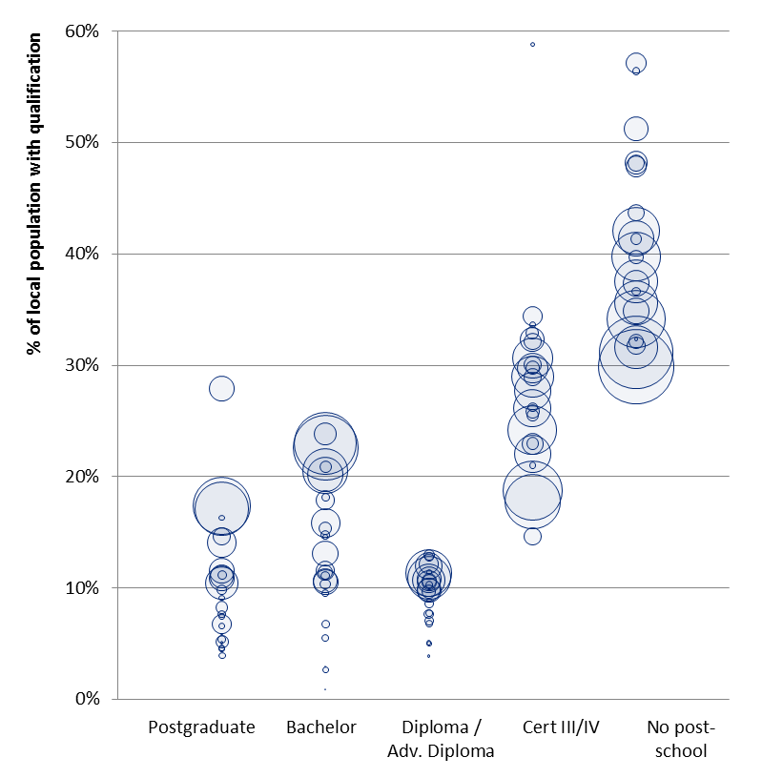
Source: HILDA, Deloitte Access Economics calculations. Note: Size of the bubble represents the number of observations in each region.

Results and discussion
The results demonstrate that there is a positive relationship between wages (for individuals both with and without higher education qualifications) and the proportion of individuals within a labour market region with higher education qualifications (Table 5.2).
            - : Labour market spillover analysis, key regression results
 | Individual with higher education qualification | Proportion of regional labour market with higher education qualification
Labour market overall | N/A | 0.07
Additional effect for those with higher education qual | 0.173*** | 0.02
Source: HILDA, Deloitte Access Economics. Note: *** represents significance at the 1% level; ** at the 5% level; and * at the 10% level.
The results suggest that having more higher education graduates in a labour market is a positive influence on wages, regardless of whether an individual has or does not have a higher education degree. More specifically, it demonstrates that a 1% increase in the percentage of individuals with a higher education qualification in a region is associated with a 0.07% wage premium for all workers in the labour force who either already have higher education training, or have not undergone higher education. It should be noted that this is not statistically significant. Full model results are reported in Appendix B.

Limitations and assumptions
As described in Section Table 4.3, the limitations and assumptions relating to data cleaning, attrition, ability to control for cohort effects and cognitive ability, and the extent to which historical relationships will continue to hold true in the future equally apply here. There are also several other limitations and assumptions that should be made explicit here.
Data cleaning
In addition to the criteria outlined in Table 4.3, observations were only included in this analysis if they reported their State/Territory and ABS Remoteness Area. Remote and Very Remote Australia are aggregated together due to small sample sizes available in HILDA for these categories at a State/Territory level.
Static analysis of labour markets
It should be noted that this is a static analysis of labour markets, in that it assumes that lower skilled individuals do not respond to higher wages elsewhere and migrate to a region if there is a greater proportion of higher skilled workers and lower skilled workers are relatively scarce (assuming that a greater proportion of higher skilled workers results in higher wages for all workers). This dynamic movement is captured through the CGE modelling and analysis (as described in Section 5.2.2).
Interpretation of results
The results presented above may be driven by the combination of there being:
- higher wages in major cities for reasons external to educational attainment; and
- people with higher education degrees being significantly more likely to live in major cities, making holding a higher education degree a good indicator of whether an individual lives in a major city. This means that regions with higher concentrations of higher education degrees (which are more likely to be major cities) earn higher wages, on average.
The analysis presented here attempts to control for this to an extent by including controls for population density within an area – however, as the control is limited by the resolution of area level data for individuals in the HILDA sample (that is, within a Major City of a given state/territory), there may still be significant variation in population density within that region). This approach differs from Moretti (2004) which controls for these factors using a fixed effects model.

Implications
The results of this modelling suggest that there are positive spillovers to others in the labour market from increasing the proportion of higher education graduates. This means that not only do higher education graduates improve their labour force outcomes (as a result of their increased attainment), it also means that a more highly skilled and productive workforce is associated with improved outcomes for all.
For example, the sharing of knowledge and skills through formal and informal interaction generates positive externalities across workers. Alternatively, spillovers from education may arise through search externalities, or endogenous skill-biased technical change – that is, changes in production technology that favours higher skilled workers over lower skilled workers, resulting from relatively increased productivity, and therefore increased relative demand.
The outputs of this analysis are used to inform the parameterisation of labour demand curves in the CGE model – in particular, the calibration of the cross-skill labour demand elasticities. This is discussed further in Section 5.2.2.

Estimating broader market benefits with the CGE model
The Deloitte Access Economics Regional General Equilibrium Model (DAE-RGEM) is a dynamic, multi-region, multi-commodity CGE model of the global economy, including Australia.
An introduction to CGE modelling
A CGE model represents supply and demand in multiple sectors of the economy along with aggregate resource constraints. The key feature of CGE models is that they link the supply and demand in each sector to other sectors in the economy, such that a ‘shock’ to one sector flows through to all other sectors. Further, goods in each sector are produced by factors of production (such as labour and capital). An increase in the quantity of these factors, (or their productivity) increases the productive potential of the economy, with different effects on different sectors depending on their relative reliance on each factor.
All models are run under some key assumptions. For example, it is assumed that competitive product markets fully clear (supply=demand) in each period, with changes in prices facilitating this. Relative price changes are assumed to drive changes in producer and consumer behaviour and it is common to assume simple accumulation rules for factors like capital and labour (that is, that investment in one period becomes capital in the next).
CGE models represent the impact of a policy by looking at the impact when it is introduced, compared with a baseline scenario. In this case the ‘policy’ is a shift in the skills mix in the economy, which the individual level econometric modelling provides an associated wage premium. Households in DAE-RGEM provide labour in return for wages. The actual wage rate they receive reflects the marginal product of labour (that is, the incremental value a unit of labour adds to production).
In the baseline, the productivity of labour is projected to grow over time and, in conjunction with improved productivity in the use of other factors like capital, drive forecast growth in the economy. Against this baseline growth it is possible to simulate the economy-wide impact of additional growth in labour productivity, with this productivity increase parameterised by the econometrically estimated wage premium.

Assumptions of the CGE framework
This section discusses some of the important assumptions of the CGE model as it is applied in this context. There are further, more general assumptions about the CGE modelling framework, which are discussed in Appendix C.

Assumption 1: Wage premiums estimated in the HILDA data set are a reflection of increased productivity
The assumption here is that workers are paid, on average, an amount equal to their productivity. This implies that having observed an increase in a worker’s wage, it can be inferred that their productivity, and therefore output, has increased by a commensurate amount.
The link between productivity and wages is, in practice, more nuanced. It can be a function of the way in which wages are set in the market – for example, through somewhat rigid wage bargaining processes and resulting pay scales – and can be influenced by imperfections in the labour market, such as monopsony power of employers.
Biesebroeck (2015) reviews the literature on this link and finds evidence for a variety of factors that may bias wages in both directions. These biases include factors at the systemic level, as well as heterogeneous factors across workers (such as age, gender and race). Interestingly for this analysis, Biesebroeck finds relatively consistent evidence that young workers tend to be underpaid for their level of productivity relative to older workers. Given time of career is explicitly modelled here, labour productivity may be understated in the earlier years, and overstated in later years. This may slightly underestimate the public benefits, if the setting of the discount rate places greater weight on earlier benefits. Nonetheless, as a whole the evidence from the literature tends to support the notion a one-for-one link between productivity and wages is a good approximation of actual outcomes in the labour market.

Assumption 2: Higher education qualifications are economic endowments
An important part of CGE models is that they assume that households are making the best decisions to maximise their consumption, and firms are making decisions to maximise their profits.
However, there is no internal feedback process in the model between the wages that are paid to different skill types, and the supply of those skills. The skill mix in the labour force is effectively an ‘endowment’. High wages for certain graduates does not lead to additional training and skill building in that field of study. In other words, this endowment of skills is not set by market incentives. The endowment is calibrated to the 2011 Census.
Importantly though, the model does distinguish unemployment levels for different types of labour. For instance, in the 2011 Census, the unemployment rate for high school leavers is 8.1%, whereas the unemployment rate for bachelor of education graduates is 1.8%. There is a non-linear functional relationship between the wage increase and the unemployment in a given sector. As a certain skillset is demanded more, the rate of unemployment falls, and the wage increases required to induce further decreases becomes greater.
Assumption 3: simplified substitutability patterns of labour types
In the CGE model as specified here, industries use different mixes of the various skills types.
These skills are represented by their occupation level, and their industry of employment. For example, if 1,000 Law graduates and 1,000 Arts graduates enter the workforce, they will be sorted differently by different rates of occupational and industrial employment. Once they have entered the workforce in a given occupation/industry combination, the model does not distinguish between the Arts skills versus the Law skills. Further, the skills are assumed to be used in a similar way, in that the marginal substitutability of different skills is the same for all industries. The rate at which a financial services firm will substitute a certain share of its managers for more sales workers, will be the same as a firm in communications sector.

Simulating higher education in the broader economy
To understand the effects of a particular higher education qualification on the broader economy, two simulations are run in the CGE model. The only distinction between the two of these simulations is a small change in the skill endowment in the labour force. One may have slightly more graduates, and slightly fewer high-school finishers, in the labour force.
As a more specific example, one simulation may have 1,000 more Bachelor of Education graduates and 1,000 fewer individuals with no-post school qualification, than the other simulation. At a conceptual level, the magnitude of this number is not important. In the CGE modelling framework, individuals in different skill sets can differ in three important ways:
- they earn different wages, meaning they have different levels of productivity (see Assumption 1 in Section 5.2.1);
- they have different industry of employment patterns; and
- they have different rates of unemployment within their skillset.
Changing the composition of the skills mix in the labour force in turn impacts labour productivity, industry labour supply and unemployment in the economy. The CGE model estimates these impacts on the economy overall, as measured by Gross National Product (GNP).
For the group holding a particular qualification, the observed average wages, and rate of unemployment is the combination of two effects. The first is the human capital associated with that qualification – the ‘qualification effect’; the second is the differences in demographic make-up or average cognitive ability of the group with that qualification – the ‘demographic effect’. Defining the attribution between these two effects is the purpose of the econometric exercise discussed in Section 4.
Figure 5.2 below visualises how the overall value of labour services of a group of individuals is made up of two dimensions:
- a weekly wage component (vertical axis); and
- the share of those individuals who are employed, which is a product of the participation rate and the employment rate.
The figure also shows how the observed differences in labour services value are comprised of the qualification effect, and the demographic effect.
The goal of this study is to understand the public benefits of higher education qualifications, so the simulations run in the CGE model are adjusted to measure the qualification effect only (the blue coloured box in Figure 5.2 below), rather than the combination of the qualification affect and any demographic effects. These adjustments are discussed in further detail in Appendix C.
                - : The differences in the value of labour services for average high school leavers and graduates, attributing between qualification and demographics
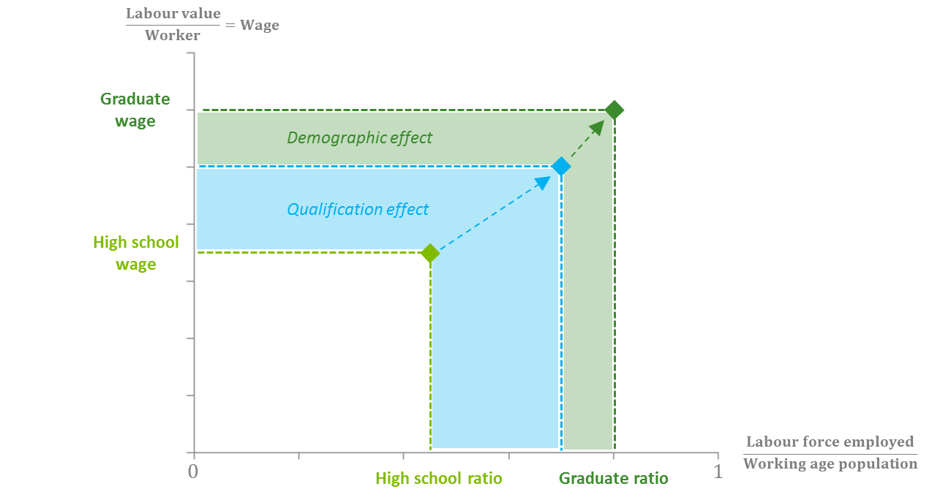
Source: Deloitte Access Economics
The patterns of wages and likely employment status vary over an individual’s working life. Those who undertake higher education generally do so following school, between the ages of 19-25. Logically the flow of benefits from a higher education qualification will commence after the qualification has been completed.
              - : wages, employment and participation by age for bachelor level engineering qualification holders
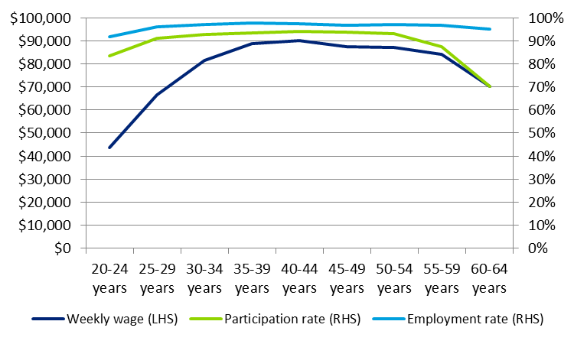
Source: ABS Census of Population and Housing, Deloitte Access Economics

The relevant datasets (ABS Census and HILDA) capture observations of wages and employment from the full range of different career stages. This is reflective of the labour force in any given year. However, the timing of benefits is important because the flow of benefits (both public and private) is delayed relative to the decision to undertake higher education.
Given this sequence of benefit flows, the public and private effects are estimated for each year, over an individual’s typical working life. The wage and participation profiles are generally defined in the ABS Census data in five year brackets, so these are smoothed to single year estimates using a quadratic functional form. Further details on this method are provided in Appendix C.
This stream of annual economy-wide benefits, measured by GNP in each year, is rolled into a single figure using a Net Present Value (NPV) calculation. The typical discount rate used in this calculation is 7%, in line with OBPR benchmarks, but different discount rates are presented as a form of sensitivity analysis.
The private benefit, which is an NPV of post-tax wage gains resulting from an individual’s career, is deducted from the economy-wide benefits, leaving the public benefits estimate. The relative public and private benefits are then expressed as shares of the total economy-wide benefits.
To summarise the overall process, the effects of a particular higher education qualification are estimated by conducting two simulations of the Australian economy in the CGE model.
- the only difference between the two simulations is a small increase in amount of labour services available in the qualification of interest, and a corresponding reduction of labour services available at the high-school level;
- these labour services estimates are adjusted for demographic effects, which influence observed wage premiums and employment probabilities;
- the CGE model reports annual estimates of GNP impact over the 46 years of a typical working lifetime (aged 19-65) - these also account for variation in wages and likelihood of employment over a typical career;
- the stream of annual GNP estimates are expressed as a single figure using a NPV formula, from which the private benefits (an NPV post-tax wage increments) are deducted, to leave public benefits and the private benefits.
The resulting estimates of public benefit by course and qualification level are presented in the following section. Key sensitivities are quantified in Appendix D.

Results and discussion
A summary of the relative private and public returns from higher education by qualification and discipline are summarised in Table 5.2 below.
The results from the empirical analysis align with the conceptual determinants, with the results from the CGE model analysis of relative private and public benefits concluding that for bachelor degree qualifications, 45% of total market benefits are private (measured by post-tax earnings premiums), and 55% are public (measured by deviations in GNP less the private benefits). The GNP measure of economic activity accounts for changes in foreign capital flows, which is likely in the context of increased investment, and so is the most appropriate here.
There is a relatively modest level of variability across disciplines, but those with the greater relative public return are Engineering, Science and Business, while the disciplines with the greater relative private return are Education, Arts, and Health.
- Engineering graduates typically work in manufacturing and mining, which are capital intensive sectors, so an increase in labour productivity will have a proportionally larger investment effect; and
- Education graduates typically sit in lower income tax brackets, the sector is labour intensive, and their employers are more likely to be public sector, meaning company taxes are not applicable.
There is no material difference between the average postgraduate degree and bachelor degree benefit shares, this is due to offsetting effects:
- progressive taxation: observed postgraduate wages are generally higher, meaning they pay a marginally greater share of their income in tax; and
- compositional effect: bachelor degree holders tend to have qualifications in fields with greater public benefits – see Table 5.3.
Since the sub-bachelor econometric analysis did not show a statistically significant earnings premium, the public/private shares estimates are characterised by a greater level of uncertainty than bachelor or postgraduate level qualifications. Given the econometric analysis did not reveal a statistically significant variation in earnings for qualification holders from different provider types, there is no basis to expect significant differences in the split of public and private benefits.
            - : Relative private and public benefits by discipline, bachelor and postgraduate
 | Medicine | Other Health | Educ. | Eng. | Bus. | Arts | Science | IT | Ave.

Bachelor level
Private benefits | 50% | 50% | 51% | 39% | 44% | 48% | 41% | 45% | 45%
Public benefits | 50% | 50% | 49% | 61% | 56% | 52% | 59% | 55% | 55%

Postgraduate level
Private benefits | 49% | 51% | 52% | 42% | 44% | 50% | 48% | 45% | 47%
Public benefits | 51% | 49% | 48% | 58% | 56% | 50% | 52% | 55% | 53%
Source: Deloitte Access Economics RGEM CGE model, HILDA Survey, ABS Census (2011). Shares use NPV calculations at the 7% rate
The average public-private benefits splits across disciplines, shown in the far right column of Table 5.2, are calculated as an average of discipline-specific results, using weightings. These weightings are based on the share of wages for different disciplines within qualification levels, and the highest qualification held (thus while there may be a large quantum of bachelor level graduates in a given discipline, their share of wages earned may be low if there is a high propensity for bachelor level graduates in that discipline to undertake postgraduate study). These shares are given in Table 5.3 below.
            - : Share of wages earned, by discipline, bachelor and postgraduate
 | Medicine | Other Health | Educ. | Eng. | Bus. | Arts | Science | IT | Total
Bachelor level | 4% | 13% | 13% | 14% | 36% | 6% | 8% | 6% | 100%
Postgraduate level | 5% | 9% | 15% | 9% | 42% | 5% | 9% | 6% | 100%
Source: Deloitte Access Economics RGEM CGE model, HILDA Survey, ABS Census (2011).

Time profile of benefits
A key component of the empirical public and private benefits results is the time profile over which they accrue. This helps to understand the economic mechanisms that help to generate the benefits, the nature of the benefits themselves, and the possible variability of benefits under different circumstances.
              - : Public and private benefits profile, Engineering bachelor level
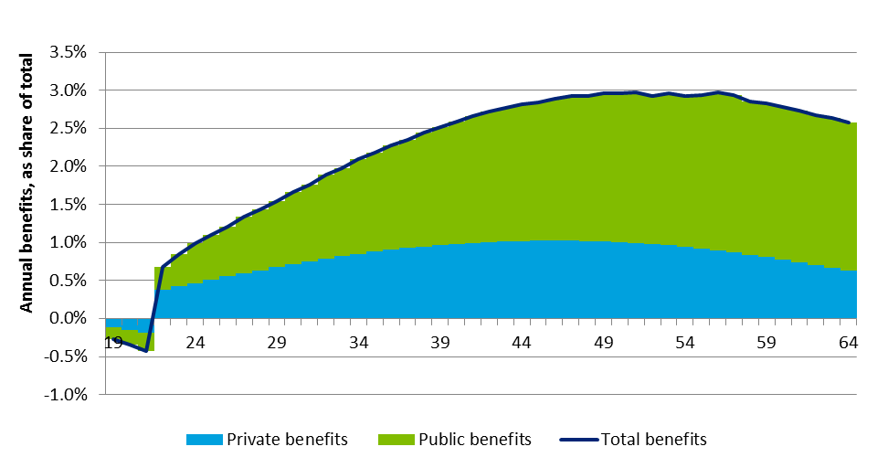 Source: Deloitte Access Economics RGEM CGE model, HILDA Survey, ABS Census (2011). Annual benefits are expressed as shares of undiscounted total benefits over total working lifetime.
              - : Public and private benefits profile, Arts bachelor level
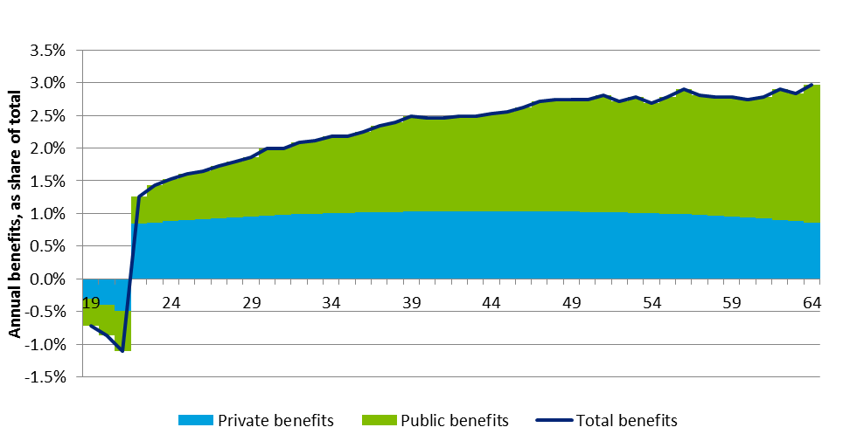
Source: Deloitte Access Economics RGEM CGE model, HILDA Survey, ABS Census (2011). Annual benefits are expressed as shares of undiscounted total benefits over total working lifetime.
Charts 5.3 and 5.4 above illustrate the profile of annual benefits for engineering and arts respectively, as a share of total benefits across an individual’s working life. Besides the magnitude of benefits, these two disciplines differ in when these benefits accrue. The typical earnings differential between workers with an arts qualification and school leavers is quite flat over a career. Conversely, for engineering graduates the earnings premium grows over time until around age 47, after which it slopes back toward the end of a career. Similarly, benefits arising from a capital investment effect are lagged, given productive capital takes time to be accumulated.
As expressed in Charts 5.3 and 5.4, the relative benefits during study are more negative for Arts bachelors than for Engineering. The absolute dollar figures are in fact similar, but given the market benefits for an Arts degree is significantly lower than an Engineering degree, the negative benefits at the time of study are greater as a share of the total.
These different temporal benefit profiles mean that when different discount rates are applied, in net present value calculations, discipline results will shift relative to each other.

Simulated relative wage impacts
As introduced in Section 3, changing the mix of qualification levels in the labour force has a relative scarcity effect, and a productivity uplift effect. The relative scarcity effect suggests that the increase in wages for a group of upskilling individuals is offset by the reduction in wages for others already qualified in the workforce. The productivity uplift effect suggests that as the economy has increased its productive capacity, there will be upward pressure on wages across the economy. The empirical results contained in Section 5.1, along with other relevant literature, suggest that the productivity effect is the stronger of the two, given that those with equivalent skill levels do not see statistically significant falls in their wage as the share of higher education qualified workers increases.
Table 5.5 reports the relevant wage simulation results for comparison with the empirical exercise in Section 5.1. These show the relative dominance of the productivity uplift effect as compared to the relative scarcity effect. A result where only the relative scarcity was present would mean any rise in wages for the group receiving higher education would be completely offset by wage declines for others in the labour force.
Overall, the wage simulations suggest a stronger productivity uplift effect than the relative scarcity effect. This is measured by the share of wage uplift offset by the fall in others' wages. 82% of the partial wage increment is retained as a productivity uplift, while 18% of the partial wage uplift increment is the relative scarcity effect.
As a simplistic example, if there were 1000 additional graduates, and the annual wage differential between school-leavers and higher education qualified individuals is $10,000, then the partial equilibrium increase in wages is $10 million. The results of the CGE modelling indicates that the general equilibrium productivity uplift would be 82% of this, or $8.2 million. The difference of $1.8 million reflects that graduates are now relatively less scarce.
The CGE results are more conservative than the relevant empirical results, in terms of the effect of higher education on others in the labour force. The CGE results indicate that higher education will have a small negative effect on wages for those who already hold equivalent skills. The empirical econometric exercise suggests higher education will have a slight positive effect on those wages. If the CGE simulations more closely reflected the empirical results, the public benefits would be proportionally larger.
However, there is a lack of statistical strength and conclusiveness in the econometric results, and the CGE simulations capture other important discipline-specific factors, such as differing rates of unemployment for different skill types. Given these considerations, no pre or post-model adjustments of the wage differential results have been made to further align the wage simulations and the empirical results.
            - : Productivity vs. relative scarcity - share of wage uplift offset by fall in others' wages
 | Medicine | Other Health | Educ. | Eng. | Bus. | Arts | Science | IT | Ave.

Bachelor level
Productivity uplift | 68% | 70% | 71% | 88% | 88% | 85% | 86% | 88% | 82%
Relative scarcity | 32% | 30% | 29% | 12% | 12% | 15% | 14% | 12% | 18%

Postgraduate level
Productivity uplift | 67% | 67% | 66% | 76% | 76% | 67% | 69% | 74% | 71%
Relative scarcity | 33% | 33% | 34% | 24% | 24% | 33% | 31% | 26% | 29%
Source: Deloitte Access Economics RGEM CGE model, HILDA Survey, ABS Census (2011). Shares use NPV calculations at the 7% rate

Sensitivity analysis
In addition to the main scenarios considered for the combination of postgraduate and bachelor level disciplines, a number of additional sensitivities have been modelled. These demonstrate how uncertainty of existing relationships in the economy, or changes to the fundamental structure of the economy, could affect the public-private split of benefits to higher education.
Three graduate disciplines have been considered – bachelor level education, engineering and business. In particular, the following sensitivities have been examined:
- Increasing the unemployment rate: a share of benefits derived from higher education is attributable to the lower unemployment rates for higher education graduates relative to individuals with no post-school qualification. A stylised example considers the effect of increasing the baseline unemployment rate for bachelor education graduates by 50% during the first five years of their working life.
- Increasing the substitutability between skills and the primary factors of production: these parameters govern the ease with which skills can move between the sectors, and the ease with which industry can alter demand for the factors of production (e.g. change capital for labour). Given uncertainty over the true values of the parameters, upper and lower bounds have been tested.
- Decreasing the significance of the mining sector: as the industrial share of the standard CGE model is largely constant through time, it may not be reflective of the current and future Australian economy. A stylised example considers the effect of halving the mining sector’s significance in the economy – from 10% of output in 2011 to 5% of output by 2030 – on the benefits on engineering (only) undergraduates.
The effect of the sensitivities on the split of private-public benefits are summarised in Chart 5.5. The results are given as percentage point deviations in the private share of benefits, for given a change in the sensitivity parameters. A full description of all sensitivities and results is given in Appendix D.
Given our analysis, the private-benefit split of benefits are likely to lie within a five percentage point band around the central results. The direction and precise magnitude of the effect are ambiguous, depending on the discipline in question.
For instance, a 50% increase in the unemployment rate for education graduates that lasts five-years (representing a 16% average increase in unemployment over their working lives) leads to a one percentage point loss in the private share, which falls from 51% to 50%. In contrast, a similar shock leads to an increase in the private share of benefits for engineering graduates, from 39% to 43%.
Out of the tested parameters, the unemployment rate is the most important factor driving the private-public split results. While increasing the unemployment rate has the effect of decreasing the private benefits received by graduates (as the number of employed persons and the average wage decreases), it has a larger effect on other skill categories. Consistent with the literature, the region-wide higher unemployment rate depresses wages for other skills (Blanchflower and Oswarld, 2005; Carroll, 2011).
In contrast, the key results have muted responses to changes in skills substitution parameters, with the direction of change depending on the disciplines targeted. Indeed, while increasing the substitutability for education graduates by 50% decreases the share of private benefits by 2%, the same change increases the private benefits share by approximately 2% for both engineering and business.
The difference in results is driven by the relative capital intensity of the industries where the skills are likely to move into. By increasing the substitution of skills, education graduates are more likely to be employed. Education students enter into sectors that are more capital intensive, such as business services, compared to government services. Conversely, with an increase in skill substitutability, business and engineering graduates are more likely to be employed in other government services, which is relatively less capital intensive.
The mechanism of factor substitution parameters can be thought of as follows:
- a higher substitution parameter will lead to a higher use of the skilled labour as their supply increases and price falls (compared to the central case);
- this means more of the output increase for the industry can be facilitated by the skilled labour, and there are fewer requirements for resources from elsewhere in the economy;
- consequently, the additional graduates are more concentrated in their typical sector, rather than being distributed across multiple sectors;
- this means the demand uplift for other resources is more muted, with less growth in other factor prices; and
- smaller increases in other factor prices leads to smaller public benefits.
In the extreme case, if the extra economic activity can be produced entirely by additional labour, there are no spillover benefits to other factors of production, meaning no public benefits, beyond increased personal income taxation. This case is simplified also because there would normally be second-round aggregate demand growth due to the increase in productivity, leading to higher factor prices in general.
More broadly, there are fewer allocative efficiencies (and public benefit) to be gained from moving factors, and the gains are internalised by the skilled graduates. The private-public share adjusts to the average levels seen for other disciplines.
The capital intensity also explains the direction of the results, depending on the capital intensity where the skills are likely to be employed, versus the capital intensity where additional resources are likely to be drawn from. When the skill substitutability of education graduates is increased, more graduates will be employed in the government services sector, which can grow without drawing resources from other sectors. Given government services are relatively labour intensive, with a lower value-added to worker ratio, there is likely to be a higher public benefit if resources are not drawn into government services.
              - : Summary of private share percentage point deviations for key sensitivities
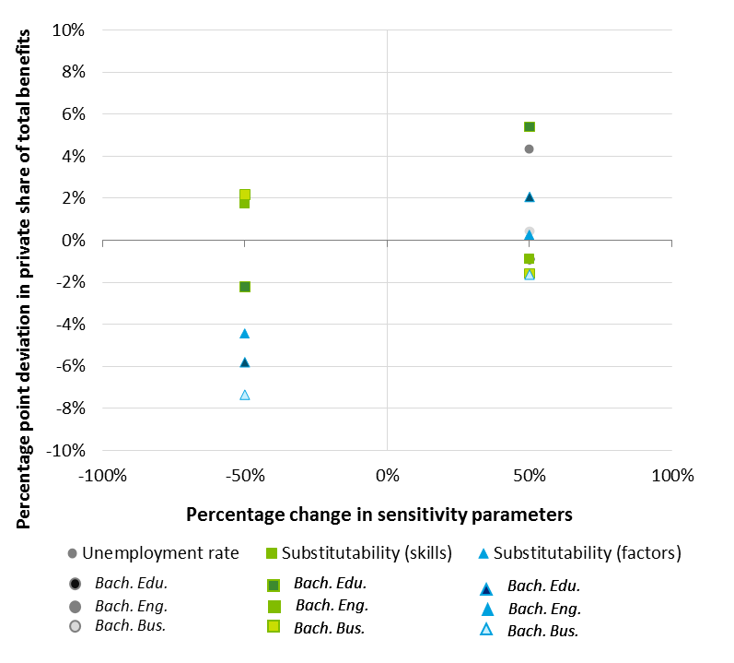
Source: Deloitte Access Economics RGEM CGE model. Shares use NPV calculations at the 7% rate

Extending beyond the core analytical framework of this study
This section outlines the nature by which more complex market and non-market based measures of public benefits from higher education attainment may manifest. This is achieved through a systematic assessment of the nature of benefits captured by the CGE model framework, and the subsequent identification of potential additional benefits when compared to the taxonomy of benefits set out in Section 2. This is the final stage of the methodology discussed in Section 3 (see Figure 5.3).
                - : Illustrative summary of approach

Market benefits from more complex productivity spillovers
The original CGE modelling and analysis developed for this study illustrates the dynamic response of the economy to increased levels of labour productivity resulting from higher education attainment.
The primary mechanism by which flow-on economic activity is stimulated in this framework is the accumulation of physical capital (including from overseas) in response to improved capital productivity, leading to higher rates of employment and total economic income. There are other more complex ways in which market based spillover benefits may eventuate which are not captured in this framework. These are discussed in turn below.
Dynamically linking the higher education system to the labour market
There are limitations of the current model framework in linking the training market to the broader labour market. These relate to Assumption 2 discussed in Section 5.2.1, and can be categorised as follows:
- No endogenous skills supply: the approach in the model treats skill levels as endowments - this excludes the possibility for growth in particular industries to further induce human capital accumulation (further higher education), through increased relative demand for skilled labour in the economy; and
- Industry skills demand is linked to industry output demand: the approach in the model assumes that skills requirements for a given level of industry output respond to relative prices in a highly structured way– the regulatory changes to early childhood workforce requirements is one counterexample to this;
These two limitations may mean estimates of public market benefits for certain disciplines are more conservative or ‘biased’ than others. In particular, the qualifications and disciplines that are most affected by this ‘bias’ in the empirical analysis conducted here are those where the industries which graduates participate in are:
- proportionally more higher education labour-intensive in its production;
- currently, or in the near future, are expected to experience higher education skill shortages; and
- expected to experience secular structural growth and therefore generate increased demand for higher education qualifications.
The analysis provided in Section 6 of this report, in addition to the figures presented above, gives some indication of the qualifications and disciplines that are most affected by these systematic observations regarding the limits of the current CGE model framework.
Broader knowledge-based spillovers and the effect of technology
The CGE model framework utilised in this study captures the technological relationship between different types of labour within industry including the relative substitutability between workers with different levels of qualifications and human capital. This relationship allows for the relative scarcity of different types of labour to be effectively captured in a dynamic economic framework, and total spillover wage effects from changes in the composition of labour skills to be directly estimated (see Section 3.1.3).
Importantly however, increased levels of human capital can cause spillover returns to other workers in the economy through means other than changes to the relative scarcity of different workers and developmental spillovers from the increased accumulation of capital. Higher rates of educational attainment can affect the technology of industry and enhance the productivity of adjacent workers through knowledge spillover effects and improved rates of technological progress (Marginson, 2007). For example, as a person improves their human capital through higher rates of educational attainment, they affect the rates of human capital of the persons they work adjacently too by directly or indirectly sharing their knowledge and expertise (McMahon, 2004; Moretti, 2004).
These ‘osmosis’-like effects of knowledge spillovers are inherently difficult to identify or measure in a detailed and systematic fashion. In general terms, it is likely that higher education qualifications and disciplines that are associated with industries and occupations that are more creative, collaborative and ‘knowledge-based’ will benefit more from these effects.
In more tractable terms, there are a number of other notable phenomena that will affect the level of spillover benefits from higher education which are not effectively captured in the CGE model framework, these are outlined further below.
Computerisation and digital disruption
As digital disruption continues to alter the way people communicate and interact in the workplace, and computerisation continues to alter the skill requirements of workers, the Australian economy will require a workforce which not only has traditional ‘higher skills’, but also a workforce consisting of knowledge-workers that are creative, innovative and highly adaptable to the dynamic, technologically-changing nature of work in the future.
As shown in Chart 5.6 below, based on Frey and Osborne (2013), computerisation is likely to have a dramatic impact on labour demand across a wide range of employment types. According to their estimates, 47% of total US employment is in the high risk category where occupational tasks are susceptible to being substituted with computer capital/technological automation.
              - : Probability of computerisation by occupation type, US labour market
Source: Frey and Osborne (2013)
Commonly cited examples of computerisation are the advent of driverless cars, speech recognition, language translation, pattern recognition and computerised inventory management systems that mean a number of industries, from transportation to sales to office and administrative support, will have lower demand for workers with certain skills (for example, see Brynjolfsson and McAfee, 2011).
The empirical analysis conducted for this study takes a static view of the nature of technology in the Australian economy and therefore does not meaningfully capture the impact of disruptive technological change like that outlined here (beyond that already reflected in the baseline results).
A defining feature of this phenomenon is that—unlike historical effects of technological progress—the effects of computerisation and digital disruption are not limited to workers completing more menial, routine and predominately manual tasks. Computerisation has the potential to significantly displace workers whose vocation includes more complex cognitive tasks, which are can be associated with higher degree qualifications (CEDA, 2014). For example, many service, sales, and administrative support roles are expected to be affected by computerisation and digital disruption, as outlined in Chart 5.6 above.
In general terms, the impact of computerisation and digital disruption implies that the spillover returns from certain higher education qualifications and disciplines will be relatively higher (compared to those estimated in the CGE model framework) for those whose graduates participate in industries that are less affected by this phenomena, as their inherent human capital gained through their qualification attainment will continue to have productive value to industry into the future.
It should be noted though, that higher education can play a significant role in fostering the generation of knowledge-workers that can not only avoid being at risk of computerisation and automation, but through their creativity and innovation, take advantage of emerging technologies to augment their productivity, shedding away low-value, routine tasks and focussing on higher-value activities. Indeed, as identified by Deloitte Access Economics (2014) in their report on Australia’s innovation imperative, a key part of innovation is being able to take advantage of digital infrastructure that facilitate knowledge flows in order to connect ideas, innovate old ideas and create new ideas in order to generate further economic value.
While the CGE model framework takes a static historical-based view of the Australian economy when assessed against this force of disruption, the implicit assumptions regarding the nature and form of higher education qualifications is similarly static and historically-based. Innovations to the content, delivery and form of higher education qualifications in the future may have profound effects on their relative value in terms of additional human capital, thereby affecting both the private and public returns that are generated in the context of a changing economic landscape (Deloitte Access Economics, 2015). The longer- term nature of this means it is more of a foresighting or scenario analysis task than a forecasting exercise.
Entrepreneurship and business ownership
As outlined above, the current CGE model framework takes industry technologies as given—that is, there is no inherent mechanism in the framework to explain how total factor productivity growth occurs endogenously over time.
Technological progress is known to be determined by a range of factors, including rates of educational attainment and investments in research and development by firms and the government (Elnrasi and Fox, 2014). Technological advancement is also affected by the presence of entrepreneurs and innovators, who play a critical role in developing new technologies, products and businesses which ultimately drive long-term economic growth (Deloitte Access Economics, 2015).
There is evidence to suggest that some higher education qualifications and disciplines are more likely to produce entrepreneurs and business owners. Indeed, certain higher education fields are able to encourage the development of skills and cognitive thinking required for business leadership or innovative commercial activities for students that graduate in these fields (often by design).
As shown below in Chart 5.7, the manager occupation makes up the highest proportion of employed persons aged 15-64 in the non-school qualifications of agriculture and environment studies (25%) and in terms of management and commerce (22%). Other non-school qualification fields with noticeable proportions include information and communications technology (18%) and physical and natural sciences (16%).
These indicators provide some evidence to suggest that certain higher education disciplines have a greater propensity to produce graduates who are entrepreneurs or business owners. However, it should be noted that the manager occupation has only a very approximate equivalence to entrepreneurs or business owners. Further empirical research to expand on this evidence base for entrepreneurs or business owners specifically would allow for more tractable conclusions to be made here.
              - : Proportion of employed persons aged 15-64 years in manager occupation, by main non-school qualification field
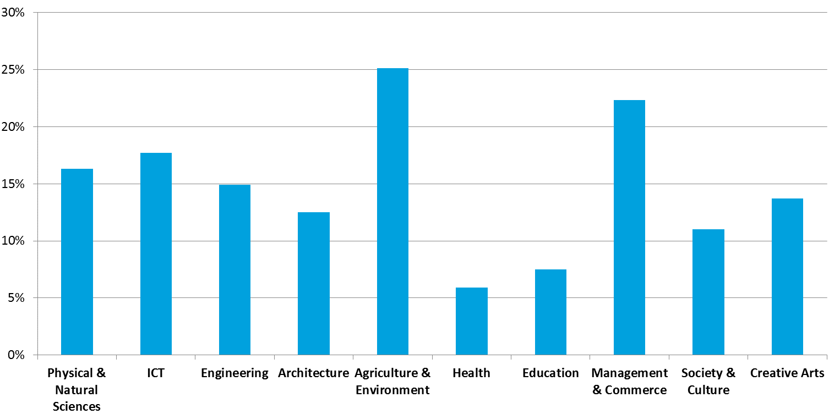
Source: ABS Cat. 4235.0 – Qualifications and Work, Australia, 2015. Note: Non-school qualifications here refers to all non-school qualifications, including postgraduate degrees, master degrees, graduate diplomas, graduate certificates, bachelor degrees, Advanced Diplomas, Diplomas, and Certification I, II, III and IV.
In summary, the analysis of broader knowledge-based spillovers provided here indicates several conditions under which public benefits from attainment of specific higher education qualifications and disciplines may not be fully captured in the current CGE based empirical analysis.
In particular, the qualifications and disciplines that are most affected by this ‘bias’ in the empirical analysis conducted here are those where the industries which graduates participate in are:
- least likely to be replaced by computerisation and digital disruption into the future; and
- most likely to produce entrepreneurs/business owners who more effectively harness and realise the economic benefits of technological progress.

Non-market benefits from higher education
As outlined in Section 2 of this report, non-market private and public benefits are also generated through higher education attainment. These benefits are defined as improvements to welfare that occur indirectly to the market mechanisms of the labour supply and demand, which characterise private and public market benefits. These benefits can be measured in pecuniary terms—in terms of the willingness to pay or the value of avoided costs (e.g. through measures like the value of a statistical life)—or in non-pecuniary terms, such as increased levels of happiness and civic engagement.
A comprehensive review of the literature on the private and public benefits from higher education attainment has been undertaken as part of this study. A summary of the key findings from this review is provided below.
Findings from previous studies
Personal health
- An OECD (2014) report finds that 90% of Australian adults with tertiary education reported they were in good health, compared to 84% of those with upper- or post-secondary non-tertiary education, and 76% of those without upper secondary education (OECD, 2014).
- While this correlation does not control for income effects and raises questions of causality (e.g. more economically well-off, healthier individuals receive higher levels of education), analysis conducted in other countries suggests that improvements in health follow education and that this holds true even when effects, such as income or parents’ education, are controlled for (McMahon, 2009).
- Fletcher and Frisvold (2009) found that attending college is associated with an increase in the likelihood of accessing preventive care.
- An analysis of Australian data has found that university graduates have an average Body Mass Index (BMI) 0.5 points lower than non-graduates (Savage and Norton, 2012).
- Grossman (2009) concluded that the value of education to own health is approximately 40% of value of the market benefits of education that graduates receive, while McMahon estimated the value of health benefits to represent 54% of the private market benefits of a university education (McMahon, 2009).
- It is also estimated that those with university education live five to seven years longer in Western economies (Grossman, 2006). In value terms, McMahon (2009) estimates the additional longevity arising from a university education to be USD $484 per year of higher education in 2007.
Personal wellbeing
- Even when controlling for secondary effects such as health and income, education itself has been found to have a positive effect on happiness - a study conducted by Di Tella et al. (2003) found that a university education contributes directly to happiness.
- An analysis of Australian data also found greater life satisfaction in university graduates (Savage and Norton, 2012). University graduates were found to have better workplace relationships, feel connected to their local community, and have higher acceptance of other religions and races than non-graduates. These relationships can have a positive effect on overall happiness, as well as benefit society via increased social cohesion and connectivity (Savage and Norton, 2012).
- However, given the intricate links between the factors that influence happiness, some studies have found there to be no direct contribution aside from the secondary effects (Helliwell, 2003).
Personal finance
- Studies have also found that university graduates are able to more efficiently manage financial assets compared with those who did not complete higher education, even after controlling for income levels. McMahon estimates the total savings arising from the efficient choices made by university graduates to be equivalent to $856 in 2007 USD per year of college (McMahon, 2009).
Civic participation
- Research in the US indicates that educational attainment has large and statistically significant effects on subsequent voter participation and support for free speech and that additional schooling appears to increase the quality of civic knowledge as measured by the frequency of newspaper readership (Dee, 2004).
Overall, it is clear from this review that there is very limited research which considers how private or public non-market benefits may be expected to vary on the basis of qualification and discipline. Studies that find that higher education attainment generated non-market benefits (even after controlling for income benefits) do not consider how these returns might be affected by discipline of study or qualification level.
At a conceptual level there is limited scope for a tractable exposition of the way in which private and public benefits might be expected to vary on the basis of higher education qualification or discipline. Non-market benefits are generally defined in very broad terms and relate to the concept of education and human capital only at an aggregate level (McMahon, 2004; Chapman and Lounkaew, 2011; Lomax-Smith, 2011).
This study has identified one notable way in which non-market benefits may be expected to vary on the basis of qualification, which relates to industry specific flow-on non-market benefits that are not meaningfully captured in the CGE model framework. A systematic discussion of these effects is provided below, with possible implications for the findings provided here discussed in detail.
Possible flow-on non-market benefits
The CGE model framework developed as part of this study captures private and public market benefits from higher education attainment. These benefits are measured in terms of the incomes paid to the factors of production which are used to produce total economic output.
In the context of the CGE model, it is also possible to consider how flow-on impacts from productivity benefits relate to overall welfare in the society. When the output of an industry increases due to higher levels of labour productivity the value of this additional industry specific output is equal to its hedonic value to society, as determined by the relative prices paid to factor incomes in the general equilibrium framework. That is, an increase in output in a particular industry is measured in terms of its value relative to other forms of output in the economy, in a context where all resources are utilised to maximise total welfare (given certain constraints).
A key assumption in this CGE framework is the existence of idealised or frictionless markets and prices, where incomes paid to factors of production are equal to their marginal value towards producing total economic output and overall welfare. This assumption implies that any flow-on pecuniary benefits (which are valued by society) are ‘priced in’ to the value of goods and services produced in the economy, and ultimately to the incomes paid to factors of production, including wages paid to labour and the value of human capital generated through higher education attainment.
In reality, the extent to which industries and sectors in the Australian economy can be considered to represent perfectly functioning markets is varied. The divergence of industries from this assumption may imply that there are particular non-market benefits that spillover from enhanced levels of human capital and productivity which are not captured in the value of additional economic output and incomes, as measured in the CGE model framework.
The primary industries or sectors in the economy which are most divergent from this assumption are in the public or government sector. The existence of more rigid wage structures tied to public policy objectives implicit in the public sector limit the extent to which flow-on benefits to society (from improved government services, such as education or healthcare) can be dynamically captured in the CGE model framework’s characterisation of the sector.
Take, as an example, the education sector. An increase in the proportion of workers in this industry with a higher education qualification may mean proportionally more higher education qualified staff working in schools. To the extent that higher education qualifications are associated with improved quality of the schooling system, the impact of this increase in human capital would be an improvement in the outcomes of the schooling system, which may be measured in terms of results on standardised tests, like the OECD Programme for International Student Assessment (PISA).
It has been established that improved student outcomes for Australian students can have significant long-term impacts on economic growth and national income. For example, using a similar approach that developed for this study, Deloitte Access Economics have estimated that a 5% increase in average student PISA scores would result in a $12 billion increase in Australia’s GDP in the year 2066 (Deloitte Access Economics, forthcoming).
To some extent, the flow-on benefits that result from increased higher education attainment in the schooling system are captured in the market economy. Higher educated professionals in the schooling system receive higher levels of remuneration in recognition of their increased work value—including the value of their human capital towards generating learning outcomes for students. To the extent that the government allocates public funding towards uses of resources in the economy that generate public benefit, this flow-on benefit is ‘internalised’ in the market economy. Indeed, as the productivity or quality of the sector improves, governments may optimally invest further in the schooling system to realise greater social benefit, which is also captured in the flow-on economic benefits measured through the CGE model framework (in an fashion that is analogous to private industry investing in more in businesses due to increased labour productivity).
Recognising the above observation, it is possible that significant quanta of flow-on benefits from higher education attainment in the education sector (or other public sectors of the economy) are not effectively captured in the market economy, and therefore in the CGE model framework. This is due to the inherent definition of public goods (that is, goods which are not optimally produced by the private market), as well as the fact that it is difficult to effectively measure the ‘quality’ of public sector industries in relation to the social outcomes that they generate. Further the effective prioritisation of public resources towards these factors is restricted by the limitations of government in raising revenue through taxation, and political considerations, among other factors.
The observation that these non-market benefits are most prevalent in the public sector implies that the total public benefits for higher education qualifications and disciplines that are most intensively utilised by the public sector may be underestimated in the CGE model framework. However, it should be noted that the presence of flow-on non-market benefits is not necessarily restricted to the public sector. In more general terms, the existence of significant non-market spillover benefits is related to industry specific ‘market failure’ and ‘government failure’ (i.e. a market failure not fully addressed by government) that is not captured in the CGE model framework.
To illustrate this point, Chart 5.8 and Chart 5.9 below show the variance in wage setting arrangements between sectors and industries in the Australian economy. In general terms, sectors and industries with a greater prevalence of individual wage setting agreements can be considered to more closely align with the implicit assumptions of the CGE model framework, with respect to the perfect pricing mechanisms in the economy.
              - : Wage setting by sector
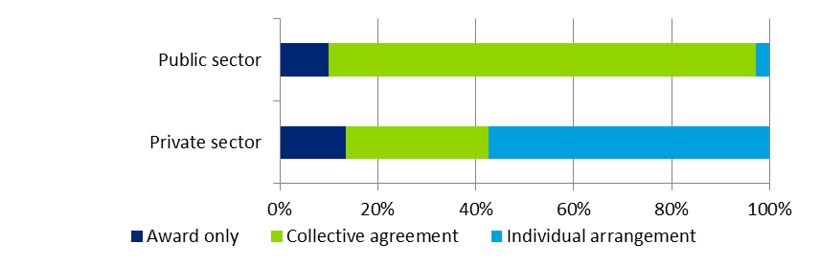
Source: ABS Cat No. 6306, May 2014
              - : Wage setting by ANZSIC-1 Industry
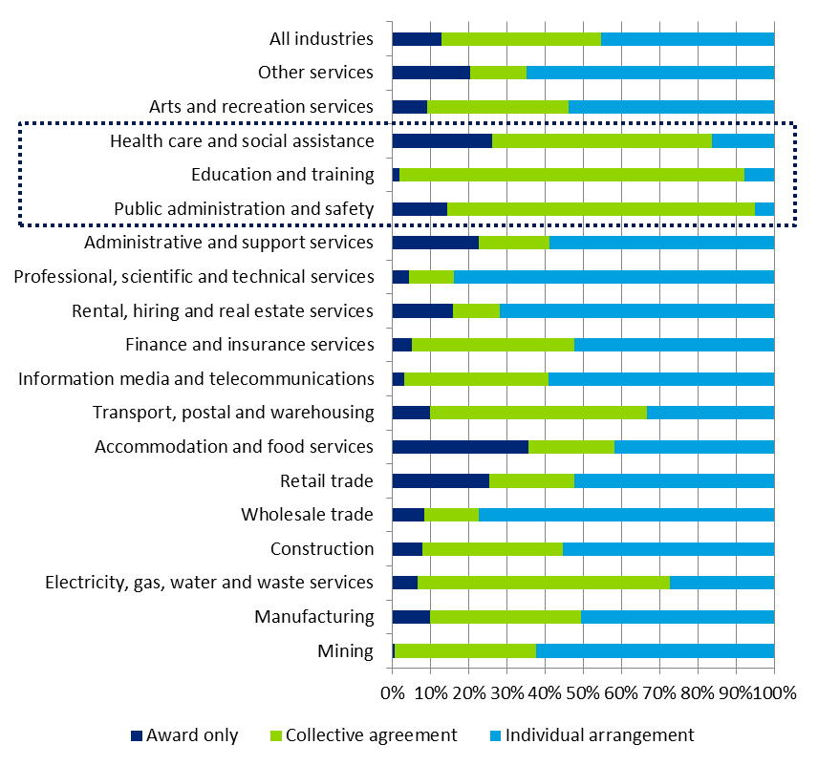
Source: ABS Cat No. 6306, May 2014
The above exposition of how non-market public benefits may vary on the basis of industry sector gives some indication of the how these benefits may vary on the basis of discipline. In particular, the relative public benefits in disciplines such as education, health and arts—where graduates are more likely to be employed in the public sector—may be underestimated in the central empirical analysis developed here through the use of the CGE model framework.
In practice, an analysis that would seek to comprehensively capture all possible non-market flow-on benefits for all disciplines and qualifications as outlined here would be highly complex. The tractability of such an exercise is limited by a dearth of consistent measures that relate ‘quality’ in these sectors of the economy and the value of the outcomes that they produce for society. As such, a qualitative assessment to inform and complement any policy implications that follow from the findings of this study is considered appropriate.

A dynamic view of the benefits to higher education
The key empirical results presented in Sections 4 and 5 are based on observed, historical relationships between the tertiary education system and the labour force, and the labour force relative to the economy overall. This section explores how some of the key features of these relationships may change in the future, and the implications of these for the estimates of private and public benefits of higher education.

Structural reform in the tertiary education sector
The demand-driven system reforms introduced over 2010 to 2012 may have had an impact on the relative public and private benefits of higher education by influencing:
- the relative scarcity of university graduates;
- the skill mix within the economy;
- the take-up of alternative pathways; and/or
- the market shares of provider types.
Each of these hypotheses are explored in this section, supported by data on the scale and degree of changes in commencements in higher education since 2012.
Relative scarcity of university graduates
The number of undergraduate and postgraduate commencements has increased since the introduction of the demand-driven system (4.8% and 5.3% average annual growth, respectively between 2012 and 2014), although it was generally trending upwards before 2012 (Chart 6.1).
              - : Undergraduate and postgraduate commencements
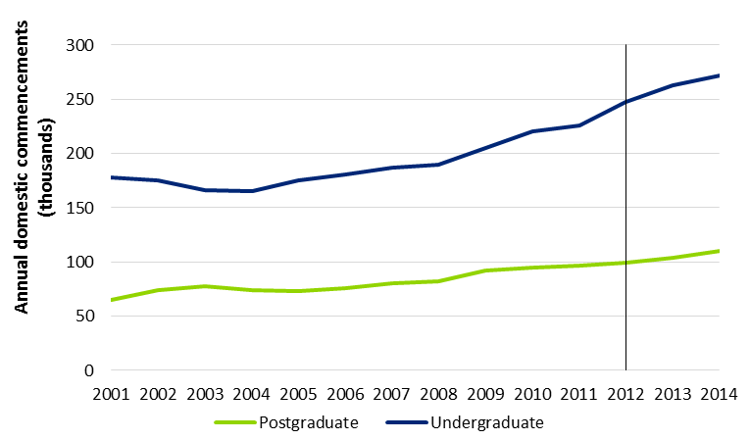
Source: Higher Education UCube. Note: Only includes domestic students.
However, whether this increase in commencements has translated into a decrease in the relative scarcity of university graduates in the labour market (and population more generally) is dependent on whether higher education completion rates have changed over this period. Unfortunately, this cannot be presently observed, as data for 2015 and 2016 (when those who commenced in 2012 would be likely completing their studies) is not yet available.
Skill mix within the economy
Examining higher education commencements since 2001, the relative shares of each field of education has not changed dramatically (Chart 6.2). While there have been increases in the share of total enrolments in Health (from 11% in 2001 to 18% in 2014) and declines in Management and Commerce (from 19% in 2001 to 16% in 2013, rebounding to 17% in 2014), these shifts and trends were already occurring before the introduction of the demand driven system in 2012.
              - : Field of education shares of bachelor commencements
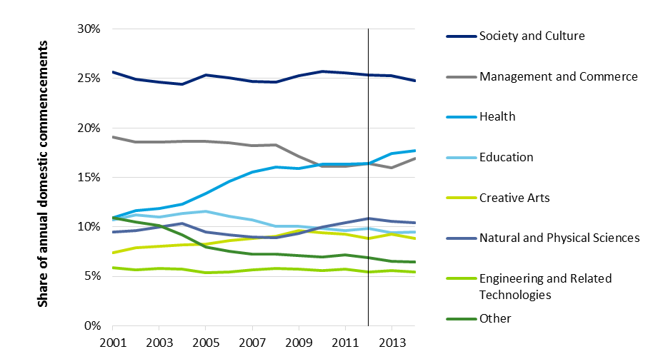
Source: Higher Education UCube. Note: Only includes domestic students.
Broadly, this suggests that the introduction of the demand driven system has not changed the fields students are choosing to enrol in (and suggests if these patterns of enrolment continue to hold, that the current skills mix in the economy will not change over time as a result of the introduction of the demand-driven system).
Take-up of alternative pathways
The introduction of the demand driven system is thought to have driven some learners into enrolling into higher education qualifications rather than VET qualifications. Chart 6.3 shows the number of commencements in sub-bachelor degrees (defined as undergraduate other degrees), bachelor degrees and VET Diploma or higher qualifications between 2003 and 2014.
The quantum of VET Diploma or higher commencements is far greater than sub-bachelor degrees, both before and after the introduction of the demand-driven system. The number of sub-bachelor degree commencements has remained steady over the period, and the growth in bachelor degrees has continued at broadly the same pace set from 2008. VET Diploma or higher commencements have fluctuated over the period, and decreased since 2012.
              - : Comparison of bachelor, sub-bachelor and VET Diploma or higher commencements
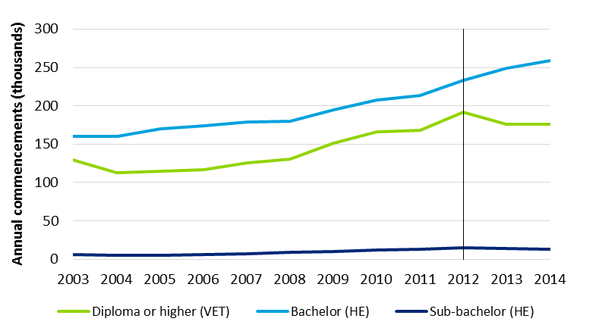
Source: Higher Education UCube, NCVER VOCSTATS. Note: Sub-bachelor is the ‘Undergraduate Other’ category; only includes domestic higher education students, and government-funded VET.
However, it should be noted that there are a number of other factors that may have driven changes in VET commencements, and may limit the extent to which these changes can be attributed to the demand-driven system. These factors include:
- the impacts of deregulation of the VET system in some jurisdictions;
- stagnation in levels of government-subsidies; and
- the introduction of VET FEE-HELP for Diploma and above level and some Certificate IV level qualifications.
Changing provider mix
Chart 6.4 illustrates the mix of commencements by provider groupings. Since 2012, the Group of 8 (Go8) share of commencements has fallen from 24% to 22%, whilst Australian Technology Network (ATN), Innovative Research Universities (IRU), Other and NUHEPs have each increased their shares by approximately one percentage point.
              - : Comparison of provider mix, by commencements
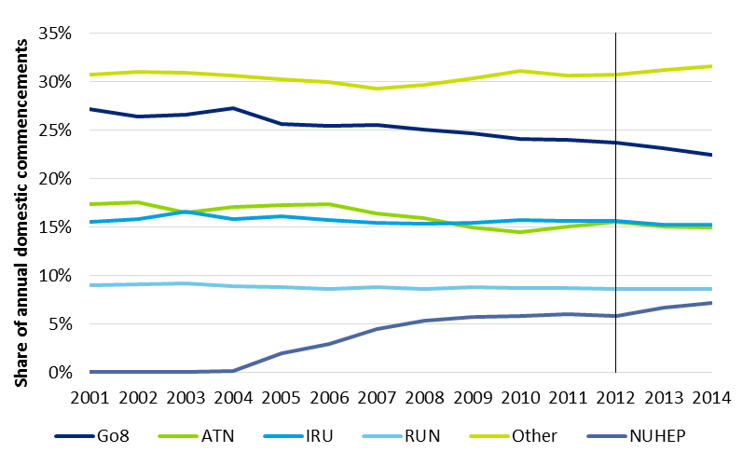
Source: Higher Education UCube. Note: Only includes domestic students, all education levels.
The decreasing share of commencements at Go8 universities continues the trend pre-2012, as NUHEPs has grown from 2004 to 7% of all commencements in 2014. Whilst the shares of commencements for some provider groups are decreasing, this does not necessarily imply that the quantum of commencements at each provider group is decreasing.
The demand-driven system has stimulated growth in certain segments of the higher education system. However, the system-wide perspectives presented here suggest that in recent years the structural make-up of the tertiary education sector has not changed to the extent that average public and private benefits of higher education would have materially changed due to these reforms.

Evolving linkages between education and the workforce
Another dynamic component of the public benefits framework is the sectors in which different graduates work. It is often a secondary consideration that graduates from particular discipline do not enter a unique industry corresponding to that field of education. In fact, there is a complex mapping between education fields and industries, as shown in Figure 6.1 below. This mapping is fully characterised in the CGE model, but this is assumed to be static over time.
                - : Mapping of higher education disciplines to industry, 2011
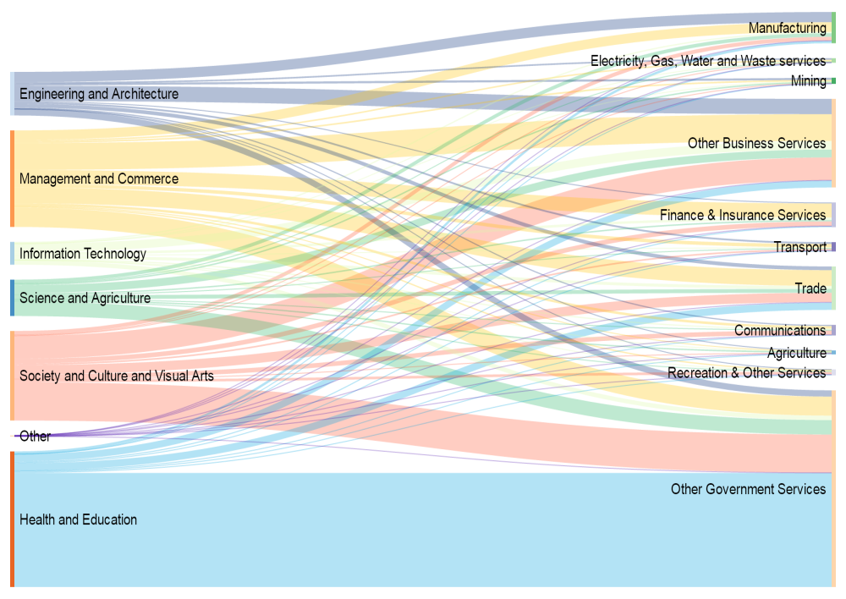
Source: ABS Census of Population and Housing, 2011. The width of the bar represents the share of the Australian labour force
There is a relative lack of data on the dynamics of the mapping between education and industry of work. The most reliable data source for this kind of information is the ABS Census. This measures the stock of the labour force, rather than the flows into different parts. Given a typical career is over 40 years, measuring incremental changes in stocks between five-year census’ will not reveal large movements in labour force composition.
              - : Shifts in discipline to industry mapping – Bus/Law, Engineering, IT, Science
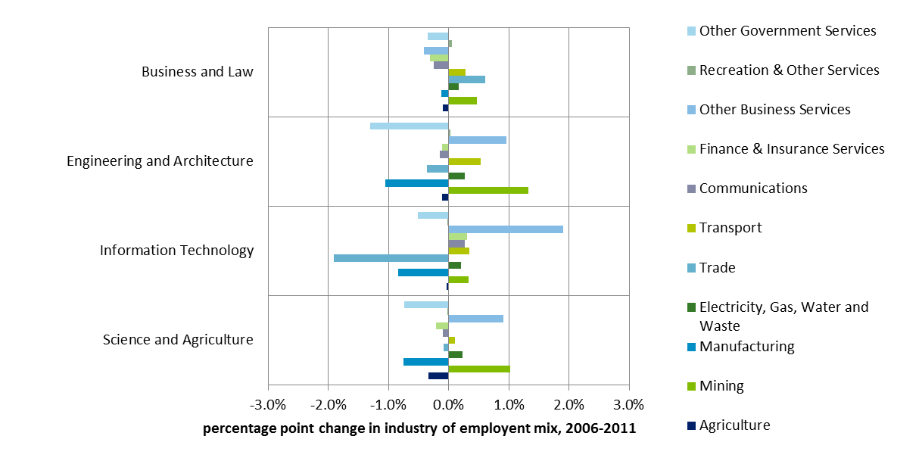
Source: ABS Census of Population and Housing, 2006 & 2011
That noted, Charts 6.5 and 6.6 show how industry of employment has changed for the major education disciplines. Engineering, IT, and Science have all shifted away from manufacturing, in line with the decline of this sector overall (see Section 6.4). For Engineering and Science graduates, manufacturing employment has been displaced by employment in the mining sector. To a lesser extent, there has been a shift away from government services, toward business services within those disciplines. The sectoral shifts by health and education graduates have been relatively minor, but Society, culture and visual arts graduates have shifted away from government services to recreational and business services.
Over longer time scales, say 20 to 30 years, these mapping shifts can become more pronounced, and this may alter the relative public and private benefits. For example, if engineering students are increasingly employed in the financial services sector for their generic analytical ability, rather than being employed in the manufacturing sector, this will affect the typical capital intensity associated with engineering graduates, which may then affect the magnitude of public benefits to some degree. This may be offset by the higher wages (assumedly, if workers are drawn to his sector) in the financial services sector resulting in greater income tax receipts.
Overall, the observed pace of these changes in recent years has been sufficiently slow, and certain effects likely to be sufficiently offsetting, that the effect of education-labour market dynamics is not likely to materially affect the validity of the estimates presented in Section 4.
              - : Shifts in discipline to industry mapping - Education, Art, Health
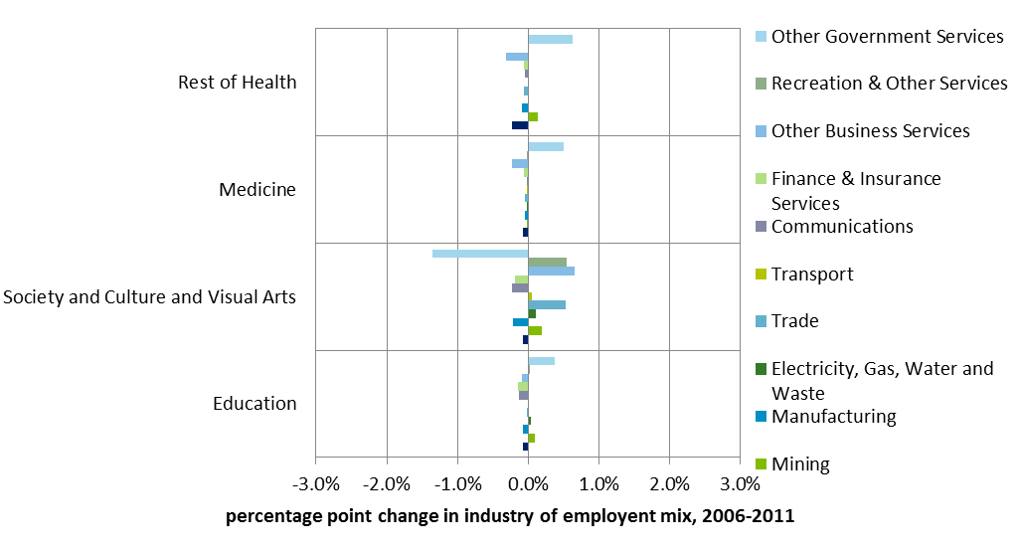
Source: ABS Census of Population and Housing, 2006 & 2011

Short-term skills mismatch and industry cycles
Short-term skills mismatches and volatility in employment at a sector specific-level may mean individuals are drawn into sectors that may use more of their generic cognitive ability and demographic advantages, rather than their qualification. This can be thought of as a form of ‘qualification underutilisation’, and could lower both the private and public returns to education.
Cyclical skills mismatches can be measured by large changes in the unemployment rate for those with a particular qualification. Charts 6.7 and 6.8 show the largest movements in qualification unemployment levels at the four-digit ASCED qualification level, which contains 83 categories. This shows major upticks in Architecture unemployment (albeit from a low base), while unemployment levels in curriculum and education studies have fallen significantly.
              - : 2006-2011 Greatest increase in unemployment, by detailed field of study
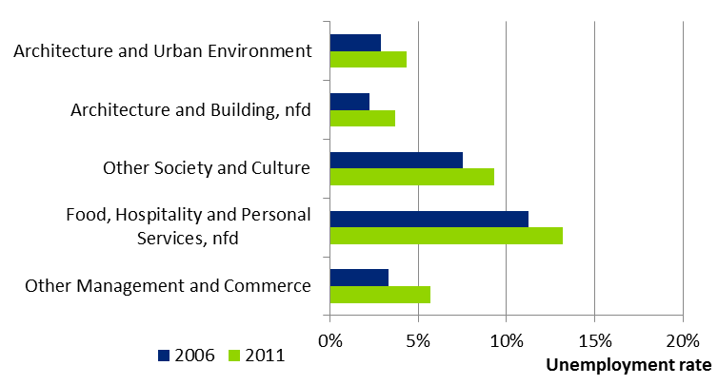
Source: ABS Census of Population and Housing, 2011 and 2006
              - : 2006-2011 Greatest reduction in unemployment, by detailed field of study
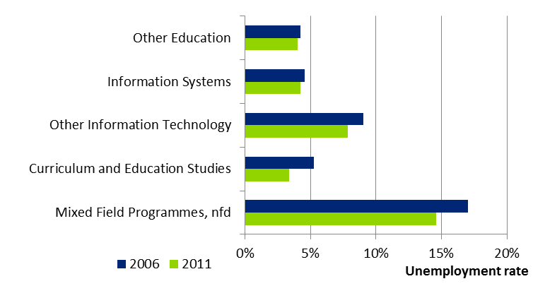
Source: ABS Census of Population and Housing, 2011 and 2006
Chart 6.9 shows the unemployment rate recorded for individuals who have finished their studies within the previous 12 months. This is a good measure of the overall skills take-up for certain disciplines, in terms of the flow of training by discipline, rather than the stock. This shows graduates from the education and health disciplines are relatively quickly adopted into the workforce, compared to the IT and Food & Hospitality sectors. It is important to note that this measure is from the ABS Survey of Education and Work, and does not distinguish between higher education and VET level qualifications.
              - : unemployment rate within 12 months of completing qualification
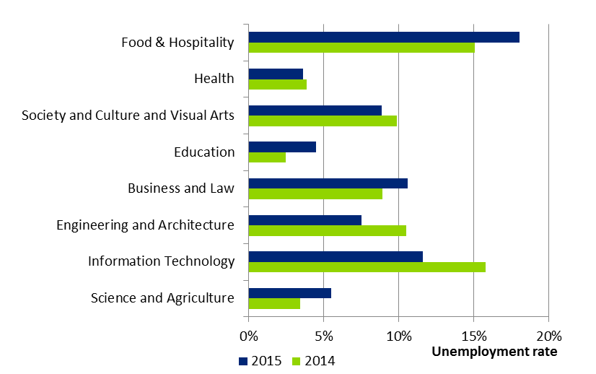
Source: ABS survey of Education and Work, 2015
Chart 6.9 shows the unemployment rate recorded for individuals who have finished their studies within the previous 12 months. This is a good measure of the overall skills take-up for certain disciplines, in terms of the flow of training by discipline, rather than the stock.

Projected structural change in the economy
Another dynamic factor that will be consequential for relative public and private benefits is longer-term structural change in the economy. It has been well established that the underlying structural growth in the Australian economy will see an increase in demand for workers with higher education qualifications.
Deloitte Access Economics has estimated that around 3.8 million new university qualifications (2.5 million new undergraduate qualifications and 1.3 million new postgraduate qualifications) will need to enter Australia’s knowledge economy over the period 2015–2025 to meet this demand. This means that on average, Australia will need approximately 227,000 new undergraduate qualifications and 115,000 new postgraduate qualifications each year over this period (Deloitte Access Economics, 2015).
The top five industries projected to need the largest increases in skilled graduates over the next 10 years are outlined in Chart 6.10 below. The growing demand in qualifications from these industries largely aligns with the underlying structural growth in the Australian economy, with a shift in the economy towards these industries in place of mining and manufacturing (among other sectors).
              - : Five industries with the largest demand for new university qualifications
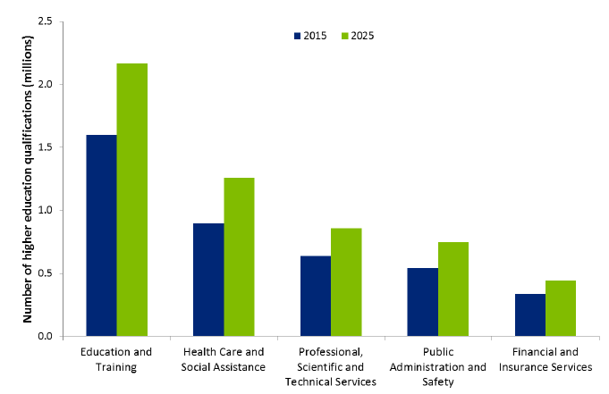
Source: Deloitte Access Economics, 2015
The CGE model used to understand the public and private benefits has some forward-looking components, but does not incorporate the full range of observable longer term trends, such as population aging, and other longer-term ‘megatrends’. Chart 6.11 below shows the industry mix of employment over the past 30 years, and for the next 10 years:
- the manufacturing sector in 1986 employed 1.1 million people, or 16% of those employed in Australia. By 2026 this is expected to be 730,000, or 5% of those employed;
- the health sector in 1986 employed 570,000 people, or 8% of those employed in Australia. By 2026 this is expected to be 2.1 million, or 15% of employment – this will be the largest sector of the economy by employment;
- the mining sector workforce has grown from 110,000 in 1986 to 230,000 in 2016, yet remains less than 2% of overall employment – this is expected to plateau over the next 10 years; and
- the business services sector has added a million employees over the past 30 years, and is projected to add another 400,000 in the next 10 – by that stage it will represent 13% of the total employment in Australia.
This longer-term variation in the sectoral mix of the economy will alter the key economic relationships that drive public and private market benefits.
              - : Industry mix of employment, 1985-86 to 2025-26
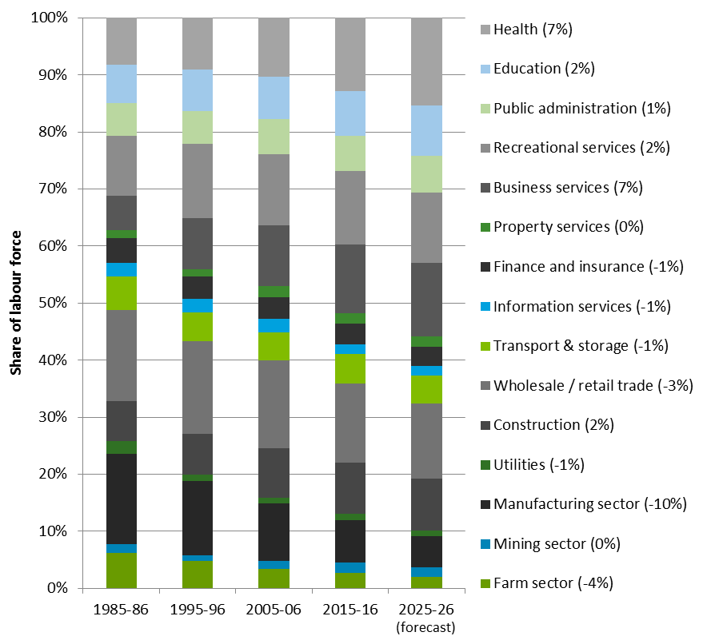
Source: Deloitte Access Economics. Percentage point change of labour share from 1986 to 2026 in parentheses.

Implications
The primary estimates in this analysis are from HILDA, which were observed in a pre-DDS policy environment. Furthermore:
- short term fluctuations in demand and industry cycles will cause differentials in employment and wage outcomes;
- longer term sectoral change in the economy will shift industry demand at a longer timescale still; and
- how graduates sort into industries in the economy may change over time, albeit over the longer term.
These dynamic effects could foreseeably impact the public and private relativities of market benefits to higher education for certain disciplines. Any policy design using this evidence base will therefore need to consider these dynamic factors. However, based on the analysis presented in this section, it seems unlikely that public and private benefit splits overall could shift significantly from current estimates in the next five years. Longer-term, employment growth forecasts over the next 10 years suggest that certain disciplines, particularly the health sector, will be characterised by greater public benefits from higher education. This will have the effect of moving estimated public/private benefits splits for these disciplines closer to the current average.
The uncertainty associated with these dynamics is explored through the sensitivity testing of key parameters, discussed in Section 5.3.1, and Appendix D. While the public and private shares of market benefits to higher education will be affected by changes in the relationships within the labour market, the broad relativities are expected to persist within a five percentage point band over the medium term.

Implications of this research
The analysis and findings presented in this study represent a significant extension on the existing empirical research base regarding the private and public benefits from higher education. In particular, previous studies have not systematically considered the attributable private and public returns to higher education at a qualification and discipline level, including flow-on productivity benefits to the broader economy.
While the empirical method employed here is more comprehensive and detailed in its scope than previous studies, it is not completely exhaustive in its measurement of all the possible private and public benefits from higher education that have been identified conceptually. The nature and quanta of these additional benefits may have implications on the empirical findings developed here. These implications are discussed in the following section through a structured analysis of the complex market and non-market mechanisms that fall outside of the CGE model framework.

Implications of the key findings
The findings from this analysis present a number of implications for higher education research and policy in Australia.
Private benefits
The evidence presented here suggests that private returns to higher education vary on the basis of qualification and discipline. However—in contrast to recent studies by Norton (2012) and Daly et al., (2015)—there is also evidence of variation in the returns to higher education that can be explained by qualification specific effects, relative to variations in the demographic and ability characteristics.
This implies that simple comparisons of average earnings for higher education degree holders compared to those without any post-school education overstate the actual private benefits from these qualifications in absolute and relative terms (i.e. between qualification levels and disciplines). Overall, the findings from this study represent more robust attributable estimates of the return to higher education, providing a more appropriate basis upon which to determine the rates of contribution that students should make towards their education (as they account for the benefits associated with the qualification itself, removing the effects of other confounding factors).
Public benefits and their ratio to private benefits
This study also finds variation in the ratio between private and public benefits from higher education on the basis of qualification and discipline. This is in contrast to the conclusion made by Lomax-Smith (2011), following the research findings of Chapman and Lounkaew (2011; and 2015). This variation in relative private and public benefits follows from the manner in which public benefits are estimated—through (1) net receipts to government (e.g. through taxation revenue); and (2) flow on productivity effects to industry output from enhanced labour productivity.
As outlined in Section 1 of this report, existing funding policy intends to apportion the contribution between private and public sources of funding (i.e. between students and the government) towards the average cost of a higher education program in direct proportion to the benefits that result from higher education attainment—at a discipline level for bachelor degree programs.
Currently, the relative quanta of these private and public contributions varies on a discipline basis with an overall average split of private to public contributions of approximately 42% private to 58% public, with this subject to changes in overall composition.
Further, on a discipline basis, the evidence developed through this study indicates that the relative private and public benefits do not vary greatly on the basis of discipline, and do not vary to the same extent as current contribution rates. For example, the current contribution proportions for the funding cluster of:
- law, accounting, administration, economics, and commerce is 84% private and 16% public; and
- dentistry, medicine or veterinary science is 32% private and 68% public.
In comparison, the results of this study suggest that for the:
- business field of education, 44% of benefits are private and 56% are public; and
- medicine field of education, 50% of the benefits are private and 50% are public.
Overall, the ratio of private to public benefits for bachelor level ranges from 39:61 to 51:49, with a weighted average of 45:55. This range is relatively narrow, and falls within the overall range of sensitivity estimated by McMahon (2004) of 40:60–60:40 (noting the differences in McMahon’s empirical approach to this study’s methodology).
Like any modelling approach, the analysis here relies on a simulation of the real world, and is therefore not without its limitations. In particular, where some fields of education might be expected to generate significant non-market flow-on benefits (beyond those captured in this study’s analysis), the relative public benefits presented in this study are likely to be underestimated (as discussed in Section 5.4 of this report).
While it is not possible to tractably determine the quantum of these omitted benefits, they are most likely to be present in disciplines where graduates tend to be employed in the public sector (i.e. Education, Medicine, Health and Arts). Notably, these fields of education are also those that are estimated to have the largest relative private benefit (or smallest relative public benefit) in this study’s central empirical analysis. This implies that the range of relative private and public benefits may in fact be narrower than is implied by this study’s central empirical results.
In addition to the main scenarios considered for the combination of postgraduate and bachelor level disciplines, a number of additional sensitivities were modelled. These demonstrate how uncertainty of existing relationships in the economy, or changes to the fundamental structure of the economy, could affect the public-private split of benefits to higher education. Given our analysis, the private-benefit split of benefits are likely to lie within a five percentage point band around the central results. The direction and precise magnitude of the effect are ambiguous, depending on the discipline in question.

Final observations
The approach that has been employed in this study is the most comprehensive and rigorous quantitative methodology available to estimate private and public benefits from higher education.
It should be noted that there is not a perfect concordance between the fields of education used to estimate private and public benefits in this study, and the current CSP funding clusters and HECS-HELP contribution bands. This limits the extent to which the results developed as part of this study can be compared directly to the current Government and student contribution rates.
The specific fields of education presented in this study have been determined on the basis of data availability—namely, based on the fields of education included in the HILDA dataset which have a sufficient number of observations for the purpose of estimation. In practice, a different approach to clustering or grouping disciplines for the purpose of estimation may provide different empirical results. Further research may be conducted to determine how disciplines may be grouped together on the basis of similar private to public benefit ratios.
This study also finds that relative private and public benefits for post-graduate higher education programs (excluding higher degree research) largely correspond to the relative benefits for bachelor degrees—with the notable exception of the Arts field of education, where employment patterns differ between undergraduate and postgraduate cohorts.
While the estimates developed in this study for sub-bachelor qualifications are not statistically significant, there is little evidence to suggest that relative private and public benefits would systematically differ from those estimated for bachelor qualifications. Similarly, while there is tentative evidence that private benefits from higher education qualifications may differ on the basis of provider, there is no evidence to suggest that private and public benefits would differ systematically on this basis—as was concluded in the 2014 Deloitte Access Economics study: Funding implications in expanding access to Commonwealth supported higher education places.
The implications for funding discussed here are reliant—in part—on the premise that funding policy intends to apportion the contribution between private and public sources of funding towards the average cost of a higher education program in direct proportion to the benefits that result from higher education attainment. It should be noted that other approaches to funding arrangements for higher education may follow from the empirical evidence developed as part of this study.

References
Acemoglu, D and Angrist, J 2010, ‘Human-Capital Externalities? Evidence from Compulsory Schooling Laws’, NBER Macroeconomics Annual, 15(1), 9–59.
Appiah, E and McMahon, WW 2002, ‘The social outcomes of education and feedbacks on growth in Africa’, Journal of Development Studies, 38(4), 27-68.
Chapman, B. (1997), ‘Conceptual issues and the Australian experience with income contingent charges for higher education,’ The Economic Journal, 107: 738–751
Chapman, B and Lounkaew, K 2011, Higher education base funding review: The value of externalities for Australian higher education, Report commissions for Lomax-Smith 2011 Base Funding Review
Chapman, B and Lounkaew, K 2015, ‘Measuring the value of externalities from higher education’, Higher Education, 70(5), 767–785.
Clarke, A and Skuterud, M 2013, ‘Why do immigrant workers in Australia perform better than those in Canada? Is it the immigrants or their labour markets?’, Canadian Journal of Economics, 46(4) 1431–1462.
Deloitte Access Economics 2014, Funding implications in expanding access to Commonwealth supported higher education places, report prepared for the Commonwealth Department of Education
Deloitte Access Economics 2015, The importance of universities to Australia’s prosperity, report prepared for Universities Australia.
Deloitte Access Economics 2016, The economic impact of improving schooling quality, forthcoming report for Commonwealth Department of Education and Training
Department of Education and Training 2015, Higher Education in Australia: A review of reviews from Dawkins to today, Department of Education and Training, Canberra 2015
Department of Education and Training 2016, Driving innovation, fairness and excellence in Australian education, Discussion paper, Department of Education and Training
Elnasri, A and Fox, KJ 2014, The contribution of research and innovation to productivity and economic growth, UNSW, Australian School of Business Research Paper.
Fryer, Roland G, J 2016, ‘The Production of Human Capital in Developed Countries: Evidence from 196 Randomized Field Experiments’, NBER Working Paper.
Grossman, M and Kaestner, R 1997, ‘Effects of education on health, The Social Benefits of Education, Ann Arbor: University of Michigan Press.
Heckman, J and Klenow, P 1997, ‘Human capital policy’, Working paper, Economics Department, University of Chicago.
Jackson, K 2001, ‘The Higher Education Contribution Scheme’, Parliament of Australia http://www.aph.gov.au/About_Parliament/Parliamentary_Departments/Parliamentary_Library/Publications_Archive/archive/hecshttp://www.aph.gov.au/About_Parliament/Parliamentary_Departments/Parliamentary_Library/Publications_Archive/archive/hecs [Accessed 18 July 2016]
Kemp, D and Norton, A 2014, Review of the demand driven funding system, report for the Commonwealth Department of Education
Leigh, A 2008, ‘Returns to education in Australia’, Economic Papers, 27(3), 233–249.
Leigh, A and Ryan, C 2008, ‘Estimating returns to education using different natural experiment techniques’, Economics of Education Review, vol. 27, no. 2, pp. 149–160.
Lochner, L 1999, ‘Education, work and crime: theory and evidence’, mimeo, University of Rochester.
Lomax-Smith J 2011, Higher education base funding review: Final report, report for the Department of Education, Employment and Workplace Relations
Marginson, S 2007, ‘The public/private divide in higher education: A global revision’, Higher Education, 53(3), 307–333.
Marginson, S 2012, The problem of public good(s) in higher education, Presentation delivered at the 41st Australian Conference of Economists, Melbourne, 8-12 July 2012.
McMahon, WW 2002, Education and development: Measuring the social benefits, Oxford and New York: Oxford University Press.
McMahon, WW 2004, The social and external benefits of education, International Handbook on the Economics of Education, Edward Elgar: 211-259
McMahon, WW 2006, ‘Education finance policy: Financing the nonmarket and social benefits’, Journal of Education and Finance, 32(2), 264-284
McMahon, WW 2009, Higher learning, greater good: The private and social benefits of higher education, JHU Press
Miller, P, Mulvey, C and Martin, N 2006, ‘The return to schooling: Estimates from a sample of young Australian twins’, Labour Economics, 13(5), 571–587.
Moretti, E 2004, ‘Estimating the social return to higher education: Evidence from longitudinal and repeated cross-sectional data’, Journal of Econometrics, 121(1-2), 175–212.
Norton, A 2012, Graduate Winners: Assessing the public and private benefits of higher education, Grattan Institute.
Norton, A and Cherastidtham, I 2014, Mapping Australian higher education, 2014-15, Grattan Institute
Noonan, P 2015, Building a sustainable funding model for higher education in Australia – a way forward, Mitchel Institute discussion paper, January 2015
OECD 2011, Education at Glance 2011, OECD Publishing
OECD 2014, Education at a Glance 2014: Education Indicators, OECD Publishing
Parliamentary Budget Office 2016, Higher education loan programme: Impact on the budget, Report no. 2
Psacharopoulos, G and Patrinos, HA 2004, Return to investment in education: a further update, Education Economics, 12(2), 111–134.
Rosen, HS and Gayer, T 2010 Public finance 9th Edition, McGraw Hill Higher Education.
Savage, J and Norton, A 2012, Non-financial benefits of Higher Education Analysis, Grattan Institute.
Summerfield, M, Freidin, S, Hahn, M, Li, N, Macalalad, N, Mundy, L, Watson, N, Wilkins, R and Wooden, M (2015), ‘HILDA User Manual – Release 14’, Melbourne Institute of Applied Economic and Social Research, University of Melbourne
Topel, R 1999, Labor Markets and Economic Growth Robert Topel University of Chicago, Handbook of Labor Economics, 3(3), 2943–2984.
Wilkins, R 2015, The Household, Income and Labour Dynamics in Australia (HILDA) Survey: Selected Findings from Waves 1 to 12, University of Melbourne.

- : Further discussion of the literature
This appendix provides additional detail and extends the discussion on a number of themes from Section 2, namely:
- extending the overview of econometric approaches to calculating private benefits – from Section 2.2.1 – to include approaches that utilise structural features of an education system;
- a more thorough examination and explanation of the method employed by Chapman and Lounkaew (2011; and 2015), including the application of McMahon (2004) – extending Section 2.2.2; and
- an extended discussion of how the realisation of benefits may differ by provider type – following Section 2.2.5.
Utilising structural features
The fundamental empirical question, or difficulty, in estimating private returns to education is how to accurately account for differences in innate ability. This ability bias is likely to overstate the returns to education, as individuals with higher education are already more likely on average to receive higher wage premiums. A number of researchers have utilised structural features within the Australian education context to control for this bias.
Leigh and Ryan (2008) estimate a 13% return to each year of schooling using a simple OLS approach. Using strict eligibility dates for school entry, they compare students of very similar age, but with a full year difference in schooling. This identification strategy assumes that the average innate ability for two groups of students – some born just before an arbitrary cut-off date, and others born just after – will be very similar. These estimates produce an 8% return to education, which suggests that the OLS estimates are upwardly biased by 39%.
The authors also exploit differences in compulsory schooling laws across states. This strategy relies on assuming that the average cognitive ability of students is unlikely to vary across states. These estimates produce 12% returns, suggesting an upward bias of 9%.
In the schools sector, Miller, Mulvey and Martin (2006) compare twins with different years of education using the Australian Twin Register and telephone interview responses from 1996 to 2000. The authors estimate a 5-7% causal return to each year of school education; suggesting an upward bias of 10-28% for their simple OLS measures.
Chapman and Lounkaew (2011; 2015) and McMahon (2004)
Few studies have rigorously or comprehensively explored the public benefits from higher education. McMahon (2004) presents the first widely cited canvass of the literature and survey of empirical efforts to calculate non-market public benefits from education.
McMahon identifies the most common and accepted approach for calculating market benefits. First, estimate the total social rates of return using cross-country comparisons, then estimate the private returns to schooling based on individual earnings data using a Mincer-type equation. As the social return is assumed to be comprehensive, the difference between these returns is, by definition, the public market benefits.
McMahon notes that these returns are often overestimated due to the lack of controls or dynamic considerations, in particular temporal changes in technology and policy. Heckman and Klenow (1997) control for advances in medical technology (and thus all technology) using life expectancy, and observe their social rates of return fall from 30% to 11%. Topel (1999) uses time fixed effects to control for global trends over time that may confound rising education, and finds that his social rates of return fall from 23% to 6%.
Comparing two different studies using this general method in the literature, McMahon posits that the average ratio of public-private market benefits is approximately even (i.e. 50:50). The bounds of these results are between 37% and 61% for the proportion of total social market benefits attributable to public market benefits – see Table A.1.
  - : Proportion of total social market benefits to education attributable to public market benefits
Region | Study | Method | Proportion
OECD | Topel (1999); Pscharopoulos and Patrinos (2002) | Difference between total social market return using cross-country comparisons (23%) and private market return using Mincer equation (9%), equals the public market benefit (14%). | 61%
USA | McMahon (2002) | Growth simulations (40 years) using a dynamic difference equation model. | 37%
Source: McMahon (2004)
Incorporating the literature on non-market benefits, McMahon posits that non-market private benefits are equivalent to 80% of the value of social market returns. Furthermore, the ratio of public-private non-market returns is assumed to be in proportion to the public-private ratio of market returns (in this case, using the 37% lower bound result) – see Table A.2.
  - : Proportions and estimates of social returns to Higher Education (OECD)
 | Social market returns (public and private) | Non-market private returns | Non-market public returns | Total social returns
 | Survey of literature from Psacharopoulos and Patrinos (2002) | Assumed to equal 80% of market social returns | Assumed to be the same proportion of non-market private returns, as market public returns are of market private returns (37%). | Sum of each return
Rate of return | 8.5% | 6.8% | 2.5% | 17.8%
Proportion of total return | (48%) | (38%) | (14%) | (100%)
Source: McMahon (2004)
Note: In comparing rates of return in this way it is necessary to assume that the base upon which rates of return are calculated (i.e. the cost of education/the level of investment) is the same across all benefit types. If this assumption does not hold then these comparisons are not correct – see footnote 20 and the discussion on pages 28-29 in Section 2 of this report.
As part of a funding review for higher education in Australia, Chapman and Lounkaew (2011; 2015) use HILDA data from 2008 to estimate the value of total externalities between approximately $10,600 and $16,000 (in 2014 terms) for an additional year of higher education.
Following a survey of the literature, the authors propose to use a range of 40% to 60% for the proportion of observed wage premiums to be attributable to human capital theory, compared to signalling theory (Barrett, 2012; Herault and Zakirova, 2011). Additionally, the authors assume a 10% ability or motivation bias for graduate students, however it is unclear where they determine this figure or how it is implemented in their calculations.
Using the results from McMahon (2004), the authors assume that the value of non-market public benefits is proportional to 30% of the market social (public and private) returns. This ratio is derived from the market social rate of return (8.5%) and non-market public benefits (2.5%), assuming that the relative ratio (2.5/8.5 ≈ 30%) is constant – see Table A.2 and Figure A.1. The limitations of these assumptions are discussed in Section 2.2.2 of this report.
Chapman and Lounkaew recognise that their results are “uncomfortably aggregate”, noting that the literature to date has yet to attempt to rigorously partition similar results by field of education, or otherwise.
      - : Illustration of the public-private benefits estimation by Chapman and Lounkaew (2011; 2015)
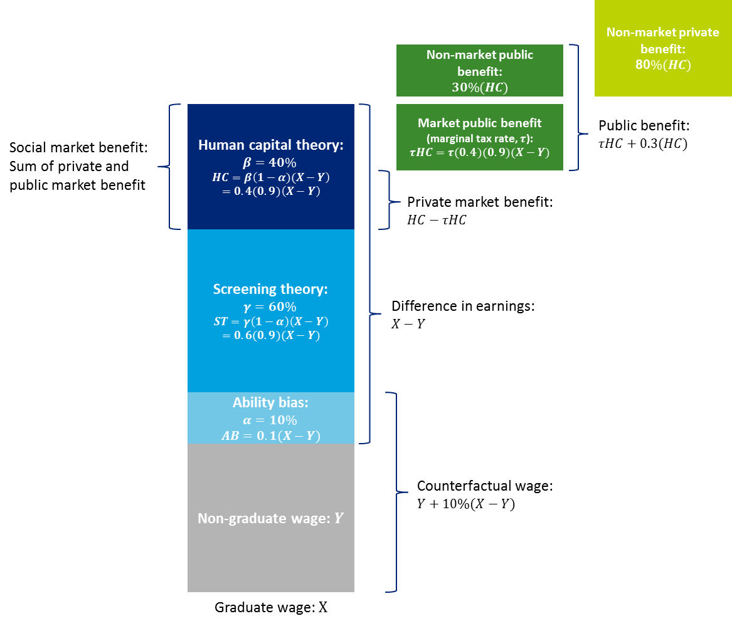
Source: Deloitte Access Economics illustration of Chapman and Lounkaew (2011; 2015). The use of the ability bias term is unclear. Specifically, it is not clear whether the ability bias is considered as a subset of the proportion of earnings attributed to screening theory, or in addition to. The above schematic assumes that ability bias is considered separate to screening theory, as the authors do not explicitly refer to ability bias in their discussion of screening. This representation uses the lower bounds of the human capital allocation (40%), compared to the upper bound (60%). The authors do not estimate non-market private benefits; this calculation is adapted from McMahon (2004).
Public-private benefits by provider type
Deloitte Access Economics (2014) investigated the extent to which the ratio of private to public benefits from higher education provided by non-university higher education providers (NUHEPs) might be expected to systematically vary from university providers. In this research it was determined that variations in the quality of institutions’ higher education degree programs (measured in terms of student’s private market outcomes) should not be directly used as a basis upon which to determine the contributions made by government and students in the context of relative private and public benefits.
This study highlighted the fact CSP places are not predicated on differing course quality, and must be applied consistently across providers that offer ‘like’ programs that meet a certain quality standard (set out in the Threshold Standards defined in the TEQSA Act 2011, Australian Qualification Framework, and other legislation and regulation) with an associate estimated efficient average cost of delivery (for a given level of quality). This is consistent with the principle established by Kemp and Norton (2014) that all higher education providers should have access to Commonwealth Supported Places (CSPs) on the same basis.
For a given level of quality in the provision of teaching and learning (i.e. higher education programs) factors that may influence the private to public benefits from higher education at different providers relate to the specific nature of the institution, its activities and operations. For example, NUHEPs notably have no obligation to undertake research and development activities when compared to universities; and rurally located university campuses have a particular social-mission to serve the needs of a particular community when compared to metropolitan-based universities (Deloitte Access Economics, 2014).
Noting this, it is possible that a university is able to deliver teaching and learning in such a way that it is uninhibited by or unrelated to any of the research or other obligations it produces, and that does not materially sacrifice the production of such obligations insofar as to compromise the institution’s ability to function as a ‘university’ (Loyd et al 1993; Johnes, 1997; Izadi et al, 2002; Johnes and Johnes, 2006). In other words, the institution of a university (and the value it provides to society), does not necessarily need to be structured such that the inputs used in the production of teaching and learning and research are shared in the way they currently are (Deloitte Access Economics, 2014).
This can be seen by the fact that, internationally, teaching only institutions are known to produce teaching and learning of the same quality as public universities, and research only institutions can be shown to produce research of a public university standard, and these institutions exist in isolation and may not necessarily be dependent on the institutional structure of a university to achieve relative cost efficiencies and competitiveness (Bonaccorsi et al., 2014; Cohn and Cooper, 2007; Johnes, 1997; Loyd et al 1993; Izadi et al., 2002).
As a result, Deloitte Access Economics (2014) notes that if government CSP funding (i.e. the public contribution) is intended only to support the efficient production of teaching and learning on a ‘like’ basis then, in principle, there is no reason to support that the split of public/private benefits of a degree from a given provider (e.g. universities) differ to that of a degree from another (e.g. NUHEPs). However, if CSP funding is intended to support other activities of the university (including research or community-service objectives associated with regionally located providers), then the public benefit accrued from the contribution of a CSP dollar at some providers will differ from others.
Importantly though, this difference in public benefits does not per se reflect a difference in the ratio of private to public benefits from higher education attainment in general, but rather the other activities or services that are specific to any given provider (Deloitte Access Economics, 2014). Such a variation in benefits is therefore more appropriately captured in the efficient cost measure of the specific activities that government funding and student contributions are intended to support, which is a separate research question to the appropriate apportionment of contribution towards the efficient cost of ‘like’ teaching and learning programs – the focus of this study’s research.
Recognising this point, and following consultations with providers, Deloitte Access Economics estimates the efficient cost of bachelor degrees for NUHEPs (for ‘like’ programs) to be within 70-100% of the cost for university providers. If a 25% cross-subsidy to university research is assumed to be intended by government contributions towards student places at universities, such that NUHEPs do not additionally create new research and knowledge – a public benefit – then a funding band for NUHEPS, equivalent to 42-60% of university funding rates is estimated.
It should be noted in this context that while the total contribution towards NUHEP programs may be expected to differ to universities on this basis, the share of the private and public contribution towards efficient cost (controlling for support used to fund research) would not be expected to vary—in accordance with the principles set out above. An analogous conclusion may be drawn for distinctions between other types of providers (e.g. regional vs. metro providers), who are funded for activities and services that are extraneous to the ‘like’ basis upon which they are provided CSP funding towards higher education programs.

- : Econometric analysis
This appendix provides further detail on the empirical approaches, data transformations, and intermediate findings of the econometric analysis undertaken in this study.
Data cleaning and preparation
Key variables of interest
The key variables of interest for the core econometric analysis were:
- real weekly wages (earnings model);
- labour force status (employment model);
- education variables – including qualification level, field of education; and provider type;
- controls for demographic characteristics – including age, gender, born in Australia, indigenous status, State of residence, ABS Remoteness Area, disability, English language proficiency, hours worked (earnings model), employment status (employment model), family type (employment model), and age of youngest child (employment model); and
- controls for cognitive ability (tested in Wave 12 of the HILDA survey) - including Backward Digits Span (BDS), Symbol Digits Modalities (SDM), and a shortened (25-item) version of the National Adult Reading Test (NART-25).
Beyond the core analysis of qualification effects, econometric techniques were used to assess labour market spillovers for those with and without higher education. Beyond those set out above, the key variables of interest were labour market and region-specific control variables, defined at a State by Remoteness Area level;
- the weighted proportion of individuals with a higher education qualification (bachelor degree or higher);
- regional unemployment rate; and
- population density.
Transformations and descriptive statistics
Work was undertaken to ‘sense-check’ the data, including identifying implausible values (or combinations of values), and transform certain variables to prepare them for analysis. These transformations are presented here, along with the descriptive statistics relating to subpopulations of interest, to begin to understand the nature of the interactions between key variables.
Data filtering
Where relevant, the following data filters, similar to those noted by Sinning (2014), were applied. The sample included those:
- aged 25 to 64 years;
- who were employed (earnings model);
- reported positive earnings from wages and salaries (earnings model);
- had zero business income;
- reported details about their educational attainment and, if applicable, field of education; and
- did not hold a doctorate (to exclude higher degree research degrees, noting that masters degrees by research are unable to be distinguished from masters degrees by coursework, and are hence included in the sample).
Observations with any missing data were excluded.
Application of human capital variables
Data on human capital variables was collected only in Wave 12 of the HILDA survey. These data on field of education, cognitive ability and university attended was applied to other waves, to allow all waves of data to be used in the regressions. Individuals without the Wave 12 variables were excluded from the analysis. Data relating to field of education and university were applied to the earlier waves if the individual had reported having a post-school qualification, but not otherwise.
Treatment of Diplomas and Advanced Diplomas (sub-bachelor)
The results do not separate Diplomas and Advanced Diplomas obtained from a higher education provider from those obtained from a VET provider. Preliminary specifications of the model attempted such a distinction, but there were insufficient observations and variation in the data to allow for separate effects.
In particular, the individuals in the HILDA dataset predominately obtained their Diplomas and Advanced Diplomas from VET providers rather than higher education providers (given that the diplomas are relatively new offering from those providers).
Aggregation of fields of education
The fields of education in the analysis were aggregates of those available in the HILDA database, as described in Table B.1. This aggregation was undertaken on the basis of a plausible grouping of fields, based on their content and, in some cases, average wages. See, for example, the separation of Medicine from Rest of Health.
  - : Fields of education and average real weekly wages
HILDA Field of Education | Aggregated Field of Education | Average full-time real weekly wage (male, $) | Average full-time real weekly wage (female, $)
Natural and Physical Sciences | Science | 1,599 | 1,277
Information Technology | IT | 1,619 | 1,351
Engineering and Related Technologies | Engineering | 1,467 | 1,373
Architecture and Building | Engineering | 1,113 | 1,289
Agriculture, Environmental and Related Studies | Science | 971 | 806
Medicine | Medicine | 2,312 | 1,783
Nursing | Nursing | 1,506 | 1,191
Other health-related | Rest of Health | 1,425 | 1,129
Education | Education | 1,475 | 1,238
Management and Commerce | Management and Commerce | 1,755 | 1,242
Law | Law | 1,665 | 1,704
Society and Culture | Arts | 1,464 | 1,195
Creative Arts | Arts | 1,166 | 905
Food, Hospitality and Personal Services | Other | 1,017 | 796
Other | Other | 1,448 | 1,270
Source: HILDA, Deloitte Access Economics. Note: The fields of education here are based on those available in the HILDA dataset, which disaggregate some of the 12 broad Australian Standard Classification of Education (ASCED) fields of education further to give a total of 15 fields of education.
Interactions between qualification level and field of education
As part of the testing and refinement of the econometric model, the interactions between qualification levels and field of education were explored. Table B.2 shows the average wages by field of education and qualification level. It is apparent that wages vary across these two dimensions, particularly for Medicine.
  - : Average real weekly wages by field of education and qualification level
HILDA Field of Education | Postgrad - masters or doctorate | Grad diploma, grad certificate | Bachelor or honours | Adv diploma, diploma | Cert III or IV
Natural and Physical Sciences | 1,049 | 1,035 | 939 | 846 | 823
Information Technology | 1,527 | 1,382 | 1,423 | 1,029 | 719
Engineering and Related Technologies | 1,492 | 1,330 | 1,412 | 1,149 | 922
Architecture and Building | 1,797 | 745 | 1,022 | 851 | 733
Agriculture, Environmental and Related Studies | 903 | 1,082 | 775 | 443 | 672
Medicine | 1,692 | 2,035 | 1,159 | 456 | 537
Nursing | 1,349 | 1,013 | 785 | 522 | 535
Other health-related | 1,123 | 814 | 932 | 628 | 551
Education | 1,159 | 920 | 943 | 521 | 614
Management and Commerce | 1,742 | 1,515 | 1,243 | 926 | 662
Law | 1,530 | 1,346 | 1,365 | 1,001 | 816
Society and Culture | 1,025 | 825 | 771 | 534 | 590
Creative Arts | 1,065 | 550 | 637 | 521 | 426
Food, Hospitality and Personal Services | 679 | 1,325 | 978 | 602 | 524
Other | N/A | N/A | N/A | 996 | 612
Source: HILDA, Deloitte Access Economics
However, the corresponding interaction variables were excluded from the final model specification. When included, mixed results were obtained in terms of the significance of the interaction terms and their explanatory power, in part stemming from the small numbers of observations for some field of education/qualification level combinations (and the lack of variation in the terms across waves, given the application of human capital variables observed in Wave 12 to other waves).
Use of five-year age brackets
Chart B.1 illustrates the variation in average real weekly wages by age, for full-time and part-time workers and by gender. To capture these shapes, age is included in the model in five-year brackets. Several different forms of this variable were tested (age and age squared, ten-year brackets and five-year brackets), and it was found that using five-year age brackets provided the best fit of the model.
    - : Average real weekly wages for all workers, by gender, full-time/part-time status and age
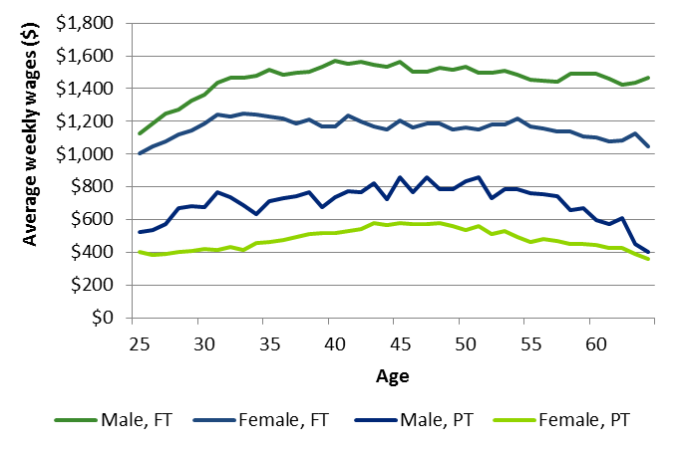
Source: HILDA, Deloitte Access Economics
Interaction between qualification level and age
Sinning (2014), for example, notes that individuals with different levels of educational attainment may have different wage trajectories over time – as they accumulate experience and later move towards retirement. Chart B.2 shows the trajectories in the HILDA data.
As a result, the analysis considers the impact that different levels of experience may have on the earnings of individuals with different levels of educational attainment by including interaction terms between educational attainment and the age variables. (Age is a proxy for experience since experience is not directly measured in the HILDA data).
    - : Average real weekly wages for all workers, by qualification level and age
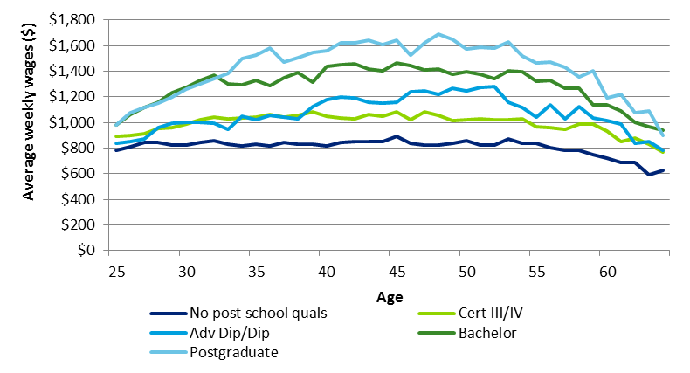
Source: HILDA, Deloitte Access Economics
Hours worked
Hours worked by an individual (in a typical week) is included in the earnings model because the model uses log weekly wages as the dependent variable. There are two possible effects: (i) weekly wages can be viewed simply as hourly wage times hours worked, and (ii) hourly wages may vary with hours worked. Chart B.3 shows the relationship between wages and hours worked. Weekly wages increase in a fairly linear fashion between 0 and 50 hours a week and then level out. The higher variability of average wages at higher levels of hours worked reflects smaller numbers of observations. Log hours worked per week was used in the model.
    - : Average real weekly wages for all workers, by hours worked
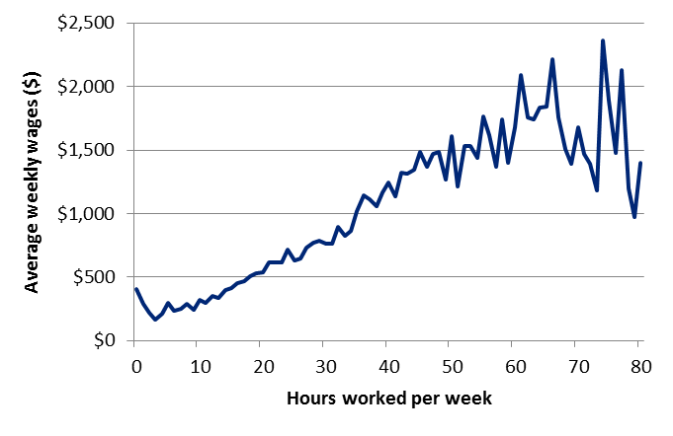
Source: HILDA, Deloitte Access Economics. Note: Individuals working more than 80 hours per week are excluded from this chart for the purposes of readability.
Provider level variables
Provider level variables were included in the econometric modelling, using the groupings from Wilkins (2015), to evaluate whether the private benefits from higher education significantly varied by provider group. The groupings used were:
- Group of 8 (Go8): The University of Adelaide, The Australian National University, The University of Melbourne, Monash University, The University of New South Wales, The University of Queensland, The University of Sydney and The University of Western Australia;
- Australian Technology Network (ATN): Curtin University of Technology, University of South Australia, RMIT University, University of Technology Sydney and Queensland University of Technology;
- Innovative Research Universities (IRU): Flinders University, Griffith University, La Trobe University, Murdoch University, University of Newcastle, James Cook University and Charles Darwin University); and
- Regional Universities Network (RUN): Central Queensland University, Southern Cross University, University of Ballarat, University of New England, University of Southern Queensland and University of the Sunshine Coast.
- The remaining 13 universities are classified as ‘Other’ universities.
The econometric results suggested that these provider variables did not have a significant impact on wages, and did not significantly improve the fit of the model. As a result, these variables were excluded from the final model specification.
State/Territory and ABS Remoteness Area
Table B.3 shows the unweighted number of observations across time, by ABS Remoteness Area and State/Territory in the HILDA data. Each unique combination of State/Territory and Remoteness Area is defined as a ‘region’ for the purposes of the labour market spillovers modelling.
The table below suggests that the geographic cross-section has sufficient observations to develop a picture of average educational attainment in different regional labour markets.
  - : Distribution of observations across ABS Remoteness Area, by state/territory
State/Territory | Major City | Inner Regional | Outer Regional | Remote and Very Remote
New South Wales | 19,158 | 6,071 | 1,819 | 101
Victoria | 17,383 | 5,036 | 899 | 0
Queensland | 10,087 | 5,430 | 3,058 | 544
South Australia | 5,414 | 965 | 1,032 | 311
Western Australia | 6,148 | 1,120 | 639 | 494
Tasmania | 0 | 1,967 | 689 | 34
Northern Territory | 0 | 0 | 665 | 200
Australian Capital Territory | 2,142 | 1 | 0 | 0
Source: HILDA, Deloitte Access Economics
Empirical methodology and results
Private wage gain from higher education
Method
A. Earnings model – conditional on employment
The earnings model is specified as an ‘augmented Mincer equation’, based on Mincer’s (1974) seminal work on the effects of education on wages and taking into account the key variables detailed above. The estimated equation is given by:
$$\log_{e}{w_{it}}=β_{0}+β_{1}E_{it}+β_{2}X_{it}+β_{3}{θθ}_{it} +γ_{t}+ϵ_{it}$$
where:
- $w_{it}$ is the wage of individual $i$ at time $t$ and log_{e} means natural logarithm;
- $E_{it}$ is a vector of educational characteristics (qualification level, field of education);
- $X_{it}$ is a vector of individual characteristics (including demographic characteristics and cognitive ability);
- $θ_{tit}$ is a vector including the natural logarithm of hours worked and a dummy for employed full-time;
- $γ_{t}$ is a year fixed effect; and
- $ϵ_{it}$ is a random error.
The β’s are parameters to be estimated and the data is obtained by pooling across the waves of HILDA data. Our preferred estimation method is an ordinary least squares regression. Standard errors are be clustered at the individual level, to account for the likelihood that the outcomes of each individual (and hence the error terms) are highly correlated over time. Parallel models for male and female subpopulations were also estimated.
Weights were not be used as part of this estimation. This is because the weights provided as part of the HILDA dataset may not accurately represent the way in which attrition occurs in the subsamples of interest (as opposed to the HILDA sample as a whole).
B. Employment model – conditional on participation in the labour force
The second part of this modelling examines the effect of higher education (including qualification level and field of education) on the likelihood of an individual participating in the labour force to be employed.
This propensity is estimated using a linear probability model, which isolates the effect of higher education and controls for other explanatory characteristics. The functional form of this equation is shown below:
$$\operatorname{Pr}\left({Employed}_{it}=1 | Participation_{it}=1\right)=α_{0}+α_{1}E_{it}+α_{2}X_{it}+γ_{t}$$
where:
- $Employed$ is a dummy variable that equals one if individual $i$ at time $t$ is employed and equals zero if they are not employed;
- $Participation$ is a dummy variable that equals one if individual $i$ at time $t$ is participating in the labour force and equals zero if they are not;
- $E_{it}$ is a vector of educational characteristics (qualification level, field of education); and
- $X_{it}$ is a vector of individual characteristics (including demographic characteristics and cognitive ability); and
- $γ_{t}$ is a year fixed effect.
The α’s are parameters to be estimated and the data is obtained by pooling across the waves of HILDA data. Standard errors are be clustered at the individual level, to account for the likelihood that the outcomes of each individual (and hence the error terms) are highly correlated over time.
C. Participation model
The participation model similarly uses a linear probability model to isolate the effect of higher education (and other explanatory variables) on the likelihood of an individual participating in the labour force. The functional form of the equation is shown below:
$$\operatorname{Pr}\left({Participation}_{it}=1 \right)={αγ}_{0}+γ_{1}E_{it}+γ_{2}X_{it}+γ_{t}$$
where:
- $Participation$ is a dummy variable that equals one if individual $i$ at time $t$ is participating in the labour force and equals zero if they are not;
- $E_{it}$ is a vector of educational characteristics (qualification level, field of education); and
- $X_{it}$ is a vector of individual characteristics (including demographic characteristics and cognitive ability); and
- $γ_{t}$ is a year fixed effect.
The γ’s are parameters to be estimated and the data is obtained by pooling across the waves of HILDA data. Standard errors are be clustered at the individual level, to account for the likelihood that the outcomes of each individual (and hence error terms) are highly correlated over time.
Results
A. Earnings model – conditional on employment
Table B.4 shows the estimation results for the earnings model. The results are consistent with those shown in the body of this report, but details three different specifications of the model – with (1) education and labour force controls only; (2) education, labour force and demographic controls; and (3) education, labour force, demographic and cognitive ability controls.
  - : Coefficient estimates on log weekly wages of employed graduates
Dependent variable: Log weekly wages | Education and labour force controls only (1) | Adding demographic controls (2) | Full model, adding cognitive ability controls (3)
Qualification level
Postgraduate | 0.368*** | 0.336*** | 0.248***
Bachelor | 0.281*** | 0.253*** | 0.170***
Sub-bachelor | 0.117*** | 0.101*** | 0.067*
Certificate III/IV | -0.005 | -0.013 | -0.048
Field of Education
Science | 0.024 | 0.030 | 0.010
IT | 0.125* | 0.096 | 0.076
Engineering | 0.070 | 0.064 | 0.085*
Medicine | 0.176 | 0.176 | 0.118
Nursing | 0.243*** | 0.281*** | 0.309***
Other Health | 0.044 | 0.061 | 0.082
Education | 0.098*** | 0.118*** | 0.119***
Management and Commerce | 0.093*** | 0.079** | 0.080**
Law | 0.241*** | 0.221*** | 0.215***
Food and Hospitality | -0.139** | -0.150** | -0.133*
Labour force characteristics
Employed full-time | 0.301*** | 0.279*** | 0.260***
Log hours worked | 0.749*** | 0.731*** | 0.757***
Demographics
Aged 30-34 |  | 0.031** | 0.041**
Aged 35-39 |  | 0.045** | 0.048**
Aged 40-44 |  | 0.035* | 0.021
Aged 45-49 |  | 0.036* | 0.017
Aged 50-54 |  | -0.005 | -0.008
Aged 55-59 |  | -0.080*** | -0.100***
Aged 60-64 |  | -0.114*** | -0.148***
Male |  | 0.054*** | 0.073***
Not born in Australia |  | 0.069*** | 0.047*
Indigenous |  | 0.077* | 0.150***
Has long-term health condition |  | -0.114*** | -0.073***
Low English language proficiency |  | -0.243*** | -0.169
Cognitive ability
Backward Digits Span (BDS) |  |  | 0.005
Symbol Digits Modalities (SDM) |  |  | 0.002*
National Adult Reading Test (NART-25) |  |  | 0.016***
Source: Deloitte Access Economics. Note: *** represents significance at the 1% level; ** at the 5% level; and * at the 10% level. Base categories are: no post-school qualification, FoE Arts, and Aged 25-29. Coefficient estimates for: year fixed effects, state and remoteness area are not reported for brevity.
The results suggest that bachelor and postgraduate degrees have a positive impact on an average individual’s earnings, relative to an individual with no post-school qualification (the omitted category of qualification). The effect for sub-bachelor and Certificate III/IV holders is not statistically significant.
Broadly, the results align with our understanding of the relationship between education and wages. The addition of field of education and cognitive ability variables represent new extensions on the existing literature. The inclusion of cognitive ability allows the model to control, to an extent, for unobserved ability bias – wherein higher ability individuals may self-select into more education, given the positive relationship between education and earnings.
Impact of experience on earnings
Sinning (2014) considers the impact that different levels of experience may have on the earnings of individuals with different levels of educational attainment. As such, models that included interaction terms between educational attainment and experience (proxied here by five year age groups) were also estimated. Table B.5 presented selected results.
  - : Wage premium of employed graduates, key regression results
Dependent variable: log weekly wages | Postgraduate | Bachelor | Sub-bachelor | Certificate III/IV
Qualification level coefficient | 0.059 | 0.084** | 0.037 | -0.024
Additional interaction effect (age x qual level)
Aged 30-34 | 0.138** | 0.136*** | -0.066 | 0.024
Aged 35-39 | 0.210*** | 0.146** | 0.043 | 0.014
Aged 40-44 | 0.300*** | 0.192*** | 0.114* | -0.043
Aged 44-49 | 0.299*** | 0.096 | 0.091 | -0.083
Aged 50-54 | 0.166** | 0.078 | 0.042 | -0.054
Aged 55-59 | 0.171* | -0.08 | -0.188 | -0.067
Aged 64-69 | 0.147 | 0.228* | 0.187 | 0.166
Source: Deloitte Access Economics. Note: *** represents significance at the 1% level; ** at the 5% level; and * at the 10% level. Base categories are: No post-school qualification, FoE Arts, and Aged 25-29.
The results suggest that there are significant positive wage premiums for those with postgraduate degrees (between 20% and 36%, relative to an individual with no post school qualification, depending on age), and for most age groups holding bachelor degrees (between 0.4% and 28%).
The results also suggest that there is no statistically significant wage premium from holding sub-bachelor and Certificate III/IV qualifications. The findings from this model for field of education (in terms of magnitude of coefficients and statistical significance) are broadly similar to those presented in Section 4.2.1.
Given the additional complexity that these interaction terms add to the interpretability of results (and limited additional explanatory power they provide), this form of the model was not selected as the final specification.
B. Employment model – conditional on participation in the labour force and participation model
The results in Table B.6 show the results of the modelling from the employment (likelihood of employment, conditional on participation) and participation (likelihood of labour force participation) model.
  - : Coefficient estimates on likelihood of employment (given participation), and likelihood of labour force participation of graduates
Explanatory variable | Employed, conditional on participation (1) | Labour force participation (2)
Qualification level
Postgraduate | 0.000 | 0.057***
Bachelor | 0.002 | 0.038***
Sub-bachelor | -0.001 | 0.016
Certificate III/IV | -0.003 | 0.038***
Field of Education
Science | 0.011* | 0.036**
IT | 0.003 | 0.035**
Engineering | 0.022*** | 0.037***
Medicine | -0.002 | 0.053*
Nursing | 0.027*** | 0.105***
Other Health | 0.020*** | 0.108***
Education | 0.022*** | 0.063***
Management and Commerce | 0.011** | 0.047***
Law | 0.012 | 0.034
Food and Hospitality | 0.008 | 0.033
Demographics
Aged 30-34 | 0.003 | -0.001
Aged 35-39 | 0.010** | 0.008
Aged 40-44 | 0.019*** | 0.001
Aged 45-49 | 0.024*** | -0.011
Aged 50-54 | 0.028*** | -0.040***
Aged 55-59 | 0.030*** | -0.147***
Aged 60-64 | 0.030*** | -0.348***
Male | 0.004 | 0.095***
Indigenous | -0.077*** | -0.056**
Has long-term health condition | -0.034*** | -0.198***
Youngest child aged 0-4 |  | -0.332***
Youngest child aged 5-14 |  | -0.061***
Youngest child aged 0-4 x Male |  | 0.310***
Youngest child aged 5-14 x Male |  | 0.070***
Cognitive ability
Backward Digits Span (BDS) | 0.000 | -0.001
Symbol Digits Modalities (SDM) | 0.001*** | 0.004***
National Adult Reading Test (NART-25) | 0.001*** | 0.003***
Source: Deloitte Access Economics. Note: *** represents significance at the 1% level; ** at the 5% level; and * at the 10% level. Base categories are: no post-school qualification, FoE Arts, and Aged 25-29. Coefficient estimates for: year fixed effects, state, remoteness area, household family structure are not reported for brevity.
The key result from this analysis is individuals with post-school qualifications have higher likelihoods of participation in the labour force, but not necessarily likelihoods of employment given that participation. There is a positive impact from holding a qualification in most fields of education (relative to Arts) on the likelihoods of labour force participation and employment.
Labour market spillovers from higher education
Method
The purpose of this stream of econometric analysis is to gain an understanding of the labour market spillovers from higher education and the relative scarcity and productivity effects of higher education.
This specification is a linear regression model, with data obtained by pooling across the waves of HILDA data (adapted from Clarke & Skuterud, 2013). The functional form of the equation is shown below:
$$\log_{e}{w_{it}}=δ_{0}+δ_{1}E_{it}+δ_{2}E_{it}{\overline{E}}_{rqt}+δ_{3}X_{rt}+δ_{4}βE_{it}+βE_{it}{\overline{E}}_{rt}+βX_{rt}+Z_{it}+γ_{t}+ϵ_{it}$$
where the variables are denoted as follows:
- $w_{it}$ is the wage of individual i at time t;
- $E_{ij}$ is a vector of dummy variables indicating an individual’s highest level of qualification;
- $E_{ijt}{\overline{E}}_{rqt}$is a set of interaction terms between an individual’s education level and the average level of education in the region;
- $X_{rt}$ is a vector of geography controls indicating the region of residence, unemployment rate in the region, and average education in the region;
- $Z_{it}$ is a vector of individual characteristics (including demographic characteristics and cognitive ability);
- $γ_{t}$ is a dummy variable capturing time-specific fixed effects; and
- $ϵ_{it}$ is a random error.
The average level of education in a region, denoted as${\overline{E}}_{rqt}$, is defined as the share of the workforce in the region that has a higher education qualification (that is, bachelor or higher). Regions are defined from the interaction of ABS Remoteness Area and State/Territory. The δ’s are parameters to be estimated.
A model with a more complex form for the average level of education in a region was also estimated. The average level of education was represented by a set of variables giving the shares of the workforce in each region with a particular qualification level or higher. (See Table B.7 for an example.) However, the results of this modelling were mixed and more complex to interpret, and ultimately, the simpler specification of the average level of education was chosen.
  - : Example of regional average levels of education
 |  |  | Region 1 | Region 2 | Region 3 | Region 4
Attainment levels
Year 12 or below |  |  | 5% | 5% | 5% | 5%
VET qualification (Certificate I-IV) |  |  | 15% | 5% | 5% | 5%
Sub-bachelor |  |  | 20% | 30% | 20% | 20%
Bachelor |  |  | 40% | 40% | 50% | 40%
Postgraduate |  |  | 20% | 20% | 20% | 30%
Constructed variables | Variable label | Corresponding coefficients
Sub-bachelor or higher | $${\overline{E}}_{r1t}$$ | $$θ_{j1}$$ | 80% | 90% | 90% | 90%
Bachelor or higher | $${\overline{E}}_{r2t}$$ | $$θ_{j2}$$ | 60% | 60% | 70% | 70%
Postgraduate or higher | $${\overline{E}}_{r2t}$$ | $$θ_{j3}$$ | 20% | 20% | 20% | 30%
Regardless of the construction of the average level of education variable, it is important to note that there is a certain degree of simultaneity underlying the analysis, given dependencies between regional labour markets. For example, if a regional labour market receives an exogenous shift of labour from a low skill level to a higher skill level, then this may increase the productivity and wages of the remaining low skill level group. Other low skill workers may be drawn into that labour segment, either from outside the region, or from outside the labour force. These extra workers will dampen the observed wage increase of those initially ‘left behind’ in the lower skilled segment of the labour force.
Results
The full results of this analysis are presented in Table B.8. Column (1) provides the results of the model with just the higher education qualification, proportion of population in a region with the higher education qualification, and the interaction term. This shows that there is a positive relationship between the proportion of individuals in a region with a higher education qualification and weekly wages. Column (2) adds in controls for field of education, and the positive relationship still holds.
Column (3) presents the full model, with controls for labour market characteristics demographics and cognitive ability. In this model, the coefficient on proportion of population in region with higher education qualification is much smaller, and no longer significant – suggesting that various demographic and labour force characteristics are stronger drivers of wage variation than are the regional effects.
  - : Coefficient estimates of labour productivity spillovers from higher education
Dependent variable: log weekly wages | (1)  Qual. only | (2)  Incl. FOE | (3)  Full model
Qualification level
Has HE qual | 0.413*** | 0.362*** | 0.173***
Proportion of population in region with HE qual | 0.659*** | 0.576*** | 0.069
Has HE qual x Proportion of pop in region with HE qual | -0.188 | -0.231 | 0.017
Field of Education
Science |  | 0.173*** | -0.021
IT |  | 0.326*** | 0.092
Engineering |  | 0.349*** | 0.057
Medicine |  | 0.218 | 0.157
Nursing |  | 0.168*** | 0.338***
Other Health |  | 0.016 | 0.077
Education |  | 0.186*** | 0.173***
Management and Commerce |  | 0.413*** | 0.192**
Law |  | 0.289*** | 0.090**
Food and Hospitality |  | -0.103 | -0.192**
Labour force characteristics
Employed full-time |  |  | 0.305***
Log hours worked |  |  | 0.760***
Regional unemployment rate |  |  | -0.037***
Demographics
Aged 30-34 |  |  | 0.033*
Aged 35-39 |  |  | 0.022
Aged 40-44 |  |  | -0.011
Aged 45-49 |  |  | -0.022
Aged 50-54 |  |  | -0.043
Aged 55-59 |  |  | -0.141***
Aged 60-64 |  |  | -0.281***
Male |  |  | 0.052**
Indigenous |  |  | 0.162***
Has long term health condition |  |  | -0.103***
Cognitive ability
Backward Digits Span (BDS) |  |  | -0.003
Symbol Digits Modalities (SDM) |  |  | 0.002
National Adult Reading Test (NART-25) |  |  | 0.018***
Source: Deloitte Access Economics. Note: *** represents significance at the 1% level; ** at the 5% level; and * at the 10% level. HE means higher education. Base categories are: no post-school qualification, FoE Arts, and Aged 25-29. Coefficient estimates for: year fixed effects, state, remoteness area and population density are not reported for brevity.

- : CGE modelling
This section describes the data and methods used to (i) parameterise the Deloitte Access Economics Regional General Equilibrium Model (DAE-RGEM) with different ‘skills’ as defined by the set of discipline specific qualifications, and (ii) simulate the economy-wide impacts for a given change in the skills mix.
In particular, given that higher education in general improves labour outcome through three channels – (i) increased average wages for those employed, (ii) improved participation in work, and (iii) a higher chance of being employed – these factors are calibrated into the baseline model.
Database creation
DAE-RGEM uses the Global Trade Analysis Project (GTAP) 9 database, which is a fully documented, publicly available global data base containing complete input-output production functions, macro-economic data, and bilateral trade information for 140 countries and 57 sectors, as the starting point of the Australian economy in 2011. In particular, GTAP 9 splits labour into five major occupation categories (Walmsley and Carrico, 2014).
For the purpose of this exercise, the aggregate wage, labour supply and employment figures for the Australian economy are taken as given. Table C.1 shows the shares required to parameterise the model with different skill categories.
  - : Model parameterisation data requirements and sources
Input requirements | Source | Notes
Wage share by occupation x industry x skill | Estimated from ABS 2011 Census of Population and Housing | The wage is calculated as the product of (i) average weekly wages and (ii) employment.
Employment share by occupation x industry x skill
Labour supply share by skill
Average unemployment rate by skill
The above shares are calculated using data from the ABS 2011 Census of Population and Housing, which provides a count of persons in the Australian economy based on (i) their highest level of education and field of study, (ii) their labour force status, (iii) their industry of employment, (iv) their occupation, and (iii) their average weekly wage.
The ABS reporting categories, such as the Australian and New Zealand Standard Industry Classification (ANZSIC) industries and Australian and New Zealand Standard Classification of Occupations (ANZSCO) were mapped to the relevant GTAP industries and occupations, while the Australian Standard Classification of Education (ASCED) level of education and field of study were mapped to the specified 37 skill categories of interest. The skill mappings for the level of education (Table C.2) and field of study (Table C.3) are given below, with each combination of mapped level and field of education giving a skill category.
  - : Mapping levels of education into skills
ASCED level of education (narrow fields) | Mapped level of education
Postgraduate Degree Level, nfd | Postgraduate level
Doctoral Degree Level | Postgraduate level
Master Degree Level | Postgraduate level
Graduate Diploma and Graduate Certificate Level, nfd | Postgraduate level
Graduate Diploma Level | Postgraduate level
Graduate Certificate Level | Postgraduate level
Bachelor Degree Level | Bachelor level
Advanced Diploma and Diploma Level, nfd | Sub-bachelor level
Advanced Diploma and Associate Degree Level | Sub-bachelor level
Diploma Level | Sub-bachelor level
Certificate Level, nfd | VET level
Certificate III & IV Level | VET level
Certificate I & II Level | High school leavers
Level of education inadequately described | Not applicable
Level of education not stated | Not applicable
Not applicable | High school leavers

  - : Mapping fields of study into skills
ASCED field of study (narrow fields) | Mapped field of education
Natural and Physical Sciences, nfd | Science
Mathematical Sciences | Science
Physics and Astronomy | Science
Chemical Sciences | Science
Earth Sciences | Science
Biological Sciences | Science
Other Natural and Physical Sciences | Science
Information Technology, nfd | IT
Computer Science | IT
Information Systems | IT
Other Information Technology | IT
Engineering and Related Technologies, nfd | Engineering
Manufacturing Engineering and Technology | Engineering
Process and Resources Engineering | Engineering
Automotive Engineering and Technology | Engineering
Mechanical and Industrial Engineering and Technology | Engineering
Civil Engineering | Engineering
Geomatic Engineering | Engineering
Electrical and Electronic Engineering and Technology | Engineering
Aerospace Engineering and Technology | Engineering
Maritime Engineering and Technology | Engineering
Other Engineering and Related Technologies | Engineering
Architecture and Building, nfd | Engineering
Architecture and Urban Environment | Engineering
Building | Engineering
Agriculture, Environmental and Related Studies, nfd | Science
Agriculture | Science
Horticulture and Viticulture | Science
Forestry Studies | Science
Fisheries Studies | Science
Environmental Studies | Science
Other Agriculture, Environmental and Related Studies | Science
Health, nfd | Other health
Medical Studies | Medicine
Nursing | Other health
Pharmacy | Other health
Dental Studies | Other health
Optical Science | Other health
Veterinary Studies | Other health
Public Health | Other health
Radiography | Other health
Rehabilitation Therapies | Other health
Complementary Therapies | Other health
Other Health | Other health
Education, nfd | Education
Teacher Education | Education
Curriculum and Education Studies | Education
Other Education | Education
Management and Commerce, nfd | Business
Accounting | Business
Business and Management | Business
Sales and Marketing | Business
Tourism | Business
Office Studies | Business
Banking, Finance and Related Fields | Business
Other Management and Commerce | Business
Society and Culture, nfd | Art
Political Science and Policy Studies | Art
Studies in Human Society | Art
Human Welfare Studies and Services | Art
Behavioural Science | Art
Law | Business
Justice and Law Enforcement | Business
Librarianship, Information Management and Curatorial Studies | Art
Language and Literature | Art
Philosophy and Religious Studies | Art
Economics and Econometrics | Business
Sport and Recreation | Art
Other Society and Culture | Art
Creative Arts, nfd | Art
Performing Arts | Art
Visual Arts and Crafts | Art
Graphic and Design Studies | Art
Communication and Media Studies | Art
Other Creative Arts | Art
Food, Hospitality and Personal Services, nfd | Food and hospitality
Food and Hospitality | Food and hospitality
Personal Services | Food and hospitality
Mixed Field Programmes, nfd | Food and hospitality
General Education Programmes | Food and hospitality
Social Skills Programmes | Food and hospitality
Employment Skills Programmes | Food and hospitality
Other Mixed Field Programmes | Food and hospitality
Field of study inadequately described | Not applicable
Field of study not stated | Not applicable
Not applicable | Not applicable
Chart C.1 shows the employment industry composition for different disciplines of study compared to high school leavers. While high school leavers are hired across the economy, higher education graduates tend to be employed predominantly in the service industries. In particular, over 80% of graduates in medicine, other health, and education are employed in ‘other government services’, which includes the education and training, and health and social assistance industries.
    - : industry of employment for different disciplines (postgraduate and bachelor combined)
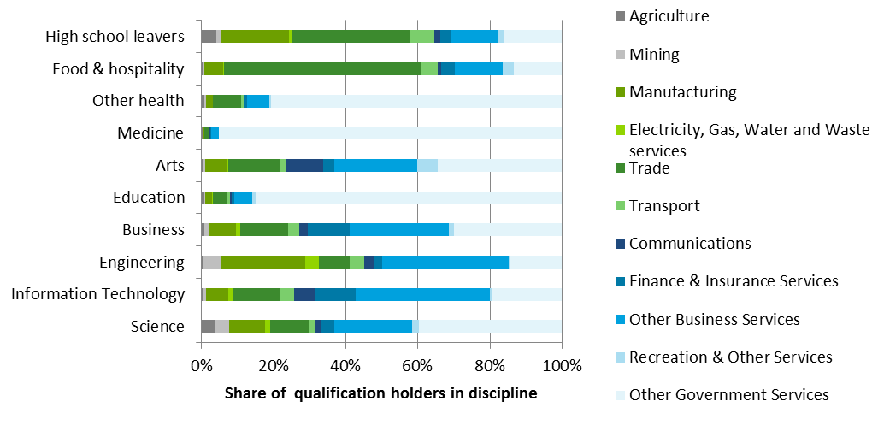
Source: ABS 2011 Census of Population and Housing, Deloitte Access Economics
Graduates with post-schooling qualification on average earn more than high school leavers (Chart C.2). While the returns to each level of additional qualifications differ across the disciplines, there is in general an increase in earnings associated with higher AQF level study, from VET through to the postgraduate level.
    - : average annual earnings for different disciplines, incremental from high school averages
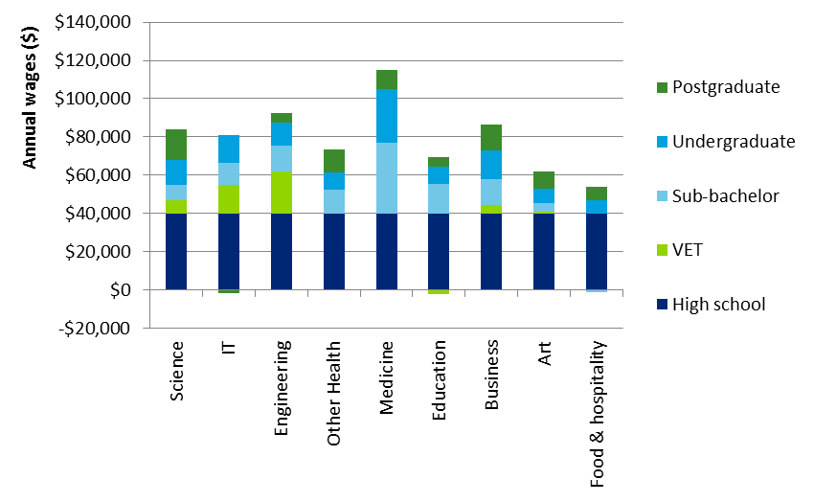
Source: ABS 2011 Census of Population and Housing, Deloitte Access Economics
The higher average wages earned by individuals with post-school qualifications mean that a greater share of wages is attributed to them relative to their share of employment (Chart C.3). For instance, while business undergraduates compose 3.1% of the employed population, their wages make up 5.1% of the total wage bill. In comparison, while high school leavers make up 41% of the workforce, their wage makes up only 30%.
    - : share of employment and wage for postgraduate and undergraduate graduates by discipline
Source: ABS 2011 Census of Population and Housing, Deloitte Access Economics
The average unemployment rate for each skill category in 2011 is summarised in Chart C.4. The unemployment rate is highest for high school leavers – at 8.1% - and varies across the disciplines. In particular, the unemployment rate is lowest for graduates in health (medicine and other health) and education.
The effect of a postgraduate degree versus a bachelor degree on the unemployment rate is ambiguous. While it is associated with a lower unemployment rate for science, medicine, other health, and arts, the opposite is true for IT, engineering and education.
    - : Average unemployment rate for postgraduate and bachelor graduates by discipline
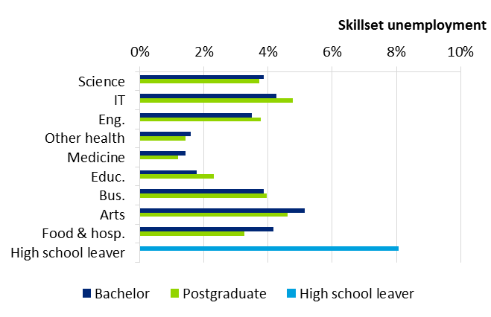
Source: ABS 2011 Census of Population and Housing, Deloitte Access Economics
Once the database is parameterised for the base year (2011), the skills mix of the economy is assumed to remain constant unless otherwise specified or shocked. The distribution of the skilled workers across industries and occupations, the average wage and unemployment rate is then determined endogenously within the model based on industry requirements and the relative price of the factor inputs.
Development of simulations
This section outlines the approach used to simulate moving a group of high school leavers into another skill category, i.e. higher education graduates of a particular discipline. Here, the labour supply increase is adjusted to account for:
- the premium attributable to the qualification itself; and
- other time-varying dynamics, with an individual’s wages, participation rates and unemployment rates likely to vary over their working life.
Table C.4 outlines the data requirements for generating a dynamic labour supply shock. It is assumed that the same age-specific change in wages, unemployment and participation applies equally for all industries and occupations for the same skill category.
  - : Shock generation data requirements and sources
Input requirements | Source |  | Notes
Isolating the effects of the qualification
Wage premium attributable to qualification |  | Econometrics results |  | Assumed to be constant over an individual’s working life time.
Participation premium attributable to qualification |  | Econometrics results
Employment premium attributable to qualification |  | Econometrics results
Accounting for time-varying dynamics
Wage by skill x age (working period) |  | Estimated from ABS 2011 Census of Population and Housing |  | The age profiles were smoothed using ABS wages over the working life (25-29 years old to 60-64 years old).
Unemployment rate by skill x age (working period) |  | Estimated from ABS 2011 Census of Population and Housing
Participation rate by skill x age (working period) |  | Estimated from ABS 2011 Census of Population and Housing
Period of study for each skill |  | Assumption |  | It is assumed each bachelor’s degree requires three years of study (five years for Medicine), and each postgraduate degree requires five years of study (seven years for Medicine).
Wage and likelihood of employment during study period |  | Estimated from ABS 2011 Census of Population and Housing, Universities Australia (2013) |  | Assumed to be equal across all student disciplines.
Further details on the econometric estimates for the proportion of wage, participation and employment rate premiums attributable to the different degrees can be found in Appendix B.
Figure C.1 summarises the approach for transforming additional graduates with a particular qualification into effective additional labour supply units in a static context. This uses the so-called Harberger Convention, which means that physical quantities (such as a week of full time equivalent labour) can be represented as value quantities or units of factor services, (such as $1000 of labour services). This allows us to adjust on the quantity or price side, for an equivalent value of labour services to the economy.
For example, to simulate the impact of providing 1,000 typical individuals with no post-school qualification a bachelor level engineering degree, the following steps are required:
- Calculate the wage premium associated with an average engineering graduate over a high school leaver. The average engineering graduate earns 120% more than their high school leaver counterpart.
- Use econometric results on the proportion of the wage premium attributable to the qualification. It is 38% for the case of engineering. Consequently, the qualification-specific wage premium over high school leavers is 45% (120% x 38%).
- Use the qualification-specific wage premium to adjust for the number of additional ‘average’ individuals to be added to engineering. The part attributable to the qualification is equal to 659 individuals.
- From the 659 average engineering graduates and 1,000 high school leavers, work out the resultant labour supply based on the skill-specific participation rates. The average participation rate for engineering graduates between the ages of 25-64 is 90%, compared to 70% for high school graduates. This gives a participation rate premium of 29%.
- Similar to the method used for the wage premium, attribute a proportion to the qualification. In this case, it is 38%. The qualification-specific participation rate premium is 11% (38% x 29%).
- Consequently, 700 high school leavers will be taken from the labour supply (1,000 x 70%), while 512 engineering graduates will be added (111% x 70% x 659).
- While employment is determined within the model, an out of model adjustment to the labour supply is required to account for the qualification premium associated with lower unemployment rates for the engineering graduates.
- Using the skill-specific unemployment rates from the DAE-RGEM baseline results, determine the number of employed persons out-of-model for the two skill categories. For instance, bachelor engineering graduates face an average unemployment rate of 3.4% compared to 8.1% for high school leavers. This represents a premium (in employment) of 5%.
- Attributing a share of the employment premium to the degree (71%), the qualification adjusted premium is 3.5%.
- Consequently, to mimic a qualification-adjusted unemployment rate of 4.9%, and employment of 487 individuals, the labour supply for engineering needs to be shocked by an additional 503 units to account for the full unemployment rate of 3.5%.
- The adjusted labour supply is then inputted as a simulation the model. To represent a movement of 1,000 individuals from high school leavers into bachelor graduate, 700 individuals will be taken out of the labour supply for high school leavers, and 503 individuals will be added to the labour supply of bachelor engineering graduates.
The above adjustments represent the average simulation over the cohort’s working life. However, in addition to the qualification dimension, additional steps are taken to account for the time variability in labour market outcomes over the course of a career.
      - : Premium adjustment framework for labour supply shock generation
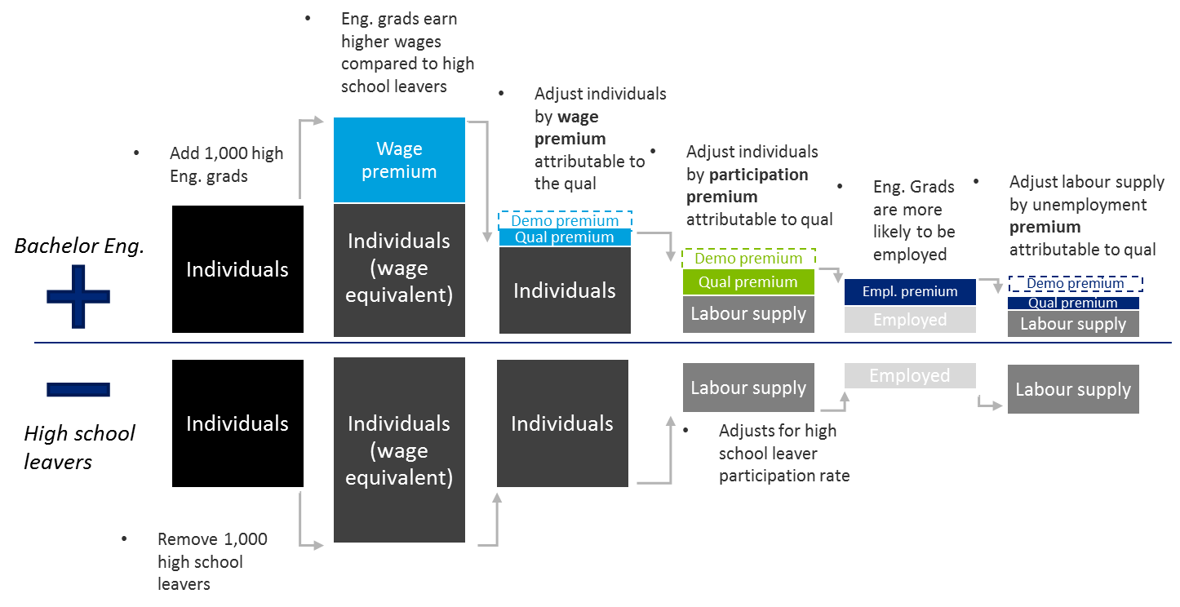
During studies
Taking graduates fully out of the labour supply during their studies would overstate the cost of higher education. Indeed, Universities Australia’s 2013 publication University student finances in 2012 finds that approximately 80% of bachelor and postgraduate domestic students work during full time study.
Accounting for the fewer hours worked during the school term, it is calculated that a student during their studies is equivalent to 0.4 of an average full-time equivalent (FTE) worker.
Therefore, only approximately 600 of the studying cohort are taken out of the workforce during the study period. It is assumed that they earn the same per hour wage as their high school leaver counterparts.
Working life
Chart C.5 shows the smoothed age-specific effective wage (relative to the average wage) for higher education engineering graduates and high school leavers during their working life. High school leavers have relatively flatter wage earnings over their working life, reaching a maximum of 110% around age 40. They also tend to have relatively higher wages during the beginning of their working life (starting out at approximately 80% of average wages for the skill category) compared to university graduates.
In contrast, the earnings for postgraduate and bachelor engineering graduates tend to peak slightly latter (around age 50 for postgraduate and age 45 for bachelor), and wages remain relatively high at the end of their careers.
    - : Smoothed age-specific wage relative to average (Engineering)
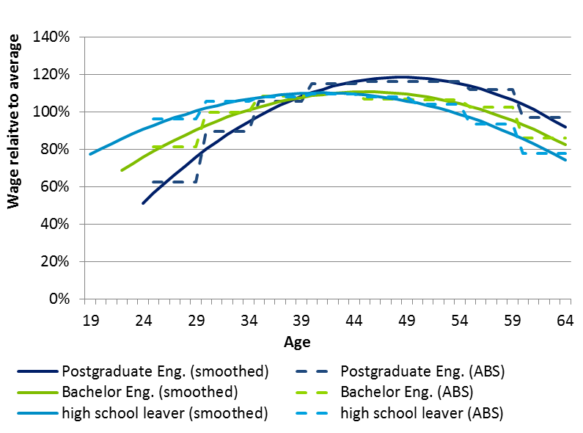
Source: ABS 2011 Census of Population and Housing, Deloitte Access Economics
Chart C.6 shows the smoothed age-specific participation rate for graduates of engineering. The figures are given in absolute values (rather than relative to an average) as participation is not determined endogenously within the model. As the labour supply is shocked directly, and the adjustment from additional individuals with a particular skill to additional labour supply with a particular skill is made out of model.
    - : Smoothed age-specific participation rate (Engineering)
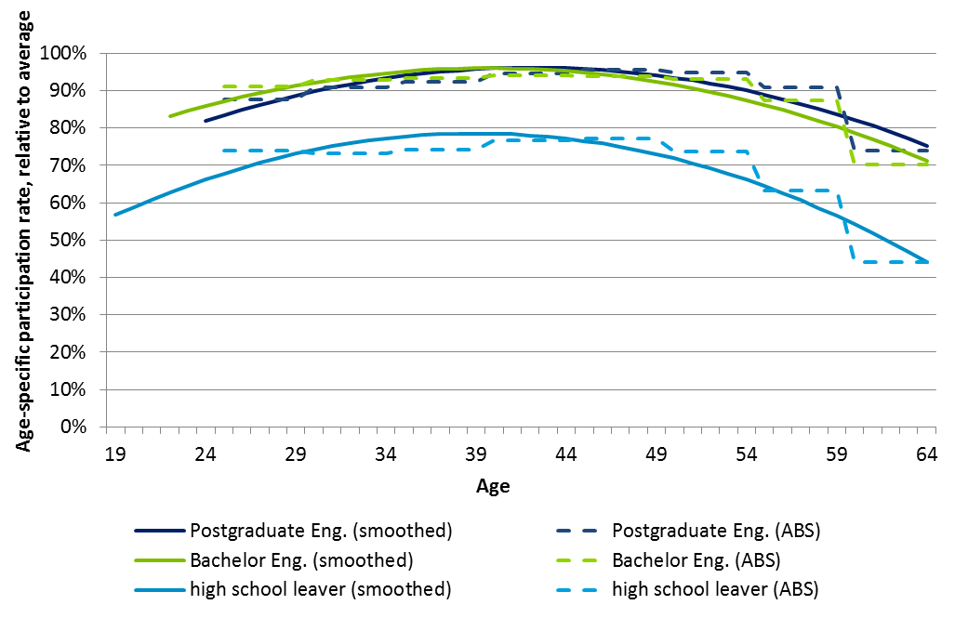
Source: ABS 2011 Census of Population and Housing, Deloitte Access Economics
Similarly, Chart C.7 shows the smoothed age-specific unemployment rate (relative to the average unemployment rate) for higher education engineering graduates and high school leavers. It finds that as an individual initially enters the labour market, they are more likely to be unemployed. This is particularly the case for high school leavers, with the average 19 year old high school leaver two times as likely to be unemployed than the average school leaver – at 16.4%.
Adjusting for these factors relative to the average unit of labour supplied allows a dynamic shock that accounts for age-specific variations over an individual’s working life. The age-specific labour supplies are used as inputs into the DAE-RGEM model.
    - : Smoothed age-specific unemployment rate adjustment relative to average (Engineering)
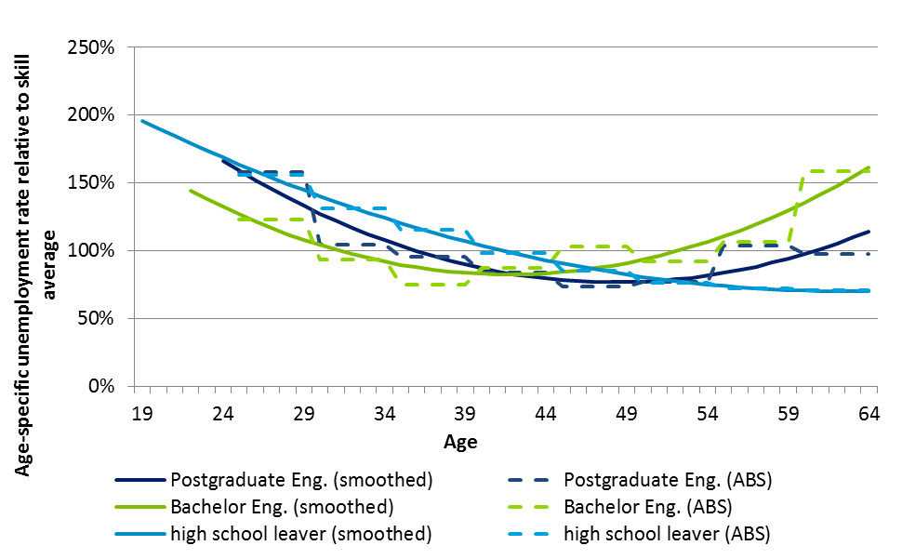
Source: ABS 2011 Census of Population and Housing, Deloitte Access Economics

Out-of-model adjustments
Based on the time-dynamic shocks, the DAE-RGEM produces on a variety of outputs comparing a ‘baseline’ path of the economy where the skills mix of the economy does not change, with a ‘policy’ path of the economy where the skills mix has been shocked exogenously.
The Gross National Product (GNP) deviation resultant from the change in the skills mix is defined as the total benefits. GNP is the most appropriate measure of benefits as it discounts for foreign ownership of capital, where the returns will flow out of the economy.
The private benefit is defined as the additional post-tax income received by the marginal individuals who are moved into a higher skill category:
$$Private benefit =policy post tax wages for marginal graduates-$$
$baseline post tax wage for marginal school leavers$
The policy wage for the marginal higher education graduates is compared to the baseline wage for the high school leavers to account for the price effect of wages lowering as additional workers join a particular skill category.
Using the pre-tax income (model output), the post-tax income is calculated out of model. This is because income taxes in the CGE model are based on average tax rates, and cannot account for the higher marginal taxes paid as worker income increases. Without adjustment, this could potentially underestimate the share of public benefit.
The broad methodology is as follows:
- Work out average tax rates from the 2015-16 tax rates, including income tax and the 2% Medicare rebate for the tax brackets
- Adjust the average baseline and policy pre-tax incomes received by high school leavers and higher education graduates by the tax rates derived above
- Calculate the marginal tax rate paid on the additional income by the average worker.
- For instance, the marginal tax rate on additional earnings by bachelor engineering graduates (relative to high school graduates) is 35%. This is significantly higher than the average 25% reported straight from the model.
- Apply the marginal tax rate to the total additional pre-tax income received by the marginal individuals who are moved into a higher skill category.
The public benefits are then defined as the difference between the total and private benefits. In addition to the additional taxation paid by the marginal movers into the higher skill category, other public benefits and costs include:
- Net payment to other factors, including other workers, and to capital
- Direct taxes paid by other factors of production and indirect taxes paid on goods and services production.
- Net transfer income overseas from additional foreign investment in Australia.
A decomposition of the annual benefits resulting from engineering graduates as a share of total benefits across an individual’s working life is shown in Chart C.8.
    - : Total benefit decomposition profile, Engineering bachelor level
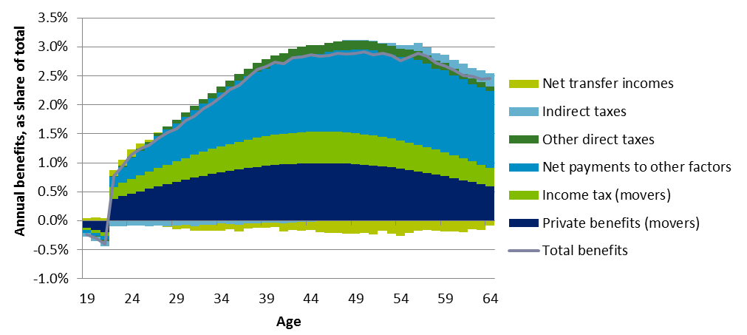
Source: Deloitte Access Economics DAE-RGEM model
- : CGE Sensitivity analysis
In addition to the main scenarios for the combination of postgraduate and bachelor level disciplines, modelling for a number of additional sensitivities were also undertaken to demonstrate how changes in the fundamental structure of the economy could affect the public-private benefit split. The results on bachelor level education, engineering, and business degrees has been considered.
Skill-specific unemployment rate
Given that a share of private benefits from higher education results from lower unemployment rates relative to high school leavers, a simulation was developed to test how changes in the skill-specific unemployment rate could affect results.
The baseline unemployment rate is simulated to increase by 50% coinciding with a graduate’s entry into the workforce. It is expected to remain elevated for five years, before returning to baseline unemployment rates over time.
This represents situations where there could be an oversupply of graduates (of a particular discipline) at a point in time. The additional supply would lead to a higher unemployment rate for those graduates if it is not met by sufficient demand. In response to the higher unemployment rate, fewer students enter the course, and unemployment rate returns to its normal rate over time. For instance, this could describe business and finance students entering the job market at the beginning of the Global Financial Crisis, or alternatively engineering students entering the job market at the end of the mining boom.
The shock to the unemployment rates for the three disciplines is given in Chart D.1.
    - : Skill-specific unemployment rates for sensitivity analysis
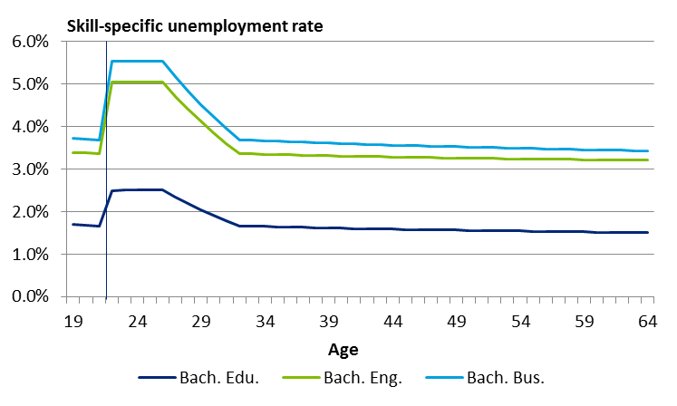
Source: Deloitte Access Economics
As a result of temporary higher unemployment rate for the skills, average unemployment rate over the working life of graduates is higher by approximately 14%. Both private and public benefits are expected to decrease as a result of the higher unemployment rate. However, the effect on the private-public benefit share depends on the discipline.
For instance, a higher unemployment rate for education is expected to lead to a one percentage point increase in the public share of benefits. This means that a relatively larger proportion of the loss is internalised by the individual. In contrast, a higher unemployment rate for engineering and business leads to an increase in the private share of benefits (Table D.1).
The mechanism at work is as follows:
- increasing the unemployment rate decreases the number of skilled workers employed;
- the lower employment moderates the negative impact on wages for the skill category (compared to the central case);
- output in industries where the graduates are likely to be employed increases by a smaller amount; and
- less redistribution elsewhere in the economy to support production.
Consequently, as the industry where education graduates are typically employed (i.e. government services) is relatively less capital intensive compared to other sectors of the economy, there is less of a flow-on distribution to capital creation in other sectors of the economy. Consequently, public benefits fall at a slower rate compared to private benefits, and the share of public benefits increases.
The opposite effect is at play for engineering (and to a lesser extent business). As unemployment in those disciplines increase, while there is a small negative effect on the individual (as their chance of finding employment decreases), there is a larger negative effect on other factors that aren’t required to support production in a higher value-added per worker industry like mining or financial services.
  - : Select public-private shares for unemployment sensitivity analysis
 | Private share | Public share | Change in private share | Change in public share
Bach. Edu.
Base unemployment (1.5%) | 51% | 49% | - | -
High unemployment (1.7%) | 50% | 50% | -1% | 1%
Bach. Eng.
Base unemployment (3.2%) | 39% | 61% | - | -
High unemployment (3.6%) | 43% | 57% | 4% | -4%
Bach. Bus.
Base unemployment (3.4%) | 43.5% | 56.5% | - | -
High unemployment (3.9%) | 44.0% | 56.0% | 0.4% | -0.4%
Source: Deloitte Access Economics DAE-RGEM model. Note: unemployment rate in brackets give the average skill-specific unemployment rate averaged over the working life of the individuals.
Skills substitution
The skills substitution parameter affects the degree to which skills can be substituted between industries.
As there is no direct parameter, it is proxied by an occupation-industry segment where the highest proportion of graduates of a particular discipline is employed. For instance, for education graduates, this is the manager-government services category, which is the destination segment for 79% of graduates. For engineering, this is the manager-business services category, where approximately 30% of graduates are employed. Similarly, 22% of business graduates are employed in the same segment.
In the central scenario, the substitution parameter was based on literature values, then tuned to provide consistent results, such that the Rybczynski effect is contained. These parameters were subject to significant testing. However, given inherent uncertainty over the values, modelling has been undertaken to show how sensitive the results are to the baseline parameter assumptions.
Table D.2 shows that the direction and magnitude of the results depend on the discipline shocked. For instance, increasing the substitutability for the Manager-Government services segment for education, has the effect of reducing private shares of benefits by two percentage points.
  - : Select public-private shares for skill substitutability sensitivity analysis
 | Private share | Public share | Change in private share | Change in public share
Bach. Edu.
Low (50%) | 56% | 44% | 5% | -5%
Base (100%) | 51% | 49% | - | -
High (200%) | 49% | 51% | -2% | 2%
Bach. Eng.
Low (50%) | 37% | 63% | -2% | 2%
Base (100%) | 39% | 61% | - | -
High (200%) | 40% | 60% | 2% | -2%
Bach. Bus.
Low (50%) | 43% | 57% | -1% | 1%
Base (100%) | 44% | 56% | - | -
High (200%) | 46% | 54% | 2% | -2%
Source: Deloitte Access Economics DAE-RGEM model
Increasing the substitution rate in combination with an increase in the labour supply for a skill category leads to the following effects:
- Given an increase in the labour supply, the wage for the particular skill category falls;
- With a higher substitution rate, more individuals of the skill category will be employed within their typical sector compared to the central case;
- The industry expands with less need to draw resources from other sectors; and
- There is a smaller redistributive shift in the economy.
The magnitude and direction of the effect depends on the degree to which skills are concentrated within a particular occupation-industry segment. For skills concentrated in relatively more labour intensive industries like government services, increasing the substitution will lead to a large positive effect. In contrast, for skills not as concentrated in a particular class and within more capital intensive industries more generally, there will be a smaller negative effect.
Factor substitution
In addition to the skills specific factor that determines the substitutability between particular graduate types, there are also model parameters governing the responsiveness of demand for the primary factors of production (the five occupations of labour, capital, land and natural resources) to a change in the relative prices of the factors.
Default values from the GTAP database were used in the baseline. Two sensitivities have been considered:
- A 50% reduction in the substitutability between all primary factors for all industries relative to the default parameters; and
- A 50% increase in the substitutability between all primary factors for all industries relative to the default parameters.
The results are summarised in Table D.3. It finds an increase in the substitutability between factors leads to an increase in the share of private benefits. The transmission mechanism is as follows:
- A positive labour supply simulation for a particular skill category will decrease the price of that particular factor;
- A higher substitution parameter means that industries will respond and employ more of the skilled labour;
- The industry requires fewer resources from other sectors, and the redistribution effect is lessened.
- Consequently, more of the total benefits are captured by the skilled labour rather than other factors of production, and the private share of benefits increases.
  - : Select public-private shares for factor substitutability sensitivity analysis
 | Private share | Public share | Change in private share | Change in public share
Bach. Edu.
Low (50%) | 45% | 55% | -6% | 6%
Base (100%) | 51% | 49%
High (150%) | 53% | 47% | 2% | -2%
Bach. Eng.
Low (50%) | 34% | 66% | -4% | 4%
Base (100%) | 39% | 61%
High (150%) | 39% | 61% | 0% | 0%
Bach. Bus.
Low (50%) | 36% | 64% | -7% | 7%
Base (100%) | 44% | 56%
High (150%) | 42% | 58% | -2% | 2%
Source: Deloitte Access Economics DAE-RGEM model
Industry composition
Within the standard model, the industrial structure of the model is largely constant over time, with the industries growing proportionally larger with the broad economy. For instance, in the baseline for 2011, the mining sector made up 10% of value added. Given that the mining sector is likely to make up a smaller part of the Australian economy in the future, sensitivity analysis tests the effect of a reduction in mining value added for engineering graduates. Indeed, nearly 40% of workers in the mining industry hold engineering qualifications.
In a stylised example, we impose constraints on mining industry output in the baseline such that it accounts for 5% of value added by 2030. Then bachelor engineering graduates are added to the skill pool.
Table D.4 shows that a decrease in the share of the mining sector is associated with a three percentage point increase in the share of private benefits. This is because as the mining sector decreases, other sectors including other business services and government services expand to take its place. Consequently, a higher proportion of mining graduates will be employed in these industries. As other industries in the economy tend to be less capital intensive compared to mining, there is likely to be less allocative gains associated with induced capital investment.

  - : Select public-private shares for industry composition sensitivity analysis
 | Private share | Public share | Change in private share | Change in public share
Bach. Eng.
Base mining (10% of GVA) | 39% | 61% | - | -
Low mining (5% of GVA) | 43% | 58% | 3% | -3%
Source: Deloitte Access Economics DAE-RGEM model

- : Other considerations
The bulk of the work in this study was conducted to understand the public and private benefits of higher education qualifications. In addition to this work, modelling has been undertaken to quantify the relative public and private benefits of labour market outcomes for individuals with higher education qualifications. Importantly, these benefits do not isolate the effect of the qualification itself, rather they combine the demographic and cognitive ability effects along with the qualification effect.

As such, these results cannot be interpreted as the private and public benefits that accrue from a representative individual choosing to gain a higher education qualification (and therefore are not applicable to associated funding policy). Rather, they are the benefits associated with a hypothetical scenario where a representative individual with a higher education qualification and associated demographic characteristics is endowed to the Australian economy (e.g. through skilled migration).

This modelling uses the same approach described in Section 5 and further in Appendix C, but instead models the full labour market differential between school-leavers and qualification holders. To understand the effects of a higher education qualification holders on the broader economy, two simulations are run in the CGE model. The only distinction between the two of these simulations is a small change in the skill endowment in the labour force. One has slightly more graduates, and slightly fewer high-school finishers, in the labour force.
As a more specific example, one simulation may have 1,000 more Bachelor of Education graduates and 1,000 fewer individuals with no-post school qualification, than the other simulation. At a conceptual level, the magnitude of this number is not important. In the CGE modelling framework, individuals in different skill sets can differ in three important ways:
- they earn different wages, meaning they have different levels of productivity (see Assumption 1 in Section 5.2.1);
- they have different industry of employment patterns; and
- they have different rates of unemployment within their skillset.
The observed differences in labour market outcomes are included in the modelling process. Unlike the bulk of the analysis in this report, there is no prior econometric exercise undertaken to split the effect of the qualification itself from the demographic and cognitive ability attributes that may affect labour market outcomes.
To summarise the overall process, the effects of a particular set of higher education qualification holders are estimated by conducting two simulations of the Australian economy in the CGE model.
- the only difference between the two simulations is a small increase in amount of labour services available in the qualification of interest, and a corresponding reduction of labour services available at the high-school level;
- these labour services estimates account for both demographic effects and qualification effects, which influence observed wage premiums and employment probabilities;
- the CGE model reports annual estimates of GNP impact over the 46 years of a typical working lifetime (aged 19-65) - these also account for variation in wages and likelihood of employment over a typical career;
- the stream of annual GNP estimates are expressed as a single figure using a NPV formula, from which the private benefits (an NPV post-tax wage increments) are deducted, to leave public benefits and the private benefits.
Table E.1 below provides the relative public and private benefits of higher education holders for each discipline at the bachelor level. The average split of total market benefits for bachelor level qualification holders are 47% private, and 53% public. These results are similar to the relative benefits of the qualification effect only: the private benefits share is two percentage points higher than the qualification only result, and conversely the public share is two percentage points lower.
On a discipline-specific level, the magnitude of the effect is dependent on the current premium associated with a particular degree. The transmission mechanism at work is as follows:
- shocking the model by the total effect increases the labour supply of the shocked qualification by a greater amount (in average effective units);
- a supply increase of graduates of a particular discipline increases production in sectors that relies the most on those graduates; and
- to support additional production in the sector, resources must be drawn from elsewhere in the economy by offering a higher rate of return.
As the increase in average effective units is larger for engineering graduates (and to a lesser extent business graduates), this requires a greater redistribution within the economy. There are diminishing returns as free resources in the economy get used and resources must be drawn from competing sectors. As the productivity of the marginal unit of labour or capital drawn decreases, the public benefits increase at a slower rate compared to private benefits
  - : Relative benefits (labour endowment – hypothetical scenario)
 | Medicine | Other Health | Educ. | Eng. | Bus. | Arts | Science | IT | Ave.
Private benefits share | 51% | 50% | 51% | 43% | 46% | 50% | 45% | 46% | 47%
Public benefits share | 49% | 50% | 49% | 57% | 54% | 50% | 55% | 54% | 53%
Source: Deloitte Access Economics DAE-RGEM model
It is not surprising that the gross measure of qualification effects plus demographic and cognitive ability effects is close to the qualification-only result. Indeed the main reason for the differential is that the gross shocks involve greater degrees of redistribution of labour across all sectors.

Limitation of our work
General use restriction
This report is prepared solely for the use of Australian Government Department of Education and Training. This report is not intended to and should not be used or relied upon by anyone else and we accept no duty of care to any other person or entity. The report has been prepared for the purpose of informing the Department of relative public and private benefits of higher education. You should not refer to or use our name or the advice for any other purpose.

Contact us
Deloitte Access Economics
ACN: 149 633 116
Level 2
8 Brindabella Circuit
Brindabella Business Park
Canberra Airport ACT 2609
Tel: +61 2 6263 7000
www.deloitteaccesseconomics.com.au

Deloitte Access Economics is Australia’s pre-eminent economics advisory practice and a member of Deloitte's global economics group. For more information, please visit our website www.deloitteaccesseconomics.com.au
About Deloitte
Deloitte refers to one or more of Deloitte Touche Tohmatsu Limited, a UK private company limited by guarantee, and its network of member firms, each of which is a legally separate and independent entity. Please see www.deloitte.com/au/about for a detailed description of the legal structure of Deloitte Touche Tohmatsu Limited and its member firms.
Deloitte provides audit, tax, consulting, and financial advisory services to public and private clients spanning multiple industries. With a globally connected network of member firms in more than 150 countries, Deloitte brings world-class capabilities and deep local expertise to help clients succeed wherever they operate. Deloitte's approximately 200,000 professionals are committed to becoming the standard of excellence.
About Deloitte Australia
In Australia, the member firm is the Australian partnership of Deloitte Touche Tohmatsu. As one of Australia’s leading professional services firms. Deloitte Touche Tohmatsu and its affiliates provide audit, tax, consulting, and financial advisory services through approximately 6,000 people across the country. Focused on the creation of value and growth, and known as an employer of choice for innovative human resources programs, we are dedicated to helping our clients and our people excel. For more information, please visit our web site at www.deloitte.com.auwww.deloitte.com.au.
Liability limited by a scheme approved under Professional Standards Legislation.
Member of Deloitte Touche Tohmatsu Limited
© 2016 Deloitte Access Economics Pty Ltd

An evidence base of efficient costs is also required, though that is not the focus of this work.
The empirical interpretation of the McMahon (2004) findings in subsequent literature, including Chapman and Lounkaew (2011, 2015), may not have been accurate.
This study does not effectively capture market-based productivity spillovers, but rather seeks to capture non-market public returns in pecuniary terms.
A further consideration that affects these relativities is the nature of Australia’s taxation system, with larger productivity benefits generating proportionally larger public returns due to the progressive nature of marginal income taxes.
It should be noted that some of McMahon’s comparable estimates do not relate specifically to higher education attainment (rather he considers years of educational attainment in general), and that these estimates are not specific to Australia.
As part of these changes, from 2005, HECS places became known as Commonwealth Supported Places (CSP) and the total program of student loans from the Australian government became known as the Higher Education Loan Program (HELP).
This research was undertaken by Deloitte Access Economics in support of the Base Funding Review.
The review also recommended that base funding for non-university provision of higher education courses be adjusted down by up to 10% in recognition that these providers are not required to undertake research.
This had previously been accompanied by a plan to deregulate student contribution amounts, which is no longer supported by the Government.
It should be noted that the current Australian Government policy does not include arrangements for student fees to increase to cover the reduction in government subsidies, though this is a potential outcome.
See for example, http://www.who.int/ionizing_radiation/research/gbd/en/
Humanities, science, allied health, mathematics and statistics, information technology, engineering, architecture, medicine, nursing, dentistry, education, visual and performing arts, commerce, law and economics.
Norton (2012) includes a 10% ability bias measure (based on Leigh, 2008) to discount the returns from higher education relative to high school levers. However, this measure ignores other demographic characteristics (beyond gender) which drive differences in wage earnings (noting that the only additional measure Leigh includes is years of experience). It also ignores the fact that heterogeneity in ability bias occurs between fields of education, as well as between those with and without higher education. As such, discipline specific benefits cannot be considered to be casual.
See Appendix A for a discussion of econometric approaches that utilise structural features to account for ability bias.
Wage model characteristics include: age, place of birth, Indigenous status, state of residence, population density of region of residence, disability and English language proficiency. Propensity into employment model additionally includes: family type and age of youngest child. Cognitive controls include: Backward digits span, Symbol digits modalities and Shortened version of the National Adult Reading Test (NART-25).
Based on observations from the ABS 2011 Census—see Deloitte Access Economics (2015)
For example, in lieu of strong evidence for educational externalities within the Australian context, Leigh (2008) assumes that the social return is simply equal to the mean increase in pre-tax earnings See Appendix A for an extended discussion of McMahon (2004) and Chapman and Lounkaew (2011; and 2015).
Dentistry, medicine, law, commerce, engineering, information technology, mathematics, architecture, science (excluding mathematics), education, nursing, agriculture, humanities, and performing arts.
It should be noted that private and public IRR estimates cannot be used to determine relative private and public benefits. For example, government (or students) could make no contributions towards the cost of higher education, implying that their ‘rate of return’ is infinitely large—however, this does not affect the measure of relative benefit.
It should be noted that some of McMahon’s comparable estimates do not relate specifically to higher education attainment (rather he considers years of educational attainment in general), and that these estimates are not specific to Australia.
See Chevalier et al. (2004), Ferrer and Riddell (2001), Jaeger and Page (1996), and Park (1999) for international studies.
See footnote 20 regarding the OECD figures above.
Clarke and Skuterud (2011) attempt to identify whether superior labour market outcomes for Australian immigrants (compared to Canadian immigrants) is a function of the distribution of home countries – and thus, a reflection of differences by country-of-origin – or whether broader labour market conditions at the regional level are more responsible for these differences. Clearly, parallels can be made.
Arbitrarily, they also use 5% samples for the 2006 Census only.
Two obvious examples of latent differences are females who exit the labour force for motherhood and older adults who exit to retirement.
A popular tool in health economics, propensity matching involves comparing two groups with similar characteristics, bar their treatment (i.e. tertiary graduation status). The identification strategy assumes that by matching and controlling for observable characteristics (e.g. age, gender, wealth), the researcher can also control for unobservable characteristics (e.g. innate ability, motivation) – thus, more accurately identify the causal effects of treatment.
A range of other relevant studies have been identified and find similar results, a further review of these studies is included in Appendix A of this report.
The clusters include the Group of 8 (Go8); the Australian Technology Network (ATN); the Innovative Research Universities (IRU); the Regional Universities Network (RUN); and other universities (including overseas universities).
The validity of the selection tool employed in this study is questionable. In particular, there is likely to exist considerable variation within these groups of student characteristics.
Noting the significant limitations of McMahon’s research, and subsequently, the estimates of Chapman and Lounkaew.
The spillover benefits estimated by McMahon are considered to be ‘uncomfortably accurate’ and not applicable to the Australian context.
This study does not effectively capture market-based productivity spillovers, but rather captures seeks to capture non-market public returns in pecuniary terms.
The term market-based productivity is used here as productivity is used conventionally in economics. Higher education may increase the quality of a worker’s output, which in some fields is a public benefit, not captured in the market mechanism. This concept is introduced further in discussed in Section 3.1.5, then discussed in more detail in Section 7.1.
Because the models are estimated on the natural logarithm of real weekly wages, the coefficient on the qualification dummy variables are approximately equal to the percentage differentials in real weekly wages.
Sub-bachelor degrees in this report are defined as Advanced Diploma/Diploma qualifications obtained at a VET or higher education provider. Whilst sub-bachelor is normally restricted to qualifications obtained at a higher education provider, the sample size of these individuals in HILDA is too small for the estimated results to be reliable.
The size of this number is important only for numeric accuracy purposes. Too small, and the two results will not bear any significant difference; too large, and movement will distort the economy unnecessarily (e.g. average wages for high schoolers exceeding bachelor graduates, etc.).
The industry of employment mix could also be a result of the qualification and demographic effects. For simplicity in this analysis, we assume that the destination industry of employment after study is a result only of the qualification itself.
By defining the wage at the weekly level, this includes the part-time/full-time hours variation.
This study assumes that the bulk of the market benefits from higher education relate to wages and employment outcomes after the completion of the qualification. This sets aside any uplift in wages during the qualification, as well as option value of further study.
Australian Government, Department of Prime Minister and Cabinet: Cost Benefit Analysis Guidance note, p.6.
Skills substitutability is proxied by the substitutability of a particular occupation-industry class. The class with the highest concentration of graduates from a particular discipline has been shocked in the analysis. This is manager-government services for education, and manager-other business services for engineering and business. Primary factors of production are: land, capital, natural resources, and the five occupation categories of labour.
To the extent that the current rate of higher education attainment is below its dynamic equilibrium level—the flow-on dynamic effects which induce further rates of higher education attainment (and therefore labour productivity) may be more pronounced in industries which use higher education skilled workers most intensively.
Curriculum and education studies is the study of developing and evaluating appropriate curricula and teaching strategies and practices (ABS ASCED, 2001).
It should be noted that these are forecasts of the economy’s demand for total university qualifications, not total persons with a university qualification. That is, one person may be able to supply multiple university qualifications to the economy (for example, a PhD graduate who also has a bachelor’s degree).
Weighted in terms of total earnings under each discipline recorded in ABS Census data.
For relevant international literature, see Aakvick, Salvanes and Vaage (2003); Angrist and Krueger (1991); Becker and Siebern-Thomas (2001); Card (1995); Oreopoulos (2003); and Webbink and van Wassenburg (2004).
The authors make a number of different comparison groups, based on whether a student is born one, two or three months either side of a cut-off date.
For example, in lieu of strong evidence for educational externalities within the Australian context, Leigh (2008) assumes that the social return is simply equal to the mean increase in pre-tax earnings.
Haveman and Wolfe (1984), Wolfe and Haveman (2001)
For international studies, see Chevalier et al. (2004), Ferrer and Riddell (2001), Jaeger and Page (1996), and Park (1999).
It should be noted that this study is focused only on the relative private and public benefits from higher education attainment, and not the measure of average cost across which private and public contributions should be apportioned. These costs are being evaluated through a separate research exercise.
These are calculated by adding the qualification level coefficient to the individual age bracket coefficients, e.g. for bachelor holders aged 55-59: (-0.08)+0.084=0.004, or 0.4%.
GTAP is a research program based at the Center for Global Trade Analysis in Purdue University's Department of Agricultural Economics.
Occupation categories are: officials and managers, technicians, clerks, service/shop workers, and agricultural and unskilled labour.
This is given by the four levels of post-school education (postgraduate, bachelor, sub-bachelor, and VET) timed by the nine broad fields of study (Medicine, Other health, Education, Engineering, Business and Commerce, Arts (including visual arts), Science, Information Technology, and Food & Hospitality), plus an additional category for those without post-school qualifications.
In the context of a Heckscher-Ohlin model, The Rybczynski effect is the observation that under certain conditions, an increase in endowments can affect the outputs of different goods, to lower overall GDP, when full employment is sustained.
The structural change is phased in gradually over the 2012-2030 period.
The size of this number is important only for numeric accuracy purposes. Too small, and the two results will not bear any significant difference; too large, and movement will distort the economy unnecessarily (e.g. average wages for high schoolers exceeding bachelor graduates, etc.).

