

Undergraduate Applications and Offers, February 2017



Opportunity through learning

ISBN  
978-1-76051-086-2 [PDF]  
978-1-76051-087-9 [DOCX]

Creative Commons

With the exception of the Commonwealth Coat of Arms, the Department’s logo, any material protected by a trade mark and where otherwise noted all material presented in this document is provided under a [Creative Commons Attribution 4.0 International](http://dnet.hosts.network/education/Resources/Documents/Creative%20Commons%20Attribution%204.0%20International) (http://creativecommons.org/licenses/by/3.0/au/) licence.

The details of the relevant licence conditions are available on the Creative Commons website (accessible using the links provided) as is the full legal code for the [CC BY 4.0 International](http://dnet.hosts.network/education/Resources/Documents/CC%20BY%204.0%20International) (http://creativecommons.org/licenses/by/4.0/legalcode).

The document must be attributed as the Undergraduate Applications and Offers, February 2017.

Contents

1. Introduction 5

Purpose of the Report 5

Overview of the Data 5

Acknowledgements 5

2. Highlights 6

Total Applications and Offers – TAC and Direct 6

Field of education 6

Underrepresented groups 7

Australian Tertiary Admission Rank (ATAR) 7

Applications and Offers through Tertiary Admissions Centres 7

Direct Applications and offers 8

3. Applicants 9

Number of Applicants 9

State and Territory 9

Prior Education 9

4. Offers 11

Overall trends 11

State and Territory 11

Offer rate 11

Year 12 status 11

5. Field of Education 14

Applications 14

Offers 14

Offer rate 14

6. Australian Tertiary Admission Rank (ATAR) 16

7. Under-Represented Groups 18

Socioeconomic status 18

Regional status 19

Indigenous status 20

8. University Group 22

Applications 22

Offers 22

Offer rates 22

9. TAC Applications and Offers 24

TAC Applications 24

Prior Education – TAC applications 24

TAC Offers 25

Prior Education – TAC offers 25

10. Direct applications and offers 27

Applications 27

Offers 27

11. Data Qualifications 29

12. Glossary 30

University Group 30

Australian Technology Network 30

Group of Eight 30

Innovative Research Universities 30

Regional Universities Network 31

Undergraduate Applications and Offers, February 2017

# Introduction

## Purpose of the Report

This report looks at the third round data submission on applications and offers processed through Tertiary Admissions Centres (TACs) and the first round data submission on applications made directly to universities for the first semester of the 2017 academic year. It provides trends in the number of applications, offers and characteristics of applicants. As such, these trends are leading indicators of the response of universities to the demand for higher education in 2017.

## Overview of the Data

Data in this report are derived from the University Applications and Offers Data Collection. The data refer to domestic undergraduate student applications and offers as of 27 February 2017. While over 98% of all first semester applications data, both Tertiary Admissions Centres (TAC) and direct, are received by this date, applicants can make decisions on their offers until the close of the application process.

Applications and offers reports are published on the department’s website:

[www.education.gov.au/higher-education-statistics](http://www.education.gov.au/higher-education-statistics).

## Acknowledgements

The department would like to thank all officers of TACs and universities for submitting high quality applications and offers data for the 2017 academic year.

# Highlights

## Total Applications and Offers – TAC and Direct

* The actual number of individuals applying either through a TAC or directly for a university place in 2017 was 340,027, an increase of 1.4% compared to 2016. The increase in applications at this same point in time in 2016 was 1.9%. Direct applicants made up 33.1% of total applicants in 2017.
* There were 281,113 unique offers made, a decrease of 0.2% on 2016. The increase in offers in 2016 was 1.2%. Direct offers accounted for 31.8% of total offers in 2017.
* Unique applications and offers refer to the number of individuals who may apply or receive an offer both through a TAC or direct through a university. Hence, the number of unique or individual applications and offers is less than the sum of TAC and direct applications and offers shown elsewhere in this report.
* The offer rate in 2017 was 82.7%, a decline of 1.3 percentage points from the previous year.
* Following the introduction of the demand driven system from 2012, the offer rate measures the way in which universities choose to respond to student demand.
* Nationally, Year 12 applicants decreased by 1.3% and the number of offers to Year 12 applicants decreased by 1.4%. The number of non-Year 12 applicants increased by 3.3% and offers to non-Year 12 applicants increased by 0.8%. The offer rate for Year 12 applicants was 87.1%, which was higher than the offer rate of 79.6% for non-Year 12 applicants.

## Field of education

* Nationally, the most popular broad field of education (in terms of number of applications) in 2017 was Health (86,392 applicants or 25.4% of all applicants). This was followed by Society and Culture (75,571 applicants or 22.2%) and Management and Commerce (43,421 applicants or 12.8%).
* Fields of education that recorded strongest growth in applications in 2017 were Architecture and Building (10.1%). This was followed by Information Technology (8.5%) and Natural and Physical Sciences (4.9%).
* Society and Culture received the largest number of offers (64,337 or 22.9% of total offers). This was followed by Health (63,792 or 22.7% of total offers).
* Information Technology recorded the largest increase in offers (6.9%). This was followed by Natural and Physical Sciences (4.5%).
* Natural and Physical Sciences had the highest offer rate at 96.8%, but showed a decline in 2017 of 0.4 percentage points. Health had the lowest offer rate of 73.8% in 2017. Architecture and Building experienced the largest fall in the offer rate in 2017 of 4.1 percentage points.

## Underrepresented groups

* In 2017, applicants from a low SES background increased by 1.5%. On the other hand, applications from medium and high SES backgrounds experienced slower growth of 0.4% and 0.8%, respectively.
* In 2017, offers to applicants from a high SES background have shown the smallest decrease (-0.5%) compared with offers to applicants from a low SES background (-0.6%) and medium SES background (-1.0%).
* Applicants from a low SES background were less likely to receive an offer compared with medium SES and high SES applicants. Their offer rate was 81.0% compared with 82.8% for applicants from a medium SES background and 84.1% for applicants from a high SES background in 2017.
* In 2017, applications from metropolitan residents increased by 1.3%, while applications from non-metropolitan residents decreased by 0.8%.
* Offers made to metropolitan applicants decreased by 0.5% compared with a decrease of 1.6% in offers made to non-metropolitan applicants.
* Applications from non-metropolitan residents were more likely to result in an offer compared with applications from metropolitan residents, 85.4% compared with 82.1% respectively.
* Nationally, there were 7120 applicants from an Indigenous background, an increase of 5.5% from 2016 and offers to Indigenous applicants increased by 3.3%.
* The offer rate for Indigenous applicants was 79.5%, which was 1.7 percentage points lower than the offer rate for persons who identified as non-Indigenous.

## Australian Tertiary Admission Rank (ATAR)

* In 2017, 27.8% of all offers made to applicants were for those with an ATAR of at least 70.05. Offers to applicants who achieved an ATAR above 90 accounted for 10.1% of all applicants.
* The share of offers for applicants in the ATAR band 50.00 or less has decreased from 3.4% in 2016 to 2.7% in 2017 or from 9486 to 7657.
* During this time, the likelihood of an applicant with a low ATAR receiving an offer has recorded a greater increase than an applicant with a higher ATAR. In part, this is because offer rates for applicants with a higher ATAR are starting from a higher base so there is less scope for an increase in offer rates. Offer rates for Year 12 applicants in the 50.00 or less ATAR band increased from 39.7% (16,995 applicants) in 2014 to 48.5% (16,527) in 2017. The offer rates for the top three ATAR bands, while already high, have remained relatively steady.

## Applications and Offers through Tertiary Admissions Centres

* As of 27 February 2017, there were 265,678 applications made through Tertiary Admissions Centres (TACs). This is a decrease of 2.5%, compared with the same time in 2016. This follows a decrease of 0.8% at the same point in time between 2015 and 2016.
* There were 214,553 offers made in 2017, a decrease of 2.9% compared with the same time in 2016. This follows a decrease of 1.2% between 2015 and 2016.
* More than four-fifths of applications (80.8%) attracted an offer in 2017, a decrease of 0.4 percentage points over 2016. This follows a decrease of 0.3 percentage points between 2015 and 2016.

## Direct Applications and offers

* The total number of applications (per person per university) made directly to universities in 2017 was 126,270, an increase of 18.3% when compared with 2016.
* There were 95,279 offers resulting from direct applications, an increase of 12.4% between 2016 and 2017.
* Offer rates in relation to direct applications decreased from 79.4% to 75.4% over the same period.
* Compared to TAC applicants, direct applicants were less likely to be Year 12 students and hence were more likely to be older. Female and Indigenous applicants made up a larger share of direct applicants than TAC applicants.

# Applicants

## Number of Applicants

As of 27 February 2017, there were 265,678 applications were made through TACs, including double counting of applicants who had submitted applications in several states. When individual applicants were counted, this decreased to 240,576. On the other hand, there were 118,964 applicants who applied directly to universities (reduced from 126,270 direct applications). The total number of applicants across Australia by February 2017, therefore was, 359,540 adding both TAC and direct applicants together.

Further analysis shows that there was an overlap of 19,513 applicants who applied through TACs as well as directly to universities, hence the number of individuals (ie, unique applicants) that applied for a university place in February 2017 was 340,027, an increase of 1.4% compared to 2016. Direct applicants made up of 33.1% of total applicants until the end of February 2017.

## State and Territory

Compared with 2016, WA recorded the largest growth in applicants (5.3%), followed by Victoria (4.0%), NT (2.3%) and Queensland (1.1%). ACT (-3.2%), NSW and Tasmania (-0.9%) and South Australia (-0.2%) experienced negative growth.

Table : Applicants by states and territory, February 2016 and February 2017

|  |  |  |  |
| --- | --- | --- | --- |
| State/Territory | 2016 | 2017 | % Change |
| NSW | 108,923 | 107,955 | -0.9% |
| VIC | 87,427 | 90,892 | 4.0% |
| QLD | 65,239 | 65,941 | 1.1% |
| WA | 29,527 | 31,092 | 5.3% |
| SA | 24,714 | 24,673 | -0.2% |
| TAS | 7,775 | 7,702 | -0.9% |
| ACT | 6,511 | 6,304 | -3.2% |
| NT | 2,386 | 2,441 | 2.3% |
| Australia | 335,327 | 340,027 | 1.4% |

## Prior Education

* Nationally, Year 12 applications, decreased by 1.3% in 2017, following an increase of 2.2% in 2016 (excluding WA).
* NSW (-2.4%), Victoria (-0.9%), South Australia (-1.8%) and Tasmania (-18.3%) recorded decreases in Year 12 applications.
* All states and territories recorded increases in Non-Year 12 applications, except for the ACT in 2017. WA recorded the largest increase (8.9%) in non-Year 12 applications.
* This is in line with a broader trend in recent years that has seen non-Year 12 applicants less likely to apply for admission through TACs and more likely to apply directly to universities.

Table : Applicants by Year 12 status, by state and territory, February 2016 and February 2017

|  |  |  |  |  |  |  |
| --- | --- | --- | --- | --- | --- | --- |
| State/Territory | Year 12 | | | Non-Year 12 | | |
| **2016** | **2017** | **Change** | **2016** | **2017** | **Change** |
| NSW | 45,379 | 44,295 | -2.4% | 63,544 | 63,660 | 0.2% |
| VIC | 40,497 | 40,152 | -0.9% | 46,930 | 50,740 | 8.1% |
| QLD | 25,488 | 25,603 | 0.5% | 39,751 | 40,338 | 1.5% |
| WA | 12,481 | 12,521 | 0.3% | 17,046 | 18,571 | 8.9% |
| SA | 10,154 | 9,970 | -1.8% | 14,560 | 14,703 | 1.0% |
| TAS | 2,118 | 1,730 | -18.3% | 5,657 | 5,972 | 5.6% |
| ACT | 2,202 | 2,216 | 0.6% | 4,309 | 4,088 | -5.1% |
| NT | 721 | 741 | 2.8% | 1,665 | 1,700 | 2.1% |
| Australia | 139,408 | 137,572 | -1.3% | 195,919 | 202,455 | 3.3% |

* Nationally, Year 12 applications represent 40.5% of total applications, a decrease of 1.1 percentage points compared with 2016.
* Victoria recorded the highest proportion of Year 12 applications (44.2%) and Tasmania recorded the lowest proportion of Year applications (22.5%).

Table 3: Proportion of Year 12 highest preference applications by state and territory, February 2016 and February 2017

Table : Proportion of Year 12 highest preference applications by state and territory, February 2016 and February 2017

|  |  |  |  |
| --- | --- | --- | --- |
| State/Territory | 2016 | 2017 | Change |
| NSW | 41.7% | 41.0% | -0.6 p. p |
| VIC | 46.3% | 44.2% | -2.1 p. p |
| QLD | 39.1% | 38.8% | -0.2 p. p |
| WA | 42.3% | 40.3% | -2.0 p. p |
| SA | 41.1% | 40.4% | -0.7 p. p |
| TAS | 27.2% | 22.5% | -4.8 p. p |
| ACT | 33.8% | 35.2% | 1.3 p. p |
| NT | 30.2% | 30.4% | 0.1 p. p |
| Australia | 41.6% | 40.5% | -1.1 p. p |

# Offers

## Overall trends

Combined offers made through TACs and offers made directly by universities shows that there were 292,995 offers made until 27 February 2017. There were 199,736 unique offers made through TACs and 93,259 unique offers made directly by universities. Accounting for 11,882 applicants who were offered a place both though TACs and directly by universities, the total number of applicants who received an offer across Australia was 281, 113 until the end of February 2017, a decrease of 0.2% on 2016. Offers made to direct applicants accounted for 31.8% of total offers.

## State and Territory

Victoria (1.6%), Queensland (1.0%), NT (0.9%) and WA (0.1%) recorded growth in offers in 2017. All other states and territories recorded negative growth in offers, ranging from -2.2% in Tasmania to -0.3% in SA.

Table : Applicants receiving offers and offer rates by state and territory, February 2016 and February 2017

|  |  |  |  |  |  |  |
| --- | --- | --- | --- | --- | --- | --- |
| State/Territory | Offers | | | Offer rates | | |
| **2016** | **2017** | **Change** | **2016** | **2017** | **Change** |
| NSW | 93,775 | 91,767 | -2.1% | 86.1% | 85.0% | -1.1 p. p |
| VIC | 69,567 | 70,684 | 1.6% | 79.6% | 77.8% | -1.8 p. p |
| QLD | 56,529 | 57,079 | 1.0% | 86.6% | 86.6% | -0.1 p. p |
| WA | 25,007 | 25,036 | 0.1% | 84.7% | 80.5% | -4.2 p. p |
| SA | 20,248 | 20,187 | -0.3% | 81.9% | 81.8% | -0.1 p. p |
| TAS | 7,100 | 6,946 | -2.2% | 91.3% | 90.2% | -1.1 p. p |
| ACT | 5,486 | 5,457 | -0.5% | 84.3% | 86.6% | 2.3 p. p |
| NT | 1,850 | 1,867 | 0.9% | 77.5% | 76.5% | -1.1 p. p |
| Australia | 281,549 | 281,113 | -0.2% | 84.0% | 82.7% | -1.3 p. p |

## Offer rate

The national offer rate in 2017 was 82.7%, a decline of 1.3 percentage points from the previous year. Tasmania recorded the highest offer rate (90.2%) while on the other hand Victoria recorded the lowest offer rate (76.5%) in 2017. The offer rate was down in 2017 in all states and territories except for the ACT.

## Year 12 status

* Nationally, offers to Year 12 applicants decreased by 1.4% in 2017. This follows an increase of 3.3% in 2016 (excluding WA).
* Tasmania recorded the largest decline in offers to Year 12 applicants (18.2%), followed by NSW (5.3%) and WA (3.7%).

Nationally, offers to non-Year 12 applicants increased by 0.8%. This follows a fall of 0.2% in 2016 (excluding WA).

Table : Offers by Year 12 status, by state and territory, February 2016 and February 2017

|  |  |  |  |  |  |  |
| --- | --- | --- | --- | --- | --- | --- |
| State/Territory | Year 12 | | | Non-Year 12 | | |
| **2016** | **2017** | **Change** | **2016** | **2017** | **Change** |
| NSW | 40,947 | 38,781 | -5.3% | 52,828 | 52,986 | 0.3% |
| VIC | 32,745 | 33,552 | 2.5% | 36,822 | 37,132 | 0.8% |
| QLD | 23,257 | 23,581 | 1.4% | 33,272 | 33,498 | 0.7% |
| WA | 10,707 | 10,310 | -3.7% | 14,300 | 14,726 | 3.0% |
| SA | 8,868 | 8,954 | 1.0% | 11,380 | 11,233 | -1.3% |
| TAS | 2,052 | 1,679 | -18.2% | 5,048 | 5,267 | 4.3% |
| ACT | 2,086 | 2,081 | -0.2% | 3,400 | 3,376 | -0.7% |
| NT | 587 | 635 | 8.2% | 1,263 | 1,232 | -2.5% |
| Australia | 121,592 | 119,870 | -1.4% | 159,957 | 161,243 | 0.8% |

* Nationally, applications from Year 12 students were more likely to receive an offer than non-Year 12 students. In 2017, the Year 12 offer rate was 87.1% compared with the non-Year 12 offer rate of 79.6%.
* Offer rates for Year 12 students decreased by 0.1 percentage points to 87.1% in 2017. Offer rates for non-Year 12 students decreased by 2.0 percentage points in 2017, following a decrease of 1.3 percentage points in 2016.
* In 2017, Year 12 offer rates were higher than the non-Year 12 offer rates in all states and territories.
* Above-average offer rates to Year 12 applicants were recorded in Tasmania (97.1%), ACT (93.9%), Queensland (92.1%), South Australia (89.8%) and NSW (87.6%) in 2017.

Table : Offer rates by Year 12 status, by state and territory, February 2016 and February 2017

|  |  |  |  |  |  |  |
| --- | --- | --- | --- | --- | --- | --- |
| State/Territory | Year 12 | | | Non-Year 12 | | |
| **2016** | **2017** | **Change** | **2016** | **2017** | **Change** |
| NSW | 90.2% | 87.6% | -2.7 p. p | 83.1% | 83.2% | 0.1 p. p |
| VIC | 80.9% | 83.6% | 2.7 p. p | 78.5% | 73.2% | -5.3 p. p |
| QLD | 91.2% | 92.1% | 0.9 p. p | 83.7% | 83.0% | -0.7 p. p |
| WA | 85.8% | 82.3% | -3.4 p. p | 83.9% | 79.3% | -4.6 p. p |
| SA | 87.3% | 89.8% | 2.5 p. p | 78.2% | 76.4% | -1.8 p. p |
| TAS | 96.9% | 97.1% | 0.2 p. p | 89.2% | 88.2% | -1.0 p. p |
| ACT | 94.7% | 93.9% | -0.8 p. p | 78.9% | 82.6% | 3.7 p. p |
| NT | 81.4% | 85.7% | 4.3 p. p | 75.9% | 72.5% | -3.4 p. p |
| Australia | 87.2% | 87.1% | -0.1 p. p | 81.6% | 79.6% | -2.0 p. p |

* In 2017, offers to Year 12 applicants represented 42.6% of total offers, a decrease of 0.5 percentage points from 2016.
* Victoria recorded the highest proportion of offers to Year 12 applicants (47.5%), followed by South Australia (44.4%). NT recorded the largest increase (2.3 percentage points) in the proportion of offers to Year 12 applicants compared with 2016, followed by SA (0.6 percentage points). Tasmania recorded a 4.7 percentage points fall in the proportion of offers to Year 12 applicants compared with 2016.

Table : Proportion of offers to Year 12 applicants by state and territory, February 2016 and February 2017

|  |  |  |  |
| --- | --- | --- | --- |
| State/Territory | 2016 | 2017 | Change |
| NSW | 43.7% | 42.3% | -1.4 p. p |
| VIC | 47.1% | 47.5% | 0.4 p. p |
| QLD | 41.1% | 41.3% | 0.2 p. p |
| WA | 42.8% | 41.2% | -1.6 p. p |
| SA | 43.8% | 44.4% | 0.6 p. p |
| TAS | 28.9% | 24.2% | -4.7 p. p |
| ACT | 38.0% | 38.1% | 0.1 p. p |
| NT | 31.7% | 34.0% | 2.3 p. p |
| Australia | 43.2% | 42.6% | -0.5 p. p |

# Field of Education

## Applications

* Nationally, the most popular broad field of education (in terms of number of applicants) in 2017 was Health (86,392 or 25.4% of all applicants). This was followed by Society and Culture (75,571 or 22.2% of all applicants) and Management and Commerce (43,421 or 12.8% of all applicants).
* Among all broad fields of education, Architecture and Building recorded the largest increase in applications (10.1%). This was followed by Information Technology (8.5%) and Natural and Physical Sciences (4.9%).
* The largest decrease in applications was recorded in Agriculture, Environmental and Related Studies (-4.1%), followed by Creative Arts (-2.9%).

## Offers

* Nationally, Society and Culture received the largest number of offers (64,337 or 22.9% of total offers). This was followed by Health (63,792 or 22.7% of total offers).
* Among all broad fields of education, Information Technology recorded the largest increase in offers (6.9%). This was followed Natural and Physical Sciences (4.5%).

Table : Applicants and offers by field of education February 2016 and February 2017

|  |  |  |  |  |  |  |
| --- | --- | --- | --- | --- | --- | --- |
| Field of education | Applicants | | | Offers | | |
| **2016** | **2017** | **Change** | **2016** | **2017** | **Change** |
| Natural and Physical Sciences | 30,663 | 32,171 | 4.9% | 29,801 | 31,138 | 4.5% |
| Information Technology | 9,474 | 10,281 | 8.5% | 8,039 | 8,595 | 6.9% |
| Engineering and Related Technologies | 18,787 | 19,585 | 4.2% | 16,199 | 16,565 | 2.3% |
| Architecture and Building[1] | 8,718 | 9,599 | 10.1% | 6,959 | 7,264 | 4.4% |
| Agriculture, Environmental and Related Studies | 4,711 | 4,519 | -4.1% | 4,293 | 4,018 | -6.4% |
| Health | 84,403 | 86,392 | 2.4% | 63,299 | 63,792 | 0.8% |
| Education | 28,293 | 28,790 | 1.8% | 23,560 | 23,725 | 0.7% |
| Management and Commerce | 43,934 | 43,421 | -1.2% | 39,623 | 38,470 | -2.9% |
| Society and Culture | 75,686 | 75,571 | -0.2% | 65,585 | 64,337 | -1.9% |
| Creative Arts | 29,115 | 28,280 | -2.9% | 22,754 | 21,966 | -3.5% |
| Australia | 335,327 | 340,027 | 1.4% | 281,549 | 281,113 | -0.2% |

Note: Hospitality and Mixed Field Programs are not shown due to the small number of applications/ offers. Hence, the total number of applications/offers does not equal the sum of applications/offers by broad field of education in the above table.

## Offer rate

* Among all broad fields of education, Natural and Physical Sciences recorded the highest offer rate (96.8%), followed by Agriculture, Environmental and Related Studies (88.9%).
* Health (73.8%) and Architecture and Building (75.7%) recorded the lowest offer rates in 2017.
* Offer rates in all fields in 2017 decreased compared to 2016, the smallest decrease was in Natural and Physical Sciences, down by 0.4 percentage points.
* The largest falls in the offer rate were in Architecture and Building, down 4.1 percentage points; Agriculture, Environmental and Related Studies, down 2.2 percentage points, Engineering and Related Technologies and Management and Commerce, both down by 1.6 percentage points.

Table : Offer rates by field of education, February 2016 and February 2017

|  |  |  |  |
| --- | --- | --- | --- |
| Field of education | Offer Rate | | |
| **2016** | **2017** | **Change** |
| Natural and Physical Sciences | 97.2% | 96.8% | -0.4 p. p |
| Information Technology | 84.9% | 83.6% | -1.3 p. p |
| Engineering and Related Technologies | 86.2% | 84.6% | -1.6 p. p |
| Architecture and Building | 79.8% | 75.7% | -4.1 p. p |
| Agriculture, Environmental and Related Studies | 91.1% | 88.9% | -2.2 p. p |
| Health | 75.0% | 73.8% | -1.2 p. p |
| Education | 83.3% | 82.4% | -0.9 p. p |
| Management and Commerce | 90.2% | 88.6% | -1.6 p. p |
| Society and Culture | 86.7% | 85.1% | -1.5 p. p |
| Creative Arts | 78.2% | 77.7% | -0.5 p. p |
| Australia | 84.0% | 82.7% | -1.3 p. p |

Note: Offer rates are expressed as the number of offers as a percentage of first preference applications. Given that offers may result from lower order preferences, offer rates for fields of education may exceed 100%.

# Australian Tertiary Admission Rank (ATAR)

* In 2017, 27.8% of all offers were made to applicants with an ATAR of at least 70.05. Offers to applicants who achieved an ATAR above 90 accounted for 10.1% of all offers.
* The share of offers for applicants in the ATAR band 50.00 or less has decreased from 3.4% in 2016 to 2.7% in 2017 or from 9486 to 7657.

Table : Share of offers by ATAR band, February 2014-February 2017

|  |  |  |  |  |
| --- | --- | --- | --- | --- |
| ATAR band | 2014 | 2015 | 2016 | 2017 |
| 50.00 or less | 6,742  (2.5%) | 7,018  (2.6%) | 9,486  (3.4%) | 7,657  (2.7%) |
| 50.05-60.00 | 11,647  (4.4%) | 11,883  (4.3%) | 11,209  (4.0%) | 10,490  (3.7%) |
| 60.05-70.00 | 18,552  (7.0%) | 18,259  (6.7%) | 17,815  (6.3%) | 18,896  (6.7%) |
| 70.05-80.00 | 22,959  (8.7%) | 21,797  (8.0%) | 23,671  (8.4%) | 22,934  (8.2%) |
| 80.05-90.00 | 26,418  (10.0%) | 25,655  (9.4%) | 26,817  (9.5%) | 27,014  (9.6%) |
| 90.05 or more | 27,604  (10.4%) | 26,531  (9.7%) | 28,304  (10.1%) | 28,284  (10.1%) |
| No ATAR/ Non-Yr 12 | 150,799  (57.0%) | 162,510  (59.4%) | 164,247  (58.3%) | 165,838  (59.0%) |
| Total | 264,721  (100.0%) | 273,653  (100.0%) | 281,549  (100.0%) | 281,113  (100.0%) |

* From 2014 to 2017, offer rates for applicants in the ATAR band 50.00 or less increased from 39.7% (or 16,695) in 2014 to 46.3% (or 16,527) in 2017. The offer rates for the top three ATAR bands, while already high, have remained relatively steady.

Figure : Offer rates by ATAR band, February 2014-February 2017

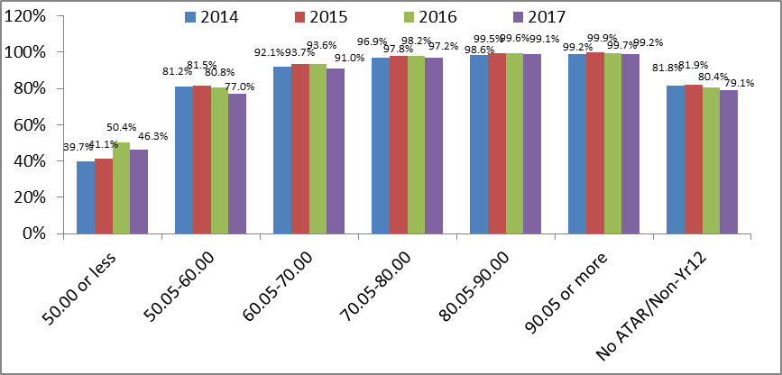

Engineering (24.0%) and Natural and Physical Sciences (17.1%) recorded the largest share of offers made to applicants who achieved an ATAR in the highest band (90.05 or more). This reflects the relatively high ATAR entry requirements for courses in these fields.

Architecture and Building (4.6%), Information Technology (4.0%), Education (3.6%), Society and Culture (3.5%) and Creative Arts (2.9%) all recorded an above average share of offers made to applicants who achieved an ATAR of 50.00 or less.

Table : Share of offers by ATAR band for each field of education, February 2017

|  |  |  |  |  |  |  |  |  |
| --- | --- | --- | --- | --- | --- | --- | --- | --- |
| Field of education | 50.00 or less | 50.05-60.00 | 60.05-70.00 | 70.05-80.00 | 80.05-90.00 | 90.05 or more | No ATAR/ Non-Yr 12 | Total |
| Natural and Physical Sciences | 609  (2.0%) | 856  (2.7%) | 1,874  (6.0%) | 3,283  (10.5%) | 4,697  (15.1%) | 5,340  (17.1%) | 14,479  (46.5%) | 31,138  (100.0%) |
| Information Technology | 341  (4.0%) | 520  (6.1%) | 841  (9.8%) | 810  (9.4%) | 618  (7.2%) | 411  (4.8%) | 5,054  (58.8%) | 8,595  (100.0%) |
| Engineering and Related Technologies | 189  (1.1%) | 324  (2.0%) | 822  (5.0%) | 1,453  (8.8%) | 2,907  (17.5%) | 3,979  (24.0%) | 6,891  (41.6%) | 16,565  (100.0%) |
| Architecture and Building | 334  (4.6%) | 261  (3.6%) | 491  (6.8%) | 758  (10.4%) | 945  (13.0%) | 595  (8.2%) | 3,880  (53.4%) | 7,264  (100.0%) |
| Agriculture, Environmental and Related Studies | 76  (1.9%) | 141  (3.5%) | 263  (6.5%) | 432  (10.8%) | 409  (10.2%) | 213  (5.3%) | 2,484  (61.8%) | 4,018  (100.0%) |
| Health | 1,165  (1.8%) | 1,887  (3.0%) | 3,507  (5.5%) | 4,299  (6.7%) | 4,473  (7.0%) | 4,775  (7.5%) | 43,686  (68.5%) | 63,792  (100.0%) |
| Education | 861  (3.6%) | 1,192  (5.0%) | 1,947  (8.2%) | 1,731  (7.3%) | 1,206  (5.1%) | 454  (1.9%) | 16,334  (68.8%) | 23,725  (100.0%) |
| Management and Commerce | 1,193  (3.1%) | 1,873  (4.9%) | 3,048  (7.9%) | 3,218  (8.4%) | 4,137  (10.8%) | 4,603  (12.0%) | 20,398  (53.0%) | 38,470  (100.0%) |
| Society and Culture | 2,222  (3.5%) | 2,355  (3.7%) | 3,867  (6.0%) | 4,398  (6.8%) | 5,324  (8.3%) | 6,387  (9.9%) | 39,784  (61.8%) | 64,337  (100.0%) |
| Creative Arts | 632  (2.9%) | 1,026  (4.7%) | 2,028  (9.2%) | 2,309  (10.5%) | 2,212  (10.1%) | 1,457  (6.6%) | 12,302  (56.0%) | 21,966  (100.0%) |
| Total | 7,657  (2.7%) | 10,490  (3.7%) | 18,896  (6.7%) | 22,934  (8.2%) | 27,014  (9.6%) | 28,284  (10.1%) | 165,838  (59.0%) | 281,113  (100.0%) |

Note: Hospitality and Mixed Field Programs are not shown due to the small number of offers, hence the total number of offers does not equal the sum of offers by broad field of education in the above table.

# Under-Represented Groups

## Socioeconomic status

* As of 27 February 2017, 19.8% of total applications were from applicants from a low socioeconomic status (SES) background, compared with 50.2% for applicants from a medium SES background and 28.1% for applicants from a high SES background (based on the postcode measure of SES[2]).
* To be represented in proportion to their share in the population, low and high SES applicants would each need to constitute 25.0% of the pool of applicants, with medium SES applicants constituting the remaining 50.0%.
* In 2017, applicants from a low SES background increased by 1.5% compared with the 2016 applications. On the other hand, applications from medium and high SES backgrounds experienced less than average growth 0.4% and 0.8%, respectively.

Table : Applicants and Offers by socioeconomic status, February 2016 and February 2017

|  |  |  |  |  |  |  |
| --- | --- | --- | --- | --- | --- | --- |
| SES | Applicants | | | Offers | | |
| **2016** | **2017** | **Change** | **2016** | **2017** | **Change** |
| Low | 66,183 | 67,186 | 1.5% | 54,727 | 54,396 | -0.6% |
| Medium | 169,953 | 170,687 | 0.4% | 142,830 | 141,412 | -1.0% |
| High | 94,773 | 95,508 | 0.8% | 80,775 | 80,355 | -0.5% |
| Total* | 335,327 | 340,027 | 1.4% | 281,549 | 281,113 | -0.2% |

* The Australia total includes data that could not be coded to an SES value.

* In 2017, offers to applicants from a high SES background have shown the smallest decrease (-0.5%) compared with offers to applicants from a low SES background (-0.6%) and medium SES background (-1.0%).

However, applicants from a low SES background were less likely to receive an offer. Their offer rate was 81.0% compared with 82.8% for applicants from a medium SES background and 84.1% for applicants from a high SES background in 2017.

Figure : Offer rates by socioeconomic status, February 2016 and February 2017

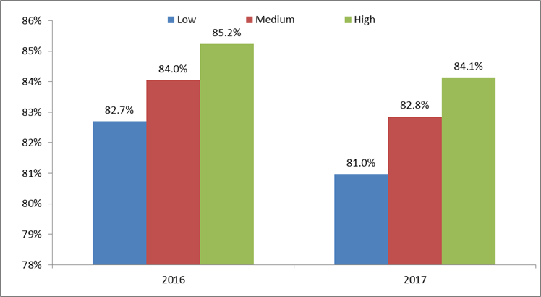

## Regional status[3]

* About 75.0% of applications were from applicants living in metropolitan areas in 2017.
* In 2017, applications from metropolitan residents increased by 1.3%, while applications from non-metropolitan residents decreased by 0.8%.
* Offers made to metropolitan applicants decreased by 0.5% compared with a decrease of 1.6% in offers made to non-metropolitan applicants.
* Applications from non-metropolitan residents were more likely to result in an offer compared with applications from metropolitan residents, 85.4% compared with 82.1% respectively.

Table : Applicants and Offers by region, February 2016 and February 2017

|  |  |  |  |  |  |  |
| --- | --- | --- | --- | --- | --- | --- |
| Region | Applicants | | | Offers | | |
| 2016 | 2017 | Change | 2016 | 2017 | Change |
| Metro | 251,635 | 254,790 | 1.3% | 210,084 | 209,055 | -0.5% |
| Non-Metro | 79,719 | 79,057 | -0.8% | 68,607 | 67,480 | -1.6% |
| Total* | 335,327 | 340,027 | 1.4% | 281,549 | 281,113 | -0.2% |

*The Australia total includes data that could not be coded to a region.

Figure : Offer rates by region, February 2016 and February 2017

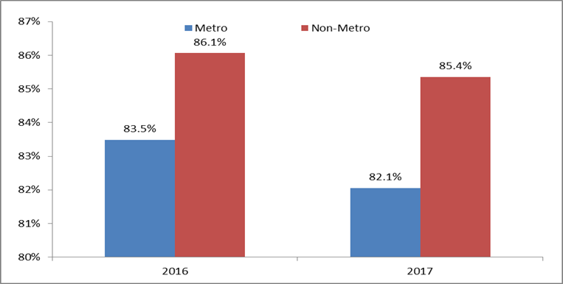

## Indigenous status

* Nationally, there were 7120 applications made by Indigenous applicants[4] in 2017, an increase of 5.5% compared with 2016. This represents 2.1% of all applications applied through TACs and directly to universities.
* Nationally, 5659 offers were made to Indigenous applicants, an increase of 3.3%.
* As of 27 February 2017, just under four fifth of Indigenous applicants (79.5%) had received an offer. This is a decrease of 1.7 percentage points compared with the same period last year. The offer rate for non-Indigenous applicants was 83.1% in 2017, a decrease of 1.2 percentage points over 2016.

Figure : Offer rates by Indigenous status, February 2016 and February 2017

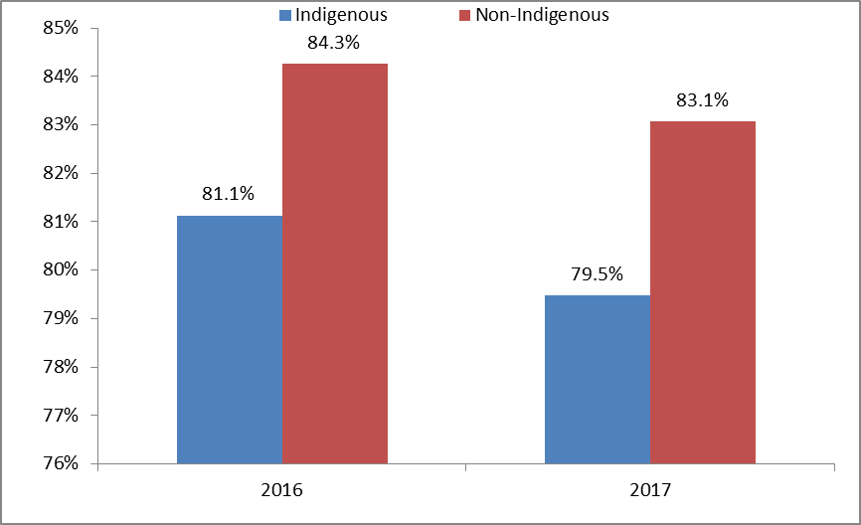

Table : Applicants and Offers by Indigenous status, February 2016 and February 2017

|  |  |  |  |  |  |  |
| --- | --- | --- | --- | --- | --- | --- |
| Indigenous | Applications | | | Offers | | |
| 2016 | 2017 | Change | 2016 | 2017 | Change |
| Indigenous | 6,752 | 7,120 | 5.5% | 5,478 | 5,659 | 3.3% |
| Non-Indigenous | 317,986 | 320,788 | 0.9% | 267,911 | 266,465 | -0.5% |
| Total* | 335,327 | 340,027 | 1.4% | 281,549 | 281,113 | -0.2% |

*The Australia total includes data that could not be assigned to an Indigenous status.

# University Group

## Applications

The Innovative Research Universities (IRU) recorded the largest increase in applications (6.9%), followed by Australian Technology Network (ATN) (6.1%) in 2017.

Applications decreased among the other two university groups with applications to the Group of Eight (Go8) and Regional Universities Network (RUN) decreasing by 2.8% and 2.2%, respectively.

## Offers

The IRU universities recorded the largest increase in offers (5.3%), followed by ATN universities (1.4%) in 2017. Offers by the other two university groups decreased, where the Go8 and RUN universities recorded decreases of -1.6% and -1.3%, respectively.

Table : Applicants and offers by university group, February 2016 and February 2017

|  |  |  |  |  |  |  |
| --- | --- | --- | --- | --- | --- | --- |
| Type of university | Applicants | | | Offers | | |
| 2016 | 2017 | Change | 2016 | 2017 | Change |
| Group of Eight (Go8) | 77,644 | 75,474 | -2.8% | 57,052 | 56,127 | -1.6% |
| Australian Technology Network (ATN) | 61,548 | 65,279 | 6.1% | 48,432 | 49,126 | 1.4% |
| Innovative Research Universities (IRU) | 43,586 | 46,581 | 6.9% | 36,935 | 38,886 | 5.3% |
| Regional Universities Network (RUN) | 29,627 | 28,968 | -2.2% | 27,882 | 27,513 | -1.3% |
| Australia | 335,327 | 340,027 | 1.4% | 281,549 | 281,113 | -0.2% |

## Offer rates

* Applications to Go8 universities and ATN universities were least likely to receive an offer in 2017 (offer rates of 74.4% and 75.3% respectively), reflecting the higher entry requirements at these universities.
* The offer rate increased by 0.9 percentage points at both Go8 universities (to 74.4%) and RUN universities (to 95.0%) in 2017.
* Offer rates decreased at both ATN universities (3.4 percentage points to 75.3%) and IRU universities (1.3 percentage points to 83.5%).

Figure : Offer rates by university group, February 2016 and February 2017

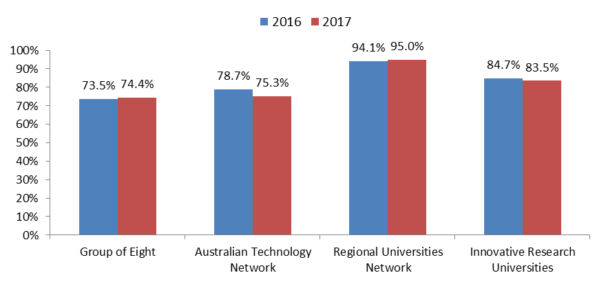

Note: Offer rates are expressed as the number of offers as a percentage of first preference applications. Given that offers may result from lower order preferences, offer rates for university groups may exceed 100%.

# TAC Applications and Offers

## TAC Applications

* The Department receives five submissions of applications and offers data from Tertiary Admissions Centres (TACs) annually. At the end of the third submission (reference date of 27 February 2017) there were 265,648 applications, a decrease of 2.5% compared to 2016. This follows a decrease of 0.8% between 2015 and 2016 (excluding WA).
* Compared with 2016, only Queensland recorded a positive growth (0.7%) in applications. All other states and territories experienced decline in applications, ranging from -0.2% (SA/NT) to -6.2% (Victoria).

Table : Highest preference applications by state and territory, February 2016 and February 2017

|  |  |  |  |
| --- | --- | --- | --- |
| State/Territory | 2016 | 2017 | Change |
| NSW/ACT | 83,076 | 80,460 | -3.1% |
| Vic. | 70,573 | 66,204 | -6.2% |
| Qld. | 57,766 | 58,169 | 0.7% |
| WA | 17,221 | 17,095 | -0.7% |
| SA/NT | 27,482 | 27,425 | -0.2% |
| Tas. | 16,425 | 16,325 | -0.6% |
| Australia | 272,543 | 265,648 | -2.5% |

Notes: State and territory refers to tertiary Admission Centres’ (TACs’) jurisdictions

## Prior Education – TAC applications

* Nationally, Year 12 applications decreased by 0.2% in 2017, following an increase of 1.6% in 2016.
* All states and territories recorded increases in Year 12 applications, except for   
  NSW/ACT (-1.4%) and Victoria (-0.7%).
* Non-Year 12 applications decreased by 5.7% in 2017, following a decrease of 3.7% in 2016.
* This is in line with a broader trend in recent years that has seen non-Year 12 applicants less likely to apply for admission through TACs and more likely to apply directly to universities.

Except Queensland (0.1%), all states and territories recorded declines in non-Year 12 applications in 2017: Victoria (-17.1%), WA (-7.0%) and NSW/ACT (-6.0%), SA/NT (-1.4%) and Tasmania (-0.8%).

Table : Highest preference applications by Year 12 status, by state and territory February 2016 and February 2017

|  |  |  |  |  |  |  |
| --- | --- | --- | --- | --- | --- | --- |
| State/Territory | Year 12 | | | Non-Year 12 | | |
| **2016** | **2017** | **Change** | **2016** | **2017** | **Change** |
| NSW/ACT | 51,476 | 50,760 | -1.4% | 31,600 | 29,700 | -6.0% |
| Vic. | 46,908 | 46,588 | -0.7% | 23,665 | 19,616 | -17.1% |
| Qld. | 29,301 | 29,671 | 1.3% | 28,465 | 28,498 | 0.1% |
| WA | 12,701 | 12,893 | 1.5% | 4,520 | 4,202 | -7.0% |
| SA/NT | 13,124 | 13,233 | 0.8% | 14,358 | 14,161 | -1.4% |
| Tas. | 3,274 | 3,284 | 0.3% | 13,151 | 13,041 | -0.8% |
| Australia | 156,784 | 156,429 | -0.2% | 115,759 | 109,218 | -5.7% |

Note: Hospitality and Mixed Field Programs are not shown due to the small number of applications/offers. Hence, the total number of applications/offers does not equal the sum of applications/offers by broad field of education in the above table.

## TAC Offers

Table : Offers and offer rates by state and territory, February 2016 and February 2017

|  |  |  |  |  |  |  |
| --- | --- | --- | --- | --- | --- | --- |
|  | Offers | | | Offer rates | | |
| State/Territory | **2016** | **2017** | **Change** | **2016** | **2017** | **Change** |
| NSW/ACT | 70,706 | 67,128 | -5.1% | 85.1% | 83.4% | -1.7 p. p |
| Vic. | 55,323 | 52,851 | -4.5% | 78.4% | 79.8% | 1.4 p. p |
| Qld. | 47,098 | 47,785 | 1.5% | 81.5% | 82.1% | 0.6 p. p |
| WA | 14,151 | 13,073 | -7.6% | 82.2% | 76.5% | -5.7 p. p |
| SA/NT | 20,265 | 19,874 | -1.9% | 73.7% | 72.5% | -1.3 p. p |
| Tas. | 13,517 | 13,842 | 2.4% | 82.3% | 84.8% | 2.5 p. p |
| Australia | 221,060 | 214,553 | -2.9% | 81.1% | 80.8% | -0.4 p. p |

* As of 27 February 2017, there were 214,553 offers made, a decrease of -2.9% compared with the same time in 2016. This follows an increase of 0.3% between 2015 and 2016.
* Except Queensland (1.5%) and Tasmania (2.4%), all states and territories recorded negative growth in offers. WA recorded the largest decrease in offers (-7.6%), followed by NSW/ACT (-5.1%), Victoria (-4.5%) and SA/NT (-1.9%).
* More than four-fifths of applications (80.8%) attracted an offer in 2017, a decrease of 0.4 percentage points over 2016. This follows a decrease of 0.3 percentage points between 2015 and 2016.

## Prior Education – TAC offers

* Nationally, offers to Year 12 applicants decreased by 1.1% in 2017. This follows an increase of 3.0% in 2016.
* Offers to Year 12 applicants increased in SA/NT (2.0%), followed by Queensland (1.7%) and Victoria (1.6%). All other states and territories recorded negative growth in offers: NSW/ACT and Tasmania (both -4.6%), followed by WA (-4.3%).
* Offers to non-Year 12 applicants fell by 5.8% nationally. This follows a fall of 6.8% in 2016.
* Tasmania (4.1%) and Queensland (1.2%) recorded positive growth in non-Year 12 offers. All other states and territories recorded negative growth in non-Year 12 offers, ranging from -17.5% (Victoria) to -5.9% (NSW/ACT).

Table : Offers by Year 12 status, by state and territory, February 2016 and February 2017

|  |  |  |  |  |  |  |
| --- | --- | --- | --- | --- | --- | --- |
| State/Territory | Year 12 | | | Non-Year 12 | | |
| **2016** | **2017** | **Change** | **2016** | **2017** | **Change** |
| NSW/ACT | 45,781 | 43,682 | -4.6% | 24,925 | 23,446 | -5.9% |
| Vic. | 37,852 | 38,441 | 1.6% | 17,471 | 14,410 | -17.5% |
| Qld. | 25,576 | 26,015 | 1.7% | 21,522 | 21,770 | 1.2% |
| WA | 10,515 | 10,063 | -4.3% | 3,636 | 3,010 | -17.2% |
| SA/NT | 10,504 | 10,719 | 2.0% | 9,761 | 9,155 | -6.2% |
| Tas. | 2,633 | 2,511 | -4.6% | 10,884 | 11,331 | 4.1% |
| Australia | 132,861 | 131,431 | -1.1% | 88,199 | 83,122 | -5.8% |

# Direct applications and offers

## Applications

* As of 27 February 2017, there were 126,270 direct applications made to universities, an increase of 18.3% on the number of direct applications in 2016.
* Non-Year 12 applicants represent the majority of direct applications. Applications from these applicants accounted for 94.1% of applications as of 27 February 2017, in comparison with 96.3% in 2016.
* The largest increases in direct applications were in Engineering and Related Technologies, up 46.1%, Architecture and Building, up 42.8% and Information Technology, up 38.8%.
* Note, caution should be exercised in interpretation of direct applications data at disaggregated level, for example, by field of education, since universities’ direct admissions processes can vary from year to year.

Table : Direct applications by broad field of education, February 2016 and February 2017

|  |  |  |  |
| --- | --- | --- | --- |
| Field of education | 2016 | 2017 | Change |
| Natural and Physical Sciences | 9,437 | 13,028 | 38.1% |
| Information Technology | 2,951 | 4,096 | 38.8% |
| Engineering and Related Technologies | 4,132 | 6,037 | 46.1% |
| Architecture and Building | 1,473 | 2,103 | 42.8% |
| Agriculture, Environmental and Related Studies | 1,711 | 1,819 | 6.3% |
| Health | 20,537 | 24,735 | 20.4% |
| Education | 12,373 | 14,230 | 15.0% |
| Management and Commerce | 12,949 | 14,847 | 14.7% |
| Society and Culture | 32,340 | 36,168 | 11.8% |
| Creative Arts | 8,462 | 8,956 | 5.8% |
| Australia | 106,693 | 126,270 | 18.3% |

Note: Hospitality and Mixed Field Programs are not shown due to the small number of applications/offers. Hence, the total number of applications/offers does not equal the sum of applications/offers by broad field of education in the above table.

## Offers

* As of 27 February 2017, there were 95,306 direct offers made by universities, an increase of 12.4% on the number of direct offers made in 2016.

The largest increases in direct offers between February 2016 and February 2017 were in Natural and Physical Sciences, up 39.4%, followed by Engineering and Related Technologies, up 37.9% and Information Technology, up 32.4%.

Table : Direct offers by broad field of education, February 2016 and February 2017

|  |  |  |  |
| --- | --- | --- | --- |
| Field of education | 2016 | 2017 | Change |
| Natural and Physical Sciences | 7,350 | 10,244 | 39.4% |
| Information Technology | 2,454 | 3,249 | 32.4% |
| Engineering and Related Technologies | 3,536 | 4,877 | 37.9% |
| Architecture and Building | 1,302 | 1,611 | 23.7% |
| Agriculture, Environmental and Related Studies | 1,496 | 1,572 | 5.1% |
| Health | 15,352 | 17,026 | 10.9% |
| Education | 10,481 | 11,524 | 10.0% |
| Management and Commerce | 11,277 | 12,337 | 9.4% |
| Society and Culture | 24,305 | 25,934 | 6.7% |
| Creative Arts | 7,137 | 6,905 | -3.3% |
| Australia | 84,768 | 95,306 | 12.4% |

Note: Hospitality and Mixed Field Programs are not shown due to the small number of applications/offers. Hence, the total number of applications/offers does not equal the sum of applications/offers by broad field of education in the above table.

# Data Qualifications

The data referred to in this report contains applications and offers for domestic undergraduate university places through TACs and universities as of 27 February 2017. This data represents approximately 98.1% cent of applications data and 98.5% of final offers data in 2016 received from TACs and universities.

It should be noted that:

* Applications and offers data in this report refer to TAC data and applications made directly to universities. More comprehensive comparisons, including detailed direct applications and offers, will be incorporated in the final report.
* Only applications made to [Table A institutions](http://docs.education.gov.au/node/33865) and University of Notre Dame (Table B) are included in the analysis.
* The data does not include applications from overseas students.
* All references to “applications” (in TAC data) in this report relate to highest preference applications.
* A small proportion of applicants make applications to more than one TAC resulting in some double counting of applicants.
* All references to “2017” in this report relate to the 2017 third round submission through TACs and the first round data submission on applications made directly to universities as of 27 February for the first semester of the 2017 academic year.
* All references to “Year 12” applicants in this report relate to applicants who attempted an ACACA Year 12 program or the International Baccalaureate in the year of application.
* While completing Year 12 and gaining a tertiary entrance score is the most common way to gain entry to university, TACs and universities take a number of other qualifications into consideration, particularly for adults applying who have not recently completed Year 12. Some pathways to gaining entry to a university degree include sitting the Special Tertiary Admissions Test (STAT), articulating from certificate and/or diploma level studies in vocational education and training (VET), university bridging or foundation programs and previous higher education (completed or commenced).

# Glossary

Australasian Curriculum Assessment Certification Authorities (ACACA) Year 12 programs: Each State has its own approved Year 12 program. ACACA is the national body responsible for monitoring senior secondary curricula and certification in Australia and New Zealand. The current programs by State are: NSW Higher School Certificate, ACT Year 12 Certificate, Queensland Certificate of Education, Queensland Senior Certificate, South Australian Certificate of Education, Northern Territory Certificate of Education, Tasmanian Certificate of Education, Victorian Certificate of Education, Western Australian Certificate of Education. ACACA Year 12 programs may be undertaken in schools, VET institutions or higher education providers.

Current Year 12 applicant: An applicant who attempted an ACACA Year 12 program or the International Baccalaureate in the year of application.

Offer rate: The offer rate is a percentage calculated as the number of valid offers made to applicants with at least one valid preference divided by the number of applicants with at least one valid preference.

## University Group

### Australian Technology Network

* Curtin University of Technology
* Queensland University of Technology
* RMIT University
* University of South Australia
* University of Technology, Sydney

### Group of Eight

* Monash University
* The Australian National University
* The University of Adelaide
* The University of Melbourne
* The University of New South Wales
* The University of Queensland
* The University of Sydney
* The University of Western Australia

### Innovative Research Universities

* Charles Darwin University
* Flinders University of South Australia
* Griffith University
* James Cook University
* La Trobe University
* Murdoch University

### Regional Universities Network

* Central Queensland University
* Southern Cross University
* Federation University of Australia
* University of New England
* University of Southern Queensland

Note: The following Table A universities are not aligned to a university group: Australian Catholic University; Charles Sturt University; Deakin University; Edith Cowan University; Macquarie University; Swinburne University of Technology; University of Canberra; The University of Newcastle; University of Tasmania; University of Western Sydney; University of Wollongong; and Victoria University.

1. A strong growth in applications and offers in Architecture and Building was influenced by the introduction of a course at one institution in 2017.
2. SES in this report is based on the students' postcode of permanent home residence, with the SES value derived from the 2011 ABS Socio-Economic Index for Areas (SEIFA) Index of Education and Occupation (IEO). The postcode measure of SES provides an indication of the level of disadvantage of an applicant by providing data on the disadvantage associated with the geographical area (postcode) of the applicant’s home address. The postcode measure uses a population reference point of 25% for low SES. The postcodes that comprise the bottom 25% of the population aged between 15 to 64 years are considered low SES postcodes. Applicants with a home address in a low SES postcode are classified as applicants from a low SES background. Applicants with residential addresses outside Australia, and Australian resident applicants with postcodes that do not have SEIFA values are classified as ‘unknown’.
3. Applicants’ postcode of permanent home residence has been used to construct indicators of applicants’ geographic region. To categorise applicants, postcodes are assigned to two groups (metropolitan and non-metropolitan) based on the ABS Australian Statistical Geography Standard (ASGS).
4. Data on Indigenous status (Aboriginal, Torres Strait Islander, or both) is based on a self-reported question on

   TAC applications forms.