

New research block grant data requirements

Consultation Paper



January 2017

**Context**

On 7 December 2015, the Australian Government announced new Research Block Grant (RBG) funding arrangements for Higher Education Providers (HEPs) as part of the National Innovation and Science Agenda (NISA).[1] These arrangements combined existing RBGs into two programs, the Research Support Program (RSP) and the Research Training Program (RTP). These policy innovations are in direct response to the *Review of Research Policy and Funding Arrangements*, led by Dr Ian Watt AC (Watt Review)[2] and are designed to drive greater research-industry collaboration by increasing incentives for success in industry and other end-user engagement. In addition improvements to program guidelines were made in response to recommendations of the *Review of Australia’s Research Training System* undertaken by the Australian Council of Learned Academies (ACOLA Review).

Comprehensive information on the new RBG arrangements and their legislative basis can be found at: <http://www.education.gov.au/research-block-grants>.

The new arrangements commenced on 1 January 2017.

In its consultation paper on new block grant arrangements released in May 2016, the department flagged its intention to improve income and student data collections to meet recommendations of both the Watt and ACOLA reviews. These changes to improve measures of research training performance and research engagement have been agreed by the Minister for Education and Training with a view to implementation in 2018 data collections (for the 2017 reference year).

**About this paper**

This consultation paper:

1. Seeks feedback on a new compliance model for the Australian Competitive Grants Register,
2. Seeks feedback on new indicators required to measure HDR student completion, industry engagement and field of research reporting,
3. Provides advice on the collection of high-level compliance data for the expenditure of RBG allocations from 1 January 2017 onwards, and
4. Provides provisional definitions for new income sub-categories within Categories 2, 3 and 4 of the Higher Education Research Data Collection (HERDC).[3]

The commencement of any revised arrangements will depend on the nature of the changes adopted and the time required for the implementation of new arrangements.

**How to make a submission**

Consultation questions are provided throughout this document. Feedback received through this consultation process will inform the development of the final *2018 HERDC Specifications for the collection of 2017 data* paper and revisions to the Higher Education Student Data Collection (HESDC) and annual financial statements. These revisions will be made in 2017.

The department is inviting submissions in response to these questions by **COB Wednesday 8 March 2017**.

To make a submission please fill out the form that is available on the department’s website at <http://www.education.gov.au/consultation-reporting-requirements-research-block-grants-universities>

Ensure that you answer all required questions on the form. Written comment fields are provided but are limited to approximately 250 words. You will be notified if there is a part of the form that is incorrect, invalid or missing.

Once you have completed the form click on the submit button.

If you realise that you have made a mistake, correct the mistake and click the submit button again. The department will accept the most recent submitted form.

The department will not accept supplemental material without prior written approval.

The department will not accept late submissions without prior written approval.

To seek further advice on how to fill out and submit the form, seek an extension to deadline or provide supplemental material please contact [RBGrants@education.gov.au](mailto:RBGrants@education.gov.au).

Table of Contents

1 Potential new approaches: the Australian Competitive Grants Register 4

Issue 1: ACGR application and assessments process 4

2 Improved measurement of the research training system 8

Issue 2: More comprehensive data on HDR completion timeframes 8

Issue 3: Industry engagement data for HDR students 12

Issue 4: Field of Research Reporting 14

3 RBG expenditure reporting 16

Issue 5: Collecting compliance data 16

4 Provisional definitions of the new HERDC sub‑categories 18

Issue 6: Category 2 – Changes to sub-categories 18

Issue 7: Category 3 – Changes to sub-categories 20

Issue 8: Category 4 – Reporting CRC income on a calendar year basis 22

# Potential new approaches: the Australian Competitive Grants Register

## Issue 1: ACGR application and assessments process

The department maintains the Australian Competitive Grants Register (ACGR) as a definitive list which forms the basis of income reported under Category 1 in the Higher Education Research Data Collection (HERDC).

The re-balancing in incentives between success in Category 1 and Category 2, 3 and 4 under the new RBG arrangements raises an opportunity to review the administration of the ACGR.

There are a number of problems arising from the current ACGR arrangements. The ACGR does not accurately reflect all competitive research won by HEPs in Australia with some income genuinely won by HEPs on a competitive basis excluded. Schemes that fund a wide range of activities under one scheme including competitive grants, non-competitive grants and non-research activities cannot be currently listed as they do not always identify which components are competitive, so income received from competitive processes under that scheme cannot be reported. This creates inaccuracies in reporting between income categories, especially when combined with the minimum funding threshold for listing of $1 million per annum.

Funding bodies are increasingly moving away from traditional stand alone, competitive schemes towards more strategic, investment-driven approaches resulting in the likelihood of more significant pools of funding not being listed on the ACGR. There are also issues around timeliness and effort required on the part of the department to administer the ACGR.

The ACGR process was reviewed in 2010 with assistance from the sector with a focus on streamlining existing procedures. However, these changes have not been able to address the inherent limitation with using a static, definitive list.

**Proposals**

To address these issues, the department seeks the sectors’ views on three options to enhance reporting arrangements for Category 1.

**OPTION 1 – Remove ACGR and rely on an income self-assessment model at the project level**

HEPs currently self-assess Categories 2, 3 and 4 incomes in an effective manner. This option would provide for Category 1 income to be assessed in the same manner.

Moving to a self-assessment model would be done in conjunction with simplification of the current ACGR assessment criteria to enable quick accurate classification of competitive income.

Removing the need to report against the full list of schemes in the ACGR would require classifying income against a list of sub-categories to maintain historical data series. The proposed sub-categories are included in Table 1:

Table 1 – Proposed Category 1 sub categories

|  |  |
| --- | --- |
| Commonwealth | Non Commonwealth |
| National Health and Medical Research Council (NHMRC) | State Government |
| Australian Research Council (ARC) | Industry |
| Other | Private - Not-for-Profit |
| Rural R&D | Other |

**Potential benefits and risks**

This approach removes timing issues related to finalising the ACGR. HEPs would be able to code income as they go when the grant is awarded or paid. There would no longer be an onus on HEPs to encourage scheme managers to apply for listing on the ACGR. HEPs would only assess the income that they win, rather than encouraging scheme managers to list for schemes they may never receive income from.

With changes to the nature of the assessments (assessing each project rather than the broader scheme), individual projects that have previously been ineligible based on the broader scheme not meeting the criteria would now be eligible for reporting as Category 1 income.

This option would allow the removal of the minimum annual funding criterion, allowing income from smaller schemes to be reportable under Category 1.

This option would also address terminating schemes. HEPs would only need to assess project eligibility once to be able to report the income until the payments are complete. There would be a one stage process for grants awarded without any need to assess the entire scheme.

The changes proposed in this option would address the accuracy and completeness of Category 1 and improve reporting for all competitively awarded research income in Australia. However, this option may also introduce a risk of inconsistencies in the income reported when compared across universities. While this is an important issue, this risk exists across all categories and the department aims to reduce variance in interpretations by working with the sector each year to clarify any difference in interpretation of HERDC Specifications.

**OPTION 2 – a Sector maintained ACGR, self-assessed at the scheme level**

Some stakeholders have suggested that a hybrid approach to generating an ACGR where the department maintains an online listing of schemes that universities have self-assessed as competitive throughout the year and nominated for listing. HEPs would nominate schemes and the proposed sub-category for the scheme.

The same streamlining of criteria as described in option 1 would apply. However, the HEP would need to assess at the scheme level rather than project level as is possible with Option 1.

**Potential benefits and risks**

This option has the potential to share the effort of generating the ACGR and spread the workload over a longer period. This would offer the opportunity for the ACGR to be finalised earlier than currently, noting that some programs may still be established and commence disbursement of funds late in the year.

The list would maintain the current transparency of schemes eligible for reporting under Category 1 and maintain scheme-level data within HERDC.

While this option may improve timeliness of the ACGR as it is now, it does not allow for a ‘code as you go’ process like Option 1. Option 2 does not address the major problems of scheme‑based assessments. Maintaining scheme-based assessments would also require the maintenance of some of the complex elements of the assessment criteria, generating difficulties for assessors within universities.

This approach may lead to the duplication of effort between HEPs where assessments occur at the same time prior to listing and to the need to reconcile different views on scheme eligibility arising from more complex assessment criteria.

This option would still require annual assessments including in cases of expired schemes with residual funding disbursements.

There would also be a requirement for the department to constantly monitor self-assessments to mitigate errors in the listings (various spellings, duplication of or confusion between organisations with similar named schemes).

This option does have many of the constraints of the current arrangements including a set timeframe, and broad assessments of schemes rather than projects. While this would assist in the duplication of effort and maintain the current level of reporting, this option would not address the issue of funding schemes changing from traditional approaches to investment driven approaches, and possibly eligible projects being excluded due to the scheme being broadly ineligible.

**OPTION 3: Maintain current arrangements**

The department could continue to maintain the current arrangements.

**Potential benefits**

This option would limit change in existing processes for HEPs during the implementation of the new RBG programs. However, maintaining the current arrangements would not address any of the difficulties described in this chapter, and would not assist the department in working towards all data categories reflecting all relevant and eligible income. If current arrangements are continued, the department would need to consider if there is any scope for further improvement to processes.

Table 2 sets out the current and proposed compliance models for ACGR listing.

Table 2 – comparison or current and proposed arrangements for ACGR listing

|  |  |
| --- | --- |
| Current Arrangements | Proposed Arrangements |
| The department opens applications for new schemes to apply for listing on the ACGR. Subject to an assessment against the criteria, schemes are listed for up to five years. | **Option 1:** HEPs undertake self-assessment for all Category 1 income against the criteria in line with current practices for Category 2, 3 and 4. |
| As above | **Option 2:** HEPscontribute to a public listing published by the department by nominating which schemes have been self-assessed as Category 1 income. |
| As above | **Option 3:** The department maintains current arrangements and examines whether improvements to processes are possible. |

**Questions:**

1. **Please indicate your preference:** 
   * **Option 1: No ACGR**
   * **Option 2: Open ACGR**
   * **Option 3: Maintain current arrangements**
   * **Option 4: None of the above**
2. **If none of the above, please outline your alternative proposal**

# 

# Improved measurement of the research training system

In response to the increased flexibility introduced under new RBG arrangements, the department is seeking to collect:

* More comprehensive data on Higher Degree by Research (HDR) completion timeframes,
* Industry engagement data for HDR students, and
* Field of Research (FoR) reporting for HDR students.

This work aligns with the department’s strategic data plan to ensure its data collections are fit for purpose, providing useful information to both the department and relevant stakeholders.

These particular data improvements will be implemented in the Higher Education Student Data Collection (HESDC) collected through the Higher Education Information Management System (HEIMS). The finalisation of technical implementation issues will be resolved through existing HEIMS consultation processes and a technical working group.

Current HESDC data for HDR students provides good demographic information on students but very little useful information regarding the time it takes them to complete their HDRs, the active time spent on their HDR, the overall effort invested, intensity of engagement with industry and how their HDR connects to the rest of the research system.

HESDC data elements currently provide data on the number of domestic and overseas students supported by the RTS, APA and IPRS programs. A unique student identifier has not been reported for HDR students preventing the department from tracking the progress and outcomes of HDR students.

The lack of a unique identifier also inhibits the connection of the demographic and other student data in HEIMS and when combined with limited information regarding the HDR itself prevents effective benchmarking of research training activities and undermines analysis of the factors contributing to HDR student success.

From 2017 the number of students supported by the RTP will be captured using the same mechanisms previously used for its predecessor programs. CHESSN will be reported as a unique identifier for all domestic RTP students with the option to report a CHESSN for overseas students. This will significantly enhance the capacity to link existing data for analytical purposes. However, only the collection of additional data will provide a better understanding of the research training system, allow the outcomes of the RTP to be better monitored and provide an improved set of benchmarking statistics for the sector.

## **Issue 2:** More comprehensive data on HDR completion timeframes

**Issues**

An examination of research articles on the topic indicates that at least three dimensions of enrolment need to be captured to effectively compare HDR students on completion performance:

* Elapsed time – the actual duration of time from commencement to completion (including periods of leave),
* Effort – the Equivalent Full-Time Student Load (EFTSL) for any period (excludes periods of leave and adjusts for periods of study below full-time), and
* Candidacy time – actual time spent in HDR (elapsed time minus leave).

Each of these dimensions is useful in their own right but collecting all three allows comparison between continuous full-time enrolments and the more complex enrolments such as the example illustrated in Figure 1.

Figure 1 – Example of dimensions of HDR enrolments

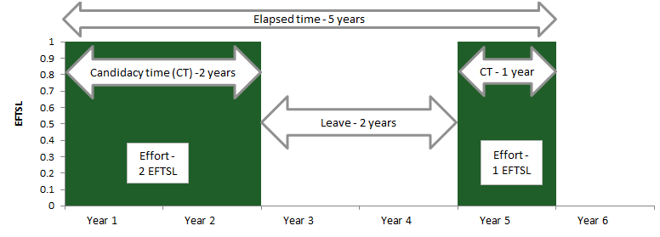

**Elapsed time**

The HESDC currently has a measure of HDR elapsed time based on the course commencement month (YYYYMM in HEIMS element 358) and course completion year (YYYYp in HEIMS element 415). This is the only time measure collected for HDR students but is clearly geared to coursework enrolments where the period represents a semester of study rather than the more flexible and variable nature of HDR enrolments.

The use of this measure as a completion date introduces error into analysis of the elapsed time between commencement and completions. The use of HDR course completion as an end date itself also adds further uncertainty as this is partly dependent on the administrative practice of individual institutions, so may potentially include time consumed by administrative processes in addition to time spent by a student on the HDR.

**Effort**

Elapsed time is useful for comparing completion times for students with continuous enrolment at full-time load such as Student 1 and Student 2 in the Figure 2. However, it is misleading when comparing a full-time student such as Student 1 to a part-time student such as Student 3. Despite Student 3 having double the elapsed time, the total effort to complete the HDR is the same.

The use of effort, as measured by EFTSL, also allows differentiation between part-time students with different study loads such as Student 3 and Student 4 where Student 4 has undertaken 50 per cent more work within the same elapsed time.

With a study at the University of Newcastle[4] estimating that around one third of students mix full‑time and part-time studies, capturing of EFTSL will provide effective comparative data.

Figure 2 – Examples of contrasting HDR student completion timeframes

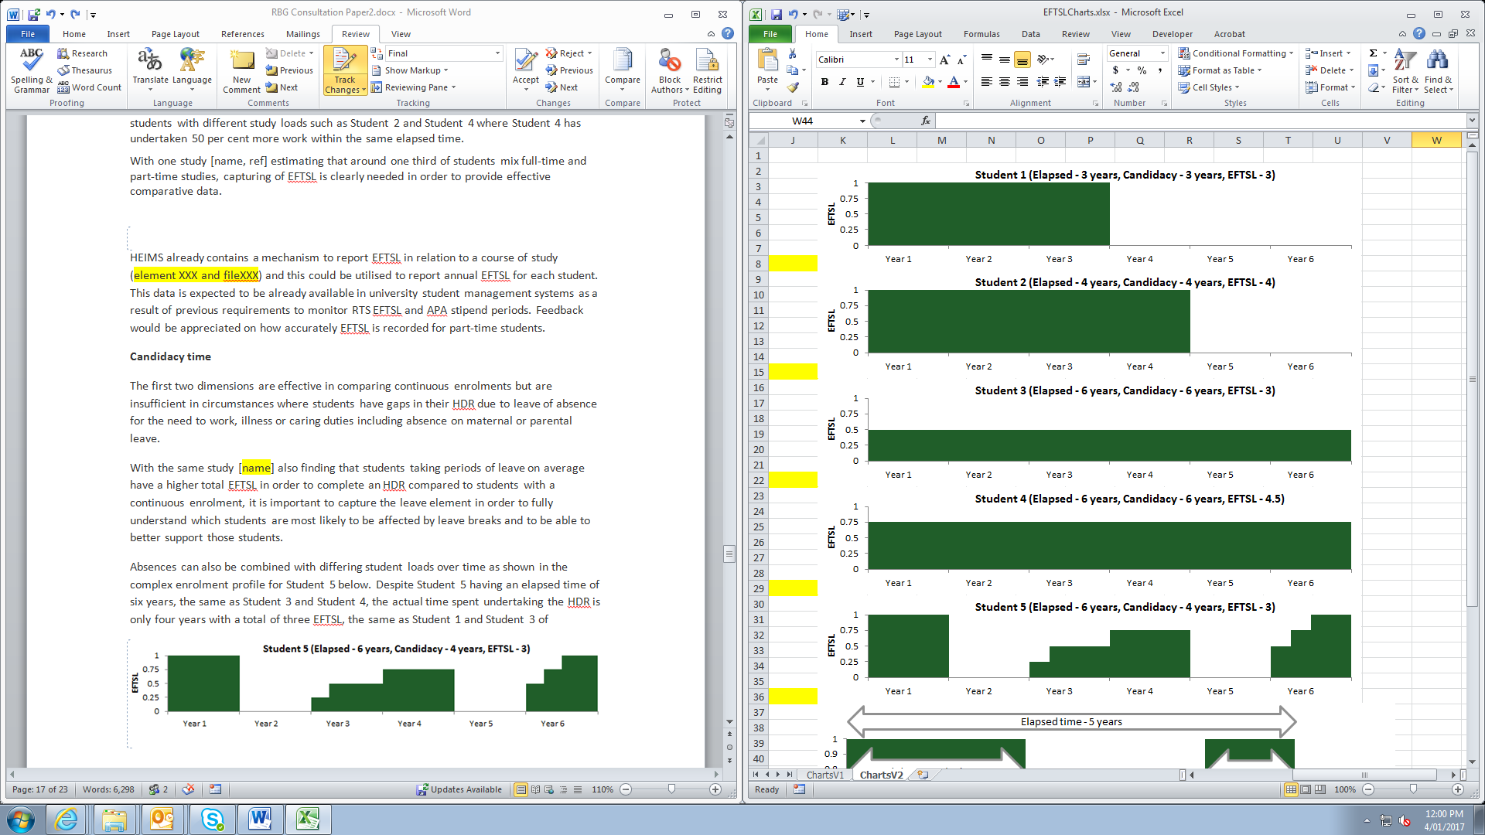

While the HESDC already captures EFTSL values (element 339) the data collected under this element does not necessarily provide all the information required to undertake comprehensive analysis of HDR effort. For example the lack of unique student identifiers for all HDR students (e.g. overseas students) means that HDR effort is effectively reset for a student following a change of university.

**Candidacy time**

The first two dimensions are effective in comparing continuous enrolments but are insufficient in circumstances where students have gaps in their HDR due to leave of absence for the need to work, illness or caring duties including absence on maternal or parental leave.

A later study by Bourke et al[5] found that students taking long periods of leave on average have a higher total EFTSL in order to complete an HDR compared to students with a continuous enrolment. It is therefore important to calculate candidacy time in order to fully understand which students are most likely to be affected by leave breaks and to better support policy development in this area. Candidacy time demonstrates the actual span of time spent on the HDR and can be calculated from deducting leave periods from elapsed time.

Absences can also be combined with differing student loads over time as shown in the complex enrolment profile for Student 5 in Figure3. Despite Student 5 having an elapsed time of six years, the same as Student 3 and Student 4 in Figure 2, the actual time spent undertaking the HDR is only four years with a total of three EFTSL, the same as Student 1 and Student 3.

Figure 3 – Example of student with mixed enrolment profile

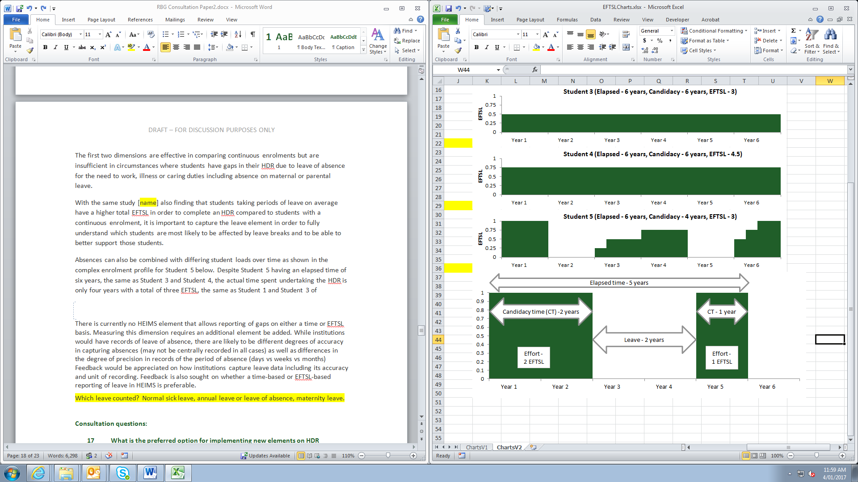

While institutions are expected to have leave records for students, there may be variations in the quality of data across the sector due to lack of centralised reporting, differences in the degree of precision in records of the period of absence (days vs weeks vs months) and a lack of differentiation between different types of leave or other absences such as suspension. There is currently no HEIMS element that allows reporting of leave on either a time or EFTSL basis. Consideration will need to be given to whether different types of leave are all treated equally in reporting. For example, are basic annual and personal leave to be treated the same as suspensions, long term leave such as maternity leave and other absences.

**Data changes**

The department is seeking views on four possible data changes to improve the information on HDR completion timeframes:

* **Change 1 (elapsed time)** – create a new HEIMS element to collect an HDR student’s thesis submission date (YYYYMM).
* **Change 2 (elapsed time)** – create a new HEIMS element, or modify the existing completions element 415, to capture completion year and month (YYYYMM)
* **Change 3** **(effort)** – retain the current HEIMS element 339 or create a new HEIMS element to report either EFTSL or cumulative EFTSL in relation to a HDR course of study
* **Change 4 (candidacy time)** – create a new HEIMS element to report gaps during a HDR such as leave or suspensions

**Potential benefits and risks**

The identified benefits include:

* Change 1 would provide a more precise end point for the time spent undertaking the HDR and exclude any time consumed by administrative and examination processes.
* Change 2 would align the precision of commencement dates with completion dates for HDR, improving current data holdings, and understanding on the full period required for completion. Given that the focus of current completion reporting is aimed at reporting of undergraduate and other coursework completions, it may be preferable to create a new HEIMS element rather than change the existing 415 element.
* Change 3 should not require any data in addition to that already recorded in university student management systems to meet previous requirements to monitor RTS EFTSL and APA stipend periods. If so, the proposal to create a new HEIMS element would be relatively simple to implement and would provide substantially improved information on the amount of time student spend completing HDRs. Whether EFTSL is recorded on a cumulative or by period basis would need to be considered. A new element could also replace the current element 460 (Previous RTS EFTSL), maintaining the same number of HEIMS elements. However, if the current element 339 was considered sufficient to appropriately capture effort then no additional information would be required from universities.
* Change 4 would require a new data element to capture leave and other periods of absence in order to calculate candidacy time. However, this would provide for a much richer data set in conjunction with other changes and provide for analysis on the impact of students taking long periods of leave. When combined with other personal and HDR characteristics this offers the potential to identify and support students at higher risk of encountering difficulties in their HDR.

**Questions**

1. **Is the proposed model appropriate?**
2. **Are there any technical barriers to implementation? For example issues with reporting leave data, or reporting undergraduate completions by month.**
3. **If there are there any other issues that should be considered, or you have an alternative model, please outline these here.**

## **Issue 3: Industry engagement data for HDR students**

**Issues**

The Australian Government’s NISA initiative seeks to improve opportunities for HDR students to engage with industry and other end-users of research. This is intended to enhance the innovation system’s ability to utilise the research capacity of universities as students with experience in commercial environments move into academia and industry. As outlined in the ACOLA Review there is currently an absence of data to determine the extent of involvement of industry in HDR training.

HDR students can interact with businesses and other end users in highly varied ways during their HDR with different lengths, depth and intensity of engagement. For example, these interactions may be through formal industry placements or self-organised short-term internships while other students may be undertaking an integrated program of study which involves consistent engagement with industry throughout their entire HDR. These varying types of engagement have implications in how the department collects data on industry engagement for HDR students.

The department intends to take a broad view of industry engagement with some of the activities that could be considered for inclusion in the definition of industry engagement for HDR students being:

* an HDR student working on an industry defined research problem,
* an HDR student supervised by an employee in industry,
* an HDR student working on the student’s own HDR project in an industry setting, and
* an HDR student undertaking a formal cadetship, internship or employment with an industry employer (undertaken either at the same time as the HDR project or during a break in the HDR).

**Proposal**

Developing a comprehensive data set on all possible variations to activities involved in industry engagement would be a complex and costly process and is considered beyond the scope of these current data improvements.

The department instead proposes the creation of a new HEIMS data element to collect the total time HDR students’ spend in industry engagement activities. This provides useful yet relatively low cost data that can be readily linked to other student and course information.

This information would be reported on an EFTSL basis. The EFTSL would be considered a standalone data element, separate to information recorded in relation to the HDR itself.

**Potential benefits and risks**

This would provide information on the numbers of HDR students and their time spent in industry and when combined with other data improvements (e.g. field of research) would provide a real improvement to the sector’s and the government’s evidence base and analytical capacity.

**The example of Lisa:**

As part of her PhD, Lisa undertakes a formal industry placement in a business for a period of 6 months in the reporting year. During this time she works full-time on her PhD with a business co-supervisor in a business environment. The EFTSL reported for both Lisa’s HDR and industry experience would be 1.0.

**The example of Aaron:**

Aaron undertakes a PhD in the field of geology. Due to the nature of this project, Aaron has consistent interactions with the mining industry throughout his PhD. The total number of days in which Aaron has interactions with industry in the reporting year is 20 half days and 80 full days. This is a total of 90 days or one quarter of a year meaning the EFTSL reported for Aaron would be 0.25.

**Questions:**

1. **Is the proposed new unit of measurement (i.e. industry engagement reported as EFTSL) appropriate?**
2. **What definition of ‘industry engagement’ should be used for the new HDR engagement element and what activities should be included?**
3. **Are there any technical barriers to implementation? For example, issues with tracking engagement HDR enrolments.**

## **Issue 4: Field of Research Reporting**

**Issues**

Data on the subject of a student’s HDR is currently reported by the Field of Education (FoE) at the six-digit level with the option for reporting a supplementary FoE where an HDR spans multiple FoEs. These FoEs are used to classify high-cost or low-cost completions used in the current RTP formula. However, the use of FoE does not align with other data on the research system which is classified by Field of Research (FoR). This limits more detailed analysis of the HDR training system and its linkages to the broader Australian research system as well as preventing effective comparisons with international HDR regimes.

The FoR will be collected according to the Australian and New Zealand Standard Research Classification Field of Research (FoR), a hierarchical classification with three levels—Divisions (two-digits), Groups (four-digits) and Fields (six-digits).

Figure 4 – illustration of Field of Research

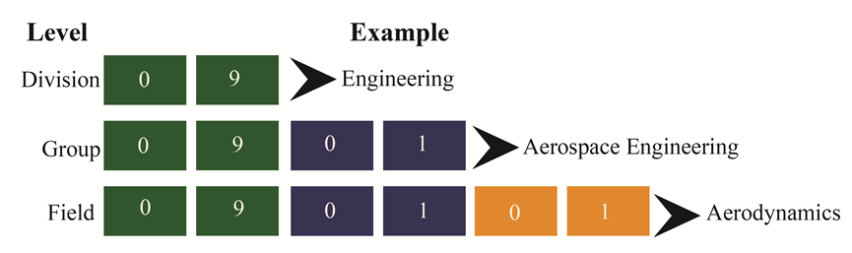

Different levels of FoR classification codes are used across agencies for international comparisons, grant applications and to classify research outputs. For example:

* the FoR aligns at the two-digit Division level with the OECD's Fields of Science 2007 classification, allowing for international comparisons,
* the Australian Research Council’s (ARC) Excellence for Research in Australia (ERA) uses two and four-digit FoR to classify research outputs, and
* the NHMRC uses six-digit FoR to classify research activities.

**Proposal**

To improve the quality of available data the department proposes to collect FoR data for HDR students at the six-digit level through a new HEIMS element. This data could either be collected based on a student’s enrolment or based on a student’s course of study similar to current arrangements for FoE.

Given that research projects often cross over multiple research fields there will also be an optional additional HEIMS element for the reporting of FoR data for a secondary field in addition to the primary field. The supplementary FoR will also be reported at the six-digit level.

As FoE data is used to classify high-cost or low-cost completions in the current RTP allocation formula the department is required to continue collecting FoE data alongside the new FoR data.

**Potential benefits**

FoR reporting at the six-digit level will allow for:

* aggregation of data to four and two digit levels to match other data sets
* improved evaluation of the performance of the research training system as recommended in the ACOLA *Review of Australia’s Research Training System*
* detailed analysis of differentiating completion rates, attrition rates and HDR demographics across different research fields
* analysis of alignment with government, not-for-profit and commercial R&D expenditure
* improved data on concordance between FoE and FoR
* integrated analysis with sources held at other agencies such as NHMRC and ARC
* international statistical comparisons
* Track the emerging research workforce and its alignment to the needs of the research sector

**Questions**

1. **Are institutions able to accurately classify HDRs at the six digit FoR level?**
2. **Are there any technical barriers to implementation?**

# RBG expenditure reporting

## **Issue 5: Collecting compliance data**

**Issues**

**Research Training Program (RTP)**

The new arrangements allow HEPs the flexibility to spend RTP funds on a mix of fees offsets, stipends and allowances for both domestic and international students.

To ensure that universities comply with the requirement of a maximum of 10 per cent of funding spent on RTP scholarships on overseas students (subparagraph 1.6.30 of the [*Commonwealth Scholarships Guidelines (Research) 2017*](https://www.legislation.gov.au/Details/F2016L01602) the department will require some annual high-level expenditure reporting.

**Research Support Program (RSP)**

In line with new more flexible funding arrangements, HEPs are able to spend their RSP funds on any activities related to research, with the exception of stipends for HDR students. While the department had proposed in its previous [consultation paper](https://docs.education.gov.au/node/40701) to exclude costs associated with supporting research students, in recognition that research students are integrated into the fabric of HEPs research operations this type of RSP expenditure is permitted. However, it is important that HEPs are not using this flexibility to bypass RTP legislated caps on overseas students or to support activities that should primarily be funded through the RTP.

**Proposals**

**RTP**

The department proposes to collect the following data in relation to annual expenditure for the RTP (Table 3).

Table 3 – RTP compliance data

|  |  |  |
| --- | --- | --- |
| Total HEP RTP expenditure | Total domestic students | Total overseas students |
| RTP Fees offsets | $ | $ |
| RTP Stipends | $ | $ |
| RTP Allowances | $ | $ |
| Total for all types of support | **$** | **$** |

Given that the information will be required to be audited the department proposes that this information be collected through a new note in annual financial statements.

**RSP**

The department is seeking feedback on HEPs’ intended use of RSP funding and whether this funding will be used to support the research training activities of HDR students.

**Questions:**

1. **Are there any technical barriers to implementation? For example, complications with providing data through annual financial statements.**
2. **What proportion of RSP funding does the HEP intend to use to support additional fees offsets for HDR students?** 
   * **No funding to support additional fees offset for HDR students**
   * **More than 0 and less than 5 per cent**
   * **5 – 10 per cent**
   * **10 – 20 per cent**
   * **More than 20 per cent**

# Provisional definitions of the new HERDC sub‑categories

The Watt Review recommended that a review of RBG engagement data be undertaken to examine research income counted in Categories 2, 3 and 4 of the HERDC. The intent was to determine which data provides the most appropriate measures of end-user R&D engagement. The department subsequently reviewed the data as part of the new research block grant arrangements, canvassed in the May 2016 consultation paper. It identified that:

* While R&D income is the most robust, available measure of R&D engagement, the sub-categories of HERDC Categories 2, 3, and 4 include some income streams (such as income from HDR students) that may not be an appropriate or reliable measure of research engagement, and
* More accurate classification of end-user R&D engagement income would further sharpen incentives for engagement.

The existing HERDC income categories are currently a mix of classification systems based on organisational characteristics (who is funding the R&D) and/or transactional characteristics (type of R&D funding agreement) rather than functional characteristics (why is the R&D being funded). As recommended by the Watt Review and agreed through the May 2016 consultation process, new sub-categories for HERDC Categories 2, 3 and 4 will commence for the reporting of the 2017 reference year data, in 2018.

These new sub-categories attempt to better identify functional characteristics, building on the current organisational/transactional based categories. A purely functional classification system would require a costly overhaul of the HERDC process (for example classifying R&D income by type; basic, applied research and experimental development) and would also lose valuable data (including historical trend data).

The Government, through its National Innovation and Science Agenda, identified a need to better measure and understand the role of universities in fostering innovation through R&D engagement and collaboration. One way is to measure the extent that investment in university R&D comes from end-users (such as private industry) that have their own immediate and specific objectives for funding the R&D. The sub-categories that the department has developed are therefore in keeping with the recommendations of the Watt Review that were accepted by the government.

The tables below provide provisional definitions and exceptions/exclusions. These definitions attempt to introduce functional characteristics to more clearly distinguish end-user engagement from general purpose R&D income as agreed through the May 2016 consultation process. Based on these proposed definitions, we have provided a decision tree for category 2, 3 and 4 income in Figure 5.

Issue 6: Category 2 – Changes to sub-categories

The new Category 2 merges R&D income from State/Territory/Local sub-categories and splits each income stream into ‘own-purpose’ and ‘other’ sub-categories. The new sub-categories aim to better measure end-user engagement by government as recommended by the Watt Review. Practical definitions of ‘own-purpose’ and ‘other’ subcategories are required to better align with the objective of government funding. Table 4 provides the provisional definitions for these sub-categories of Category 2 R&D income.

According to Table 4 the department proposes that the ‘own-purpose’ sub-category equate to government-commissioned research services and that all other forms of support (not captured elsewhere in HERDC) be defined as ‘other’ research.

In most cases, government procurements or contracts will equate to ‘own purpose’ income whereas grants and other forms of program support will equate to ‘other’ income. However, research income arrangements may involve grants covered by a contract or other funding agreement (i.e. with local governments). In categorising funds as either ‘own purpose’ or ‘other’ income, HEPs should consider:

* projects developed primarily by the funding agency, or jointly by the funding agency and the investigator(s) as ’own purpose’ income, and
* funding for research where the project was developed primarily by the investigator(s) as ‘other’ income.

Table 4 – Category 2 provisional definitions

|  |  |  |
| --- | --- | --- |
| New sub-categories | Provisional definition | Exceptions |
| Commonwealth – own purpose | Procurements (contracts) with any Australian Government department or agency  Incl. government business enterprises | Excl. public-private partnerships  Excl. donations or bequests from governments |
| Commonwealth – other | Grants or program support from any Australian Government department or agency  Incl. income from Research and Development Corporations where they are statutory corporations or authorities. | Excl. Competitive, peer reviewed grants listed in the ACGR |
| State/Local – own purpose | Procurements (contracts) with any State, Territory or local government department or agency  Incl. government business enterprises | Excl. public-private partnerships  Excl. donations or bequests from governments |
| State/Local – other | Grants or program support from any State, Territory or local government department or agency | Excl. Competitive, peer reviewed grants listed in the ACGR |

Note: Unless otherwise noted standard inclusions and exclusions listed in the HERDC specifications apply.

**Questions:**

1. **Do the proposed definitions exclude any income currently reported in category 2?**
2. **Are there any technical barriers to implementation?**

Issue 7: Category 3 – Changes to sub-categories

In response to government priorities and previous consultation Category 3 sub-categories will be amended to allow engagement with different types of end-users to be more clearly differentiated. Table 5 sets out provisional definitions for the Category 3 sub-categories of R&D income. The proposed sub-categories separate the country of origin (Australian vs. International sources) and the type of organisation (for-profit vs. not-for-profit vs. philanthropic sources).

HDR fees are ineligible income for the reporting of 2017 data in 2018.

International income of all types has been measured in Category 3 and has been a significant and growing income source for many Australian universities, increasing from 8.6% of total R&D income in 2000 to 12.0% of total R&D income in 2015. Total international R&D income from competitive, peer reviewed grants was $121 million in 2015 and other international R&D income was $179 million, which has historically included HDR fee income. Excluding HDR fee income from the scheme leaves international R&D income at around 8%, still a significant figure. This figure includes competitive grant income from international government sources and from supranational or intergovernmental organisations regardless of whether it is own-purpose. International government income has therefore been retained in Category 3 as separate sub-categories (See Table 5) but following the approach outlined for Category 2. If these sub-categories were not retained then international government engagement could not be accurately measured or, by definition, competitive grant income from international governments may be excluded from HERDC. An option is to move international government income from Category 3 to Category 2; however, this would break the Category 3 time series.

**Treatment of not-for profit organisations**

A *not-for-profit* organisation does not operate for the profit or gain of its individual members, whether these gains would have been direct or indirect. A not-for-profit organisation can take many forms. For further guidance on not-for-profit organisations see the Australian Tax Office [website](https://www.ato.gov.au/non-profit/getting-started/is-your-organisation-not-for-profit-/). Income from other not-for-profit universities is excluded from HERDC.

Many not-for-profit organisations operate as charities. However, even these organisations may contract university R&D for their own purposes rather than as a more general donation where the organisation receives no material benefit or advantage. Philanthropic income (donations and bequests) has therefore been separated from own-purpose R&D income from private not-for profits.

Table 5 – Category 3 provisional definitions of R&D income

|  |  |  |
| --- | --- | --- |
| New sub-categories | Provisional definition | Exceptions |
| Australian – Industry | Contracts with, or grants from, any for-profit private market sector business based in Australia  Incl. Australian subsidiaries of multi-national businesses or multi-nationals with the Head Office in Australia  Incl. syndicated R&D arrangements  Incl. income from for-profit, industry-owned Research and Development Corporations | Excl. private, not-for-profit businesses or philanthropic organisations and individuals |
| Australian – Private, not-for-profit | Contracts with, or grants from, any private not-for-profit organisation based in Australia  Incl. mutuals, cooperatives and foundations  Incl. grants from, or contracts with, charity organisations  Incl. Australian subsidiaries of multi-national private, not-for-profit organisations or multi-nationals with the Head Office in Australia  Incl. income from not-for-profit, industry-owned Research and Development Corporations |  |
| Australian – Philanthropy | Donations or bequests from any non-government organisation or individual based in Australia | Excl. grants from, or contracts with, charity organisations |
| International – Industry | Contracts with, or grants from, any for-profit private market sector business based outside Australia | Excl. Australian subsidiaries of multi-national businesses or multi-nationals with the Head Office in Australia |
| International – Private, not-for-profit | Contracts with, or grants from, any private not-for-profit organisation based outside Australia  Incl. mutuals, cooperatives and foundations  Incl. grants from, or contracts with, charity organisations and international universities | Excl. Australian subsidiaries of multi-national not-for-profits or multi-nationals with the Head Office in Australia |
| International – Philanthropy | Donations or bequests from any non-government organisation or individual based outside Australia |  |
| International – Government (own purpose) | Contracts with any non-Australian government organisation or agency  Incl. Supranational or intergovernmental organisations such as the European Commission, OECD or United Nations | Excl. Competitive grants from international research funding agencies |
| International – Government (other) | Grants or program support from any non-Australian government organisation or agency  Incl. Supranational or intergovernmental organisations such as the European Commission, OECD or United Nations  Incl. Competitive grants from international research funding agencies |  |

Note: Unless otherwise noted standard inclusions and exclusions listed in the HERDC specifications apply. A donation is defined as money given to a university by a donor for a broad research purpose with no expectation of material benefits or advantage such as specific research deliverables and reporting except for recognition of the donor and the expenditure of the money in accordance with the donor's wishes. A bequest has all the elements of a donation except that it is received from the estate of a deceased person.

**Questions:**

1. **Do the proposed definitions exclude any income currently reported in category 3?**
2. **Are there any technical barriers to implementation?**
3. **Are there any proposed sub-categories that are insignificant in size (at a sector level) and warrant a rational consolidation with other sub-categories?**

Issue 8: Category 4 – Reporting CRC income on a calendar year basis

Category 4 (Cooperative Research Centre, CRC) income is typically less than 3% of total R&D income from the university sector and receives its own Part B within the HERDC specifications. As discussed at the beginning of this chapter, the current sub-categories are based around the relationship of funding sources to a CRC rather than identifying the type of end-user organisation funding the research. The Department is therefore changing the sub-categories of Category 4 by replacing ‘Non-higher education provider (HEP) participant’ and ‘Third party’ Category 4 sub-categories with ‘Industry’ and ‘Other.’ Table 6 sets out the provisional definitions for the Category 4 sub-categories. Category 4 income will also now be reported on a calendar year basis to align with the remainder of the HERDC income collection. To manage the transition, HEPs will be able to ‘double count’ the six month period that overlaps the relevant financial/calendar year.

These changes have been agreed with the CRC Association.

Table 6 – New Category 4 provisional definitions

|  |  |  |
| --- | --- | --- |
| Sub-categories | Provisional definition | Exceptions |
| Australian Government grants to CRCs^ | Competitive, peer reviewed grants from Australian Government CRC program and grants from other programs |  |
| Industry | Contracts with, or grants from, any private sector business  Incl. Income from private sector CRC members and non-members  Incl. Contracts with, or grants from, any private not-for-profit organisation based in Australia | Excl. University contributions |
| Other | Donations, bequests, contracts or grants from any other State, Territory or local government organisation or individual.  Incl. Contracts from Australian Government departments or agencies  Incl. University contributions |  |

Note: Unless otherwise noted standard inclusions and exclusions listed in the HERDC specifications apply. ^Unchanged.

**Consultation questions:**

1. **Do the proposed definitions exclude any income currently reported in category 4?**
2. **Are there any technical barriers to implementation?**

Figure 5 – Eligible research income decisions chart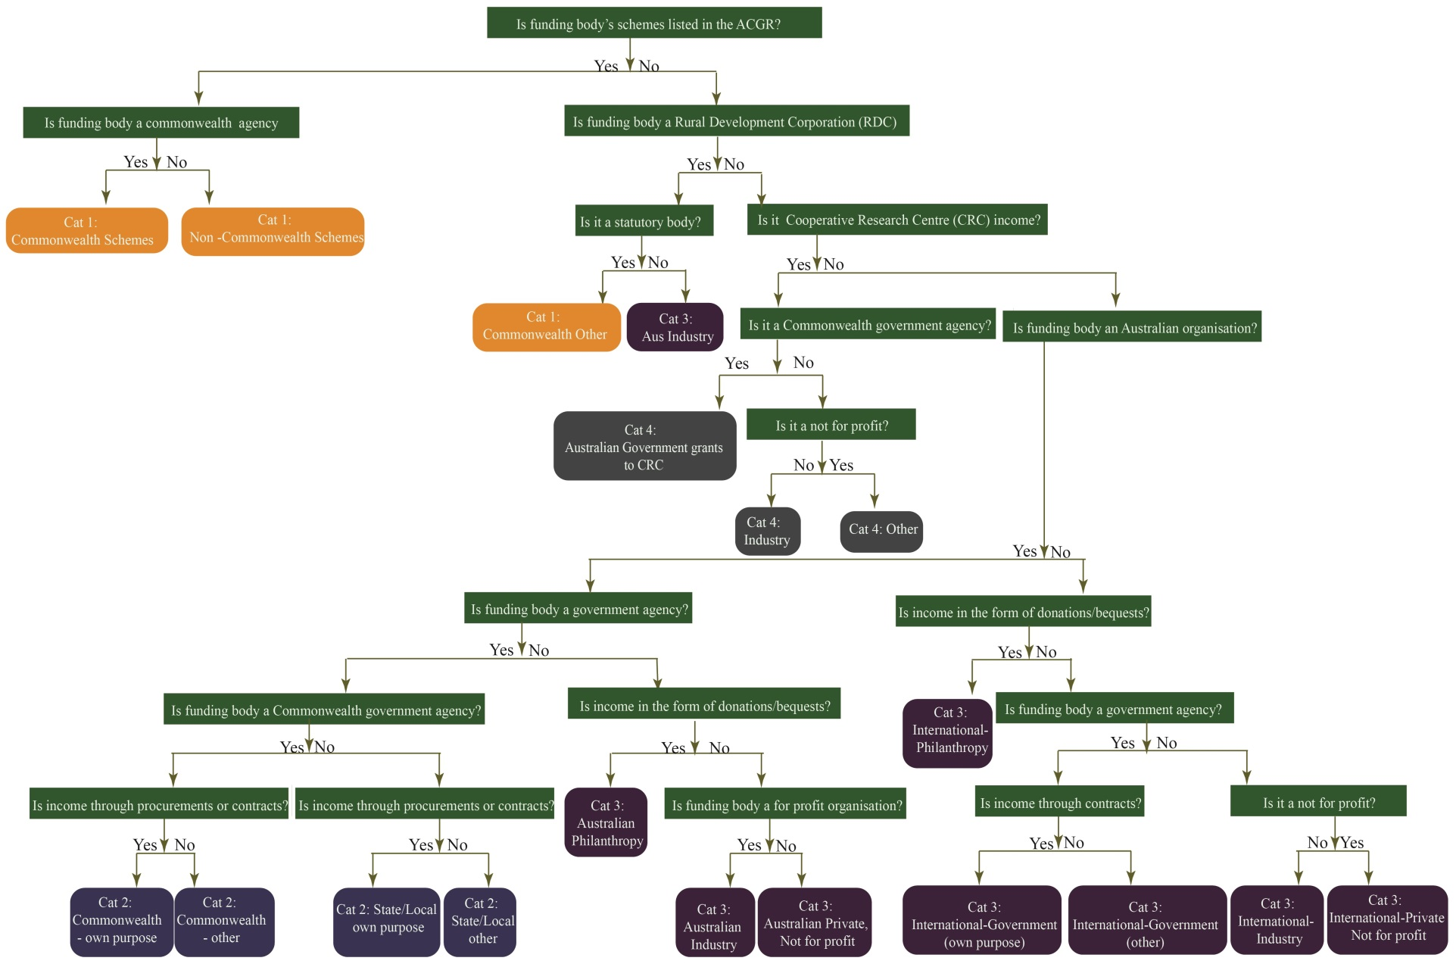

1. <http://www.innovation.gov.au/page/new-research-funding-arrangements-HEPs>
2. <https://www.education.gov.au/review-research-policy-and-funding-arrangements>
3. <https://www.education.gov.au/higher-education-research-data-collection>
4. Bourke, S., Holbrook, A., Lovat, T. & Farley, P. (2004). Attrition, completion and completion times of PhD candidates. Paper presented at the AARE Annual Conference, November/ December 2004, Melbourne. Available at <http://aare.edu.au/04pap/bou04849.pdf>
5. Bourke, S., Holbrook, A. & Lovat, T. (2006). Relationships of PhD candidate, candidature and examination characteristics with thesis outcomes. Paper presented at the AARE Annual Conference, November 2006, Melbourne. Available at <http://www.aare.edu.au/data/publications/2006/bou06655.pdf>