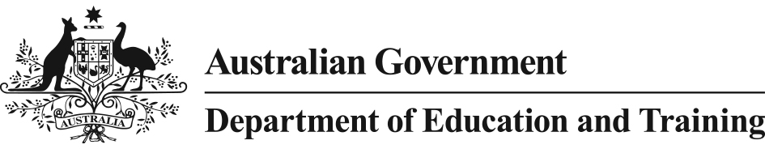

Literacy and Numeracy Test for Initial Teacher Education Students

Fact sheet
Overview
In 2015 all Education Ministers agreed that, from 1 July 2016, the national Literacy and Numeracy Test for Initial Teacher Education Students (the test) will be used as the required means to demonstrate that initial teacher education students are in the top 30 per cent of the adult population for personal literacy and numeracy.
This standard has been in place since 2011, as part of the Accreditation of initial teacher education programs in Australia: Standards and Procedures (Standards and Procedures).
The intention of the test is that from 1 July 2016, all initial teacher education students will have been assessed as having the high level personal literacy and numeracy skills required to meet the demands of teaching. In practical terms, this only includes those completing their studies from the second half of 2016 onwards.
The new Standards and Procedures, agreed in 2015, incorporate a range of new requirements including changes to the content, structure and operation of initial teacher education programs, as well as improvements to program accreditation. They also include a focus on evidence of student outcomes rather than inputs alone. The test is one element of this integrated set of improvements to initial teacher education programs. The cumulative impact of these changes will result in graduate teachers being better prepared to meet the challenges of the classroom and having a positive impact on student learning.
Literacy and Numeracy Test
The test is computer-based and consists of a literacy component and a numeracy component. The test is designed to assess elements of an individual’s personal literacy and numeracy skills that can appropriately be measured through an online, machine marked assessment.
The literacy component assesses an individual’s reading, spelling and technical skills in writing. The numeracy component looks at an individual’s capability in numbers and algebra, measurement and geometry, and statistics and probability.
Each component consists of 65 questions, for a total of 130 test questions.
Test administration
The Australian Council for Educational Research is administering the test in selected testing centres located throughout the country and through an invigilated online environment (remote proctoring).
The test is available in set windows throughout the year.
Initial teacher education students pay to sit the test. Each component costs $92.50 or $185 for both components.
More detailed questions and answers are available at https://www.studentsfirst.gov.au/teacher-quality. Information about the administration of the test, including sample questions is available at https://teacheredtest.acer.edu.au/.

