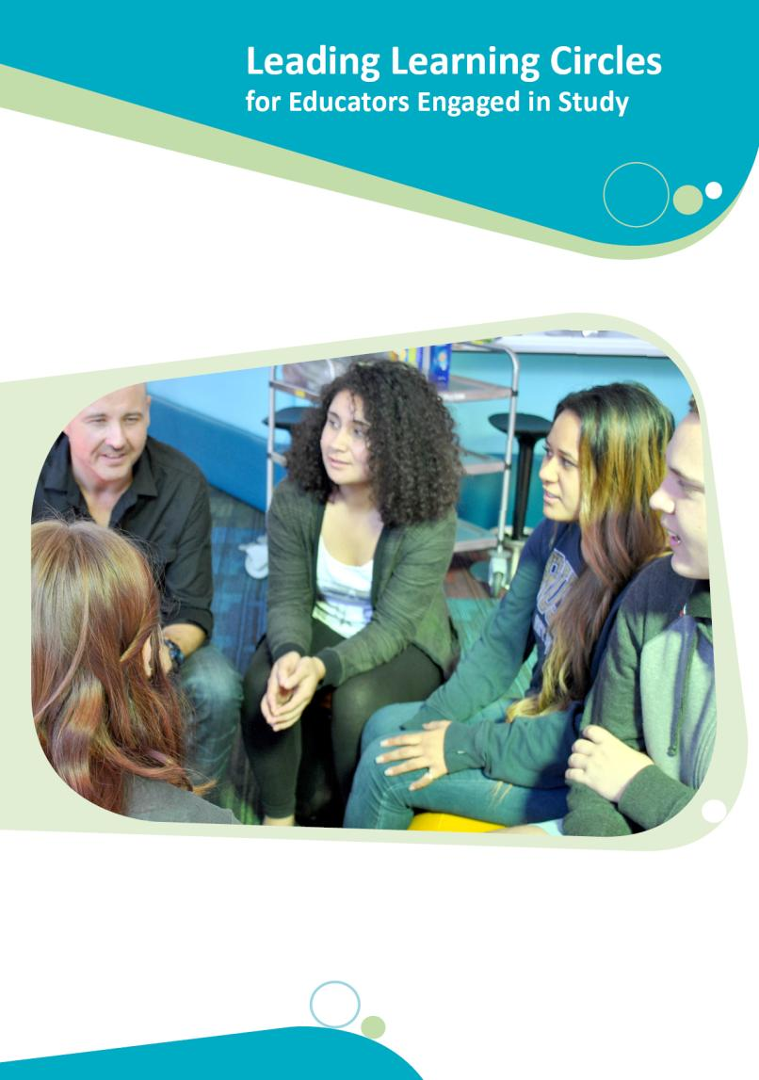

Leading Learning Circles for Educators Engaged in Study

With the exception of any material protected by a trade mark where otherwise noted all material presented in this document is provided under a Creative Commons Attribution 3.0 Australia licence (http://creativecommons.org/licenses/by/3.0/au/).

The details of the relevant licence conditions are available on the Creative Commons website (accessible using the links provided) as is the full legal code for the CC BY 3.0 AU licence
(http://creativecommons.org/licenses/by/3.0/au/legalcode).

The document must be attributed as Leading Learning Circles for Educators Engaged in Study.

ISBN: 978-1-74361-796-0 (PRINT)
ISBN: 978-1-74361-797-7 (PDF)

ISBN: 978-1-74361-798-4 (DOCX)



Table of Contents
Introduction 5
Guided Conversations for Learning Circles 6
The Role of the Pedagogical Leader as Facilitator 6
Critical Reflection 7
What is Reflection? 7
Figure 1 – The Circle of Change Revisited Process 8
What is Critical Reflection? 10
The Process 14
Circle of Change Model of Critical Thinking 15
Tips for Pedagogical Leaders 19
The Conversations 22
Conversation 1 – Studying While Working as an Educator 23
Conversation 2 – Building a Learning Circle 24
Conversation 3 – Creating a Supportive Climate in the Learning Circle 25
Conversation 4 – Critical Reflection. What Is It? 26
Conversation 5 – A Template for Creating Targeted Conversations 28
Conversation 6 – Promoting Children’s Learning 29
Conversation 7 – Supporting Children’s Wellbeing 30
Conversation 8 – Building Relationships With Parents 32
Conversation 9 – Creating Inclusive Programmes for Aboriginal
and Torres Strait Islander Children and Their Families 34
Conversation 10 – Understanding Policies and Procedures 36
Conversation 11 – Providing Physical Care 37
Conversation 12 – Meal Time Routines 38
Conversation 13 – Duty of Care 39
References 41
Appendix 45
Figure 2 – The Circle of Change Revisited, Model of Critical Thinking 46
Circle of Change example 48

This resource Leading Learning Circles for Educators Engaged in Study has been developed to assist pedagogical leaders support educators in their service who are undertaking study. The resource has been funded by the Australian Government Department of Education and developed by the Child and Family Studies team at Griffith University led by Dr Jennifer Cartmel.

This resource must not be reproduced for sale.


Introduction
From January 2014, the National Quality Framework for Early Childhood Education and Care requires early childhood educators to hold or be working towards a qualification. This has meant that significant numbers of educators are undertaking study to gain formal qualifications. According to the National Centre for Vocational Education Research (NCVER) there is a need for educators in the early childhood workforce, who are undertaking study, to feel supported to strive to achieve their career goals and remain in the workforce (NCVER, 2013).
Leading Learning Circles for Educators Engaged in Study (Leading Learning Circles) is designed to assist pedagogical leaders support educators in their service, who are undertaking study. The resource outlines a process of guided conversations in the form of learning circles. A learning circles approach can be used to establish learning communities which nurture emerging educators and improve retention of staff in the early childhood workforce. This approach encourages educators to engage in reflective practice linking study to everyday practice in order to benefit their performance and therefore improve learning outcomes for children.
Leading Learning Circles supports the implementation of critical reflection as part of every educator’s core practice, which in turn supports the facilitation of quality practices in early childhood settings. The key focus is to link training, theory and practice and is based on the highly effective Circle of Change Revisited model (Cartmel, Macfarlane & Casley, 2012; Macfarlane & Cartmel, 2012).
This resource explains the process of reflection and thinking and how to facilitate the learning circles. It includes a series of 13 conversations that can be used by pedagogical leaders supporting educators engaged in study. These guided conversations follow a pattern of questioning using reflective thinking processes within a conversation.

This reflective thinking process consists of four steps:
  - Deconstruct – educators describe the situation from their perspective
  - Confront – educators describe how they feel about the issue
  - Theorise – educators share the sources of the ideas – linking to their study, research and other’s ideas
  - Think Otherwise – educators describe how their thinking has changed and how they will act in the future


Guided Conversations for Learning Circles
Learning circles are the ideal strategy to support educators engaged in study. They are a “safe” space for programme debriefing, to provide focused time to discuss workplace or study issues, to model critical thinking and reflection processes, and to encourage reciprocal and cooperative learning.

Educators, in a move to develop quality practice, need to learn to perceive themselves differently and to develop the confidence and ability to participate actively and creatively rather than be passive recipients of others’ actions. Learning and transformational change in workplaces occurs if educators engage in a culture of dialogue with each other to find common ground so they can share knowledge, ideas and possibilities (Cartmel, Macfarlane & Casley, 2012).
The guided conversations outlined in this resource will assist pedagogical leaders to encourage educators to focus on the knowledge associated with the principles and practices of early childhood education and care and relate this to their programme of study.
Educators undertaking study are encouraged to be more reflective about their role as an early childhood educator. In guided conversations they are supported to discover, build upon and become familiar with effective strategies for working with children and families so these become essential core practices.

The Role of the Pedagogical Leader as Facilitator
It is essential that pedagogical leaders have tools they can use to build the capacity of educators who are undertaking study.
By meeting with small groups of these educators, pedagogical leaders can assist educators to develop peer support networks and facilitate discussion on aspects of their study programmes. Support networks have a number of benefits, including:
- helping educators have a greater sense of purpose about the importance of their role and responsibilities working with young children and their families
- reducing the anxiety sometimes associated with study
- linking study to everyday practice and supporting the development of a greater understanding of the processes that underpin quality practice in early childhood settings.

The pedagogical leader, as facilitator of the learning circle, uses a series of questions to help stimulate the conversation amongst the educators about the knowledge that underpins the practices presented in their studies. As educators discuss the content of their programmes of study and consider the principles underpinning their work and the practices they are using, it is important to use reflective activities. Learning circles and focused conversations have been developed and adapted for the purpose of promoting critical reflection amongst educators (Cartmel, et al, 2012; Casley & Cartmel, 2009; Macfarlane & Cartmel, 2012).
Figure 1 summarises the blending of the reflective thinking process and the Circle of Change Revisited process. The Circle of Change Revisited process describes the practical strategies of gathering the group together including establishing group protocols. Further, it outlines some of the reflective thinking processes individuals can employ to assist them to build their confidence and competence as students and educators.

Critical Reflection
Reflective practice is a form of ongoing learning that involves engaging with questions of philosophy, ethics and practice. Its intention is to gather information and gain insights that support, inform and enrich decision making about children’s wellbeing and development. As professionals, educators examine what happens in their settings and reflect on what they might change. Critical reflection involves closely examining all aspects of events and experiences from different perspectives. Educators often frame their reflective practice within a set of overarching questions, developing more specific questions for particular areas of enquiry.
Excerpt from Belonging, Being & Becoming The Early Years Learning Framework For Australia (p. 13) and My Time Our Place, Framework for School Age Care (p. 11).

What is Reflection?
Reflective practice is seen as a ‘core activity’ (Moss & Petrie, 2002) for educators in early childhood settings. It is understood as the ability to examine the activities within daily work and to use this examination as a means of improving practice and knowledge. It is a dialogic process with the individuals’ thinking going ‘to and fro’ as early childhood principles and practices are considered from multiple perspectives.
In disciplines where building relationships is crucial to practice, reflective practice must be a vital component (Ruch, 2005). Ruch (2005) states that when combining relationship-based and reflective practice four shared implications are present.

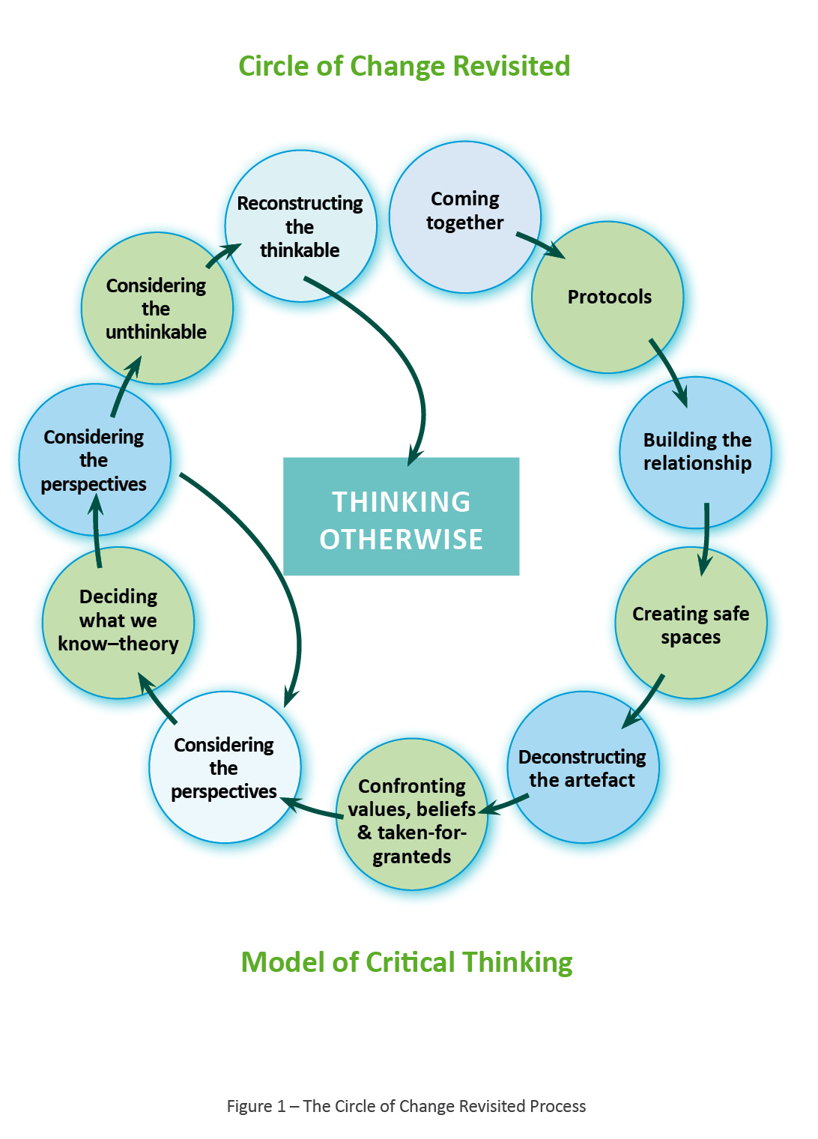
Figure 1 Circle of Change Revisited Process – Model of Critical Thinking
- Coming Together
- Protocols
- Building the relationship
- Creating safe spaces
- Deconstructing the artefact
- Confronting values, beliefs & taken-for-granteds
- Considering the perspectives
- Deciding what we know-theory
- Considering the perspectives (after this step, return to step 7 or continue to step 10)
- Considering the unthinkable
- Reconstructing the thinkable
- Thinking otherwise

These are “enhanced understandings of the client, the personal and professional self, the social and organisational contexts of practice and the diverse “knowledges” informing practice” (p.112). These implications are vital to practice in early childhood settings where relationship based practice is key. Thus, reflective practice must be a key component of practice in this sector.
However, while it is understood that the virtues of reflective practice should be highlighted in sectors like early childhood education and care there is still some confusion about what it actually is and how it should be undertaken. Russell (2005) states that “fostering reflective practice requires far more than telling people to reflect and hoping for the best” (2005, p. 203). Reflective practice can be taught, and it is ideal to blend developing reflective skills with study towards qualifications.
In early childhood settings, reflective practice is essential to creating new and shared understandings about principles and practices and is important to achieving quality practice in this sector. However, reflective practice requires more than a shift in practice – it also requires a shift of the mind, will and heart (Scharmer, 2009).

This means that educators are using all their senses including watching, listening, feeling and thinking. Furthermore, they must be open-minded when they are thinking about what they do. They will be working from a space of possibility (Macfarlane, Cartmel & Nolan, 2011). It is anticipated that for educators engaged in study, the benefits of blending reflective practice with conversations about content of study programmes will lead to the development of new practices. These practices will be more responsive, less fragmented and help to solve the challenging and complex problems that children and families face.
.
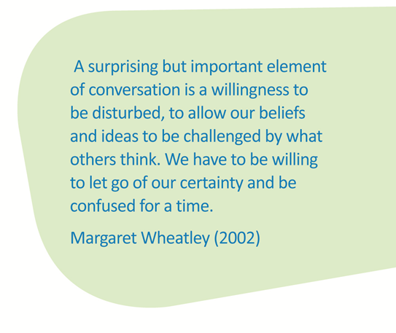

Moreover, one of the key misconceptions about reflective practice is that it is undertaken in isolation. Dialogue is essential to reflective practice, as without dialogue individuals cannot comprehend new understandings about practice successfully. As working environments become more complex, the uncertainty and riskiness that are inherent in some environments (Craft & Paige-Smith, 2011; Ruch, 2005) cannot be managed in isolation. Further, when individuals are engaged in programmes of study, conversations and debriefing are important components of quality reflection and thus are essential aspects of the process.
In understanding reflective practice it is also necessary to understand what makes reflection critical. Reflection is not inherently critical and so there are strategies that need to be employed to ensure that criticality is present. Some of these strategies will be discussed in the following sections.

What is Critical Reflection?
Critical reflection is the deepest type of reflection and the one that really helps the professional learning of educators and subsequently improves practice in early childhood settings. As the reflective thinking process goes ‘to and fro’ creating new ideas and mixes with perspectives about practices as described in educators’ studies, the thinking process also draws on everyday experiences and understanding. In other words ‘tacit knowledge' and contemporary early childhood theory and research assist educators to think more deeply about practice.
Gardner (2009) states that critical reflection “encourages rigorous exploration for professional practice experience and can be used for both learning and research” (p. 181). This notion is critical for supporting educators engaged in study. To allow deeper understanding and learning to occur certain strategies are necessary to ensure that reflection is critical and while there is much written about what these strategies are, there is little written about ‘how’ to put them in place. There are many models of reflection, few of these actually state how the actual process of reflection moves to a point where it is critical.

The model of critical reflection that forms the foundation for this resource is based on educators meeting together to support each other with the critical reflection process. This is the process educators also use to communicate with children (Macfarlane & Cartmel, 2008). It means ‘shutting down the habit of judging based on our past experience’ and opening up to genuine inquiry. (Macfarlane, Cartmel & Nolan, 2011)
.
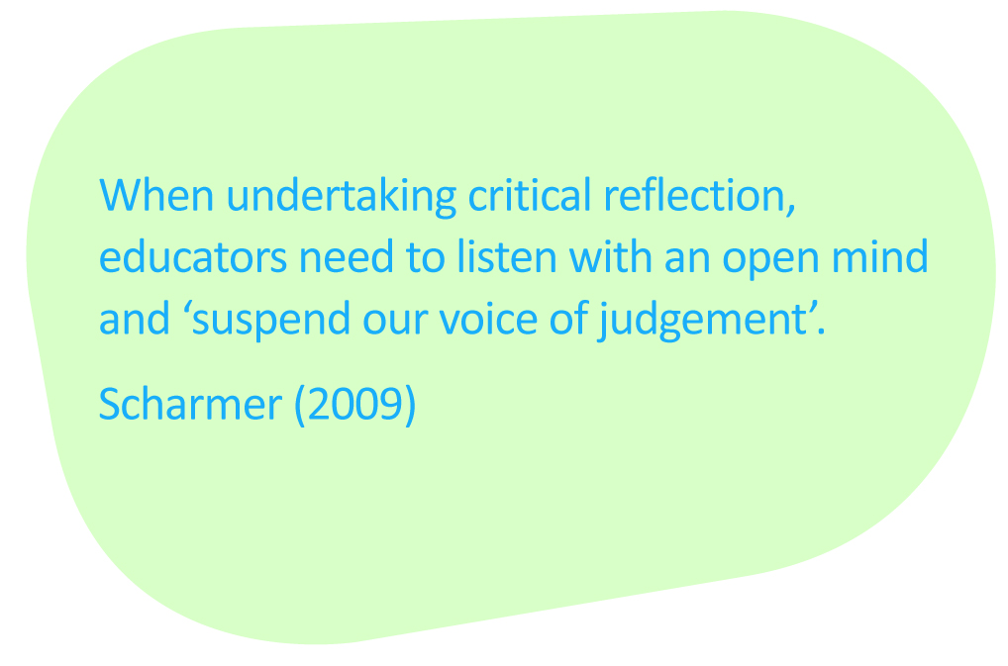

In this process, educators listen self-reflectively to ‘hear ourselves through others ears’ (Kahane, 2002, p. 4), engaging in talking and listening to build connectedness between the group. The group should take ownership of the process recognising and respecting the diversity of values, ideas and opinions. Everyone involved in the reflective process is actively discovering and exchanging knowledge and ideas, identifying their capabilities and creating possibilities. This is particularly useful when working with emerging educators who are undertaking study. The process provides them with the opportunities to link their practice, understanding and new knowledge.
This process follows a particular framework with four stages – Deconstruct, Confront, Theorise and Think Otherwise. The decision to name and group the stages in this way is built on theory and research undertaken in the area of reflective practice and is also underpinned by aspects of poststructuralist and postmodern theories. As Gardner (2009) states the inclusion of these theories enables the exposition of “missing perspectives, dominant discourses, examples of binary thinking and constructions of power” (p.182), thus encouraging the articulation and highlighting of values and beliefs and taken-for-granted assumptions and understandings. Such a process is imperative to the process of critical reflection as it is the inability to work within and against (Lather, 1996) taken-for-granteds that leads to the process breaking down. This process helps those undertaking study to consider why and how they practice with children and their families in the early childhood sector.

The Impact of Tacit Knowledge
Tacit knowledge is the information an individual holds within their consciousness. For educators in the early childhood sector tacit knowledge allows them to consider their role and responsibilities. It includes things that educators instinctively know but find difficult to impart to another educator. Tacit knowledge is the experience of knowing what we know but not being able to put it into words (Kinsella, 2007). Educators engaged in study often use their tacit knowledge but are unaware of its impact on their practice.
Tacit knowledge is key to how an educator practises and behaves and is the foundation on which reflective practice is built. Consequently, it is very important to find ways to access it (Osmond & O’Connor, 2004). Tacit knowledge has both a positive and negative impact on reflective learning. There are some very positive ways of using tacit knowledge to develop educators’ confidence and self-esteem as they engage in the reflective process. On the other hand, tacit knowledge can constrain knowledge if educators are unaware that possible internalised understandings may constrain what they think and do. It is critical that educators engaged in study are aware of the tacit knowledge in the process of developing their reflective skills.
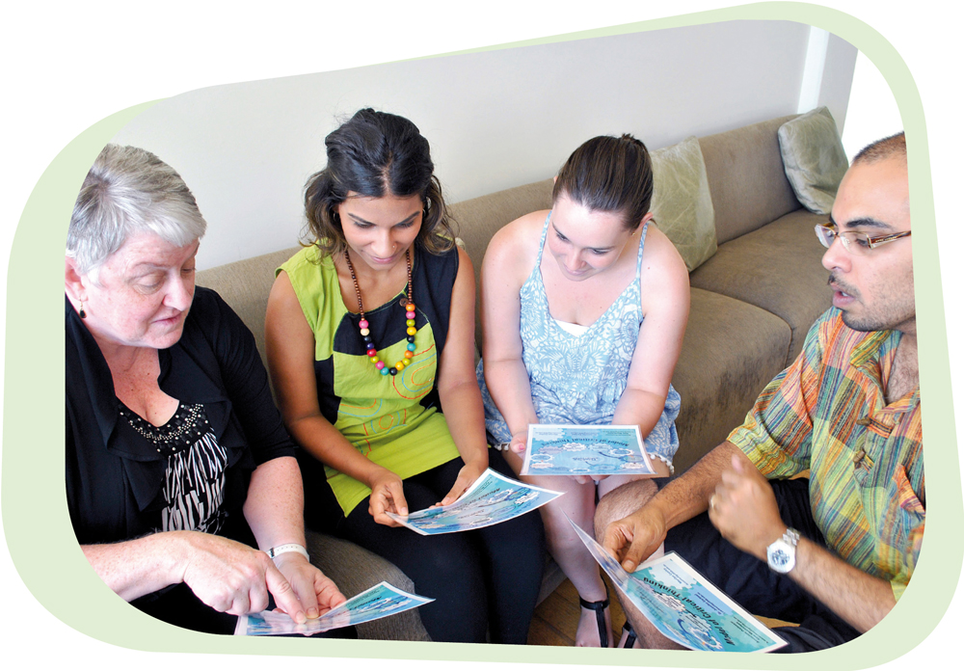

The following example from a staff meeting highlights how tacit knowledge was used in a positive way.
Context: Emerging and experienced educators were having a reflective conversation about providing experiences to support children’s play and learning and the difference between art and craft.
Jordan | Hannah
Teaching art is about teaching aspects of artistic development such as line, colour, tone and composition. | Well then what is craft?
To me craft is about producing a product such as making a paper basket or Father’s Day Card. | It never occurred to me that there was a difference between art and craft, the penny has dropped for me and my practice will change as I don’t think I have been talking to children about their artistic development. I have only been doing craft.
In this example Jordan has used tacit knowledge in relation to creativity to assist Hannah to ‘think otherwise’.
On the other hand, there can be a negative consequence on ongoing learning if an introspective reflective process is always undertaken only within an existing knowledge base. In this process the educators engaged in studies only rely on their personal experience and preference and do not take into account recommendations from authorities such as Health Departments and research. The following example demonstrates an introspective reflective process.
Context: Educators discussing food handling policy
Michelle | Kay
We need to review the procedures we have for our food handling policies. |  | Our food handling procedures just needs to say that children should wash their hands before meals.
Are you sure that is enough? |  | I don’t see why not – we all wash our hands before eating. What else do we need to be concerned about?
What about storage and preparation surfaces? |  | But the children bring their own food, surely we don’t need to worry about that. When I cook with the children I wash my hands too.
In the above example Kay has relied on her personal knowledge and has used this to influence others thinking. If Michelle can confront this and critically reflect on the issue and use the knowledge from her programme of study then there may be a change in practice.
Note: In this brief reflective conversation just relying on personal preference without investigating training resources and contemporary research and practice could be detrimental.

Ongoing learning is about how to interact with the world and the types of capacities that develop because of particular interactions. To think only in habitual ways and to continue to see the world from one worldview is to disregard other options that are different from what is already known. It is important for educators to think about ongoing learning and reflective practice as a ‘sense of awareness’ of self and belonging or connection where there is an opportunity to move beyond reactive actions to where the source of ideas and effectiveness of actions are enhanced significantly. Educators in early childhood settings need to link their studies with quality practices. By using critical reflection educators are able to describe and use practices that will be in the best interests of children and families.
In undertaking studies, educators must not see themselves as the “repository of objects of knowledge” (Moss & Petrie, 2002, p.145), but rather, must engage in a process that allows
them to construct new understandings that are informed by contemporary theory, research
and practice. Such a process enables educators to examine possibilities so that they are unconstrained by their own beliefs and value systems, and by taken-for-granted understandings and ideas (Fook & Gardner, 2007, Noble, Macfarlane & Cartmel, 2005). In using this process educators have more opportunities to transform their thinking and understandings in order
to work towards the qualifications that guide them to support children to achieve high
quality outcomes.

How Does this Reflective Process Occur in Practice?
One example of how the reflective process works in practice is using the Circle of Change Revisited Model of Critical Thinking. This model of practice uses a critical reflection model and combines it with the notion of learning circles.
Quality practices will emerge out of educators’ everyday reflective practice. Cartmel (1997) found that early childhood educators who engaged in critically reflective conversations with other educators found it easier to describe and write about their practices. Consequently, educators engaged in study, who have reflective conversations with each other, feel supported and find it easier to embed high quality practices in their settings. In relation to the early childhood programme, identifying the strengths and improvements can be undertaken by deconstructing what is occurring in the setting. This means that questions are raised to confront and unpack the issues. Evidence can be gained by theorising what one already knows and understands about what they are doing. It can come from what they are studying including what they read, hear, watch and see. This process makes it easier for educators engaged in studies to link the training with daily practices in early childhood settings. Educators can then think otherwise and act on the new ideas that emerge from their thinking about their practice.

The Process
The pedagogical leaders in early childhood settings can be facilitators of the learning circle process. However, they need to consider a number of elements to ensure success. The physical environment and the emotional climate of the learning circle need to be optimum to ensure that educators feel ‘safe’ as they engage in conversations about the content of their study programmes and professional practice.
These conversations become a deeply reflective process that require some specific layers of questioning and are a very highly skilled activity. One of the critical parts of the process is use of all the body’s resources – senses, memories and feelings (Stanfield, 2002, p.24) to come to terms with what is being considered.
This process leverages both group and personal experiences at the same time. While the group is going through the reflective thought process about studies they are undertaking, practices they use every day in the workplace and conversations they have with colleagues, each person is also going through this process personally inside their head. As they listen and talk with other educators they are reviewing personal ideas about professional principles and practices.
The facilitator of the learning circles needs to consider how much their role impacts on each participant as well as the dynamics of the group. The facilitator cannot underestimate the importance of educators articulating their ideas. The educators’ explanation of what they understand as well as their feelings, moods, memories and associations are linked to triggering the deeper levels of thinking.
As a facilitator it is useful to have some ideas for questions to stimulate the reflection process within the conversations. The conversations later in this guide contain a sample of questions to support critical reflection on a range of topics.
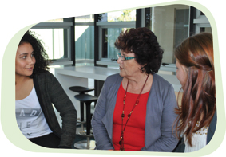

Circle of Change Revisited Model of Critical Thinking
The facilitator of the learning circles needs to use the following model of critical reflection
in the conversation and questioning to stimulate thinking. This is a four step model – Deconstruct, Confront, Theorise and Think Otherwise. These four steps scaffold the reflective thinking process.

1. Deconstruct
To deconstruct means to pull apart the main tenets of theory, which govern particular practices and closely examine their composition, especially practices that have been enshrined as ‘normal’ and ‘proper’ practice. This stage is useful for educators as a means of critiquing texts and understandings about practice. In the deconstruct stage, educators are seeking to state the facts that are present in a particular scenario or artefact. During this stage a focus on emotive responses is discouraged, as the practice of objectively looking at the facts of the situation is key to eventually understanding it in multiple ways. During the deconstruct stage it is helpful to introduce some reflective questions that assist in the unpacking that needs to take place.

Deconstruct ensures that everyone deals with the same information. The pedagogical leader, as facilitator of the learning circle, should try to elicit all aspects of the objective information (external reality). The aim is to develop a shared image of what the group is discussing. Each educator in the group should be questioned. This is important. Educators are actually learning about different perspectives as the responses from other educators are explored. This triggers thinking to move beyond current knowledge and understandings.
What did you see – equipment, objects?
What happened?
What words, phrases stand out?

2. Confront
In the confront stage educators approach personal, social, and systemic issues head on by examining difficult, previously thought of as ‘untouchable,’ topics. This stage is useful for educators as they focus on personal practice and confronting issues that arise during the course of the day. The confront stage is where emotive responses become more evident and the process of breaking down values and beliefs occurs. Again this is not an easy process but it is helpful to use Lather’s (1996) notion of ‘double science’ here. This double science includes both a macro and micro analysis in which educators use the practice of working within and against normalised convention and inquiry (Macfarlane, 2006). To work within and against means that educators bring all values and beliefs to the conversations (Gardner, 2009), either consciously or unconsciously. They are then encouraged to use these understandings to inform the conversations and also to work against them so that other possible perspectives are made visible. The way in which this occurs depends largely on the facilitator of the conversation and so group communication and facilitation skills are crucial. However, once again there are questions that can facilitate this process. Another important element of the confront stage is mindful presence. To engage with others in a critical way it is important for an educator to be fully present and attentive to the task.
Rinaldi (2001) emphasises the importance of listening not just with our ears but all our senses. This means that it is important to be present and hear with all senses; to observe and recall what is occurring so that reflection can occur, and to suspend personal judgement to ensure consideration of other educators’ ideas.
Educators need to explore their personal relationship to the topic being discussed– this level acknowledges the personal and varied responses to any situation –based on the wisdom of years of experience. Questions at this level illuminate what educators feel. Facilitators must ensure everyone is encouraged to have a turn at speaking to the group.

3. Theorise
In the theorise stage it is important to carefully consider practice at all levels and question what is and what could be by thinking broadly. This stage is useful for educators to understand the importance of linking theory to practice and the need to apply what is learned theoretically to what is implemented in the field. However, it is not only knowledge of theory that is important in this stage. Experiential knowledge (Gardner, 2009) and tacit knowledge (Kinsella, 2007) are also important. The importance of tacit knowledge is dealt with earlier in this paper.
Here the notion of within and against is important once again. As Foucault (1980) attests discourses produce objects and subjects, which they appear simply to describe (Macfarlane, 2006). Foucault argues, ‘…[d]iscourses are not about objects: they constitute them and in the practice of doing so, conceal their own invention’ (1980, p.49). This means that educators are produced by the theoretical and philosophical underpinnings of their discipline. Adherence to disciplinary knowledge produces particular ways of thinking, which both enables and constrains practice. Therefore, to reflect critically, it is crucial to work within and against particular discursive productions to ensure that a variety of perspectives are considered.
This next level of questioning really encourages educators to get to the significance of the material being discussed. At this point the facilitator may ask for everyone’s perspective or one person’s response may be worth interrogating with more questions.
What is happening here, what is this all about?
Why is this significant, how do you know this is significant?
Where have you read/heard about this?
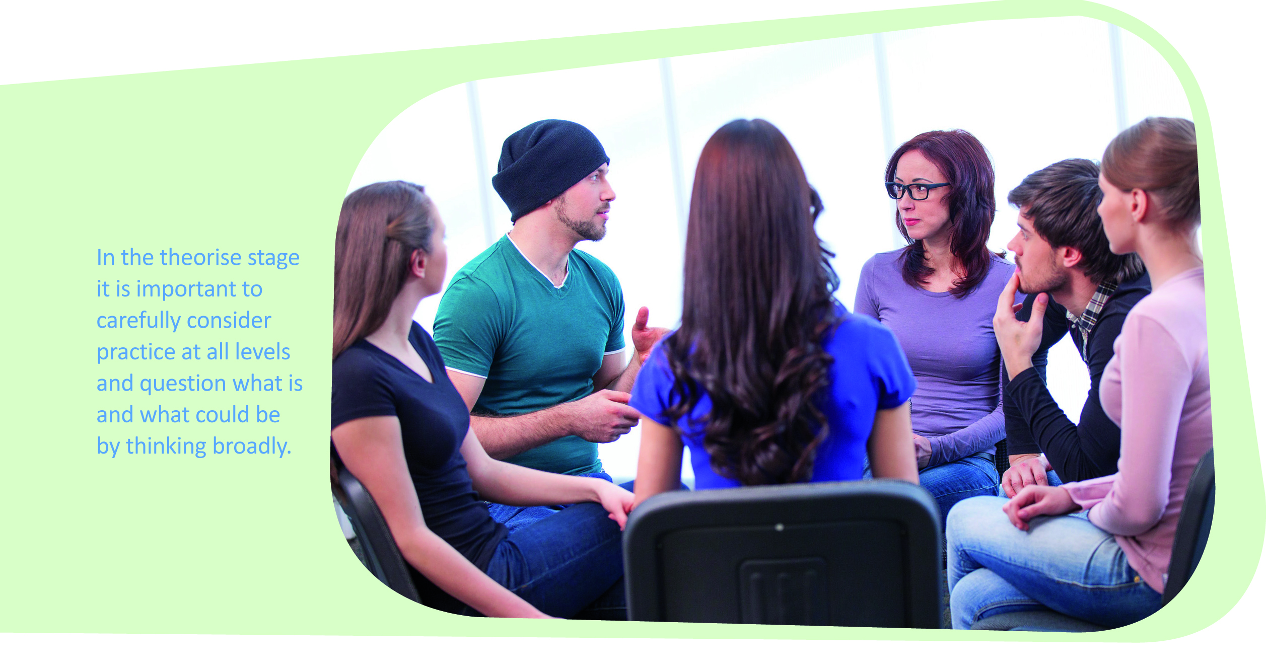

4. Think Otherwise
To think otherwise it is important to challenge oneself to think outside the dominant frameworks and ideas and come up with different ways, or better ways of practising. This stage is useful for educators to understand and recognise there are multiple perspectives and a variety of opinions about practice. However, it is important to understand that thinking otherwise requires more than thinking differently. To effectively think otherwise educators must think about ideas where the unthinkable is possible.
In Foucault’s (1984) terms thinking otherwise enables a focus on the reasonableness of understandings of truth (Macfarlane, 2006). This process allows new and disqualified perspectives to become apparent. It highlights how ideas of propriety become formed. Without this aspect critical reflection is not possible.
Pedagogical leaders need to encourage educators to take up this part of the reflection process before the conversation session is finished. It helps educators to articulate
what they have thought about during the learning circle and what they intend to do with the information.
What have you learnt from this?
What will you take away from this conversation in relation to your work with children, colleagues, parents?
What ideas have you changed?
What will you change about your practice?
Using this process helps educators to feel confident about new knowledge and practices they are learning about in their studies. In order for the process to work effectively it is important to create the ‘safe’ space for the conversations to occur.
The following section contains some strategies that pedagogical leaders can use to facilitate and create the ‘safe’ space.
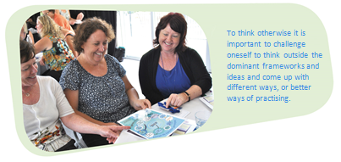

Tips for Pedagogical Leaders
Allow sufficient time for a learning circle (45 – 60 minutes)
Encourage everyone to be an active listener
Ensure everyone participates
Provide a safe space in which everyone feels comfortable to contribute
The state of mindfulness requires listening with all senses
Encourage educators to have an open mind and suspend judgement
Learn how to ask questions that encourage responses based on deep thinking
Information flows in every direction in a conversation so be prepared to keep ideas
on the focus topic.
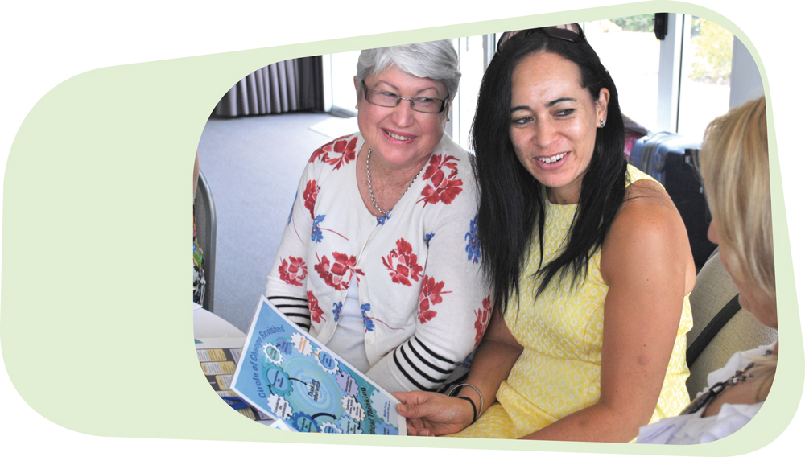

Suggested Group Protocols for Educators
Discuss with the educators some group protocols that will help to ensure that the conversations flow smoothly. Some examples of protocols are:
- only one person talking at a time
- all ideas accepted
- make sure each person has a chance to make a response to the questions before moving onto the next question.

Building Relationships within the Group
Ideally a learning circle could have up to 15 educators. If the team of educators is larger, divide them into smaller groups and assign a facilitator for each group. To help educators get to know each other the following activities can be used:

Activity One – Interviews
1. Divide the educators into pairs.
2. Ask them to take three minutes to interview each other. Each interviewer has to find three interesting facts about their partner.
3. Bring everyone back to together and ask everyone to present the three facts about their partner to the rest of the group. Watch the time on this one, keep it moving along.

Activity Two - Who is the mystery person?
- On a blank sheet of paper/post it note write the answers to the following questions:
- Your favourite colour
- An animal that portrays the way you see yourself
- A song that is a favourite or describes your philosophy on life
- A mode of transport that symbolises you
- A TV/Movie character that you identify with
- Fold the paper and place it in the bowl in the centre of the table.
- One person draws a paper from the bowl, reads the clues aloud and everyone at the table tries to guess who has answered the questions.

Activity Three – ‘if’
1. Ask the educators to sit in a circle.
2. Write 10 ‘if’ questions on cards and place them (question down) in the middle of the circle.
- If you could go anywhere in the world, where would you go?
- If I gave you $10,000, what would you spend it on?
- If you could watch your favourite movie now, what would it be?
- If you could be someone else, who would you be?
- If you could have any question answered, what would it be?
- If you could watch your favourite TV show now, what would it be?
- If you could have any kind of pet, what would you have?
- If you had to be allergic to something, what would it be?
- If you could eat your favourite food now, what would it be?
- If you could learn any skill, what would it be?
The first educator takes a card, reads it out and gives their answer, comment or explanation. The card is returned to the bottom of the pile before the next educator takes their card.
This is a simple icebreaker to get educators talking and listening to others in the group. Keep it moving and don’t play for too long. Write your own additional ‘if’ questions to add to the list.

The Conversations
The following section contains the series of 13 conversations. The first three topics are about establishing the learning circles as study groups and the remainder of the topics are drawn from the competencies that are part of the training package for educators studying in early childhood settings. The conversations contain sets of questions that will help to stimulate the conversation. As the pedagogical leader you may like to develop your own conversation based on the format, see Conversation 5 – A template for creating targeted conversations.
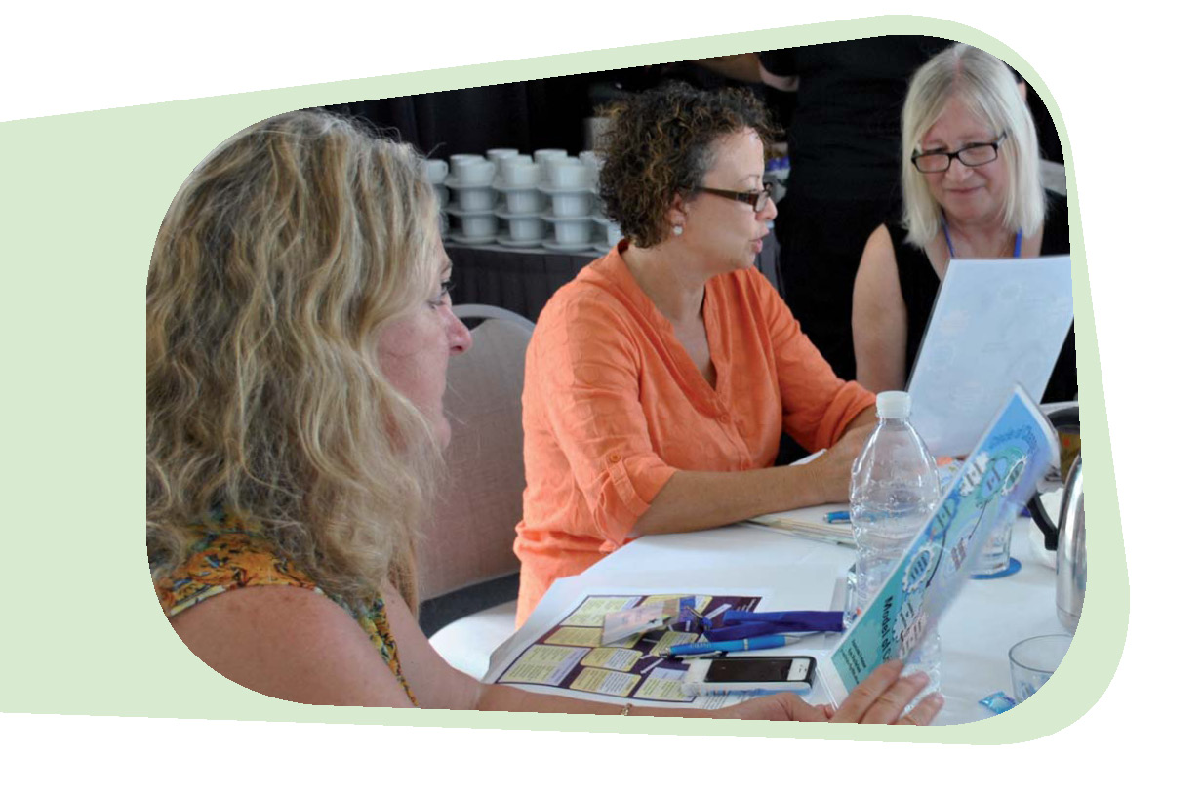

Conversation 1– Studying While Working as an Educator

Opening
Today’s session will help us to consider what is involved with being an educator who is working and studying. We will discuss different learning styles and the importance of being part of a learning community.

Deconstruct
What are some of the things that led to you undertaking study?
What has motivated you to undertake study?
What motivates you to learn?

Confront
What are the advantages of working and studying at the same time?
What is frustrating for you?

Theorise
What are the possible effects of studying on you personally?
What are the possible effects of studying on your workplace?
What are other implications?

Think Otherwise
What would you like to happen as a result of your study programme?
What do you now know about how you study?

Closing
We have used this conversation process to help us think about how we learn. We can continue to use this process because it has some questions that help guide our thinking that support your study programme and leads to engaging in the learning process and to us extending our knowledge and gaining new ideas.


Additional Information
Rutyna, B. (2011). Mentoring - Learning with others, building capacity. In The Loop,
Summer,12, 3 – 6.
White, A. (2013). Supporting a professional, qualified, growing, responsive and collaborative workforce. In the Loop, Winter, 6 – 7.

Conversation 2 – Building a Learning Circle

Opening
Today’s session will enable us to form a learning circle that can be used to build a supportive group to help you with your current studies. The need to help each other to link study for qualifications with our day to day practice in early childhood settings is critical. This type of assistance will help you feel motivated and build your confidence.

Deconstruct
What would be the benefits of forming a study group?
What images do you have of this group?

Confront
Who here has experience in being part of a study group?
What are the advantages of such a group?
What are the disadvantages?

Theorise
What motivates learners?
What helps learners to engage with the information they are trying to understand?
What kind of resources should we use?

Think Otherwise
What would we like to happen?
How often will we meet? Where we will meet?
What are some of the topics from your study programme that you would like some help with?

Closing
We have used this conversation process to help us think about how we learn. We can continue to use this process because it has some questions to guide our thinking which supports your study programme. It also promotes leadership and engagement in the learning process, extends our knowledge and builds new ideas.


Additional Information
Cartmel, J., Macfarlane, K. and Casley, M. (2012). Reflection as a tool for quality:
Working with the National Quality Standard. Research in Practice Series
Volume 19 Number 4. Early Childhood Australia Inc.
Stanfield, B. (2000). The Art of Focussed Conversation. Gabriola Island, VC Canada:
New Society Publishers.

Conversation 3 – Creating a Supportive Climate in the
Learning Circle

Opening
Today we are going to spend time discussing what makes you feel comfortable when you are part of a group discussing the knowledge and practices you use as an early childhood educator.

Deconstruct
What is going to make you comfortable being part of the group?

Confront
What is the easiest part of being in a group?
What is the hardest part?
What kinds of behaviour make a supportive group? Why?
What kind of behaviour makes it not work? Why so?

Theorise
What are some different styles of listening? What do we know about active listening?
What do we know about learning as a group?
What do we know about adult learners?

Think Otherwise
From what you have heard, what could be the guidelines for the learning circle
study group?
What would the study group need to allow for an open and honest conversation
about practice?
What things have we not mentioned?

Closing
Thank you for all your suggestions. Now we have started using the learning circle process to study together.


Additional Information
Macfarlane, K., Casley, M., Cartmel, J. and Smith, K. (2014). Understanding the ‘how’: a model of practice for critical reflection for children’s services practitioners. Journal of Playwork Practice, 1 (1), 65-77.

Conversation 4 – Critical reflection. What is it?

Opening
As part of the National Quality Framework educators are required to participate in critical reflective practice. In order to understand what critical reflection is I thought it would be a good idea to talk to each other about what critical reflection means to us and how we might use it in our everyday practice.

Deconstruct
What does the word reflection mean to you?
What does critical reflection mean? Is this a different type of reflection?
What do the Early Years Learning Framework and/or Framework for School Age Care say about reflection?
Do you use reflection in your work with children, families and colleagues? How do you do this?

Confront
How do you feel about using critical reflection to discuss your concerns/issues?
How do you personally feel about the use of critical reflection in assisting you to develop as an early childhood educator?
Where has it been more difficult than expected? Why or Why not?
What challenges do you face in engaging in critical reflection?
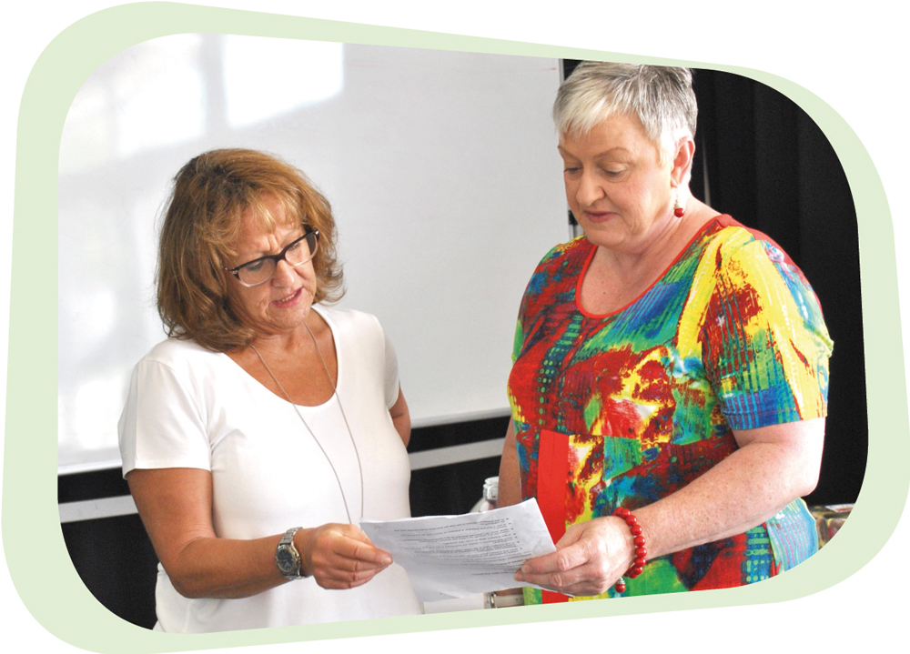

Theorise
What are the key points that are emphasised in the process of critical reflection?
What would it take to keep you engaged in critical reflection? And how could it relate to linking study and practice?

Think Otherwise
In order to think critically, what knowledge about our practices do we need to build that underpins our work with children and their families?
What is some of the underpinning knowledge we will need to be effective?
What are the next steps?
How will we know we are using critical reflection?

Closing
This session has been very helpful to all of us in looking at the purpose of critical reflection. Reflective practices are seen as a way to enhance the quality of education and care offered to children. Your ability to reflect on your work provides you with the feedback to nurture your self-esteem and professional growth.


Additional Information
Australian Children’s Education and Care Quality Authority. (2012).
The National Quality Standards. Retrieved from www.acecqa.gov.au
Department of Education, Employment and Workplace Relations (DEEWR). (2009). Belonging, Being & Becoming: The Early Years Learning Framework for Australia. Canberra, ACT: Commonwealth of Australia.
Cartmel, J., Macfarlane, K. and Casley, M. (2012). Reflection as a tool for quality: Working with the National Quality Standard. Research in Practice Series Volume 19 Number 4. Early Childhood Australia Inc.


Conversation 5 – A Template for Creating Targeted Conversations
Choose some of the questions from each step to help structure the reflective conversation.

Opening
Tell the educators that you are going to have a conversation about an aspect that is of interest to them, linking their study with practice.

Deconstruct
Describe the situation or experience.
What practices, processes are being used here? What have we done here that we
always do?
What is the context – what else is happening for us, for the families, for the child,
for community, for colleagues?

Confront
Are there ways of doing things in this situation that we should confront?
What can we do to confront taken for granted ways of acting? Are there ways that we ask them to conform? Are we conforming to others?
What is expected by others – what is woven into this situation that is difficult
to confront?

Theorise
Are there theories that help us here? From where can these be drawn?
Can we draw ways of understanding from philosophy or cultural understandings?
What are the values being exemplified here?

Think Otherwise
How else could we think? What has been revealed?
What could we prioritise that we hadn’t before?
Where are we now – what new insight do we have?
What do I know now that will help me think and see differently?
What will I do differently?

Closing
Draw the ideas to a close and thank everyone for their participation.

Additional Information
Maybe you have something that you would like the
educators to read or watch to stimulate the conversation.

Conversation 6 – Promoting Children’s Learning

Opening
As educators, a very important part of our role is to promote children’s learning.

Deconstruct
What do we mean by children’s learning?
How do we currently promote children’s learning?
What strategies do you use to promote children’s learning?
What information does the Early Years Learning Framework and Framework for School Age Care provide in terms of promoting children’s learning?
What is the relationship between play and learning?

Confront
What do you need to consider to ensure that you are promoting children’s learning?
How do you feel about the strategies you use to promote children’s learning?
What is expected of others?

Theorise
What are influencing factors in the formation of your understanding about
children’s learning?
How do you find information about promoting children’s learning?

Think Otherwise
What could we do to improve our practice for promoting children’s learning?
What else do you need to know about children’s learning?

Closing
This conversation has allowed you to investigate what we mean by children’s learning in the broader context of early childhood education and care. You have also investigated and critically reflected on why play is important, how to implement and assess a play-based programme and your role in the process.


Additional Information
Australian Children’s Education and Care Quality Authority. (2013). Guide to the National Quality Standards. Retrieved from www.acecqa.gov.au
Australian Government Department of Education, Employment and Workplace Relations. (DEEWR), (2009), Belonging, being and becoming: The Early Years Learning Framework for Australia. Canberra: Commonwealth of Australia.
Barblett, L. (2010) Why play-based Learning? Every Child Magazine, 16, p.1. Retrieved from http://www.earlychildhoodaustralia.org.au/every_child_magazine/every_child_index/why_play-based_learning.html
Kennedy, A. (2012). Evaluating and communicating about children’s learning. NQS PLP e-Newsletter No 48. Retrieved from http://www.earlydchildhoodaustralia.org.au/nqsplp/e-newsletters/newsletters-46-50/newsletter-48/

Conversation 7 – Supporting Children’s Wellbeing

Opening
As educators, a very important part of our role is to support children’s social and emotional wellbeing. High quality early childhood settings promote children’s social and emotional wellbeing, and are characterised by warm, positive and stimulating staff–child interactions, engaging and challenging activities and a safe and healthy environment.

Deconstruct
How do we currently support the social and emotional wellbeing of individual children in our service?
What do our policies say about social and emotional wellbeing?
How do you provide warm and positive interactions?
How do you assist children who are showing signs of stress?
How do you ensure the toys, equipment, games and resources are catering for the abilities and interests of the children?
How do you reduce the risk of potential injury and discuss risks with children?

Confront
What do you need to consider when you are ensuring that you are supporting children’s wellbeing in relation to their happiness, ability to feel relaxed, health, nutrition, sleep, and rest?
What are your beliefs and values around children’s social and emotional wellbeing?
How do you feel about the current strategies used to support children’s wellbeing?
What are the challenges that we face in trying to cater for individual children’s social and emotional wellbeing?

Theorise
What are influencing factors in the formation of your understanding about children’s social and emotional wellbeing?
Why is it important that each child’s social and emotional wellbeing is supported? Why do we do it?

Think Otherwise
What could we do to improve our practice for ensuring the social and emotional wellbeing of all children in our care?
How can we ensure that each child’s social and emotional wellbeing is met within a
group setting?

Closing
This is a challenging topic and it is hard to distinguish a right and wrong answer. The learnings you gather from these conversations can be put into practice blending your studies with daily practices. We can continue these conversations as issues arise and reflect and evaluate our practice to improve outcomes for the children in our care and meet the National Quality Standard.
Sometimes we are torn between routines that keep our centre running smoothly and catering for the individual needs of children. It is also sometimes challenging to support one child’s need when it may impact on another child’s need. We need to continue to be reflective in our thinking to ensure that these needs are being met as much as practically possible.


Additional Information
The Circle of Security International website (circleofsecurity.net) includes useful information and resources in relation to children’s wellbeing.
Hunter Institute of Mental Health. (n.d.). RESPONSE ABILITY Driving child and youth wellbeing. Retrieved from http://www.responseability.org/__data/assets/pdf_file/0007/4885/Educators-Guide-for- the-website.pdf
Kids Matter. (n.d.). Understanding mental health in early childhood. Retrieved from https://www.kidsmatter.edu.au/early-childhood
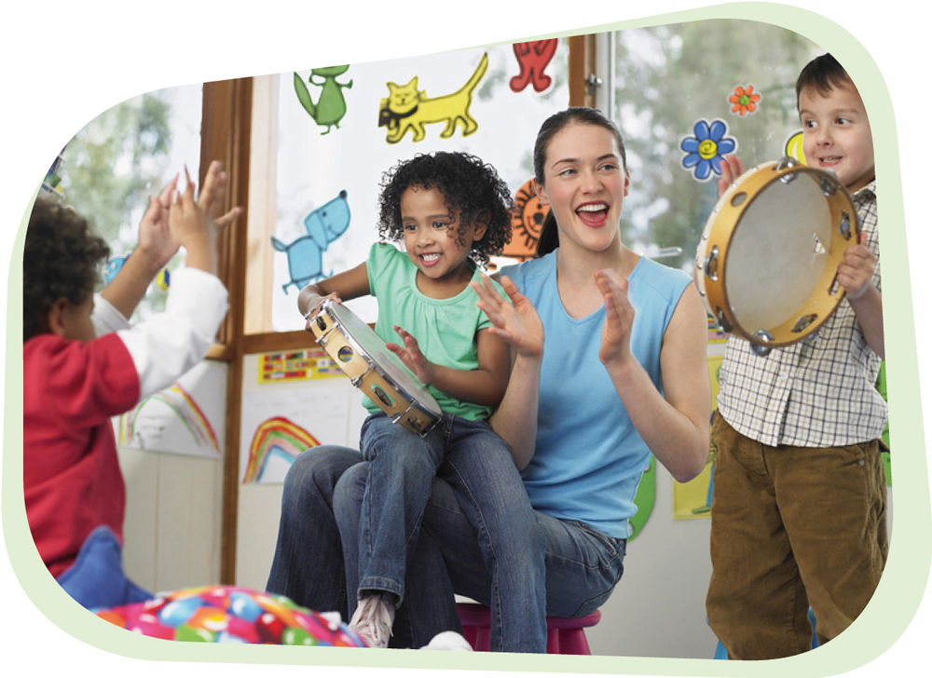

Conversation 8 - Building Relationships With Parents

Opening
Establishing genuine partnership with parents and acknowledging the unique and specific needs of each individual family is central to providing effective early childhood education and care. Working collaboratively and including parents in decision making about their child’s learning will ensure the best possible outcomes for each child.

Deconstruct
What do you do now to start to build a relationship with a new parent?
Who is involved in this process?
What use of your time and skills are put into developing relationships?
What information do you need when the child first joins the group?
What information can you gain as you build the relationship?

Confront
How do you feel about developing relationships with parents? How do you think the parents might feel? What makes you think that is the situation?
Why is building a relationship with parents important? What makes it easy to build a relationship with parents? What makes it challenging? What other things might we try to build relationships? How will we know if we are being responsive to parents?

Theorise
What have you been reading about building relationships with parents?
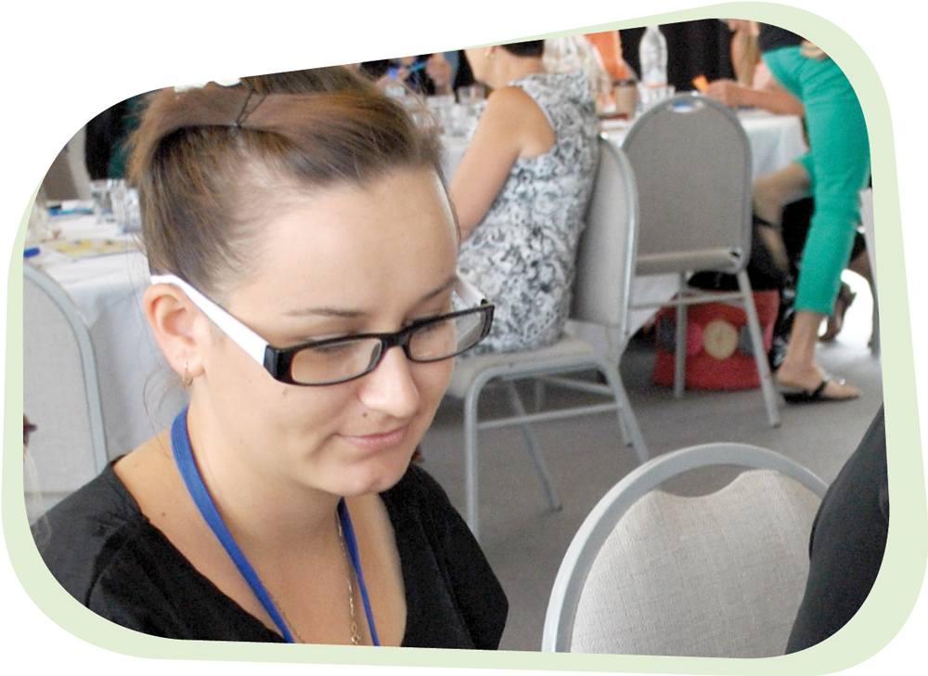

Think Otherwise
What will we do now to help build better relationships?
How can we help each other?
What resources (eg. time, place, furniture) are needed?

Closing
Building relationships with parents is an important part of your role as an educator. We have had time to think and talk about: what is important, what works, how we can work together and what is possible.


Additional Information
Australian Children’s Education and Care Quality Authority. (2013). Guide to the National Quality Standards. Retrieved from www.acecqa.gov.au
Australian Government Department of Education, Employment and Workplace Relations (DEEWR), (2009), Belonging, Being and Becoming: The Early Years Learning Framework for Australia. Canberra: Commonwealth of Australia.
Australian Government Department of Education, Employment and Workplace Relations (DEEWR), (2011), My Time, Our Place: Framework for School Age Care in Australia. Canberra: Commonwealth of Australia.
Stonehouse, A. (2012). Collaborative partnerships with families. NQS PLP e-Newsletter No 35, Retrieved from http://www.earlychildhoodaustralia.org.au/nqsplp/wp-content/uploads/2012/05/NQS_PLP_E-Newsletter_No35.pdf
Stonehouse, A. (2013). Communicating with families about children’s Learning. NQS PLP e-Newsletter No 68, Retrieved from ttp://www.earlychildhoodaustralia.org.au/nqsplp/wp-content/uploads/2013/11/NQS_PLP_E-Newsletter_No68.pdf

Conversation 9 - Creating Inclusive Programmes for Aboriginal and Torres Strait Islander Children and Their Families

Opening
“Culturally competent educators acknowledge the diversity of communities and are inclusive of all family groups” (Australian Government Department of Education, Employment and Workplace Relations [DEEWR], 2010, p.17). Aboriginal and Torres Strait Islander families, like all families have high expectations that their children will achieve and have access to the same educational outcomes as all children in the programme.
We must always consider the feelings of families when they arrive at our service as they may already be feeling somewhat alienated and unsure if they have previously encountered barriers to the inclusion of their children in mainstream early childhood programmes.
“Belonging, being and becoming are not new concepts to Aboriginal and Torres Strait Islander Australians. They are the essence of Aboriginal and Torres Strait Islander identities”. (DEEWR), (2010, p.22).

Deconstruct
Tell us what you know about Aboriginal and Torres Strait Islander culture and history? In what ways do you think cultural values and historical events have affected the way in which Aboriginal and Torres Strait Islander families are today? What do you currently do to develop positive attitudes towards cultural differences or promote children’s cultural competence?

Confront
How do you feel about including Aboriginal and Torres Strait Islander culture into your programme? What makes you feel good about how you work with Aboriginal and Torres Strait Islander children and their families? What concerns might you have?
What do you think is the most important part in working with Aboriginal and Torres Strait Islander families? What appears to be the key issues in creating a culturally inclusive programme?

Theorise
What information have you found that builds your understandings about Aboriginal and Torres Strait Islander families?

Think Otherwise
What actions do we need to take to ensure our service is accessible to Aboriginal and Torres Strait Islander children and their families? What kind of support might be helpful to you? How will we know that we are being inclusive?

Closing
Having open and honest conversations about what you know and what you don’t
know about Aboriginal and Torres Strait Islander culture and history is part of the journey to creating accessible services. Identifying and understanding particular barriers faced by Aboriginal and Torres Strait Islander families are other steps in the journey. Breaking down barriers and seeing the strength and qualities of culture is what will make the difference.


Additional Information
Australian Government Department of Education, Employment and Workplace Relations. (DEEWR), (2009). Belonging, being and becoming: The Early Years Learning Framework for Australia. Canberra: Commonwealth of Australia, p.16.
Australian Government Department of Education, Employment and Workplace Relations (DEEWR), (2010). Educators’ Guide to the Early Years Learning Framework for Australia. Canberra: Commonwealth of Australia.
Connor, J. (2011). Understanding cultural competence. NQS PLP e-Newsletter No 7. Retrieved from http://www.earlychildhoodaustralia.org.au/nqsplp/ wp- content/uploads/2012/05/EYLFPLP_E-Newsletter_ No7/pdf
Early Childhood Australia (2014). Talking about practice: Exploring Reconciliation in early childhood practice. NQS PLP e-Newsletter No 48. Retrieved from http://www.earlychildhoodaustralia.org.au/nqsplp/wp-content/uploads/2014/02/NQS_PLP_E-Newsletter_No71.pdf
Queensland Department of Education, Training and Employment (2013). Foundations for Success Guideline for extending and enriching learning for Aboriginal and Torres Strait Islander children in the Kindergarten Year. Retrieved from http://deta.qld.gov.au/indigenous/pdfs/foundations-for-success-2013.pdf

Conversation 10 - Understanding Policies and Procedures

Opening
Early childhood educators need to demonstrate the skills and knowledge required to address duty of care expectations, applying relevant legislation and work within an ethical framework. Educators need to contribute to the development of policy and procedures and understand how to use the service policies and procedures when responding to children and families who access children’s services.

Deconstruct
What do you know about the policies in our service?
What do our policies and procedures tell us about?
What kinds of issues have you had to respond to where policies and procedures were used?
Examples of policies might be – Maintaining confidentiality; Sun smart; Responding to ethical dilemmas; Play (superheroes, rough and tumble).
How are these policies and procedures followed?

Confront
How do you feel about using policies and procedures to develop a response to an issue?
How helpful was the policy? Why or Why not?

Theorise
What is the difference between legislation and policies?
What do you know about policy development and review?

Think Otherwise
What could we do now to re-evaluate our practice and come up with new policies or procedures to ensure that they are relevant to our service and incorporate current legislative requirements?
What could we put into place as educators to ensure that our policies and practice stay current?

Closing
This conversation has been very helpful in examining our current policy and how it relates to our practice. It is really important to use your studies as a way of understanding and helping to contribute to policy development and review.


Additional Information
Early Childhood Australia (2006). Code of Ethics. Retrieved from www.earlychilhoodaustralia.org.au/
code_of_ethics/early_childhood_australia_code_of_ethics.html
Australian Children’s Education and Care Quality Authority. (2013). Guide to the National Quality Standards. Retrieved from www.acecqa.gov.au

Conversation 11 – Providing Physical Care

Opening
“Provide care for children” is a very ambiguous statement which could mean different things to different people. We are going to have a conversation (perhaps even several conversations) around what this statement means for us individually and collectively, and how exploring this may contribute to positive change in our practice to provide best outcomes for children in our care.

Deconstruct
What do you consider when providing for children’s physical care?
(Physical care defined as rest; toileting; food & drink; clothing)
How do you encourage children to develop skills to help them achieve tasks for themselves? Or to help each other? (Consider the learning environment and engagement with families)

Confront
What are the current daily organisational structures and routines? Discuss how you plan the day based on the needs of educators or the needs of the children. How do you transition to and from these?
Maybe use a daily plan from your services and consider whether the organisation is based on the educators’ needs or the child’s needs?

Theorise
How could you evaluate our routines and practices to ensure that the children are central to what we do and why we do it?
What do you know about high quality practice regarding the organisation of ‘the day’ in early childhood settings?
What do you need to consider about child rearing practices within and across cultures in terms for providing for the child’s care?

Think Otherwise
What new understandings do you have about the way in which we should practice providing for children’s physical care?

Closing
This has helped us think critically about why we do what we do, and the need to understand the theory behind our practice.


Additional Information
Another conversation could be held using the same questions
but focusing on the experience for children who are new to the service.

Conversation 12 – Meal Time Routines

Opening
There are many routines that children participate in the daily life of an early childhood setting. These may include sleep/rest; play; arrival; departure etc.
In this conversation we will endeavour to examine how we can provide adequate food and drink for children’s health within a group setting.

Deconstruct
What is our philosophy to provide healthy foods for children?
What happens in the service to follow this philosophy? What are the policies and practices? Consider special dietary needs?
What are the legislative requirements?

Confront
How do you feel about our policies?
What are some of the joys and what are some of the challenges in meal time routines?

Theorise
What do you know about healthy eating for children?
Whose purpose do our current procedures and routines serve?
What are the issues that have come to light during this conversation that we need to explore when we start to think otherwise about the provision of food and drink to children?

Think Otherwise
Do you feel that it is possible to support the individual needs of children and the overall routines of the centre simultaneously?
How do you feel that we could support the needs of individual children and the needs of the routines of the centre with regard to food and drink routines and procedures?
How could we support families to make healthy food and drink choices for their children?
How could we support children to make healthy food and drink choices for themselves?

Closing
Thank you for your contribution to this conversation. The suggestions and ideas
brought forward today can be useful to your studies and to your career in the early childhood sector.


Additional Information
Better Health Channel (n.d.) Food and Nutrition. Retrieved from http://www.betterhealth.vic.gov.au/
Department of Health. (2013). Get Up and Grow: Aboriginal and Torres Strait Islander specific: Staff handbook. Retrieved from http://www.health.gov.au/
Department of Health. (2013). Get Up & Grow: Healthy Eating and Physical Activity for Early Childhood – Directors/Coordinators Book. Retrieved from http://www.health.gov.au/

Conversation 13 – Duty of Care

Opening
We have a duty of care to the children in the service and to families and other visitors who come into our centre and work within relevant legal and ethical frameworks.
We are sometimes confronted by differing personal values and belief systems which we need to be open and non-judgemental. During this conversation we will investigate together what our legal and ethical responsibilities are as an educator working within early childhood settings.

Deconstruct
What is ‘duty of care’?
To whom do we provide duty of care?
What are some of the other areas of law that may be relevant to our work role?
What does it mean to work ethically?

Confront
How do you feel about the importance of confidentiality within your role?
How do you respond to people who have very differing values and beliefs to yourself? Are there any issues that would inhibit you from being open to other ways of thinking? Why?
How do you recognise and address conflict of interest?
How do you feel about responding when you are aware that a child’s rights and interests are not being protected?

Theorise
What are the issues that we have highlighted in today’s conversation that we need to explore further?
Are we all aware of the legal and ethical requirements of our position as it relates to position specifications and responsibilities?
Do we know what the policies and procedures tell us about confidentiality, duty of care and ethics?

Think Otherwise
What would happen if we were always open to the values and beliefs of others even when they are very different to our own?

Closing
Sometimes it can be a little confronting when we find our own personal values and beliefs challenged and so we need to remember this when we are faced with other values and beliefs that differ considerably from our own. Duty of care is an essential component of an educator’s role. Sometimes it can be confronting when we find our own personal values and beliefs challenged and so we need to remember this when we are faced with other values and beliefs that differ considerably from our own.


Additional Information
Australian Children’s Education and Care Quality Authority. (2013). Guide to the Education and Care Services National Law and the Education and Care Services National Regulations 2011.
Retrieved from www.acecqa.gov.au
Australian Children’s Education and Care Quality Authority. (2013). Guide to the National Quality Standards. Retrieved from www.acecqa.gov.au (Consider standards 2, 4 and 5).
Convention on the Rights of the Child - http://www.unicef.org/crc/files/Rights_ overview.pdf
Early Childhood Australia (2006). Code of Ethics.
Retrieved from www.earlychildhoodaustralia.org.au/code_of_ethics/
early_childhood_australia_code_of_ethics.html

References
Australian Children’s Education and Care Quality Authority. (2013). Guide to the National Quality Standards. Retrieved from www.acecqa.gov.au
Australian Children’s Education and Care Quality Authority. (2012). The National Quality Standards. Retrieved from www.acecqa.gov.au
Australian Children’s Education and Care Quality Authority. (2013). Guide to the Education and Care Services National Law and the Education and Care Services National Regulations 2011. Retrieved from www.acecqa.gov.au
Australian Government Department of Education, Employment and Workplace Relations
(DEEWR), (2009), Belonging, Being and Becoming: The Early Years Learning Framework for Australia. Canberra: Commonwealth of Australia.
Australian Government Department of Education, Employment and Workplace Relations (DEEWR), (2010). Educators’ Guide to the Early Years Learning Framework for Australia. Canberra: Commonwealth of Australia.
Australian Government Department of Education, Employment and Workplace Relations
(DEEWR), (2011), My Time, Our Place: Framework for School Age Care in Australia. Canberra: Commonwealth of Australia.
Australian Government Department of Education, Employment and Workplace Relations (DEEWR), (2012). Engagement of students in Children’s Services qualifications, NCVER Consultancy report, Canberra, ACT: Commonwealth of Australia.
Australian Government Department of Health and Ageing. (2012). Social and Emotional Wellbeing. A Guide for Children’s Services Educators. Hunter Institute of Mental Health. Retrieved from http://www.responseability.org/__data/assets/pdf_file/0007/4885/Educators -Guide-for-the-website.pdf
Barblett, L. (2010). Why play- based Learning? Every Child, 16 (1), p.1. Retrieved from http://www.earlychildhoodaustralia.org.au/every_child_magazine/every_child_index/why_play-based_learning.html
Better Health Channel (n.d.). Food and Nutrition. Retrieved from http://www.betterhealth.vic.gov.au/
Cartmel, J. (1997). Aspects of a practicum in postgraduate early childhood education, Unpublished Masters dissertation. Brisbane: Queensland University of Technology.
Cartmel, J., Macfarlane, K. & Casley, M. (2012). Reflection as a tool for quality: Working with the National Quality Standard, Research in Practice Series, 19(4). Canberra: Early Childhood Australia.
Casley, M. & Cartmel, J. (2009). Dialogues of Discovery, Brisbane: Early Childhood Australia Queensland Branch.
Connor, J. (2011). Understanding cultural competence. NQS PLP e-Newsletter No 7. Retrieved from http://www.earlychildhoodaustralia.org.au/nqsplp/ wp-content/uploads/2012/05/EYLFPLP_E-Newsletter_ No7/pdf
Convention on the Rights of the Child. Retrieved from http://www.unicef.org/crc/files/Rights_overview.pdf
Cooper, G., Hoffman, K., Marvin, R. & Powell, B. (1998). Circle of Security. Retrieved from
www.circleofsecurity.org
Craft, A. & Paige-Smith, A. (2011). What does it mean to reflect on our practice? In A. Paige-Smith & A. Craft, Developing reflective practice in the early years (2nd Ed). New York: Open University Press. 13-24.
Department of Health. (2013). Get Up and Grow: Aboriginal and Torres Strait Islander specific: Staff handbook. Retrieved from http://www.health.gov.au/
Department of Health. (2013). Get Up & Grow: Healthy Eating and Physical Activity for Early Childhood – Directors/Coordinators Book. Retrieved from http://www.health.gov.au/
Early Childhood Australia (2006). Code of Ethics. Retrieved from www.earlychilhoodaustralia.org.au/ code_of_ethics/early_childhood_australia_code_of_ethics.html
Early Childhood Australia (2014). Talking about practice: Exploring Reconciliation in early childhood practice. NQS PLP e-Newsletter No 48. Retrieved from http://www.earlychildhoodaustralia.org.au/nqsplp/wp-content/uploads/2014/02/NQS_PLP_E-Newsletter_No71.pdf
Fook, J. & Gardner, F. (2013). Critical reflection in context. New York: Routledge.
Fook, J., & Gardner, F. (2007). Practising critical reflection: A resource handbook. Maidenhead: Open University Press.
Foucault, M. (1980). ‘Truth and power’ in Gordon, C. (ed.), Power/knowledge: selected interviews and other writings, 1972-77, pp. 109-133, New York: Pantheon Books.
Foucault, M. (1984). Polemics, politics and problematisations. In P. Rabinow (Ed.), Michel Foucault, ethics: Essential works of Foucault 1954–1984 (Vol. 1, pp. 111–119). London: Penguin.
Gardner, F. (2009). Affirming values: Using critical reflection to explore meaning and professional practice. Reflective practice: International and multidisciplinary perspectives, 10 (2), 179-190.
Hunter Institute of Mental Health. (n.d.). RESPONSE ABILITY Driving child and youth wellbeing. Retrieved from http://www.responseability.org/__data/assets/pdf_file/0007/4885/Educators-Guide-for- the-website.pdf
Kahane, A. (2002). Changing the World by Changing How We Talk and Listen. Retrieved from http://www.scribd.com/doc/14812092/Kahane-on-Talking-and-Listening.
Kennedy, A. (2012). Evaluating and communicating about children’s learning. NQS PLP e-Newsletter No 48. Retrieved from http://www.earlychildhoodaustralia.org.au/nqsplp/e-newsletters/newsletters-46-50/newsletter-48/
Kids Matter. (n.d.). Understanding mental health in early childhood. Retrieved from https://www.kidsmatter.edu.au/early-childhood.
Kinsella, E. A. (2007). Embodied reflection and the epistemology of reflective practice. Journal of the Philosophy of Education, 14 (3), 395-409.
Lather, P. (1996). ‘Methodology as subversive repetition: Practices toward a feminist double science’. Paper presented at the American Educational Research Association Conference, New York City, New York, 8th – 12th April.
Lovett, S., & Gilmore, A. (2003). Teachers’ learning journeys: The quality learning circle as a model of professional development. School Effectiveness and School Improvement 14(2),189–211.
Macfarlane, K. (2006). An analysis of parental engagement in contemporary Queensland schooling, PhD thesis. Queensland University of Technology: Brisbane, Queensland.
Macfarlane, K. & Cartmel, J. (2008). ‘Playgrounds of learning: valuing competence and agency in birth to three-year-olds’. Australian Journal of Early Childhood, 33(2), 41-47.
Macfarlane, K., & Cartmel, J. (2007). Report: Circle of change revisited, Brisbane, QLD: Health and Community Services Workforce Council, Griffith University.
Macfarlane, K., Cartmel, J., & Maher, C. (2007). Circle of change: Innovative approaches to field education. Every Child, 13(2), 27.
Macfarlane, K., Cartmel, J. & Nolan, A. (2011). Developing and Sustaining Pedagogical Leadership in Early Childhood Education and Care Professionals – Final Report, Australian Learning and Teaching Council, Surrey Hills: Australia.
Macfarlane, K., Casley, M., Cartmel, J. & Smith, K. (2014). Understanding the ‘how’: a model of practice for critical reflection for children’s services practitioners. Journal of Playwork Practice, 1(1), 65-77.
Moss, P., & Petrie, P. (2002). From children’s services to children’s spaces: Public provision, children and childhood. London: Routledge Falmer.
Noble, K., Macfarlane, K. & Cartmel, J. (2005). Circle of change: challenging orthodoxy in practitioner supervision. Pearson: Frenchs Forrest.
Osmond, J. & Darlington, Y. (2005). Reflective analysis: Techniques for facilitating reflection. Australian Social Work, 58(1), 3-14.
Osmond, J., & O’Connor, I. (2004). Formalizing the unformalized: Practitioners’ communication of knowledge in practice. British Journal of Social Work, 34, 677–692.
Queensland Department of Education, Training and Employment. (2013). Foundations for Success Guideline for extending and enriching learning for Aboriginal and Torres Strait Islander children in the Kindergarten Year.
Queensland Department of Education, Training and Employment (2013). Foundations for Success Guideline for extending and enriching learning for Aboriginal and Torres Strait Islander children in the Kindergarten Year. Retrieved from http://deta.qld.gov.au/indigenous/pdfs/foundations-for-success-2013.pdf
Rinaldi,C. (2001) The Pedagogy of Listening: The Listening perspective from Reggio Emilia. Innovations, 8(4), 1-4.
Rolfe, S. (2004). Rethinking attachment for early childhood practice: Promoting security, autonomy and resilience in young children. London: Allen & Unwin.
Ruch, G. (2005). Relationship based practice and reflective practice: Holistic approaches to contemporary child care social work. Child and Family Social Work, 10, 111-123.
Russell, T. (2005). Can reflective practice be taught? Reflective practice: International and multidisciplinary perspectives, 6 (2), 199-204.
Rutyna, B. (2011). Mentoring - Learning with others, building capacity. In the Loop, Summer, 3-6.
Scharmer, O. (2009). Theory U: Leading from the future as it emerges. Theory , San Francisco, California: Berry-Koeheler.
Schoen, D. (1983). The reflective practitioner. New York: Basic Books.
Senge, P., Scharmer, O.,C., Jaworski, J. & Flowers, B.,S. (2005). Presence: An exploration of profound change in people, organizations and society. New York, NY: Double Day.
Stanfield, B. (2000). The Art of Focussed Conversation. Gabriola Island, VC Canada: New Society Publishers.
Stonehouse, A. (2012). Collaborative partnerships with families. NQS PLP e-Newsletter No 35 2012. Retrieved from http://www.earlychildhoodaustralia.org.au/nqsplp/wp-content/uploads/2012/05/NQS_PLP_E-Newsletter_No35.pdf
Stonehouse, A. (2013). Communicating with families about children’s learning. NQS PLP e-Newsletter No 68 2013. Retrieved from http://www.earlychildhoodaustralia.org.au/nqsplp/wp- content/uploads/2013/11/NQS_PLP_E-Newsletter_No68.pdf
UN General Assembly, Convention on the Rights of the Child, 20 November 1989, United Nations, Treaty Series, vol. 1577, p. 3, available at: http://www.refworld.org/docid/3ae6b38f0.htm
Wheatley, M. (2002). Some friends and I started talking……..UTNE Reader. Retrieved from http://www.utne.com/community/some-friends-and-i-started talking.aspx#axzz34IUREw4i, 11 June, 2014
White, A. (2013). Supporting a professional, qualified, growing, responsive and collaborative workforce. In the Loop. Winter, 6-7.

Appendix

A Case Study – Circle of Change Revisited
Circle of Change Revisited (COCR) is a strategy to encourage educators to embrace critical reflection in everything they do. COCR was developed in conjunction with field education for child and family students. It was an innovative approach to the problem of locating, managing, supervising, and assessing work-integrated learning placements for large numbers of university students.
Using the process of democratic conversations the COCR brought together students, academics and educators to discuss practices and principles of early childhood education and care (Macfarlane & Cartmel, 2007). The COCR model is based on the notion of learning circles (LCs), which are used in adult learning settings for the purpose of conversations promoting critical reflection. The circles usually involve 6-15 participants who respect each other as being equal (Lovett & Gilmore, 2003).
The Circle of Change Revisited is a way for educators to “take time to stop and examine their assumptions” (Senge, Scharmer, Jaworski & Flowers, 2005, p. 33) so that they can form new understandings with regard to important issues. In these conversations participants can discuss workplace issues and support each other in learning about the features of their work with children and families.
The learning occurs through shared inquiry and dialogue. Educators can progress at their own pace, drawing on their tacit knowledge and life experiences. The process builds knowledge and understandings and increases educators’ self-awareness and self-confidence. The COCR conversations start where educators are at and involve a spiralling process of reflection and thinking actions (see Figure 2 – Circle of Change Revisited Process).

Figure 2 - Circle of Change Revisited, Model of Critical Thinking
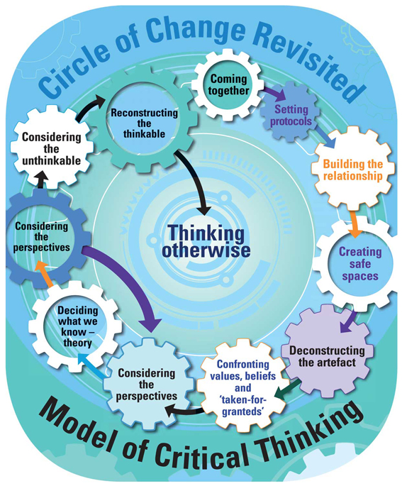
- Coming together
- Setting protocols
- Building the relationship
- Creating safe spaces
- Deconstructing the artefact
- Confronting values, beliefs and ‘taken-for-granteds’
- Considering the perspectives
- Deciding what we know – theory
- Considering the perspectives
- Considering the unthinkable
- Reconstructing the thinkable
- Thinking otherwise

Figure 2 – The Circle of Change Revisited, Model of Critical Thinking

Participants have made very positive comments about the COCR process.
“I found it highly satisfying to engage as individuals, sharing experiences, considering other viewpoints and learning more in a stimulating and thought-provoking environment” (Educational leader).
“It is great to feel more confident and use a more critical approach to learning”
(Group leader).
“All the new knowledge really empowers me to feel confident and change practices” (Educational leader).
In the COCR process participants decide what issues to explore and how much time to spend on particular topics. Some rules and routines are required for the process to be successful. It is useful to designate a facilitator to help guide the conversation and to ensure that everyone has the opportunity to participate equally. Sometimes the role of facilitator may be shared around the group.
Setting up and facilitating COCR requires commitment and work to ensure that the group operates effectively as facilitators of their own learning and reflective practice. The aim is to be a democratic conversation amongst equals. It is not meant to be a way of learning a lot of facts or for everyone to reach agreement. It is to deepen each participant’s understanding of the principles and practices that guide educators work with children, and empower each to act on beliefs and based on shared understandings.
The COCR model was developed to challenge thinking, that is, to develop in educators the ability to be critical and insightful thinkers. As critical thinkers educators are able to reflect on everyday events and to consider changes to their practice. This process helped educators to make changes that would contribute to the wellbeing of the children with whom they worked. The structure of the COCR was such that it was a democratic space in which conversations would involve a model of critical thinking that would facilitate change in attitudes, thinking, and practice (Macfarlane, Casley, Cartmel & Smith, 2014; Macfarlane & Cartmel, 2012).
The first three steps of the model – deconstruct, confront, and theorise - teach educators to inform their thinking through multiple perspectives in order that they might become more able to ‘think otherwise’ (step four) (Foucault, 1984). The COCR conversations are intended to lead action and change. They are democratic in spirit and encourage genuine participation. This COCR process enables staff to understand the impact of the practices that are occurring in the field. It provides the time and space for conversations that lead to change in attitudes and practices. The COCR helps educators to develop their knowledge and skills, and resilience, which are important during a career in the early childhood education and care sector.

Circle of Change Revisited example used with the experienced and novice educators
Note: This Circle of Change Revisited example shows how practice can be seen in multiple ways when new perspectives are taken into account. The educators use the critical reflection model to highlight elements of quality practice with children.

Deconstruct
What?
Who? Facilitator: What practice have you noticed that you want to know more about?
Trina (novice educator): I can’t understand why Adriane lets parents stay as long as they want when they are dropping their children off. Wouldn’t it be much easier for them to just drop the children at the front door?

Confront
What?
How? Adriane (Educator): I would not find it easier as it would create chaos for me and the other staff. When the parents and I spend time getting to know each other it helps the children to trust and build a relationship with me. To me a mass drop off does not respect the needs of the children and their parents.
Trina: But the arrival time isn’t part of the programme. It is such an insignificant part of the child’s day.
Facilitator: What do others think?
Jay: (Educator) I find that if the parents are friendly and comfortable with the staff the children seem to settle more quickly.
Brenna: (Novice educator) I remember feeling safer and more friendly with other adults if I knew that my parents knew them.

Theorise
Why? Adriane: I believe it was important to greet parents and children individually and help them settle into their environment.
Jay: When children and parents arrive it is a good time to exchange information. It is a good time to find out about what children have been doing since they were last at the centre. It is also a chance to find out about what parents value, their children rearing beliefs and their aspirations for the care of their children.
Trina: I hadn’t thought about that. Does it really matter that educators know what children have been doing at home and vice versa for parents to know what children have been doing at the centre?
Brenna: But some children only come one or two days a week.
Adriane: I know that the time spent with each child and parents helps me to get to know them better and therefore we can build a trusting relationship with each other.

Think Otherwise
What next? Trina: I have been finding it a bit hard to get to know the children and get them to talk to me, maybe I will try to use the arrival time to help build relationships.
Adriane: I have realised that maybe I don’t emphasise in my programme and observations the significance of routines.
As these educators deconstruct their practice and use concrete examples of what they consider important, it is easy for a facilitator to augment such conversations with theory and literature, asking novice educators to make the transition to understanding how quality practice is underpinned in this way. The conversation in the Circle of Change (COC), allowed educators to discuss the importance of this practice as part of an established routine that assisted the child’s attachment to their primary care giver (Rolfe, 2004) and the development of family partnerships (DEEWR), (2009); where routines suit the child and their family, rather than the routine practices with children being designed to be seen as efficient.

