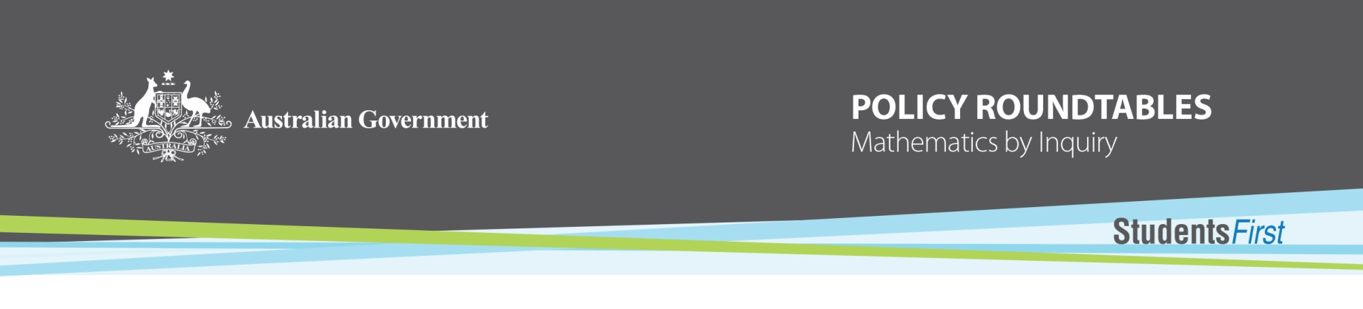

Mathematics by Inquiry

Roundtable key messages

The Mathematics by Inquiry Roundtable participants met Friday 7 May 2015, Adelaide SA, to discuss the findings of two desktop reviews and to provide advice on the priorities to be addressed by the Mathematics by Inquiry project.

There was general agreement from participants on the quality and outcomes from the desktop reviews conducted by the Australian Association of Mathematics Teachers and the Australian Academy of Science. A summary of some of the key messages highlighted from the roundtable include the following:

**Vison:**

* There is a need for a shared vision and strategy for mathematics education in Australia that encompasses goals for the short and long term.

**Students:**

* Students do not see the importance and relevance of mathematics to their lives and potential careers.
* Students tend to think that only those with innate mathematical talent are good at mathematics. We need to change this mindset.
* They are missing out on being taught problem solving and reasoning proficiencies and connections to the ‘big ideas’.
* Their views about the relevance and value of mathematics are significantly influenced by their parents who may have negative feelings and a lack of understanding about the importance of mathematics knowledge and skills.
* What is taught in schools is largely defined by the Australian Curriculum. It appears that the content outlined through the descriptors is being delivered but the teaching of proficiencies, in particular, reasoning and problem solving, requires improvement.
* Assessments need to reflect the expected learning of students. Most current assessments do not assess students’ problem solving and reasoning proficiencies. There need to be changes to how students are assessed in order for teachers to shift how they teach mathematics.
* It is important to make connections between different mathematical content.

**Teaching:**

* There is a concern with teacher knowledge and skills on mathematics and mathematics content pedagogical knowledge, especially of those teachers who are teaching out of their own subject area.
* Some teaching practice and mathematics content is driven by the text book being used.

**Resources:**

* Teachers can be supported through well annotated student resources that outline connections with but not limited to: the big ideas; relevance to real world examples, different pedagogies, extension work for higher achieving students, connections to other learning areas, context or environment support.
* Resources for teachers need to be coherent, have a narrative and support the transference of mathematical knowledge. It is important that resources avoid the atomisation of content.
* Teachers can spend a lot of time searching for appropriate resources because there are so many currently available.
* There is value in helping teachers to create and customise their own resources for their classrooms.
* The Education Services Australia managed Scootle is a great resource that needs to be maintained and made more user friendly for teachers. In particular, there needs to be a capacity for searches to be more discerning and more specific.
* The provision of more annotated work samples and content elaborations that address proficiencies and big ideas on ACARA’s website would assist teachers.

**School leadership:**

* Involvement of the school leadership team an essential to drive a cultural shift in how mathematics is taught and delivered to students.
* To date the focus in primary schools has predominantly been on literacy. There needs to be a similar strong emphasis placed on numeracy.

**Parents:**

* There is a need to involve parents into their child’s mathematics education, to change their negative perceptions about mathematics and acceptance that poor performance in mathematics is alright.
* Parents are seeking more regular feedback on achievement and ways to support their child’s learning but don’t know where to start.

**Next steps:**

A tender will be conducted seeking applications to address the areas of need as validated in the roundtable.