
Department of Education and Training
  - National
  - Collaborative Research
  - Infrastructure Strategy Project
  - Reviews - Overarching
  - Report
December 2014
www.kpmg.com.au

Contents
Executive Summary 3
1 Introduction and Background 10
2 Scope, Methodology and Approach 13
3 Summary of project ratings 18
4 Common themes of project performance against the review framework 23
5 Examples of better practice 32
6 Key opportunities for performance improvement across the programme 35
7 Common areas of risk across projects 39
8 Common themes from stakeholder consultation 41
Appendices 43
Appendix A – Project descriptions 43
Appendix B – Rating Definitions 46
Appendix C – Project Graphs 50

Executive Summary

Background and scope
The National Collaborative Research Infrastructure Strategy (NCRIS) programme currently funds 27 research infrastructure projects which are managed by 15 different lead agencies. For the NCRIS 2013 funding round $185.9 million was provided by the Australian Government.
The key objective of the programme is to establish research facilities and resources that are collaborative, national¹ and non-exclusive; serving the needs and enhancing the capability of the Australian research and innovation system. Such infrastructure resources should be focussed in areas where Australia is, or has potential to be, world class.
Australian Microscopy & Microanalysis Research Facility:
Examples of only two of the research outcomes are as follows.
The NanopatchTM will help to eradicate infectious diseases by making vaccination programs more effective worldwide.
Lighter and stronger alloys engineered at the atomic scale are reducing the environmental impact of transport and construction.
Source: NCRIS 2014 Showcase material
KPMG was engaged to undertake a review of the efficiency and effectiveness of each of the 27 projects and their lead agents, which currently make up the NCRIS network. Each project was visited by the review team, following a desk-based review of project information provided by the lead agent. The operational maturity of each project was assessed along with: governance, effectiveness, efficiency, financial management and compliance, integration and strategic policy alignment of each project.
Individual reports were developed to summarise the outcomes of the reviews. This report draws together common issues and themes arising from the project reviews, it also draws on additional programme information provided by the Department of Education and Training (the Department).
¹ Noting that national infrastructure is on a larger scale than institutional infrastructure, but does not include ‘landmark’ infrastructure.

Programme overview
A consistent message received from lead agents and the broader group of stakeholders interviewed was that the NCRIS programme has made a substantial contribution towards scientific research capability as well as research outcomes in Australia.
This has been achieved primarily through:
- providing access to facilities and resources (infrastructure) which may have either been previously unavailable to many researchers or duplicated, diverting scarce research funds that could be used on more productive pursuits. For example, the super computer facilities at the National Computational Infrastructure could not have been developed without NCRIS funding, and instrumentation such as the mass spectrometers used at Bioplatforms Australia. This later facility was not previously networked hence restricted in enabling more significant and larger projects or the development of framework datasets;
- expert staff to support researchers often leading to the achievement of enhanced results. For example, the use of necropsy service to analyse common organs and tissues associated with mice experimentation which is used in a range of human medical research initiatives; and
- the development of a significant skill base and technical capabilities that are often sought after internationally, such as the technical skill base of instrumentation staff at one of the project’s research facilities.
Terrestrial Ecosystem Research Network:
“The ability to be able to refer to TERN when commencing a project…. provides for better or more directed project design and so provides a cost benefit. For example, this can equate to 10% or more in time savings.”
“TERN is not only lowering the cost of research but enabling projects (through) the infrastructure it provides.”
Source: NCRIS 2014 Showcase material
There are numerous individual achievements as a result of the programme.
A key factor contributing to the success of the programme has been the strategic allocation of resources, whereby a road mapping process is utilised to collaboratively identify research infrastructure needs and direct funding accordingly. This road mapping process is recognised and utilised internationally, for example by the European Union, as an important tool to ensure targeted allocation of infrastructure resources across the research and innovation system.

Project assessments
When considering the maturity of the individual projects 16 of the 27 projects (59%) were considered “optimised”, the highest rating category. The next nine were rated at “measured” (33%), one as “managed” and the last as “repeatable”². The maturity rating framework assesses the overall sophistication of operations, policies and processes of each project.
When each project was assessed against component areas of governance, effectiveness, efficiency, financial management and compliance, integration and strategic policy alignment, there were very few projects that scored in the lower ranges. The majority of scoring ratings were eight and nine out of ten. These ratings were used to assess the degree to which each project addressed the questions identified in the overall review framework.
This indicates that the projects are generally of a mature nature and addressed the majority of criteria in the project review framework to a high degree. Over a relatively large number of projects (27) with complex requirements, it is unusual to have so many projects that score consistently high.

Common themes
There were a number of common themes identified across the 27 projects reviewed. These included:
- Effective governance arrangements – most projects had implemented effective governance arrangements that had been designed to meet the needs of the project. Those we assessed as particularly effective had a skills based board with an active network that could be drawn upon to support the project, as well as clearly defined roles and responsibilities. In addition, the skills and capability of the Project Director were considered to have made a significant impact, with those that have both a deep technical and scientific understanding as well as broader commercial acumen performing most impressively.
- Effective collaboration and integration – most projects were highly collaborative, with some by their very nature achieving this programme criteria requirement. For example, some projects make data publically available through open source software. The collaborative approach to undertaking research has been, and continues to be, a significant cultural change for the academic community. Many projects also leveraged other NCRIS and related projects.
- Nature of the lead agent – the majority of projects have lead agents that are a university (56%). The remaining projects lead agents are made up of Public Funded Research Agencies (PFRAs) (18%), companies (22%) or unincorporated joint ventures (4% but only one project). The form of these entities have different advantages. For example, universities and PFRAs bring existing support, controls and often significant in-kind support, whereas special purpose companies potentially bring greater flexibility, agility and at times, focus. For future projects, there is no ‘one size fits all’ approach, rather, the benefits, objectives, content and existing capability will be important determinants in choosing an appropriate lead agent and project vehicle.
² Based on the project assessment framework discussed in Appendix B.
- Co-investment – there has been a significant level of co-investment in the majority of the projects. For every dollar invested in NCRIS projects by the Australian Government an additional $1.06³ has been co-invested. The NCRIS principles encourage co-investment, but there is no specified level or threshold requirement. A multiplier effect of more than one demonstrates that the funding provided by the Australian Government is being well leveraged. It is important to note that this amount is likely to be understated as it only includes direct financial support, it does not include the significant levels of in-kind support provided to many projects.
- Use and impact of NCRIS funding – of the $185.9 million made available through NCRIS 2013, the funds are mainly used to support the ongoing operation of the facilities through technical staff salaries (74% of project employees are technical staff) with low levels of administrative expenditure (11% in 2013-14). It was evident in visiting the projects that they operate on very lean budgets, with project directors consistently being very conscious of the funds available and implementing measures to contain costs as well as limit any discretionary expenditure.
When considering measures of output and outcome⁴, noting that measurement is not uniform across projects, 848 grants with a total value of $379.59 million have been awarded involved the use of NCRIS projects. As a direct result of research utilising the projects, there have been 5,265 publications, 3,391 citations, 226 other publications and 1,376 conference papers produced. This is along with a significant number of research advances and achievements. We note that the figures are likely to be understated as not all projects collect this data.
³ Source: NCRIS Project survey, undertaken by Orima Research
⁴ Ibid

Broader observations
Whilst technically outside the scope of this engagement, a broader observation is that this programme has been established to address a form of “market failure”. That is, without Government investment the vast majority of these facilities and resources would not be funded; by the private sector or even by research organisations. While some of the projects are able to recover a percentage of operational costs, raising significant levels of capital to establish such infrastructure is highly unlikely.
Should the programme not continue there would be significant levels of inefficiency in the research and innovation system, as the research environment would revert back to its previous state prior to the NCRIS programme, i.e. facilities/projects would either simply not be available or would be duplicated through purchasing highly specialised and technical equipment in multiple institutions. In addition, there would be a loss of highly skilled technical staff that this programme, and previous programmes, have established.
The broader message regarding the benefit of the programme is consistent with an independent programme evaluation undertaken in 2010⁵ which concluded that the current NCRIS programme model was appropriate and that there was “a clear, ongoing need for government funding of research infrastructure”.
There have also been a number of studies that support the value of investing in the research and innovation system and the benefits to the national economy, these include:
- A recent study commissioned by Research Australia concluded that, between 1992-93 and 2004-05, expenditure on Australian research and development (R&D) returned a net benefit of approximately $29.5 billion to the economy.⁶
- A study commissioned by the Australian Society for Medical Research⁷ concluded that for every dollar invested in Australian health R&D, an average of $2.17 in health benefits is returned to the economy.⁸
- The Productivity Commission has indicated that public investment in research plays a significant role in building innovation capacity and driving productivity⁹ ¹⁰ . In Australia’s case in particular, the OECD has identified that public and private research and development supports and actively enhances our national productivity.¹¹
Based on this logic, the provision of targeted research infrastructure that is utilised on a collaborative basis, provides a strong foundation for the achievement of these and future economic and capability benefits.
⁵ NCRIS Review 2010 - http://www.education.gov.au/2010-evaluation-national-collaborative-research-infrastructure-strategy-ncris, undertaken by Allen’s Consulting
⁶ Lateral Economics
⁷ Access Economics
⁸ Discussion Paper: Health and Medical Research and the Future in NHMRC’s 75th Year: The virtuous cycle and the economic benefits of health and medical research (confidence range of $0.57 to $6.01)
⁹ Productivity Commission, 2007, www.pc.gov.au/projects/study/science/docs/finalreport.
¹⁰ National Academy of Sciences, 2010, www.aps.org/policy/reports/upload/rags-revisited.PDF
¹¹ www.oecd.org/dataoecd/2/31/39374789.pdf

Examples of better practice
There were numerous examples of better practice observed at a project level. For the purposes of this review better practice includes innovative practices and/or initiatives to increase the efficiency or effectiveness of the project. Some that were common to a number of projects included:
- Engagement with end-users – by way of example, one of the projects regularly consults with end-users in relation to possible future uses of its output, including through formal workshops. Further, the project’s engagement with end-users has seen it contracted to develop a specific monitoring tool for the Department of Environment.
- Broadly inclusive governance structures – a large number of projects have put in place governance arrangements that draw on a broader community of stakeholders and include a range of key skills and capabilities to guide the project.
- Facilitating meritorious research – those projects that are highly utilised and need to ration the supply of their infrastructure regularly have mechanisms to manage access. For example, making use of an external committee to assess proposals for use of equipment, and ensuring all researchers of merit, regardless of host organisation, have an opportunity of access.
Other individual examples, include utilising crowd-sourcing technology to allow volunteers to digitise biodiversity data and providing advice at no cost, to researchers and clinicians to ensure the most appropriate facility and methodology is utilised.

Areas for improvement
The two most significant areas for improvement identified through this review are:
- Portfolio review - the programme is currently in a transition phase, whereby it would benefit from a review of the portfolio of projects to ensure they are adequately focused, representing the most appropriate mix of projects to meet the Nation’s research and innovation needs. This may mean that some projects will no longer be funded and other emerging capabilities would be added. There are a number of programme criteria to further target funding which would be beneficial in achieving the broader outcomes of the programme.
- Enhanced measurement of impact – many of the projects had difficulty demonstrating the impact of the project in a quantitative form. In addition, the programme does not have a framework in place to measure overall programme impact and effectiveness on a consistent and combined basis. It is noted that this is a complex area, given the significant variety in the nature, size and objectives of the projects. This is an area that the Department is currently considering and can be improved upon in future.

Risks
The three most common risks across projects were:
- Funding uncertainty – this was a huge concern to most projects, resulting in deferral of key decisions and utilising arrangements that are not highly efficient, for example, stop-gap decisions to ensure commitments are not made beyond the current funding horizon, and for companies, going-concern issues as well as the loss of key staff.
- Key person risk – many projects have multi-skilled their staff to achieve savings and are now dependent on a small number of highly skilled individuals. For example, one project has a dependency on particular individuals to operate and maintain the facilities.
- Technological obsolescence – many of the facilities are reliant on highly advanced technology. A key risk is the requirement to keep such technology relevant through the investment of more advanced equipment. For example, one project has a four year useful life that is currently approximately halfway through.

Conclusion
25 of the 27 projects were rated as being ‘measured’ or ‘optimised’, the two highest project maturity ratings. This is viewed along with component ratings in which:
- 22 projects received consistently high ratings (i.e. 7 – 10 out of 10);
- three projects received individual component area ratings of five or six; and
- only two received multiple components area ratings of less than six.
While there were areas of improvement identified in the individual project reports, the results indicate that from an overall perspective these projects are operating in an efficient and effective manner. This is a positive achievement for a group of such diverse and highly complex projects.
The views of stakeholders were consistently positive regarding the programme’s significant contribution in providing collaborative research infrastructure to the national research and innovation system.

1 Introduction and Background

1.1 The National Collaborative Research Infrastructure Strategy
In recognition of the importance of national collaborative research infrastructure and the challenges of scale in relation to its development by any single institution, the Australian Government has provided a series of funding programmes for large-scale research infrastructure. These programmes have included the Major National Research Facilities Program ($183 million over five years from 2001), the Systemic Infrastructure Initiative ($246 million over five years from 2001), the National Collaborative Research Infrastructure Strategy ($542 million over six years from 2006) and the Super Science Initiative (SSI $901 million over four years from 2009)¹².
Bioplatforms Australia:
An example of one of the NCRIS projects is Bioplatforms Australia which provides a network organised into four technology platforms – genomics, proteomics, metabolomics and bioinformatics. Services are offered through 20 separate facilities located around Australia.
Bioplatforms Australia catalyses research collaborations to build new capability and critical data resources to support some of Australia’s biggest scientific challenges. The focus spans agriculture, biomedicine and the environment.
For example: greater food security through increased yields and disease protection of wheat; and identifying genetic mutations that lead to melanoma cancer.
Source: NCRIS 2014 Showcase material
The intent of the National Collaborative Research Infrastructure Strategy (NCRIS) 2013 extension is to ensure currently operational national, collaborative research infrastructure facilities most critical to support broader government policy agendas will continue to function while review and evaluation is undertaken to plan and manage strategic, long-term future funding and investments. This encompasses research infrastructure funded under NCRIS 2006 and SSI¹³. In the 2013-14 Budget, $185.9 million was made available through NCRIS 2013, with funding allocated to projects across the 2013-14 and 2014-15 financial years. A total of 27 research infrastructure projects managed by 15 different lead agents located across Australia are currently funded through the programme.
¹² National Collaborative Research Infrastructure Strategy Program Guidelines, 2013-14 to 2014-15, page 5
¹³ National Collaborative Research Infrastructure Strategy Program Guidelines, 2013-14 to 2014-15, page 4

The key principles underpinning NCRIS are that:
- Australia’s investment in research infrastructure should be planned and developed with the aim of maximising the contributions of the R&D system to economic development, national security, social wellbeing and environmental sustainability;
- infrastructure resources should be focussed in areas where Australia is, or has the potential to be, world-class (in both discovery and application driven research) and provide international leadership;
- major infrastructure should be developed on a collaborative, national, and nonexclusive basis. Infrastructure funded through NCRIS should serve the research and innovation system broadly, not just the host/funded institutions. Funding and eligibility rules should encourage collaboration and co-investment. It should not be the function of NCRIS to support institutional level (or even small-scale collaborative) infrastructure;
- access is a critical issue in the drive to optimise Australia’s research infrastructure. In terms of NCRIS funding there should be as few barriers as possible to accessing major infrastructure for those undertaking meritorious research;
- due regard be given to the whole-of-life costs of major infrastructure, with funding available for operational costs where appropriate; and
- the Strategy should seek to enable the fuller participation of Australian researchers in the international research system¹⁴.

1.2 Comparable International Programmes
In recognition of the benefits of large-scale research infrastructure, and the challenges associated with funding them, governments around the world provide financial support for the construction and maintenance of such facilities.

1.2.1 United Kingdom
Public sector funding for science and research in the UK is channelled through:
- seven UK research councils who provide funding for specific projects and programmes; and
- higher education funding bodies who provide block grants to universities.¹⁵
Research Councils UK (RCUK), a partnership of the seven research councils, has published a strategic framework for capital investment, ‘Investing for Growth: Capital Infrastructure for the Twenty-First Century’. The framework guides how individual Research Councils will plan future investments in research infrastructure.¹⁶
¹⁴ National Collaborative Research Infrastructure Strategy Program Guidelines, 2013-14 to 2014-15, page 28
¹⁵ https://www.gov.uk/government/policies/investing-in-research-development-and-innovation/supporting-pages/science-and-research-funding
¹⁶ http://www.rcuk.ac.uk/research/Infrastructure/lfr/
The UK Department for Business Innovation and Skills manages the Large Facilities Capital Fund (LFCF), which provides support for large infrastructure that could not be funded through individual Research Councils’ budgets. Funding is provided for:
- the construction of new facilities;
- the expansion or enhancement of existing facilities; and
- the upgrading or replacement of existing facilities.
Across the four financial years 2011-12 to 2014-15 £352 million has been provided for research infrastructure through the LFCF. RCUK provides advice to the UK Government in relation to the prioritisation of this funding.¹⁷

1.2.2 European Union
The European Commission’s European Strategy Forum on Research Infrastructures has developed and periodically updates a roadmap to guide investment in “research infrastructures of pan-European interest corresponding to the long term needs of the European research communities, covering all scientific areas”.¹⁸ The latest update of the roadmap was published in December 2010 and focussed on projects relevant to energy, food and biology.
In terms of funding, the EU provided €1.85 billion for research infrastructure between 2007 and 2013 and will provide around €2.5 billion for research infrastructure between 2014 and 2020 as part of its Horizon 2020 Programme.¹⁹ Horizon 2020 is the EU’s broader research and innovation programme which will provide €80 billion in total for research and innovation projects.²⁰

1.2.3 Canada
In Canada, the Canada Foundation for Innovation (CFI) contributes funds towards the operation and maintenance of large scale science research facilities through the Major Science Initiatives fund (MSI). According to the CFI “a major science initiative addresses a set of leading-edge scientific problems or questions of such significance, scope and complexity that it requires unusually large-scale facilities and equipment, substantial human resources, and complex operating and maintenance activities. As such, MSIs are typically too large to be funded exclusively by any one organization and have a life cycle extending over many years.” Through the MSI, CAD$185 million is being provided between 2012-13 and 2016-17.²¹
The CFI provides additional support for the operation and maintenance of science infrastructure through the Infrastructure Operating Fund.²²
¹⁷ Department for Business Innovation and Skills, The Allocation of Science and Research Funding, 2011-12 to 2014-15, page 38, https://www.gov.uk/government/uploads/system/uploads/attachment_data/file/32478/10-1356-allocation-of-science-and-research-funding-2011-2015.pdf
¹⁸ http://ec.europa.eu/research/infrastructures/index_en.cfm?pg=esfri
¹⁹ http://ec.europa.eu/research/infrastructures/index_en.cfm?pg=framework_prog
²⁰ http://ec.europa.eu/programmes/horizon2020/en/what-horizon-2020
²¹ http://www.innovation.ca/en/OurFunds/CFIFunds/MajorScienceInitiativesFund
²² http://www.innovation.ca/en/OurFunds/CFIFunds/InfrastructureOperatingFund

2 Scope, Methodology and Approach

2.1 Scope
The scope for this review comprised an objective assessment of performance by the lead agent against the appropriate elements of the Better Practice Guide for Public Sector Governance, with emphasis on the governance, financial management, and administrative efficiency of funded research infrastructure projects and facilities. The review took into consideration the individual circumstances of each research infrastructure project to provide context for comparison across projects and research sectors.
A brief summary of each of the 27 NCRIS projects is provided at Appendix A.

2.2 Summary of review methodology and approach
Our approach to this review was marked by the completion of a number of distinct work phases:

2.2.1 Planning
During the planning phase of this engagement we:
- received a briefing from the Department on the background to and objectives of the review;
- confirmed the scope, activities, timelines and deliverables of the review;
- confirmed roles and responsibilities of the KPMG review team and Departmental contact officers;
- held initial discussions regarding baseline data for desktop analysis;
- obtained contact details for project lead agents, other project participants and stakeholders; and
- discussed travel plans for project lead agent site visits.

2.2.2 Framework Development
KPMG worked in close consultation with the Department to define the review framework first developed as part of the proposal for this engagement. The revised framework is presented in section 2.4.

2.2.3 Desktop Analysis
During the desktop analysis phase of our engagement we conducted an extensive review of project documents provided by the Department against our review framework. Documents reviewed included programme guidelines and related policy documentation, project plans, annual business plans, annual progress reports and a range of additional information specific to particular projects.

2.2.4 Site Visits and Consultation
Following desktop analysis, the KPMG review teams conducted site visits to each of the 27 NCRIS facilities. During the site visits KPMG:
- toured and observed the facilities;
- discussed the elements of the review framework and issues identified during desktop analysis with project management; and
- reviewed files to verify initial findings and perform high level assessment of whether project procedures and controls were being applied.

2.2.5 Analysis and Synthesis
Following site visits and consultation KPMG’s review teams analysed and synthesised the information gathered during the previous review stages. National teleconferences between review teams were conducted to ensure a consistent approach across projects and to identify common themes and issues.

2.2.6 Reporting
KPMG has prepared 27 individual project reports and this overarching report is designed to identify issues and possible areas of focus across the programme.
This report draws together common issues and themes identified in the individual project reports. It is provided for the consideration of the Department.

2.3 Review ratings
- Each project has been rated using two scales:
- Project Maturity Rating – this was the first lens the project was viewed through, it provides an overall assessment of each projects operations, policies and processes. Noting that projects can establish a mature operating state more quickly than others, the rating is not time based.
- Component Ratings – each element assessed e.g. governance, effectiveness, etc, was rated out of 10. This rating is not tied to the above maturity rating, it is the degree to which the review framework questions were addressed. If an element has received a rating e.g. 7 out of 10, there will not necessarily be an improvement suggestion (if this was not deemed beneficial to the project).
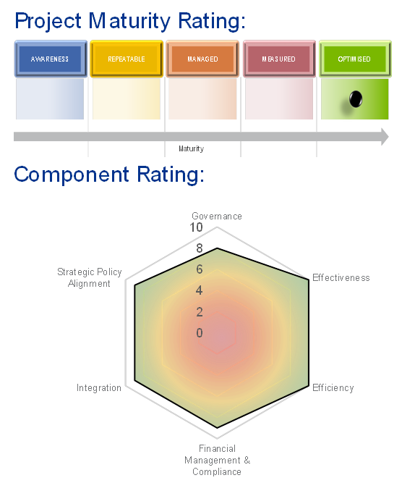
The reason these rating were selected, was to provide a balanced perspective in assessing each project. The KPMG team also utilised their professional experience and judgement to determine the ratings, they are not formula driven.
The graphic on the right, provides an overview of the ratings, further explanation is provided at Appendix B.

2.4 The Review Framework
The elements and specific questions that form the basis of KPMG’s review framework are set out in the table below:

NCRIS Review Framework

Appropriateness of governance arrangements
- Are the governance arrangements for managing the project appropriate?
- Is the structure of the governance arrangements appropriate for the project i.e. size, model utilised?
- Are the governance arrangements effective in managing the project i.e. are they executed in line with their design?

Effectiveness

Has the project achieved its objectives whilst keeping with the six key underlying strategic principles?
- Has the project achieved the objectives as outlined in the Project Plan/Business Plan?
- Has the project changed/adapted its access and service offering to meet new demands and opportunities?
- Does the project act in the interests of institutions beyond the host institution?
- Has the project led to the creation of a cohort of specialist technicians to support the capability?
- Is the project facility being used by leading researchers?
- Is the project creating a platform for collaboration between Australian and international researchers?
- Has there been co-investment?

Efficiency

Has project funding been optimally used to achieve objectives?
- Is the project facility being well utilised and is there any evidence of demand that is greater/less than the supply?
- Are services being provided at a reasonable price?
- Is any downtime reasonable?
- Are project administration costs reasonable?

Integration

Has the project (particularly lead agents) worked collaboratively with relevant public institutions, international bodies, participating organisations or sub-contractors?
How well is the project broadly integrated into the research sector (nationally/internationally)?
How many participating organisations/sub-contractors are using the infrastructure?
Has the project developed linkages with relevant research agencies?

Financial Management and Compliance

Have financial and compliance arrangements been appropriately managed?
Are there financial management policies and processes in place, are they effectively executed?
How are the financial and compliance arrangements managed e.g. in-house, by another central team or outsourced?
Are funds managed and reported in a transparent manner?
Has the project complied with the funding agreement?

Strategic Policy Alignment

Do NCRIS projects further the Government’s strategic long term policy priorities?
Is the project aligned with other research funding programmes and priorities?
Is the project aligned to national or international policy/research priorities?
Does the project engage in foresighting?

3 Summary of project ratings

3.1 Maturity rating and component ratings
To assess each project on a consistent basis the following ratings were developed:
- Project maturity rating – this was the first lens in which each project was viewed through. It assessed how mature overall operations and processes of the project were. This rating is not necessarily related to the age of the facility rather its overall level of sophistication. The KPMG teams undertaking the project reviews utilised their previous experience and comparative project assessments to select an appropriate maturity rating.
- Component ratings – as per the review framework outlined in the previous section each project was considered across six elements: governance, effectiveness, efficiency, financial management and compliance, integration and strategic policy alignment. Higher scores indicated that each sub-element in the framework was more fully addressed. However, scoring highly in the component ratings did not necessarily mean that the project would achieve a high maturity rating.
The following graphs outline the overall ratings.
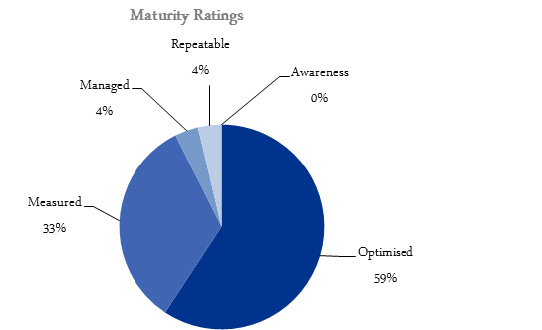

Most projects were either measured or optimised (the two most mature categories) See Appendix B for further definitions of these categories.
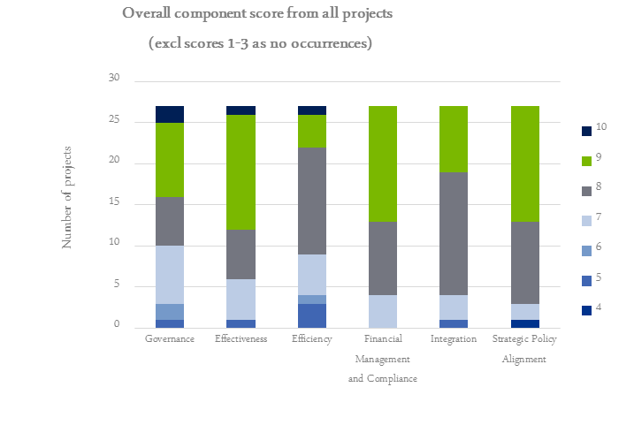
Overall, there were very few projects that scored in the lower ranges against the component areas. The majority of scoring ratings were eight and nine out of ten.
These two graphs indicate that the projects are generally of a mature nature and addressed the majority of criteria in the project review framework to a high level. Over a relatively large number of projects (27) with complex requirements, it is unusual to have so many projects that score consistently highly in relation to the component ratings.

3.2 Lead Agent: Type of organisation
In the table and graph below, the 27 NCRIS Lead Agents were grouped into their respective type of organisation: Company, Publicly Funded Research Agency (PFRA), Unincorporated Joint Venture and University for comparative purposes. As can be seen below the majority of projects have a university as a lead agent.

The impact on the project of the type of Lead Agent is explored in the following section.
Type | Projects
Company | Astronomy Australia Limited (AAL)  AuScope Limited  Australian National Fabrication Facility (ANFF)  Biofuels  Bioplatforms Australia  Translating Health Discovery (THD)
PFRA | Atlas of Living Australia (ALA)  Australian Animal Health Laboratory (AAHL)  National Deuteration Facility (NDF)  Nuclear Science Facilities (NSF)  Pawsey High Performance Computing Centre (Pawsey)
Unincorporated Joint Venture | European Molecular Biology Laboratory (EMBL)
University | Australian Microscopy and Microanalysis Research Facility (AMMRF)  Australian National Data Service (ANDS)  Australian Phenomics Network (APN)  Australian Plant Phenomics Facility (APPF)  Australian Plasma Fusion Research Facility (APFRF)  Australian Urban Research Infrastructure Network (AURIN)  Groundwater  Heavy Ion Accelerators (HIA)  Integrated Marine Observing System (IMOS)  National Computational Infrastructure (NCI)  National eResearch Tools and Resources (NeCTAR)  National Imaging Facility (NIF)  Population Health Research Network (PHRN)  Research Data Storage Initiative (RDSI)  Terrestrial Ecosystem Research Network (TERN)

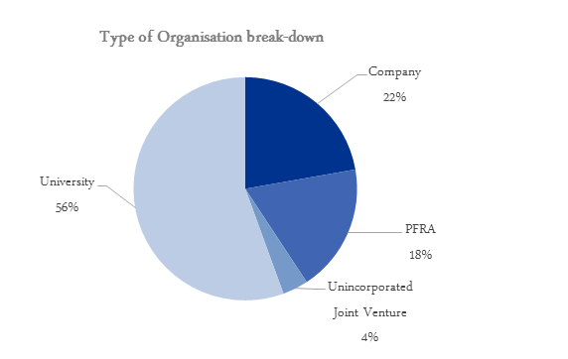

3.2.1 Average expenditure²³
Projects were compared based on the Lead Agent organisation type. As demonstrated in the below table, as a group, PFRA’s had the smallest average expenditure per project, and no PFRA project spent more than $10 million. Both universities and companies had a large range, which is evident in the expenditure graph, provided at Appendix C.
Given the vast difference in project type and nature, it is difficult to draw meaningful conclusions from this particular analysis.
Type | Total Expenditure ($) | Average Expenditure ($)
Company | 87,427,488 | 14,571,248
PFRA | 22,263,630 | 4,452,726
Unincorporated JV | 6,940,000 | 6,940,000
University | 137,531,454 | 9,168,764

²³ Data collected by ORIMA Research (question 88), provided to KPMG via email on 21 November 2014

3.2.2 Cost category breakdown ²⁴
Project expenditure was further broken down into category types, and compared based on percentage of total costs. There is considerable variability in categories of expenditure each project utilises its funding for. Unincorporated Joint Ventures administration percentage is higher than other projects, however, there is only one project that takes this form and as such does not represent a trend.
The most significant trend is that most projects allocate their expenditure to the first category “Maintenance of existing infrastructure”. PFRAs identified “Other” as the highest category of expenditure, which includes staff costs.
Type | Maintenance of existing infrastructure | Acquisition of new infrastructure | Administration | Other
Company | 38% | 13% | 9% | 40%
PFRA | 28% | 0% | 7% | 65%
Unincorporated JV | 77% | 0% | 15% | 8%
University | 47% | 11% | 12% | 30%

We note that there is a high level of expenditure that has been categorised as “Other” which may indicate that there has been some inconsistency in the allocation of expenditure. In future, clearer definitions of expenditure categories may be required.
²⁴ Data collected by ORIMA Research (question 88), provided to KPMG via email on 21 November 2014

4 Common themes of project performance against the review framework

4.1 Effective Governance Arrangements
KPMG found that NCRIS projects have generally put in place effective governance arrangements. A variety of governance arrangements are applied across projects but they are generally well adapted to the specific partnership arrangements of individual projects.
Due to the collaborative nature of NCRIS, KPMG did find that there is some tension between ensuring that project boards have the requisite skills to provide effective strategic direction and the authority to act decisively while ensuring that collaborators are adequately represented. Most NCRIS boards manage this tension well. There were exceptions noted for five projects where:
- some of the host institution’s governance arrangements appeared to be creating some inefficiencies in relation to reporting and recruitment;
- oversight arrangements for some sub-projects did not appear to be robust;
- the project board ensured representation of key stakeholders but was not skills-based; and
- there did not appear to be a clear delineation and articulation of project management and project governance. The respective roles and responsibilities required articulation.

4.2 Good Strategic Alignment
NCRIS projects were generally well aligned with one or more priority areas identified in the 2011 Strategic Roadmap for Australian Research Infrastructure.
NCRIS projects were also well utilised by recipients of Australian Research Council (ARC) grants, indicating alignment between NCRIS and the ARC.
Some projects have invested significantly to identify long-term strategic trends in their field of research and to position themselves for maximum relevance and contribution. For example, one project invested in a facility review by a group of eminent Australian and international experts. Another project invested in a formal analysis of the changing strategic environment.

4.3 Effective Collaboration
This collaborative principle is at the heart of NCRIS and recognises that “major national research infrastructure is at a scale that cannot be funded by business or individual research organisations, and that funding through cost recovery is not practical and can skew access in favour of host institutions.”²⁵ As part of this review KPMG evaluated the effectiveness of each project in creating a platform for collaboration and promoting the interests of institutions beyond the host under the ‘effectiveness’ element of the NCRIS Review Framework.
On the whole, KPMG found that projects performed well in relation to collaboration and non-exclusivity. Some projects, particularly those that focus on making information and tools more widely available via the internet are intrinsically collaborative and non-exclusive. Some NCRIS projects do not hold infrastructure themselves, but operate to facilitate access to infrastructure held by other institutions.
Other NCRIS projects have capacity constrains in relation to utilisation and must prioritise and encourage usage from outside the host institution. For example, one project has computational facilities that are very heavily utilised by leading researchers, and access is highly sought after by both public and private sector institutions. In response, the project has put two schemes in place to facilitate access for meritorious research. In 2013-14 only 37% of the project’s users were based at the host institution.
While most NCRIS projects perform well in relation to collaboration and non-exclusivity, there are some exceptions observed. See section 6.1 for more detail.

4.4 Nature of the Lead Agent
Over the course of KPMG’s review of NCRIS projects it became clear that the nature of the lead agent had a significant impact on the flexibility with which projects are managed. NCRIS projects are led by a range of institutions including universities, government science agencies, and not-for-profit companies established specifically to manage a project.
Projects led by universities and government science agencies generally enjoyed the support of mature and well-established systems and resources for financial management, human resources, legal advice, information technology, facilities and the other overheads necessary to run complex science facilities. These supports have generally been provided at no cost to NCRIS projects, that is, overheads have been provided as in-kind support and NCRIS funds have not been diverted to cover their expense. However, the processes imposed by universities and government science agencies do not necessarily facilitate nimble decision making or administrative flexibility.
In contrast, projects led by not-for-profit companies set up specifically for that purpose tended to be marked by adaptability and administrative flexibility. By way of example, one of the projects is led by a company limited by guarantee. The project’s company secretary carries out day-to-day financial transactions using MYOB accounting software while an external accounting firm provides financial reporting and annual audit services. These arrangements are adequate for the project’s size and function but are far leaner than the arrangements in place at projects led by universities and government science agencies. Another project also led by a company limited by guarantee, utilises similar financial management arrangements.
²⁵ National Collaborative Research Infrastructure Strategy Program Guidelines, 2013-14 to 2014-15, page 5

However, it is also worth noting that projects led by not-for-profit companies do face some different risks than those led by universities or government science agencies. For example, incorporated entities have strict solvency requirements imposed by corporate law and may need to cease operations more quickly in the face of funding uncertainty than unincorporated projects hosted by a university or government science agency.
One project lead agent that has its organisational roots in an industry peak body has been able to leverage its deep understanding of policy issues and pre-existing professional networks for the benefit of the project.
The characteristics of a high performing lead agent included:
- A high calibre board, with a mix of research and scientific content knowledge, innovating and strategic thinking abilities, well developed commercial acumen as well as the ability to be decisive;
- Board members that were well connected in the research and business community that could leverage this professional network to benefit the project;
- A Project Director that is able to engage at many different levels, to manage and oversee the project but also translate and promote the benefits of the project in a manner that is relevant to many different audiences;
- In projects that operated with a number of nodes, developing and maintaining ongoing and productive relationships between the hub and nodes was essential;
- Mechanisms that brought key stakeholders together to periodically consider issues from a strategic and broad perspective, providing a mechanism to guide the direction of the project as well as to innovate and identify areas of future improvement; and
- An embedded project management capability including the ability to manage and mitigate risks as well as well-developed problem solving abilities.
Of these characteristics the most important by far were observed to be the composition of the board and the calibre of the Project Director.

4.5 Co-Investment and Cost Recovery
An element of the third NCRIS principle is that “funding and eligibility rules should encourage collaboration and co-investment”. KPMG has conducted analysis of co-investment under NCRIS 2013 in relation to projects for which comparable information was available.
The diagram illustrates each projects’ NCRIS project funding and compares that funding to cash co-investments pledged in NCRIS 2013 project plans.
When considered at the overall programme level, co-investment is greater than NCRIS funding by a factor of 1.06. That is, for every dollar of NCRIS funding an additional $1.06 of co-investment has been generated, which represents significant leverage of public funds. By way of comparison some research programs encourage co-investment through weighted selection criteria, for example, ARC Centres of Excellence. Other programmes such as Linkage Projects (a large collaborative research programme) specify a 75% cash co-investment for any grant awarded.
These figures are likely to be understated as there is a significant level of in-kind co-investment. In addition to this there are a range of project co-contributions that are not formally measured and captured. For example, the Australian National University (ANU) is the lead agent of four NCRIS 2013 projects for which it provides significant corporate support in the form of HR, legal and finance support, and significant infrastructure support in the form of building, utilities etc. The ANU does not currently fully cost and record these contributions.
The diagram at Appendix C also demonstrates that while the majority of projects received a co-investment, some projects do not.
While cost recovery through service revenue is not a principle of NCRIS, and indeed, NCRIS was partly established to address some of the difficulties created by the need for facilities to cost-recover, KPMG notes that the nature of some projects endows them with greater ability to earn service revenue and use it to maintain and operate facilities. For example, projects such as the National Computational Infrastructure and the Australian National Fabrication Facility have direct commercial application and accordingly have the greatest potential to earn significant service revenue. However, most NCRIS projects are not able to charge service fees that would enable cost recovery and attempting to do so would likely detract from NCRIS principles, particularly developing infrastructure on a collaborative, national, non-exclusive basis and minimising barriers to access for meritorious research.
Australian Animal Health Laboratory (AAHL):
Due to the support of NCRIS, the laboratory is available as a national resource to enable research scientists from across the world to work on infected live cells, all contained within the quarantined biosecure area.
Source: NCRIS 2014 Showcase material
Of those that did cost recover, all had appropriate policies and procedures in place to ensure that this was undertaken consistently. A number also included a statement in relation to how applicants would be prioritised, to ensure transparency. The Australian National Fabrication Facility had established an Access and Pricing Committee which meets quarterly at each node to review utilisation and implement prioritisation strategies as required.

4.6 Leverage of Past Australian Government Investments
The $185.9 million²⁶ made available through NCRIS in the 2013-14 budget was provided to ensure the continued operation of national, collaborative science infrastructure established or maintained through previous science infrastructure programmes. These programmes have included:
- $542 million initial NCRIS investment from 2004-05 to 2010-11 for operational and capital funding ($527 million in Administered funding);
- $989.4 million Super Science creation and development of research infrastructure for capital funding only from 2008-09 to 2014-15;
- $60.0 million through the Collaborative Research Infrastructure Scheme for operational funding only, as a one-off research block grant under the Higher Education Support Act 2003 in late 2012; and
- $746.1 million through Education Investment Fund.
The combined total of these past investments is around $2.5 billion. The relatively modest expenditure on NCRIS 2013 has allowed past investments to be leveraged to deliver ongoing economic and scientific benefit.
As noted in section 1.2, in recognition of the benefits of large-scale research infrastructure and the challenges associated with funding these projects, governments around the world provide financial support for the construction and maintenance of such facilities. When considering investment in comparable international programs, Australia’s current funding of research infrastructure is at a similar level to its international counterparts. On an annual basis, Australia’s investment approximately equalled that made by the United Kingdom (£352 million over the four year period 2011-12 to 2014), was modest compared to the European Union (€1.85 billion between 2007 and 2013) and was stronger than Canada (CAD$185 million between 2012-13 and 2016-17).
As noted in section 4.5 and 4.6, NCRIS has a considerable level of co-investment and also leverages previous infrastructure research programmes.
²⁶ The $185.9 million included operational funding only from 1 July 2013 to 30 June 2015 ($180.2 million in Administered funding)

4.7 Impact of funding
In assessing the impact of the NCRIS programme funding the following aspects have been considered: inputs (programme expenditure), outputs (employment, project usage) and outcomes (research outcomes).

4.7.1 Input: Programme expenditure
In 2013-14, the 27 NCRIS projects reported Federal Government expenditure totalling $254.2²⁷ million (this is a combination of the $185.9 million previously noted and funding that remained available to the projects under the previous Collaborative Research Infrastructure Scheme (CRIS) programme). The spending profile of NCRIS projects over this period reflects that many are in the maintenance phase, with 50% of Federal Government funding spent on maintenance of existing infrastructure compared to 11% on the acquisition of new infrastructure. Other areas of significant expenditure for the NCRIS projects include ‘other’ (24%, which primarily relates to salaries) and administration costs (11%). The below graph summarises the 2013-14 spending profile of NCRIS projects.
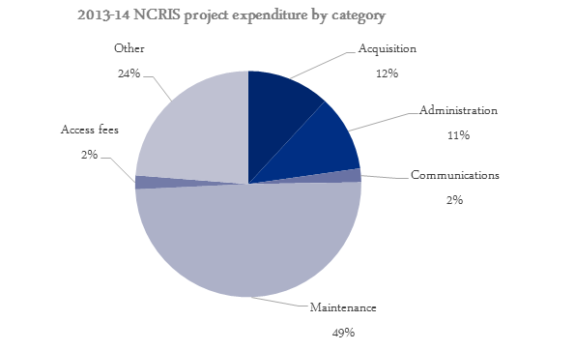
Included in the ‘administration’ cost (11%) is governance (2%), travel (2%) and administrative costs (7%). In KPMG’s experience the general rule of thumb for government programmes is that approximately 10% of total programme costs should be spent on programme management and administrative costs. This may increase up to a total of 20% of total programme costs for highly complex programmes, e.g. for international development programmes. A rule of thumb is that many corporates consume approximately 15 – 20% of their costs on administrative/corporate costs, whereas not-for-profit entities typically spend in the order of 8 – 12%.
In a benchmarking study undertaken by the Australian National Audit Office, it estimated that on average organisations spend between 0.110 – 4.832% of their costs on the finance function for public sector organisation this increased to 0.890 – 9.852%.²⁸
²⁷ Data collected by ORIMA Research (question 88), provided to KPMG via email on 21 November 2014
²⁸ ANAO Benchmarking the Finance Function, Report 25, 2000-01
Based on this benchmark, the 11% spent by NCRIS projects on programme management and administration is assessed to be reasonable.
Whilst at a whole-of-programme level, the cost of programme management and administration is reasonable, significant variation in expenditure profiles is observed at the project level.. Key differences in the expenditure profile at the project level include:
- 15 projects invested in infrastructure acquisition, this represented between 1% and 56% of their total expenditure;
- 26 projects spent funding on infrastructure maintenance, this represented between 1% and 95% of their total expenditure; and
- projects spent between 1% and 41% of their total expenditure on project administration costs.
The first two observations reflect the difference in nature of the projects and partly their stage of development. There were two projects that reported programme administration costs of more than 20%, however both had relatively low total expenditure ($1.76 million and $6.71 million) and would be considered ‘outliers’.
This is the first time this expenditure has been categorised and measured this way, any inherent inaccuracies in classification of expenditure would be expected to improve with subsequent measurement processes.

4.7.2 Output: Employment
A large number of jobs and roles have been created as a result of NCRIS funding, with NCRIS projects directly employing 1,599 FTE in 2013-14²⁹. As illustrated in the below graph, 74% of FTE employed are technical staff to operate the projects/facilities.
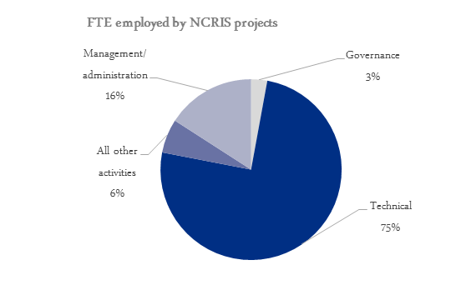
²⁹ Data collected by ORIMA Research (question 50-52), provided to KPMG via email on 21 November 2014
The high proportion of technical staff indicates that NCRIS projects do not have a significant FTE overhead for corporate functions, with the majority of their FTE directly contributing to the development, maintenance and enhancement of the research infrastructure projects. This is an important statistic as a funding for NCRIS 2013 is primarily directed towards operations and maintenance of facilities, now that most projects have progressed past the establishment phase.

4.7.3 Output: Project usage
The first principle underlying NCRIS is that “Australia’s investment in research infrastructure should be planned and developed with the aim of maximising the contributions of the R&D system to economic development, national security, social wellbeing and environmental sustainability”³⁰. One question that can be used to measure the contribution of NCRIS to this principle is ‘how do research grant recipients use infrastructure funded under NCRIS?’ Whilst data on research grants awarded is not collected by all NCRIS projects, the 19 projects that did collect data (three of which reported that no such grants had been awarded due to the project still being in the development phase) indicated high usage of NCRIS funded research infrastructure by research grant recipients.
For those projects where data on research grants was available, NCRIS infrastructure had been used by 848 research grants with a total value of $379.59 million. The number of research grants by individual project varies significantly (between 2 and 442) as indicated in the table at Appendix C.
Despite the above figures being understated – 30% of NCRIS projects were unable to supply data on research grants usage – it is evident that NCRIS makes a strong contribution to Australia’s research and innovation system through the high usage of research infrastructure by the research community.

4.7.4 Outcomes: Research outcomes
The use of research infrastructure funded by NCRIS projects is further evidenced through project publication data. Scientific journal publications and conference papers have been produced as a direct result of researchers making use of project infrastructure. The number of journals, citations and conference papers generated is summarised in the below table.
Publication item | # of projects that reported data | # of items reported
- Scientific journal publications produced by researchers | 20 | 5,265
- Citations of the publications referred to in (1) above | 9 | 3,391
- Other publications citing the project | 6 | 226
- Conference papers | 14 | 1,376
Similar to the research grants data, the publication data is highly likely to be understated as not all projects collect project publication data and those that do only ‘partially’ monitor project data.
³⁰ National Collaborative Research Infrastructure Strategy Program Guidelines, 2013-14 to 2014-15, page 28

4.7.5 Broader programme considerations
As noted in section 4.5, whilst some NCRIS projects have direct commercial application and the ability to earn significant service revenue, the majority of projects would be unable to rely solely on fee-for-service.
While technically outside the scope of this engagement, this points to a broader consideration that is, this programme exists due to the fact that there has been and will continue to be, evidence of “market failure”. Without Government funding, the vast majority of NCRIS facilities and resources would not be funded, certainly not by the private sector or even by research organisations. While some of the projects are able to recover costs, raising significant levels of capital to establish such infrastructure is highly unlikely.
Pawsey Supercomputing Centre:
“Magnus” – Australia’s Brand New, World-Class Petascale supercomputer.
A petascale system, able to process over 1,000,000,000,000,000 calculations every second. 10,000 times as many processors than a standard computer.
Source: NCRIS 2014 Showcase material
Should the programme not continue there would be significant levels of inefficiency in the research and innovation system, as the research environment would revert back to its previous state, i.e. facilities/projects would either simply not be available or would be duplicated through purchasing highly specialised and technical equipment in multiple institutions. In addition, there would be a loss of highly skilled technical staff that this, and previous programmes, have established.
The message regarding the benefit of the programme is consistent with an independent programme evaluation undertaken in 2010³⁴ which concluded that the current NCRIS programme model was appropriate and that there was “a clear, ongoing need for government funding of research infrastructure”.
Further to this, a recent study commissioned by Research Australia³⁵, concluded that, between 1992-93 and 2004-05, expenditure on Australian research and development (R&D) returned a net benefit of approximately $29.5 billion. Previous analysis³⁶ from study commissioned by the Australian Society for Medical Research concluded that for every dollar invested in Australian health R&D, an average of $2.17 in health benefits is returned (confidence range of $0.57 to $6.01).³⁷
More broadly, public investment in research plays a significant role in building innovation capacity and driving productivity³⁸ ³⁹. In Australia’s case in particular, the OECD has identified that public and private research and development supports and actively enhances our national productivity.⁴⁰
Each of these studies point to the value of investing in the research and innovation system and the benefits to the national economy.
³⁴ http://www.education.gov.au/2010-evaluation-national-collaborative-research-infrastructure-strategy-ncris, undertaken by Allen’s Consulting
³⁵ Lateral Economics
³⁶ Access Economics
³⁷ Discussion Paper: Health and Medical Research and the Future in NHMRC’s 75th Year: The virtuous cycle and the economic benefits of health and medical research
³⁸ Productivity Commission, 2007, www.pc.gov.au/projects/study/science/docs/finalreport
³⁹ National Academy of Sciences, 2010, www.aps.org/policy/reports/upload/rags-revisited.PDF
⁴⁰ www.oecd.org/dataoecd/2/31/39374789.pdf

5 Examples of better practice
While conducting the review of NCRIS projects KPMG noted a number of examples of better practice. For the purposes of this review better practice includes innovative practices and/or initiatives to increase the efficiency or effectiveness of the project.
This section documents some of the examples of better practice with broader significance for the overall programme.

5.1 Engagement with End-Users
Some projects have performed particularly well in their engagement with end-users. Strong engagement with end-users is important because it promotes maximisation of “the contributions of the R&D system to economic development, national security, social wellbeing and environmental sustainability”.⁴¹
Examples of better practice observed by KPMG in relation to end-user engagement include:
- regular consultation with end-users in relation to possible future uses of the output, including through formal workshops. The project’s engagement with end-users has seen it contracted to develop a specific monitoring tool for the Department of Environment;
- appointment of staff based around Australia, who manage relationships with research institutions in their jurisdiction. This has enabled the project to maintain partnerships and contractual relationships;
- high responsiveness to user feedback, adopting a monitoring and evaluation framework in 2013 and engaging a consulting company to undertake user surveys. The results are reported to a Usability Committee to inform subsequent software releases;
- success in establishing productive relationships with Australia’s biomedical sector, in part because of the involvement of senior researchers and scientists in expert advisory committees.

5.2 Monitoring Research Outcomes
Some projects have put in place particularly effective mechanisms to monitor the research outcomes produced through their facilities. Tracking these outcomes is valuable because it allows the effectiveness of the project and the broader programme to be more accurately evaluated.
An example of better practice in relation to research monitoring is an NCRIS project that has processes in place to track publications involving international collaborations enabled by project-supported facilities.
⁴¹ First NCRIS principle, National Collaborative Research Infrastructure Strategy Program Guidelines, 2013-14 to 2014-15, page 28

5.3 Broadly Inclusive Governance Structures
KPMG’s review indicated that some projects have made particular efforts to ensure that their boards draw in representatives from the broader community of stakeholders, rather than a more narrow representation of formal project partner institutions. Broader stakeholder representation on project boards should help promote decision making that is consistent with collaborative, national, non-exclusive infrastructure development. Example characteristics of boards with broad stakeholder representation observed by KPMG were:
- movement towards establishing a Members Committee of Key Stakeholders;
- representation of formal project partners, which mitigates the risk of partiality by engaging an external member to provide objective counsel;
- inclusion of a Facility User Group as part of its governance structure in order to provide representation for the broader user community;
- selection of Board members based on ability to guide the project and take a broad, national perspective on development;
- a nine member board comprising: an independent Chair, Director of the project, one nominee appointed by each of the major collaborators and three additional independent board members; and
- high representation including research community representatives, infrastructure operators and development partners.

5.4 Initatives to Facilitate Access for Meritorious Research
- For projects with limited usage capacity and high utilisation rates there is a risk that researchers outside of host and formal partner institutions may find it difficult to arrange access for meritorious research. Some projects have put formal mechanisms in place to mitigate this risk. For example, one project has two specific schemes in place to facilitate access for meritorious research. In 2013 15 per cent of facility usage was through Scheme 1 while 5 per cent was through Scheme 2. Another example is two projects that make use of an external committee to assess proposals for use of equipment, ensuring all researchers of merit, regardless of host organisation, have an opportunity of access.

5.5 Individual examples of good practice
The following list provides individual examples of good practice noted for different projects:
- establishment of a vendor panel to leverage pricing for procurements at a national level.
- establishment of a data licencing policy to ensure users are aware of the appropriate ways in which they can use the data provided.
- the Governing Board signs off budgets which is then entered into a single sub-contract and signed by all parties providing transparency and clarity of funding.
- development of a five year plan for capital infrastructure and a 50 and 100 year plan for the Australian Nuclear and Science Technology Organisation (ANSTO).
- high level of involvement in the research community through linked laboratory relationships, and also undertook marketing, sponsorship of conferences and presentations to raise awareness and encourage collaboration.
- establishment of an International Advisory Committee which provides advice on international trends to inform strategic direction and provides a valuable link to the international research community. This project also negotiated the movement of underused assets from one node to another where demand had been identified, to maximise utilisation and avoid duplication.
- containment of administrative funding to 5% of overall funding and monitoring a detailed administrative cost budget.
- capturing of user feedback by engaging an external organisation to undertake user surveys following each beta release.
- proactive management of conflicts of interest of Board and Expert Advisory Committee members with a standing item on the agenda of these meetings.
- provision of a quarterly risk register for review by the Board.
- a separate business area certifies the income and expenditure statements prior to submitting them to the Department of Education and Training.
- provision of advice, at no charge, to researchers and clinicians to ensure the most appropriate facility and approach is utilised.
- establishment of an Endowment Fund which generates income through investing the funds.
- development of a Strategic Framework document (one page) that identifies the different elements of the project, key linkages and inter-relationships. In addition, the project has developed DigiVol, a tool that allows volunteer contributors to digitise biodiversity data that is locked up in biodiversity collections, field notebooks and survey sheets. Facilitating the contributions of an enthusiastic volunteer community is a powerful method for leveraging NCRIS funding and maximising the project’s contribution to environmental sustainability, in line with the first NCRIS principle.
- project nodes are funded under a just-in-time model for large procurements, allowing better management of cash flows and investment earnings.
- the 2013-15 Project Plan identifies a number of areas for further enhancement to optimise existing capability. To further consider these initiatives a feasibility study is conducted on each initiative.
- the governing body appointed an independent panel to review the implementation of the project.

6 Key opportunities for performance improvement across the programme
While conducting the review of NCRIS projects KPMG noted a number of opportunities for improvement. This section documents some of the opportunities for improvement with broader significance for the overall programme.

6.1 Collaboration
While most NCRIS projects performed well in relation to collaboration there were a small number of projects where usage was significantly concentrated among researchers based at the host institution. For example:
- one project’s response to the 2014 NCRIS survey indicated that 49 researchers had used the facility in 2013-14. 27 of these researchers were based at the host institution, 13 were based at international institutions and only 9 were based at other Australian institutions;
- 87 per cent of users of a project were based at host institutions;
- one project appears to reserve a high proportion of usage for partner agencies as compared to external researchers, with some potential to increase the proportion of usage available for meritorious research as the project’s user base expands; and
- some facilities of one project are not well utilised by researchers external to the host institution.
During consultation, one project’s management pointed out that while only a limited number of external researchers made direct use of that facility, the research outcomes allow researchers to collaborate at a theoretical level with Australian and international colleagues. This general principle would likely hold true for all projects with usage concentrated among host-institution researchers.
However, given that the collaboration principle is designed to address difficulties of cost and scale in relation to physical infrastructure build, it would be preferable if all NCRIS facilities were directly used by significant numbers of researchers external to the project’s host. Or other projects have targets set in consultation with the Department on a case-by-case basis. Projects without significant external usage may not be a close fit with NCRIS principles.

6.2 Utilisation
Most NCRIS projects exhibited good rates of utilisation when broad consideration was given to their effective capacity (i.e. capacity taking into account staffing limitations rather than simple physical capacity). However, a small number of project facilities, or parts of project facilities, were under-utilised. Four examples are:
- a heliac magnetic confinement device that currently operates at approximately 30% utilisation, i.e. one of the available three days (the other two being maintenance days);
- a smarthouse and environmental growth room that have potential to improve occupancy rates;
- one project advised that their utilisation rates have plateaued in the last three years; and
- considerable unutilised floor space identified for one project. However, we note that the facility was designed to allow for flexibility to scale-up and to allow for medium to longer term future capacity increases.
As noted in the last example, there are particular reasons why utilisation rates of these facilities are low and management are working to address them. However, consistently low utilisation is a possible indicator that sufficient demand does not exist for a piece of infrastructure.
In addition, KPMG noted that while most projects measure utilisation rates and that, on the whole, projects appear well utilised, not all projects had developed KPIs around utilisation. Because good utilisation rates are contextual and vary depending on the nature of the facility, lack of KPIs around utilisation make it difficult to assess performance in this area.

6.3 Comprehensive Measurement and Recording of Co-investment
Data collected indicates that NCRIS 2013 funds have produced a co-investment ratio of around 1.06. That is, for every dollar invested by the Australian Government co-contributors have invested another $1.06. However, this calculation could only be made on the basis of measured and recorded co-contributions. Not all co-contributions are formally measured and recorded. For example:
- one university is the lead agent for four NCRIS projects. The university only formally records and measures direct salary co-investment but does not record significant corporate and infrastructure support;
- a publicly funded research organisation is the lead agent for two NCRIS projects. The organisation currently only measures in-kind contributions for salary and on costs and has not calculated any other additional costs e.g. procurement support, facility running costs, security, etc; and
- one project does not fully account for in-kind co-investment.
More comprehensive measurement of co-investment (where possible) would provide a more accurate picture of programme impact.
KPMG notes that this ratio is likely to change as the proportions of funding change over the life of the programme. The period over which this ratio is calculated and nature of the funding (i.e. capital or operational funding), should be taken into consideration.

6.4 Enhanced Measurement of Impact
During the course of this review KPMG noted that a number of projects could improve measurement of project impact. For example:
- one project does not currently conduct formal measurement of project impacts, such as scientific publications produced through use of the facility;
- a sub-project was unable to provide KPMG with information relating to the evaluation criteria, including the number of participating organisations and subcontractors using its infrastructure. Furthermore, the sub-project had not reported utilisation, downtime data or level of demand for the infrastructure;
- there was no system to record the number of times one project’s Australia alumni had exploited access to international facilities and vice-versa. Facilitated access is the key objective of the project;
- one project does not capture information concerning acknowledgements, citations, publications etc; and
- one project found it difficult to provide accurate data relating downtime.
One possible approach that would provide a broader economic perspective is Cost Benefit Analysis (CBA). This type of analysis considers costs and benefits from a whole-of-society perspective. This is important for the consideration of projects involving research as the benefits of research outcomes tend to primarily flow beyond the research organisation. A CBA approach is ideally suited for the comparison of potential NCRIS projects as it enables consideration of:
- investment costs;
- ongoing costs; and
- research outcomes.
Economic theory and best practice methods are employed to quantify costs and benefits. For example, it may be possible to quantify research outcomes in terms of improvements in productivity of labour and capital and overall performance of relevant industries.
KPMG suggests that this technique is developed as part of a broader programme impact framework, to develop a range of different measurement tools and techniques.

6.5 Portfolio review
An observation made by KPMG which was reinforced through the stakeholder consultation process (see section 8) was the need to review the portfolio of projects. That is, to re-assess the relevance, need and performance of each project as well as at an overall portfolio level. This is likely to mean that some projects will not continue to be funded, others may need a path correction or change in direction, and emerging capability needs may be funded.
Further, the criteria for funding should be further refined to provide greater clarity when assessing projects. For example, ensuring projects are truly national and truly collaborative were considered of vital importance to the programme. In practice, the NCRIS principles may need to be refined or to be further clarified in the Programme Guidelines. A number of different perspectives were raised including:
- Recognising different levels of research infrastructure e.g. global, landmark, national and state/regional; as well as the most appropriate avenue to fund such infrastructure, for example through the ARC infrastructure grants programmes.
- Considering the use of NCRIS funding, that is, should it be utilised for the initial purchase of infrastructure and then the ongoing maintenance and operations should be funded through other forms e.g. partner institutions/organisation. The benefit of this approach is the commitment of key institutions/organisations.
- Consider whether there would be an improved outcome through a broad capabilities focus recognising that some projects will be more successful than others (i.e. a balanced portfolio) or targeting a particular capability or grouping of capabilities to achieve a concentrated outcome rather than spreading funds across multiple projects at lesser amounts.
- Consider issues associated with technical obsolescence in the system and how to manage asset replacement, especially those assets that involve rapid technological evolution and/or development.
- Where possible create stronger linkages with State government programmes, to fully leverage funding sources.
It may be useful to group and analyse projects across the portfolio through a number of different lenses e.g. by capability, integration potential, time-horizon of benefit, hard versus soft infrastructure, international standing, potential user groups, possibility of user charging, commercial returns and level of involvement with other institutions/organisation and jurisdictions e.g. State/Territory governments. Each of these facets brings different characteristics, advantages and disadvantages.

7 Common areas of risk across projects

7.1 Uncertainty Around Funding
Uncertainty over long-term funding is a perennial risk and challenge for the research sector. However, it is worth noting that during KPMG consultation the impact of funding uncertainty on long term planning, the maintenance of infrastructure and the retention of staff was raised by the majority of NCRIS projects as a key area of risk.
Particularly illustrative examples of the impact of funding uncertainty include:
- A large number of projects stated that funding uncertainty makes it difficult for them to retain key staff, who, in the face of uncertain career prospects, may need to accept offers of permanent employment at other institutions.
- Some projects stated that funding uncertainty has forced them to defer decisions in relation to infrastructure maintenance and deployment. This risk was specifically raised by those projects whose work involves decades long recording of trends.
- Some projects stated that funding uncertainty was detracting from their ability to plan strategically.
- One project stated that as a not-for-profit company their project faces heightened risks in relation to funding uncertainty, due to the stringent requirements around insolvent trading imposed by corporate law. This heightened risk would apply to all NCRIS projects led by incorporated entities with few other sources of revenue or financial support outside NCRIS.
- One project stated that they would be able to engage more early-career IT specialists with longer-term funding certainty. At the present time the project generally engages experienced technical staff who are immediately productive.

7.2 Key Person Risk
Most NCRIS projects are operated with a high degree of efficiency. One of the key sources of this efficiency is the multi-skilling and commitment of project management and staff. This approach has delivered impressive benefits to NCRIS projects but has introduced a risk that if key staff were to leave a project it would be difficult to replace them through a recruitment process. Some NCRIS projects would be unviable if key managers or staff were to depart. The risk that these staff might depart is compounded by the uncertainty over long-term funding.
Key person risk is pertinent (to varying degrees) across most NCRIS projects. Some examples of the type of NCRIS managers and staff who would be difficult to replace include:
- specific management teams and multi-skilled technical staff;
- instrument staff; and
- specialist technical staff.
In addition to these examples, one project indicated that a major drawcard for their researchers was the longer term potential of being headhunted for high salary private sector jobs, and the inability to offer job security did not help with this problem. Another project also indicated that they had difficulty attracting and retaining highly specialised technical staff required to operate the super computer due to short term contracts.

7.3 Potential Technological Obsolescence
NCRIS 2013 projects support a range of infrastructure at the leading edge of technological development. The development of this infrastructure represents a significant financial investment for the Australian Government and co-investors. Indeed, NCRIS 2013 and its predecessor programmes were established in part because the scale of the infrastructure means that it is not feasible or efficient for a single institution to build the infrastructure and recover costs from users.
However, the rapid pace of technological development in many NCRIS fields of endeavour creates a risk that infrastructure will be rendered obsolete. For example, one of the projects is a leader in its field and demand for access is high. However, the project’s management advised KPMG that rapid developments in e-infrastructure require it to regularly upgrade its facilities to remain relevant and that without such upgrades the project would be unable to secure collaborations with key research organisations or engage and retain skilled personnel. The project is attempting to mitigate this risk by building more collaborations with private industry.
Another example of the risk of obsolescence and thus the need to upgrade specialised equipment and instrumentation is the Australian National Fabrication Facility (ANFF) which uses a range of specialised equipment such as solar simulators, substrate bonders and polymer nanofibre electrospinners. In addition, the ANFF owns and operates over 500 pieces of equipment, resulting in challenges in remaining at the leading edge whilst also maintaining and replacing such a diverse range of equipment.
Because of their different focus areas, not all NCRIS projects will be equally attractive propositions for private investment. Potential technological obsolescence and the high costs involved in addressing it are risks of varying degree for all NCRIS projects.

8 Common themes from stakeholder consultation
As part of developing this Overarching Report a selected group of stakeholders were interviewed, the objective being to target stakeholders that understand the programme at a broader level and how it relates to the national research and innovation system.
A number of these stakeholders have been involved in multiple projects and/or have a national role.

8.1 The need for a programme such as NCRIS
There was a consistent and strong view that the NCRIS programme has been highly beneficial and has significantly improved the scientific research capability in Australia. The design and structure of the programme including the Road mapping processes has been valuable to prioritise and target areas of research capability need, providing a strategic and broad ranging perspective.
The programme has also made an impact on research institutions and agencies’ ability to operate in a more collaborative manner; a cultural change which is a significant shift to the academic community.
Encouraging innovation through a principles based approach versus a highly prescriptive criteria basis, was also considered the most appropriate approach for this type of programme. For example, one of the benefits of the programme has been that the projects have achieved a significant level of co-funding. This level of co-funding has exceeded early expectations and has come about without prescribing entry requirements.
Stakeholders indicated that the programme has transformed national collaborative research; the programme is moving into a different phase of its lifecycle, given that most projects have moved from the establishment phase into the ongoing operations and delivery phase.

8.2 Review of projects and the portfolio
Given the position in the programme lifecycle, the most common comment was the need to review the portfolio of projects. That is, to re-assess the relevance, need and performance of each project as well as at an overall portfolio level. Refer to section 7.5 for a more detailed discussion.

8.3 Measurement of outcomes
The ability to measure the impact and overall benefits in a quantitative manner was consistently raised, with stakeholders indicating that this is a very complex and difficult area. This is especially the case given the vast difference in nature, size, domain, output and outcome of the projects.
This is not unique to this programme, it is an issue that many research organisations and projects grapple with.

8.4 Funding security
The issue of having funding security and the impacts on the projects was also raised consistently, with stakeholders identifying the inefficiencies created through uncertainty of funding.

8.5 The Department’s role
A number of stakeholders commented that the Department plays a valuable role in overseeing the projects. In the earlier phases of the programme the Department had taken a heavier or more hands-on role which also involved a significant level of reporting and related activity. Currently, the level of reporting and monitoring was considered balanced and appropriate for the nature of the programme.

8.6 The form of the Lead Agent
Some stakeholders indicated that the form and structure of the Lead Agent has potential to make a significant difference to the project, both from an operational perspective as well as at an outcome level.
That is, having a strategic and skills based board with a mix of research and scientific content understanding along with business and commercial acumen is highly valuable. In addition, the Project Director role is crucial to the success of the project.

8.7 Encouraging projects to support early career researchers
A small number of stakeholders indicated that there should be a greater focus on providing access to the project facilities to early career researchers. The rationale was that in a number of cases this is where significant scientific break-throughs and Nobel laureates emanate from.
While a number of the projects give priority to meritorious research, this is not necessarily supporting early career researchers. This is not a requirement of the current programme.

Appendices

Appendix A – Project descriptions
Project | Description
Astronomy Australia Limited (AAL) | AAL supports a range of projects to ensure that Australian astronomers stay internationally competitive and have access to the best Australian and overseas astronomical research infrastructure. Projects include a share in the Giant Magellan Telescope project and access to significant infrastructure, such as the Magellan telescopes.
Atlas of Living Australia (ALA) | The ALA project is a national database that will enable researchers and other users to find, access, combine, and visualise data on Australian flora and fauna. The information is accessed through a single, easy to use website and can be used to:  - improve understanding of Australian biodiversity;  - assist researchers to build a more detailed picture of Australia’s biodiversity; and  - assist environmental managers and policy makers to develop more effective means of managing and sustaining Australia’s biodiversity.
AuScope Limited | AuScope has developed a world-class infrastructure system for earth sciences, including physical infrastructure to acquire and manage data, and software to develop models and simulations. AuScope invests in data and knowledge infrastructure and technology, and forms collaborative partnerships between government, academia and industry to assist Australian researchers to better monitor and understand the structure and evolution of Australia with greater accuracy.
Australian Animal Health Laboratory (AAHL) | AAHL helps protect Australia’s multi-billion dollar livestock and aquaculture industries, and the general public, from emerging infectious disease threats. It is dedicated to research into infectious diseases that affect the health of humans, domestic animals and wildlife. It is described as “a leading edge, purpose built, high security research and diagnostic facility for… emergency animal diseases.”
Australian Microscopy and Microanalysis Research Facility (AMMRF) | The AMMRF comprises equipment, instrumentation and expertise in microscopy and microanalysis. It offers both Australian publicly funded researchers and industrialists a complete, modern suite of instruments, supported by expert technical and scientific staff, for characterisation of the structure and chemistry of materials—whether physical or biological—across length scales from the micrometre to the atomic.
Australian National Data Service (ANDS) | ANDS exists “to transform Australia’s research data environment by making Australian research data collections more valuable through managing, connecting, enabling discovery and supporting the multiple uses of this data… The outcome of this activity will be that Australia’s research data as a whole becomes a national strategic resource.”
Australian National Fabrication Facility (ANFF) | ANFF provides researchers and industry with access to over 500 facilities with fabrication capability for nanoparticles, nanostructures, nanosensors and nanotechnological devices. The facility enables users to process or manipulate hard materials (such as metal, semiconductors and ceramics) and soft materials (such as polymers) and transform these into structures that have application in sensors, pharmaceutical and medical devices and nano electronics.
Australian Phenomics Network (APN) | The APN provides Australian and international researchers with mouse models for the study of a range of diseases, including cancer, diabetes and immunological and blood disorders. The APN has reduced the cost to researchers of accessing mouse models of disease, and provides specialised equipment and expertise to undertake characterisation of these models to further scientific research.
Australian Plant Phenomics Facility (APPF) | The APPF measures the phenotype (physical attributes) of plants leading to the development of new and improved crops, healthier food, more sustainable agricultural practices, improved maintenance and regeneration of biodiversity and the use of crops to develop pharmaceuticals. The project is a world-leading plant research facility, consisting of three separate facilities: a high throughput plant phenotyping facility, a deep phenotyping and field phenotyping facility, and a model plant phenotyping and high resolution glasshouse analysis facility.
Australian Plasma Fusion Research Facility (APFRF) | The APFRF is a uniquely versatile plasma research facility. It consists of the H-1 heliac magnetic confinement device and the smaller MAGPIE prototype device (MAGnetised Plasma Interaction Experiment), for investigating the interaction of plasma with materials, especially those potentially suitable for fusion reactors.
Australian Urban Research Infrastructure Network (AURIN) | AURIN is a national collaboration delivering eResearch infrastructure to enable better understanding of the current state of Australia’s cities and towns. AURIN is delivering access to diverse data from multiple sources, and is facilitating data integration and data interrogation using open source e-research tools.
Biofuels | The Biofuels project provides new facilities and upgrades existing infrastructure to support research into the conversion of agricultural wastes to fuels, including a renewable biocommodities pilot plant and a photobioreactor facility.
Bioplatforms Australia | Bioplatforms provides services and scientific infrastructure in the specialist fields of genomics, proteomics, metabolomics and bioinformatics. It operates through a network of funded infrastructure facilities across four platforms.
European Molecular Biology Laboratory (EMBL) | EMBL Australia is the first and only Associate Member of the European Molecular Biology Laboratory and is focused on supporting cutting-edge research in molecular biology. Based on the global EMBL model, participating universities fund research projects for nine years. This model provides young, promising researchers with long-term funding security to foster innovation and enable greater risk taking. Researchers are selected using the rigorous EMBL selection process to ensure the most talented young researchers enter the program.
Groundwater | The Groundwater Project provides long-term groundwater monitoring and a database to allow Australian groundwater resources to be evaluated against a background of continuing climate variability and oncoming climate change. The project has six sites, which monitor a range of environmental parameters relevant to groundwater, including river and ground water levels and automatic weather stations, as well as a range of state of the art analytical facilities.
Heavy Ion Accelerators (HIA) | HIA comprises of the 14UD pelletron accelerator and a superconducting 'booster' linear accelerator (LINAC). HIA supports Australia's only experimental nuclear physics program, a major accelerator mass spectrometry program and facilities for ion-beam modification and analysis of materials.
HPC Pawsey | HPC Pawsey is a supercomputing project, which has built infrastructure consisting of a petascale high performance computing (HPC) system, a data centre, and two smaller HPC systems. This infrastructure will prioritise research in geosciences and radio astronomy, and process data including that produced by the Australian Square Kilometre Array Pathfinder radio telescope.
Integrated Marine Observing System (IMOS) | IMOS deploys and recovers a wide range of ocean observing equipment in the coastal and blue-water oceans around Australia measuring physical, chemical and biological variables. The instruments are operated by 12 facilities around Australia, including the IMOS Office. This national system for observing the ocean will help to better understand climate change in Australia and improve international collaboration and cooperation.
National Computational Infrastructure (NCI) | The NCI is building an internationally significant high performance computer which will prioritise Australian research in climate change, earth systems science, and national water management. The NCI project provides world-class, high-end services to Australia’s researchers, the primary objectives of which are to raise the ambition, impact, and outcomes of Australian research through access to advanced, computational and data-intensive methods, support, and high-performance infrastructure.
National Deuteration Facility (NDF) | The NDF, as part of ANSTO, offers the facilities, staff and expertise to produce molecules where all or part of the molecular hydrogen is in the form of the stable (non-radioactive) isotope deuterium. The facility produces deuterated proteins, biopolymers, nucleic acids and synthesized small organic molecules.
National Imaging Facility (NIF) | The NIF has established a national network that provides state of the art imaging of animals, plants and materials for the Australian research community. As an integrated imaging technology-based facility, the NIF merges the expertise of neuroscientists, imaging researchers and clinicians, platform engineers, and computational scientists from 10 universities and research institutes, along with ANSTO, to provide open access to an array of world-leading imaging instrumentation and aptitudes.
National eResearch Collaboration Tools and Resources (NeCTAR) | NeCTAR has established national infrastructure to provide Australian researchers with access to a full suite of digitally enabled data and analytic and modelling resources, relevant to their research, at their desktop. NeCTAR aims to enhance research collaboration and research outcomes through improved and continued operation of its eResearch infrastructure.
Nuclear Science Facilities (NSF) | The primary aim of the NSF, as part of ANSTO, is to provide world-leading national accelerator mass spectrometry and ion beam analysis facilities. The NSF project exploited earlier investments in both the Open Pool Australian Lightwater (OPAL) Research Reactor by extending the neutron scattering capabilities associated with the reactor and significantly upgraded ANSTO’s existing accelerator science capability by instituting the Centre for Accelerator Science (CAS).
Population Health Research Network (PHRN) | The PHRN provides researchers with the ability to link de-identified population health data from a diverse and rich range of health data sets, across sectors and jurisdictions. This supports nationally and internationally significant population-level research that will improve health and wellbeing and enhance the effectiveness and efficiency of health services.
Research Data Storage Initiative (RDSI) | The RDSI is a national network of data storage that will improve the availability, management and sharing of data. It is aimed at strengthening Australia’s capabilities in data intensive research and data intensive research collaboration. In practical terms, this is achieved by providing significantly increased capacity for research data holdings; developing and improving associated access and data sharing capabilities; and enhancing the capability and capacity to provide research data services to the sector.
Terrestrial Ecosystem Research Network (TERN) | TERN connects ecosystem scientists and enables them to collect, contribute, store, share and integrate data across disciplines. Collectively, this increases the capacity of the Australian ecosystem science community to advance science and contribute to effective management and sustainable use of Australia’s ecosystems.
Translating Health Discovery (THD) | THD aims to improve Australia’s capacity to translate great medical discoveries into products for patients. That is, turn interesting ideas into products ready for testing in clinical trials. The THD project supports translational health researchers by providing access to both state of the art facilities and world class commercialisation expertise.

Appendix B – Rating Definitions
Maturity Ratings
Definitions of the project maturity rating levels are outlined below.
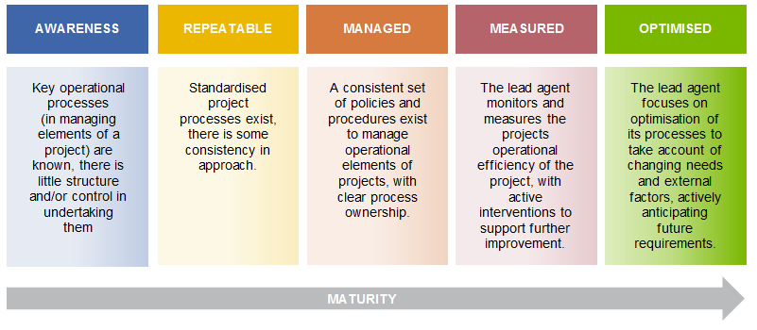

Component Ratings
Definitions of each of the component ratings is outlined below.

Governance
Low (1-3) | Medium (4-7) | High (8-10)
- Project has no defined governance structure in place to manage project delivery  - Reporting to Government lacks substance and completeness  - Risk Management – no risk management policy exists, risks have not been identified | - Project has a defined governance structure in place  - There is a lack of, or no, evidence to indicate the governance arrangements are being followed  - The governance arrangements provide limited strategic guidance to management, often delving into operational matters  - Project governance structure does not include key stakeholder representatives  - Project governance structure is too complex for the nature and size of the project e.g. too many members  - No documentation to support delineation in roles between management and the governance structure  - Evidence of minimal reporting to Government  - Risk Management – a risk management policy exists and some evidence of risk identification occurs but risks are not regularly monitored | - Project has a defined and documented governance structure in place  - There is evidence of governance structures being used for decision making in minutes, agendas, action items  - The governance arrangements provide strategic guidance to management  - Governance structures are supported by documented policies and procedures e.g. board membership, terms of reference etc.  - Clear delineation of roles between management and the governance structure  - Reporting – strong management reports to Government and internal governance structures  - Risk Management – a risk management policy exists and there is evidence of ongoing monitoring and identification and management of risks

Effectiveness
Low (1-3) | Medium (4-7) | High (8-10)
- The project is not tracking performance against outlined objectives  - No evidence of co-investment  - The infrastructure is not being used by any other researchers/organisations | - The project has limited reporting against objectives  - Limited co-investment  - The infrastructure is being used by a small number of other researchers/organisations | - The project has a comprehensive reporting framework for measuring performance against objectives  - Significant co-investment  - The infrastructure is in high demand from other researchers/organisations

Efficiency
Low (1-3) | Medium (4-7) | High (8-10)
- Low usage rates for the infrastructure, prioritisation of the infrastructure is not consistently or well managed  - Pricing is high in comparison to industry benchmarks  - Pricing results in cross subsidizing other programs/facilities  - Cost overheads are significantly higher than expected  - A high level of unscheduled downtime | - Moderate usage rates for the infrastructure, prioritisation of the infrastructure is reasonably consistently and/or well managed  - Pricing is comparable/slightly higher than industry benchmarks  - Cost overheads are somewhat higher than expected  - Some unscheduled downtime | - High usage rates for the infrastructure, prioritisation of the infrastructure is consistently and well managed  - Pricing is below industry benchmarks  - Cost overheads are reasonable  - Limited unscheduled downtime

Financial Management and Compliance
Low (1-3) | Medium (4-7) | High (8-10)
- No/very basic financial management reporting  - No/very basic budgets established for the project  - Lack of financial controls (manual or non-existent)  - No/very basic financial management policies and procedures  - The project has breached the funding agreement in the past (Department may know) | - Limited financial reporting  - Project has developed a budget but does not track progress against it  - Weak financial controls in place (manual processes or delegation responsibility e.g. travel approvals)  - Financial management policies exists, but are out of date or are not followed | - Regular financial reporting against budgets  - Strong financial controls (automated and defined delegations)  - Financial management policies exist, have been updated and are being actively used.

Integration
Low (1-3) | Medium (4-7) | High (8-10)
- Lack of industry/research sector integration  - No linkages to other relevant research agencies, including government and non-government | - Small amount of industry/research sector integration  - Limited linkages to other relevant research agencies, including government and non-government | - Strong industry/research sector integration  - Strong linkages to other relevant research agencies, including government and non-government

Strategic Policy Alignment
Low (1-3) | Medium (4-7) | High (8-10)
- The project has limited alignment with NCRIS priorities  - Little alignment to international or national policy/research priorities  - No consideration of long-term/future opportunities for the infrastructure or ground breaking knowledge/direction (i.e. foresighting) | - The project has some alignment with NCRIS priorities  - Alignment with international or national policy/research priorities  - Some consideration of long-term/future opportunities for the infrastructure or ground breaking knowledge/direction (i.e. foresighting) | - The project has strong alignment with NCRIS priorities  - Strong alignment with international or national policy/research priorities  - Well-articulated consideration of long-term/future opportunities for the infrastructure or ground breaking knowledge/direction (i.e. foresighting)

Appendix C – Project Graphs
The following graph provides the total expenditure by project, grouped by type of lead agent for FY2013-14.⁴² For the purposes of confidentiality, project names have been removed.
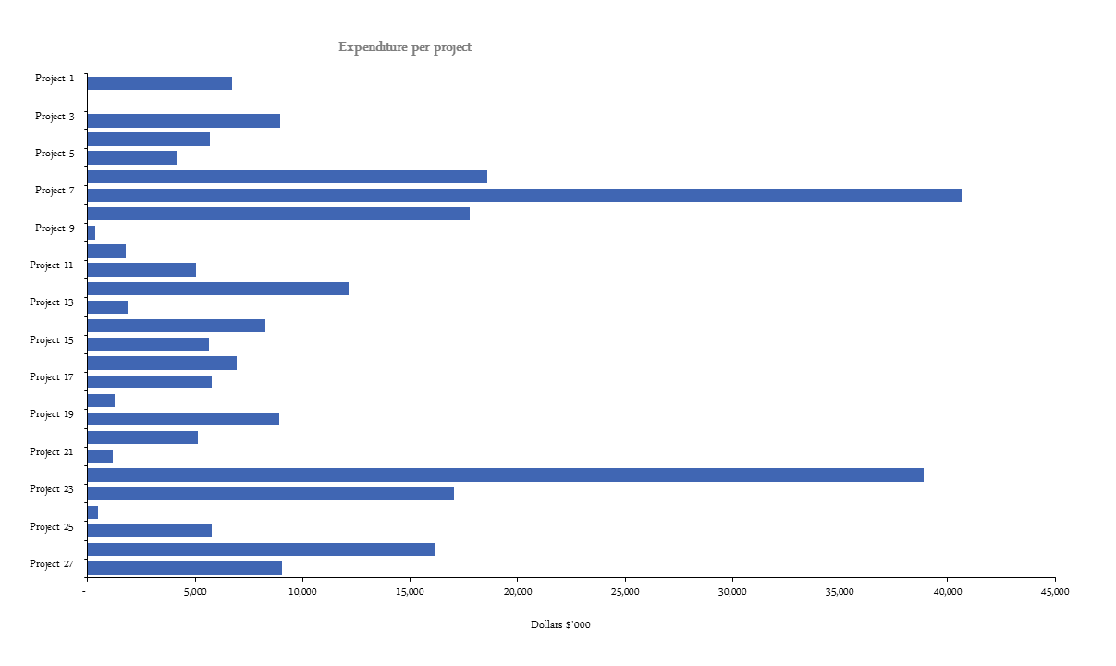
⁴² Source: Data collected by ORIMA Research (question 88), provided to KPMG via email on 21 November 2014
The following graph provides the co-investment by project associated with NCRIS and CRIS funding for 2013/14.⁴³ For the purposes of confidentiality, project names have been removed.
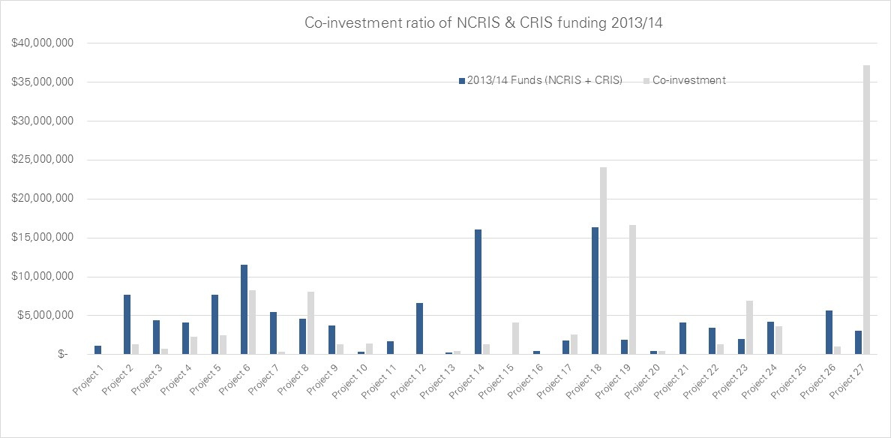
⁴³ Source: Data collected by ORIMA Research (question 86), provided to KPMG via email on 30 April 2015

The following table provides a summary of the number and funding level of grants awarded that utilise NCRIS projects in FY2013-14.⁴⁴
Project | Number of grants | Grant $
Project 1 | 4 | 1,045,000
Project 2 | 17 | 12,930,000
Project 3 | 442 | 88,400,000
Project 4 | 46 | 21,918,000
Project 5 | 25 | 73,472,556
Project 6 | 1 | 100,000
Project 7 | 2 | -
Project 8 | 7 | 36,000,000
Project 9 | 96 | 27,896,827
Project 10 | 2 | 2,300,000
Project 11 | 51 | 58,732,350
Project 12 | 46 | 6,981,000
Project 13 | 27 | 7,964,573
Project 14 | 48 | 41,852,274
Total | 848 | 379,592,580
44 Source: Data collected by ORIMA Research (question 35), provided to KPMG via email on 21 November 2014
Disclaimer

Inherent Limitations
This report has been prepared as outlined in the Scope, Methodology and Approach Section. The services provided in connection with this engagement comprise an advisory engagement, which is not subject to assurance or other standards issued by the Australian Auditing and Assurance Standards Board and, consequently no opinions or conclusions intended to convey assurance have been expressed.
The findings in this report are based on a qualitative study and the reported results reflect information collected from Project Lead Agents, the Department of Education and Training as well as external stakeholders.
No warranty of completeness, accuracy or reliability is given in relation to the statements and representations made by, and the information and documentation provided by, the Department of Education and Training management and personnel consulted as part of the process.
KPMG have indicated within this report the sources of the information provided. We have not sought to independently verify those sources unless otherwise noted within the report.
KPMG is under no obligation in any circumstance to update this report, in either oral or written form, for events occurring after the report has been issued in final form. The findings in this report have been formed on the above basis.

Third Party Reliance
This report is solely for the purpose set out in the Scope and Approach Section and for the Department of Education and Training, and is not to be used for any other purpose or distributed to any other party without KPMG’s prior written consent.
This report has been prepared at the request of the Department of Education and Training in accordance with the terms of KPMG’s engagement Work Order dated 27 August 2014. Other than our responsibility to the Department of Education and Training, neither KPMG nor any member or employee of KPMG undertakes responsibility arising in any way from reliance placed by a third party on this report. Any reliance placed is that party’s sole responsibility.

