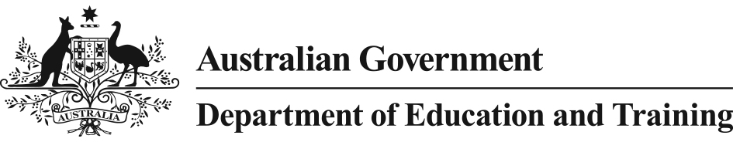 

Literacy and Numeracy Test for Initial Teacher Education Students

*Overview*

The Australian Government believes that the first step to achieving a quality education, which is so critical for the future of young Australians and our nation, is to focus on the quality, professionalism, and status of the teaching profession. One aspect of lifting quality is to ensure that teachers possess the strong personal literacy and numeracy skills needed to foster the development of these skills in their students.

To give effect to improving the literacy and numeracy of teachers, the Australian Government is introducing the Literacy and Numeracy Test for Initial Teacher Education Students (the Test). The Test will assist higher education providers, teacher employers and the general public to have increased confidence in the skills of graduating teachers.

The Australian Government has adopted a two phased implementation of the Test which will assess aspects of personal literacy and numeracy in students undertaking all initial teacher education courses.

# 2015 Implementation

The first phase of the Test commenced with a targeted implementation in late August and late September 2015 on a voluntary basis for up to 5000 students. Delivery of the Test in 2015 was funded by the Australian Government; with Testing centres located in seven capital cities (Perth, Melbourne, Sydney, Brisbane, Adelaide, Darwin and Canberra) and two regional locations (Albury, New South Wales and Ballarat, Victoria). Students who elected to sit the Test in 2015 have benefited from being able to establish their levels of personal literacy and numeracy against a national assessment tool at no cost.

A phased implementation in 2015 provided experience in the Test’s implementation before it becomes a requirement for all students in initial teacher education courses from 1 July 2016. Students who passed the Test in 2015 will be considered to have met the new requirements.

# 2016 National Implementation

From 1 July 2016, national implementation of the Test will commence. From this point, all students undertaking an undergraduate or postgraduate initial teacher education course will be required to pass the Test to meet the new requirements.

The Test will be made available to higher education providers in a flexible way so that delivery can take into account students in all locations, as well as students with special consideration or circumstances. It is anticipated that higher education providers will determine timing for sitting the Test to take into account individual course structures.

Students who sit the Test and successfully complete one component of the Test, but not the other, will be able to ‘bank’ the component that they pass and will not have to sit that part of the Test again. However, students will need to successfully pass both components of the Test to meet the new requirements.

It is the Government’s expectation that from 2016 the cost of sitting the Test will be the responsibility of students.

The Government is working with stakeholders to confirm arrangements for delivery of the Test in 2016. Further information for initial teacher education students will be released through higher education providers once finalised.