

**2014 University Experience Survey National Report**

**March 2015**



# ISBN 978-1-76028-130-4 (DOCX)

# Acknowledgements

The UES Consortium, consisting of Graduate Careers Australia (GCA) and the Social Research Centre (SRC), wish to acknowledge with warm gratitude the work of the many people involved in the research process. Without the contribution of the students who took the time to complete the 2014 UES and the invaluable assistance, advice and support provided by the participating institutions and their Survey Managers, these important data would not be available.

Our thanks go also to the Department of Education, which funded this work and provided support throughout the project. Particular thanks go to Phil Aungles, Sam Pietsch, Dr Andrew Taylor, Gabrielle Hodgson and Ben McBrien.

Dennis Trewin (Dennis Trewin Statistical Consulting) provided an independent technical review of the 2013 UES project. This review is presented in Appendix J.

The UES Project Director was Dr Noel Edge (GCA). The Project Team consisted of Graeme Bryant (GCA), David Carroll (GCA), Bruce Guthrie (GCA), Daniela Iarossi (SRC), Rebecca Lam (SRC), Darren Matthews (GCA), Dianna McDonald (SRC), Eric Skuja (SRC), Daniel Smith (SRC), Sonia Whiteley (SRC) and Alistair Wilcox (SRC). Andrew Ward (Senior Statistician, SRC) conducted and reported on the psychometric analyses of the University Experience Questionnaire presented in Appendices B and D.

For more information on the conduct and results of the 2014 UES, please contact the UES Consortium at ues@graduatecareers.edu.au.

# Executive summary

The University Experience Survey (UES) was developed to provide a national architecture for collecting feedback on key facets of the higher education student experience and, in doing so, obtain important data on the levels of engagement and satisfaction of current commencing and later-year undergraduate students. The UES was developed in 2011 and administered to 24 universities as a pilot in 2011. The full-scale UES was subsequently administered as an online and telephone-based survey in 2012, and an online-only survey in 2013 and 2014.

The UES measures five facets of the student experience: Skills Development, Learner Engagement, Teaching Quality, Student Support and Learning Resources. The UES also contains demographic and contextual items to facilitate data analysis and reporting, and two open-response items that allow students to provide textual feedback on the best aspects of their higher education experience and those most in need of improvement (Section 1.1).

The core features of the 2013 UES were retained for the 2014 survey, including a centralised approach to sampling using data from the Higher Education Information Management System (HEIMS) and online-only data collection. There were, however, several differences between the 2013 and 2014 administrations. First, while the approach to sampling in 2013 involved drawing a fixed number of students from large population strata, required sample sizes in 2014 were calculated taking into account the number of records available and response rates from the 2013 UES. Second, one questionnaire item from the student support focus area was removed on the basis of psychometric evidence showing lack of fit. Third, module rotation was removed on the basis of analysis conducted in 2013 that showed no substantial variation between questionnaire sequences (Section 1.2).

The 2014 UES project included a pilot of the UES questionnaire and methodology on students of 15 volunteer non-university higher education institutions (NUHEIs) under the name Student Experience Survey (SES). The pilot administration was a success, achieving a response rate of 47.9 per cent (Section 1.2.1). Because the SES was a small-scale pilot study, only high-level aggregate results for NUHEI students are presented in this report. NUHEI students were generally more likely to be satisfied with their educational experience than university students. For example, 85 per cent of NUHEI students indicated satisfaction with their entire educational experience, compared with 81 per cent of university students; however it is important to note that these results do not account for any differences in student characteristics between NUHEI and universities (Section 4.7). An analysis of the psychometric properties of the University Experience Questionnaire (UEQ) as administered to NUHEI students is presented in Appendix D.

As in 2013, the results of the 2014 UES are reported as the percentage of surveyed students who expressed satisfaction with their higher education experience. One outcome of this is that the results presented in the 2013 and 2014 UES reports are not directly comparable to those presented in the 2012 report (Section 1.3).

As was the case in 2012 and 2013, all 40 Australian universities participated in the 2014 UES. The fieldwork period ran from August to October 2014 (Section 2.1). The “in-scope” population consisted of 330,772 commencing and later-year students (Section 2.2). A stratified sampling approach was employed, with strata defined on the basis of institution and subject area (Section 2.3).

Students were sent one initial email invitation and between five and ten reminders. A hardcopy letter was sent to non-responding students for whom a postal address was available. Incentives were allocated on an institutional basis, with $1,000 worth of prizes drawn for each institution. An engagement campaign was conducted in the lead-up to and throughout the fieldwork period to build awareness of the UES and encourage participation (Section 2.6).

The response rate for the 2014 UES was 30.1 per cent, up from 29.3 per cent in 2013. Institutional response rates ranged from 50.4 per cent to 20.9 per cent. Responses were received from 99,112 students, which equated to 108,322 valid surveys once combined and double degrees were taken into account (Section 3.1).

The sample of secured responses closely matched the in-scope population on most characteristics, but males were notably under-represented (Section 3.2). Post-stratification weighting to correct the gender imbalance in the sample of secured responses did not have a substantial impact on the results at the national level, so it was decided to analyse the data without applying weights (Section 3.3). Stratum-level sampling and response maximisation adopted for the 2014 UES resulted in a general increase in the number of strata that achieved the desired level of statistical precision (Section 3.4).

**Basic national results**

Percentage satisfied results for all five UES focus areas and two key questionnaire items are presented in the table below, stratified by stage of studies. Because the focus areas represent different facets of the student experience, it is inadvisable to make direct comparisons across them. It is interesting, however, to note the aspects with which a smaller proportion of students expressed satisfaction.

|  | **Focus areas** | | | | | **Questionnaire items** | |
| --- | --- | --- | --- | --- | --- | --- | --- |
| **Skills Development** | **Learner Engagement** | **Teaching Quality** | **Student Support** | **Learning Resources** | **Quality of entire educational experience** | **Quality of teaching** |
| Commencing | 79 | 60 | 84 | 76 | 88 | 83 | 83 |
| Later year | 85 | 63 | 79 | 68 | 81 | 77 | 77 |
| **Total** | **81** | **61** | **82** | **73** | **86** | **81** | **81** |

Percentage satisfied results varied a little on the basis of demographic and contextual characteristics, but considerably on the basis of subject area. The narrowest range in results across subject areas was observed in relation to the student support focus area, with 15 percentage points separating the subject areas with the highest and lowest results. The widest range was observed in relation to learner engagement, with 30 percentage points separating the highest and lowest subject areas. Some notable cases of variation within broad fields of education were also observed, which underscores the fact that broad disciplinary aggregations can hide much useful detail (Section 4.1).

When the results from the 2013 and 2014 UES collections are compared (see table below), the largest difference in terms of focus area results was seen in relation to student support, with 14 percentage points separating 2013 and 2014. A year-on-year difference of this magnitude is most likely the result of the aforementioned changes to the questionnaire and survey method in 2014 (Section 4.2).

|  | **Focus areas** | | | | | **Questionnaire items** | |
| --- | --- | --- | --- | --- | --- | --- | --- |
| **Skills Development** | **Learner Engagement** | **Teaching Quality** | **Student Support** | **Learning Resources** | **Quality of entire educational experience** | **Quality of teaching** |
| 2013 | 79 | 57 | 79 | 59 | 83 | 79 | 79 |
| 2014 | 81 | 61 | 82 | 73 | 86 | 81 | 81 |

When considering the individual questionnaire items, it is interesting to observe that many of the highest results relate to learning resources, including library resources and facilities, teaching spaces and online learning materials. Moreover, 81 per cent of students indicated satisfaction with both the quality of teaching and their entire educational experience. Many of the lowest results were associated with the student support and learner engagement focus areas (Section 4.3).

When institutional percentage satisfied results on the quality of teaching and the entire educational experience are ordered, there is a fairly even increase in results from the bottom of the distribution to near the top, with a few institutions at the top of the distribution notably higher than the majority of institutions (Section 4.4).

Comparing results from the UES to the National Survey of Student Engagement (NSSE), conducted in the USA and Canada, suggests that respondents to the NSSE are more likely to be satisfied with their educational experience than respondents to the UES, especially later-year students. A similar result is obtained when later-year respondents to the UES are compared with final-year students who responded to the National Student Survey (NSS) in the UK. It is important to note, however, that these results do not account for potential differences in the composition of the respective student populations, nor methodological differences between the surveys (Section 4.5).

In addition to questions on their higher education experience, students were also asked to indicate whether they had seriously considered leaving their university in 2014. Overall, 17 per cent indicated that they had considered leaving. Commencing students, older students, Aboriginal and Torres Strait Islander students, students with a disability and students who were first in their family to attend university were the most likely to consider early departure, as were those who had achieved low grades to date. The most common reasons given for considering early departure are situational in nature, including health or stress, difficulties relating to finances and workload, and study/life balance (Section 4.6).

# Contents

Acknowledgements i

Executive summary ii

Contents v

List of tables vii

List of figures viii

1 Introduction and overview 1

1.1 Background to the University Experience Survey 1

1.2 The 2014 UES 2

1.2.1 The Student Experience Survey 3

1.3 Reading the results in this report 4

1.4 Important caveats 4

1.5 Overview of this report 5

2 Methodology 6

2.1 Institutional participation 6

2.2 Survey population 7

2.2.1 Commencing students 7

2.2.2 Later-year students 7

2.3 Sampling design 7

2.3.1 Sample frame 7

2.3.2 Approach to sampling 8

2.4 Additional questionnaire elements and populations 9

2.4.1 Institution-specific items 9

2.4.2 Additional populations 9

2.5 Online survey 9

2.6 Student engagement strategy 9

2.6.1 Pre-survey engagement 9

2.6.2 Response maximisation 10

2.7 Higher education liaison strategy 11

2.8 Data processing 11

2.8.1 Definition of the analytic unit 11

2.8.2 Data cleaning and preparation 11

3 Response and representativeness 13

3.1 Response rates 13

3.2 Response characteristics 13

3.3 Weighting 16

3.4 Stratum-level precision 18

3.5 Precision of national estimates 18

4. Key results from the 2014 UES 21

4.1 The university experience of specific groups 21

4.2 University experience perceptions over time 24

4.3 Results on individual questionnaire items 26

4.4 The university experience of students from different institutions 28

4.5 International comparisons 30

4.6 Early departure 32

4.7 Results for non-university higher education students 34

Appendix A: University Experience Questionnaire (UEQ) 38

Appendix B: Analysis of the psychometric properties of the revised Student Support focus area 40

B.1 Introduction 40

B.2 Analytical approach 40

B.2.1 Fit to the Rasch model 41

B.2.2 Ordered category thresholds 41

B.2.3 Item and person targeting 41

B.2.4 Unidimensionality 42

B.3 Fit to the Rasch model 42

B.4 Ordered category thresholds 44

B.5 Item and person targeting 45

B.6 Summary 46

B.7 About the Rasch model 47

Appendix C: Course Experience Questionnaire (CEQ) 48

Appendix D: Analysis of the UEQ as administered to students from non-university higher education institutions 49

D.1 Introduction 49

D.2 Assessing item and focus area quality 49

D.2.1 Learner Engagement 49

D.2.2 Learning Resources 53

D.2.3 Skills Development 54

D.2.4 Student Support 56

D.2.5 Teaching Quality 58

D.2.6 Focus area summaries 61

D.3 Differential item functioning 62

D.3.1 NUHEI and UES 62

D.3.2 NUHEI subgroups 63

D.4 Missing responses 65

D.5 Summary 67

Appendix E: Production of scores 69

Appendix F: Promotional website tiles 71

Appendix G: Construction of confidence intervals 72

Appendix H: Response category percentages 73

Appendix I: Subject area definitions 77

Appendix J. Independent review of the 2014 UES 79

# List of tables

Table 1. UES project overview, 2013 and 2014 2

Table 2. Institutions that participated in the SES pilot 3

Table 3. Operational cohorts for the 2014 UES 6

Table 4. UES response rates, 2013 and 2014 13

Table 5. 2014 UES response characteristics and population parameters by subgroup 14

Table 6. 2014 UES response characteristics and population parameters by subject area 14

Table 7. Comparison of raw and weighted percentage satisfied scores by subgroup 16

Table 8. Comparison of raw and weighted percentage satisfied scores by subject area 17

Table 9. Strata meeting desired level of precision, 2013 and 2014 18

Table 10. Percentage satisfied results by subgroup with 90 per cent confidence intervals 19

Table 11. Percentage satisfied results by subject area with 90 per cent confidence intervals 19

Table 12. Percentage satisfied scores by subgroup 21

Table 13. Percentage satisfied scores by subject area 23

Table 14. Percentage satisfied results by subject area, 2013 and 2014 25

Table 15. Percentage satisfied results for UEQ items by stage of studies, 2013 and 2014 27

Table 16. Percentage of students considering early departure by subgroup 32

Table 17. Selected reasons for considering early departure, 2013 and 2014 34

Table 18. Summary results for non-university higher education institutions and universities 34

Table 19. Skill Development items 38

Table 20. Learner Engagement items 38

Table 21. Teaching Quality items 38

Table 22. Student Support items 39

Table 23. Learning Resources items 39

Table 24. Open-response items 39

Table 25. Selected Rasch model outputs for item assessment 41

Table 26. Item statistics for Student Support 42

Table 27. Number of Student Support items answered by UES respondents 43

Table 28. Person and item separation indices for Student Support 44

Table 29. CEQ items administered in the 2014 UES 48

Table 30. NUHEI item statistics for Learner Engagement, with UES measures for comparison 50

Table 31. NUHEI item statistics for Learning Resources, with UES measures for comparison 53

Table 32. NUHEI item statistics for Skills Development, with UES measures for comparison 55

Table 33. NUHEI item statistics for Student Support, with UES measures for comparison 57

Table 34. NUHEI item statistics for Teaching Quality, with UES measures for comparison 59

Table 35. Overall NUHEI summary statistics, by focus area 61

Table 36. Notable DIF effects, NUHEI versus matched UES students 63

Table 37. NUHEI characteristics, items and DIF measures for Learner Engagement 63

Table 38. NUHEI characteristics, items and DIF measures Learning Resources 63

Table 39. NUHEI characteristics, items and DIF measures for Skills Development 64

Table 40. NUHEI characteristics, items and DIF measures for Student Support 64

Table 41. NUHEI characteristics, items and DIF measures for Teaching Quality 65

Table 42. Summary of missing responses, by NUHEI and UES students 66

Table 43. Skills Development item response category percentages 73

Table 44. Learner Engagement item response category percentages 73

Table 45. Teaching Quality item response category percentages 74

Table 46. Student Support item response category percentages 75

Table 47. Learning Resources item response category percentages 76

Table 48. UES subject areas and corresponding ASCED fields of education 77

# List of figures

Figure 1. Percentage satisfied results on the quality of entire educational experience 29

Figure 2. Percentage satisfied results on the quality of teaching 29

Figure 3. Entire educational experience rated positively, UES and NSSE, 2008 to 2014 30

Figure 4. Overall satisfaction with course quality, UES CEQ and NSS, 2008 to 2014 31

Figure 5. Percentage of students considering early departure by average grades to date 33

Figure 6. Category probabilities for Student Support 44

Figure 7. Person-item map for Student Support 45

Figure 8. NUHEI category probabilities for “Extent” items, Learner Engagement 51

Figure 9. NUHEI category probabilities for “Frequency” items, Learner Engagement 51

Figure 10. NUHEI person-item map for Learner Engagement 52

Figure 11. NUHEI category probabilities for Learning Resources 53

Figure 12. NUHEI person-item map for Learning Resources 54

Figure 13. NUHEI category probabilities for Skills Development 55

Figure 14. NUHEI person-item map for Skills Development 56

Figure 15. NUHEI category probabilities for Student Support 57

Figure 16. NUHEI person-item map for Student Support 58

Figure 17. NUHEI category probabilities for “Extent” scale items, Teaching Quality 59

Figure 18. NUHEI category probabilities for Rating scale items, Teaching Quality 60

Figure 19. NUHEI person-item map for Teaching Quality 60

Figure 20. SPSS syntax to recode UEQ items into the conventional reporting metric 69

Figure 21. SPSS syntax used to compute UES focus area scores 69

Figure 22. SPSS syntax used to compute focus area satisfaction variables 70

Figure 23. SPSS syntax used to compute item satisfaction variables 70

Figure 24. UES 2014 promotional website tiles 71

# 1 Introduction and overview

## 1.1 Background to the University Experience Survey

The University Experience Survey (UES) was developed to provide a national architecture for collecting feedback on key facets of the higher education student experience and, in doing so, obtain important data on the levels of engagement and satisfaction of current students. The UES focuses on aspects of the higher education student experience that are measurable, linked with learning and development outcomes, and for which institutions can reasonably be assumed to have responsibility.

Specifically, the UES was designed to measure five facets of the higher education student experience: Skills Development, Learner Engagement, Teaching Quality, Student Support and Learning Resources. These are operationalised by means of summated rating scales, underpinned by 46 individual questionnaire items. These items are supplemented by two open-response items that allow students to provide textual feedback on the best aspects of their higher education experience and those most in need of improvement. The UES also contains two additional sets of items, demographic and contextual, to facilitate data analysis and reporting. A full list of UEQ items is presented in Appendix A.

The UES was developed in 2011 on behalf of the Australian Government by a consortium led by the Australian Council for Educational Research (ACER) and including the University of Melbourne’s Centre for the Study of Higher Education (CSHE) and the Griffith Institute for Higher Education (GIHE). The Consortium designed and validated the University Experience Questionnaire (UEQ) and data collection methodology, which involved conducting a pilot of the UES on a sample from 24 universities. From this they made recommendations about further development. In 2012, the Consortium was engaged to review and readminister the UES. The UES was refined to be relevant to policy and practice, and to yield robust and useful data that could be used for informing choice and continuous improvement. Linkages were made to facilitate international benchmark comparisons. The 2012 UES was administered as a mixed-mode online-telephone survey.

In mid-2013, the tender to administer the second iteration of the UES proper was awarded to a consortium consisting of Graduate Careers Australia (GCA) and the Social Research Centre (SRC), hereafter GCA-SRC. The survey instrument was largely unchanged from 2012, with the major difference between the 2012 and 2013 collections being that, while the former collected data at the student level, the latter collected data at the course level.[1] In other words, a student completing a double or combined degree was invited to provide feedback on both course elements in the 2013 UES.

The approach to sampling and data collection for the 2013 UES differed substantially from that of the 2012 survey. While the sample frame for the 2012 UES was based on a “bottom-up” approach, with participating institutions providing extracts from their student data systems to the 2012 UES Consortium to serve as a basis for the sample frame, population data from the Higher Education Information Management System (HEIMS) was used to create the sample frame for the 2013 UES. This ensured a nationally consistent approach to sampling that had not previously been possible. Moreover, while the 2012 UES had been administered as a mixed-mode survey, the 2013 UES was administered entirely online. Compared to a mixed-mode online-telephone survey, an online-only data collection methodology is more cost effective, convenient for students, requires a shorter fieldwork period and mitigates potential problematic survey mode effects.

## 1.2 The 2014 UES

The core features of the 2013 UES were retained for the 2014 survey, including a centralised approach to sampling based on HEIMS data (see Section 2.3) and online-only data collection. Table 1 presents an overview of the 2013 and 2014 UES collections. The in-scope population definition was unchanged from previous implementations of the survey and consisted of commencing and later-year onshore undergraduate students (see Section 2.2). The in-scope population size was smaller in 2014 than 2013 due to relatively higher proportions in the overall population of students in postgraduate and non-award courses, offshore students and students in the middle years of their courses. Also, a slightly higher proportion of students were excluded by institutions during the sample verification process in 2014 compared with the previous year.

Table 1. UES project overview, 2013 and 2014

| **Project element** | **2013** | **2014** |
| --- | --- | --- |
| Number of participating institutions | 40 | 40 |
| Number of “in-scope” students | 341,343 | 330,772 |
| Data collection period | August-November | August-October |
| Data collection mode | Online | Online |
| Overall response rate (%) | 29.3 | 30.1 |
| Number of completed surveys (student level) | 100,225 | 99,112 |
| Number of valid surveys (course level) | 108,940 | 108,322 |
| Analytic unit | Course | Course |

The approach to sampling changed markedly in 2014. In the 2012 and 2013 UES collections, a fixed number of students were sampled from large population strata (> 1,333 students), which often led to oversampling. In 2014, required sample sizes were calculated at the stratum level, taking into account the number of records available and response rates from the 2013 UES. As a result, although marginally fewer surveys were completed in 2014 than 2013, the number of strata meeting desired precision targets increased considerably (see Section 3.4).

There were only two major questionnaire changes between 2013 and 2014. First was the removal of the item “At university during year x, to what extent have you used university services to support your study?” on the basis of psychometric evidence showing lack of fit within the student support focus area.[2] To enable valid comparisons between the 2013 and 2014 UES collections, the 2013 results have been recalculated without this questionnaire item. Consequently, the 2013 results for the student support focus area presented in this report will differ from those published in the 2013 report. An analysis of the psychometric properties of the revised student support focus area is presented in Appendix B. The key findings from this analysis are, firstly, that there remains one poorly fitting questionnaire item within the student support focus area (relating to English language support), and secondly, that a number of items in this focus area display a lack of applicability to students.

Second was the removal of module rotation in 2014. Unlike 2013, in which five module rotations were presented to students, only one questionnaire sequence was employed for the 2014 UES (see Section 2.5).

As part of the 2013 UES, six scales from the Course Experience Questionnaire component of the Australian Graduate Survey (AGS) were administered on a trial basis to students from 14 institutions. This trial resulted in a recommendation that the Good Teaching Scale (GTS), Generic Skills Scale (GSS), Clear Goals and Standards Scale (CGS) and Overall Satisfaction Item (OSI) be administered to a sample of later-year students across all participating institutions to facilitate international benchmarking. It was further recommended that the CEQ scales should only be presented to a small sample of students of a sufficient size to yield national-level estimates that are precise within ±7.5 percentage points of the true population value at a 90 per cent confidence level. As with the UEQ, sampled students in double degrees were provided with the opportunity to complete the CEQ for each course element individually. A list of CEQ items administered in the 2014 UES is presented in Appendix C.

As was the case in previous implementations, institutions were given the opportunity to add institution-specific items to the UES. These institution-specific items were only presented to students after they had completed and submitted the UEQ component,[3] resulting in a clear demarcation between the two.

### 1.2.1 The Student Experience Survey

The 2014 UES project included a pilot of the UES questionnaire and methodology on students of 15 volunteer non-university higher education institutions (NUHEIs). These are listed in Table 2. It was recognised early in the process that the name “University Experience Survey” could discourage participation by students of NUHEIs, so the survey was retitled the Student Experience Survey (SES) for this population. Where required, questionnaire item wordings were similarly modified. These differences aside, the administration of the SES was essentially identical to the UES. A total of 1,444 completed surveys were returned from a sample of 3,039 in-scope students, representing a strong response rate of 47.9 per cent (cf. 30.1 per cent for the UES).

Table 2. Institutions that participated in the SES pilot

|  |  |
| --- | --- |
| Alphacrucis College | Polytechnic West |
| Avondale College of Higher Education | Raffles College of Design and Commerce |
| Blue Mountains International Hotel Management School | Sydney College of Divinity |
| Christian Heritage College | Tabor Adelaide |
| Holmesglen Institute of TAFE | Tabor College NSW |
| Marcus Oldham | Tabor College Tasmania |
| Melbourne Institute of Technology | Tabor College Victoria |
| Melbourne Polytechnic (formerly NMIT) |  |

Because the 2014 SES was a small-scale pilot study involving a convenience sample of 15 of the approximately 130 NUHEIs currently operating in Australia, detailed results for NUHEI students are not presented in the body of this report as they may not necessarily be representative of the non‑university higher education sector as a whole. High-level aggregate SES results are presented in Section 4.7.

An analysis of the psychometric properties of the UEQ as administered to NUHEI students is presented in Appendix D. The main purposes of this analysis are to investigate how well the UEQ items fit within their respective focus areas when administered to NUHEI students, and whether the two cohorts respond to the questionnaire differently, with the aim of determining whether the current UEQ is an appropriate instrument for measuring NUHEI students’ engagement and satisfaction with their higher education experience. The results of the analysis indicate that most items demonstrate good fit within their respective focus areas, and most items are answered similarly by university and NUHEI respondents. A number of items, especially in the student support focus area, did not apply or were not answered by large proportions of NUHEI and university students alike, echoing the findings of the previously discussed analysis of the student support focus area (see Appendix B).

## 1.3 Reading the results in this report

It is essential that the analysis and reporting of the UES data are conducted in statistically sound and appropriate ways. Since its introduction, the UES data have been reported in two metrics: average scores and percentage satisfied results. Average scores are based on a rescaling of the response scales, with the four-point scales recoded onto a scale that runs 0, 33.3, 66.6 and 100, and five-point scales recoded onto a scale that runs 0, 25, 50, 75 and 100. Scores for each focus area are then computed as the mean of the constituent item scores. Percentage satisfied results reflect the percentage of students who report a focus area score of 55 or greater. This specific value was chosen because it is clearly above the midpoint of the response scale and reflects the maximum percentage of graduates satisfied with their higher education experience. At the individual response level, satisfaction is represented by a binary variable taking the value of one if the student is satisfied with a particular facet of their higher education experience and zero otherwise.

Extensive consultation with the higher education sector indicated a near-universal preference for the reporting of percentage satisfied results over focus area average scores. Percentage satisfied results were seen as being a more understandable measure, especially for less expert users of the UES data, and are straightforward for institutions to replicate and benchmark against. As such, percentage satisfied results are presented throughout this report. In relation to UES focus areas, “percentage satisfied” reflects the percentage of students who give a focus area score of 55 or greater out of a possible 100. In cases where the results on individual UES items are reported, percentage satisfied reflects the percentage of responses in the top two response categories. One consequence of this is that the results presented in the 2013 and 2014 UES reports are not directly comparable to those presented in the 2012 report. Information on the production of UES focus area average scores and associated percentage satisfied variables is presented in Appendix E.

## 1.4 Important caveats

While the UES has now been trialled and administered three times using best practice techniques, it is critical that certain caveats are borne in mind when interpreting the results in this report, especially in cases when these results are to be used to inform policy decisions. First, it is possible that the results are biased to some extent by the fact that not all members of the target population return a completed response. If non-respondents differ systematically from those who did respond to the UES, the results will not reflect the true experiences of students in the broader higher education student population. If, for example, students who are more engaged with their higher education institution tend to be more likely to respond to the UES than those who are less so, the estimates relating to Learner Engagement may be upwardly biased relative to the true population parameter, or vice-versa.

Post-stratification weighting is a common method employed to ensure that the sample of responses reflects the survey population in terms of key demographic and enrolment characteristics. Exploratory analysis, discussed further in Section 3.3, suggested that corrective weighting does not provide any significant advantage for the 2014 UES. Similar analysis undertaken for the 2013 UES report yielded essentially identical results. As such, all results presented in this report are based on unweighted data unless otherwise noted.

It is important to consider that bias on the basis of unobservable characteristics may still be influencing the results—in any case this type of bias may not be corrected by the application of post‑stratification weights. It is difficult to say whether any such bias exists without gathering data from non-respondents, which was not undertaken as part of the 2014 UES. Readers are asked to consider the possible existence of such bias when interpreting the results in this report.

Moreover, it is important to bear in mind that the UES does not encompass all the aspects on which students could evaluate their courses, nor does it explicitly measure the relative importance that students place on different aspects of their higher education experience.

Finally, an optimal analysis of UES results should account for the inherent hierarchical structure of the data. Students are nested within subject areas, and subject areas are nested within institutions. The experience of students within the same subject area (academic department) may be correlated due to exposure to the same lecturers. Likewise, experience scores for subject areas may be correlated within an institution due to the similar background of the students who attend that institution. To minimise bias, UES data should ideally be analysed using a multilevel model that accounts for this nesting of students within subject areas, within institutions. In order to maintain consistency with past reports and other presentations of UES data, to ensure that the results are clear and meaningful to the widest possible audience, and to enable the results presented herewith to be easily replicated, only single-level analyses are presented in this report.

## 1.5 Overview of this report

This report presents an overview of the 2014 UES, including the conduct and administration of the survey, and key results based on the national UES data file, which consists of 108,322 responses from 99,112 students representing 40 higher education institutions. All statistics relating to UES focus areas and their constituent items reflect the percentage of students who indicated that they were satisfied with their higher education experience. The UES focus areas relate to Skills Development, Learner Engagement, Teaching Quality, Student Support and Learning Resources. Selected statistics are presented with 90 per cent confidence intervals to demonstrate the variability of estimates due to sampling variation. Summary statistics on the reasons why students considered leaving their current university are also shown. Supplementary analyses and additional materials are presented in appendices and referenced in the body of the report.

# 2 Methodology

## 2.1 Institutional participation

All 37 Table A and 3 Table B higher education institutions participated in the 2014 UES. Under the Higher Education Support Act (HESA) 2003, Table A institutions are self-accrediting providers, eligible for funding under the Act. Table B institutions are also self-accrediting, but are not eligible for general Commonwealth funded places. For the purpose of administering the UES, participating institutions were assigned to operational cohorts based on fieldwork commencement date. As a result, the 40 participating institutions were split into 13 operational cohorts; the largest comprising five institutions and the smallest comprising single institutions. Table 3 lists the institutions in each cohort, along with corresponding fieldwork commencement and completion dates.

Table 3. Operational cohorts for the 2014 UES

| **Operational cohort** | **Institution** | **Commencement date** | **Completion date** |
| --- | --- | --- | --- |
| Cohort 1a | Deakin University | 4 August | 8 September |
| Griffith University | 9 September |
| University of Melbourne | 10 September |
| James Cook University | 11 September |
| Cohort 1b | University of Southern Queensland | 5 August | 11 September |
| University of South Australia | 17 September |
| University of Western Sydney | 17 September |
| University of Divinity | 17 September |
| Cohort 1c | The University of Adelaide | 7 August | 11 September |
| Cohort 2a | Charles Sturt University | 11 August | 19 September |
| The Australian National University | 19 September |
| Edith Cowan University | 26 September |
| Macquarie University | 30 September |
| Murdoch University | 1 October |
| Cohort 2b | Federation University | 12 August | 29 September |
| University of the Sunshine Coast | 30 September |
| University of Wollongong | 1 October |
| University of Canberra | 3 October |
| Cohort 2c | University of Sydney | 13 August | 26 September |
| University of Queensland | 2 October |
| University of Notre Dame Australia | 14 August | 6 October |
| Cohort 3a | Central Queensland University | 18 August | 26 September |
| Southern Cross University | 10 October |
| Charles Darwin University | 15 October |
| Australian Catholic University | 10 October |
| Cohort 3b | Monash University | 19 August | 19 September |
| Queensland University of Technology | 30 September |
| University of Tasmania | 6 October |
| University of Newcastle | 14 October |
| Flinders University | 15 October |
| Cohort 3c | Victoria University | 20 August | 6 October |
| La Trobe University | 10 October |
| Cohort 3d | The University of New South Wales | 21 August | 30 September |
| The University of New England | 2 October |
| The University of Western Australia | 3 October |
| Cohort 4a | University of Technology, Sydney | 1 September | 7 October |
| RMIT University | 22 September |
| Curtin University of Technology | 3 October |
| Cohort 4b | Bond University | 2 September | 9 October |
| Cohort 4c | Swinburne University of Technology | 1 October | 27 October |

## 2.2 Survey population

The in-scope survey population for the 2014 UES consisted of commencing and later-year onshore undergraduate students enrolled in Table A and B higher education institutions. The in-scope population consisted of 330,772 students. The definitions used for commencing and later-year students in the 2014 UES are essentially unchanged from 2013. These are described in the following subsections.

### 2.2.1 Commencing students

Commencing students were defined as first-year students who were enrolled in an undergraduate course, studying onshore, commenced study in the relevant target year and enrolled for at least one semester.

Records conforming to the agreed definition of a commencing student were extracted from the national HEIMS Submission 1 student file by the Department. Individual institutions were then asked to verify, where possible, that the selected students were still enrolled.

### 2.2.2 Later-year students

Later-year students were defined as final-year students who were enrolled in an undergraduate course, studying onshore and generally in their third year of study. In 2013, the complexity of identifying later-year students was acknowledged and a number of different approaches were trialled. The task is relatively easy for full-time students in three-year courses, but more difficult for part-time and external students, those who took leaves of absence and those who transferred from one course to another. To address this, two different options were used in practice.

*Option 1*, based on the ratio of EFTSL completed successfully (E355) and currently in progress (E339) to the total EFTSL for the course (E350) proved the better option for 9 of the 40 institutions in 2013.[4] In 2014 this was re-evaluated and two institutions were changed to Option 2, for a total of seven institutions using this solution.

*Option 2*, which adjusts for attendance mode (E330) and course duration (E350) was the standard solution used for the remaining 33 institutions. This solution may under-sample if large numbers of students engage in accelerated progression during Semester 2 or Summer Term. As such, specific adjustments were required to accommodate the idiosyncrasies of a small number of institutions.

Records conforming to the agreed definition of a later-year student were extracted from the HEIMS Submission 1 Student File and individual institutions were asked to verify, where possible, that the selected students were still enrolled.

## 2.3 Sampling design

### 2.3.1 Sample frame

As with 2013, the sample frame for the 2014 UES was based on a “top-down” approach using population data from HEIMS to create the sample frames for individual universities. Compared with the “bottom-up” approach utilised for the 2012 UES, whereby institutions provided extracts from their student data systems to the survey administrators to serve as a basis for the sample frame, the approach adopted for the 2013 and 2014 UES implementations reduces the likelihood of accidental bias being introduced to the sample selection process and ensures a nationally consistent approach to sampling. While it would have been ideal to use validated Submission 2 data for this purpose, this was not possible due to the timeline for data collection. To address this, each institution was asked to verify, where possible, whether or not the selected students were still enrolled.

### 2.3.2 Approach to sampling

As in previous implementations, a stratified sampling approach was employed for the 2014 UES collection, with strata defined on the basis of institution and subject area;[5] however the approach to determining sample size differed markedly compared with the earlier surveys. In the 2013 UES, the approach to sampling was broadly consistent with that of the 2012 survey. The number of students for each stratum was calculated using the approach described in the 2012 UES National Report.[6] All students were selected for strata up to 1,333 students, effectively a census of these strata. For strata larger than 1,333 students, a random sample of 1,333 students was drawn in the hope that this would yield at least 200 responses. According to the report, this value was derived from a desire for error bands of ±5 per cent at a 95 per cent level of confidence.[7]

An analysis of this approach suggested that it had a number of shortcomings. In general, large strata were substantially oversampled and often achieved completed surveys well in excess of the target of 200, with the result that students from large strata were substantially over-represented. This had the flow-on effect of increasing the gender imbalance in the sample of secured responses, as many of the large strata consisted of course offerings where males are traditionally underrepresented, such as nursing and education. Lastly, the sampling approach did not take into consideration the differential response rates across strata.

In 2014, required sample sizes were calculated at the stratum level taking into account the number of records available and the goal of reporting stratum-level results at a level of precision of ±7.5 percentage points at a 90 per cent level of confidence.[8] In order to establish the required sample sizes, a target number of completed surveys was calculated for each stratum in order to achieve the desired level of precision. The number of students to be sampled from each stratum to achieve this target was estimated using the response rate for that stratum from the 2013 UES, or the overall response rate for the institution if no stratum-level response rate was available (i.e. no in-scope students fell into the stratum in the 2013 collection).

The sample selection was validated against population parameters to ensure that appropriate proportions of gender, qualification, mode of attendance, subject area and citizenship characteristics were present in the sample.

## 2.4 Additional questionnaire elements and populations

### 2.4.1 Institution-specific items

As with previous implementations, institutions were offered the option of including non-standard, institution-specific items as part of the 2014 UES. Fifteen institutions chose to do so, up from three institutions who added institution-specific items to their 2013 UES. Frequent inclusions were the Workplace Relevance Scale, originally developed for (but not incorporated into) the CEQ, and an item to monitor students at risk of discontinuing their studies.

### 2.4.2 Additional populations

Institutions were given the opportunity to add additional populations to the UES. Ten institutions surveyed 13 additional populations, including postgraduate, middle-year, offshore and enabling students. Responses from students in these populations are not included in the national data file and therefore do not appear in any of the results presented in this report.

## 2.5 Online survey

As was the case in 2013, the 2014 UES was administered entirely online. The 2012 UES was administered as a mixed-mode online-telephone survey. The move to a single-mode survey in 2013 was motivated by a desire for a cost-effective methodology that would still achieve the necessary response whilst mitigating potential survey mode effects associated with combining self-completed and interviewer-administered questionnaires. The online survey was programmed and hosted by GCA-SRC. Students were required to login to complete the survey.

The UES items were organised into a modular structure for ease of administration. Unlike the 2013 survey, in which different module rotations were presented to students to counteract potential order effects, only one questionnaire sequence was used for the 2014 UES on the basis of analysis conducted in 2013 that showed no substantial variation between rotations.[9]

## 2.6 Student engagement strategy

GCA-SRC designed and disseminated a range of promotional methods and materials to build UES awareness in the higher education sector and encourage participation amongst the student population. There were two main phases of student engagement. The first was an awareness-building campaign focusing on pre-survey engagement, which ensured that students were aware of the survey well in advance of the start of fieldwork. The response maximisation phase commenced after the survey was deployed and centred on scheduled invitation and reminder correspondence encouraging completion of the survey, and an incentive strategy. These are discussed in greater detail below.

### 2.6.1 Pre-survey engagement

The pre-survey engagement strategy utilised several different media, which were developed by GCA-SRC and, as required, disseminated to participating higher education institutions. Institutions were not obligated to use these promotional materials, but doing so was strongly encouraged. Some developed their own promotional materials to supplement those provided by GCA-SRC.

The following media formed part of the national engagement strategy:

* The standalone UES website ([www.ues.edu.au](http://www.ues.edu.au)), which provided information about the survey, including FAQs and results from the 2013 UES.
* Website tiles, which were designed to be placed on institutional websites, learning management systems, news feeds, student association websites, etc. Example website tiles are presented in Appendix F.
* Institutional communications, including PowerPoint slides for teaching staff to use in lectures, emails to be sent by university management explaining the purpose and importance of the UES, and explanatory text to appear on learning management systems.
* Social media posts, which could be disseminated to students through institutional Facebook and Twitter accounts.

### 2.6.2 Response maximisation

Students were sent one initial email invitation and between five and ten email reminders, depending on length of time in field and response rate. The majority of institutions opted to allow GCA-SRC to approach students directly via email, while two institutions chose to send the prescribed invitation and reminder emails themselves.

The email invitations were UES branded and included a hyperlink directly to the online survey as well as manual login and helpdesk details. Students were able to advise of a change to their enrolment status, opt-out of the survey or unsubscribe by reply email. Students who had completed a survey, those who had opted out of the survey and those who had been disqualified from participating were removed from each email reminder sample file prior to the email reminders being sent.

Seventeen institutions provided mobile telephone numbers to GCA-SRC to facilitate SMS follow-up and one institution sent SMS internally. SMS follow-up was primarily used as a means of alerting students to the impending closure of the prize draw or an alert to the survey period closing.

A hardcopy letter was sent to non-responding students (for whom a postal address was available) after the initial email invitation. The letter was timed to arrive prior to prize draw cut-off, typically within the first two weeks of the fieldwork period. A small number of institutions were selected to receive a second letter, based on two criteria: a low response to online correspondence based on learnings from the 2013 UES, or lower than expected results based on 2013 UES outcomes.

Incentives were allocated on an institutional basis, with $1,000 worth of prizes in the form of gift vouchers drawn for each institution. The incentives consisted of a major prize to the value of $500 and five runner-up prizes, each to the value of $100.

A key focus of the 2014 UES was working collaboratively with institutions, wherever possible, to maximise participation rates in the survey. Feedback was sought from institutional Survey Managers regarding the timing and targeting of follow-up and reminder activity. Moreover, many institutions undertook supplementary activities to promote the 2014 UES and encourage student participation. The most commonly employed methods were notifications on learning management systems, emails from the Vice-Chancellor, social media posts, institutional websites and internal staff emails.

## 2.7 Higher education liaison strategy

Given that the success of the UES is contingent on the acceptance and support of the higher education sector, GCA-SRC placed a high priority on successful collaboration with the higher education sector throughout the 2014 UES.

Throughout June and early July 2014, GCA-SRC contacted Vice-Chancellors at the Table A and B institutions and invited them to participate in the 2014 UES. Concurrently, an introductory email was sent to institutional survey staff to make them aware of the survey. This allowed survey staff to prepare for their anticipated involvement in the project and provided the opportunity for early discussions on privacy policies, additional items and populations, and their ability to prepare population and sample details. A UES administration guide was also prepared and sent to institutions to assist them in undertaking the UES at their institution. Promotional materials required to facilitate the pre-survey engagement were distributed to institutional contacts prior to the commencement of data collection fieldwork. Moreover, the second day of GCA’s annual two-day Survey Manager Information Forum (SMIF), held in mid-July, was dedicated to the 2014 UES.

Regular updates were provided to institutions throughout the data collection phase of the project. As was the case in 2013, the online survey included real-time reporting functionality, which allowed institutions to monitor the progress of data collection and engage with the project management team regarding targeted non-response follow-up activities, as appropriate.

## 2.8 Data processing

### 2.8.1 Definition of the analytic unit

The analytic unit for the 2012 UES was the student. The data file contained one record for each respondent to the survey. For the 2013 UES, changes to the instrument allowed students in double degrees to respond separately for each course element, which were treated as two separate responses for analytical purposes. The analytic unit for the 2013 and 2014 UES implementations is the course. In the 2013 data set and again in 2014, a response was defined as valid and complete if the student had completed units in the course, there was a minimum of one valid UES focus area score, and, in the case of double degrees for which the student had at least one valid UES focus area score for each course, the courses were in two different subject areas. When double degree students had completed units in both components and they were in the same subject area, the first record was selected for analysis. Of the 99,112 students who completed the 2014 UES, 9,210 (9.3 per cent) furnished a valid response for their second course element, resulting in 108,322 valid responses.

### 2.8.2 Data cleaning and preparation

To ensure consistency in the cleaning process, records were first merged from all separate institution level files (as collected on the online platform) into one master file. Sample variables were merged from the original population file for checking and to fill any sample data missing from the online collection platform as a result of students prematurely exiting the online questionnaire.

Revised course names entered by students were manually looked up against a master course list for the relevant institution. Where a course name matched multiple course codes, the student was assigned to the course with the highest enrolment where no conflicts between the different courses existed. Where an appropriate course code for the course name supplied by the student could not be found, queries were sent to the Survey Manager of the relevant institution. In cases where the Survey Manager advised that a combined course did not exist for two degrees listed by a student, they were treated as two unrelated concurrent degrees.

Following this process, the scope status of the student (i.e. whether they were enrolled in a degree eligible for the UES) was re-derived based on revised course level data. Students who had switched from an eligible undergraduate course to an ineligible course, such as postgraduate coursework or research, were excluded. All items in the body of the questionnaire were re-filtered to their respective bases to ensure there were no errant responses. After cleaning, normalised UES variables, UES scale variables and consolidated demographic variables were derived. In the case of double degrees, UES scale variables were derived separately for each course. After the data were finalised, the student level file was split to course level.

* Where a student was enrolled in a single degree, the student level record became the course level record.
* Where a student was enrolled in a double degree and had completed units in only one course, the student level record became the course level record.
* Where a student was enrolled in a double degree (including two concurrent unrelated degrees) and had completed units in both courses, two course level records were created: the student level record minus course-specific items completed for the second degree, and the student level record with course-specific items completed for the first degree replaced with those completed for the second degree.

# 3 Response and representativeness

## 3.1 Response rates

While the overall institutional response rate remains an important measure of survey administration effectiveness, there was a shift in the 2014 UES from overall response rates to stratum-level response rates. Institutions were given targets for each subject area and encouraged to promote student engagement and participation at this level (see Section 2.3.2).

The overall response rates achieved for each institution in 2014 are presented in Table 4, along with the response rate achieved in 2013. In spite of the more challenging response rate targets, more than half of the institutions improved upon their response rate from 2013, yielding a national response rate of 30.1 per cent (up from 29.3 per cent in 2013).

Table 4. UES response rates, 2013 and 2014

| **University** | **2013** | **2014** | **University** | **2013** | **2014** |
| --- | --- | --- | --- | --- | --- |
| University of Divinity | 50.5 | 50.4 | Deakin University | 29.2 | 30.1 |
| Bond University | 32.8 | 42.8 | The University of Melbourne | 34.5 | 29.6 |
| Central Queensland University | 36.0 | 38.6 | The University of Sydney | 30.3 | 29.6 |
| The University of Queensland | 32.5 | 38.6 | Macquarie University | 26.3 | 29.5 |
| The University of Adelaide | 41.4 | 38.4 | Federation University Australia | 22.1 | 29.3 |
| Charles Darwin University | 40.5 | 37.3 | University of Wollongong | 23.5 | 29.3 |
| University of the Sunshine Coast | 29.2 | 37.3 | Curtin University | 26.1 | 28.1 |
| The University of New Englanda | 32.9 | 37.0 | University of Canberra | 24.4 | 27.8 |
| Monash University | 39.7 | 36.9 | The University of New South Wales | 27.0 | 27.7 |
| James Cook University | 29.0 | 36.5 | The University of Notre Dame Australiaa | 26.0 | 27.1 |
| University of Tasmania | 33.0 | 35.7 | Griffith University | 23.5 | 26.8 |
| Murdoch University | 30.6 | 35.6 | Victoria University | 17.9 | 26.8 |
| Charles Sturt University | 32.3 | 35.4 | La Trobe University | 33.0 | 26.7 |
| University of Southern Queensland | 25.2 | 35.0 | University of Technology, Sydney | 28.2 | 25.7 |
| The Australian National University | 29.3 | 33.5 | Queensland University of Technology | 29.4 | 25.0 |
| Edith Cowan University | 29.3 | 33.4 | RMIT University | 20.8 | 25.0 |
| Flinders University | 35.2 | 32.9 | University of Western Sydney | 26.6 | 24.2 |
| Southern Cross University | 24.4 | 32.4 | Swinburne University of Technology | 25.5 | 22.6 |
| The University of Western Australia | 39.7 | 30.8 | Australian Catholic University | 23.7 | 20.9 |
| University of South Australia | 25.2 | 30.8 |  |  |  |
| The University of Newcastle | 34.0 | 30.3 | **Total** | **29.3** | **30.1** |

a Institution sent email invitations to their own students in 2014.

In some cases where institutions achieved lower response rates in 2014 compared with 2013, this is a direct result of the revised sampling approach, which aimed to reduce oversampling of students from the larger strata. In total the 2014 UES achieved 99,112 completed surveys, fewer than the 100,225 achieved in 2013 due to the revised sampling approach.

## 3.2 Response characteristics

Response rates are arguably less important than the sample representativeness. To investigate this, characteristics of the sample of secured responses are presented alongside parameters of the in-scope population in Table 5 (subgroup) and Table 6 (subject area). To account for the course-level nature of the UES response file, the population file was similarly modified for the purpose of this investigation, in that double degree students were treated as two separate analytic units.

It is evident that many of the characteristics of the sample of secured responses match those of the in-scope population, especially stage of studies, indigenous status, disability status and study mode. Language spoken at home and citizenship status are also surprisingly similar, given that students who speak a language other than English at home and international students are traditionally less likely to participate in similar surveys. As was the case in 2012 and 2013, the largest potential source of non-response bias is in relation to gender, with male students substantially under-represented in the sample of secured responses. Students who were the first in their family to attend university were somewhat under-represented in the sample of secured responses, but not to the same degree as gender.

Table 5. 2014 UES response characteristics and population parameters by subgroup

| **Group** | **Subgroup** | **UES sample** | | **In-scope population** | |
| --- | --- | --- | --- | --- | --- |
| **n** | **%** | **n** | **%** |
| Stage of studies | Commencing | 66,474 | 61.4 | 239,631 | 61.4 |
| Later year | 41,848 | 38.6 | 150,418 | 38.6 |
| Gender | Male | 36,498 | 33.7 | 167,592 | 43.0 |
| Female | 71,824 | 66.3 | 222,457 | 57.0 |
| Indigenous | Aboriginal or Torres Strait Islander | 1,264 | 1.2 | 4,660 | 1.2 |
| Not Aboriginal or Torres Strait Islander | 105,871 | 98.8 | 381,136 | 98.8 |
| Home language | English | 81,557 | 78.2 | 288,988 | 76.5 |
| Other | 22,671 | 21.8 | 88,599 | 23.5 |
| Disability | Disability reported | 5,657 | 5.2 | 16,733 | 4.3 |
| No disability reported | 102,665 | 94.8 | 373,316 | 95.7 |
| Study mode | Internal | 93,029 | 85.9 | 342,544 | 87.8 |
| External/multi-modal | 15,293 | 14.1 | 47,505 | 12.2 |
| International | Domestic student | 96,994 | 89.5 | 342,872 | 87.9 |
| International student | 11,328 | 10.5 | 47,177 | 12.1 |
| First in family | First in family | 28,547 | 47.9 | 112,663 | 53.0 |
| Not first in family | 31,022 | 52.1 | 99,961 | 47.0 |
| **Total** | | **108,322** | **100** | **390,049** | **100** |

The sample also closely matches the in-scope population in terms of subject area (see Table 6). The largest difference between the sample and population was observed in relation to the business and management subject area (2.7 percentage points), which was the only difference greater than one percentage point. The similarity of the sample and population in terms of subject area is somewhat surprising given the under-representation of males who, as a group, tend to enrol in different courses than females. This may be attributable to targeted engagement and follow-up of students in under-performing subject areas undertaken during data collection fieldwork. The largest subject areas in the sample are humanities (10.3 per cent), business management (7.5 per cent), nursing (7.0 per cent), natural and physical sciences (6.4 per cent), and health services and support (5.4 per cent). These five subject areas together constitute more than a third of the entire sample.

Table 6. 2014 UES response characteristics and population parameters by subject area

| **Group** | **Subgroup** | **UES sample** | | **In-scope population** | |
| --- | --- | --- | --- | --- | --- |
| **n** | **%** | **n** | **%** |
| Natural and Physical Sciences | Natural & Physical Sciences | 6,986 | 6.4 | 27,694 | 7.1 |
| Mathematics | 414 | 0.4 | 1,092 | 0.3 |
| Biological Sciences | 1,993 | 1.8 | 5,561 | 1.4 |
| Medical Science & Technology | 3,024 | 2.8 | 8,417 | 2.2 |
| IT | Computing & Information Systems | 3,390 | 3.1 | 12,470 | 3.2 |
| Engineering and Related Technologies | Engineering – Other | 3,771 | 3.5 | 14,289 | 3.7 |
| Engineering – Process & Resources | 572 | 0.5 | 1,930 | 0.5 |

**Table 6. (continued)**

| **Group** | **Subgroup** | **UES sample** | | **In-scope population** | |
| --- | --- | --- | --- | --- | --- |
| **n** | **%** | **n** | **%** |
|  | Engineering – Mechanical | 707 | 0.7 | 2,466 | 0.6 |
| Engineering – Civil | 947 | 0.9 | 3,452 | 0.9 |
| Engineering – Electrical & Electronic | 814 | 0.8 | 2,582 | 0.7 |
| Engineering – Aerospace | 477 | 0.4 | 1,454 | 0.4 |
| Architecture and Building | Architecture & Urban Environments | 1,984 | 1.8 | 7,074 | 1.8 |
| Building & Construction | 491 | 0.5 | 2,524 | 0.6 |
| Agriculture and Environmental Studies | Agriculture & Forestry | 680 | 0.6 | 1,820 | 0.5 |
| Environmental Studies | 1,113 | 1.0 | 3,271 | 0.8 |
| Health | Health Services & Support | 5,861 | 5.4 | 22,064 | 5.7 |
| Public Health | 1,311 | 1.2 | 4,170 | 1.1 |
| Medicine | 1,988 | 1.8 | 5,821 | 1.5 |
| Nursing | 7,621 | 7.0 | 29,045 | 7.4 |
| Pharmacy | 1,096 | 1.0 | 2,812 | 0.7 |
| Dentistry | 542 | 0.5 | 1,383 | 0.4 |
| Veterinary Science | 526 | 0.5 | 1,482 | 0.4 |
| Physiotherapy | 870 | 0.8 | 2,672 | 0.7 |
| Occupational Therapy | 1,056 | 1.0 | 2,814 | 0.7 |
| Education | Teacher Education – Other | 2,192 | 2.0 | 6,835 | 1.8 |
| Teacher Education – Early Childhood | 2,025 | 1.9 | 5,942 | 1.5 |
| Teacher Education – Primary & Secondary | 5,203 | 4.8 | 18,480 | 4.7 |
| Management and Commerce | Accounting | 1,667 | 1.5 | 6,278 | 1.6 |
| Business Management | 8,152 | 7.5 | 39,734 | 10.2 |
| Sales & Marketing | 875 | 0.8 | 3,688 | 0.9 |
| Management & Commerce – Other | 4,677 | 4.3 | 19,039 | 4.9 |
| Banking & Finance | 922 | 0.9 | 3,731 | 1.0 |
| Society and Culture | Political Science | 651 | 0.6 | 1,963 | 0.5 |
| Humanities inc History & Geography | 11,105 | 10.3 | 41,500 | 10.6 |
| Language & Literature | 599 | 0.6 | 1,550 | 0.4 |
| Social Work | 2,377 | 2.2 | 6,266 | 1.6 |
| Psychology | 4,757 | 4.4 | 13,579 | 3.5 |
| Law | 4,049 | 3.7 | 13,501 | 3.5 |
| Justice Studies & Policing | 965 | 0.9 | 3,713 | 1.0 |
| Economics | 1,222 | 1.1 | 4,990 | 1.3 |
| Sport & Recreation | 225 | 0.2 | 965 | 0.2 |
| Creative Arts | Art & Design | 3,192 | 2.9 | 12,270 | 3.1 |
| Music & Performing Arts | 1,405 | 1.3 | 4,274 | 1.1 |
| Communication, Media & Journalism | 3,733 | 3.4 | 13,084 | 3.4 |
| Food, Hospitality and Personal Services | Tourism, Hospitality & Personal Services | 95 | 0.1 | 308 | 0.1 |
| **Total** | | **108,322** | **100** | **390,049** | **100** |

## 3.3 Weighting

In the 2012 UES, weighting was undertaken to ensure that reported results were representative of the overall population. In 2013, weighting was trialled to correct the serious gender imbalance in the sample of secured responses, but was found to have no substantial impact on the results at a national level. Given the serious under-representation of males in the 2014 UES sample (see Table 5), corrective weighting was again trialled. To facilitate this, post-stratification weights by gender, subject area and stage of studies were computed separately for each institution.[10] This resulted in a total of 3,754 non-zero weighting strata.[11] Weights ranged in size from 0.7 to 56.0. The mean weight was 3.7 and the median 3.1.

Table 7. Comparison of raw and weighted percentage satisfied scores by subgroup

| **Group** | **Subgroup** | **Quality of entire educational experience** | | **Quality of teaching** | | **Teaching Quality** | |
| --- | --- | --- | --- | --- | --- | --- | --- |
| **Raw** | **Weighted** | **Raw** | **Weighted** | **Raw** | **Weighted** |
| Stage of studies | Commencing | 83 | 82 | 83 | 82 | 84 | 83 |
| Later year | 77 | 76 | 77 | 76 | 79 | 78 |
| Gender | Male | 78 | 78 | 78 | 77 | 80 | 79 |
| Female | 82 | 82 | 82 | 82 | 83 | 83 |
| Indigenous | Aboriginal or Torres Strait Islander | 81 | 81 | 83 | 82 | 83 | 82 |
| Not Aboriginal or Torres Strait Islander | 80 | 80 | 81 | 80 | 82 | 81 |
| Home language | English | 82 | 81 | 82 | 81 | 83 | 82 |
| Other | 76 | 75 | 77 | 76 | 79 | 78 |
| Disability | Disability reported | 78 | 78 | 79 | 79 | 80 | 80 |
| No disability reported | 81 | 80 | 81 | 80 | 82 | 81 |
| Study mode | Internal | 81 | 80 | 81 | 80 | 82 | 81 |
| External/multi-modal | 79 | 79 | 80 | 79 | 81 | 81 |
| International | Domestic student | 81 | 81 | 81 | 80 | 82 | 82 |
| International student | 74 | 74 | 76 | 75 | 78 | 78 |
| First in family | First in family | 83 | 83 | 83 | 83 | 85 | 84 |
| Not first in family | 83 | 83 | 82 | 82 | 84 | 83 |
| **Total** | | **81** | **80** | **81** | **80** | **82** | **81** |

Because the costs of weighting can include increased variance in estimates, difficulty in the calculation of standard errors and additional complexity when analysing the data, raw (unweighted) and weighted percentage satisfied results were compared to establish the utility of weighting the UES data. As in 2013, two questionnaire items and one focus area were selected for this analysis: the quality of the entire educational experience and quality of teaching items, and the teaching quality focus area. These were selected because they relate to what is arguably the core focus of the UES—the quality of teaching and the entire educational experience. The results are presented in Table 7 (subgroup) and Table 8 (subject area).[12]

Table 8. Comparison of raw and weighted percentage satisfied scores by subject area

| **Group** | **Subgroup** | **Quality of entire educational experience** | | **Quality of teaching** | | **Teaching Quality** | |
| --- | --- | --- | --- | --- | --- | --- | --- |
| **Raw** | **Weighted** | **Raw** | **Weighted** | **Raw** | **Weighted** |
| Natural and Physical Sciences | Natural & Physical Sciences | 84 | 82 | 85 | 83 | 85 | 84 |
| Mathematics | 79 | 79 | 78 | 78 | 81 | 81 |
| Biological Sciences | 86 | 86 | 86 | 86 | 86 | 86 |
| Medical Science & Technology | 86 | 86 | 86 | 86 | 87 | 87 |
| IT | Computing & Information Systems | 74 | 74 | 72 | 71 | 75 | 75 |
| Engineering and Related Technologies | Engineering – Other | 77 | 77 | 74 | 73 | 77 | 76 |
| Engineering – Process & Resources | 73 | 71 | 70 | 69 | 75 | 73 |
| Engineering – Mechanical | 74 | 74 | 68 | 68 | 72 | 72 |
| Engineering – Civil | 78 | 78 | 72 | 71 | 76 | 76 |
| Engineering – Electrical & Electronic | 78 | 78 | 74 | 76 | 79 | 79 |
| Engineering – Aerospace | 76 | 76 | 73 | 74 | 76 | 77 |
| Architecture and Building | Architecture & Urban Environments | 75 | 75 | 73 | 73 | 78 | 78 |
| Building & Construction | 76 | 76 | 70 | 71 | 74 | 76 |
| Agriculture and Environmental Studies | Agriculture & Forestry | 83 | 83 | 81 | 81 | 83 | 83 |
| Environmental Studies | 83 | 82 | 84 | 82 | 85 | 85 |
| Health | Health Services & Support | 82 | 82 | 83 | 82 | 84 | 84 |
| Public Health | 80 | 78 | 80 | 78 | 80 | 78 |
| Medicine | 79 | 79 | 77 | 76 | 80 | 79 |
| Nursing | 78 | 77 | 79 | 79 | 80 | 79 |
| Pharmacy | 81 | 81 | 81 | 81 | 80 | 81 |
| Dentistry | 73 | 73 | 68 | 68 | 75 | 76 |
| Veterinary Science | 83 | 85 | 86 | 87 | 85 | 86 |
| Physiotherapy | 88 | 87 | 86 | 85 | 88 | 88 |
| Occupational Therapy | 87 | 85 | 85 | 84 | 88 | 87 |
| Education | Teacher Education – Other | 78 | 79 | 79 | 79 | 80 | 79 |
| Teacher Education – Early Childhood | 81 | 81 | 83 | 82 | 83 | 83 |
| Teacher Education – Primary & Secondary | 82 | 82 | 81 | 81 | 81 | 81 |
| Management and Commerce | Accounting | 78 | 77 | 77 | 77 | 79 | 78 |
| Business Management | 78 | 78 | 77 | 76 | 78 | 78 |
| Sales & Marketing | 80 | 79 | 78 | 78 | 80 | 80 |
| Management & Commerce – Other | 77 | 77 | 75 | 75 | 78 | 77 |
| Banking & Finance | 75 | 75 | 73 | 72 | 74 | 72 |
| Society and Culture | Political Science | 85 | 85 | 82 | 82 | 84 | 83 |
| Humanities inc History & Geography | 83 | 83 | 85 | 85 | 86 | 86 |
| Language & Literature | 86 | 85 | 87 | 86 | 89 | 88 |
| Social Work | 81 | 81 | 82 | 82 | 84 | 84 |
| Psychology | 84 | 84 | 87 | 87 | 87 | 88 |
| Law | 82 | 81 | 83 | 83 | 85 | 84 |
| Justice Studies & Policing | 81 | 80 | 82 | 81 | 83 | 82 |
| Economics | 74 | 73 | 72 | 73 | 75 | 76 |
| Sport & Recreation | 79 | 78 | 80 | 80 | 82 | 83 |
| Creative Arts | Art & Design | 79 | 79 | 79 | 79 | 82 | 82 |
| Music & Performing Arts | 81 | 80 | 85 | 84 | 85 | 84 |
| Communication, Media & Journalism | 83 | 83 | 83 | 83 | 84 | 84 |

**Table 8. (continued)**

| **Group** | **Subgroup** | **Quality of entire educational experience** | | **Quality of teaching** | | **Teaching Quality** | |
| --- | --- | --- | --- | --- | --- | --- | --- |
| **Raw** | **Weighted** | **Raw** | **Weighted** | **Raw** | **Weighted** |
| Food, Hospitality and Personal Services | Tourism, Hospitality & Personal Services | 91 | 92 | 86 | 87 | 84 | 86 |
| **Total** | | **81** | **80** | **81** | **80** | **82** | **81** |

It is evident from Tables 7 and 8 that post-stratification weighting as undertaken does not notably affect the results at a national level, which suggests that the under-representation of males in the sample of secured responses has not introduced any serious bias. This is consistent with the results obtained in 2013 and is presumably related to the fact that the sample of secured responses reflects the in-scope population on most characteristics and subject area in particular. It was decided to analyse the data without applying weights. All results presented in this report, aside from those in Tables 7 and 8, are based on unweighted data.

## 3.4 Stratum-level precision

One of the major methodological improvements for the 2014 UES was the change in focus from the institution level to the stratum level (subject areas within institutions) for both sampling and response maximisation (see Section 2.3.2). The original intention of these methodological refinements was to reduce gender bias by targeting male-dominated subject areas for more intense and targeted response maximisation activities.

While the national response rate increased in 2014 relative to 2013, gender bias did not decrease (see Section 3.2). The main positive outcome from the stratum-level response maximisation was a general increase in the number of strata that met the desired level of precision (see Section 2.3.2). Table 9 shows that a combined total of 477 additional strata achieved the desired level of precision across the five focus areas in 2014, with more than 100 additional strata meeting precision targets in relation to each of the skills development, teaching quality and student support focus areas.

Table 9. Strata meeting desired level of precision,a 2013 and 2014

| **Focus area** | **2013** | | **2014** | | **Change** |
| --- | --- | --- | --- | --- | --- |
| **n** | **%** | **n** | **%** |
| Skills Development | 614 | 59.0 | 715 | 68.0 | 9.0 |
| Learner Engagement | 479 | 46.0 | 551 | 52.4 | 6.4 |
| Teaching Quality | 629 | 60.4 | 731 | 69.6 | 9.2 |
| Student Support | 405 | 38.9 | 522 | 49.7 | 10.8 |
| Learning Resources | 638 | 61.3 | 723 | 68.8 | 7.5 |
| **Total strata** | **1,041** |  | **1,051** |  |  |

a ±7.5 percentage points at a 90 per cent level of confidence.

## 3.5 Precision of national estimates

Because the 2014 UES data constitute a sample of the in-scope student population, it is reasonable to use statistical methods to analyse the sample of secured responses. To gauge the variability of the estimated results due to sampling variation, Tables 10 and 11 present percentage satisfied results for the quality of the entire educational experience and the quality of teaching items by subgroup and subject area, respectively, with 90 per cent confidence intervals around the point estimates. These confidence intervals have been calculated as 1.645 times the standard error. Because the student population is finite, and because the sample of secured UES responses constitutes more than a quarter of this population, standard errors have been adjusted by a finite population correction. This correction reduces the size of the confidence intervals surrounding the estimates. The calculation of these confidence intervals is explained in Appendix G.

Table 10. Percentage satisfied results by subgroup with 90 per cent confidence intervals

| **Group** | **Subgroup** | **Quality of entire educational experiencea** | **Quality of teachinga** |
| --- | --- | --- | --- |
| Stage of studies | Commencing | 82.6 (82.4,82.9) | 82.5 (82.3,82.7) |
| Later year | 77.0 (76.7,77.3) | 77.3 (77.0,77.6) |
| Gender | Male | 77.9 (77.6,78.2) | 77.5 (77.2,77.9) |
| Female | 81.7 (81.5,81.9) | 82.0 (81.8,82.2) |
| Indigenous | Aboriginal or Torres Strait Islander | 80.6 (79.1,82.2) | 82.6 (81.1,84.1) |
| Not Aboriginal or Torres Strait Islander | 80.4 (80.3,80.6) | 80.5 (80.3,80.7) |
| Home language | English | 81.8 (81.6,82.0) | 81.7 (81.5,81.9) |
| Other | 75.9 (75.5,76.3) | 76.6 (76.2,77.0) |
| Disability | Disability reported | 78.2 (77.5,79.0) | 79.0 (78.3,79.7) |
| No disability reported | 80.6 (80.4,80.8) | 80.6 (80.4,80.8) |
| Study mode | Internal | 80.6 (80.4,80.8) | 80.6 (80.4,80.8) |
| External/multi-modal | 79.4 (79.0,79.9) | 80.0 (79.5,80.4) |
| International | Domestic student | 81.2 (81.0,81.4) | 81.1 (80.9,81.3) |
| International student | 74.2 (73.6,74.8) | 75.6 (75.0,76.2) |
| First in family | First in family | 83.2 (82.9,83.5) | 83.4 (83.1,83.7) |
| Not first in family | 83.2 (82.9,83.5) | 82.4 (82.1,82.7) |
| **Total** | | **80.5 (80.3,80.6)** | **80.5 (80.4,80.7)** |

a Results are presented as estimate (lower confidence limit, upper confidence limit).

As expected in this large national sample, the confidence intervals are generally narrow. At a national level, for example, the one-sided width of the 90 per cent confidence interval is around 0.2 percentage points for both items (see bottom row of Table 10), although the confidence intervals tend to be wider when the sample is subdivided. The subject area with the widest confidence interval was tourism, hospitality and personal services, with one-sided widths of 4.1 and 4.8 percentage points observed in relation to the entire experience and teaching quality items, respectively. This is not surprising, given that the point estimates are based on a small number of observations, even at the national level. It is important to note that greater variability would likely be observed if this same exercise was performed on the data of a single institution; regardless, this analysis has given evidence that the results presented in this report are likely to be close to the unknown population parameters.

Table 11. Percentage satisfied results by subject area with 90 per cent confidence intervals

| **Group** | **Subgroup** | **Quality of entire educational experiencea** | **Quality of teachinga** |
| --- | --- | --- | --- |
| Natural and Physical Sciences | Natural & Physical Sciences | 83.7 (83.1,84.4) | 85.0 (84.4,85.6) |
| Mathematics | 79.0 (76.4,81.6) | 78.4 (75.8,81.0) |
| Biological Sciences | 86.2 (85.2,87.3) | 86.2 (85.2,87.3) |
| Medical Science & Technology | 86.0 (85.1,86.8) | 86.2 (85.4,87.0) |
| IT | Computing & Information Systems | 74.0 (72.9,75.0) | 71.6 (70.6,72.7) |

**Table 11. (continued)**

| **Group** | **Subgroup** | **Quality of entire educational experiencea** | **Quality of teachinga** |
| --- | --- | --- | --- |
| Engineering and Related Technologies | Engineering – Other | 77.3 (76.3,78.2) | 73.9 (72.8,74.9) |
| Engineering – Process & Resources | 72.5 (69.9,75.1) | 70.4 (67.8,73.0) |
| Engineering – Mechanical | 73.7 (71.4,76.0) | 68.4 (65.9,70.8) |
| Engineering – Civil | 78.2 (76.3,80.1) | 71.6 (69.6,73.7) |
| Engineering – Electrical & Electronic | 77.5 (75.5,79.5) | 74.4 (72.3,76.4) |
| Engineering – Aerospace | 75.9 (73.2,78.5) | 72.7 (70.0,75.5) |
| Architecture and Building | Architecture & Urban Environments | 75.2 (73.8,76.5) | 73.0 (71.6,74.4) |
| Building & Construction | 76.4 (73.5,79.2) | 70.1 (67.0,73.1) |
| Agriculture and Environmental Studies | Agriculture & Forestry | 82.9 (81.1,84.8) | 81.0 (79.0,83.0) |
| Environmental Studies | 82.8 (81.3,84.3) | 84.0 (82.5,85.4) |
| Health | Health Services & Support | 82.3 (81.6,83.0) | 82.8 (82.1,83.5) |
| Public Health | 79.8 (78.3,81.3) | 79.9 (78.4,81.4) |
| Medicine | 79.1 (77.9,80.3) | 76.8 (75.6,78.1) |
| Nursing | 77.8 (77.2,78.5) | 79.3 (78.7,80.0) |
| Pharmacy | 80.7 (79.2,82.3) | 81.3 (79.8,82.8) |
| Dentistry | 72.7 (70.2,75.1) | 67.5 (64.9,70.1) |
| Veterinary Science | 82.9 (80.7,85.1) | 86.3 (84.3,88.3) |
| Physiotherapy | 87.5 (86.0,89.0) | 86.2 (84.6,87.8) |
| Occupational Therapy | 86.6 (85.3,88.0) | 85.4 (84.0,86.8) |
| Education | Teacher Education – Other | 78.3 (77.1,79.5) | 78.8 (77.6,80.0) |
| Teacher Education – Early Childhood | 81.4 (80.2,82.5) | 82.8 (81.7,83.9) |
| Teacher Education – Primary & Secondary | 81.6 (80.8,82.3) | 81.2 (80.5,82.0) |
| Management and Commerce | Accounting | 78.3 (76.9,79.8) | 77.0 (75.6,78.5) |
| Business Management | 78.2 (77.5,78.9) | 76.8 (76.1,77.5) |
| Sales & Marketing | 79.9 (77.9,81.8) | 78.2 (76.2,80.2) |
| Management & Commerce – Other | 77.3 (76.4,78.1) | 74.9 (74.0,75.8) |
| Banking & Finance | 75.2 (73.1,77.2) | 72.5 (70.4,74.6) |
| Society and Culture | Political Science | 84.5 (82.5,86.4) | 82.3 (80.3,84.3) |
| Humanities inc History & Geography | 82.7 (82.2,83.2) | 85.4 (84.9,85.9) |
| Language & Literature | 85.5 (83.6,87.3) | 86.6 (84.8,88.4) |
| Social Work | 81.1 (80.0,82.1) | 82.3 (81.3,83.3) |
| Psychology | 83.9 (83.2,84.6) | 86.7 (86.0,87.3) |
| Law | 81.7 (80.8,82.5) | 83.3 (82.5,84.1) |
| Justice Studies & Policing | 80.7 (78.9,82.5) | 82.4 (80.7,84.2) |
| Economics | 73.7 (71.9,75.5) | 72.2 (70.4,74.0) |
| Sport & Recreation | 78.7 (74.7,82.6) | 79.9 (76.0,83.8) |
| Creative Arts | Art & Design | 79.0 (78.0,80.0) | 79.3 (78.2,80.3) |
| Music & Performing Arts | 81.0 (79.6,82.4) | 85.0 (83.7,86.2) |
| Communication, Media & Journalism | 82.6 (81.7,83.5) | 83.2 (82.3,84.0) |
| Food, Hospitality and Personal Services | Tourism, Hospitality & Personal Services | 90.5 (86.4,94.6) | 86.3 (81.5,91.1) |
| **Total** | | **80.5 (80.3,80.6)** | **80.5 (80.4,80.7)** |

a Results are presented as estimate (lower confidence limit, upper confidence limit).

# 4. Key results from the 2014 UES

## 4.1 The university experience of specific groups

Percentage satisfied results for all five focus areas are presented in Table 12, stratified by a number of important demographic and contextual characteristics, with overall results presented in the bottom row. It is critical to note that the results presented in this section are based on a series of separate analyses and thus do not reflect any interactions between any of the characteristics. This approach was first adopted for the 2013 UES Report in the interest of parsimony of reporting and explanation, and is maintained here for consistency.

Considering first the overall results, there is much variation in percentage satisfied results. These ranged from 86 per cent in relation to the learning resources focus area, down to 61 per cent for the learner engagement focus area. Encouragingly, a relatively large proportion of students indicated satisfaction with the quality of teaching provided by their institution and their skills development (82 and 81 per cent, respectively). In terms of the student support provided by their institution, 73 per cent of survey respondents expressed satisfaction. Because the five UES focus areas represent different facets of the student experience, it is inadvisable to make comparisons across them. It is interesting, however, to note the aspects with which a smaller proportion of students expressed satisfaction.

Table 12. Percentage satisfied scores by subgroup

| **Group** | **Subgroup** | **Skills Development** | **Learner Engagement** | **Teaching Quality** | **Student Support** | **Learning Resources** |
| --- | --- | --- | --- | --- | --- | --- |
| Stage of studies | Commencing | 79 | 60 | 84 | 76 | 88 |
| Later year | 85 | 63 | 79 | 68 | 81 |
| Gender | Male | 78 | 61 | 80 | 71 | 84 |
| Female | 83 | 61 | 83 | 74 | 86 |
| Age group | Under 25 | 82 | 65 | 82 | 72 | 86 |
| 25 to 29 | 80 | 53 | 80 | 72 | 83 |
| 30 to 39 | 79 | 46 | 82 | 76 | 84 |
| 40 and over | 79 | 42 | 84 | 78 | 84 |
| Indigenous | Aboriginal or Torres Strait Islander | 82 | 55 | 83 | 76 | 87 |
| Not Aboriginal or Torres Strait Islander | 81 | 61 | 82 | 73 | 86 |
| Home language | English | 82 | 61 | 83 | 73 | 86 |
| Other | 80 | 60 | 79 | 70 | 84 |
| Disability | Disability reported | 77 | 59 | 80 | 77 | 83 |
| No disability reported | 82 | 61 | 82 | 72 | 86 |
| Study mode | Internal | 82 | 65 | 82 | 72 | 86 |
| External/multi-modal | 81 | 40 | 81 | 74 | 84 |
| International | Domestic student | 82 | 62 | 82 | 73 | 86 |
| International student | 80 | 57 | 78 | 70 | 84 |
| First in family | First in family | 80 | 59 | 85 | 77 | 89 |
| Not first in family | 79 | 63 | 84 | 75 | 88 |
| Previous university experience | Current university | 80 | 58 | 84 | 74 | 86 |
| Another university | 78 | 53 | 84 | 76 | 86 |
| New to higher education | 80 | 62 | 84 | 76 | 89 |
| **Total** | | **81** | **61** | **82** | **73** | **86** |

Later-year students were more likely to be satisfied with their skill development compared with those who had recently commenced their studies, and were marginally more likely to be satisfied with their level of engagement. They were, on the other hand, less likely than commencing students to indicate their satisfaction with the teaching quality, student support and learning resources provided by their institution.

Considering male and female students, most differences in percentage satisfied results were fairly marginal, with female students generally more likely to be satisfied with their educational experience than male students. A difference between males and females of five percentage points was observed in relation to the skills development focus area; however this result may be influenced by differences in the courses undertaken by male and female students. No difference between males and females was observed in relation to learner engagement.

In relation to study mode, internal students were vastly more likely to be satisfied with their level of engagement than those studying externally or by mixed mode, with 25 percentage points between the groups. The differences in relation to the other four focus areas were relatively small.

There is a clear negative association between age and learner engagement, with young students (aged under 25) much more likely to be satisfied with their level of engagement than students in the three older age groups, and students aged 40 and over in particular. This result is consistent with the fact that older students are more likely to study either externally or by mixed-mode delivery, which are, as previously identified, study modes characterised by relatively low levels of student engagement as compared with internal delivery. Older students are also presumably more likely to be balancing their studies with their work and family lives, which would further limit their learner engagement opportunities (as measured by the UES). Interestingly, though, older students were more likely to express satisfaction with the student support provided by their institution.

Aboriginal and Torres Strait Islander students, while constituting only 1.2 per cent of the sample (see Table 5), were less likely than their non-Indigenous classmates to be satisfied with their level of engagement, a result which is of some concern. They were, however, somewhat more likely to be satisfied with the student support provided by their institution. Differences between Indigenous and non-Indigenous students in relation to the other three focus areas were smaller in magnitude and, given the width of the confidence intervals associated with the percentage agreement results for Aboriginal and Torres Strait Islander students (see Table 10), may not be statistically significant.

Students who spoke English as their main language at home were more likely than those from a non-English speaking background to be satisfied with every aspect of their educational experience. Aside from teaching quality, however, which saw four percentage points separate the two language groups, differences tended to be fairly small. A similar pattern is observed in relation to domestic students, who were more likely than international students to be satisfied with every aspect of their educational experience. These differences were largest in relation to learner engagement and teaching quality.

Students who reported having a disability were much more likely to be satisfied with student support, with five percentage points separating them from students who did not report any disability. The opposite is observed in relation to the four other focus areas; however, with the exception of skills development, these differences were relatively small.

Few noteworthy differences were observed based on whether the student was the first in their family to attend university, with the largest difference being that students who were the first in their family to attend university were less likely to be satisfied with their level of engagement. Considering whether students had previous university experience, it is interesting to note that students who had previously been enrolled at another university were less likely to be satisfied with their level of engagement, especially in relation to students new to higher education. There were no other notable differences on the basis of this characteristic.

Looking now at subject area (see Table 13), there is considerable variation in percentage satisfied results both across and within subject areas. The narrowest range of results across subject areas is seen in relation to student support, with 15 percentage points separating the subject areas (medical science and technology with the highest results, and economics with the lowest), followed by the teaching quality (17 percentage points), skills development (19 percentage points) and learning resources (20 percentage points) focus areas. The widest range is observed for learner engagement, with 30 percentage points separating the two subject areas with the highest and lowest results (physiotherapy, and justice studies and policing, respectively). There are also some notable cases of variation within broad fields of education. Within the society and culture broad field of education, for example, economics students were considerably less likely to express satisfaction in relation to skills development and teaching quality than students in other subject areas.[13] Another example can be seen for dentistry students in relation to teaching quality and learning resources. These two results underscore the fact that broad disciplinary aggregations hide much of the detail that is relevant to schools, faculties and academic departments.

Table 13. Percentage satisfied scores by subject area

| **Group** | **Subgroup** | **Skills Development** | **Learner Engagement** | **Teaching Quality** | **Student Support** | **Learning Resources** |
| --- | --- | --- | --- | --- | --- | --- |
| Natural and Physical Sciences | Natural & Physical Sciences | 80 | 63 | 85 | 74 | 88 |
| Mathematics | 76 | 57 | 81 | 78 | 85 |
| Biological Sciences | 85 | 67 | 86 | 75 | 90 |
| Medical Science & Technology | 84 | 69 | 87 | 79 | 91 |
| IT | Computing & Information Systems | 75 | 58 | 75 | 71 | 83 |
| Engineering and Related Technologies | Engineering – Other | 79 | 66 | 77 | 71 | 86 |
| Engineering – Process & Resources | 82 | 75 | 75 | 71 | 81 |
| Engineering – Mechanical | 76 | 69 | 72 | 67 | 81 |
| Engineering – Civil | 80 | 72 | 76 | 67 | 82 |
| Engineering – Electrical & Electronic | 78 | 67 | 79 | 73 | 88 |
| Engineering – Aerospace | 79 | 65 | 76 | 69 | 82 |
| Architecture and Building | Architecture & Urban Environments | 81 | 69 | 78 | 67 | 73 |
| Building & Construction | 79 | 60 | 74 | 69 | 82 |
| Agriculture and Environmental Studies | Agriculture & Forestry | 76 | 62 | 83 | 73 | 87 |
| Environmental Studies | 84 | 64 | 85 | 76 | 87 |
| Health | Health Services & Support | 84 | 63 | 84 | 74 | 88 |
| Public Health | 81 | 64 | 80 | 75 | 88 |
| Medicine | 88 | 76 | 80 | 73 | 82 |
| Nursing | 86 | 61 | 80 | 75 | 86 |

**Table 13. (continued)**

| **Group** | **Subgroup** | **Skills Development** | **Learner Engagement** | **Teaching Quality** | **Student Support** | **Learning Resources** |
| --- | --- | --- | --- | --- | --- | --- |
|  | Pharmacy | 84 | 67 | 80 | 72 | 85 |
| Dentistry | 85 | 57 | 75 | 70 | 76 |
| Veterinary Science | 84 | 75 | 85 | 73 | 86 |
| Physiotherapy | 90 | 76 | 88 | 78 | 88 |
| Occupational Therapy | 90 | 74 | 88 | 78 | 91 |
| Education | Teacher Education – Other | 80 | 59 | 80 | 72 | 86 |
| Teacher Education – Early Childhood | 86 | 55 | 83 | 75 | 87 |
| Teacher Education – Primary & Secondary | 82 | 61 | 81 | 73 | 86 |
| Management and Commerce | Accounting | 76 | 50 | 79 | 71 | 83 |
| Business Management | 79 | 58 | 78 | 71 | 85 |
| Sales & Marketing | 83 | 65 | 80 | 70 | 86 |
| Management & Commerce – Other | 76 | 57 | 78 | 70 | 85 |
| Banking & Finance | 73 | 49 | 74 | 68 | 84 |
| Society and Culture | Political Science | 82 | 68 | 84 | 74 | 86 |
| Humanities inc History & Geography | 80 | 56 | 86 | 72 | 85 |
| Language & Literature | 80 | 55 | 89 | 75 | 85 |
| Social Work | 85 | 53 | 84 | 76 | 84 |
| Psychology | 83 | 56 | 87 | 76 | 89 |
| Law | 86 | 57 | 85 | 69 | 85 |
| Justice Studies & Policing | 79 | 46 | 83 | 74 | 84 |
| Economics | 72 | 55 | 75 | 64 | 82 |
| Sport & Recreation | 81 | 65 | 82 | 66 | 86 |
| Creative Arts | Art & Design | 80 | 64 | 82 | 71 | 81 |
| Music & Performing Arts | 81 | 71 | 85 | 71 | 79 |
| Communication, Media & Journalism | 83 | 66 | 84 | 71 | 87 |
| Food, Hospitality and Personal Services | Tourism, Hospitality & Personal Services | 84 | 61 | 84 | 76 | 93 |
| **Total** | | **81** | **61** | **82** | **73** | **86** |

While confidence intervals are not shown in Table 13, it is important to interpret the results with respect to the remarks made in Section 3.5 concerning the precision of estimates in the UES. It is possible that some of the differences in this table, especially those seen in relation to subject areas containing small numbers of observations, may not be statistically significant.

## 4.2 University experience perceptions over time

Table 14 compares results from the 2014 UES with those from 2013. When reading the results in this table there are several critical issues to bear in mind. First, while confidence intervals are not shown in Table 14, it is important again to consider the precision of the estimates, especially in relation to subject areas based on small numbers of observations. Some apparent differences may not be statistically significant. Second, there were two notable methodological changes between 2013 and 2014, specifically the adoption of a stratum-level approach to sampling and response maximisation, and the removal of module rotation. At least some of the differences in results between the two collections under examination may be attributable to these changes. Finally, as noted in Section 1.2, one questionnaire item was removed from the student support focus for the 2014 UES. Although the 2013 focus area results have been recalculated without this item, it is possible that respondents may have approached the other questions in this focus area differently due to the exclusion of this item.

Table 14. Percentage satisfied results by subject area, 2013 and 2014

| **Group** | **Subgroup** | **2013ab** | | | | | **2014a** | | | | |
| --- | --- | --- | --- | --- | --- | --- | --- | --- | --- | --- | --- |
| **SD** | **LE** | **TQ** | **SS** | **LR** | **SD** | **LE** | **TQ** | **SS** | **LR** |
| Natural and Physical Sciences | Natural & Physical Sciences | 77 | 58 | 83 | 60 | 87 | 80 | 63 | 85 | 74 | 88 |
| Mathematics | 73 | 53 | 80 | 64 | 87 | 76 | 57 | 81 | 78 | 85 |
| Biological Sciences | 82 | 62 | 84 | 62 | 87 | 85 | 67 | 86 | 75 | 90 |
| Medical Science & Technology | 80 | 63 | 82 | 62 | 87 | 84 | 69 | 87 | 79 | 91 |
| IT | Computing & Information Systems | 72 | 58 | 74 | 58 | 81 | 75 | 58 | 75 | 71 | 83 |
| Engineering and Related Technologies | Engineering – Other | 76 | 63 | 71 | 57 | 81 | 79 | 66 | 77 | 71 | 86 |
| Engineering – Process & Resources | 79 | 69 | 73 | 57 | 82 | 82 | 75 | 75 | 71 | 81 |
| Engineering – Mechanical | 76 | 61 | 70 | 54 | 78 | 76 | 69 | 72 | 67 | 81 |
| Engineering – Civil | 78 | 66 | 71 | 55 | 81 | 80 | 72 | 76 | 67 | 82 |
| Engineering – Electrical & Electronic | 73 | 63 | 72 | 58 | 80 | 78 | 67 | 79 | 73 | 88 |
| Engineering – Aerospace | 77 | 63 | 71 | 55 | 82 | 79 | 65 | 76 | 69 | 82 |
| Architecture and Building | Architecture & Urban Environments | 77 | 61 | 75 | 52 | 71 | 81 | 69 | 78 | 67 | 73 |
| Building & Construction | 72 | 53 | 70 | 53 | 81 | 79 | 60 | 74 | 69 | 82 |
| Agriculture and Environmental Studies | Agriculture & Forestry | 73 | 56 | 77 | 62 | 85 | 76 | 62 | 83 | 73 | 87 |
| Environmental Studies | 79 | 61 | 84 | 64 | 84 | 84 | 64 | 85 | 76 | 87 |
| Health | Health Services & Support | 80 | 61 | 81 | 59 | 86 | 84 | 63 | 84 | 74 | 88 |
| Public Health | 84 | 61 | 83 | 63 | 87 | 81 | 64 | 80 | 75 | 88 |
| Medicine | 85 | 73 | 75 | 58 | 78 | 88 | 76 | 80 | 73 | 82 |
| Nursing | 84 | 55 | 75 | 61 | 84 | 86 | 61 | 80 | 75 | 86 |
| Pharmacy | 84 | 65 | 80 | 60 | 85 | 84 | 67 | 80 | 72 | 85 |
| Dentistry | 82 | 62 | 72 | 55 | 76 | 85 | 57 | 75 | 70 | 76 |
| Veterinary Science | 85 | 71 | 84 | 57 | 81 | 84 | 75 | 85 | 73 | 86 |
| Physiotherapy | 87 | 77 | 86 | 65 | 90 | 90 | 76 | 88 | 78 | 88 |
| Occupational Therapy | 85 | 70 | 82 | 61 | 90 | 90 | 74 | 88 | 78 | 91 |
| Education | Teacher Education – Other | 81 | 54 | 78 | 60 | 85 | 80 | 59 | 80 | 72 | 86 |
| Teacher Education – Early Childhood | 84 | 49 | 82 | 62 | 84 | 86 | 55 | 83 | 75 | 87 |
| Teacher Education – Primary & Secondary | 82 | 60 | 80 | 58 | 84 | 82 | 61 | 81 | 73 | 86 |
| Management and Commerce | Accounting | 74 | 45 | 76 | 60 | 82 | 76 | 50 | 79 | 71 | 83 |
| Business Management | 77 | 54 | 76 | 57 | 83 | 79 | 58 | 78 | 71 | 85 |
| Sales & Marketing | 78 | 57 | 75 | 55 | 81 | 83 | 65 | 80 | 70 | 86 |
| Management & Commerce – Other | 75 | 52 | 75 | 59 | 82 | 76 | 57 | 78 | 70 | 85 |
| Banking & Finance | 71 | 45 | 71 | 56 | 83 | 73 | 49 | 74 | 68 | 84 |
| Society and Culture | Political Science | 76 | 52 | 82 | 57 | 81 | 82 | 68 | 84 | 74 | 86 |
| Humanities inc History & Geography | 78 | 52 | 84 | 58 | 83 | 80 | 56 | 86 | 72 | 85 |
| Language & Literature | 77 | 51 | 88 | 67 | 85 | 80 | 55 | 89 | 75 | 85 |
| Social Work | 83 | 48 | 82 | 60 | 80 | 85 | 53 | 84 | 76 | 84 |
| Psychology | 82 | 55 | 86 | 64 | 86 | 83 | 56 | 87 | 76 | 89 |
| Law | 83 | 54 | 81 | 57 | 84 | 86 | 57 | 85 | 69 | 85 |
| Justice Studies & Policing | 74 | 44 | 75 | 56 | 81 | 79 | 46 | 83 | 74 | 84 |

**Table 14. (continued)**

| **Group** | **Subgroup** | **2013ab** | | | | | **2014a** | | | | |
| --- | --- | --- | --- | --- | --- | --- | --- | --- | --- | --- | --- |
| **SD** | **LE** | **TQ** | **SS** | **LR** | **SD** | **LE** | **TQ** | **SS** | **LR** |
|  | Economics | 68 | 50 | 71 | 50 | 81 | 72 | 55 | 75 | 64 | 82 |
| Sport & Recreation | 85 | 60 | 78 | 59 | 89 | 81 | 65 | 82 | 66 | 86 |
| Creative Arts | Art & Design | 78 | 60 | 80 | 56 | 79 | 80 | 64 | 82 | 71 | 81 |
| Music & Performing Arts | 78 | 71 | 82 | 59 | 78 | 81 | 71 | 85 | 71 | 79 |
|  | Communication, Media & Journalism | 81 | 61 | 82 | 57 | 85 | 83 | 66 | 84 | 71 | 87 |
| Food, Hospitality and Personal Services | Tourism, Hospitality & Personal Services | 81 | 58 | 83 | 57 | 91 | 84 | 61 | 84 | 76 | 93 |
| **Total** | | **79** | **57** | **79** | **59** | **83** | **81** | **61** | **82** | **73** | **86** |

a SD = Skills Development, LE = Learner Engagement, TQ = Teaching Quality, SS = Student Support, LR = Learning Resources.

b Due to changes in methodology, care should be taken when comparing 2013 and 2014 results (see Section 4.2). Moreover, the 2013 results on the student support focus area will differ to those presented in the 2013 UES National Report, as these have been recalculated without a questionnaire item omitted from the 2014 UES (see Section 1.2).

At the national level, higher percentage satisfied results were observed across all five focus areas in 2014. The largest difference in results between years was seen in relation to the student support focus area, with 14 percentage points separating 2013 (59 per cent) and 2014 (73 per cent). A year-on-year difference of this magnitude is most likely the result of changes to the questionnaire and survey method and, as will be discussed in Section 4.3, appears to be related to unusually large increases on several questionnaire items in this focus area.

The next largest difference was observed in relation to learner engagement (4 percentage points), followed by teaching quality and learning resources (each with 3 percentage points). Two percentage points separated 2013 and 2014 in relation to skills development. Given the large number of observations at the national level, these differences are likely to be statistically significant; however, as noted previously, they may be due to methodological differences between the 2013 and 2014 collections.[14]

## 4.3 Results on individual questionnaire items

Table 15 presents percentage satisfied results for the 46 individual survey items underpinning the five UES focus areas, stratified by stage of studies. Results from the 2013 UES are presented to facilitate comparisons over time. When reading the results in Table 15, the previously discussed caveats on comparing the 2013 and 2014 UES collections should be borne in mind (see Section 4.2). Detailed response category percentages are presented in Appendix H.

Table 15. Percentage satisfied results for UEQ items by stage of studies, 2013 and 2014

| **Focus area** | **Item** | **2013ab** | | | **2014a** | | |
| --- | --- | --- | --- | --- | --- | --- | --- |
| **C** | **LY** | **Tot.** | **C** | **LY** | **Tot.** |
| Skills  Development | Developed critical and analytical thinking | 66 | 73 | 69 | 68 | 76 | 71 |
| Developed ability to solve complex problems | 53 | 64 | 58 | 57 | 67 | 61 |
| Developed ability to work effectively with others | 57 | 64 | 60 | 59 | 67 | 62 |
| Developed confidence to learn independently | 67 | 75 | 70 | 69 | 77 | 72 |
| Developed written communication skills | 57 | 68 | 61 | 58 | 71 | 63 |
| Developed spoken communication skills | 47 | 58 | 52 | 50 | 61 | 54 |
| Developed knowledge of field studying | 76 | 78 | 77 | 78 | 80 | 79 |
| Developed work-related knowledge and skills | 60 | 62 | 60 | 62 | 65 | 63 |
| Learner  Engagement | Felt prepared for your study | 56 | 61 | 58 | 63 | 69 | 66 |
| Had a sense of belonging to your university | 52 | 47 | 50 | 54 | 50 | 53 |
| Participated in discussions online or face-to-face | 54 | 59 | 56 | 57 | 63 | 59 |
| Worked with other students as part of your study | 60 | 64 | 62 | 62 | 67 | 64 |
| Interacted with students outside study requirements | 45 | 47 | 46 | 46 | 48 | 46 |
| Interacted with students who are very different from you | 54 | 52 | 53 | 55 | 53 | 55 |
| Been given opportunities to interact with local students | 56 | 54 | 55 | 58 | 57 | 58 |
| Teaching  Quality | Study well structured and focused | 68 | 61 | 65 | 71 | 64 | 68 |
| Study relevant to education as a whole | 71 | 68 | 70 | 74 | 70 | 72 |
| Teachers engaged you actively in learning | 62 | 59 | 61 | 65 | 62 | 64 |
| Teachers demonstrated concern for student learning | 59 | 56 | 57 | 61 | 59 | 60 |
| Teachers provided clear explanations on coursework and assessment | 63 | 61 | 62 | 66 | 62 | 65 |
| Teachers stimulated you intellectually | 68 | 65 | 67 | 70 | 68 | 69 |
| Teachers commented on your work in ways that help you learn | 49 | 49 | 49 | 51 | 52 | 52 |
| Teachers seemed helpful and approachable | 70 | 68 | 69 | 73 | 71 | 72 |
| Teachers set assessment tasks that challenge you to learn | 77 | 72 | 75 | 79 | 75 | 77 |
| Quality of teaching | 81 | 76 | 79 | 83 | 77 | 81 |
| Quality of entire educational experience | 82 | 76 | 79 | 83 | 77 | 81 |
| Student  Support | Experienced efficient enrolment and admissions processes | 68 | 63 | 66 | 73 | 70 | 72 |
| Induction/orientation activities relevant and helpful | 51 | 42 | 48 | 60 | 50 | 56 |
| Received support from university to settle into study | 52 | 40 | 47 | 62 | 51 | 58 |
| Administrative staff or systems: available | 63 | 56 | 61 | 65 | 60 | 63 |
| Administrative staff or systems: helpful | 61 | 53 | 58 | 62 | 56 | 60 |
| Careers advisors: available | 47 | 42 | 45 | 49 | 45 | 47 |
| Careers advisors: helpful | 47 | 41 | 44 | 49 | 44 | 47 |
| Academic or learning advisors: available | 61 | 57 | 59 | 63 | 59 | 62 |
| Academic or learning advisors: helpful | 64 | 59 | 62 | 66 | 62 | 65 |
| Support services: available | 54 | 49 | 52 | 56 | 53 | 55 |
| Support services: helpful | 54 | 51 | 53 | 57 | 55 | 56 |
| Offered support relevant to circumstances | 28 | 24 | 26 | 48 | 43 | 46 |
| Received appropriate English language skill support | 20 | 16 | 18 | 38 | 31 | 35 |
| Learning  Resources | Quality of teaching spaces | 86 | 80 | 84 | 88 | 82 | 86 |
| Quality of student spaces and common areas | 78 | 70 | 75 | 80 | 73 | 78 |
| Quality of online learning materials | 86 | 82 | 84 | 88 | 84 | 86 |
| Quality of computing/IT resources | 83 | 77 | 80 | 85 | 79 | 83 |
| Quality of assigned books, notes and resources | 81 | 76 | 79 | 82 | 77 | 80 |
| Quality of laboratory or studio equipment | 85 | 77 | 82 | 87 | 80 | 84 |
| Quality of library resources and facilities | 88 | 84 | 87 | 89 | 87 | 88 |

a C = Commencing, LY = Later year, Tot. = Total.

b Due to changes in methodology, care should be taken when comparing 2013 and 2014 results (see Section 4.2).

In relation to these individual items, percentage satisfied relates to the percentage of responses in the top two response categories. It is interesting to observe that many of the highest percentage satisfied results relate to the items constituting the learning resources focus area, with the quality of library resources and facilities especially highly rated (88 per cent), along with the quality of teaching spaces and online learning materials (both with 86 per cent). It is also reassuring to see a large percentage of responses expressing satisfaction with the quality of teaching and the entire educational experience (both with 81 per cent), which were also amongst the highest-rated items. Many of the lowest results were associated with the student support and learner engagement focus areas, which may be of some concern to institutions. In relation to student support, only 35 per cent of respondents indicated that they received appropriate English language support, whilst fewer than half believed that they had been offered support relevant to their circumstances (46 per cent), and that careers advisors were available and helpful (each with 47 percent). In relation to student engagement, only 46 per cent reported interacting with students outside of study requirements.

As expected, some of the largest differences in percentage satisfied results between commencing and later-year students were observed in relation to the skills development focus area, specifically written communication skills (13 percentage), spoken communication skills (11 percentage points) and the ability to solve complex problems (each with 10 percentage points). Commencing students, on the other hand, were much more likely than later-year students to indicate satisfaction with the support they received to settle into study, with 11 percentage points separating them. A similar result was observed in relation to enrolment and admissions processes (10 percentage points). Given that these experiences would still be fresh in the minds of commencing students, these are hardly surprising results. In general, commencing students were more likely to indicate satisfaction with the items relating to teaching quality, student support and learning resources, whereas later-year students were more likely to indicate satisfaction with the items relating to skills development and learner engagement.

Table 15 also demonstrates the extent of the variation in percentage satisfied results between items in the same focus area. The smallest variation is observed in relation to the learning resources focus area, with 10 percentage points separating the lowest and highest results. Conversely, 37 percentage points separated the lowest and highest percentage satisfied results in the student support focus area. In general, however, there was more variation in percentage satisfied results between the items in different focus areas than in the same focus area.

Although these same broad trends were also observed in 2013, several notable differences were observed between years in relation to the magnitude of the results. In particular, students who completed the 2014 UES were more likely than those who completed the 2013 survey to indicate that they were offered support relative to their circumstances (20 percentage points), received appropriate English language skill support (17 percentage points) and support provided by the university to settle into study (11 percentage points); all items within the student support focus area. By way of comparison, the average increase across questionnaire items between 2013 and 2014 was four percentage points. It is highly likely that these large differences are related to the removal of the university services item from the 2014 UEQ and the impact this modification had on how students approached the remaining items. The “offered support” and “English language” items, for instance, were directly adjacent to the now-omitted university services item on the 2013 UEQ and recorded much higher proportions of “not applicable” responses in 2014. The removal of module rotation in 2014 may also be a contributing factor.

Interestingly, no item obtained a higher result in 2013 than 2014. Given the previously discussed methodological differences between the two collections, these results should be interpreted with caution. They do not necessarily reflect genuine improvements in practice.

## 4.4 The university experience of students from different institutions

Percentage satisfied results on the entire educational experience and teaching quality items are given in Figures 1 and 2, respectively, for students from different higher education institutions. While this analysis is useful in terms of measuring differences in quality between institutions in the Australian higher education sector, it is important to note that this analysis does not account for differences in course offerings between institutions and the composition of the student bodies. To avoid creating a simplistic “league table” of higher education institutions, university names have been replaced with randomly-assigned numerical identifiers in Figures 1 and 2.[15]

Because of the relatively small number of students at the institutional level, 90 per cent confidence intervals have been included in these figures. A wider confidence interval implies that there is more variability in results. If the confidence intervals for two institutions overlap, this suggests that there may be no statistically significant difference between the results. If the confidence intervals do not overlap, then any difference between results is likely to be statistically significant.

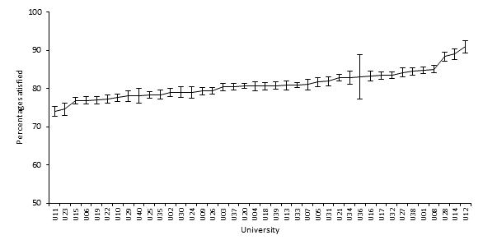

Figure 1. Percentage satisfied results on the quality of entire educational experience

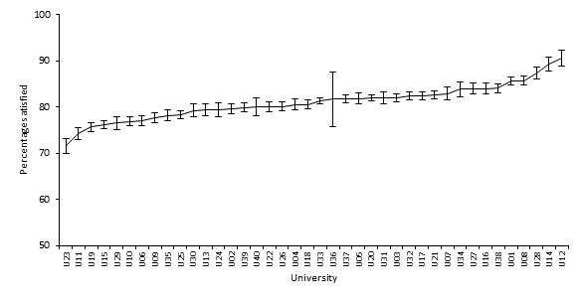

Figure 2. Percentage satisfied results on the quality of teaching

When institutional percentage satisfied results are ordered for the two selected items, there is a fairly even increase from the bottom of the distribution to near the top, with a few institutions at the top of the distribution notably higher than the majority of institutions. Looking at Figure 1, which reports percentage satisfied results on the quality of the entire educational experience item, the majority of institutions in the lower third of the distribution are significantly different to those in the higher third of the distribution, when confidence intervals are considered. While there does not appear to be many significant differences between institutions in the middle of the distribution, there are institutions at both ends of the distribution that are significantly different to those in the middle.

A similar picture emerges from Figure 2. Indeed, there is a strong correlation in the ranking of institutions in both figures and the slopes of the lines are similar; however, given that the items on which these two figures are based constitute part of the teaching quality focus area, this is not an unexpected result.

## 4.5 International comparisons

A consideration when developing the UES was to ensure the ability to use the data for benchmarking against similar student satisfaction surveys conducted in other national contexts. The “overall satisfaction” question on the National Survey of Student Engagement (NSSE), for example, is highly similar to the quality of the entire educational experience item on the UES.[16] NSSE collects information on student participation in programs and activities that institutions provide for their personal development. It is administered widely in the USA and Canada, with 473,633 students from 716 colleges and universities completing the 2014 NSSE.[17]

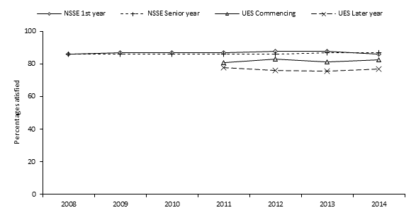

Figure 3. Entire educational experience rated positively, UES and NSSE, 2008 to 2014

Figure 3 presents the percentage of surveyed students who rated their entire educational experience positively. Data from the 2011 UES should be treated with caution, as this was a pilot administration in which only 24 universities participated. The caveats noted in Section 4.2 concerning changes to the UES collection methodology should also be considered in relation to this figure. It is also critical to note that, while the 2012, 2013 and 2014 UES collections included every Australian university, NSSE is only administered to a subset of universities and colleges in the USA and Canada, which number more than 2,700 in total. If the institutions that participate in NSSE differ from those that do not, the results will not necessarily reflect an unbiased estimate of student satisfaction at the overall sector level. If, for example, the NSSE is administered to students of “better” institutions, the results will be biased upward. Therefore, as more years of UES data are gathered using a consistent data collection methodology, comparing movements over time within sectors (Australia and USA/Canada) could be more valid than comparing the two sectors directly.

Bearing these caveats in mind, Figure 3 shows that respondents to the NSSE are more likely to be satisfied with their educational experience than respondents to the UES, especially amongst later-year students. It is also interesting to note that the percentage satisfied results of NSSE first- and senior-year students are much closer together than those of commencing and later-year students from the UES. The reason for this is not clear, but could relate to non-random participation in NSSE, in terms of both students and institutions, fundamental differences between the Australian and North American higher education sectors, or other methodological differences between the two surveys.

In 2014, four CEQ scales were administered to a small sample of UES respondents to facilitate benchmarking with the UK National Student Survey (NSS), which contains several questions with similar wording. Most notably, both the CEQ and NSS have an overall satisfaction item with near-identical wording,[18] measured on a five-point Likert-type response scale. The NSS, administered mostly to final year undergraduates, is run across all publicly funded higher education institutions in England, Wales, Northern Ireland and Scotland,[19] reducing the potential for non-random selection inherent in the NSSE.

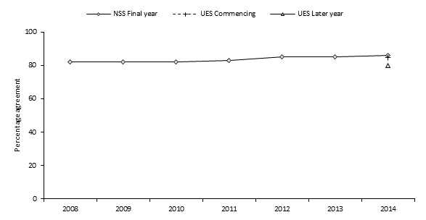

Figure 4. Overall satisfaction with course quality, UES CEQ and NSS, 2008 to 2014

Figure 4 presents the percentage of NSS and UES CEQ respondents who were satisfied with the quality of their course. Comparing final/later-year students, it can be seen that UK students are more likely to express satisfaction with the quality of their course, with around six percentage points separating the two groups. Given the large number of responses to both surveys,[20] this difference is likely to be statistically significant; however it does not account for potential differences in the composition of the respective undergraduate student populations, nor methodological differences between the two surveys. It is interesting, however, that both surveys show Australian-enrolled students to be less likely to be satisfied with their higher education experience than their overseas counterparts. Also of interest in this figure is the extent to which the NSS overall satisfaction results are consistent over time.

## 4.6 Early departure

In addition to the items asking students to rate their level of satisfaction with different aspects of their educational experience, students were also asked to indicate whether they had seriously considered leaving their university during 2014. The results of this question are presented by student subgroup in Table 16. Overall, 17 per cent of respondents indicated that they had considered leaving, the same proportion as in 2013.

Table 16. Percentage of students considering early departure by subgroup

| **Group** | **Subgroup** | **Per cent considering departure** | **Group** | **Subgroup** | **Per cent considering departure** |
| --- | --- | --- | --- | --- | --- |
| Stage of studies | Commencing | 18 | Disability | Disability reported | 24 |
| Later year | 15 | No disability reported | 16 |
| Gender | Male | 16 | Study mode | Internal | 17 |
| Female | 17 | External/multi-modal | 18 |
| Age group | Under 25 | 16 | International | Domestic student | 17 |
| 25 to 29 | 19 | International student | 14 |
| 30 to 39 | 21 | First in family | First in family | 19 |
| 40 and over | 21 | Not first in family | 16 |
| Indigenous | ATSI | 27 | Previous university experience | Current university | 19 |
| Not ATSI | 17 | Another university | 17 |
| Home language | English | 18 | New to higher education | 18 |
| Other | 14 | **Total** | | **17** |

As might be expected, commencing students were more likely than later-year students to consider leaving their university; however the difference between these two groups was only three percentage points. This unusually small difference may be due to the fact that many commencing students who considered leaving university had already done so by the time the UES was conducted in August, well into Semester 2, and would not appear in the data.

Young students aged under 25 were less likely than their older classmates to have considered leaving their university. Aboriginal and Torres Strait Islander students were notably more likely to consider early departure than non-Indigenous students. This is interesting in light of the fact that Indigenous students were more likely to be satisfied with the support provided by their university (see Table 12). It could be that the support provided by their institution allowed them to remain enrolled in their courses, since the students who completed the UES were those who did not ultimately leave their university, at least at the time the UES was administered.

Students who spoke English as their main language at home were more likely to consider leaving their university than those who spoke a language other than English at home. A similar pattern is observed in relation to domestic and international students.

Students who reported having a disability were more likely to have considered leaving their university than students who did not report having a disability. As was the case with Aboriginal and Torres Strait Islander students, students with a disability were more likely to express satisfaction with the level of support provided by their university (see Table 12). Students who were the first in their family to attend university were more likely than their peers to have considered leaving their university. This result is logical, considering that these students would generally know less about what to expect at university than those with a family history of higher education. No substantial differences in departure intentions were observed in relation to study mode, gender or previous university experience.

The percentage of students considering leaving their university in 2013 is plotted against (self-reported) average grades in Figure 5. The expected relationship is observed, with students achieving lower grades much more likely to consider early departure than students achieving high grades. This is most apparent for students achieving a grade of less than 50 per cent, of whom more than 40 per cent considered early departure in 2014.

Figure 5. Percentage of students considering early departure by average grades to date



Figure 5. Percentage of students considering early departure by average grades to date

Students who expressed a serious consideration of leaving their university in 2014 were then asked to indicate, from a list of 30 possible reasons, why they considered doing so. These are summarised in Table 17, along with equivalent results from the 2013 UES. Students could select as many reasons as applied, so the percentages do not total 100. It is evident from the table that some of the most common reasons relate to situational factors, such as health or stress (31 per cent), difficulties relating to finances and workload, and study/life balance (each with 28 per cent), unspecified personal reasons (24 per cent) and the need to do paid work (23 per cent). The fact that these reasons were indicated by such a large percentage of students underscores the importance of student support in terms of allowing students to continue with their studies.

Table 17. Selected reasons for considering early departure, 2013 and 2014

| **Departure reason** | **Per cent of those considering departure** | | **Departure reason** | **Per cent of those considering departure** | |
| --- | --- | --- | --- | --- | --- |
| **2013** | **2014** | **2013** | **2014** |
| Health or stress | 31 | 31 | Other | 13 | 15 |
| Financial difficulties | 29 | 28 | Gap year / deferral | 12 | 11 |
| Workload difficulties | 28 | 28 | Commuting difficulties | 11 | 11 |
| Study / life balance | 29 | 28 | Academic exchange | 10 | 10 |
| Expectations not met | 24 | 25 | Fee difficulties | 9 | 9 |
| Personal reasons | 24 | 24 | Other opportunities | 9 | 9 |
| Need to do paid work | 24 | 23 | Social reasons | 8 | 8 |
| Boredom/lack of interest | 21 | 22 | Travel or tourism | 7 | 7 |
| Career prospects | 20 | 21 | Institution reputation | 7 | 7 |
| Change of direction | 20 | 20 | Administrative support | 7 | 6 |
| Need a break | 20 | 19 | Moving residence | 5 | 5 |
| Family responsibilities | 18 | 18 | Standards too high | 6 | 5 |
| Quality concerns | 15 | 15 | Graduating | 5 | 5 |
| Academic support | 15 | 15 | Government assistance | 4 | 3 |
| Paid work responsibilities | 15 | 15 | Received other offer | 3 | 3 |

Encouragingly for institutions, the most common (arguably) institutional factor indicated by students was that their expectations had not been met (25 per cent). Other institutional factors were indicated much less frequently (e.g. academic support, administrative support, institutional reputation). Several dispositional factors were also relatively common, including boredom or lack of interest (22 per cent), career prospects (21 per cent), a change in direction (20 per cent) and a need to take a break (19 per cent). These results are broadly consistent with the 2013 UES.

## 4.7 Results for non-university higher education students

As discussed in Section 1.2.1, the 2014 UES project included a pilot of the UES questionnaire and methodology on students of 15 NUHEIs under the name “Student Experience Survey”. Because the 2014 SES was a pilot project involving a small convenience sample of NUHEIs, only high-level aggregate results are presented for this cohort. These results are presented in Table 18, along with benchmark results for university students.

Table 18. Summary results for non-university higher education institutions and universities

|  | **Focus areas** | | | | | **Questionnaire items** | |
| --- | --- | --- | --- | --- | --- | --- | --- |
| **Skills Development** | **Learner Engagement** | **Teaching Quality** | **Student Support** | **Learning Resources** | **Quality of entire educational experience** | **Quality of teaching** |
| NUHEIs | 88 | 71 | 89 | 82 | 80 | 85 | 86 |
| Universities | 81 | 61 | 82 | 73 | 86 | 81 | 81 |

When comparing results for NUHEI and university students there are several important caveats to consider. First, only 15 of the approximately 130 NUHEIs currently operating in Australia were participants in SES pilot and these were not selected in a random fashion. Hence, they may not be representative of the non-university higher education sector as a whole. Second, the NUHEIs in the sample tend to teach a narrower range of subject areas than the universities (23 compared with 45, respectively). Finally, the demographic characteristics of the two samples differ in several important respects. In particular, NUHEI students are more likely than their peers from universities to be international students, speak a language other than English at home and be the first in their family to enrol in higher education. Differences in results between NUHEI and university students may be attributable, at least in part, to these factors.

As shown in Table 18, NUHEI students tended to be more likely than university students to indicate satisfaction with their higher education experience. Only in relation to the learning resources focus area did a larger proportion of university students than NUHEI students indicate satisfaction. The largest differences between NUHEIs and universities across the five focus areas were observed in relation to learner engagement and student support, with 10 percentage points separating the two student cohorts. The smallest differences across focus areas were observed in relation to skills development (6 percentage points favouring NUHEIs) and learning resources (6 percentage points favouring universities). Four percentage points and six percentage points separated NUHEI and university students regarding satisfaction with the quality of their entire educational experience and the quality of teaching, respectively.



**APPENDICES**

# Appendix A: University Experience Questionnaire (UEQ)

Table 19. Skill Development items

| **Stem** | **Item** | **Response scale** |
| --- | --- | --- |
| To what extent has your course developed your: | critical thinking skills? | Not at all / Very little / Some / Quite a bit / Very much |
| ability to solve complex problems? |
| ability to work with others? |
| confidence to learn independently? |
| written communication skills? |
| spoken communication skills? |
| knowledge of the field(s) you are studying? |
| development of work-related knowledge and skills? |

Table 20. Learner Engagement items

| **Stem** | **Item** | **Response scale** |
| --- | --- | --- |
| At university during 2014, to what extent have you: | felt prepared for your study? | Not at all / Very little / Some / Quite a bit / Very much / Not applicable |
| had a sense of belonging to your university? |
| In 2014, how frequently have you: | participated in discussions online or face-to-face? | Never / Sometimes / Often / Very often |
| worked with other students as part of your study? |
| interacted with students outside study requirements? |
| interacted with students who are very different from you? |
| At university during 2014, to what extent have you: | been given opportunities to interact with local students? | Not at all / Very little / Some / Quite a bit / Very much / Not applicable |

Table 21. Teaching Quality items

| **Stem** | **Item** | **Response scale** |
| --- | --- | --- |
| Thinking about your university course: | overall how would you rate the quality of your entire educational experience this year? | Poor / Fair / Good / Excellent |
| how would you rate the quality of the teaching you have experienced? |
| During 2014, to what extent have the lecturers, tutors and demonstrators: | engaged you actively in learning? | Not at all / Very little / Some / Quite a bit / Very much |
| demonstrated concern for student learning? |
| provided clear explanations on coursework and assessment? |
| stimulated you intellectually? |
| commented on your work in ways that help you learn? |
| seemed helpful and approachable? |
| set assessment tasks that challenge you to learn? |
| In 2014, to what extent has your university course been delivered in a way that is: | well structured and focused? | Not at all / Very little / Some / Quite a bit / Very much |
| relevant to your education as a whole? |

Table 22. Student Support items

| **Stem** | **Item** | **Response scale** |
| --- | --- | --- |
| At university during 2014, to what extent have you: | received support from your university to settle into study? | Not at all / Very little / Some / Quite a bit / Very much / Not applicable |
| experienced efficient enrolment and admissions processes? |
| felt induction/orientation activities were relevant and helpful? |
| During 2014, to what extent have you found administrative staff or systems (e.g. online administrative services, frontline staff, enrolment systems) to be: | available? | Had no Contact / Not at all / Very little / Some / Quite a bit / Very much / Not applicable |
| helpful? |
| During 2014, to what extent have you found careers advisors to be: | available? | Had no contact / Not at all / Very little / Some / Quite a bit / Very much / Not applicable |
| helpful? |
| During 2014, to what extent have you found academic or learning advisors to be: | available? | Had no contact / Not at all / Very little / Some / Quite a bit / Very much / Not applicable |
| helpful? |
| During 2014, to what extent have you found support services such as counsellors, financial/legal advisors and health services to be: | available? | Had no contact / Not at all / Very little / Some / Quite a bit / Very much / Not applicable |
| helpful? |
| been offered support relevant to your circumstances? | Not at all / Very little / Some / Quite a bit / Very much / Not applicable |
| received appropriate English language skill support? |

Table 23. Learning Resources items

| **Stem** | **Item** | **Response scale** |
| --- | --- | --- |
| Thinking of this year, overall how would you rate the following learning resources provided for your university course? | Teaching spaces (e.g. lecture theatres, tutorial rooms, laboratories) | Poor / Fair / Good / Excellent / Not applicable |
| Student spaces and common areas |
| Online learning materials |
| Computing/IT resources |
| Assigned books, notes and resources |
| Laboratory or studio equipment |
| Library resources and facilities |

Table 24. Open-response items

| **Stem** | **Item** | **Response scale** |
| --- | --- | --- |
| What have been the best aspects of your course? | What have been the best aspects of your course? | Open response |
| What aspects of your course most need improvement? | What aspects of your course most need improvement? |

# Appendix B: Analysis of the psychometric properties of the revised Student Support focus area

B.1 Introduction

As discussed in Section 1.2, a psychometric assessment of responses to the 2013 UES identified one item in the student support focus area that was answered unpredictably by respondents and whose inclusion in the calculation of scores was likely to degrade the quality of measurement.

This appendix summarises a re-assessment of the student support focus area in light of the omission of the problematic item from the 2014 UES. As in 2013, the Rasch measurement model was used to assess the following aspects:

* How well the items in the focus area seemed to work together to measure a common trait.
* Whether the rating scale categories were used by respondents in a consistent manner.
* Whether there was a distinctive hierarchy of items and persons along the measured variable.
* How well the items were matched to the sample of respondents.

## B.2 Analytical approach

The Rasch model provides many outputs that can be used to test how well questionnaire items contribute to an underlying trait (or dimension) and also how consistently respondents answer questions. As explained in Section B.7, the model estimates the probability that a person with a given attitude will choose a particular response to an item. Persons who possess high levels of the underlying trait will be more likely to *endorse* items. By contrast, persons with low levels of the underlying trait will be more likely to *disendorse* items. Some items are very easy for respondents to endorse (that is, the item difficulty is low) whereas other items are only endorsed by those respondents with high levels of the underlying trait (such items have a high difficulty).

Overall then, for a set of items that are effectively measuring the underlying dimension, we expect:

* Difficult items that are most likely to be endorsed by those with high levels of the underlying trait;
* Easy items that are most likely to be disendorsed by those with low levels of the trait; and
* A predictable progression in between.

The Rasch model provides a number of statistics summarising how well items and persons fit this expected progression in difficulty and attitude. Items or persons that deviate significantly from our expectation are evidence of items that measure different traits or persons that answer questions in unexpected ways. Both of these are undesirable and degrade the quality of derived measures.

The following diagnostic outputs were used in the assessment of quality.

### 

### B.2.1 Fit to the Rasch model

The Rasch model calculates several fit statistics for both items and persons. Several that are of particular use are explained in Table 25.

Table 25. Selected Rasch model outputs for item assessment

| **Statistic** | **Meaning** | **Ideal range** |
| --- | --- | --- |
| Infit mean square | This is the mean of the squared residuals, [21] giving relatively more weight to the performances of persons closer to the item value. | 0.6-1.4 for rating scale items with an expected value of 1. Low values indicate items whose responses can be easily predicted from other items. High values indicate unpredictable responses. |
| Outfit mean square | This is the mean of the squared residuals, across all items |
| Point-measure correlation | This is the correlation between the Rasch measures and the responses for an item. | Low values indicate poor fit and negative values suggest miscoding (where a scale is reversed relative to other items). |
| Item discrimination | This relates to how well an item discriminates between high and low scoring persons. | The expected value is 1. High values indicate better than expected by the model and low values indicate an item that discriminates less than expected. |
| Person separation index | This indicates how well the set of items is able to distinguish between the persons measured | Values below 2 imply that the instrument may not be sensitive enough to distinguish between high and low scoring persons. |
| Item separation index | This indicates how well the sample of persons enables the item locations to be determined | Values below 3 imply that the person sample is not large enough to confirm the hierarchy of item difficulty. |

### B.2.2 Ordered category thresholds

In analysing rating scale data, it is important to assess how well the categories are contributing to the creation of interpretable measures. This is determined by checking that the categories fit the model, namely that the difficulty of selecting item categories progresses in a hierarchical manner. Where too few respondents select a category or where there are too many categories, the difficulties of some item categories will be unpredictable. Disordering or instability among item categories can be detected by plotting the probability of responding to any particular category, given the difference between a person’s attitude and the item’s difficulty.

### B.2.3 Item and person targeting

Measurement tools need to be “fit for purpose” in the sense that they must be designed for the persons expected to be measured. For instance, in the field of educational testing, a teacher would not administer a test designed for 12 year-olds to those who are already 15. Although some of the less capable 15 year-olds may struggle with the more difficult questions, we would expect the test to be too easy for the group as a whole. If the Rasch model were used to analyse such data, we would expect to see person scores that are well above the item difficulties. When the items and the persons are not well matched, the instrument has limited use as a diagnostic tool.

Since the Rasch model calculates person and item estimates on the same scale, a side-by-side plot of person and item measures quickly shows how well matched the instrument is to the intended respondents.

### B.2.4 Unidimensionality

A requirement of the Rasch model is that measures must be unidimensional, so that constructing measures should proceed by one clearly theorized trait at a time. Indicators of misfit are typically used to reveal the extent to which any item or person performance suggests more than one underling latent trait is at work.[22] A further tool is the principal components analysis of Rasch model residuals, which can identify items with substantial variance that remains unexplained by the primary Rasch measure.

The following sections summarise these aspects of quality for the student support focus area, namely item fit, category thresholds, and targeting.

B.3 Fit to the Rasch model

The Rasch summary statistics are shown in Table 26. The most difficult item for respondents to endorse was *englang* (“To what extent have you received appropriate English language skill support?”) and the easiest was *effenrolm* (“To what extent have you experienced efficient enrolment and admissions processes?”). For these two items, the proportion of respondents indicating “Very much” was 17% and 37%, respectively.

Table 26. Item statistics for Student Support

| **Item** | **Measure** | **Mean square** | | **Point-**  **measure**  **correlation** | **Item**  **discrimination** | **Missing**  **values**  **(%)** | **Measure**  **(2013)** |
| --- | --- | --- | --- | --- | --- | --- | --- |
| **Infit** | **Outfit** |
| uniservices | - | - | - | - | - | - | 1.53 |
| englang | 0.91 | 1.78 | 1.76 | 0.62 | 0.26 | 64.24 | 1.28 |
| carhelp | 0.35 | 0.88 | 0.90 | 0.69 | 1.10 | 60.21 | 0.12 |
| offsup | 0.35 | 1.38 | 1.36 | 0.67 | 0.67 | 35.15 | 0.81 |
| caravail | 0.34 | 0.82 | 0.84 | 0.69 | 1.14 | 59.38 | 0.11 |
| supavail | 0.11 | 0.89 | 0.88 | 0.68 | 1.10 | 67.07 | -0.11 |
| suphelp | 0.06 | 0.95 | 0.93 | 0.67 | 1.06 | 68.02 | -0.15 |
| indorien | -0.16 | 1.11 | 1.18 | 0.59 | 0.80 | 10.82 | -0.23 |
| admhelp | -0.17 | 0.80 | 0.80 | 0.68 | 1.21 | 16.97 | -0.49 |
| supsettle | -0.20 | 0.93 | 0.98 | 0.65 | 1.02 | 0.22 | -0.19 |
| acdavail | -0.22 | 0.67 | 0.68 | 0.70 | 1.33 | 28.04 | -0.54 |
| admavail | -0.29 | 0.75 | 0.76 | 0.67 | 1.23 | 16.84 | -0.59 |
| acdhelp | -0.32 | 0.73 | 0.72 | 0.69 | 1.30 | 28.43 | -0.64 |
| effenrolm | -0.77 | 1.27 | 1.33 | 0.54 | 0.70 | 0.20 | -0.91 |

The high mean square and low discrimination values for *englang* suggest that it was answered in a very unpredictable way by UES 2014 respondents—whether or not they received English language support seemed to be unrelated to their rating of other items in this focus area. In 2013, *englang* was the next worst fitting item after the now-omitted *uniservices*.[23] Including it in the calculation of student support scores risks lowering the quality of measurement for this focus area. Since *englang* was answered by only a minority of students, the omission of the misfitting (but widely answered) *uniservices* would likely have a larger net effect on the quality of focus area scores.

The item measures for 2013 are shown as the right-most column in Table 26, including that for *uniservices*. The Rasch model centres item difficulties on zero by default during the estimation procedure, so some variation from 2013 to 2014 in item positions should be expected. Given the size of the cohort, though, large changes in the relative position of items should not occur. For the student support focus area, item locations have changed the most for *offsup* and *englang*. Overall, items now measure a narrower range of the underlying trait compared to 2013.

The high degree of item-level “missingness” suggests that only selected aspects of student support were relevant to respondents. Only two items—*supsettle* (“To what extent have you received support from your university to settle into study?”) and *effenrolm*—seemed to apply to the group as a whole. Three additional items—*indorien* (“To what extent have you felt induction/orientation activities were relevant and helpful”), *admavail* (“To what extent have you found administrative staff or systems to be available”) and *admhelp* (“To what extent have you found administrative staff or systems to be helpful”)—appeared to be relevant to a large majority of respondents.

Table 27 shows the number of student support items answered by respondents. Fewer than 13% of respondents answered all items and 51% of respondents skipped five or more items.

Although the Rasch model makes use of all available data, estimates for datasets with a significant extent of missing responses will be associated with higher standard errors.[24] To improve measurement precision for this focus area, then, it would be best to re-visit its theoretical basis and develop items that are of relevance to a much greater proportion of respondents.

Table 27. Number of Student Support items answered by UES respondentsa

| **Items answered** | **Percentage of**  **respondents** | **Cumulative**  **percentage**  **of respondents** |
| --- | --- | --- |
| 1 | < 0.01 | < 0.01 |
| 2 | 0.81 | 0.82 |
| 3 | 4.14 | 4.96 |
| 4 | 3.25 | 8.21 |
| 5 | 9.70 | 17.91 |
| 6 | 7.11 | 25.02 |
| 7 | 15.84 | 40.86 |
| 8 | 10.44 | 51.30 |
| 9 | 13.69 | 64.98 |
| 10 | 7.69 | 72.67 |
| 11 | 8.99 | 81.67 |
| 12 | 5.51 | 87.17 |
| 13 | 12.83 | 100.00 |

a This table only includes records with at least one completed item for this focus area.

The person and item separation indices are presented in Table 28, along with Cronbach's alpha, for both 2013 and 2014. The indices show how precisely the instrument enables persons and items to be located on the measurement scale. For both years, the large number of respondents ensures that item locations are well established. The discrimination among persons is only marginally adequate, however, and somewhat worse in 2014. The degree of missingness among items will be a major contributor to reduced person separation.

Table 28. Person and item separation indices for Student Support

| **Summary statistic** | **2014** | **2013** |
| --- | --- | --- |
| Person separation index (> 2) | 2.07 | 2.2 |
| Item separation index (> 3) | 78.58 | 140.3 |
| Cronbach's alpha | 0.92 | 0.91 |

B.4 Ordered category thresholds

Figure 6 shows the probabilities of respondents selecting the various response categories for the student support items, all of which use a common five-category response scale (see Appendix A). Respondents whose position is low on the latent trait (on the left end of the x-axis) are most likely to select “Not at all” to these items. By contrast, respondents with high levels of the trait (on the right end of the x-axis) are most likely to select “Very much”. Respondents in the middle will select one of “Very little”, “Some” or “Quite a bit”, depending on their precise location on the trait.

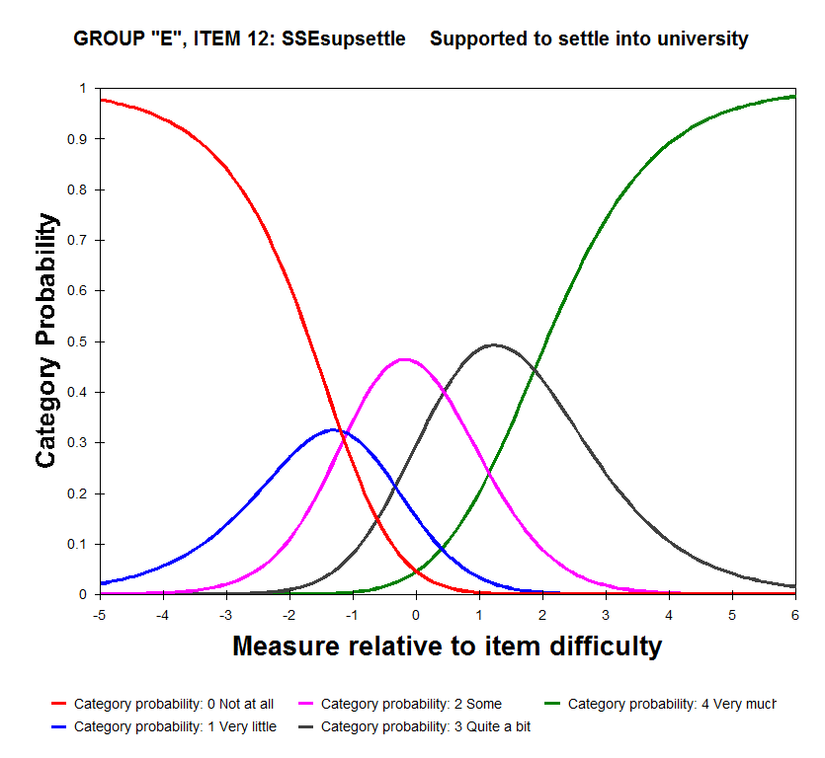

Figure 6. Category probabilities for Student Support

An important Rasch parameter is the “threshold” between two categories, shown in the figure where two probability curves intercept. For this scale, these thresholds are -1.20 logits (where the red “Not at all” curve intersects with the blue “Very little” curve), -1.10 logits (Very little/Some), 0.43 logits (Some/Quite a bit) and 1.87 logits (Quite a bit/Very much). The general guide for a five-category response scale is that thresholds should advance by at least 1.0 logits—gaps smaller than this indicate a category that represents too narrow a segment of the latent variable, or a concept that is not well understood by respondents.[25] The two lowest thresholds here advance by only 0.1 logits so combining “Not at all” and “Very little” into a single category may be merited.

B.5 Item and person targeting

The final aspect of quality to be assessed is how well matched the items were to the persons being measured. Since the item difficulties and person measures are on the same scale, a simple side-by-side plot of the two sets of parameters will verify the targeting (see Figure 7).

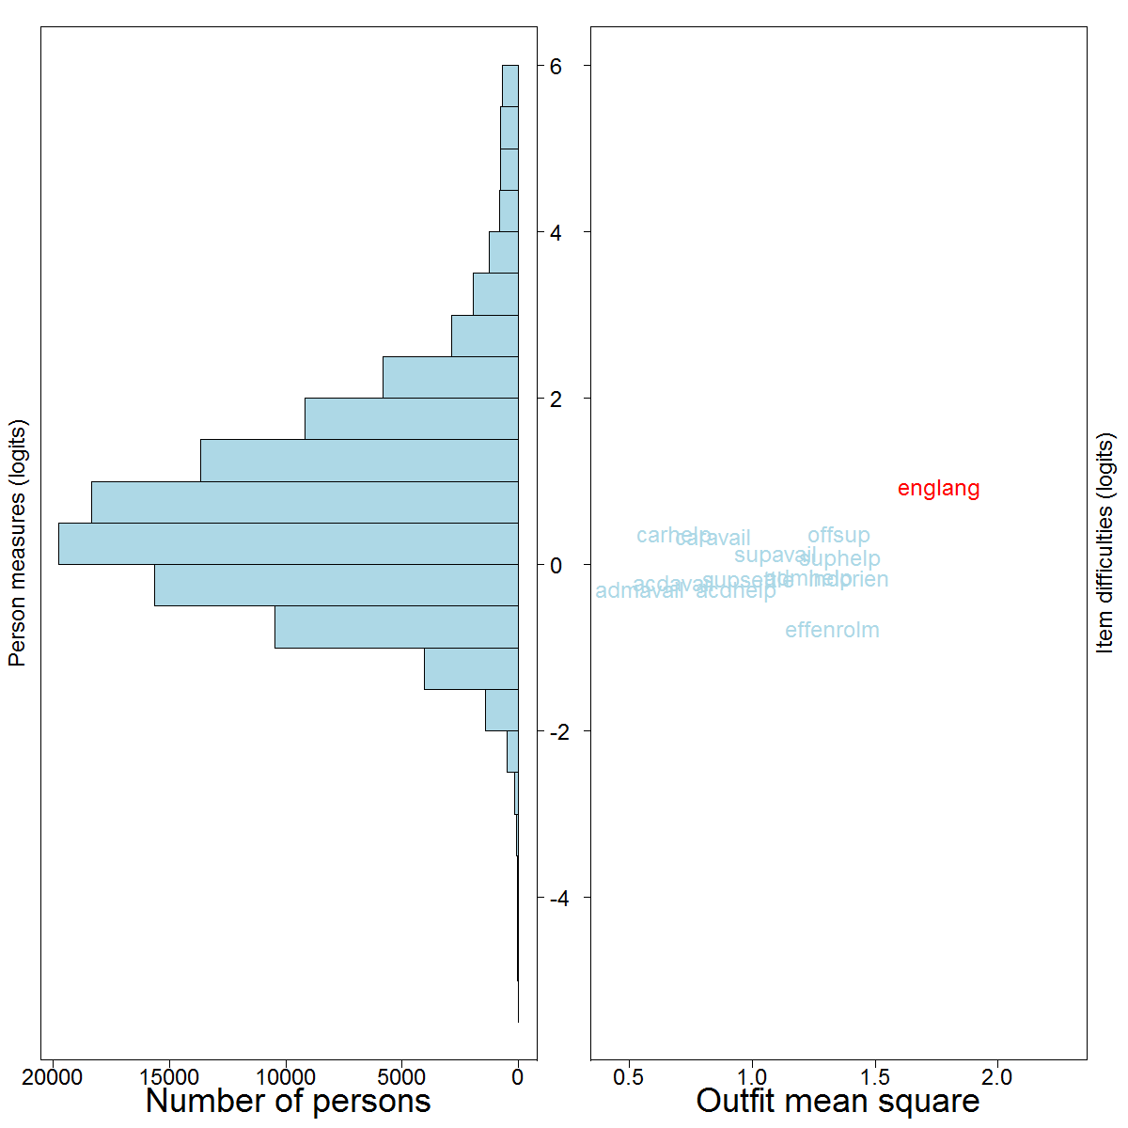

Figure 7. Person-item map for Student Support

This graph shows the distribution of person measures on the left and item difficulties on the right. The left side is organised so that persons with higher measures on student support are at the top and those with lower measures are at the bottom.[26] The items on the right side are arranged from the most difficult to endorse at the top to the easiest at the bottom, with the horizontal dimension representing item fit. The misfitting item (*englang*) is highlighted.

When items and persons are well matched, the two plots will show significant overlap, as they do here. Evident, however, is that the persons cover a greater range of the underlying trait than do the items—this means that respondents at the tails of the distribution (those who are low on the trait and those who are high) are measured with limited precision.[27] Measurement would be much improved for these respondents if there were additional items, some easier to endorse and some harder to endorse than the current items, that were a closer match to the respondents' locations on the trait.

A starting point would be to remove one or two items with low discrimination from the existing set and replace them with items that target the respondents with low precision. For instance, given that a number of respondents achieved the maximum score on this focus area,[28] it may be useful to develop items that are harder to endorse so these students can be separated.[29]

B.6 Summary

This appendix has presented a summary of results from a psychometric assessment of the student support focus area in the 2014 UES, following the omission of the *uniservices* item the instrument. The Rasch measurement model was used to calculate person scores and item difficulties and to determine how well items worked together to measure an underlying unidimensional attribute.

The key findings were as follows:

* There remained one misfitting item in the focus area (*englang*, “To what extent have you received appropriate English language skill support?”).
* Person separation declined slightly from 2013 and there was a lack of items targeted at students at the tails of the underlying trait, resulting in low measurement precision for these respondents.
* There was very little progression between the difficulties of the two lowest rating scale categories (“Not at all” and “Very little”) suggesting that respondents did not distinguish between the two.

Recommendations for future development of the student support focus area are as follows:

1. Based on its item fit statistics and on the large extent of missing data, the *englang* item should be omitted from the calculation of focus area scores and potentially from the instrument altogether.
2. The apparent lack of applicability of a number of items in the student support focus area requires an investigation into the theoretical foundation of its constituent items and potentially the development of replacement items that are more widely relevant to respondents.
3. The general lack of person separation and the low precision of estimates at the tails of the student distribution could also be remedied by the development of additional items.

B.7 About the Rasch model

Responses to the questionnaires were analysed using the Rasch measurement model. Rasch analysis is a method for obtaining objective, fundamental, linear measures from stochastic observations of ordered category responses.[30] It calculates measures that are directly comparable across different administrations of a questionnaire and seamlessly accommodates missing data. As already described, in the process of deriving measures the Rasch model provides a large range of diagnostics about the quality of the measures and of the items used in their construction. These diagnostics enable the direct assessment of how well the measure “holds together” and whether or not the individual items contribute usefully to the construction of scores.

In mathematical notation, the Rasch model may be represented by the following equation:

$$\log_{e}\left(\frac{π_{nik}}{1-π_{nik}}\right)=β_{n}-δ_{n}-τ_{k}$$

where $π_{nik}$ is the probability of person $n$ on item $i$ choosing category $k$; $β_{n}$ is the person attitude, $δ_{i}$ is the item difficulty, and $τ_{k}$ is the difficulty of threshold $k$. This equation is solved iteratively to yield estimates and standard errors for each of these parameters (one for each person, item and item threshold).

An attractive and intuitive feature of the Rasch model is that a person’s likelihood of endorsing a particular item depends only on the person’s attitude and the item difficulty.

Measures were calculated for each person who completed one or more of the items in each facet. The usual scale for Rasch measures is logits (log-odds), which has a theoretical range of $\left(-∞,+∞\right)$. The analysis reported here was conducted using the Winsteps software. Winsteps uses Joint Maximum Likelihood Estimation to solve the above equation.[31]

# Appendix C: Course Experience Questionnaire (CEQ)

Table 29. CEQ items administered in the 2014 UES

| **Scale** | **Itema** | **Response scale** |
| --- | --- | --- |
| Good Teaching Scale | The staff put a lot of time into commenting on my work. | Strongly disagree / Disagree / Neither agree nor disagree / Agree / Strongly agree |
| The teaching staff normally gave me helpful feedback on how I was going. |
| The teaching staff of this course motivated me to do my best work. |
| My lecturers were extremely good at explaining things. |
| The teaching staff worked hard to make their subjects interesting. |
| The staff made a real effort to understand difficulties I might be having with my work. |
| Generic Skills Scale | The course helped me develop my ability to work as a team member. |
| The course sharpened my analytic skills. |
| The course developed my problem-solving skills. |
| The course improved my skills in written communication. |
| As a result of my course, I feel confident about tackling unfamiliar problems. |
| My course helped me to develop the ability to plan my own work. |
| Overall Satisfaction Item | Overall, I was satisfied with the quality of this course. |
| Clear Goals and Standards | It was always easy to know the standard of work expected. |
| I usually had a clear idea of where I was going and what was expected of me in this course. |
| It was often hard to discover what was expected of me in this course. R |
| The staff made it clear right from the start what they expected from students. |

a R = Reverse coded for scoring purposes.

# Appendix D: Analysis of the UEQ as administered to students from non-university higher education institutions

## D.1 Introduction

As discussed in Section 1.2.1, the 2014 UES project included a pilot administration of the UES on students from non-university higher education institutions (NUHEIs) under the name of “Student Experience Survey” (SES). This appendix summarises a psychometric analysis of the UES items and focus areas as answered by NUHEI students as part of the SES pilot. The Rasch measurement model was used to assess the following aspects:

* How well the items in each focus area seemed to work together to measure a common trait.
* Whether the rating scale categories were used by respondents in a consistent manner.
* Whether there was a distinctive hierarchy of items and persons along the measured variable.
* How well the items were matched to the sample of respondents.
* Whether some groups of respondents seemed to be responding to items in very different ways from other respondents, with a focus on comparing NUHEI and university respondents.

These aspects will be explored for each focus area in turn. Recommendations for refining the existing items and scales will be made.

The next section summarises three aspects of quality for each of the focus areas, namely item fit, category thresholds, and targeting. See Section B.2 in Appendix B for an overview of the analytical approach, including an explanation of these diagnostic outputs used in the assessment of quality.

## D.2 Assessing item and focus area quality

### D.2.1 Learner Engagement

This section summarises results for the learner engagement focus area, which contains the following items and response scale types.[32]

| **Variable** | **Item text** | **Scale** |
| --- | --- | --- |
| feelprepared | Felt prepared for study | Extent |
| interactdiff | Interacted with different students | Frequency |
| interactoth | Student interaction outside study | Frequency |
| opploc | Opportunities to interact with local students | Extent |
| partidiscus | Online or face-to-face discussions | Frequency |
| sensebelong | Sense of belonging to university | Extent |
| workothers | Worked with other students | Frequency |

A summary of the item statistics for the learner engagement focus area is shown in Table 30. These are in order of item difficulty where *interactoth* (“How frequently have you interacted with students outside of study requirements?”) was endorsed by relatively few students whereas *feelprepared* (“To what extent have you felt prepared for your study?”) was endorsed by relatively many students.[33] There was no evidence of misfit for any of the items, with the various statistics remaining within acceptable bounds.

Also included in the table is the item difficulty for all university respondents (the last column, “Measure (UES)”). This enables differences in item difficulties for NUHEI and university students to be identified at a glance. More detailed checks for item differences are presented in Section D.3.

Table 30. NUHEI item statistics for Learner Engagement, with UES measures for comparison

| **Item** | **Measure** | **Mean square** | | **Point-measure**  **correlation** | **Item**  **discrimination** | **Measure (UES)** |
| --- | --- | --- | --- | --- | --- | --- |
| **Infit** | **Outfit** |
| interactoth | 0.62 | 1.01 | 1.00 | 0.68 | 1.04 | 0.64 |
| interactdiff | 0.22 | 0.90 | 0.92 | 0.63 | 1.11 | 0.31 |
| workothers | 0.09 | 0.80 | 0.78 | 0.69 | 1.28 | -0.08 |
| partidiscus | 0.06 | 0.95 | 0.94 | 0.64 | 1.07 | 0.14 |
| opploc | 0.02 | 1.16 | 1.17 | 0.64 | 0.83 | -0.32 |
| sensebelong | -0.36 | 0.95 | 0.96 | 0.64 | 1.04 | -0.10 |
| feelprepared | -0.66 | 1.17 | 1.28 | 0.49 | 0.71 | -0.60 |

Figure 8 shows the probabilities of NUHEI respondents selecting the various categories of the learner engagement items that use the “Extent” response scale (*opploc*, *sensebelong* and *feelprepared*). Respondents whose position is relatively low on the latent trait (on the left end of the x-axis) are most likely to select “Not at all” to these items. By contrast, respondents with high levels of the trait (on the right end of the x-axis) are most likely to select “Very much”. Respondents in the middle will most likely select one of “Very little”, “Some” or “Quite a bit”, depending on their precise location on the trait.

An important Rasch parameter is the “threshold” between two categories, shown in the figure where two probability curves intercept. For this particular scale, these thresholds are -1.54 logits (Not at all/Very little), -0.76 (Very little/Some), 0.50 (Some/Quite a bit) and 1.79 (Quite a bit/Very much). The general guide for a five-category response scale is that thresholds should advance by at least 1.0 logits.[34] This is not the case for the two lowest thresholds and so combining adjacent categories may be merited.

As an aside, the uneven spacing of thresholds evident in this figure is in contrast to the assumption made when calculating focus area scores, namely that rating scale categories are equally-spaced cardinal numbers that can be used in arithmetic calculations. A particular strength of the Rasch model is that it avoids this arbitrary assignment of numbers to categories, instead estimating the most likely location on the underlying trait for persons, items and categories. It is recommended that focus area scores be calculated through the Rasch model in future. The maximum likelihood estimation procedures of the Rasch model also accommodate missing response in a much more robust way and also enable the calculation of standard errors.

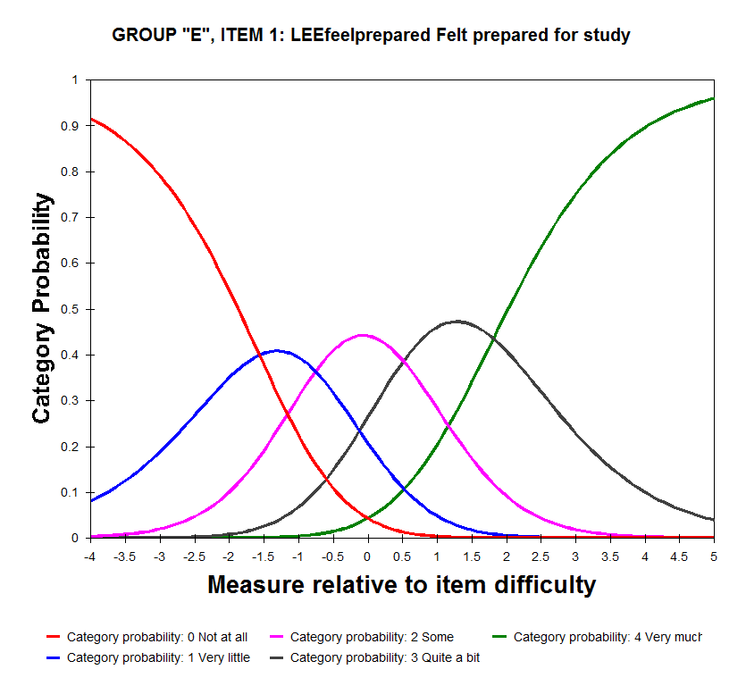

Figure 8. NUHEI category probabilities for “Extent” items, Learner Engagement

The corresponding graph for items using the “Frequency” scale (namely *interactoth*, *interactdiff*, *workothers* and *partidiscus*) is shown in Figure 9. For this scale, the thresholds are located at -1.73 logits (Never/Sometimes), 0.19 logits (Sometimes/Often) and 1.54 logits (Often/Very often). This progression meets the guidelines and so no collapsing of categories is indicated.

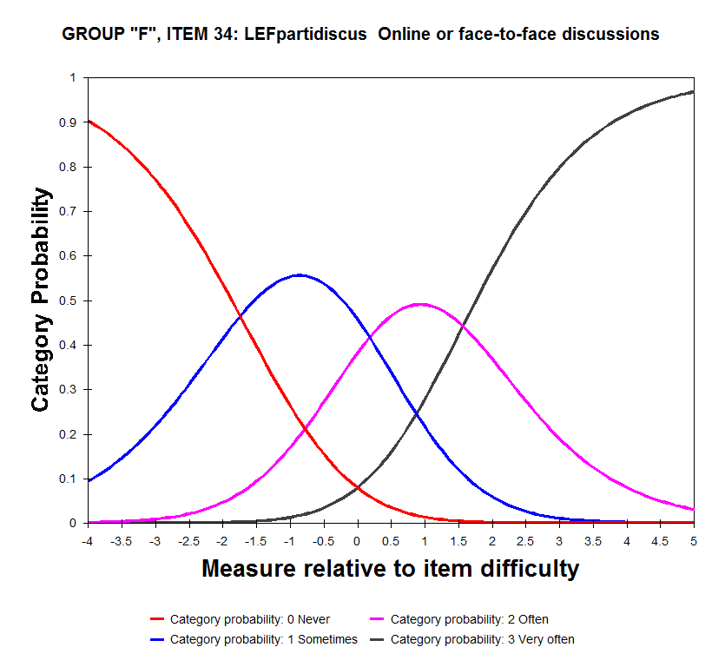

Figure 9. NUHEI category probabilities for “Frequency” items, Learner Engagement

The final aspect of quality to be assessed is how well matched the items were to the persons being measured. Since the item difficulties and person measures are on the same scale, a simple side-by-side plot—or Wright Map—of the two sets of parameters will verify the match (see Figure 10).

This graph shows the distribution of person measures on the left and the item difficulties on the right. The left side is organised so that persons with higher measures on the learner engagement focus area are at the top and those with lower measures are at the bottom. The items on the right side of the map are arranged from the most difficult to endorse at the top to the least difficult at the bottom.[35]

When items and persons are well matched, the two plots will show significant overlap, as they do here. Evident, however, is that the persons cover a greater range of the underlying trait than do the items—this means that the respondents at the tail of the distribution (those who are very low on the trait and those who are very high) are measured with limited precision.[36] Measurement would be improved for these respondents if there were additional items, some easier to endorse than the current items and some harder to endorse, that were a closer match to the respondents' locations on the trait.[37]

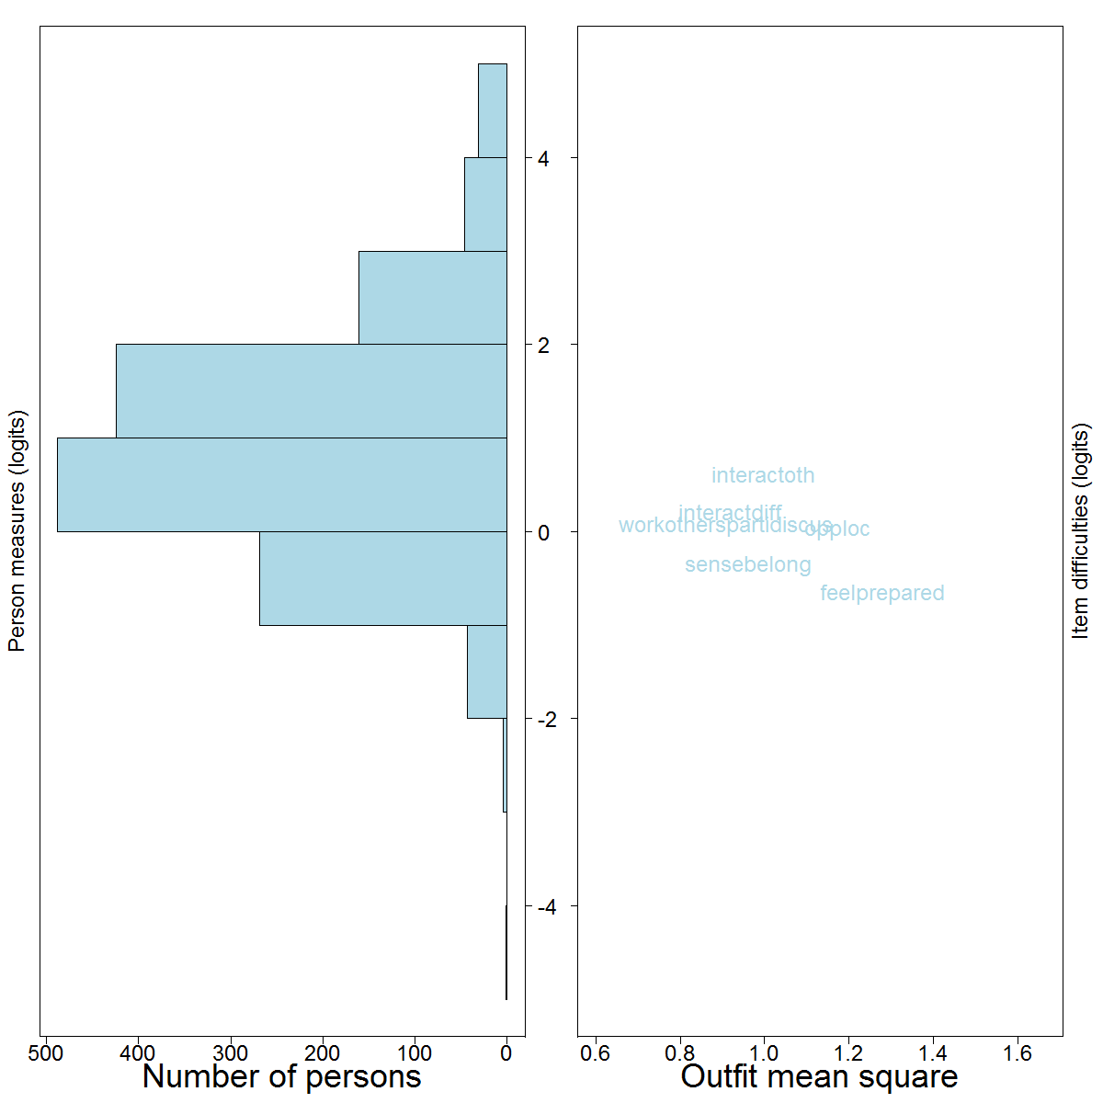

Figure 10. NUHEI person-item map for Learner Engagement

### D.2.2 Learning Resources

The learning resources focus area is measured by the following seven items.

| **Variable** | **Item text** | **Scale** |
| --- | --- | --- |
| qlcompit | Computing/IT resources - quality | Rating |
| qlequip | Laboratory or studio equipment - quality | Rating |
| qllibres | Library resources and facilities - quality | Rating |
| qlonlmat | Online learning materials - quality | Rating |
| qlstdspc | Student spaces - quality | Rating |
| qltchspc | Teaching spaces - quality | Rating |
| qltxtbook | Textbooks and learning resources - quality | Rating |

A summary of fit statistics for this focus area is shown in Table 31, in order of most difficult to endorse (*qlstdspc*, “Student spaces and common areas”) down to least difficult (*qltchspc*, “Teaching spaces”). No fit issues are evident for these items. Measures generally align well with those for the university respondents, apart from qltxtbook ("Assigned books, notes and resources") which was easier for non-university students to endorse than for university students.

Table 31. NUHEI item statistics for Learning Resources, with UES measures for comparison

| **Item** | **Measure** | **Mean square** | | **Point-measure**  **correlation** | **Item**  **discrimination** | **Measure (UES)** |
| --- | --- | --- | --- | --- | --- | --- |
| **Infit** | **Outfit** |
| qlstdspc | 0.47 | 1.07 | 1.07 | 0.73 | 0.92 | 0.41 |
| qlcompit | 0.34 | 0.96 | 0.96 | 0.74 | 1.04 | 0.15 |
| qlequip | 0.19 | 1.03 | 1.04 | 0.73 | 0.95 | -0.08 |
| qltxtbook | -0.11 | 0.94 | 0.96 | 0.71 | 1.06 | 0.40 |
| qlonlmat | -0.21 | 1.01 | 1.02 | 0.70 | 0.98 | -0.22 |
| qllibres | -0.31 | 1.07 | 1.04 | 0.71 | 0.95 | -0.51 |
| qltchspc | -0.36 | 0.89 | 0.89 | 0.72 | 1.11 | -0.15 |

The category probabilities for this scale are shown in Figure 11. The thresholds are located at -2.11 logits (Poor/Fair), -0.40 logits (Fair/Good), and 2.52 logits (Good/Excellent). The separation between these meets the guidelines so that no collapsing of categories is warranted.

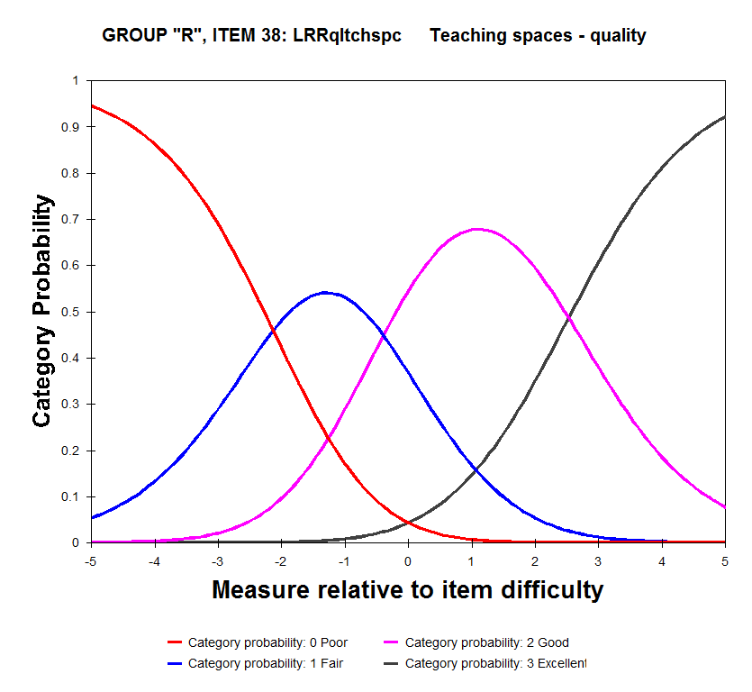

Figure 11. NUHEI category probabilities for Learning Resources

The person-item map for the learning resources focus area is shown in Figure 12. The issue of inadequate targeting is again evident, especially at the high end of the trait where a large group of students have achieved the maximum possible measure. If it was desired to estimate these respondents’ measures more accurately or to discriminate better between the most satisfied students, more items would be required that are harder for the group to endorse.

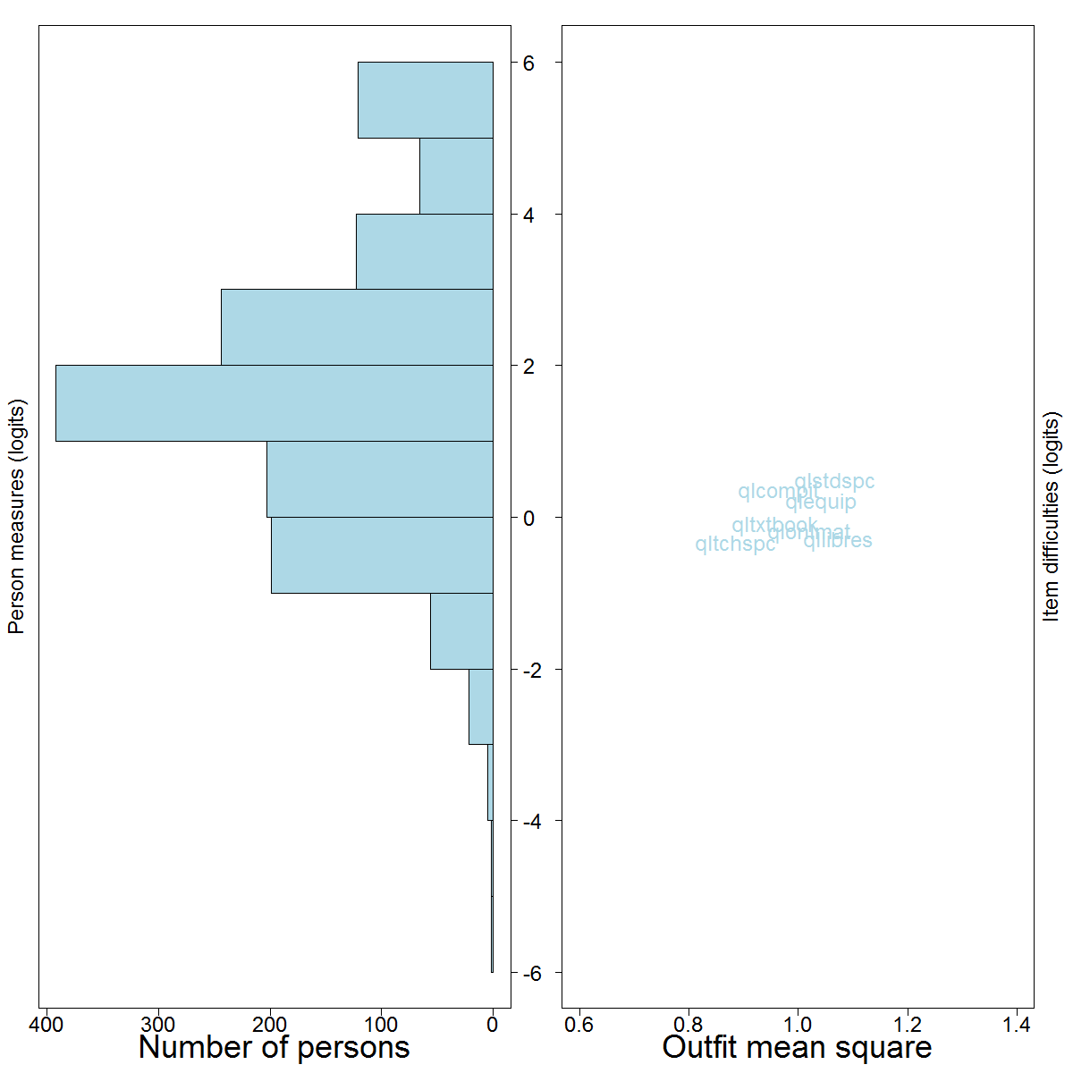

Figure 12. NUHEI person-item map for Learning Resources

### D.2.3 Skills Development

The skills development focus area is constituted by the following eight items.

| **Variable** | **Item text** | **Scale** |
| --- | --- | --- |
| expconfind | Independent learning developed by course | Extent |
| expknowl | Knowledge of study areas developed by course | Extent |
| expprbslv | Complex problem solving developed by course | Extent |
| expspeak | Spoken communication developed by course | Extent |
| expthink | Critical thinking skills developed by course | Extent |
| expwriting | Written communication developed by course | Extent |
| expwrkoth | Teamwork developed by course | Extent |
| expwrkskill | Work readiness developed by course | Extent |

The Rasch summary statistics are shown in Table 32. The most difficult item for respondents to endorse was *expprbslv* (“To what extent has your course developed your ability to solve complex problems?”) and the easiest was *expknowl* (“To what extent has your course developed your knowledge of the fields you are studying?”)—“Very much” was selected by fewer than a quarter of respondents for *expprbslv* but by almost half for *expknowl*.

Table 32. NUHEI item statistics for Skills Development, with UES measures for comparison

| **Item** | **Measure** | **Infit** | **Outfit** | **Point-measure**  **correlation** | **Item**  **discrimination** | **Measure (UES)** |
| --- | --- | --- | --- | --- | --- | --- |
| expprbslv | 0.63 | 0.78 | 0.79 | 0.81 | 1.22 | 0.29 |
| expwrkoth | 0.46 | 1.32 | 1.33 | 0.74 | 0.69 | 0.24 |
| expspeak | 0.45 | 1.12 | 1.12 | 0.76 | 0.88 | 0.68 |
| expwriting | 0.10 | 1.04 | 1.05 | 0.75 | 0.95 | 0.15 |
| expthink | -0.15 | 0.79 | 0.80 | 0.78 | 1.21 | -0.30 |
| expwrkskill | -0.21 | 0.95 | 0.94 | 0.76 | 1.06 | 0.16 |
| expconfind | -0.30 | 0.98 | 0.99 | 0.76 | 1.02 | -0.41 |
| expknowl | -0.99 | 0.94 | 1.01 | 0.71 | 1.04 | -0.83 |

The modelled probability curves are shown in Figure 13. For this graph, the thresholds are adequately spaced: -3.11 logits (Not at all/Very little), -1.47 logits (Very little/Some), 0.80 logits (Some/Quite a bit), and 3.78 logits (Quite a bit/Very much).

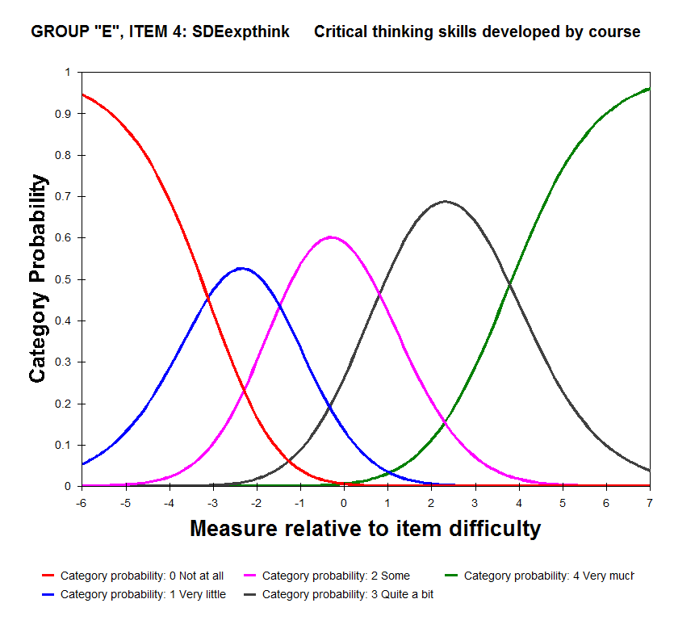

Figure 13. NUHEI category probabilities for Skills Development

The person-item map for NUHEI students on the Skills Development focus area is shown in Figure 14, where the need for additional items to distinguish between the top-scoring students is again apparent.

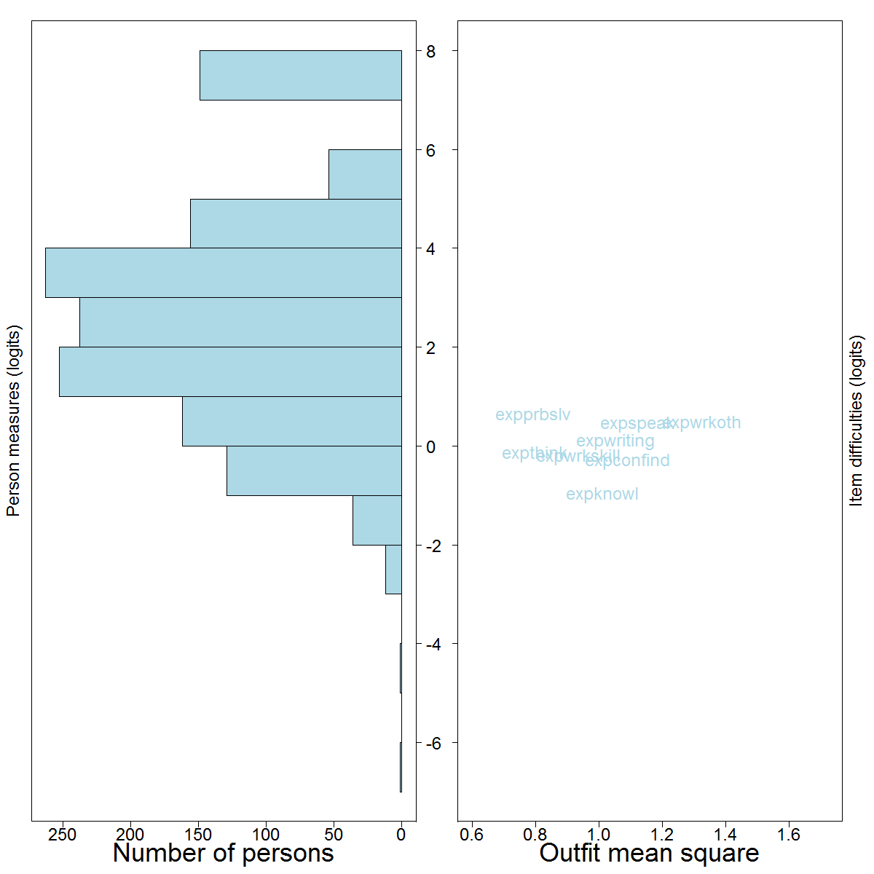

Figure 14. NUHEI person-item map for Skills Development

### D.2.4 Student Support

The student support focus area in 2014 consists of the following thirteen items.

| **Variable** | **Item text** | **Scale** |
| --- | --- | --- |
| acdavail | Academic or learning advisors available | Extent |
| acdhelp | Academic or learning advisors helpful | Extent |
| admavail | Admin staff/systems available | Extent |
| admhelp | Admin staff/systems helpful | Extent |
| caravail | Careers advisors available | Extent |
| carhelp | Careers advisors helpful | Extent |
| effenrolm | Efficient enrolment and admissions processes | Extent |
| englang | English language support received | Extent |
| indorien | Induction / orientation activities relevant / helpful | Extent |
| offsup | Have been offered relevant support | Extent |
| supavail | Other advisors available | Extent |
| suphelp | Other advisors helpful | Extent |
| supsettle | Supported to settle into university | Extent |

The Rasch summary statistics are shown in Table 33. The most difficult item for respondents to endorse was *caravail* (“To what extent have you found careers advisors to be available?”) and the easiest was *effenrolm* (“To what extent have you experienced efficient enrolment and admissions processes?”). The high mean square and low discrimination values for *englang* (“To what extent have you received appropriate English language support?”) suggest that it was answered in a very unpredictable way by NUHEI respondents. Including this item may degrade the quality of scores for this focus area, especially since fewer than half of all respondents provided a rating for the item. Despite the generally satisfactory Rasch statistics, the amalgamation into one focus area of items rating both the availability and helpfulness of services is problematic—calculating an aggregate score from such disparate, unevenly answered items has questionable validity and value.

Table 33. NUHEI item statistics for Student Support, with UES measures for comparison

| **Item** | **Measure** | **Mean square** | | **Point-measure**  **correlation** | **Item**  **discrimination** | **Measure (UES)** |
| --- | --- | --- | --- | --- | --- | --- |
| **Infit** | **Outift** |
| caravail | 0.64 | 0.90 | 0.94 | 0.70 | 1.04 | 0.34 |
| suphelp | 0.59 | 0.90 | 0.90 | 0.72 | 1.12 | 0.06 |
| supavail | 0.54 | 0.85 | 0.85 | 0.72 | 1.16 | 0.11 |
| carhelp | 0.51 | 1.01 | 1.01 | 0.68 | 0.96 | 0.35 |
| englang | 0.26 | 1.91 | 1.90 | 0.57 | 0.10 | 0.91 |
| offsup | -0.01 | 1.35 | 1.34 | 0.65 | 0.72 | 0.35 |
| admhelp | -0.14 | 0.87 | 0.84 | 0.69 | 1.16 | -0.17 |
| acdavail | -0.17 | 0.67 | 0.67 | 0.71 | 1.32 | -0.22 |
| admavail | -0.25 | 0.73 | 0.71 | 0.71 | 1.28 | -0.29 |
| acdhelp | -0.33 | 0.74 | 0.71 | 0.69 | 1.27 | -0.32 |
| indorien | -0.35 | 1.09 | 1.22 | 0.61 | 0.84 | -0.16 |
| supsettle | -0.59 | 0.91 | 0.99 | 0.64 | 1.07 | -0.20 |
| effenrolm | -0.72 | 1.32 | 1.34 | 0.56 | 0.70 | -0.77 |

The category probability curves are shown in Figure 15. The thresholds are located at -1.40 logits (Not at all/Very little), -0.96 logits (Very little/Some), 0.51 logits (Some/Quite a bit) and 1.85 logits (Quite a bit/Very much). Based on this spacing, it may be useful to collapse the “Very little” category into one of the adjacent categories.

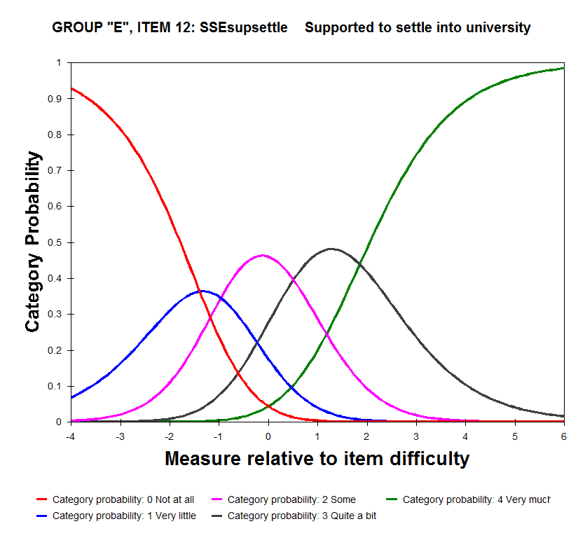

Figure 15. NUHEI category probabilities for Student Support

The person-item map for the student support focus area is shown in Figure 16. Note that the location of items has been adjusted slightly to minimise the extent of overlapping labels, so their relative positions may not exactly match the measures in Table 33. While the item difficulties cover a broader range than for other focus areas, a number of students are being measured only approximately by the present instrument. The misfitting item (*englang*) is highlighted.

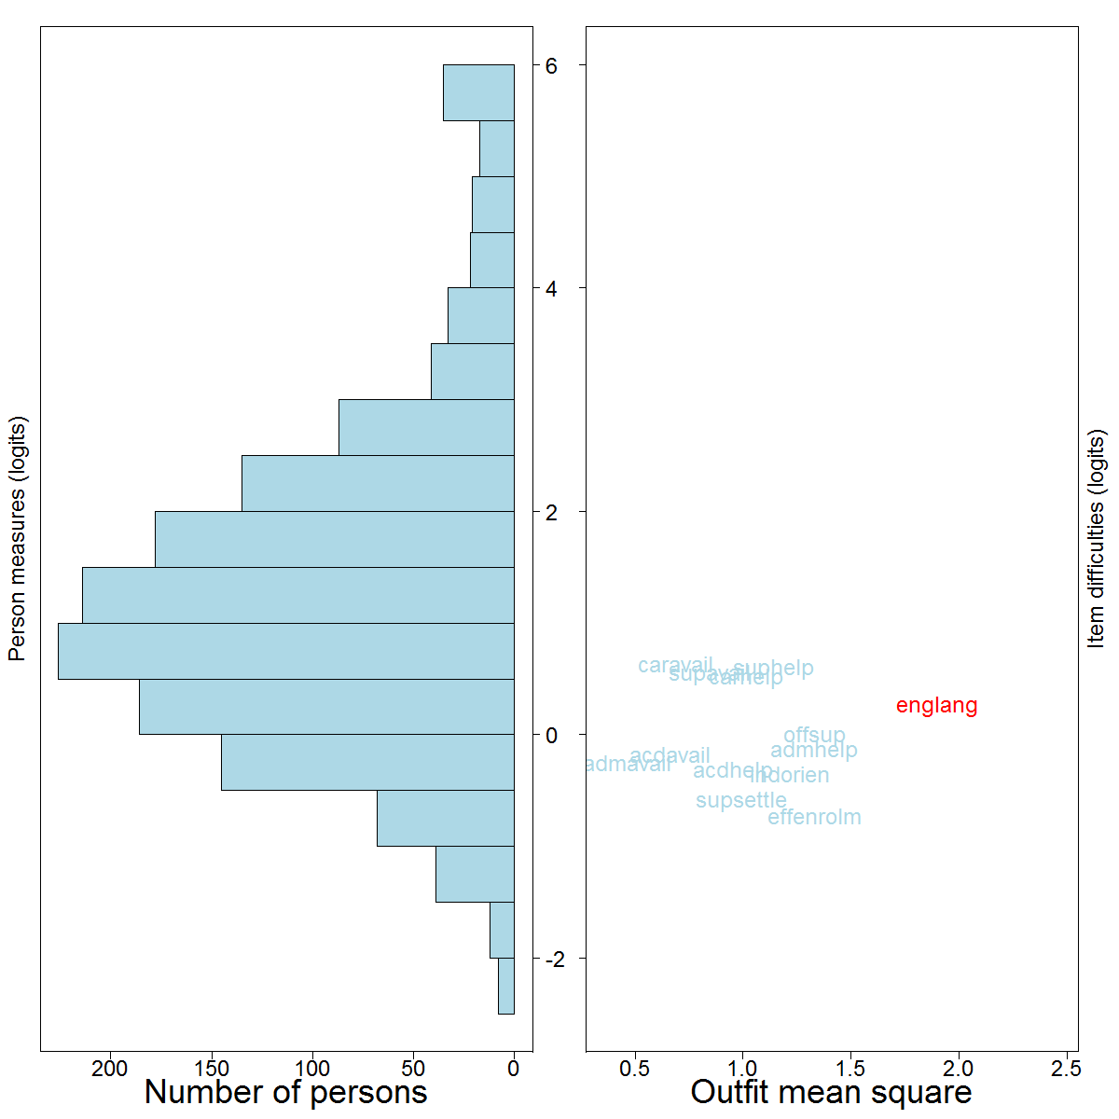

Figure 16. NUHEI person-item map for Student Support

### D.2.5 Teaching Quality

The final focus area, teaching quality, is measured by the following eleven items, based on a combination of the Extent and Rating response scales.

| **Variable** | **Item text** | **Scale** |
| --- | --- | --- |
| qlovledu | Quality of overall educational experience | Rating |
| qlteach | Quality of teaching | Rating |
| stdrelev | Course relevant to education overall | Extent |
| stdstruc | Course well structured | Extent |
| tchactiveng | Teaching staff actively engaged students | Extent |
| tchasschlng | Teaching staff set challenging assessments | Extent |
| tchclexpec | Teaching staff explained coursework and assessment | Extent |
| tchconlrn | Teaching staff concerned about student learning | Extent |
| tchfeedbck | Teaching staff provided constructive feedback | Extent |
| tchhelpapp | Teaching staff were helpful and approachable | Extent |
| tchstimint | Teaching staff provided intellectual stimulation | Extent |

The Rasch fit statistics for the focus area are summarised in Table 34. The most difficult item to endorse was *qlovledu* (“Overall, how would you rate the quality of your entire educational experience this year?”) and the easiest was *tchhelpapp* (“To what extent have the lecturers, tutors and demonstrators seemed helpful and approachable?”). While no items demonstrated signs of misfit, the inclusion of an overall rating item such as *qlovledu* among a mix of more specific items is potentially problematic. It is recommended that scores for this focus area be calculated without *qlovledu* in future.

Table 34. NUHEI item statistics for Teaching Quality, with UES measures for comparison

| **Item** | **Measure** | **Mean square** | | **Point-measure**  **correlation** | **Item**  **discrimination** | **Measure (UES)** |
| --- | --- | --- | --- | --- | --- | --- |
| **Infit** | **Outfit** |
| qlovledu | 0.44 | 1.03 | 1.11 | 0.72 | 0.95 | 0.30 |
| tchfeedbck | 0.38 | 1.17 | 1.18 | 0.74 | 0.81 | 0.85 |
| tchclexpec | 0.36 | 1.06 | 1.04 | 0.76 | 0.95 | 0.08 |
| stdstruc | 0.23 | 0.86 | 0.86 | 0.78 | 1.15 | -0.03 |
| qlteach | 0.20 | 0.89 | 0.89 | 0.75 | 1.11 | 0.20 |
| tchactiveng | 0.07 | 0.79 | 0.80 | 0.79 | 1.22 | 0.12 |
| tchconlrn | 0.06 | 1.13 | 1.11 | 0.75 | 0.88 | 0.31 |
| tchstimint | -0.08 | 0.87 | 0.86 | 0.78 | 1.14 | -0.22 |
| stdrelev | -0.46 | 1.05 | 1.09 | 0.72 | 0.94 | -0.46 |
| tchasschlng | -0.53 | 1.00 | 1.01 | 0.72 | 0.99 | -0.67 |
| tchhelpapp | -0.67 | 1.12 | 1.03 | 0.73 | 0.93 | -0.50 |

The category probability curves for the nine items on the “Extent” scale are shown in Figure 17. The thresholds are located at -3.25 logits (Not at all/Very little), -1.54 logits (Very little/Some), 0.99 logits (Some/Quite a bit) and 3.81 logits (Quite a bit/Very much). These thresholds are adequately spaced so that no categories need to be combined for this focus area.

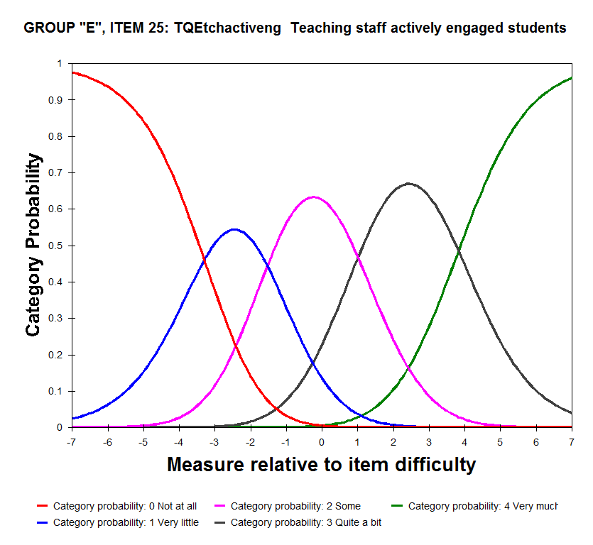

Figure 17. NUHEI category probabilities for “Extent” scale items, Teaching Quality

The category probabilities for the two items using the “Rating” scale are shown in Figure 18. The thresholds are located at -3.14 logits (Poor/Fair), -0.32 logits (Fair/Good) and 3.46 logits (Good/Excellent) and are adequately spaced.

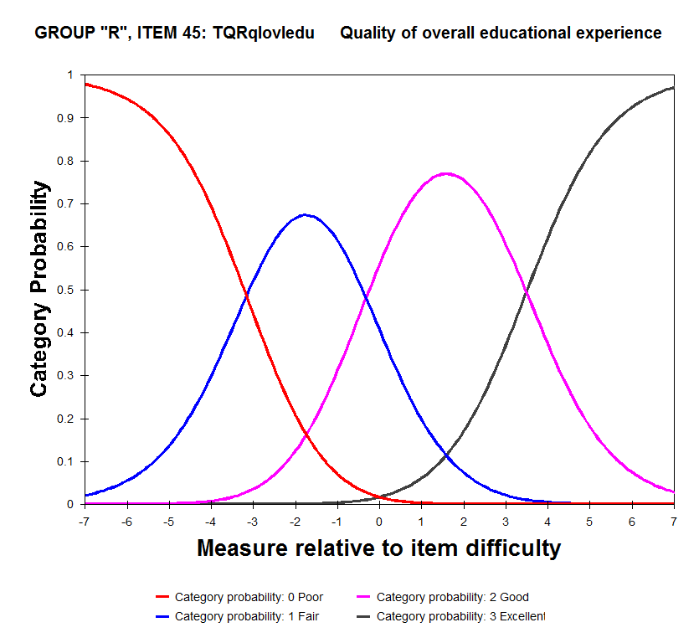

Figure 18. NUHEI category probabilities for Rating scale items, Teaching Quality

The person-item map in Figure 19 shows that items cover a very narrow range of the teaching quality trait compared to persons, suggesting that more items are needed to measure persons accurately for this focus area.

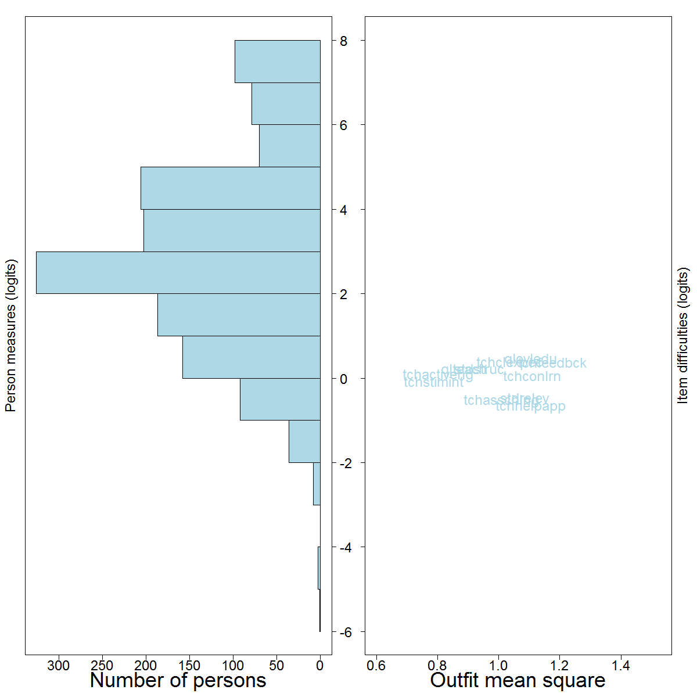

Figure 19. NUHEI person-item map for Teaching Quality

### D.2.6 Focus area summaries

To complement the individual item results given in the preceding sections, Table 35 presents a summary of fit statistics as they apply to each of the five focus areas as a whole. The statistics presented are as follows:

* Person separation, which indicates how well a set of items is able to distinguish between the persons measured.
* Item separation, which indicates how well a sample of persons is able to separate the items on an instrument.
* Cronbach's alpha, which is an index of repeatability of the order of persons as measured by the set of items.

The separation indices are Rasch outputs and should be no less than 2 for persons and no less than 3 for items.[38] Cronbach's alpha, included for completeness, is a widely-reported correlation deriving from classical test theory and for which higher values are taken to be indicative of better reliability and consistency for a set of items.

Table 35. Overall NUHEI summary statistics, by focus area

| **Focus area** | **Person**  **separation** | **Item**  **separation** | **Cronbach's**  **alpha[39]** |
| --- | --- | --- | --- |
| Learner Engagement | 1.79 | 10.39 | 0.78 |
| Learning Resources | 1.89 | 5.93 | 0.89 |
| Skills Development | 2.47 | 10.22 | 0.91 |
| Student Support | 2.15 | 10.83 | 0.94 |
| Teaching Quality | 2.76 | 7.40 | 0.95 |

The highlighted values in for learner engagement, learning resources and skills development indicate that the sets of items for these focus areas are not sensitive enough to distinguish between high (and low) scoring respondents. The other two focus areas do not have particularly strong person separation indices either, as was already evident from the person-item maps, so all five would benefit from the inclusion of more targeted items. A reasonable approach would be to omit the item with the lowest separation index for each focus area, and then to develop one or two new items that are targeted at the tails of the distribution.

The item separation indices are adequate and indicate that sufficient person responses were obtained to confirm the hierarchy of item difficulties with respect to the underlying trait.

## D.3 Differential item functioning

In the Rasch model, the probability of a respondent choosing a particular category for an item is related only to the difference between the person's and the item's positions on the underlying trait (see Section B.7 in Appendix B for details). It is not expected that systematic differences between an item's modelled and actual responses should occur for any particular subgroup of respondents.

Differential item functioning (DIF) investigates the items on an instrument, one at a time, for signs of interaction with respondent characteristics. The process calculates the item difficulty separately for each characteristic and identifies if one group of respondents scored higher than another group of respondents on an item, after adjusting for the overall scores of the respondents. The analysis cannot identify the reason for the discrepancies, but does flag items for closer scrutiny by item developers to ensure that including an item on a questionnaire does not “disadvantage” any particular group—that is, the items do not distort the measures of this group.

A DIF analysis was carried out on an extensive set of respondent characteristics. NUHEI respondents are compared with university respondents in Section D.3.1. DIF effects for subgroups of NUHEI respondents are investigated in Section D.3.2.

### D.3.1 NUHEI and UES

In comparing NUHEI and UES item difficulties, it was desirable to minimise the impact on DIF of the heterogeneous nature of the UES cohort—namely, that any observed DIF effects should more likely be due to a different capability or understanding of item by NUHEI students than to NUHEI students being different from UES students in their basic characteristics. To achieve this, a subset of UES students was selected that matched as closely as possible the characteristics of the NUHEI students. The DIF analysis was then performed on the NUHEI students and the matched UES students.

For each NUHEI respondent, the closest matching UES student was identified. Where there were multiple matching students, one match was selected at random. The method is referred to as nearest neighbour matching, implemented in the *Matchit* package in R.[40] This process resulted in 1,494 NUHEI students and 1,494 matched UES students.

A difference in item calibrations of more than 0.5 logits is typically taken as suggestive of substantive DIF effects. For the NUHEI and matched UES students, only one item (*englang*, “To what extent have you received appropriate English language skill support”) demonstrated a difference in item difficulty of this magnitude (see Table 36). The item with the next largest difference is included for comparison purposes (*suphelp*, “To what extent have you found support services such as counsellors, financial/legal advisors and health services to be helpful”).

A positive DIF measure implies that the item was unexpectedly difficult for NUHEI students to endorse compared to matched UES students. A negative DIF measure implies that the item was unexpectedly easy for NUHEI students to endorse compared to matched UES students.

In this table, *suphelp* was endorsed less often by NUHEI respondents, compared to matched UES respondents, whereas *englang* was endorsed more often. Given the extent of misfit for *englang*, as described in Section D.2.4, its large DIF measure may not be relevant. For *suphelp*, though, questionnaire developers may like to consider if there are reasons for this unexpected difference between the two groups. If not, the item may be a candidate for revision or omission.

Table 36. Notable DIF effects, NUHEI versus matched UES students

|  |  |
| --- | --- |
| **Item** | **DIF measure**  **(NUHEI—UES)** |
| **Student** **Support** |  |
| englang | -0.51 |
| suphelp | 0.43 |

### D.3.2 NUHEI subgroups

A DIF analysis was also undertaken for subgroups of NUHEI respondents with respect to their demographic and enrolment characteristics. Notable item differences are presented for learner engagement items in Table 37, learning resources items in Table 38, skills development items in Table 39, student support items in Table 40, and teaching quality items in Table 41.

For example, Table 37 shows learner engagement items with large DIF effects for the different respondent characteristics. Respondents in the 30 to 39 years and the 40 years and over age groups were less likely to endorse *interactoth* (“How frequently have you interacted with students outside study requirements”) than younger respondents. Similarly, respondents whose study location was external were less likely to endorse *workothers* (“How frequently have you worked with other students as part of your study”) than internal students. So while older students and external students found these items more difficult to endorse than other students, it might be expected that they have less need or less opportunity to interact or work with other students, in which case the DIF effects are not surprising. The same may be said for some of the subject areas identified in this table. Careful scrutiny by item developers is required to determine if any items merit refinement or omission in future.

Table 37. NUHEI characteristics, items and DIF measures for Learner Engagement

| **Characteristic** | **Subgroup** | **Item** | **DIF measure** |
| --- | --- | --- | --- |
| Age | 30 to 39 years | interactoth | 0.59 |
| 40 years and over | 0.82 |
| Campus | External | workothers | 0.49 |
| Subject area | Accounting | workothers | -0.56 |
| Architecture & Forestry | interactoth | -1.05 |
| opploc | 0.57 |
| Communication, Media & Journalism | partidiscus | -0.52 |
| Humanities inc History & Geography | workothers | 0.50 |
| Music & Performing Arts | feelprepared | 0.62 |
| workothers | -0.50 |
| Social Work | interactoth | 0.64 |
| Teacher Education – Primary & Secondary | feelprepared | 0.63 |
| interactoth | -0.62 |

Table 38. NUHEI characteristics, items and DIF measures Learning Resources

| **Characteristic** | **Subgroup** | **Item** | **DIF measure** |
| --- | --- | --- | --- |
| Course type | Associate degree | qltxtbook | 0.54 |
| Diploma | qlcompit | -0.53 |
| Gender | Female | qllibres | 0.51 |

**Table 38. (continued)**

| **Characteristic** | **Subgroup** | **Item** | **DIF measure** |
| --- | --- | --- | --- |
| Subject area | Accounting | qlstdspc | -0.85 |
| Architecture & Forestry | qlcompit | -1.26 |
| qlequip | 0.65 |
| qllibres | -0.61 |
| qlonlmat | 0.75 |
| Art & Design | qlcompit | -0.65 |
| qlequip | -1.04 |
| qlonlmat | 0.88 |
| Communication, Media & Journalism | qllibres | -1.04 |
| Humanities inc History & Geography | qlequip | 0.58 |
| Music & Performing Arts | qllibres | -1.40 |
| qltxtbook | 0.61 |
| Nursing | qlcompit | 0.89 |
| qlequip | -1.34 |
| qltchspc | -0.63 |
| Social Work | qlonlmat | -0.69 |
| qltxtbook | -0.86 |
| Teacher Education – Early Childhood | qllibres | 0.79 |
| Teacher Education – Other | qltxtbook | -0.62 |
| Teacher Education – Primary & Secondary | qllibres | -0.59 |

Table 39. NUHEI characteristics, items and DIF measures for Skills Development

| **Characteristic** | **Subgroup** | **Item** | **DIF measure** |
| --- | --- | --- | --- |
| Age | 30 to 39 years | expwrkoth | 0.62 |
| Attendance type | Part-time | expwrkoth | 0.78 |
| Campus | External | expspeak | 0.61 |
| expwrkoth | 0.64 |
| Disability | Reported disability | expknowl | -0.66 |
| expspeak | 0.62 |
| Language spoken at home | Language other than English | expknowl | 0.51 |
| Subject area | Accounting | expthink | 0.52 |
| Art & Design | expwriting | 0.71 |
| Business Management | expknowl | 0.58 |
| Computing & Information Systems | expknowl | 0.62 |
| Humanities inc History & Geography | expknowl | -0.57 |
| expspeak | 0.75 |
| expthink | -0.54 |
| expwriting | -0.81 |
| expwrkoth | 0.79 |
| Music & Performing Arts | expwriting | 0.80 |
| expwrkoth | -0.78 |
| Nursing | expwriting | 0.51 |
| Teacher Education – Early Childhood | expprbslv | 0.59 |
| expwrkskill | -0.55 |
| Teacher Education – Primary & Secondary | expspeak | -0.55 |
| expwrkoth | -0.53 |

Table 40. NUHEI characteristics, items and DIF measures for Student Support

| **Characteristic** | **Subgroup** | **Item** | **DIF measure** |
| --- | --- | --- | --- |
| Age | 40 years and over | effenrolm | -0.50 |
| englang | 0.79 |
| offsup | 0.55 |
| Disability | Reported disability | offsup | 0.50 |
| Subject area | Accounting | offsup | 0.60 |
| Communication, Media & Journalism | admavail | 0.53 |
| effenrolm | 0.54 |

**Table 40. (continued)**

| **Characteristic** | **Subgroup** | **Item** | **DIF measure** |
| --- | --- | --- | --- |
|  | Humanities inc History & Geography | englang | 0.55 |
| Music & Performing Arts | indorien | 0.60 |
| supsettle | 0.52 |
| Social Work | effenrolm | -0.55 |
| Teacher Education – Other | offsup | -0.67 |

Table 41. NUHEI characteristics, items and DIF measures for Teaching Quality

| **Characteristic** | **Subgroup** | **Item** | **DIF measure** |
| --- | --- | --- | --- |
| Disability | Reported disability | tchhelpapp | 0.56 |
| International | International student | qlovledu | 0.51 |
| qlteach | 0.60 |
| tchclexpec | -0.56 |
| Previous university experience | Previously enrolled in a different course at the current university | tchhelpapp | 0.51 |
| Subject area | Accounting | qlteach | 0.90 |
| tchactiveng | -0.59 |
| Architecture & Forestry | qlovledu | -0.56 |
| Art & Design | tchconlrn | 0.50 |
| Communication, Media & Journalism | qlteach | -0.55 |
| stdstruc | 0.80 |
| tchactiveng | -0.55 |
| tchfeedbck | -0.86 |
| Computing & Information Systems | qlovledu | 0.70 |
| qlteach | 0.73 |
| tchclexpec | -0.51 |
| tchfeedbck | -1.12 |
| tchstimint | 0.56 |
| Humanities inc History & Geography | tchstimint | -0.50 |
| Music & Performing Arts | tchclexpec | 0.62 |
| Teacher Education – Early Childhood | tchclexpec | 0.75 |
| Teacher Education – Other | tchclexpec | 0.64 |

## D.4 Missing responses

The final analysis undertaken here is the extent to which items were skipped or could not be answered by NUHEI students, compared to university students. The Rasch model naturally accommodates such missing responses, but measures derived from items that are missing many responses may be unstable and associated with larger standard errors.[41] Neither of these outcomes are desirable and the validity of including affected items needs to be considered carefully.

The percentage of missing responses for each item is presented in Table 42 for NUHEI and for UES respondents. In this context, a response was missing if it was anything other than a rating scale category (that is, if it was “Not asked”, “Not applicable”, “Do not know answer/Refused item”, “Item skipped”, and so on).

Table 42. Summary of missing responses, by NUHEI and UES students

| **Item** | **Missing responses (%)** | |
| --- | --- | --- |
| **NUHEI** | **UES** |
| **Learner Engagement** | | |
| feelprepared | 0.41 | 0.20 |
| interactdiff | 0.48 | 0.16 |
| interactoth | 0.20 | 0.15 |
| opploc | 4.02 | 3.67 |
| partidiscus | 0.41 | 0.15 |
| sensebelong | 0.07 | 0.12 |
| workothers | 0.34 | 0.14 |
| **Learning Resources** | | |
| qlcompit | 10.16 | 10.41 |
| qlequip | 33.40 | 31.10 |
| qllibres | 5.59 | 6.29 |
| qlonlmat | 4.98 | 3.56 |
| qlstdspc | 10.02 | 10.13 |
| qltchspc | 9.07 | 7.86 |
| qltxtbook | 4.70 | 4.35 |
| **Skills Development** | | |
| expconfind | 0.95 | 1.32 |
| expknowl | 0.95 | 1.31 |
| expprbslv | 1.16 | 1.31 |
| expspeak | 1.02 | 1.32 |
| expthink | 0.95 | 1.30 |
| expwriting | 0.95 | 1.31 |
| expwrkoth | 0.89 | 1.32 |
| expwrkskill | 1.09 | 1.36 |
| **Student Support** | | |
| acdavail | 12.47 | 28.04 |
| acdhelp | 12.82 | 28.43 |
| admavail | 4.50 | 16.84 |
| admhelp | 4.70 | 16.97 |
| caravail | 41.65 | 59.38 |
| carhelp | 42.67 | 60.21 |
| effenrolm | 0.20 | 0.20 |
| englang | 52.69 | 64.24 |
| indorien | 7.50 | 10.82 |
| offsup | 21.27 | 35.15 |
| supavail | 48.19 | 67.07 |
| suphelp | 48.94 | 68.02 |
| supsettle | 0.41 | 0.22 |
| **Teaching Quality** | | |
| qlovledu | 0.14 | 0.07 |
| qlteach | 0.27 | 0.22 |
| stdrelev | 0.75 | 0.99 |
| stdstruc | 0.95 | 1.13 |
| tchactiveng | 0.89 | 0.76 |
| tchasschlng | 0.89 | 0.76 |
| tchclexpec | 0.95 | 0.72 |
| tchconlrn | 0.68 | 0.75 |
| tchfeedbck | 0.89 | 0.78 |
| tchhelpapp | 0.89 | 0.74 |
| tchstimint | 0.95 | 0.79 |

It is evident that a number of items did not apply or were not answered by many students, especially in the student support focus area. The extent of “missingness” in this focus area was less for NUHEI respondents than for UES respondents, however.

The item *qlequip* ("Laboratory or studio equipment") could safely be omitted from the learning resources focus area without significant impact on scores.

The extent of missingness for items in student support does bring into question the validity of the calculated scores and the aspects of student experience the focus area represents. Dropping affected items would profoundly influence the scores for this focus area, and this action is not recommended as a remedy. Instead, the theoretical basis of each item needs to be re-examined and its membership in the focus area confirmed. It may be possible to develop replacement items that are relevant to a larger proportion of the population and that capture the intent of the student support focus area. This is a longer-term undertaking, though, requiring qualitative research and pilot testing before administration to the whole population.

## D.5 Summary

This appendix has presented a summary of results from a psychometric assessment of NUHEI responses to the 2014 University Experience Survey. The Rasch measurement model was used to calculate person scores and item difficulties across the five focus areas, and to determine how well items within each focus area seemed to be working together to measure an underlying unidimensional attribute.

The key findings were as follows:

* Most items seemed to meet the Rasch model's assumptions adequately. One item in the student support focus area (*englang*, “To what extent have you received appropriate English language skill support?”) exhibited poor fit statistics, however.
* A comparison of item responses between NUHEI respondents and “like” UES respondents revealed two items (*suphelp*, “To what extent have you found support services such as counsellors, financial/legal advisors and health services to be helpful”, and *englang*) that were answered very differently by NUHEI respondents. Within NUHEI students, some subgroups answered items in notably different ways, with most differences occurring across subject areas.
* Most focus areas manifested a lack of items targeted at students at the tails of the underlying trait, resulting in low measurement precision for these respondents.

Recommendations for future development and administration of the UES are as follows:

1. Based on its item fit statistics and on the large extent of missing data, the *englang* item should be omitted from the calculation of scores and potentially from the instrument altogether.
2. Items with notably different calibrations among subgroups of respondents should be investigated carefully to determine the reasons for the differences and to ensure that focus area scores are not being skewed by the inclusion of these items.
3. The *qlequip* item in the learning resources focus area should be considered for omission from the calculation of scores due to its high level of missing responses.
4. In the longer term:
   1. The apparent lack of applicability to students of a number of items in the student support focus area, for both university and NUHEI students, requires an investigation into the theoretical foundation of its constituent items and potentially the development of items that are more relevant to respondents.
   2. The general lack of precision at the tails of the student distributions suggest that additional items are needed if it is desired to measure these respondents more accurately. The least sensitive items can be omitted on statistical grounds but the construction of new items requires a return to first principles to determine the attributes that will enable greater discrimination between high (and low) scoring students.

# Appendix E: Production of scores

A series of steps are taken to produce the focus area percentage satisfied results used in this report. A selection of the SPSS syntax used to produce these scores is presented below.

To begin, all UEQ items are rescaled into the conventional reporting metric. Four-point scales are recoded onto a scale that runs from 0, 33.3, 66.6 and 100, and five-point scales recoded onto a scale that runs from 0, 25, 50, 75 and 100. These rescaled items are denoted with an “r” suffix. The SPSS syntax to recode the UEQ items to the conventional reporting metric is shown in Figure 20.

RECODE qlovledu (1=0) (2=33.3) (3=66.6) (4=100) (ELSE=SYSMIS) INTO qlovledur.

RECODE partidiscus (1=0) (2=33.3) (3=66.6) (4=100) (ELSE=SYSMIS) INTO partidiscusr.

…

RECODE qllibres (1=0) (2=33.3) (3=66.6) (4=100) (ELSE=SYSMIS) INTO qllibresr.

RECODE supsettle (1=0) (2=25) (3=50) (4=75) (5=100) (ELSE = SYSMIS) INTO supsettler.

RECODE effenrolm (1=0) (2=25) (3=50) (4=75) (5=100) (ELSE = SYSMIS) INTO effenrolmr.

…

RECODE englang (1=0) (2=25) (3=50) (4=75) (5=100) (ELSE = SYSMIS) INTO englangr.

Figure 20. SPSS syntax to recode UEQ items into the conventional reporting metric

Scores for each focus area are then computed as the mean of the constituent item scores. A focus area score is only computed for respondents who have a valid item score for at least six skill development items, five learner engagement items, eight teaching quality items, six student support items and five learning resources items respectively. The SPSS syntax used to generate focus area average scores is shown in Figure 21. The recoded item scores are not retained in the analysis file.

Because the reporting metric for the 2013 UES is percentage satisfied (see Section 1.3), satisfaction variables must be created for each focus area. Percentage satisfied results reflect the percentage of students who achieve a threshold focus area score of 55 or greater. At the individual response level, satisfaction is represented by a binary variable taking the value of one if the student is satisfied with a particular facet of their higher education experience and zero otherwise. The SPSS syntax used to generate these satisfaction variables is presented in Figure 22.

COMPUTE DEVELOPMENT=MEAN.6(expthinkr, expprbslvr, expwrkothr, expconfindr, expwritingr,

expspeakr, expknowlr, expwrkskillr).

COMPUTE ENGAGEMENT=MEAN.5(opplocr, sensebelongr, feelpreparedr, partidiscusr, workothersr,

interactothr, interactdiffr).

COMPUTE TEACHING=MEAN.8(qlteachr, qlovledur, stdstrucr, stdrelevr, tchactivengr, tchconlrnr,

tchclexpecr, tchstimintr, tchfeedbckr, tchhelpappr, tchasschlngr).

COMPUTE SUPPORT=MEAN.6(englangr, offsupr, indorienr, supsettler, admavailr, admhelpr, caravailr, carhelpr, acdavailr, acdhelpr, supavailr, suphelpr, effenrolmr).

COMPUTE RESOURCES=MEAN.5(qltchspcr, qlstdspcr, qlonlmatr, qlcompitr, qltxtbookr, qlequipr, qllibresr).

Figure 21. SPSS syntax used to compute UES focus area scores

RECODE DEVELOPMENT (55 THRU 100=1) (MISSING=SYSMIS) (ELSE=0) INTO DEVELOPMENT_SAT.

RECODE ENGAGEMENT (55 THRU 100=1) (MISSING=SYSMIS) (ELSE=0) INTO ENGAGEMENT_SAT.

RECODE TEACHING (55 THRU 100=1) (MISSING=SYSMIS) (ELSE=0) INTO TEACHING_SAT.

RECODE SUPPORT (55 THRU 100=1) (MISSING=SYSMIS) (ELSE=0) INTO SUPPORT_SAT.

RECODE RESOURCES (55 THRU 100=1) (MISSING=SYSMIS) (ELSE=0) INTO RESOURCES_SAT.

Figure 22. SPSS syntax used to compute focus area satisfaction variables

At the item level, satisfaction reflects a response in the top two categories of both the four- and five-point response scales. As with the focus area satisfaction variables discussed previously, satisfaction with a particular UEQ item is represented by a binary variable taking the value of one if the student is satisfied and zero otherwise. An excerpt of the SPSS syntax used to generate these item satisfaction variables is presented in Figure 23.

RECODE qlovledu (1=0) (2=0) (3=1) (4=1) (ELSE=SYSMIS) INTO qlovledu_sat.

RECODE partidiscus (1=0) (2=0) (3=1) (4=1) (ELSE=SYSMIS) INTO partidiscus_sat.

…

RECODE qllibres (1=0) (2=0) (3=1) (4=1) (ELSE=SYSMIS) INTO qllibres_sat.

RECODE supsettle (1=0) (2=0) (3=0) (4=1) (5=1) (ELSE=SYSMIS) INTO supsettle_sat.

RECODE effenrolm (1=0) (2=0) (3=0) (4=1) (5=1) (ELSE=SYSMIS) INTO effenrolm_sat.

…

RECODE englang (1=0) (2=0) (3=0) (4=1) (5=1) (ELSE=SYSMIS) INTO englang_sat.

Figure 23. SPSS syntax used to compute item satisfaction variables

# Appendix F: Promotional website tiles







Figure 24. UES 2014 promotional website tiles

# Appendix G: Construction of confidence intervals

The 90 per cent confidence intervals presented in Tables 10 and 11 were calculated using the Finite Population Correction (FPC) to account for the relatively large size of the sample relative to the in-scope population. The FPC is generally used when the sampling fraction exceeds 5 per cent. In order to calculate the standard errors for the survey estimates, no non-response bias was assumed and thus simple random sample survey errors were used. This approach is similar to the one employed to construct confidence intervals for the UES estimates presented on the *MyUniversity* website.

Because percentage agreement scores are reported for the 2014 UES, the formula for the confidence interval of a proportion is used.

$$95\% CI bound\left(\hat{p}\right)=1.645×FPC×SE\left(\hat{p}\right)=1.645×\sqrt{\frac{N-n}{N-1}}\sqrt{\frac{\hat{p}(1-\hat{p})}{n}}$$

where $\hat{p}$ is the estimated proportion of satisfied responses (i.e. the top two response categories), $N$ is the size of the population in the relevant subgroup, $n$ is the number of valid responses in the relevant subgroup, $FPC$ is the Finite Population Correction and $SE\left(\hat{p}\right)$ is the standard error. The survey frame (see Section 2.3.1) was used to determine the size of the population.

The 90 per cent confidence interval of each estimated proportion is then calculated as the proportion plus or minus its 90 per confidence interval bound.

The use of simple random sample survey errors assumes a simple random sample at the level of estimation. A national estimate, for example, assumes that the survey was a simple random sample at the national level, while subject area estimates assumes that it was a simple random sample at the national subject area level. Because the UES was conducted using stratified sampling at the institution by subject area level (see Section 2.3.2), standard errors calculated at the national level will be upwardly-biased. As such, the confidence intervals presented in Tables 10 and 11 are conservative and should be treated as indicative only.

Weighted stratified estimates would be more efficient and potentially more representative than those presented in this report; however the relatively fine stratification in the UES results in strata sample sizes that are, in many cases, too small to allow the calculation of the standard errors of the weighted estimates (i.e. too many strata with n < 25).

# Appendix H: Response category percentages

Table 43. Skills Development item response category percentages

| **Item and response categories** | | **Commencing (%)** | **Later year (%)** | **All students (%)** |
| --- | --- | --- | --- | --- |
| Developed critical and analytical thinking | Not at all | 1 | 1 | 1 |
| Very little | 5 | 4 | 4 |
| Some | 27 | 20 | 24 |
| Quite a bit | 45 | 44 | 45 |
| Very much | 23 | 32 | 26 |
| Developed ability to solve complex problems | Not at all | 1 | 1 | 1 |
| Very little | 7 | 6 | 7 |
| Some | 34 | 27 | 31 |
| Quite a bit | 41 | 43 | 42 |
| Very much | 16 | 24 | 19 |
| Developed ability to work effectively with others | Not at all | 2 | 2 | 2 |
| Very little | 9 | 6 | 8 |
| Some | 30 | 24 | 28 |
| Quite a bit | 39 | 40 | 40 |
| Very much | 19 | 27 | 22 |
| Developed confidence to learn independently | Not at all | 1 | 1 | 1 |
| Very little | 5 | 4 | 5 |
| Some | 24 | 18 | 22 |
| Quite a bit | 43 | 42 | 42 |
| Very much | 26 | 35 | 30 |
| Developed written communication skills | Not at all | 2 | 1 | 1 |
| Very little | 8 | 6 | 7 |
| Some | 32 | 22 | 28 |
| Quite a bit | 40 | 41 | 41 |
| Very much | 18 | 29 | 22 |
| Developed spoken communication skills | Not at all | 3 | 3 | 3 |
| Very little | 13 | 9 | 11 |
| Some | 34 | 27 | 32 |
| Quite a bit | 34 | 38 | 36 |
| Very much | 15 | 23 | 18 |
| Developed knowledge of field studying | Not at all | 0 | 1 | 1 |
| Very little | 3 | 3 | 3 |
| Some | 19 | 16 | 18 |
| Quite a bit | 45 | 42 | 44 |
| Very much | 33 | 37 | 35 |
| Developed work-related knowledge and skills | Not at all | 1 | 2 | 2 |
| Very little | 7 | 8 | 8 |
| Some | 29 | 26 | 28 |
| Quite a bit | 42 | 39 | 41 |
| Very much | 20 | 26 | 22 |

Table 44. Learner Engagement item response category percentages

| Item and response categories | | Commencing (%) | Later year (%) | All students (%) |
| --- | --- | --- | --- | --- |
| Felt prepared for your study | Not at all | 1 | 1 | 1 |
| Very little | 7 | 5 | 6 |
| Some | 28 | 24 | 27 |
| Quite a bit | 42 | 43 | 43 |
| Very much | 21 | 26 | 23 |
| Had a sense of belonging to your university | Not at all | 2 | 3 | 3 |
| Very little | 10 | 14 | 12 |
| Some | 33 | 33 | 33 |
| Quite a bit | 38 | 33 | 36 |
| Very much | 17 | 16 | 17 |
| Participated in discussions online or face-to-face | Never | 8 | 7 | 7 |
| Sometimes | 36 | 31 | 34 |
| Often | 36 | 37 | 36 |
| Very often | 21 | 26 | 23 |

**Table 44. (continued)**

|  |  |  |  |  |
| --- | --- | --- | --- | --- |
| Worked with other students as part of your study | Never | 7 | 6 | 7 |
| Sometimes | 31 | 26 | 29 |
| Often | 37 | 35 | 36 |
| Very often | 25 | 33 | 28 |
| Interacted with students outside study requirements | Never | 16 | 15 | 16 |
| Sometimes | 38 | 37 | 38 |
| Often | 27 | 27 | 27 |
| Very often | 18 | 20 | 19 |
| Interacted with students who are very different from you | Never | 7 | 8 | 7 |
| Sometimes | 38 | 39 | 38 |
| Often | 36 | 35 | 36 |
| Very often | 19 | 19 | 19 |
| Been given opportunities to interact with local students | Not at all | 3 | 4 | 4 |
| Very little | 11 | 12 | 11 |
| Some | 28 | 27 | 28 |
| Quite a bit | 33 | 30 | 32 |
| Very much | 25 | 27 | 26 |

Table 45. Teaching Quality item response category percentages

| Item and response categories | | Commencing (%) | Later year (%) | All students (%) |
| --- | --- | --- | --- | --- |
| Quality of entire educational experience | Poor | 2 | 4 | 3 |
| Fair | 15 | 19 | 17 |
| Good | 57 | 55 | 56 |
| Excellent | 26 | 22 | 25 |
| Quality of teaching | Poor | 2 | 4 | 3 |
| Fair | 16 | 19 | 17 |
| Good | 54 | 52 | 53 |
| Excellent | 28 | 26 | 27 |
| Teachers engaged you actively in learning | Not at all | 1 | 1 | 1 |
| Very little | 6 | 7 | 6 |
| Some | 29 | 29 | 29 |
| Quite a bit | 45 | 42 | 44 |
| Very much | 20 | 20 | 20 |
| Teachers demonstrated concern for student learning | Not at all | 1 | 2 | 2 |
| Very little | 7 | 9 | 8 |
| Some | 30 | 30 | 30 |
| Quite a bit | 41 | 39 | 40 |
| Very much | 20 | 20 | 20 |
| Teachers provided clear explanations on coursework and assessment | Not at all | 1 | 1 | 1 |
| Very little | 6 | 8 | 7 |
| Some | 27 | 29 | 28 |
| Quite a bit | 44 | 42 | 43 |
| Very much | 22 | 20 | 21 |
| Teachers stimulated you intellectually | Not at all | 1 | 1 | 1 |
| Very little | 5 | 6 | 5 |
| Some | 25 | 26 | 25 |
| Quite a bit | 45 | 43 | 44 |
| Very much | 25 | 24 | 25 |
| Teachers commented on your work in ways that help you learn | Not at all | 2 | 3 | 3 |
| Very little | 13 | 12 | 12 |
| Some | 34 | 33 | 34 |
| Quite a bit | 35 | 35 | 35 |
| Very much | 16 | 17 | 16 |
| Teachers seemed helpful and approachable | Not at all | 1 | 1 | 1 |
| Very little | 4 | 5 | 4 |
| Some | 23 | 23 | 23 |
| Quite a bit | 42 | 41 | 42 |
| Very much | 30 | 30 | 30 |

**Table 45. (continued)**

|  |  |  |  |  |
| --- | --- | --- | --- | --- |
| Teachers set assessment tasks that challenge you to learn | Not at all | 1 | 1 | 1 |
| Very little | 3 | 4 | 3 |
| Some | 18 | 20 | 19 |
| Quite a bit | 50 | 47 | 49 |
| Very much | 29 | 27 | 28 |
| Study well structured and focused | Not at all | 1 | 2 | 1 |
| Very little | 4 | 6 | 4 |
| Some | 25 | 29 | 26 |
| Quite a bit | 50 | 46 | 49 |
| Very much | 20 | 18 | 19 |
| Study relevant to education as a whole | Not at all | 0 | 1 | 1 |
| Very little | 3 | 4 | 4 |
| Some | 23 | 24 | 23 |
| Quite a bit | 46 | 44 | 45 |
| Very much | 27 | 27 | 27 |

Table 46. Student Support item response category percentages

| Item and response categories | | Commencing (%) | Later year (%) | All students (%) |
| --- | --- | --- | --- | --- |
| Received support from university to settle into study | Not at all | 2 | 4 | 3 |
| Very little | 8 | 13 | 10 |
| Some | 28 | 32 | 30 |
| Quite a bit | 36 | 30 | 34 |
| Very much | 26 | 20 | 24 |
| Experienced efficient enrolment and admissions processes | Not at all | 2 | 3 | 2 |
| Very little | 6 | 7 | 6 |
| Some | 19 | 20 | 19 |
| Quite a bit | 36 | 33 | 35 |
| Very much | 37 | 37 | 37 |
| Induction/ orientation activities relevant and helpful | Not at all | 2 | 5 | 3 |
| Very little | 9 | 14 | 11 |
| Some | 29 | 31 | 30 |
| Quite a bit | 34 | 30 | 33 |
| Very much | 26 | 20 | 24 |
| Administrative staff or systems: available | Not at all | 1 | 2 | 2 |
| Very little | 6 | 9 | 7 |
| Some | 27 | 29 | 28 |
| Quite a bit | 41 | 38 | 40 |
| Very much | 24 | 22 | 23 |
| Administrative staff or systems: helpful | Not at all | 2 | 4 | 3 |
| Very little | 8 | 10 | 9 |
| Some | 27 | 29 | 28 |
| Quite a bit | 38 | 35 | 37 |
| Very much | 25 | 22 | 23 |
| Careers advisors: available | Not at all | 4 | 6 | 5 |
| Very little | 13 | 16 | 14 |
| Some | 34 | 34 | 34 |
| Quite a bit | 31 | 29 | 30 |
| Very much | 18 | 16 | 17 |
| Careers advisors: helpful | Not at all | 5 | 8 | 6 |
| Very little | 12 | 15 | 14 |
| Some | 34 | 32 | 33 |
| Quite a bit | 30 | 27 | 29 |
| Very much | 19 | 17 | 18 |
| Academic or learning advisors: available | Not at all | 1 | 2 | 2 |
| Very little | 6 | 8 | 7 |
| Some | 29 | 30 | 30 |
| Quite a bit | 41 | 38 | 40 |
| Very much | 22 | 21 | 22 |

**Table 46. (continued)**

|  |  |  |  |  |
| --- | --- | --- | --- | --- |
| Academic or learning advisors: helpful | Not at all | 2 | 3 | 2 |
| Very little | 5 | 7 | 6 |
| Some | 27 | 28 | 27 |
| Quite a bit | 40 | 37 | 39 |
| Very much | 26 | 25 | 25 |
| Support services: available | Not at all | 3 | 5 | 4 |
| Very little | 11 | 13 | 11 |
| Some | 30 | 29 | 30 |
| Quite a bit | 33 | 31 | 32 |
| Very much | 23 | 23 | 23 |
| Support services: helpful | Not at all | 4 | 6 | 5 |
| Very little | 10 | 11 | 11 |
| Some | 30 | 28 | 29 |
| Quite a bit | 32 | 30 | 31 |
| Very much | 25 | 25 | 25 |
| Offered support relevant to circumstances | Not at all | 15 | 19 | 17 |
| Very little | 11 | 13 | 12 |
| Some | 26 | 25 | 25 |
| Quite a bit | 23 | 20 | 22 |
| Very much | 24 | 22 | 23 |
| Received appropriate English language skill support | Not at all | 31 | 38 | 33 |
| Very little | 9 | 10 | 10 |
| Some | 22 | 21 | 22 |
| Quite a bit | 20 | 17 | 19 |
| Very much | 18 | 14 | 17 |

Table 47. Learning Resources item response category percentages

| **Item and response categories** | | **Commencing (%)** | **Later year (%)** | **All students (%)** |
| --- | --- | --- | --- | --- |
| Quality of teaching spaces | Poor | 1 | 3 | 2 |
| Fair | 9 | 13 | 11 |
| Good | 45 | 47 | 46 |
| Excellent | 45 | 37 | 42 |
| Quality of student spaces and common areas | Poor | 3 | 7 | 4 |
| Fair | 13 | 18 | 15 |
| Good | 43 | 44 | 44 |
| Excellent | 40 | 32 | 37 |
| Quality of online learning materials | Poor | 1 | 2 | 2 |
| Fair | 9 | 12 | 10 |
| Good | 42 | 46 | 44 |
| Excellent | 47 | 40 | 45 |
| Quality of computing/IT resources | Poor | 2 | 3 | 3 |
| Fair | 11 | 15 | 12 |
| Good | 46 | 48 | 47 |
| Excellent | 41 | 34 | 38 |
| Quality of assigned books, notes and resources | Poor | 2 | 3 | 2 |
| Fair | 13 | 17 | 15 |
| Good | 50 | 52 | 51 |
| Excellent | 35 | 28 | 32 |
| Quality of laboratory or studio equipment | Poor | 2 | 4 | 2 |
| Fair | 10 | 13 | 11 |
| Good | 43 | 46 | 44 |
| Excellent | 45 | 37 | 42 |
| Quality of library resources and facilities | Poor | 1 | 2 | 1 |
| Fair | 8 | 9 | 8 |
| Good | 38 | 42 | 39 |
| Excellent | 53 | 47 | 51 |

# Appendix I: Subject area definitions

Table 48. UES subject areas and corresponding ASCED fields of education

| **Subject area** | **ASCED field of educationa** |
| --- | --- |
| Natural & Physical Sciences | 0103 (Physics and Astronomy), 0105 (Chemical Sciences), 0107 (Earth Sciences), 010000 (Natural & Physical Sciences), 019900 (Other Natural & Physical Sciences), 019999 (Natural & Physical Sciences n.e.c.) |
| Mathematics | 0101 (Mathematical Sciences) |
| Biological Sciences | 0109 (Biological Sciences) |
| Medical Science & Technology | 019901 (Medical Science), 019903 (Forensic Science), 019905 (Food Science and Biotechnology), 019907 (Pharmacology), 019909 (Laboratory Technology) |
| Computing & Information Systems | 0201 (Computer Science), 0203 (Information Systems), 0299 (Other IT), 020000 (Information Technology) |
| Engineering – Other | 0301 (Manufacturing Engineering), 0305 (Automotive Engineering), 0311 (Geomatic Engineering - includes Surveying), 0399 (Other Engineering and Related Technologies), 0317 (Maritime Engineering and Technology), 030000 (Engineering and Related Technologies). |
| Engineering – Process & Resources | 030300 (Process & Resources Engineering), 030301 (Chemical Engineering), 030303 (Mining Engineering), 030305 (Materials Engineering), 030307 (Food Processing Technology), 030399 (Process & Resources Engineering n.e.c.) |
| Engineering – Mechanical | 0307 (Mechanical & Industrial Engineering & Technology) |
| Engineering – Civil | 0309 (Civil Engineering) |
| Engineering – Electrical & Electronic | 0313 (Electrical & Electronic Engineering & Technology) |
| Engineering – Aerospace | 0315 (Aerospace Engineering & Technology) |
| Architecture & Urban Environments | 0401 (Architecture & Urban Environment), 040000 (Architecture and Building) |
| Building & Construction | 0403 (Building) |
| Agriculture & Forestry | 0501 (Agriculture), 0503 (Horticulture and Viticulture), 0505 (Forestry Studies), 0507 (Fisheries Studies), 0599 (Other), 050000 (Agriculture, Environmental and Related Studies) |
| Environmental Studies | 0509 (Environmental Studies) |
| Health Services & Support | 0609 (Optical Science), 0615 (Radiography), 061700 (Rehabilitation Therapies), 061705 (Chiropractic & Osteopathy), 061707 (Speech Pathology), 061709 (Audiology), 061711 (Massage Therapy), 061713 (Podiatry), 061799 (Rehabilitation Therapies n.e.c.), 0619 (Complementary Therapies), 0699 (Other Health), 060000 (Health) |
| Public Health | 0613 (Public Health) |
| Medicine | 0601 (Medical Studies) |
| Nursing | 0603 (Nursing) |
| Pharmacy | 0605 (Pharmacy) |
| Dentistry | 0607 (Dental Studies) |
| Veterinary Science | 0611 (Veterinary Studies) |
| Physiotherapy | 061701 (Physiotherapy) |
| Occupational Therapy | 061703 (Occupational Therapy) |
| Teacher Education – Other | 070107-070199 (Teacher-Librarianship through to Teacher Education n.e.c.), 0703 (Curriculum and Education Studies), 0799 (Other), 070100, 070000 |
| Teacher Education – Early Childhood | 070101(Teacher Education: Early Childhood) |
| Teacher Education – Primary & Secondary | 070103 (Teacher Education: Primary), 070105 (Teacher Education: Secondary) |
| Accounting | 0801(Accounting) |
| Business Management | 0803 (Business & Management) |
| Sales & Marketing | 0805 (Sales & Marketing) |
| Management & Commerce – Other | 0809 (Office Studies), 0899 (Other Management & Commerce), 080000 |
| Banking & Finance | 0811 (Banking & Finance) |
| Political Science | 0901 (Political Science and Policy Studies) |
| Humanities inc History & Geography | 090300 (Studies in Human Society), 090301 (Sociology), 090303 (Anthropology), 090305 (History), 090307 (Archaeology), 090309 (Geography), 090311 (Indigenous Studies), 090313 (Gender Specific Studies), 090399 (Studies in Human Society n.e.c.), 0999 (Other Society and Culture), 0913 (Librarianship, Information Management and Curatorial Studies), 0917 (Philosophy and Religious Studies), 090000 (Society and Culture) |

**Table 48. (continued)**

|  |  |
| --- | --- |
| Language & Literature | 0915 (Language and Literature) |
| Social Work | 0905 (Includes Social Work and Counselling) |
| Psychology | 0907 (Includes Psychology and Behavioural Science) |
| Law | 0909 (Law) |
| Justice Studies & Policing | 0911(Justice and Law Enforcement) |
| Economics | 0919 (Economics and Econometrics) |
| Sport & Recreation | 092100 (Sport and Recreation), 092101 (Sport and Recreation Activities), 092103 (Sports Coaching), 092199 (Sport and Recreation n.e.c.) |
| Art & Design | 1003 (Visual Arts & Crafts), 1005 (Graphic & Design Studies), 1099 (Other Creative Arts), 100000 (Creative Arts) |
| Music & Performing Arts | 1001 (Includes Music, Dance & Theatre Studies, Dance, Performing Arts n.e.c.) |
| Communication, Media & Journalism | 1007 (Includes Journalism) |
| Tourism, Hospitality & Personal Services | 1101 (Food & Hospitality) and 1103 (Personal Services), 0807 (Tourism), 110000 (Food, Hospitality and Personal Services), 1201 (General Education Programmes), 1203 (Social Skills Programmes), 1205 (Employment Skills Programmes), 1299 (Other Mixed Field Programmes), 120000 (Mixed Field Programmes). |

a ASCED refers to the Australian Standard Classification of Education, published by the Australian Bureau of Statistics. The code “n.e.c.” denotes fields of education not elsewhere classified.

# Appendix J. Independent review of the 2014 UES

REPORT TO GRADUATE CAREERS AUSTRALIA ON THE QUALITY REVIEW OF THE UNIVERSITY EXPERIENCE SURVEY, 2013

**Dennis Trewin AO, FASSA Statistical Consultant**

1. Terms of Reference

I was asked to review the 2014 University Experience Survey (UES) from the point of view of its statistical validity. This is the main purpose of this report.

This follows similar reports I did for the 2011 pilot study and the 2012 and 2013 UESs.

1. My Qualifications

My main qualification for this review was that I was Australian Statistician from 2000 until 2007. This was a culmination of a long career in official statistics. Much of my early career was in survey methods. I was Director of Statistical Methods at the Australian Bureau of Statistics (ABS) in the late 1970s and have retained that interest since then.

I have formally been accredited as a statistician by the Statistical Society of Australia. I have undertaken a number of statistical reviews since leaving the ABS. For example, I am currently undertaking a quality audit for Statistics Sweden focussing on their ten most important statistical outputs.

I have been active in international consulting in a number of countries. Over the last 4 years, I have been reviewing the statistical outputs of the Swedish National Statistics Office. One of the problems they are trying to address is the increasing non-response rates in their household surveys. I have also undertaken an efficiency and quality review for Statistics Denmark this year.

Other relevant external appointments are Past President of the International Statistical Institute, Past President of the International Association of Survey Statisticians, Chairman of the Policy and Advocacy Committee of the Academy of the Social Sciences of Australia, and Associate Commissioner of the Productivity Commission for the Inquiry into the Not-for-Profit Sector.

I have active associations with three Australian Universities. I don’t believe they represent a conflict of interest. First, I am a Council member at the University of Canberra. I am also Chairman of their Audit and Risk Management Committee. I work as a Statistical Adviser at James Cook University primarily working on the report on the State of the Tropical Regions. At Swinburne University I chair the Advisory Board for the Institute for Social research.

1. My Approach

I have studied the various documents that were provided to me by Graduate Careers Australia (GCA) and The Social Research Centre (SRC). I also visited both Offices on 3 December 2014 where I had an opportunity to ask a range of questions about the survey processes and how effectively they worked in practice. I subsequently spoke to Sonia Whitely of SRC who was interstate on 3 December.

The following framework has been used for the preparation of previous reports and I have used it again for this report. It is based on the business process model used for statistical collections, starting from design through to estimation and analysis based on the actual data collection. The framework has been used to identify the main potential sources of error in the UES. It only covers the Accuracy Dimension of the Quality assurance Framework used by the Australian Bureau of Statistics and many other national statistical agencies.

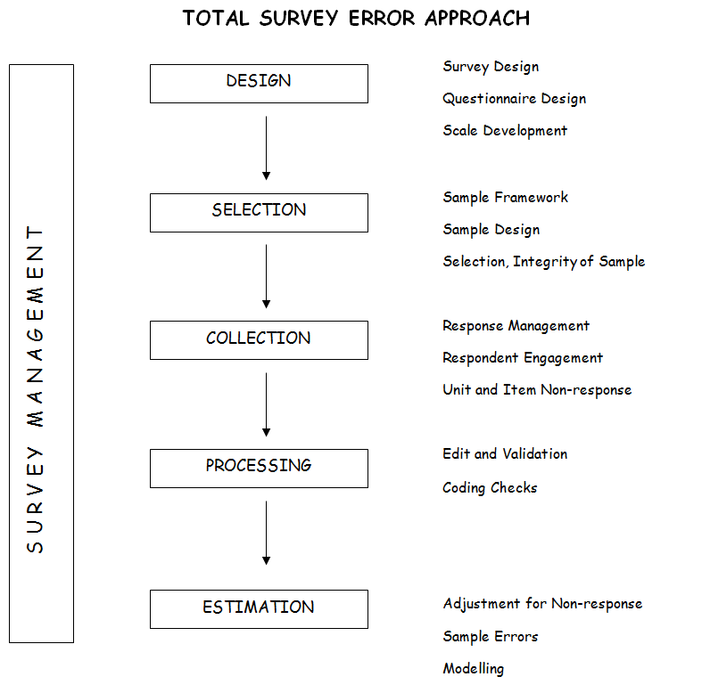**Total Survey Error Approach**

1. Design
   1. Survey Design
   2. Questionnaire Design
   3. Scale Development
2. Selection
   1. Sample Framework
   2. Sample Design
   3. Selection, Integrity of Sample
3. Collection
   1. Response Management
   2. Response Engagement
   3. Unit and Item Non-response
4. Processing
   1. Edit and Validation
   2. Coding Checks
5. Estimation
   1. Adjustment for Non-response
   2. Sample Errors
   3. Modelling
6. Summary of Findings

I have provided an overview of my assessment here. More details, using the framework above, are provided in the following parts of the Report. My assessment of whether the survey has met the requirements of the Department of Education or not are considered in the concluding paragraphs of this Section.

My assessment is that the main areas of risk to survey quality are sampling errors and non-response bias. The sample is large and significant sample errors are only really a concern at the most detailed level. Also, a well-thought through mitigation strategy was in place for other types of errors. Therefore, the focus of this Summary is on non-response bias.

A very professional approach has been taken to the design of the UES right through the various design stages. The 2014 UES has built on the previous UESs especially the experience learned during the 2013 UES. In particular, significant effort was devoted to maximising response (for a student population where response rates are traditionally low) and ensuring the achieved sample was representative. The latter was done by developing specific response rate targets for each institution by course type stratum. These are the so-called reportable strata. An overall response rate of 30.1% was achieved, whilst less than the target of 35%, this is good for a survey of this type and an improvement on previous rounds. Opportunities for further improvement should be explored in future surveys.

An interesting experiment was conducted in the pilot study of non-university higher education institutions which resulted in higher response rates for these institutions (48% compared with 30% for universities). The rolling incentives used in this pilot study to achieve this higher response rate appear to be well worth investigating for UES 2015.

Important steps taken to improve response and representation included (1) to engage as closely as possible with each University through an especially appointed survey manager, (2) a promotion and marketing campaign, (3) a planned and targeted reminder strategy, and (4) the use of incentives. These initiatives appear to be successful but no doubt could be further improved in light of experience.

Steps were also taken to improve the representativeness of the achieved sample especially in the targeting of the reminder action through the use of target response rates for individual strata although some of these targets were very ambitious and probably impossible to achieve. As a consequence of the above steps, the sample was reasonably representative in respect of most of the key population characteristics. These include year of study, mode and type of attendance, Indigenous/Non-Indigenous, Disability and International/Domestic.

However, as in the previous year, the sample was not representative on gender (43% male in the population, 34% in the sample) and the response rates for Universities varied from 21% to 50% due to, in large part, the extent of student engagement at the University. However, the variability in response rates in Universities has reduced somewhat. As fourteen Universities have a response rate greater than or equal to 35%, it suggests to me that this level of response rate is achievable.

The response rates by field of study also varied somewhat but not by large amounts. For example, they were relatively high for Psychology and relatively low for Business Management and Natural & Physical sciences.

Analysis showed that gifts (shopping vouchers) did provide an incentive to respond but it seemed that it was more of an incentive for females than males. Different incentives for males should be investigated eg tickets for concerts or sports events. The other major initiative to increase response rates would be to obtain a higher level of co-operation from low performing Universities. As well as visiting the senior Executives of these Universities, it would be appropriate if the UES could be listed on the agenda of a Universities Australia meeting of the Vice-Chancellors or the Deputy Vice-Chancellors, Education.

In addition to the steps taken to ensure the representativeness of the sample, weighting procedures can mitigate against non-response bias. They should also be used to adjust for the fact that students from universities where a sample was used have a smaller probability of selection than those universities where censuses were conducted. The question has been asked as to whether to weight the responses or not. I would strongly recommend that weights be used. It is consistent with good practice and it would be most unusual if weights were not used in a survey of this type with differential response rates and different sample fractions across strata.

Why does it matter? If you don’t weight, the estimates will be biased towards the characteristics for those that are over-represented in the sample. In the UES 2014, the unweighted estimates would be biased towards the responses of females, Universities with high response rates and Universities where censuses were conducted (mostly smaller universities). Based on the information I was shown:

* Females tend to have higher satisfaction levels than males,
* Not surprisingly, the Universities with higher response rates have higher satisfaction levels as the students are less engaged, and
* There did not appear to be strong association between satisfaction levels and the size of Universities.

In summary, unweighted answers would have an upward bias in satisfaction which calculations by GCA have suggested are rather small. Although the bias may be small at the most aggregated levels, it is preferable not to have this bias and improve the ‘face validity’ of the survey to potential critics. The biases at lower levels of aggregation are not clear but are likely to be larger. Also, although the biases may be small when looking at levels they will become more significant when looking at differences, either over time or between population groups (e.g. fields of study) within the same survey.

The strata were designed to support estimation for the most important domains (Universities, field of study, year of study) and weighting should take place at that level. Separate weights should be used for each stratum based on the effective sample sizes. If this happens, the stratification and weighting procedures mitigate against potential non-response bias from differential response rates at these levels. Furthermore, it is recommended that post-stratification be undertaken on the gender variable as the response rate for females is much higher than that for males and there are differences in their survey characteristics.

The estimates for fields of study for each University are also of special interest (ie the reportable strata). Not all these estimates are reliable. For some the effective sample size is low resulting in significant sampling errors. Also, response rates are very low in some cases and it is not clear that the sample is sufficiently representative to keep the risk of non-response bias to a low level. In fact the use of post-stratification weights by gender may be more important to the accuracy of the estimates at this more detailed level.

The focus on a representative sample and the use of weighting to stratum/post-stratum population benchmarks is consistent with international trends for dealing with non-response as higher response rates are becoming harder and harder to obtain especially when face to face interviewing is not used.

There are other potential sources of error such as those arising from poor questionnaire design or an inaccurate sample framework. I believe the risks from both these error sources are low.

There was no need for evaluation and testing of the survey instruments for UES 2014 as the UES 2013 questionnaire worked quite well and there were only minor changes. One test of the adequacy of a questionnaire is the item non-response. If the questions are confusing, respondents will tend not to answer them. If the questionnaire is too long, there will be a tendency to not answer the questions at the end. The average item non-response was 1.1% which is low compared with most surveys. It is about the same as UES 2013 (1.0%) but considerably lower compared with UES 2012 (7.7%).

The availability of the HEIMS data base as a sample framework provides greater assurance that the whole student population is being covered, simplifies the sample selection process, provides the survey administrator control over who is included in the survey and prevents the gaming problems that have apparently existed in some past surveys (but not UES). The accuracy of this survey framework is important to good response rates, especially the contact details. Furthermore, the use of HEIMS has enabled centralised data collection by SRC. Validity checks undertaken by SRC and the Universities suggest HEIMS is reasonably accurate in the sense that it is largely consistent with University records.

Has the survey met the client requirements?

The main survey requirements are:

1. The general survey methodology used must be an initial approach to respondents via email providing links to an online survey instrument, followed by targeted communications to meet required response rates which may include hard copy mail outs.
2. The content is as for UES 2013 (with one question deleted) and supports the estimation of scales for ‘Learner Engagement’, ‘Teaching Quality’, ‘Learning Resources’, ‘Student Support’ and ‘Skills Development’. The specified content also includes a number of specified analysis variables.
3. In addition, elements of the Course Experience Questionnaire (CEQ) must be administered to a sub-sample of students of sufficient size to achieve the accuracy required for international benchmarking.
4. Also, participating institutions must be provided with the opportunity to add institution specific items.
5. The scope will include commencing and later year undergraduate degree students.
6. The UES must be conducted on the basis of a random stratified sample and the Department will provide HEIMS for that purpose.
7. A student engagement strategy which will support robust response rates should be designed and implemented.
8. The survey design must facilitate the publication of results based on the following stratification variables (institution, field of study, stage of studies).
9. At this level of stratification, estimates of percentage agreement for the ‘quality of entire educational experience’ item, in the teaching quality section of the questionnaire, are required at a confidence level of 90% for differences of + or – 5% (later modified to 7.5% with the approval of the Department).
10. Statistical analysis should be used to determine whether any additional variables should be used for post-enumeration weighting to achieve representativeness.
11. A detailed publication of the results of UES2014 should be published.
12. Confidence intervals for the estimates should be estimated.

The survey design and operation met all the specified requirements for the survey with the exception of requirement (ix) as outlined above. Many of the reportable strata meet this requirement but some do not because the response rate did not reach the required level for the sampling errors to be sufficiently small. I would say that in most cases this would be because the response rate target was unreasonably high.

REPORT AGAINST ERROR FRAMEWORK

1. Survey Design

The survey design is very dependent on the survey objectives. These are specified in the contract with the Department of Education. The most relevant requirements are as follows.

- The general survey methodology used must be an initial approach to respondents via email providing links to an online survey instrument, followed by targeted communications to meet required response rates which may include hard copy mail outs.

- The content is as for UES 2013 (with one question deleted) and supports the estimation of scales for ‘Learner Engagement’, ‘Teaching Quality’, ‘Learning Resources’, ‘Student Support’ and ‘Skills Development’. The specified content also includes a number of specified analysis variables.

- In addition, elements of the Course Experience Questionnaire (CEQ) must be administered to a sub-sample of students of sufficient size to achieve the accuracy required for international benchmarking.

- Also, participating institutions must be provided with the opportunity to add institution specific items.

- The scope will include commencing and later year undergraduate degree students.

- The UES must be conducted on the basis of a random stratified sample and the Department will provide HEIMS for that purpose.

- A student engagement strategy which will support robust response rates should be designed and implemented.

- The survey design must facilitate the publication of results based on the following stratification variables.

- At this level of stratification, estimates of percentage agreement for the ‘quality of entire educational experience’ item, in the teaching quality section of the questionnaire, are required at a confidence level of 90% for differences of + or – 5% (later modified to 7.5% with the approval of the Department).

- Statistical analysis should be used to determine whether any additional variables should be used for post-enumeration weighting to achieve representativeness.

- A detailed publication of the results of UES2014 should be published.

- Confidence intervals for the estimates should be estimated.

It is important to note that the accuracy of survey estimates is largely dependent on the size of the sample rather than the fraction of the population that is being sampled. Consequently, the sample size should be much the same for the smallest and largest universities, and for each course, if you want estimates of the same accuracy. This assumes similar response rates.

Did the design meet the above requirements? The design used for UES 2014 was consistent with the specified requirements for the survey. However, it did not meet requirement (ix) for all strata mainly because the response rates were too low for some strata. In my view, it was not possible to completely meet this requirement because the target response rates were unrealistically high in some strata and some thought needs to be given to this prior to the design of UES 2015.

1. Questionnaire Design

There was no need for evaluation and testing of the survey instruments for UES 2014 as the UES 2013 questionnaire worked quite well and there were only minor changes. The main changes were (i) to eliminate one question from the ‘student services’ scale as psychometric tests showed it was not relevant to this scale and (b) the non-use of rotating panels because analysis showed the order of the panels did not matter. The questionnaire appears to have worked quite well. One test of the adequacy of a questionnaire is the item non-response. If the questions are confusing, respondents will tend not to answer them. If the questionnaire is too long, there will be a tendency to not answer the questions at the end. The average item non-response was 1.1% which is low compared with most surveys. It is about the same as UES 2013 (1.0%) but considerably lower compared with UES 2012 (7.7%).

Furthermore, item non-response did not vary much by item except for those students doing a double degree where fatigue might have been a factor. However, it was still only slightly higher for those students and still low compared with most surveys.

1. Scale Development

Prior to UES 2014 psychometric techniques were used to re-analyse the scales based on data from UES 2013. The same five scales were retained but one question was deleted from the ‘student support’ scale. This is consistent with a professional approach to scale development. It also supports consistency between the UES 2013 and UES 2014 surveys and would help analysis of changes between the two years. There is one exception. The ‘student support’ scale will vary between the two years because of the deletion of a question. This will be the reason for much of the change between 2013 and 2014 for this scale so movements cannot be reliably interpreted. I would suggest that this scale be recompiled for 2013 with the question deleted. Then a reliable movement between the two years can be estimated. Some thought needs to be given to how this data is to be presented.

1. Framework of Students

An important initiative in UES 2013 was the availability of the HEIMS data base as a sample framework. This provides greater assurance that the whole student population is being covered, simplifies the sample selection process, provides the survey administrator with greater control over who is included in the survey and prevents the gaming problems that have apparently existed in some past surveys administered by Universities in a decentralised way (but not UES). The availability of an accurate survey framework, and accurate contact details, is also important for good response rates. Otherwise, non-contacts could be a major source of non-response.

One potential source of non-contact is selected students not opening the email. The University email address has been used on the expectation that students would use it during term when the survey was conducted. This seems like a reasonable assumption but it should be tested. This would be reasonably straightforward as it is possible to tell whether an email has been opened or not. If this number is reasonably large, consideration should be given to other ways of contacting these students, rather than mainly relying on university email.

1. Sample Design

The sample design was relatively straightforward and appropriate for the objectives of the survey.

Stratification was based on a combination of University x Type of course x Year of Study which is equivalent to the reportable strata for the output phase. This was appropriate given that each of these variables, and combinations of them, are disaggregations of particular interest and also because the stratification will assist the accuracy of the estimates. It also facilitates the compilation of weights that adjust for differences in the response rates and sampling fractions.

The design used for UES 2012 and UES 2013 specified that where the number of students in a stratum was less than 1333, all students were included in the survey. This was true for most strata. If there were more than 1333 students in a stratum, a sample of the 1333 students was chosen randomly. The logic for this cut-off is not entirely clear but it was stated in UES2012 to ensure a sample size of 200 but this seemed to be assuming a relatively low response rate.

As I proposed in my last Report, the sample design should be revisited prior to the 2014 survey. The analysis of this approach suggested that this approach to determining the sample had a number of shortcomings. In general, large strata were over sampled and often achieved completed interviews in excess of 200. Consequently, students from large strata were substantially over-represented which also accentuated the gender imbalance because females were over-represented in the largest courses. Furthermore, the sample design did not take account of differential response rates across strata.

A different approach was taken to the sample design in UES 2014. It took account of the need to maximise the number of reportable strata. Target response rates were estimated for each reportable stratum although some of these were unrealistically high. These target response rates were used to tailor the response follow-up effort. Response rate targets for Universities varied considerably. They varied from 22% for Melbourne University (although it achieved a significantly higher response rate) to 68% for Bond University.

I am advised that the 35% target is actually 32.1% when calculated at the stratum level and aggregated.  Rather than a broad target of 35%, the objective has for as many strata as possible to exceed their target response rate. This requires the support of the institutions. Furthermore, the focus of the survey is on results at the institution level and institution by field of study level. National estimates are a lower priority.

I agree that this sample design is more appropriate to meet the survey objectives. It has not been possible to provide estimates for all reportable strata but that is because it would have been necessary to obtain response rates that are unrealistically high for most of the strata that do not meet the confidence level objective. The sample errors for this sample design will be greater at the national level than what they would have been if the sample design had been optimised for national estimates but, as noted above, these are of lower priority.

1. Sample Selection and Administration

The sample selection was undertaken by SRC for all Universities based on the HEIMS framework. The student contact details were provided by the Universities and appeared to be reasonably accurate although some reformatting of street addresses was required to meet Australian Post standards. In fact, the sample was a Census for most Universities. If the sample fraction was high for a University, it was decided to conduct a Census to keep it simple. Also, two of the larger Universities decided to conduct a Census. The final outcome was that a sample was only used in eight of the largest Universities.

The Survey Managers in each University assisted with the selection and administration. The relationship with the survey managers was good in most Universities and the arrangements, involving joint responsibility, seem to have worked well.

1. Response Management

The overall response rate was 30.1% less than the target of 35% but slightly higher than 29.3% for UES 2013 and significantly higher than the response rate for UES 2012. It should also be noted that the non-response follow-up effort was targeted at strata where the response rate was significantly below the target response rate. This was the correct strategy but may not have maximised the overall response rate.

A lower response rate will increase sampling errors and increase the risk of non-response bias. I have deliberately used the word risk. For example, if the achieved sample is still representative, there will be no non-response bias. Furthermore, even if some parts of the population are under-represented, there will only be non-response bias if their characteristics tend to be different to the rest of the population. Representativity is a very important objective for surveys that have inherently low response rates like those of student populations. In fact, it can be shown that following up non-respondents that are more typical of current respondents than the majority of non-respondents will reduce the representativeness of the sample. SRC have managed the reminder action (using a targeted approach) to maximise the number of reportable strata. This also improved the representativity of the sample. As a consequence, the achieved sample is reasonably representative of the population. It was the correct strategy but there may be some opportunities for improvement in UES 2015 as noted below.

It is becoming more common to compile statistical measures that assess the representativity of the sample on a dynamic basis. One such statistic is known as the R-factor and another is known as the distance function which essentially measures the ‘distance’ between respondents and non-respondents on certain attributes that are known for both. These types of measure might be considered for future surveys (References: Schouten B, Cobben F and Bethlehem J, (2009), “Indicators for the representativeness of survey response”, Survey Methodology, 35, 101-113; Sarndal C-E (2007) “The Calibration approach in survey theory and practice”, Survey Methodology, 33, 99-119).

The main means of increasing response rates were:

1. A variety of activities at improving student awareness as well as promotion of the survey. These can also be reinforced at the University level eg lecturers mentioning the survey and its purpose in the classroom.
2. The explicit support of the University and the effectiveness of the appointed Survey Manager.
3. Reminders, both generic and targeted.
4. Incentives in the way of shopping vouchers.
5. Follow-up using different communication modes such as hard copy letters to students who didn’t reply to the original email invitation and sms where mobile telephone numbers were provided (17 out of 40 Universities)
6. Explicit Institutional efforts at strengthening response in some universities.

These seem appropriate but the effectiveness of all these strategies should be reviewed prior to the commencement of UES 2015. There is some data available to suggest reminders, incentives and the hard copy letter are important but perhaps they could be better targeted. There is also anecdotal evidence that (vi) significantly increased response rates.

Reminders were definitely important in increasing the response rate and sample size. However, it would be worth analysing whether they have increased the representativeness of the sample. Certainly the higher sample size as a result of reminder action will reduce the size of sampling errors so that is one positive outcome. It may be worthwhile to introduce further targeting of non-respondents to be followed up.

We know that males are under-represented but how to increase the male response rates? It is a global problem not just something that is peculiar to UES. Research has shown that females are more likely to engage in online activity characterised by communication and exchanging of information whereas males are more likely to engage in online activity characterised by seeking of information. I am not sure how to use this fact in encouraging increased male participation and could not find any relevant research. It is also known that incentives increase response rates. However, the shopping vouchers used for UES 2014 are more likely to increase female rather than male participation. It might be worth experimenting with different types of incentives for males eg tickets to concerts or sports events.

For the non-university, higher education pilot study, a rolling incentive program was used. A much higher response rate was achieved (47.9%). The rolling incentive program may have made a difference and this is certainly worth investigating.

There is considerable variation in response rates across universities. In general, the universities with low response rates were less engaged although in case of Swinburne there were administrative difficulties with the sample selection. Increasing engagement will require the support of the Vice-Chancellor or the Deputy Vice-Chancellor (Education) at these universities. This may require discussion at the University level and/or the regular meetings organised by Universities Australia. Fourteen universities achieved a response rate of 35% or more suggesting this is achievable for most universities.

The survey literature suggests a mixed mode of communication is the best way of increasing response rates. This is usually referring to the general population where it is more obvious that this is the case as different age cohorts will, on average, have different communication preferences. It is less obvious for student populations and the experience of UES 2014 should be analysed to see whether mail or mobile contacts have had an impact and perhaps might be used in different ways for UES 2015. It was noted that the letters seemed to have a very positive impact on response.

1. Engagement of Universities

A significant and impressive effort was put into the promotion and marketing campaign and the engagement of Universities. The key elements were:

* The nomination of a senior survey contact and a survey manager; communication to Universities went through these persons.
* The use of incentives to increase student interest and co-operation.
* Regular feedback to Universities on progress during the data collection phase.
* Targeted non-response follow-up activities.

How did these initiatives work? The improved response rate, and reasonable representativity in the sample, suggests they worked well. The appointment of survey managers is an essential step.

As a general comment, the extensive surveying of the student population makes their co-operation more difficult. There appears to be scope for some rationalisation of surveys and this should be examined at both the University and sector levels. If students are surveyed excessively, their co-operation is likely to diminish. Student surveys are initiated by both the Government and the University sectors. Rationalisation cannot occur without the agreement of both so efforts at rationalisation need to involve both sectors.

1. Unit and Item Non-response

Significant effort was devoted to maximising response (for a population where response rates are traditionally low) and ensuring the achieved sample was representative. An overall response rate of 30.1% was achieved, whilst less than the target of 35%, this is good for a survey of this type.

As discussed above, a number of steps were taken to improve response. These appear to have been successful but no doubt could be improved in light of experience. Steps were also taken to improve the representativeness of the achieved sample especially in the targeting of the reminder action. As a consequence, the sample was reasonably representative in respect of most of the key population characteristics. These include year of study, mode and type of attendance, Indigenous/Non-Indigenous, Disability and International/Domestic.

The sample was not representative on gender (43% male in the sample, 34% for the respondents and the response rates for Universities varied from 21% to 50% representing, in large part, the extent of student engagement at that level.

The data was not completely representative with respect to field of study. However, it was not too bad. Psychology students were over-represented. Students of management studies and physical and natural sciences were under-represented where there are more male students. For other fields of study, there were no significant differences.

What is the risk of non-response bias? Non-response bias will only exist if there are differential response rates among the population sub-groups AND the survey characteristics of those population sub-groups are different. I believe the achieved sample may be subject to some non-response bias largely because of the differential response rates for gender and field of study (to a much lesser extent) where we know the average survey characteristics are different. I don’t believe the differential response rates for Universities will have much impact because the average survey characteristics are not that different.

In addition to the steps taken to ensure the representativeness of the sample, weighting procedures can mitigate against non-response bias. Although my assessment is that the non-response bias is likely to be relatively small, I would still recommend that weighting be undertaken. This would overcome any possible non-response bias problems with fields of study and universities. Furthermore, post-stratification weights based on gender would help to overcome any non-response bias problems from this source. Weighting is discussed in more detail below.

The average item non-response was 1.1% which is low compared with most surveys. This does not appear to be a significant issue for the reliability of the survey.

1. Edit, validation and imputation

I have not looked closely at the procedures except for the information provided in the Methodological Report. Based on the documentation, the procedures used were consistent with good practice and provided data files that were suitable for analysis. Furthermore a number of edits were built into the questionnaire.

1. Coding of Open Ended Responses

Most of the questions are self-coding. The only coding required was to code the courses undertaken by students to the fields of study used by UES mainly to check whether there were differences to those recorded on HEIMS. This impacted about 1.7% of records. From the methodological report, it appeared that this work was undertaken to a satisfactory standard.

1. Estimation, including adjustment of non-response

As mentioned above, the sample was not representative on gender (43% male in the population, 34% in the sample) and the response rates for Universities varied from 21% to 50%, due in large part to the extent of student engagement. Furthermore, samples were used in the larger universities so some in-scope students were deliberately excluded on a random basis. Adjustments can be made as part of the estimation process by the use of weights. This is standard survey practice.

There has been some discussion of whether weighting should be used or not. Stratum level weighting should be used and this will adjust for differential non-response across the strata (university, field of study, first/final year students). It will also allow for differential sampling fractions across strata. However, it will not adjust for any differences between respondents and non-respondents within strata. Post-stratification will assist in this respect. This involves weighting respondents within a stratum differently according to their characteristics with respect to potential post-stratification variables.

To warrant the use of post-stratification to reduce possible non-response bias, there has to be both a differential non-response rate for the categories (within a post-stratification variable such as gender) AND the survey characteristics for these categories have to be different. For example, the response rate for females was much higher than that for males. If the characteristics of females were different to those for males, the use of post-stratification would reduce non-response bias. In fact, there are differences. Females tend to have a higher satisfaction levels so unweighted data would have an upward bias.

Having looked at the potential post–stratification variables that might be considered for UES, only gender is worth considering. As mentioned above there were differential response rates across the two gender categories as well as some differences in their average survey characteristics. However, for the other potential post-stratification variables, there was little difference in response rates across the categories so there would be no gains from using these variables for post-stratification purposes.

Although I cannot be certain, I think the steps taken with the survey design to improve the representativeness of the sample, and the use of stratification and post-stratification with separate weighting of strata/post-strata, should mean that non-response bias is low. Why do I say this? For a CEQ study in 2005, analysis was undertaken by ACER which showed the most important determinants of student ‘satisfaction’ scales were the variables used for stratification in UES and gender. The most important variable for the CEQ was field of study and this is likely to be the case for UES as well. It was used as a stratification variable so there would be adjustments for any differences across fields of study if weighting was used.

Returning to the question of whether to weight the responses or not, I would strongly recommend that weights be used. It is consistent with good practice and it would be most unusual if weights were not used in a survey of this type with differential response rates.

What would be the impact if you didn’t weight? If you don’t weight, the estimates will be biased towards the estimates for those that are over-represented. In the UES 2014, the unweighted estimates would be biased towards the responses of females, Universities with high response rates and those Universities where a Census was used. Based on the information I was shown:

* Females tend to have higher satisfaction levels than males,
* Not surprisingly, the Universities with lower response rates have lower satisfaction levels as the students are less engaged but the differences are not great and
* There did not appear to be strong association between satisfaction levels and the size of Universities.

In summary, unweighted answers would have a small upward bias. Although the bias may be small at the most aggregated levels, it is preferable not to have this bias and improve the ‘face validity’ of the survey to potential critics. Also, although the biases may be small when looking at levels they will become more significant when looking at differences, either over time or between population groups (e.g. fields of study) within the same survey. They are also more likely to be significant at the reportable stratum level.

The focus on a representative sample and the use of weighting to population benchmarks to stratum/post-stratum population benchmarks is consistent with international trends for dealing with non-response as higher response rates are becoming harder and harder to obtain especially when face to face interviewing is rarely used now.

1. Sampling errors

Details about sampling errors should be estimated and presented to assist with analysis of report. This should be based on actual data. They do not have to be calculated for every estimate – only sufficient estimates to provide readers with a feeling for the size of the sampling errors. However, they should be estimated for each level of publication – e.g. total population, field of study, University and field of study x University.

As the most important estimates are ‘% satisfied’ it might be able to present graphically. As the underlying distribution is binomial there will be an approximate relationship between the percentage satisfied and the effective sample size. The ‘% satisfied’ does not change that much so one approach could be to estimate sample errors (or confidence intervals) for different sample sizes for when ‘% satisfied’ is 60%, 70%, 80% and 90%. These four alternative could be shown as four separate lines on a graph with sampling errors as the vertical axis and effective sample size as the horizontal axis. The approximate sample errors for other ‘% satisfied’ can easily be interpolated from this graph.

Strictly speaking the sample is not a random sample which is an important assumption for most estimates of sampling errors. The students in the sample have self-selected to the extent they have agreed to respond to the UES. However, for the purposes of estimating sample errors, I believe it is OK to assume the sample is random. In fact, there is no other realistic assumption.

1. Modelling

Another question that might be asked is the impact of non-response on the modelling that is undertaken to estimate the scales. The answer is that the impact should be negligible. If the model is valid, it should apply to both respondents and non-respondents. Therefore, a model based on respondents only should still be representative of the whole population.

Another question that might be asked is whether to use weighted or unweighted data when modelling. The answer is that it does not matter greatly. If the underlying model is correct, models estimated on either weighted or unweighted data should both be unbiased. However, if weighted data is available I suggest you use it as studies have shown this will provide more accurate estimates of the parameters of the model but there is not a lot in it.

1. Publication

Criteria need to be established for determining what data should be published. The key question is whether data for every reportable stratum should be published or not. Because of the small sample size, some reportable strata (ie University x Field of study x year of study) will have sampling errors higher than those specified in the Department of Education contract.

Furthermore, the non-response rate for some strata will be so high that the risk of non-response bias may be high. This may be mitigated to a large extent if separate weights are used at the post-stratification level for males and females.

I suggested that estimates for all reportable strata should be published together with information on sample errors so users can assess the reliability of the data for their purposes. Furthermore, data in these tables with high sampling errors (e.g. standard errors of 20% or higher) could be marked with an asterisk to highlight the high sampling errors. This is the ABS practice rather than suppressing cells with high sampling errors. That is, a ‘user beware’ approach be adopted rather than suppressing those cells with high sampling errors.

A similar approach might be taken to those reportable strata subject to the risk of high non-response bias. There will be considerable overlap with those with high sampling errors mentioned in the previous paragraph. Ideally, the ‘rule’ should be based on a mixture of low response rates and the extent of gender representation. Some empirical work should be undertaken to determine the exact criteria. Alternatively a simple criteria based on response rates (eg less than 20%) might be used.

Of course, any cells that are confidential should be suppressed – less than 5 respondents may be a suitable guideline.

The publication should also provide readers with the information to enable them to assess the accuracy of the survey for their purposes. This would include sampling errors. Furthermore, there should be a description of the more significant non-sampling errors and a discussion of the risks they pose to use of the estimates. Quantitative data should be provided wherever possible. Non-response is clearly the non-sampling error of most significance.

Information on the design of the survey, survey variables and other meta data should be published especially to assist the more informed reader. This is the Methodological Report which was published for UES 2013. It was a good quality document that would have considerably assisted users of the UES results. It is intended to do the same for UES 2014 and the draft Report I have seen is also a good quality and appropriate document.

Conclusions

The survey design and operation met all the specified requirements for the survey with the exception of requirement (ix) as outlined above. Many of the reportable strata meet this requirement but some do not because the response rate did not reach the required level for the sampling errors to be sufficiently small. I would say that in most cases this would be because the response rate target was unreasonably high.

The main risks to quality are sampling errors (at the reportable stratum level) and non-response bias both of which have been discussed in detail above. In particular, the relatively low response rate of 30.1% leaves open the potential for non-response bias to be an important influence. However, reasonable steps have been taken at the data collection stage to mitigate the impact of non-response bias. If weighting, as described in this document, is used in estimation the residual impact should not be large for the major aggregates. However, it may be more significant in relative terms for smaller aggregates so more care should be taken in interpreting these estimates.

31 DECEMBER 2014

1. Throughout this report, “course” is synonymous with “degree program”.
2. Refer to Graduate Careers Australia and the Social Research Centre. (2014). *2014 University Experience Survey National Report*. Retrieved 4 Feb., 2015, from https://docs.education.gov.au/system/files/doc/other/ ues13_report.pdf
3. “UEQ” is used where necessary in this report to distinguish between the UES questionnaire proper and additional non-standard elements, including the CEQ and institution-specific items.
4. The numbers in parentheses refer to HEIMS data elements.
5. Subject area definitions are presented in Appendix I.
6. Radloff, A., Coates, H., Taylor, R., James, R. & Krause, K. (2012). *2012 University Experience Survey National Report*. Retrieved 15 Dec., 2014, from http://www.innovation.gov.au/highereducation/Policy/ Documents/UES2012NationalReport.pdf
7. These error bands were calculated on the basis of average scores, not percentage satisfied results.
8. The original precision target was ±5 percentage points at a 90 per cent level of confidence; however it became apparent that, when the required sample sizes were compared with the response rates achieved in 2013, it would not be possible to achieve the required number of responses for a substantial proportion of the strata.
9. Version A of the rotations was selected as it had the most logical flow of modules and showed negligible non-response in 2013.
10. For each institution, the post-stratification weights equal the in-scope population frequency of each stratum, defined on the basis of gender, subject area and stage of studies, divided by the frequency of the corresponding stratum in the sample of responses. When weights are applied, the weighted total of the sample approximates the total of the population.
11. When calculating the weights, 11 cases in the response file were found to belong to strata that had no corresponding strata in the population file. Because weights could not be calculated for these strata, the cases were excluded from the analysis presented in Tables 7 and 8.
12. This analysis was conducted using the *Weight Cases* procedure in SPSS, which gives cases different weights by simulated replication for statistical analysis. As such, the value of the weighting variable should indicate the number of observations represented by single cases in the data file.
13. A plausible explanation for this may be related to the fact that, while economics is rightly classified as a social science, economics departments are often located in business schools. An examination of Table 13 suggests that the university experience of economics students is generally closer to that of management and commerce students than that of society and culture students.
14. A clear potential source of differences between 2013 and 2014 is differential response rates at the stratum level. To investigate this, weights were computed by diving 2013 stratum counts by those from 2014. These weights were then applied to the 2014 sample so that the distribution of responses across strata would reflect that of the 2013 UES. This was found to have only a trivial impact on the 2014 results, which provides some evidence that the annual differences reported in Table 15 are not strongly related to differences in stratum level response rates between years. That being said, if late responders to the UES differ systematically to early responders, reducing the response requirements across many strata in 2014 could have introduced bias, which would not be addressed by the analysis described in this note.
15. For example, “U01” represents the same institution in Figures 1 and 2. Moreover, it also represents the same institution in the 2013 and 2014 editions of this report.
16. “How would you evaluate your entire educational experience at this institution?”
17. Indiana University. (2014). *About NSSE*. Retrieved 16 Dec., 2014, from http://nsse.iub.edu/html/about.cfm
18. “Overall, I am satisfied with the quality of the [this] course.”
19. HEFCE. (2013). *The National Student Survey*. Retrieved 16 Dec., 2014, from http://www.thestudentsurvey. com/the_nss.html
20. In all, 3,057 and 2,506 commencing and later-year students, respectively, responded to the CEQ item. The level of statistical precision achieved for this item was ±1.1 and ±1.3 percentage points at a 90 per cent confidence level for commencing and later-year students, respectively, at the national level.
21. The residual values represent the differences between the Rasch model’s theoretical expectation of item performance and the performance actually encountered for the item. Following usual statistical convention, residuals are squared to make the difference between actual and predicted values positive.
22. Bond, T.G., & Fox, M. (2007). *Applying the Rasch model: Fundamental measurement in the human sciences*. (2nd ed.) Mahwah, NJ: Erlbaum.
23. The infit mean square value in 2013 was 1.54 and the item discrimination was 0.73.
24. Linacre, J.M. (2014). *Winsteps® Rasch measurement computer program user's guide*. Beaverton, Oregon: Winsteps.com
25. Linacre, J.M. (1999). Investigating rating scale category utility. *Journal of Outcome Measurement*, *3*(2), 103-122. Retrieved from http://www.jampress.org/JOM_V3N2.pdf
26. Note that the location of items has been adjusted slightly to minimise the extent of overlapping labels, so their positions may not exactly match the measures in the table of item statistics.
27. In particular, such persons will have large standard errors of measurement relative to those in the middle of the distribution. For example, one respondent approximately in the centre of the distribution had an estimated measure of 0.03 logits with an accompanying standard error of 0.31 logits. Another respondent at the very top of the scale measured 5.70 logits, but this was associated with a standard error of 1.83 logits signifying much less certainty in their location on the underlying trait.
28. In the field of educational testing, students who correctly answer all items on a test cannot be distinguished. Additional, harder items are required to separate these top performers.
29. For more details on targeting of measurement instruments to respondents, see Bond, T.G., & Fox, M. (2007). *Applying the Rasch model: Fundamental measurement in the human sciences*. (2nd ed.) Mahwah, NJ: Erlbaum.
30. Linacre 2014, *op. cit.*
31. Wright, B.D., & Masters, G.N. (1982). *Rating Scale Analysis*. Chicago: MESA Press.
32. Refer to Appendix A for a list of response scale categories.
33. For instance, 23% of NUHEI students indicated that they interacted with other students “Very often” whereas 36% said they felt “Very much” prepared for their study. The first item was more difficult to endorse than the second.
34. Linacre 1999, *op. cit.*
35. Note that the location of items has been adjusted slightly to minimise the extent of overlapping labels, so the relative positions may not exactly match the measures in the table of item statistics.
36. In particular, such persons will have large standard errors of measurement relative to those in the middle of the distribution. For example, one respondent approximately in the centre of the distribution had an estimated measure of 0.16 logits with an accompanying standard error of 0.47 logits. Another respondent at the very top of the scale measured 4.84 logits, but this was associated with a standard error of 1.84 logits signifying much less certainty in their location on the underlying trait.
37. For more details on targeting of measurement instruments to respondents, see Bond & Fox, *op. cit.*
38. Linacre 1999, *op. cit.*
39. Cases with missing data are dropped from the calculation of Cronbach's alpha so these values should be seen as only approximate. For a discussion on the limitations of this statistic for assessing instrument quality, refer to Sijtsma, K. (2009). On the use, the misuse and the very limited usefulness of Cronbach's alpha. *Psychometrika*, *74*(1), 107-120.
40. Ho, D.E., Imai, K., King, G., & Stuart, E.A. (2011). MatchIt: Nonparametric preprocessing for parametric causal inference. *Journal of Statistical Software*, *42*(8), 1-28.
41. Linacre 2014, *op. cit.*