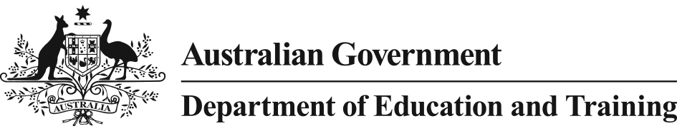

Programme Guidelines - Online National Assessment Platform

# Overview

Australian education ministers are committed to reforming national assessment by moving it online. A technical platform is required to deliver online assessments. The Australian Government will fund the development of an online national assessment platform as its contribution to the overall programme of work to transition the education sector to online assessment. The platform will enable online delivery of the National Assessment Program (NAP), in particular the NAP – Literacy and Numeracy (NAPLAN) test. Benefits of the online platform are:

* decreased turnaround time of results to teachers and students
* enhanced diagnostic value of the NAPLAN test by providing adaptive testing to enable better support for students at the upper and lower ends of the performance scale
* increased accessibility of the NAPLAN test to students with additional learning needs.

# Objectives

As part of the delivery of the Australian Government’s *Students First* policy, the development of a national platform will deliver the NAP online (including the NAPLAN test). The platform will, in the future, have the capability to deliver formative assessments at the classroom or jurisdictional level.

# Programme funding

Funding of $24.7 million has been allocated for development of the platform up to 2016-17. Key costs include system procurement, component integration, customisation, project management, and change management.

Following establishment, ongoing maintenance costs will be shared with states and territories.

All funding provided under this programme will be reported on the Department of Education and Training website.

# Project

Funding will be provided to Education Services Australia (ESA) to develop the online national assessment platform. There will be a phased transition to online assessment, commencing with the NAP-Civics and Citizenship sample assessment to be delivered on the platform in 2016. The platform will be used to deliver NAPLAN online from 2017 on an opt-in basis for schools that are ready. The remaining schools will transition to NAPLAN online in 2018 and 2019 as they become technically ready.

# Guidelines

The online platform will be compliant with government and industry standards for security, interoperability, privacy, and accessibility. The platform will be capable of delivering the national assessment program online, and have the potential to deliver classroom based assessment items. It will be able to successfully integrate with the external systems of partner and stakeholder agencies for the successful exchange of data. Development of the online platform will be overseen by various working groups established by the Council of Australian Governments (COAG) Education Council.

# Consultation

In the development of the online platform, ESA will engage with the Australian Curriculum, Assessment and Reporting Authority (ACARA), states and territories, non-government education authorities and relevant working groups.

# Grant recipient obligations

ESA will be required to meet all obligations outlined in the grant agreement, including:

* submitting detailed planning documentation
* meeting milestones as outlined in the grant agreement
* obtaining approval for sub-contracting
* complying with relevant Australian Government policies and guidelines
* providing regular reports every three months, as well as annual reports and a final report which will include details of all expenditure
* acquitting the grant in full at the conclusion of the project.

# Roles and responsibilities

The move to online assessment for the education sector involves many stakeholders. The key governance groups and organisations include:

* **Education Council**: established by the Council of Australian Governments (COAG), it provides national coordination of education policy, including online assessment.
* **Online Assessment Working Group** (OAWG): established by the Education Council to steer the development and implementation of national online assessment. The OAWG contains representatives of key national education peak bodies and each state and territory government education authority.
* **Australian Government Department of Education and Training**: provides policy development, funding and programme management.
* **State and territory governments**: will ensure that government schools are ready to move to online assessment, and will work with non-government education authorities in their jurisdictions to coordinate the transition to online delivery across sectors.
* **ESA**: will develop the online national assessment platform to deliver online assessments to schools.
* **ACARA**: will develop and administer the online test items to be delivered on the platform. ACARA is responsible for domestic national assessments, including NAPLAN
* **National Schools Interoperability Program** (NSIP): will facilitate interoperability of state and territory education ICT systems with the national platform.

# Evaluation

While evaluation will be ongoing, via regular project reporting and monitoring, there will also be a final evaluation at the conclusion of the development of the platform. This will include

* evaluating whether the project met its objectives
* issues which arose during the platform development and how these were addressed
* recommendations for the future.

# Conflict of interest

As outlined in the grant agreement, any conflict of interest by ESA or its staff must be fully disclosed. The Department of Education and Training will advise ESA of any steps required to resolve or otherwise deal with the conflict. Failure to notify or resolve the conflict of interest may result in termination of the grant agreement.

Conflict of interest by Department of Education and Training staff is dealt with by the department’s *Conflict of Interest Guidelines*.

# Programme Contact

Director

Online Assessment Team

Department of Education and Training,

LOC: C50MA9

GPO Box 9880, Canberra ACT 2601

# Privacy

In administering the programme, the department and funding recipient are bound by the provisions of the Privacy Act 1988 (the Privacy Act). For further information please go to: <http://education.gov.au/privacy>

Or write to:

Privacy Contact Officer

Legal and Compliance Group

Department of Education and Training

GPO Box 9880, Canberra ACT 2601

Or email: [privacy@education.gov.au](mailto:privacy@education.gov.au)

Privacy complaints may be made to the Office of the Australian Information Commissioner but will only be actioned where a complaint was made in the first instance to the department.