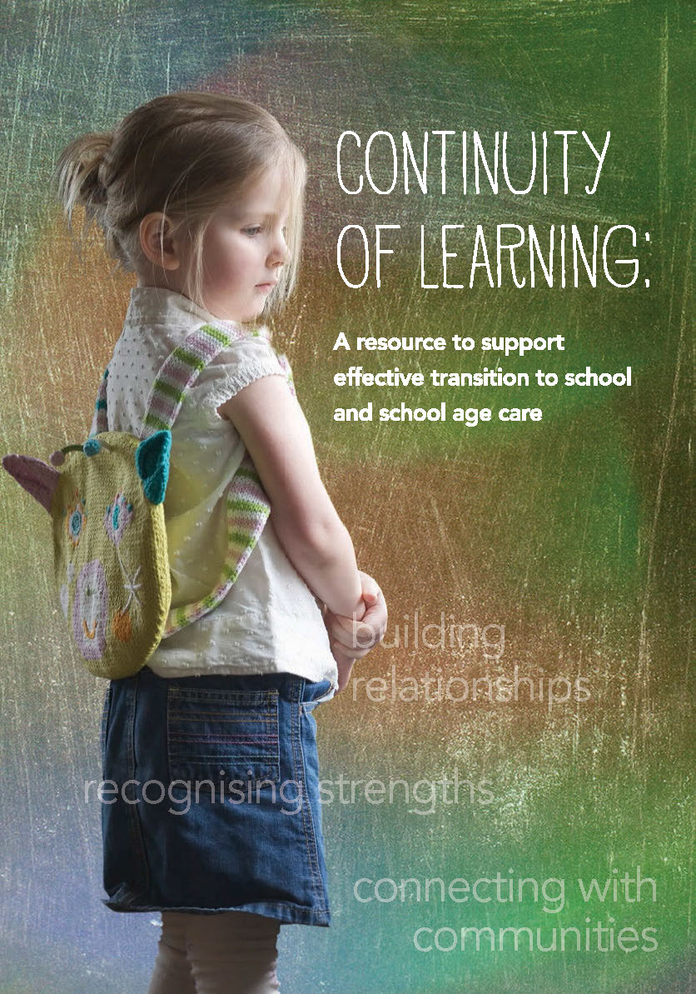
fa


Continuity of learning:
A resource to support effective transition to school and school age care

Continuity of Learning: A resource to support effective transition to school and school age care has been produced by the Australian Government Department of Education.
This resource has been developed by Charles Sturt University’s Educational Transitions Continuity and Change research team led by Professors Sue Dockett and Bob Perry, who wish to acknowledge the valuable contribution from a wide range of early childhood, school age care and school settings, and their children, families, educators and communities.
Suggested citation: Dockett, S. & Perry, B. (2014). Continuity of Learning: A resource to support effective transition to school and school age care. Canberra, ACT: Australian Government Department of Education.

With the exception of any material protected by a trade mark where otherwise noted all material presented in this document is provided under a Creative Commons Attribution 3.0 Australia licence (http://creativecommons.org/licenses/by/3.0/au/).
The details of the relevant licence conditions are available on the Creative Commons website (accessible using the links provided) as is the full legal code for the CC BY 3.0 AU licence (http://creativecommons.org/licenses/by/3.0/au/legalcode).
The document must be attributed as Continuity of Learning: A resource to support effective transition to school and school age care.
ISBN: 978-1-74361-792-2 (PRINT)
ISBN: 978-1-74361-793-9 (PDF)
ISBN: 978-1-74361-794-6 (DOCX)

Contents
Continuity of learning: 2
Contents 4
Section 1: Setting the scene 5
Introduction 5
Section 2: Background literature 13
Transition to school 13
Section 3: Principles and practices 17
Principle 1: Secure, respectful and reciprocal relationships 17
Principle 2: Partnerships 43
Principle 3: High expectations and equity 66
Principle 4: Respect for diversity 83
Principle 5: Ongoing learning and reflective practice 99
Section 4: References 117
Section 5: Appendix 126
Transition to school position statement 126

Section 1: Setting the scene

Introduction
Belonging, Being and Becoming, The Early Years Learning Framework for Australia (Department of Education, Employment and Workforce Relations (DEEWR), 2009) is a significant document in many ways.
Not only is it the first national Australian early years learning framework, but it is also the first framework in Australia to encompass all early childhood education services, promoting learning outcomes for children from birth to five years of age and through the transition to school.
The Early Years Learning Framework describes a number of principles of early childhood pedagogy, including an emphasis on providing for continuity in experiences and enabling children to have successful transitions (DEEWR, 2009, p. 4). Further, the concept of ‘becoming’ is described as including children building and shaping their identity through their evolving experiences and relationships which include change and transitions (DEEWR, 2009, p. 20).
The description of transition outlined in The Early Years Learning Framework is broad – covering the process of moving between home and early childhood settings, between a range of different early childhood settings, or from early childhood settings to full-time school.
A broad approach to transition also features in the learning framework guiding school age care in Australia. The document My Time, Our Place. Framework for School Age Care in Australia (DEEWR, 2011) recognises that children and families make transitions between home, school and school age care and emphasises the importance of complementary relationships across these contexts. In this latter document, the role of educators is noted as working with children, families, other professionals and the broader community to ensure successful transitions between settings [so] that children feel secure and confident and assisting children to understand the traditions, routines and practices of the settings to which they are moving and to feel comfortable with the process of change (DEEWR, 2011, p. 16).
The National Quality Standard for Early Childhood Education and Care and School Age Care (National Quality Standard) (Australian Children’s Education and Care Quality Authority (ACECQA, 2013) aims to promote continuous improvement in education and care services through a comprehensive system of regulatory and quality assurance processes. The National Quality Standard is linked to both The Early Years Learning Framework and the Framework for School Age Care. Of the seven quality areas identified, Quality Area (QA) 6 refers specifically to Collaborative partnerships with families and communities. Within this quality area, there is emphasis on promoting continuity of learning and transitions for each child by sharing relevant information and clarifying responsibilities (Standard 6.3). The transition to school is mentioned specifically in this standard, as educators are encouraged to reflect upon the question, “How do we support each child’s successful transition to formal schooling?”
Across Australia, a range of policy documents and support materials have been developed with the aim of promoting positive transitions to school and school age care. In 2011, the Transition to School: Position Statement (Educational Transitions and Change (ETC) Research Group, 2011) was released, having been developed in collaboration with researchers, policy-makers and practitioners. The Position Statement was generated through dialogue between and among these groups in an effort to offer a clear position about transition, supported by a solid international research base and evidence-based professional practice (Dockett & Perry, 2014). Alongside the framework documents – The Early Years Learning Framework and Framework for School Age Care – and the National Quality Standard, the Transition to School: Position Statement forms a cornerstone of this resource.

Transition to School: Position Statement
The Transition to School: Position Statement directs attention to the processes of transition and reconceptualises transition to school in the context of social justice, human rights (including children’s rights), educational reform and ethical agendas, and the established impact of transition to school on children’s ongoing wellbeing, learning and development.
Transition to school is taken to be a dynamic process of continuity and change as children move into the first year of school. The process of transition occurs over time, beginning well before children start school and extending to the point where children and families feel a sense of belonging at school and when educators recognise this sense of belonging.
Transition to school is characterised by:
- Opportunities – including those for all involved to support change and continuity; to build relationships; extend their understandings through interactions and to recognise starting school and school age care as significant events in the lives of children and families.
- Aspirations – as all look forward to positive engagement with school and positive outcomes, both social and educational; professional partnerships are formed and communities provide support and resources to promote positive engagement with school.
- Expectations – as all enact high expectations for all participants in the transition; multiple participants are recognised and respected for their role in contributing to children’s education; and children meet challenges with the support of friends and responsive adults.
- Entitlements – as high quality services are provided for all children and families; families and communities are confident that access and equity are promoted; respect is demonstrated for existing competencies, cultural heritage and histories; and personal and professional regard is afforded to those involved in the transition to school and school age care.
The full Position Statement is reproduced in the Appendix of this document. It is also available from the Charles Sturt University website (PDF).

The resource
This resource is focused on children’s transition to school, including the transition to school age care (or out of school hours care), and the ways in which early childhood services utilising the framework documents The Early Years Learning Framework and Framework for School Age Care and the National Quality Standard can work with children, families, other educators and professionals, as well as communities, to promote positive transitions for all children.
The resource is designed to share narratives of transition that draw on the experiences and perceptions of children, families, educators and communities as they support all those involved in the transition to school and school age care.
The resource has been generated from a wide range of site visits to early childhood and school settings; conversations with diverse stakeholders; survey responses and document analysis. In compiling the resource, conversations with children, parents, educators, other professionals and community members have been considered.
These conversations have occurred in settings encompassing family day care; occasional care; mobile children’s services; long day care; preschool/kindergarten; and schools (government, independent and special). This has promoted understandings about effective transitions in metropolitan, suburban, regional, rural and remote communities.
The aim of the resource is twofold: to share narratives of effective transition practice and to provoke reflection on these stories and their relevance for other settings.
Each of the narratives reflects a specific approach to transition and a specific context. Rather than suggesting that there should be a uniform approach to transition, readers are invited to reflect on the principles and perspectives underpinning each narrative and to consider how these, along with the elements of the Position Statement and National Quality Standard, may inform their own approaches to transition.

Reflecting on transition
The narratives included in the resource indicate that many individuals and groups are engaged in practices that support effective transitions. This compilation of approaches provides opportunities to acknowledge the efforts that are being made across the country to support all involved as children make educational transitions.
The narratives also remind us that each transition is unique. No matter how many times educators have engaged in transition practices, or how many children from families have already started school or school age care, for the child making the transition and those around them, this transition is unique. For educators involved with transition, this means that there is a constant stream of children and families for whom the transition to school and school age care are new and special.
While the differences across the narratives remind us that no two transitions are experienced in exactly the same way, they also provide opportunities to learn from the perspectives and practices of others. The power of comparisons is often not so much in the ways they reflect similarities or differences from our own contexts, but in the alternative lenses they provide for our own practice and the questions that are raised about practices we take for granted (Einarsdóttir, Perry, & Dockett, 2008).

Organisation of the resource
Many children, families, educators and community members, involved in early childhood services, schools and school age care programmes have contributed to the resource. We share their stories of effective transitions practice by drawing on four frames of reference:
- The principles espoused in The Early Years Learning Framework and the Framework for School Age Care. These principles emphasise the importance of:
- Secure, respectful and reciprocal relationships
- Partnerships
- High expectations and equity
- Respect for diversity
- Ongoing learning and reflective practice.
- The principles reflected in the Transition to School: Position Statement (ETC, 2011), which characterise transitions as times of:
- Opportunity
- Aspiration
- Expectation
- Entitlement.
- The perspectives of all involved in transition, including:
- Children
- Families
- Educators
- Communities.
- Specific elements of the National Quality Standard 6.3: The service collaborates with other organisations and service providers to enhance children’s learning and wellbeing
6.3.1 Links with relevant community and support agencies are established and maintained
6.3.2 Continuity of learning and transitions for each child are supported by sharing relevant information and clarifying responsibilities
6.3.3 Access to inclusion and support assistance is facilitated
6.3.4 The service builds relationships and engages with the local community.
Where relevant, other elements of the National Quality Standard are also noted.

Using the resource
The resource contains the following sections:
- Setting the scene
- An overview of literature, highlighting recent trends and issues in research around transition to school and school age care.
- A section relating to each of the five principles outlined in The Early Years Learning Framework and the Framework for School Age Care. Each section outlines:
- An overview of relevant literature and research
- Several narratives of practice illustrating some aspect of the principle.
Educators are encouraged to read the narratives in multiple ways, using multiple lenses. To facilitate this, key elements of each narrative are nominated – referring to the principles of the framework documents, effective transition practices, perspectives of those involved, and elements of the Position Statement and National Quality Standard.
Readers are encouraged to offer alternative naming and interpretations of the narratives and to consider the relevance for their own contexts and practices.
It is anticipated that the conversations generated by the narratives – and the related literature – will contribute to ongoing learning and reflective practice around transition.
- References
- The Transition to School: Position Statement
The organisation of the resource offers varied responses to the following questions:
- What do:
secure, respectful and reciprocal relationships
partnerships
high expectations and equity
respect for diversity
ongoing learning and reflective practice
look like for children, families, educators and communities at the time of transition to school or school age care?
- How do these principles and the experiences associated with them contribute to the opportunities, expectations, aspirations and entitlements afforded by and related to these transitions?
- What are considered to be effective transition practices?
- How do these practices reflect elements of the National Quality Standard?
To assist in the navigation of the resource, a number of design features have been used.
Each of the principles is represented by a colour:
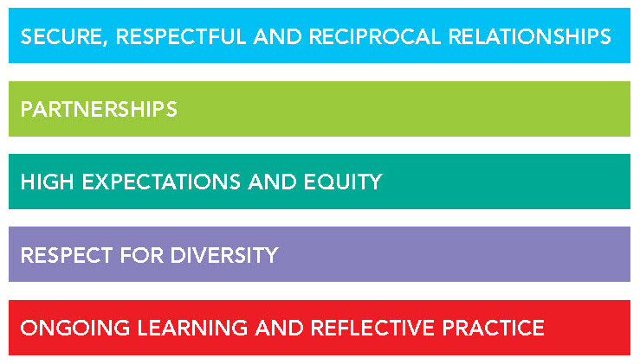

Symbols are used to indicate the four pillars of the Transition to School: Position Statement
Symbol | Position Statement | Example
 | Opportunities | To shape identities, extend learning, build relationships with and among children, families, educators and communities; recognise starting school as a significant life event
 | Aspirations | To learn and make friends; promote positive educational outcomes; work collaboratively; provide ongoing support and resources
 | Expectations | To face and address challenges; provide and receive support;  be regarded as competent; work in partnership
 | Entitlements | To access high quality, respectful and challenging education; demonstrate and recognise the capabilities of stakeholders; professional and personal regard; recognise the valuable involvement of multiple stakeholders

Symbols are used to identify a range of effective transition practices
Symbol | General  Practice | Example
 | Connecting with children | Buddy programmes  Children engage with peers  Introducing children and families to educators before commencement  Personal communication with children before they start school  Sharing expectations and experiences of school  Respecting children’s knowledge of school  Saying goodbye  Visits to the school and school age care services before commencement
 | Connecting with families | Welcoming families  Families meet before school starts  Inviting families to visit the school and/or school  age care setting  Information sharing  Referring families to appropriate support services  Providing spaces for parents to meet  Seeking – and listening to – advice from parents  Meeting new parents to discuss the transition  Regular communication with families  Working collaboratively with families and support services  Recognition of the significance of starting school for parents
 | Connecting with professionals | Collaboration between educators  Communicating with other professionals  Working collaboratively across services  Developing a communication strategy  Establishing professional networks  Strong leadership to support transition
 | Connecting with  communities | Being seen in the community  Community recognition of the importance of transition  Sharing information  Respecting knowledge of the community and existing connections with the community  Engaging the community in transition
 | Flexible and responsive transition programmes | Recognition that transition is different for each child Involving a range of stakeholders in transition programmes  Accessing appropriate support for children and families  Providing resources in a range of languages  Providing access to interpreters  Promoting continuity for children  Identifying strategies to support children who arrive at short notice
 | Recognising strengths | Developing portfolios, or other artefacts celebrating children’s growth and achievements  Respecting issues that matter to young children. Sharing aspirations and expectations  Holding challenging, but realistic expectations for children  Family-centred practice  Recognising family knowledge about their children  Challenging stereotypes  Promoting collaboration among educators and other professionals
 | Reflective practice | Regular meetings of educators  Establishing networks  Joint professional development  Working with a mentor  Pedagogical conversations  Reflection on assumptions around transition  Advocating for change  Reciprocal visits to different settings  Monitoring transition over time  Acknowledging child and family reflections
 | Building relationships | Ongoing positive interactions between and among children, families and educators  Demonstrated respect for all involved in transition  Willingness to engage with other stakeholders in transition

Section 2: Background literature

Transition to school
Starting school is one of the major transitions individuals make throughout their lives. While the transition to school can be a time of excitement and eagerness, it can also be tinged with anxiety and concern. Many children revel in the changes and challenges brought about by their move to school; others find the changed demands and expectations overwhelming. Changed demands are not only evident for children: families and educators, too, experience changes as each new child, or group of children, starts school. Children, families and schools all exist within communities and they, too, reap benefit and provide support when the connection to school is positive and ongoing.
Several themes have emerged from a wide range of recent research about the transition to school:
- Children’s transition to school has implications for their learning and development – both at the time of transition and into the future (Sayers et al., 2012). Children’s identities and positioning as learners are affirmed early in their school careers, influencing experiences and expectations (McNaughton, 2002; Penman, 2006). Relationships are at the core of positive transition to school experiences. This holds for all involved in transition (Dockett & Perry, 2007; Griebel & Niesel, 2013; Jerome, Hamre & Pianta, 2009; Ladd, Herald, & Kochel, 2006).
- Positive transitions are context dependent. Just as any child has the potential to experience a positive transition, “almost any child is at risk of making a poor or less successful transition if their individual characteristics are incompatible with the features of the environment they encounter” (Peters, 2010, p. 2).
- While evidence related to children from backgrounds described as disadvantaged or complex indicates that a positive start to school is instrumental in promoting positive life trajectories, it is also the case that these children may experience a more problematic transition to school than their advantaged peers (Rosier & McDonald, 2011; Smart, Sanson, Baxter, Edwards & Hayes, 2008). However, such experiences must be considered in the light of expectations. High expectations for all children and families, coupled with recognition of the strengths and funds of knowledge they bring, are cornerstones of effective transition to school approaches, regardless of the backgrounds of those involved (Dockett, 2014; Perry, 2014).
- Notions of readiness and transition are often conflated and much discussion about transition still focuses on individual children’s skills as they start school (Dockett & Perry, 2013a; Petriwskyj, Thorpe, & Tayler, 2005). This is in contrast to research that emphasises the importance of child, family, community and school characteristics in promoting positive transitions (Dockett & Perry, 2009; SNAICC, 2013).
- Transition from home to school, or from a prior-to-school setting to school, is often characterised by discontinuity across the areas of relationships, pedagogy, curriculum, resources and support (Dockett & Perry, 2007; Podmore, Sauvao, & Mapa, 2001; Rimm-Kaufman & Pianta, 2000).
- Discontinuity is particularly the case for children with additional educational needs (Dockett, Perry, & Kearney, 2011; Janus, Lefort, Cameron & Kopechanski, 2007; SCOPE, 2010).
- Approaches that support positive transitions for Aboriginal and Torres Strait Islander children recognise the importance of relationship building during transition; high quality programmes and experiences; strengths-based approaches; flexibility; cultural competence and the involvement of Aboriginal and Torres Strait Islander staff (Armstrong et al., 2012; Dockett, Perry & Kearney, 2010; Dockett et al., 2007; SNAICC, 2013).
- Recognition of diversity – at the individual child, family, and community level – underpins effective approaches to transition to school. Recognising, respecting and responding to cultural and linguistic diversity is one essential element of this (Dockett & Perry, 2005; Sanagavarapu & Perry, 2005).
- Building relationships between educators involved in transition is a key factor in promoting continuity and a sense of belonging for all involved (Hartley, Rogers, Smith, Peters, & Carr, 2012). When educators collaborate, transitions can be regarded as opportunities to forge partnerships (Bennett, 2013), and to create potential meeting places (Moss, 2013), where educators can engage in reflection, analysis and critique, develop joint understandings and share their expertise. Where transition creates a meeting place, there is potential for many perspectives and interactions to be regarded as valuable.
These messages from research are compatible with the principles outlined in The Early Years Learning Framework, Framework for School Age Care and the National Quality Standard. They are also the basis for the Transition to School: Position Statement (ETC, 2011).
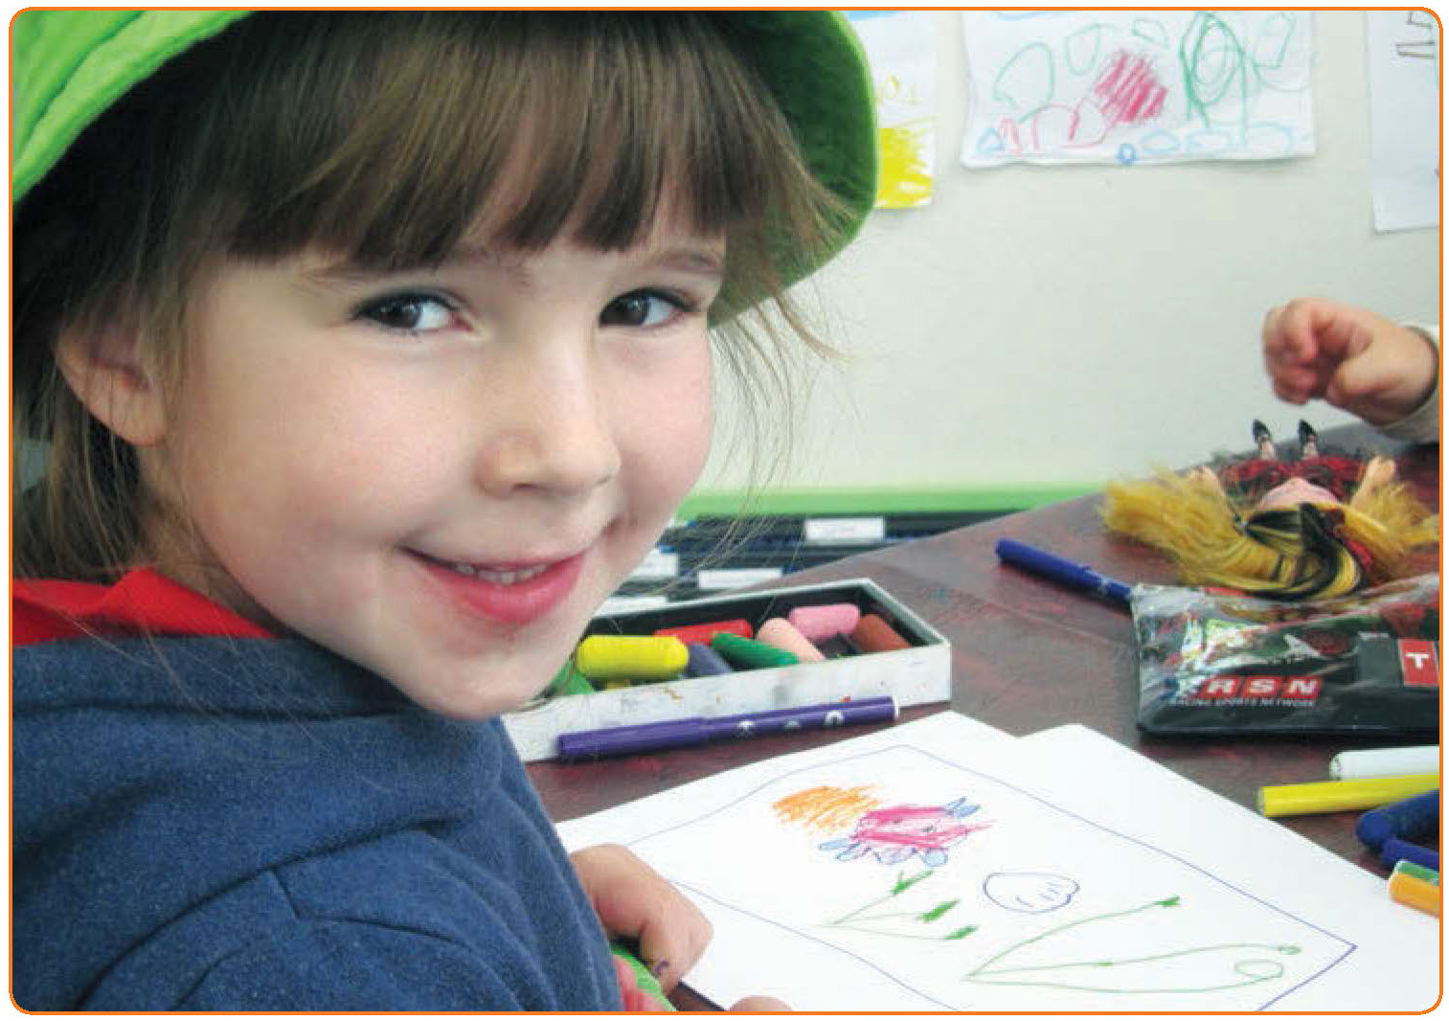

Transition to school age care
While the transition to school has been researched extensively across the last decades, this is not the case for transition to school age care, defined as “recreation, play and leisure-based programmes for children aged 5-12 years in before and after school settings, and in the vacation periods” (Cartmel, 2007, p. iii). School age care services are primarily, but not necessarily, located on school sites. Despite this, staff are not necessarily considered to be members of school staff. One of the consequences is lack of clarity about roles and responsibilities around school-family communication. This is particularly relevant for children and families making the transition to school, where interactions between families and school may be mediated by school age care staff (Cartmel, 2007; Dockett & Perry, 2006; Garey, 2002). While children’s involvement in school and school age care has the potential to build collegiality between and among school staff, school age care staff and families, it can also present challenges when school age care staff are regarded – or regard themselves – as ‘outsiders’ to the school environment, even though they might be co-located with schools (Cartmel, 2007).
For many children, starting school also involves starting school age care. Over 315,000 children attended approved outside school hours care in 2012 (DEEWR, 2013). While the average attendance at school age care was 11.5 hours per week (DEEWR, 2013), attendance patterns varied considerably. Some children attend school age care irregularly; others for a few hours each day, possibly before or after school; and still others for up to 5 hours each day (Cartmel, 2007). In the latter case, children can spend almost as long in school age care as they do at school.
School age care can provide continuity in contexts of change:
Each year children may change classrooms and teachers, but a stable school age care setting can provide children with that strong sense of belonging to help sustain them through change. (DEEWR, 2012, p. 67)
The availability of school age care is one of the factors considered by families in selecting schools. Positive experiences of school age care are linked to positive engagement with school, both for children (Moss & Petrie, 2002; Simoncini, 2010), and families (Petrie, Egharevba, Oliver, & Poland, 2000).
In many instances the issue of transition to school age care, and the potential for school age care to support educational transitions more broadly, seems to have been overlooked. This may be because school age care is seen as supplementary to education and hence, not considered to be educationally focused. Indeed, the importance of school age care being focused on children’s leisure and general wellbeing, rather than an extension of school, has been argued strongly (Cartmel, 2007; Smith & Barker, 2002). Despite this, there have been calls to consider school age care as an integral – though unique – part of educational systems (Pálsdóttir, 2010) and to recognise its contribution to engagement with, and outcomes of, education.
While the research base around school age care is limited, it is reasonable to assume that the same elements that underpin a range of other effective educational transitions (Perry et al., 2007) also apply to the transition to school age care.
These emphasise:
- The importance of relationships
- Focusing on strengths and competencies, rather than deficits
- Promoting inclusivity, rather than exclusivity
- Responsiveness to local communities
- Dedicated support and resources
- High quality programmes.
Further, the characterisation of transition underpinning the Transition to School: Position Statement (ETC, 2011) also seems relevant when considering transition to school age care.
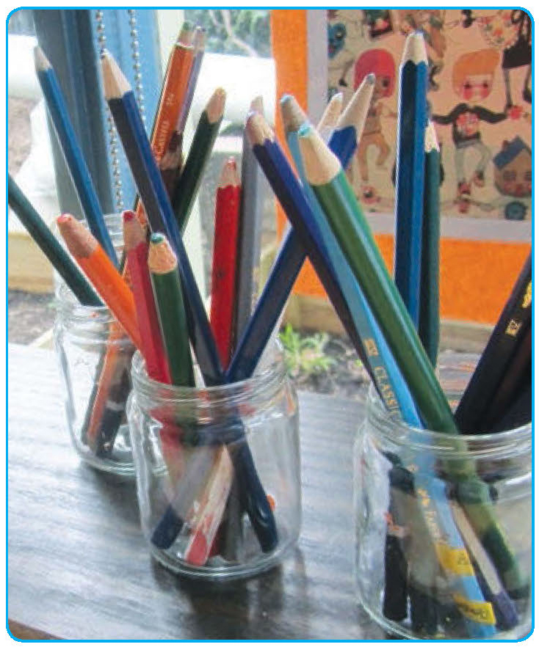

Section 3: Principles and practices

Principle 1:
Secure, respectful and reciprocal relationships
Effective transition practices have, as their base, a commitment to building secure, respectful and reciprocal relationships. One outcome of such relationships is that all participants regard themselves – and other participants – as valued members of the school community (Dockett & Perry, 2001).
Children, families and educators experience changes in relationships as children start school. These can include losing contact with some people, building new relationships, and maintaining established relationships. For children with special education needs and their families, the changes in relationships are often major, as prior-to-school support ceases and new relationships with new resource staff need to be built (Dockett et al., 2011; Rosenkoetter, Hains, & Dogaru, 2007). More than any other element of transition, relationships between and among children, families and educators are the basis for continuity between home, prior-to-school, school and school age care settings (Dockett & Perry, 2007).

Relationships involve a wide range of people and can take many forms. For children, relationships with siblings and peers play an important role in helping them adjust to school (Dockett & Perry, 2013b; Ladd et al., 2006; Peters, 2003), and early, positive relationships with educators influence ongoing relationships as well as educational outcomes (Jerome et al., 2009; Mashburn & Pianta, 2006).
The quality of adult relationships also impacts on experiences of transition. Family relationships with educators, and educators’ relationships with each other – be they prior-to-school, school, school age care educators or school principals – provide models for children’s relationships with educators.
They also generate collaboration which is focused on supporting young children as they make the transition to school and school age care (Dockett, Perry & Kearney, 2012).
While there is consensus that relationships are important during transition to school and school age care, there is less agreement about what constitutes secure, respectful and reciprocal relationships.
In their extensive study of social interactions and successful educational environments, Bryk and Schneider (2002, 2003) outlined four elements of effective social relationships – which they labelled relational trust. In the context of transition to school or school age care, these elements reflect:
- Social respect – acknowledgement that many people are involved in children’s education and educational transitions. Social respect involves valuing the contribution of each of these stakeholders – including children, families, educators, and community members.
- Personal regard – seen in the willingness of participants in transition to create and maintain a climate of openness, to listen as well as to share information, and to engage in genuine discussion.
- Competence – where each is regarded as competent in their roles. This involves recognition of the competence of parents and families, as well as the competence of educators to promote sound outcomes for all children. Most of all, the competence of children is recognised.
- Perceived integrity – where all involved are consistent in what they say and do. Integrity also requires that principles of everyday ethics are applied and there is a strong sense that all involved are committed to the wellbeing of those making the transition.
These elements form the basis of secure, respectful and reciprocal relationships which, in turn, have the potential to generate supportive and effective educational environments.
While there is consensus that relationships are important during transition to school and school age care, there is less agreement about what constitutes secure, respectful and reciprocal relationships.

Narratives
- Jason: Friends and buddies
- Communication is the bridge
- All about school: A book to build connections
- Community picnic to celebrate starting school
- Play days help link children and parents
- The importance of time
- Reflecting the community
- Knowing names
- A safe, secure place
- Christmas card
- Big buddies
- Goodbye from preschool is an important part of transition
- Feeling welcome
- Advice for transition
- Riding the bus

Jason: Friends and buddies
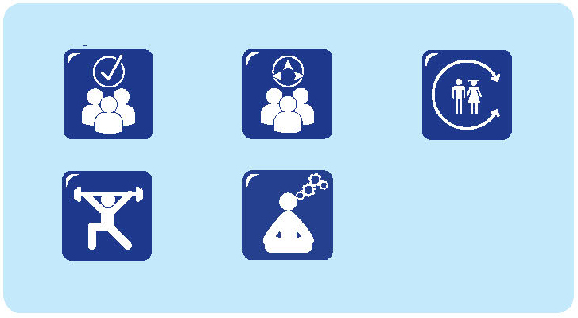
Jason had recently started school. He talked about his experiences as he drew.
I felt scared on my first day of school.
Why were you scared on the first day of school?
Because I missed my mum, because school takes six hours and I missed her because it was my first day of school.
Do you remember coming to school before your first day?
I remember this school before I came here, we had set up games down there (in the school hall), we had lots of friends, and I remember Michael building a big tower.
When you came to school did anyone show you around?
My neighbour Oscar showed me around the school. My first buddy was Angel, and then it swapped to another buddy but I can’t remember her name.
What was special about having a buddy?
They helped me with work, and they helped us work and showed us even more around the school, there were some places we didn’t know.
What advice would you give someone coming to school?
You could tell them the rules, don’t run on the concrete or you could hurt yourself, and keep your hands and feet to yourself, so nobody gets hurt.
What were you scared of the most when you started school?
I know something that was scary; going to school on your first day without your mum and all that.
What helps to make it feel better?
Look for a friend and just have a little drink, try and stay calm.
How do you stay calm?
Try and not think about it.
If you’re coming to school, and you’ve never been to school before, and you think you need a friend, what is something you could do if you wanted to make a new friend?
Play with them and then the next day you can play with them again and then they will probably be your friend, if you keep playing with them, that’s how I got my first friend.
I know another way to make a friend, be nice to them and then they will be nice to you and you can become friends maybe.
QA 1.1.6; 5.1.3; 5.2.1; 6.3.2

Communication is the bridge
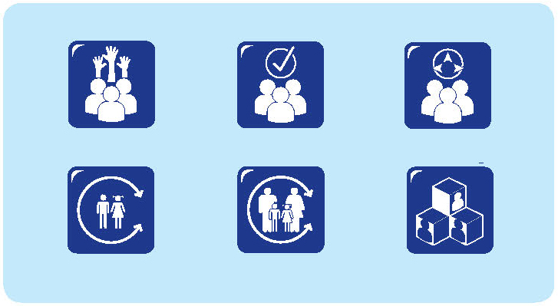
Daniel is the director of a school age care service located on the grounds of a primary school. The service provides before and after school care as well as vacation care, operating from a building located between the preschool and the primary school buildings. Daniel has an early childhood teaching background. He describes his approach to building communication with families and other educators.
Before families start, we encourage them to come and visit. One visit is OK, but if they come to visit several times, they get a better idea of how the service works. We also have an information pack we give to families. We work our service on a primary carer model, so we aim to have staff making connections with children and vice versa.
Before school hours care is available from seven am and is provided by one staff member because of small numbers. We provide breakfast and see this early time as a quiet indoor time. Eight o’clock is considered wake up time and the children become more active. The older children go to their classrooms at eight thirty. I walk with the preschool and first year of school children to their classrooms.
The after school hours programme caters for larger numbers and involves two staff. The preschool and first years of school teachers walk with the children to our building. We have a buddy system, so that the younger children feel supported and the older ones can have some responsibility. The children eat afternoon tea with their buddies – they usually sit in groups together. Afternoon tea is generally finger food that the children help prepare. The programme is planned around listening to what children want and need, balanced with the outcomes in the Framework for School Age Care.
We make sure we provide drama and play opportunities each day along with a ‘chill out’ space for those children who need time to sit quietly and relax. One of the challenges we face is the balance between providing an exciting programme that caters for the children’s interests and needs and some parents’ requests for homework to be done. We hold the position that we do not want the centre to become a ‘homework club’. We have a family night each term to build strong connections with and between families. Sometimes, children are keen to share with their families the things they have been doing in school age care. We have had some really interesting drama performances and art exhibitions!
In terms of governance, we have an advisory committee with representation from families, the school principal, the preschool director and the school age care director. This group is also linked to the governing council of the school. The advisory committee has developed a policy to ensure that communication between educators, school age care staff and families is both effective and timely. We have developed an information of importance half page form and have criteria for what defines this type of information. The form is filled in by the educator responsible for the child at the time and then handed in person to the next educator who has responsibility for the child. A copy is given to the office for the information of the school principal and filing. What this means for our staff is that if a child has, for example, been upset because they have lost something or had an altercation with another child during the day, I get that information when the child comes to the centre and can be alert to their wellbeing. Then I can share this with parents when they collect the child and write a very brief statement about how the child was and share this with the classroom teacher with a copy to the school principal.
This sounds like a lot of work but as a school community we believe it is important to know the child in the context of their whole school day. We want to be seen as a community not a group of single educators. Children’s wellbeing is paramount at our service and this communication is the ‘bridge’ to support children as they move from one setting to another.
QA 4.2.2; 4.2.3; 6.1.1; 6.1.3; 6.3.2

All about school: A book to build connections
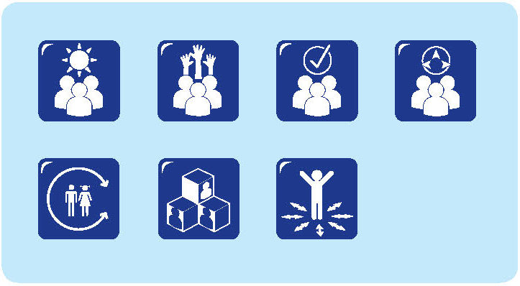
Children who attend our children’s centre will move to many different schools – too many and across an area too large to participate in all the transition programmes. To help manage this and to promote connections between children and the various schools, we have a scrapbook – All about school – about transition and we invite children and families to share information in this book. Educators also make contributions. The book is available at all times on a special table for children, families and educators to contribute to and to read and review.
The introduction to the book describes its purpose: for children to share their stories, questions, concerns, expectations, excitements, experiences and knowledge about school. We use the book to connect children’s school and preschool experiences and to make sure that we are listening to any of the issues or concerns that children have, as well as the things they find exciting. So far, in the book, we have some discussions – where parents or educators have scribed what children have wanted to say – questions, drawings and photos. The children have been very keen to share their entries with the others at the centre and we talk about the book a lot. Because it is difficult for us to visit all the schools they will attend, this book provides a way to share their experiences, and to make connections with preschool, as well as with other children’s experiences.
When children visit their school, or try on their uniform, they document it in the All about school book. We find that they start to identify themselves as a school student, and we encourage this. They have really taken ownership of the book, and there is a sense of belonging coming out of it... this is MY school, MY uniform, this is going to be ME...
We have found that their knowledge of school has grown, and they are very positive about making the transition to school. They seem to be aware of some of the challenges they will meet at school, but talk about these in a positive way.
The children are excited when we share the book. They know who will be going to the same school. Some know which schools other children will be going to as well. We use the book in discussions and talk about any things the children are not sure of, as well as the things they can’t wait to tell us. We have learned a great deal from the book as well.
The parents have told us that the book has helped reduce the anxiety some of the children were feeling. They are keen to share it with parents, and to have parents help them contribute to the book. Steve’s mum said he had shown her the book, and the pictures he had drawn, as well as the friends he will have at school. She said he was proud of going to school and wanted a photo at the front of his school, as well as a photo in his uniform – all to go in the book. She thought that he had become much more confident than he had been about starting school.
QA 1.1.2; 1.1.6; 5.1.1; 5.1.3; 6.3.2
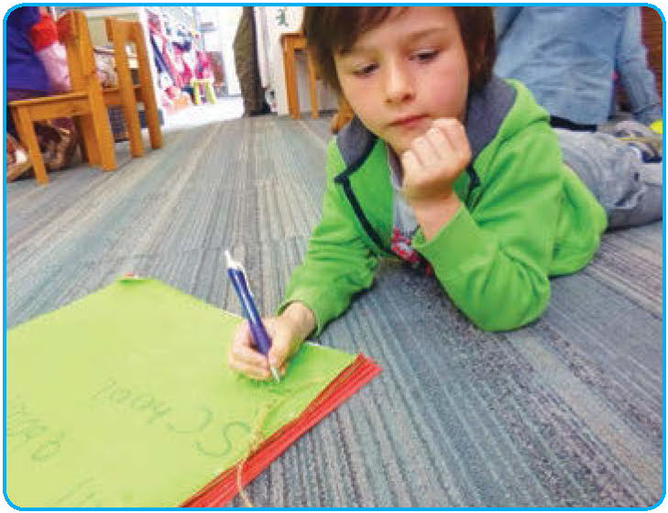

Community picnic to celebrate starting school
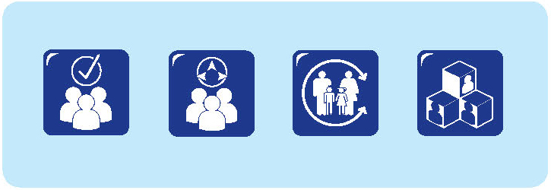
For 10 years one community has celebrated their children starting school through a community picnic. Initially organised by a network of early childhood education professionals, led by the Children’s Services Coordinator from the local city council and lately organised jointly by the coordinator and an early childhood services provider, the School Starters’ Picnic grew out of attempts to increase community awareness and participation in transition to school.
Throughout the city, children who are eligible to start school in the following year are invited to the picnic. These invitations are distributed through schools, prior-to-school settings and the local press and electronic media. They have the imprimatur of the local city council and the backing of the Lord Mayor. The picnic is held in October or November in the year before the children start school, providing everyone with a reminder that they need to be considering what is involved in starting school well before the first day.
Over the years corporate sponsorship has provided special hats for all the children who attended, backpacks and other materials of use and interest to the children. Information bags have been distributed, containing materials for children, as well as relevant information for parents about helping their child make the transition to school. Activities at the picnic have been run by schools, interagency groups, prior-to-school providers and various other community groups. Local community groups and performers have provided various forms of entertainment including music. As well, there is a junior farmyard, appearances from the local rugby league team and other community groups. All activities are free and there is a sausage sizzle and mobile coffee shop. The picnic has always been supported by the Lord Mayor, who attends and, in opening the picnic, typically describes the importance of school transition. The School Starters’ Picnic has become an expected event in the city’s calendar and one that is much anticipated by children starting school and their families. The first picnic in 2005 was attended by about 60 people. More than 400 people per year are now attracted and there is valuable media coverage which further enhances its impact.
One major attraction at the picnic, especially for those children starting school, is the appearance of the city’s transition to school ambassador, Billy Backpack. The children get to sing and dance with Billy who has his own special starting school song, written and performed by a local band. Billy was the winning design from a community competition held across all primary schools in the local area. He has grown to be the face of the transition to school in the area and is so popular that he has needed to be cloned.
Through the picnic, starting school is marked by the community as an important time. Awareness is raised and children and families are celebrated. Information can be shared and connections made. The Starting School Picnic has become a community institution. It is a central part of the overall agenda for transition to school in the city.
QA 6.3.4

Play days help link children and parents
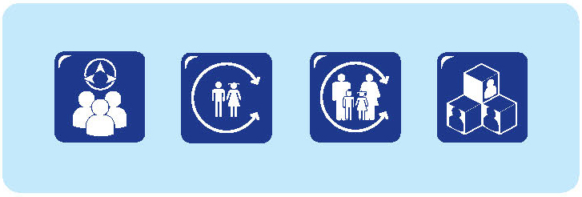
At the school orientation meeting in November last year, parents were told who would be in their child’s class and who their teacher would be. My daughter, Sara, is the third in our family to start school and we did not have this information for the others. In fact, classes and teachers did not seem to be decided until well after school had started in the new year. So, it was a bit of a surprise but Sara was very pleased to know because her best friend Tracy was in her class and she knew the teacher from earlier transition to school events.
Another thing that did happen at the same orientation meeting was that there was a parent from each class nominated by the transition to school coordinator to be the central contact for families from that class. We were all asked to provide contact details – phone and email address – to this person who in the case of Sara’s class was Maria. I did this but was a bit uncertain of why.
Just before Christmas, I received an email from Maria announcing that all members of Sara’s new class and their families were invited to a play date in a nearby park on January 5. This was described as a chance for children and families to get to know each other. Once Sara knew that Tracy would be there she was very excited about the date.
On the day, 15 of the new children with at least one of their parents or grandparents and sometimes siblings, attended the play date. When we arrived, Tracy was not there and Sara found it difficult to find anyone to play with. She soon met Corinne and they played on the seesaw. I got to meet Corinne’s mum while they were playing. Once Tracy arrived, she joined in with the others.
I know Tracy’s mum quite well. She met Corinne’s mum – Ingrid –and we had a great discussion about lunchboxes and other school things. By the end of the day, Sara and I had met lots of children and parents and made some connections. We decided to meet again in January, before school started.
The play date was very easy for Maria to organise. People came and went as it suited them and some children and families did not attend. Sometimes this was because they were away on the day; sometimes it was because they did not feel comfortable attending. Play dates do not work for everyone but this one certainly worked for Sara and me.
After the play date, Sara knew a lot of the children in her class on her first day, and I knew I could talk with other parents about anything I needed or was concerned about.
The play date worked because we knew which children were going to be in which class, well before Christmas, and because a parent was willing to be the class contact.
It was a really comfortable way to meet the people we would see at school.
QA 6.3.4

The importance of time
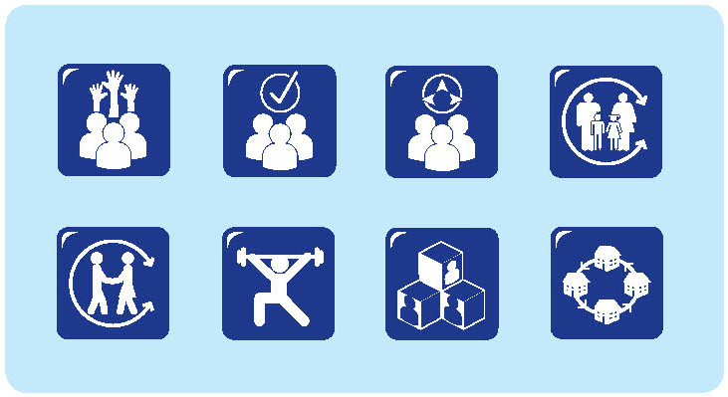
Our children’s centre operates as part of a community hub. Some of the families who use our services have complex needs. That can mean that we make referrals to a lot of other services and that other services refer children and families to us. To make this work, we need to have really good relationships with the other services but we also need to have really good relationships with the families if they are to get the support they need.
Our approach is to take the time to get to know the families. From our experiences, we know that building trust and confidence takes time. We are located in a small community, so we are also very much aware of issues about confidentiality. If families are to trust us, they need to know that we take confidentiality very seriously and won’t be sharing their details with everyone who comes in.
We have a process that we follow to negotiate consent with families, so that we can share the information that is relevant to support them into services and into school. But we are also very concerned that families are not let down by that exchange of information between professionals. We are proud that this has not happened at all.
Referring families to additional services requires careful consideration and negotiation. My strategy is to engage with the parents, build their confidence and trust and work through the services with them. It’s a real advantage to have strong links to an early intervention service.
Our approach is to take the time to get to know the families. From our experiences, we know that building trust and confidence takes time.

Often this means that we can work with families to identify children with special needs and have them access support before they go to school. The other advantage of working closely with the early intervention services is that we can take away some of the stigma that often goes with accessing early intervention and support.
The services come to us and work with the children here in the children’s centre. We have negotiated consent for this with the parents and we work on the understanding that they might be working, or not able to take the child to the services, and sometimes it is just easier for this to happen in the child care environment because it is easier to do the assessments in this space. The children here are used to having many different people coming in from the community. Having people come to us enriches the programmes and supports the educators in extending their programmes.
It’s also good for consistency for the children, because we can all be working on the same things together. There are real advantages for children getting support in their usual play environment as well – they know us, they know the environment and they feel comfortable. It’s also good for the parents to get that additional support through being able to access different services through the centre.
We work on building relationships. We’re here to support families – their wellbeing as well as their children’s wellbeing. Sometimes, we‘ve known the parents and children for two years and it may have taken a good six to nine months to actually engage with them, to get their confidence and to be able to support them. If that has to happen each time they need to access support, it would take a long time to get things happening.
We know it can be hard for families to be referred to services – both to the early learning centre and other support services. When they have to attend it can take a really long time to break down the resistance and barriers that have been created.
With some families, I’ve spent a long time working to build up their confidence and trust. It’s taken a while, but when I can talk with a parent and ask Is this OK if I ask you this? and they say yes, and talk to me about the issue, or even give me a hug when we have finished, I know we have come a really long way from the early times when there may have been some real resistance. It can be tough, because we may need to talk about child protection issues and behaviour or other serious concerns, but in the end it is beneficial for everyone if we can build those positive relationships.
We work on building relationships. We’re here to support families – their wellbeing as well as their children’s wellbeing. Sometimes, we‘ve known the parents and children for two years and it may have taken a good six to nine months to actually engage with them, to get their confidence and to be able to support them.

One spin off I have seen as well is that when we have good relationships with families in the children’s centre, it can have an impact on how the family is viewed in the community and the school.
Sometimes, it has taken lots of time and listening and no judgement. But there is a real pleasure when you start seeing success stories in the school newsletter, particularly when you know where the families were previously. You know that the persistence was worth it.
It will always be an ongoing process. But when families are coming into the environment and they see people who care, they feel comfortable.
Transitions are easier because they feel like they belong and they know they can trust us, they know we are not going to let them down. It doesn’t matter if the children have already made the transition to school; they know they are always welcome.
When I have spent such a long time building relationships and it is working well, I try to model what I do for other staff and families. There is always some element of staff turnover and I think it is important to be very clear about the strategies that seem to work in building positive relationships.
It can be very easy to make good connections with families we think are like us, and much harder to make those connections with families who may not have chosen to use the service or who have complex support needs.
We try to build good relationships with all our families and we start that process by being positive and understanding that some relationships need to be built over a long time.
QA 4.2.3; 6.1.3; 6.2.2; 6.3.1; 6.3.3; 6.3.4

Reflecting the community

Our centre provides preschool education for Aboriginal children. It is located within the community and has strong links to the community. We have children from the community attending and we have people from the community working in the centre and accessing training as well. When children and families come to the centre, it feels like an extension of the community.
We aim to make sure that the community feels connected to the preschool and the preschool is connected to the community. We have several community noticeboards around the centre where people can post information about coming events. We also have photos of people in the community who are involved in different groups and organisations: the local medical service, the Elders, and some of the groups they are involved in.
Also, we include information about NAIDOC week celebrations and other relevant things. When the families arrive, they often look at the noticeboard to see what is happening. It’s fantastic when the children can see someone they know on the noticeboard.
Recently when we took a group of children to visit the school, we noticed that they had also started a noticeboard for community events.
The children were very excited to see some of the same information from preschool here on the school noticeboard, including some people they knew, or were related to. It was a really important element of continuity – to see that the school valued what was happening in the community as much as we did.
We aim to make sure that the community feels connected to the preschool and the preschool is connected to the community.

QA 6.3.4

Knowing names
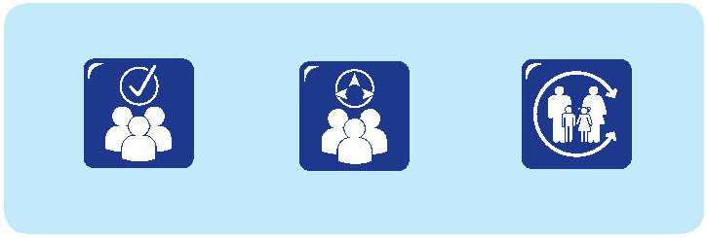
Rani and her family have recently moved into their own home having previously rented in another area of the city and also having lived overseas for extended periods. Rani’s father is from India and, after Rani and her sister were born, the family returned to India and shared a house with Rani’s father’s extended family (as is the tradition).
Each time they have returned to live in Australia, Rani has attended an inner city child care centre. While Rani is quite a shy child, she revels in contact with children and adults alike and, for her, an important part of these relationships is knowing people’s names and them knowing her name and also knowing about her family.
By the time Rani started school in her new neighbourhood she had visited the school several times with her family, playing in the playground and on the oval, and had attended a family and community function at the end of the previous year.She had also participated in two of the four orientation visits because her mother had noticed a sign outside the school and had been able to arrange Rani’s participation.
Rani is an articulate child who had engaged confidently and actively in the preschool programme at the child care centre. She has strong support from, and involvement with, her extended family who felt that she would very much enjoy being at school.
During the first few weeks her enthusiasm for being at school was not what the family had anticipated. She seemed to have a positive connection with her teacher and talked about her day but the ‘spark’ that had been anticipated was not there.
One day, on their way to the beach, her grandmother asked how school was going. Rani talked about the teacher, the routines and her success at managing her lunch box but then added Nana, there are lots of people there and I don’t know their names. It unfolded that she was concerned that she did not know the names of all the children in the class and that they did not know her name.
Nana started to play games with Rani to help learn the names of the other children in the class. They tried to recall who sat next to who, whose names were listed on the news chart and even whose names were listed on the board most often.
By the time Rani started school in her new neighbourhood she had visited the school several times with her family, playing in the playground and on the oval, and had attended a family and community function at the end of the previous year.

Over time, Rani was able to recite the names of all the children in her class.
QA 6.2.1; 6.3.2

A safe, secure place

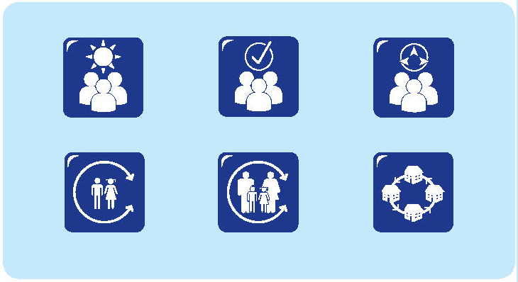
Aunty Jess has an integral role in the transition programme. She is employed by the school as the Aboriginal Home School Liaison officer, but she does much more than that title suggests. She helps me a great deal in my role as a first year of school teacher, and I know she helps others as well.
She has strong links to the community, so she is able to talk with families about starting school and let them know what needs to be done about enrolment and other aspects of starting school. She can also let us know who we might expect and how we might best get in touch with them.
With some families, we send letters inviting them to come and visit. We phone other families and with some others, Aunty Jess talks to them at home.
The children and families find it very comforting to have Aunty Jess involved in the transition programme. She is a familiar face and a sense of security. Often the children and families will go to her for information or for a chat, before they will come to the teachers. It’s a bit easier to ask things of people you know.
The children all call her Aunty Jess and that helps as well. It’s a bit easier than getting your tongue around Mrs Smith or Mr Jones.
It is great that Aunty Jess is the link between us and the community. But we also have to be wary of assuming that she has to manage everything related to Aboriginal children and families. We are very happy for Aunty Jess to take the lead and advise us, because she knows the children and the families and the community, but it is also up to all of us to build strong connections with all of our children and families. So, we work together to get to know them.
Aunty Jess is involved in all of our transition sessions. When the children start school, she spends the first term and often part of the second term as well, in the classroom.
She works with the teacher, but again remains that familiar face for children and families. I’ve often seen her sitting in the playground with a group of children around her. There’s a real sense of comfort and belonging that comes from that group.
The children come and go, and many play with the other children in the playground, so it’s certainly not limiting their interactions; it’s more like there is a safe, secure place to come back to.
QA 4.2.2; 4.2.3; 6.3.4

Christmas card
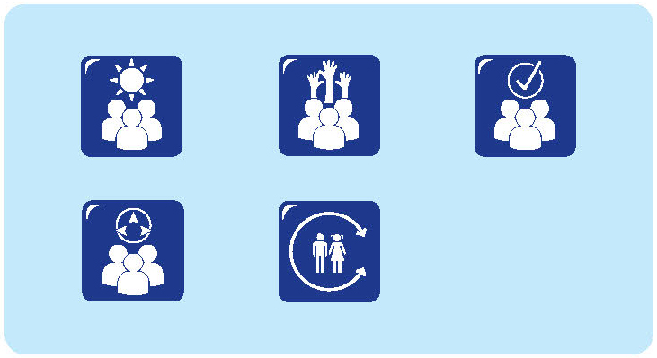
Every year I get the list of children who are starting school and I write them all a Christmas card or a holiday postcard. The children moving into Year 1 get one as well. So, I get to say hello to the new group and a sort of goodbye to the class I have had all year.
The postcard is just to help the new children get to know me and to let the older ones know that I still care about them. So, I talk a little bit about my Christmas and what I’ve been doing and I try to reflect on something that I know they might like.
I’ve met the new children several times, so I have an idea of some of what interests them and I can make it a bit personal.
I went diving at the beach and saw a stingray. I knew one of the children was interested in stingrays, so I told her about that.
Then I talk about how I’m getting ready for school and how I’ve started to put labels on books or I’ve started to set up the classroom.
I ask if they’re getting ready for school as well, and maybe ask about their uniform, or their lunch box. I tell them I’m looking forward to seeing them soon at school.
This year, Clare wrote back to me. She had some concerns and her mum helped her write back to me to tell me about them.
She was a bit worried about what she was going to do in the school playground, because she was used to the preschool playground and lots of equipment to play with.
So I could reassure her. As well, it helped me plan to have our lunch over in the preschool playground one day a week and I decided to set up an activity centre in the playground for the children who were a bit concerned about what they might do.
QA 5.1.1; 6.3.2

Big buddies
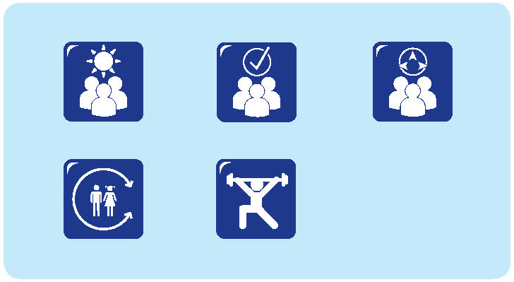
A group of Year 5 buddies shared their experiences of being a big buddy. Their school is situated in a community characterised by high levels of cultural and linguistic diversity.
What’s special about your school?
This is the best school. We have lots of things in the school and we get along with other people. We learn lots of things, but at the same time we want to enjoy things as well. We’re in Year 5, so most of us have been in the school for a long time.
This is a generous school. We donate things to other people who have been in the bush fires and lost their homes. We donate money, but make it fun so we have a mufti day or wear different clothes.
There’s a variety of people here. Like some come from Asia, some are Australian born, some come from America, England. So you get to meet people from different cultures and different races. And it’s really fun to meet them because you know a friend that isn’t born in the same place as you are, so you can learn more things about them and they will learn more things about your culture.
How did you feel about your first day at school?
Very happy because it’s your first time going to school, and then you meet all these different people and then try and make friends.
I felt short because everyone was taller than me in kindergarten. It made me feel lonely.
I was actually a bit scared but then I realised that my family friends were at school with me and I was alright. I started crying because I didn’t think I knew anyone, but then when my parents left they thought I was going to cry again, but I was brave.
…you get to meet people from different cultures and different races. And it’s really fun to meet them because you know a friend that isn’t born in the same place as you are, so you can learn more things about them and they will learn more things about your culture.

I thought school was like a different planet. I thought I was the only one living on this earth with my family so when I went to school I felt really scared.
I was a bit curious about what was going to happen at school, with activities and things.
I felt a mixture of excitement and scared and kind of loneliness. And then my friend was away on the first day and I kept thinking ‘When is he going to come, is he coming tomorrow or next week?’ And then he never came, but he came the next year, so it was like I got new friends.
What makes a good buddy?
Knowledge and discipline, because next year they will find it easier to understand what they have to do in school life.
Listening to them so you know what they want and if they are doing something naughty, telling them not to do it. And then listening to what they want so then you know.
You let them do what they want and then you help them if they need it.
Being helpful to each other so if they can’t do this, you should help them try to figure out what to do and how to do it.
You need to set a good example, because next year we are Year 6. So you need to be calm. You have to control your temper and stay calm.
I think also encouraging your buddy to do things. Because sometimes they’re too scared to do things, so maybe you need to encourage them.
What’s good about being a buddy?
Seeing the children happy about starting school. Being looked up to as a role model.
Helping them in time of need and when they need to learn something you can just be there and they’ll learn.
How do you think you’ll feel when you start high school?
The same feeling when we started school because we’re starting in a new school and we may not know other people.
Happy because some friends that you know might go to the same school.
I’m scared because it’s like going to an unknown world like, you don’t know anyone there and you don’t know what you’re going to be doing.
Like we are starting school again, although we might have a bit more courage because we know it’s going to be better and soon we’ll be in Year 12.
I think that when you start in a different school, you’ll be scared but at the same time, you will have more courage and you can make friends straight away.
We’re walking into a new world with no one that knows you, but now your friends might be there to help you.
And you might not feel scared because you’ve already felt the experience, but you can feel a little bit scared and nervous because there’s older people who are smarter than you.
I was actually a bit scared but then I realised that my family friends were at school with me and I was alright. I started crying because I didn’t think I knew anyone, but then when my parents left they thought I was going to cry again, but I was brave.
How do you make friends?
You make friends due to your personality. So, if you’re a nice person you will meet nice people.
You need to make a connection so that your friend is someone you go to, so that there’s always someone going to be there when you’re really sad or you need help.
And then if you see a friend doing something wrong, you have to tell them not to do it, because you need to be a good friend and your friend needs to be a good friend to you.
You need to be trustworthy so they know you can help them whenever they’re hurt or stuck in something.
*NB Prep is the name of the first year of school in some states of Australia.
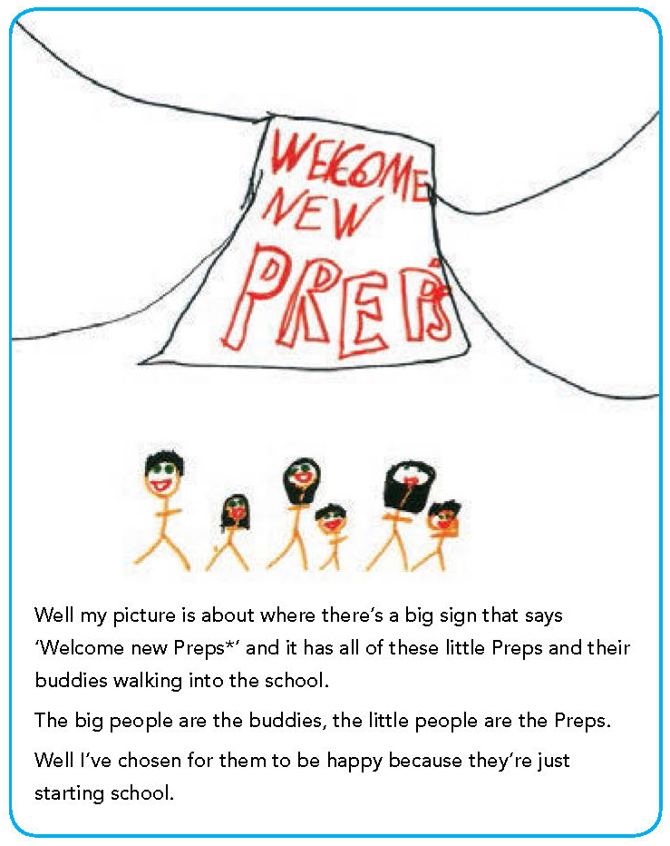
QA 1.1.6; 5.1.3; 5.2.1; 5.2.3; 6.3.4

Goodbye from preschool is an important part of transition
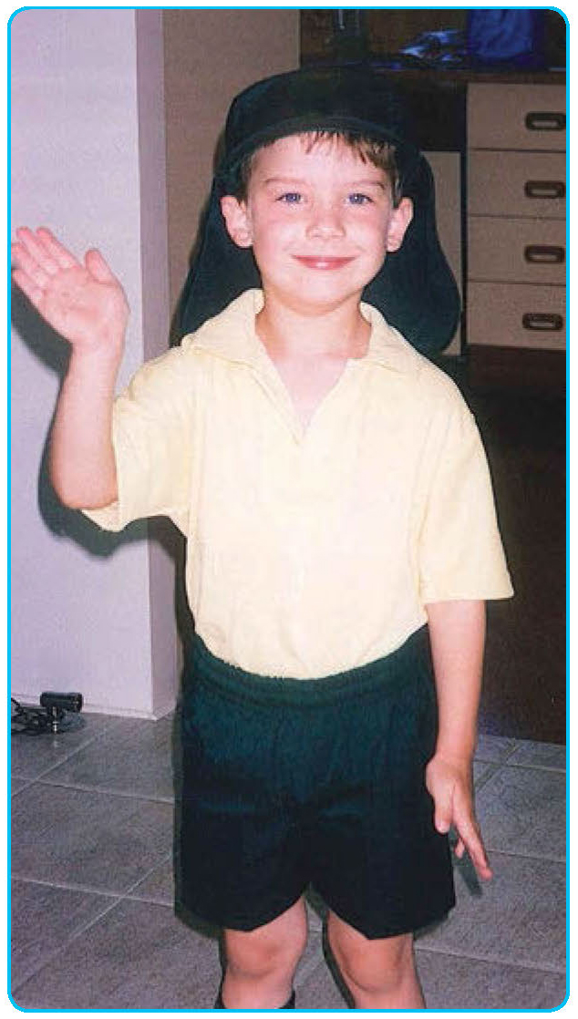
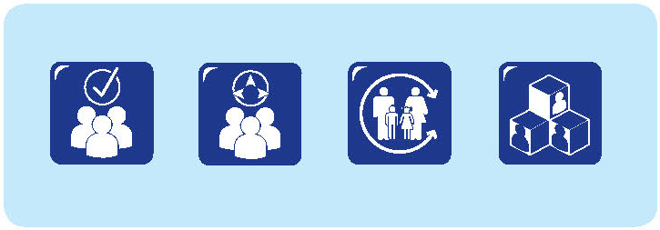
Peter is a teacher at the school his daughter Melissa attends. He reflects on the experiences in his family as Melissa started school.
My daughter Melissa started school this year. She loved her preschool experience – it was here on-site at the school. She was really confident when she did the transition visits and she knew the school really well.
Even though I work in the school, there were some really weird things. The weirdest thing for me as a Dad was the lunch order – schools take for granted what parents should know, but we don’t know it...
It was hard for my wife when Melissa started school – her little girl had grown up.
Things are different at school. Not like preschool... all those notes that come home all the time!
Goodbye from preschool is an important part of transition.
I found the portfolios given to us by the preschool quite amazing – they showed the children’s growth.
It was hard for my wife when Melissa started school – her little girl had grown up. Things are different at school. Not like preschool... all those notes that come home all the time!

QA 6.3.2

Feeling welcome

My input was valued
I am a Bundjalung woman. My culture is important to me and it is celebrated here at this school. The school recognises and works with my children’s strengths and the school works to meet my family’s needs. When we first started here I felt welcome immediately.
Straight away there was a welcoming…and so straight away I had this, instead of the barriers that normally get put up, there was How can we work to suit your family’s needs? And it was like a breath of fresh air, it really was. So I was engaged which meant that my children were engaged …we were all engaged. The school worked out how to work with us straight away.
It’s all about the relationships. I feel like I have really good relationships with the principal and the teachers. At the start, they would all be out the front of the school.
It was a real greeting, a welcoming into the school. Like you just feel it, you feel welcome. There’s opportunities to have conversations, and I could have conversations about our previous experiences. I felt valued as a parent, my views, my ways, were important.
My children are very different learners and that was valued. I felt that my input as a parent was welcome and seen as important.
I find that the communication with the school is really a two- way process. And whether it is catching someone to have a conversation or ringing up to talk to the admin person, I know the information will filter through.
Straight away there was a welcoming…and so straight away I had this, instead of the barriers that normally get put up, there was How can we work to suit your family’s needs? And it was like a breath of fresh air, it really was.
They made him feel special
Several other parents described a genuine sense of community about the school:
The communication is great. It’s never an issue to try and catch up with the teachers.
My son has additional needs. As busy as they were, the teachers always made him feel special and welcome.
You can come into the classroom at any time. You are always made to feel welcome. It’s great for parents to see what is happening, what the children are learning.
You don’t ever have to ask if you can come in early, or sit for 15 minutes or watch. It’s just like you can come any time.
There’s always opportunities to help out in the classroom. And they are never short of a thank you either. If you go in and help, you will always get a huge thank you.
When we first came to visit, there was no rushed tour. We were invited to walk through and ask questions. No one shut their door and said ‘You can’t come in, it’s lesson time’.
When the principal spoke with the teachers and the children you could see there was a lot of respect for each other. The children also talked with me and my son – it just felt like we would be welcome there.
QA 6.2.1; 6.3.2

Advice for transition
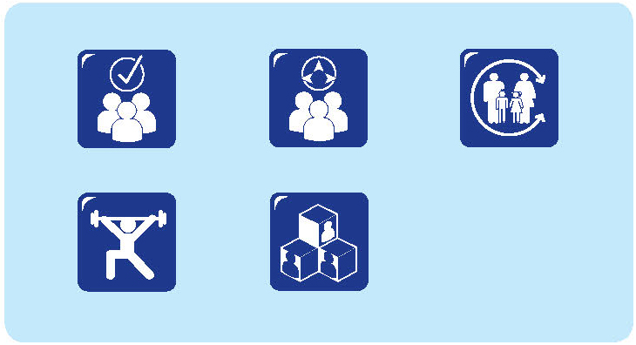
My husband and I were not really sure about which school would be best for our two children. So we visited some of the local schools and went to several information evenings for parents. The schools seemed happy enough for us to do this and we didn’t feel any pressure to make a decision immediately.
What convinced us to choose this school? It was the principal! We went to the information night and his enthusiasm was just so infectious, we were inspired. The principal and teachers seemed friendly, open and honest, interested in everyone’s children and keen to look at trying new things. As well, the school had a preschool on site, so it was a place where both our children could come to the one place – one to start school and the other to start preschool.
The eldest of our children, our daughter, is a fairly confident child but the orientation visits were scary for her. The children made the visits on their own, without their parents, who had to leave their children at the office. There was an expectation that they would fit into the classroom activity that was occurring and our daughter was a little bit intimidated by this.
From the parents’ perspective the visits were very rushed; you felt you were intruding on the class and it was hard because you didn’t know the teachers.
My advice? It would be better if parents could have dedicated one-to-one time with the teacher. There needs to be a welcoming process and way to involve grandparents if they are going to be bringing or collecting children.
Teachers knowing parents is as important as knowing the child. Parents need to meet the teachers as ‘adult to adult’ – this is who I am.
When our daughter started school she grew in confidence when there were older children to support her, especially her designated buddy. At the end of her first term at school the principal invited the parents of the new students to a meeting to discuss the transition process and ways that it might be improved. This was a very positive meeting and parents suggested some of these things:
- a longer transition period with ongoing opportunities for parents to talk with teachers about their child and family context
- clear and regular communication about what is happening for their children, what is expected of them and ways that the parents might be involved
- more consideration to be given to the activities that are provided at the beginning of transition visits – so that the classroom is welcoming and includes activities that the children are familiar with, like painting, water play, an investigation table, cutting and pasting, construction and so on, and with children free to choose from these
- activities and opportunities for children and families to get to know each other
- teachers being able to talk with parents by name.
The principal and the teachers have taken these suggestions on board. I can already see some changes in the way things will be done when our son starts school.
QA 6.1.2; 6.2.1; 6.3.4

Riding the bus
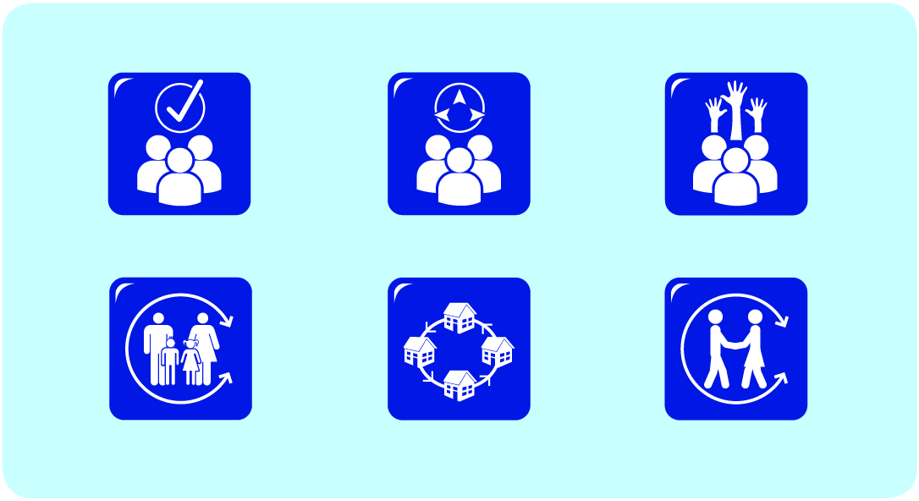
I am the deputy principal of a small school in an Aboriginal community. Whenever I can, I like to get on the bus and be part of the pick-up for the children as they come to school. Sometimes that is difficult because, as deputy principal, I have a few other things that demand some attention. We are a small school in a rural area and there is not a lot of public transport, so the school bus is a really important part of helping children get to school.
We have a large number of Aboriginal children who attend our school. We have good connections with two early childhood services in the area, and we make contact with families mainly through these centres. When the children come to school, we try to maintain the relationships with families, but have to find creative ways to do it, because the children no longer attend the early childhood services.
I find that regular phone calls are a good way to keep in touch, and it always helps to say hello when families are at the school. But it is difficult for some families to get to the school.
The school provides a supported bus service that goes out to pick-up many of the Aboriginal children and, sometimes, the families as well.
I like to be on the bus. It gives me some time to talk with the children and for us to get to know each other. I also get some time to talk with the Aboriginal Home School Liaison Officer and share some of the things she manages in her day to day role. I like to be seen out in the community – it’s much easier for families to talk with me when they know who I am and what I look like and when we are in some place other than school.
I think it is important for the teachers, as well as the families, to see me on the bus. It sends the message that relationships with children, and families and communities are important, and that we all have the responsibility to build relationships. If I can model one way of doing this, I hope others will see it as a normal and expected part of their role.
QA 6.3.4
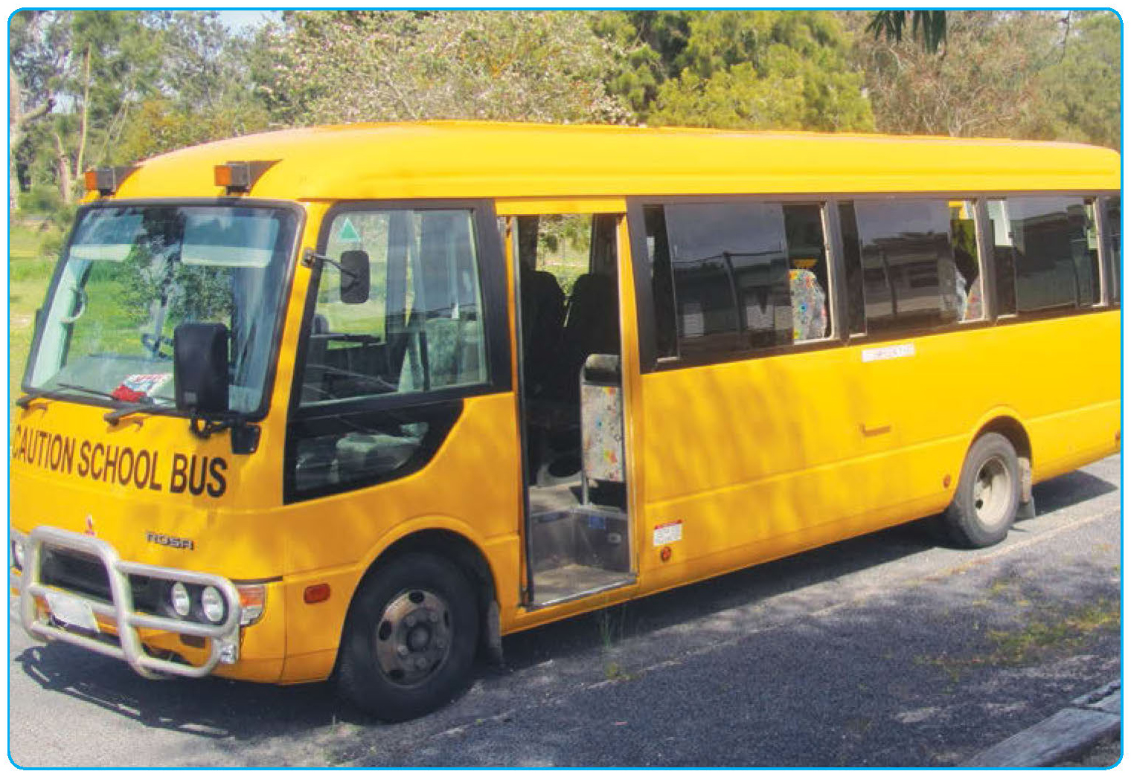

Principle 2:
Partnerships
Many partnerships support effective transitions. Partnerships between educators and families recognise and respect the critical role of each in the lives of young children; partnerships with community confirm the importance of early childhood education within that community; partnerships with other professionals set the context for consistency and continuity as children move from one educational setting to another; and partnerships between educators and children convey a sense of value and respect that promotes learning and development.
While each partnership is unique, effective partnerships extend secure, respectful and reciprocal relationships by focusing on common goals. They are characterised by:
- respect for the knowledge, expertise and contributions of each partner;
- mutual respect and trust;
- willingness to engage in open communication;
- reciprocity;
- shared decision-making; and
- working towards common goals.
(Blue-Banning, Summers, Frankland, Nelson, & Beegle, 2004; Dunst, 2002; Lumsden, 2005).
Forging effective partnerships across the early childhood and school age care sectors can be both challenging and rewarding, as educators work to “realise and value diversity while simultaneously forging common directions that foster a just and humane society” (Tayler, 2006, p. 262).

Partnerships with families
The importance of partnerships between educators and families is embedded within The Early Years Learning Framework and Framework for School Age Care. The common goal of these partnerships relates to promoting children’s learning outcomes and wellbeing. This is achieved when families and educators work from a base of responsive relationships; communicate their expectations and attitudes; share relevant information; promote flexible ways of interacting around common goals; acknowledge the strengths they each bring to the partnership and commit to working from these. This approach reflects family-centred practice (Davis, Day, & Bidmead, 2002; Rouse, 2012).
Effective partnerships between educators and families integrate actions that promote positive relationships – such as active listening, empathy, respect, non-judgemental responses and the creation of culturally safe spaces– with processes that facilitate opportunities to discuss possible actions and shared decision-making (Rouse, 2012). They recognise the diversity of families and connections between educators, families and communities (Mason-White, 2012).
Strong and committed leadership underpins many partnerships between educators and families (Bull, Brooking, & Campbell, 2008; Tayler 2006). Educational leaders play important roles in determining the educational climate and culture of an organisation. When they work actively to build and promote partnerships, educational leaders demonstrate their regard for partnerships and model strategies to enact them.

Partnerships with communities
Partnerships with communities reflect the value of early childhood education and school age care within those communities. As a consequence, both communities and education and care services are regarded as valuable resources to be acknowledged, supported and celebrated. Partnerships with communities incorporate more than family involvement; they extend to the incorporation of community values, aspirations and expectations within the educational contexts of prior-to-school, school and school age care settings.
They require the presence of community within services and the presence of educators within the community (Fasoli et al., 2007; Sanders, 2001). Partnerships with communities have the potential to support positive educational outcomes and to build collaborative, resource-rich communities (Urbis Keys Young, 2006).
Partnerships with communities are a core element of quality early childhood practice in all communities. In many Aboriginal and Torres Strait Islander communities, early childhood educators are actively engaged in the local community, contributing to the development of that community, just as community members contribute to the development of the early childhood service (Mason-White, 2012).

Partnerships with other professionals
Many other professionals are engaged in early childhood education. Partnerships that draw on a wide range of professional expertise can generate integrated and consistent support for children and families. In addition, educators themselves can derive support and encouragement from their partnerships with other professionals. Opportunities for critical and reflective practice are generated when groups of professionals meet (Flottman, McKernan, & Tayler, 2011).
Working in partnership with other professionals recognises that children and families may utilise a range of early childhood services and can promote continuity across services. This is important for all children and families, but particularly important for children with special education needs (Branson & Bingham, 2009).
Much recent interest has been directed to integrated, or ‘linked-up’, early childhood services and their potential to provide holistic, consistent support for families and children (Corter & Pelletier, 2010; Eastman, Koop, Newton, & Valentine, 2012; Moore & Skinner, 2010). Integrated services are based on the enactment of partnerships between professionals. The collaboration that characterises these partnerships requires educators to acknowledge, trust and respect the knowledge of others; utilise open and reciprocal approaches to communication; and engage in shared decision-making as they work towards common goals. In addition, it is important for partners in integrated service delivery to establish clear roles and responsibilities and to create opportunities for evaluation and reflection.
Effective partnerships with other professionals recognise and value the diverse expertise and different backgrounds of partners. They are based on the assumption that differing expertise is required to address complex situations. Further, effective partnerships demonstrate a sense of collective ownership and optimism about the partnership (Wong, Sumsion, & Press, 2012). This is built over time as relationships based on trust and respect are directed towards common goals, approaches and/or philosophies.

Partnerships with children
While partnerships with children may look different from partnerships with adults, the same elements of respectful and trusting relationships, open communication and working collaboratively are at the heart of effective pedagogy and positive educational outcomes. The United Nations Convention on the Rights of the Child (United Nations, 1989) provides additional justification for partnerships with children, emphasising children’s rights to be involved in decisions which affect them as well as rights to participation and appropriate support. Recognising children’s rights within educational contexts serves as an important reminder that children are active participants in, rather than merely recipients of, services and programmes. While it is important to recognise children’s roles within families and communities, partnerships with children direct our attention to their “individual agency and their important relationships outside the family” (Press, Wong, & Sumsion, 2012, p. 34).
Partnerships with children reflect opportunities for children to share their views and perspectives and for these to be taken seriously. Stonehouse and Gonzalez-Mena (2004) argue that partnerships with children are based on positive relationships; respect for diversity and individuality; and regard for children as partners.

Effective collaboration
Effective partnerships generate collaboration. Partnerships can support many forms of collaboration (Winkworth & White, 2011). Some partnerships focus on information sharing, generating networks or communication strategies to promote awareness of various contexts or approaches. Other partnerships support coordination, where partners work together to support a common goal, often involving the alignment of resources or effort. Still other partnerships promote formal systems change as a way to promote shared focus, goals and working together to address complex issues (Keast & Mandell, 2013).
All collaboration promotes the collective achievement of something that would not have been possible by one person or group alone. This may involve the pooling of resources, coordination of approaches or generation of innovative responses. The diversity of forms of collaboration and the variety of outcomes reflects different contexts, participants and goals.
The potential partners – be they children, families, communities, other professionals, organisations or systems – each bring a range of resources and strengths to the collaboration. Effective collaborations are characterised by supportive leadership, inclusive approaches and recognition of the strengths of each partner. They incorporate opportunities for discussion as well as decision-making, and ensure that the perspectives of all are heard and respected (Keast & Mandell, 2013).
Working in partnership and contributing to collaboration can be both challenging and rewarding. As educators seek to engage in partnerships with children, families, communities and other professionals, there can be challenges to be inclusive, recognise the diversity and strengths of those involved and respect the range of backgrounds, experiences and qualifications contributing to the partnership.
Effective partnerships acknowledge both context and culture (in their many guises) as they strengthen relationships and work towards common goals. The collaborative work of partnerships can be reflected in many ways – from information sharing to inter-agency work.
Each has the potential to inform and improve educational practice.

Narratives
- Bringing community professionals together around the transition to school
- Playing school
- Community hub partnerships
- Breakfast with the community
- There's been a whole day happening
- What they need to know about me
- A new transition and school setting for Martin
- A voice for the child and parent: Family day care and transition to school
- Don't stand up really big
- Interviewing the principal
- Partnership with parents and educators
- Moving around
- We are part of the school

Bringing community professionals together around the transition to school
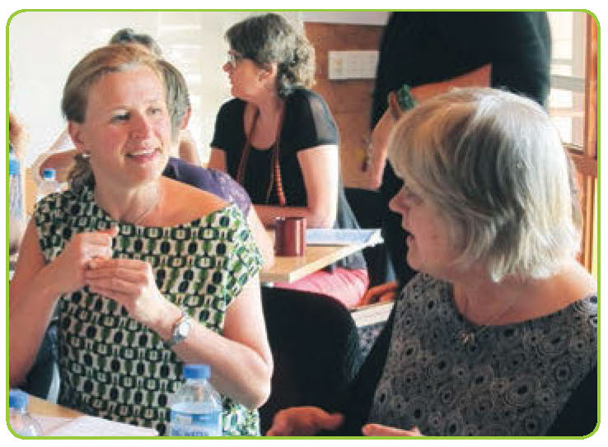
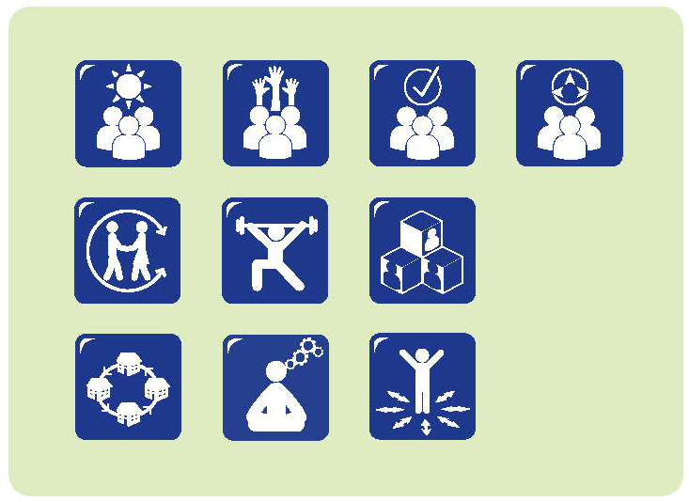
It can be very inspiring to attend our network meetings where more than forty professionals get together to talk about and act on early childhood education matters, especially transition to school. The network has only been running for 12 months and started off with a much smaller number of participants. However, word got around and the network has just grown and grown.
Members now include the school principal (who is the real driving force behind the network); school educators (including the transition coordinator); educators from many prior-to-school settings; regional education consultants; parents; regional, state and federal members of parliament; local university educators; and health, Indigenous and other interagency groups. We have been able to access some funding to get the network up and running. That has been a great help.
A meeting has been held in each term of 2013 but there have been many more meetings of smaller groups that are part of the network. For example, the local Aboriginal and Torres Strait Islander Health Service, in conjunction with the school and the prior-to-school settings, has run health screening days for children starting school in 2014. Another time, some members of the network found funding to buy copies of Your child’s first year of school: Getting off to a good start. They managed to buy enough copies to donate to the local libraries, so parents could get access.
The network has not been easy to get going – children attend our school from 13 different suburbs and lots of prior-to-school settings. Over a third of our children starting school did not access educational settings in the year before they started, so that meant that we had to be creative to make connections with these children and their parents.
The network is a really effective way of compiling evidence about transition – what works and what we need to do. For example, we can talk about the data from the Australian Early Development Index for our area. Because we involve a range of people and they have different expertise, we can unpack data like this, explain it and work out what it means for us.
It can be pretty confronting to hear that over a third of our children are rated as developmentally vulnerable when they start school and to see that that is far higher than the state average. But we can also identify strengths among our children. So, working out what the information means and how we can respond collaboratively is really important.
We have already achieved a lot. Through the network we have supported the re-establishment of a weekly playgroup for under 5s and their families. We have also supported a group of educators (from schools and prior-to-school settings), parents and children, to work on some books and calendars. They provide some information and have reminders about things that need to be done before school starts as well as things that children and families can do to prepare for school.
While we are proud of what has already been achieved, we know there is still a lot to be done. Our plans for 2014, so far, include:
- continuing to build the network and making sure it is sustainable after the funding has gone;
- continuing to strengthen links with interagency teams;
- improving prior-to-school attendance in the year before children start school;
- bringing other schools, both government and non-government, into the community network; and
- tracking, monitoring and evaluating the implementation and influence of the network.
QA 1.2.3; 4.2.2; 4.2.3; 6.3.1; 6.3.2; 6.3.3; 6.3.4; 7.3.5

Playing school

The children will soon start their orientation visits to school. Here in the children’s centre, we’ve been talking about what they think school will be like. Some have brothers and sisters at school, so they’ve been to visit the school to collect them. They all have some ideas about school – from books and television as well.
We think it is important to explore children’s expectations of school and to use these to help guide what we do around transition. So, it’s really trying to take children’s ideas and issues seriously.
We’ve set up a school area. That all came from the children. We had discussions about what they knew about school and what happened at school, and they decided what should go in a school area. So, there are some school uniforms, a whiteboard, desk, pencils, paper, ruler and a map. The children use the space for lots of role play.
We have lots of group discussions. We’ve done some brainstorming about school and what it will be like. It’s good to get the children’s views. More than that though, we make sure we use their views to help us plan the visits to schools. So, some of them were interested in having lunch at school and what that would be like. They had some ideas about what would go in a lunch box, and when we went to visit the school, they tried some of those things out. They had their lunchboxes in their backpacks and were sitting on the lunch seats – just like they will at school.
Before we went on the visit we had some discussion about the library and borrowing books. Now that we’ve been to the library, seen the books and been shown how the borrowing system works, we can talk about it some more.
QA 1.1.6; 5.1.2; 6.3.1
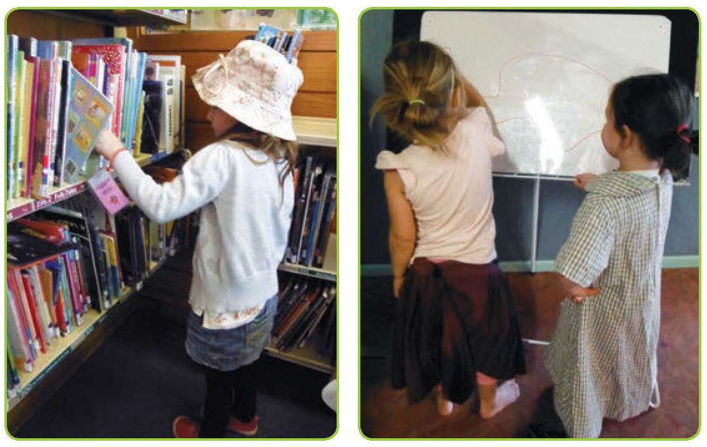

Community hub partnerships
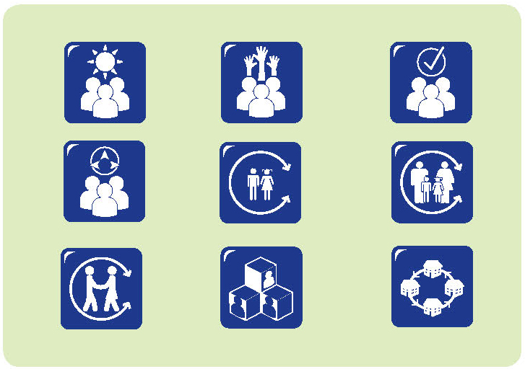
We are part of a community hub – with the primary school, early learning centre, library and neighbourhood centre all located on the same site. Our early learning centre also offers after school care and vacation care. As well, we have a number of wrap around services that operate within the early learning centre – these are mainly allied health and adult education services.
Partnerships are essential for us to work effectively. While we have good relationships between the different professionals and services, our partnerships also depend on the commitments of the different organisations involved.
Community hub meetings are held once a month with all stakeholders which includes people from the school and the early learning centre and other coordinators. Anyone who can attend, does. There is also a monthly Board meeting, which includes the director of the early learning centre, school principal, other stakeholders and external community members. We are committed to partnerships at the organisational level, to make what we have really a community hub. To help make this work we have formal agreements between the different services and we make time to reflect on how these agreements are being implemented and how we can make them better, so that we can look at how we can do things together, and be resourceful and not duplicate.
One of our strengths is our local community volunteers. We have 15 community volunteers, linking the community with the children and the school. We have the school breakfast club in the early learning centre, so the children in the early learning centre and the school get to know the volunteers. There are also the older and younger children together for the breakfast club.
They like mixing in the early learning centre space, rather than the school space, because it is more comfortable for the younger ones. When the younger children go to school, they already know the volunteers and the older children so it takes away that stress factor for these younger children and their families.
Another way we try to build connections is with our mascot bears. There are three bears in the early learning centre and everyone thinks they are special. The bears go with us on excursions, they go to the school, they go on holidays; they appear on Facebook. They’ve had more hits on Facebook than any of the other items about the centre!
Most people in the community know about the bears. They help us, the educators, be seen in the community and they help others see us as belonging to the community. We think our children learn from the role models they see around them – including in the community.
Community isn’t just your family; it is not just outside… the bears have been everywhere, they have been overseas, and children have shared their experiences through this connection. It is all about community and belonging.
I think we still need to work on what we see as the important connections between what happens before school and what happens at school. There are lots of assumptions about what happens in child care and what happens in school. Here we have a really good platform where we can work out how to support each other.
We can assume that children will bring a lot of learning with them when they start school. When we’re planning transition, we try to be very mindful of what other services provide and the good relationships that already exist between parents and services.
QA 4.2.2; 4.2.3; 6.3.1; 6.3.2; 6.3.3; 6.3.4

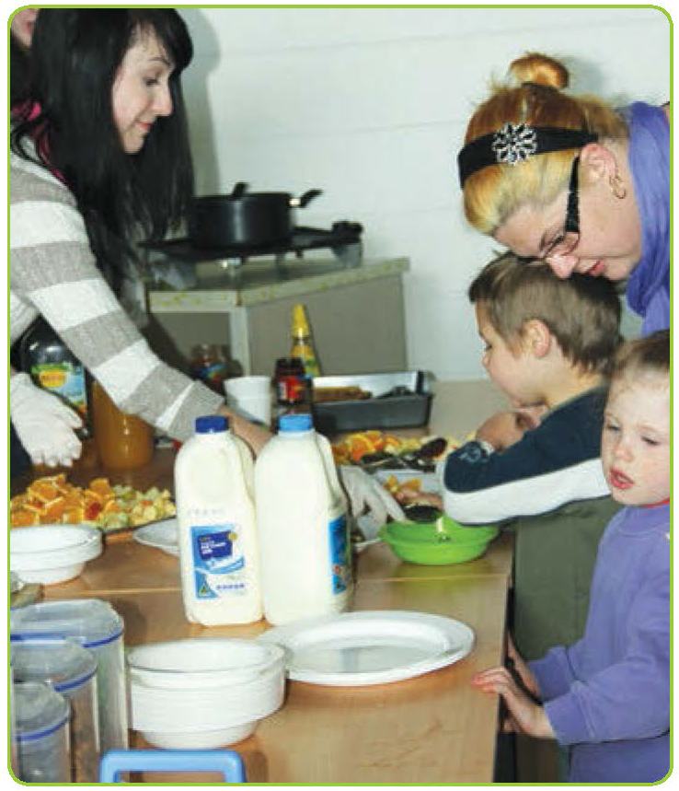
Breakfast with the community
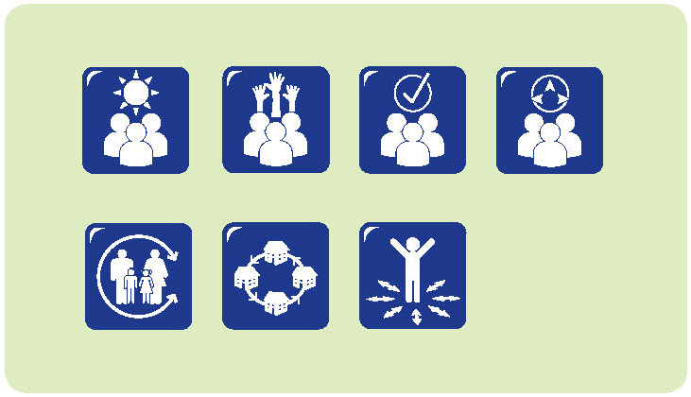
As a school, we have lots of informal connections with the community. One of my priorities as principal is to build community connections. We have a monthly community breakfast where some volunteers from a community organisation come in and provide breakfast. The same group has run a breakfast programme in the community for some time. This area has a reputation for requiring additional support, so it was seen as a way to provide services to the community.
When the school was opened, the organisation wanted to continue the programme from our site. I said no. They were a bit surprised, but I said I don’t want to say to our parents that I don’t think they will give their children breakfast. If children arrive here and they are hungry I will deal with that, but I don’t want a programme that says I don’t believe that you will be able to manage this.
What I want is a programme that builds community. So we negotiated with the organisation and now we have breakfast with the community once a month. The volunteers come and serve breakfast. The children, parents and educators come and share breakfast together. It’s an informal opportunity for conversation, over food at the beginning of the day. It’s great.
It’s totally different from any breakfast programme I’ve seen elsewhere. It’s not about providing a free breakfast. It’s about our community.
At the first breakfast, a lot of parents asked how much it cost. I told them it was free. And some said they were quite able to pay and wanted to make a donation. So now the breakfast programme has a donation tin and if people want or are able, they can make a donation. That’s the way we work with parents, we acknowledge that there will be some parents who would like to make a donation and some who don’t. We just try to be respectful and aware of where people are at.
QA 6.3.1; 6.3.4

There’s been a whole day happening
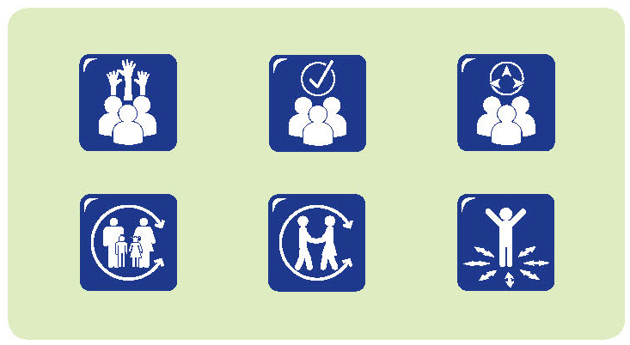
My daughter Sally really likes after school care. She used to go to before school care as well, but that seemed to make the day really long. Now she has her day at school and is very happy to go to after school care. She loves it.
I find the communication on the school side a bit of a challenge, because I don’t get to see Sally’s teacher at the end of the day. If Sally’s had a challenging morning, I can let the teacher know and then they’ll let me know how she goes through the day. Sometimes I feel like I’m the one missing out when I’m not there to pick her up at 3 o’clock and hear about her day and see if there’s any issue to sort out.
But the people at after school care have been great. There seems to be some proactive communication from the school day teacher, sending stuff with Sally to the after school care centre and then the after school care teachers taking responsibility for passing that on.
They have done a really good job. Even though they have only had the child from say 3 till 6 o’clock, they haven’t forgotten that the children have actually been at school all day as well.
There’s been a whole day happening! The after school teachers have been able to get a sense of how the child’s school day was and can pass that on. It’s great that the teachers trust each other enough to pass on the information. I know that Sally’s teacher makes time to visit the after school care programme and Sally tells me that the after school teacher knows about what happens at school.
Sometimes I feel like I’m the one missing out when I’m not there to pick her up at 3 o’clock and hear about her day and see if there’s any issue to sort out.
As a parent, I also feel like I can trust the after school care teachers to help me understand what Sally’s day has been like.
QA 4.2.2; 4.3.2; 6.3.2; 7.3.2

What they need to know about me
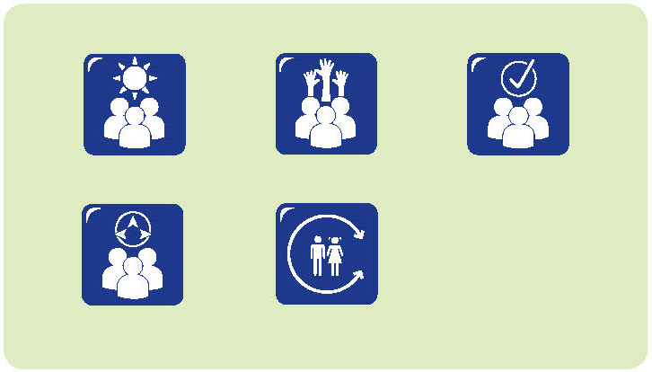
Brayden and Gus were soon to start school. They had visited their new school several times. They were asked what they would like their new teacher to know about them as they started school.
Brayden:
The teacher needs to know who my friends are.
My favourite things are outside – baseball, football, cricket. But we didn’t do any of that [when we went to visit].
The teacher needs to know that banana makes me sick.
Gus:
It feels different at big school… different children, different teachers.
It would be good if we had the same teachers [as preschool].
Mums and Dads need to know what class and the teachers’ names and the names of the other children and what we need to wear.
Sara and Liam engaged in a similar conversation.
Sara:
Bugs. I love bugs and I love looking for them in the garden. When she [teacher] is in the playground, she might see me looking for bugs. Teachers would hear me and Rudi talking about bugs.
Liam:
The teacher needs to know I like playing with Flynn and I like playing with cars and paper planes.
What will the classroom be like?
Alex and Liam discussed what their new classroom might be like.

Alex:
In my new classroom after Christmas, I would like to see a dragon and a crocodile, a bird and a parrot. That would make me feel good. Fluffy things in the classroom make you feel good. I hope my new class would be like a rainbow; walls would be rainbow colours and a sandpit inside and a real Christmas tree.
Liam:
In my new class next year I hope at ‘brain break’ you get to share food like coconut and I hope you have Show and Tell whenever you want to. I hope you get to go to your brother’s class at activity time and I hope there is a television you can turn on whenever you want to. It would be good if there was a cooking room where you could cook whatever you want to.
QA 1.1.6; 5.1.3; 6.3.2

A new transition and school setting for Martin
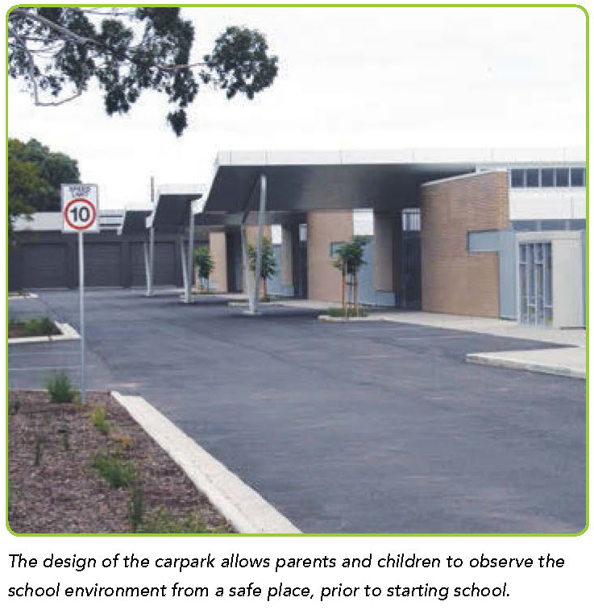
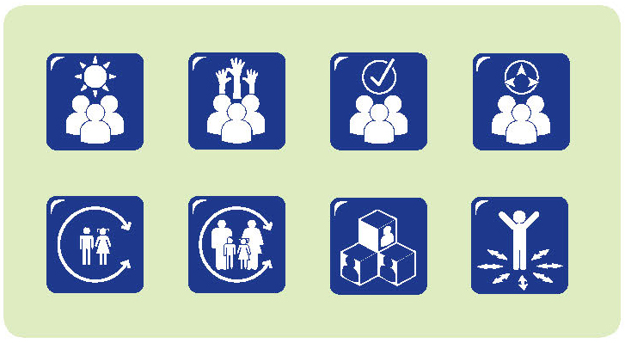
Martin, our six-year-old son, has severe autism. He had been enrolled in a special class at the local primary school and this proved to be unsuccessful for Martin. We became increasingly concerned about his deteriorating emotional wellbeing and his high level of anxiety whenever school was mentioned.
The special class environment at the school was not working and his teacher reported that Martin cried all day, so much so that he would vomit. After making the decision to move him and enrol Martin at a special school, we met with the teacher – Jane – to develop his transition plan. Jane made many positive suggestions. We felt like we were working together to help Martin make this next transition.
In this transition, Martin did not commence school until the fourth week of term. This allowed the other children time to settle back into the school routine, re-establish friendships and develop relationships with new staff. When Martin started he made the transition into a settled group and the educators were able to focus on his needs.
During the three weeks before he started at the special school, Martin and I drove slowly past the school on many occasions, so he could orientate himself to getting ready, the journey and the visual setting of the school. Towards the middle of the second week, I started to park and stop the car so we could observe the children playing outdoors. As he became familiar with the surroundings and more relaxed, I got him out of the car and we walked around the school boundary observing and talking about what was happening. At the end of the week we were able to go in the gate and sit and observe. Jane was very supportive of this.
Martin’s choice is to be outside and Jane indicated that he could stay outside until he was ready to be inside. The classrooms all have indoor/outdoor access and he is safe outside because of the high level of visual supervision.
To support Martin when he started school, the teachers developed a social story about me leaving. This was given to us to read and share with Martin at home before he started. Other parents have since told me that this was a successful strategy used when their children started school.
Martin’s first week at school was negotiated carefully.
Jane debriefed with me every day. She shared his experiences through the day and we talked about his general wellbeing. Jane encouraged me to share any observations of his behaviour at home that might indicate he was feeling anxious.
Martin has now been attending school for two terms. He is not anxious about going to school and, while he continues to spend the majority of his day outdoors, we are confident that the environment is very much individualised for Martin and he is achieving at his level. As parents we were overwhelmed about what schooling might mean for Martin. We have learnt to trust the school, the educators and our child, knowing that his education will always be complex, but that educators are willing to work with us as partners. We feel recognised and respected and confident in knowing that there is flexibility and an identifiable pathway for Martin’s learning and wellbeing.
QA 1.1.5; 5.1.1; 6.3.2; 6.3.3

A voice for the child and the parent: Family day care and the transition to school
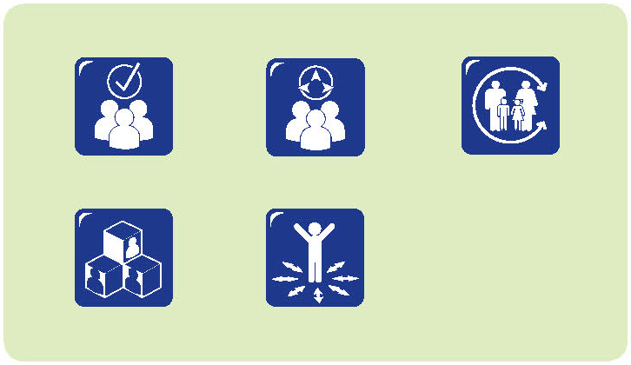
I’ve been a family day care educator for 23 years. My aim is to provide continuity in care. Sometimes I care for children from the time they are babies right through to after school care. A priority for me is building strong partnerships with families. So, when the children start, I get to know their routines, talk to the parents about what works for their child, what the child likes, doesn’t like, and what makes them feel settled. I try to be responsive to each child, and I know they are all different. As well, I think it is important for parents to feel that they are welcome in my home – after all, it’s where their children spend a lot of their time! I have regular contact with the parents – many like to have updates sent to them, or just like to know what we’re doing through the day.
I’m really happy to have a role when the children move on to school. I feel like I know the children really well, and the parents trust me. So I’m not surprised when some of the parents ask if I can go to the orientation visits with the children. When parents are working it can be very hard for them to get time off to go with the children, and some of them work quite a distance away as well.
I see my role as the go-between. Because I know the children and the parents, I can be a voice for both. I can share information with the parents about what happened, and I can share information with the teachers at school about how the child responded to the visit.
When one of the children is about to start school, we build a few routines into our day. So, if we are going to playgroup, we can drive past the school and talk about it. It helps the children start to think about the school as their school.
Depending on the event, sometimes we all go to visit the school, even the younger children. They’re clearly not starting school, but it helps them to become familiar with school and it really helps the child who is starting school, because they feel they are not on their own. When we get back, we can all talk about the experience.
I feel that I have strong relationships with the parents and the children – and even with the school. They trust me to support the children.
Because the parents know me well and because we have built a partnership, they are confident that I will do the best for their child. They also know that I will respect their rights – so they are comfortable with any information that is shared.
QA 6.3.2

Don’t stand up really big
i
I am in Year 5. I was really excited to meet my new buddy today. I have been a buddy before and I wanted to be a buddy again because if the new children have trouble finding friends, I can help them.
I remember having a buddy when I stated school, actually I had two; I had Stephanie and Rowena. It was good to know someone and have someone who could show you around and help you find people.
I like it when we go into their classroom every Tuesday and help them with maths and help them learn. I like teaching them things.
They are all different so I had to fix my teaching for them. Like, if they could use a twenty dice, then you could use it in a game. But if they couldn’t use it, then you had to find an easier one.
I like helping the new children and letting them know there is someone there who can help them. I hope they like this school. In the playground I will make sure my new buddy knows where to find everything.
If people want to be a buddy, they should know not to stand up really big when they are talking to their buddy, because the new buddies could be scared. I remember my buddy, she always stood up so tall, but if you crouch down to their height, it’s not as scary. I think it’s important to be patient with them, be very kind and including.
When you are a buddy, you need to make the new children feel safe. It’s a big step up from preschool to school. It’s different and school is all new to them, and it’s big.
QA 1.1.6; 5.1.3; 6.3.2
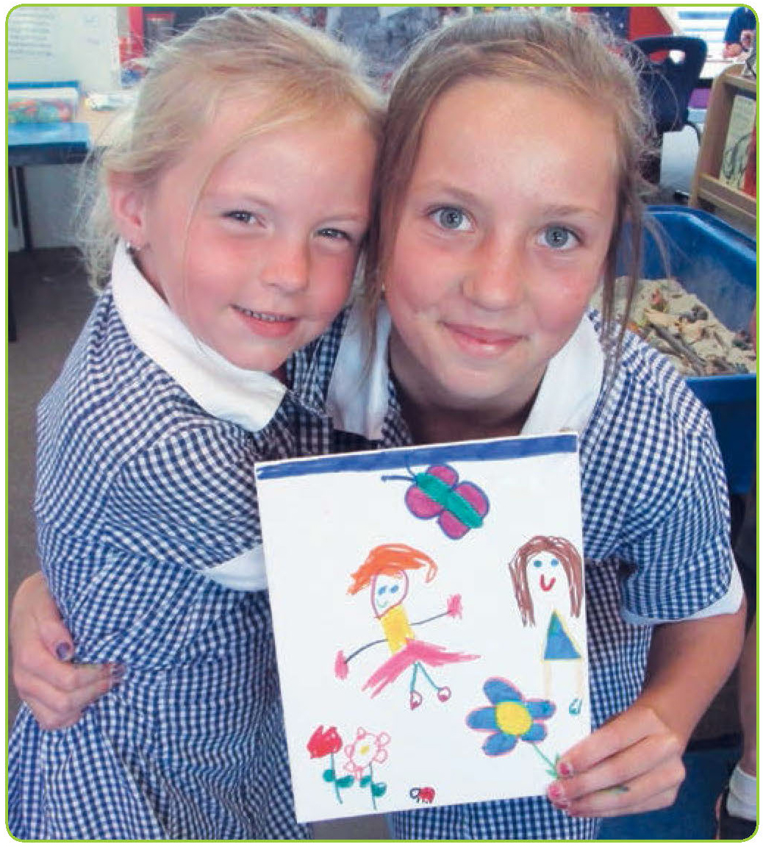

Interviewing the principal
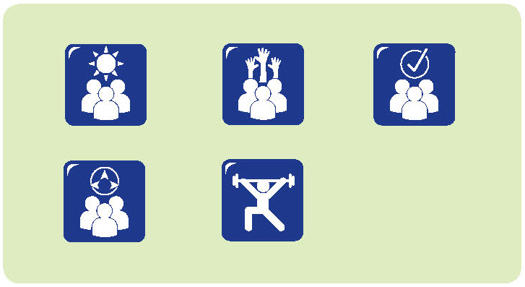
Last year one of the children who attended our centre – Jade – went with her parents to visit several schools in the area. The family were unsure about which school would be the best for her, so they decided to visit several to gather information.
Jade participated in the interviews. In fact, she asked most of the questions. The principals thought they were interviewing the parents, but really Jade was interviewing them.
She asked questions that were important for her, like where her classroom would be, who her teacher would be, whether she could be with her friends, and where they would play.
Then Jade talked with her parents about what she had learned. She could tell them which principal she liked most – mainly because they listened to her and spoke to her seriously.
Not all children want to interview principals, but they can be encouraged to tell us how they felt they were treated when they went to visit schools.
Parents talk about really positive interactions when the principal talks to them and to the child. Others describe how they, or their child, felt ignored by school staff and how uncomfortable they felt as a result.
QA 1.1.6; 6.3.2

Partnership with parents and educators
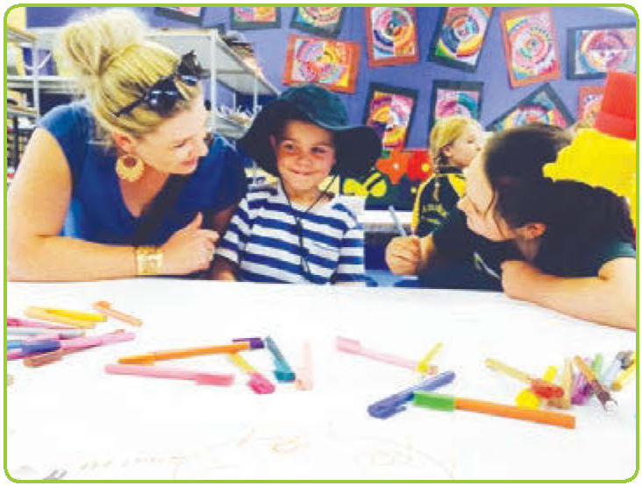
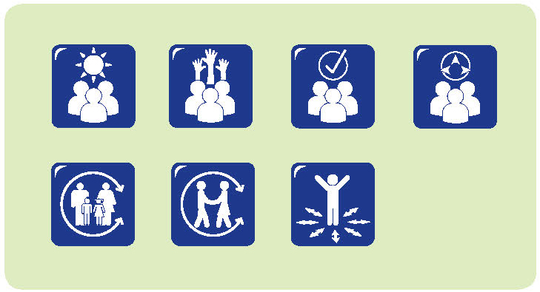
It’s a real bonus being an integrated service. We are an early childhood school, so we have babies to Year 2 on site. There are lots of chances for the children to connect, so Year 2s visit the babies’ room and sing songs with them, or sometimes the babies come to visit the classrooms, we all go to the hall, we all go to the library. So every child in the school is always in everybody’s space. There’s not an area where toddlers are not allowed.
In my role as community coordinator, I get to work across the whole school and with all the families. Our philosophy is that when we enrol a child, we enrol a family. As teachers, we see our role as helping to grow a whole person, and that means working with the family. We don’t say that you have to take on the family’s problems. What we say is that you have access to resources and can help them find the resources they need, and that makes your teaching job easier.
We have a leadership team that emphasises the focus on professional discussion among all staff; we’re not child care staff and school staff – we are one staff. We have at least one whole staff meeting each term and we have a focus for these. There is one next week about communication with families – not just families for children at school, but communication with families, from babies through to Year 2s.
Having the meetings and the focus helps us all work together on transitions. It’s also about our relationships – relationships staff to staff; staff to child; staff to families. Families know that they can come to any one of us and generally a person can answer their question. If not, they know who to refer to. So families leave an interaction with an answer or know that we will get back to them with an answer. They’re never left hanging.
It’s not always easy to make meetings like that work. Our principal is always willing to help and she will cover a class so the teacher can be involved. We just try to maximise the number of people who can be involved so we are all working together. And, if it works for the children and families, it works for us too. It’s about seeing resources well spent – a little bit of time and effort has massive benefits It’s worth a disruptive day!
We have a focus on children’s wellbeing. That means that we have partnerships with families and with other organisations. We meet with the occupational therapists, speech therapists, social workers. Every year, the whole staff goes to visit the local child and family health centre and we work with their whole staff. We talk through what we each do and what we can provide and how to access it. Sometimes we have visiting therapists come to those meetings as well. So, our job isn’t just about teaching. It’s about much more than that. We’re interested in people’s wellbeing as well as teaching and learning.
A number of our children have Individual Learning Plans. When we have review meetings, we have parents, teachers and other professionals who are involved come along to review what is happening. They can be like case conferences, where we can all back each other up and support the parents, so we make sure there is one set of consistent messages and strategies, instead of lots of confusing information.
It’s also important to be confident enough to talk about what worked, and what we could have done differently or better, and to have those conversations with everyone. So, even though we are working in different areas, we can see what supports work and what is not as good as it could be. It’s not necessarily about more services – it’s about better services and better quality.
QA 4.2.2; 4.2.3; 6.3.1; 6.2.3; 6.3.4; 7.2.1

Moving around
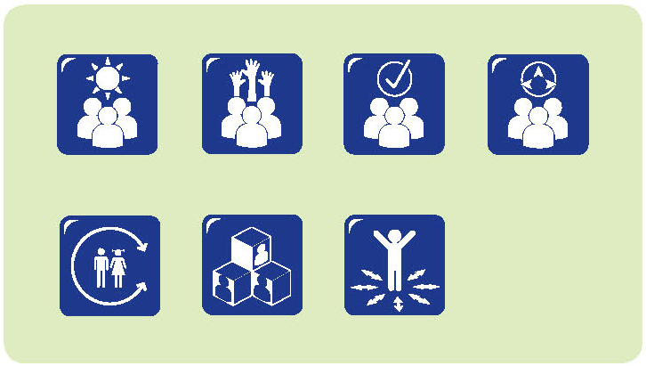

We’ve only just arrived
My partner is in the Defence Force. We moved here just a few months before Harrison started school. Harrison has autism, so I was really concerned about his transition to school. He had been at preschool for just a short time, but the preschool teacher, his school teacher and I met to plan his transition. Because of the timing of our arrival, we missed the transition days. But we were in time to go to a couple of events – the barbeque and the pancake day.
They helped Harrison become familiar with the school. We did things like walking through the school at weekends and we brought his scooter up here so he could ride around.
The school also has an aide – a Defence Transition Aide – and he has been great. Alan has been in the army, so he understands what it’s like to leave children for seven months and to go through all those things and also to understand what the children are going through as well.
He has been a really good help for Harrison. He can come into the classroom to help Harrison but mostly Alan is there in the playground to talk to him, take him for a walk, to help him out if he is having a bad day, for example if he is missing Dad.

Every school should expect mobile children
Defence Force Aides work with families across the country. They have particular roles in supporting children whose families move or are posted to different locations. For some families, this can occur every second year. It can also happen at any time during the year. Aides work with families and also with schools where there are several children of Defence Force families.
As a Defence Force Aide, I see my job as developing relationships and engaging in the new school community. It’s about working with families and with parents to provide information and often relieve anxiety. We really focus on children’s social and emotional wellbeing. We recognise that teachers are the educational experts, so we aim to complement what they do. It’s about nurturing. Mostly, we have aides that work in one school. It’s important that they work with the school culture and get to feel really a part of that school – to be able to say ‘This is my school; these are my children, my staff, my families.’
We develop activity based programmes. If we have 25 students in a school, we would be at the school for 10 hours a week. We try to spend some time meeting and greeting students and families, maybe some activities during class time, but mostly being in the playground and offering some alternative options for the children – maybe some games in the library, or a craft group. One aide does tree time – where they’ll be sitting out in the playground under a tree with a story book. So the children have an option. If they are happy playing, that is great. If not, they can come and sit and talk. They can bring a friend or just come up and say hello.
It’s about the aide being a special person for them. It’s about making the children feel worthwhile, being listened to, respecting their emotions, respecting the fact that sometimes they might just come to school and they’re pretty tired. They don’t actually feel like putting themselves out there and smiling and trying to be everyone’s new best friend. Sometimes it’s about just giving them the space they need so they can just sit and relax.
The effectiveness of the programme is about understanding the child’s emotional needs and working with the school and their focus on the academic element.
We also support parents. Often the first connection they make when they move is with the school, but they can be anxious about this and worried about all sorts of things. We can help with the connection and information.
The school I work with has been really responsive. They’ve become really aware of the information they put out about the school – on the website and Facebook. They’re more aware of communicating with families and sharing what happens for the children. They are much more wary of assuming that the children and families who come to school have lived in the area for a long time and know what is happening around them.
They’re actually recognising mobile students, whereas in the past, these children just turned up. Now schools are celebrating these children and looking for ways to support them.
In one school, they’re doing a project with the children on tiles, making a river of tiles. So, as the children leave, they will decorate a ceramic tile and that will form part of the school corridor.
It’s a very tangible way of saying to the children When you come here you are welcome, you’re important to us and when you leave, we want to remember you. At another school, they recognise children who are leaving at an assembly. They might present the child with something – it doesn’t matter what it is. It could be a laminated copy of the school song! Something personal. Schools are recognising that the children may have only been there for a short while, but they are celebrating that.
Every school should expect mobile children. Every school should expect that they are going to have children turning up unexpectedly. It’s about how they deal with that. How do they make those children feel welcome and valued and respected? How do they help them fit in, and not stand out as different?
There are lots of practical things schools can do. Can you get the uniform easily? Do you have to order it months ahead? Does it matter if children are not there on the first day in the school shirt with the logo – is it enough that they are wearing the same coloured shirt? What about books and resources? Schools can have stashes of extra resources – uniforms, pencils books, the lot. That’s much better than having children start school feeling mortified because they haven’t got the right gear.
Transition can build really strong, resilient students. We just need to make sure we recognise what they are dealing with and work together to offer some appropriate support.
QA 1.1.5; 4.2.2; 4.2.3; 5.1.1; 6.3.1; 6.3.2

We are part of the school

I am the director of a school age care service that operates as part of the school.
I am invited to be part of the transition programme and they always introduce me to the parents when they have an information night. I usually give a presentation so the parents can find out about the routines we have and how the service operates. After the presentation I usually stay around for a while so parents can ask their questions.
When the children and the families come for the transition programme, we have several groups rotating through different activities. I usually take responsibility for one of the activities with the children and another with the parents.
So, one day I had a gross motor activity, where I had some equipment on the quadrangle and the children played some games. Later, I spent some time with parents and we talked about what happened at before and after school care.
As well, we run some of those activities in the before and after school room.
It works well when the families see me as part of the school. They all get to know me and, when the children start before and after school care, we already have some connection. I think it’s always much easier to ask questions when you know the person, so it helps to build a good relationship with the children and the families.
Because all the children who have done the transition programme have been to the before and after school care room, it’s a familiar place. And with the teachers at school as well – because we work together, we think of ourselves as partners.
It works well when the families see me as part of the school. They all get to know me and, when the children start before and after school care, we already have some connection.

QA 4.2.2; 4.2.3; 6.3.2

Principle 3:
High expectations and equity
In educational contexts, the term high expectations is often used to refer to efforts to recognise each child’s learning strengths and to build on these in ways that assist children to realise their full potential. It does not imply that the same standards or expectations are set for all – rather that educators focus on developing, enhancing and extending the strengths of each child in ways that enhance educational outcomes and promote the attainment of potential (Saffigna, Church, & Tayler, 2011).
In this resource we advocate for high expectations for children, and also extend the concept to include all those who engage with children as they make the transition to school and school age care. From this, we acknowledge the importance of high expectations for, between and among children, educators, family members, communities and educational organisations. For example, we note the importance of educators’ high expectations for themselves and other professionals; the high expectations of family members for their children and the educators with whom they engage; and children’s expectations of those who share their transition journey.
Strengths-based approaches recognise the competencies of people as well as the issues or challenges they face (McCashen, 2005). They acknowledge that those living with, and experiencing, strengths and challenges hold a great deal of knowledge about these and how they might be managed and utilised. Both children and adults can hold this knowledge. Strengths-based approaches to starting school recognise the insights and hopefulness that children, their families, educators and communities bring to the transition and the ways in which these are integral to processes of change.
Underlying the focus on high expectations for children is research supporting the view that they are very responsive to the expectations of those around them: in other words, children tend to perform to expectations. As a consequence, children who are expected to learn and do well tend to live up to this expectation. Conversely, children who are not expected to do well – for whatever reason – tend to respond in ways that meet this expectation and are unlikely to demonstrate their full learning potential (Hinnant, O’Brien, & Ghazarian, 2009). This sets the scene for a self-fulfilling prophecy.
A wide range of evidence confirms that children learn when they are expected to succeed (Hinnant et al., 2009; Saffigna, Church, & Tayler, 2011). High expectations in early childhood education recognise that children have already learned a great deal and have the potential to continue learning and experience success. Holding high expectations recognises agency and strengths – each individual’s capacity to influence what happens for and around them, and the potentials and possibilities that can be found within children, their families and communities. It also means recognising the importance of aspirations – the goals, ambitions and hopes for the future.
Just as it is important to recognise children’s agency, it is important to recognise the professional agency of educators – the degree to which they believe they can affect change for and with children. Saffigna, Church, and Tayler (2011, p. 10) note that educators “who have high expectations for every child are also more likely to take responsibility for children’s learning and have high levels of professional agency”. That is, these educators find ways to support diverse learners and work towards positive outcomes for all.
Educators who believe they can affect change tend to have high expectations for themselves and their colleagues, and they convey this in their interactions. For example, these educators work in partnership with families, often devoting considerable time and energy to building and promoting connections. They share their high expectations with children and families, and celebrate children’s strengths while providing appropriate support in other areas.
This extends to the ways in which children’s achievements are assessed, reported and shared. Further, they are committed to ongoing learning and reflective practice.
Holding high expectations for all children requires a view of children as competent and capable (James, Jenks, & Prout, 1998). While guided by broad understandings of development, educators who subscribe to this view move beyond age-based perspectives of competence, recognising the importance of social and cultural contexts as children attempt new tasks and build their capabilities (Lansdown, 2005; Mason-White, 2012). They work to create welcoming, inclusive environments, where children and families feel safe and supported, and where the range of learning opportunities encourages meaningful engagement for all children.
Early childhood educators’ expectations influence young children’s own expectations of themselves, including their sense of who they are and what they can achieve (self-concept), the value they place on that (self-esteem), and beliefs about their abilities to achieve specific outcomes (Arthur, Beecher, Death, Dockett, & Farmer, 2014; Rubie-Davis, Hattie, & Hamilton, 2006). Children make evaluative judgements about different aspects of their lives and different contexts in their lives – for example, they make judgements about their learning, their friends and their abilities (Marsh, Ellis, & Craven, 2002). These judgements are based on their own evaluations and the evaluations of others, as children observe the impact of their own actions and the reactions of others. When children believe they are competent and capable, and when others around them validate this belief, they act and interact in ways that demonstrate competence.
Educators’ expectations influence children’s learning dispositions – their preferred ways of approaching and responding to situations. Learning dispositions provide the basis for children being “ready, willing and able” (Carr & Claxton, 2002, p. 9) to participate in a wide range of experiences and to achieve a wide range of outcomes. Educators’ expectations influence not only the experiences in which children engage, but also their ways of approaching and engaging in experiences.
While it is important for educators to hold high expectations for all, it is also important that such expectations are realistic, and that appropriate support is available to help children achieve these. Holding expectations that are unattainable sets children up for failure and is likely to result in children believing that they are incompetent. Holding expectations that can be achieved without much effort conveys the belief that children are incapable of achieving more. Knowing what expectations are appropriately challenging, and how best to support children as they work towards these, requires educators to have developed trusting relationships with both children and families. As children start school, these relationships need to extend to other educators and professionals who know and work with the children. Educators are well placed to advocate for high expectations among parents, family members and other professionals (Saffigna, Church, & Tayler, 2011).
Low expectations deny access to high quality education outcomes for children. Low expectations for groups of children – related to factors such as gender, ethnicity, cultural background, socioeconomic status, disability or age – serve to reinforce stereotypes and diminish the professionalism of early childhood educators (Harlin, Sirota, & Bailey, 2009; Hinnant et al., 2009). Holding high expectations for all children is an issue of equity and social justice.
The lowering of expectations for some groups of children – even unintentionally – can result in children from these groups performing to expectations, reinforcing the lowered expectations and perpetuating stereotypes. Adopting and enacting high expectations for all children is regarded as the most effective way to break this cycle of low expectations. Educators who reflect critically on their own practice are well placed to identify instances of bias or inequity and move to address these.
Addressing issues of equity requires attention to notions of citizenship, status and rights. It involves recognising and challenging barriers that impede participation for children, families and communities on the basis of gender, ethnicity, cultural background, socioeconomic status, disability or age. Promoting equity is seen as a cornerstone of social inclusion, which aims “to ensure that all young children have fair and equitable access to resources, services, and facilities which are conducive to their development and wellbeing” (Bernard van Leer, n.d., p. 2).

Expectations and transition to school
All stakeholders in transition to school and school age care have expectations: children, families, educators, other professionals, community members. Effective transitions are likely to occur when stakeholders share similar high expectations and work together to enact these (Dockett & Perry, 2007). Communication among the participants in transition provides an important context for sharing and discussing expectations. While all involved aim towards effective transitions, there is consistent research that different groups of stakeholders have different expectations. Within the contexts of positive, trusting relationships and meaningful partnerships, differences can be triggers for reflective practice and ongoing learning.
In general terms, different participants in the transition to school and school age care are reported to hold different expectations that reflect their experiences, perceptions, interactions, and knowledge about the transition. Children’s expectations of school are influenced by the expectations and experiences of those around them – their parents and other family members, and their educators (Chan, 2012; Dockett & Perry, 2013b; Turunen & Dockett, 2013). Australian research reports that children about to start school expect that school will be different from home or preschool, and that they will be required to make adjustments to school. They expect to encounter large groups of people, learn at school, respond appropriately to school rules, and make friends (Dockett & Perry, 2004a; 2005).
When asked about what matters most as their children start school, parents’ responses emphasise children’s adjustment to the new school environment, as well as the importance of a welcoming, responsive and challenging educational environment (Dockett & Perry, 2004b). While the details of these expectations are specific to individuals and their contexts, similar expectations have been reported by Aboriginal families (Dockett, Mason, & Perry, 2006), parents with diverse cultural backgrounds (Dockett & Perry, 2005; Sanagavarapu & Perry, 2005), and parents of children with disabilities (Russell, 2005).

Narratives
- She's perfectly capable
- We found out so much
- The forest
- It's not all over after a few weeks
- The Hope Tree
- We are letting go
- Different names
- Recognising Aboriginal children's assets as they start school
- Three wishes
- Who's ready for what?

She’s perfectly capable
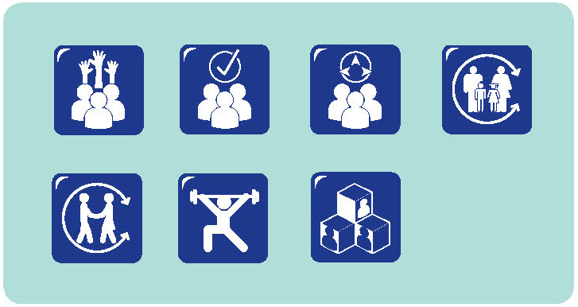
We had a phone call today from a community support organisation asking if an Aboriginal girl could start at the preschool immediately. I had a vague thought that we had already spoken with someone about this and I had thought she had already been enrolled. But when the preschool educators and I talked, we realised that there had been several different people, from different organisations, all engaged with the family and all suggesting that it would be good if the child could attend preschool.
A couple had already made inquiries and we said we were happy to help. It’s great that they all agree that our preschool would be a good place for the child – we are very happy to welcome her and the family. But it seems like there had been a lot of talking done without involving mum and the child.
We got back to the different organisations and let them know we had a place for the child. At the same time, we also said that we would work the details out with mum.
As it turns out, mum had also made some inquiries about preschool. One of her other children had attended the preschool some time ago. She indicated that times were a bit tough and that she was getting support from a range of organisations. However, we know she is also perfectly capable.
We’ve previously met her and know her, and she is perfectly capable of making the decision about preschool. We’re happy to meet and work with her. We want to focus on people’s strengths; we assume that everyone is doing the best they can and we assume that everybody with support can do enough.
Mum may need some support, but she doesn’t need people making all the decisions for her.
QA 6.2.1; 6.3.1

We found out so much
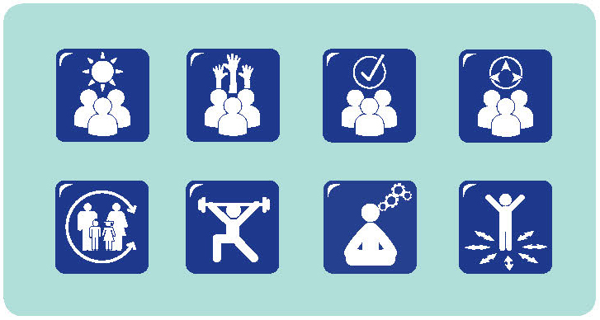
We are a special education unit for children with multiple disabilities. Most of our children have some form of cerebral palsy; our children are all in wheelchairs. Many of them have attended preschool. When it is time for the children to start school the disability coordinator and the guidance officer work with parents to identify the best school option for each child.
Then we have meetings with all the people involved with the child – including parents, educators, support workers, the disability coordinator – where we talk about the child, what they can do, what they like, what their needs are. I always ask about the expectations of the parents. Often times, the expectations seem low. I do think it is really important that parents want their children to be happy, but as an educator, I’m also interested in how we can improve the children’s mobility, their communication and their engagement with school.
I keep in mind that we are working to help these children make their lives better. We look at the national curriculum, particularly the general capabilities, and make lots of adjustments.
We focus on communication which is relevant for our children. We focus on literacy so that they are able to read and write – aiming to help them develop the skills to be independent wherever possible.
I recall one child, who was in a wheelchair. What most people saw was a child who didn’t communicate, move or do much – he just stayed in the wheelchair. But if you read to him, he would laugh at the appropriate places. I thought there was something special going on.
I went to a conference and they talked about using flip charts with letters of the alphabet. I wanted to try it with him. I worked out that he could blink yes or no. So I could show him the letters and ask if it was this page. If he wanted that letter, he would blink. He wrote ‘h-l-o’ and then ‘hello Robyn’. You should have heard everyone celebrating!
From then on, his communication just leapt ahead. We were able to find out so much from that child! It proved that you can’t look at any child and just say they can’t learn. It’s all about seeing, trying, experimenting and believing – having high expectations. Just thinking the best of our children.
QA 1.1.5; 1.1.6; 1.2.3; 5.1.1; 6.3.2; 6.3.3

The forest
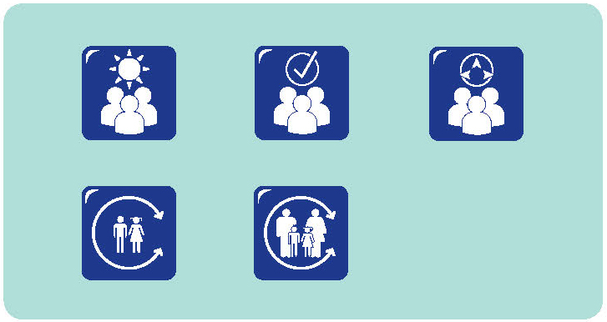
As part of our transition playgroup sessions at the school, we planned a mapping project with all the children. This year, we decided to produce a forest as a way of displaying and sharing what we found out.
We started off with blank trees. Our first tree was our Friendship Tree. We have photos of the children who come to the group posted on the tree. We will make a copy of that tree for each of the children, so they have the names and photos of children they will be seeing at school next year and can revisit it during the holiday break. They like to revisit it in the playgroup quite often, and we play lots of name games to help the children get to know each other and, hopefully, form friendships.
We also have a Big Tree where we record parents, and children’s comments. I asked the parents to write down their aspirations for the playgroup – what they wanted to get out of the sessions. I didn’t get many written responses, but I did get a lot of people talking to me. The other comments on the tree are from children. We call it the Discovery Tree because it represents all the places we have visited around the school and some of the activities we have been doing. Each time we walk around the school we discover something new and we record it on the tree. We find it helps children map the different parts of the school and the different things that happen. The children talk with the parents about these things as well, so it really promotes conversations. Early on, the parents came with us on our walks around the school.
It’s important for them to know what happens in a classroom and where things are. For some parents, it’s been many years since they were at a school and they want to be able to have conversations with their children about what school is like now.
Then we have the Helper Tree. We have photos and information about different people around the school and how they help others. So there is the principal, the ladies in the office, the teachers and we’ve just started to add pictures of the children with their buddies.
Often, the children will ask about what comments have been added to the trees and we have the opportunity to recognise a question or an issue, or what somebody has learned about school, and discuss it as a group. It makes an interesting display for parents and educators, but it’s also an important resource that we can revisit regularly, to check on how children’s feelings have changed, whether they have additional concerns or what new knowledge they have about school.
In their conversation, children described some of the information that had been added to the trees.
We know lots about school. It’s on the trees! We know what the principal does.
He looks after the students and the teachers and the school. He likes you to say Hi when you walk past his office.
He works.
He works on the computer.
What will you do at school?
Draw and write words.
You learn stuff. I’m not sure what… maybe reading and stuff. And maths. My brother does maths.
We don’t run inside.
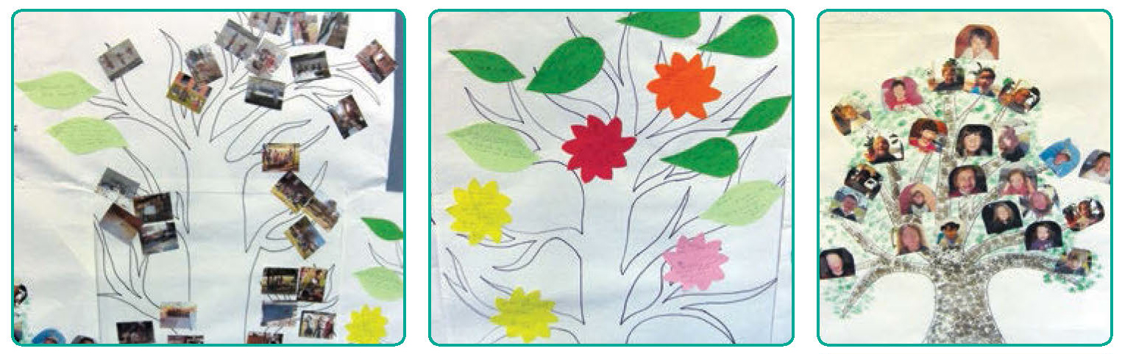
We have to put our hands up when you want to ask a question.

QA 1.1.2; 1.1.6; 6.3.2; 6.3.4

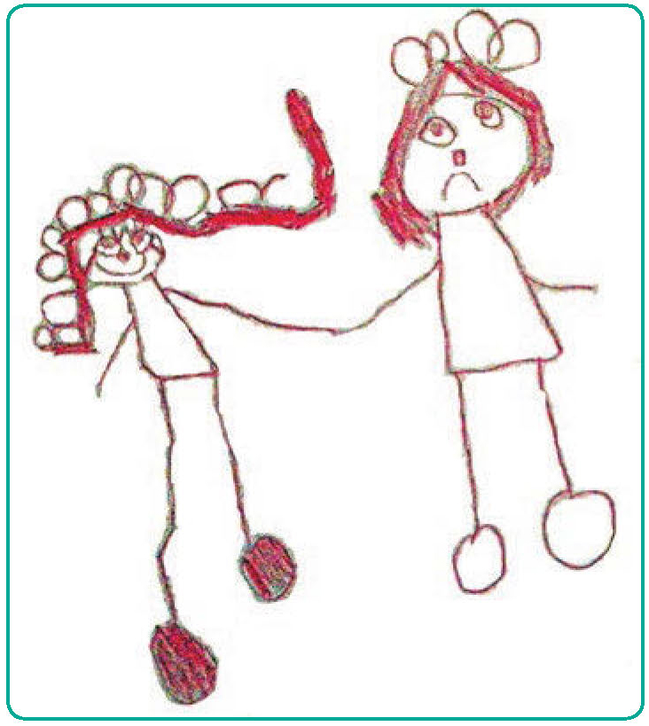
It’s not all over after a few weeks
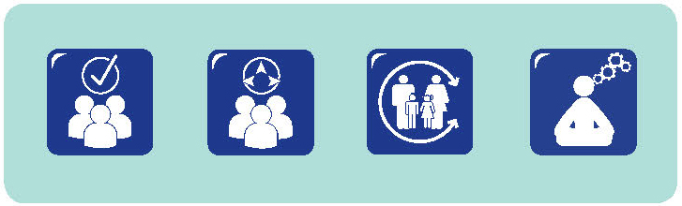
My older daughter started school a while ago. She‘s quite quiet and I was worried about her. I never worried about my younger daughter because she’s quite outspoken. Initially, my younger daughter made the transition to school really well and it was fabulous. She was very excited for the first few weeks.
Then things started to fall apart. There were some changes and the classes were changed. So she ended up in a different class, with a different teacher and different children. She did not cope very well.
Thankfully, I was able to talk to the teacher and the principal and they were fabulous too and we sorted it all out.
I think it’s a problem when you have the routine happening and then it gets changed. It’s not just like once the child has been coming to school for a few weeks and they’re not crying, that it’s all over.
I heard of one boy who took a similar track as my daughter. He was the life of the classroom, always willing to show what he could do, where he had been or what he had learned. That lasted about two months before he started doing really strange things like talking back to his peers and the teacher.
After some investigating and talking with the boy, the teacher found out that he was being bullied during break times by some older children. He did not know how to handle this but the teacher did and, happily, things returned to normal after a few weeks or so.
I think you need to monitor things for a few months and make sure you help the children along the way.
Even when they seem really confident and outgoing, they can struggle to cope with so many changes.
QA 6.2.1; 6.3.2

The Hope Tree
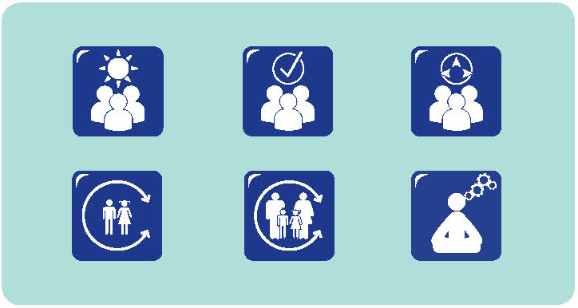
We have a large visual format we use. It’s called the Hope Tree. Basically it’s a large tree figure with lots of leaves. Over the times the parents come to the playgroup, we talk about their expectations for the children and for school. If they wish, they can write these on the leaves and add them to the tree. The leaves are available by the tree, so people can add things when they want.
It’s not something that they are pressured to do, more a different way of sharing information. Sometimes people are more comfortable adding something to the tree than they are in raising it in a group. In this group we have a wide range of people from diverse backgrounds; some don’t speak English very well and many of them have no experience of the school system in Australia. So, they can add things to the tree to share their expectations.
I’ve seen several of the parents looking at the tree and discussing the leaves. It’s a great way to start conversations and for parents to feel that they are not alone in their concerns or hopes for the children.
Some of the things parents have contributed are comments that they hope their children will be safe at school; that people will be there to help them; that someone would care about the children and that the school was a happy place for the children.
The Hope Tree has been useful in promoting conversations among the parents, but it is also an important source of information for us as educators. We took some of the leaves with us to one of our recent executive leadership days and spoke about the parents’ expectations and how they matched those of the school. It’s really important for the school leadership to know what parents’ hopes are for their children. So now we can see it as a part of the school management plan, to recognise and respond to parents’ hopes for their children. That can be a great starting point for us to make connections and to share information.
QA 6.3.2; 6.3.4

We are letting go
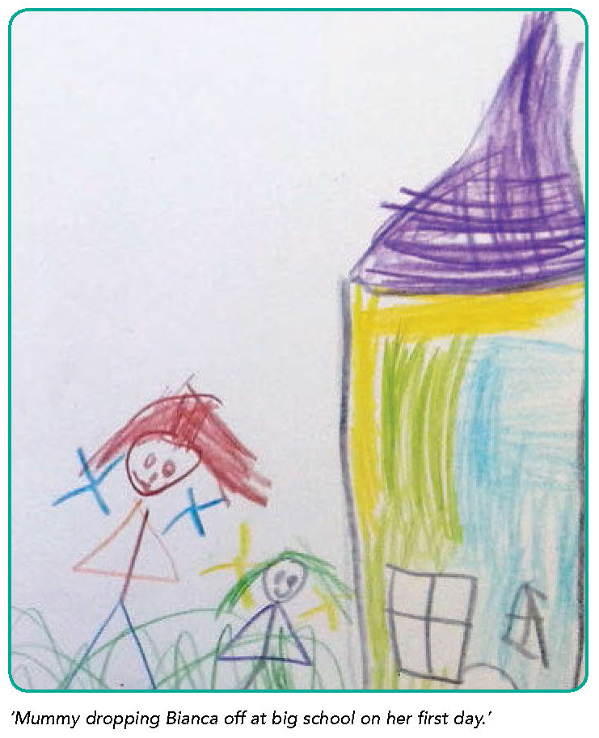
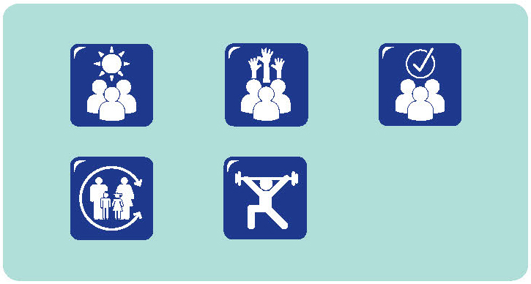
Soon after the beginning of the school year, a group of parents were discussing their transition experiences.
I have a big expectation, I do. My children are everything and I am their advocate. If I notice a child is not happy, or not doing very well, I do expect the teachers to notice and pick up on that and work on it. That’s what I see at this school. The teachers invite us in – you can approach them and point out what is happening for your child and they will work on it. I have big expectations of this school.
We are letting go of our most precious things in the world and putting them out there, so we have to put a lot of trust in them getting it right.
Helping our children in ways that we would approve. It’s not just reading and writing, it’s so much that they are learning – behaviour, attitude, respect, morals. And we are letting go so someone else can teach them these things. That’s a big step for parents. You’re thinking of the child and what they are doing at school and how they’re learning so much.
We’re actually learning to let go, letting go and letting them experience life – good and bad. So, it’s definitely a transition for all of us as well. We have to have high expectations of the school. Otherwise, we couldn’t let go.
QA 6.3.2

Different names

Children were asked about things that are different between preschool and school.
- schools are bigger than preschools
- there are more people in schools
- eating lunch is different
- you have more teachers at preschool
- sometimes you can sleep at preschool
- you play at preschool and you learn at school
- you call your teachers differently.
Alice has recently started school and attends the before school programme on the school site. At the end of her first week of school, she was excited to tell her mother.
I know a secret! Mrs Dawes was away today, so we had Miss Evans. But that’s not her real name! Her real name is Shona! You know, Shona from before school care? She was our teacher for today. She said that while she was our teacher we had to call her Miss Evans. But I know her real name is Shona, like in before school care.
QA 5.1.1; 6.3.2
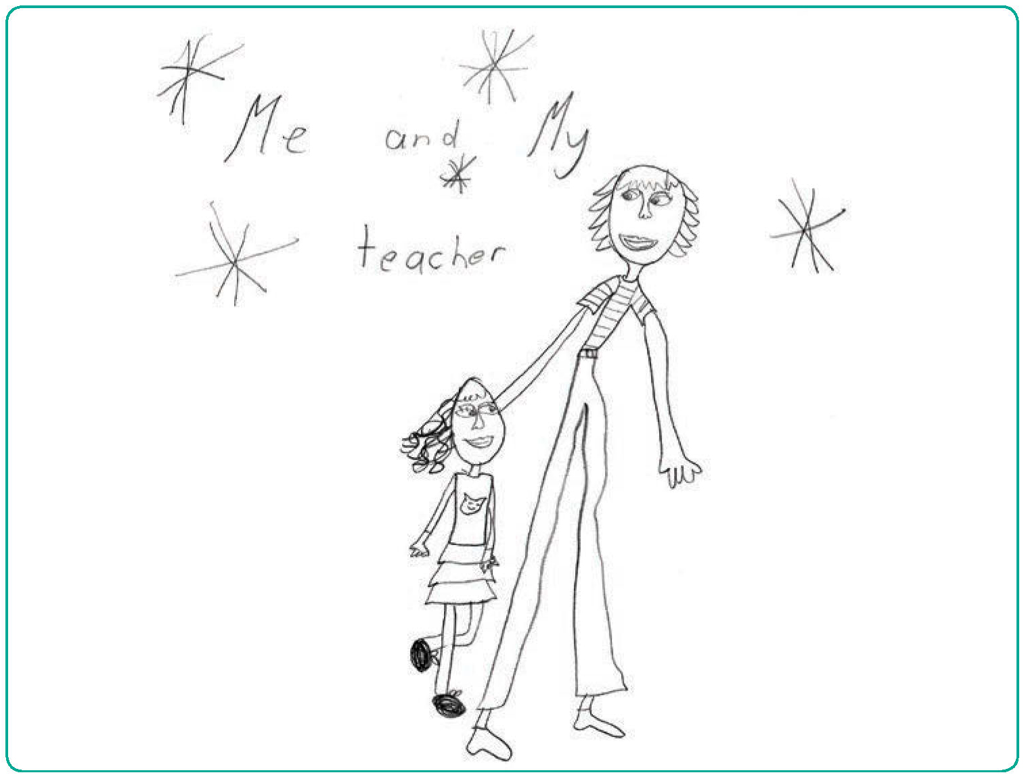

Recognising Aboriginal children’s assets as they start school
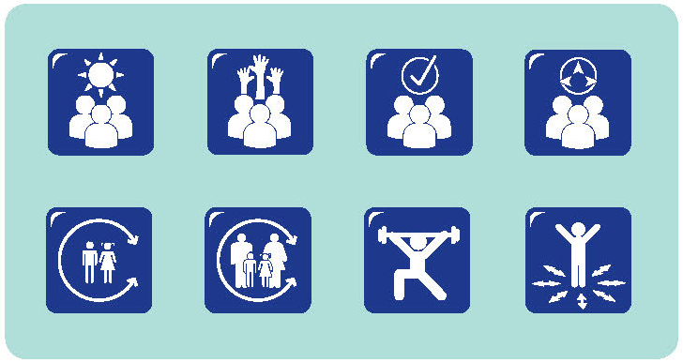
Leonie McIntosh, a Wiradjuri educator and researcher, shared some of her experiences and research results about children starting school.
When we read the reports, it seems like Aboriginal children coming to school have a great many problems. Yet, when we look at the Aboriginal children making the transition to school, we see their strengths and the possibilities for them to grow and learn. As an Aboriginal educator, I want everyone to have high expectations of our children, recognising their strengths rather than focusing on perceived problems.
I have spent some time talking with the community about what they regard as children’s strengths when they start school.
They identified a wide range of things, including children’s:
- cultural knowledge and their sense of cultural identity
- knowledge of their family and community
- sense of belonging to that community
- use of initiative – if they see something that needs doing, they will do it
- social skills, such as being compassionate, caring, capable of sharing and showing respect.
The research supports my conversations with school educators about their expectations of and for Aboriginal children. Looking at strengths helps re-frame the way people look at information; if we look for problems and challenges, we will find them. If we balance this with recognising strengths and focus attention on how we can build on these, we can approach things in different ways.
Designing a transition programme based on strengths is quite different from designing a programme to overcome perceived deficits. You can still have many of the same activities, so you can still have opportunities for children to draw. But the focus might be on the meaning of the drawing, not on whether or not the child holds their pencil correctly.
QA 1.1.2; 5.1.3; 6.3.2; 6.3.4

Three wishes

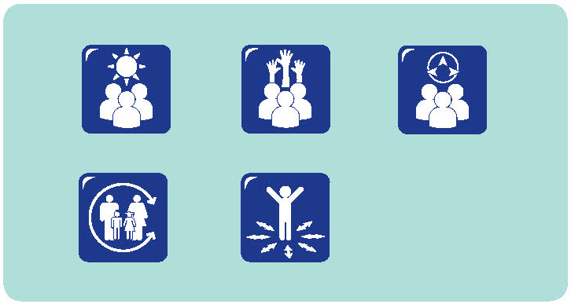
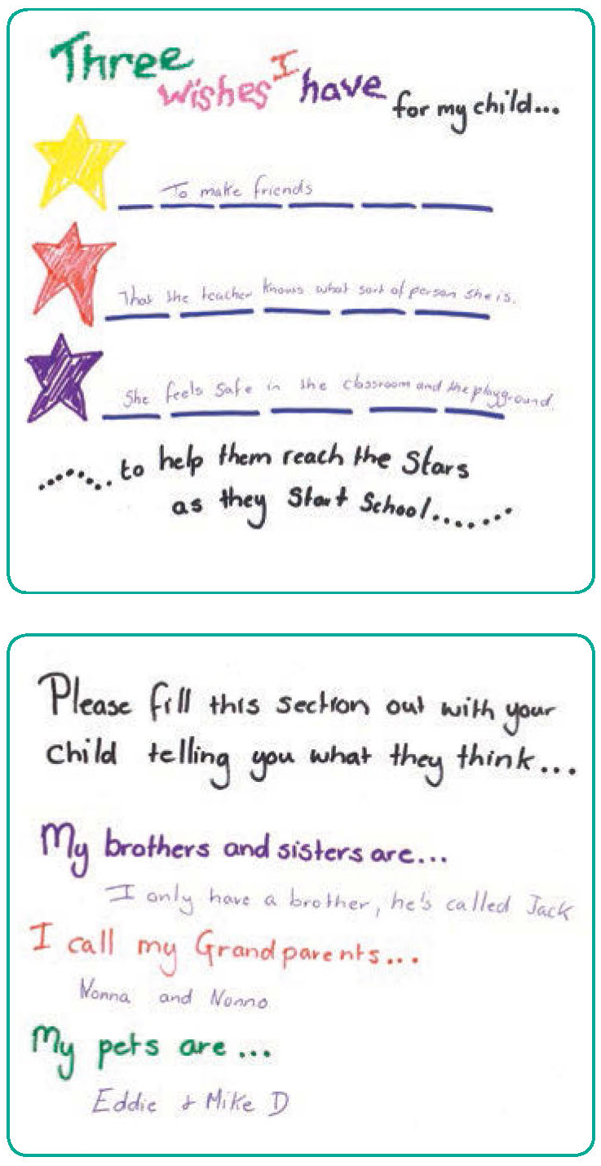
We have developed a booklet for transition. We ask parents to write in it and share three wishes they have for their children as they start school. It’s about embracing what parents know and how well they know their children. It’s about saying that parents know their children best.
The three wishes are aspirational – it’s about parents being able to articulate what their aspirations are so that schools and teachers can work together with them to achieve those aspirations. Most of the parents have positive aspirations – about children being happy and safe, being confident learners.
Some parents want their children to have better school experiences than they had – or to do better at school than they did. We continue to ask parents about their wishes as the children go through school. At the end of each year, we remind parents that they can make any requests to teachers for next year, but they have to use educational grounds to justify their request.
The three wishes are aspirational – it’s about parents being able to articulate what their aspirations are so that schools and teachers can work together with them to achieve those aspirations. Most of the parents have positive aspirations – about children being happy and safe, being confident learners.

We have about 100 parents writing requests each year. They are just so spot on! They are unbelievable. They can articulate what their children need and they say things like:
My child responds really well to a teacher who speaks really quietly and individually to them; or my child learns best when they are not forced to participate in everything; or my child needs to be able to perform in public, but they need lots of encouragement to do it and they will just dig their heels in if they are embarrassed; my child needs to be challenged a bit more.
QA 6.1.2; 6.2.1; 6.3.2

Who’s ready for what?
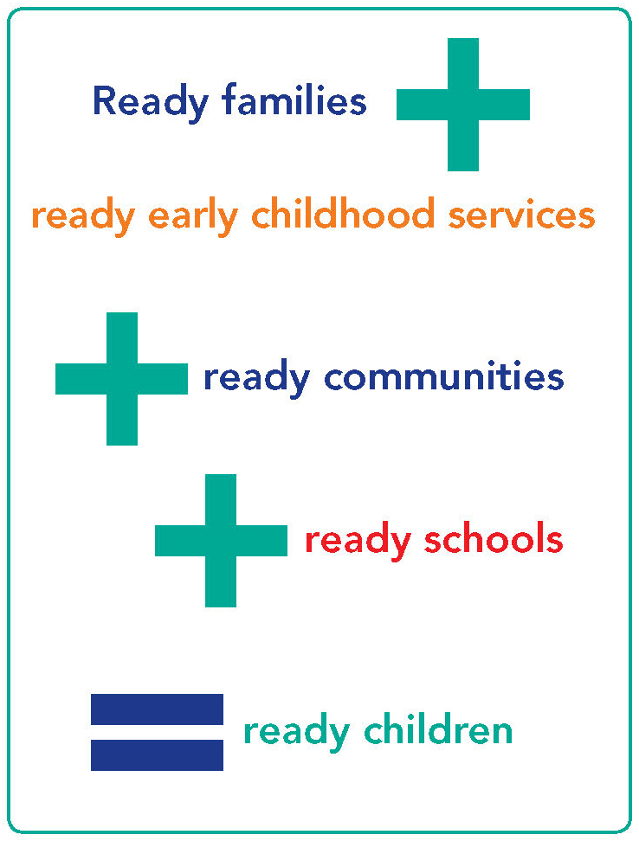
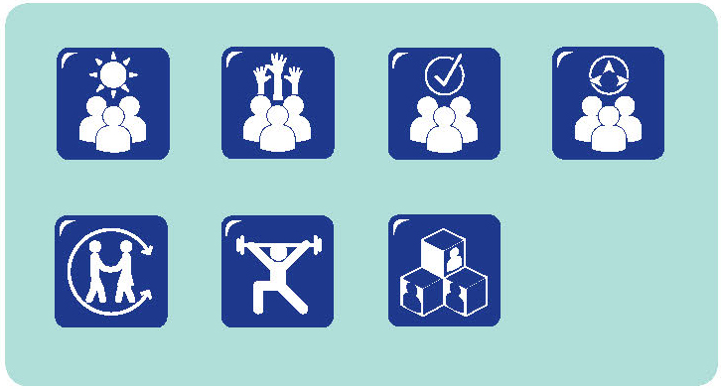
My dilemma as an educator working in long day care is always about whether we are getting the children ready for school or getting schools ready for the children.
My belief is that schools should be ready for the children. There are lots of discussion about the literacy programmes being used in schools and whether we should be using them in preschool. But we have had lots of discussions and we’re very comfortable not pushing that approach onto children before school. Our aspirations are for schools to be ready for children, to have better places for play and to be comfortable spaces for families.
We think we can promote that by having lots of interaction with the school, sharing what we do and why we do it and by sharing information that helps them prepare for the children and families who will be attending.
We invite school staff to come and visit and see the play space that children come from and the ways they engage and we engage with them. We share information about The Early Years Learning Framework and how we are using it and we invite them to talk with us about what happens at school.
We want to send the message that we can work together, learn from each other. We expect to have good interactions with the school staff and we expect them to have good interactions with us.
We use The Early Years Learning Framework to share information with children and families and encourage them to share this with the school. We develop a portfolio around the outcomes. It has photos and learning stories that illustrate how each child has achieved the outcomes as well as other interesting or important things for each child.
The children have real ownership of their portfolios – they’re so proud of them and can tell you about the learning stories. We encourage the children to take the portfolios to school and share them with the teachers.
It takes a while to do it, but schools see it as a way of finding out some more about each child. Some schools say they want different information about children – more about behavioural issues or concerns – so it can be a challenge to come up with a format that works for us and them as well, but we can do that if we keep talking and if we have that growing respect between our organisations.
We think we are helping schools get ready for the children by sharing the information we regard as important about the children and about our setting and inviting school people to visit and see how we operate a play programme, how we focus on children’s strengths and interests and how we report this to parents.
QA 4.2.3; 6.3.2

Principle 4:
Respect for diversity
Australia is characterised by diversity: including, but not limited to, geographic, social, economic, ethnic, cultural, linguistic and educational diversity. In addition, substantial numbers of Australians experience disabilities. Children, families, educators and communities are likely to be affected by these differences in a range of ways.
Contemporary notions of diversity encompass the multiple differences that make individuals unique (Durand, 2010). While understandings of diversity have been used to consider differences among groups of people related to gender, race, ethnicity, culture, language background and disability, broader conceptualisations now utilise the term diversity to refer to the many individual differences between and among children, families and communities (Saffigna, Franklin, Church, & Tayler, 2011). Recognising diversity requires acknowledgement that difference is complex, multi-faceted and relevant for all.
From an early age, children recognise differences between themselves and others (Connolly, 2011), and are aware of the attitudes to such differences of those around them (Bar-Tal, & Teichman, 2005). Young children are active interpreters of their environment and their interactions within it. Their attitudes towards difference are “grounded in their day-to-day experiences” (Connolly, 2007, p. 51). Children learn respect from engaging with those who demonstrate respect. Educational environments that promote respect and tolerance for difference, that are “free from stigma and discrimination, and which discourage the development of bias and prejudice, not only addresses children’s rights in the here and now… [but also lead] to the development of better societies…” (Bernard van Leer Foundation, n.d., p. 5).
Experiences of exclusion, stigmatisation, discrimination or disrespect also have both short and long term implications. Not only are such experiences an infringement of the rights of individuals, they also have potentially negative effects on people’s sense of self and identities, and undermine their sense of belonging and citizenship.
Like most people, many educators view their practice as ‘normal’, taking for granted their ways of being and doing. In Australia, as in other countries, “the beliefs and practices of the dominant group…have been validated and legitimised above those of other cultural groups…the values, beliefs and practices of this group have been the standard by which everyone else is judged” (Durand, 2010, p. 838). Demonstrating respect for diversity requires educators to broaden their worldviews and knowledge and to examine their own culture, perspectives and experiences of diversity (Rogoff, 2003). Engaging in ongoing learning and reflective practice provides the basis for this examination (Maude et al., 2009).

Inclusion
Approaches to diversity are inextricably linked to concepts of inclusion, which incorporate “social inclusion (belonging and being valued as a person) and academic inclusion (being supported to succeed in learning)” (Petriwskyj, 2010, p. 196).
Inclusive contexts operate from the premise that all children are capable of learning and have rights to high quality education and care. They also recognise the strengths of families, educators and communities, and seek to create environments that promote positive, respectful opportunities for families and communities to shape their engagement with educators and educational settings (Baquedano-López, Alexander, & Hernandez, 2013). Inclusive educational settings have the potential to support and respect diversity.
Children with disabilities or special education needs, and their families, encounter many challenges as they navigate the transition to school and school age care. These include the availability of appropriate support (Janus, Kopechanski, Cameron, & Hughes, 2008; Petriwskyj, 2010); discontinuities as children move between early childhood settings and schools (Dockett, Perry & Kearney, 2011); as well as increasing demands and expectations for families (Breen, 2009; Ryan & Cole, 2009). Educators too, encounter challenges relating to professional development, structural issues, access to adequate funding, and systemic pressures (Grace, Llewwllyn, Wedgwood, Fenech, & McConnell, 2008; Petriwskyj, 2010). When educators, families and other professionals work collaboratively and have access to organisational support, potential exists for individualised, responsive practice that addresses the diverse capabilities of all children.

Belonging and identity
Respect for diversity is about:
…belonging and mutual acceptance (Bernard van Leer Foundation 2007, p. 5)
…becoming comfortable and supportive of diversity requires a certain mindset, a certain point of view, a certain process of sensitivity… (Durand, 2010, p. 837)
Such respect is enacted in behaviours and attitudes that promote a sense of belonging and feelings of welcome and acceptance. Respect for diversity is seen in environments where young children and those around them display positive attitudes towards others, regardless of their backgrounds or identities. Examples of respectful behaviours include prosocial interactions, open and responsive interactions, social awareness and empathy, including awareness of the impact of prejudice and discrimination. Skills to support these behaviours include perspective taking, negotiation and conflict resolution (Bernard van Leer Foundation, 2007).
“Belonging is the relational dimension of personal identity… that locates every individual… at a particular position in space, time and human society and – most important, connects people to each other” (Woodhead & Brooker, 2008, p. 3). There are many ways in which people feel a sense of belonging and many contexts in which belonging is experienced. A sense of belonging involves feeling cared for and valued, as well as having opportunities to express personal agency; it carries feelings of security and acceptance, recognition and respect.
As children make the transition to school, Broström (2002) has described the importance of ‘feeling suitable’ – feeling like they belong in the new context. Feeling suitable – belonging – at school is a critical element of engaging with school and those at school for children, families, educators and communities.
A sense of belonging within the family and community is a fundamental element of identity. The identity of Aboriginal and Torres Strait Islander children is integrally linked to their belonging within family and community (Mason-White, 2012). Acknowledging and celebrating the strength of Aboriginal and Torres Strait Islander families and communities requires recognition of the cultural knowledges and practices of each community (Guilfoyle, Saggers, Sims, & Hutchins, 2010), as well as the differences that exist for individuals within those communities.
Demonstrating respect for diversity involves recognising the ways in which discrimination and prejudice has impacted, and continues to impact, on the lives of Aboriginal and Torres Strait Islanders. It requires educators to value Aboriginal and Torres Strait Islander cultures, languages and traditions, challenge stereotypes, and to demonstrate this in their practice. These approaches are underpinned by partnerships with families and communities (Imtoual, Kameniar, & Bradley, 2009).

Welcoming
Children, families, educators, other professionals and community members experience a sense of belonging when they feel welcome in various early childhood settings, schools and school age care settings.
There is no one way to create welcoming environments; they will be different in each context and for the individuals involved.
However, there are some elements that have been identified as contributing to culturally affirming spaces (Saffigna, Franklin, Church, & Tayler, 2011). These include:
- Recognising and supporting children’s home languages
Language is a key element of personal, family and cultural identity (Makin, Jones-Diaz, & McLaughlan, 2007). Children’s competence in their home language is linked to their development of further languages and educational outcomes (Han, 2012; Yazici, Ilter, & Glover, 2010), and their personal identities as they make the transition to school (Rich & Davis, 2007).
- Working in partnership with families and communities
Respectful partnerships with families and communities promote the sharing of information and working towards common goals. Families and communities feel welcome in educational spaces when their roles are recognised and valued, and when their practices are treated with respect (Baquedano-López et al., 2013).
- Working in partnership with families and other professionals
A number of professionals may be involved in working with children and families with additional needs. Working collaboratively in teams focused on the child and family provides opportunities to coordinate resources and support, while at the same time promoting consistent focus on common goals. Transdisciplinary teams (Davies, 2007) involve professionals from different disciplines working and learning together with families as they deliver coordinated services.
- Promoting a sense of connection with the community
Children’s learning and development is facilitated when they, and their families, are considered as valued members of their community – both their educational community and their broader community. Community will mean many things to many people – it is important that educators respect diverse connections with community and value these. The importance of such connections is embodied in Aboriginal understandings of, and connections to, place (Atkinson, Nelson, & Atkinson, 2009; Harrison & Greenfield, 2011).
In summary, educators are well placed to support and maintain responsive, inclusive educational settings as they:
- demonstrate respect for diversity and encourage children and families to be comfortable with diversity;
- challenge dominant discourses related to diversity as well as children’s learning and development;
- avoid stereotypes and suspend judgements;
- advocate for appropriate resources to support and maintain responsive, inclusive services;
- recognise the strengths of children, families and community members, as well as the strengths that they and other professionals bring to the educational context;
- respond to the individuals with whom they interact, guided, but not limited by, awareness of diversity;
- reflect on their own understandings, practices and expectations;
- seek out and incorporate Aboriginal and Torres Strait Islander knowledges and, with the help of local family and community members, incorporate these in appropriate ways in educational programmes and interactions;
- promote children’s sense of identity, recognising the importance of belonging;
- recognise and include children’s home languages;
- work in partnership with families and communities; and
- promote a sense of connection with the community.
The principle of respect for diversity is integrally linked with each of the other principles that underpin the The Early Years Learning Framework and Framework for School Age Care. The principle of equity holds that each child and family has the right to access educational opportunities that support them to reach their full potential. These opportunities will differ according to the diverse characteristics of those involved. Such opportunities also rely on high expectations – the sense that children and their families are competent and, with appropriate support, capable of attaining positive educational outcomes. Equity and respect for diversity are also key elements of trusting relationships and effective partnerships.
Finally, respect for diversity can only be accomplished when educators reflect critically on their own positions, understandings and expectations and are willing to consider other perspectives.

Narratives
- We're on the road almost all the time
- Transition with special needs
- Catering for diversity
- Will I have special time with mum?
- We're a quiet space
- Parents provide information for new parents
- More than on language

We’re on the road almost all the time
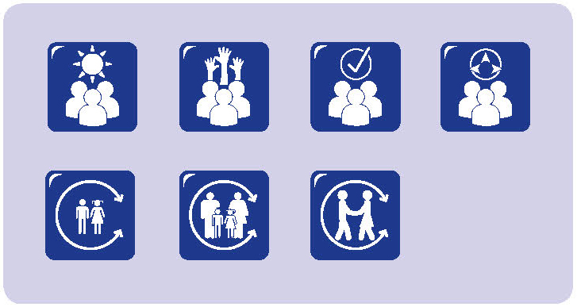
We are a mobile children’s service. In a week, we’d usually travel several hundreds of kilometres, setting up preschools in a range of different locations. The regional School of the Air organises some mini-schools each year, so that the children can get together. We try to set up a preschool at the same time, so that the younger children can come as well and experience a preschool programme while the older ones are getting a taste of school. It’s a great chance for us all to get together because people come in from all around and usually stay for the whole week.
The children who access our preschools start school in many different ways. Some go away to boarding school, though mostly that happens for high school. Some will travel in to school each day, but if the families live a long way out, they often look at renting a place in town during the week and one of the parents and the child will stay in town for school days and go home at the weekend.
Others will stay at home and do School of the Air, either with their parent – almost always mum – or maybe a governess.
We find that some families are keen to have their children start school as late as possible – because that means they can put off these disruptions for a while longer.
If they are looking at a child going to boarding school for high school, most parents think that the older the children are, the better.
Some of the parents have done their own school through School of the Air, but it’s all changed a bit since then, especially with the use of computers.
When we meet with the parents we have lots of conversations about what it will be like, what they need to know and how they think they will cope. If it’s their first child starting school, it’s also about what to expect for the children and what they need to know and be able to do as well.
Mostly, the mums are working on building up their confidence to do school – to still be mum, but then to be the teacher as well.
QA 4.2.2; 6.2.1; 6.3.2; 6.3.4

Transition with special needs
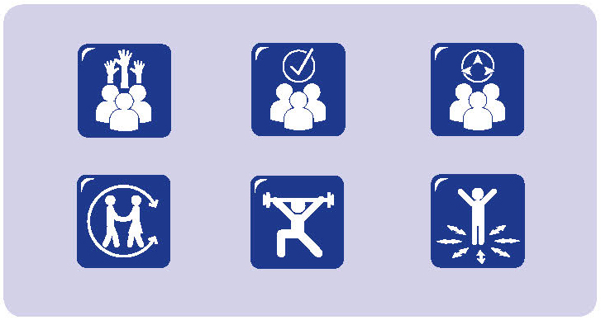
There are five students starting school next year in our school- based support unit. They all have high needs; each with a diagnosed disability and each with their own individual needs. The staff at the school have developed a specific programme, so that we can cater for them individually. Instead of having them come with all the other new children for one day a week throughout the whole last term, we have worked on a programme that invites these five children and their parents/ carers to come every Tuesday over a five-week period.
We anticipate that these children find it difficult to cope with the large environment and may be overwhelmed by large numbers of children moving around as they go to their classes. We also know that it is difficult for the children and their parents/ carers to be separated for long periods. We try to set up some experiences that ease that a bit. In the past, we have found that asking them to be at school for a full day is just too stressful for the children and their parents/carers.
The children and their parents/carers are here for two hours, attending the same class that they will be attending next year. Our classes in the learning support unit have a maximum of seven students, so the transitioning children don’t feel overwhelmed. In the final week of the programme, the parents are invited to come to the staffroom and have a coffee with the principal and support staff.
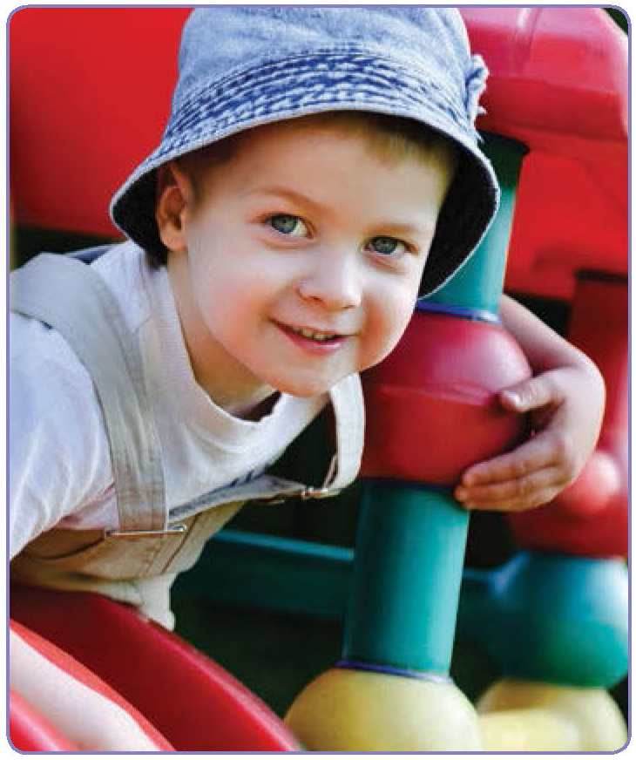
It’s about being on the same grounds as their child, but just that little bit further away than the previous weeks. It’s a dual anxiety – the child leaving the parent and the parent leaving the child. Particularly so for these children, because the parents have invested so much into making sure everything is OK for their child, and it is very much an intense sort of an investment.
When the children come for the two hour sessions, they play and they participate in the same programme that is running in the classroom at that time – which is very much an individualised programme. A lot of sensory activities and lots of chances todo any of the self-management strategies that they might have – some students need to rock, some need to tap or clap. It’s whatever they need to do to help themselves feel comfortable. During the two hours, the teacher and the aide get to know the child, so that when the child returns next year the staff have a bit of a ‘heads up’ on how to manage the situation if it becomes a very anxious time.
The programme is essentially about the child, and about the child being given the cues they need to make the transition successfully. We produce a booklet with pictures of who is going to be in the class, the key people – so the principal and the teachers are in there – and the places around the school.
They then have this booklet to familiarise themselves with over the weeks before they start school. Also in the booklet are all the visual prompts for what to expect at school. For many of our students who are autistic, it’s about knowing the routine. So this booklet helps to provide that, as well as having the opportunity to experience it during the sessions.
When the children start school next year, there is an expectation that they will attend for full days. However, we provide the two hour session each day for some time into the new school year, so that the children and parents can ease into the full day.
QA 1.1.2; 1.1.5; 6.3.1; 6.3.2; 6.3.3; 6.3.4

Catering for diversity
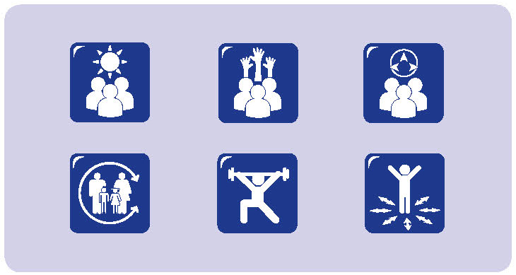
Our school has a diverse student body, with an 85% culturally and linguistically diverse family base, so catering for the diversity of our families was really important in planning the transition programme. As the transition coordinator in the school, it was my responsibility to make sure that we had leaflets that were in home languages, so that everything was accessible.
We had resources on family referral services, community health, early words – all the resources were in the home languages for families. This included the puzzles and books that were available during the programme activities. We used a lot of visuals as well to let the families know what was happening. We didn’t want them to feel confused or that they had to ask somebody all the time.
We had the bonus of having the interpreters on board. Each Tuesday morning for the four weeks of the programme, we made sure that there was either an ESL [English as a Second Language] teacher or community language teacher with each group of children and parents, as well as the teacher responsible for each activity.
We chose a group of Year Five children to help run some of the activities too. They acted sort of as buddies; we wanted to involve some older children, so that there would be some familiar faces in the playground when the new children started school. The Year Five buddies also have diverse cultural and language backgrounds, so that there is a chance for children and parents to talk to someone in their home language. It’s also about us making it clear that we celebrate and welcome diversity in our school.
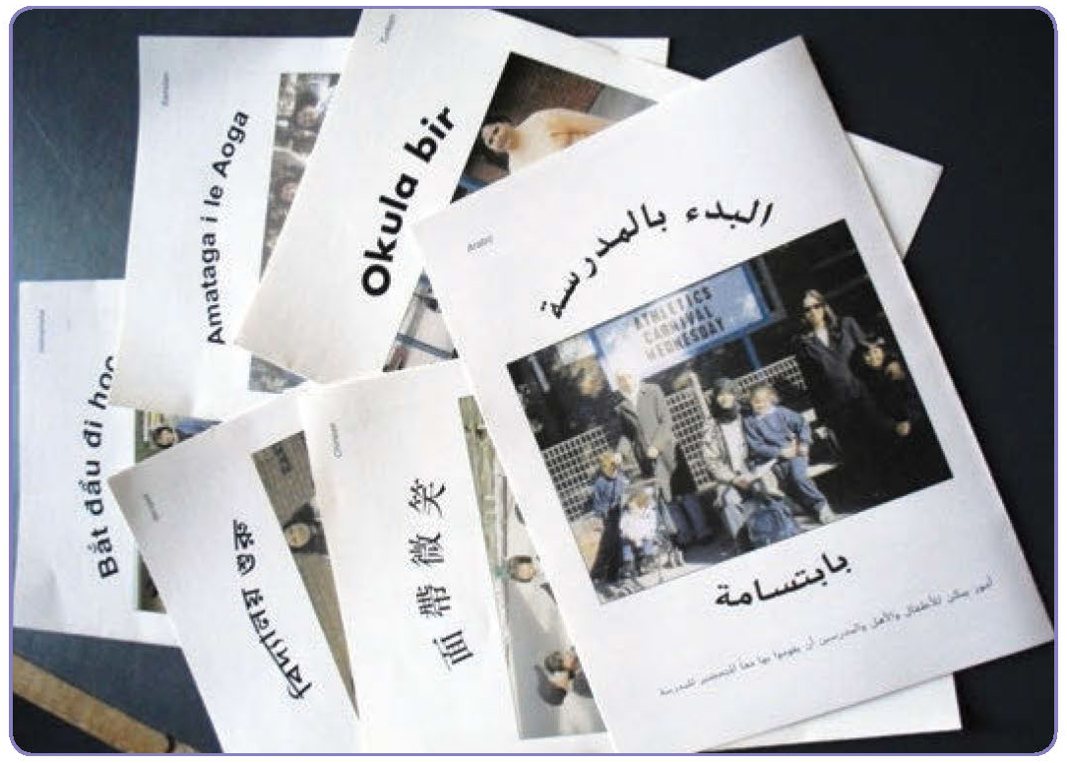
We didn’t just invite the parents and the transitioning child either; we made sure that the whole family, including younger siblings, were welcomed into the school. We think this is a really important part of celebrating and supporting transition to school.
During one of our transition sessions I saw three women all standing together in the playground while the children were doing some activities. I didn’t think I had met them, so I approached the group and asked each of them which one their child was. They said Oh no, we’re here as her support group, and that’s her child, pointing to another woman who was on the playground.
They were all focused on the child who was engrossed in her activity. They were all smiling and one commented, Look at her; she’s just rearing to go – look, look at her. And I just thought this is what it’s all about. How fantastic is it that her friends had come to support her, and that they all felt comfortable enough to come to the school to do so.
QA 5.2.1; 6.3.1; 6.3.2; 6.3.3; 6.3.4

Will I have special time with mum?
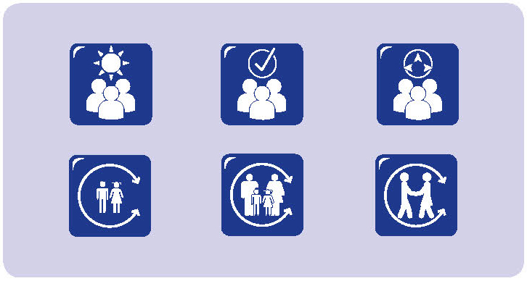
Josie is a mother of four boys, aged from three to nine years. She is reflecting on her third son’s transition to school. James had attended the early learning centre located on the school site since age 3. He was familiar with the school environment, having walked with his mother and older siblings to their classes before going to the early learning centre.
Josie explained:
I elected to be a stay-at-home mum when our oldest son was a toddler and I was expecting our second child. We had moved to a new city for my husband’s work. We didn’t know anyone, had no extended family support and my husband worked long hours. The three older boys have all attended the early learning centre which is part of the school.
Despite this, our oldest son’s transition to school was something of a challenge. He is a slightly anxious child, concerned with expectations and ‘doing the right thing.’ The principal and teachers were both supportive and understanding at this time.
When our second son started school it was quite a different experience. He just took to it all like a ‘duck to water’. I think he felt that this was his place and he revelled in everything about it. Our third son, James, is of a similar nature...calm and quietly confident. Because of this I was fully expecting that his transition would be straightforward. But it was quite the opposite.
After the first week he just refused to go to school. He cried and kicked and protested. It was dreadful! When we were eventually able to calm him and talk with him he said that he didn’t like school because it was so different...there was no choice of activity, you all had to do the same thing and you just sat and sat and listened.
The co-location of the school and the early learning centre meant that for about 5 weeks we were able to negotiate that several afternoons each week he could spend time in the early learning centre. This was gradually reduced over time and things progressed smoothly.
Some months later he asked me if he was ever going to have his ‘special time with mum’ ever again. Before he started school, one afternoon a week, when his baby brother was asleep, he and I would do something special together; just the two of us.
It seemed that this change was another factor that had saddened and confused him, impacting on how he felt about starting school. This was a significant change for him that I had never considered.
One of the things I have observed as the boys have moved from year level to year level is how extreme the changes from one class to another can be and I often wonder why this is the case. In some instances it is as if the children are migrating from one land to another.
This change seems particularly so when children start school and while I understand the different staffing arrangements I can’t help but wonder why the differences in practices are so extreme.
QA 6.2.1; 6.3.2

We’re a quiet space

I work in occasional care. We operate out of the same building as the long day care centre, but we are separate. We are primarily for children who are not using any other children’s services – so children who are not in family day care, or preschool or child care. Maybe the children spend some time with grandparents, but they are not using any other formal care.
We find that we have a fairly stable group of children over the three sessions we run. Generally, children come once a fortnight for a session of three hours. If there are some special circumstances, sometimes the children come weekly – we like to have some flexibility so we can respond to what is happening for families.
Often young children start with us here in occasional care and then we help them and the families make the transition to child care. But we do have some children who have been with us for several years and we have supported them as they make the transition to school. We find that many children really like our small, relatively quiet groups. We’re a small group and many children find that quite comforting.
One of the challenges for the children going to school is that it is so much bigger and busier and louder. We had one child who was excited to go to school, but she just found it really overwhelming. She was really set to go to school academically – she was approved for early entry. But she was thrown by the school environment. So we were able to work with the school so she could come back here and have a little bit of quiet time during that first term, as well as spending time at school.
It helped that she was not at school full-time and she could come here while she was still settling in at school. We could only keep that going for so long – about a term – but it really helped.
Often young children start with us here in occasional care and then we help them and the families make the transition to child care. But we do have some children who have been with us for several years and we have supported them as they make the transition to school.

QA 4.2.2; 5.1.3; 6.3.2; 6.3.3

Parents provide information for new parents
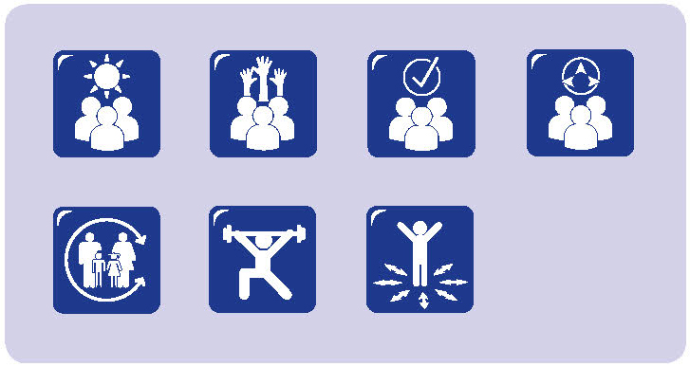
Several of us have started a morning tea group for parents of children with a disability where we meet and support each other. We organise the group and invite all the parents – especially the new ones. It really helps us think about lots of things – not just our children. We’ve almost finished an information pack for new parents. It’s not quite finished, because things happen when you have a child with a disability and with parents trying to manage lots of different demands.
We’ll give the information pack to each new family. It has lots of ‘official’ information, and it shares lots of other practical information such as what sort of equipment is available and where to obtain it and getting vouchers for taxis and things like that: things most parents don’t know about before they come to the school. So there is a lot of useful information we can pass on.
Working on the information pack has helped us all feel more comfortable and we trust each other and the school more than we did before. The school gives us some space to meet and they support us. They don’t keep us out – they always have the coffee urn on.
It’s really hard to have your child start school. I don’t think we recognise enough that many of us are still grieving. Not just with the disability, but then with having to leave the children all day at school.
It’s really hard to have your child start school. I don’t think we recognise enough that many of us are still grieving. Not just with the disability, but then with having to leave the children all day at school.
We’re so used to being there for them every minute – we know them. But we have to leave them at school all day and it feels like another loss.
The information pack will help new parents make the transition. So will the morning tea. As well the staff work with us – it feels like a partnership.
They talk with us and involve us in meetings, and they talk with us about goals for our children – goals about their physical development and their communication. They have genuine learning goals for all the children.
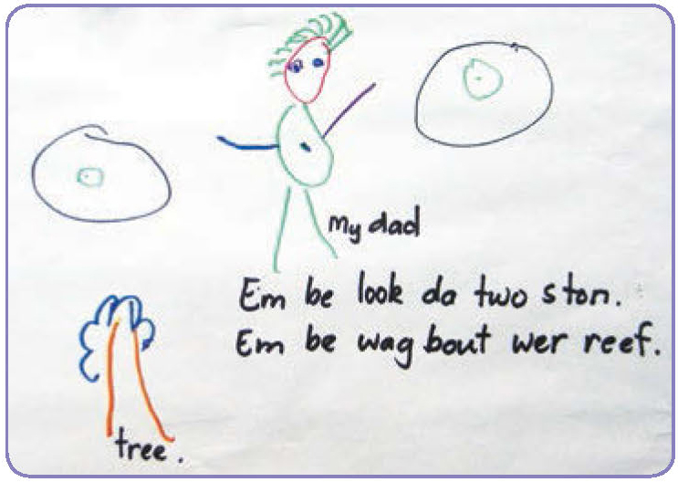
QA 6.1.2; 6.2.1; 6.3.2; 6.3.3

More than one language
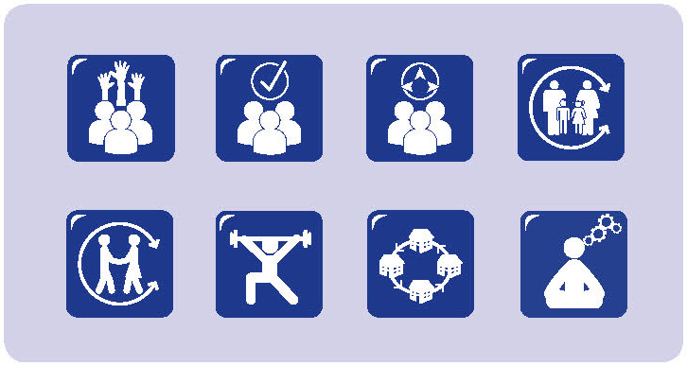
English is not the home language of many children living in Torres Strait Islander communities. As the director of a preschool in one such community, Naomi relies heavily on the expertise of Rosy, an Indigenous educator who has lived most of her life in the local community, to recognise and build on children’s home languages as well as support their learning of English.
We make sure that we recognise the language of each child and let them know that is accepted and valued. It’s the same for families as well. Sometimes family members don’t feel comfortable talking in English – especially grandparents when they drop off or pick up the children. It’s important for Rosy to be able to connect with them, talk to them, invite them in, make them feel welcome. I’m still very happy to talk with them, but I take my lead from Rosy. I think it helps make the children and the families feel safe and comfortable coming to preschool. [Naomi]
Together, Naomi and Rosy have developed a trusting and respectful relationship where they model the use of the local Creole, the traditional language and English in their interactions with each other, the children and families. Interactions with children and families are often bilingual. Rosy and Naomi work together to develop a range of resources that incorporate both English and local languages, and promote local experiences.
One outcome of using a range of languages in the preschool has been that a wide range of children’s knowledge and understandings were shared with the educators. Where things were unclear for the children, Rosy talked about the importance of being able to ask questions in different ways using different languages.
I can ask the same question in different ways. So the children might have a better understanding of what they are being asked. If they can use language, they can give a deeper, more complex answer to a question and we have a much better idea of what they know and understand. [Rosy]
The strategies used in the preschool have been continued as the children make the transition to school. While English is promoted and supported in many ways, so too are home languages and the connections that are made between home, preschool and school.
The school principal and first years of school teacher recognise the value of promoting home languages and have seen the ways in which children feel comfortable and move between the languages in their learning.

QA 1.1.2; 4.2.2; 4.2.3; 5.1.2; 5.1.3; 5.2.1; 6.2.1; 6.3.2; 6.3.4

Principle 5:
Ongoing learning and reflective practice
Ongoing learning and reflective practice are cornerstones of high quality educational settings (Bleach, 2014; Moss, 2001). Professional interactions with children, families, other professionals and community members can be complex; commitments to ongoing learning and reflective practice promote educators’ awareness of actions, and the consequences of these, and serve as the basis for improving practice.

Ongoing learning
Ongoing learning opportunities promote the professionalism of early childhood educators. Effective ongoing learning, or professional development, is shaped by the contexts in which educators operate and by the values, beliefs and expectations educators bring to those contexts.
There is a well-established connection between engagement in ongoing learning and children’s outcomes: educators who engage in ongoing learning take greater responsibility for the educational outcomes of all children, they do not regard “learning difficulties as an inevitable consequence of the home or environment” (Timperley, 2008, p. 9).

Reflective practice
Reflective practice has become a powerful discourse in education, despite some confusion about the definition and enactment of such practice (Kinsella, 2007). Much of this discourse draws on the work of Dewey (1933) and Schon (1983) who emphasised the importance of deliberate, considered action when faced with problematic situations, underpinned by a strong awareness of beliefs, values and attitudes.
Schon (1983) emphasised the relationship between reflection and experiences, distinguishing between reflection-in-action and reflection-on-action. Reflection-in-action involves educators being aware of their decisions and the bases for these as they engage in their daily practice; reflection-on-action emphasises the importance of reflecting on what has already happened, and then reviewing and critiquing it.
This dual focus reminds us that “Reflective practice is something more than thoughtful practice. It is that form of practice that seeks to problematise” (Jarvis, 1992, p. 180), in order to promote change.
Reflection-in-action directs educators’ focus to the immediate aims and consequences of their pedagogical interactions.
During these interactions, educators call upon their knowledge and past experiences as they frame their actions. Reflection-on-action provides opportunities for educators to question how they are positioned, and position themselves, in relation to broader questions of education and pedagogy.
Reflection-on-action carries a moral and ethical element and locates educators in positions that have the potential to transform educational practice, particularly to make a difference to the lives of children and families (Carr & Kemmis, 1986; Fullan, 1993) as they question taken for granted assumptions and ways of doing and being. Reflection-on-action helps educators construct different frames to view their practice, looking back on what has been done, considering different perspectives and questioning actions, values and beliefs, all with the view to understanding and improving professional practice (Parnell, 2012).
Drawing together several perspectives, Pollard (2005) outlines seven characteristics of reflective practice:
- attention to the aims and consequences of interactions, as well as effective practices;
- engaging in spiralling processes of monitoring, evaluation, and revising practice;
- using processes of evidence-based inquiry to make judgements about practice;
- attitudes that reflect willingness to consider multiple perspectives, and to examine the personal, academic and social consequences of education;
- exploring and re-framing practice based on evidence-based inquiry and research;
- dialogue with colleagues; and
- mediation of externally developed frameworks, such that educators justify the retention of existing practices, the development of innovative practices, the collaborative generation of new ideas and their application in professional environments, and/or resistance to such frameworks.
Taken together, these characteristics suggest that early childhood educators who engage in reflective practice draw upon both experience and evidence as they examine their daily practice; examine the assumptions and values they bring to their practice; recognise the contexts in which they practice; engage actively in dialogue related to practice; and interpret the curriculum frameworks with which they work.

Outcomes of reflective practice
Educators who engage in reflective practice are well-placed to promote positive outcomes for children and families. A strong commitment to ongoing, reflective practice involves educators examining their own values, beliefs and assumptions, understanding the consequences of these, and considering alternative perspectives, frameworks and approaches – all with a view to improving practice (Dahlberg, Moss & Pence, 1999; Durand, 2010; O’Connor & Diggins, 2002; Parnell, 2012).

Engaging in ongoing learning and reflective practice
Ongoing learning and reflective practice can occur in different ways, in different contexts and involve different people. It can also focus on different elements of practice. For example, Hatton and Smith (1995) describe four foci for reflection, each of which may be relevant for educators at different times:
- technical examination of skills and competencies in a specific setting;
- descriptive analysis of performance in a professional role;
- dialogic exploration of alternative ways to solve problems in a professional situation; and
- critical thinking about the effects on others of one’s actions, considering social, political, and cultural forces.

A range of strategies and approaches can support reflective practice across these foci (Arthur et al., 2014). These include:
- Guided self-reflection
A number of opportunities are available to support Australian early childhood educators as they engage in self-reflection.
- Journals
- Reflective journals can be used to record events and reflections. When used over time, they can become a record of personal and professional growth and locations for educators to engage in self-reflection.
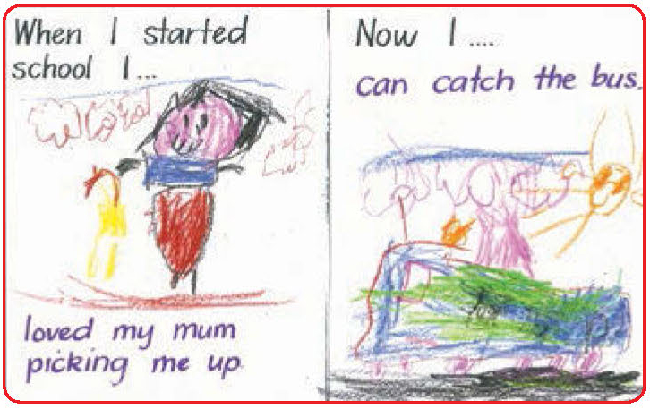
- Reflective conversations
These can be formal or informal, occurring during daily interactions, or as educators reflect back on events. They can occur with children, families, other professionals or community members. They can involve watching colleagues interact with others and reflecting on their intentions, actions and the consequences of these, taking a reflective stance by explaining practice to others, and addressing a specific topic during staff meetings. Reflective conversations can be promoted by visiting other educational settings, sharing information with families, and recognising the different perspectives of different participants. Much can be gained from reflective conversations with children. Frameworks such as Learning Circles (Cartmel, Macfarlane, & Casley, 2012; Macfarlane & Cartmel, 2007) can provide some guidance and structure to assist educators engage in reflective conversations.
- Visual displays
As educators create visual displays, they can provoke reflective conversations between those involved, the reasons for selecting and displaying materials and the consequences of the display. Visual displays can be very effective in engaging children and families in reflection.
- Communities of practice and professional networks
Communities of practice and professional networks can serve as a frame for professional inquiry and support reflective practice by providing a forum for the exploration of shared interests or issues (Buysse, Sparkman, & Wesley, 2003). Communities of practice draw together people with a range of expertise in the pursuit of shared goals. Professional networks often bring together people with similar expertise. Both provide opportunities for ongoing learning and reflective practice within a specific social and cultural context.
Reflective conversations can be promoted by visiting other educational settings, sharing information with families, and recognising the different perspectives of different participants.
The social and collaborative context for reflection is important (Wong, 2009). When educators have opportunities to share experiences with peers, feeling supported as they do so, they can be motivated to continue and to explore their practice, and the knowledge, understandings and expectations that underpin it (Alvestad & Rothle, 2007).
Participation in a professional community with colleagues can promote ongoing learning and professional development. However, participation itself is often not sufficient to generate change.
Professional communities that do not generate challenge or critique can reinforce existing practices and approaches. A climate of trust and respect is required if challenge is to be generated, and responded to, in positive ways. External expertise, sometimes in the form of a mentor, can provoke reflection and critique and help to maintain a climate of trust and respect (Timperley, 2008).
Ongoing learning and reflective practice requires time and effort (McClure, 2005). Ongoing learning and reflective practice is most likely to result when educators have multiple opportunities to engage with and consider issues, build upon what they already know and value, and explore implications for practice. To be effective, these opportunities need to occur in an environment of trust as well as challenge (Timperley, 2008). Learning and reflection are likely to be promoted when multiple ways of knowing are valued and when the existing knowledge and expertise of those involve is recognised.
Ongoing learning and reflective practice contribute to educators’ professional identities (Moyles, 2001). It also impacts on the ways in which children, families and early childhood education are conceptualised and the ways in which educators frame their professional practice and responsibility. In an era of increased attention to early childhood education, Skattebol (2010, p. 75) urges educators to examine how they and their colleagues “experience the uncertainties that accompany profound changes in teaching practice and identities and how educators can harness these uncertainties in ways that strengthen the profession.”

Ongoing learning and reflective practice in transition to school
Just as there has been increased attention to the importance of the early childhood years, there has been increased attention to transition to school and its significance for children’s ongoing engagement with school and long term outcomes. This provides many opportunities to reflect on assumptions about starting school and the ways in which this has been framed in research, policy and practice, asking questions such as:
- How is inclusion promoted in transition practices?
- What involvement do families have in transition approaches?
- How do we recognise children’s agency in their transition to school?
- What elements of social justice are promoted – or are missing – in transition strategies?
- What do we mean by a ‘smooth’ transition and why is it regarded as positive?
- Is transition identified as a series of activities, or as a range of processes?
- Can effective transitions be quantified and measured?
- What assumptions are made about who will struggle with transition and why? How does this influence practice?
- Have we taken away much of the challenge of transition for children?
(Dockett, 2014; Perry, 2014; Petriwskyj, 2014).

Narratives
- Why does it have to be so different?
- If you don't know, you'll be sad
- Being flexible in after school hours care
- The pedagogical chat
- Special after school care
- Being proactive: Transition focus group
- When do children feel they belong?

Why does it have to be so different?

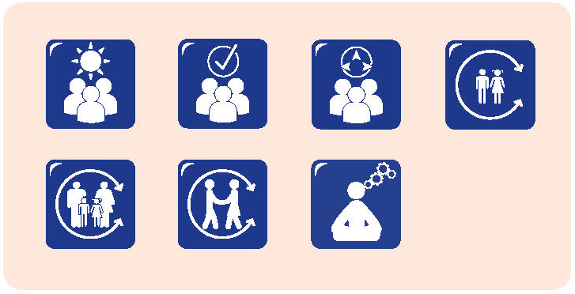

As the leader of a school-based early years setting, I have responsibility for the daily administration and educational programmes for children age 3 – 8 who attend the early learning centre, first year of school and Year 1 and 2 classes. So transition is part of my responsibility.
Over the past year I have spent a great deal of time reflecting on the positives and negatives of our current transition programme. I know changes need to be made but I want them to be informed changes with staff and parents having opportunities to contribute to the thinking. It is my vision that as a school community we can create a culture of professional inquiry in order to improve our transition practices.
As a leader I believe relationships have to be a priority in our work with children. While relationships are very much a focus in the early learning centre, they are not so much of a priority in the classroom settings in the first years of school.
My thinking was challenged by a mother whose child was five and getting ready to make the transition and begin school. She said to me He’s five and he knows it’s going to be different. I keep thinking, Why does it have to be different? We are physically located on the one site, 50 metres apart and yet children feel it’s going to be different. This troubles me and is a priority for discussion with the broader school community. I was troubled further when a week after starting school the same mother was talking with me and said His heart broke leaving you. Do we fully understand the depth of relationships and attachments we form with children and what this means when they move to another part of the school?
I have been leading the staff in transition related discussions that we have called our wonderings:
- What is our vision of the early years/ early school? What underpins our vision?
- Is there a common understanding about this vision between the educators in the early learning centre and the first years of school?
- What is the children’s vision of school? What underpins their vision?
- Parents say school is so different. Why? What is different? Do some things need to be different and why? Do some things need to look the same?
- Does learning look different or is it the day that is structured differently?
- How are we incorporating the voices of children and families in the transition process?
- What do our relationships look like in the early learning centre and different classrooms? What do we want them to look like; for children; for families; for educators?

I am questioning what advocacy role I have as a leader in supporting children’s wellbeing through transition. One goal I have set myself as a leader is to do more post-transition interviews with parents. What worked well? What didn’t? Why? Are there things we could have done differently?
My thinking has been jolted by the fact that three children, who I thought were comfortable and confident about making the transition into school, had a range of difficulties I would not have predicted. For one child it was about being put into a different class to his best friends. While teachers have the say about who goes into which of the two classes and we aim to match children with teacher’s styles, abilities of children and so on, I realise that children have very valid reasons of their own about what group they want to be in and we should be heeding these.
For another child it was about the structure of the day and he was feeling overwhelmed by a larger group doing the same thing at the same time.
My wish is that we get it right for all the children and that across the early learning centre and first years of school we have a consistent philosophy and can ensure continuity of relationships and learning, so that for parents and children any differences are comfortable and understood.
One change we have implemented is that all children starting school know who their teacher will be before the end of the year and the teacher makes contact in early January with the child and family. This has been welcomed by parents who had indicated in previous discussions that not knowing who your teacher would be had caused children and families unnecessary anxiety over the Christmas holidays.
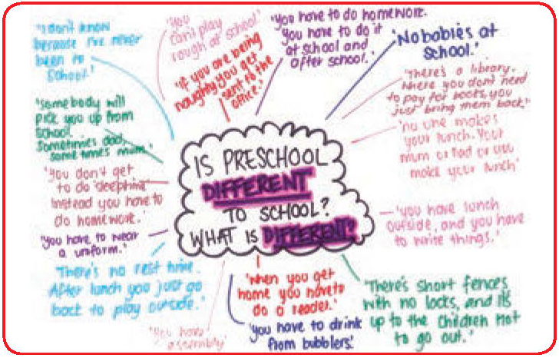
QA 1.2.3; 4.2.2; 4.2.3; 6.3.2

If you don’t know, you’ll be sad
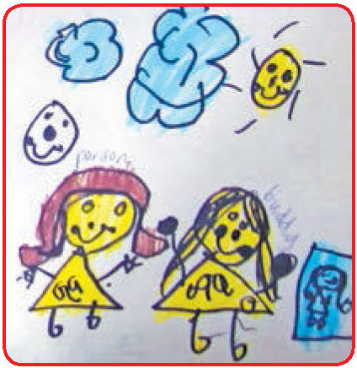
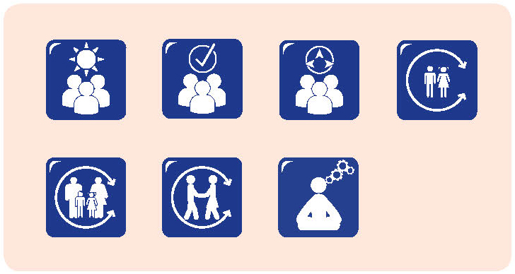
Children at a child care centre had recently been visiting the schools they would be attending. Not all the children would be going to the same school, and a variety of experiences were discussed on return to the child care centre from their new schools. As they discussed their visits and their schools, several referred to the school toilets and concerns about not knowing where the toilets were located. This theme was echoed in their drawings.
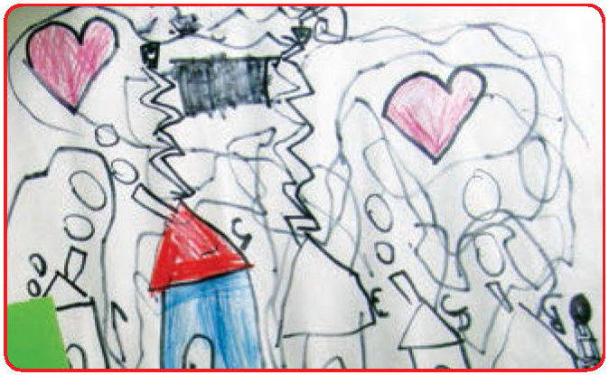
Sally: (about picture on left) So the person couldn’t find the toilet, and her buddy came and showed her where the toilet was and the person was happy.
Jack: I know where it is anyway they’ll teach me, show me where it is.
Bella: I’ve got a sign and it says, there’s a picture of a girl and a boy. The orange is girls, and boys is blue.
Gillian: (about picture on right) Everything in my school. I’m drawing me, the toilets. This is a map so the kids know where to go. First stop, the toilets.
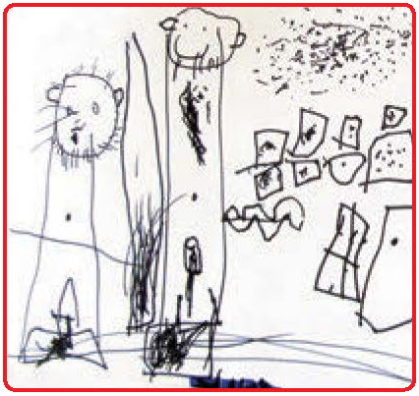
Lilly: Kids need to know how to wash their hands after the toilet because there’s germs.
Wesley: Knowing how to go to the toilet by yourself and washing your hands, then you don’t get germs everywhere.
Zara: Tristan was crying for the toilet, it’s not ok to cry at school, because you are big kids and you shouldn’t be crying otherwise the teachers will think you’re a baby.
Educator: It’s ok to cry at school, because it’s ok to feel sad, like if you miss your family.
Tristan: Don’t know where the toilet is.
Tristan: (about picture on left) Them is going to the toilets and have a door to the toilets and you shut the door to the toilets. No one told me where the toilets are, because I think about it, the toilets. I know where the toilets are, because if you don’t know, you’ll be sad.
QA 1.1.6; 5.1.3; 5.2.1; 6.3.2

Being flexible in after school hours care
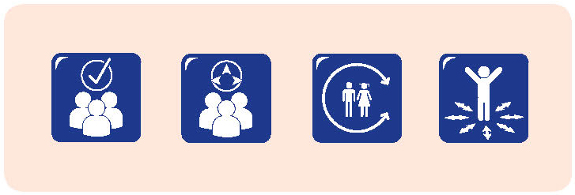
We are an after school care centre located on a school site. We have about 80 children each afternoon, mostly from the school on site. We used to have all the children together, but we found that the younger ones were feeling a bit overwhelmed by the big group and the big children. There was the size issue – with some of the younger ones half the size of the oldest children. Also, some of our older children have been coming here for years – they think they are part of the furniture!
They wanted greater flexibility. So now we offer some options. We will sometimes have 3-4 groups of about 20+, or two groups of about 40, depending on what we are offering that afternoon and what the children want to do. We have someone in the gym, so the older children tend to go over there. One of us goes over to the kindy rooms, and stays there with the younger children for a while, until they are ready to come to the main room. One of our new school starters has Down syndrome and he is much more comfortable in the smaller environment.
We aim to have ongoing conversations about how we can improve our programme. When we had all the children together, it was a bit chaotic, noisy and overwhelming.
Some children wanted to be very active; others wanted opportunities for quieter times. So we asked ourselves about what we were aiming to do and why. And we asked the children as well. From our own reflections and the information from the children, we have developed a much more flexible programme. For example, we don’t have everyone having to come to the one place to sign in. We used to have a long line to sign in; now that’s gone. Instead, we have several attendance lists, and the children can sign on here in the main room, or over in the gym, or in the kindy rooms. Then when we all come over here for afternoon tea, we consolidate the attendance lists into one.
One of the things we noticed when children started after school care was that they often looked a bit lost, especially at times of change. We have a flexible programme, but there are times when we have afternoon tea and move to different spaces throughout the afternoon. We have two main strategies to manage this. The first is that we encourage the children to have buddies. Usually there is someone from their class in after school care, and it can be really helpful to have a familiar face to help ease that transition. The second thing we do is that I make sure that the new starters know that they can come to the office area if they are feeling a bit uncomfortable. There is a little play area: it’s enough for them to bring some toys and sit down and play for a while. Sometimes there are five children together in the play area. They know when they feel comfortable to join in with the big group and they move out when they decide they are ready.
QA 1.1.6; 5.1.3; 6.3.2

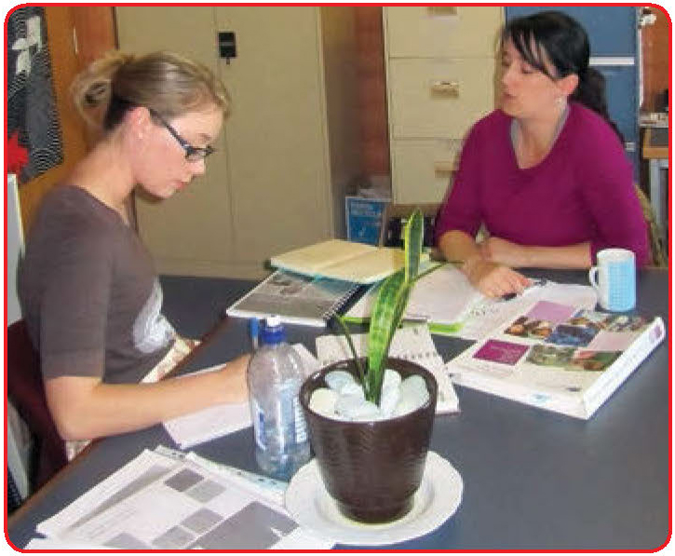
The pedagogical chat
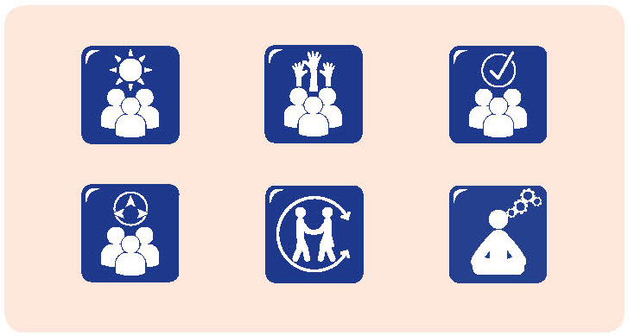
We are an early learning centre co-located with the school. One of our big challenges has been around transition and the ways we share information. We work on learning stories for all our children. We put them in a journal and encourage the children and families to take their learning journal along to school and show their new teachers.
A few years ago, we heard back from the teachers at the school. They said, Oh it was fabulous that you’ve done all that. They said, we let the children show them for news. But they weren’t regarding them as useful information from fellow educators. One time I asked them if they used the learning journals to help plan for the children. One said, They’re no use at all. They don’t tell us what we want to know. That’s not the information we’re looking for. I was just speechless.
But now things have changed. Now we meet mostly informally, but as well we have a more formal meeting once a fortnight. We talk about what we are doing and why. We visit each other’s classrooms and, when we visit, we ask about what we see happening and compare that with what we are doing in the preschool.
How did this come about?
It had a lot to do with leadership. We have leaders who could see what was happening and decided to change it. They helped us re-frame our thinking so we were not the school and the preschool – we started referring to ourselves as a learning community. And one of the aims of that learning community was to make our learning visible – not just the children’s learning, but our professional learning as well. When we started to have regular meetings together, we all had a chance to lead staff meetings – so we had preschool educators leading all the teachers and talking about what was important for us, what guided our practice and what we were trying to achieve in our centre. So, we started to have that pedagogical chat.
One of the first things we talked about was assessment and that’s where we focused on learning stories. We were able to get someone to come in and work with us for a few meetings, like a mentor. She helped us explore and describe what assessment meant in the early childhood years and how learning stories enabled us to report against outcomes but in a holistic way.
It wasn’t just about saying what a good job we were doing with learning stories – we had to really question what we were doing and why. We had some interesting conversations trying to work out what information we were keen to share and what information teachers at school wanted. It was all pretty much new for the primary teachers, but they really stuck at it. I was really impressed. It made me think they really were interested in what we were doing. We’ve had to change too. We now try to make sure we are more analytical in the learning stories we write up, making sure they are not just nice stories. So we target the way we analyse the information and that helps make them more useful for the teachers at school.
Now everyone is eager to read the learning stories. The children and families were always keen, but now the teachers are as well. They see the journals when they come to visit and stop to have a look and ask the children about them. They are so much more used to the format and what to expect that now they say they look forward to getting them. They use them for preparing for the new children – they say that they have actually got something to hang their information on – they’re not starting from scratch.
Our meetings are really important – they are our chance to stretch ourselves and look at our learning. There’s an opportunity to look at how we can do things together – not always the same things, but how we can stretch ourselves.
QA 1.2.3; 4.2.2; 4.2.3; 6.3.2

Special after school care
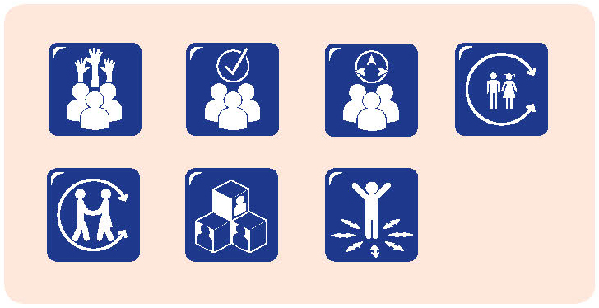
Even though we are located on one school site, we have children coming from several different schools to our after school care programme. One of our priorities is for them to get to know each other, especially the ones from different schools. Some of our after school care children come from a special school. Several of these children have multiple and severe disabilities.
Starting at after school care is an additional challenge for them and their carers, and for all of us in after school care. But it also gives us opportunities as well. We learn from the carers, and we attend some professional development to make sure we can assist. One of the great things about after school care is that it provides opportunities for the children to get to know each other and to learn about children with disabilities and how to interact with them.
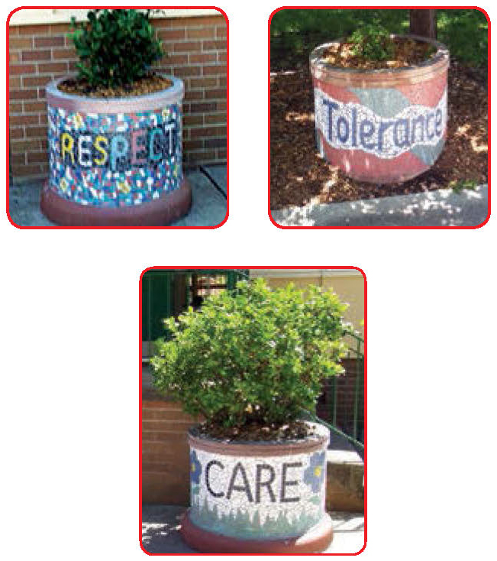
We have additional staff to support the children with additional needs. They work with us to help build our skills as well. We have staff go to training to make sure we can cater for the children with special needs. We learn about transfer and positioning and medication. We have at least three educators who have been trained in how to lift children properly and they can make sure we all use the appropriate methods.
We’ve had health professionals come and show us how to do the gastro feeds. That’s a very personal thing to do – so I only ask educators who are comfortable to do it and educators the children feel comfortable with. We have two trained educators any time we have one special needs child. So that can sometimes restrict attendance – if we don’t have the trained staff, we can’t have the children. It’s not always possible to get replacement staff with those skills.
It’s good for the other children to get to know the children with additional needs in a school age care environment. It helps build bridges. Some of the younger children have asked Why can’t she talk? and Why is she crying? Because they’re comfortable with the staff, we can explain what we’re doing.
QA 1.1.5; 4.2.3; 5.1.3; 5.2.1; 5.2.3; 6.3.2; 6.3.3
So I can tell them that crying is one way of telling us that she’s a bit frustrated. Some of the children from the special school bring their computer screens and the other children start watching games and things with them.
In a school age care environment you get opportunities to talk about those things and for all the children to get to know each other. We have seen in the school playground how that helps, when the children feel confident to approach and interact with each other – including those with disabilities. We find that the after school care environment gives them a chance to play games and just be with other children. It breaks down some barriers.

Being proactive: Transition focus group
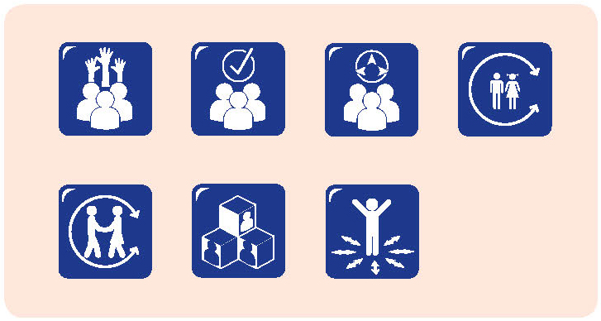
The Transition Focus Group was the initiative of an early childhood educator who was keen to strengthen connections and communication between the early childhood setting in which she worked and the school.
The group meets regularly, involving educators from the early childhood setting and one school. As well as meeting face-to-face when possible, the group also meets via Skype to overcome some of the challenges of releasing educators from the different settings.
The early childhood educator described her aim for the focus group:
Transition is everything. It’s about being on the same page. We’re looking for a common language that will become a shared language. Currently children and families have to get used to a new language, new architecture, new ways of doing.
Early meetings of the group have established an action plan, with key elements related to:
- Intentionality
- Multiple voices
- Responsiveness
- Professional collaboration
- Wellbeing
- Pedagogy and play
Participants in the transition focus group described what made the group worthwhile:
Preschool educator:
It deepens the links between us to know where the children are going and where they have come from. We visit the different settings and we share pedagogy. We look at displays and we have discussions about what we do and why, pedagogical discussions; it’s about knowing each other and knowing why we do things. It’s also about knowing what the children have experienced. So, if I know what page you’re on and if it’s not the same page as me, we can make the shift – or we can celebrate the same page.
First year of school teacher:
I want to be able to engage with the children as best I can as soon as I can, so reflecting on where they have come from is important. It has benefits for the children and families because we can enrich what we offer.
First year of school teacher:
I really value the relationship. I think it is important to know where children are coming from, so what we do is seen as a natural follow up – continuity. The parents realise that we are working together – we have a close association and they value that too. They recognise that it’s of benefit to them and the children. When we’re on the same page or when we’re talking to each other, there’s that caring that comes across.
First year of school teacher:
I’ve valued getting to know what happens before school. Getting the opportunity to read the documents, because they are different from ours. We have had time to look and match up things here when we‘ve had meetings. Getting to know people and communicate easily. It makes for a friendly atmosphere and the parents and children pick up on that too.
Preschool director:
We’ve been able to set up some really good processes that started with transition, but now we have them going throughout the year. So the communication started around transition, but now we don’t stop when transition finishes, we keep talking with each other and keep the meetings going.
Preschool teacher:
With different people involved it’s good to realise that each setting has its own culture – preschools aren’t all the same and neither are schools. We find that all sorts of changes happen in education and we often don’t get a chance to talk about them face to face. So, now we are using different documents in preschool and school and we get really busy and focus on our own, but it’s really good to hear what others are doing and how they are doing it and how that has changed. It’s much better to talk with someone about it – it makes it real, not just reading about it.
Preschool teacher:
I like the opportunity to share things and see how it’s actually translating into practice. We often go to workshops – we might hear the same speakers, but unless we work through what it means for us in practice we don’t realise the differences there can be. It’s good to attend seminars and forums together, so we can touch base at those and see how they connect, but when we get a chance to follow it up, it makes it more meaningful.
Preschool teacher:
We get to know the families really well and that assists the children in settling when they see us involved with the teachers at school.
I think we’ve also gained an appreciation of the constraints that each of our roles has, so we’re aware that teachers at school have limited time, as do we.
Early childhood settings have particularly tight budgets and that impacts on some of the things we’d like to put in place. We need to look for opportunities to do things together, so we can really make those links and become creative.
Visiting each other’s environments and the incidental conversations that come up with other teachers can be really important. We don’t see our main role as preparing children for school, but our children are interested in knowing what the next step is and that means that we should be too.
I really value the relationship. I think it is important to know where children are coming from, so what we do is seen as a natural follow up – continuity.
The parents realise that we are working together – we have a close association and they value that too.

QA 1.2.3; 4.2.2, 4.2.3; 6.3.2

When do children feel they belong?
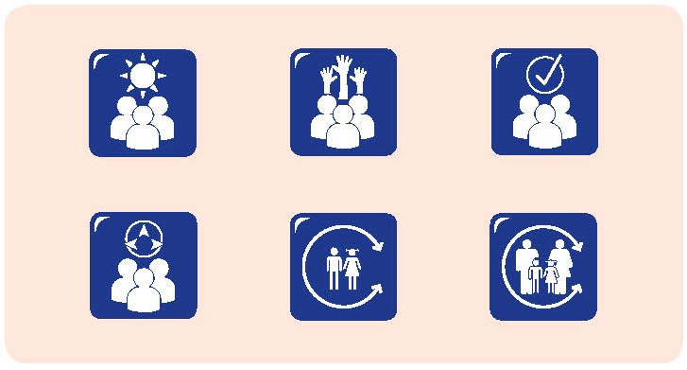
Early in the second term of school, I collected Rani from school one afternoon. As we walked home Rani offered some commentary on her day. She talked about helping another child, Rose, to find some special shells she had lost. When I asked who Rose was Rani replied Nana, she’s my friend.
Later she noticed another girl walking on the other side of the road and said Look Nana that’s my friend Bridget with her Nana. They’re walking like us.
When we arrived home we watched some television together and then Rani did some drawing. As she was drawing she was singing a song that I did not recognise. When asked if it was a new song, Rani replied Yes, I learnt it at my school.
I was really pleased to hear Rani talk about her friends from school and to know that she regarded herself as learning at school. When she first started school, Rani did not seem to be making friends or connecting with school. This was something her parents and I had talked about. However it was not clear what we could do, or even if it was considered a problem. Rani and I had played some name games to become familiar with the children in her class, but I’m not sure if this is what helped, or if it was a combination of getting used to school as well as the people in her class.
This conversation made me think that Rani now had a sense of belonging and connection with new friends and ‘her school’. At the same time, it left me wondering how teachers get to know about the feelings of children and families in those first few months of school and thinking about what indicates a successful transition.

QA 6.2.1; 6.3.2

Section 4: References
Alvestad, M., & Rothle, M. (2007). Educational forums: Frames for development of professional learning: A project in early childhood education in Norway. European Early Childhood Education Research Journal, 15(3), 407-425.
Armstrong, S., Buckley, S., Lonsdale, M., Milgate, G., Bennetts Kneebone, L., Cook, L., & Skelton, F. (2012). Starting school: A strengths based approach towards Aboriginal and Torres Strait Islander children.
Arthur, L., Beecher, B., Death, E., Dockett, S., & Farmer, S. (2014). Programming and planning in early childhood settings (6th edition). Melbourne: Cengage.
Atkinson, J., Nelson, J., & Atkinson, C. (2009). Trauma, transgenerational transfer and effects on community wellbeing. In N. Purdie, P. Dudgeon, & R. Walker (Eds.), Working together: Aboriginal and Torres Strait Islander mental health and wellbeing principles and practice (pp. 135-144). Canberra: Department of Health and Ageing.
Australian Children’s Education and Care Quality Authority (ACECQA). (2013). Guide to the National Quality Framework.
Baquedano-López, P., Alexander, R. A., & Hernandez, S. J. (2013). Equity issues in parental and community involvement in schools: What teacher educators need to know. Review of Research in Education, 37, 149-182.
Bar-Tal, D., & Teichman, Y. (2005). Stereotypes and prejudice in conflict. Cambridge: Cambridge University Press.
Bennett, J. (2013). A response from the co-author of ‘a strong and equal partnership’. In P. Moss (Ed.), Early childhood and compulsory education: Reconceptualising the relationship (pp. 52-71). London: Routledge.
Bernard van Leer Foundation. (2007). Promoting social inclusion and respect in young children’s environments. Early Childhood Matters, 108, 5-6.
Bernard van Leer Foundation. (n.d). Promoting inclusion and respect in young children’s environments. Issue area framework summary, Social Inclusion and Respect for Diversity.
Bleach, J. (2014). Developing professionalism through reflective practice and ongoing professional development. European Early Childhood Education Research Journal, 22(2), 185-197.
Blue-Banning, M., Summers, J., Frankland, H. C., Nelson, L., & Beegle, G. (2004). Dimensions of family and professional partnerships: Constructive guidelines for collaboration. Exceptional Children, 70(2), 167-184.
Branson, D., & Bingham, A. (2009). Using interagency collaboration to support family-centred transition practices. Young Exceptional Children, 12(3), 15-31.
Breen, L. J. (2009). Early childhood service delivery for families living with childhood disability: Dis-abling families through problematic implicit ideology. Australasian Journal of Early Childhood, 34(4), 14–21.
Broström, S. (2002). Communication and continuity in the transition from kindergarten to school. In H. Fabian & A-W. Dunlop (Eds.), Transitions in the early years (pp 52-63). London: RoutledgeFalmer.
Bryk, A., & Schneider, B. (2002). Trust in schools: A core resource for improvement. New York: Russell Sage Foundation.
Bryk, A., & Schneider, B. (2003).Trust in schools: A core resource for school reform. Educational Leadership, 60(6), 40-45. Bull, A., Brooking, K., & Campbell, R. (2008). Successful home-school partnerships. Ministry of Education, New Zealand.
Buysse, V., Sparkman, K. L., & Wesley, P. W. (2003). Communities of practice: Connecting what we know with what we do. Exceptional Children, 69(3), 263-277.
Carr, M., & Claxton, G. (2002). Tracking the development of learning dispositions. Assessment in Education, 9(1), 9-37.
Carr, W., & Kemmis, S. (1986). Becoming critical: Education, knowledge and action research. Lewes: Falmer/Deakin University Press.
Cartmel, J. (2007). Outside school hours care and schools. (Unpublished doctoral dissertation). Queensland University of Technology, Brisbane.
Cartmel, J., Macfarlane, K., & Casley, M. (2012). Reflection as a tool for quality: Working with the National Quality Standard, Research in Practice, 19(4).
Chan, W. L. (2012). Expectations for the transition from kindergarten to primary school amongst teachers, parents and children. Early Child Development and Care, 182(5), 639-664.
Connolly, P. (2007). The role of research: Promoting positive attitudes to ethnic diversity among young children. Early Childhood Matters, 108, 50-54.
Connolly, P. (2011). Using survey data to explore preschool children’s ethnic awareness and attitudes. Journal of Early Childhood Research, 9(2), 175-187.
Corter, C., & Pelletier, J. (2010). Schools as integrated service hubs for young children and families: Policy implications of the Toronto First Duty project. International Journal of Child Care and Education Policy, 4(2) 45-54.
Dahlberg, G., Moss, P., & Pence, A. (1999). Beyond quality in early childhood education and care: Postmodern perspectives. London: Falmer Press.
Davies, S. (Ed.) (2007). Team around the child: Working together in early childhood intervention. Wagga Wagga, NSW: Kurrajong Waratah. Davis, H., Day, C., & Bidmead, C. (2002). Working in partnership with parents: The parent adviser model. London: Harcourt Assessment.
Davis, H., Day, C., & Bidmead, C. (2002). Working in partnership with parents: The parent adviser model. London: Harcourt Assessment.
Department of Education, Employment and Workplace Relations (DEEWR). (2009). Belonging, being & becoming: The Early Years Learning Framework for Australia. Canberra: Commonwealth of Australia.
Department of Education, Employment and Workplace Relations (DEEWR). (2011). My Time, Our Place: Framework for School Age Care in Australia. Canberra: Commonwealth of Australia.
Department of Education, Employment and Workplace Relations (DEEWR). (2012). Educators’ Guide to the Framework for School Age Care in Australia.
Department of Education, Employment and Workplace Relations (DEEWR). (2013). Child care in Australia, August 2013.
Dewey, J. (1933). How we think: A re-statement of the relation of reflective thinking in the educative process. Chicago: Henry Regnery.
Dockett, S., (2014). Transition to school: Normative or relative? In B. Perry. S. Dockett, & A. Petriwskyj (Eds.), Transitions to school – International research, policy and practice (pp. 187-200). Dordrecht, The Netherlands: Springer.
Dockett, S., Mason, T., & Perry, B. (2006). Successful transition to school for Australian Aboriginal children. Childhood Education, 82(3), 139-144.
Dockett, S., & Perry, B. (2001). Starting school: Effective transitions. Early Childhood Research and Practice, 3(2).
Dockett, S., & Perry, B. (2004a). ‘School is like preschool but you can’t make noise’: Young children’s views of continuity from preschool (nursery) to school. OMEP Updates, 116, 16-20.
Dockett, S., & Perry, B. (2004b). Starting school: Perspectives of Australian children, parents and educators. Journal of Early Childhood Research, 2(2), 171-189.
Dockett, S., & Perry, B. (2005). Starting school in Australia is “a bit safer, a lot easier and more relaxing”: Issues for parents from culturally and linguistically diverse backgrounds. Early Years, 25(3), 271-281.
Dockett, S., & Perry, B. (2006). Starting school: A handbook for educators. Sydney: Pademelon Press.
Dockett, S., & Perry, B. (2007). Starting school: Perceptions, expectations and experiences. Sydney: UNSW Press.
Dockett, S., & Perry, B. (2009). Readiness for school: A relational construct. Australasian Journal of Early Childhood, 34(1), 20-26. Dockett, S., & Perry, B. (2013a). Trends and tensions: Australian and international research about starting school. International Journal of Early Years Education. 21(2-3), 163-177.
Dockett, S., & Perry, B. (2013b). Siblings and buddies: Providing expert advice about starting school. International Journal of Early Years Education, 21(4), 348-361.
Dockett, S., & Perry, B. (2014). Research to policy: Transition to School Position Statement. In B. Perry, S. Dockett, & A. Petriwskyj (Eds.), Transitions to school - International research, policy and practice (pp. 277-294). Dordrecht, The Netherlands: Springer.
Dockett, S., Perry, B., & Kearney, E. (2010). School readiness: What does it mean for Indigenous children, families, schools and communities? Canberra: Closing the Gap Clearinghouse. Retrieved from http://www.aihw.gov.au/closingthegap/documents/issues_papers/ctg-ip02.pdf
Dockett, S., Perry, B., & Kearney, E. (2011). Starting school with special needs: Issues for families with complex support needs as their children start school. Exceptionality Education International, 21(2), 45-61.
Dockett, S., Perry, B., & Kearney, E. (2012). Family transitions as children start school. Family Matters, 90, 57-67.
Dockett, S., Perry, B., Kearney, E., Hampshire, A., Mason, J., & Schmied, V. (2011). Facilitating children’s transition to school from families with complex support needs. Albury-Wodonga: Research Institute for Professional Practice, Learning and Education, Charles Sturt University.
Dockett, S., Perry, B., Mason, T., Simpson, T., Howard, P., Whitton, D., Gilbert, S., Pearce, S., Sanagavarapu, P., Skattebol, J., & Woodrow, C. (2007). Getting it together: Successful transition programmes from prior-to-school to school for Aboriginal and Torres Strait Islander children. Sydney: NSW Department of Education and Training. Retrieved from http://www.curriculum.edu.au/verve/_resources/ATSI_Successful_Transition_programmes_Report_Dec_2007.pdfDunst, C. (2002). Family-centred practices: Birth through high school. Journal of Special Education, 36, 139. doi: 10.1177/00224669020360030402
Durand, T. M. (2010). Celebrating diversity in early care and education settings: Moving beyond the margins. Early Child Development and Care, 180(7), 835-848. .
Eastman, C., Koop, D., Newton, B.J., & valentine, k. (2012). Linking schools and early years: Project evaluation. Social Policy Research Centre, University of New South Wales.
Educational Transitions and Change (ETC) Research Group. 2011. Transition to school: Position statement. Please see the Appendix for the content of this document.
Einarsdóttir, J., Perry, B., & Dockett, S. (2008) Transition to school practices: Comparisons from Iceland and Australia. Early Years, 28(1), 47-60.
Fasoli, L., Benbow, R., Deveraux, K., Falk, I. Harris, R., Hazzard, M., James, R., Johns, V., Preece, C., & Railton, K. (2007). ‘Both ways’ children’s services project. Batchelor, NT: Batchelor Institute of Indigenous Tertiary Education.
Flottman, R., McKernan, A., & Tayler, C. (2011). Practice principle 2: Partnership with professionals. Victorian Early Years Learning and Development Framework Evidence Paper.
Fullan, M. (1993). Why teachers must become change agents. The Professional Teacher, 50(6), 12-17.
Garey, A. (2002). Social domains and concepts of care: Protection, instruction, and containment in after-school programmes. Journal of Family Issues 23(6), 768-788.
Grace, R., Llewellyn, G., Wedgwood, N., Fenech,M., & McConnell, D. (2008). Far from ideal. Everyday experiences of mothers and early childhood professionals negotiating an inclusive early childhood experience in the Australian context. Topics in Early Childhood Special Education, 28(1), 18-30.
Griebel, W., & Niesel, R. (2013). The development of parents in their first child’s transition to primary school. In K. Margetts & A. Kienig (Eds.) International perspectives on transition to school: Reconceptualising beliefs, policy and practice (pp.101-110). London: Routledge.
Guilfoyle, A., Saggers, S., Sims, M., & Hutchins, T. (2010). Culturally strong childcare programmes for Indigenous children, families and communities. Australasian Journal of Early Childhood, 35(3), 68-76.
Han, W-J. (2012). Bilingualism and academic achievement. Child Development, 83(1), 200-321.
Harlin, R., Sirota, E., & Bailey, L. (2009). Review of research: The impact of teachers’ expectations on diverse learners’ academic outcomes. Childhood Education, 85(4), 253-256.
Harrison, N., & Greenfi M. (2011). Relationship to place: Positioning Aboriginal knowledge and perspectives in classroom pedagogies. Critical Studies in Education, 52(1), 65-76.
Hartley, C., Rogers, P., Smith, J., Peters, S., & Carr, M. (2012). Across the border: A community negotiates the transition from early childhood to primary school. Wellington, New Zealand: NZCER.
Hatton, N., & Smith, D. (1995). Reflection in teacher education: Towards definition and implementation. Teaching and Teacher Education, 11(1), 33-49.
Hinnant, J., O’Brien, M., & Ghazarian, S. (2009). The longitudinal relations of teacher expectations to achievement in the early school years. Journal of Educational Psychology, 101(3), 662-670.
Imtoual, A., Kameniar, B., & Bradley, D. (2009). Bottling the good stuff: Stories of hospitality and yarnin’ in a multi-racial kindergarten. Australasian Journal of Early Childhood, 34(2), 24-30.
James, A., Jenks, C., & Prout, A. (1998). Theorising childhood. Cambridge, UK: Polity Press.
Janus, M., Kopechanski, L., Cameron, R., & Hughes, D. (2008). In transition: Experiences of parents of children with special needs at school entry. Early Childhood Education Journal, 35(5), 479–485.
Janus, M., Lefort, J., Cameron, R., & Kopechanski, L. (2007). Starting kindergarten: Transition issues for children with special needs. Canadian Journal of Education, 30(3), 628-648.
Jarvis, P. (1992). Reflective practice and nursing. Nurse Education Today, 12, 174-181.
Jerome, E., Hamre, B., & Pianta, R. (2009). Teacher-child relationships from kindergarten to sixth grade: Early childhood predictors of teacher-perceived conflict and closeness. Social Development, 18(4), 915-945. DOI: 10.1111/j.1467-9507.2008.00508.x
Keast, R., & Mandell, M. (2013). Your guide to building collaborative capacity: Fact sheets. Australian Research Alliance for Children and Youth (ARACY).
Kinsella, E. (2007). Embodied reflection and the epistemology of reflective practice. Journal of Philosophy of Education, 41(3), 395-409.
Ladd, G. W., Herald, S. L., & Kochel, K. P. (2006). School readiness: Are there social prerequisites? Early Education and Development, 17(1), 115-150.
Lansdown, G. (2005). The evolving capacities of the child. Florence, Italy: UNICEF Innocenti Research Centre.
Lumsden, E. (2005). Joined up thinking in practice: An exploration of professional collaboration. In T. Waller (Ed.), An introduction to early childhood: A multidisciplinary approach (pp. 39-54). London: Paul Chapman.
Makin, L., Jones-Díaz, C., & McLaughlan, C. (Eds.) (2007). Literacies in childhood: Changing views, challenging practice (2nd ed). Sydney: Elsevier.
Marsh, H., Ellis, L., & Craven, R. (2002). How do preschool children feel about themselves? Unravelling measurement and multidimensional self-concept structure. Developmental Psychology, 38(3), 376–93.
Mashburn, A., & Pianta, R. (2006). Social relationships and school readiness. Early Education & Development, 17(1), 151-176.
Mason-White, H. (2012). Learning from good practice: Implementing the Early Years Learning Framework for Aboriginal and Torres Strait Islander children. Secretariat of National Aboriginal and Islander Child Care.
Maude, S., Hodges, L., Brotherson, M., Hughes-Belding, K., Peck, N., Weigel, C., & Sharp, L. (2009). Critical reflections on working with diverse families: Culturally responsive professional development strategies for early childhood and early childhood special educators. Multiple Voices for Ethnically Diverse Exceptional Learners, 12(1), 38-53.
McCashen, W. (2005). The strengths approach. Bendigo, Victoria: St Luke’s Innovative Resources.
McClure, P. (2005). Reflection on practice.
Macfarlane, K., & Cartmel, J. (2007). Report: Circles of change revisited. Brisbane, QLD: Health and Community Services Workforce Council, Griffith University.
McNaughton, S. (2002). Meeting of minds. Wellington, NZL Learning Media.
Moore, T., & Skinner, A., (2010). Background paper. An integrated approach to early childhood development.
Moss, P. (2001). Making space for ethics. Australian Journal of Early Childhood, 26(4), 1-6.
Moss, P. (Ed.). (2013). Early childhood and compulsory education: Reconceptualising the relationship. London: Routledge.
Moss, P., & Petrie, P. (2002). From children’s services to children’s spaces. London: Taylor & Francis.
Moyles, J. (2001). Passion, paradox and professionalism in early years education. Early Years, 21(2), 81-95.
O’Connor, A., & Diggins, C. (2002). On reflection: Reflective practice for early childhood educators. Lower Hutt, New Zealand: Open Mind Publishing.
Pálsdóttir, K. (2010). After-school centres for 6-9 year olds in Reykjavik, Iceland. Barn, 4, 9-28.
Parnell, W. (2012). Experiences of teacher reflection: Reggio inspired practice in the studio. Journal of Early Childhood Research, 10(2), 117-133.
Penman, R. (2006). The ‘growing up’ of Aboriginal and Torres Strait Islander children: A literature review. Occasional Paper No. 15, Canberra: Australian Government Department of Families, Community Services and Indigenous Affairs.
Perry, B. (2014). Social justice dimensions of starting school. In B. Perry, S. Dockett, & A. Petriwskyj (Eds.), Transitions to school – International research, policy and practice (pp. 175-186). Dordrecht, The Netherlands: Springer.
Perry, B., Dockett, S., Whitton, D., Vickers, M., Johnston, C., & Sidoti, C. (2007). Sydney region transition project. Unpublished report.
Peters, S. (2003). ‘I didn’t expect that I would get tons of friends…more each day”. Children’s experiences of friendship during the transition to school. Early Years, 23, 45-53.
Peters, S. (2010). Literature review: Transition from early childhood education to school. Ministry of Education, New Zealand.
Petrie, P., Egharevba, I., Oliver, C., & Poland, G. (2000). Out-of-school lives. Out-of-school services. London: The Stationery Offi Petriwskyj, A. (2010). Diversity and inclusion in the early years. International Journal of Inclusive Education, 14(2), 195-212.
Petriwskyj, A. (2010). Diversity and inclusion in the early years. International Journal of Inclusive Education, 14(2), 195-212.
Petriwskyj, A. (2014). Critical theory and inclusive transitions to school. In B. Perry, S. Dockett, & A. Petriwskyj (Eds.), Transitions to school – International research, policy and practice (pp. 201-215). Dordrecht, The Netherlands: Springer.
Petriwskyj, A., Thorpe, K., & Tayler, C. (2005). Trends in the construction of transition to school in three western regions, 1990-2004. International Journal of Early Years Education 13(1),55-69.
Podmore, V., Sauvao, L., & Mapa, L. (2001). Transition to school: Current issues and Pacific Islands early childhood contexts. New Zealand Annual Review of Education, 10, 71-88.
Pollard, A. (2005). Reflective teaching (2nd ed). London: Continuum.
Press, F., Wong, S., & Sumsion, J. (2012). Child-centred, family-centred, decentred: Positioning children as rights-holders in early childhood programme collaborations. Global Studies of Childhood, 2(1), 26-37.
Rich, S., & Davis, L. (2007). Insights into the strategic ways in which two bilingual children in the early years seek to negotiate the competing demands on their identity in their home and school worlds. International Journal of Early Years Education, 15(1), 35-47.
Rimm-Kaufman, S., & Pianta, R. C. (2000). An ecological perspective on the transition to kindergarten: A theoretical framework to guide empirical research. Journal of Applied Developmental Psychology, 21(5), 491–511.
Rogoff, B. (2003). The cultural nature of human development. New York: Oxford University Press.
Rosenkoetter, S., Hains, A., & Dogaru, C. (2007). Successful transitions for young children with disabilities and their families. Journal of Early Intervention, 30(1), 1-18.
Rosier, K., & McDonald, M. (2011). Promoting positive education and care transitions for children. Melbourne, Vic: Australian Institute of Family Studies.
Rouse, L. (2012). Family-centred practice: Empowerment, self-efficacy, and challenges for practitioners in early childhood education and care. Contemporary Issues in Early Childhood, 13(1), 17-26.
Rubie-Davies, C., Hattie, J., & Hamilton, R. (2006). Expecting the best for students: Teacher expectations and academic outcomes. British Journal of Educational Psychology, 76(3), 429-444.
Russell, F. (2005). Starting school: The importance of parents’ expectations. Journal of Research in Special Educational Needs, 5(3), 118-126.
Ryan, S., & Cole, K. R. (2009). From advocate to activist? Mapping the experience of mothers of children on the autism spectrum. Journal of Applied Research in Intellectual Disabilities, 22(1), 43–53.
Saffinga M., Church, A., & Tayler, C. (2011). Practice principle 3: High expectations for every child. Evidence paper, Department of Education and Early Childhood Development, Victoria.
Saffinga M., Franklin, D., Church, A., & Tayler, C. (2011). Practice principle 4: Equity and diversity. Evidence paper, Department of Education and Early Childhood Development, Victoria.
Sanagavarapu, P., & Perry, B. (2005). Concerns and expectations of Bangladeshi parents as their children start school. Australian Journal of Early Childhood, 30(3), 45 - 52.
Sanders, M. (2001). A study of the role of ‘community’ in comprehensive school, family, and community partnership programmes. The Elementary School Journal, 102, 19-34.
Sayers, M., West, S., Lorains, J., Laidlaw, B., Moore, T., & Robinson, R. (2012). Starting school: A pivotal life transition for children and their families. Australian Institute of Family Studies, 90, 45-56.
Schon, D. (1983). The reflective practitioner. New York: Basic Books.
SCOPE. (2010). Transition to school for children with disabilities: A review of the literature.
Simoncini, K. (2010). The hours after school: Young school-age children’s care arrangements and activities (Unpublished doctoral dissertation). James Cook University, Townsville.
Skattebol, J. (2010). Affect: A tool to support pedagogical change. Discourse, 31(1), 75-91.
Smart, D., Sanson, A., Baxter, B., Edwards, B., & Hayes, A. (2008). Home-to-school transitions for financially disadvantaged children: Summary report. Sydney: The Smith Family and Australian Institute of Family Studies.
Smith, F., & Barker, J. (2002). Out of school clubs at the boundary of home and school. In R. Edwards (Ed.), School’s out. Children, home and school. Regulation, autonomy or connection? (pp. 57-74). London: Routledge.
SNAICC. (2013). Supporting transition to school for Aboriginal and Torres Strait Islander children: What it means and what works?
Stonehouse, A. & Gonzales-Mena. J. (2004). Making links: A collaborative approach to planning and practice in early childhood services. Sydney: Pademelon.
Tayler, C. (2006). Challenging partnerships in Australian early childhood education. Early Years, 26(3), 249-265.
Timperley, H. (2008). Teacher professional learning and development. The Educational Practices Series – 18.
Turunen, T., & Dockett, S. (2013). Family members’ memories about starting school. Intergenerational aspects. Australasian Journal of Early Childhood, 38(2), 103-110.
United Nations. (1989). Convention on the Rights of the Child.
Urbis Keys Young. (2006). Evaluation of the Murdi Paaki COAG Trial. FAHCSIA.
Winkworth, G., & White, M. (2011). Australia’s children ‘safe and well’? Collaborating with a purpose across Commonwealth family relationships and state child protection systems. Australian Journal of Public Administration, 70(1), 1-14.
Wong, A. (2009). Dialogue engagements: Professional development using pedagogical documentation. Canadian Children, 34(2), 25-30.
Wong S., Sumsion, J., & Press, F. (2012). Early childhood professionals and inter-professional work in integrated early childhood services in Australia. Australasian Journal of Early Childhood, 37(1), 81-88.
Woodhead, M., & Brooker, L. (2008). A sense of belonging. Early Childhood Matters, 111, 3-6.
Yazici, Z., Ilter, B. G., & Glover, P. (2010). How bilingual is bilingual? Mother tongue proficiency and learning through several languages. International Journal of Early Years Education, 18(3), 259-268.

Section 5: Appendix

Transition to school position statement

Preamble
Worldwide recognition of the significance of the early childhood years for later development and wellbeing and the importance of investing in high quality early childhood education (OECD, 2006) has promoted a great deal of interest in transition research, policy and practice. This trend is seen in Australia, particularly in COAG commitments to early childhood education (Commonwealth of Australia, 2009b), including the Early Years Learning Framework (Commonwealth of Australia, 2009a). These commitments are being enacted at the same time as the Australian curriculum is being developed and implemented. It is timely to consider the transition to school as the point at which different contexts, systems, curricula, philosophies and approaches meet. Beginning school is also a time when all involved have responsibilities to promote a positive transition.
The importance of a positive transition to school has been emphasised in research around the world. It is well established that a successful start to school is linked to later positive educational and social outcomes. Children who have a positive start to school are likely to regard school as an important place and to have positive expectations of their ability to learn and succeed at school (Alexander & Entwisle, 1998; Dockett & Perry, 2007; Dunlop & Fabian, 2007; Margetts, 2007; Peters, 2010).
A successful transition to school is marked by children’s positive approach to school and a sense of belonging and engagement. Families have critical roles to play in supporting positive transitions, as do educators*, health and other professionals, as well as communities. Societies benefit when children and families view school as a positive place to be and when education is regarded as valuable, relevant and attainable. A positive start to school, leading to greater and ongoing connection with school, has been identified as a factor in disrupting cycles of social and economic disadvantage and in promoting resilience among young people (Commonwealth of Australia, 2009b; Smart, Sanson, Baxter, Edwards, & Hayes, 2008). This position statement has been developed by a group of national and international transition to school researchers who have been working in the area over the last 20 years. An overview of the researchers’ seminal research is included at the end of this document. The authors have been assisted in this task by a wide range of educators and policy makers, who have reviewed the document and enhanced it through their constructive criticism.

Purpose
This position statement has been developed as an aspirational document targeted to all concerned with the education, care and wellbeing of young children. This includes policymakers, educators, health and other professionals, families and communities. The position statement reconceptualises transition to school in the context of social justice, human rights (including children’s rights), educational reform and ethical agendas, and the established impact of transition to school on children’s ongoing wellbeing, learning and development. These principles support a range of educational entitlements around the transition to school.
The position statement is based on national and international understandings of the importance of the transition to school. It provides a strong basis for action for government, organisations and individuals as all strive for policies and practices that support the best possible start to school for all children and their families. The statement is underpinned by the importance of:
- understandings of all children as competent, capable and creative, who have already learned a great deal before they enter school, regardless of their context or backgrounds;
- acknowledging and supporting children as active participants in their own transition and learning;
- recognising and valuing the strengths of all involved in transitions to school;
- genuine partnerships involving reciprocal, responsive, respectful relationships;
- critically reflecting on established policies and practices and their underlying assumptions; and
- curriculum and pedagogy relevant to children’s characteristics, interests and circumstances.
In this document, transition to school is taken to be a dynamic process of continuity and change as children move into the first year of school. The process of transition occurs over time, beginning well before children start school and extending to the point where children and families feel a sense of belonging at school and when educators recognise this sense of belonging. This means that transition may occur over a longer period of time for some children. Transition to school is characterised by:
- opportunities;
- expectations;
- aspirations;
- entitlements.

Opportunities
Opportunities are afforded to children when they are recognised as competent and capable, when their cultural heritage and histories are respected, and when they are supported in their approaches to new and challenging situations and interactions. The transition to school provides opportunities for children to continue shaping their identities and to extend their existing knowledge, skills and understandings through interactions with adults, peers and family. Children are well placed to respond to these opportunities when they feel secure, valued and respected for who they are and the histories they bring – when they feel a sense of belonging at school. The transition to school provides opportunities for children to become citizens within school communities and to experience the rights and responsibilities associated with this. Transition to school provides opportunities for families to collaborate with educators and other professionals in ways that strengthen and support each child’s ongoing learning and development. It provides opportunities to reflect on children’s attainments and to share responsibilities for future achievements.
The transition to school is an opportunity to establish and maintain positive, respectful collaboration between home and school contexts that sets a pattern for ongoing interaction. Families have opportunities to build links for their children between prior-to-school and school experiences. During the transition to school, educators have opportunities to build relationships with children, families and communities that provide the basis for effective learning and teaching interactions. Educators have opportunities to share their own expertise, while recognising the expertise of others, as they communicate and make connections with children, other educators, families and communities. The transition to school is a specific opportunity for prior-to-school and school educators, and the systems in which they are employed, to work together and to draw support from each other. Community recognition and support for transition to school marks this transition as an important life event. Transition to school affords opportunities for communities to celebrate children and families and to demonstrate the value of early education as well as respect for those involved in this endeavour. The transition to school is an opportunity to strengthen the community identity of schools and prior-to-school settings and the place of these institutions within communities.

Aspirations
As they start school children are enthusiastic learners, keen to extend their learning in a safe and friendly environment. They seek to maintain existing friendships and build new friendships as they engage in play and learning. They hope that school will be an enjoyable context which supports their developing autonomy and their active engagement in learning. Children want their learning to be recognised and valued in both process and product. Families aspire to positive educational outcomes for their children, as well as continuity between the early childhood settings – at times of transition and beyond. They would like their children to be happy and successful at school, to have friends and be respected and recognised as individuals within the various groups of which they are members. Families also aspire to contribute to their children’s education through the development of trusting, respectful and reciprocal relationships. Educators aspire to the development of strong partnerships with families, other educators, professionals and communities as part of strong and supportive educational environments in the first year of school. They want children to learn to their full potential in an inspiring, challenging and supportive environment. Communities aspire to provide ongoing support and resources to promote children’s positive engagement in school and to reap the social, cultural, educational and economic benefits of education that are regarded as valuable, relevant and attainable. Communities also aspire to provide the support, resources, services and living conditions that promote the wellbeing of children and families. Communities with strong social networks and access to resources that can be mobilised to support children and families are well positioned to promote positive transitions to school. Within educational organisations and systems, policy makers aspire to all children engaging in positive educational trajectories and achieving sound educational outcomes. This is based on commitments to reducing inequalities in educational access and outcomes. Strategies to achieve positive educational outcomes for all include continuity of curriculum and pedagogy and strong coordination between the prior-to-school and school sectors.
Educators have opportunities to share their own expertise, while recognising the expertise of others, as they communicate and make connections with children, other educators, families and communities. Educators aspire to the development of strong partnerships with families, other educators, professionals and communities as part of strong and supportive educational environments in the first year of school

Expectations
Transition to school is a time of changing expectations for all involved. Children and families start school with a range of expectations about what school will be like and what it means to be a school student or parent of a school student. Children start school expecting to learn and to be recognised as learners. They expect to encounter challenges and to be supported in their approaches to these. Children expect to engage with their friends, family and community at school and about school. Children seek continuity of support as they encounter change as they start school: changes in themselves, their environments and their interactions. Families expect that their knowledge of their children will be respected at school. They expect that their children’s educators will draw on this, as well as their own expertise and that of other professionals, to create the best possible learning environments for their children. Families expect to contribute to their children’s education, and may seek guidance from educators about how partnerships can operate effectively. Families expect children’s safety and wellbeing to be central features in decisions about educational provision. They expect schools to recognise the strengths their children bring, as well as to be responsive to their diverse learning needs. Families expect to be advocates for their children, and to be supported in this by the advocacy of other professionals. Educators expect to engage with children, families, other educators and professionals in the creation of positive learning and teaching environments during the transition to school. They expect appropriate support and resources to create challenging learning environments for all children. Educators expect to work with children, families and other professionals to recognise children’s strengths and to provide appropriate support. They expect appropriate professional recognition and regard for their roles in promoting each child’s learning, development and wellbeing during the transition process. Communities expect schools to be sites where children are regarded as competent and capable learners, experience a sense of belonging, and enact the rights and responsibilities of citizenship. Effective schools attend to the wellbeing of all involved, generate positive and respectful learning environments and have regard to the communities in which they are located. Within educational systems and organisations, there are expectations that all children will benefit from education. Further, education is identified as a major force for reducing inequality and disadvantage and promoting long-term social and economic productivity. Policy makers within educational organisations and systems expect that specific programs will be required to promote educational engagement and attainment for all children. One key area for such focus is the transition to school.
Entitlements
All children are active participants in their transition, entitled to access high quality education that is respectful of, and responsive to, their existing competencies, cultural heritage and histories. High quality education builds upon these competencies by creating educational environments that provoke, recognise and celebrate each child’s learning potential. These environments acknowledge the central roles of families and communities in children’s educational outcomes. There is potential for transitions to school to provide a site for the enactment of these entitlements from the very beginning of children’s school careers. Families are entitled to be confident that their children will have access to education that promotes equity and excellence and that attends to the wellbeing of all children. Families are entitled to be respected as partners in their children’s education.
Children and families start school with a range of expectations about what school will be like and what it means to be a school student or parent of a school student. High quality education builds upon these competencies by creating educational environments that provoke, recognise and celebrate each child’s learning potential.
Educators are entitled to professional regard and respect for their work with children, families and communities during the transition process. They are entitled to levels of professional support and resourcing that facilitate the creation of the best possible learning and teaching environments for all children, and to opportunities for ongoing professional development and critical reflection, both individually and collaboratively. Communities are entitled to be regarded as essential contributors to children’s education, and to have a major role and place within education institutions. Policy makers are entitled to expect that education systems will work towards alignment and continuity, providing necessary supports and provocations to promote high quality education for all. Educational systems and organisations are entitled to expect that educators, families and communities will be active contributors to the wellbeing, learning and development of young children.

Recommendations
This position statement has been developed as a call to action for all with an interest in the wellbeing, development and learning of young children. This includes policymakers, educators, health and other professionals, families and communities. In urging individuals, groups, communities, organisations, systems and governments to recognise the importance of a positive transition to school for all children, we recommend the development of processes, practices and policies that incorporate the following:
- Recognition of transition to school as an integral component of quality educational provision.
- Commitment to equity and excellence in the development of transition programs, evident in the engagement of children, families, professionals, educators and community members in the implementation of relevant, appropriate and meaningful approaches.
- Approaches to ensure that all children, families and communities have access to appropriate support across the processes of transition.
- Focus on the competencies, strengths and achievements of children and families as they make the transition to school.
- Acknowledgement of the central role of relationships in positive transitions and opportunities for those involved to build and maintain these relationships.
- Recognition of children’s active roles in shaping their transition experiences and the importance of consulting them about transition.
- Enactment of the principles of family engagement in education, based on trusting, respectful and reciprocal relationships.
- Appropriate support for educators whose roles encompass transition to school, including support for the development of curriculum and pedagogy that supports positive transitions, opportunities for critical reflection on policies and practices and appropriate professional development.
- Recognition of the transition to school as an opportunity to build positive connections between the many systems and sectors that engage with young children and their families.
- Acknowledgement of the major roles in transition played by those outside school systems, including prior-to-school educators, special educators and other professionals, families and communities.
- Opportunities for systems and sectors to define transition approaches and to consider constructive alignment of curriculum and pedagogies across educational contexts.
- Ongoing commitment to the entitlements of all children, families and educators in positive transitions to school.
Communities are entitled to be regarded as essential contributors to children’s education, and to have a major role and place within education institutions. This position statement has been developed as a call to action for all with an interest in the wellbeing, development and learning of young children.

References
Alexander, K. L., & Entwisle, D. R. (1998). Facilitating the transition to first grade: The nature of transition and research on factors. Elementary School Journal, 98(4), 351-364.
Commonwealth of Australia. (2009a). Belonging, being, becoming: The Early Years Learning Framework for Australia.
Commonwealth of Australia. (2009b). National quality framework for early childhood education and care.
Dockett, S., & Perry, B. (2007). Transitions to school: Perceptions, expectations, experiences. Sydney: University of NSW Press.
Dunlop, A-W., & Fabian, H. (Eds.) (2007). Informing transitions in the early years: Research, policy and practice. London: OUP/McGraw Hill.
Margetts, K. (2007). Preparing children for school: Benefits and privileges. Australian Journal of Early Childhood, 32(2), 43–50.
OECD. (2006). Starting strong II. Early childhood education and care, Executive summary.
Peters, S. (2010). Literature Review: Transition from early childhood education to school. Wellington: New Zealand Ministry of Education.
Smart, D., Sanson, A., Baxter, B., Edwards, B., & Hayes, A. (2008). Home-to-school transitions for financially disadvantaged children: Summary report. Sydney: The Smith Family and Australian Institute of Family Studies.

Authors
The authors of this statement are leading researchers in the field of transition, from Australia and around the world. Individually and collectively, they have conducted high quality research on the transition to school over many years, published widely in prestigious academic journals, addressed learned forums, informed professional practice and provided input for policy. Their work has formed the basis of advice for various levels of government, educational organisations and systems and provided the framework for approaches to transition in their respective countries, as well as internationally. The researchers and key publications are listed below.
Professor Sue Dockett, Murray School of Education, Charles Sturt University.
Dockett, S., Perry, B., & Kearney, E. (2010). School readiness: what does it mean for Indigenous children, families, schools and communities?
Issues Paper 2. Canberra: Closing the Gap Clearinghouse.
Emeritus Professor Aline-Wendy Dunlop, University of Strathclyde, Scotland.
A-W., & Fabian, H. (Eds.) (2007). Informing transitions in the early years: Research, policy and practice. London: OUP/McGraw Hill.
Professor Jóhanna Einarsdóttir, Faculty of Education, University of Iceland, Iceland.
Einarsdóttir, J. (2010). Children's experiences of the first year of primary school. European Early Childhood Education Research Journal,18 (2), 163-180.
Professor Anders Garpelin, School of Education, Culture and Communication at Mälardalen University, Sweden.
Garpelin, A. (2004). Accepted or rejected in school, European Educational Research Journal, 3(4), 729-742.
Professor Beth Graue, Department of Curriculum and Instruction, University of Wisconsin, Madison, USA.
Graue, E. (2006). The answer is readiness ─ Now what is the question? Early Education and Development, 17(1), 43-56.
Associate Professor Linda Harrison, Charles Sturt University.
Harrison, L., Clarke, L., & & Ungerer, J. (2007). Children's drawings provide a new perspective on linkages between teacher-child relationship quality and school adjustment. Early Childhood Research Quarterly, 22, 55-71.
Dr Mei Seung (Michelle) Lam, Assistant Professor, Department of Early Childhood Education, Hong Kong Institute of Education, Hong Kong.
Lam, M. S., & Pollard, A. (2006). A conceptual framework for understanding children as agents in the transition from home to kindergarten. Early Years: An International Journal of Research and Development, 26(2), 123-141.
Dr Noella Mackenzie, Murray School of Education, Charles Sturt University.
Mackenzie, N.M (2008) Becoming a writer: Can we predict how children will engage with the writing process at school entry? Journal of Reading, Writing and Literacy, 3(1), 1-19.
Associate Professor Kay Margetts, Melbourne Graduate School of Education, The University of Melbourne.
Margetts, K. (2009). Early transition and adjustment and children's adjustment after six years of schooling. European Early Childhood Education Research Journal, 17(3), 309 – 324.
Dr Elizabeth Murray, School of Teacher Education, Charles Sturt University.
Murray, E., & Harrison, L. J. (2005). Children’s perspectives on their first year of school: Introducing a new pictorial measure of school stress. European Early Childhood Education Research Journal, 13,111-127
Professor Bob Perry, Murray School of Education, Charles Sturt University.

Dockett, S., & Perry, B. (2007). Transitions to school: Perceptions, expectations, experiences. Sydney: University of NSW Press.

Dr Sally Peters, Department of Human Development and Counselling, University of Waikato, New Zealand.
Peters, S. (2010). Literature review: Transition from early childhood education to school. Wellington: Ministry of Education.
Dr Anne Petriwskyj, Faculty of Education, Early Childhood, Queensland University of Technology.
Petriwskyj, Anne (2010) Who has rights to what? Inclusion in Australian early childhood programs. Contemporary Issues in Early Childhood, 11(4). 342352.
Dr Tuija Turunen, Murray School of Education, Charles Sturt University; University of Lapland, Finland.
Turunen, T. A. (2011). Memories about starting school. What is remembered after decades? Scandinavian Journal of Educational Research. (In press).

Research students
Several research higher degree students made invaluable contributions to this Position Statement:
Wendy Goff, Charles Sturt University
Kathryn Hopps, Charles Sturt University
Cathy Kaplun, Charles Sturt University
Amy MacDonald, Charles Sturt University
Leonie McIntosh, University of Western Sydney
Susanne Rogers, Charles Sturt University
The development of this statement has been facilitated through funding support from the following organisations; Charles Sturt University, Australian Government Department of Education, Employment and Workplace Relations, The Ian Potter Foundation, NSW Department of Education and Training – Western Region, South Australian Department of Education and Children’s Services, Victorian Department of Education and Early Childhood Development – Hume Region& Regional Express.
The opinions expressed in this document are those of the authors and do not necessarily reflect the opinions of the funding bodies.
ISBN 978-1-86467-231-2
© 2011
Research Institute for Professional Practice, Learning and Education Charles Sturt University
Transition to school: Position statement by Educational Transitions and Change (ETC) Research Group is licensed under a Creative Commons Attribution-NonCommercial-NoDerivs 3.0 Unported Licence
Suggested Citation: Educational Transitions and Change (ETC) Research Group. (2011). Transition to school: Position statement Albury-Wodonga: Research Institute for Professional Practice, Learning and Education, Charles Sturt University.
