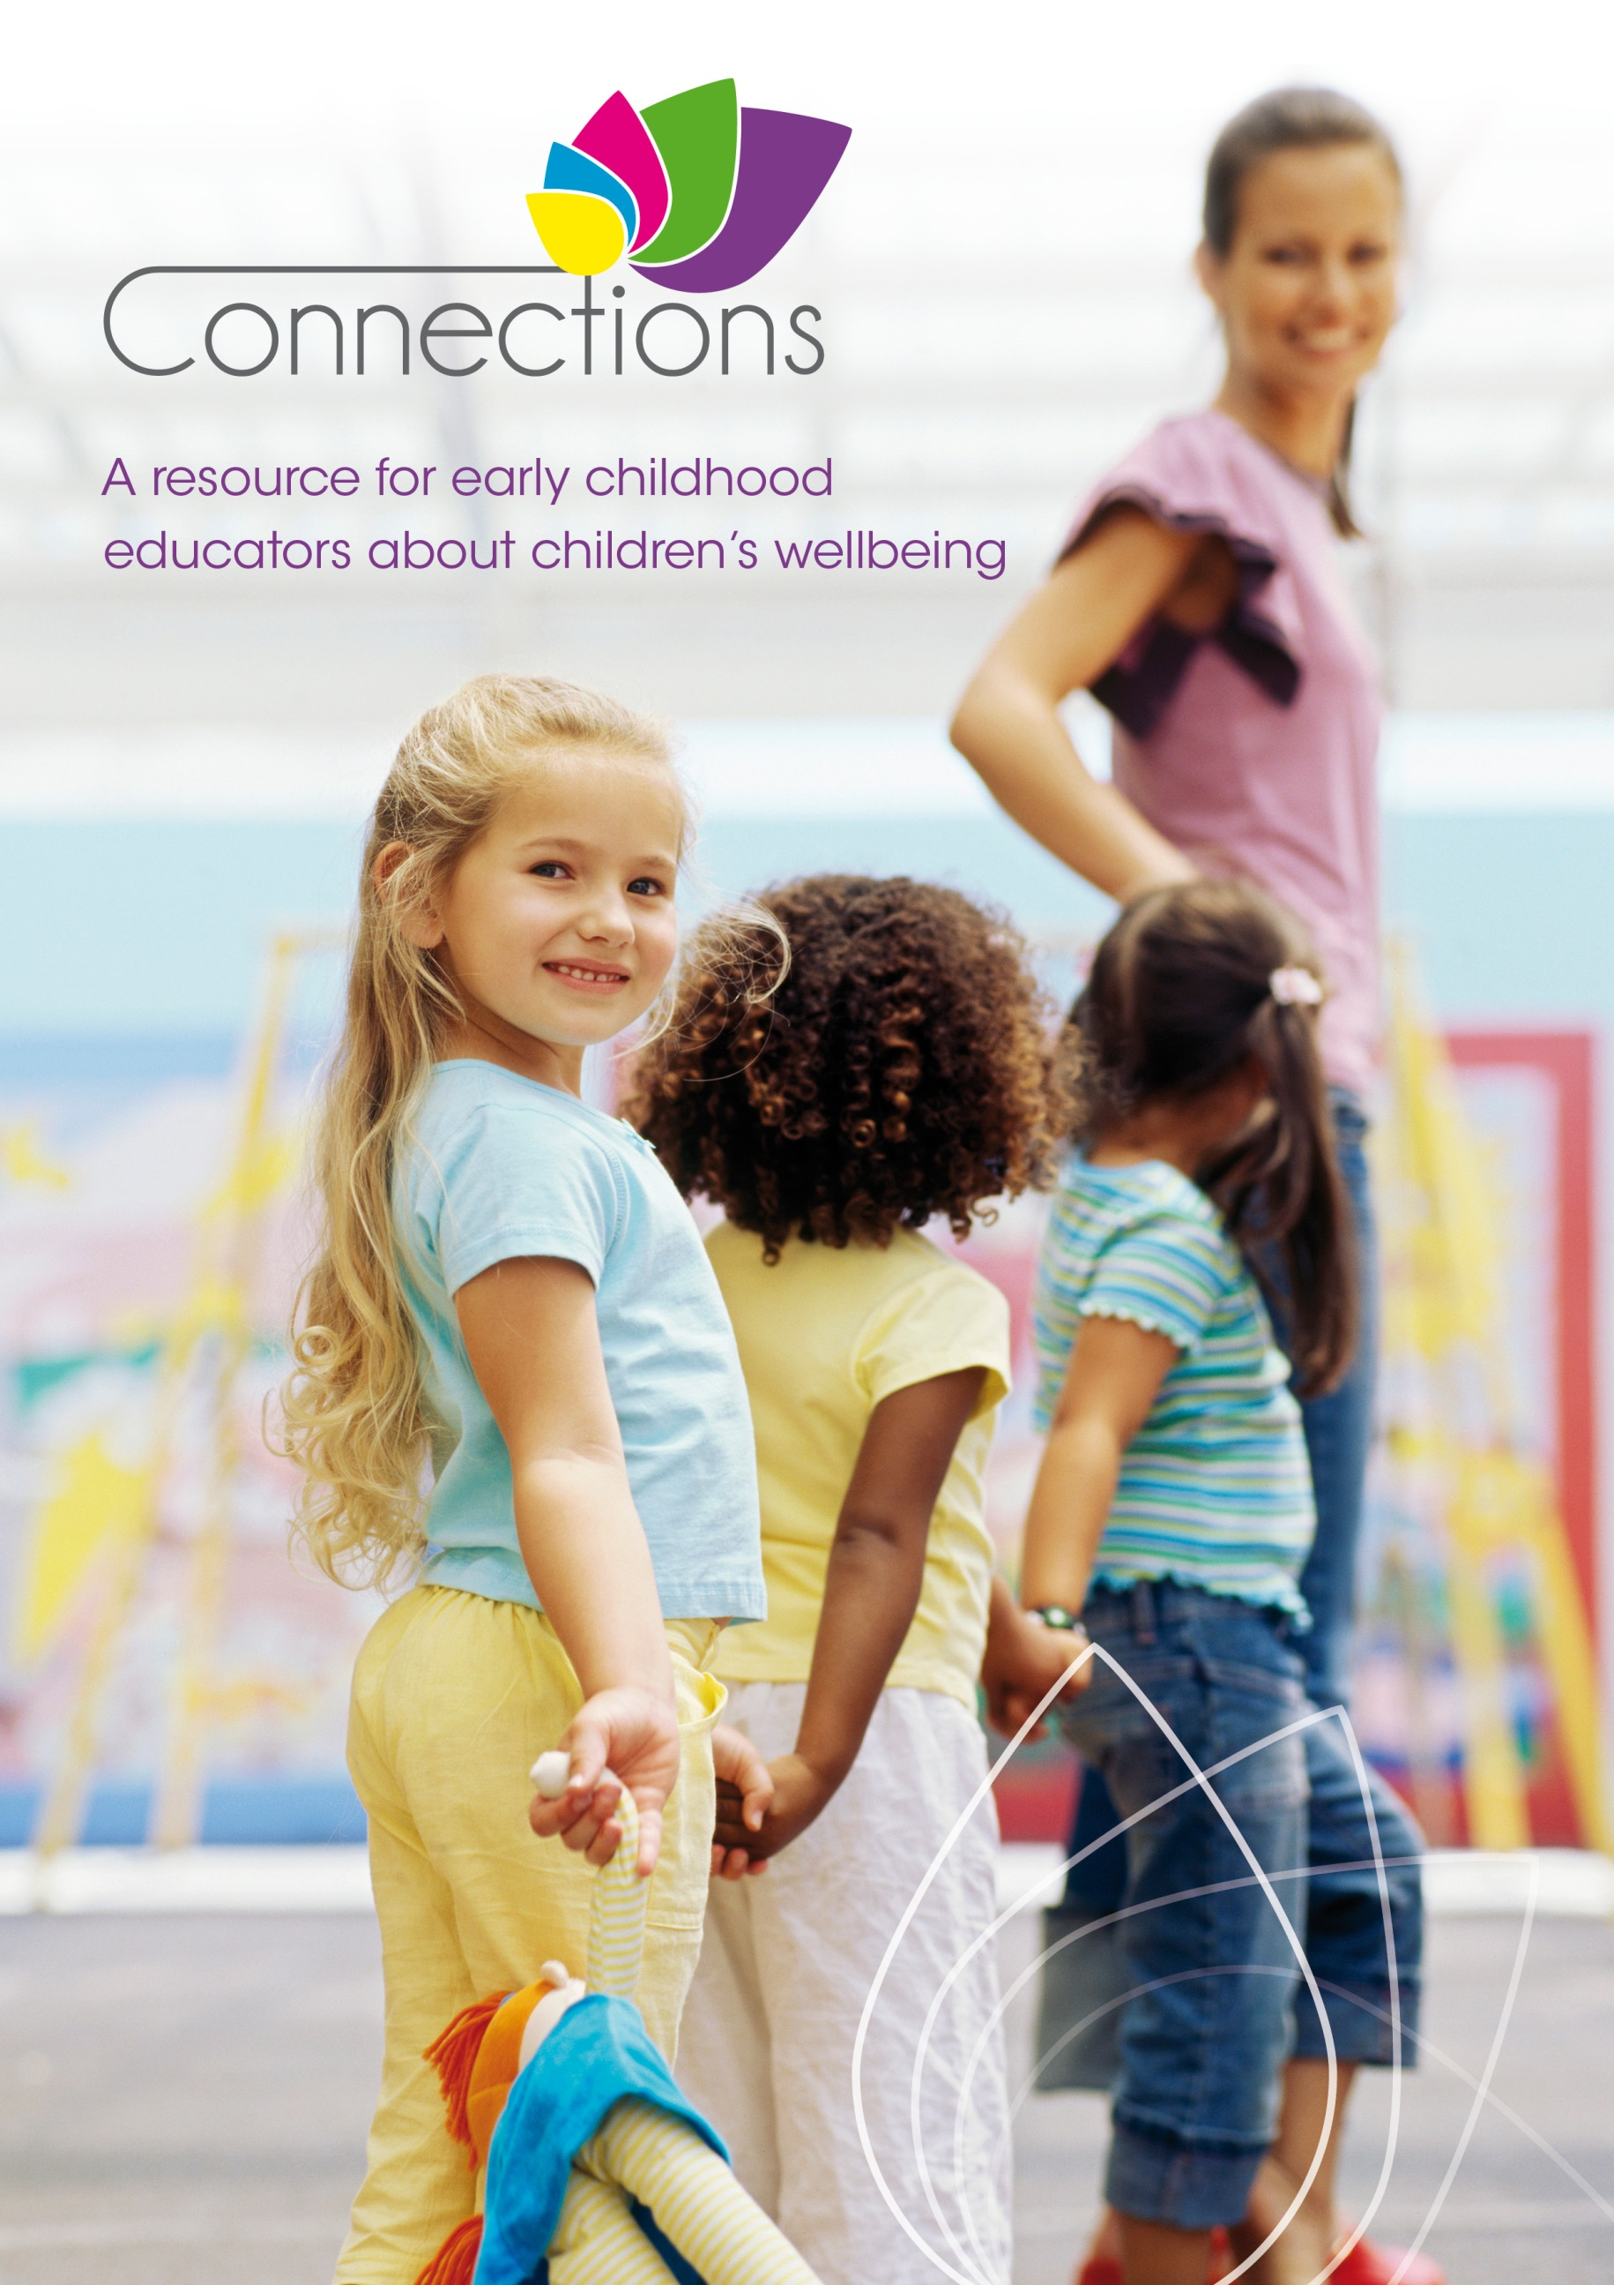
Front cover

Connections; A resource for early childhood educators about children’s wellbeing

The Connections resource for early childhood educators to support children’s mental health and wellbeing has been funded by the Australian Government Department of Education under the Child Care Services Support Programme. The resource has been developed by the Hunter Institute of Mental Health.

With the exception of the Commonwealth Coat of Arms and where otherwise noted all material presented in this document is provided under a Creative Commons Attribution 3.0 Australia (http://creativecommons.org/licenses/by/3.0/au/) licence.
The details of the relevant licence conditions are available on the Creative Commons website (accessible using the links provided) as is the full legal code for the CC BY 3.0 AU licence (http://creativecommons.org/licenses/by/3.0/au/legalcode).
The document must be attributed as Connections – A resource for early childhood educators about children’s wellbeing.
IBSN: 978-1-74361-460-0 [PRINT]
IBSN: 978-1-74361-461-7 [PDF]
IBSN: 978-1-74361-462-4 [DOCX]
Suggested citation: Hunter Institute of Mental Health. (2014). Connections: A resource for early childhood educators about children’s wellbeing. Canberra, ACT: Australian Government Department of Education.

Preface

Connections is a practical and reflective resource for early childhood educators to guide you in supporting children’s mental health and wellbeing. It is intended for use by educators who care for children (birth to eight years) in a range of settings including Long Day Care, Family Day Care, Preschool and Out of School Hours Care.
Positive mental health in early childhood is critical for children’s wellbeing and development in the present (being); and it also has important implications for their future (becoming). Children who are supported in their mental health and wellbeing in early childhood have a strong foundation for developing the skills, values and behaviours they need to experience positive physical and mental health as an adult. They are more likely to reach a higher level of education; attain and retain employment; build healthy and satisfying relationships; and participate actively in the community. This benefits both individuals and the communities in which they live.
Research into supporting children’s mental health and wellbeing in the early years has grown rapidly over the past 20 years. As researchers learn more about the brain and how it develops in early childhood, our understanding of how to improve long-term outcomes for children expands.
As an early childhood educator, you play an important role in the lives of the children attending your service. Connections provides you with current, evidence based information about mental health and wellbeing in early childhood and the skills and practices necessary to support it. By nurturing the mental health and wellbeing of children, we not only make a real difference to their lives, we contribute to building a prosperous and sustainable society for all Australians.
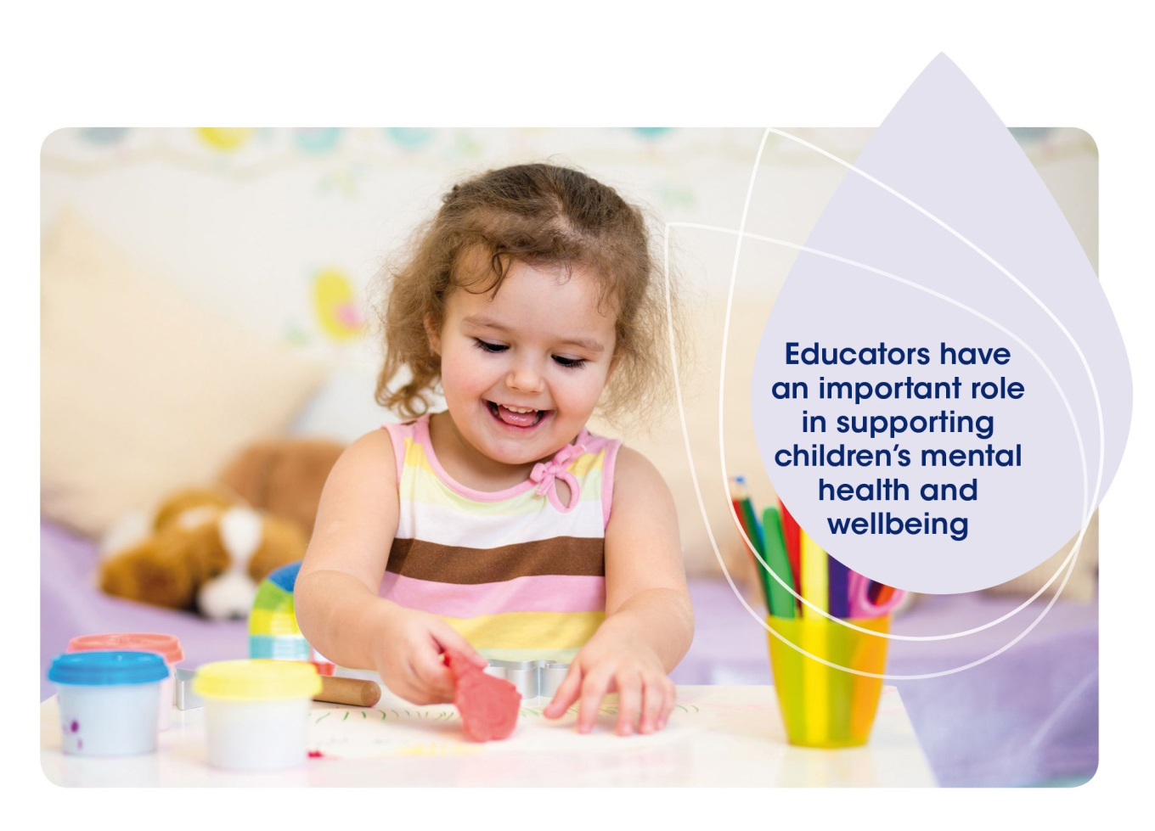

Contents

Using This Resource 1
Key Concepts 9
Areas of Practice
Partnerships 21
Professional Practice 29
Environment 37
Social and Emotional Development 43
Early Intervention 51
Connections Tools
Connections Decision Making Tree 60
Child Wellbeing Plan 64
Fact Sheets
- Attachment and Mental Health 70
- Brain Development for Mental Health 72
- Communicating with Children 74
- Leadership for Early Childhood Mental Health and Wellbeing 76
- Risk and Protective Factors 78
- Trauma, Loss and Grief 80
- Aboriginal and Torres Strait Islander Wellbeing 82
- Refugee and Migrant Families 84
- Children of Parents with a Mental Illness 86
- Family Conflict and Separation 88
- Abuse and Violence 90
- Children with Additional Mental Health Needs 92
- Supporting Additional Mental Health Needs 94
- Support Agencies and Professionals 96
- Discussing Mental Health Difficulties with Families 98
- Helping a Person in Distress 100
Acronyms and Initialisms 102
Acknowledgements 103

Using This Resource

What is Connections?
Connections is a practical and reflective resource for early childhood educators to guide you in supporting children’s mental health and wellbeing. Connections:
- Provides definitions of commonly used mental health terms;
- Outlines the knowledge, skills and practices associated with positive mental health and wellbeing outcomes for children;
- Demonstrates the links between supporting children’s mental health and wellbeing and the National Quality Standard (NQS), Belonging, Being and Becoming – The Early Years Learning Framework for Australia (EYLF) and My Time, Our Place – Framework for School Age Care in Australia (MTOP); and
- Encourages you to think about what you already do to support children’s mental health and wellbeing, and how you can continue to grow your knowledge, skills and practices.
You will already be familiar with many of the practices and themes covered in Connections as part of providing a quality early childhood service. This resource is designed to show you how these practices are also linked to supporting children’s mental health and wellbeing.

What are the aims of Connections?

Connections aims to:
- Develop a shared understanding and language amongst educators about mental health and wellbeing in early childhood;
- Assist educators to feel more comfortable and confident discussing children’s mental health with families and other early childhood professionals;
- Help educators to promote positive mental health in all children;
- Assist educators to support children and families with additional mental health needs at their service; and
- Guide educators to identify when a child or family may benefit from external support, and to better understand the range of support options available to children and families.
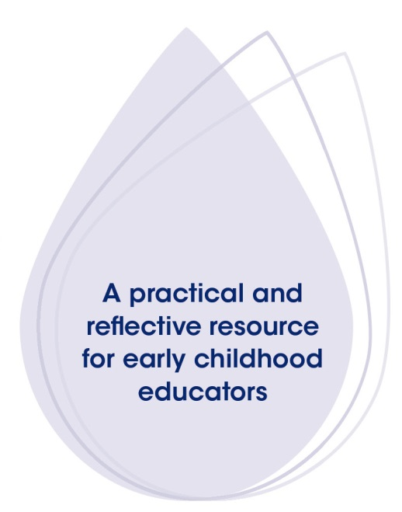

If you are familiar with the practices and themes described in Connections, think how you might support your colleagues to further develop their skills in this area.

Why is it called Connections?

Using This Resource
There are a number of connections that are important for children’s mental health and wellbeing including:
- The relationships children form with their families, carers and communities;
- The way connections are formed in the developing human brain;
- The partnerships that educators build with families, health professionals, other agencies and members of the community to support children’s mental health and wellbeing; and
- The connections that exist between early childhood development and longer-term health, learning and social outcomes, for individuals and communities.

How can educators use Connections?
Connections is designed to be used in a number of ways. It can be read as a whole or it can be explored in sections. Alternatively it can be used as a reference point, as it contains fact sheets on selected topics.
Overall the resource is designed to support reflective practice in early childhood education and care settings. Reflective practice is defined in My Time, Our Place – Framework for School Age Care in Australia (MTOP) as:
 A form of ongoing learning that involves engaging with questions of philosophy, ethics and practice. Its intention is to gather information and gain insights that support, inform and enrich decision-making about children’s wellbeing and development (MTOP, pg. 11).
The reflective questions at the end of each section can be used to support professional development discussions among educators for sessions ranging from half an hour to longer if time permits. Whilst it is recommended that educators answer these questions as part of a group, they can also be used as individual reflective exercises for family day care or mobile service educators.
Links to additional programmes and resources can be found at the end of each section for those educators who would like to find out more.

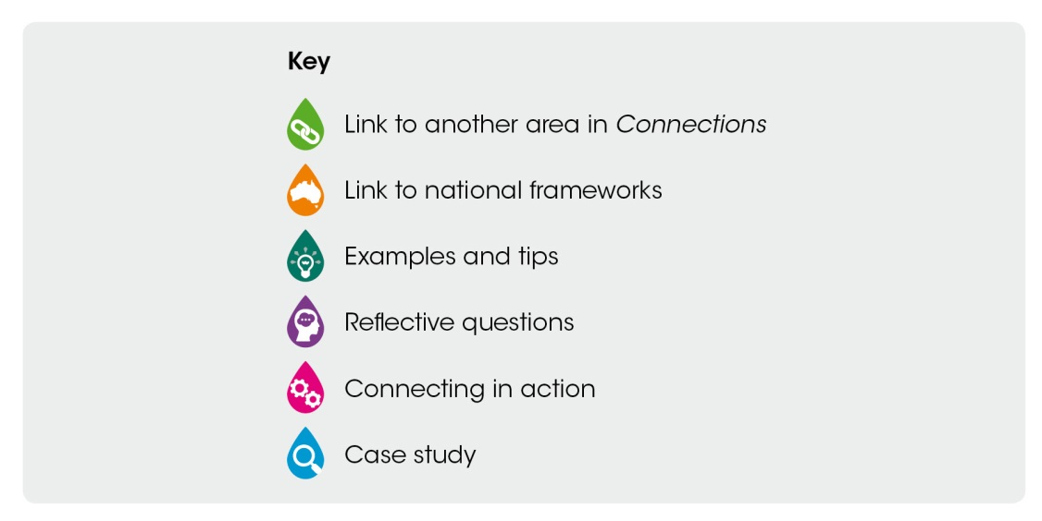
Key Diagram
The key diagram shows six different symbols that are used throughout the document. Each symbol is used at the beginning of a new section to show when there is a link to another section of the resource, a link to a national framework, a list of examples and tips, reflective questions, the beginning of a Connecting in action section or a case study in the upcoming text.
While practical examples are given in each Area of Practice, Connections does not intend to give step-by-step guidance for every situation. How an educator supports a child’s mental health within their service depends greatly on the individual child, their family, the service and the situation. You are encouraged to consider contextual factors before using one or more of the examples listed in this resource.

Structure of Connections
Connections has three main components; Key Concepts, Areas of Practice, and Fact Sheets.

Using This Resource
- Key Concepts – Provides definitions of commonly used mental health terms, discusses the importance of mental health and wellbeing in early childhood, and talks about your role as an educator to support the children at your service.
Reading and understanding Key Concepts will help you to understand the rest of the resource in more depth. Read this section before moving on to the Areas of Practice.
- Areas of Practice – Explains the five areas of early childhood practice that have been identified through research and expert opinion as being critical to achieving positive mental health outcomes for children.¹ They include Partnerships, Professional Practice, Environment, Social and Emotional Development and Early Intervention.
While the information in Connections has been divided into five Areas of Practice, many of the themes and topics presented in each section are related and often cross over.
- Fact Sheets – Provide further information for educators on specific topics related to children’s mental health and wellbeing.
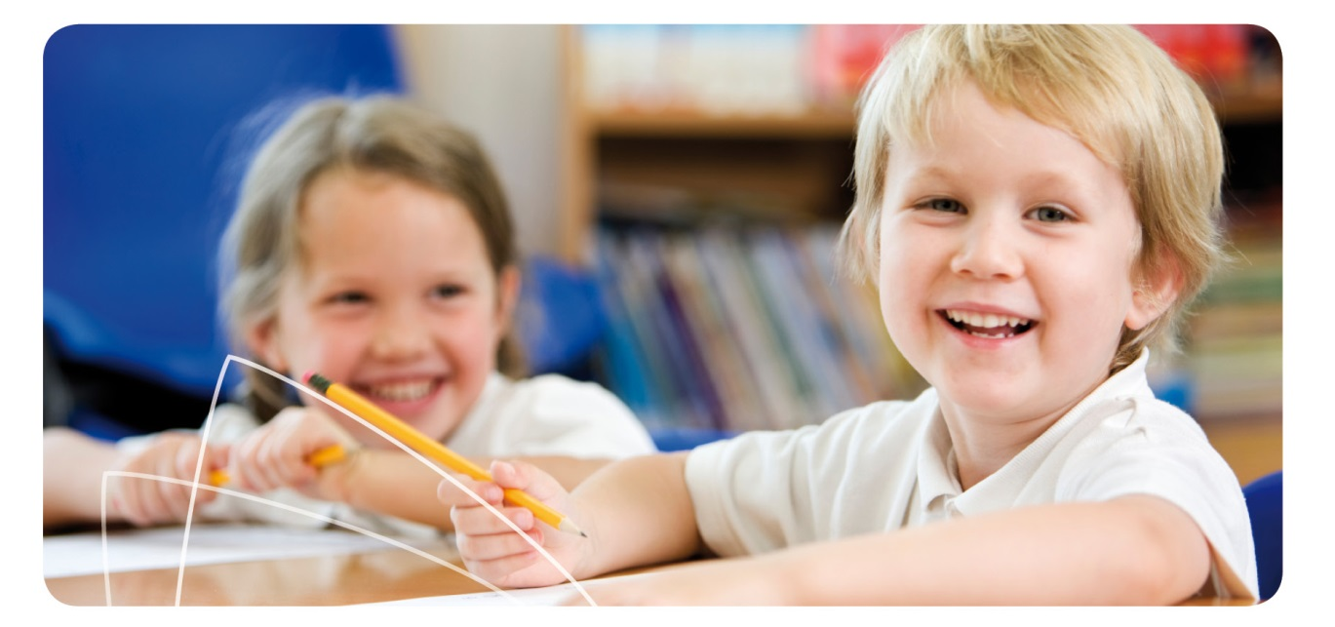
Hunter Institute of Mental Health and Community Services & Health Industry Skills Council. Children’s mental health and wellbeing: Exploring competencies for the early childhood education and care workforce. Final report. Canberra: Department of Education, Employment and Workplace Relations; 2012. Available from: www.himh.org.au/Final_Report_MH_Competencies.pdf
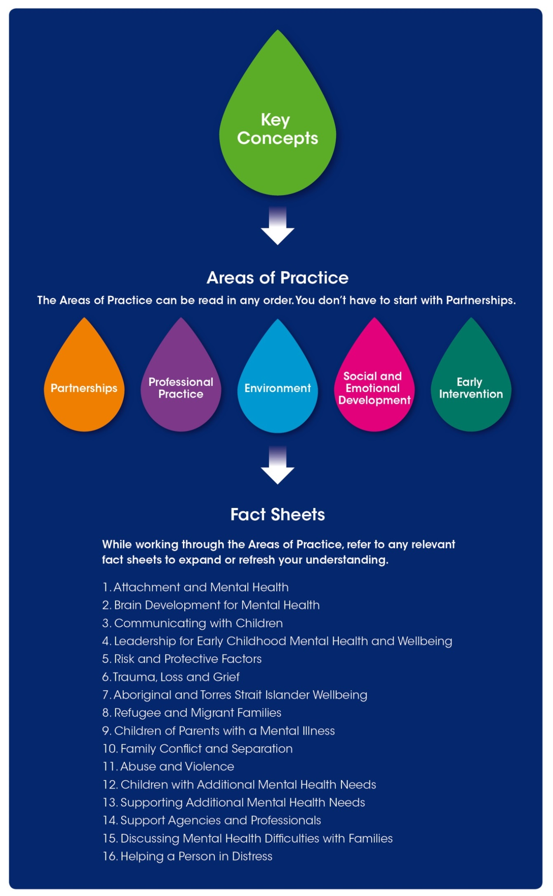
Diagram of the structure of Connections

Using This Resource
This diagram shows how the resource is structured. The first section following Using This Resource is Key Concepts.
After Key Concepts, there are five areas of practice. These include Partnerships, Professional Practice, Environment, Social and Emotional Wellbeing and Early Intervention. The areas of practice can be read in any order and you don’t have to start with Partnerships.
After the areas of practice come 16 fact sheets. You can refer to any relevant fact sheets to expand or refresh your understanding as you are working through the areas of practice. Fact sheet topics include:
- Attachment and Mental Health
- Brain Development for Mental Health
- Communicating with Children
- Leadership for Early Childhood Mental Health and Wellbeing
- Risk and Protective Factors
- Trauma, Loss and Grief
- Aboriginal and Torres Strait Islander Wellbeing
- Refugee and Migrant Families
- Children of Parents with a Mental Illness
- Family Conflict and Separation
- Abuse and Violence
- Children with Additional Mental Health Needs
- Supporting Additional Mental Health Needs
- Support Agencies and Professionals
- Discussing Mental Health Difficulties with Families
- Helping a Person in Distress

How does Connections relate to quality practice?

Using This Resource
Early childhood education and care is guided by several important national frameworks:
- The National Quality Framework (NQF) – Includes the National Quality Standard (NQS) and sets a national benchmark for the quality of education and care services.
- Belonging, Being and Becoming – The Early Years Learning Framework for Australia (EYLF) – Establishes key principles, practices and outcomes to support early childhood educators. It identifies children as co-collaborators and agents of their learning, providing a sense of success now and for future learning in a social and group context.
- My Time, Our Place – Framework for School Age Care in Australia (MTOP) – Assists educators in providing children with opportunities and a foundation for future success through an approach built on partnerships with children, families, communities and schools.
The skills and practices presented in Connections are closely aligned with the professional standards and principles reflected in the NQS, EYLF and MTOP frameworks. Quotes from the frameworks are included throughout the resource to highlight these links for educators.
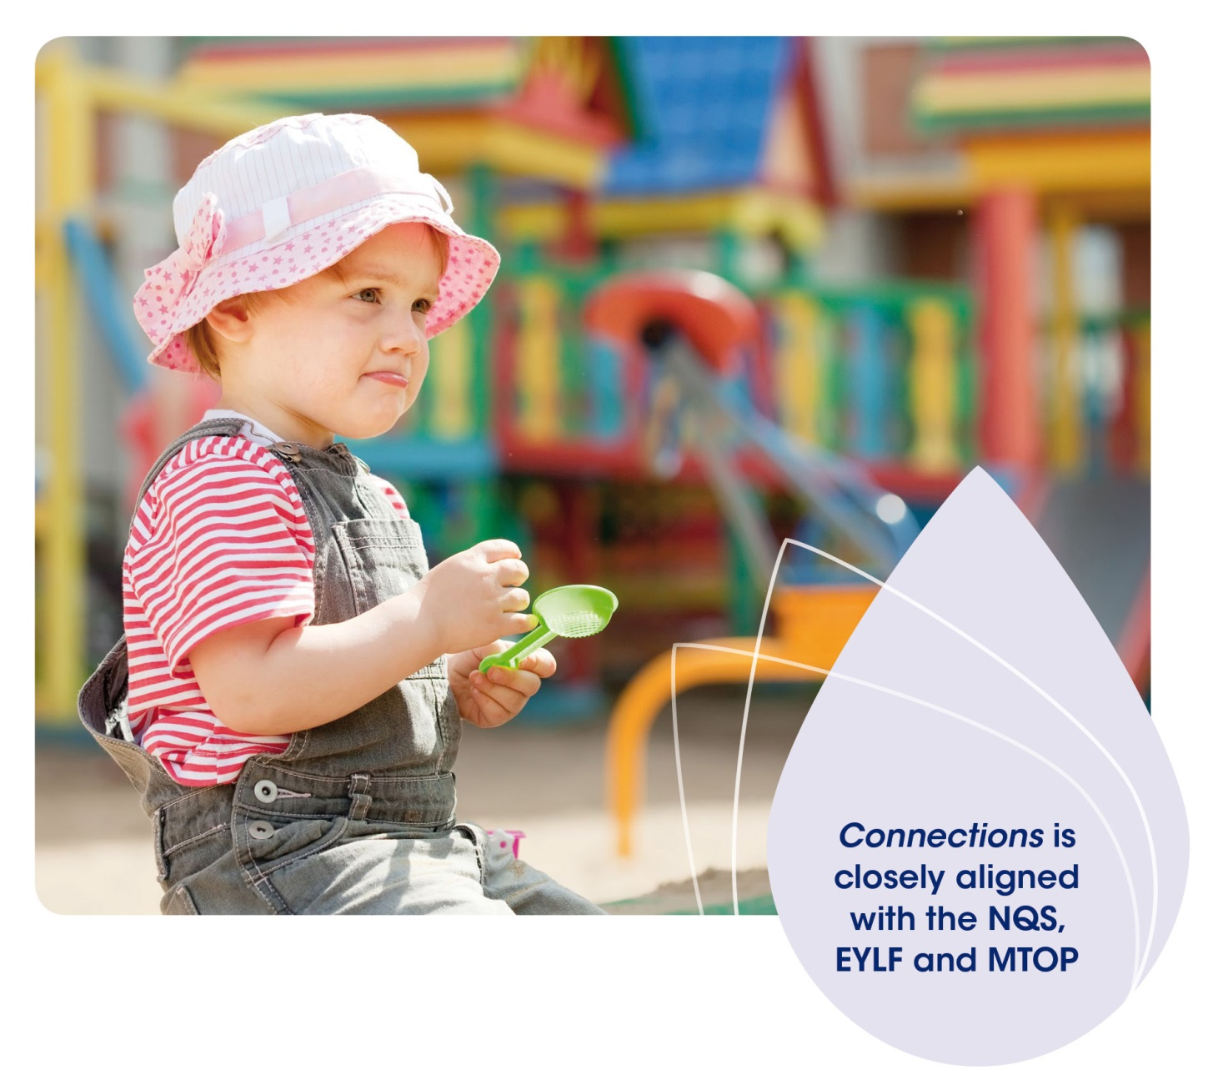

How can Connections help with quality improvement?

Using This Resource
In order to get the most from Connections, you are encouraged to use the resource as part of your service’s quality improvement processes. The information and reflective questions presented in Connections can be used to help you complete the following plans or cycles:
- Quality Improvement Plan – Connections can be used when completing your Quality Improvement Plan under the NQF. Links between the skills and practices presented in Connections and the NQS are listed throughout the five Areas of Practice.
- Early Years Learning Framework planning cycle and My Time, Our Place – Framework for School Age Care planning cycle – Connections is most helpful in the Question and Plan stages of these cycles. For example, you can use the information in Connections to “identify individual and group strengths, interests and goals,” or to “design learning experiences” to enhance the mental health and wellbeing of children and families at your service.

How does Connections align with other mental health promotion initiatives?
Connections complements other mental health related resources and programmes available in the early childhood sector, several of which are listed in the diagram on the following page. Some are designed for use in early childhood services; others have been developed to support training and education. For those who are already familiar with other materials, you will find that Connections reinforces the same key messages and is consistent with other programmes and frameworks, such as KidsMatter Early Childhood.
For those who are less familiar with topics relating to children’s mental health, Connections will be an excellent starting point to guide your exploration of this important issue. You can use the print resource in your service as a first point of reference, then visit the KidsMatter website or explore other resource materials for further information if you wish.
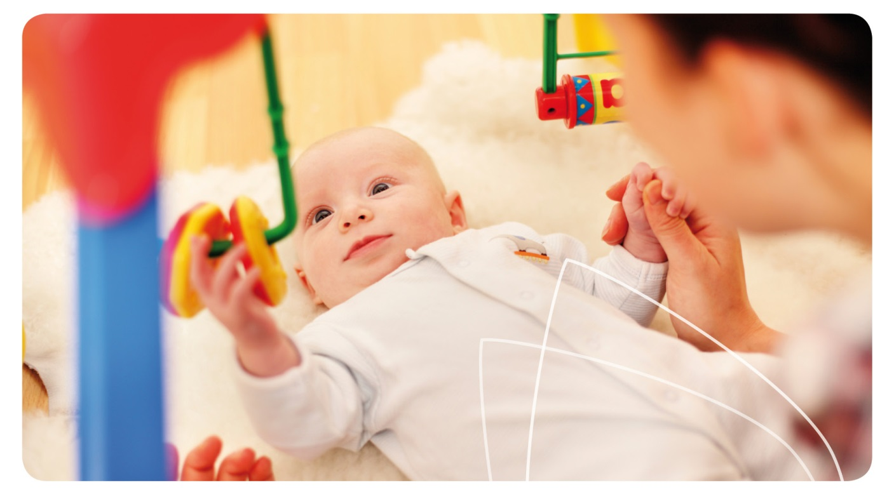

Mental health resources for early childhood education and care (ECEC) services

Using This Resource
Connections – A printed resource distributed to early childhood education and care services nationally, also available online.
KidsMatter Early Childhood – A national initiative funded by the Australian Government aimed at supporting Australian schools and ECEC services to promote and support children’s mental health. KidsMatter is a framework that educators can use to help them focus on areas which make a difference to children’s mental health and wellbeing and provides a range of resources on their website (www.kidsmatter.edu.au). Services that have signed up to implement KidsMatter Early Childhood have access to a support person based in their state or territory to help with planning, practice change and reflection.
Foundations – A magazine for ECEC services distributed in parts of New South Wales, also available online.
Social Emotional Early Development Strategy (SEEDS) - Resources available in Queensland.
The Victorian Prevention and Health Promotion Achievement Program: ECEC services – A Healthy Together Victoria programme that supports services to create healthier environments and recognises achievements in promoting the wellbeing of children.
Raising Our Little Ones – An online resource developed by the Secretariat for National Aboriginal and Islander Child Care (SNAICC) which brings together both traditional and contemporary child rearing practices from Aboriginal and Torres Strait Islander communities across Australia.
Keeping Families and Children in Mind – A learning programme developed by the national initiative Children of Parents with a Mental Illness (COPMI). The e-course supports learners to develop a family sensitive approach when working with families where a parent has a mental illness.
Australian Child and Adolescent Trauma, Loss and Grief Network – An online community and information resource assisting professionals to better recognise and respond to children and young people’s diverse and often complex needs in the face of threats and losses encountered early in their lives.

Resources for vocational education and training
Response Ability – Multi-media resources for registered training organisations. Some online components.
Healthy Early Years Training Strategy – Queensland online training resources that include a module on social and emotional wellbeing.

Resources for teacher education
Response Ability – Multi-media resources for universities. Some online components.

What is the role of early childhood education and care leaders?

Using This Resource
Early childhood education and care leaders play a critical role in the success of Connections being incorporated into their service. Leaders are not only educators who hold management or educational positions, such as directors, supervisors, coordinators or educational leaders, but also those people within the service who are respected and followed by their colleagues.
Previous research has shown that greater results are achieved when there is strong leadership and uptake of a resource by service leaders. This includes encouraging educators to engage with the material, and commit to incorporating the principles of the resource into their daily practice.
You are encouraged to make time to read Connections and consider how best to use it within your service to build the capacity of your colleagues to support the mental health and wellbeing of children and families. Further information about leadership can be found in the Leadership for Early Childhood Mental Health and Wellbeing fact sheet (page 76).
Effective leadership promotes a positive organisational culture and builds a professional learning community (NQS 7.1).

Workshop ideas for Connections
There are many ways to understand and unpack the ideas and concepts presented in Connections. Some suggestions are to:
- Take the case studies included in Connections as a starting point, and add in more detail relevant to the context of your service;
- Reflect on each skill and practice and come up with other examples or tips for how you would incorporate them into your daily practice;
- Come up with a list of further resources for each fact sheet, eg books, magazines, learning experiences, websites or newsletters; or
- Research a particular topic, present the information to your colleagues and design some questions for the group to discuss.
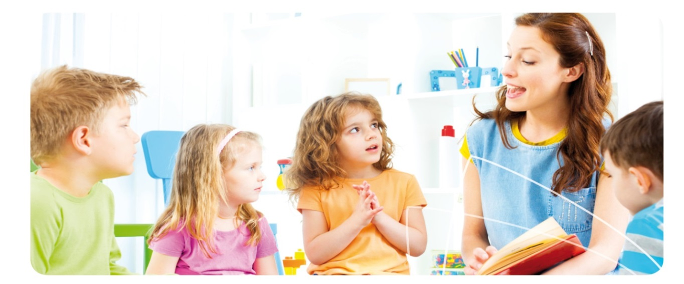
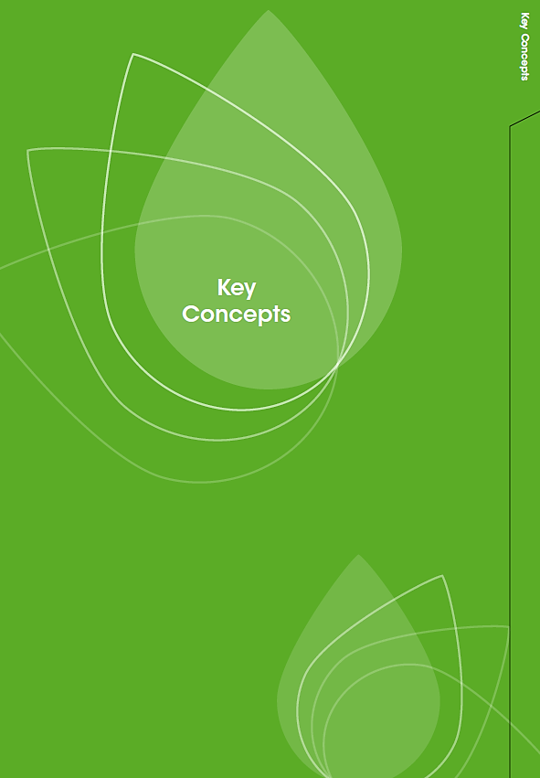
Front of tab to start a new section; Key Concepts.

Back of tab to start a new section; Key Concepts.

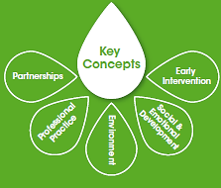

Key Concepts

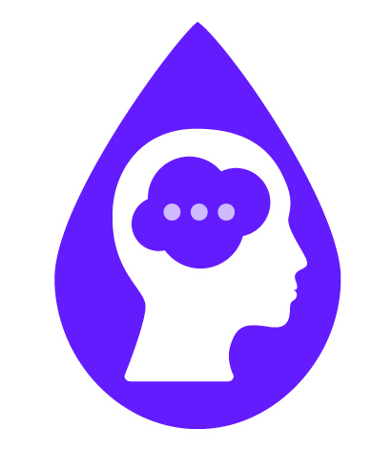 Reflective questions
Before working through Connections, think about what mental health and wellbeing means to you. Here are some questions to help you do this.
- What do the following words or phrases mean to you?
- Mental health and wellbeing;
- Social and emotional wellbeing;
- Resilience.
- What about these words or phrases?
- Emotional and behavioural difficulties;
- Mental health difficulties;
- Mental illness.
- What other terms have you heard people use to describe these words or phrases?
- What specific strategies can you identify that you are using at the moment, to support children’s mental health and wellbeing?
- What would you like to know more about to enhance your practice in relation to children’s mental health and wellbeing? Make a list of questions or topics to explore further as you work through this resource.

What is mental health and wellbeing?

Key Concepts
- Mental health and wellbeing refers to a person’s psychological, social and emotional wellbeing. It is related to our thoughts, feelings and behaviour.
- Mental health is a positive capacity that makes up part of a person’s overall wellbeing, just as physical health does. Mental health is not the same as mental illness.
- Mental health and wellbeing is our ability to manage our thoughts, feelings and behaviour positively, so that we can:
- Experience satisfaction and happiness in our lives;
- Cope with stressful events and sadness;
- Achieve our goals and potential; and
- Maintain positive connections with others.^{1,2}
- Like physical health, the level or quality of our mental health and wellbeing can change over time, depending on what is happening in our lives.
- Mental health and wellbeing is important because it affects people’s quality of life and sense of satisfaction. It also influences our physical health, learning and long-term outcomes, such as employment and financial security.²

What is mental health and wellbeing in early childhood?
- Mental health and wellbeing in early childhood is related to thoughts, feelings and behaviour, and is viewed within the context of the child’s development.
- The human brain and body develop rapidly in the early years, so children’s feelings, behaviour and capacity to do things will change over time. Children gradually build new skills and are active participants in their own exploration, development and learning.
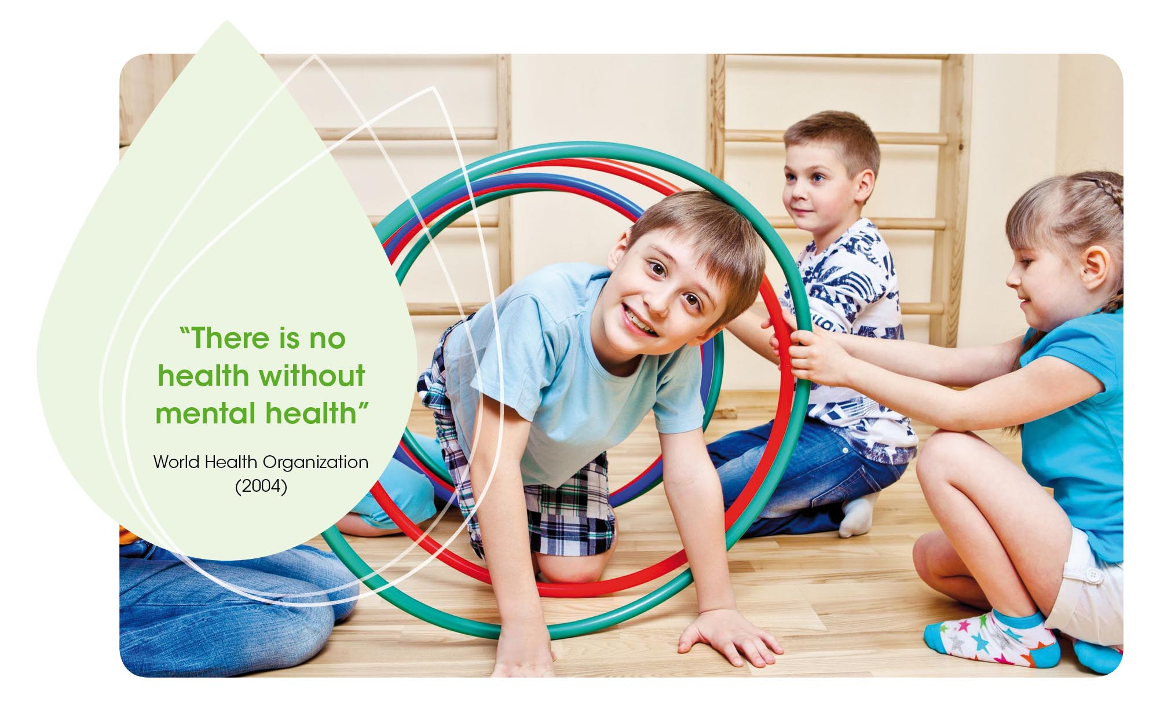
- Mental health and wellbeing is the capacity of a young child – within the context of their development, family, environment, care settings and culture – to:

Key Concepts
  - Participate in the physical and social environment;
  - Form healthy and secure relationships;
  - Experience, manage, understand and express emotions;
  - Understand and manage their behaviour;
  - Interact appropriately with others, including peers; and
  - Develop a secure sense of self.³
- Just like adults, children’s wellbeing changes from time to time depending on their development, their relationships and what is happening in their lives. It is normal for children to express a range of emotions, including happiness, sadness and anger.
Children have a strong sense of wellbeing (EYLF/MTOP Outcome 3).

What other terms are used to describe mental health?
- People have different beliefs and understandings of mental health based on their culture, education and life experiences. Some people use other words or phrases to talk about our social and emotional needs. It is good to be aware of a range of different terms.
- The term social and emotional wellbeing is often used in the early learning context.⁴ It is used in Belonging, Being and Becoming – The Early Years Learning Framework for Australia (EYLF) and in My Time, Our Place – A Framework for School Age Care in Australia (MTOP).
- Many Aboriginal and Torres Strait Islander people also prefer the term social and emotional wellbeing where it may indicate a broader concept of social, emotional, cultural and spiritual wellbeing that includes individuals, community and country.⁵
- Resilience is the capacity to deal with tough times, solve problems or recover from difficult events. Resilience is what helps us to bounce back from a challenge and to re-establish our mental health and wellbeing.⁴
Children develop their emerging autonomy, interdependence, resilience and sense of agency (EYLF/MTOP Outcome 1).

What are mental illnesses and neurodevelopmental disorders?
- A mental illness is a medical condition that impacts upon a person’s thoughts, feelings or behaviour. Nearly half of the population (45%) will experience some form of mental illness at some stage of life.⁶
- A neurodevelopmental disorder is a condition in which there is a difference in the way the brain develops, which can also affect thoughts, feelings or behaviour. The term neuro refers to the brain and the nerves that extend throughout the body.⁷
- Mental illnesses and neurodevelopmental disorders can be diagnosed by health professionals, such as a GP, paediatrician, psychiatrist or clinical psychologist.
- Mental illnesses and neurodevelopmental disorders arise through complex interactions between biological, psychological, environmental and social factors.^{1,7,8}

Key Concepts
- There are many different mental illnesses and neurodevelopmental disorders, each with their own symptoms and treatment. Some that may be diagnosed in childhood include:
  - Anxiety and related disorders;
  - Depression and related disorders;
  - Autism spectrum disorders; and
  - Attention Deficit Hyperactivity Disorder (ADHD).^{7,8}
- Neurodevelopmental disorders such as autism or ADHD are usually ongoing. Anxiety, depression and other forms of mental illness may be ongoing, or may occur in a single episode, or as a series of episodes.
- When a person has a mental illness or a neurodevelopmental disorder, they need additional support at certain times to reach their best possible level of wellbeing. They may also need guidance to help them manage their feelings and social interactions.
Educators are not expected to diagnose mental illnesses or neurodevelopmental disorders. However educators may work in partnership with families and/or health professionals during this process and have an important role in supporting the child and family.
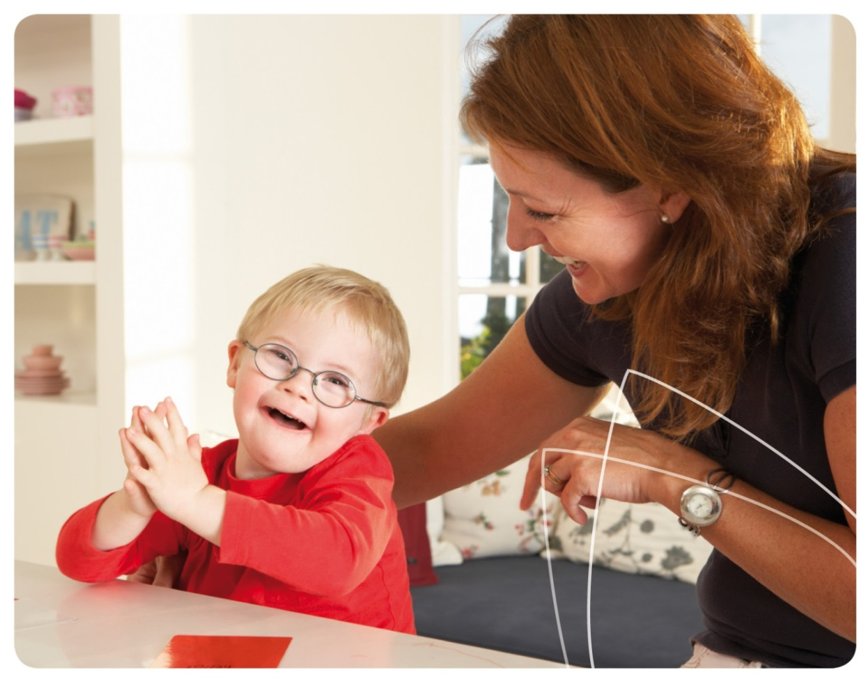

What are mental health difficulties?

Key Concepts

- Mental health difficulties is the term used throughout Connections to describe a range of challenges that people may experience in their thoughts, feelings or behaviour.
- Mental health difficulties include: long periods of feeling upset, worried or sad; behaving aggressively; withdrawing from others; or not coping with day-to-day tasks. Some people use the term emotional and behavioural difficulties to describe these issues in children.
- Mental health difficulties can occur in response to general life challenges. They may also occur in the context of a mental illness or neurodevelopmental disorder. We all experience mental health difficulties at times.
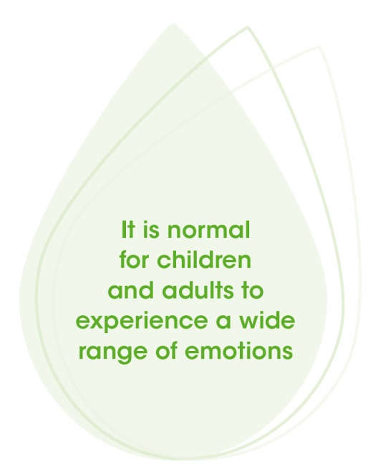

- It is normal for children and adults to experience a wide range of emotions. Learning how to manage feelings and cope in positive ways is an important part of child development and takes time.⁸ Children need support to help them cope and to guide their learning.
- If a child has ongoing or severe mental health difficulties, or their development seems particularly different from their peers, further assessment and support from a health professional is recommended.
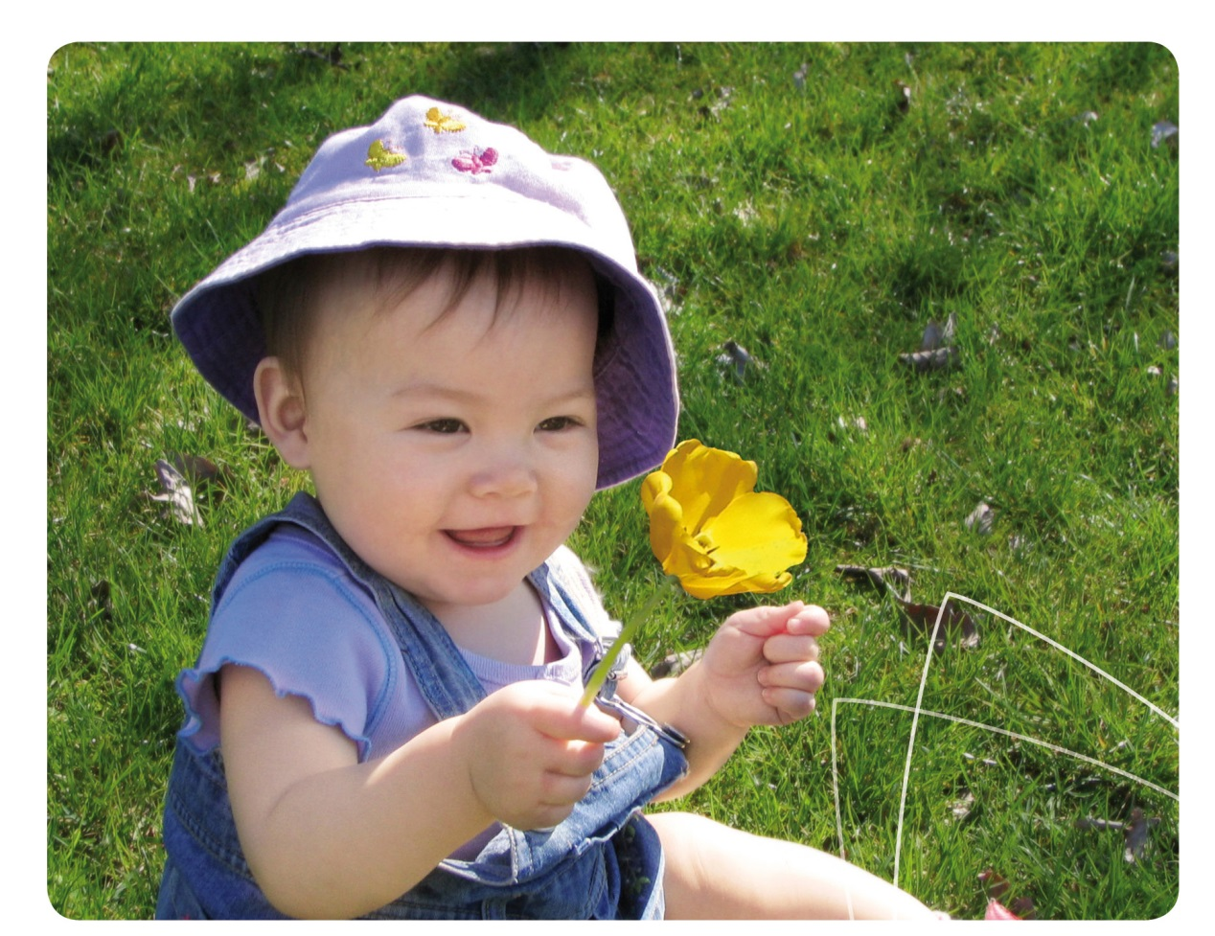

Additional mental health needs

Key Concepts
Additional mental health needs is used in Connections as an umbrella term to describe a person’s mental health support needs. It is like the broader term additional needs but relates specifically to social and emotional aspects of the person’s life.
Additional mental health needs can be used to include people who are facing general life challenges as well as those who may have a mental illness or neurodevelopmental disorder. It is about needing extra social or emotional support at that time, whatever the reason.

Connecting these ideas
We have covered many different terms. The diagram below* can be helpful in understanding how these ideas fit together.⁹
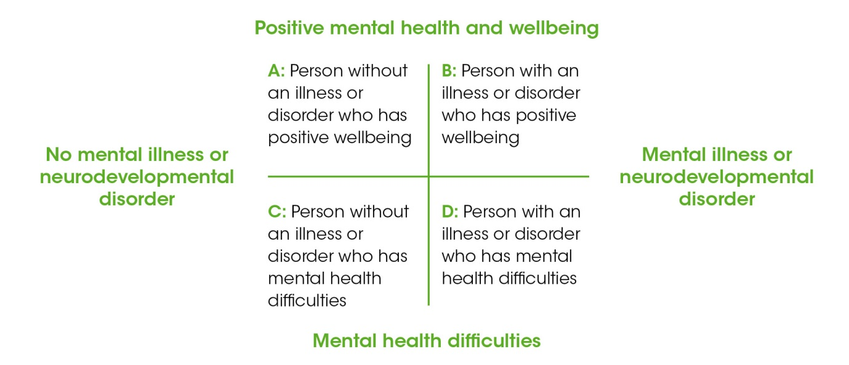
The diagram is divided into four sections by one vertical line and one horizontal line (like a cross). At the top of the vertical line is the heading, ‘positive mental health and wellbeing.’ At the bottom of the vertical line is the heading, ‘mental health difficulties.’
On the left hand side of the horizontal line is the heading, ‘no mental illness or neurodevelopmental disorder.’ On the right hand side of the horizontal line is the heading, ‘mental illness or neurodevelopmental disorder.’
If a person is in the top left quadrant of the diagram, they are described as being, ‘A: Person without an illness or disorder who has positive wellbeing.’
If a person is in the top right quadrant of the diagram, they are described as being, ‘B: Person with an illness or disorder who has positive wellbeing.’
If a person is in the bottom left quadrant of the diagram, they are described as being, ‘C: Person without an illness or disorder who has mental health difficulties.’
If a person is in the bottom right quadrant of the diagram, they are described as being, ‘D: Person with an illness or disorder who has mental health difficulties.’
* Dual Continua Model of Mental Health. Adapted from Miles J, Espiritu RC, Horen NM, Sebian J and Waetzig, E. A public health approach to children’s mental health: A conceptual framework. Expanded executive summary. Washington: Georgetown University Center for Child and Human Development; 2010.
- Over the course of their lives people can move between different groups (A, B, C or D) depending on what is happening in their life and how they are coping at a particular point in time.
- Most people have times when they experience positive wellbeing and times when they are not coping so well. This is a normal part of life, and may relate to issues like stress, changes in physical health, or energy levels.
- People with a mental illness or a neurodevelopmental disorder can experience wellbeing, particularly when they are in a positive life situation and are able to access the type of support they need, when they need it.
- People with a mental illness or a neurodevelopmental disorder can also experience mental health difficulties, either because of their condition, or because of environmental and other factors, such as life challenges that they may be facing.
- People without a disorder who experience unresolved mental health difficulties, eg through trauma or ongoing stress, may be at greater risk of developing certain kinds of mental illness, such as depression, anxiety disorders or substance dependence.

 Case studies: Connecting theory and practice

Key Concepts
Read these case studies, reflect on what you have already learnt and answer the questions below.
- Humra has recently started preschool and is becoming more confident and outgoing every day. She has made friends with another girl and seems to be enjoying her experiences at preschool and at home. Educators are encouraging and supporting her growing independence and self-care.
- Aisha was diagnosed with post-natal depression after the birth of her baby, Catelyn. She is feeling down and finds it hard to cope with day-to-day tasks at the moment. Aisha is worried about how the illness might affect her relationship with her daughter.
- Jacob is seven and has ADHD. He is coping well at school and home and has a close group of friends. His mum, teacher and after-school carers work together and use strategies recommended by his psychologist to help Jacob manage transitions and develop positive social skills.
- Longwei is worried about a few things in his life. He finds it hard to sleep and there is a lot of tension at home at the moment. Longwei works part-time as an early childhood educator and thinks that stress is also affecting his work with children and families.
- Which part of the diagram best describes each person’s situation - A, B, C or D?
- What could you do to support the mental health and wellbeing of Humra, Aisha, Jacob and Longwei and their families?
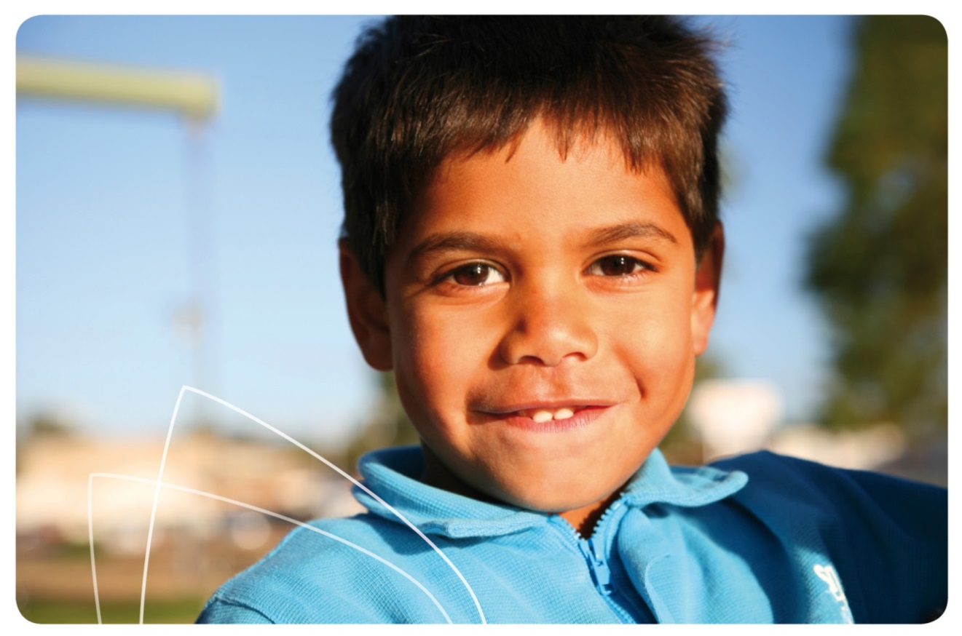

Why is early childhood an important time for mental health?

Key Concepts
- Early childhood development can have far reaching consequences for the person’s future physical and mental health and wellbeing. It also affects a person’s relationships, educational success, financial security and community participation.^{2,9}
- The first few years of life are critical for attachment and brain development, two factors which have important effects on mental health and wellbeing. These factors are both influenced by the quality of the child’s early relationships with family and caregivers.
- Secure attachment relationships occur when adults respond to children’s needs in a consistent, timely and sensitive way. Secure attachment is the most effective type of attachment relationship for promoting mental health and wellbeing.¹⁰
- Early brain development lays the foundations for brain structures and for how the brain functions. The way the connections between brain cells develop in the first few years of life is affected by the quality of the child’s early relationships and their environment.¹¹
- When adults provide high quality education and care for children – which includes building secure relationships within a supportive environment – they are also playing an important role in promoting children’s mental health and wellbeing, now and in the future.
- For more information on why the early years are particularly important for mental health, refer to the fact sheets on Attachment and Mental Health (page 70) and Brain Development for Mental Health (page 72).
Children become strong in their social and emotional wellbeing (EYLF/MTOP Outcome 3).
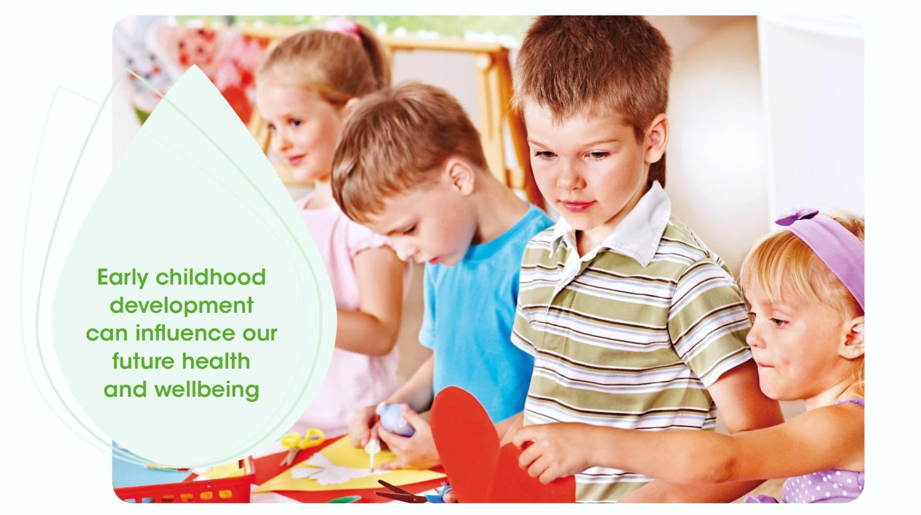

Brains are built over time

Key Concepts
Some educators may find analogies helpful in explaining these concepts. The Center on the Developing Child at Harvard University compares brain development to building a house:
The basic architecture of the brain is constructed through an ongoing process that begins before birth and continues into adulthood.
Like the construction of a home, the building process begins with laying the foundation, framing the rooms, and wiring the electrical system in a predictable sequence, and it continues with the incorporation of distinctive features that reflect increasing individuality over time.
Brain architecture is built over a succession of “sensitive periods,” each of which is associated with the formation of specific circuits that are associated with specific abilities. The development of increasingly complex skills and their underlying circuits builds on the circuits and skills that were formed earlier.
Through this process, early experiences create a foundation for lifelong learning, behaviour, and both physical and mental health. A strong foundation in the early years increases the probability of positive outcomes and a weak foundation increases the odds of later difficulties.
*National Scientific Council on the Developing Child. The science of early childhood development: Closing the gap between what we know and what we do. Cambridge (US): Harvard University; Center on the Developing Child; 2007. p.5.

What are risk and protective factors?

- Mental health and wellbeing is shaped by interactions between many factors. These may be internal to the person (eg their thoughts, beliefs, genetic makeup or brain development), or external, relating to a person’s environment, cultural background or life situation.¹
- Risk factors are things in a child’s life that are associated with a higher risk of mental health difficulties, mental illness or a neurodevelopmental disorder. They may occur at an individual, family or community level. Examples include chronic health problems or disability, a family history of illness or disorder, family conflict or community violence.
- Protective factors are things in a child’s life that support positive development and good mental health and wellbeing. Examples include having nurturing, affectionate and secure relationships with adults and having the opportunity to develop effective personal skills, such as problem-solving, social skills and managing feelings effectively.
- When we support children and families effectively, we can reduce risk factors and enhance protective factors for children. This approach can help to ensure that as they grow up, children have the opportunity to develop their best possible mental health and wellbeing.
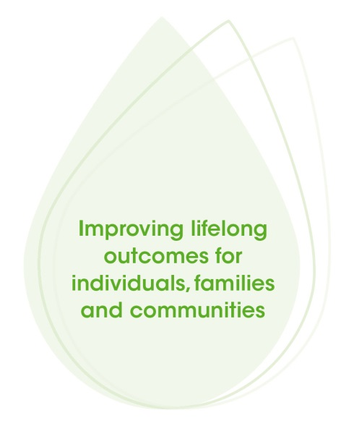

Each child is supported to build and maintain sensitive and responsive relationships with other children and adults (NQS 5.2).

What is the role of educators in mental health and wellbeing?

Key Concepts
- Early childhood educators have an important role to play in supporting children’s mental health and wellbeing. The relationships and interactions that educators have with children on a day-to-day basis help to shape the development of their brain.
- Educators contribute to improving lifelong outcomes for individuals, families and communities by:
  - Understanding the factors that influence mental health and wellbeing;
  - Promoting positive development and wellbeing among all children;
  - Identifying children or families who may need additional support;
  - Providing additional support for children within the service;
  - Working in partnership with families and helping to identify potential external sources of support when appropriate;
  - Being inclusive of all children and families;
  - Caring for their own mental health and wellbeing; and
  - Supporting the mental health and wellbeing of colleagues.
- In performing this role, educators demonstrate a number of important values and principles that may already be a part of their day-to-day practice.³ These include:
  - Child development – Dedication to supporting the best possible development and wellbeing of infants and children.
  - Diversity and inclusion – Respect for diversity and inclusion of children and families from different cultural backgrounds, family environments, and children of all abilities.
  - Quality service provision – Commitment to making children’s mental health and wellbeing a key part of providing a quality service with an emphasis on continuous improvement, ethical decision-making and evidence-based practice.
  - Early intervention – Commitment to supporting children with additional mental health needs. Early identification and early intervention are essential in promoting positive outcomes for each child and their family.
  - Partnerships – Appreciation that working in partnership with families and other professionals is an important part of supporting children’s development, mental health and wellbeing.
  - Professional development – Commitment to reflective practice and ongoing learning about mental health and wellbeing, including formal and informal professional development.
  - Raising awareness – Dedication to raising awareness of the mental health needs of children and families.
Each child’s health is promoted (NQS 2.1).

Connections will show you how to include a focus on children’s mental health and wellbeing within your existing activities and how this is consistent with current professional practice and values.

Key Concepts
Answers: Case studies question 1
A = Humra B = Jacob C = Longwei D = Aisha
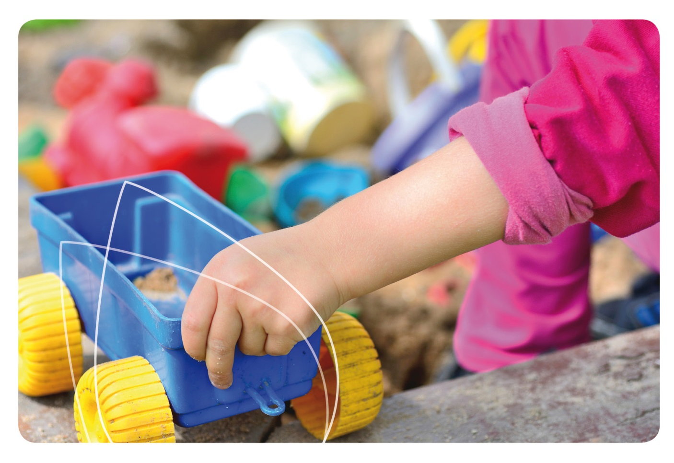

Key concepts: More information

Key Concepts
¹ Parham J, Patterson A. Understanding mental health and wellbeing: An introduction to mental health, mental health promotion, prevention of mental ill-health and early intervention: participant booklet. Adelaide: Australian Network of Promotion, Prevention and Early Intervention for Mental Health; 2008.
² World Health Organization; Department of Mental Health and Substance Abuse; Victorian Health Promotion Foundation; University of Melbourne. Promoting mental health: Concepts, emerging evidence, practice; A summary report. Geneva: World Health Organization; 2004. Available from: www.who.int/mental_health/evidence/en/promoting_mhh.pdf
³ Hunter Institute of Mental Health and Community Services & Health Industry Skills Council. Children’s mental health and wellbeing: Exploring competencies for the early childhood education and care workforce. Final report. Canberra: Department of Education, Employment and Workplace Relations; 2012. Available from: www.himh.org.au/earlychildhood
⁴ Stafford K, Moore C, Foggett K, Kemp E and Hazell T. Proving and improving: Exploring the links between resilience, behaviour and academic outcomes. In: AARE 2007 International Education Research Conference: Papers collection. Fremantle; 2008. Available from: www.unilife.curtin.edu.au
⁵ Zubrick S, Dudgeon P, Graham G, Glaskin B, Kelly K, Paradies Y, Scrine C and Walker R. Social determinants of Aboriginal and Torres Strait Islander social and emotional wellbeing. In: Purdie N, Dudgeon P, Walker R, editors. Working together: Aboriginal and Torres Strait Islander mental health and wellbeing principles and practice. Canberra: Department of Health and Ageing; 2010. Available from: aboriginal.childhealthresearch.org.au
⁶ Australian Bureau of Statistics. National survey of mental health and wellbeing summary of results. Canberra: Australian Bureau of Statistics; 2009. Catalogue 4326.0. Available from: www.abs.gov.au
⁷ Mitchell KJ. The genetics of neurodevelopmental disease. Current Opinion in Neurobiology. 2010; 21:197-203.
⁸ Kay-Lambkin F, Kemp E, Stafford K and Hazell T. Mental health promotion and early intervention in early childhood and primary school settings: A review. Journal of Student Wellbeing. 2007; 1:31-56.
⁹ Miles J, Espiritu RC, Horen NM, Sebian J and Waetzig, E. A public health approach to children’s mental health: A conceptual framework. Expanded executive summary. Washington: Georgetown University Center for Child and Human Development; 2010.
¹⁰ Rees C. Children’s attachments. Paediatrics and Child Health. 2008; 18:219-226.
¹¹ National Scientific Council on the Developing Child. The science of early childhood development: Closing the gap between what we know and what we do. Cambridge (US): Harvard University; Center on the Developing Child; 2007.
Davey L. How to talk about children’s mental health. Washington: Frameworks Institute; 2010.
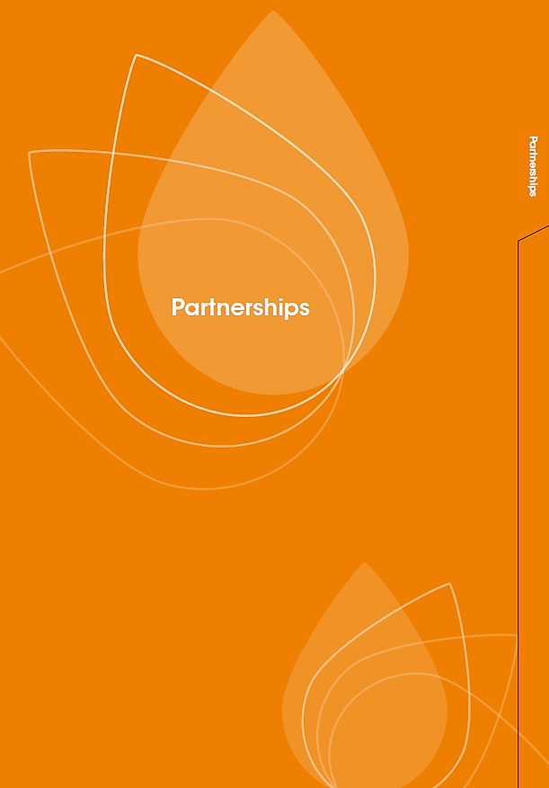

Front of tab to start a new section; Partnerships
Back of tab to start a new section; Partnerships.
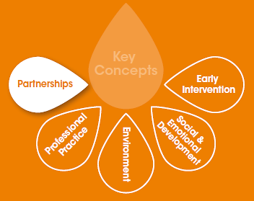

Partnerships

Shared goal
To build effective partnerships with families, professionals, agencies and the community, that will help us to promote children’s mental health and wellbeing.

Why are partnerships important for children’s mental health and wellbeing?
- Successful partnerships enable educators, families, professionals, agencies and community members to share information and collaborate to support children’s development, mental health and wellbeing. They also help vulnerable children feel more secure.
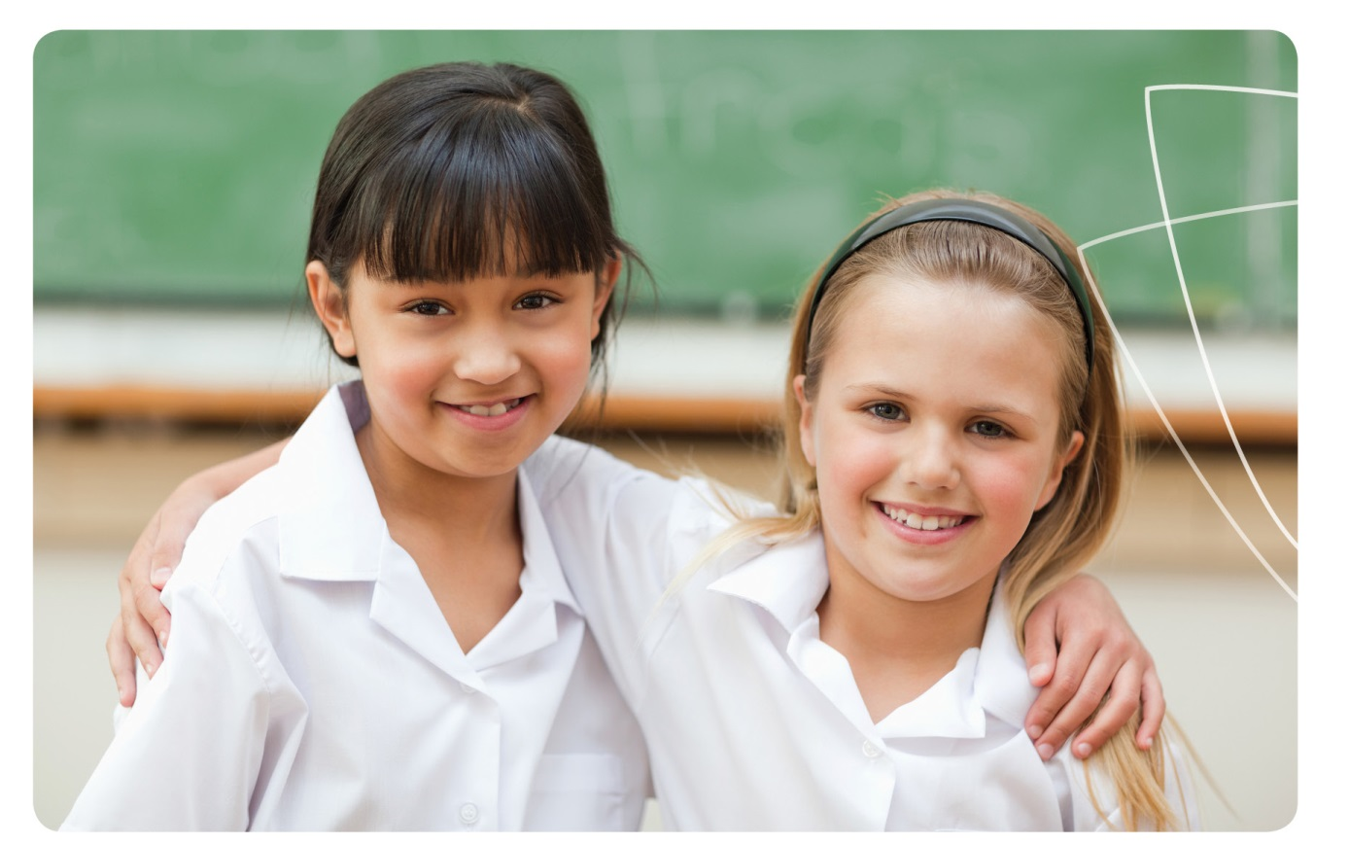
- When families are well-supported by educators they are better equipped to nurture their child’s development, mental health and wellbeing.

Partnerships
- If a child begins to experience mental health difficulties, educators and families may feel more comfortable talking about the situation if they already have a good partnership.
- If a child has additional mental health needs, professional partnerships between health professionals, educators and families are essential in achieving the best possible outcomes for that child and their family.
Respectful supportive relationships with families are developed and maintained (NQS 6.1).

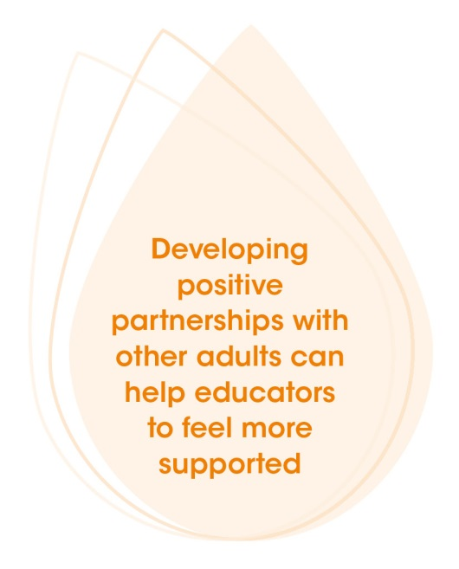
How do effective partnerships benefit educators?
- By working with families, professionals and agencies, services may have access to helpful information and strategies to manage or guide behaviour.
- Developing positive partnerships with other adults can help educators to feel more supported, trusted, respected and appreciated in their role.
- Creating effective partnerships helps educators meet the standards and principles reflected in the National Quality Standard (NQS), Belonging, Being and Becoming – The Early Years Learning Framework for Australia (EYLF) and My Time, Our Place – Framework for School Age Care in Australia (MTOP).

Partnerships (EYLF/MTOP Principle 2)

Case study
Hasna comes in on a Tuesday morning with baby Layla. Like any new mum, she looks tired but you can also tell she’s been crying. You say good morning to Hasna and ask her how she is. She bursts into tears and tells you that her father-in-law has just been admitted to hospital with cancer and is not doing well. She mentions that she’s worried about the effect all this stress might be having on Layla and asks if the baby could come to your service more often over the next few weeks.
- How would you respond to Hasna?
- What information could you give to her about supporting Layla through this time?
- How could you support Hasna and Layla within the service?

Skills and practices for all educators

Partnerships
Educators build effective partnerships in a number of ways such as:

Partnership skills
- Considering situations from several perspectives, such as the perspective of the child, family members, collaborating agencies and culturally diverse communities.
- Using respectful, engaging and effective verbal and non-verbal communication skills to foster strong partnerships with families, professionals, agencies and community members.
- Modelling prosocial values and behaviours in partnerships, such as empathy, inclusion, sharing, cooperation and helping other people.
Educators, coordinators and staff members are respectful and ethical (NQS 4.2).

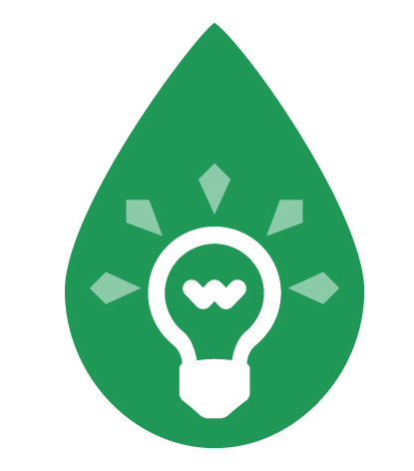 Examples and tips
- Put yourself in other people’s shoes when connecting with children, families, community members or health and educational professionals. What would you be thinking and feeling if you were them? What are their priorities at this time?
- Be aware that factors you don’t know about may be influencing the behaviours and feelings of others, eg parents or caregivers may be sleep deprived, unwell or affected by drugs or alcohol; they may have experienced abuse or violence in the past. Remain non-judgemental.
- Be respectful of other people’s beliefs, values and opinions. Families are more comfortable sharing information with educators if they feel their views are respected and are being taken into account.
- Use active listening skills, for example summarising your understanding of a conversation and clarifying points if needed.
- Show empathy by acknowledging how the other person might be feeling, eg “I can see this is frustrating for you…”
- Think about your body language and what you are communicating through your tone of voice, gestures or facial expressions. What message are you sending to others?

Partnerships with families

Partnerships
- Working with family members to develop an understanding of each child’s development, interests, family and cultural context.
- Giving professional advice to families about children’s development, including their strengths and their psychological, social and emotional development.
- Recommending reliable sources of information and support for families in regard to children’s development, mental health, and social and emotional wellbeing.
Families are supported in their parenting role and their values and beliefs about child rearing are respected (NQS 6.2).

Examples and tips
- Share the positive aspects of the child’s day with their families at pick-up time, eg “Bianca and Erin had great fun in the sandpit today…”
- Make time to listen to any concerns that a family member might have about their child’s behaviour or feelings. Be guided by the family about whether the child should be involved in detailed discussions.
- Try not to make any assumptions about a situation; individual families will have different needs, preferences or requests.
- Recommend some useful resources for families about children’s mental health and wellbeing, such as the KidsMatter resources or the Raising Children Network.
- If necessary, arrange for an interpreter to visit your service when talking with families from diverse backgrounds.
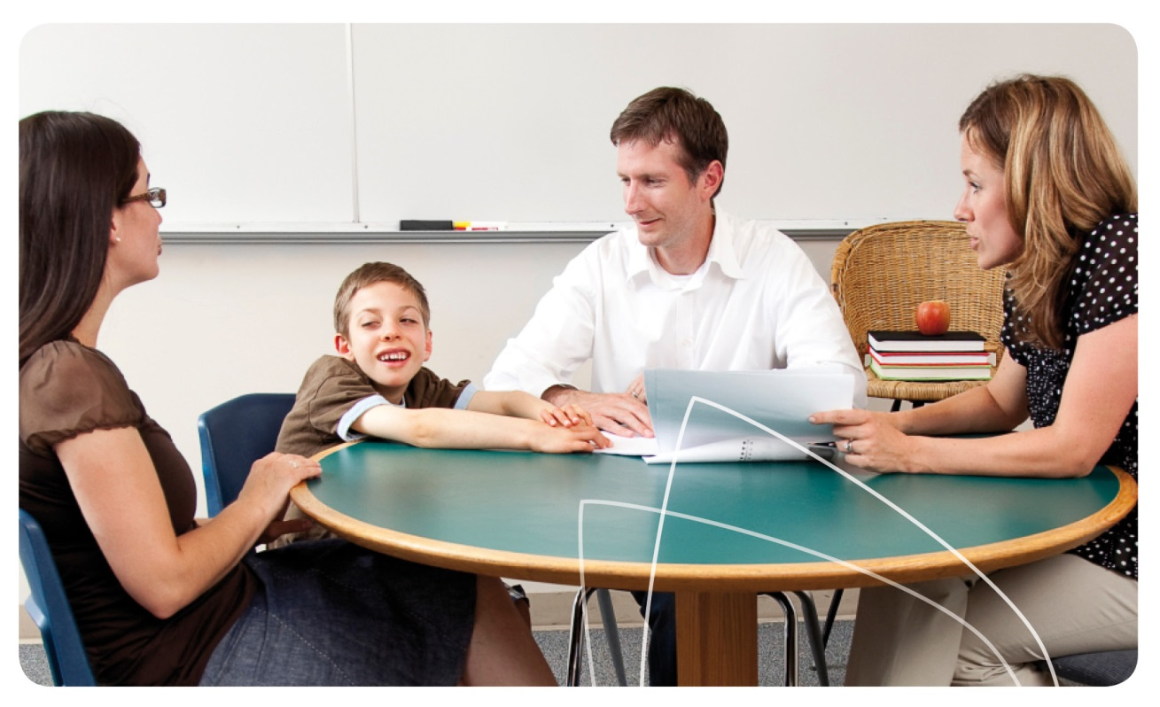

Partnerships with professionals and the community

Partnerships
- Building partnerships and working with external support agencies, child health or child development specialists, when requested by the family, to support the mental health and wellbeing of children and families.
- Developing partnerships with other groups, professional associations or networks to share information and opportunities relevant to children’s development, mental health and wellbeing.
- Collaborating with community members and relevant agencies to give children and families opportunities to explore diversity.
The service collaborates with other organisations and service providers to enhance children’s learning and wellbeing (NQS 6.3).

Examples and tips
- Visit the Support Agencies and Professionals fact sheet (page 96) to enhance your knowledge of the types of professionals who work to support families with additional mental health needs.
- Put together a list of health professionals and agencies in your local area that can provide assessment and support for children with mental health difficulties, mental illness and/or neurodevelopmental disorders, eg GPs, psychologists, and child and family health specialists.
- If a child is assessed by a health professional or support agency, your service may have access to a report or an existing support plan. Become familiar with any documentation and if needed, discuss it with your director, supervisor or coordinator.
- Share your observations of a child’s emotions or behaviour with a collaborating health professional or support agency during the assessment process if requested, and if approved by the child’s family.
- Implement the recommended strategies consistently in your service, record the outcomes, and communicate the child’s progress regularly with the family and other professionals as requested.

Connecting with quality practice
As you have read through the Partnerships Area of Practice, you will have seen some quotes from the NQS, EYLF or MTOP. These show how working in partnership to support children’s mental health and wellbeing is relevant to quality practice in early childhood education and care.
Read over these quotes again. Does working in partnership to support children’s mental health and wellbeing help to support any other elements of the NQS, EYLF or MTOP?

Reflective questions

Partnerships
- How are “respectful supportive relationships with families…developed and maintained” at your service? (NQS 6.1)
- How does your service work in partnership with families to support children’s mental health and wellbeing? What else could you do?
- What information could you provide to families of children with additional mental health needs? How can you tell if this information is reliable?
- How does your service work together with health professionals and support agencies to assist children and families with additional mental health needs? What could you do to strengthen your partnership with these professionals?
- Revisit the case study for the Partnerships Area of Practice and think about your answers. Would you respond any differently to these case study questions now? What additional information would you like to know or find out?

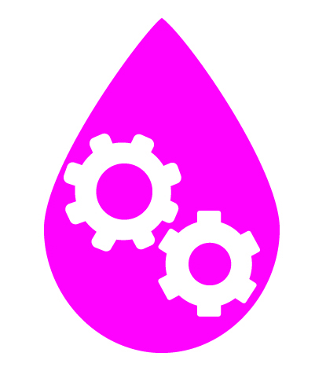 Connecting in action
Now that you have read about and reflected on partnerships for children’s mental health and wellbeing, think about how you can put this information into action.
- What skills and practices do you think you or your service could enhance? Set a goal for what you would like to achieve.
- What steps will you or your service take to enhance this skill or practice? Who will be responsible for each step?
- How will you know when you have reached your goal? How can you make sure this change continues in your service after achieving your goal?
Once you have finished thinking about these questions, you may wish to update your Quality Improvement Plan to reflect your answers.


Partnerships: More information

Partnerships
Andrews J. Inclusive practice: Working with families who are vulnerable. Putting Children First (NCAC Newsletter). 2009;31:18-20 [cited 2013 Nov 29]. Available from: ncac.acecqa.gov.au/educator-resources/pcf-articles/Vulnerable_families_Sep09.pdf
Education Services Australia Ltd as the legal entity for the Standing Council on School Education and Early Childhood (SCSEEC). A toolkit for working with families from pre-birth to 8 years. Engaging Families in the Early Childhood Development Story. 2013.
Early Childhood Australia. Talking about practice (TAPS): Partnerships with families. E-learning video. 2011. Available from: www.earlychildhoodaustralia.org.au/nqsplp/e-learning-videos/talking-about-practice/partnerships-with-families
Elliot R. Engaging families: Building strong communication. Research in Practice Series, 12(2). Canberra: Early Childhood Australia Inc; 2005. Available from: www.earlychildhoodaustralia.org.au
Hood M. Partnerships: Working together in early childhood settings. Research in Practice Series, 19(1). Canberra: Early Childhood Australia Inc; 2012. Available from: www.earlychildhoodaustralia.org.au
Hunter Institute of Mental Health and Community Services & Health Industry Skills Council. Children’s mental health and wellbeing: Exploring competencies for the early childhood education and care workforce. Final report. Canberra: Department of Education, Employment and Workplace Relations; 2012. Available from: www.himh.org.au/earlychildhood
KidsMatter Australian Early Childhood Mental Health Initiative. Component 3: Working with parents and carers [cited 2013 Nov 29]. Available from: www.kidsmatter.edu.au/early-childhood/framework
KidsMatter Australian Early Childhood Mental Health Initiative. Literature review. Component 3: Working with parents and carers. Canberra: Department of Health and Ageing; 2012. Available from: www.kidsmatter.edu.au/sites/default/files/public/KMEC-Component3-Literature-Review.pdf
KidsMatter Australian Early Childhood Mental Health Initiative. Building partnerships between families and early childhood staff [cited 2013 Oct 24]. Available from: www.kidsmatter.edu.au/early-childhood/about-partnerships/about-working-together/building-partnerships-between-families-and
Raising Children Network. Families with vulnerabilities. 2006 [cited 2013 Oct 24]. Available from: www.raisingchildren.net.au
Secretariat of National Aboriginal and Islander Child Care (SNAICC). Opening doors through partnerships: Practical approaches to developing genuine partnerships that address Aboriginal and Torres Strait Islander community needs. North Fitzroy: Department of Families, Housing, Community Services and Indigenous Affairs; 2012. Available from: www.snaicc.org.au

This page is for any notes you wish to make

Notes
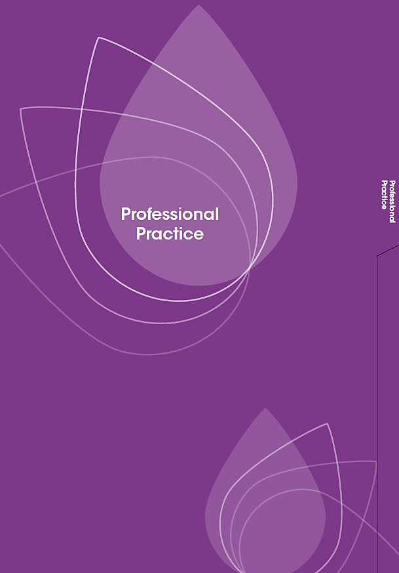
Front of tab to start a new section; Professional Practice

Back of tab to start a new section; Professional Practice
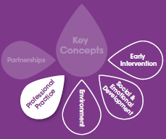

Professional Practice

Shared goal
To build the capacity of services, educators, families and the community to promote children’s mental health and wellbeing.

Why is professional practice important for children’s mental health and wellbeing?

- The term professional practice is used in Connections to talk about the importance of educators maintaining and enhancing their professional capacity to support children’s mental health and wellbeing. Key aspects include reflective practice, professional development, awareness raising and self-care.
- Although it may be difficult to find time for these activities, reflection and ongoing professional development are important for educators to undertake and form part of an educator’s professional and ethical practice. They help educators keep their knowledge and skills up-to-date, in order to best support children’s development, mental health and wellbeing.
- By raising awareness of the mental health needs of children and families, educators encourage communities to work together to promote positive outcomes for all children in terms of their development, mental health and wellbeing.
- When educators care for their own wellbeing, including their mental health, they will be better equipped to support the mental health and wellbeing of each child at their service.
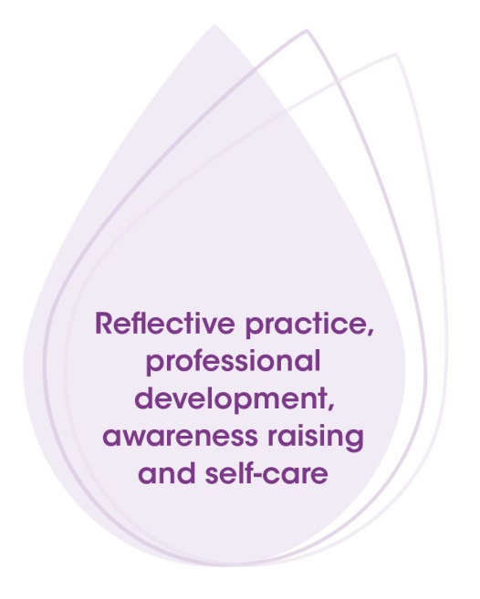

Ongoing learning and reflective practice (EYLF/MTOP Principle 5)

How does professional practice benefit educators?

Professional Practice
- Through reflective practice and professional development, educators can increase not only their confidence in supporting children and families with mental health difficulties, but also their skills and capacity to perform this role.
- Raising awareness and responding to the needs of children and families, at an individual or community level, can help educators to feel more connected with other professionals and community members and enhance professional satisfaction.
- Caring for their own mental health and wellbeing helps educators to enjoy life, cope with stressful events and sadness, achieve their goals and potential, and maintain positive connections with others.
- Engaging in professional practice for mental health and wellbeing helps educators meet the standards and principles reflected in the National Quality Standard (NQS), Belonging, Being and Becoming – The Early Years Learning Framework for Australia (EYLF) and My Time, Our Place – Framework for School Age Care in Australia (MTOP).
Effective leadership promotes a positive organisational culture and builds a professional learning community (NQS 7.1).


Case study

Professional Practice
Your director, Stan, has just been to a conference on children’s mental health and wellbeing. He talks to you and your colleagues about what he has learnt at the next staff meeting and describes some of the strategies your service can use to support children with additional mental health needs. After the meeting, you go into the staff room to make a cup of tea. June, one of the other educators, is there and she starts talking about mental health issues in children. She says she can’t understand what all the fuss is about; kids will be kids and they’ll grow out of it eventually.
- What would you say to June?
- How could you help June to broaden her understanding of mental health and wellbeing?
- What could you do to make sure the mental health needs of the children in June’s care were being met?

Skills and practices for all educators
Educators demonstrate professional practice for mental health in a number of ways such as:

Making time for reflection and professional development

- Reflecting on your professional practice with respect to early childhood mental health and wellbeing. Identify what you and your service are already doing well and what you might be able to enhance or do differently to improve outcomes for children and families.
- Identifying opportunities for professional development on a range of topics that relate to children’s mental health, such as attachment, brain development, behaviour, or supporting those with additional mental health needs.
- Participating in formal or informal learning to enhance your knowledge and skills relating to children’s mental health, wellbeing and development, or factors affecting them.
- Seeking mentoring from experienced practitioners and consulting with them in regard to daily practices and goals, including a focus on mental health and wellbeing.
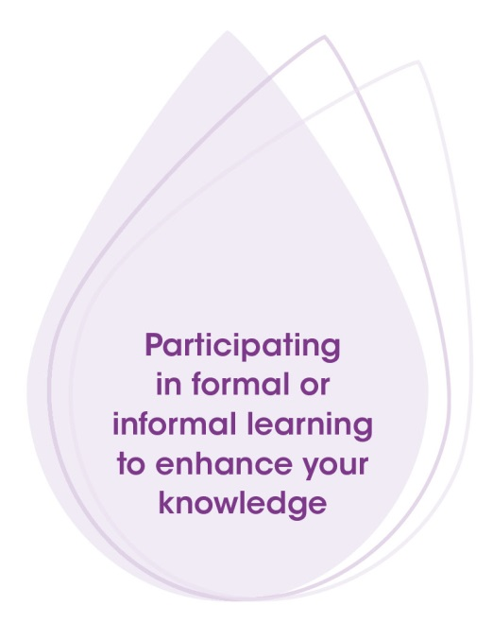

There is a commitment to continuous improvement (NQS 7.2).

Examples and tips
- Identify opportunities for professional development by looking through early childhood newsletters and publications or by talking with other educators.

Professional Practice
- Find out about programmes such as KidsMatter, Mental Health First Aid or You Can Do It. A list of programmes can be found at: www.kidsmatter.edu.au/early-childhood/programs
- Attend seminars and conferences about children’s mental health and wellbeing. Summarise what you’ve learnt for colleagues at your next staff meeting.
- Read newsletters, magazines and other material about the mental health, wellbeing and development of children and the needs of families, eg Every Child, the magazine of Early Childhood Australia (ECA).
- If there is a colleague that you respect and admire, meet with them regularly to discuss how best to support children and families, including a focus on mental health.
- Network with educators from other services to share information on upcoming community events or recommendations for guest speakers to attend your service.

Raising awareness about children’s mental health needs
- Talking about mental health and wellbeing, its importance in early childhood and the needs of children and families with colleagues, families, professionals, and other members of the community.
- Contributing to the development of a philosophy, policies, procedures or other documents that will support the mental health and wellbeing of children and families in your service.
- Actively promoting and responding to the mental health needs of children and families in your service and community, especially those experiencing mental health difficulties, mental illness and/or neurodevelopmental disorders.
- Being respectful of privacy when discussing people’s mental health needs. Ensure that confidentiality is maintained and that any conversations are necessary and professional.
 Children become strong in their social and emotional wellbeing (EYLF/MTOP Outcome 3).

Examples and tips

Professional Practice
- Find out about issues relevant to children’s mental health and wellbeing and their development, and share information with colleagues and community members. When finding out more about a topic, think about whether the information is based on sound evidence and the views of professionals. Is it reliable?
- Correct misinformation when you hear it, eg if someone says, “Parents with a mental illness can’t look after their children properly,” explain this is incorrect. People experiencing a mental illness can be very effective and successful parents.
- Avoid using language that reinforces stereotypes and stigma. Instead use language like, ‘experiencing a mental illness,’ ‘having mental health difficulties,’ or ‘admitted to hospital.’
- Contribute to online educator discussion forums on children’s social and emotional wellbeing.
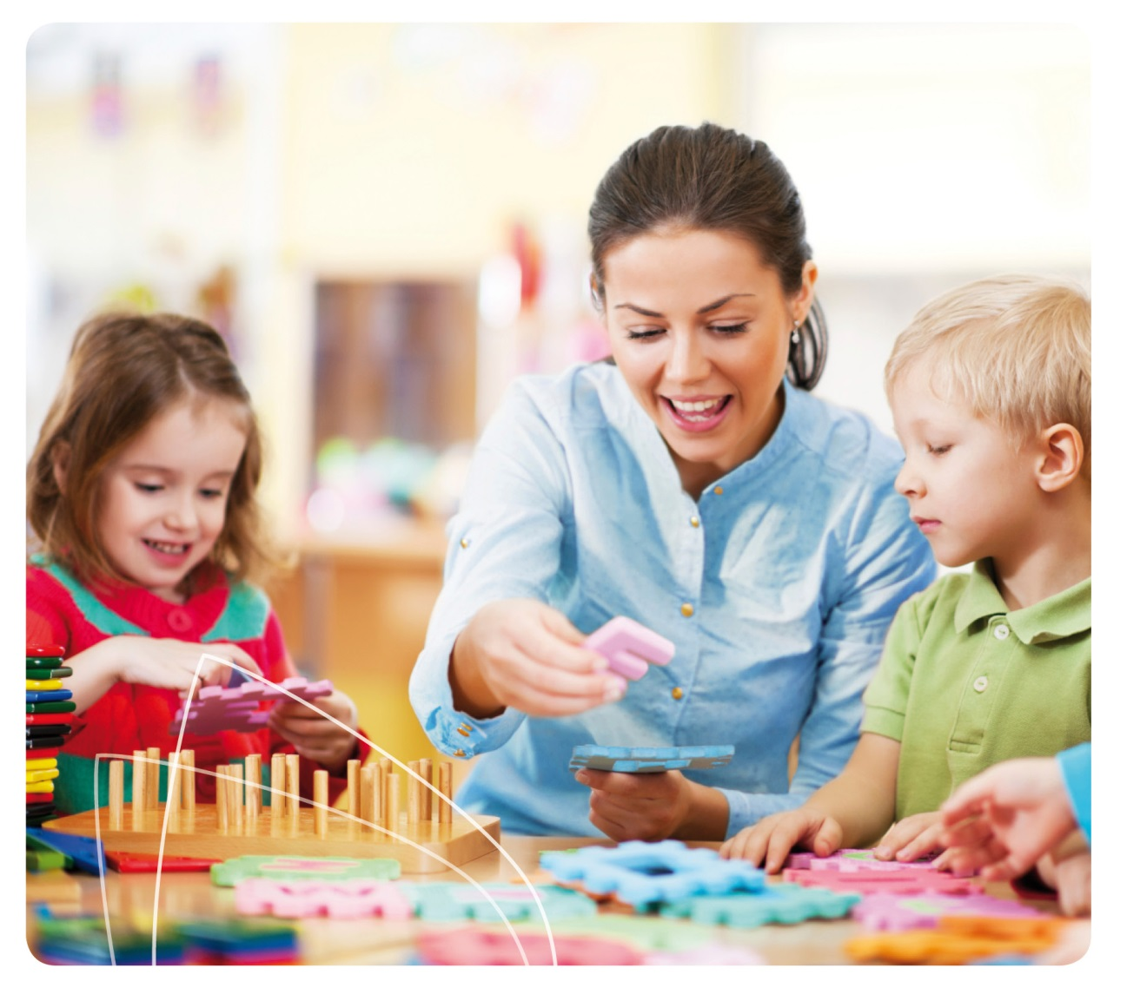

Caring for yourself and others

Professional Practice
- Making time to reflect on your own mental health and wellbeing, as an important part of your overall health and wellbeing and a factor that affects your quality of life.
- Actively maintaining your mental health and wellbeing through activities such as:
  - Looking after your physical health;
  - Building and maintaining strong relationships with family and friends;
  - Balancing your professional role and personal life;
  - Making time for the activities you enjoy and which help you relax;
  - Learning how to monitor and reduce stress in positive ways;
  - If you have spiritual beliefs, taking time for spiritual practice; and
  - Recognising when you need help from others and asking for their support.
- Maintaining an awareness of the mental health and wellbeing of other people and respecting that this is an important aspect of the person’s health. Help others to maintain their wellbeing where you can, within your professional role.
Staffing arrangements enhance children’s learning and development and ensure their safety and wellbeing (NQS 4.1).

Examples and tips
- Be mindful that your physical wellbeing and stress levels can affect your ability to care for and educate others.
- Monitor your stress levels and regularly schedule in time for relaxing.
- If you feel overwhelmed at work, speak with your director or coordinator about additional support.

Connecting with quality practice
As you have read through the Professional Practice Area of Practice, you will have seen some quotes from the NQS, EYLF or MTOP. These show how building the capacity of services, educators, families and the community to promote mental health is relevant to quality practice in early childhood education and care.
Read over these quotes again. Does building the capacity of services, educators, families and the community to promote mental health help to support any other elements of the NQS, EYLF or MTOP?

Reflective questions

Professional Practice
- What activities help you to recharge your batteries? How often do you do them?
- What are the signs that you’re struggling with stress? Do you listen to them and look after yourself?
- What professional development regarding children’s mental health and wellbeing do you have planned this year? What other opportunities are available?
- How can you raise awareness of the importance of children’s mental health and wellbeing both individually and as a service?
- Revisit the case study for the Professional Practice Area of Practice and think about your answers. Would you respond any differently to these case study questions now? What additional information would you like to know or find out?

Connecting in action
Now that you have read about and reflected on professional practice for children’s mental health and wellbeing, think about how you can put this information into action.
- What skills and practices do you think you or your service could enhance? Set a goal for what you would like to achieve.
- What steps will you or your service take to enhance this skill or practice? Who will be responsible for each step?
- How will you know when you have reached your goal? How can you make sure this change continues in your service after achieving your goal?
Once you have finished thinking about these questions, you may wish to update your Quality Improvement Plan to reflect your answers.


Professional practice: More information

Professional Practice
Amulya J. What is reflective practice? Massachusetts (US): Center for Reflective Community Practice, Massachusetts Institute of Technology; 2004. Available from: www.itslifejimbutnotasweknowit.org.uk/Practicestart
Central Queensland University Library. Evaluating books, journals, journal articles and websites. 2013 [cited 2013 Oct 24]. Available from: libguides.library.cqu.edu.au/evaluating-resources
Children’s Services Central. Reflective practice. Sydney: Children’s Services Central [cited 2013 Nov 29]. Available from: www.cscentral.org.au/Resources/Publications/reflective-practice.pdf
Dahlberg G, Moss P, and Pence A. Beyond quality in early childhood education and care: Languages of evaluation (2nd Ed.). London: Falmer Press. 2007.
Early Childhood Australia. Talking about practice (TAPS): Reflecting on practice. E-learning video. 2011. Available from: www.earlychildhoodaustralia.org.au/nqsplp/e-learning-videos/talking-about-practice/reflecting-on-practice
Early Childhood Intervention Australia (Victoria); Department of Education and Early Childhood Development; Workwell Consulting Pty Ltd. Early childhood intervention practitioner competencies. Hawthorn: Department of Education and Early Childhood Development; 2009. Available from: www.eciavic.org.au
Hazel G, Kemp E, Newman E, Twohill S. The importance of social belonging for staff in early childhood services. Every Child. 2011;17(4):8-9. Available from: www.earlychildhoodaustralia.org.au
Hunter Institute of Mental Health and Community Services & Health Industry Skills Council. Children’s mental health and wellbeing: Exploring competencies for the early childhood education and care workforce. Final report. Canberra: Department of Education, Employment and Workplace Relations; 2012. Available from: www.himh.org.au/earlychildhood
KidsMatter Australian Early Childhood Mental Health Initiative. All about parents’ and carer’s mental health [cited 2013 Oct 24]. Available from: www.kidsmatter.edu.au/families/resources/about-families/parents-and-carers
KidsMatter Australian Early Childhood Mental Health Initiative. Resources to support children’s mental health: About partnerships [cited 2013 Nov 29]. Available from: www.kidsmatter.edu.au/early-childhood/resources-support-childrens-mental-health/about-partnerships
Kieff J. Informed advocacy in early childhood care and education: Making a difference for young children and families. US: Pearson Education; 2009.
Johnson J A. Finding your smile again: A child care professional's guide to reducing stress and avoiding burnout. St Paul: Redleaf Press; 2007.
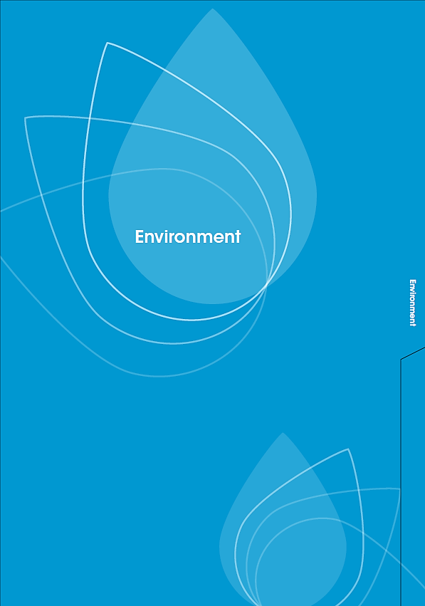
Front of tab to start a new section; Environment

Back of tab to start a new section; Environment
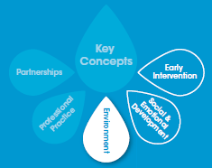

Environment

Shared goal
To create a supportive, inclusive environment that fosters a sense of belonging and connectedness.

Why is the environment important for children’s mental health and wellbeing?
- The environments where children grow up and learn influence their development, mental health and wellbeing, and their outcomes in later life.
- Positive environments nurture children’s mental health and wellbeing. They help them to develop a strong sense of identity, promote feelings of safety and security, and foster a sense of belonging and connectedness.
- Environments that are inconsistent, unpredictable, unsafe or stressful can sometimes be associated with negative outcomes, such as mental health difficulties or mental illness.
The environment is inclusive, promotes competence, independent exploration and learning through play (NQS 3.2).

How does a positive environment benefit educators?
- A positive environment for children has the added benefit of making the workplace more relaxed, inclusive, supportive and friendly for educators.
- Creating a positive environment for mental health and wellbeing helps educators meet the standards and principles reflected in the National Quality Standard (NQS), Belonging, Being and Becoming – The Early Years Learning Framework for Australia (EYLF) and My Time, Our Place – Framework for School Age Care in Australia (MTOP).
Children are connected with and contribute to their world (EYLF/MTOP Outcome 2).

Case study

Environment
Quan is a twelve month old boy who has just started coming to your service. Until now he has been at home every day with his mum, Lien, but she is now returning to work. Lien seems upset about leaving Quan and says she feels like a bad mum. When Lien leaves, Quan screams, kicks and cries and is difficult to settle.
- What could you do to help Quan calm down?
- What could you do to help Lien feel comfortable about leaving Quan?
- What daily routines could you put in place to make this process easier for Quan and his mum?

Skills and practices for all educators
Educators create supportive and inclusive environments in a number of ways such as:

Promoting children’s sense of security
- Building positive relationships with all children and adults, based on care, respect and effective communication. This helps children feel secure and shows them positive social skills.
- Connecting with children and being responsive to all their physical and emotional needs. Care and consistency are important to promoting secure attachment.
- Maintaining a regular routine, communicating this to children and giving them an opportunity to shape the routine and environment, so they can predict what will happen next.
- Thinking about how the service environment affects children’s feelings and behaviour. Children feel more secure and competent if spaces are warm, friendly, welcoming and well organised.
- Providing targeted additional support during periods of transition to help children feel more secure, eg when coming into your service, moving between learning experiences, developing greater independence or preparing for school.
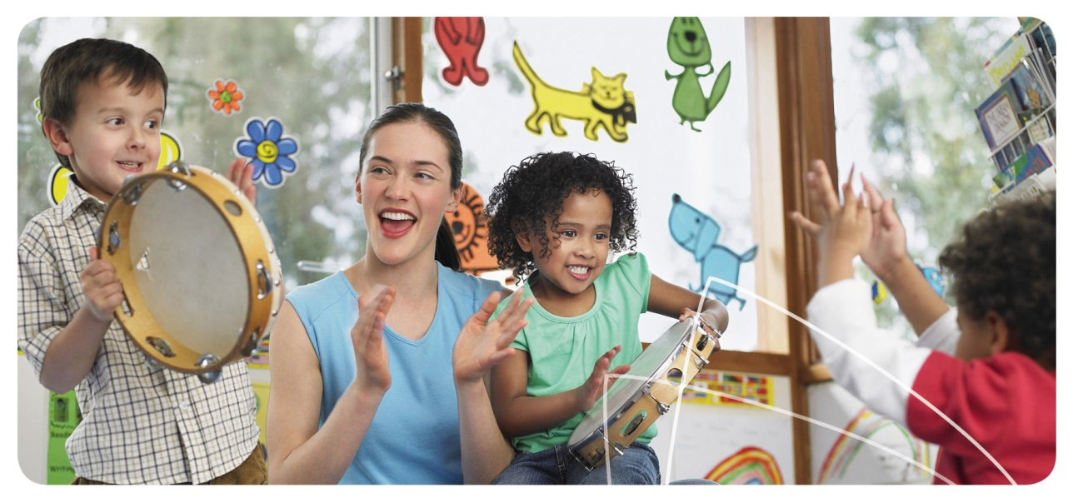
Children feel safe, secure and supported (EYLF/MTOP Outcome 1).

Examples and tips
- Have areas for active play and quiet time. Create a special calm area with objects like books, a lounge, pillows or bean bags. Playing classical or instrumental music can also be restful.

Environment
- Shape the environment so that children can see themselves and their interests reflected in their surroundings, eg create a family board in each room showing photos of the children and their families, including extended family members, pets and special interests.
- Establish regular drop-off routines with families, depending on the needs of the child and caregivers, eg a kiss, cuddle or wave from the window. Encourage families to leave without showing distress and talk with them later if they need reassurance.
- Give children notice of change by letting them know what is happening, eg “Five more minutes before we pack away and have story time.” Use words, sign language and graphic symbols to provide babies and young children with notice of a change.

Supporting inclusion and participation

- Modelling sensitive and respectful behaviour toward diverse cultures and people, and ensuring diversity is reflected throughout the service environment in genuine ways.
- Working in partnership with families, health and education professionals to encourage the participation and social inclusion of all children (including those with additional mental health needs).
- Supporting opportunities for children and families to connect with your service and the community, through special events and every day learning experiences.
- Creating an inclusive and nurturing workplace where other educators are also supported in their mental health and wellbeing.
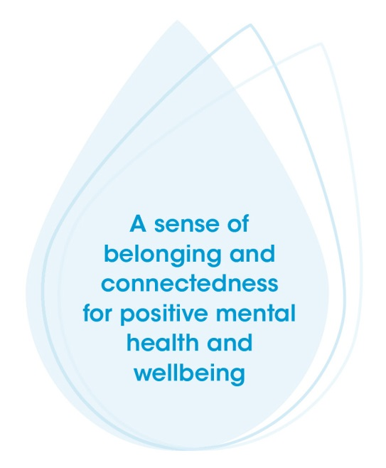

Children respond to diversity with respect (EYLF/MTOP Outcome 2).

Examples and tips

Environment
- Learn about diversity among the families and children in your service, including cultural diversity, family diversity, individual needs and personal interests. For example, do some research on the internet, read some books or ask family members a few questions.
- Ask families about cultural or child rearing practices you could use at your service to provide continuity and security.
- Use music, games, books, art, photos, food, instruments and cultural practices from different cultures in your service. Use images and stories to represent family diversity, eg blended families, single parents, extended families and same sex partnerships. These resources can be used in intentional teaching times to talk about diversity and inclusion.
- Display information about upcoming community events for families, eg community fairs or multicultural days.
- For examples and tips on working with other professionals to support the inclusion of children with additional mental health needs, refer to the Partnerships Area of Practice (page 21).

Connecting with quality practice
As you have read through the Environment Area of Practice, you will have seen some quotes from the NQS, EYLF or MTOP. These show how creating a positive environment for mental health is relevant to quality practice in early childhood education and care.
Read over these quotes again. Does creating a positive environment for mental health and wellbeing help to support any other elements of the NQS, EYLF or MTOP?
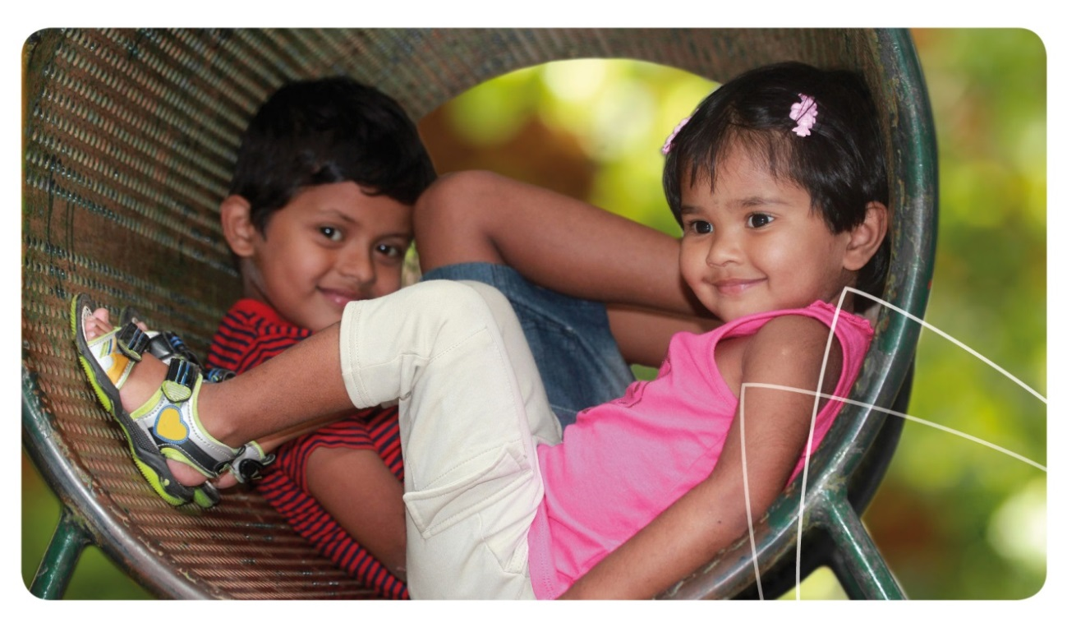

Reflective questions

Environment
- How do you help children and families from a variety of cultural backgrounds or family types feel that they belong at your service? How do you promote inclusion for children with additional needs, including additional mental health needs?
- What would a child see, hear and feel when they are at your service? Get down to their level and look around. How does your service environment help “children feel safe, secure and supported?” (EYLF/MTOP Outcome 1). What changes would you make?
- How do you involve families and community members in your service? What are some other ways you could include them?
- How do you help other educators to feel supported and included in your workplace? What else could you do to support your colleagues in their mental health and wellbeing?
- Revisit the case study for the Environment Area of Practice and think about your answers. Would you respond differently to any of these case study questions now? What additional information would you like to know or find out?

Connecting in action

Now that you have read about and reflected on a positive environment for children’s mental health and wellbeing, think about how you can put this information into action.
- What skills and practices do you think you or your service could enhance? Set a goal for what you would like to achieve.
- What steps will you or your service take to enhance this skill or practice? Who will be responsible for each step?
- How will you know when you have reached your goal? How can you make sure this change continues in your service after achieving your goal?
Once you have finished thinking about these questions, you may wish to update your Quality Improvement Plan to reflect your answers.
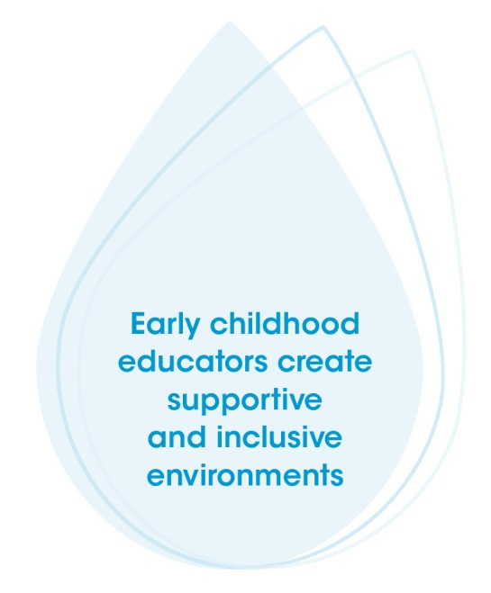

Environment: More information

Environment
Davis E, Priest N, Davies B, Sims M, Harrison K, Herrman H, Waters E, Strazdins L, Marshall B, Cook K. Promoting children’s social and emotional wellbeing in childcare within low socioeconomic areas: Strategies, facilitators and challenges. Australasian Journal of Early Childhood 2010; 35:77- 82.
Early Childhood Australia. Talking about practice (TAPS): Environments for belonging, being and becoming. E-learning video. 2011. Available from: www.earlychildhoodaustralia.org.au/nqsplp/e-learning-videos/talking-about-practice/environments-for-belonging-being-and-becoming
Hunter Institute of Mental Health. Responding to the challenge. Foundations: Developing social and emotional wellbeing in early childhood. 2009;2: 8-9. Available from: www.himh.org.au/foundations
Giugni M. Exploring multiculturalism, anti-bias and social justice in children’s services. Sydney: Children’s Services Central; 2007. Available from: www.cscentral.org.au/Resources/Exploring_Multiculturalism.pdf
Hunter Institute of Mental Health and Community Services & Health Industry Skills Council. Children’s mental health and wellbeing: Exploring competencies for the early childhood education and care workforce. Final report. Canberra: Department of Education, Employment and Workplace Relations; 2012. Available from: www.himh.org.au/earlychildhood
National Scientific Council on the Developing Child. Young children develop in an environment of relationships. Working Paper 1. Cambridge (US): Centre on the Developing Child, Harvard University; 2004. Available from: www.developingchild.harvard.edu
KidsMatter Australian Early Childhood Mental Health Initiative. Component 1: Creating a sense of community [cited 2013 Nov 29]. Available from: www.kidsmatter.edu.au/early-childhood/framework
Oberklaid F. Brain Development and the life course – the importance of the early caretaking environment. Putting Children First (NCAC Newsletter). 2007;24:8-11. Available from: ncac.acecqa.gov.au/educator-resources/pcf-articles/Brain_Development_Life_Course_Dec07.pdf
Siddiqi A, Irwin L, Hertzman C. Total environment assessment model for early child development. Geneva (SUI): World Health Organization’s Commission on the Social Determinants of Health. 2007 June. Available from: www.who.int/social_determinants/resources/ecd_kn_evidence_report_2007.pdf
Secretariat of National Aboriginal & Islander Child Care. Aboriginal and Torres Strait Islander children’s cultural needs resource. North Fitzroy: Secretariat of National Aboriginal & Islander Child Care Inc; 2013. Available from: www.snaicc.org.au
Secretariat of National Aboriginal & Islander Child Care. Early Years Learning Framework (EYLF) factsheets. North Fitzroy: Secretariat of National Aboriginal & Islander Child Care Inc; 2012. Available from: www.snaicc.org.au
VicHealth. Social inclusion as a determinant of mental health and wellbeing. Melbourne: VicHealth; 2005 January. Available from: www.vichealth.vic.gov.au/Publication
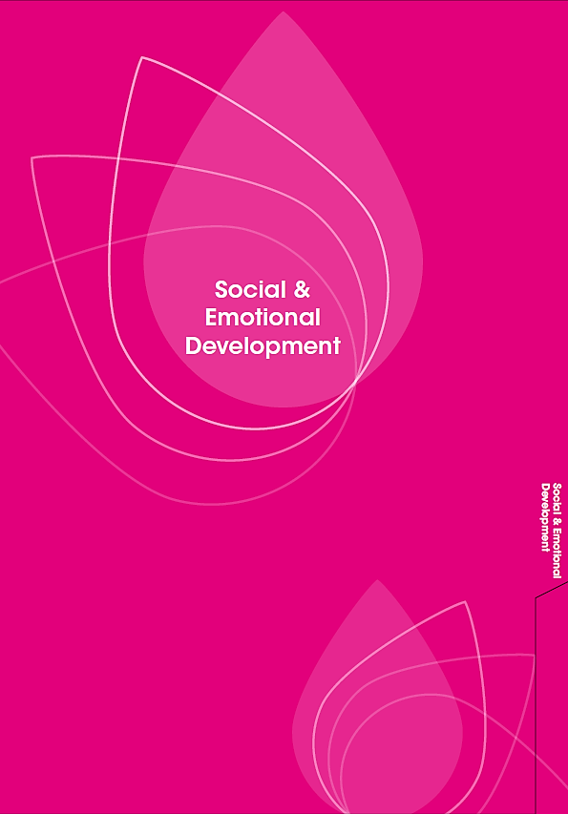
Front of tab to start a new section; Social and Emotional Development

Back of tab to start a new section; Social and Emotional Development
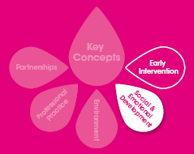

Social and Emotional Development

Shared goal
To support the best possible social and emotional development of children.

Why is the quality of children’s social and emotional development important for mental health and wellbeing?
- Early social and emotional development helps to lay the foundations for future mental health and wellbeing, and for physical health and learning.
- Positive social and emotional development in childhood lays a strong foundation, so people are more likely to experience positive mental health and wellbeing, and less likely to develop mental health difficulties.
- By creating trusting relationships with children, within a supportive environment that provides diverse learning opportunities, we help them to develop a positive sense of self and to learn key social and emotional skills that they can build on in the future.
Children have a strong sense of wellbeing (EYLF/MTOP Outcome 3).

How does supporting the social and emotional development of children benefit educators?
- By supporting children’s optimal social and emotional development, educators are able to build positive and rewarding relationships with the children at their service.
- Educators feel a sense of accomplishment in nurturing children’s self-esteem, as well as helping them to develop the skills necessary to form healthy and satisfying relationships.
- Supporting children’s social and emotional development helps educators meet the standards and principles reflected in the National Quality Standard (NQS), Belonging, Being and Becoming – The Early Years Learning Framework for Australia (EYLF) and My Time, Our Place – Framework for School Age Care in Australia (MTOP).
Each child is supported to build and maintain sensitive and responsive relationships with other children and adults (NQS 5.2).

Social & Emotional Development

Case study
Ben is a five year old boy who has experienced neglect in the past and is now living in out-of-home care. He has been coming to your service for two weeks. Ben loves Star Wars and enjoys pretending to be Luke Skywalker. He has difficulty socialising with his peers and often plays aggressively with other children. He picks up sticks, pretends they are Lightsabers and hits the other children with them. The other children don’t want to play with Ben because of his behaviour.
- How could you build a secure and trusting relationship with Ben?
- What strategies would you use to help Ben learn how to play with other children more cooperatively?
- What strategies could you use with other children in the group to support the development of positive relationships between Ben and his peers?

Skills and practices for all educators
Educators support children’s positive social and emotional development in a number of ways such as:

Building relationships
- Getting to know children, by observing their interests and behaviour and by sharing information with families and carers.
- Identifying how each child might signal what they need or want, which means looking for different cues from infants, toddlers, preschoolers and older children.
- Responding to physical and emotional needs in a caring and consistent way, to promote secure attachment. This includes offering comfort or support when children seem upset or frightened, or uncertain about what to do.
- Using effective listening skills, and positive verbal and non-verbal communication strategies with children, families and other educators.
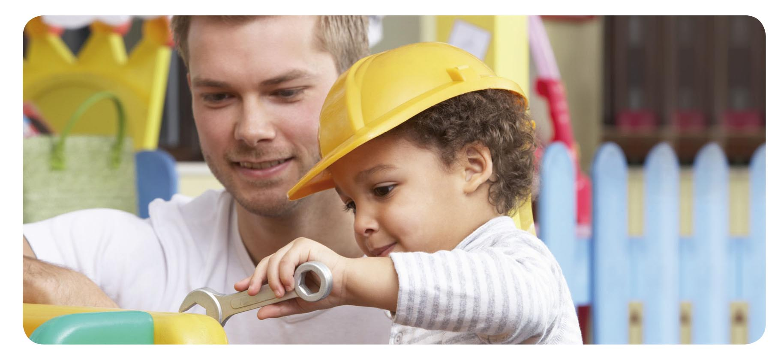
Respectful and equitable relationships are developed and maintained with each child (NQS 5.1).

Social & Emotional Development

Examples and tips
- Learn about children’s strengths, favourite toys, games, learning experiences and friends by asking them questions, talking with their families and watching them play.
- Ask family members about and record information on each child’s family. Include details on the family members most involved in their care, if the child has any siblings and whether the family appears to have good local support.
- Think about how each child lets you know what they need or how they feel. Do they cry or use words? Do they use hand gestures, movements or facial expressions? Does this change when they are tired or frustrated? Keep in mind their stage of development. Being attuned to children’s cues is an important part of building secure attachment.
- If a child is upset, take time to acknowledge their feelings and comfort them. This is important for their sense of security and for learning how to manage feelings.
- Use direct and positive language rather than criticism to let children know what you want and why it is important, eg “Walking feet inside. We don’t want to trip over.” Be calm and consistent, you may need to repeat instructions.

Guiding values, emotions and behaviour
- Helping children to develop prosocial values and behaviours, such as empathy, inclusion, sharing, cooperation and helping other people. Be aware of the child’s development and what might be reasonable for them at their particular stage.
- Planning a range of learning experiences that help children to recognise their own feelings and the feelings of others.
- Helping children learn how to understand and manage their behaviour, by being clear about appropriate behaviour, or by showing children how to do something. Experiences of consistent care and secure attachment also help children learn how to manage feelings.
- Giving children language and skills for dealing in a positive way with strong or challenging feelings, like anger or frustration.
Children learn to interact in relation to others with care, empathy and respect (EYLF/MTOP Outcome 1).

Examples and tips

Social & Emotional Development
- Provide experiences that involve taking turns or cooperating, eg card or circle games, or working on a large floor puzzle.
- Discuss behaviours and emotions using stories, songs, drawing or role playing with dolls or other people. Explain what other children are feeling, eg “Thomas is excited because…”
- Acknowledge and put names to children’s feelings. Validate their feelings and help them respond in a helpful way, eg “You’re feeling angry because Ethan is using the purple marker. I know it is hard to wait our turn sometimes. After you’ve finished colouring this section green, why don’t you ask Ethan for the purple marker then.”
- Help children to create a book of photographs of themselves showing different emotions. Write captions for each photo, eg “Today I was happy because…”
- Show children words and skills to use in communication with peers, eg “Stop, I don’t like that,” or holding up their hand.
- Talk with children about ways to manage all feelings such as happiness, sadness or anger, eg “When I’m happy I like to dance” or “When Ava is angry, she takes big, deep breaths to calm down.”
- Consider pairing a child with a ‘buddy’ who has similar interests but is more advanced in their social and emotional development.

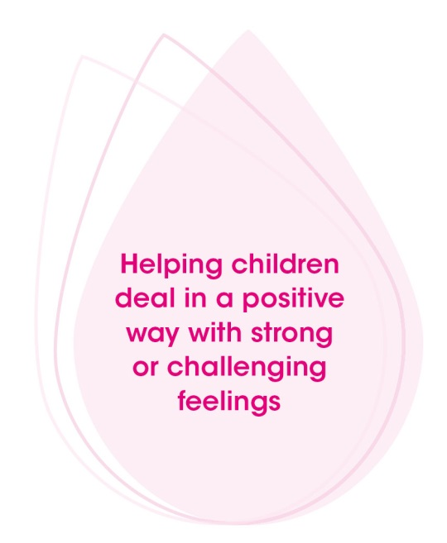

Promoting a positive sense of self
- Showing warmth and interest in children’s feelings and experiences, even during routine tasks like feeding and toileting, as well as during play and other learning experiences.
- Acknowledging children’s strengths and designing learning experiences with their development, interests and preferences in mind.
- Recognising their efforts and achievements in a genuine and child-centred way.

Children develop knowledgeable and confident self-identities (EYLF/MTOP Outcome 1).

Examples and tips
- Make time to sit and interact with children during inside and outside learning experiences. Show interest in their work and give them meaningful, positive feedback, eg “Wow. Your rocket is looking great. Tell me about this bit here…what does this do?”
- Focus on the process and personal achievements involved in a task, ie the concentration, problem solving, cooperation and persistence required, rather than the quality of the finished product.
- When giving praise, link it to a specific action that the child can do again, eg “I really like the way you asked Alex if he wanted to play….” or, “thank you for setting the table, Sam.” Resist the urge to overpraise.
- Provide children with the opportunity to talk about themselves and their family, either in small groups or individually. Practice with some of the less confident children beforehand. This provides children with the opportunity to share their interests and build their confidence in speaking to others.

Social & Emotional Development
- Provide opportunities for children to display their work in meaningful ways, eg create a space for projects or constructions for families to see when they come to pick up their child.
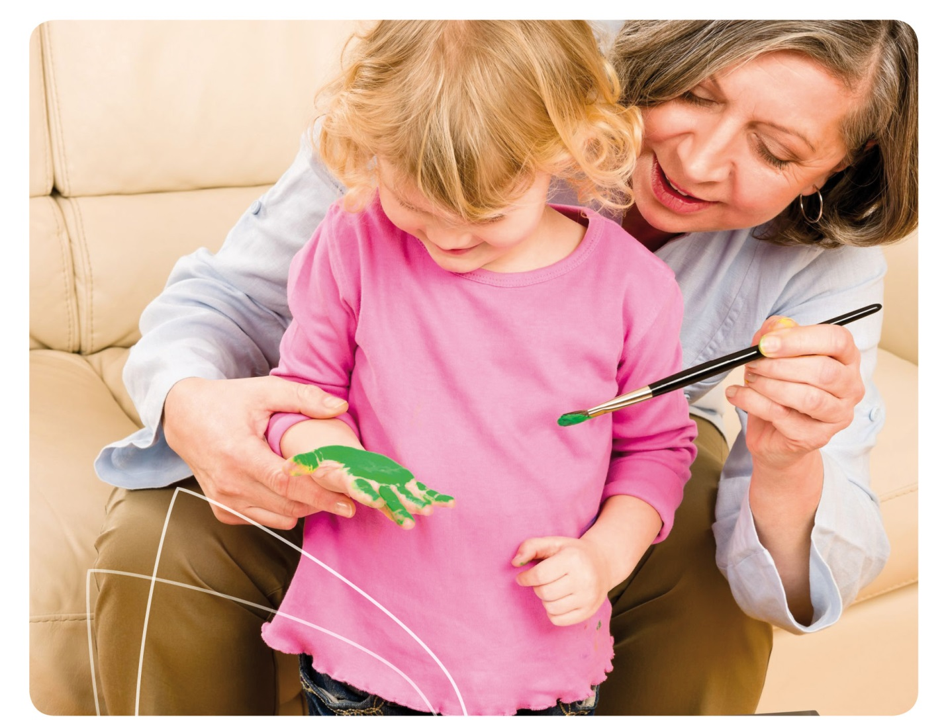

Promoting autonomy

Social & Emotional Development
- Creating different opportunities for children to explore, play and learn, appropriate to their stage of development. Encouraging exploration while being there to provide assistance if needed.
- Providing support to children to allow them to develop and try their own solutions, negotiate with others and make their own choices within a safe setting.
- Giving infants and children repeated opportunities to practise when they are developing a new skill, so they can build mastery and competence. This helps children develop a sense of agency, knowing they can shape the world around them.
Children develop their emerging autonomy, interdependence, resilience and sense of agency (EYLF/MTOP Outcome 1).

Examples and tips
- Encourage children to try things on their own, while providing safe boundaries and being there if they need you. Resist the urge to step in and help them too soon.
- When a child asks you a question, pause, and then ask them what they think or how they could fix the problem before giving them your answer.
- Repeat learning experiences, or vary them slightly, to build familiarity yet gradually extend children’s ideas or skills, eg re-read a favourite book, but talk about a different part of the story each time.
- Provide creative learning experiences that children can work on over a few days, eg collages of boxes, plates, timber and other household items, or using construction toys.

Connecting with quality practice
As you have read through the Social and Emotional Area of Practice, you will have seen some quotes from the NQS, EYLF or MTOP. These show how supporting children’s best possible social and emotional development for mental health is relevant to quality practice in early childhood education and care.
Read over these quotes again. Does promoting children’s best possible social and emotional development for mental health help to support any other elements of the NQS, EYLF or MTOP?

Reflective questions

Social & Emotional Development
- What do you do to develop and maintain a “respectful and equitable relationship” with each child you care for? (NQS 5.1)
- What are the interests of each child you care for? What influences their behaviour?
- What learning experiences can you provide to focus on and extend each child’s strengths?
- How do you encourage children to develop problem solving skills? What language do you use?
- Revisit the case study for the Social and Emotional Area of Practice and think about your answers. Would you respond any differently to these case study questions now? What additional information would you like to know or find out?

Connecting in action
Now that you have read about and reflected on positive social and emotional development for children’s mental health and wellbeing, think about how you can put this information into action.
- What skills and practices do you think you or your service could enhance? Set a goal for what you would like to achieve.
- What steps will you or your service take to enhance this skill or practice? Who will be responsible for each step?
- How will you know when you have reached your goal? How can you make sure this change continues in your service after achieving your goal?
Once you have finished thinking about these questions, you may wish to update your Quality Improvement Plan to reflect your answers.
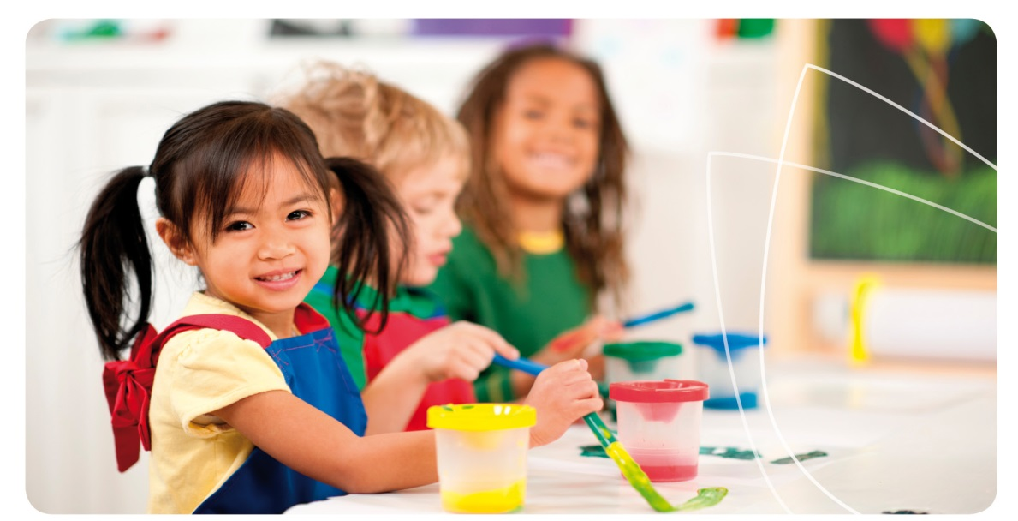

Social and emotional development: More information

Social & Emotional Development
Denham SA, Weissberg RP. Social-emotional learning in early childhood: What we know and where to go from here. In: Chesebrough E, King P, Gullotta TP, Bloom M, editors. A blueprint for the promotion of prosocial behavior in early childhood. New York: Kluwer Academic/Plenum Publishers; 2004.
Early Childhood Australia. Talking about practice (TAPS): Social and emotional learning. E-learning video. 2011. Available from: www.earlychildhoodaustralia.org.au/nqsplp/e-learning-videos/talking-about-practice/social-and-emotional-learning
Hunter Institute of Mental Health and Community Services & Health Industry Skills Council. Children’s mental health and wellbeing: Exploring competencies for the early childhood education and care workforce. Final report. Canberra: Department of Education, Employment and Workplace Relations; 2012. Available from: www.himh.org.au/earlychildhood
KidsMatter Australian Early Childhood Mental Health Initiative. Component 2: Developing children’s social and emotional skills [cited 2013 Nov 29]. Available from: www.kidsmatter.edu.au/early-childhood/framework
KidsMatter Australian Early Childhood Mental Health Initiative. Resources to support children’s mental health: Social development [cited 2013 Nov 29]. Available from: www.kidsmatter.edu.au/early-childhood/resources-support-childrens-mental-health/about-social-development
Moore T. Fostering young children’s social-emotional well-being: Building positive relationships with children and families. Plenary paper presented at: Knox Early Childhood Conference; 2007; Melbourne, Australia. Available from: www.rch.org.au/uploadedFiles/Main/Content/ccch/TM_KnoxECConf07_paper.pdf
National Scientific Council on the Developing Child. Children's emotional development is built into the architecture of their brains: Working paper no. 2. Cambridge (US): Harvard University; Center on the Developing Child; 2004. Available from: www.developingchild.harvard.edu
Shanker S. Self-Regulation. Foundations: Developing social and emotional wellbeing in early childhood. 2011;7:16-19. Available from: www.himh.org.au/foundations
Stonehouse A. Supporting children’s development: Making choices in play. Putting Children First (NCAC Newsletter). 2009;29:3-5. Available from: ncac.acecqa.gov.au/educator-resources/pcf-articles/Supporting_Children's_Development_Making_Choices_Mar09.pdf
Zero to Three. Connecting with babies: The power of parent/child interaction. Video. 2012 [cited 2013 Dec 19]. Available from: www.zerotothree.org/child-development/early-childhood-mental-health
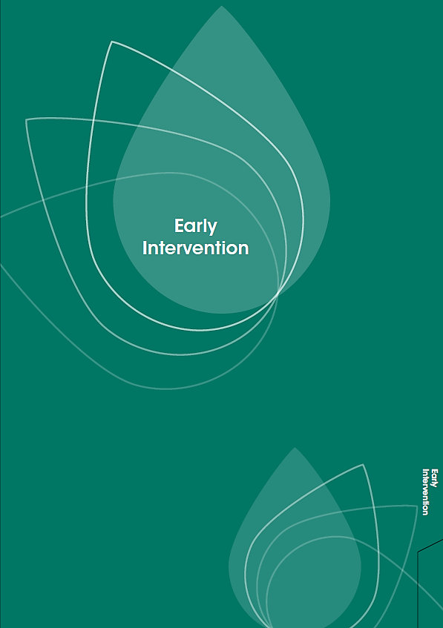
Front of tab to start a new section; Early Intervention

Back of tab to start a new section; Early Intervention
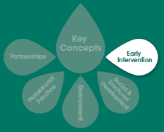

Early Intervention

Shared goal
To monitor children’s mental health and wellbeing, and support children and families who have additional mental health needs.

Why is early intervention important for children’s mental health and wellbeing?
- Early intervention involves identifying children or families with additional mental health needs, and working with them and other professionals (if necessary) to support the child’s wellbeing and development.
- The term additional mental health needs is used in this resource to describe children or families who experience mental health difficulties, mental illness and/or neurodevelopmental disorders. Further information and definitions can be found in Key Concepts (page 9).
- The term early intervention is used in this resource to describe the type of intervention that assesses and deals with mental health difficulties. Early intervention for mental health occurs in the early stages of a potential mental illness or neurodevelopmental disorder, with the aim of preventing the illness or reducing its impact. Early intervention for mental health can occur at any age or stage of life.
- Providing appropriate support as early as possible promotes the best outcomes for children with additional mental health needs in terms of their wellbeing and development. This helps them to do well in other areas of life, including physical health, learning, employment and community participation.
Each child’s health is promoted (NQS 2.1).

How does early intervention for children benefit educators?

Early Intervention
- The value of an educator’s role is reaffirmed by assisting children and families with their wellbeing and developmental needs.
- Families, health professionals and support agencies can provide educators with specific advice to help them manage difficult or concerning behaviour. Educators can use these new skills and ideas in other situations with other children.
- Monitoring children’s mental health and wellbeing, and supporting children and families with additional mental health needs, helps educators to meet the standards and principles reflected in the National Quality Standard (NQS), Belonging, Being and Becoming – The Early Years Learning Framework for Australia (EYLF) and My Time, Our Place – Framework for School Age Care in Australia (MTOP).
The service collaborates with other organisations and service providers to enhance children’s learning and wellbeing (NQS 6.3).

Case study
Annika is three years old and has been attending your service for one year. She always actively engages in play with her friends. She especially loves listening to music and dancing. However for the past week, Annika has been spending inside activity time in the book corner and not interacting with the other children or educators. During this week’s intentional teaching time, Annika has been sitting with the other children but not contributing. This is out of character for her. You try to talk to Bianca, Annika’s mother, one afternoon, but she is in a rush to pick up Annika’s older sister from school and can’t stay.
- How could you find out what’s happening in Annika’s life that might explain the changes in her behaviour?
- What strategies could you put in place to support Annika in your service?
After working with Bianca to put these support strategies in place for several weeks, Annika still seems very quiet. Bianca asks to meet with you again and says she is worried about her daughter. She wonders what else the family and your service can do to help Annika.
- How would you and Bianca decide whether Annika might benefit from assessment and support by an external agency or professional?
- What types of services or professionals may be able to assist with further assessment and advice?

Skills and practices for all educators

Early Intervention
Educators support children and families with additional mental health needs in a number of ways such as:

Monitoring children’s mental health and wellbeing
- Maintaining open communication with all families so they feel comfortable in discussing their needs or their child’s needs.
- Observing and documenting in detail the development and wellbeing of all children at your service. This makes it easier to tell when any concerns come up about a child’s mental health.
- Being aware of the potential impact of a family situation on the mental health and wellbeing of children and caregivers, eg physical or mental illness, family separation, violence or financial disadvantage.
- Identifying children who may be showing early signs of mental health difficulties, mental illness and/or developmental disorders, eg changes in behaviour, differences in development as compared with peers, or ongoing emotional or behavioural difficulties.
- Discussing any concerns with your supervisor, coordinator or team members, to consider whether a child or their family may need additional support – either from within your service or from external service providers.
- Providing families with information about their child’s development and behaviour in a respectful, helpful and caring way.
Children have a strong sense of wellbeing (EYLF/MTOP Outcome 3).
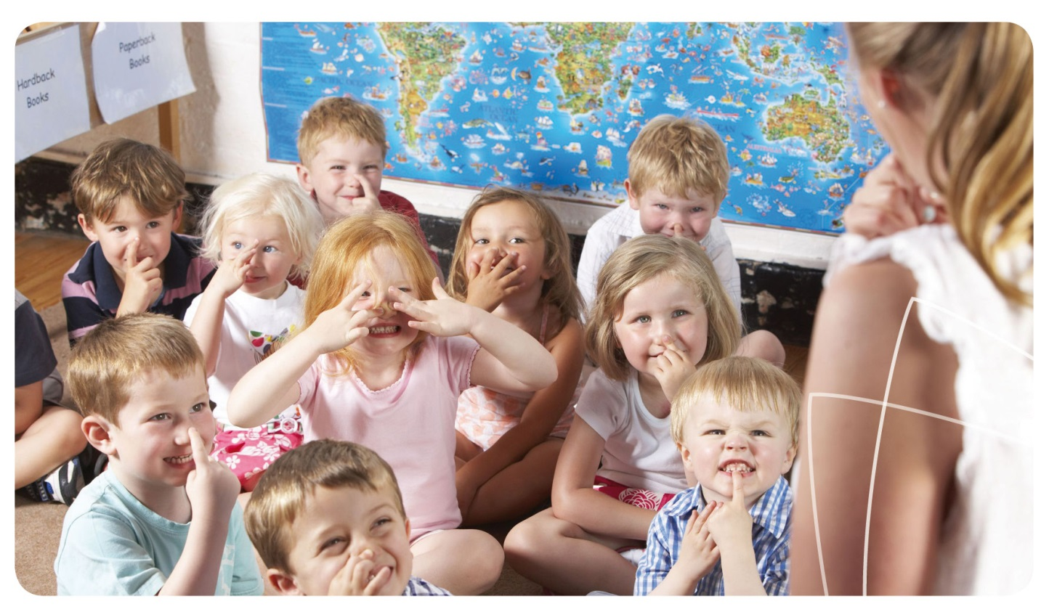

Examples and tips

Early Intervention
- When observing a child’s behaviour, make a note of where they are playing, the learning experience they are having and the people they are interacting with. This information will help you identify patterns of behaviour and understand the child’s development.
- If you are advised of a change in a child’s life, eg parents’ separation, family illness or the death of a pet, document it and let other educators know. Respect confidentiality; only advise those educators who need to know because they are directly involved in the child’s care.
- If they agree, make time to meet with families periodically to talk about how things are going. This gives families an opportunity to discuss their child’s needs and what is happening at home. Try to do this regularly, not only when problems or concerns arise.
- Be aware of the potential signs of mental health difficulties, mental illness or neurodevelopmental disorders. For more information, refer to the fact sheet Children with Additional Mental Health Needs (page 92).
- For more information on speaking with families, refer to the fact sheet Discussing Mental Health Difficulties with Families (page 98).

Supporting children or families with additional mental health needs
- Responding with empathy to a child or family member who is distressed or in need of additional support, within the boundaries of your early childhood professional role.
- Contributing to the development, implementation and maintenance of strategies for additional support for the child. This is done in partnership with the family and may also involve inclusion support agencies or external health professionals.
- Helping families to identify assessment and support options external to your service if needed, such as health professionals and family support agencies. These services may relate to a child’s development or to the family’s support needs.
- Finding out about the particular needs of any child who has been diagnosed with a mental illness or neurodevelopmental disorder. Even children with the same or a similar diagnosis will have different needs.
- Keeping appropriate documentation on how the strategies for additional support are put into practice within your service and whether these have been helpful. Support needs may change as the child develops or additional assessments are completed.
- Maintaining professional communication with the family, other educators, inclusion support agencies or health professionals, to ensure that the child’s additional mental health needs are being met within your service.
Educators and coordinators are focused, active and reflective in designing and delivering the programme for each child (NQS 1.2).

Examples and tips

Early Intervention
- When a child is upset, acknowledge their emotions and show understanding; problems that seem minor to adults can be very upsetting for a child. Refer to the fact sheet about Helping a Person in Distress (page 100) for more information.
- Consider whether a child or family could benefit from making contact with an external support agency or professional. You might like to use the Connections Decision Making Tree (page 60) to guide your thinking.
- If children do not want to participate in group experiences, allow them the space to observe rather than insisting they join in. Refer to the fact sheet Supporting Additional Mental Health Needs (page 94) for more practical suggestions.
- Develop strategies for supporting the child’s wellbeing and guiding their behaviour within your service. You may wish to use the Child Wellbeing Plan as a guide (page 64).
- Read the Partnerships Area of Practice (page 21) for examples and tips on working with professionals who support children with additional mental health needs.

Connecting with quality practice
As you have read through the Early Intervention Area of Practice, you will have seen some quotes from the NQS, EYLF or MTOP. These show how providing early intervention for mental health is relevant to quality practice in early childhood education and care.
Read over these quotes again. Does providing early intervention for mental health and wellbeing help to support any other elements of the NQS, EYLF or MTOP?
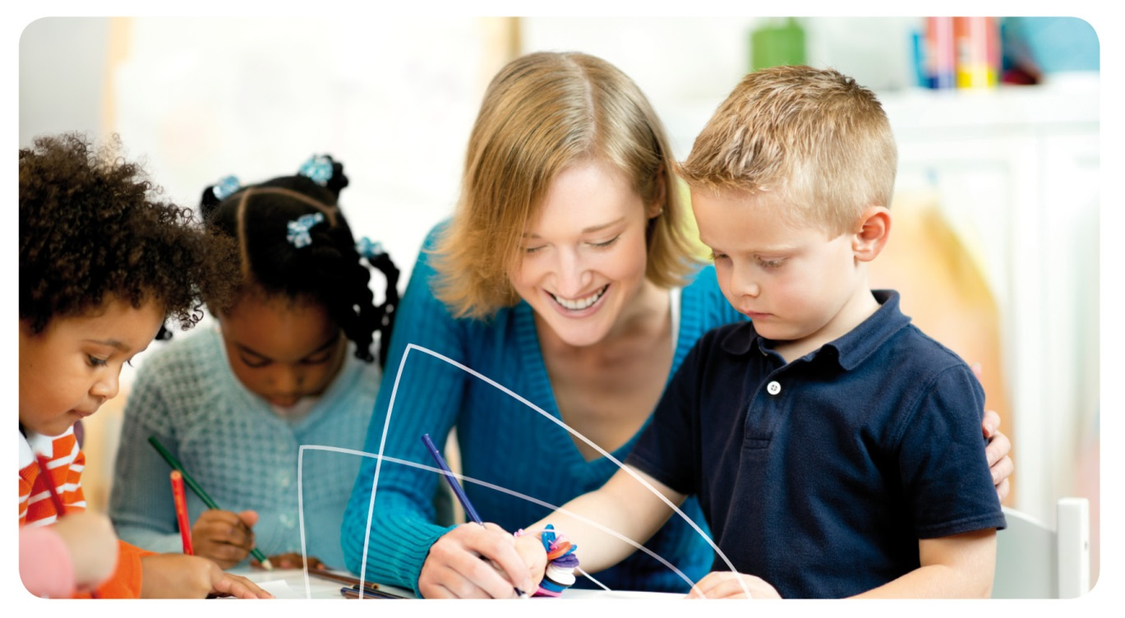

Reflective questions

Early Intervention
- Are any families using your service experiencing particular social or emotional challenges that might influence their child’s wellbeing, eg postnatal depression, work stress or family conflict? What can you do to support them?
- Are there any children at your service who have been diagnosed with a mental illness or a neurodevelopmental disorder? How can you support them to manage their feelings and their interactions with others?
- Are there any children who have ongoing emotional or behavioural difficulties and who might benefit from additional support from an external agency for assessment or early intervention?
- How can you best communicate your concerns to a child’s family while ensuring a “respectful supportive relationship” is maintained? (NQS 6.1) You might like to consider writing down some points or role-playing with a colleague.
- Revisit the case study for the Early Intervention Area of Practice and think about your answers. Would you respond any differently to these case study questions now? What additional information would you like to know or find out?

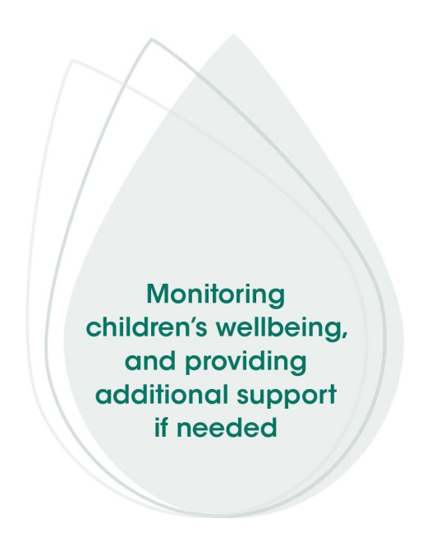
Connecting in action
Now that you have read about and reflected on early intervention for children’s mental health and wellbeing, think about how you can put this information into action.
- What skills and practices do you think you or your service could enhance? Set a goal for what you would like to achieve.
- What steps will you or your service take to enhance this skill or practice? Who will be responsible for each step?
- How will you know when you have reached your goal? How can you make sure this change continues in your service after achieving your goal?
Once you have finished thinking about these questions, you may wish to update your Quality Improvement Plan to reflect your answer

Early intervention: More information
Cologon K. Inclusion in education. Towards equality for students with disability. Sydney: Children and Families Research Centre Institute of Early Childhood Macquarie University and Children with Disability Australia; 2013.

Early Intervention
Harvard University; Centre on the Developing Child. Three core concepts in early development. Multimedia. 2013 [cited 2013 Oct 24]. Available from: www.developingchild.harvard.edu/resources/multimedia/videos/three_core_concepts
Hunter Institute of Mental Health and Community Services & Health Industry Skills Council. Children’s mental health and wellbeing: Exploring competencies for the early childhood education and care workforce. Final report. Canberra: Department of Education, Employment and Workplace Relations; 2012. Available from: www.himh.org.au/earlychildhood
Hunter Institute of Mental Health. Social and emotional wellbeing: A guide for children’s services educators. Canberra: Department of Health and Ageing; 2007. Available from: www.responseability.org/home/guides
Kay-Lambkin F, Kemp E, Stafford K & Hazell T. Mental health promotion and early intervention in early childhood and primary school settings: A review. Journal of Student Wellbeing. 2007;1:31-56. Available from: www.ojs.unisa.edu.au
Kearns K. Birth to big school: Working in children’s services. 3rd ed. Frenchs Forest: Pearson Education Australia; 2006.
KidsMatter Australian Early Childhood Mental Health Initiative. Component 4: Helping children who are experiencing mental health difficulties [cited 2013 Nov 29]. Available from: www.kidsmatter.edu.au/early-childhood/framework
KidsMatter Australian Early Childhood Mental Health Initiative. Risk and protective factors in early childhood [cited 2013 Oct 24]. Available from: www.kidsmatter.edu.au/early-childhood/about-mental-health/risk-and-protective-factors/risk-and-protective-factors-early
Nixon D & Gould K. Emerging: Child development in the first three years. Katoomba: Social Science Press; 2000. The first year of life: Emotional development; p.69-82. The second year of life: Social and emotional development; p.140-145.
Owens A. Supporting children with additional needs. Putting Children First (NCAC Newsletter). 2007;23:6-8. Available from: ncac.acecqa.gov.au/educator-resources/pcf-articles/Supporting_Children_with_Additional_Needs_Sept07.pdf

Connections Tools

Connections Decision Making Tree
The Connections Decision Making Tree (page 60) is designed to assist educators who are concerned about a child’s mental health and wellbeing to make a decision about how to proceed. The tool should be used as a guide only and educators should draw on their knowledge, experience, intuition and the advice of other educators in making their decision. Educators are therefore encouraged to use this tool in consultation with their director, supervisor or coordinator.
If you suspect a child is experiencing abuse or neglect at any time, follow your organisation’s child protection procedures without delay.

Child Wellbeing Plan
The Child Wellbeing Plan (page 64) is an optional tool for educators to complete when a child has additional mental health needs and could benefit from extra support from their early childhood service. The purpose of the tool is to share information amongst educators working with the child, as well as between educators and families, to ensure consistent, supportive and individualised care for children with additional mental health needs. It can be used for children who do not already have an Individual Education Plan (IEP) in place and who are:
- Showing signs of mental health difficulties that do not require support from an external agency or professional at present;
- Waiting for assessment by a support agency or professional;
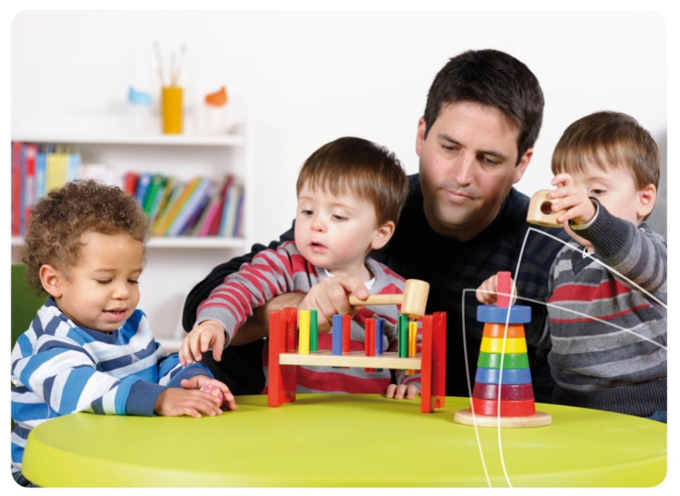
- Already working with an agency or professional and have been diagnosed with a neurodevelopmental disorder or mental illness; or

Connections Tools
- Already working with an agency or professional but do not currently meet the criteria for a specific diagnosis.
The Child Wellbeing Plan will be most useful to educators if:
- It is completed together with the child’s parent or caregiver;
- The purpose of the tool is explained to the family in advance;
- It is kept in a place that can be accessed easily, eg in the child’s file with their observation notes;
- The plan is updated on a regular basis; and
- All educators (including casuals) are aware of the plan and are advised when any changes are made.
Educators and coordinators are focused, active and reflective in designing and delivering the programme for each child (NQS 1.2).
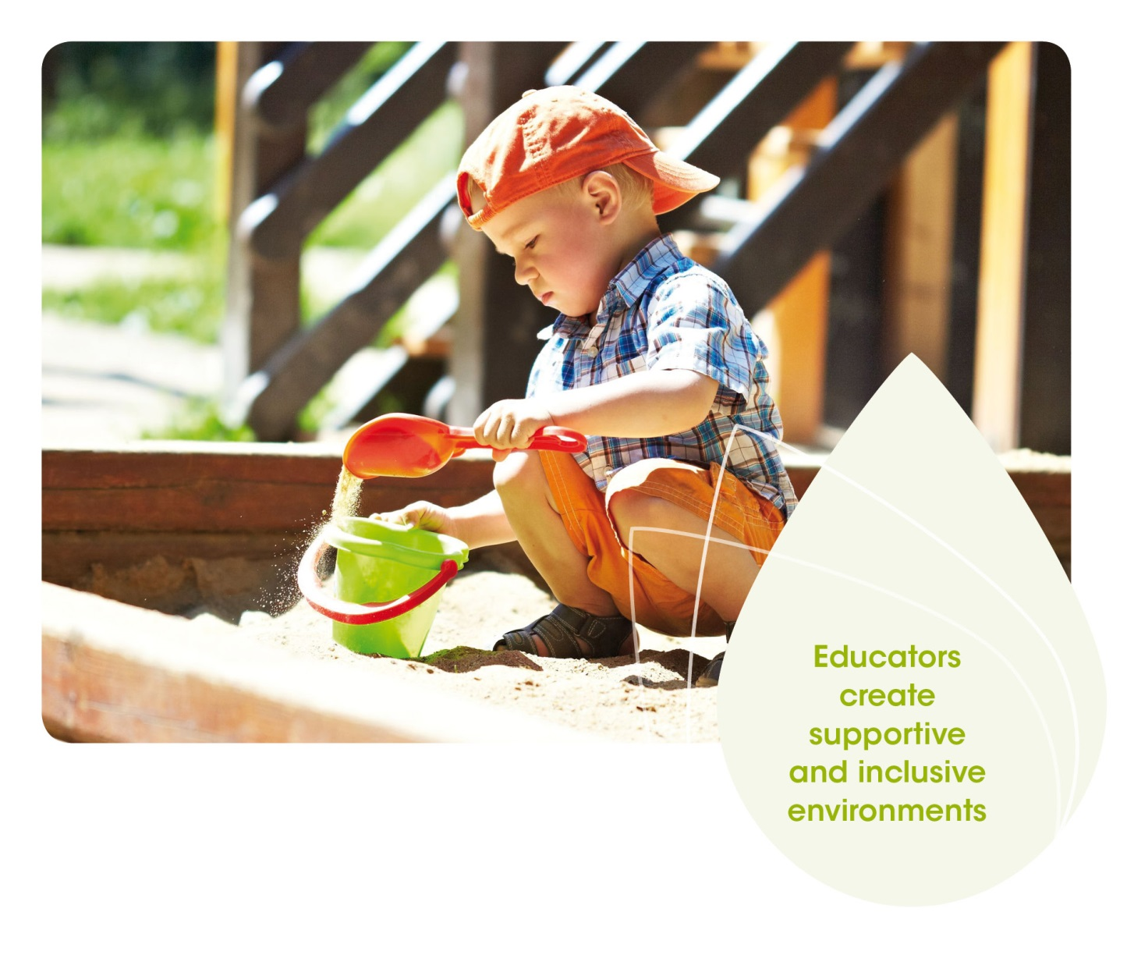

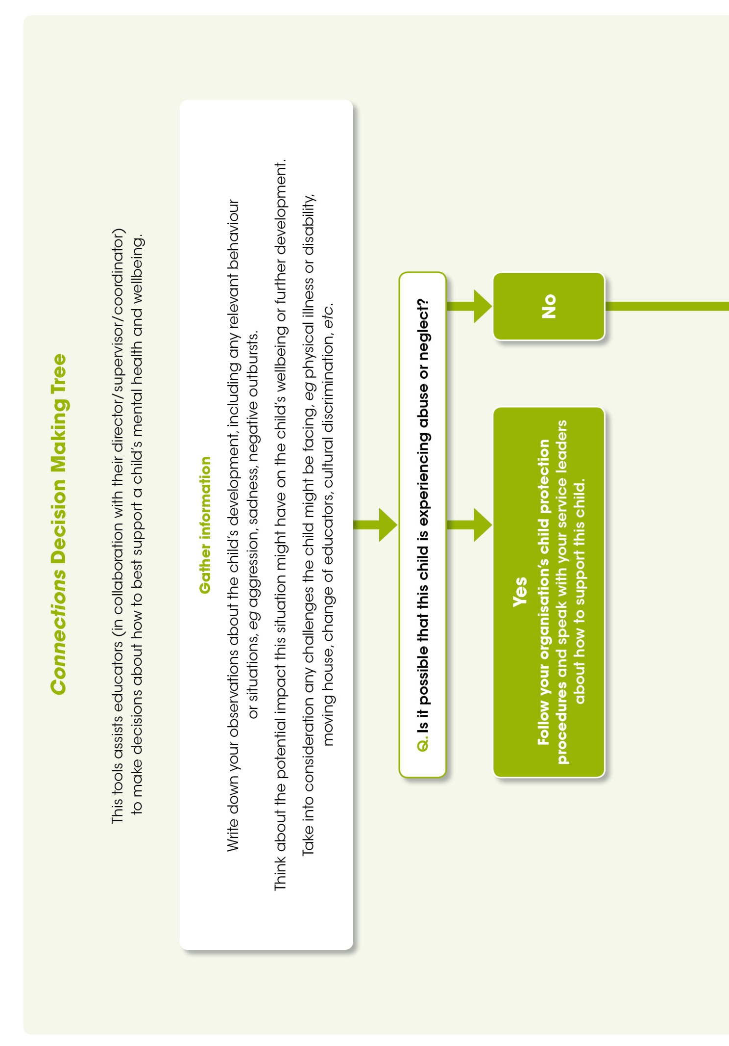
Connections Decision Making Tree

Connections Tools
This is the first page of the Connections Decision Making Tree. This tool assists educators (in collaboration with their director/supervisor/coordinator) to make decisions about how to best support a child’s mental health and wellbeing.
The first box of the decision making tree is titled ‘gather information.’ It prompts you to ‘write down your observations about the child’s development, including any relevant behaviour or situations, eg aggression, sadness, negative outbursts. Think about the potential impact this situation might have on the child’s wellbeing or further development. Take into consideration any challenges the child might be facing, eg physical illness or disability, moving house, change of educators, cultural discrimination, etc.’
The next box asks you a question and provides two responses: ‘yes’ and ‘no.’ The question is, ‘is it possible that this child is experiencing abuse or neglect?’
If you answer ‘yes,’ you are prompted to ‘follow your organisations child protection procedures and speak with your service leaders about how to support this child.’
If you answer ‘no,’ you are directed to the next box in the Connections Decision Making Tree which is on the next page.

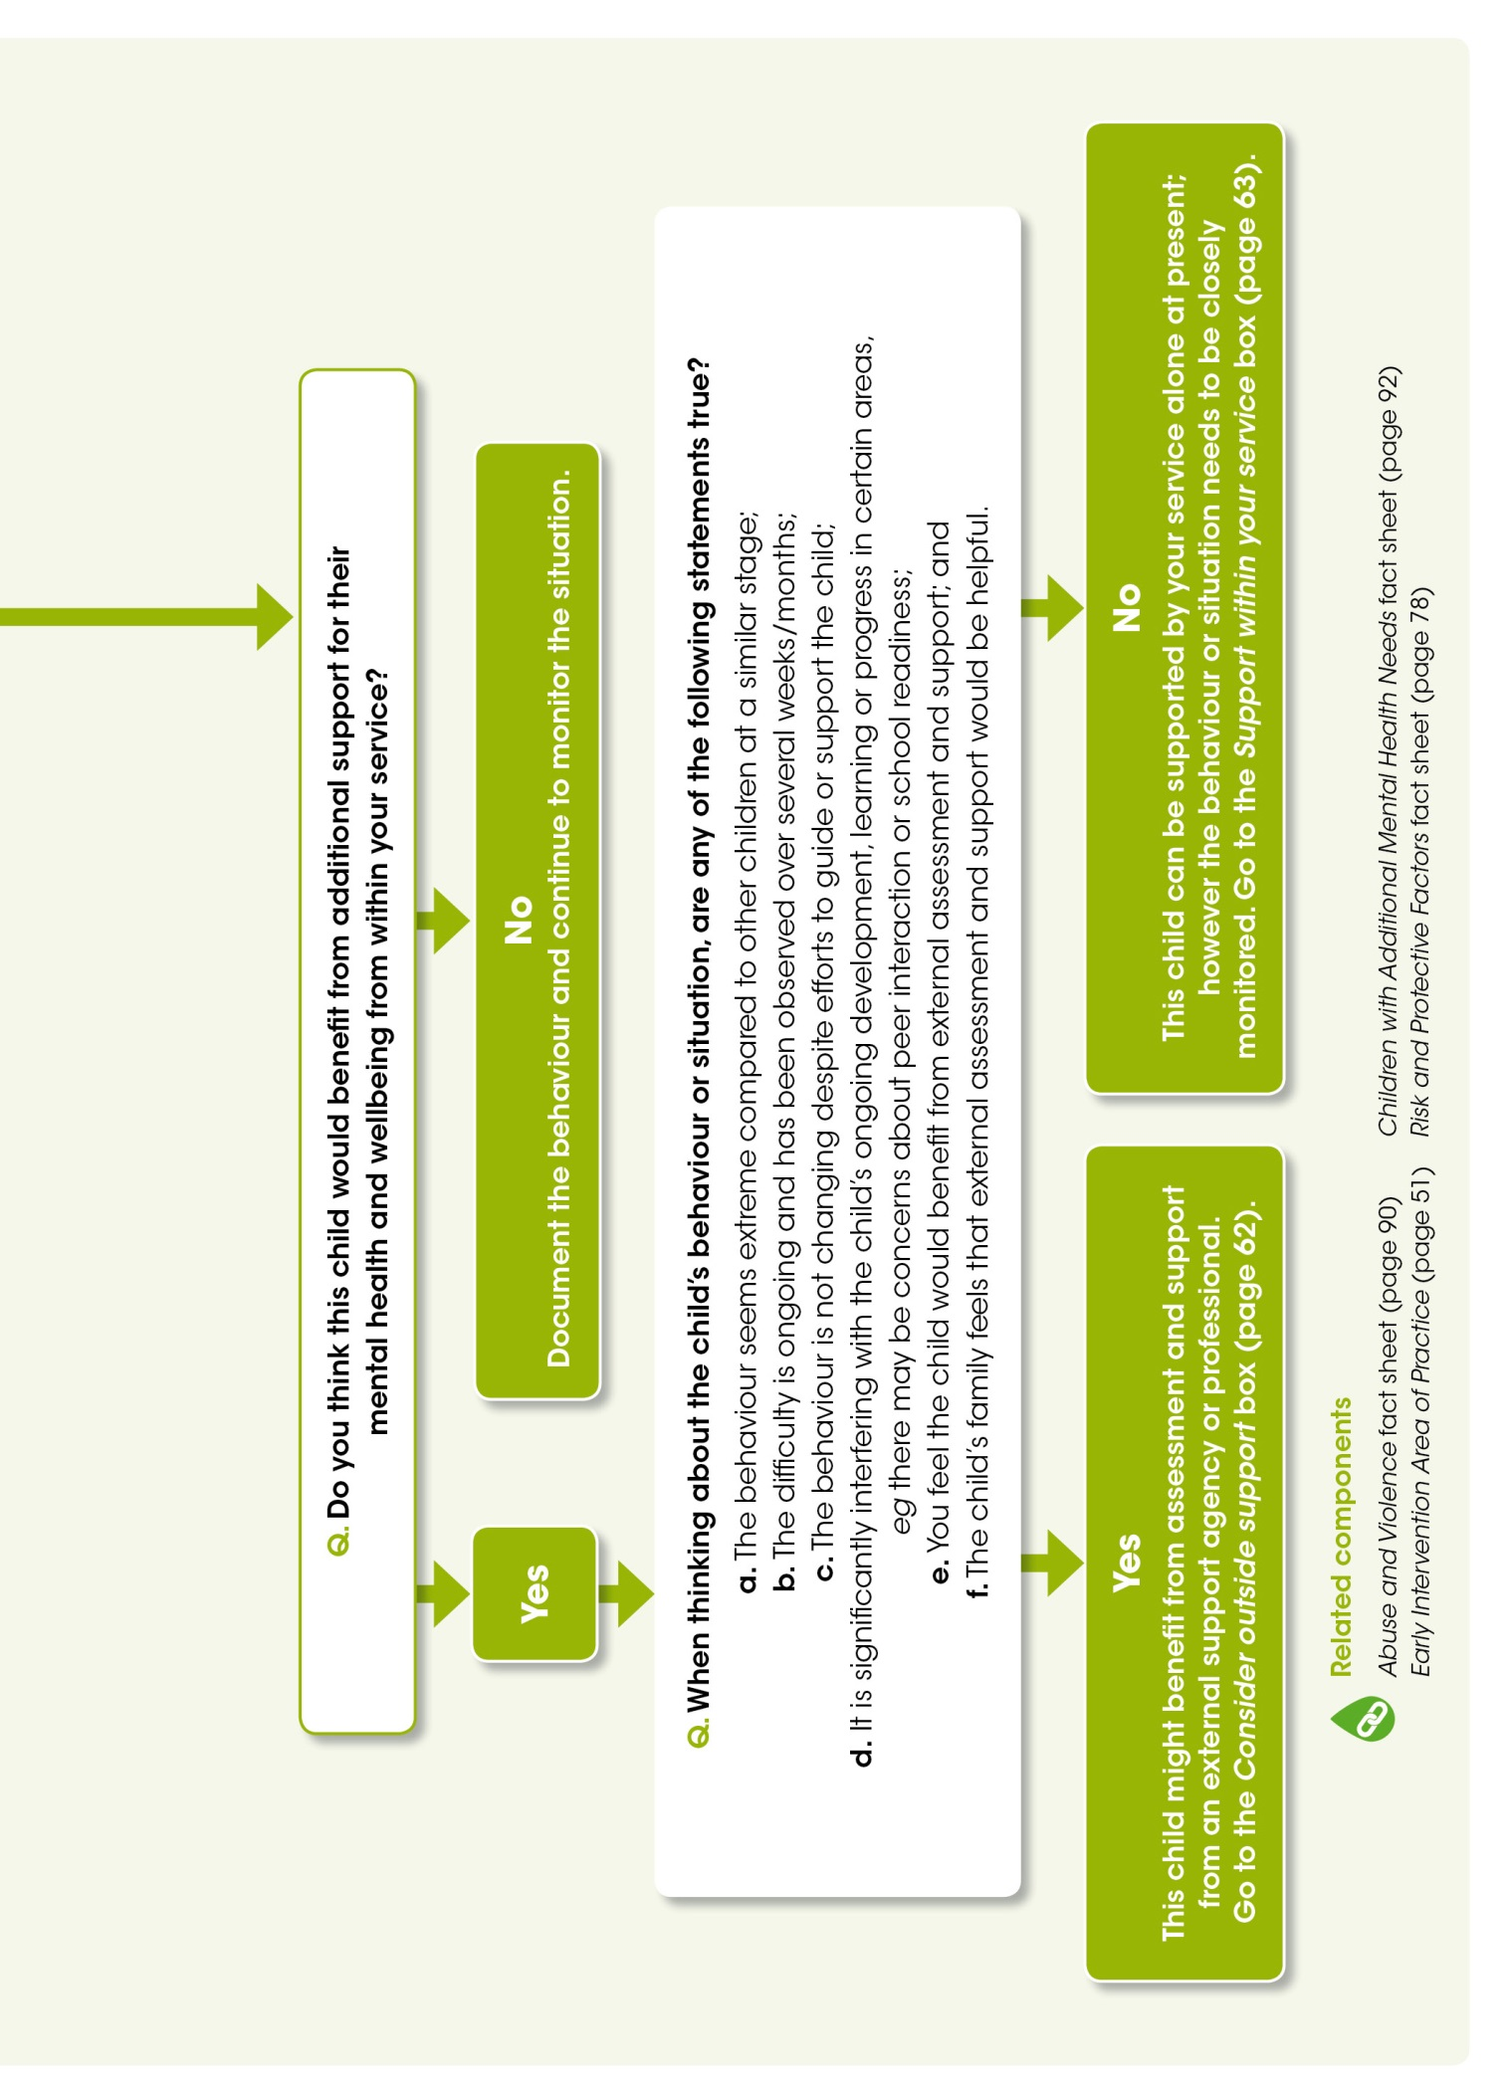
This is the second page of the Connections Decision Making Tree. The first box asks you a question and provides two responses: ‘yes’ and ‘no.’ The question is, ‘do you think this child would benefit from additional support for their mental health and wellbeing from within your service?’

Connections Tools
If you answer ‘no,’ you are prompted to ‘document the behaviour and continue to monitor the situation.’
If you answer ‘yes,’ you are directed to the next box in the Connections Decision Making Tree.
The next box asks you a question and provides two responses: ‘yes’ and ‘no.’ The question is, ‘when thinking about the child’s behaviour or situation, are any of the following statements true?’
Six statements are then provided including:
- The behaviour seems extreme compared to other children at a similar stage;
- The difficulty is ongoing and has been observed over several weeks/months;
- The behaviour is not changing despite efforts to guide or support the child;
- It is significantly interfering with the child’s ongoing development, learning or progress in certain areas, eg there may be concerns about peer interaction or school readiness;
- You feel the child would benefit from external assessment and support; and
- The child’s family feels that external assessment and support would be helpful.
If you answer ‘yes,’ you are advised ‘this child might benefit from assessment and support from an external support agency or professional. Go to the Consider outside support box.’
If you answer ‘no,’ you are advised ‘this child can be supported by your service alone at present; however the behaviour or situation needs to be closely monitored. Go to the Support within your service box.’
At the bottom of this page there are a number of related components listed that can help you with the above steps of the decision making process. These include Children with Additional Mental Health Needs fact sheet (page 92), Risk and Protective Factors fact sheet (page 78), Abuse and Violence fact sheet (page 90) and Early Intervention Area of Practice (page 51).

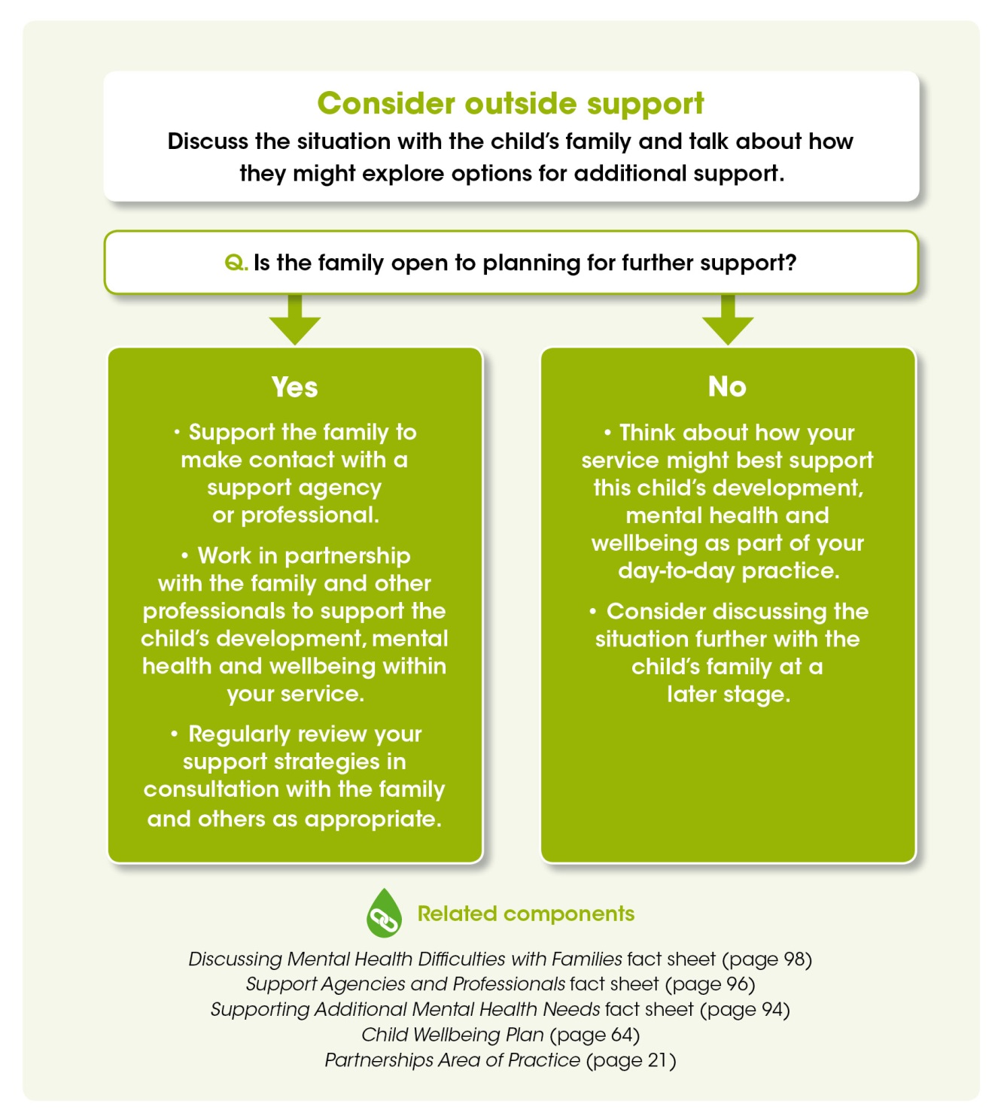
This is the third page of the Connections Decision Making Tree and is titled, ‘consider outside support.’ The text under this heading prompts you to, ‘discuss the situation with the child’s family and talk about how they might explore options for additional support.’

Connections Tools
The first box in this section asks you a question and provides two responses: ‘yes’ and ‘no.’ The question is, ‘is the family open to planning for further support?’
If you answer ‘yes,’ you are advised to:
- Support the family to make contact with a support agency or professional.
- Work in partnership with the family and other professionals to support the child’s development, mental health and wellbeing within your service.
- Regularly review your support strategies in consultation with the family and others as appropriate.
If you answer ‘no,’ you are advised to:
- Think about how your service might best support this child’s development, mental health and wellbeing as part of your day-to-day practice.
- Consider discussing the situation further with the child’s family at a later stage.
At the bottom of this page there are a number of related components listed that can help you to consider outside support. These include Discussing Mental Health Difficulties with Families fact sheet (page 98), Support Agencies and Professionals fact sheet (page 96), Supporting Additional Mental Health Needs fact sheet (page 94), Child Wellbeing Plan (page 64) and Partnerships Area of Practice (page 21).
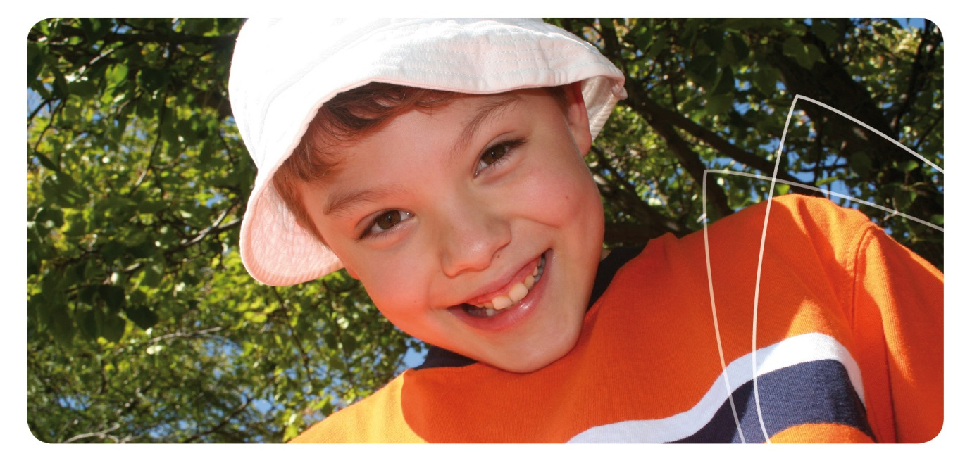
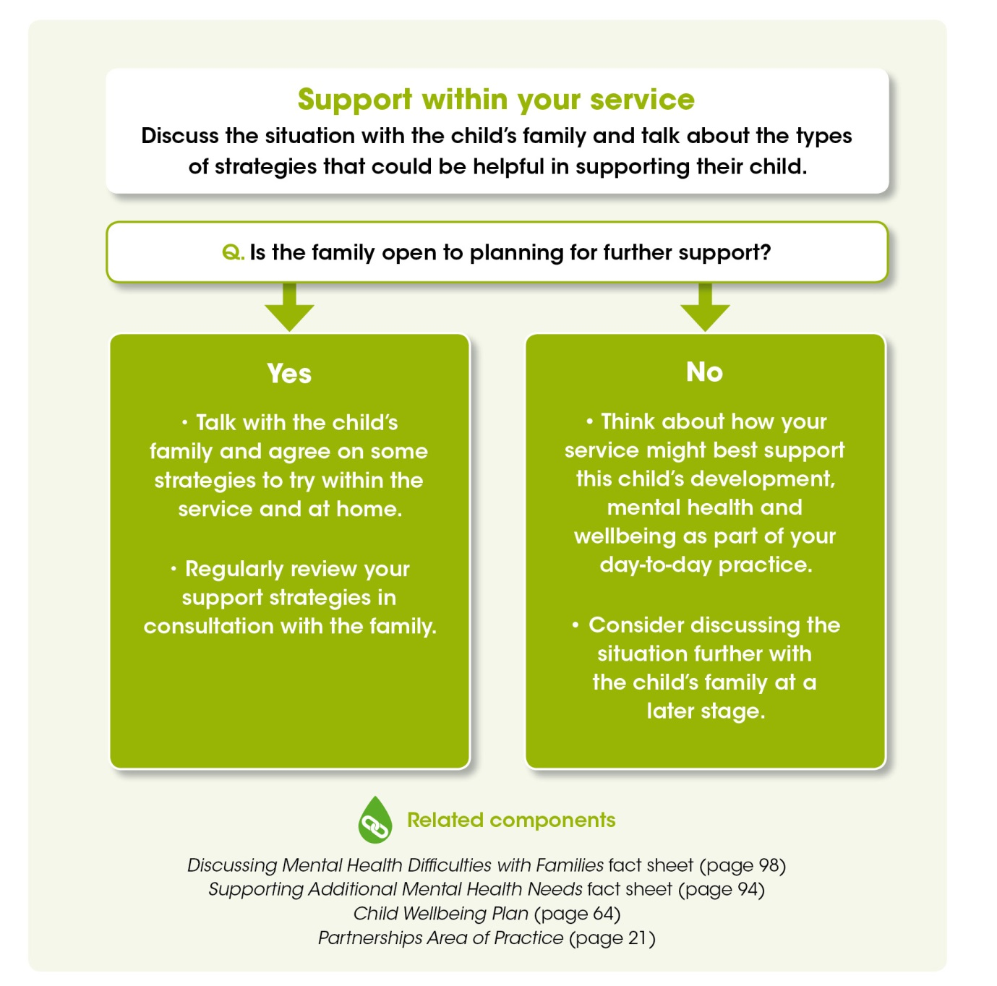
This is the fourth page of the Connections Decision Making Tree and is titled, ‘support within your service.’ The text under this heading prompts you to, ‘discuss the situation with the child’s family and talk about the types of strategies that could be helpful in supporting their child.’

Connections Tools
The first box in this section asks you a question and provides two responses: ‘yes’ and ‘no.’ The question is, ‘is the family open to planning for further support?’
If you answer ‘yes,’ you are advised to:
- Talk with the child’s family and agree on some strategies to try within the service and at home.
- Regularly review your support strategies in consultation with the family.
If you answer ‘no,’ you are advised to:
- Think about how your service might best support this child’s development, mental health and wellbeing as part of your day-to-day practice.
- Consider discussing the situation further with the child’s family at a later stage.
At the bottom of this page there are a number of related components listed that can help you to provide support within your service. These include Discussing Mental Health Difficulties with Families fact sheet (page 98), Supporting Additional Mental Health Needs fact sheet (page 94), Child Wellbeing Plan (page 64) and Partnerships Area of Practice (page 21).
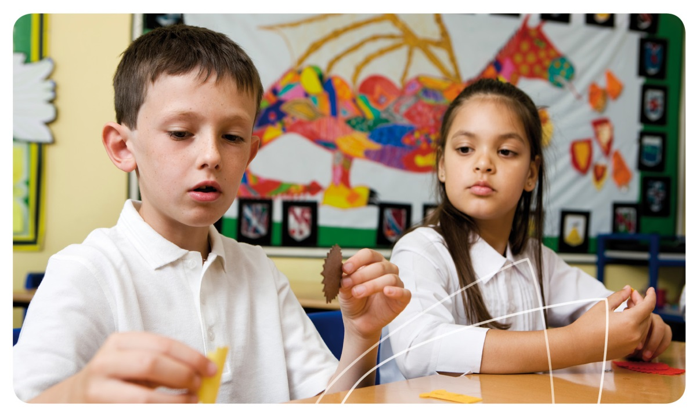

Child Wellbeing Plan

Connections Tools
Child’s Name: Date of Birth:
Start Date: Planned Review Date:
Educator: in consultation with:
Parent/Caregiver’s Name(s):
Strengths and interests
What are this child’s strengths and interests?
Area of focus
What is the behaviour that needs additional attention or support?
Influences
What influences this behaviour? Is there anything happening in the child’s life at the moment that should be taken into account, eg their health or development; events at home, in the service or community?
Thoughts and emotions

Connections Tools
What might this child be thinking and feeling?
Social interactions
How is the behaviour influencing their relationships with others?
Outcomes
What outcomes do we want to achieve with this Child Wellbeing Plan?
External support
Has the family made contact with an external support agency or professional?
Yes No Unsure
If no or unsure, think about whether this might be helpful for the child and/or the family. You may wish to use the Connections Decision Making Tree for assistance.
If yes, who is the agency or professional supporting this child?

Has a support plan been created by the agency or professional?
Yes No Unsure
If yes, what is the date of the plan?
Wellbeing strategies

Connections Tools
What strategies can we use to support this child in our service?
If there is a plan from an external agency, how could we implement their recommended strategies in our service?
Other comments
Would the parent/caregiver like to add any other comments to this plan?
Respectful supportive relationships with families are developed and maintained (NQS 6.1).

Child Wellbeing Plan review

Connections Tools
Date of Review:
Has the Child Wellbeing Plan been put into place? Yes No
What wellbeing strategies worked well?

What wellbeing strategies did not work?

What changes need to be made to the Child Wellbeing Plan?


This page is for any notes you wish to make

Notes

Front of tab to start a new section; Fact Sheets

Back of tab to start a new section; Fact Sheets

Fact Sheets
- Attachment and Mental Health 70
- Brain Development for Mental Health 72
- Communicating with Children 74
- Leadership for Early Childhood Mental Health and Wellbeing 76
- Risk and Protective Factors 78
- Trauma, Loss and Grief 80
- Aboriginal and Torres Strait Islander Wellbeing 82
- Refugee and Migrant Families 84
- Children of Parents with a Mental Illness 86
- Family Conflict and Separation 88
- Abuse and Violence 90
- Children with Additional Mental Health Needs 92
- Supporting Additional Mental Health Needs 94
- Support Agencies and Professionals 96
- Discussing Mental Health Difficulties with Families 98
- Helping a Person in Distress 100

Attachment and Mental Health

Fact Sheet 1 Attachment and Mental Health

What is attachment?
Babies and children depend on adults to provide them with food, safety, physical care, social interaction and emotional security. To help them survive, babies have an instinct to reach out and develop attachment relationships with their parents or caregivers.¹
Children develop a primary attachment to their main caregiver and they also have important secondary attachments with other key people in their lives, such as extended family members and early childhood educators. The quality of these early attachment experiences is important for mental health and wellbeing, both in childhood and later in life.

What are the different styles of attachment?
Babies and young children develop an attachment style through the many interactions they have with their families and caregivers every day.¹ This affects how they show their feelings when they become anxious and how easily they can be settled when comfort is offered. These earliest interactions with other people can have a long-term impact on the child’s life.

Secure attachment
A secure attachment style develops when caregivers understand the child’s signals for physical or emotional support, and respond to them in a sensitive, timely and consistent way. When they receive this type of responsive care, children learn that their caregivers are predictable and reliable and will help meet their needs. They develop a sense of security and safety. Children who spend most of their time in supportive environments where they are given responsive care are able to explore independently, yet are comfortable coming back to their caregiver for comfort and security if needed. Children with a secure attachment style still show distress sometimes, but can often be comforted more easily than other children and have a greater capacity to adapt to change. Secure attachment provides the best foundation for positive social and emotional development and for long-term wellbeing.²

Insecure attachment
There are different types of insecure attachment, which develop when children cannot rely on their caregivers to sensitively and consistently meet their needs. This may happen if a caregiver is not consistently available (either physically or emotionally) or is inconsistent in their response, or when the adult is dismissive of the child’s needs. Children with insecure attachment can be anxious and ‘clingy,’ needing lots of reassurance, or they may seem overly independent, not showing their needs or distress even when it would be appropriate.

Disorganised attachment
Disorganised attachment can occur when a young child has a troubled relationship with their parent or caregiver, such as in cases of abuse, neglect, trauma or family violence. It may also occur if a parent or caregiver has been traumatised. A child with disorganised attachment may view their caregiver as frightening (eg violent or unpredictable) or frightened (eg a victim of violence). Children with disorganised attachment do not have a consistent way of communicating their needs and feelings, and can be difficult to comfort when they become distressed. They may move between being anxious and angry, or seem torn between seeking comfort and pushing people away. In a stressful situation, they may get overwhelmed and mentally shut down, becoming disconnected from the world around them.

Why is attachment important?

Attachment and Mental Health
Early attachment experiences lay the foundation for mental health and wellbeing throughout childhood and into adulthood. This is partly because the quality of early relationships influences the development of the child’s brain and nervous system and the level of stress-related hormones in the body. For more information refer to the fact sheet on Brain Development for Mental Health, page 72. A person’s attachment style in childhood often stays with them into adulthood, continuing to influence their relationships and their capacity to respond effectively to challenging situations.¹
Secure attachment to caregivers helps children build close and satisfying relationships with others. It helps them learn positive ways to manage feelings and situations, and contributes to the development of a child’s trust, autonomy and self-esteem.
An insecure attachment style can present certain challenges to a child’s wellbeing. These may include low self-esteem, excessive self-reliance, distrust of others and difficulty managing feelings effectively. Children with insecure or disorganised attachment have an increased risk of mental health difficulties and mental illness later in life.²

What can educators do to encourage secure attachment?
Educators promote secure attachment by:
- Being tuned into the range of verbal or non-verbal cues that babies, toddlers, preschoolers and older children may use to communicate their needs and feelings;
- Speaking with families and observing the children in their care to learn how each child communicates their physical and emotional needs;
- Responding in a sensitive, timely, consistent and caring way to every child’s needs for comfort, reassurance, food, play or rest;
- When needed, comforting and reassuring children with gentle touch and soothing words;
- Putting in place a regular routine, and always caring for children in a consistent manner, so that babies and children know what to expect;
- Allowing time for children and educators to get to know each other, eg during their introduction to the service and through the use of staff consistency in centre based care;
- Using voice, face and body language in a warm, gentle way to show an interest in the child’s feelings and experiences; and
- Working in partnership with families to maintain routines, share information about the child’s wellbeing, and promote a sense of continuity and security.

More information
¹ Harrison L. Attachment: Building secure relationships in early childhood. Research in Practice Series. Deakin, ACT: Early Childhood Australia; 2003.
² Sims M. Caring for young children: What children need. Policy Brief No.15. Melbourne: Centre for Community Child Health; 2009. Available from: www.rch.org.au/emplibrary/ccch/PB15-caring_for_children.pdf
Dolby R. The circle of security: Roadmap to building supportive relationships. Research in Practice Series. Deakin, ACT: Early Childhood Australia; 2007.
KidsMatter Australian Early Childhood Mental Health Initiative. Literature review component 4: Helping children who are experiencing mental health difficulties. Canberra: Department of Health and Ageing; 2012. Available from: www.kidsmatter.edu.au

Brain Development for Mental Health

Why is brain development important?
Development of the brain and nervous system in the early years helps to lay the foundation for mental health and wellbeing throughout life. There are factors that will influence brain development in a way that provides a healthy foundation for the future, while other influences may lead to an increased risk of mental health difficulties or mental illness in childhood or later in life.¹

Fact Sheet 2 Brain Development for Mental Health

How does the brain develop?
Brain development is influenced by complex interactions between nature and nurture.^{1,2} Nature refers to genetics and biology, which create a basic blueprint for development. Nurture includes the environment, life events and relationships, which affect the way genes are expressed and how development unfolds over time.
The brain is part of our nervous system, which is like a network of communication channels throughout the body. Information about our environment travels through the nervous system to the brain, which interprets the input as sight, sound, touch and so on. The brain sends signals to our muscles and organs, allowing us to respond to things in our environment.
A baby has most of his or her brain cells at birth, but the connections between cells become more complex in response to early life experiences. New connections are formed and old ones that are no longer used are broken down. As children grow, connections are also coated with myelin, a substance which helps signals to be passed along more efficiently.
At birth, brain connections support basic behaviours that deal with survival, such as breathing, sleeping, feeding and early communication with caregivers. (For more information refer to the Attachment and Mental Health fact sheet page 70). Over time, more complex brain connections and pathways emerge. Children gradually acquire additional physical, social and emotional skills and can think in more complex terms.

Why are early brain connections so critical?
Early brain and nervous system connections can be thought of like a well-worn track that gradually appears when people walk through long grass. New pathways can develop, but tracks that are used more often become the easiest and most efficient ones to use again.
Connections are strengthened by repeated use, which supports our capacity for learning about the world around us. While connections change to some extent throughout life, the brain is at its most flexible and adaptable in the early years. Pathways that are used repeatedly, reinforced through our life experiences and relationships, will become strong.
The brain continues to change and mature right through into early adulthood, building on these earlier brain connections. If anything disrupts the usual process of development, particularly in the early years of life, a person may be at greater risk of mental health difficulties or mental illness in childhood, adolescence or adulthood.¹

What factors may disrupt the process of brain development?

Genetics
We inherit half of our genetic material from each biological parent, so every child has a unique combination of genes that makes up their basic blueprint for development. Brain and nervous system development is influenced by interactions between several genes and by the way these are expressed in the child’s environment. For example, genetic influences and brain development may be involved in the development of ADHD and autism.¹

Brain Development for Mental Health

Pregnancy and birth
Certain conditions or complications during pregnancy or birth may impact on brain development. For example, risk factors for certain types of mental illness or developmental disorder include exposure to drugs or alcohol during pregnancy, infectious diseases during pregnancy, diabetes, and birth complications.¹

Toxic stress
Fear and distress trigger the release of hormones (chemicals) which prepare the body to fight or run away in a dangerous situation. The fight-or-flight response is usually only turned on for a short time then hormone levels return to normal when the person is safe. When children receive sensitive care and comfort from adults, their brain and hormone systems develop as they should, and children can manage their feelings of distress as they grow up.
Toxic stress refers to chronic, ongoing stress, with limited support from adults. When children face chronic stress through abuse, neglect, family stress, poverty or violence, their body’s stress response is turned on most of the time. This causes differences in the levels of stress hormones and changes in brain development, affecting mental health and wellbeing.²

What can educators do?
Educators positively influence children’s brain development through their daily practices and in particular through the quality of their relationships with babies and children.¹ Many of the Skills and Practices outlined in the Areas of Practice for this resource relate to what we know about brain development and about fostering secure attachment.
For example, educators support positive brain development when they:
- Foster secure attachments with children through consistent and supportive relationships;
- Respond to children’s emotional needs, including offering comfort and reassurance;
- Help children to label, understand and manage their emotions;
- Provide predictable routines and consistency in care, to build a sense of security;
- Provide opportunities for exploration and mastery, using a range of different materials, so that children’s brain connections become diverse, strong and efficient; and
- Provide support for families who are facing stress or challenges and assist them to locate additional support services where needed.

More information
¹ National Scientific Council on the Developing Child. InBrief Series. Cambridge (US): Harvard University; Center on the Developing Child; 2013. Available from: www.developingchild.harvard.edu
² Ministerial Council for Education, Early Childhood Development and Youth Affairs (MCEECDYA). Early childhood development information. Available from: www.mceecdya.edu.au/mceecdya/early_childhood_development,33699.html
Alberta Family Wellness Initiative. How brains are built: The core story of brain development. Video. 2013 [cited 2013 Dec 16]. Available from: www.albertafamilywellness.org/resources/video/how-brains-are-built-core-story-brain-development

Communicating with Children

Fact Sheet 3 Communicating with Children

How do children communicate?
From the moment they are born, babies start communicating with their families and carers. Communication does not have to be through words (verbal communication) but also involves eye contact, facial expressions, touch, gesture and movement (non-verbal communication), as well as sounds such as crying, gurgling, laughing and babbling. Sometimes children communicate through their behaviour, eg hiding when it is time to stop playing with their friends.
As they grow, toddlers and young children learn to use a combination of verbal and non-verbal communication to connect with those around them. In this way young children and babies exchange information about their needs, their ideas and their feelings with the people who love and care for them.

Why is positive communication important?
Positive communication with babies and young children is important for many reasons including:

Forming secure attachment
- For babies and young children, recognising and responding to their physical and emotional needs in a consistent and caring way promotes secure attachment, which is essential for their mental health and wellbeing.

Building a positive self-concept
- From birth children develop a mental picture or idea of who they are, how others see them and whether they feel valued and competent (known as their self-concept).
- Caring and constructive communication from adults can support the development of a positive self-concept in a child.
- Consistently non-responsive, uncaring or insensitive feedback can lead to the development of poor self-esteem and a negative self-concept. This can put children at greater risk of mental health difficulties and mental illness, such as anxiety or depression.

Developing strong communication skills
- Children learn about social interactions and communication by watching others, copying their actions and then learning from the reactions of others to their behaviour. If adults communicate in a caring and respectful way with the people around them, and provide guidance, children will develop strong social skills as well.

How do educators communicate positively with children?
Educators communicate with children continually, even during routine tasks such as nappy changing or meal time. When communicating with children, it is important to consider the developmental stage of the child and use communication that is stage-appropriate.

Non-verbal communication
- Modelling positive communication by showing children the words, tone and body language you want them to use;
- Using positive facial expressions and other forms of non-verbal communication, eg touch, smiling and maintaining eye contact (where culturally appropriate);
- Being at the same level as children and gaining their attention when talking to them; and

Communicating with Children
- Organising the environment and programme to encourage interaction and communication.

Verbal communication
- Using open-ended questions or statements which encourage children to communicate their thoughts, feelings and ideas;
- Making time to actively listen to children and being interested in their ideas and activities;
- Talking with children rather than at them; being calm and patient;
- Respecting the feelings and opinions of all children, regardless of their age;
- Providing simple and clear instructions when asking children to perform a task; and
- Giving children praise for positive behaviour and acknowledging their achievements.

What are examples of negative communication?
Negative styles of communication that are best avoided include:
- Using impatient body language such as eye rolling, sighing, or foot tapping;
- Blaming or being critical of children or being judgemental;
- Lecturing, giving orders or using threats;
- Having conversations with a turned back or when walking away;
- Using, or allowing others to use sarcasm, anger, put-downs or name-calling; and
- Diminishing praise, eg “Your manners were lovely– I wish you always used them.”

What if a child is having trouble communicating?
Some differences in communication may be due to a child’s temperament and/or cultural background. However when educators have ongoing concerns, it can be helpful to observe the child carefully and document any issues, discuss them with a supervisor and if necessary, recommend that the family seek support for the child from a professional outside your service.

More information
Raising Children Network. Babies connecting and communicating. 2006-2013 [cited 2013 Oct 23]. Available from: www.raisingchildren.net.au/connecting__communicating/babies_connecting.html
Raising Children Network. Toddlers connecting and communicating. 2006-2013 [cited 2013 Oct 23]. Available from: www.raisingchildren.net.au/connecting__communicating/toddlers_connecting.html
Kearns K. Frameworks for learning and development. 2nd ed. Frenchs Forest: Pearson Education Australia; 2007.
Zero to Three. Supporting your child’s communication skills. 2012 [cited 2013 Oct 23]. Available from: www.zerotothree.org/early-care-education/early-language-literacy/communication-skills.html
Zero to Three. Connecting with babies: the power of parent/child interaction. Video. 2012 [cited 2013 Dec 19]. Available from: www.zerotothree.org/child-development/early-childhood-mental-health

Leadership for Early Childhood Mental Health and Wellbeing

Fact Sheet 4 Leadership for Early Childhood Mental Health and Wellbeing

Why is leadership important for mental health and wellbeing?
Promoting early childhood mental health and wellbeing can help to ensure positive outcomes for children now and into the future, in terms of their physical and mental health, learning, employment and community participation.¹ Quality leadership in educational settings is associated with stronger educational, social and emotional outcomes for young children.²
Leadership can be thought of as an influencing process that encourages reflection, learning and change and promotes a shared vision for the service. As outlined in Quality Area 7 within the National Quality Standard, leadership is important for building a positive organisational culture and for creating a professional learning community in which practitioners value continuous improvement. Policies and administrative systems then help educators to integrate the service vision and values into daily practice.
Early childhood education and care settings are diverse, so leadership models vary across settings. Leadership is a dynamic process, which influences culture, systems and operation of the service, and can go beyond the traditional hierarchical model of a single leader (such as a service director) to include multiple components of leadership.² Leadership can occur at all levels of early childhood services, particularly where people have a particular interest in a topic and value its importance.³
Leading the focus on mental health and wellbeing within a service or across a service network (such as among family day care educators) can be achieved by a team of educators from a range of positions.³ Pedagogical leaders, for example, may take a particular role in integrating social and emotional learning into intentional teaching activities. Others might coordinate the explicit inclusion of mental health and wellbeing into policy. A team approach can be used to share responsibility and create a sustainable focus on the issue, ensuring that mental health and wellbeing remains a core element of all activities within the service.

Some principles of effective leadership
There are a number of principles that underpin effective and quality leadership for mental health and wellbeing within educational settings.^{3,4} These include:
- Leadership starts from within – Effective leaders examine their own values and beliefs around mental health and wellbeing and encourage others to do the same.
- Leadership is about influence and responsibility – Effective leaders inspire and encourage other educators to develop professionally and personally, and assist them in promoting positive mental health outcomes for children.
- Leadership is a shared responsibility – All educators can be leaders when promoting mental health and wellbeing. Sharing leadership roles and responsibilities among educators maintains the commitment to mental health across the service.
- Leadership is based on supportive relationships – Effective leaders invest time in developing relationships with other educators that are based on trust, respect and open communication. This helps to support the wellbeing of educators themselves, so all are well-positioned to promote children’s mental health and wellbeing.

What does effective leadership for mental health and wellbeing look like?

Leadership for Early Childhood Mental Health and Wellbeing
In terms of promoting children’s mental health and wellbeing, leadership roles for educators within early childhood education and care services include:^{3,4,5}
- Creating a workplace that is supportive and inclusive for all educators and children, that fosters a sense of belonging and connectedness;
- Shaping a shared vision for the service around children’s mental health and wellbeing – such as defining goals, values and desired outcomes;
- Explicitly placing mental health and wellbeing at the core of all educator roles, and reflecting this in plans, policies and procedures within the service;
- Maintaining a focus on continuous improvement and integrating the issue of children’s mental health and wellbeing into the service’s Quality Improvement Plan;
- Encouraging reflective practice and collaborative learning among educators, including prompting staff to reflect on children’s mental health and wellbeing;
- Supporting educators to enhance their mental health and wellbeing knowledge base, through formal professional development and informal learning opportunities;
- Encouraging the growth of effective partnerships between educators, families and the community to support children’s mental health and wellbeing;
- Ensuring mental health and wellbeing activities are inclusive, culturally appropriate and relevant to community needs;
- Leading by example through promoting and valuing educators’ self-care activities and prioritising their own mental health and wellbeing; and
- Encouraging the development of systems and processes to monitor children’s mental health and wellbeing, reflect on outcomes and assess service practices.

More information
¹ World Health Organization; Department of Mental Health and Substance Abuse; Victorian Health Promotion Foundation; University of Melbourne. Promoting mental health: Concepts, emerging evidence, practice; A summary report. Geneva: World Health Organization; 2004.
² Lewis J & Hill J. What does leadership look like in early childhood settings? Every Child Magazine. 18 (4); 2012.
³ KidsMatter Australian Early Childhood Mental Health Initiative. Shared thinking: What helps a leadership team lead?; 2012. Available from: www.kidsmatter.edu.au/early-childhood
⁴ MindMatters. Key enablers for the whole school approach to mental health and wellbeing. In: Whole School Matters Draft; 2012. Available from: www.mindmatters.edu.au
⁵ Hunter Institute of Mental Health and Community Services & Health Industry Skills Council. Children’s mental health and wellbeing: Exploring competencies for the early childhood education and care workforce. Final report. Canberra: Department of Education, Employment and Workplace Relations; 2012. Available from: www.himh.org.au/earlychildhood

Risk and Protective Factors

Fact Sheet 5 Risk and Protective Factors

How is children’s mental health and wellbeing supported?
When considering children’s mental health and wellbeing, educators aim to:
- Promote each person’s best possible mental health and wellbeing;
- Prevent mental illness from developing where possible; and
- Support those who may already be experiencing mental health difficulties, mental illness or neurodevelopmental disorders.
Interventions to prevent mental illness and promote good mental health generally focus on two things:
- Reducing the risk factors associated with mental illness; and
- Increasing the protective factors associated with positive mental health.

What are risk factors for mental health difficulties?
Risk factors are the elements of a child’s life that increase their chance of developing mental health difficulties or a mental illness. They can occur at an individual, family or community level.^{1,2}

Individual
Risk factors can include physical health problems such as disability or chronic illness; genetic or biological factors; a difficult temperament; or an insecure attachment style and related behaviours.

Family
Other factors can relate to circumstances affecting the family as a whole, such as a family member with drug or alcohol dependence, mental illness or physical illness; family conflict and violence; separation and divorce; death of a pet; long-term unemployment; homelessness; or a death in the family.

Community
Other risk factors can relate to the environment in which the child is living such as war, poverty, cultural or social discrimination, bullying, neighbourhood violence or crime.

What if a child has more than one risk factor?
Some children experience a combination of these risk factors and this increases their chances of developing mental health difficulties. For example, a child living with a chronic illness has a higher risk of developing mental health concerns if their family also faces other challenges, such as mental illness, drug or alcohol dependence, or financial problems.²
While all children and families face difficulties from time to time, not everyone will go on to develop a mental health difficulty or mental illness. Often what makes the difference for a child is the amount of protective factors they have in their life.

What are protective factors for mental health?
Protective factors are the things in a child’s life that enhance their resilience to mental health difficulties, even in the face of challenging events or other risk factors.² Protective factors often appear to be the opposite of risk factors and can include:
- A positive or easy-going temperament;
- Thinking positively about yourself or having good self-esteem;
- Being hopeful about the future;
- Feeling you have some control over what happens in your life;
- Good communication, problem solving and social skills;
- Positive, nurturing, affectionate and secure relationships with adults;
- Being able to identify emotions and manage and express them appropriately; and
- Making friendships that are positive and supportive.^{2,3}

How do educators help?
Often it can seem like the risk factors affecting the infants or children in your care are impossible to control; for example, the death of a parent or cultural discrimination. This is true in some cases; however in all cases educators can work to increase the number of protective factors in a child’s life. This is part of providing a quality early childhood service.
Educators support children’s mental health and wellbeing by:
- Monitoring the presence of risk and protective factors in a child’s life;
- Creating a safe and inclusive environment where children understand their daily routines;

Risk and Protective Factors
- Communicating clearly and openly with children and families;
- Providing reassurance, and being accepting and supportive;
- Offering warm, responsive and consistent care; and
- Identifying those children who may benefit from additional support, recommending that families seek further professional advice and discussing options.³
When adults help to reduce risk factors and enhance protective factors, children are better able to build positive relationships with those around them and develop the ability to bounce back from the challenges they face in life.

More information
¹ Kay-Lambkin F, Kemp E, Stafford K and Hazell T. Mental health promotion and early intervention in early childhood and primary school settings: A review. Journal of Student Wellbeing, 2007; 1: 31-56. Available from: www.ojs.unisa.edu.au/index.php/JSW/article/viewFile/115/95
² KidsMatter Australian Early Childhood Mental Health Initiative. Risk and protective factors in early childhood [cited 2013 Nov 29]. Available from: www.kidsmatter.edu.au/early-childhood/resources-support-childrens-mental-health/information-sheet-index-0
³ Hunter Institute of Mental Health. Children and young people’s wellbeing: An educator’s guide; 2007. Canberra: Department of Health and Ageing. Available from: www.responseability.org/childrens-services/student-handouts

Trauma, Loss and Grief

Fact Sheet 6 Trauma, Loss and Grief

What is trauma?
Trauma is something a person can experience in response to a traumatic event, ie life-threatening, overwhelming or extremely upsetting. Potentially traumatic events include any form of child abuse (emotional, physical, sexual or neglect), violence, rape, natural disaster (such as bushfires and floods), injury or accidents, medical procedures, war, terrorism or torture. People respond to and cope with traumatic events in different ways, and trauma may or may not occur after experiencing a traumatic event.

What is loss?
People can experience loss when unable to get something or to keep something that they feel is valuable and important. Examples include the death of a friend, family member or pet; the ending of a relationship; loss of an important item; or major life changes, such as family breakdown or illness. People’s experience of loss is unique because it is determined by the strength of their attachment or connection to the object (person, relationship, item) representing the loss.

What is grief?
Grief is a person’s reaction to loss or a traumatic event; commonly sadness, pain and distress. These feelings might arise straightaway, or later, and may come and go.

What are the signs of trauma, loss or grief in children?
Each child will deal with trauma, loss or grief in their own way. Some examples include:
- Strong negative feelings, eg fear, anger, helplessness, numbness, anxiety or sadness. Many children feel one or more of these emotions after a traumatic event or loss.
- Changes in behaviour, eg being angry, aggressive or irritable, withdrawing from others and spending a lot of time alone, losing interest in favourite activities, showing limited or repetitive play, acting out the traumatic event, or having difficulty sleeping.
- Physical changes, eg being sick or unwell more often than usual, lacking energy, being more tired or having difficulties or changes in eating.

How long will it last?
The length of time it takes for each child to deal with grief varies; it could take days, months or years depending on the circumstances and the individual. A child’s ability to deal with grief is influenced by a number of factors, such as the type of traumatic event or loss, their relationships, environment, and their developmental stage, temperament and culture. It also depends on the level of support they receive from those around them.¹

Are there long-term effects?
For most children, signs of grief will gradually drop-off over time and they will be able to move on with their lives. If a child experiences repeated traumatic events or loss, or shows ongoing distress or grief, they may need additional help. Ongoing difficulties can affect longer-term development and capacity to form secure attachments and positive relationships. This could have lasting impacts on mental health and wellbeing, with an increased risk of depression, anxiety, or post-traumatic stress disorder.¹ If a child needs additional help, families can speak about this with their GP or a mental health professional (refer to the Support Agencies and Professionals fact sheet, page 96, for more information).

How can educators help?

Trauma, Loss and Grief
Sometimes when a family has undergone a distressing event, it may be difficult for parents or carers to support their child as much as they would like. When this is the case, it is helpful for the child to be able to get this much-needed support from the other adults in their lives. As early childhood educators, there are many things you might try to support the children in your service who have experienced traumatic events or loss, such as:
- Providing an environment where the child feels safe, secure and supported;
- Allowing the child to predict what will happen next by maintaining regular routines;
- Making time to sit or play with the child;
- Acknowledging their feelings and reassuring them if they are sad, anxious or withdrawn;
- Providing time and space where the child can be alone or with a trusted adult;
- Praising positive behaviour and reminding the child, if needed, of behavioural limits and boundaries; and
- Communicating openly and honestly with the child’s family, including letting them know if you think the child might need additional support.

What can educators say to children and their families?
If you know that there has been an event in the child’s life that may have an impact on them, be guided by the child in talking about this – resist the urge to make them talk about it. By creating a safe and supportive environment and making yourself available to children, you allow them the opportunity to express their thoughts and feelings. This can be in conversation, or through play, stories or art.
When children do express their feelings, it is important to acknowledge them and give them verbal and physical reassurance if they need it. For example if a child mentions that they are upset because their pet died, you might say, “I’m sorry to hear that. It is really sad when you lose a pet,” and comfort them. When talking with a child about their experience, it is important to keep in mind that each child comes from a different family, with a unique set of cultural, spiritual and social beliefs that may be different from your own. When a child asks difficult questions, it is sometimes helpful to ask what their parent or caregiver has already told them, to avoid giving them conflicting information.
When talking with families, it can be helpful to briefly acknowledge the situation and be empathetic, if appropriate, without taking on a counselling role. If a family needs extra support, educators may recommend accessing a health professional. For more information, refer to the Support Agencies and Professionals fact sheet (page 96).

More information
¹ Australian Child and Adolescent Trauma, Loss and Grief Network (ACATLGN) website: www.earlytraumagrief.anu.edu.au
KidsMatter Australian Early Childhood Mental Health Initiative. When times get tough. 2008 [cited 2013 Oct 23]. Available from: www.kidsmatter.edu.au/families/mental-health-difficulties/trauma/when-times-get-tough
Raising Children Network. Talking about tough topics. 2006-2013 [cited 2014 Feb 13]. Available from: raisingchildren.net.au/articles/tough_topics.html/context/285

Aboriginal and Torres Strait Islander Wellbeing

Fact Sheet 7 Aboriginal and Torres Strait Islander Wellbeing

Aboriginal and Torres Strait Islander perspectives on health and wellbeing
Many Aboriginal and Torres Strait Islander people view health in a holistic way beyond their physical wellbeing. This includes spiritual, social, economic, mental and philosophical factors and a belief that they are interconnected to each other, the earth and their spiritual ancestors. Many people prefer to use the term social and emotional wellbeing when talking about the mental health of Aboriginal and Torres Strait Islander people.

What have been the effects of the European colonisation of Australia?
The history of the European colonisation of Australia has had negative effects on the social and emotional wellbeing of Aboriginal and Torres Strait Islander people, including:
- Diminished connection to cultural identity, language, country and social practices;
- Disempowerment from a loss of independence through new, foreign laws and systems;
- Racism, discrimination, violence, stereotypes, and a lack of cultural awareness;
- Continued effects of the forced removal of children and breakdown of the traditional family structure;
- High rates of illness, substance dependence and premature death in some communities;
- A lack of access to culturally appropriate and culturally safe services; and
- Generational trauma, loss and grief caused by the impact of these and other factors.¹
The significant losses experienced in the past combined with the discrimination and inequalities experienced today continue to have significant impacts on the mental health and wellbeing of many Aboriginal and Torres Strait Islander people.

Why is this information important for educators?
Aboriginal and Torres Strait Islander children are less likely than other Australian children to attend early childhood services.² Extended family or community members may provide alternative care; however the continuing effects of colonisation also influence the ways in which many Aboriginal and Torres Strait Islander people view early childhood education and how and why they choose to access services. Barriers to participation in early childhood services can include:
- Accessibility (including a lack of transport) and lack of awareness about services;
- Distrust and fear of the removal of children;
- Racism, the fear of racism or fear of shame;
- A concern that educators may lack cultural awareness or inclusivity;
- The inability to communicate with educators through Aboriginal English; and
- A lack of inclusion, welcoming staff, cultural resources and sense of belonging.²
Being aware of the grief and loss that many Aboriginal and Torres Strait Islander families and communities continue to experience helps educators to work more effectively in partnership with Aboriginal and Torres Strait Islander families.³ This allows educators, families and communities to ensure that children achieve the best possible developmental, physical and mental health outcomes in spite of the challenges faced by many Aboriginal and Torres Strait Islander communities, in the past and today.

What are strategies to promote inclusion, reconciliation and positive wellbeing?

Aboriginal and Torres Strait Islander Wellbeing
When planning strategies to promote the inclusion and wellbeing of Aboriginal and Torres Strait Islander children, it is important to remember the diversity of Aboriginal and Torres Strait Islander communities. Throughout Australia there are hundreds of different Aboriginal and Torres Strait Islander nations. Each nation has their own cultural beliefs and practices including connection to the Dreaming and totems. Families may live on their own traditional lands or the land of another nation. Effective strategies will be based on an understanding of the local community, respecting traditional owners and acknowledging them in the service.
Educators support Aboriginal and Torres Strait Islander children and families by:

Working with children and families
- Learning more about the local community by talking to children, families and community members;
- Providing a culturally safe environment, supportive of Aboriginal and Torres Strait Islander identity, building on local strengths and incorporating local perspectives in everyday practice;
- Working cooperatively with families over time about the best ways to support them raising strong babies and children;
- Allowing time, flexibility and understanding to build trusting and respectful relationships;
- Understanding and valuing the child’s family environment and structure; and
- Acknowledging there are specific issues around trauma, loss and grief in Aboriginal and Torres Strait Islander cultures, in particular the Stolen Generation and Sorry Business.^{1,4}

Programming
- Considering information from the point of view of the child, recognising the ways in which each child learns and catering for their particular needs or differences;
- Being inclusive of Aboriginal and Torres Strait Islander cultures and spirituality in the curriculum including important dates and events;
- Teaching and using local traditional languages and Aboriginal English with children; and
- Embracing Aboriginal and Torres Strait Islander culture’s broad view of literacy, which includes not only written words but songs, poems, Dreaming stories, dance and music.⁴

More information
¹ Response Ability. Aboriginal and Torres Strait Islander wellbeing. Newcastle: Hunter Institute of Mental Health; 2010. Available from: www.responseability.org
² Trudgett M, Grace J. Engaging with early childhood education and care services: The perspectives of Aboriginal and Torres Strait Islander Australian mothers and their young children. Kulumun - Aboriginal and Torres Strait Islander Online Journal. 2011;(1):15-36.
³ Secretariat of National Aboriginal & Islander Child Care. Cultural competence in early childhood education and care services, SNAICC consultation overview. Victoria, Australia. 2012. Available from: www.snaicc.org.au/_uploads/rsfil/02865.pdf
⁴ Fisher B, Hydon C, Jewell P, & Nyland B. Walking respectfully. Exploring Aboriginal and Torres Strait Islander culture and reconciliation in early childhood practice. Melbourne, Australia: Early Childhood Australia Victorian Branch; 2008. Available from: www.earlychildhoodvictoria.org.au
KidsMatter Australian Early Childhood Mental Health Initiative. Aboriginal and Torres Strait Islander portal [cited 2014 Jan 6]. Available from: www.kidsmatter.edu.au/atsi-resources/search

Refugee and Migrant Families

Fact Sheet 8 Refugee and Migrant Families

What is the difference between a refugee, asylum seeker and a migrant?
A migrant is someone who was born overseas but has lived (or plans to live) in Australia for more than 12 months.
A refugee is a person who has left their country of birth because of a fear that they will be harmed or discriminated against on the basis of their race, religion, political opinion or membership of a particular social group.
An asylum seeker is a person who has left their country and is now asking to be recognised as a refugee. They often wait for their situation to be assessed in an immigration centre or within the community.

How is the mental health and wellbeing of refugees affected by their experiences?
Refugees may have experienced violence, warfare, imprisonment, torture, dangerous travel conditions, detainment in refugee camps or immigration centres, or loss of family members through death or separation.
Traumatic experiences can increase the risk of physical and mental health difficulties in both children and adults.¹ Some refugees may experience mental illness such as anxiety, depression or post-traumatic stress disorder.
The previous generation’s traumatic experiences can also affect children born in Australia to refugee parents. This may be through the impact of the experience on their parents’ wellbeing, their family relationships, or through hearing about traumatic experiences.

What difficulties do migrants and refugees face in Australia?
As many migrants and refugees have lost their usual cultural and social support networks, it may take some time before they can develop a sense of belonging and social inclusion in their new home.
Other challenges can include communicating in a second language or learning a new language if they do not speak English before they arrive. They may also have little money and no access to personal transport. These issues can make it hard to find out about and access local support services.
Cultural differences can also make it difficult to adjust to life in a new country, sometimes creating misunderstanding, conflict or stress. There may be differences in:
- The roles of men, women and children in society;
- The roles of government and community agencies;
- Theories and practices about raising children;
- Beliefs about discipline and guiding children’s behaviour; and
- Spiritual or religious beliefs and practices.

What can educators do to support refugee children and families?

Refugee and Migrant Families
Educators can provide additional support to refugee and migrant children and their families by:

When introducing migrant or refugee families to the service
- Allowing extra time when introducing them to the service and explaining routines;
- Recognising language differences and working with interpreters or support services;
- Being open to differences in family structure, values, and views on parenting and the role of children;
- Asking about the usual routines, caregiving practices and languages used at home; and
- Inviting family members to visit the service with the child for initial observation, or to stay during early visits until the child is settled.

Supporting babies and young children from migrant or refugee families
- Trying to use the same practices and routines in your service as those used at home;
- Helping children to develop a sense of safety and trust in their carers;
- Helping children to maintain their links to their culture and language;
- Using a range of natural and everyday objects as well as toys and books;
- Encouraging exploration, communication, social interaction and autonomy;
- Working in partnership with other agencies, eg Migrant Support Agencies; and
- Building positive attachments through the provision of a reliable and supportive environment, with a single primary caregiver (where possible).

Working with migrant or refugee families over time
- Trying to find out more about their culture and respecting their cultural diversity;
- Building a trusting relationship and inviting the family to ask about the child’s day;
- Openly communicating about each other’s views on the roles and behaviour of children;
- Inviting adults to share cultural stories, songs, dance or music with all of the children;
- Creating opportunities for families to meet and socialise with other families; and
- Providing families with information about services in your area, eg Migrant Resource Centres or Migrant Support Agencies, interpreter services, or family counselling and mental health support services.

How can educators tell if a child needs additional support?
Young children and families who have had difficult experiences of trauma or loss may require professional support from specialist services. Refer to the Children with Additional Mental Health Needs (page 92) and Trauma, Loss and Grief (page 80) fact sheets for more information.

More information
¹ Victorian Foundation for Survivors of Torture. Raising children in Australia: A resource kit for childhood services working with parents from African backgrounds. Brunswick: Victorian Foundation for Survivors of Torture; 2007. Available from: www.foundationhouse.org.au/resources/publications_and_resources.htm
Chapman M. Healing through play: Inviting spaces to support refugee children. Oakleigh South: FKA Children’s Services; 2005.
Australian Child & Adolescent Trauma, Loss & Grief Network. Refugee children and families; 2012 [cited 2013 Oct 23]. Available from: www.earlytraumagrief.anu.edu.au/refugee-children-and-families

Children of Parents with a Mental Illness

Fact Sheet 9 Children of Parents with a Mental Illness

Why is this information important for educators?
Up to 25 per cent of Australian children live with a parent or caregiver experiencing a mental illness.¹ While living with a parent or caregiver with a mental illness can pose extra challenges for children, they can still experience positive mental health and wellbeing. Relationships with adults who are understanding and supportive can make a significant difference to children’s outcomes.

How does mental illness affect parents or caregivers?
When a person has a mental illness, they can sometimes experience difficulties with thinking clearly, managing emotions, maintaining relationships or getting things done. They can experience:
- Physical health problems or side effects from the illness or its treatment;
- Conflict or strain in adult relationships, which can sometimes involve arguments or marital separation;
- An increased risk of misusing drugs or alcohol, to help them feel better;
- Financial worries related to the costs of treatment or time taken off work; and
- Feelings of shame, discomfort or withdrawal related to the stigma of mental illness.
For a parent with a mental illness this can sometimes affect their ability to:
- Meet their child’s physical needs or be available to their child physically, eg if a parent needs to be treated in hospital for a period of time or their medication is making them lethargic; and
- Respond with warmth and consistency or be available to their child emotionally, eg share their child’s happiness or excitement during daily activities.

How can parental mental illness affect children?
Sometimes when a parent is experiencing a mental illness, they are unable to look after their child as well as they would like, or to connect with their child emotionally.¹ This can cause:
- Attachment difficulties with the child including insecure or disorganised attachment;
- Poorer physical, social or emotional development of the child;
- An increased risk of the child experiencing abuse or neglect; or
- An older child taking on the care and responsibility of their parent or siblings.
Children of parents with a mental illness tend to have a higher risk of developing mental health difficulties or a mental illness themselves, which may be due to a combination of genetic factors and difficult life experiences.¹

Does this affect all children with a parent who has a mental illness?
Not all children who have a parent or carer with a mental illness will be negatively affected by the situation. However some do face particular challenges. The impact on a child will depend on:
- The developmental stage and age of the child;
- The temperament, resilience and personal resources of the child;
- The type of mental illness, its symptoms, frequency and duration;
- The family’s understanding of the condition;
- How the illness is treated or managed; and
- The capacity of other adults to provide care and support.

How do educators know if a child has a parent with a mental illness?

Children of Parents with a Mental Illness
Educators may find out that a parent or caregiver has a mental illness either by the family sharing this information directly or through conversations with the child. Children of parents with a mental illness are also more likely to display signs of mental health difficulties¹ and a detailed list of these can be found in the Children with Additional Mental Health Needs fact sheet (page 92). However in many cases, educators may not be aware of a family mental illness.

How can educators support children of parents with a mental illness?
While people with a mental illness face additional challenges in parenting, they can still care successfully and effectively for their children. It can be the understanding, help and support of others that makes all the difference. Educators can support children and families living with a mental illness by:

Within the service
- Creating a supportive, inclusive environment that fosters a sense of belonging and connectedness for children and families, eg reading stories where a parent or family member has a mental illness;
- Supporting children in their social and emotional development;
- Identifying and monitoring those children who may need additional support;
- Treating information as confidential and not disclosing it without consent; and
- If appropriate discussing any support needs with a director, supervisor or coordinator.

Working with families
- Building good relationships with the families at your service to help them feel comfortable discussing any problems or challenges they may be facing;
- When a parent or caregiver tells you about their mental illness:
- Keeping in mind that they may have experienced negativity or discrimination in the past when talking about their condition;
- Asking if the illness has been explained to the child and how it has been described;
- Talking about any changes in childcare arrangements with the family; and
- Working closely with families in an accepting and inclusive way.

Talking with the child
- Allowing the child to share their thoughts and feelings about the illness if they want; and
- Talking about the situation while being guided by each child’s individual circumstances and family preferences. It is often better to talk about the situation with children in a way that is appropriate for their development, rather than ignoring or avoiding it.

More information
¹ Australian Infant, Child, Adolescent and Family Mental Health Association. Principles and actions for services and people working with children of parents with a mental illness. Canberra: Department of Health and Ageing; 2005. Available from: www.copmi.net.au/images/pdf/principles-and-actions.pdf
Australian Infant, Child, Adolescent and Family Mental Health Association (AICAFMHA). Helping to piece the puzzle together. Australia: AICAFMHA; 2011. Available from: www.copmi.net.au/images/pdf/helping-to-piece-the-puzzle-together.pdf
Children of Parents with a Mental Illness website: www.copmi.net.au

Family Conflict and Separation

Fact Sheet 10 Family Conflict and Separation

Who is affected by family conflict or separation?
All families will face some level of conflict at times. Family conflict can occur between any mix of family members, including parents, siblings, grandparents, extended relatives and new spouses or partners. Conflict can include anger, distrust, hostility, avoidance and other negative attitudes; and can result in verbal conflict, poor communication between family members and even violence.¹ Some family conflict involves parental separation; while other conflict continues for years with parents or caregivers staying together in an unhappy relationship. Both types of conflict can affect children’s mental health and wellbeing.
Separation also affects large numbers of families each year, with the Australian Bureau of Statistics stating that in 2011, 48.3% of all divorces involved couples with children under the age of 18 years old.² Separation and divorce can be an amicable process, or it can be a process involving tension, stress and confusion. In either case, it represents a breakdown of the family unit and can be a difficult time for any children involved.

What does family conflict or separation mean for children?
Children and young people may face a number of challenges when their family experiences conflict or separation. When family conflict occurs children can experience:
- A stressful, angry or unhappy home environment;
- Family members who are emotionally unavailable to them; and
- Observing and learning poor communication and relationship skills.
When separation occurs, children can experience:
- A disruption to their daily routine, eg who picks them up, where they sleep at night, etc.;
- Spending less time with one or more family members;
- Adjusting to a new home with different furniture, toys, rules and routines; and
- Needing to form new relationships with a parent’s new spouse or partner, and sometimes their children.

How does this affect children?
Experiencing family conflict, separation or divorce can be overwhelming for many children. Children and even young babies absorb and react to the emotions of their caregivers and can become stressed, angry and unhappy in response to family conflict.¹ Some children may not feel safe in their home environment as a result of the conflict or a disruption to their routines. Others may blame themselves for what has happened or think they are guilty of doing something wrong.
When separation occurs, children may experience a heavy sense of loss and feel unsettled, anxious, confused or frustrated as they adapt to the many changes in their family life. Some children may feel pressure to choose between family members and feel guilty about loving and wanting to spend time with their other parent. On the other hand, the decreased stress from families separating can also be a relief and lead to children experiencing a more positive home environment.

Dealing with these intense emotions and thoughts can lead to children acting out, picking fights or bullying other children, becoming withdrawn, or being overly sensitive in their emotions.³ If family members are not available to their children, either physically or emotionally, children may not receive the support they need to manage their emotions and develop positive coping skills.

Family Conflict and Separation

What are the long-term consequences of unresolved family conflict?
Unresolved family conflict can affect a child’s ability to manage their emotions, form healthy relationships and develop a positive sense of self. Living in a negative and stressful environment also influences how the brain develops. Children who experience conflict or difficult family breakdown face a higher risk of future health, social, educational and economic difficulties.¹

What are the long-term consequences of family separation?
The effects of family separation can vary for each child, depending on how it is managed within the family, the level of support the child feels they have, the age and developmental stage of the child. If they are well supported, most children will recover from the distress of family separation without any long-term negative effects.

How can educators support children experiencing family conflict or separation?
Educators can help children experiencing family conflict and separation by:
- Continuing to be a nurturing, steady and stable adult presence in the child’s life;
- Creating a stress-free environment within their service. This includes maintaining routines and daily schedules for children;
- Remaining neutral when talking with parents or family members involved and representing the interests of the child;
- Not discussing the subject with family members in front of the child;
- Talking to children about the changes that are occurring within their family and at home;
- Encouraging children to talk about their feelings. Educators may need to help children identify and name the emotions they are experiencing; and
- Teaching children helpful strategies for managing their emotions (for more information refer to the Supporting Additional Mental Health Needs fact sheet, page 94).

More information
¹ McIntosh J. Children’s responses to separation and parental conflict. 2010 [cited 2013 Oct 25]. Available from: www.earlychildhoodaustralia.org.au/every_child_magazine
² Australian Bureau of Statistics. Marriages and divorces, Australia 2011. Canberra: Australian Bureau of Statistics; 2012. Cat. No. 3310.0.
³ UnitingCare. The impact of separation on children – development issues. Parramatta: UnitingCare; 2013. Available from: www.unifamcounselling.org/resources/fact_sheets
Barnes H. Working with children when their family breaks down. Putting Children First (NCAC Newsletter). 2010;35:21-23. Available from: ncac.acecqa.gov.au/educator-resources/pcf-articles/Working_w_chn_when_family_breaks_down_Sept10.pdf
Relationships Australia. Managing separation and divorce. 2013 [cited 2013 Nov 28]. Available from: www.relationships.org.au/relationship-advice/relationship-advice-topics/managing-separation-and-divorce

Abuse and Violence

Fact Sheet 11 Abuse and Violence

What is child abuse and neglect?
Child abuse or neglect includes the harmful mistreatment of a child, either intentional or unintentional, such as:
- Physical abuse – This includes physically hurting or injuring a child, for example by shaking, hitting or beating a child, throwing or pushing them, or by cutting or burning a child.
- Emotional or psychological abuse – This includes behaviours that are damaging to a child’s social and emotional development, such as rejection, withholding affection, harsh criticism, isolation and personal ridicule.
- Sexual abuse – This includes making a child watch or take part in any sexual act, such as touching others or being touched in a sexual way, having any kind of sex, posing for sexual photos or films.
- Neglect – This includes failing to meet a child’s basic needs and keep them safe, for example not providing adequate food, clothing, adult supervision, health care or education.

What is family violence?
The term family violence describes violent experiences that can occur between parents, children, siblings, aunts, uncles, cousins and grandparents. It occurs when one member of the family deliberately uses threats, force, or intimidation to control or dominate another family member.¹ It is not restricted to physical acts, it also includes psychological abuse, such as making threats against loved ones like a parent, brother, sister or pet.
While domestic violence is the term usually used to describe violence between spouses or partners, family violence can occur between any members of the immediate or extended family. The Australian Institute of Health and Welfare estimates that up to 23% of children will witness violence between parents or caregivers at some point during their childhood.²

What are the impacts on children’s mental health and wellbeing?
How a child reacts to experiencing or witnessing some form of abuse, neglect or violence will depend on a number of factors, such as how old the child is, their temperament, how they think and feel about themselves and their family situation. Even if the abuse or violence is not directly aimed toward the child, they can be affected by fear, tension and lack of security.
Even when a child does not directly witness specific incidents, family violence can still impact on the quality of the relationships that children have with their family members. If violence is occurring between a parent and another family member, the capacity of the parent to meet the physical and emotional needs of the child could be greatly reduced.³
Experiencing or witnessing abuse or violence can have a negative impact on the formation of secure attachments and on brain development. (Refer to the fact sheets Attachment and Mental Health, page 70, and Brain Development for Mental Health, page 72 for more information). Children who have these experiences are at greater risk of developing mental health difficulties or mental illness in childhood, adolescence or adulthood.

What are the warning signs of abuse or family violence?

Abuse and Violence
When there is abuse or family violence, children can feel confused, angry, sad, anxious or frightened. They may blame themselves for what is happening at home. Children may demonstrate a range of behaviours such as:
- Being aggressive, impulsive and lacking empathy for others;
- Hurting other children or pets;
- Becoming withdrawn and showing signs of low self-esteem;
- Experiencing ongoing illnesses, eg stomach aches, diarrhoea, headaches;
- Having nightmares or wetting the bed;
- Acting out violent or abusive situations during play;
- Talking, writing, or drawing about being hurt, frightened or abused;
- Significant changes in feelings or behaviours, eg becoming anxious or aggressive; and
- Frequent bruising or injuries without an appropriate explanation.³

What do educators need to do?
If you think a child has experienced abuse or violence, or you see signs of significant risk toward a child, you have a duty of care to report your concerns (NQS 2.3: Each child is protected). As a first step, speak with your director, supervisor or coordinator who can help you to work through your concerns and take appropriate action, as guided by your service’s policies and procedures. In some states and territories, educators are required by law to make a formal report (mandatory reporting). For information on who to contact, visit www.aifs.gov.au/cfca/pubs/factsheets/a142843/index.html (retrieved 2 September, 2013).

How can educators support a child who has experienced abuse or violence?
Educators can support children who have experienced abuse or violence by:
- Creating a safe and supportive environment for the child within your service;
- Teaching and modelling respectful values, beliefs and behaviours to all children;
- Allowing them to talk with you about what has happened or how they feel, if they wish;
- Letting the child know that violence, abuse or neglect is not their fault; and
- Helping them and their family to seek other advice and help if requested.

More information
¹ Family and Relationship Services Australia. Family violence. Deakin, ACT: Family and Relationship Services Australia; 2012. Available from: www.frsa.org.au/storage/information-pdfs/FRSA%20Family%20Violence.pdf
² Australian Institute of Health and Welfare (AIHW). Child Protection Australia 2011-2012. Canberra: AIHW; 2013 March. Cat. no. CWS 43. Available from: www.aihw.gov.au/publication-detail/?id=60129542755
³ Wilcox K. Family law and family violence: Research into practice. Sydney: The University of New South Wales; Australian Domestic and Family Violence Clearinghouse; 2012 Jan. Available from: www.adfvc.unsw.edu.au/PDF%20files/Research_&_Practice_Brief_2.pdf
Australian Childhood Foundation website: www.childhood.org.au
National Association for Prevention of Child Abuse and Neglect website: www.napcan.org.au/our-programs

Children with Additional Mental Health Needs

Fact Sheet 12 Children with Additional Mental Health Needs

Mental health difficulties and illness in early childhood
Like adults, children can experience a range of mental health difficulties or challenges as they grow and learn.¹ Severe or ongoing difficulties may indicate the risk or presence of a mental illness or a neurodevelopmental disorder. However many difficulties are mild or temporary, and require a child’s development to be observed over time. It is the role of health professionals to diagnose a mental illness or neurodevelopmental disorder. Educators observe children’s wellbeing and behaviour, identify potential additional mental health needs and provide appropriate support within their service.

What are externalising and internalising difficulties?
Children often express difficulties with their mental health through challenging behaviour or through changes in their behaviour, rather than talking about their thoughts or feelings. This is particularly true for younger children.
Mental health difficulties in childhood can be divided into two categories: externalising behaviours and internalising behaviours.² Most children show a range of these behaviours as they grow and learn, depending on their temperament and situation. This is a normal part of development; the issue is only a problem if the behaviour is severe, ongoing, or is making it difficult for children or families to cope.

Externalising difficulties
Externalising behaviours include a range of under-controlled behaviours associated with difficulty in self-regulation of feelings, behaviour and attention. Externalising behaviours include tantrums, defiance, aggression, impulsivity, overactivity and difficulty following instructions or making transitions. Often children just need additional guidance and support from adults in these areas, but sometimes these behaviours are associated with a neurodevelopmental disorder, such as ADHD or an autism spectrum disorder.

Internalising difficulties
Internalising behaviours relate to over-controlled behaviour and self-regulation, resulting in distress that is turned inward, such as fearfulness, anxiety, sadness, guilt, numbness and social withdrawal. Anxiety disorders are one of the most common childhood emotional disorders, and include separation anxiety, generalised anxiety and specific phobias. Depression is another internalising disorder and even young children can develop clinical depression.²

What are possible signs of early childhood mental health difficulties?
While taking into account the child’s developmental stage, temperament, culture and family context, signs of mental health difficulties in young children can include:
- Significant changes in feelings or behaviour;
- Behaviour that is out of step with peers at a similar age and stage;
- Attachment problems with families and caregivers (such as difficulty in separating);
- Being upset, anxious, withdrawn or fearful much of the time;
- Poor quality play that seems limited and repetitive;
- Difficulty managing anger and frustration (eg persistent temper tantrums or aggression);

- Difficulty in paying attention, following instructions and completing tasks; and

Children with Additional Mental Health Needs
- Frequent defiance and refusal to follow instructions.³

How can educators support children and families within their service?
The presence of mental health difficulties doesn’t necessarily indicate a mental illness or neurodevelopmental disorder, but often does suggest the need for extra support from the adults in that child’s life, including family and early childhood educators. For strategies on supporting children with additional mental health needs within your service, refer to the fact sheet Supporting Additional Mental Health Needs (page 94).

When is external assessment and support recommended?
When considering if a child needs to be referred to a health professional or support agency, it is important to remember:
- A child’s feelings and behaviours are influenced by their temperament, culture, relationships, health, family circumstances, experiences of early childhood education and care and a range of other factors. Many children show temporary changes in their behaviour when they are unwell or tired, or in association with a difficult situation such as grief, loss or family stress;
- Almost all children show difficulties in managing their feelings and behaviour at times, particularly during certain stages of development; and
- Some mental health difficulties are mild or temporary and don’t have major long-term impacts. These can often be addressed successfully as the child develops further and is provided with guidance and support from family and carers.
Assessment by a health professional or support agency would generally be recommended if:
- The behaviour seems extreme when compared with other children at a similar stage;
- The difficulty is ongoing and has been observed over several weeks or months;
- The behaviour is not changing despite efforts of adults to guide or support the child;
- It happens across more than one setting (eg at home, your service, the park); and
- It is interfering with the child’s ongoing development, learning or progress in certain areas, for example there may be concerns about school readiness.³

More information
¹ Hunter Institute of Mental Health. Response Ability vocational education and training resources: Children’s services, background reading for teachers. Newcastle: Hunter Institute of Mental Health; 2010. Available from: www.responseability.org/childrens-services/background-reading-for-teachers/background-reading
² Centre for Community Child Health. Promotion, prevention and early intervention for mental health in general practice. Monograph 3, Child behaviour: Overview of the literature. Adelaide: Ausienet, Flinders University; 2007.
³ Response Ability. Identifying emotional and behavioural problems. Newcastle: Hunter Institute of Mental Health; 2010. Available from: www.responseability.org
KidsMatter Australian Early Childhood Mental Health Initiative. Responding to children who may be experiencing mental health difficulties [cited 2013 Oct 23]. Available from: www.kidsmatter.edu.au/families/about-mental-health/should-i-be-concerned/responding-children-who-may-be-experiencing

Supporting Additional Mental Health Needs

Fact Sheet 13 Supporting Additional Mental Health Needs

How can educators tell if a child has additional mental health needs?
The term additional mental health needs is used in Connections to describe the needs of children and families experiencing mental health difficulties, mental illness and/or neurodevelopmental disorders (for more information refer to Key Concepts, page 9). Detailed information on the symptoms and signs of children with additional mental health needs can be found in the Children with Additional Mental Health Needs fact sheet (page 92).

Why is it important to support children with additional mental health needs?
Mental health and wellbeing can have a significant influence on the health, education and development of young children. Positive mental health in early childhood provides a solid foundation for children to achieve positive outcomes as they grow and later on in life.¹ Children experiencing additional mental health needs can benefit from extra support to help them participate fully in the education and care setting, and to achieve these positive outcomes.

Who can benefit from the following strategies?
The strategies outlined below may be useful for children who are showing signs of mental health difficulties that are not severe enough to warrant further assessment from a support agency or professional. They might also be helpful for children who have been referred for external support and are awaiting assessment; or children who are already working with an agency or professional and who have or have not received a diagnosis. In each situation, it is important that educators develop support strategies in partnership with families and the Child Wellbeing Plan (page 64) can be used to document this information.

What group strategies can educators use to support children with difficulties?
Some of the strategies educators can use to support children experiencing mental health difficulties can benefit the other children in their care as well. These strategies are useful as they encourage inclusiveness, reduce stigma and do not single out one particular child. They include:
- Relaxation activities, eg lying on the floor and listening to instrumental or classical music, a guided visualisation, story or practising yoga;
- Teaching positive self-talk, eg “I can do this. I can do this,” or “I am calm;”
- Reading funny books, or telling jokes or funny stories. Encouraging children to share their own funny jokes or stories;
- Discussing behaviours and emotions by role playing with dolls, other equipment, educators or other children;
- Talking over with children the times when you have been happy, sad, angry, frustrated or disappointed and how you managed these emotions;
- Giving clear and specific instructions; and
- Maintaining predictable routines and schedules, so that children experiencing mental health difficulties feel safe and secure.

What one-on-one strategies can educators use?
It is also useful for educators to be aware of, and implement strategies that focus solely on the child who has additional mental health needs. Educators can use these strategies depending on whether the child is exhibiting internalising or externalising behaviours (refer to Children with Additional Mental Health Needs, page 92, for more information on internalising or externalising behaviours).

Supporting Additional Mental Health Needs

Internalising behaviours
- If a child has withdrawn from a group learning experience to sit by themselves in another part of the service, go and sit with them. Join in with the activity they have chosen and depending on the child, either start a conversation or sit in companionable silence;
- If children do not want to participate in group experiences, allow them the space to observe rather than insisting they join in;
- If a child is finding a learning experience too challenging, reassure them they can come back to it later;
- Provide physical and verbal reassurance to a child who may be struggling to settle, eg let them sit on your lap during reading time; and
- If a child is upset, take the time to comfort them and help them to feel safe and secure (refer to the Helping a Person in Distress fact sheet, page 100, for more information).

Externalising behaviours
- Give children choices instead of demands, eg “Tom, you can choose to pack away the blocks now with everybody helping, or you can pack them away afterwards by yourself;”
- Remember to dislike the action and not the child, eg “Hitting Sam made his arm sore;”
- Reward positive behaviour when you see it, eg “Thanks for packing away the blocks, Tom. We have a new puzzle, would you like to be the first to work on it?;” and
- Make sure children demonstrating aggression get plenty of physical activity, eg if needed, redirect a small group learning experience to do star jumps, run on the spot, or dance.

More information
¹ Bartlett S. Brain development and social and emotional wellbeing. Foundations. 2012 Dec; 11:7-9. Available from: www.himh.org.au/home/our-work/current-programs/foundations
Kearns K. Frameworks for learning and development. 2nd ed. Frenchs Forest: Pearson Education Australia; 2010. Chapter 7, Support for learning: Children with additional needs.
Lantieri L. Nurturing inner calm in children. Encounter: Education for meaning and social justice. 2008;21(3):1-6. Available from: www.innerresilience-tidescenter.org/documents/Nurturing%20Inner%20Calm%20Encounter%20-%20Fall%2008.pdf
Stonehouse A. Caring for the inner child - Minimising stress in child care settings. Putting Children First (NCAC Newsletter). 2010;36:12-14. Available from: ncac.acecqa.gov.au/educator-resources/pcf-articles/CaringforInnerChildDec2010.pdf

Support Agencies and Professionals

Fact Sheet 14 Support Agencies and Professionals

When is support from an external agency or professional recommended?
Children showing mental health difficulties, such as stress, sadness, aggression or irritability, can sometimes benefit from additional support to achieve positive mental health outcomes now and into the future.¹
Warning signs of mental health difficulties can include significant changes in behaviour or emotions, problems with attachment or not reaching developmental milestones. For more information on the symptoms of mental health difficulties, refer to the Children with Additional Mental Health Needs fact sheet (page 94).
If a behaviour or issue seems to be severe, persists over time, or if there are several difficulties occurring together, then educators might recommend the family consider early intervention for mental health.

What types of professionals can help?
The following professionals can provide assessment and advice for children and families experiencing mental health difficulties:
- General Practitioner (GP) – A family’s local GP is the first place to start. GPs can provide assessment and advice, or they can refer children on to a specialist for further assessment and management.
- Paediatrician – A paediatrician is a medical doctor who specialises in providing medical care for children and can prescribe medication. A child needs to be referred by their GP to see a paediatrician.
- Psychiatrist – A psychiatrist is a medical doctor who specialises in treating mental illness or mental health difficulties and can prescribe medication. A child needs to be referred by their GP or paediatrician to see a psychiatrist.
- Psychologist – A psychologist is a health professional who can provide counselling and support for children and families and give advice on managing behaviour. They do not prescribe medication. A child does not need a referral from a GP to visit a psychologist, but a Medicare rebate or health fund subsidy may be available if they do have a referral.
- Social Worker – Social workers can also provide general counselling and support and can often put families in touch with other helpful services in their local area.
- Other health and welfare professionals – If a child has a mental health difficulty or neurodevelopmental disorder, families may also work with other professionals, depending on their needs; eg counsellors, child and family health nurses, occupational therapists or disability support services.

How can health and welfare professionals help children and families?
Professionals or support agencies provide early intervention by:
- Assessing children showing signs of mental health difficulties and providing a diagnosis where appropriate;
- Developing a support plan for children with additional mental health needs regardless of whether they have an existing diagnosis or not;

Support Agencies and Professionals
- Working with educators and families to implement the support plan;
- If appropriate, speaking with children about their experiences, thoughts and feelings, and working with them to develop problem solving skills and helpful ways of coping; and
- In some situations, providing medication to assist children experiencing mental health difficulties.
The type of support recommended by professionals will depend on various factors relating to the child, their stage of development, their family and their emotional, behavioural or mental health concern.

How can families access professionals in their local area?
A family’s local GP is often the best person to put a family in touch with an appropriate provider in their local area. A child and family health nurse or clinic can also provide advice and referral. Alternatively there are a number of websites that families can visit to locate professionals in their local area. These include:
- Health Direct: www.healthdirect.org.au
- Australian Psychological Society: www.psychology.org.au
- beyondblue: www.beyondblue.org.au/get-support/find-a-professional
- Lifeline: lifeline.serviceseeker.com.au
This information can be offered to families when educators are discussing the concerns they have about a child’s mental health and wellbeing (refer to the Discussing Mental Health Difficulties with Families fact sheet for more information, page 98).

What can educators do to prepare for children needing additional support?
Services could put together a list of the main agencies and professionals in their local area who are known to provide assessment and support to children and families experiencing mental health difficulties. Keeping some key names in mind, or having brochures from local health services at hand, may be helpful if families are seeking advice about where to start.

More information
¹ Hunter Institute of Mental Health. Response Ability vocational education and training resources: Children’s services, background reading for teachers. Newcastle: Hunter Institute of Mental Health; 2010. Available from: www.responseability.org/childrens-services/background-reading-for-teachers/background-reading
KidsMatter Australian Early Childhood Mental Health Initiative. Support services for children and families. Melbourne: Department of Health and Ageing; 2012. Available from: www.kidsmatter.edu.au/sites/default/files/public/Support%20services.pdf
KidsMatter Australian Early Childhood Mental Health Initiative. Questions to ask when making contact with external service providers. Melbourne: Department of Health and Ageing; 2012. Available from: www.kidsmatter.edu.au/sites/default/files/public/Questions%20to%20ask.pdf

Discussing Mental Health Difficulties with Families

Fact Sheet 15 Discussing Mental Health Difficulties with Families

Why is it important to talk about mental health difficulties with families?
Having difficult conversations with families about a child’s mental health and wellbeing can be one of the most challenging aspects of an educator’s role; however it is also one of the most important. For children experiencing mental health difficulties, identifying the difficulty and discussing how best to support a child allows educators, families and, if necessary, other professionals to work together to achieve the best possible outcomes for the child, in terms of their wellbeing and development.

How can educators prepare for the conversation?
There are a number of things educators can do to prepare for a difficult conversation with a family member including:
- Discussing with your director, supervisor or coordinator the best way of approaching the family and raising your concerns;
- Considering what a family member might think and feel when you talk to them about their child’s wellbeing. Think about the different ways they might respond and identify possible outcomes of the meeting. Role play the discussion with your director, supervisor or coordinator in advance;
- Making an appointment with families so they have time to discuss the issues with you and are not rushing home after work;
- If needed, organising for an interpreter to attend the meeting to make sure families fully understand the information you are giving them;
- Finding a private area for discussion where you will not be overheard or interrupted by others, including the child you’re discussing. For mobile services, this may mean organising a home visit; and
- Putting together a list of books, pamphlets or websites to visit for more information.

How can educators share their concerns with families?
When speaking with families:
- Introduce yourself, your colleagues and outline the purpose of the meeting. Emphasise what you have in common with the family; that you want to help their child learn and develop in positive ways.
- Talk about specific behaviours or changes you have observed and ask whether the family has noticed anything similar at home, eg “I’ve noticed when Ben feels angry, it seems hard for him to calm down again and manage his feelings. Is that something you see at home as well?”
- Focus on why you are concerned about this, in terms of why it may be a challenge for the child. Avoid suggesting a particular problem, a diagnosis or making judgements about what is happening, eg “Sometimes when children find it hard to manage feelings, it is difficult for them to make friends, or they can’t join in and enjoy activities with other children…”
- Share strategies for supporting the child, eg “When that happens for Ben, we’ve tried to… What works for you at home?” Talk about what seems to be most effective, so you can develop a strategy together and use it at home and in your service.
- If you have decided after talking with your supervisor that a child could benefit from seeing a support agency or professional, let the family know and provide them with information about where they might seek help, eg “It would be helpful to talk with your GP about how Ben is going. They can check out the situation with you and talk about support or further advice if you need it.”
- Be comfortable with not knowing all the answers. Often the best way to deal with not knowing something is to say, “Yes, that’s a good question. I’ll have a look into it and get back to you.”

Discussing Mental Health Difficulties with Families
- Remain friendly and positive, even if family members get upset, offended or defensive. They may disagree with you; or they may think about the issue further or discuss it again with you at another time. Keep the lines of communication open.
- If possible, reach an agreement about the next steps that is realistic and measurable, eg “Let’s meet again next week to talk about what your GP says.” Remember that the conversation can be continued over several appointments. If you feel a family is struggling to process the information you are giving them, suggest meeting another time to provide an update on how things are going.

What if a family doesn’t want to hear what I have to say?
Families may not be ready to listen to what you have to say straightaway, especially if you are raising a concern about their child’s development or mental health and wellbeing. Sensitive discussions such as these can be overwhelming for many people and they may need time to come to terms with the information being provided to them. If a family member is not open to discussing these issues, continue to record your observations, make sure your director, supervisor or coordinator is aware of the situation and consider raising your concerns again with the family at a later date. In the meantime, think about what you can do to support the child within your service.

Where do the boundaries lie?
While it is helpful to listen to families and provide them with advice and support, it is also important to remember that it is not up to educators to provide counselling or treatment. There are trained health professionals who can assist families or children who have personal concerns or mental health difficulties. Information on these professionals can be found in the Support Agencies and Professionals fact sheet (page 96).

More information
Ewin T. Saying the hard things. Foundations; Developing social and emotional wellbeing in early childhood. 2012 Feb: 3-7. Available from: www.himh.org.au/foundations
KidsMatter Australian Early Childhood Mental Health Initiative. Resources to support children’s mental health: Effective communication between families and early childhood staff. Available from: www.kidsmatter.edu.au/early-childhood/about-partnerships/about-communication/effective-communication-between-families-and
Raising Children Network. Communicating with parents: The basics. 2006-2013 [cited 2013 Oct 23]. Available from: www.raisingchildren.net.au/articles/communicating_with_parents_the_basics.html
Ramamoorthy S. & Myers-Walls JA. Communicating sensitively with parents. 2006-2013 [cited 2013 Oct 23]. Available from: www.extension.purdue.edu/providerparent/parent-provider%20relationships/communicatingsensitively.htm

Helping a Person in Distress

Fact Sheet 16 Helping a Person in Distress
Everyone becomes distressed from time to time and this is a normal part of life. There are many reasons why a person becomes upset, and emotions are influenced by current challenges as well as past experiences. When both children and adults are distressed, the emotional area of their brain and mind may take over, and they can’t always think clearly or solve problems.
Sometimes a person in distress is experiencing a deeper crisis in their mental health and wellbeing (usually an adult or adolescent), including suicidal thoughts or behaviour; panic attacks, anxiety or agitation; hallucinations or delusions (false beliefs); or other behaviour that seems irrational or dangerous to themselves or others.¹ Whether a situation appears to be an emergency or not, a person in distress can benefit from the understanding and support of the people around them.
If you are concerned about the immediate safety of a person who is in crisis or others around them, contact the Ambulance or Police for assistance by phoning 000. Make sure someone stays with the person until help arrives.
If you are concerned about a threat to a child’s safety, you should follow your organisation’s child protection policy and procedures.

How can I help a child in distress?
Children in particular can find it difficult to manage their feelings and calm down on their own, and most need support from adults when they are distressed. This is because children’s brains are still developing, and they are more likely to be affected by factors like hunger and tiredness. The level of support required will vary for each child. Educators help children in distress by:
- Ensuring safety – Some children lash out physically and may need to be put into a safe space, perhaps with pillows or blankets around. You may need to move objects or other people away from an upset child to maintain safety.
- Providing comfort – Many young children like to be cuddled when they are upset to restore their sense of security. However for some this is not helpful. These children may become more distressed if they are touched or held. If a child is upset and doesn’t respond to cuddles, stay with them and keep them safe until the emotions pass.
- Communicating – Depending on the child’s age and stage of development, talk to them about what is happening. Acknowledge their emotions and show understanding; problems that seem minor to adults can be very upsetting for a child. Help children put names to their feelings, and assist them to find a solution to their problem. Always be bigger, stronger, wiser and kind.

How can I help an adult in distress?
Adults often have greater capacity to manage their feelings and find solutions; this comes through brain development and practice. However they can still benefit from support when they become distressed. Educators can support adults in distress by:
- Ensuring safety – When people are upset, they sometimes react in ways we don’t expect or in ways that could put them at risk of harm. When someone is distressed, we can usually help them best by staying calm and making sure they are safe. If an adult is distressed, try to guide them to a safe place or a quiet room and stay with them until they feel calmer. Be mindful not to crowd, rush or unnecessarily touch them.

Helping a Person in Distress
- Providing comfort – Where possible, try to acknowledge people’s feelings in a calm and soothing way, without getting caught up in the emotional reaction yourself. This could be through things you say; through hugs or physical comfort with people you have an emotional connection with; or simply through the sound of your voice and your body language.
- Communicating – Rather than making assumptions about the situation, ask the person in distress a few questions about what is happening and how they are feeling. Let them do most of the talking. Acknowledge their feelings, be non-judgemental and show empathy. It is often not helpful to try to solve a problem for them or suggest that they look at things differently when they are upset. If the issue is within your professional role, you can talk with them about it as they become calmer.
If after listening to an adult in crisis, they have recovered from their distress and you do not feel that they are a danger to themselves or others, you might like to:
- Suggest they visit their GP to talk more about what has happened;
- Provide them with information about mental health support services that they can contact, eg Lifeline; and
- Follow up with them in a few days to ask how they are feeling and talk about how you can support them and their child within your service.

More information
Lifeline 13 11 14
Kids Helpline 1800 55 1800
SANE Helpline 1800 18 7263
Suicide Call Back Service 1300 659 467
beyondblue 1300 22 4636
¹ Mental Health First Aid. Guidelines. 2008 [cited 2013 Oct 23]. Available from: www.mhfa.com.au/cms/mental-health-first-aid-guidelines-project/#mhfaesc
British Red Cross. Emotional support in a crisis. 2009 [cited 2014 Feb 13]. Available from: www.redcross.org.uk/What-we-do/Teaching-resources/Teacher-briefings/Emotional-support
KidsMatter Australian Early Childhood Mental Health Initiative. Coping skills for managing emotions [cited 2014 Feb 13]. Available from: www.kidsmatter.edu.au/families/about-emotions/childrens-emotions/coping-skills-managing-emotions
Children of Parents with a Mental Illness website: www.copmi.net.au

Acronyms and Initialisms

ADHD | Attention Deficit Hyperactivity Disorder
COPMI | Children of Parents with a Mental Illness
ECA | Early Childhood Australia
ECEC | Early Childhood Education and Care
EYLF | Belonging, Being and Becoming – The Early Years Learning Framework for Australia
GP | General Practitioner
HIMH | Hunter Institute of Mental Health
IEP | Individual Education Plan
MTOP | My Time, Our Place – Framework for School Age Care in Australia
NQF | National Quality Framework
NQS | National Quality Standard
SEEDS | Social and Emotional Early Development Strategy
SNAICC | Secretariat of National Aboriginal and Islander Child Care

Acknowledgements
Connections has been developed by the Hunter Institute of Mental Health (HIMH); Gavin Hazel, Karen Stafford, Celia Rae, Ellen Newman, Amanda McAtamney and Jacqui Soto.

HIMH would like to acknowledge the following individuals and organisations for their contribution to the development of the resource:
- Participants in focus groups and key informant interviews conducted in New South Wales, Queensland and South Australia.
- Various stakeholders and experts consulted on specific issues including Kerry Bidwell, Psychologist; Martha Birch and Nick Kowalenko, The New South Wales Institute of Psychiatry; Kate Booth, Frank Hytten and Emma Sydenham, Secretariat of National Aboriginal and Islander Child Care (SNAICC); Clinical Practice Unit, BoysTown; Domestic Violence Resource Centre, Victoria; Cathie Gillan, Healthy Early Years Training Strategy; Sally Griffiths, Australian Community Children’s Services; Pauline Hall, Brad Morgan and Fiona Telford-Sharp, Children of Parents with a Mental Illness (COPMI) National Initiative; Amanda Harris, Australian Child & Adolescent Trauma, Loss & Grief Network; Deb Morrison, Kids Helpline; and Claire Ralfs, Relationships Australia SA.
- Staff of the Early Childhood Workforce Branch in the Australian Government Department of Education.
- The following members of the Connections National Reference Group who provided specialist advice throughout the various stages of developing this resource:
  - Christine Burgess, National Professional Support Coordinator Alliance;
  - Jo Cole, KidsMatter Early Childhood/ Australian Psychological Association;
  - Karen Curtis, Australian Children’s Education and Care Quality Authority;
  - Diane Enks, Kindergarten Union;
  - Stephanie Gotlib, Children with Disability Australia;
  - Trish Hanna, Early Childhood Intervention Australia;
  - Amanda Holt, Australian Community Children’s Services;
  - Judy Kynaston, Early Childhood Australia;
  - Robyn Monro Miller, National Out of School Hours Services Association;
  - Melisa Norris, Family Day Care Australia;
  - Michael Nuttall, Australian Primary Principals Association;
  - Robyn Paterson, National Association of Mobile Services;
  - Luba Torban, Goodstart Early Learning; and
  - Carla Yeates, Occasional Child Care Association Inc.


This page is for any notes you wish to make
Notes

Inside back cover

Back cover

